CMP 2812 Full stack development
Assessment 3: Frontend development
Harrison Macdonald
28958802

- Design
  - Architecture
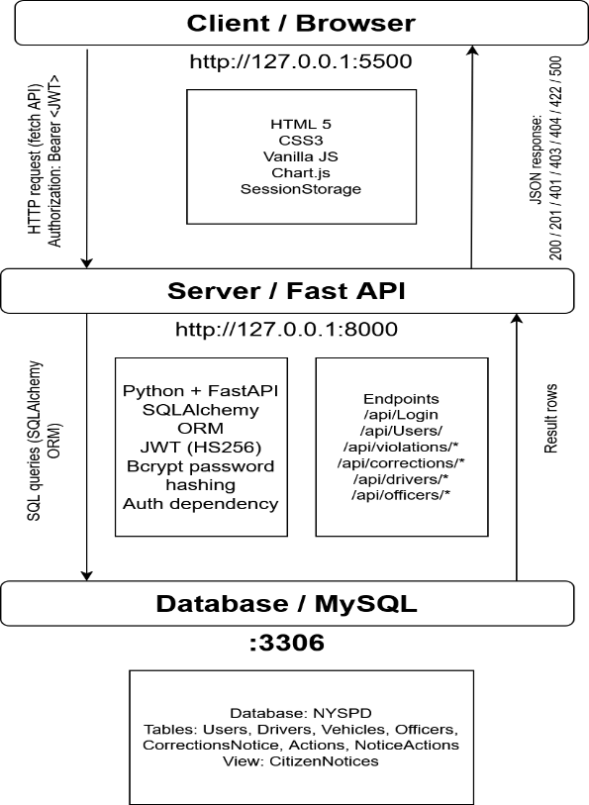
(Figure 1)
  - User Interface (UI)
  - Responsivity
- Implementation
  - HTML Structure
  - CSS and Responsive Techniques
  - JavaScript Implementation
    - DOM Manipulation and Event handling
    - API Integration and Data transformation
    - Form Validation
    - State Management
    - Error handling
  - JWT Authentication and CORS
  - Deployment

- Testing
  - Testing Approach
    - Cross-Browser Testing
    - Responsive Design Testing
    - API integration Testing
    - User Journey Testing
  - Reflection
    - Challenges
    - What Worked Well
    - Improvements
    - Future Enhancements

- References
Mozilla, (2026) MDN, web docs. Available at: https://developer.mozilla.org/en-US/ [Accessed 25th April 2026]
Mozilla, (2026) MDN, Fetch API. Available at: https://developer.mizilla.org/en-us/docs/web/API/Fetch_API [Accessed 25th April 2026]
Mozilla, (2026) MDN, Web Storage API. Available at: https://developer.mozilla.org/en-US/docs/web/API/Web_storage_API [Accessed 25th April 2026]

