1. ***FINDING "D" AND "L" OF ARMATURE AND VERIFYING IT USING PERIPHERAL SPEED AND EMF INDUCED PER TURN RESPECTIVELY***

# CODE:

clc

P=input('Enter the power rating of the machine,P:');

v= input('Enter the terminal voltage of the machine,V:'); p= input('Enter the number of poles of the machine,p:'); N= input('Enter the speed of the machine,N:');

Bav= input('Enter the specific magnetic loading,Bav:'); ac=input('Enter the specific electric loading ac:,'); eff=input('Enter the efficiency of the machine,eff:'); si=input('Enter the ratio of pole arc to pole pitch,si:'); n=(N/60);

Mac_type=input('if generator enter 1 otherwise 0, Mac_type: '); if(Mac_type==1)

Pa=(P/eff); disp(Pa) else Pa=(P);

disp(P) end

Co = ((pi^2)*Bav*ac*(1/1000)); disp(Co)

%Calculate D^2*L x=(Co*n);

D_L = Pa./x; disp(D_L)

LD_ratio = si*(pi/p);

D = ((D_L)/LD_ratio).^(1/3) L = LD_ratio*D

# OUTPUT:

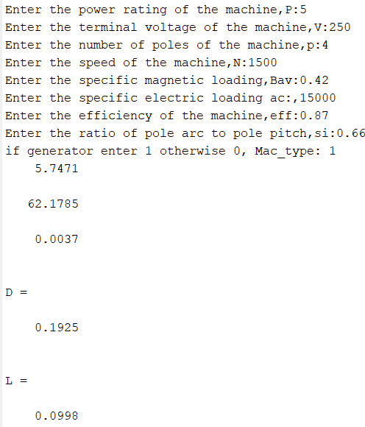

1. ***NUMBER OF POLES vs DIAMETER AND NUMBER OF POLES vs LENGTH***

# CODE:

clc; clear;

% Given machine specs (constants) P = 5000;

eff = 0.87;

Bav = 0.42;

ac = 15000;

si = 0.66;

N = 1500;

Mac_type = 1;

n = N / 60;

% Adjust power input (Pa) if Mac_type == 1

Pa = P / eff; else

Pa = P;

end

% Calculate constant Co

Co = (pi^2) * Bav * ac / 1000;

% Range of poles p_range = 2:2:12;

% Initialize arrays

D_vals = zeros(size(p_range)); L_vals = zeros(size(p_range));

% Calculate Diameter and Length for each pole count for i = 1:length(p_range)

p_i = p_range(i);

% Length to diameter ratio LD_ratio = si * (pi / p_i);

% Calculate D^2 * L D_L = Pa / (Co * n);

% Calculate Diameter (D) and Length (L) D = (D_L / LD_ratio)^(1/3);

L = LD_ratio * D;

D_vals(i) = D;

L_vals(i) = L;

end

% Plot Poles vs Diameter and Length figure;

subplot(2,1,1);

plot(p_range, D_vals, '-o', 'LineWidth', 2, 'MarkerSize', 8); xlabel('Number of Poles');

ylabel('Diameter (m)'); title('Number of Poles vs Diameter'); grid on;

subplot(2,1,2);

plot(p_range, L_vals, '-o', 'LineWidth', 2, 'MarkerSize', 8); xlabel('Number of Poles');

ylabel('Length (m)'); title('Number of Poles vs Length'); grid on;

# OUTPUT:

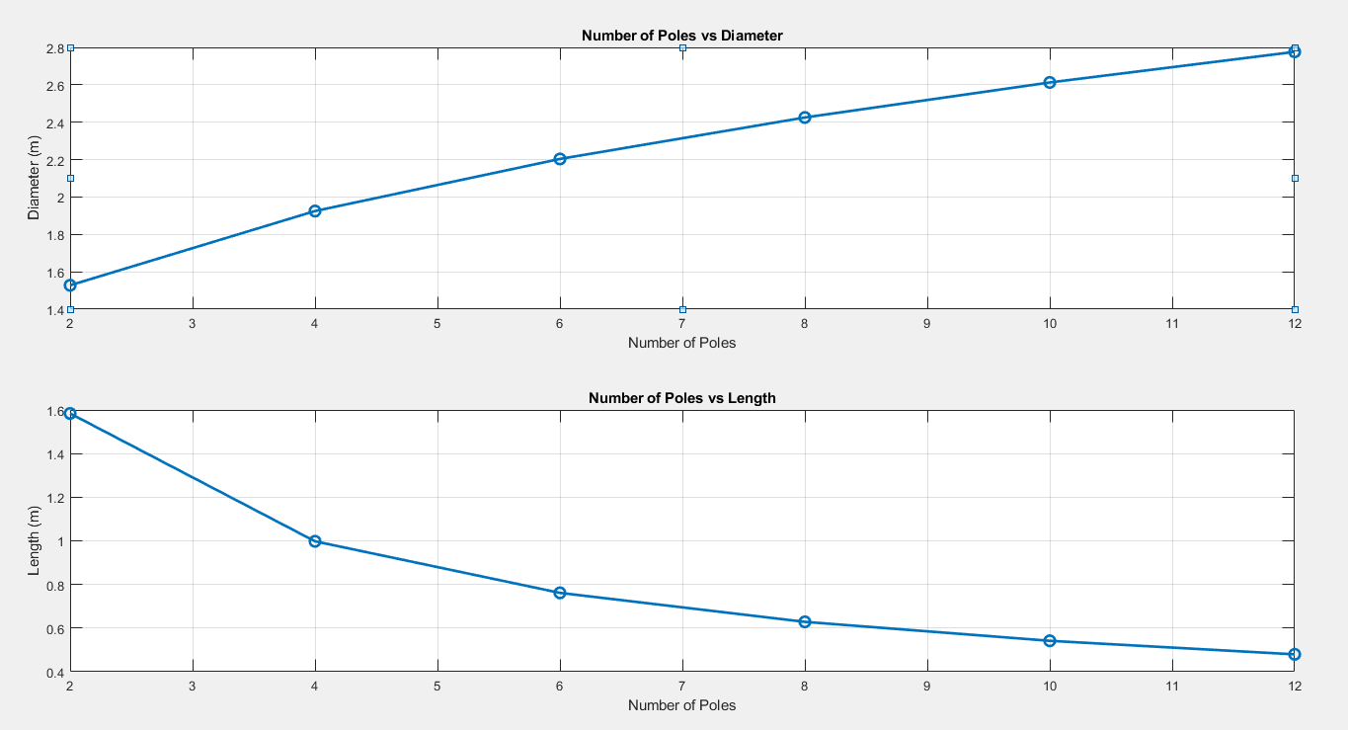

1. ***SPEED vs DIAMETER AND SPEED vs LENGTH***

# CODE:

clc; clear;

% Given machine specs (constants)

P = 5000; % Power in watts

eff = 0.87; % Efficiency (decimal)

Bav = 0.42; % Specific magnetic loading in Tesla ac = 15000; % Specific electric loading in A/m

si = 0.66; % Pole arc to pole pitch ratio p = 4; % Fixed number of poles Mac_type = 1; % Generator (1)

% Adjust power input (Pa) if Mac_type == 1

Pa = P / eff; else

Pa = P;

end

% Calculate constant Co

Co = (pi^2) * Bav * ac / 1000;

% Speed range from 1000 to 1500 rpm in increments of 100 speed_range = 1000:100:1500;

% Initialize arrays for Diameter and Length D_vals = zeros(size(speed_range));

L_vals = zeros(size(speed_range)); for i = 1:length(speed_range)

N = speed_range(i);

n = N / 60; % Convert rpm to rps

% Length to diameter ratio (constant for fixed poles) LD_ratio = si * (pi / p);

% Calculate D^2 * L D_L = Pa / (Co * n);

% Calculate Diameter (D) and Length (L) D = (D_L / LD_ratio)^(1/3);

L = LD_ratio * D;

D_vals(i) = D;

L_vals(i) = L;

end

% Plot Speed vs Diameter and Length figure;

subplot(2,1,1);

plot(speed_range, D_vals, '-s', 'LineWidth', 2, 'MarkerSize', 8); xlabel('Speed (rpm)');

ylabel('Diameter (m)'); title('Speed vs Diameter'); grid on;

subplot(2,1,2);

plot(speed_range, L_vals, '-s', 'LineWidth', 2, 'MarkerSize', 8); xlabel('Speed (rpm)');

ylabel('Length (m)'); title('Speed vs Length'); grid on;

**OUTPUT:**

