Functional Requirements Document
(FRD)

Product Cannibalization & Demand Shift Analysis System

Version 1.0
Prepared by: Harish Chavan

1. Functional Overview
The application analyzes historical sales data to identify product cannibalization and visualize business insights through interactive dashboards.

2. System Workflow
The end-to-end analysis pipeline follows a sequential flow, from raw data collection through to final business recommendations:
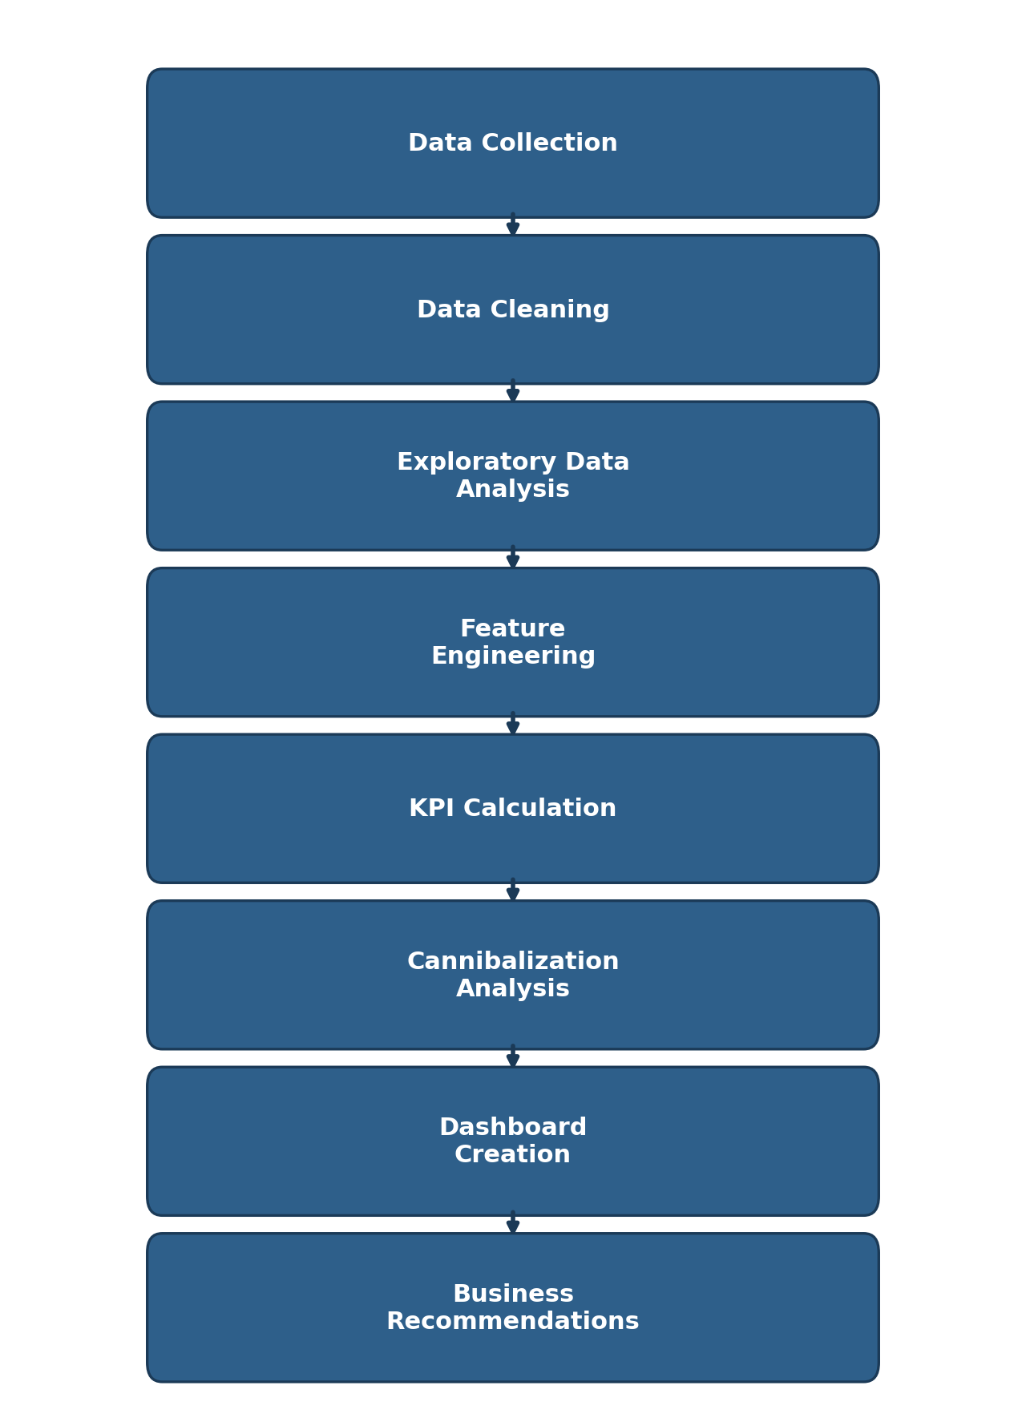

3. Functional Modules

Module 1: Data Import

Description
Load dataset into Python.

Inputs
- CSV
- Excel
- Database Export

Output
Imported dataset

Module 2: Data Cleaning

Functions
- Remove duplicates
- Handle missing values
- Fix data types
- Remove invalid entries
- Standardize categories

Output
Clean dataset

Module 3: Exploratory Data Analysis

Functions
- Distribution analysis
- Correlation analysis
- Category analysis
- Sales trend analysis
- Revenue analysis
- Outlier detection
- Seasonality analysis

Module 4: Feature Engineering

Generate
- Revenue
- Profit (if available)
- Launch Period
- Sales Difference
- Revenue Difference
- Price Difference
- Growth %
- Month
- Quarter
- Year

Module 5: Product Performance Analysis

Functions
- Best-selling products
- Worst-performing products
- Category comparison
- Region comparison
- Revenue comparison

Module 6: Cannibalization Analysis

Functions
- Compare sales before launch
- Compare sales after launch
- Calculate revenue shift
- Calculate customer migration
- Identify affected products
- Calculate cannibalization percentage
Formula
Cannibalization Rate (%) = (Sales Lost by Existing Product ÷ Sales Gained by New Product) × 100

Module 7: Customer Analysis

Functions
- Repeat customers
- Product switching
- Customer contribution
- Regional behavior
- Purchase frequency

Module 8: Pricing Analysis

Functions
- Price comparison
- Price elasticity
- Price impact on sales
- Discount effectiveness

Module 9: Marketing Analysis

Functions
- Marketing spend comparison
- Campaign effectiveness
- Marketing ROI
- Promotion impact

Module 10: Inventory Analysis

Functions
- Stock availability
- Out-of-stock frequency
- Lost sales estimation
- Inventory trend

Module 11: KPI Engine

Automatically calculate
- Total Sales
- Total Revenue
- Average Revenue
- Growth %
- Revenue Contribution
- Cannibalization %
- Market Share
- Marketing ROI
- Customer Retention
- Average Rating

Module 12: Dashboard

Dashboard Pages
# | Dashboard Page
1 | Executive Overview
2 | Sales Performance
3 | Product Performance
4 | Cannibalization Analysis
5 | Customer Insights
6 | Pricing Analysis
7 | Marketing Analysis
8 | Inventory Analysis
9 | Regional Analysis
10 | Recommendations

Dashboard Filters
Filter
Date
Category
Product
Region
Launch Status
Customer Segment
Price Range

Dashboard Visuals
Visual Type | Visual Type | Visual Type
KPI Cards | Line Chart | Bar Chart
Clustered Bar Chart | Stacked Column Chart | Waterfall Chart
Ribbon Chart | Treemap | Heatmap
Scatter Plot | Bubble Chart | Pie Chart
Donut Chart | Map | Slicers
Tables | Matrix | Decomposition Tree
Key Influencers (Interactive HTML/JS Dashboard AI Visual)

User Inputs
- Dataset upload
- Date range
- Category selection
- Product selection
- Region selection
- Launch period

User Outputs
- Sales trends
- Revenue trends
- Cannibalized products
- Revenue shift
- Customer movement
- Marketing impact
- Inventory impact
- Business recommendations

Business Rules
# | Rule
1 | A new product must have a valid launch date.
2 | Sales comparisons must use equivalent time periods before and after launch.
3 | Missing sales values are treated according to the chosen data-cleaning strategy.
4 | Revenue equals Units Sold × Selling Price when not directly available.
5 | Cannibalization is evaluated only within comparable product categories unless explicitly configured otherwise.
6 | Growth metrics should account for seasonality where possible to avoid misleading conclusions.

Non-Functional Requirements
Requirement | Description
Performance | Analyze 60,000+ records in under 30 seconds on a standard laptop
Scalability | Support future expansion to 500,000+ records
Reliability | Consistent KPI calculations across analyses
Usability | Interactive Interactive HTML/JS Dashboard with intuitive navigation
Availability | Dashboard accessible whenever the report file is opened
Maintainability | Modular Python code with documented functions
Security | Dataset stored locally with controlled access
Compatibility | Compatible with Python 3.x, Jupyter Notebook, and Interactive HTML/JS Dashboard Desktop

Expected Business Benefits
- Detect hidden revenue loss caused by product cannibalization.
- Improve new product launch decisions using data-driven evidence.
- Optimize pricing and promotional strategies.
- Reduce inventory waste by identifying declining products.
- Understand customer switching behavior across products.
- Differentiate true market growth from internal demand shifts.
- Provide executives with interactive dashboards for faster decision-making.
- Create a reusable analytics framework that can be applied to future product launches.

