Product Requirements Document
(PRD)

Product Cannibalization & Demand Shift Analysis System

Version 1.0
Prepared by: Harish Chavan

1. Project Overview

Project Description
The Product Cannibalization & Demand Shift Analysis System is a Business Analytics solution designed to identify whether the launch of a new product negatively impacts the sales of existing products. The system analyzes historical sales data, customer purchasing behavior, pricing, promotions, inventory levels, and marketing activities to distinguish genuine business growth from demand shifting between products.
The project combines Python for data preprocessing and analysis with Interactive HTML/JS Dashboard for interactive dashboards. The final solution provides business users with actionable insights to support pricing strategies, product launches, inventory planning, and marketing decisions.

2. Problem Statement
Companies regularly introduce new products to increase revenue and capture larger market share. However, these products often reduce sales of existing products instead of attracting new customers.
This phenomenon is known as Product Cannibalization.
Without proper analysis, organizations may incorrectly assume overall business growth while existing products silently lose revenue.
The project aims to detect these hidden losses and provide decision-makers with measurable business insights.

3. Business Objectives
- Detect product cannibalization.
- Measure cannibalization percentage.
- Identify products affected after new launches.
- Compare revenue before and after product launches.
- Analyze customer purchasing behavior.
- Measure pricing impact.
- Evaluate promotion effectiveness.
- Study inventory influence on sales.
- Identify actual market growth.
- Support strategic product decisions.

4. Goals
The system should help management answer questions like:
- Which products are losing sales?
- Is the decline due to a new product?
- Which customer segments switched products?
- How much revenue shifted?
- Should the old product continue?
- Should pricing be revised?
- Which marketing strategy performs better?

5. Target Audience (Recruiters)
Stakeholder | Responsibility
Business Manager | Reviews overall performance
Hiring Manager / Recruiter | Evaluates product launch success
Sales Manager | Monitors sales trends
Marketing Team | Measures campaign effectiveness
Inventory Manager | Plans stock availability
Data Analyst | Performs analysis
Executive Management | Makes strategic decisions

6. Scope

In Scope
In-Scope Areas
Sales Analysis
Customer Analysis
Revenue Analysis
Launch Analysis
Cannibalization Detection
Dashboard Visualization
EDA
KPI Generation
Forecast-ready Dataset
Business Recommendations

Out of Scope
Out-of-Scope Areas
Real-time Streaming
ERP Integration
Machine Learning Prediction
Automatic Pricing Engine
Supplier Management
Mobile Application

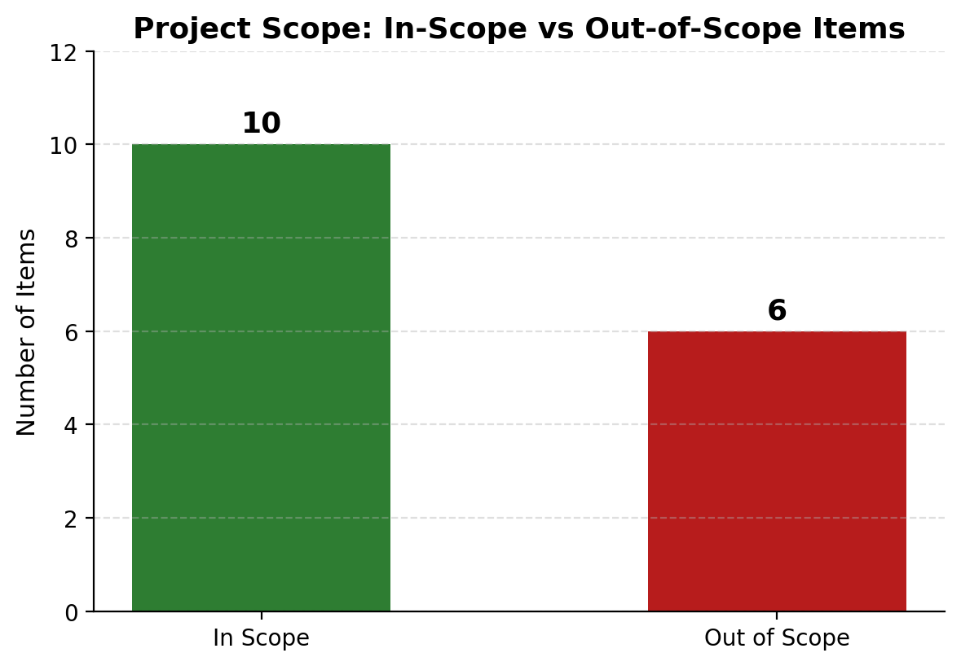

7. Business Requirements
The system must:
- Import sales dataset.
- Clean missing values.
- Remove duplicates.
- Detect sales decline.
- Compare products before and after launch.
- Calculate KPIs.
- Build Interactive HTML/JS Dashboards.
- Generate business insights.

8. Success Criteria
The project is successful if it:
- Identifies cannibalized products.
- Calculates cannibalization accurately.
- Produces actionable dashboards.
- Helps management make product decisions.
- Reduces wrong business assumptions.

9. Dataset Information
Dataset Attribute | Detail
Approximate Size | 60,000 Records
Variables | 13+ Variables
Contains | Missing Values, Duplicate Records, Categorical Variables, Numerical Variables, Time-based Data

10. Dataset Fields
Field | Description
Date | Sales date
Product_ID | Product identifier
Product_Name | Product name
Category | Product category
Sales | Units sold
Revenue | Sales revenue
Price | Product price
Marketing_Spend | Promotion cost
Customer_ID | Customer identifier
Region | Sales region
Stock_Availability | Inventory status
Launch_Status | Old/New product
Product_Rating | Customer rating

11. KPIs
KPI
Total Revenue
Total Sales
Average Selling Price
Revenue Growth %
Sales Growth %
Cannibalization Rate
Market Share
Average Rating
Customer Retention
Marketing ROI
Stock Availability %
Product Contribution %

12. Assumptions
- Historical data is available.
- Launch dates are accurate.
- Sales data is reliable.
- Products belong to known categories.

13. Constraints
- Limited historical data.
- No live database.
- Offline analysis.
- Single dataset.

14. Risks
- Incorrect launch dates.
- Missing sales records.
- Poor data quality.
- Seasonality effects.
- Pricing anomalies.

15. Deliverables
- Clean Dataset
- EDA Report
- Python Notebook
- Interactive HTML/JS Dashboard
- Business Insights Report
- Project Documentation
- Presentation

