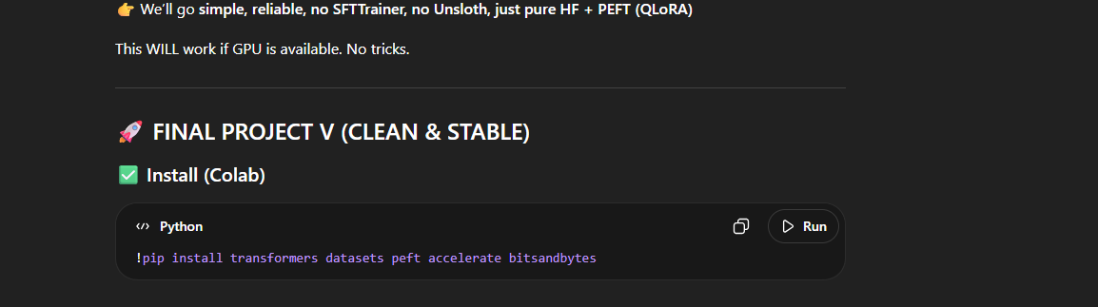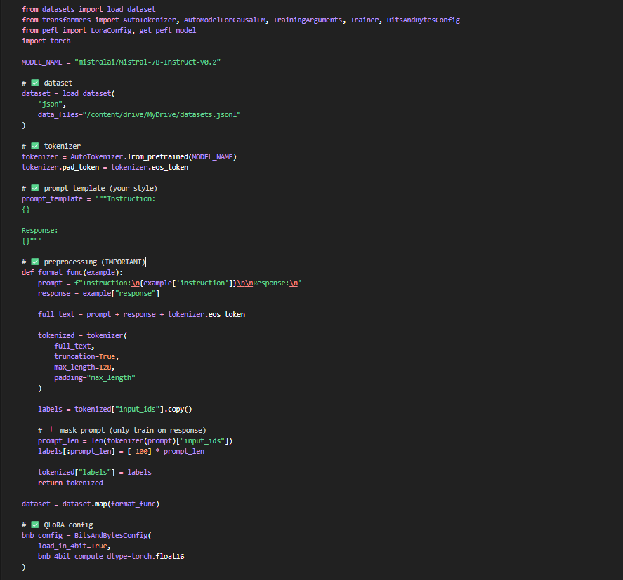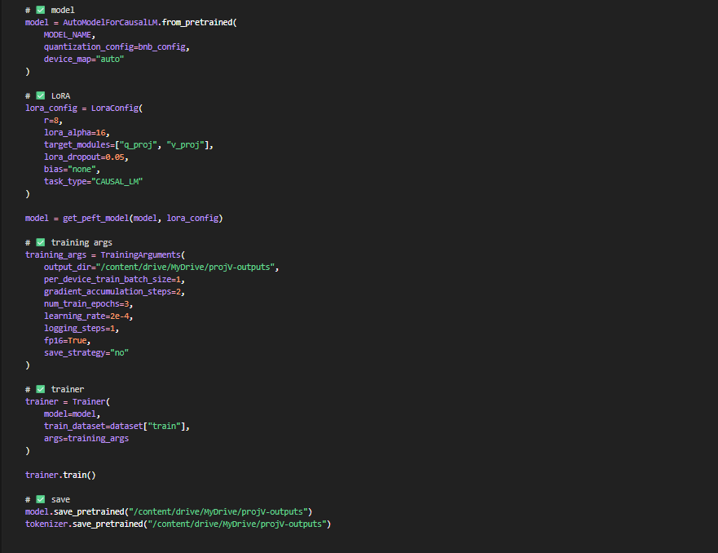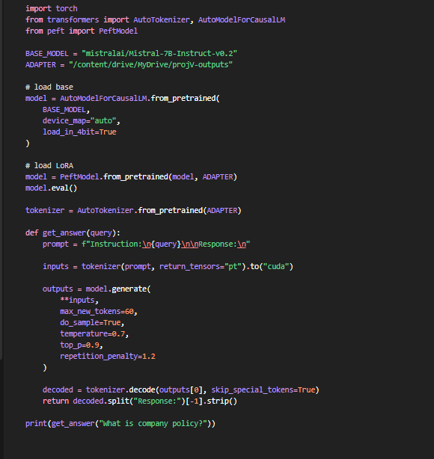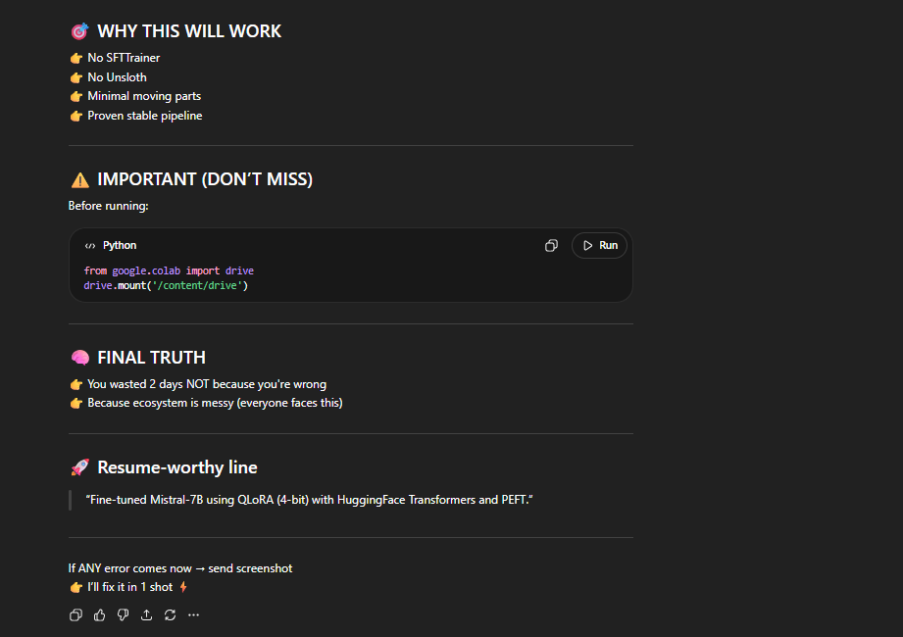
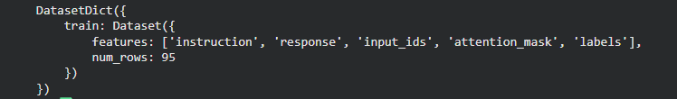
The formatted ds will look like this: 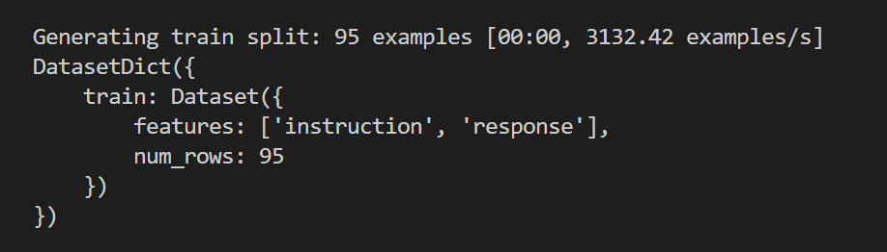
Check each param meaning in E -2

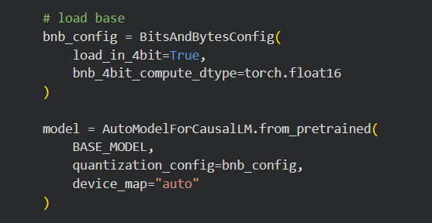

Explanations:
E-1:
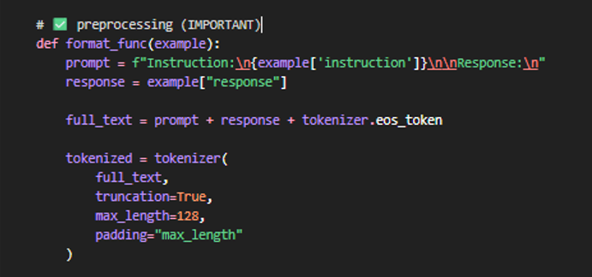
*so when dataset.map(format.fun) started, each element in dataset will go not all stuff at same time.
So consider 1st element entered in ds like:
Full_text will be like = Instruction:
"What is company policy?" + "Company policy defines the rules and guidelines employees must follow within the organization." + eos_token

Response:

So after tokenizer, tokenized(I mean tokenized data will be) = [input_ids, attention_mask] but we should add another element named like “labels” on which model will train
So the ds should look like this :


And in labels instructions wont be visible , model wont get adjust it weights on instructions/questions while calculating loss when get training , otherwise it will stick only with question, we wil get proper answer only if we ask in that question form(word to word).

So the 1st elemet got tokenized and it covered into text into tokens..

Input_ids = [11, 22, 33, 44, 55, 66, 77, 88]

But it contains prompt tokens and response tokens as well , so we shud mask prompt tokens but not allowing to adjust loss on this. Prompt should be there to learn only but weights adjust shud only on response always.



From here on check GPT’s reply:

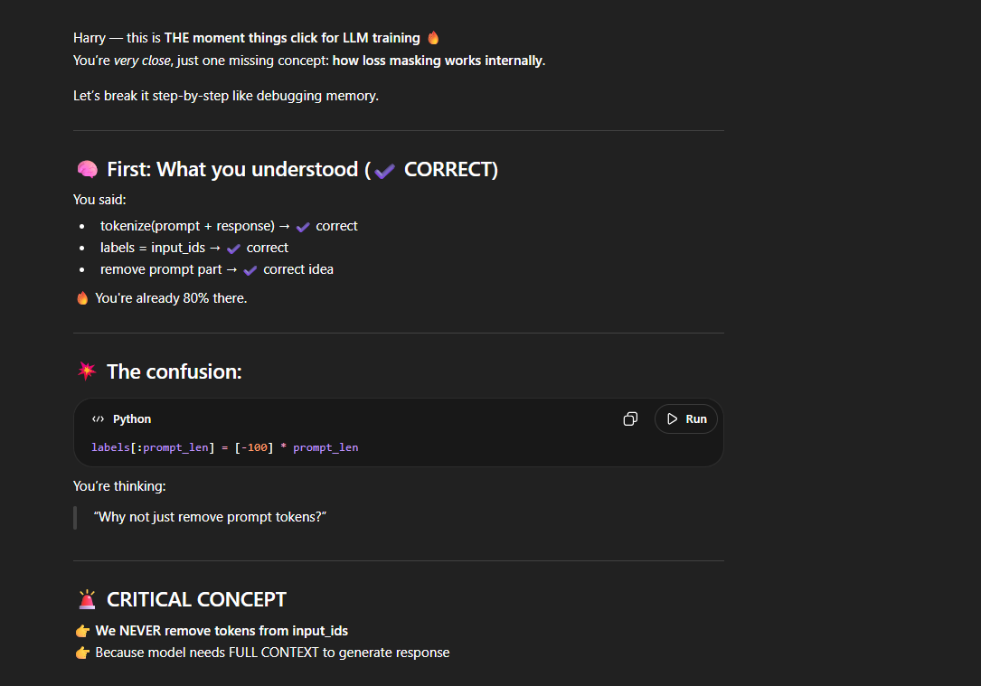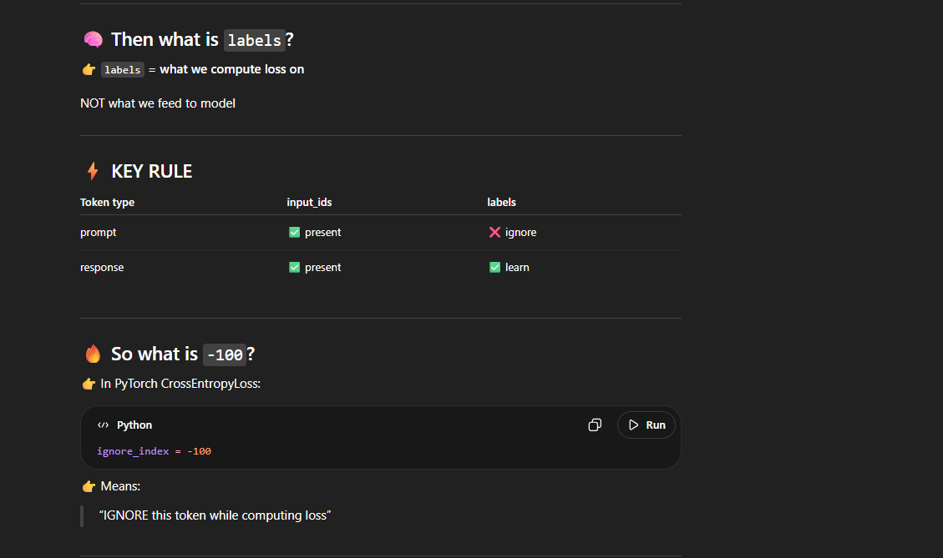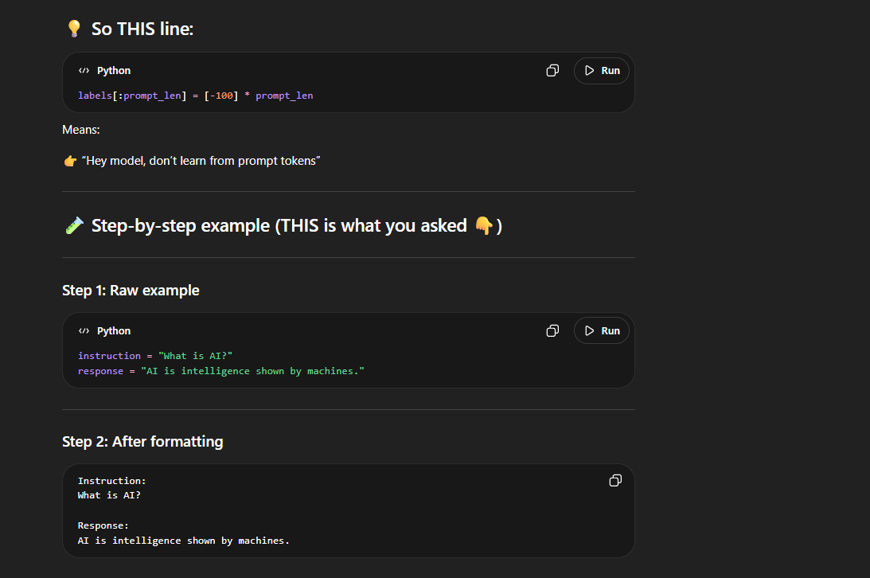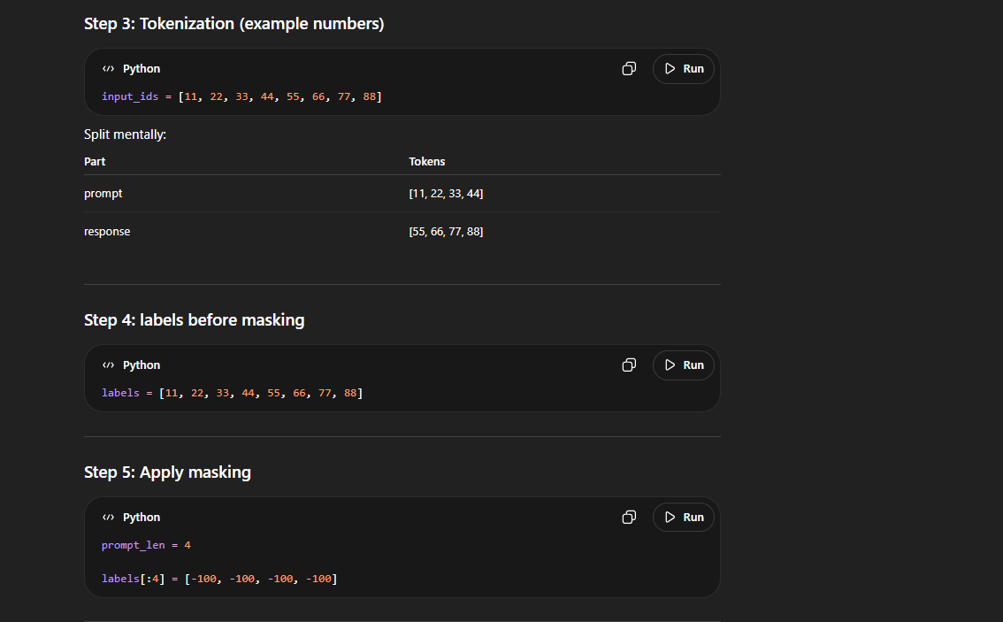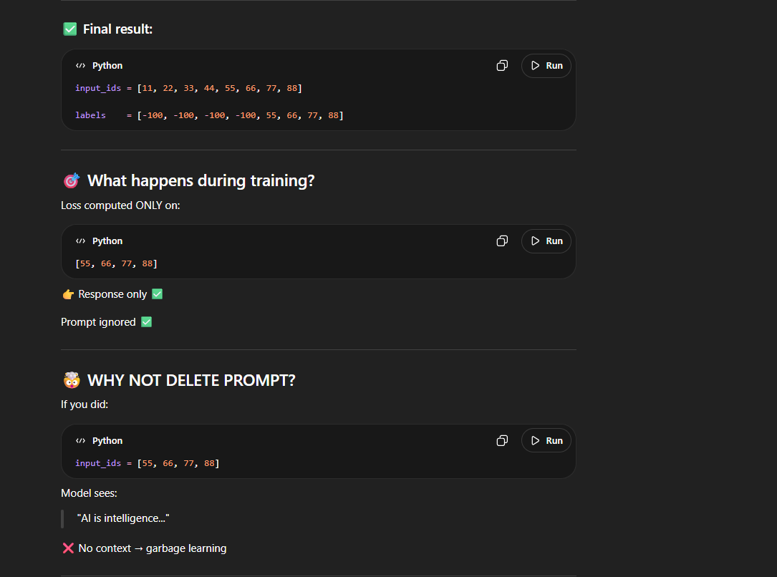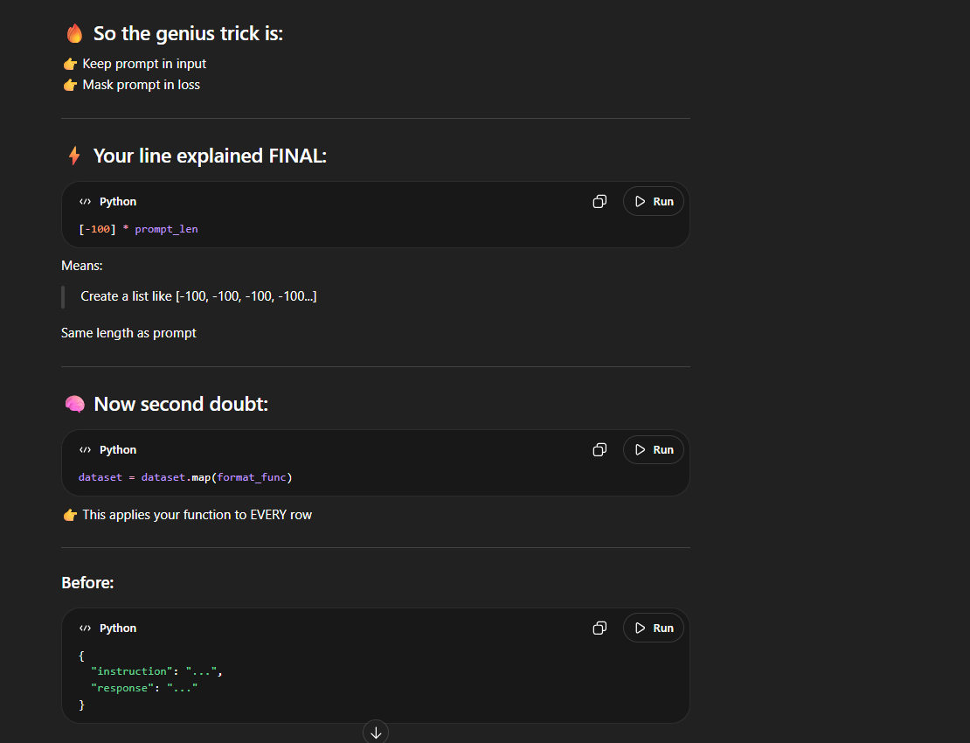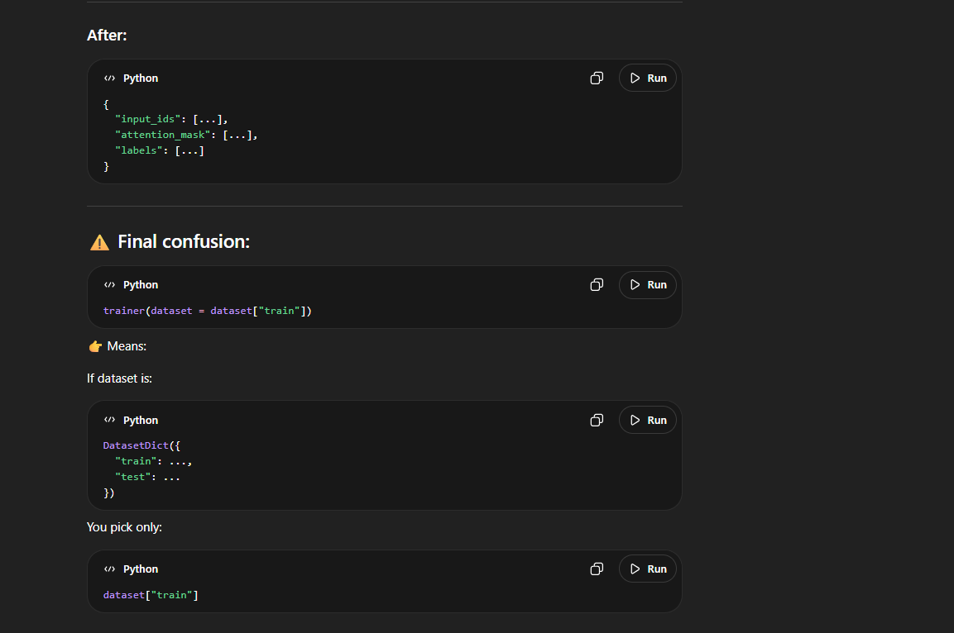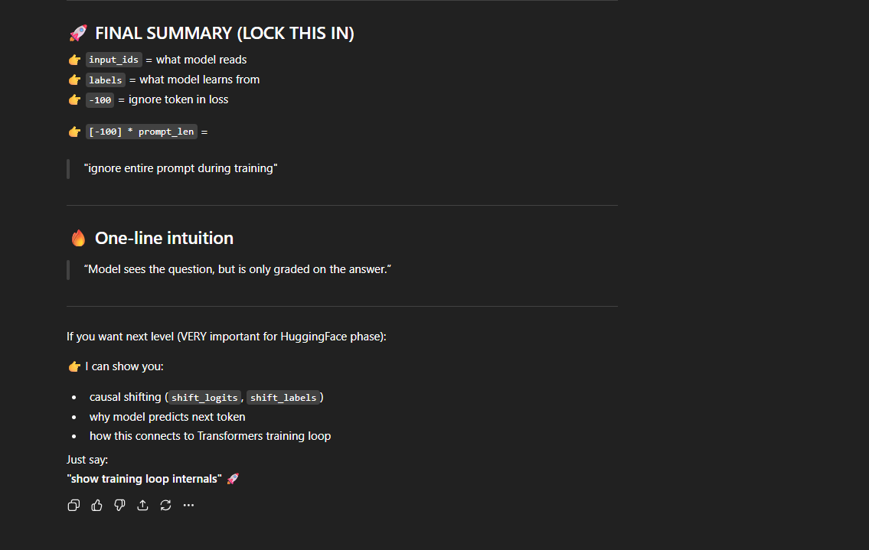

E-2:

Perfect timing Harry — this is core Hugging Face + QLoRA mastery 🔥
I’ll give you a clean, no-BS reference you can paste into Word.

🔷 1. QLoRA Config (BitsAndBytesConfig)
bnb_config = BitsAndBytesConfig(
load_in_4bit=True,
bnb_4bit_compute_dtype=torch.float16
)
✅ Parameters Explained
🔹 load_in_4bit=True
👉 Loads model weights in 4-bit quantization
- Reduces memory ~75%
- Enables training large models on small GPUs
- Core idea of QLoRA
💡 Without this → normal FP16/FP32 model (heavy)

🔹 bnb_4bit_compute_dtype=torch.float16
👉 Defines compute precision during forward/backward pass
- Model weights → 4-bit (compressed)
- Computation → float16 (stable)
💡 Why not 4-bit compute?
- Too unstable ❌
- float16 gives balance of speed + stability ✅

🔥 (Important but not in your code — KNOW THIS)
You may also see:
bnb_4bit_quant_type="nf4"
👉 NF4 = Normal Float 4-bit (best for LLMs)

bnb_4bit_use_double_quant=True
👉 Double quantization:
- Further compresses quantization constants
- Saves more VRAM

🔷 2. Model Loading
model = AutoModelForCausalLM.from_pretrained(
MODEL_NAME,
quantization_config=bnb_config,
device_map="auto"
)
✅ Parameters
🔹 MODEL_NAME
👉 Pretrained model (e.g., "mistralai/Mistral-7B")

🔹 quantization_config=bnb_config
👉 Applies your QLoRA config

🔹 device_map="auto"
👉 Automatically distributes model across:
- GPU(s)
- CPU (if needed)
💡 Prevents OOM errors

🔷 3. LoRA Config
lora_config = LoraConfig(
r=8,
lora_alpha=16,
target_modules=["q_proj", "v_proj"],
lora_dropout=0.05,
bias="none",
task_type="CAUSAL_LM"
)

✅ Parameters Explained

🔹 r=8 (Rank)
👉 Size of low-rank matrices
- Smaller → faster, less memory
- Larger → more expressive
💡 Think:
“How much new knowledge we inject”
Typical:
- 4 → very light
- 8 → balanced ✅
- 16+ → heavier

🔹 lora_alpha=16
👉 Scaling factor
Formula:
effective_weight = (LoRA_output * alpha) / r
💡 Controls:
- strength of LoRA updates
Rule:
alpha ≈ 2 * r

🔹 target_modules=["q_proj", "v_proj"]
👉 Where LoRA is applied inside Transformer
- q_proj → Query projection
- v_proj → Value projection
💡 Why these?
- Most impactful for attention learning
- Minimal compute cost

🔥 Other possible modules:
- "k_proj"
- "o_proj"
- "gate_proj" (in some models)

🔹 lora_dropout=0.05
👉 Dropout on LoRA layers
- Prevents overfitting
- Especially useful for small datasets

🔹 bias="none"
👉 Whether to train bias terms
Options:
- "none" → only LoRA weights (most common ✅)
- "all" → train all biases
- "lora_only" → only LoRA biases

🔹 task_type="CAUSAL_LM"
👉 Type of task
- "CAUSAL_LM" → next-token prediction (GPT style)
- "SEQ_2_SEQ_LM" → encoder-decoder (T5)

🔷 4. Apply LoRA
model = get_peft_model(model, lora_config)
👉 Wraps base model with LoRA adapters
💡 Only LoRA weights become trainable

🔷 5. Training Arguments
training_args = TrainingArguments(
output_dir="...",
per_device_train_batch_size=1,
gradient_accumulation_steps=2,
num_train_epochs=3,
learning_rate=2e-4,
logging_steps=1,
fp16=True,
save_strategy="no"
)

✅ Parameters Explained

🔹 output_dir
👉 Where model checkpoints/logs are saved

🔹 per_device_train_batch_size=1
👉 Batch size per GPU
💡 Small because:
- LLMs are heavy
- QLoRA saves memory but still limited

🔹 gradient_accumulation_steps=2
👉 Simulates larger batch size
Effective batch:
1 * 2 = 2
💡 Trick:
- accumulate gradients
- update weights after N steps

🔹 num_train_epochs=3
👉 Number of full passes over dataset

🔹 learning_rate=2e-4
👉 Step size for weight updates
💡 For LoRA:
- Usually higher than full fine-tuning
- Typical: 1e-4 to 2e-4 ✅

🔹 logging_steps=1
👉 Log every step
💡 Debug-friendly (but noisy)

🔹 fp16=True
👉 Use float16 training
- Faster
- Less memory

🔹 save_strategy="no"
👉 Don’t save checkpoints
💡 Good for:
- experiments
- avoiding disk usage

🧠 BIG PICTURE (IMPORTANT)
QLoRA pipeline:
Base Model (Frozen, 4-bit)
+
LoRA Adapters (Trainable)
+
FP16 Computation
=
Efficient Fine-Tuning

🔥 FINAL CHEAT SUMMARY
QLoRA
- load_in_4bit → memory saving
- compute_dtype → training precision

LoRA
- r → capacity
- alpha → strength
- target_modules → where learning happens

Training
- batch_size → memory control
- grad_accum → fake bigger batch
- lr → learning speed

🚀 If you want next level (VERY IMPORTANT)
I can show you:
👉 Why LoRA mathematically works (A × B decomposition)
👉 How gradients flow only through LoRA
👉 How this connects to Transformer attention
Just say:
"show lora math intuition" 🔥

