

Automated Test Case Document
Jira Ticket: TEST2-88

Document Classification: | Company Confidential
Document Ref: | Automated Test Case Document
Version: | 1.0
Date: | 29/10/2026
Document Author: | Automated TEST2 Evidence Review
Document Owner: | Quality Assurance / Metricell




This document and its content is copyright of Metricell Limited @ 2026 all rights reserved. All information contained herein is the intellectual property of Metricell Limited and should be treated as confidential. Any external redistribution of reproduction of part or all of the contents in any form is prohibited unless expressly agreed with Metricell Limited in writing. Any reproduced content must include the following statement; “Part or all of the content contained herein is copyright of Metricell Limited @ 2026 all rights reserved”.
Table of Contents
1 Revision History 2
2 Test Cycle Information 3
3 Test Summary 3
4 Test Cases 4
About Metricell 12

Revision History

Version | Date | Revision Author | Summary of Changes
[1.0] | 29/10/2026 | TEST2 QA Automation | Generated from TEST2 evidence review

Test Cycle Information

Tester: | Automated
Jira Ticket: | TEST2-88
Environment: | o2intelligence-v4-dev.metricell.com
Browser Details: | Google Chrome 156.0.8078.48
Date of Test: | 29/10/2026
Limitations during Testing: | Blocked criterion(s): 2, 12. See the assessment below each criterion.
Overall review outcome: | Blocked
Browser URL(s) recorded after criteria: | https://o2intelligence-v4-dev.metricell.com/gis

Test Summary

Area of test | Pass (Y/N) | Fail (Y/N) | Blocked (Y/N) | Defect No
1. Given the MS Teams Call layer is active, when the user opens its display settings, then the configured map-colouring choices and controls for detailed routes, linked sites and linked cells are visible. | N | Y | N | 1
2. Given the MS Teams Call layer is active and a configured colouring choice is selected, when the map updates, then MS Teams Call result points and the legend display the selected configured colouring and its corresponding legend section. | N | N | Y | 0
3. Given the MS Teams Call layer is active, when the user turns detailed routes on and the map refreshes, then detailed route geometry for the active MS Teams Call results is visible. | Y | N | N | 0
4. Given the MS Teams Call layer is active and detailed routes are visible, when the user turns detailed routes off and the map refreshes, then that detailed route geometry is hidden. | Y | N | N | 0
5. Given the MS Teams Call layer is active and the map is below the configured zoom level for linked sites, when display settings are open, then the linked-site control is unavailable and indicates that the user must zoom in. | Y | N | N | 0
6. Given the MS Teams Call layer is active and the map is at or above the configured zoom level for linked sites, when the user turns linked sites on and the map refreshes, then linked-site overlays for the active MS Teams Call results are visible. | Y | N | N | 0
7. Given linked-site overlays are visible at a supported zoom level, when the user turns linked sites off and the map refreshes, then those linked-site overlays are hidden. | Y | N | N | 0
8. Given linked sites are enabled and the map is at a zoom level that supports linked cells, when display settings are open, then the linked-cell control is available. | Y | N | N | 0
9. Given linked sites are disabled or the map is below the zoom level that supports linked cells, when display settings are open, then the linked-cell control is unavailable. | Y | N | N | 0
10. Given linked sites are enabled and the map is at a zoom level that supports linked cells, when the user turns linked cells on and the map refreshes, then linked-cell overlays are visible. | Y | N | N | 0
11. Given linked-cell overlays are visible, when the user turns linked cells off and the map refreshes, then those linked-cell overlays are hidden. | Y | N | N | 0
12. Given any MS Teams Call display setting is changed, when the map refreshes, then the setting is applied only to the active MS Teams Call layer and other visible map layers, standard map filters and legend point-filtering state retain their prior visible states. | N | N | Y | 0

Test Cases
Each test maps to a criterion and decisive browser evidence. Inconclusive results are reported as Failed.

Tests

Preconditions: | V4 access and ticket conditions. | Associated Requirements: | Ticket criteria below. | Automation Notes: | Screenshots below each criterion; full log retained locally.
ID / Criterion | Criteria Tested | Expected Result | Actual Result / Evidence Path | Outcome
1.0.0 | Given the MS Teams Call layer is active, when the user opens its display settings, then the configured map-colouring choices and controls for detailed routes, linked sites and linked cells are visible. | Given the MS Teams Call layer is active, when the user opens its display settings, then the configured map-colouring choices and controls for detailed routes, linked sites and linked cells are visible. | criterion-1-automobile-types.png and criterion-1-automobile-config.png establish Automobile > MS Teams Call; the recorded GET /api/platform/automobile/ms-teams-call/points matches that layer. criterion-1-final.png shows the complete Display Settings popover with detailed-route, linked-site and linked-cell controls, but no configured map-colouring choice. This directly contradicts the required colouring control.  Evidence: E01, E02, E03, E04, E05 | Failed
Criterion 1 evidence: Given the MS Teams Call layer is active, when the user opens its display settings, then the configured map-colouring choices and controls for detailed routes, linked sites and linked cells are visible.
Browser URL recorded after criterion: https://o2intelligence-v4-dev.metricell.com/gis
E01 - Gis baseline (criterion-1-gis-baseline.png)  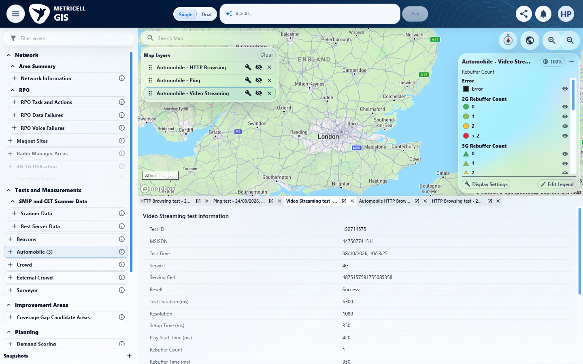 | E02 - Automobile types (criterion-1-automobile-types.png)  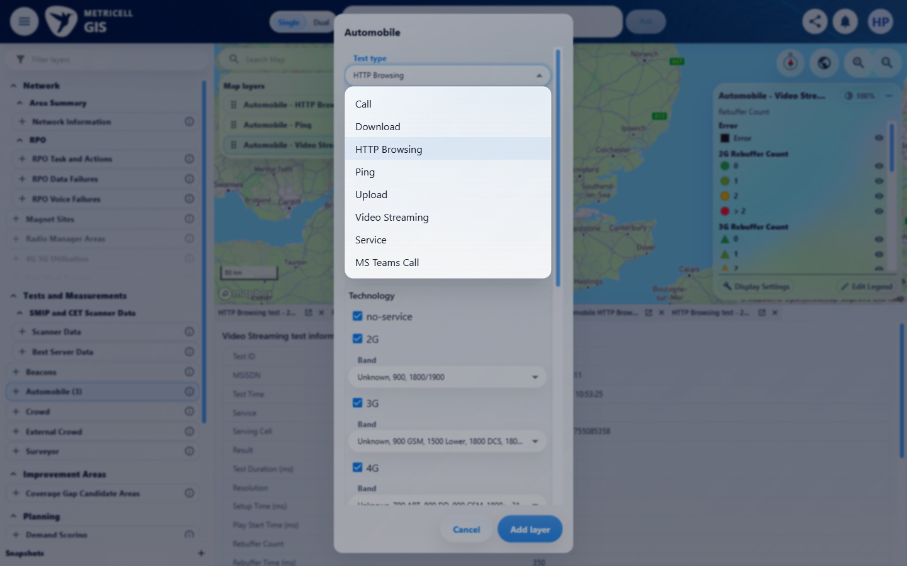

Criterion 1 continued: Given the MS Teams Call layer is active, when the user opens its display settings, then the configured map-colouring choices and controls for detailed routes, linked sites and linked cells are visible.
Browser URL recorded after criterion: https://o2intelligence-v4-dev.metricell.com/gis
E03 - Automobile config (criterion-1-automobile-config.png)  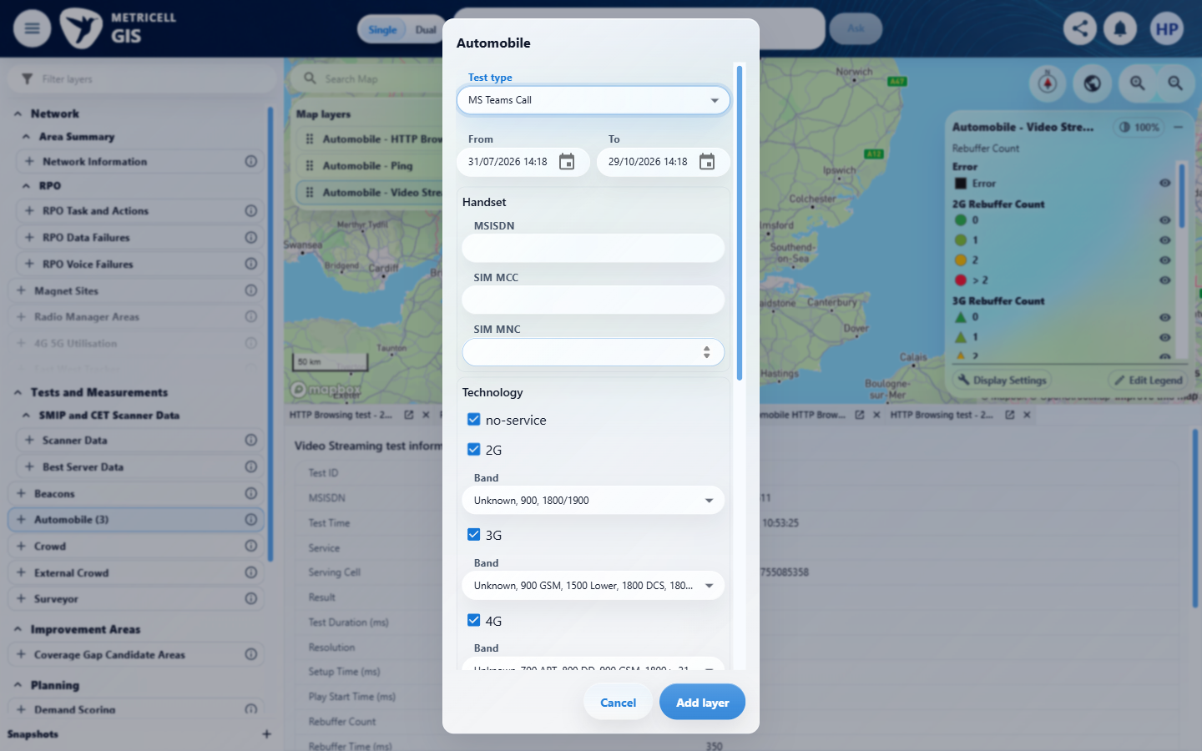 | E04 - Active layer (criterion-1-active-layer.png)  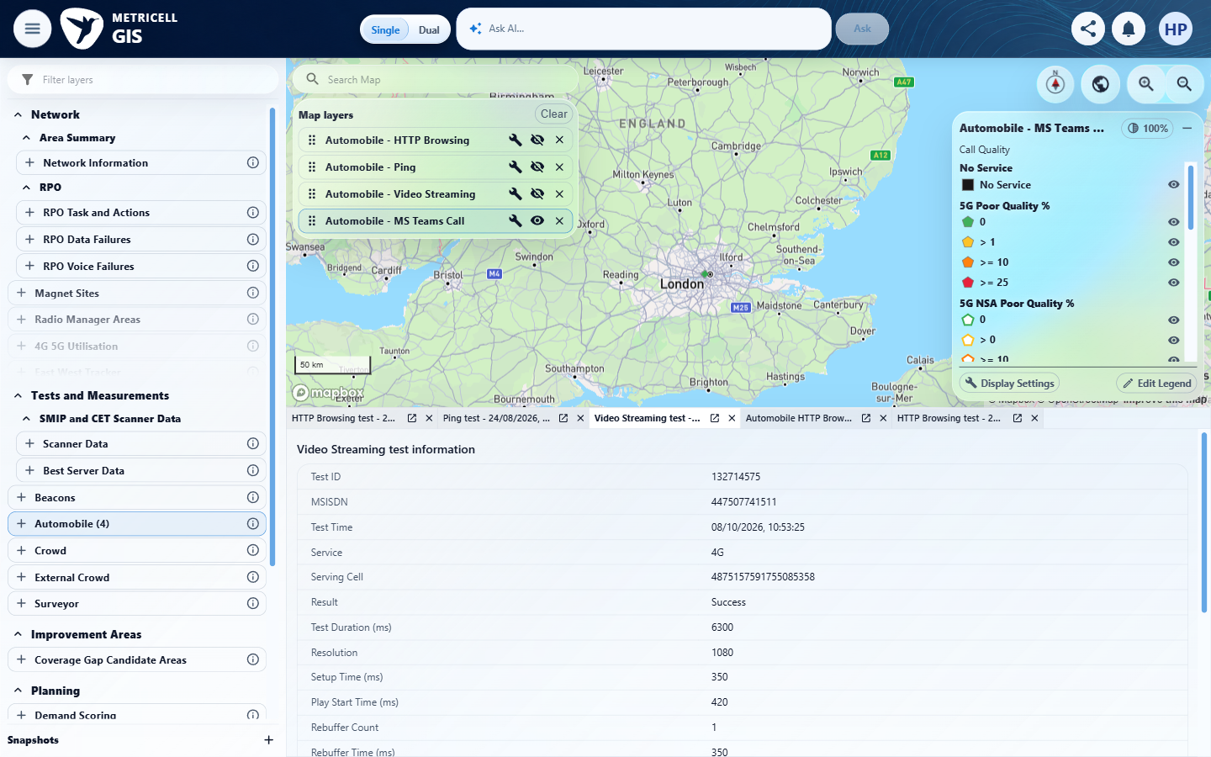

Criterion 1 continued: Given the MS Teams Call layer is active, when the user opens its display settings, then the configured map-colouring choices and controls for detailed routes, linked sites and linked cells are visible.
Browser URL recorded after criterion: https://o2intelligence-v4-dev.metricell.com/gis
E05 - Final (criterion-1-final.png)
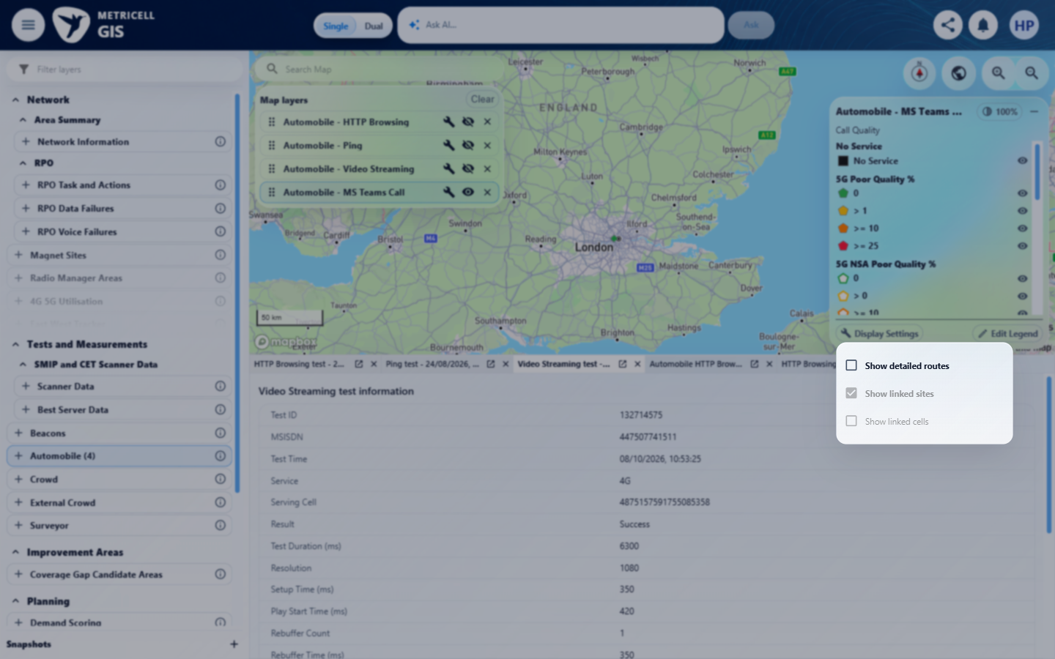

2.0.0 | Given the MS Teams Call layer is active and a configured colouring choice is selected, when the map updates, then MS Teams Call result points and the legend display the selected configured colouring and its corresponding legend section. | Given the MS Teams Call layer is active and a configured colouring choice is selected, when the map updates, then MS Teams Call result points and the legend display the selected configured colouring and its corresponding legend section. | criterion-2-before-display.png and criterion-2-final.png show the active MS Teams Call legend and the three-checkbox Display Settings popover. The configured colouring selector is absent, preventing the required selection and point/legend comparison; existing Call Quality categories alone do not establish configuration-driven colouring.  Evidence: E06, E07 | Blocked
Criterion 2 evidence: Given the MS Teams Call layer is active and a configured colouring choice is selected, when the map updates, then MS Teams Call result points and the legend display the selected configured colouring and its corresponding legend section.
Browser URL recorded after criterion: https://o2intelligence-v4-dev.metricell.com/gis
E06 - Before display (criterion-2-before-display.png)  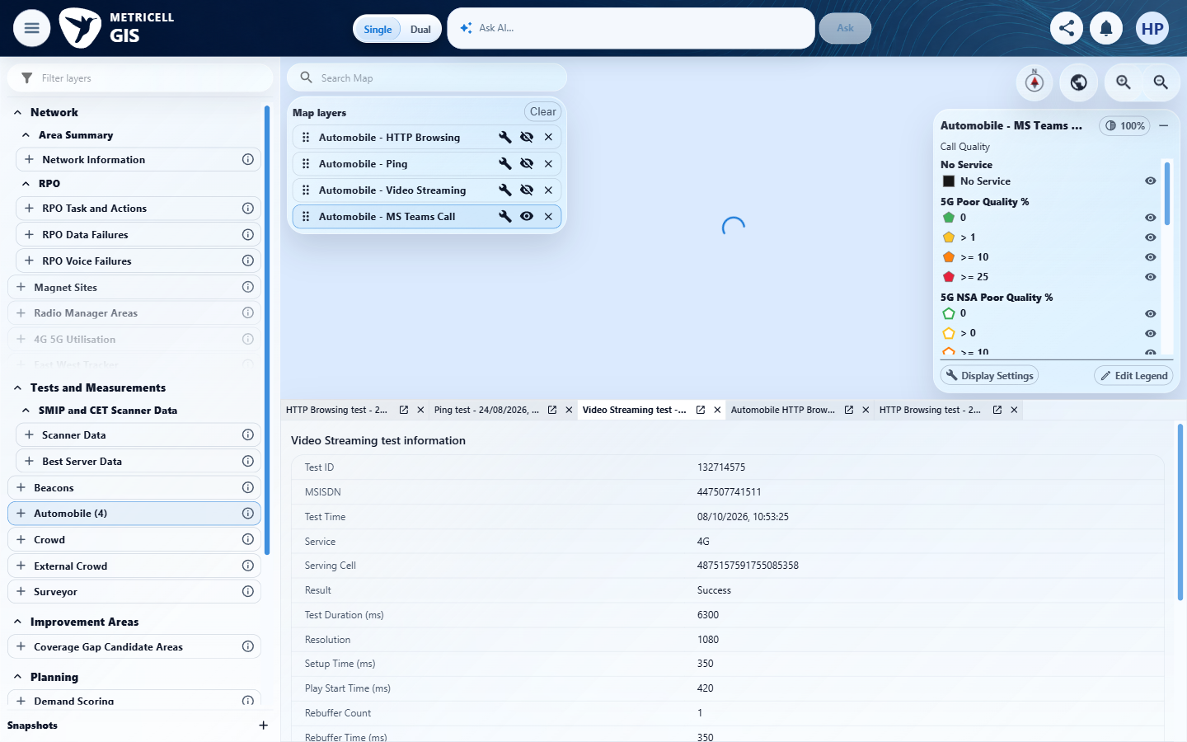 | E07 - Final (criterion-2-final.png)  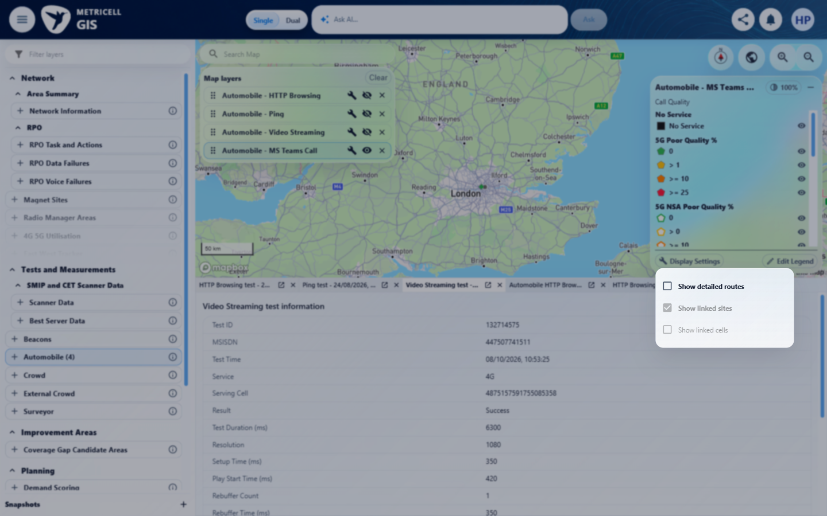

3.0.0 | Given the MS Teams Call layer is active, when the user turns detailed routes on and the map refreshes, then detailed route geometry for the active MS Teams Call results is visible. | Given the MS Teams Call layer is active, when the user turns detailed routes on and the map refreshes, then detailed route geometry for the active MS Teams Call results is visible. | At the same bounded Galgate/Hampson Green map scope, criterion-3-narrow-before-on.png has no detailed route and criterion-3-final.png shows the dense green M6 result route after enabling it. criterion-3-checked.png, captured after final, confirms Show detailed routes checked and the route visible. The recorded fullRoute=true request is for Automobile MS Teams Call. This proves the supplied route scope, without asserting dataset completeness.  Evidence: E08, E09, E10, E11, E12, E13, E14, E15, E16 | Passed
Criterion 3 evidence: Given the MS Teams Call layer is active, when the user turns detailed routes on and the map refreshes, then detailed route geometry for the active MS Teams Call results is visible.
Browser URL recorded after criterion: https://o2intelligence-v4-dev.metricell.com/gis
E08 - Before routes (criterion-3-before-routes.png)  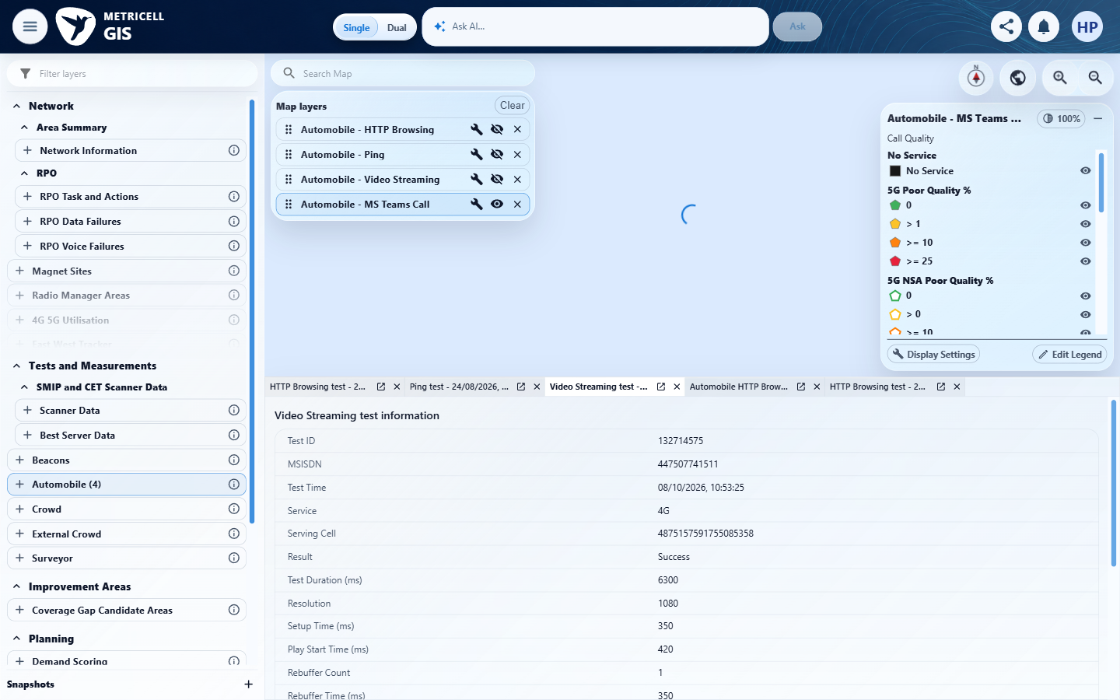 | E09 - Routes on (criterion-3-routes-on.png)  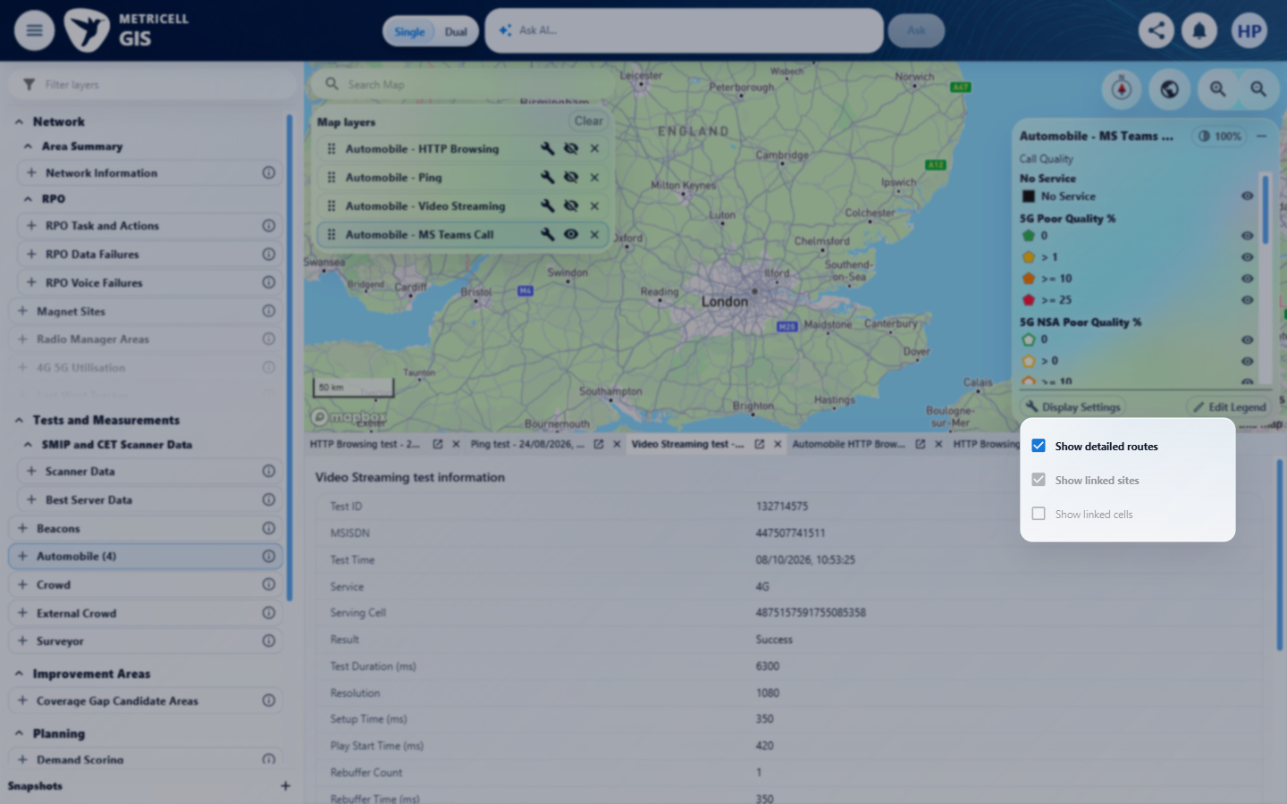

Criterion 3 continued: Given the MS Teams Call layer is active, when the user turns detailed routes on and the map refreshes, then detailed route geometry for the active MS Teams Call results is visible.
Browser URL recorded after criterion: https://o2intelligence-v4-dev.metricell.com/gis
E10 - Wider scope (criterion-3-wider-scope.png)  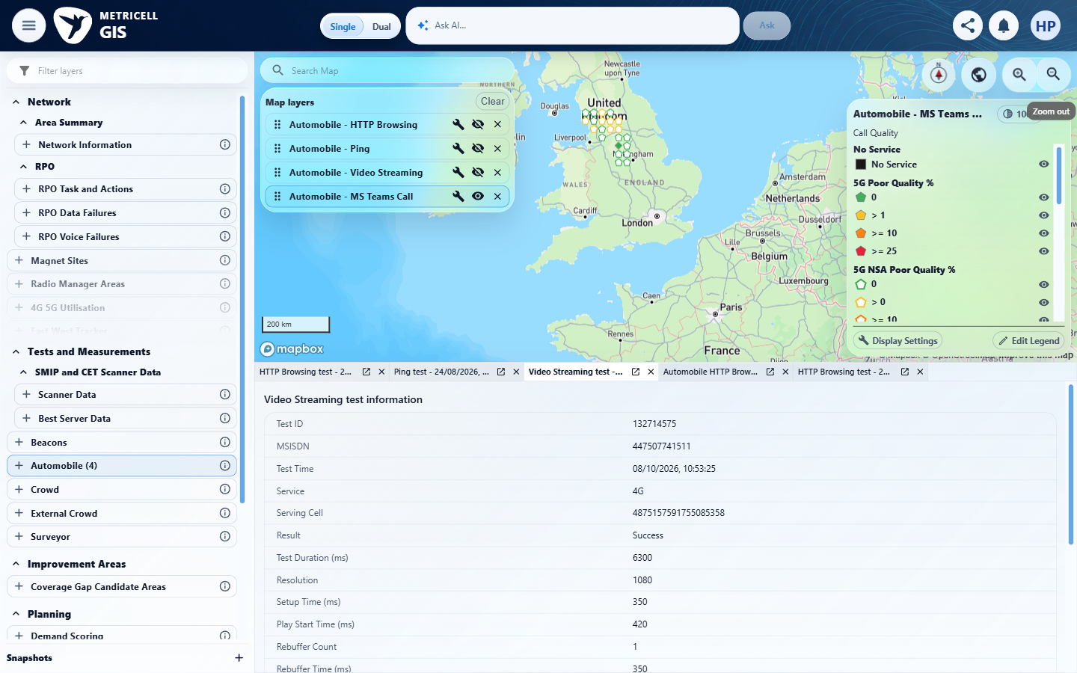 | E11 - Populated area (criterion-3-populated-area.png)  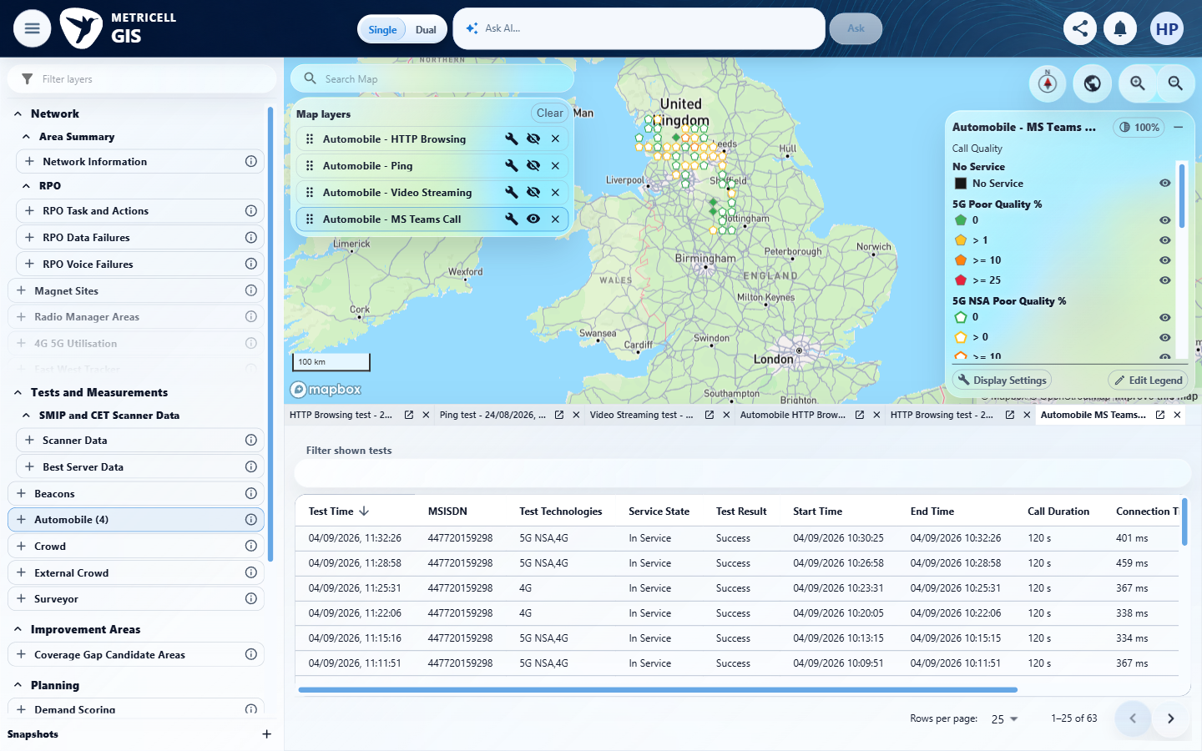

Criterion 3 continued: Given the MS Teams Call layer is active, when the user turns detailed routes on and the map refreshes, then detailed route geometry for the active MS Teams Call results is visible.
Browser URL recorded after criterion: https://o2intelligence-v4-dev.metricell.com/gis
E12 - Route search (criterion-3-route-search.png)  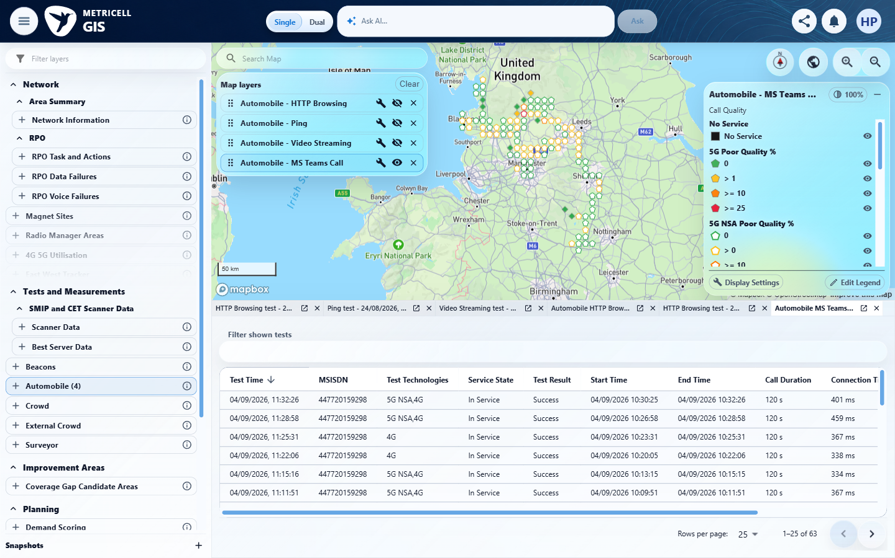 | E13 - Narrow route scope (criterion-3-narrow-route-scope.png)  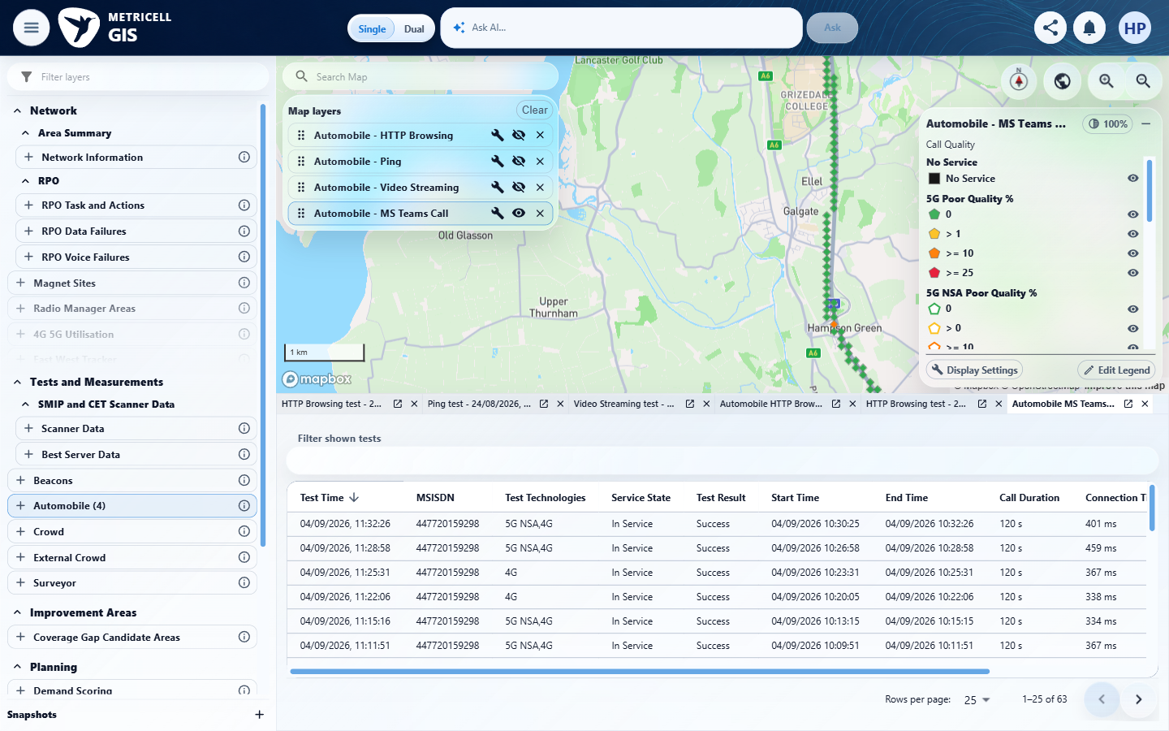

Criterion 3 continued: Given the MS Teams Call layer is active, when the user turns detailed routes on and the map refreshes, then detailed route geometry for the active MS Teams Call results is visible.
Browser URL recorded after criterion: https://o2intelligence-v4-dev.metricell.com/gis
E14 - Narrow before on (criterion-3-narrow-before-on.png)  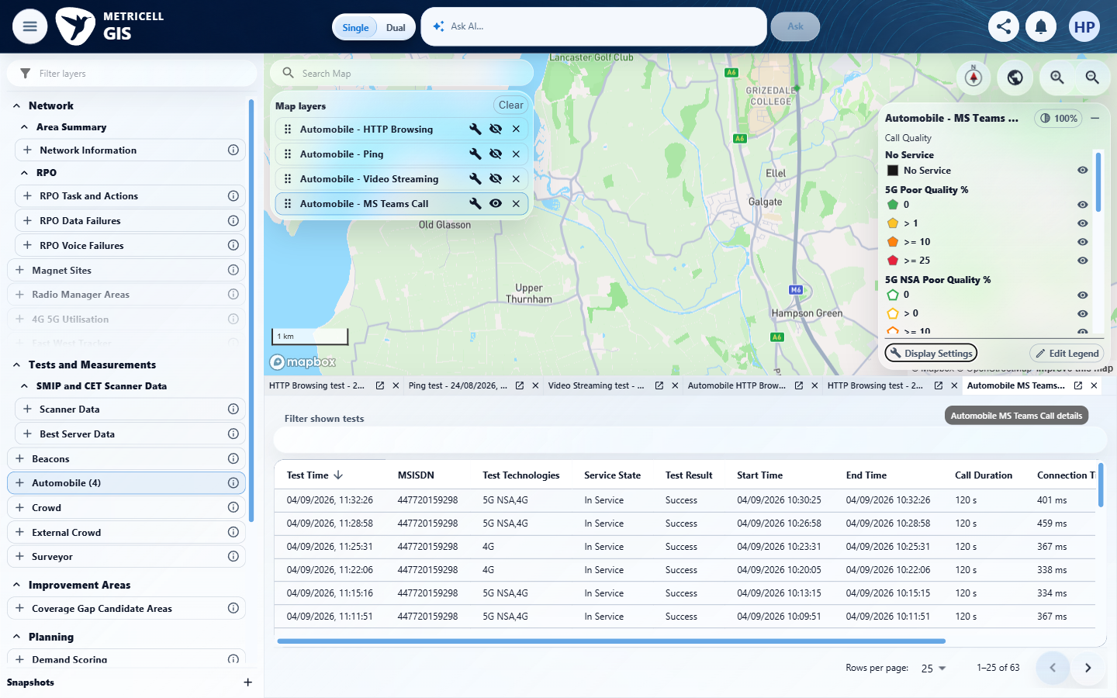 | E15 - Final (criterion-3-final.png)  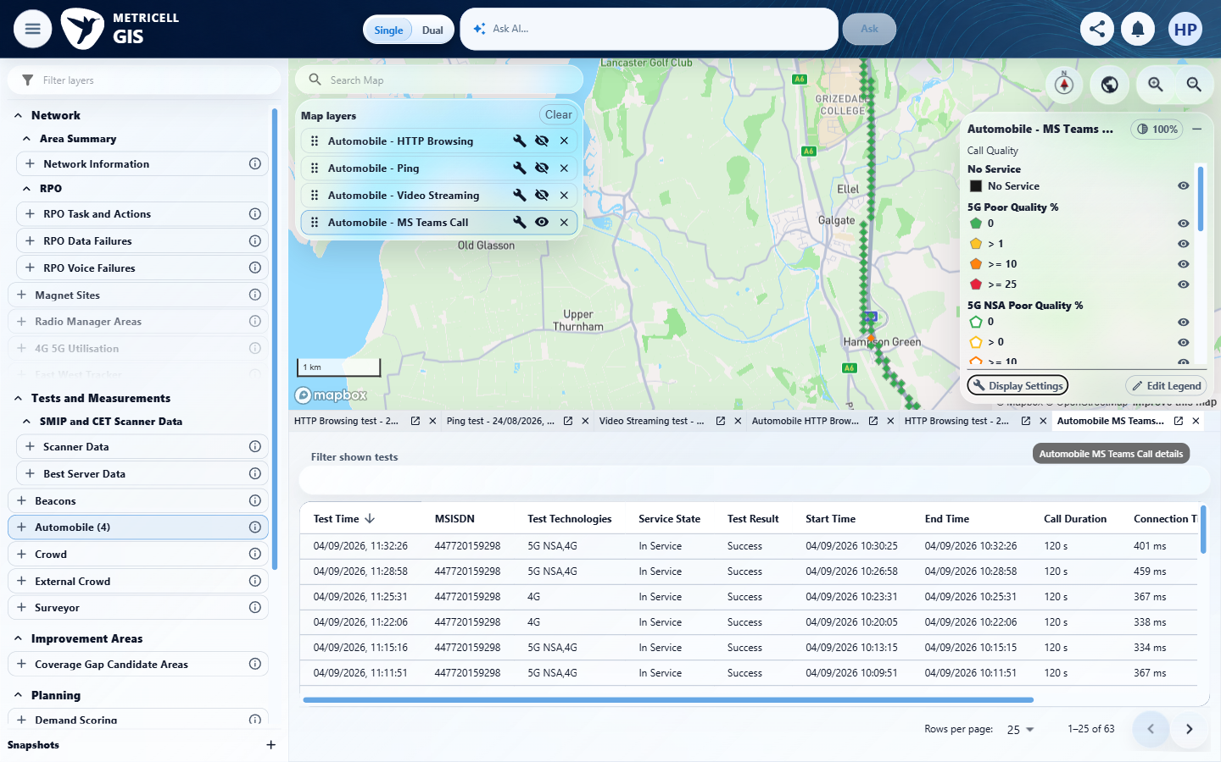
E14 detail enlargement - full screenshot above | E15 detail enlargement - full screenshot above

Criterion 3 continued: Given the MS Teams Call layer is active, when the user turns detailed routes on and the map refreshes, then detailed route geometry for the active MS Teams Call results is visible.
Browser URL recorded after criterion: https://o2intelligence-v4-dev.metricell.com/gis
E16 - Checked (criterion-3-checked.png)
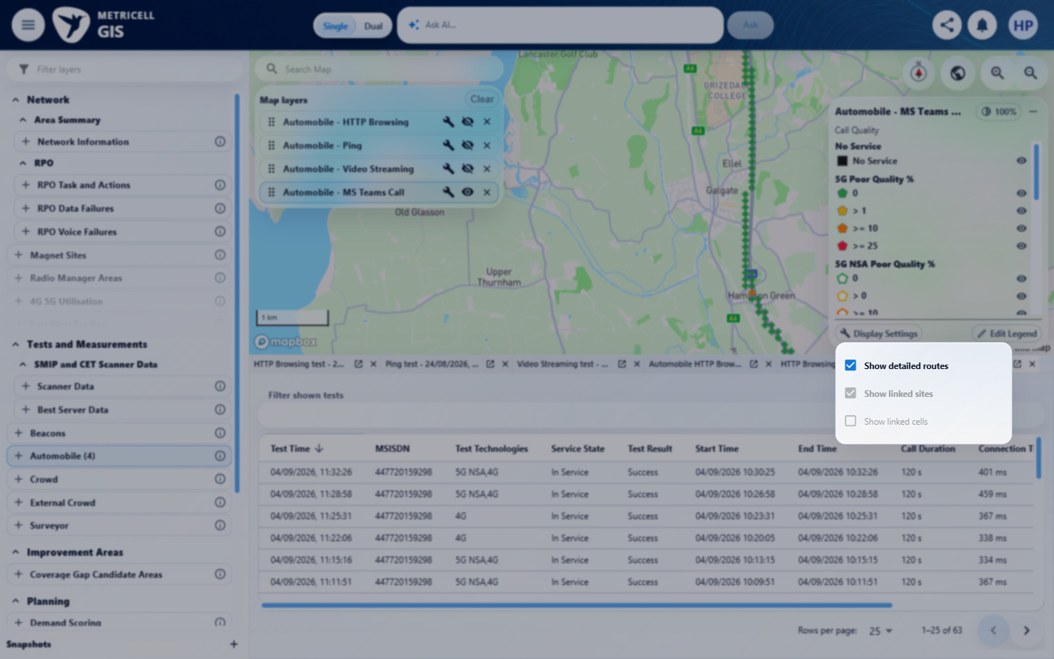

4.0.0 | Given the MS Teams Call layer is active and detailed routes are visible, when the user turns detailed routes off and the map refreshes, then that detailed route geometry is hidden. | Given the MS Teams Call layer is active and detailed routes are visible, when the user turns detailed routes off and the map refreshes, then that detailed route geometry is hidden. | criterion-4-before-off.png shows the MS Teams Call green route along the M6; criterion-4-final.png shows it removed at the matching map extent after the recorded route-off action. The other three layers remain hidden. criterion-4-baseline.png alone was not the decisive routes-on state.  Evidence: E17, E18, E19 | Passed
Criterion 4 evidence: Given the MS Teams Call layer is active and detailed routes are visible, when the user turns detailed routes off and the map refreshes, then that detailed route geometry is hidden.
Browser URL recorded after criterion: https://o2intelligence-v4-dev.metricell.com/gis
E17 - Baseline (criterion-4-baseline.png)  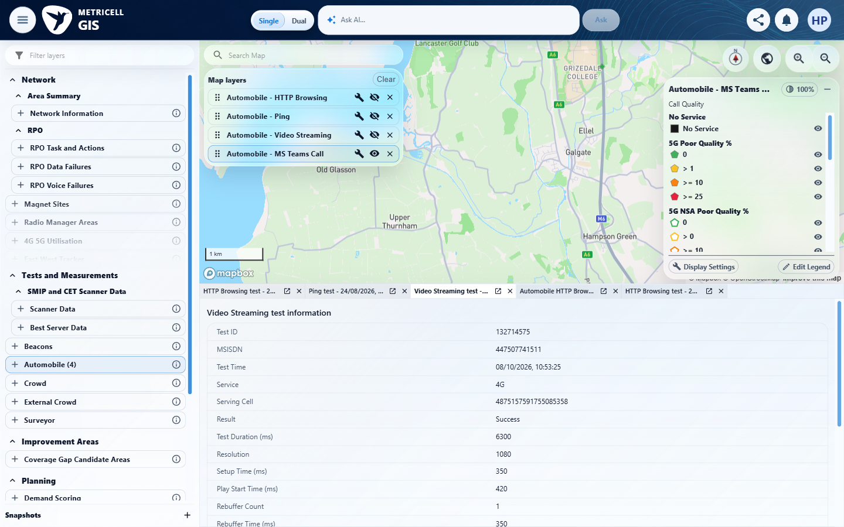 | E18 - Before off (criterion-4-before-off.png)  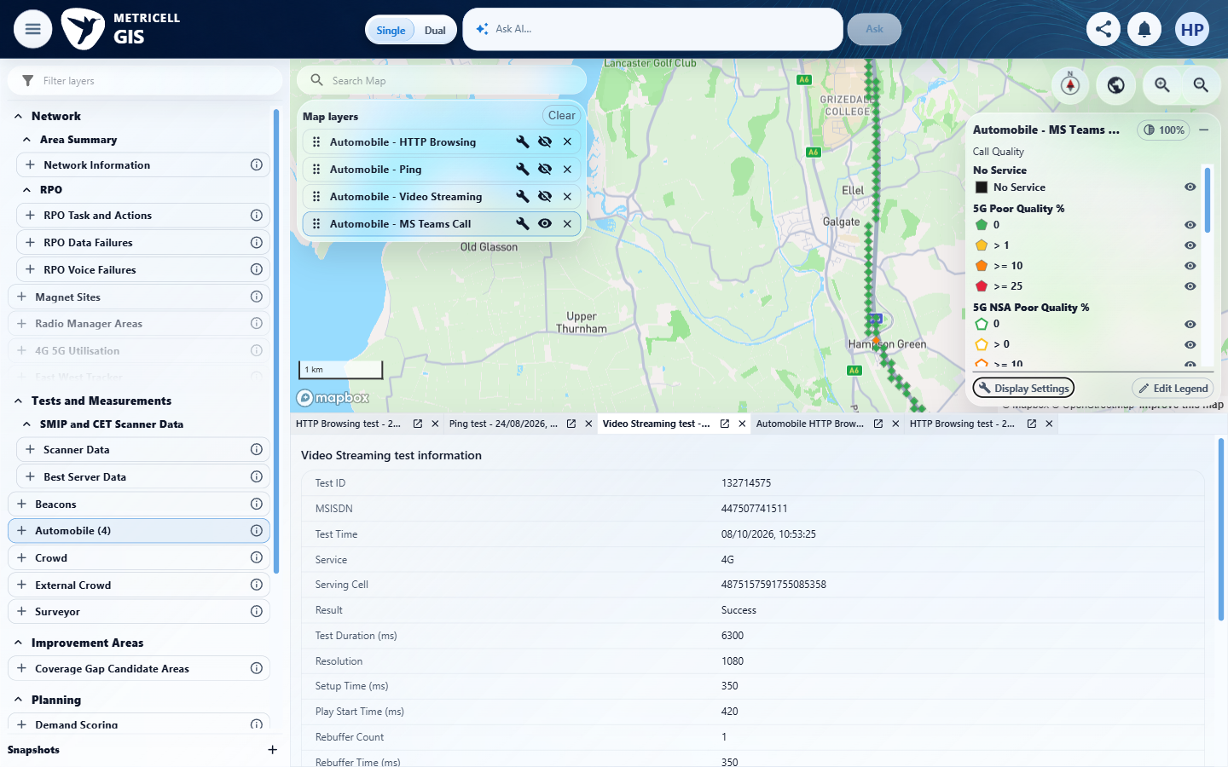

Criterion 4 continued: Given the MS Teams Call layer is active and detailed routes are visible, when the user turns detailed routes off and the map refreshes, then that detailed route geometry is hidden.
Browser URL recorded after criterion: https://o2intelligence-v4-dev.metricell.com/gis
E19 - Final (criterion-4-final.png)
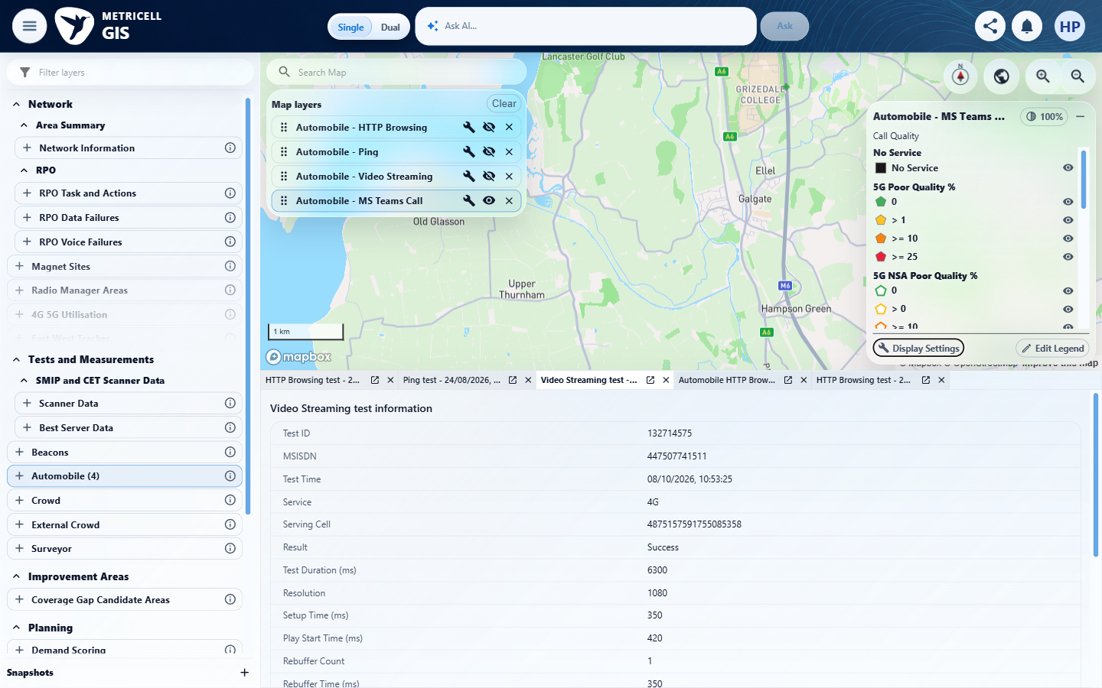

5.0.0 | Given the MS Teams Call layer is active and the map is below the configured zoom level for linked sites, when display settings are open, then the linked-site control is unavailable and indicates that the user must zoom in. | Given the MS Teams Call layer is active and the map is below the configured zoom level for linked sites, when display settings are open, then the linked-site control is unavailable and indicates that the user must zoom in. | criterion-5-before-activation.png shows the grey checked Show linked sites control at the recorded zoom 12.16. Following the recorded normal pointer activation at its visible label (after the locator refused activation), criterion-5-final.png retains the same checked unavailable control, map and detail state and displays 'Zoom in to level 13 to show linked sites.' The native disabled checkbox has no exposed keyboard activation path; the pass rests on the recorded pointer attempt and before/after captures, not the refusal or styling alone.  Evidence: E20, E21 | Passed
Criterion 5 evidence: Given the MS Teams Call layer is active and the map is below the configured zoom level for linked sites, when display settings are open, then the linked-site control is unavailable and indicates that the user must zoom in.
Browser URL recorded after criterion: https://o2intelligence-v4-dev.metricell.com/gis
E20 - Before activation (criterion-5-before-activation.png)  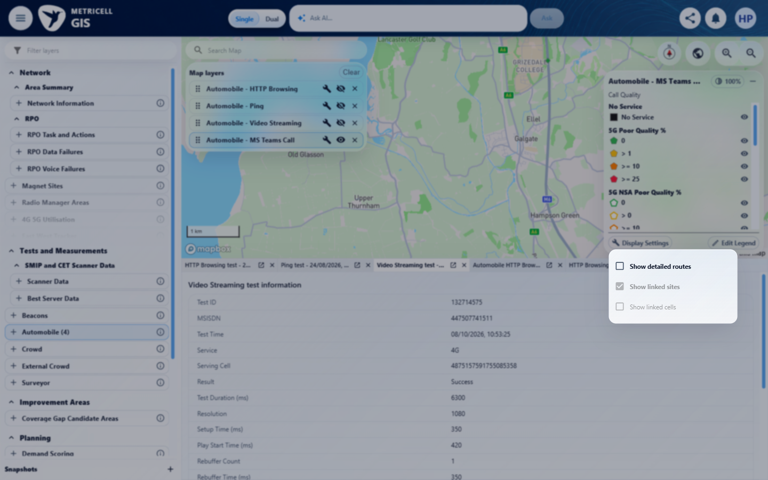 | E21 - Final (criterion-5-final.png)  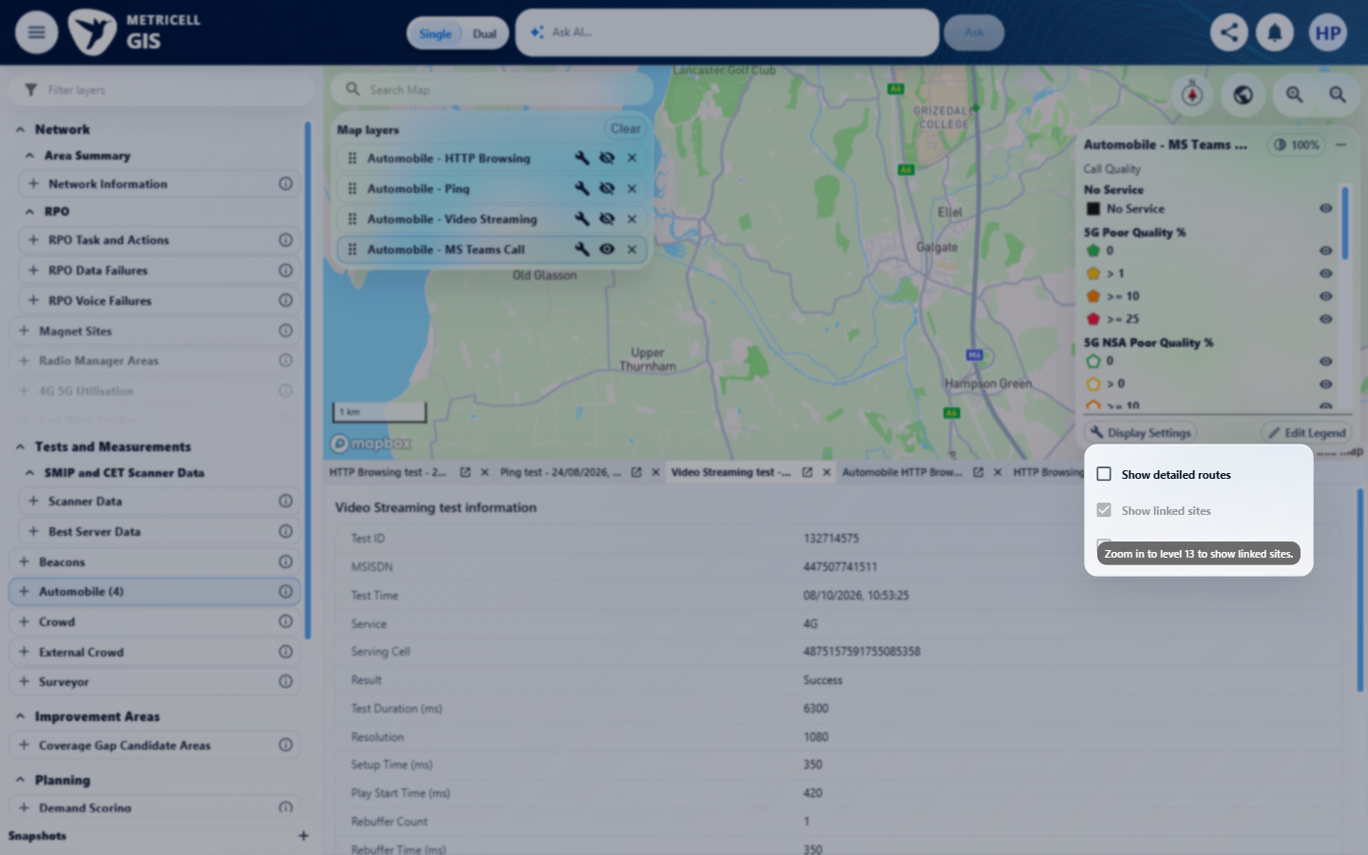
E20 detail enlargement - full screenshot above | E21 detail enlargement - full screenshot above

6.0.0 | Given the MS Teams Call layer is active and the map is at or above the configured zoom level for linked sites, when the user turns linked sites on and the map refreshes, then linked-site overlays for the active MS Teams Call results are visible. | Given the MS Teams Call layer is active and the map is at or above the configured zoom level for linked sites, when the user turns linked sites on and the map refreshes, then linked-site overlays for the active MS Teams Call results are visible. | criterion-6-supported-controls.png shows linked sites checked and cells available at the recorded supported zoom 13.16. criterion-6-recentered-before-on.png and criterion-6-final.png show the matching Galgate map before/after enabling sites: cyan connection overlays appear while the green MS Teams Call route remains. These are the decisive settled comparison after the earlier recentering.  Evidence: E22, E23, E24, E25, E26, E27 | Passed
Criterion 6 evidence: Given the MS Teams Call layer is active and the map is at or above the configured zoom level for linked sites, when the user turns linked sites on and the map refreshes, then linked-site overlays for the active MS Teams Call results are visible.
Browser URL recorded after criterion: https://o2intelligence-v4-dev.metricell.com/gis
E22 - Before zoom (criterion-6-before-zoom.png)  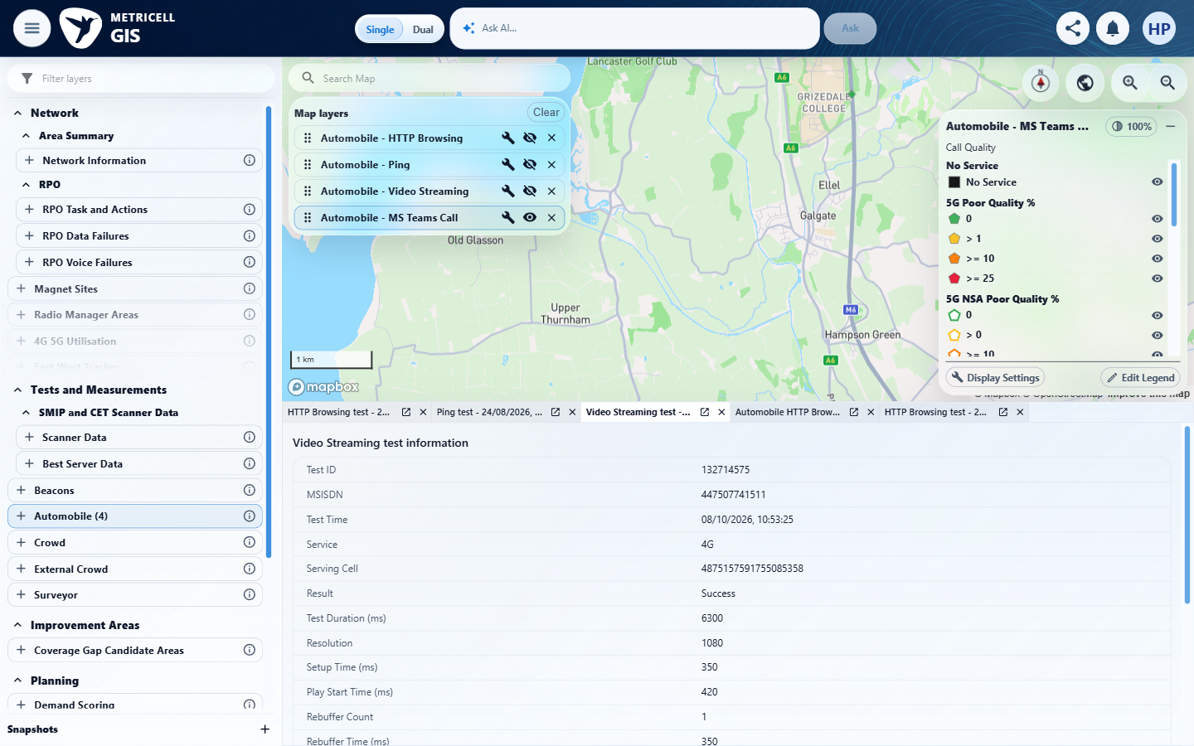 | E23 - Supported controls (criterion-6-supported-controls.png)  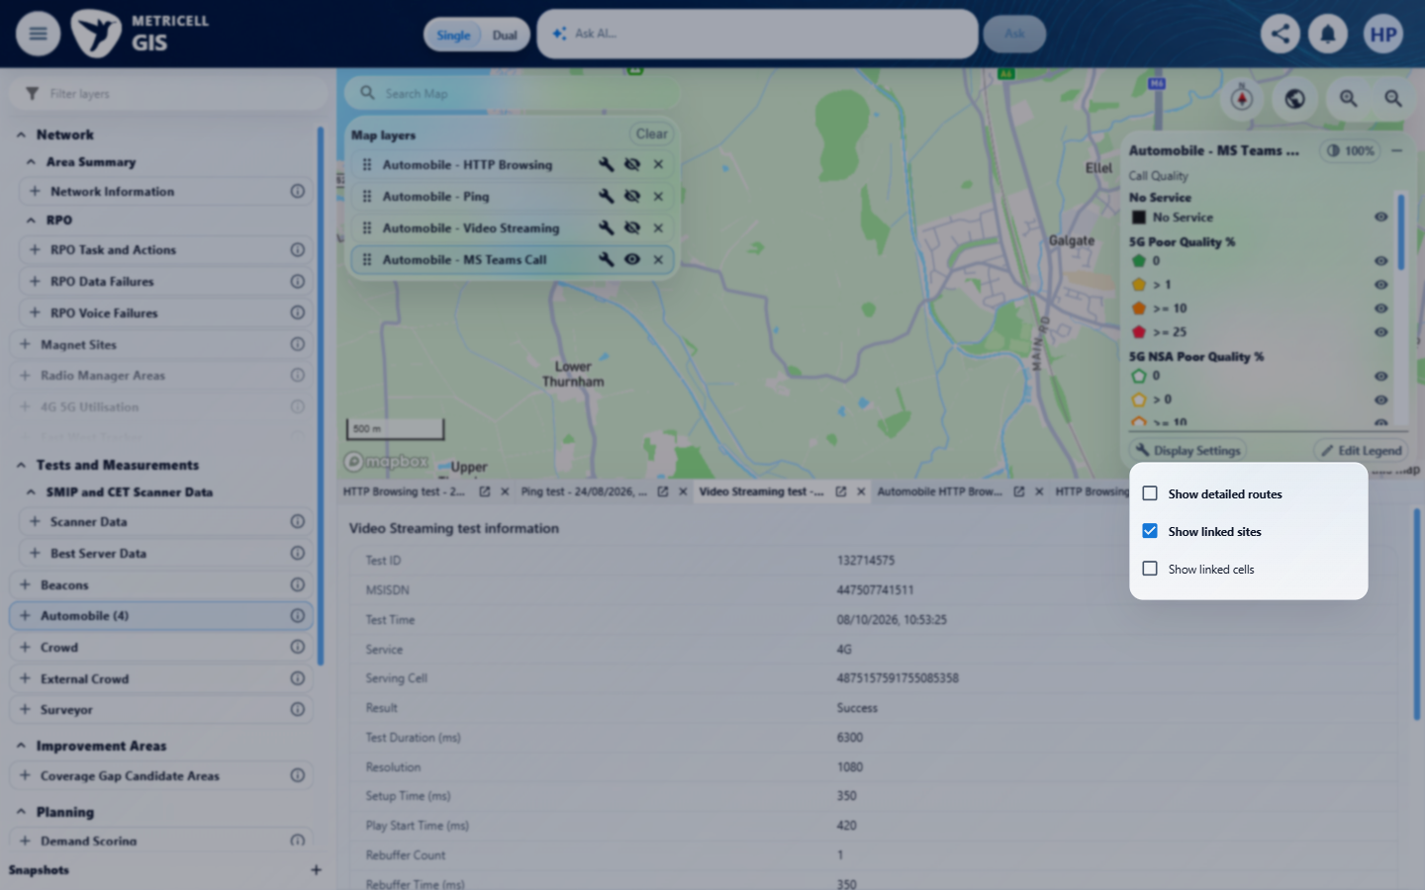

Criterion 6 continued: Given the MS Teams Call layer is active and the map is at or above the configured zoom level for linked sites, when the user turns linked sites on and the map refreshes, then linked-site overlays for the active MS Teams Call results are visible.
Browser URL recorded after criterion: https://o2intelligence-v4-dev.metricell.com/gis
E24 - Before sites on (criterion-6-before-sites-on.png)  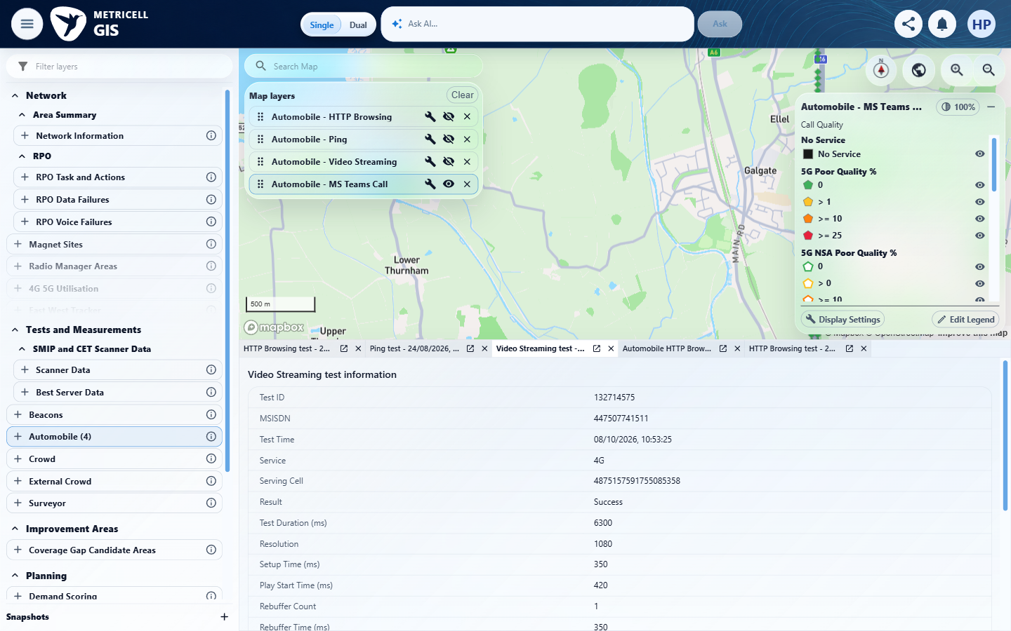 | E25 - Recentered (criterion-6-recentered.png)  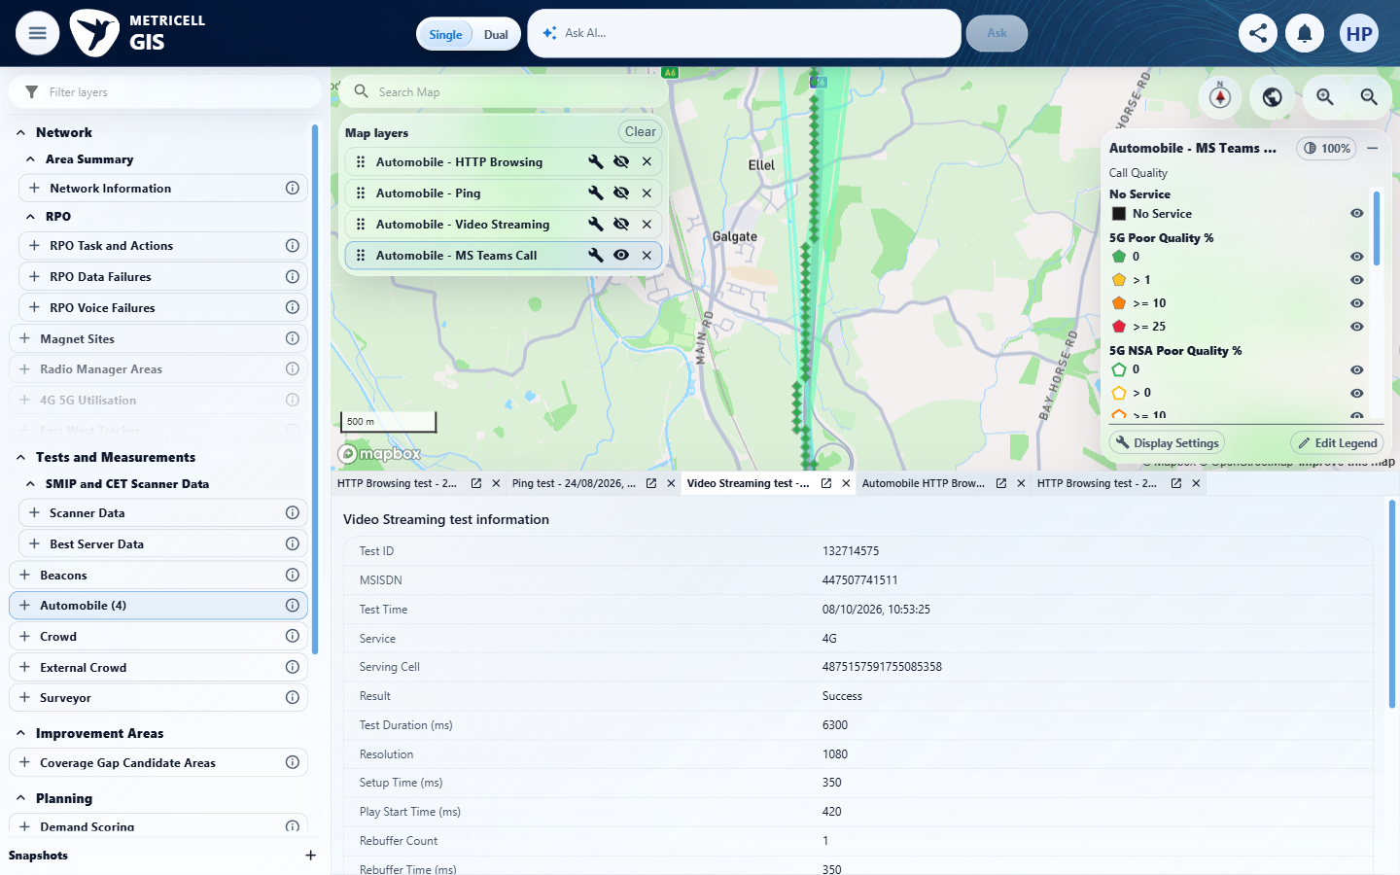

Criterion 6 continued: Given the MS Teams Call layer is active and the map is at or above the configured zoom level for linked sites, when the user turns linked sites on and the map refreshes, then linked-site overlays for the active MS Teams Call results are visible.
Browser URL recorded after criterion: https://o2intelligence-v4-dev.metricell.com/gis
E26 - Recentered before on (criterion-6-recentered-before-on.png)  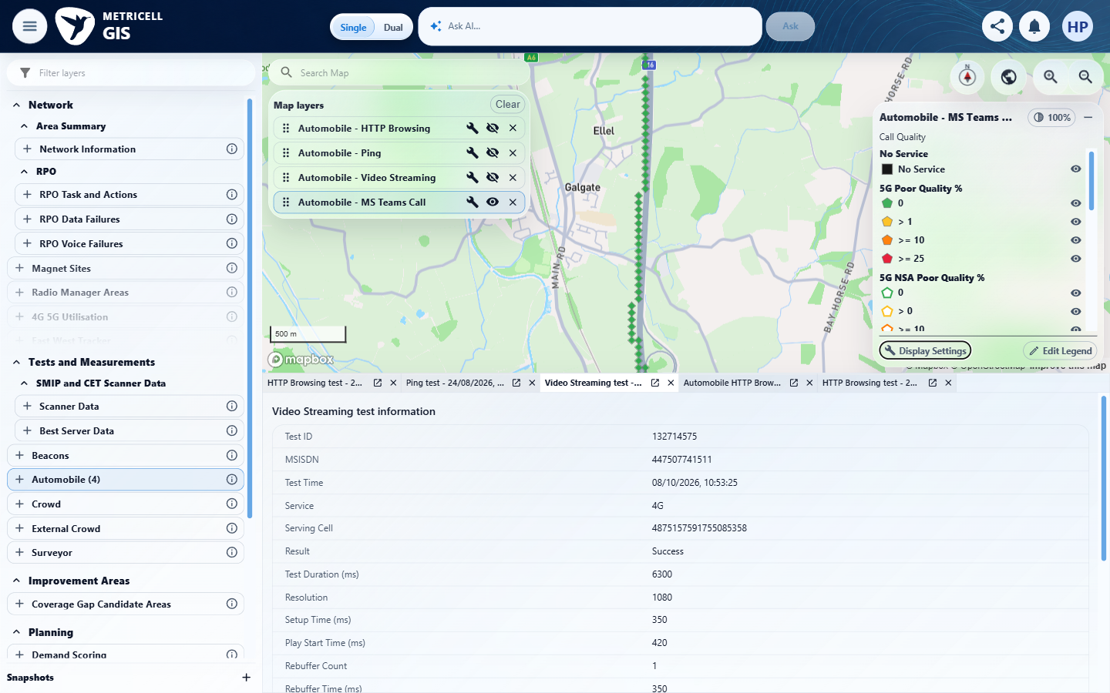 | E27 - Final (criterion-6-final.png)  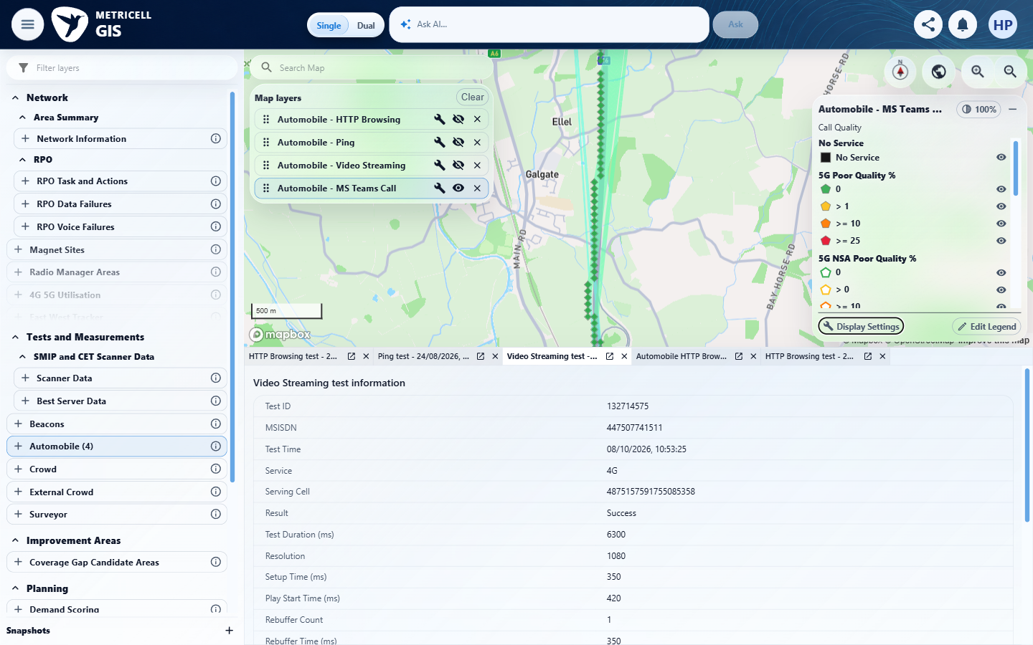
E26 detail enlargement - full screenshot above | E27 detail enlargement - full screenshot above

7.0.0 | Given linked-site overlays are visible at a supported zoom level, when the user turns linked sites off and the map refreshes, then those linked-site overlays are hidden. | Given linked-site overlays are visible at a supported zoom level, when the user turns linked sites off and the map refreshes, then those linked-site overlays are hidden. | criterion-7-before-off.png shows cyan linked-site connection overlays alongside the green MS Teams Call route; criterion-7-final.png shows those cyan overlays removed at the same supported-zoom extent after the recorded sites-off action, retaining the green route.  Evidence: E28, E26 | Passed
Criterion 7 evidence: Given linked-site overlays are visible at a supported zoom level, when the user turns linked sites off and the map refreshes, then those linked-site overlays are hidden.
Browser URL recorded after criterion: https://o2intelligence-v4-dev.metricell.com/gis
E28 - Before off (criterion-7-before-off.png)  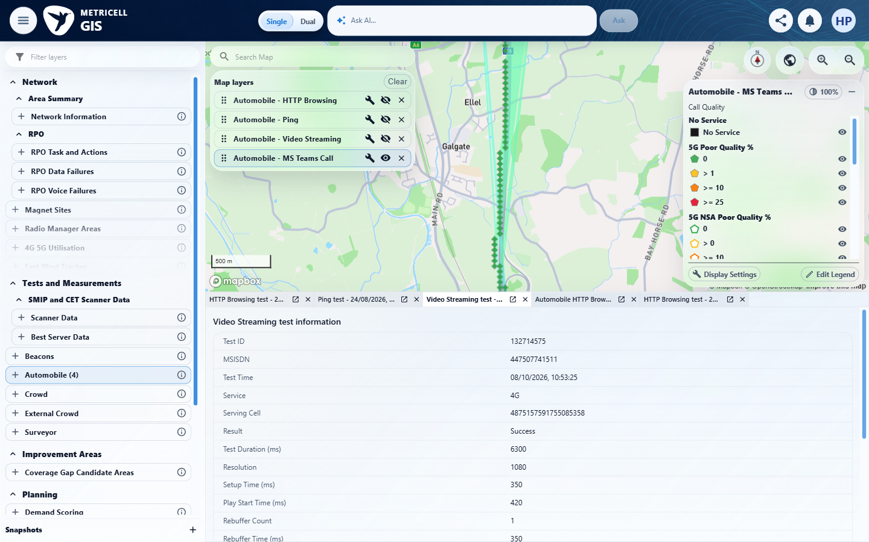 | E26 - Final (criterion-7-final.png)

8.0.0 | Given linked sites are enabled and the map is at a zoom level that supports linked cells, when display settings are open, then the linked-cell control is available. | Given linked sites are enabled and the map is at a zoom level that supports linked cells, when display settings are open, then the linked-cell control is available. | criterion-8-final.png shows Show linked sites checked and the Show linked cells control in its available, unchecked state at the recorded zoom 13.16; the active Automobile MS Teams Call layer and cyan linked-site connections are visible. This criterion concerns availability, not successful cell rendering.  Evidence: E28, E29 | Passed
Criterion 8 evidence: Given linked sites are enabled and the map is at a zoom level that supports linked cells, when display settings are open, then the linked-cell control is available.
Browser URL recorded after criterion: https://o2intelligence-v4-dev.metricell.com/gis
E28 - Before display (criterion-8-before-display.png) | E29 - Final (criterion-8-final.png)  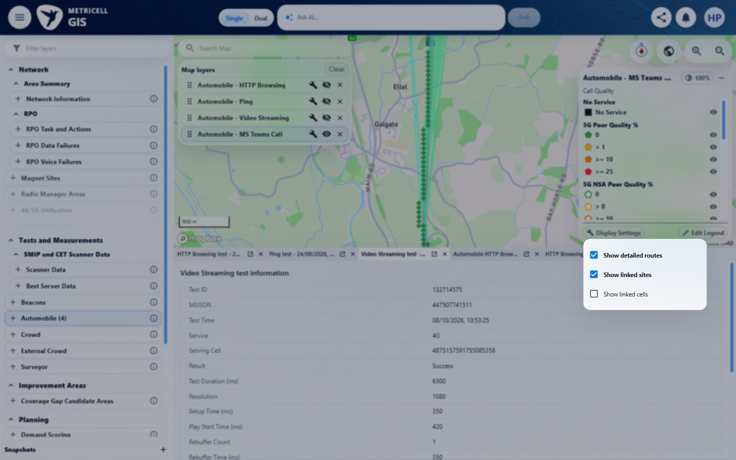

9.0.0 | Given linked sites are disabled or the map is below the zoom level that supports linked cells, when display settings are open, then the linked-cell control is unavailable. | Given linked sites are disabled or the map is below the zoom level that supports linked cells, when display settings are open, then the linked-cell control is unavailable. | Both required gating branches are evidenced. criterion-9-sites-off-before-cell-click.png to criterion-9-sites-off-after-cell-click.png show sites unchecked and cells remaining unchecked/unavailable after recorded normal pointer activation. criterion-9-low-zoom-before-cell-click.png to criterion-9-final.png show sites checked at recorded zoom 12.16 and cells remaining unchecked/unavailable after the second normal activation, with the level-13 tooltip. Map and detail state remain unchanged within each pair. The native disabled checkbox has no exposed keyboard activation path.  Evidence: E30, E31, E32, E33, E34 | Passed
Criterion 9 evidence: Given linked sites are disabled or the map is below the zoom level that supports linked cells, when display settings are open, then the linked-cell control is unavailable.
Browser URL recorded after criterion: https://o2intelligence-v4-dev.metricell.com/gis
E30 - Before sites off (criterion-9-before-sites-off.png)  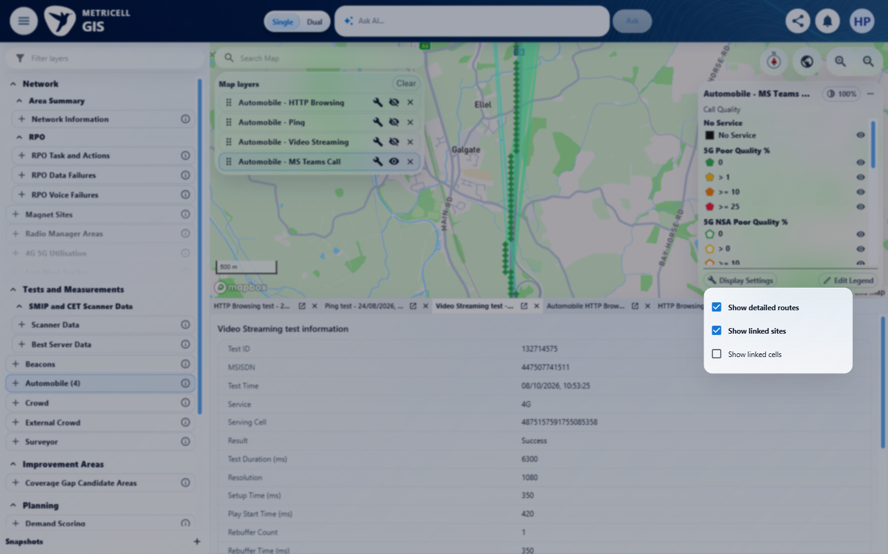 | E31 - Sites off before cell click (criterion-9-sites-off-before-cell-click.png)  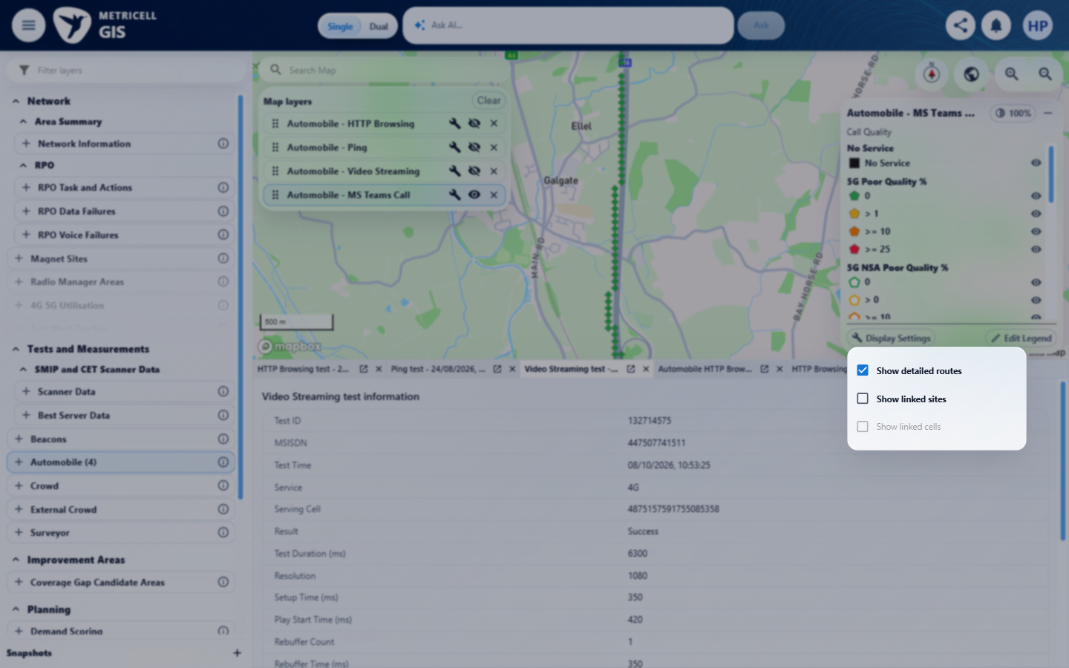

Criterion 9 continued: Given linked sites are disabled or the map is below the zoom level that supports linked cells, when display settings are open, then the linked-cell control is unavailable.
Browser URL recorded after criterion: https://o2intelligence-v4-dev.metricell.com/gis
E32 - Sites off after cell click (criterion-9-sites-off-after-cell-click.png)  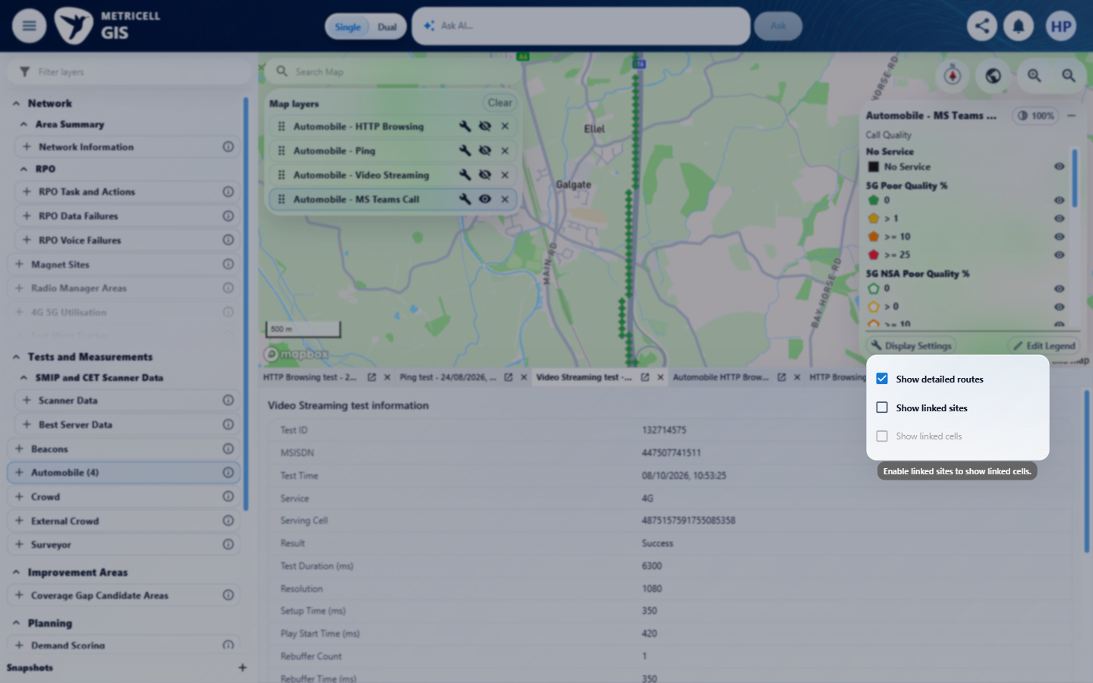 | E33 - Low zoom before cell click (criterion-9-low-zoom-before-cell-click.png)  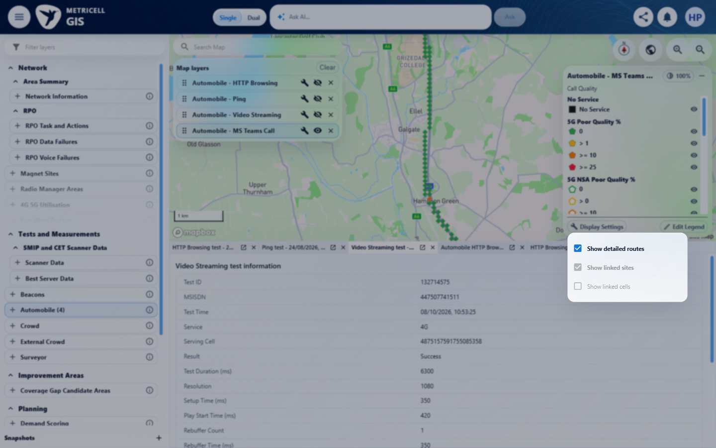

Criterion 9 continued: Given linked sites are disabled or the map is below the zoom level that supports linked cells, when display settings are open, then the linked-cell control is unavailable.
Browser URL recorded after criterion: https://o2intelligence-v4-dev.metricell.com/gis
E34 - Final (criterion-9-final.png)
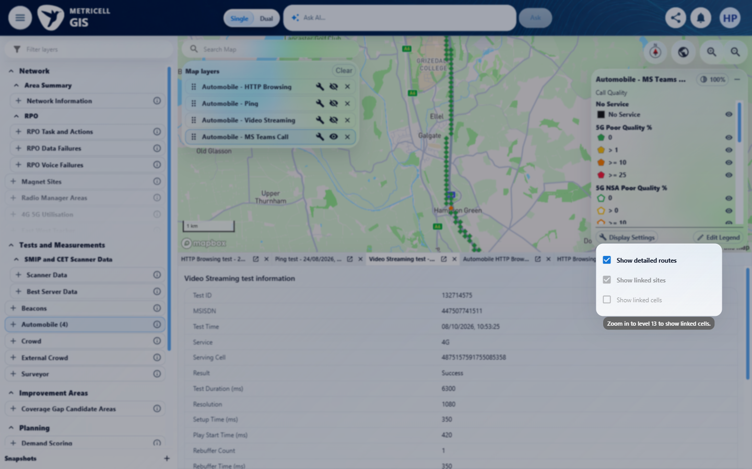

10.0.0 | Given linked sites are enabled and the map is at a zoom level that supports linked cells, when the user turns linked cells on and the map refreshes, then linked-cell overlays are visible. | Given linked sites are enabled and the map is at a zoom level that supports linked cells, when the user turns linked cells on and the map refreshes, then linked-cell overlays are visible. | criterion-10-supported-controls.png establishes sites enabled and cells available at supported zoom. The later same-scope criterion-10-north-before-on.png and criterion-10-final.png are decisive: coloured sector wedges appear at cyan site anchors 519465 and 519671 when linked cells are enabled. Purple connection lines already exist in the before image and are not claimed as newly added cells. Earlier search/pan captures are setup, not the comparison baseline.  Evidence: E28, E35, E36, E37, E38, E39 | Passed
Criterion 10 evidence: Given linked sites are enabled and the map is at a zoom level that supports linked cells, when the user turns linked cells on and the map refreshes, then linked-cell overlays are visible.
Browser URL recorded after criterion: https://o2intelligence-v4-dev.metricell.com/gis
E28 - Before cells on (criterion-10-before-cells-on.png) | E35 - Supported controls (criterion-10-supported-controls.png)  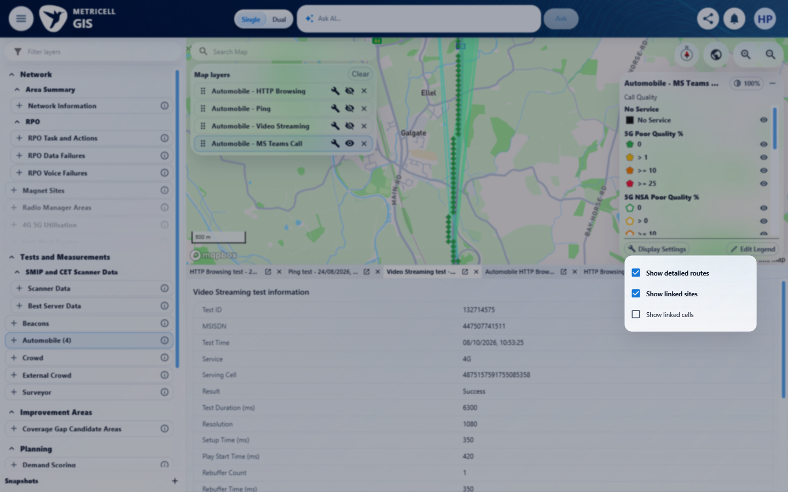

Criterion 10 continued: Given linked sites are enabled and the map is at a zoom level that supports linked cells, when the user turns linked cells on and the map refreshes, then linked-cell overlays are visible.
Browser URL recorded after criterion: https://o2intelligence-v4-dev.metricell.com/gis
E36 - Context search (criterion-10-context-search.png)  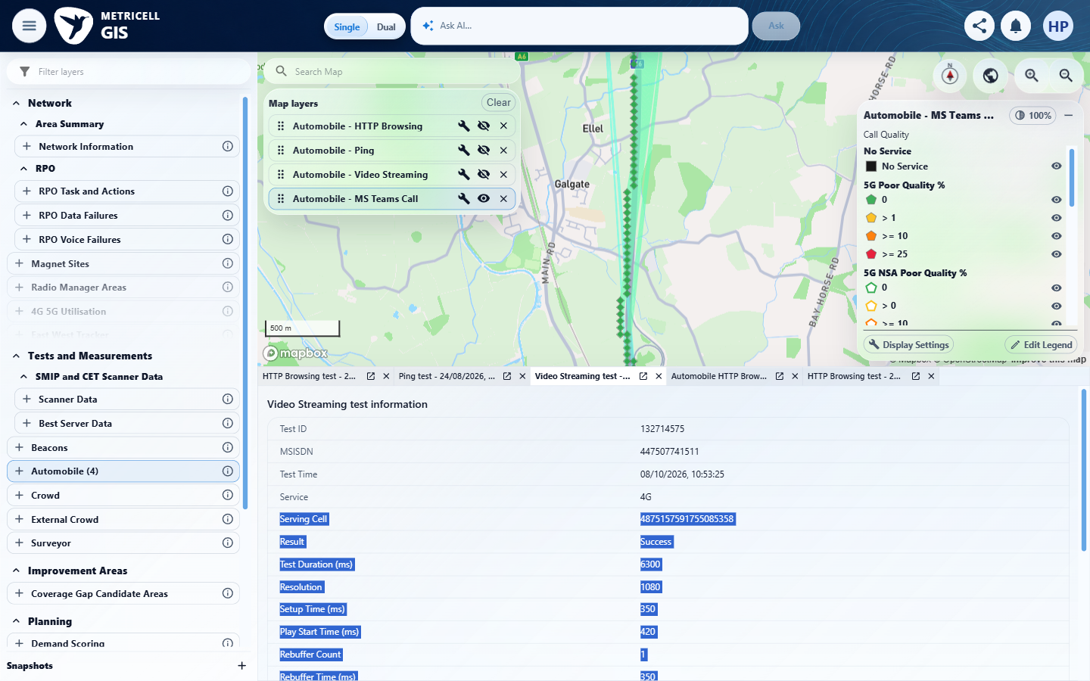 | E37 - North search (criterion-10-north-search.png)  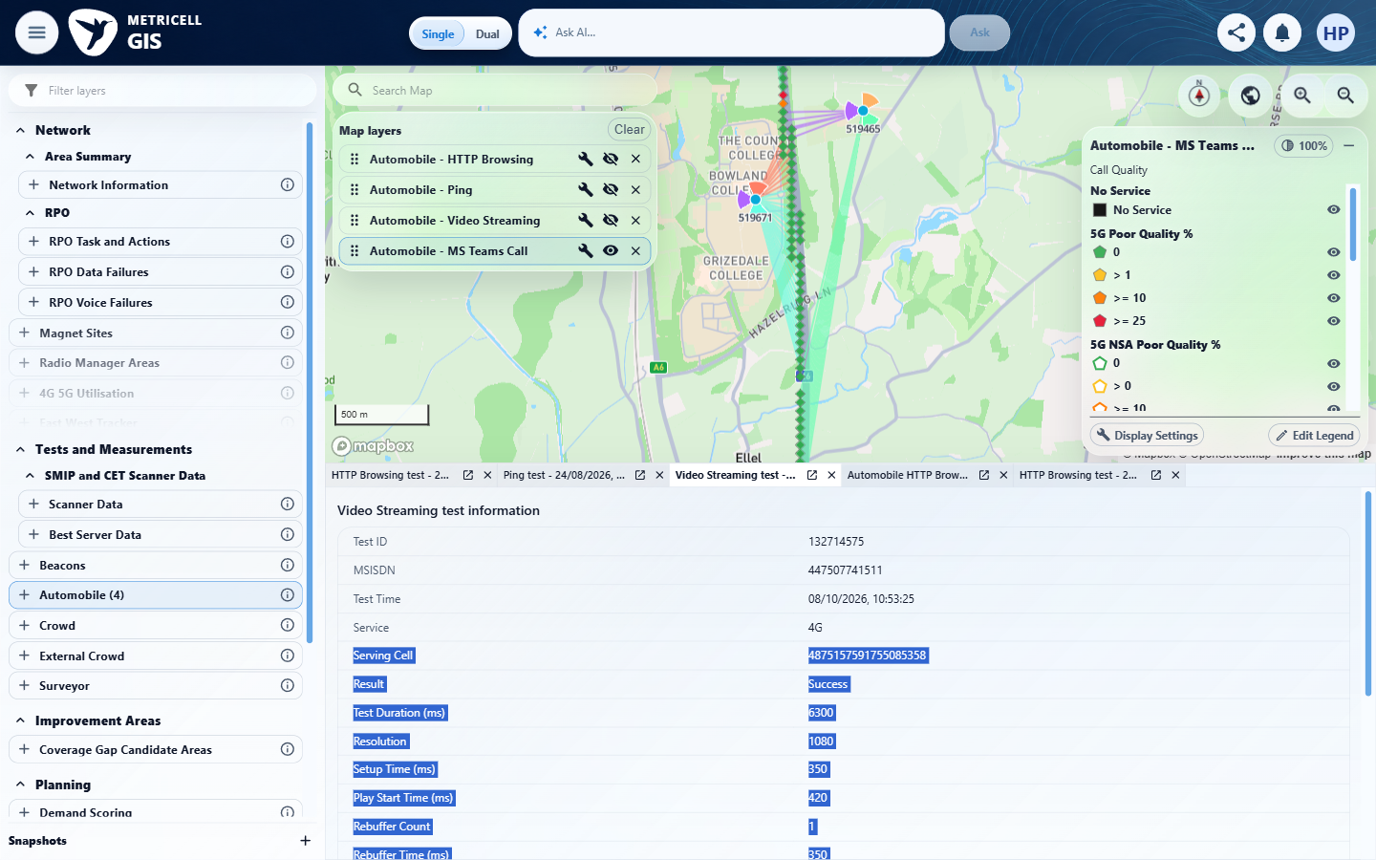

Criterion 10 continued: Given linked sites are enabled and the map is at a zoom level that supports linked cells, when the user turns linked cells on and the map refreshes, then linked-cell overlays are visible.
Browser URL recorded after criterion: https://o2intelligence-v4-dev.metricell.com/gis
E38 - North before on (criterion-10-north-before-on.png)  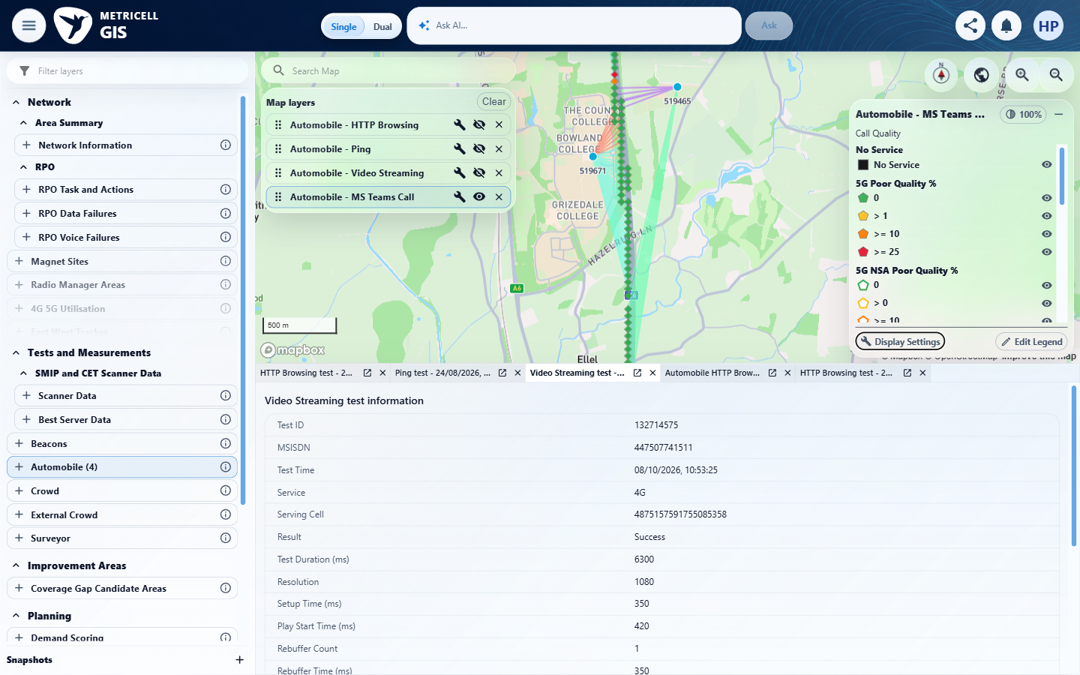 | E39 - Final (criterion-10-final.png)  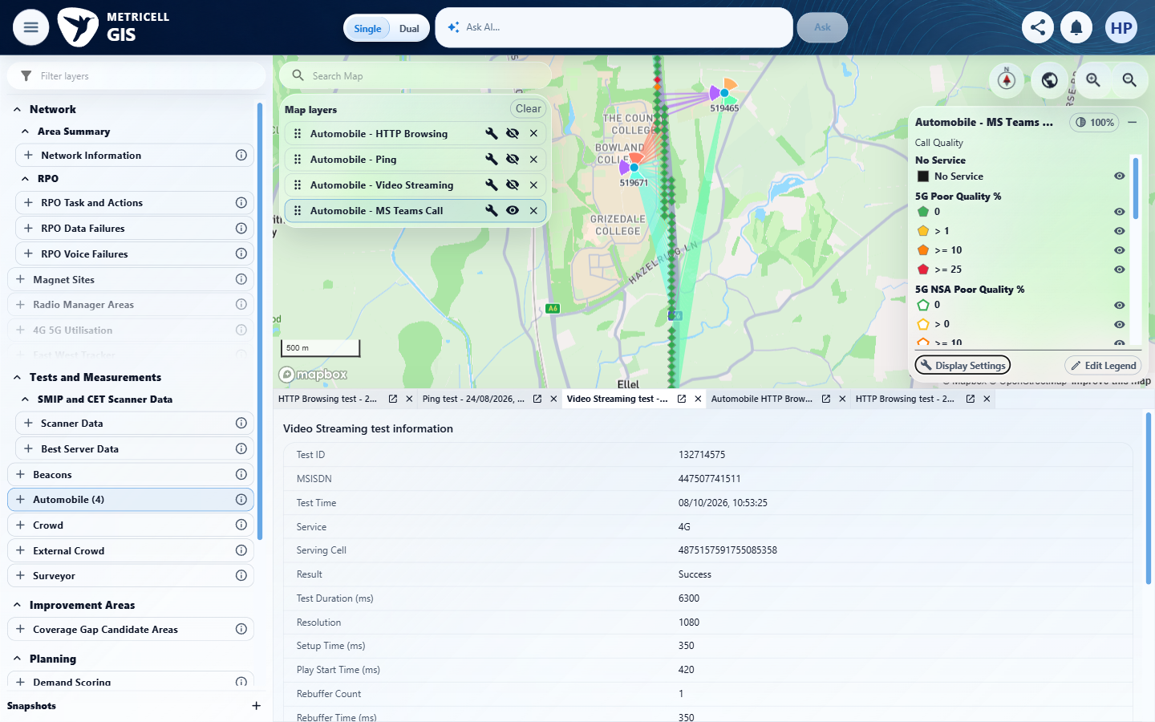
E38 detail enlargement - full screenshot above | E39 detail enlargement - full screenshot above

11.0.0 | Given linked-cell overlays are visible, when the user turns linked cells off and the map refreshes, then those linked-cell overlays are hidden. | Given linked-cell overlays are visible, when the user turns linked cells off and the map refreshes, then those linked-cell overlays are hidden. | criterion-11-before-off.png shows coloured sector wedges at sites 519465 and 519671; criterion-11-cells-checked.png confirms Show linked cells checked. criterion-11-final.png shows those wedges removed at the matching extent after disabling cells, with cyan site anchors and linking lines retained.  Evidence: E40, E41, E42 | Passed
Criterion 11 evidence: Given linked-cell overlays are visible, when the user turns linked cells off and the map refreshes, then those linked-cell overlays are hidden.
Browser URL recorded after criterion: https://o2intelligence-v4-dev.metricell.com/gis
E40 - Before off (criterion-11-before-off.png)  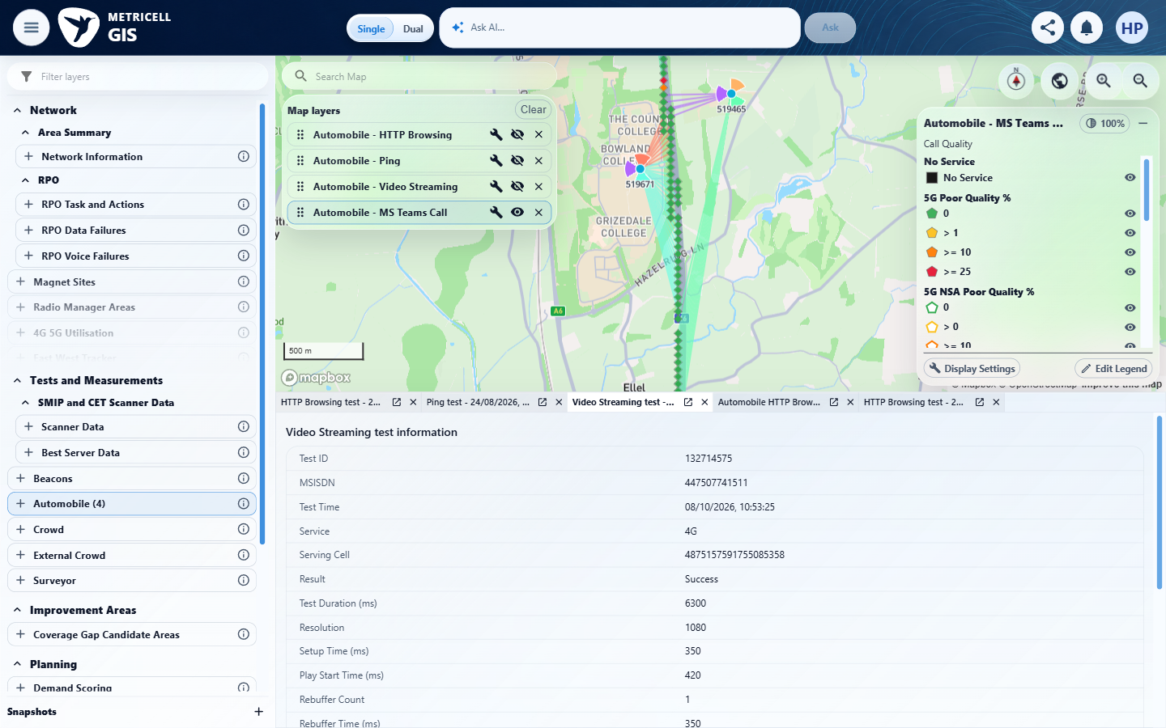 | E41 - Cells checked (criterion-11-cells-checked.png)  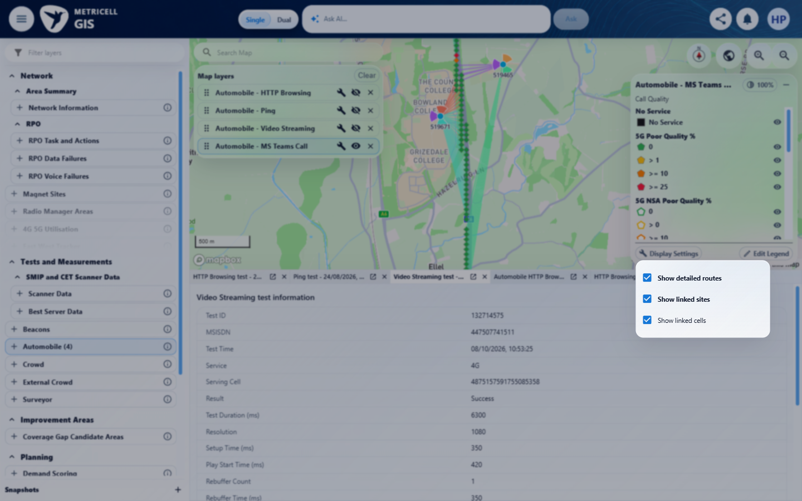

Criterion 11 continued: Given linked-cell overlays are visible, when the user turns linked cells off and the map refreshes, then those linked-cell overlays are hidden.
Browser URL recorded after criterion: https://o2intelligence-v4-dev.metricell.com/gis
E42 - Final (criterion-11-final.png)
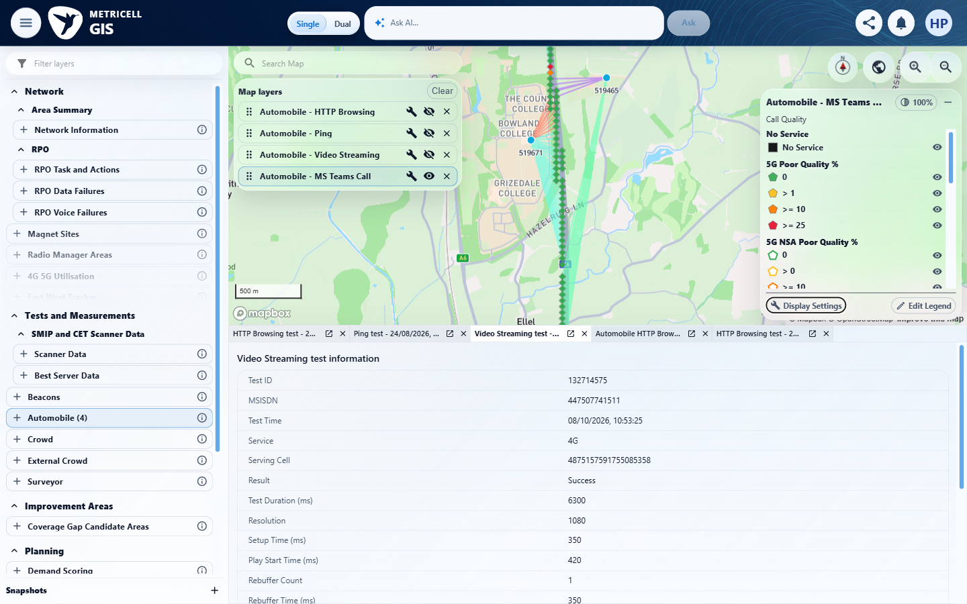

12.0.0 | Given any MS Teams Call display setting is changed, when the map refreshes, then the setting is applied only to the active MS Teams Call layer and other visible map layers, standard map filters and legend point-filtering state retain their prior visible states. | Given any MS Teams Call display setting is changed, when the map refreshes, then the setting is applied only to the active MS Teams Call layer and other visible map layers, standard map filters and legend point-filtering state retain their prior visible states. | Configured colouring isolation is Blocked because criterion-12-before-route-change.png shows no colouring selector. criterion-12-baseline-map.png/baseline-layers.png, criterion-12-after-route-change.png, criterion-12-after-site-change.png, criterion-12-after-cell-change.png and criterion-12-final.png show the route/site/cell transitions with Ping visible and HTTP Browsing/Video Streaming hidden throughout. The before/after-filters top, middle and bottom pairs retain visible blank handset/network fields and technology selections, but clipped dates and band values prevent complete exact-value comparison. Only the upper legend viewport is captured, so preservation of all legend point-filter states is Unverified. Our criteria issue: canonical item 12 omits the source acceptance criterion's explicit Route Replay preservation requirement; Route Replay options themselves are out of scope, but unchanged-state proof is required and no independent baseline/final is supplied. Source-required underlying result-data preservation also lacks a criterion-owned comparable result baseline/final. These gaps are Unverified, not demonstrated product defects. criterion-12-cleanup.png restores the three original hidden layers and Video Streaming selection; the tester records original map center/zoom was not restored.  Evidence: E43, E44, E45, E46, E47, E48, E49, E50, E51, E52, E53, E54 | Blocked
Criterion 12 evidence: Given any MS Teams Call display setting is changed, when the map refreshes, then the setting is applied only to the active MS Teams Call layer and other visible map layers, standard map filters and legend point-filtering state retain their prior visible states.
Browser URL recorded after criterion: https://o2intelligence-v4-dev.metricell.com/gis
E43 - Baseline map (criterion-12-baseline-map.png)  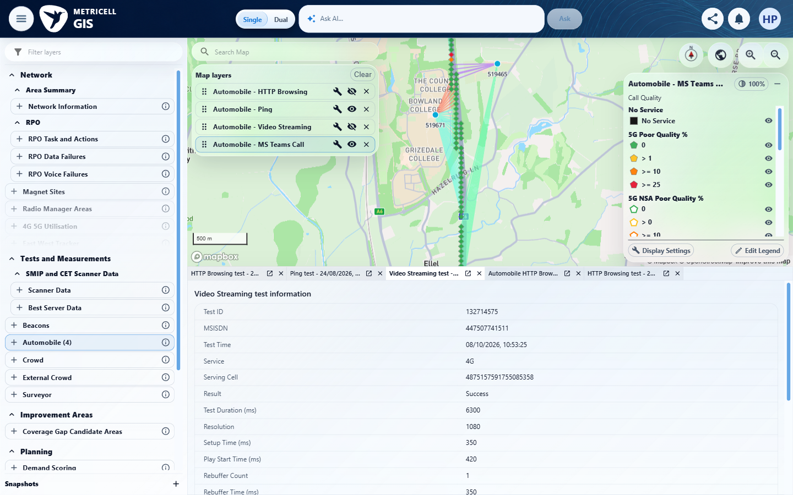 | E43 - Baseline layers (criterion-12-baseline-layers.png)

Criterion 12 continued: Given any MS Teams Call display setting is changed, when the map refreshes, then the setting is applied only to the active MS Teams Call layer and other visible map layers, standard map filters and legend point-filtering state retain their prior visible states.
Browser URL recorded after criterion: https://o2intelligence-v4-dev.metricell.com/gis
E44 - Before filters (criterion-12-before-filters.png)  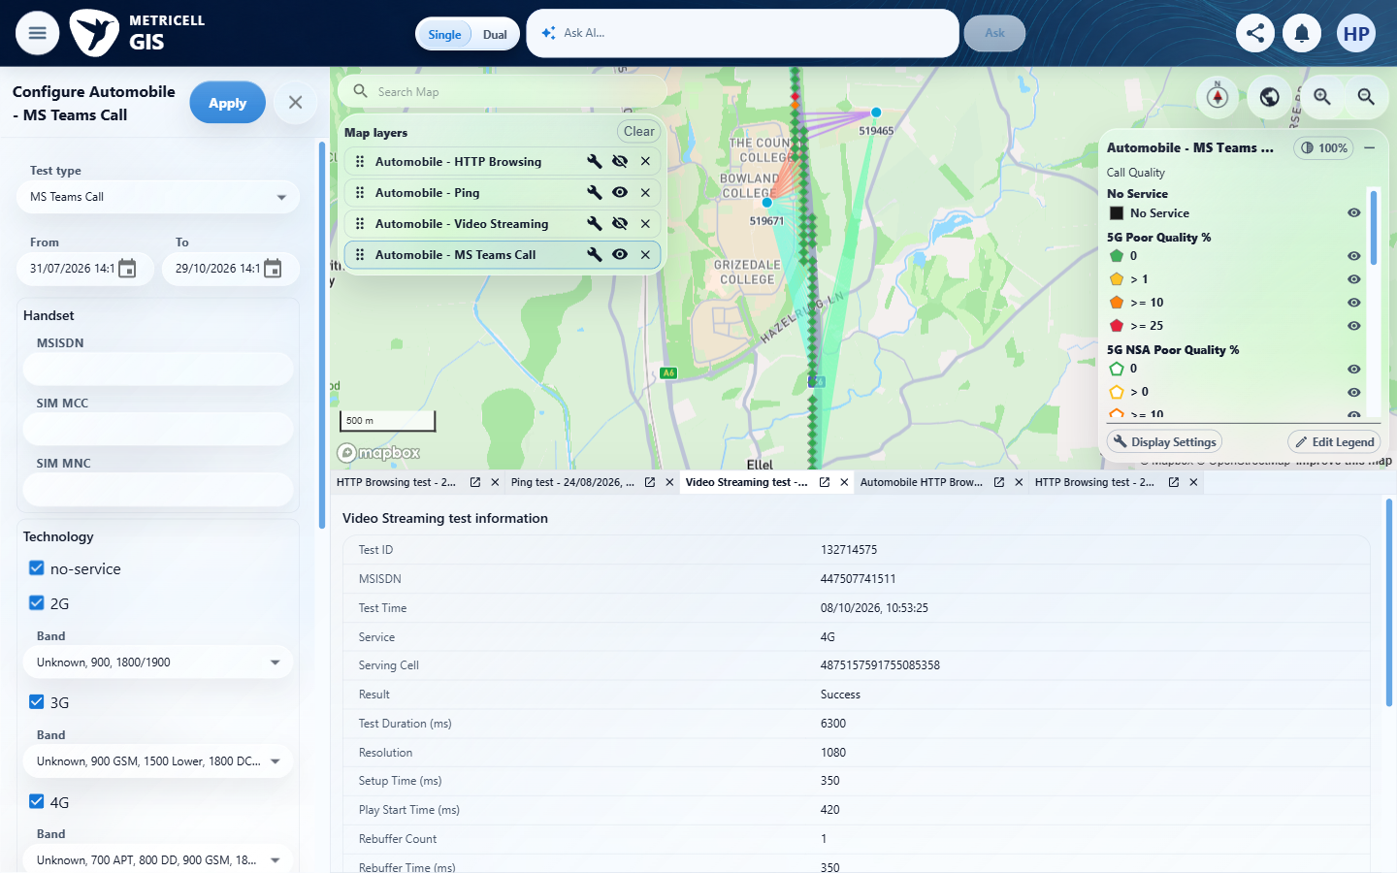 | E45 - Before filters middle (criterion-12-before-filters-middle.png)  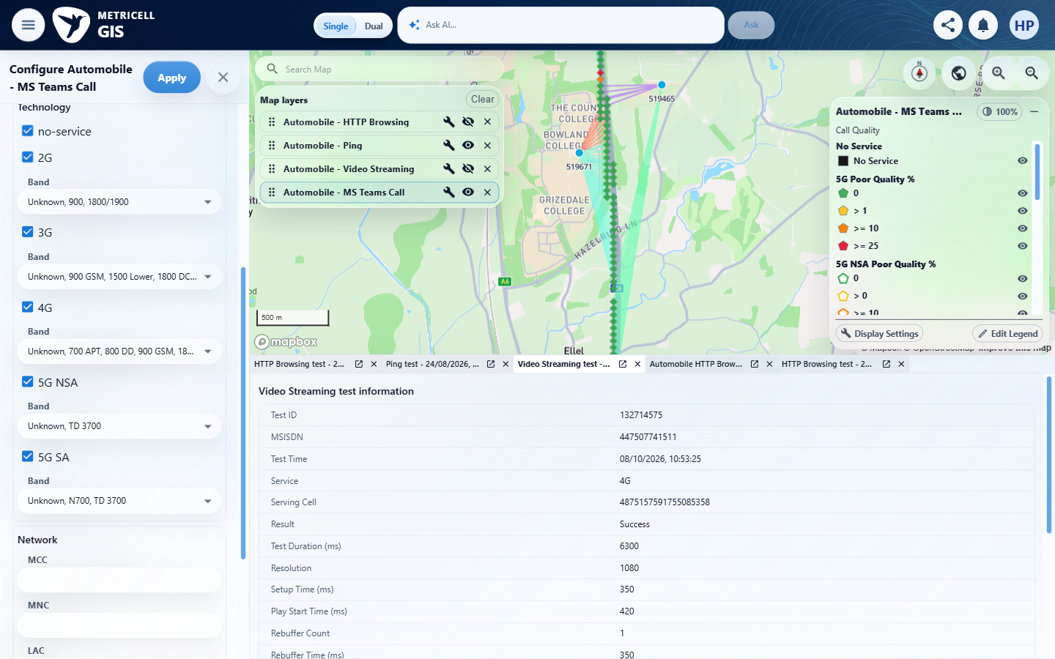

Criterion 12 continued: Given any MS Teams Call display setting is changed, when the map refreshes, then the setting is applied only to the active MS Teams Call layer and other visible map layers, standard map filters and legend point-filtering state retain their prior visible states.
Browser URL recorded after criterion: https://o2intelligence-v4-dev.metricell.com/gis
E46 - Before filters bottom (criterion-12-before-filters-bottom.png)  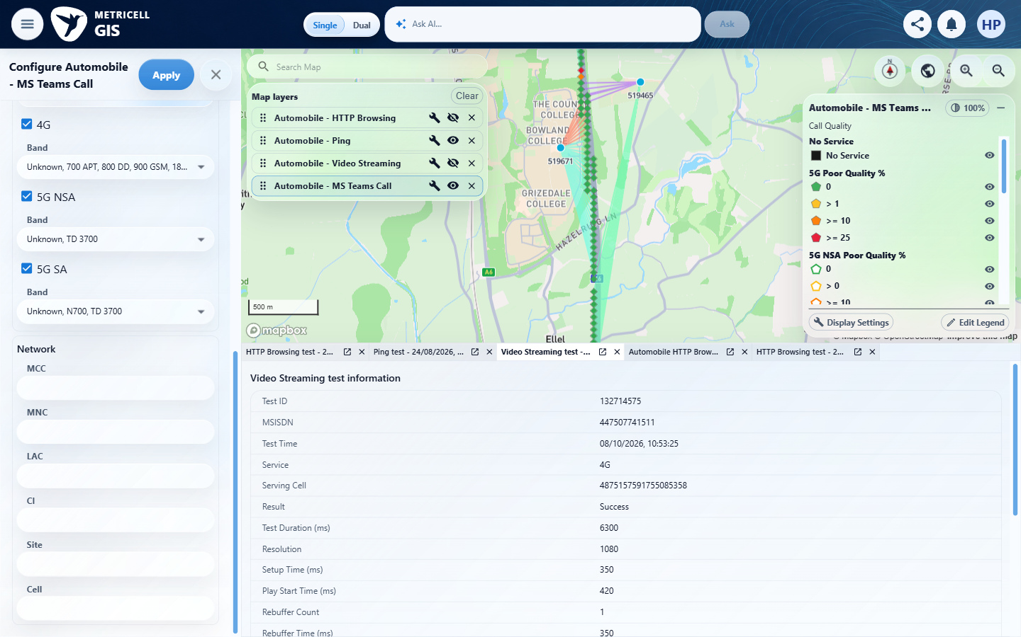 | E47 - Before route change (criterion-12-before-route-change.png)  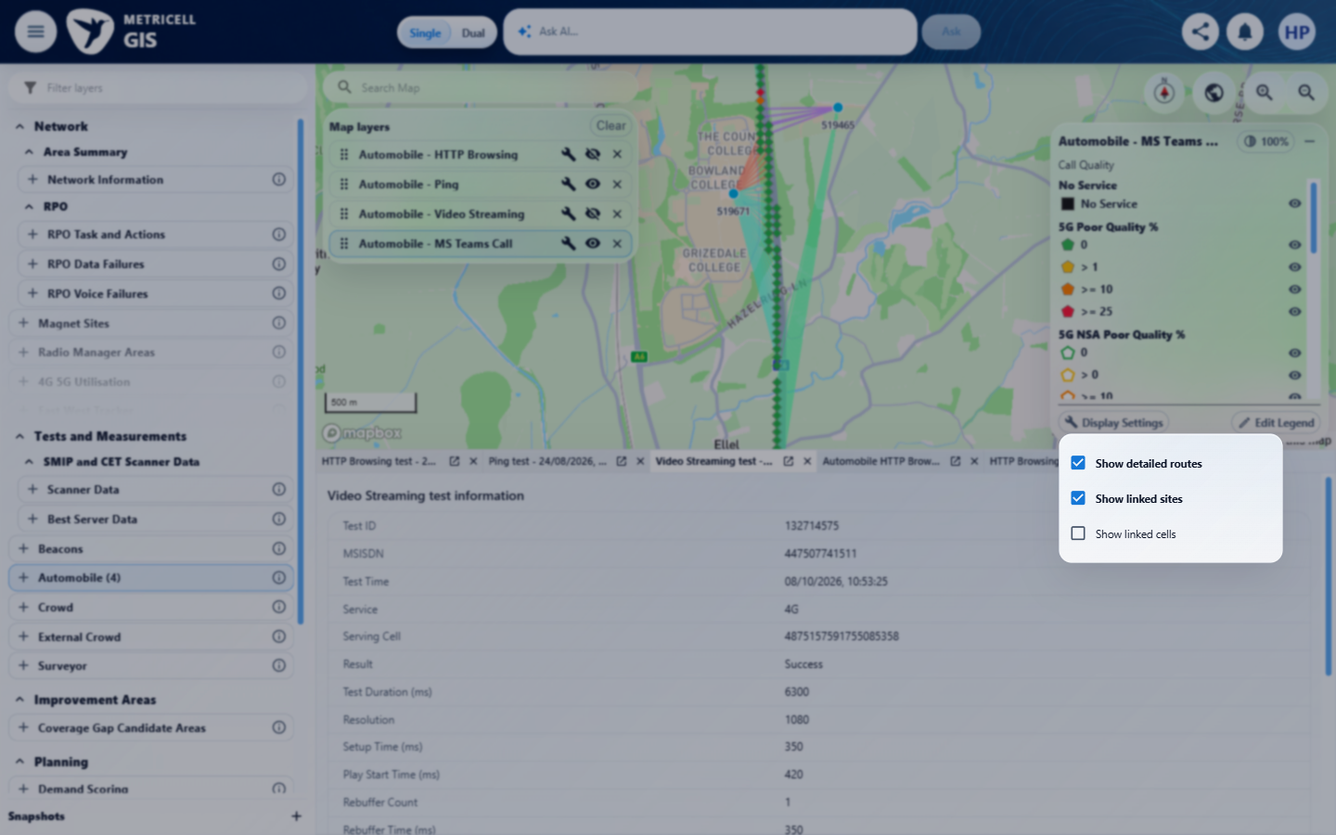

Criterion 12 continued: Given any MS Teams Call display setting is changed, when the map refreshes, then the setting is applied only to the active MS Teams Call layer and other visible map layers, standard map filters and legend point-filtering state retain their prior visible states.
Browser URL recorded after criterion: https://o2intelligence-v4-dev.metricell.com/gis
E48 - After route change (criterion-12-after-route-change.png)  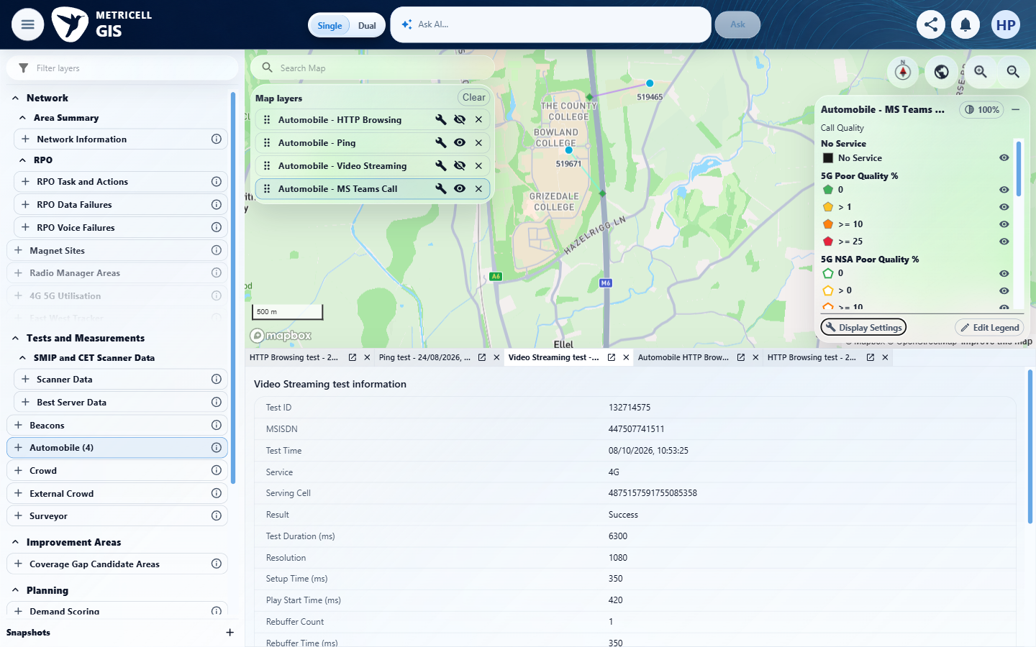 | E49 - After site change (criterion-12-after-site-change.png)  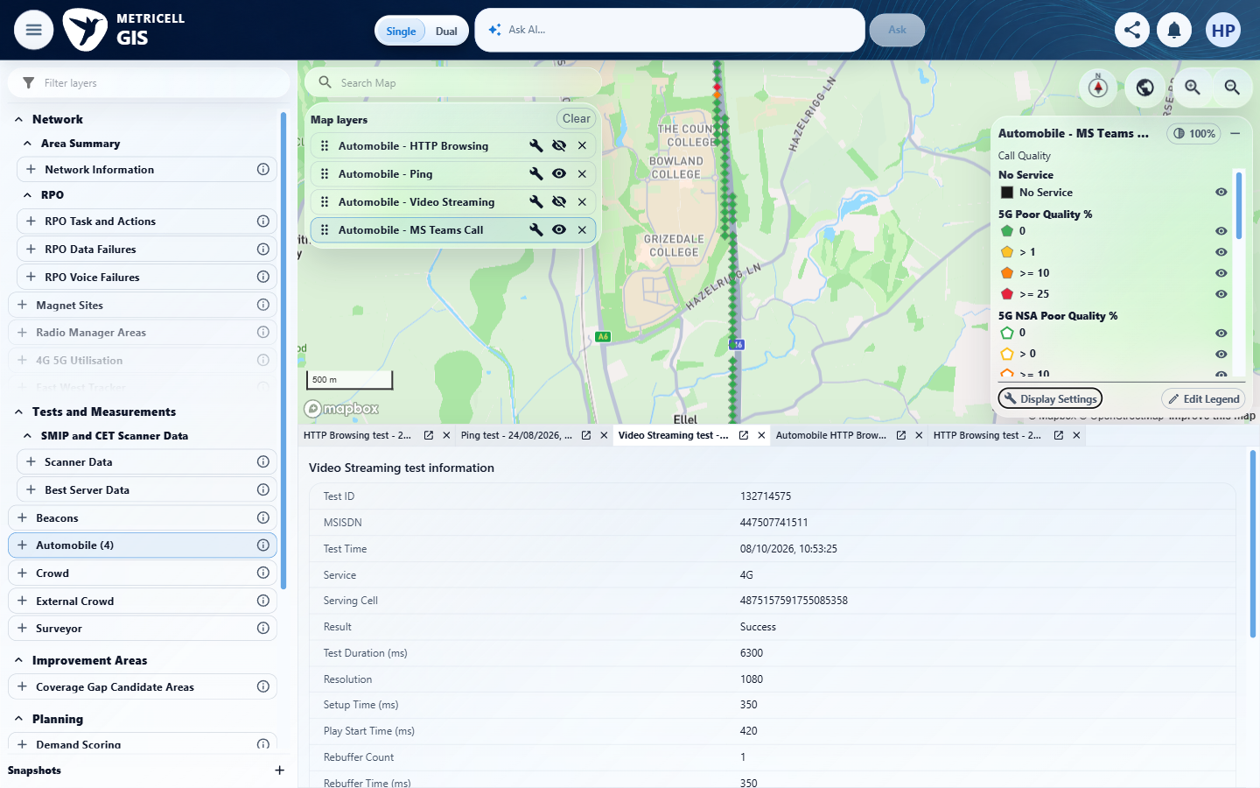

Criterion 12 continued: Given any MS Teams Call display setting is changed, when the map refreshes, then the setting is applied only to the active MS Teams Call layer and other visible map layers, standard map filters and legend point-filtering state retain their prior visible states.
Browser URL recorded after criterion: https://o2intelligence-v4-dev.metricell.com/gis
E50 - After cell change (criterion-12-after-cell-change.png)  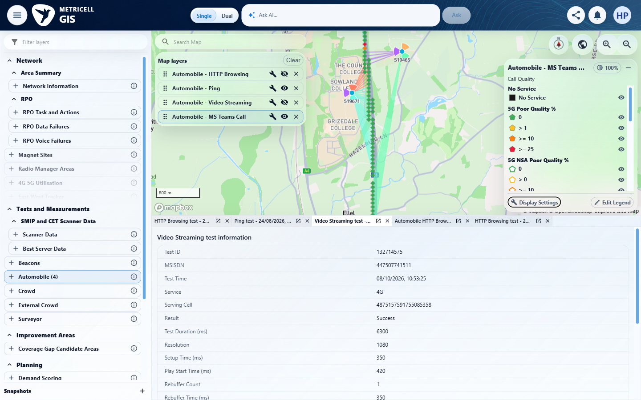 | E51 - After filters (criterion-12-after-filters.png)  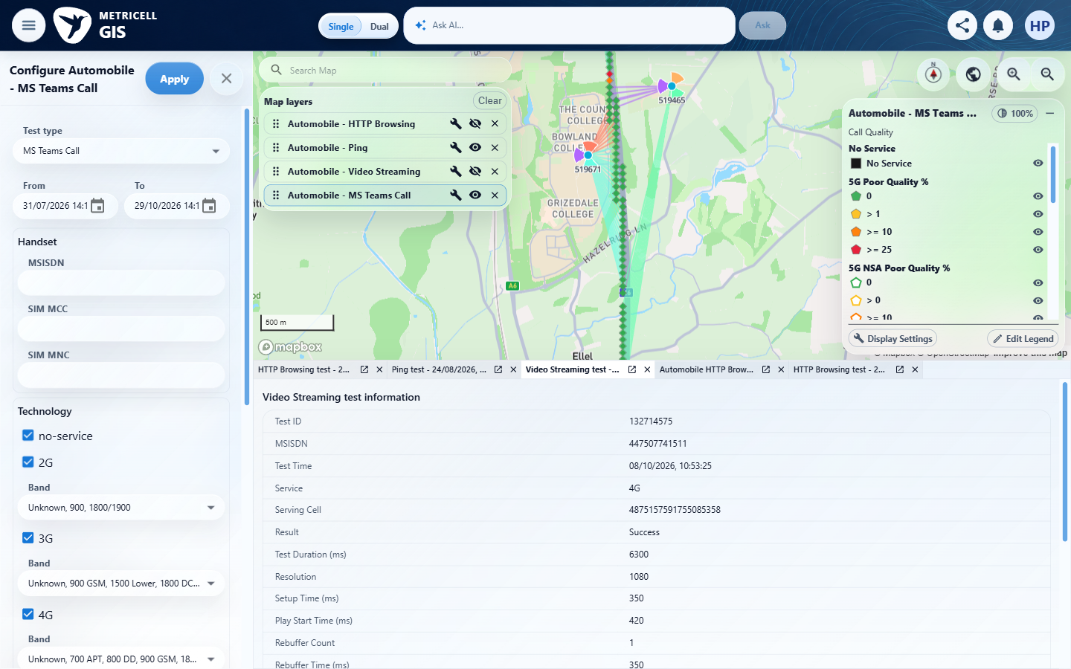

Criterion 12 continued: Given any MS Teams Call display setting is changed, when the map refreshes, then the setting is applied only to the active MS Teams Call layer and other visible map layers, standard map filters and legend point-filtering state retain their prior visible states.
Browser URL recorded after criterion: https://o2intelligence-v4-dev.metricell.com/gis
E52 - After filters middle (criterion-12-after-filters-middle.png)  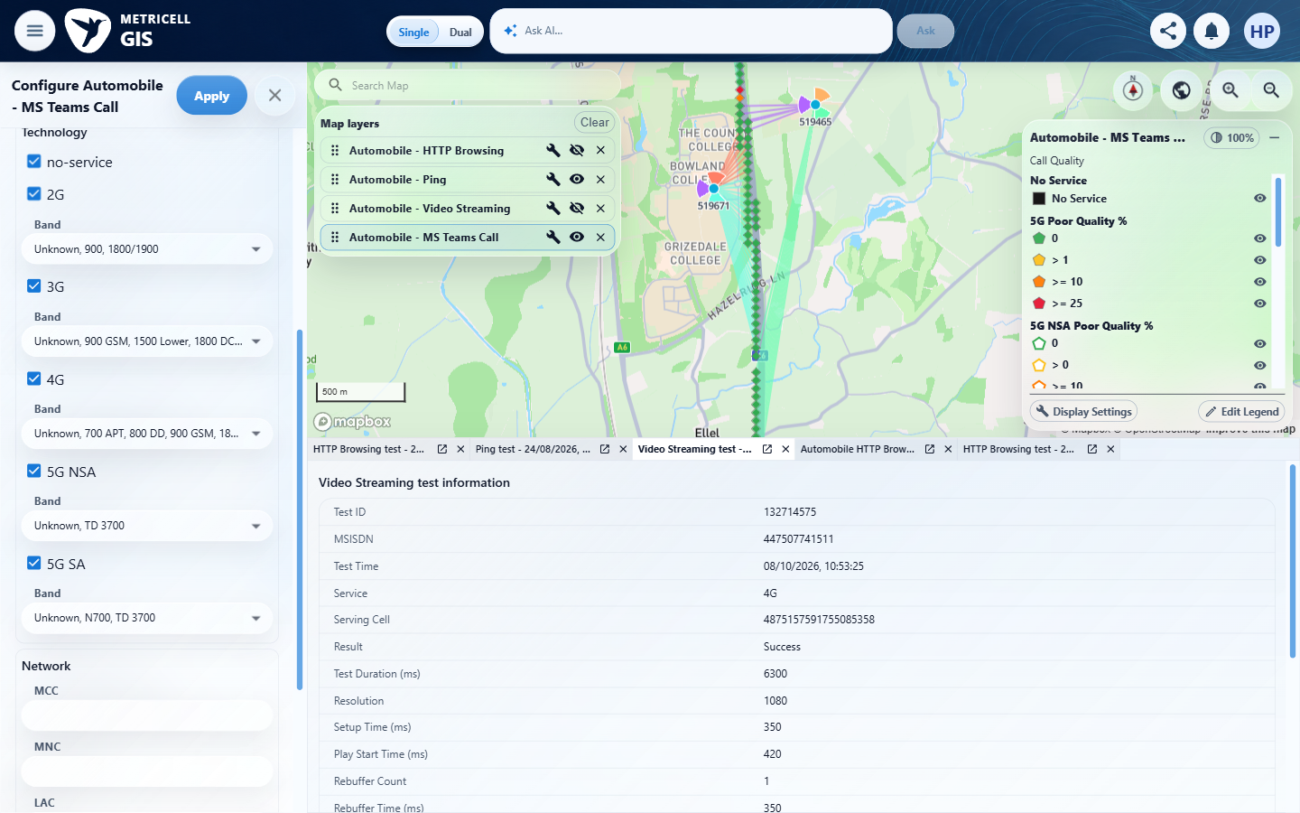 | E53 - After filters bottom (criterion-12-after-filters-bottom.png)  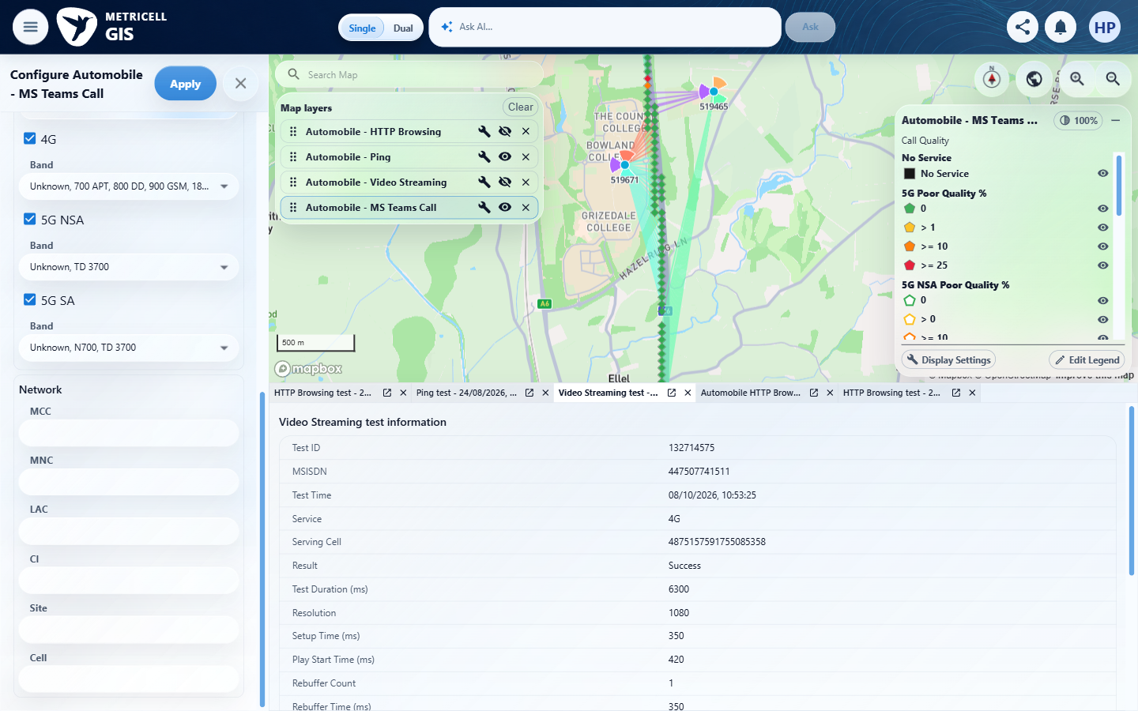

Criterion 12 continued: Given any MS Teams Call display setting is changed, when the map refreshes, then the setting is applied only to the active MS Teams Call layer and other visible map layers, standard map filters and legend point-filtering state retain their prior visible states.
Browser URL recorded after criterion: https://o2intelligence-v4-dev.metricell.com/gis
E54 - Final (criterion-12-final.png)
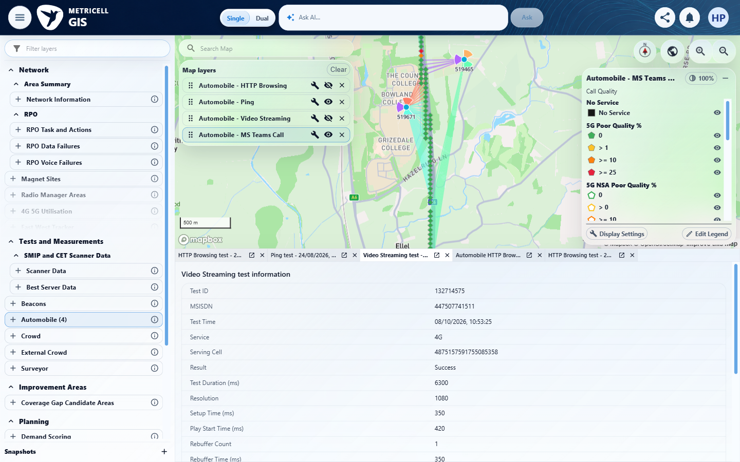

About Metricell

Metricell is on a mission to deliver connectivity. We work with our customers to design, deliver and manage wireless communication networks – with a shared ambition of achieving flawless network experience. We’ve been responsible for many first-to-market products, and our technology is characterised by the relentless pursuit of automation and digitalisation.

Our geospatial intelligence tools traverse a wide variety of business processes – from Test & Measurement to Customer Experience Management – and we’re pioneers in Crowdsourcing and Digital Self Care. Our technology is today in use by a range of customers; thousands of their personnel; and millions of subscribers worldwide.

Find out more at www.metricell.com




