

Automated Test Case Document
Jira Ticket: TEST2-90

Document Classification: | Company Confidential
Document Ref: | Automated Test Case Document
Version: | 1.0
Date: | 22/10/2026
Document Author: | Automated TEST2 Evidence Review
Document Owner: | Quality Assurance / Metricell




This document and its content is copyright of Metricell Limited @ 2026 all rights reserved. All information contained herein is the intellectual property of Metricell Limited and should be treated as confidential. Any external redistribution of reproduction of part or all of the contents in any form is prohibited unless expressly agreed with Metricell Limited in writing. Any reproduced content must include the following statement; “Part or all of the content contained herein is copyright of Metricell Limited @ 2026 all rights reserved”.
Table of Contents
1 Revision History 2
2 Test Cycle Information 3
3 Test Summary 3
4 Test Cases 4
About Metricell 12

Revision History

Version | Date | Revision Author | Summary of Changes
[1.0] | 22/10/2026 | TEST2 QA Automation | Generated from TEST2 evidence review

Test Cycle Information

Tester: | Automated
Jira Ticket: | TEST2-90
Environment: | o2intelligence-v4-dev.metricell.com
Browser Details: | Google Chrome 156.0.8078.48
Date of Test: | 22/10/2026
Limitations during Testing: | Blocked criterion(s): 5, 12, 17, 18, 21. See the assessment below each criterion.  Unverified criterion(s): 3, 4, 6, 7, 8, 11, 13, 14, 16. See the assessment below each criterion.  SIMULATED UI STATE: criterion(s) 21 use browser-local conditions, not backend integration tests. Method and recovery are disclosed with their evidence. Inconclusive evidence is reported as Failed, but is not a confirmed application defect. Pass, Fail and Blocked use Y/N. Defect No counts directly contradicted criteria, not unique Jira bugs; blockers and inconclusive evidence count as zero.
Overall review outcome: | Blocked
Browser URL(s) recorded after criteria: | https://o2intelligence-v4-dev.metricell.com/gis

Test Summary

Area of test | Pass (Y/N) | Fail (Y/N) | Blocked (Y/N) | Defect No
1. With Automobile Call results available, selecting the Call layer displays the results as selectable map points. | Y | N | N | 0
2. The shared Colour By selector offers CSR, Downlink MOS, Uplink MOS, and Estimated MOS, with CSR selected by default. | Y | N | N | 0
3. For each Colour By choice, visible Call markers use that metric's values and the legend shows its matching title, units, categories, and colours; CSR is shown as a percentage and MOS as dimensionless scores. | N | Y | N | 0
4. Changing Colour By preserves the current date, filters, group visibility, marker identities, and selected result. | N | Y | N | 0
5. For a marker representing multiple calls, CSR is 100 × successful calls divided by successful, setup-failed, operator-answered, no-service, and invalid calls; dropped calls are excluded and a zero denominator produces zero. Each MOS value is weighted by that metric's own valid sample count, and Estimated MOS uses its dedicated values rather than an average of Downlink and Uplink MOS. | N | N | Y | 0
6. The default CSR legend uses green #31AA4F for 95–100%, light green #86BE42 for 90–<95%, yellow #FCBF1A for 85–<90%, red #E61733 for 80–<85%, and dark red #AE1A32 for 0–<80%; exact boundaries use the higher band. | N | Y | N | 0
7. Each default MOS legend uses dark red #AE1A32 for 1–<2, yellow #FCBF1A for 2–<3, light green #86BE42 for 3–<4, and green #31AA4F for 4–5 inclusive; exact internal boundaries use the higher band. | N | Y | N | 0
8. When the selected MOS metric has no valid samples, it is unavailable rather than shown as zero or replaced by another metric; values outside its bands use the white, initially hidden Out of Threshold category, with no separate Not Tested category. | N | Y | N | 0
9. The CSR legend shows 2G circles, 3G triangles, 4G diamonds, 5G SA pentagons, and a fixed black-square No Service category for generation 0; No Service is separate from CSR percentage bands. | Y | N | N | 0
10. The MOS legends use squares for Downlink MOS, circles for Uplink MOS, and hexagons for Estimated MOS, grouping by the selected metric. | Y | N | N | 0
11. Each Call legend includes a fixed white-square Out of Threshold category hidden by default; bands are ordered descending, with CSR limits 0–100 and MOS limits 1–5, and displayed labels match the boundary behaviour. | N | Y | N | 0
12. Editing a metric's customisable bands, labels, marker size, or category visibility updates its Call markers and remains specific to that metric and layer instance when Colour By changes; No Service and Out of Threshold definitions cannot be edited. | N | N | Y | 0
13. Restoring a Call layer or saved GIS view restores its Colour By choice and associated legend settings; a saved configuration without a choice opens with CSR selected. | N | Y | N | 0
14. Selecting a Call marker opens its Call detail tab directly when it represents one result, or opens a cluster results tab when it represents multiple results, following the HTTP and Download GIS workflow and existing group-based visibility. | N | Y | N | 0
15. The cluster results table displays MSISDN, Test Result, Start Time, End Time, Test Duration, Call Setup Time, Connection Time, Disconnection Cause Code, LTE Return Time, CSFB Time, MOS Downlink, MOS Uplink, Estimated MOS, Band, Test Technologies, Call End Service, and Call End Serving Cell. | Y | N | N | 0
16. Each available column in the cluster results table can be sorted. | N | Y | N | 0
17. Selecting a cluster row opens a separate Call detail tab for that row's exact PointID and keeps the cluster tab open; reopening or restoring Call and Service tabs retains the relevant time and filter scope. | N | N | Y | 0
18. When a selected result has related service information, its Service Details tab can be opened. | N | N | Y | 0
19. Call technology legends and filters include 2G, 3G, 4G, and 5G SA and exclude 5G NSA. | N | Y | N | 1
20. Requesting details for a selected result with no duration displays a clear no-data message. | Y | N | N | 0
21. When point or service details cannot be returned, the selected item does not show stale detail data. | N | N | Y | 0

Test Cases
Each test maps to a criterion and decisive browser evidence. Inconclusive results are reported as Failed.

Tests

Preconditions: | V4 access and ticket conditions. | Associated Requirements: | Ticket criteria below. | Automation Notes: | Screenshots below each criterion; full log retained locally.
ID / Criterion | Criteria Tested | Expected Result | Actual Result / Evidence Path | Outcome
1.0.0 | With Automobile Call results available, selecting the Call layer displays the results as selectable map points. | With Automobile Call results available, selecting the Call layer displays the results as selectable map points. | criterion-1-final.png shows Automobile - Call map points; criterion-1-selected-point-final.png shows a selected point opening a Call test tab. Reported requests use /api/platform/automobile/call/points and /call/cluster-details, matching the confirmed Automobile/Call scope.  Evidence: E01, E02, E03, E04, E05, E06 | Passed
Criterion 1 assessment: criterion-1-final.png shows Automobile - Call map points; criterion-1-selected-point-final.png shows a selected point opening a Call test tab. Reported requests use /api/platform/automobile/call/points and /call/cluster-details, matching the confirmed Automobile/Call scope.
Criterion 1 evidence: With Automobile Call results available, selecting the Call layer displays the results as selectable map points.
Browser URL recorded after criterion: https://o2intelligence-v4-dev.metricell.com/gis
E01 - Before configuration (criterion-1-before-configuration.png)  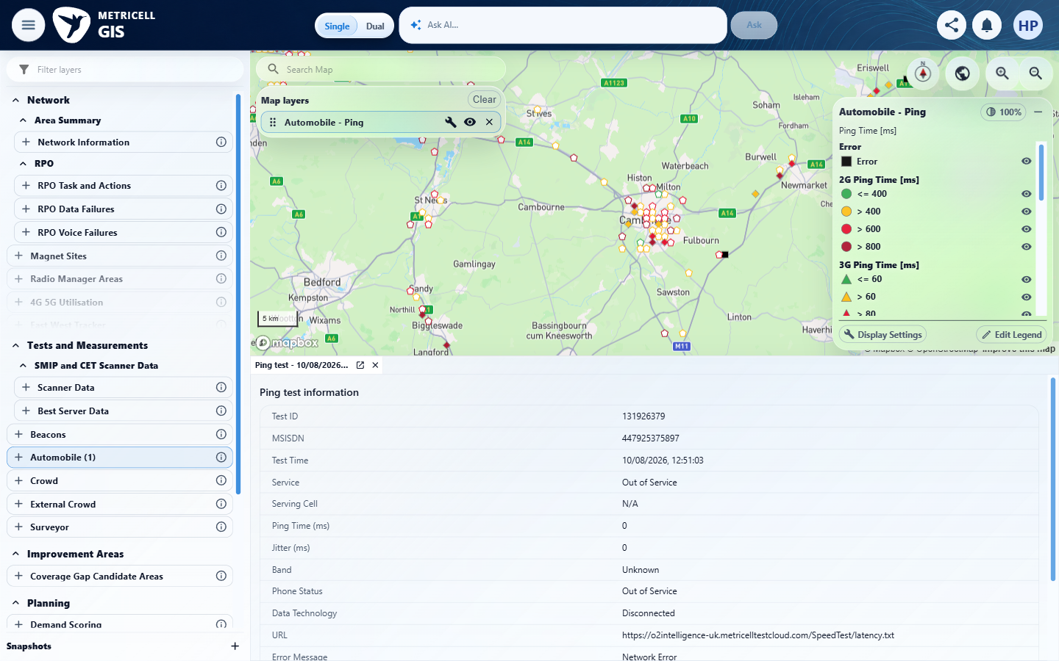 | E02 - Configuration (criterion-1-configuration.png)  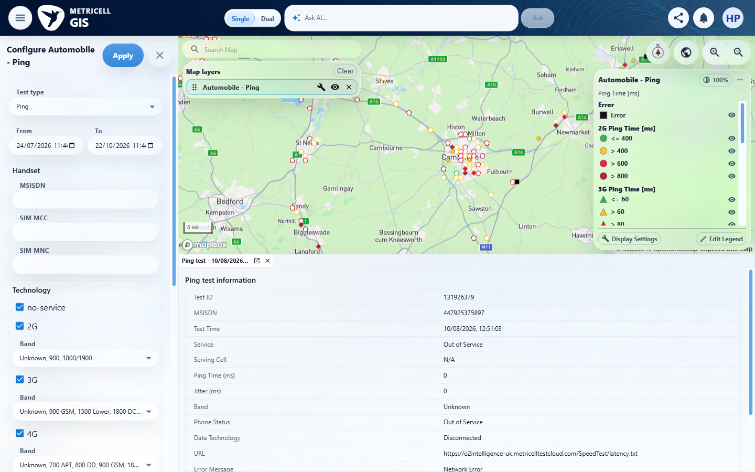

Criterion 1 continued: With Automobile Call results available, selecting the Call layer displays the results as selectable map points.
Browser URL recorded after criterion: https://o2intelligence-v4-dev.metricell.com/gis
E03 - Test types (criterion-1-test-types.png)  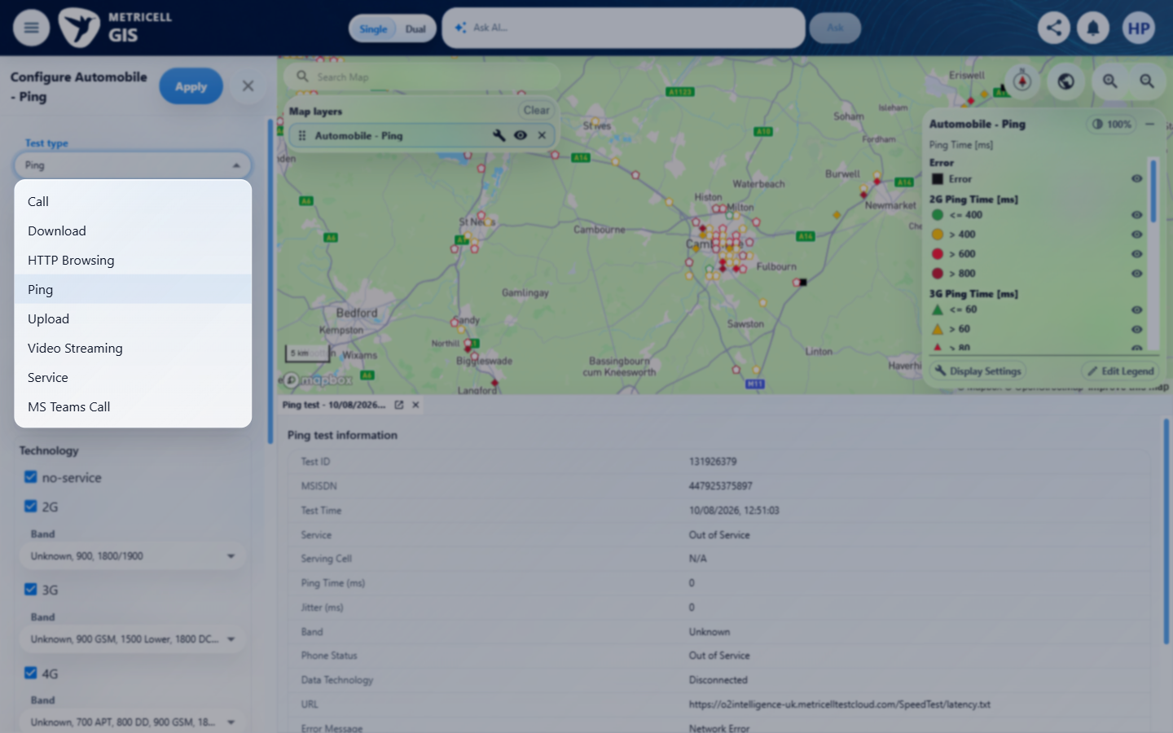 | E04 - Before apply call (criterion-1-before-apply-call.png)  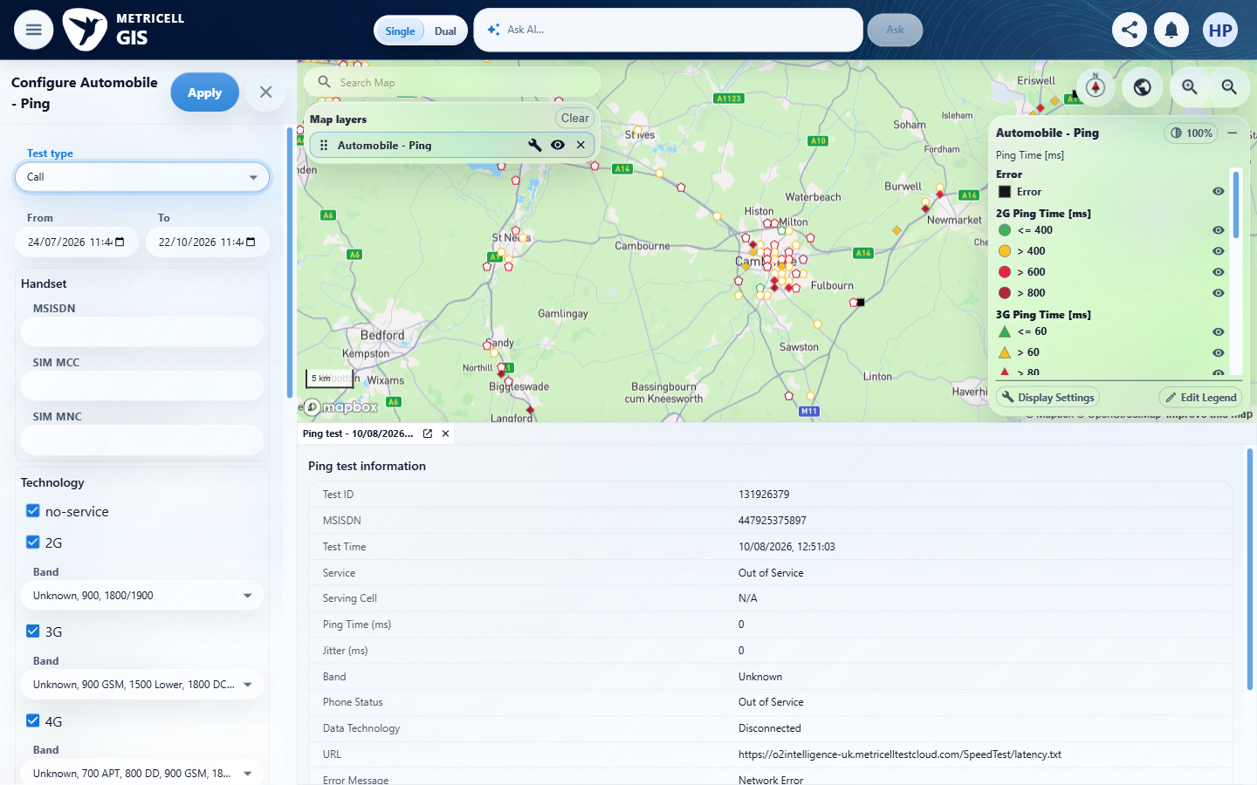

Criterion 1 continued: With Automobile Call results available, selecting the Call layer displays the results as selectable map points.
Browser URL recorded after criterion: https://o2intelligence-v4-dev.metricell.com/gis
E05 - Final (criterion-1-final.png)  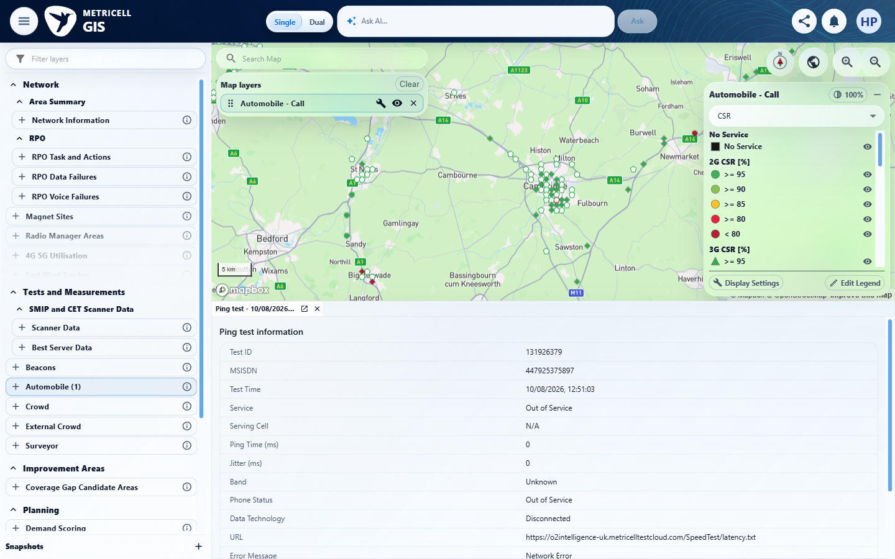 | E06 - Selected point final (criterion-1-selected-point-final.png)  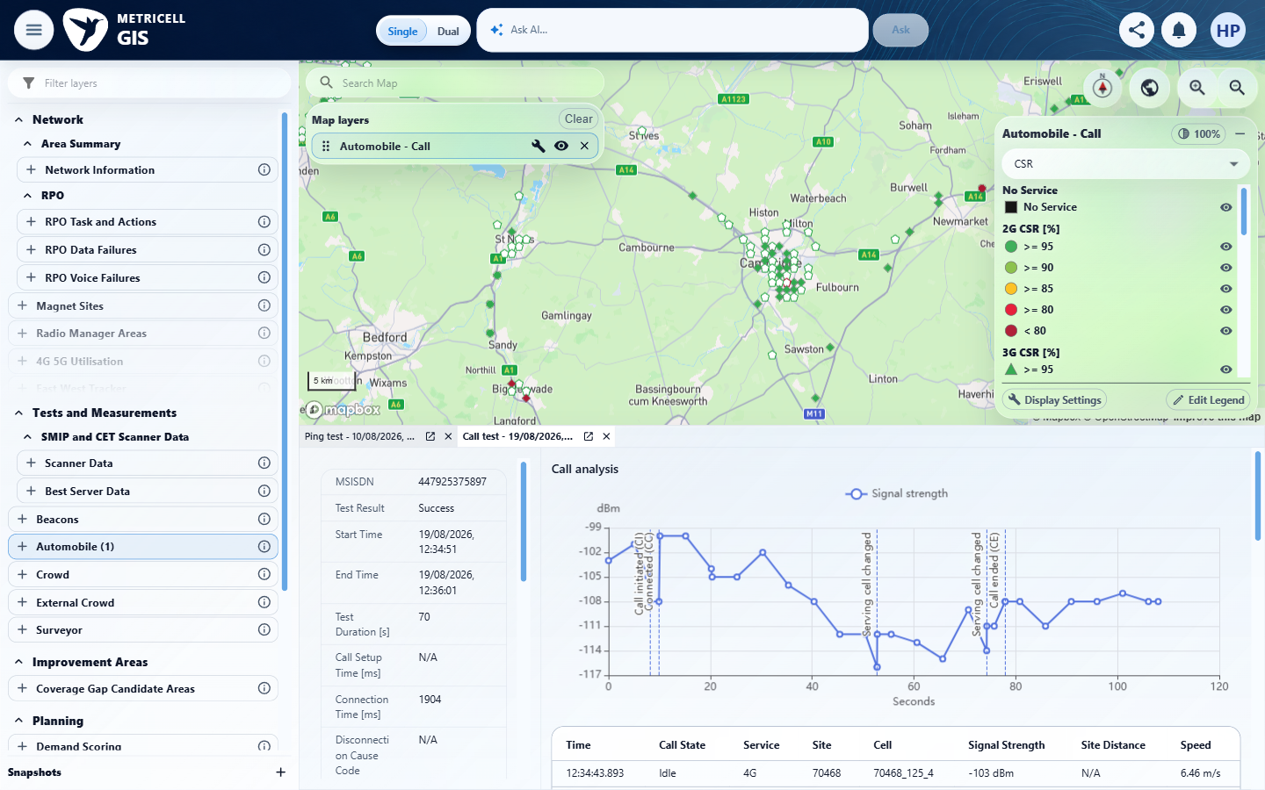

2.0.0 | The shared Colour By selector offers CSR, Downlink MOS, Uplink MOS, and Estimated MOS, with CSR selected by default. | The shared Colour By selector offers CSR, Downlink MOS, Uplink MOS, and Estimated MOS, with CSR selected by default. | criterion-2-after-apply-call.png and criterion-2-before-colour-options.png show initial CSR; criterion-2-after-colour-options.png visibly lists CSR, Downlink MOS, Uplink MOS and Estimated MOS.  Evidence: E01, E02, E07, E08, E09 | Passed
Criterion 2 assessment: criterion-2-after-apply-call.png and criterion-2-before-colour-options.png show initial CSR; criterion-2-after-colour-options.png visibly lists CSR, Downlink MOS, Uplink MOS and Estimated MOS.
Criterion 2 evidence: The shared Colour By selector offers CSR, Downlink MOS, Uplink MOS, and Estimated MOS, with CSR selected by default.
Browser URL recorded after criterion: https://o2intelligence-v4-dev.metricell.com/gis
E01 - Before configuration (criterion-2-before-configuration.png) | E02 - Before call choice (criterion-2-before-call-choice.png)

Criterion 2 continued: The shared Colour By selector offers CSR, Downlink MOS, Uplink MOS, and Estimated MOS, with CSR selected by default.
Browser URL recorded after criterion: https://o2intelligence-v4-dev.metricell.com/gis
E07 - Before apply call (criterion-2-before-apply-call.png)  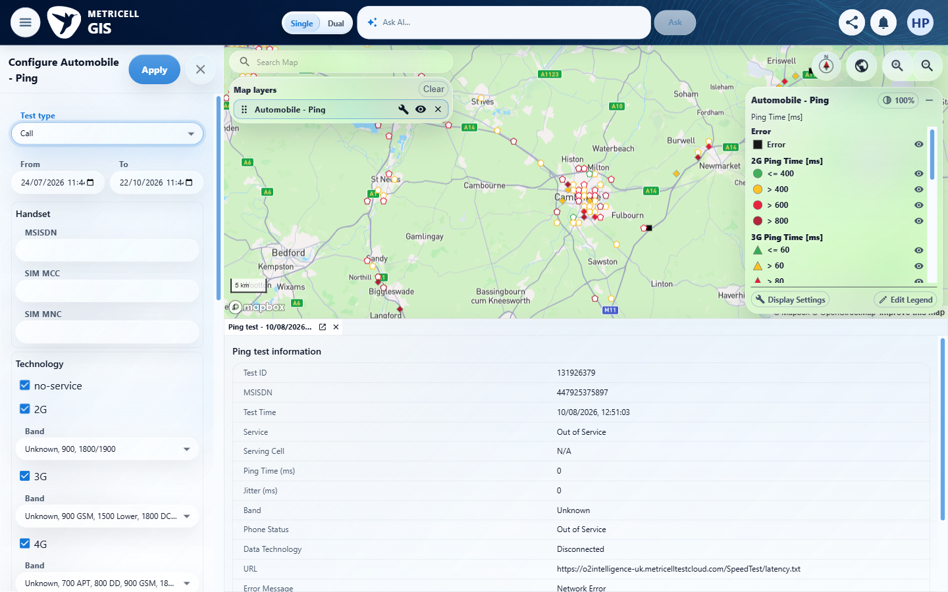 | E08 - Before colour options (criterion-2-before-colour-options.png)  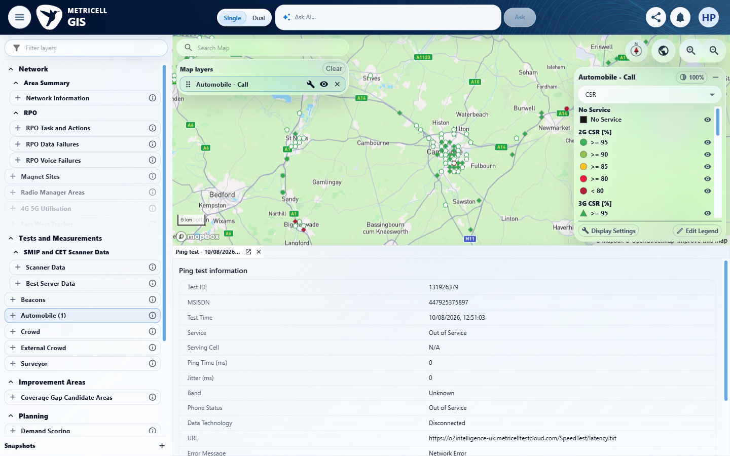

Criterion 2 continued: The shared Colour By selector offers CSR, Downlink MOS, Uplink MOS, and Estimated MOS, with CSR selected by default.
Browser URL recorded after criterion: https://o2intelligence-v4-dev.metricell.com/gis
E09 - Final (criterion-2-final.png)
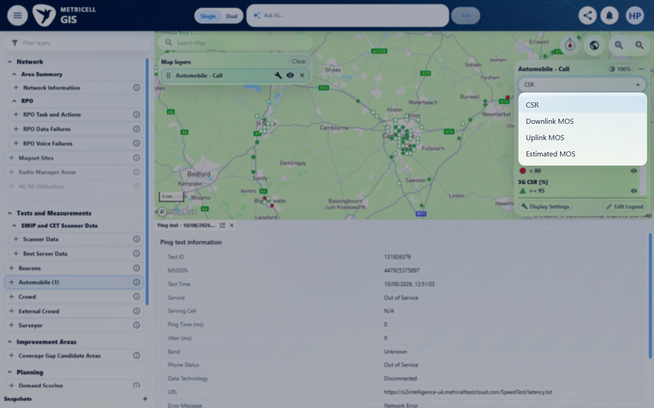

3.0.0 | For each Colour By choice, visible Call markers use that metric's values and the legend shows its matching title, units, categories, and colours; CSR is shown as a percentage and MOS as dimensionless scores. | For each Colour By choice, visible Call markers use that metric's values and the legend shows its matching title, units, categories, and colours; CSR is shown as a percentage and MOS as dimensionless scores. | criterion-3-after-downlink.png, after-uplink.png, after-estimated.png and after-csr.png show matching metric titles, symbols and percentage/score labels. They do not independently establish that each marker uses its own source values; the observed Downlink/Uplink samples are unavailable.  Evidence: E01, E10, E02, E07, E11, E12, E13, E14, E15, E16 | Failed
Criterion 3 assessment: criterion-3-after-downlink.png, after-uplink.png, after-estimated.png and after-csr.png show matching metric titles, symbols and percentage/score labels. They do not independently establish that each marker uses its own source values; the observed Downlink/Uplink samples are unavailable.
Criterion 3 evidence: For each Colour By choice, visible Call markers use that metric's values and the legend shows its matching title, units, categories, and colours; CSR is shown as a percentage and MOS as dimensionless scores.
Browser URL recorded after criterion: https://o2intelligence-v4-dev.metricell.com/gis
E01 - Gis (criterion-3-gis.png) | E10 - Before configuration (criterion-3-before-configuration.png)  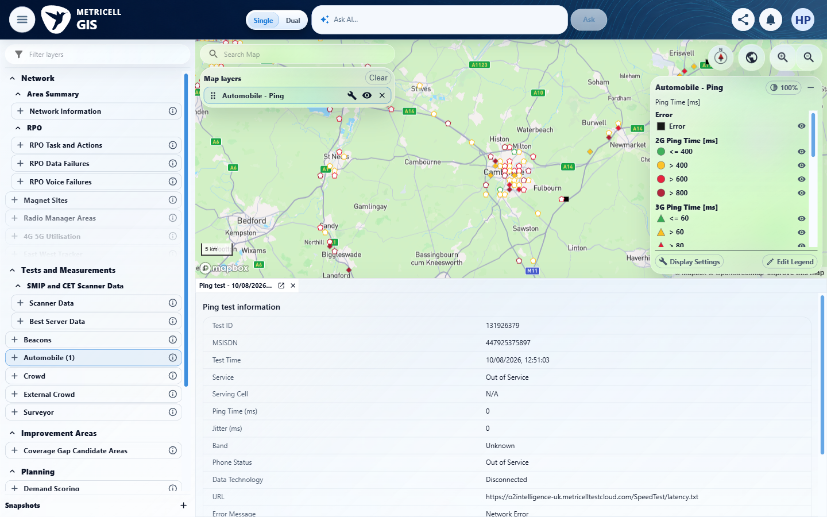

Criterion 3 continued: For each Colour By choice, visible Call markers use that metric's values and the legend shows its matching title, units, categories, and colours; CSR is shown as a percentage and MOS as dimensionless scores.
Browser URL recorded after criterion: https://o2intelligence-v4-dev.metricell.com/gis
E02 - Before call choice (criterion-3-before-call-choice.png) | E07 - Before apply call (criterion-3-before-apply-call.png)

Criterion 3 continued: For each Colour By choice, visible Call markers use that metric's values and the legend shows its matching title, units, categories, and colours; CSR is shown as a percentage and MOS as dimensionless scores.
Browser URL recorded after criterion: https://o2intelligence-v4-dev.metricell.com/gis
E11 - Before downlink (criterion-3-before-downlink.png)  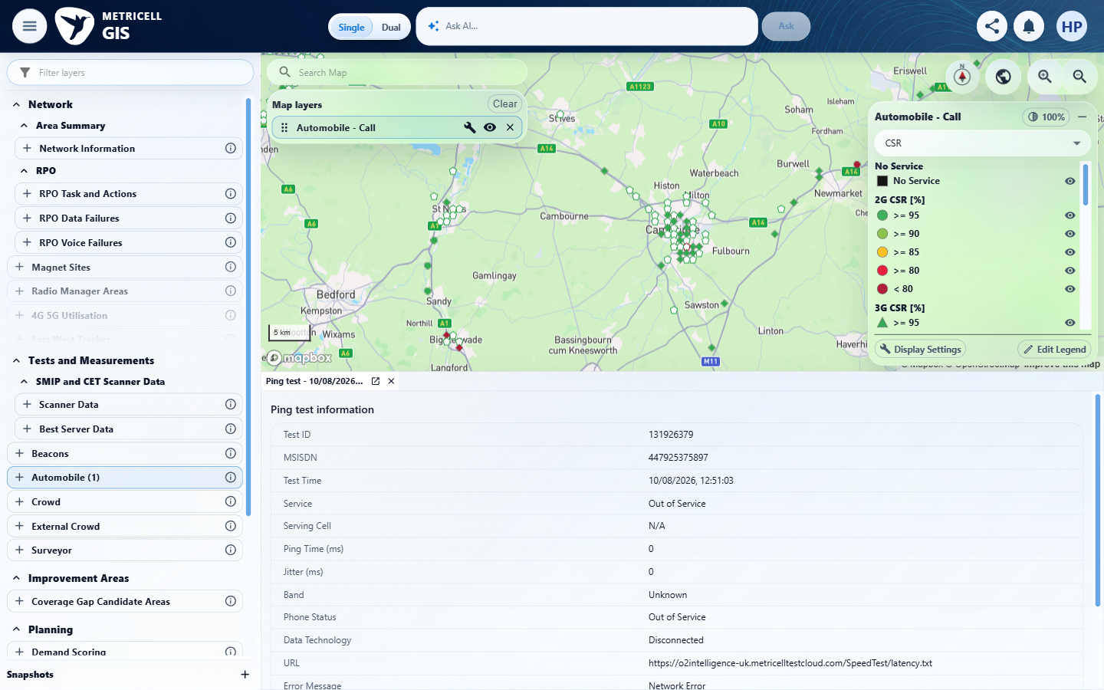 | E12 - After downlink (criterion-3-after-downlink.png)  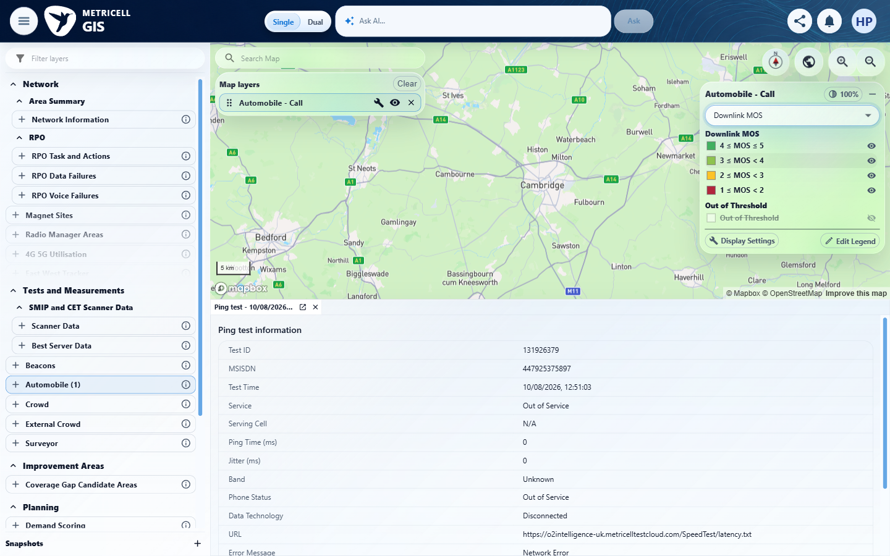

Criterion 3 continued: For each Colour By choice, visible Call markers use that metric's values and the legend shows its matching title, units, categories, and colours; CSR is shown as a percentage and MOS as dimensionless scores.
Browser URL recorded after criterion: https://o2intelligence-v4-dev.metricell.com/gis
E13 - Before uplink (criterion-3-before-uplink.png)  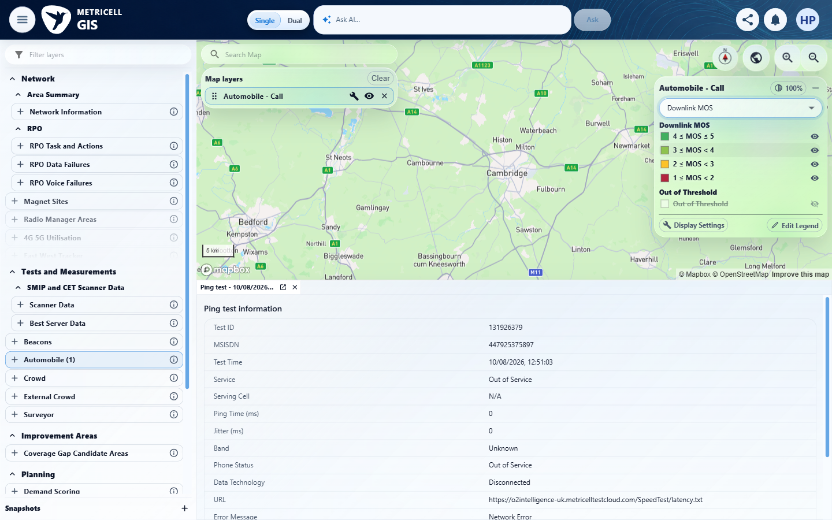 | E14 - Before estimated (criterion-3-before-estimated.png)  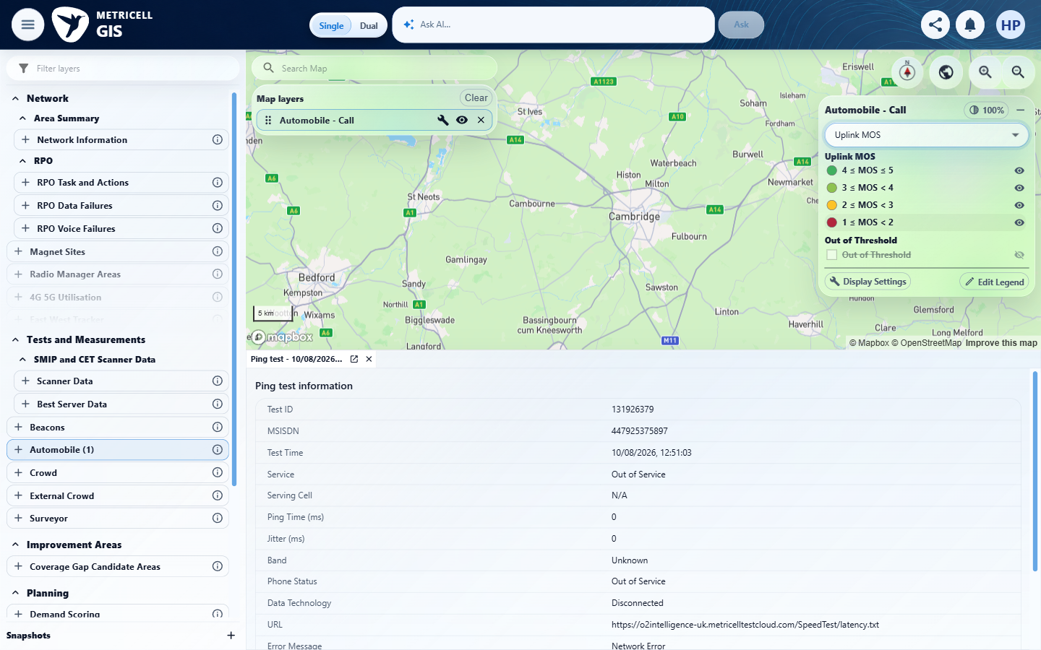

Criterion 3 continued: For each Colour By choice, visible Call markers use that metric's values and the legend shows its matching title, units, categories, and colours; CSR is shown as a percentage and MOS as dimensionless scores.
Browser URL recorded after criterion: https://o2intelligence-v4-dev.metricell.com/gis
E15 - Before csr (criterion-3-before-csr.png)  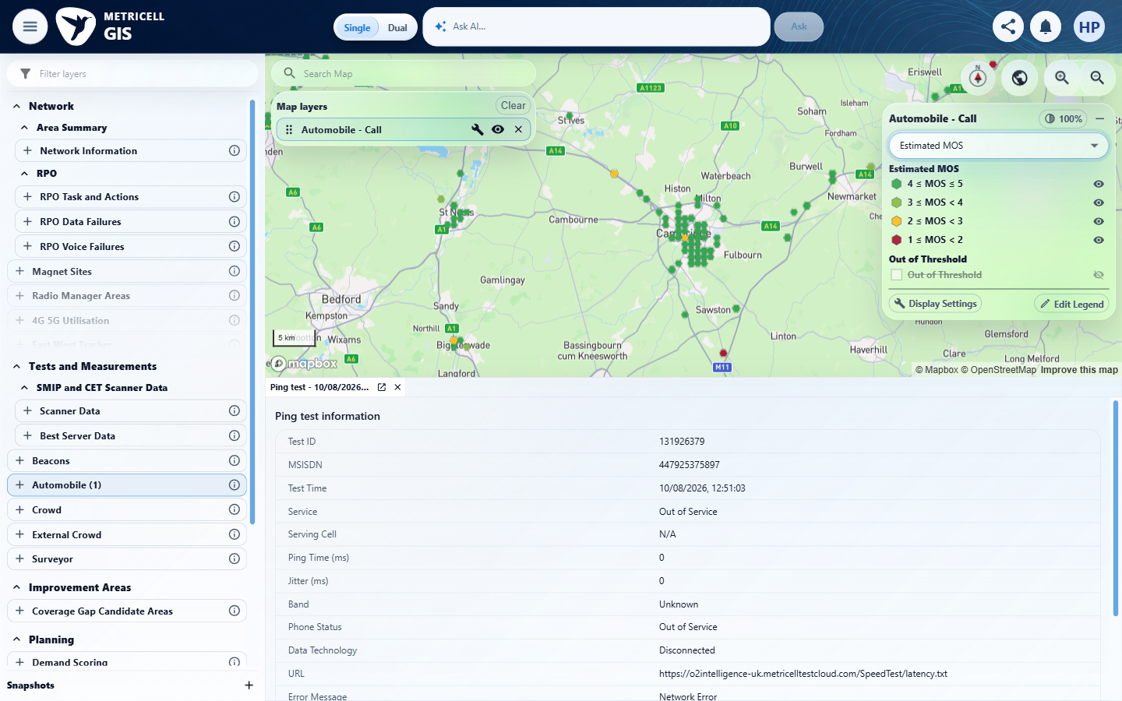 | E16 - Final (criterion-3-final.png)  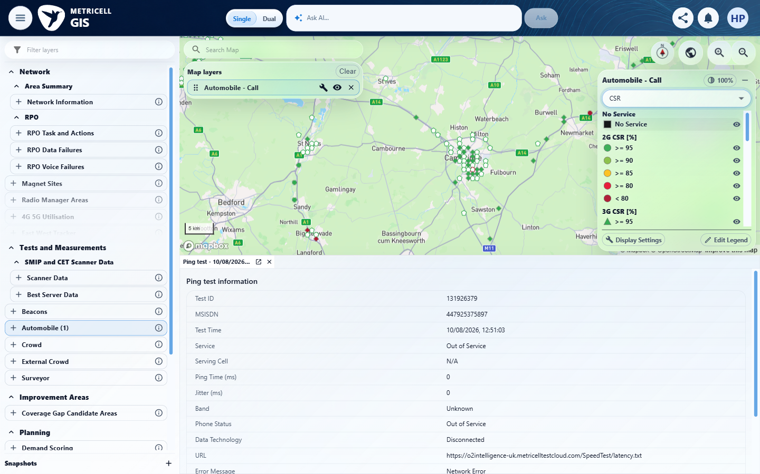

4.0.0 | Changing Colour By preserves the current date, filters, group visibility, marker identities, and selected result. | Changing Colour By preserves the current date, filters, group visibility, marker identities, and selected result. | criterion-4-baseline-map.png and baseline-layers.png establish the original Call selection; after-downlink.png, after-uplink.png and after-estimated.png retain its tab, and after-baseline-scope.png versus after-final-scope.png show the date scope. criterion-4-final.png retains the selection, but complete marker identity, group visibility and all filter preservation are not evidenced.  Evidence: E01, E10, E02, E17, E04, E11, E18, E19, E20, E21, E22, E23, E24, E25, E26, E27, E28 | Failed
Criterion 4 assessment: criterion-4-baseline-map.png and baseline-layers.png establish the original Call selection; after-downlink.png, after-uplink.png and after-estimated.png retain its tab, and after-baseline-scope.png versus after-final-scope.png show the date scope. criterion-4-final.png retains the selection, but complete marker identity, group visibility and all filter preservation are not evidenced.
Criterion 4 evidence: Changing Colour By preserves the current date, filters, group visibility, marker identities, and selected result.
Browser URL recorded after criterion: https://o2intelligence-v4-dev.metricell.com/gis
E01 - Gis (criterion-4-gis.png) | E10 - Before configuration (criterion-4-before-configuration.png)

Criterion 4 continued: Changing Colour By preserves the current date, filters, group visibility, marker identities, and selected result.
Browser URL recorded after criterion: https://o2intelligence-v4-dev.metricell.com/gis
E02 - After configuration (criterion-4-after-configuration.png) | E17 - Before call choice (criterion-4-before-call-choice.png)  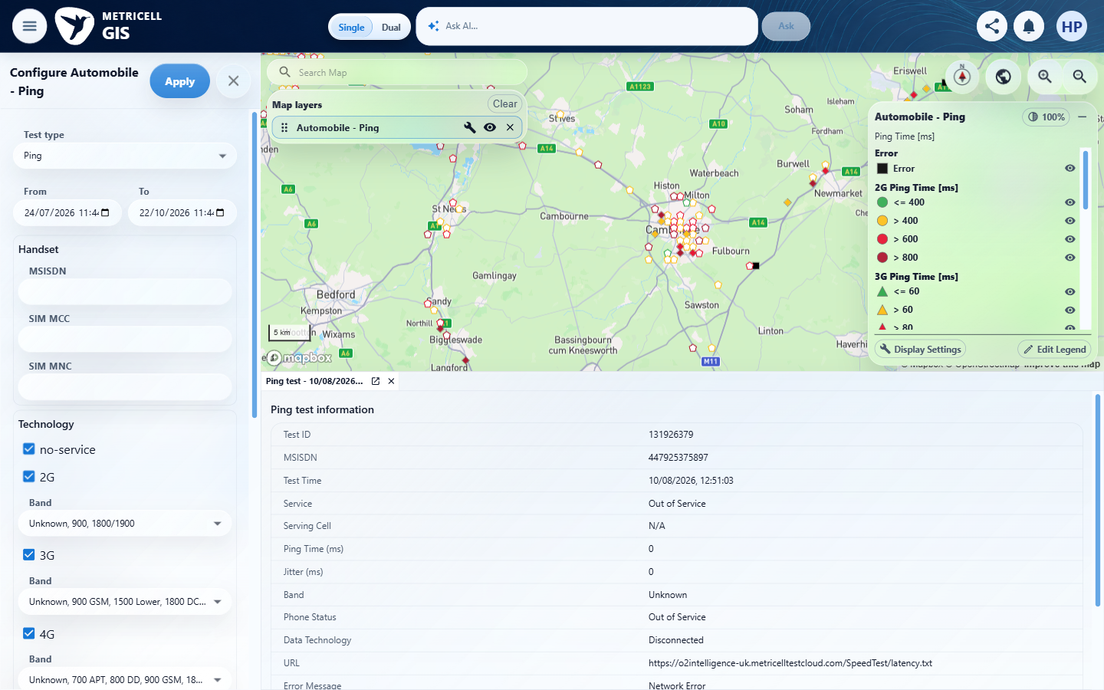

Criterion 4 continued: Changing Colour By preserves the current date, filters, group visibility, marker identities, and selected result.
Browser URL recorded after criterion: https://o2intelligence-v4-dev.metricell.com/gis
E04 - Before apply call (criterion-4-before-apply-call.png) | E11 - Before select result (criterion-4-before-select-result.png)

Criterion 4 continued: Changing Colour By preserves the current date, filters, group visibility, marker identities, and selected result.
Browser URL recorded after criterion: https://o2intelligence-v4-dev.metricell.com/gis
E18 - After select result (criterion-4-after-select-result.png)  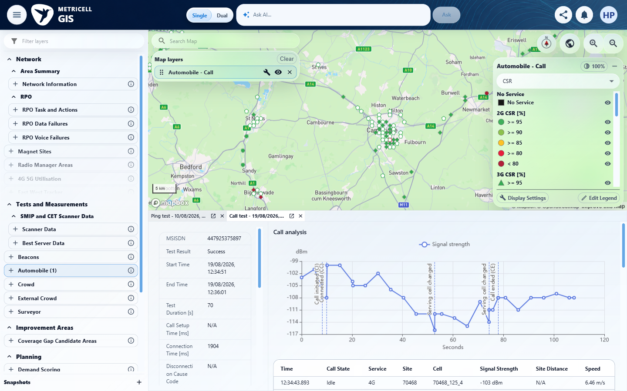 | E19 - Baseline map (criterion-4-baseline-map.png)  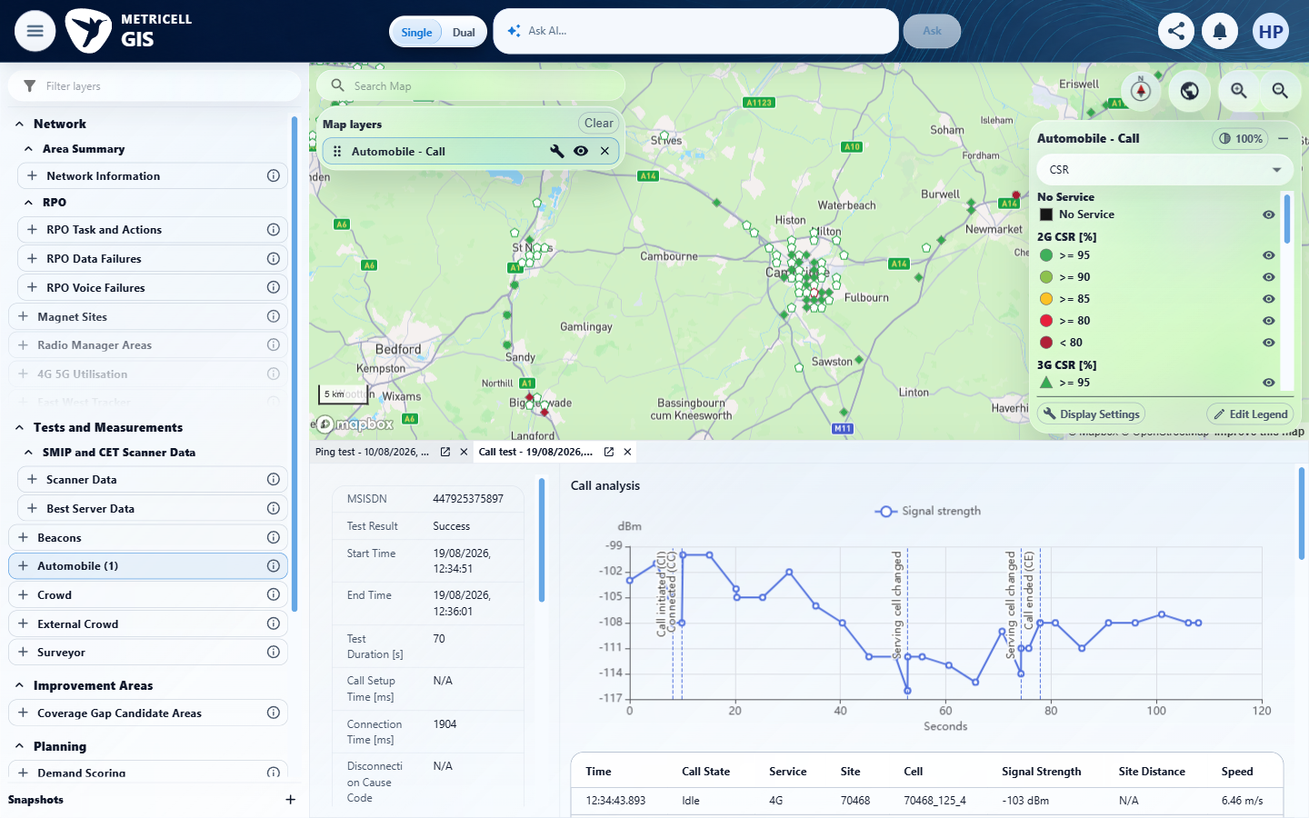

Criterion 4 continued: Changing Colour By preserves the current date, filters, group visibility, marker identities, and selected result.
Browser URL recorded after criterion: https://o2intelligence-v4-dev.metricell.com/gis
E18 - Before baseline scope (criterion-4-before-baseline-scope.png) | E20 - After baseline scope (criterion-4-after-baseline-scope.png)  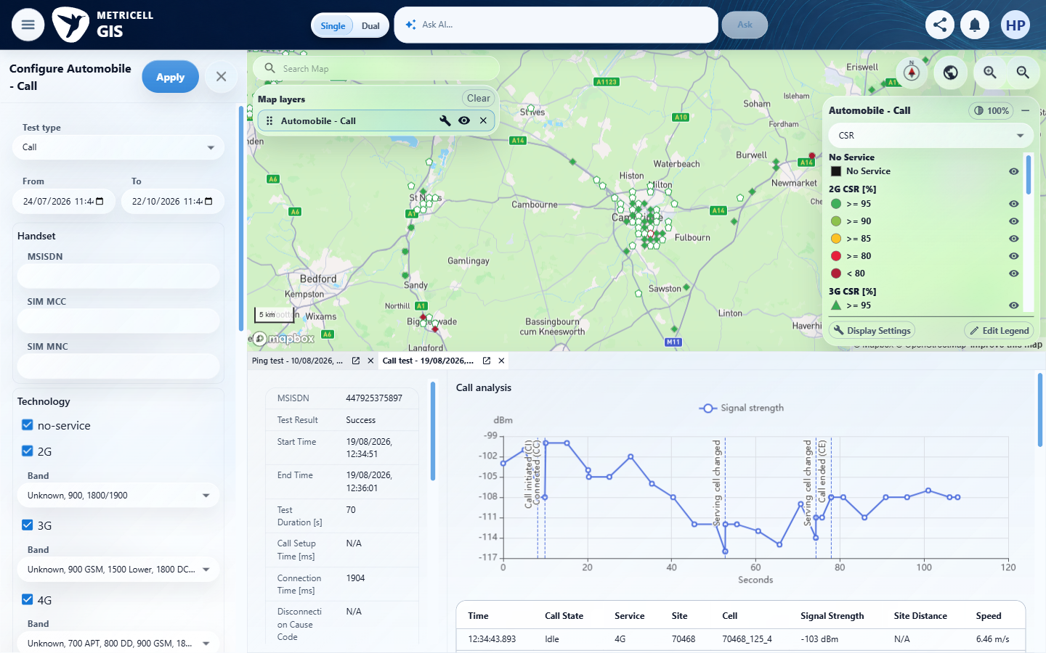

Criterion 4 continued: Changing Colour By preserves the current date, filters, group visibility, marker identities, and selected result.
Browser URL recorded after criterion: https://o2intelligence-v4-dev.metricell.com/gis
E21 - Before close baseline scope (criterion-4-before-close-baseline-scope.png)  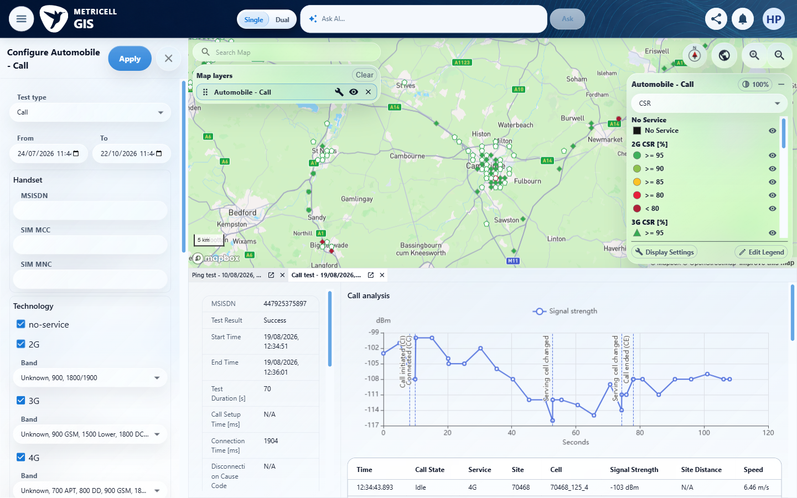 | E22 - Before downlink (criterion-4-before-downlink.png)  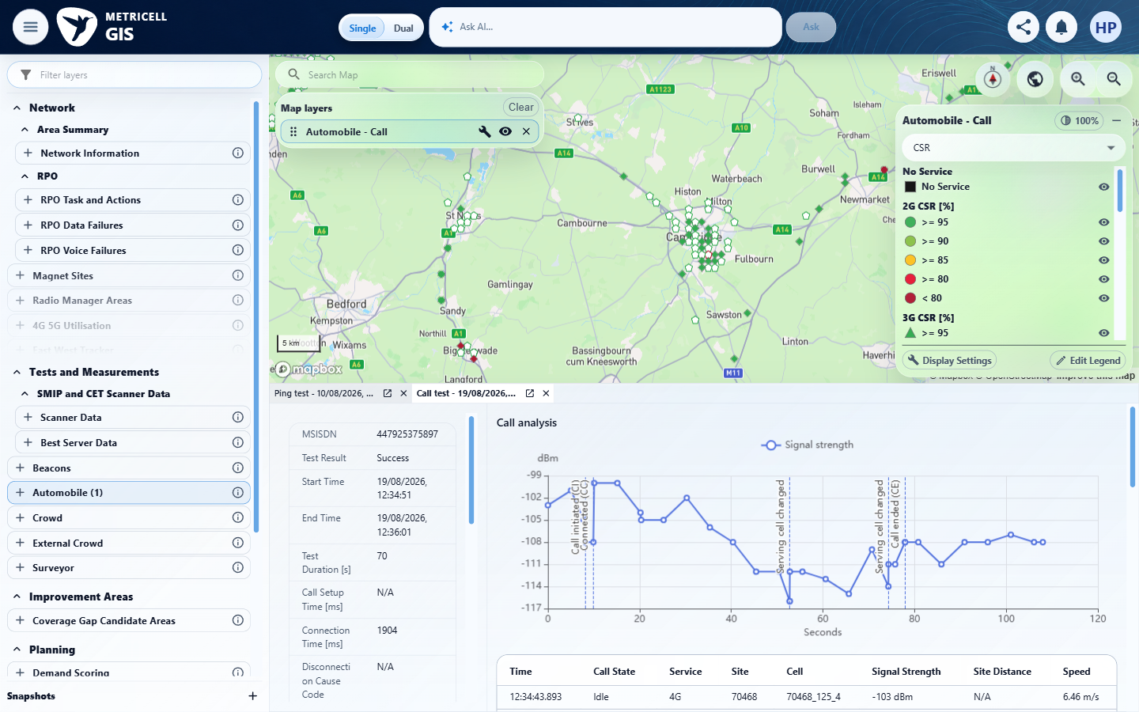

Criterion 4 continued: Changing Colour By preserves the current date, filters, group visibility, marker identities, and selected result.
Browser URL recorded after criterion: https://o2intelligence-v4-dev.metricell.com/gis
E23 - After downlink (criterion-4-after-downlink.png)  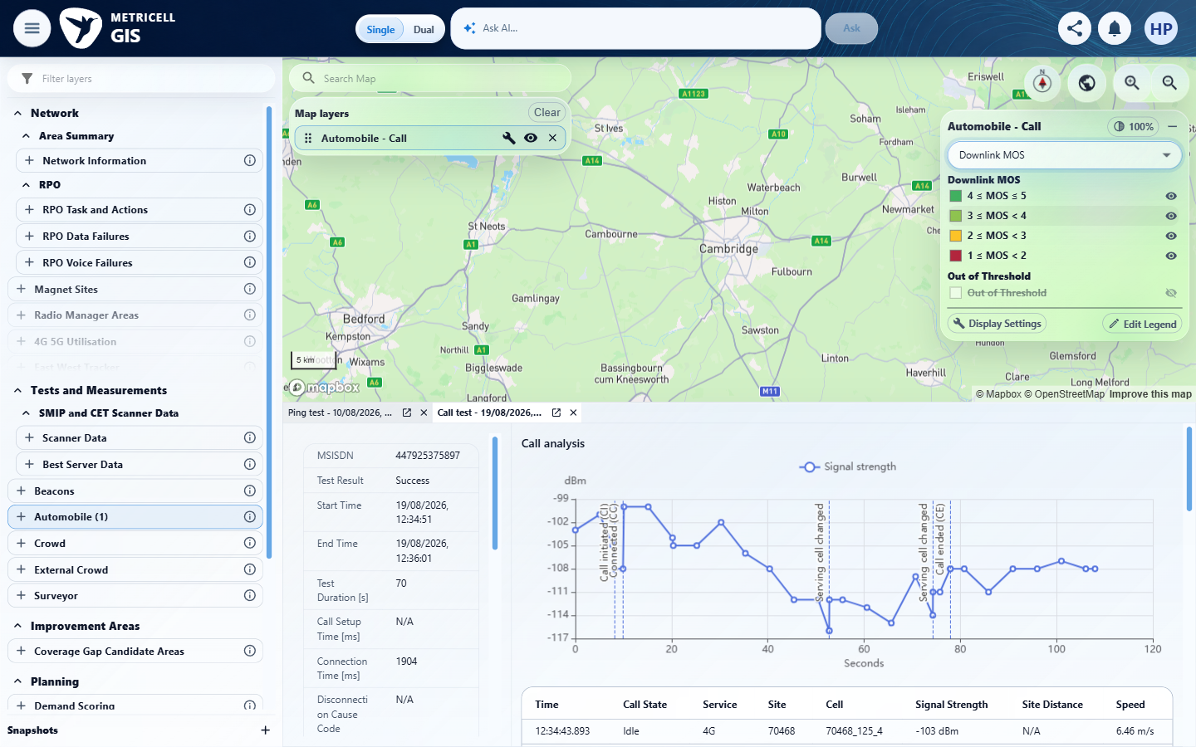 | E24 - Before uplink (criterion-4-before-uplink.png)  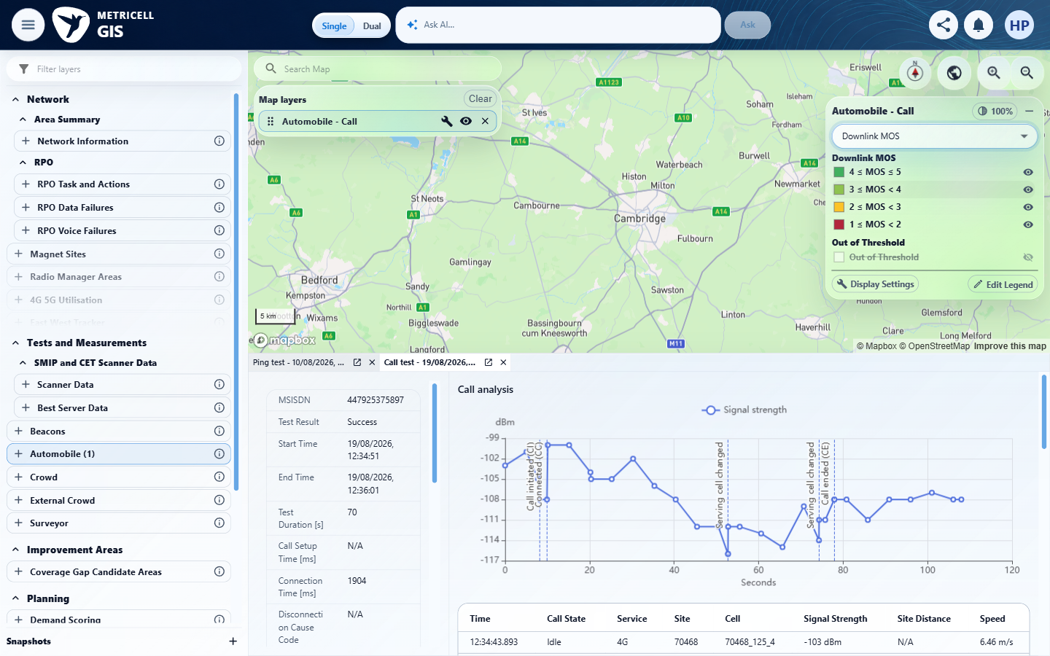

Criterion 4 continued: Changing Colour By preserves the current date, filters, group visibility, marker identities, and selected result.
Browser URL recorded after criterion: https://o2intelligence-v4-dev.metricell.com/gis
E25 - Before estimated (criterion-4-before-estimated.png)  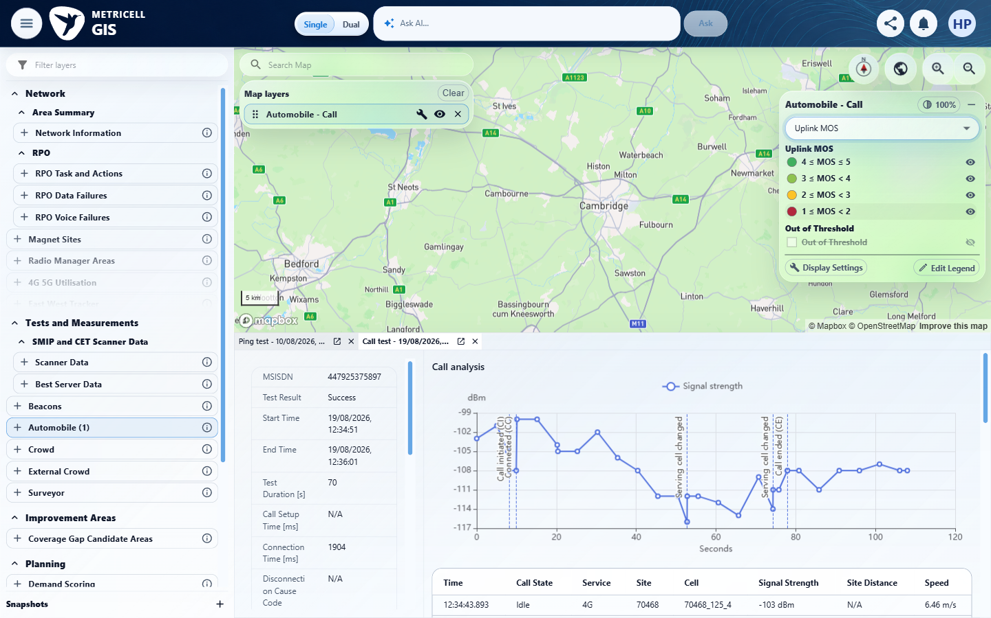 | E26 - Before final scope (criterion-4-before-final-scope.png)  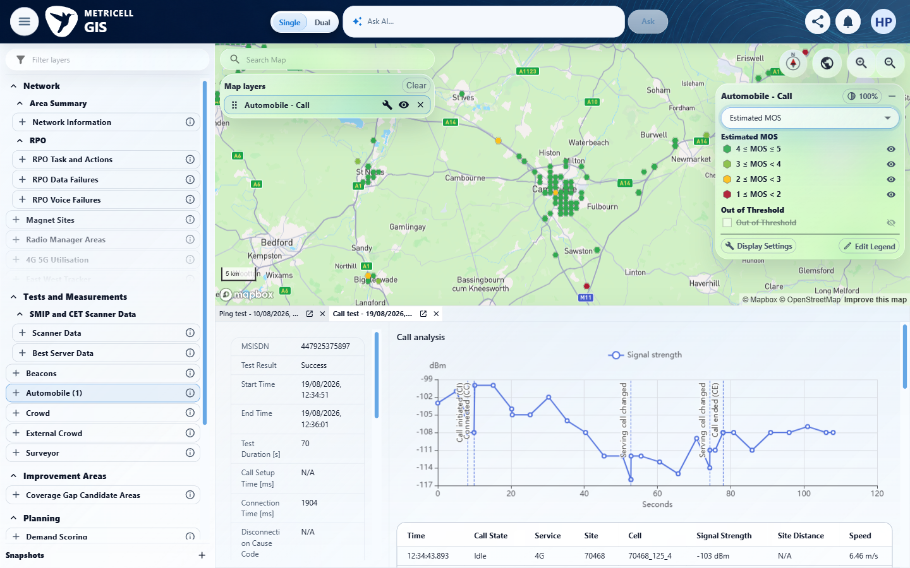

Criterion 4 continued: Changing Colour By preserves the current date, filters, group visibility, marker identities, and selected result.
Browser URL recorded after criterion: https://o2intelligence-v4-dev.metricell.com/gis
E27 - Before close final scope (criterion-4-before-close-final-scope.png)  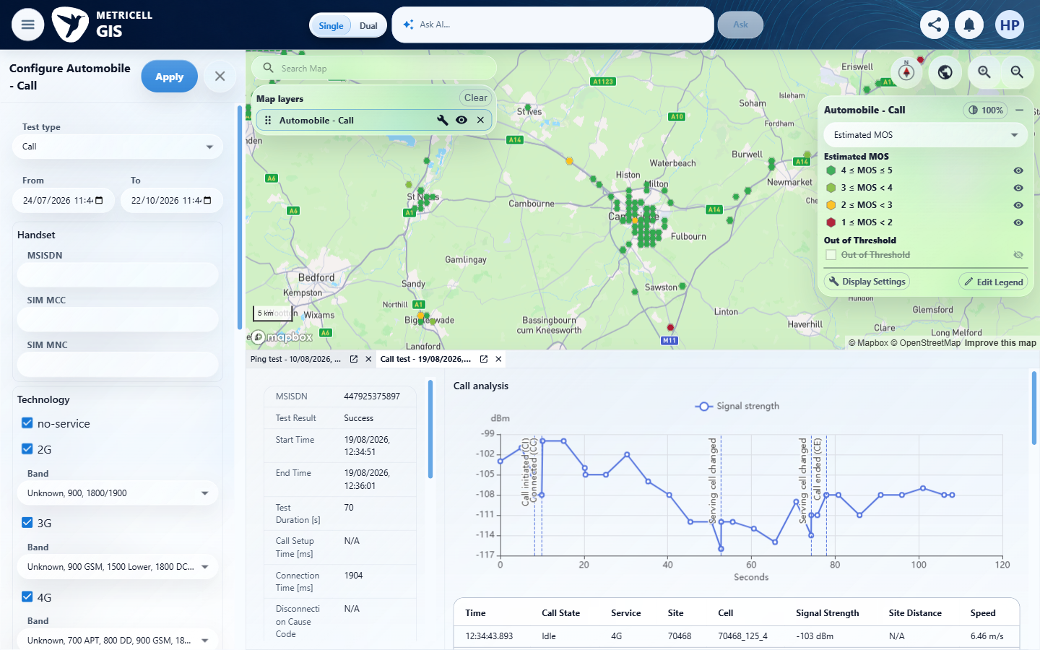 | E28 - Final (criterion-4-final.png)  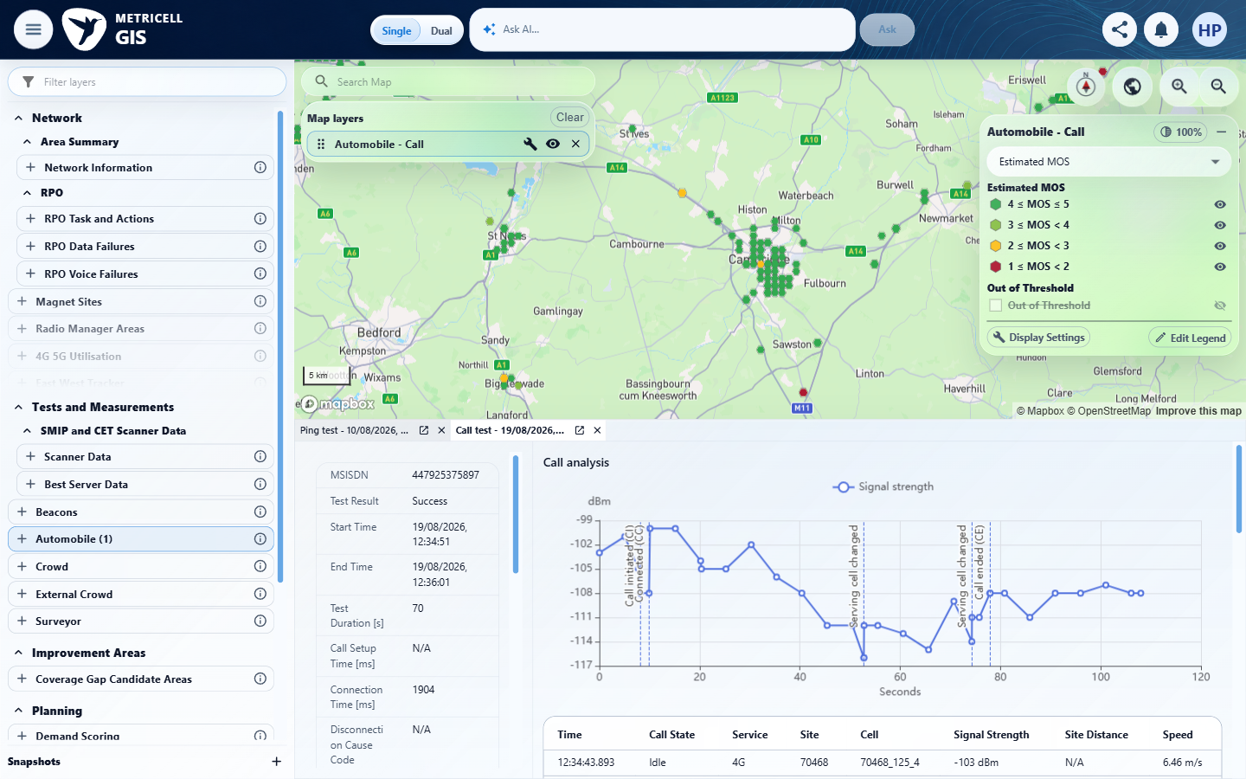

5.0.0 | For a marker representing multiple calls, CSR is 100 × successful calls divided by successful, setup-failed, operator-answered, no-service, and invalid calls; dropped calls are excluded and a zero denominator produces zero. Each MOS value is weighted by that metric's own valid sample count, and Estimated MOS uses its dedicated values rather than an average of Downlink and Uplink MOS. | For a marker representing multiple calls, CSR is 100 × successful calls divided by successful, setup-failed, operator-answered, no-service, and invalid calls; dropped calls are excluded and a zero denominator produces zero. Each MOS value is weighted by that metric's own valid sample count, and Estimated MOS uses its dedicated values rather than an average of Downlink and Uplink MOS. | The selected aggregate in criterion-5-after-aggregate-selection.png resolves to one Call result. Reported genuine responses lack the component call counts and separate MOS sample counts needed for independent CSR/weighted-MOS verification; known multi-call and zero-denominator fixtures are unavailable.  Evidence: E01, E29, E30, E31, E05, E08, E18, E06 | Blocked
Criterion 5 assessment: The selected aggregate in criterion-5-after-aggregate-selection.png resolves to one Call result. Reported genuine responses lack the component call counts and separate MOS sample counts needed for independent CSR/weighted-MOS verification; known multi-call and zero-denominator fixtures are unavailable.
Testing notes: Calculation prerequisites are missing: observed HTTP 200 Call point/cluster responses do not expose counts for successful, setup-failed, operator-answered, no-service, invalid and dropped calls or separate valid sample counts for every MOS metric. The selected aggregate resolved to single PointID 132047844, with Downlink/Uplink MOS null and Estimated MOS 4.4. A known multi-call denominator/weighting fixture and zero-denominator fixture are required.
Criterion 5 evidence: For a marker representing multiple calls, CSR is 100 × successful calls divided by successful, setup-failed, operator-answered, no-service, and invalid calls; dropped calls are excluded and a zero denominator produces zero. Each MOS value is weighted by that metric's own valid sample count, and Estimated MOS uses its dedicated values rather than an average of Downlink and Uplink MOS.
Browser URL recorded after criterion: https://o2intelligence-v4-dev.metricell.com/gis
E01 - Before configuration (criterion-5-before-configuration.png) | E29 - After configuration (criterion-5-after-configuration.png)  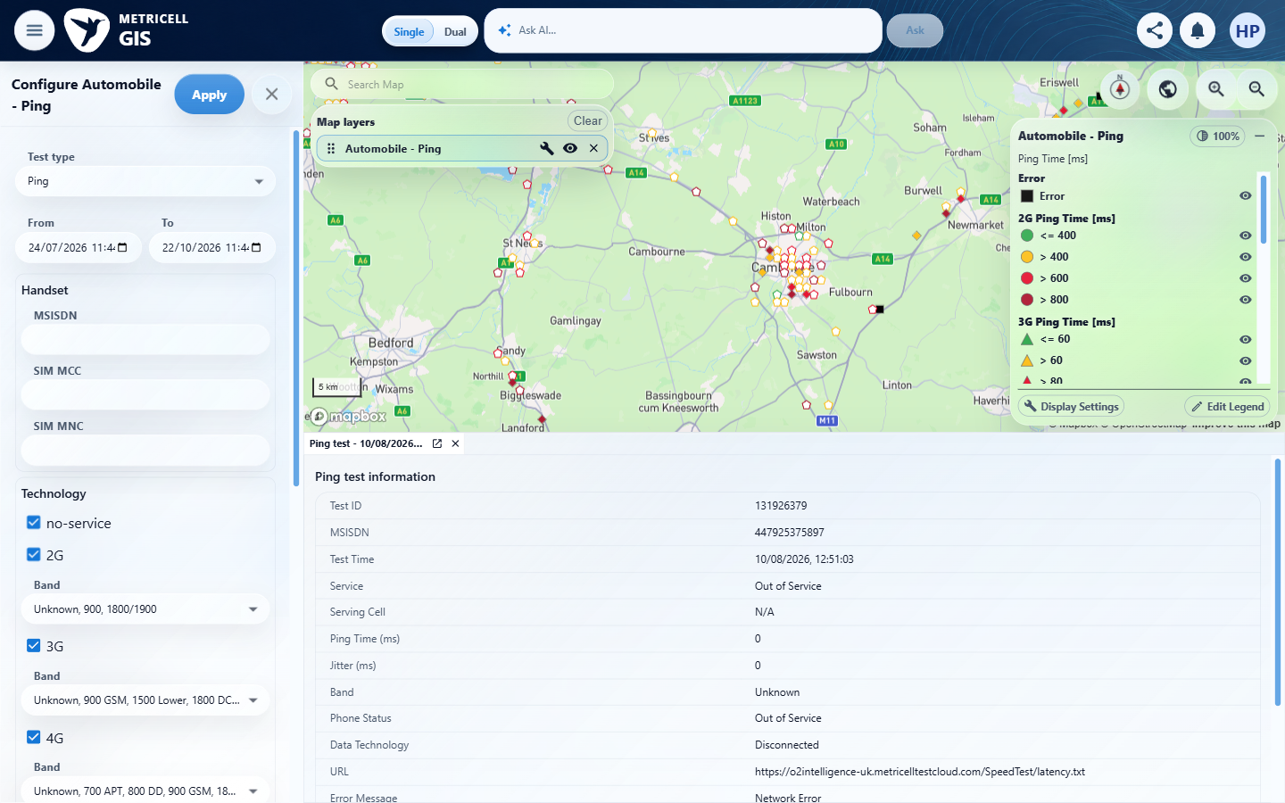

Criterion 5 continued: For a marker representing multiple calls, CSR is 100 × successful calls divided by successful, setup-failed, operator-answered, no-service, and invalid calls; dropped calls are excluded and a zero denominator produces zero. Each MOS value is weighted by that metric's own valid sample count, and Estimated MOS uses its dedicated values rather than an average of Downlink and Uplink MOS.
Browser URL recorded after criterion: https://o2intelligence-v4-dev.metricell.com/gis
E30 - Before call choice (criterion-5-before-call-choice.png)  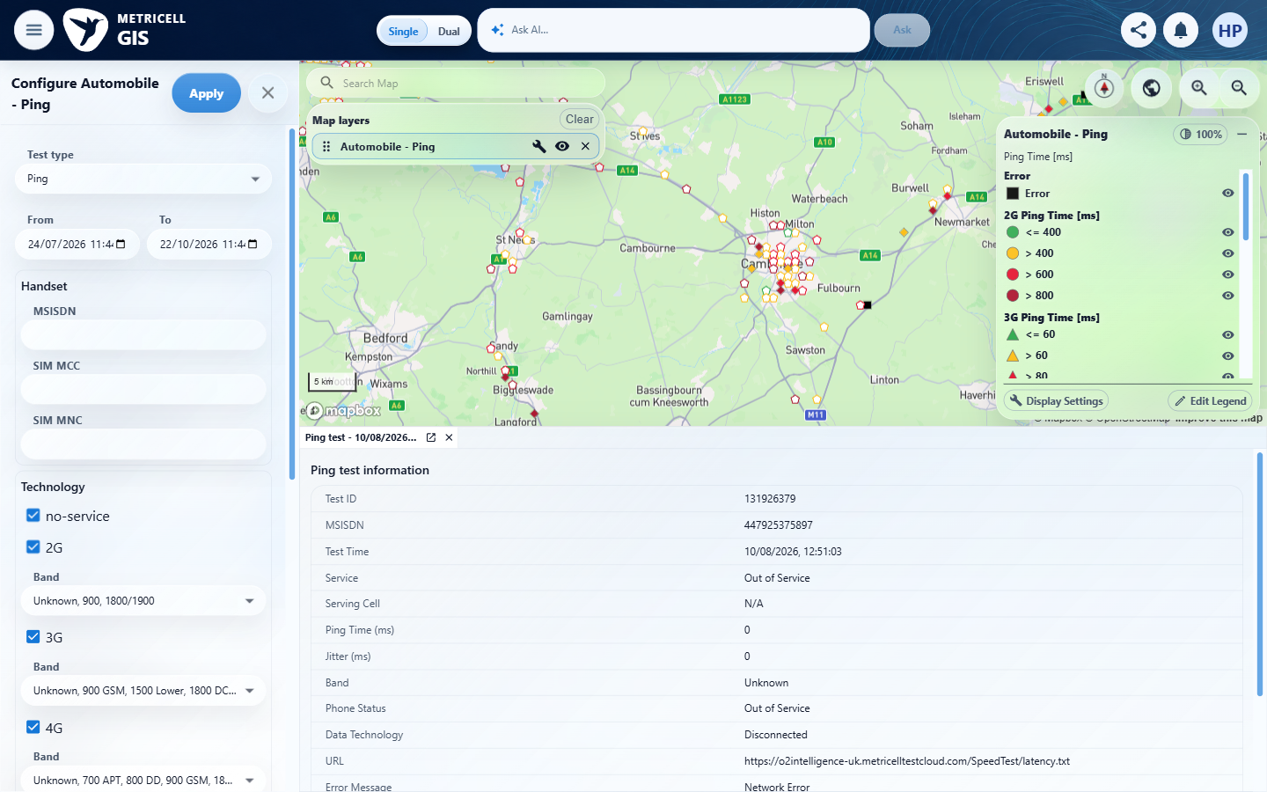 | E31 - Before apply call (criterion-5-before-apply-call.png)  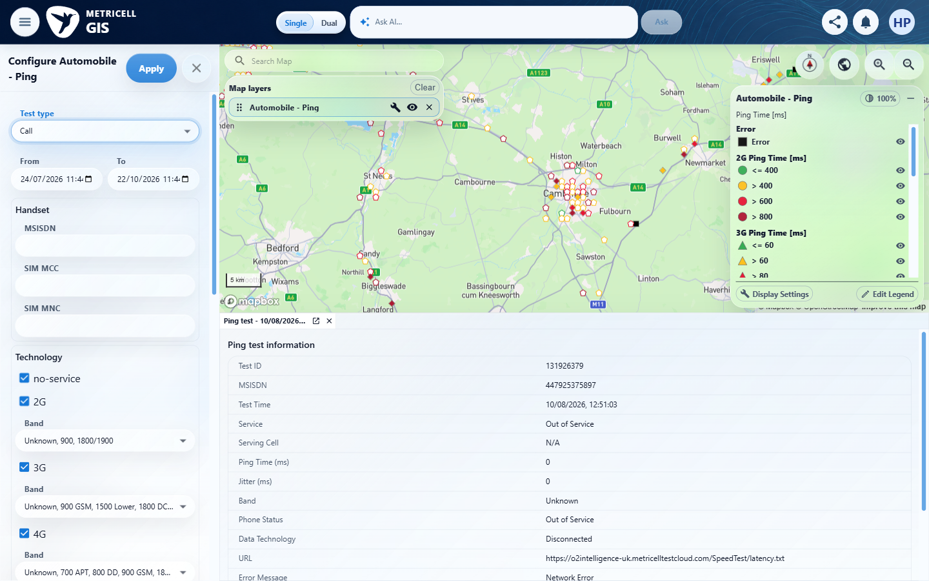

Criterion 5 continued: For a marker representing multiple calls, CSR is 100 × successful calls divided by successful, setup-failed, operator-answered, no-service, and invalid calls; dropped calls are excluded and a zero denominator produces zero. Each MOS value is weighted by that metric's own valid sample count, and Estimated MOS uses its dedicated values rather than an average of Downlink and Uplink MOS.
Browser URL recorded after criterion: https://o2intelligence-v4-dev.metricell.com/gis
E05 - After apply call (criterion-5-after-apply-call.png) | E08 - Before aggregate selection (criterion-5-before-aggregate-selection.png)

Criterion 5 continued: For a marker representing multiple calls, CSR is 100 × successful calls divided by successful, setup-failed, operator-answered, no-service, and invalid calls; dropped calls are excluded and a zero denominator produces zero. Each MOS value is weighted by that metric's own valid sample count, and Estimated MOS uses its dedicated values rather than an average of Downlink and Uplink MOS.
Browser URL recorded after criterion: https://o2intelligence-v4-dev.metricell.com/gis
E18 - After aggregate selection (criterion-5-after-aggregate-selection.png) | E06 - Final (criterion-5-final.png)

6.0.0 | The default CSR legend uses green #31AA4F for 95–100%, light green #86BE42 for 90–<95%, yellow #FCBF1A for 85–<90%, red #E61733 for 80–<85%, and dark red #AE1A32 for 0–<80%; exact boundaries use the higher band. | The default CSR legend uses green #31AA4F for 95–100%, light green #86BE42 for 90–<95%, yellow #FCBF1A for 85–<90%, red #E61733 for 80–<85%, and dark red #AE1A32 for 0–<80%; exact boundaries use the higher band. | criterion-6-after-edit-legend.png and final.png show descending CSR bands and expected visible colours/labels. Screenshots do not establish exact hexadecimal values or runtime classification at 80/85/90/95; those boundary fixtures are missing.  Evidence: E01, E29, E32, E04, E33, E08, E34 | Failed
Criterion 6 assessment: criterion-6-after-edit-legend.png and final.png show descending CSR bands and expected visible colours/labels. Screenshots do not establish exact hexadecimal values or runtime classification at 80/85/90/95; those boundary fixtures are missing.
Criterion 6 evidence: The default CSR legend uses green #31AA4F for 95–100%, light green #86BE42 for 90–<95%, yellow #FCBF1A for 85–<90%, red #E61733 for 80–<85%, and dark red #AE1A32 for 0–<80%; exact boundaries use the higher band.
Browser URL recorded after criterion: https://o2intelligence-v4-dev.metricell.com/gis
E01 - Before configuration (criterion-6-before-configuration.png) | E29 - After configuration (criterion-6-after-configuration.png)

Criterion 6 continued: The default CSR legend uses green #31AA4F for 95–100%, light green #86BE42 for 90–<95%, yellow #FCBF1A for 85–<90%, red #E61733 for 80–<85%, and dark red #AE1A32 for 0–<80%; exact boundaries use the higher band.
Browser URL recorded after criterion: https://o2intelligence-v4-dev.metricell.com/gis
E32 - Before call choice (criterion-6-before-call-choice.png)  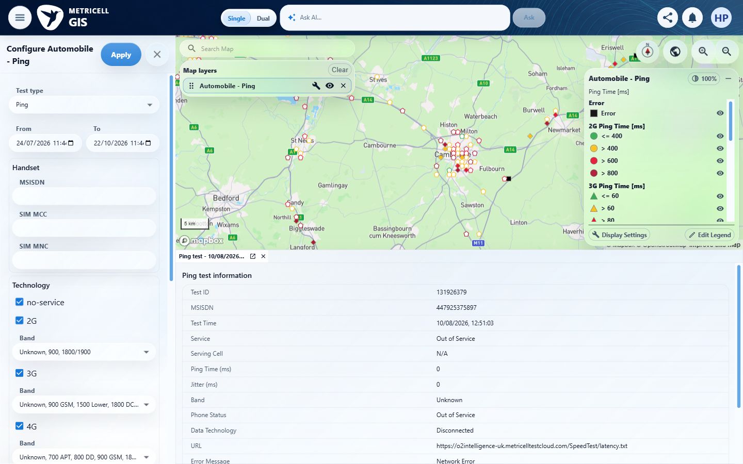 | E04 - After call choice (criterion-6-after-call-choice.png)
E32 detail enlargement - full screenshot above | E04 detail enlargement - full screenshot above

Criterion 6 continued: The default CSR legend uses green #31AA4F for 95–100%, light green #86BE42 for 90–<95%, yellow #FCBF1A for 85–<90%, red #E61733 for 80–<85%, and dark red #AE1A32 for 0–<80%; exact boundaries use the higher band.
Browser URL recorded after criterion: https://o2intelligence-v4-dev.metricell.com/gis
E33 - Before apply call (criterion-6-before-apply-call.png)  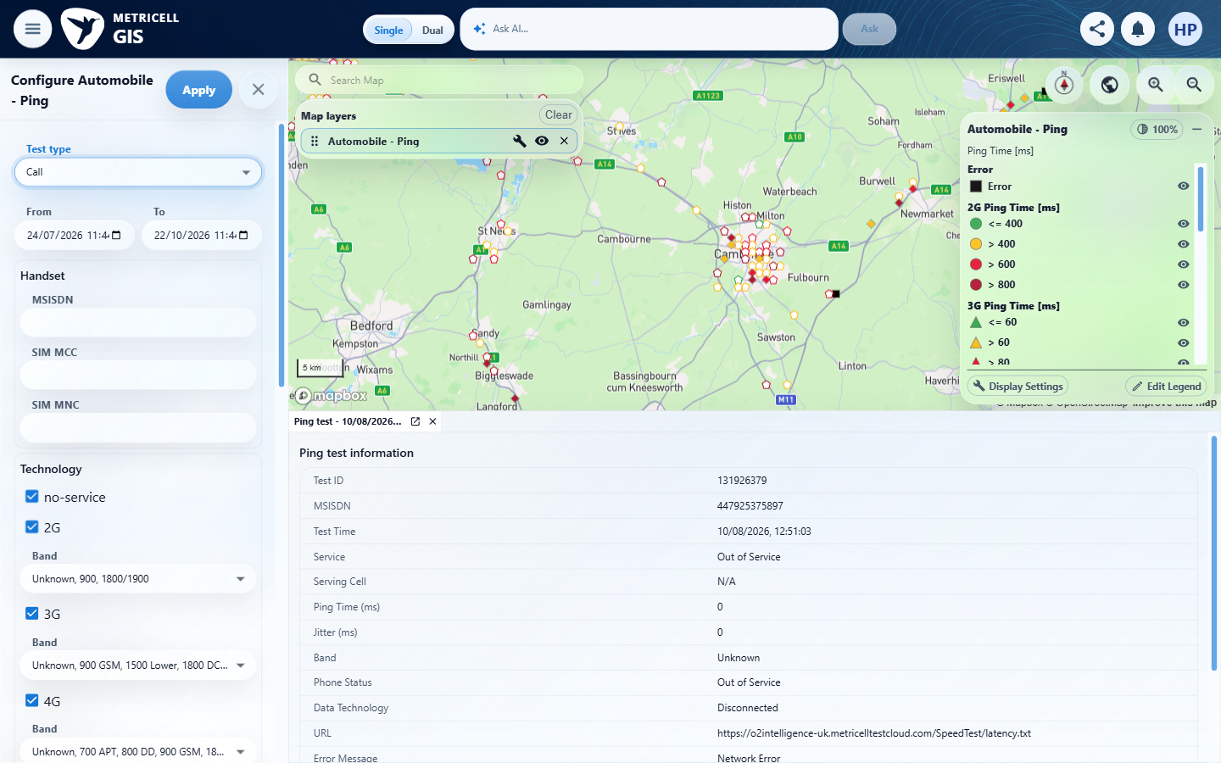 | E08 - Before edit legend (criterion-6-before-edit-legend.png)

Criterion 6 continued: The default CSR legend uses green #31AA4F for 95–100%, light green #86BE42 for 90–<95%, yellow #FCBF1A for 85–<90%, red #E61733 for 80–<85%, and dark red #AE1A32 for 0–<80%; exact boundaries use the higher band.
Browser URL recorded after criterion: https://o2intelligence-v4-dev.metricell.com/gis
E34 - Final (criterion-6-final.png)
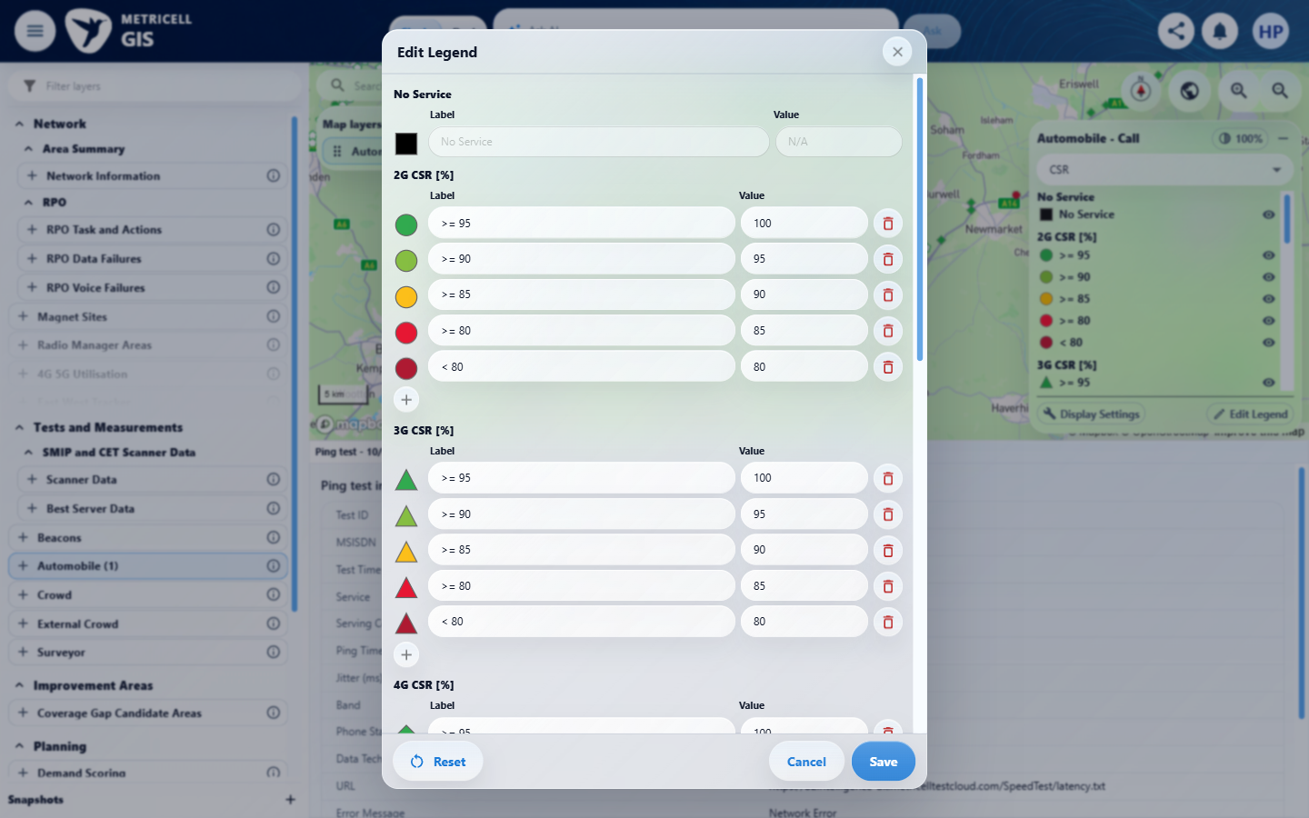

7.0.0 | Each default MOS legend uses dark red #AE1A32 for 1–<2, yellow #FCBF1A for 2–<3, light green #86BE42 for 3–<4, and green #31AA4F for 4–5 inclusive; exact internal boundaries use the higher band. | Each default MOS legend uses dark red #AE1A32 for 1–<2, yellow #FCBF1A for 2–<3, light green #86BE42 for 3–<4, and green #31AA4F for 4–5 inclusive; exact internal boundaries use the higher band. | criterion-7-after-downlink-editor.png, after-uplink-editor.png and after-estimated-editor.png show four expected score bands including the inclusive top label. Exact colour codes and runtime assignment at 2/3/4/5 are not independently demonstrated.  Evidence: E01, E10, E02, E07, E35, E11, E36, E12, E37, E38, E39, E14, E40, E41, E42, E43, E44, E45 | Failed
Criterion 7 assessment: criterion-7-after-downlink-editor.png, after-uplink-editor.png and after-estimated-editor.png show four expected score bands including the inclusive top label. Exact colour codes and runtime assignment at 2/3/4/5 are not independently demonstrated.
Testing notes: All three MOS editors have expected colours and descending labels 4 ≤ MOS ≤ 5, 3 ≤ MOS < 4, 2 ≤ MOS < 3 and 1 ≤ MOS < 2, with 1–5 input bounds. Valid Downlink/Uplink and exact 2/3/4/5 boundary fixtures were unavailable, so runtime classification and exactly-5 behaviour remain unverified.
Criterion 7 evidence: Each default MOS legend uses dark red #AE1A32 for 1–<2, yellow #FCBF1A for 2–<3, light green #86BE42 for 3–<4, and green #31AA4F for 4–5 inclusive; exact internal boundaries use the higher band.
Browser URL recorded after criterion: https://o2intelligence-v4-dev.metricell.com/gis
E01 - Gis (criterion-7-gis.png) | E10 - Before configuration (criterion-7-before-configuration.png)

Criterion 7 continued: Each default MOS legend uses dark red #AE1A32 for 1–<2, yellow #FCBF1A for 2–<3, light green #86BE42 for 3–<4, and green #31AA4F for 4–5 inclusive; exact internal boundaries use the higher band.
Browser URL recorded after criterion: https://o2intelligence-v4-dev.metricell.com/gis
E02 - Before call choice (criterion-7-before-call-choice.png) | E07 - Before apply call (criterion-7-before-apply-call.png)

Criterion 7 continued: Each default MOS legend uses dark red #AE1A32 for 1–<2, yellow #FCBF1A for 2–<3, light green #86BE42 for 3–<4, and green #31AA4F for 4–5 inclusive; exact internal boundaries use the higher band.
Browser URL recorded after criterion: https://o2intelligence-v4-dev.metricell.com/gis
E35 - After apply call (criterion-7-after-apply-call.png)  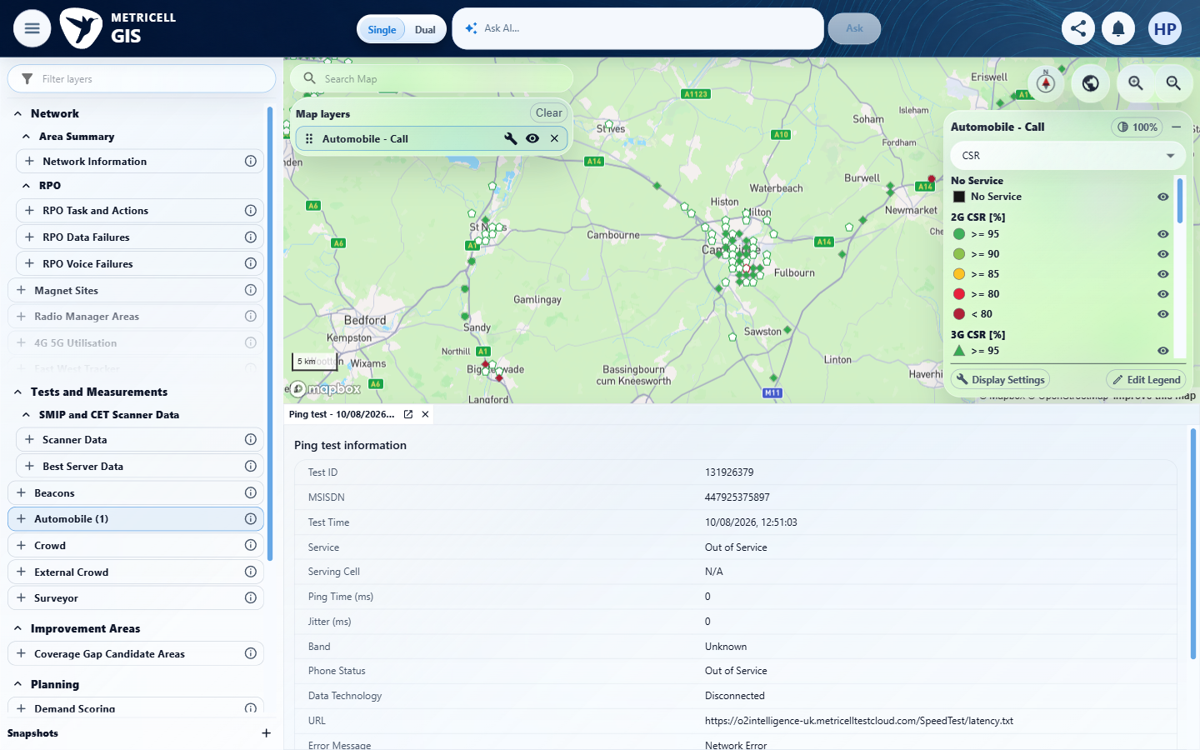 | E11 - Before downlink (criterion-7-before-downlink.png)

Criterion 7 continued: Each default MOS legend uses dark red #AE1A32 for 1–<2, yellow #FCBF1A for 2–<3, light green #86BE42 for 3–<4, and green #31AA4F for 4–5 inclusive; exact internal boundaries use the higher band.
Browser URL recorded after criterion: https://o2intelligence-v4-dev.metricell.com/gis
E36 - After downlink (criterion-7-after-downlink.png)  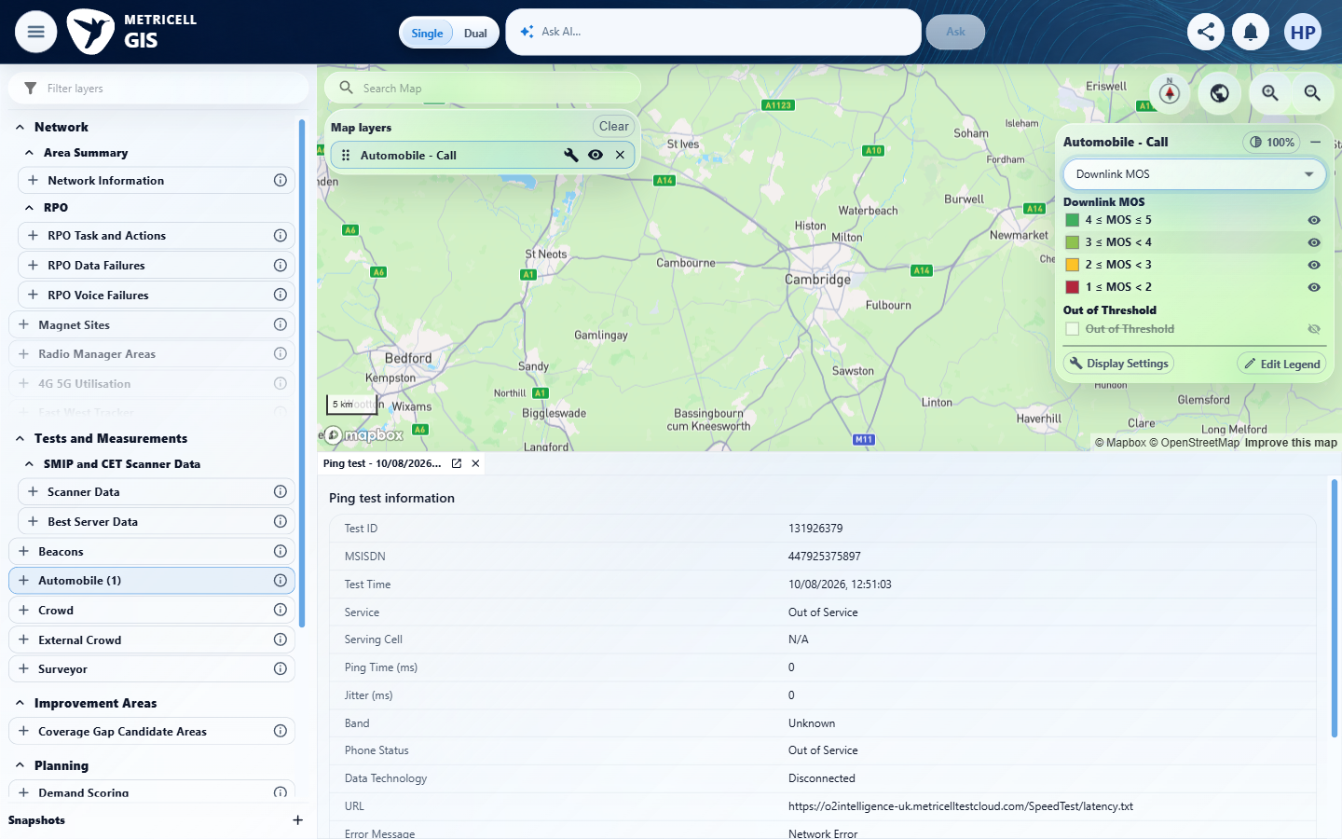 | E12 - Before downlink editor (criterion-7-before-downlink-editor.png)

Criterion 7 continued: Each default MOS legend uses dark red #AE1A32 for 1–<2, yellow #FCBF1A for 2–<3, light green #86BE42 for 3–<4, and green #31AA4F for 4–5 inclusive; exact internal boundaries use the higher band.
Browser URL recorded after criterion: https://o2intelligence-v4-dev.metricell.com/gis
E37 - Before cancel downlink (criterion-7-before-cancel-downlink.png)  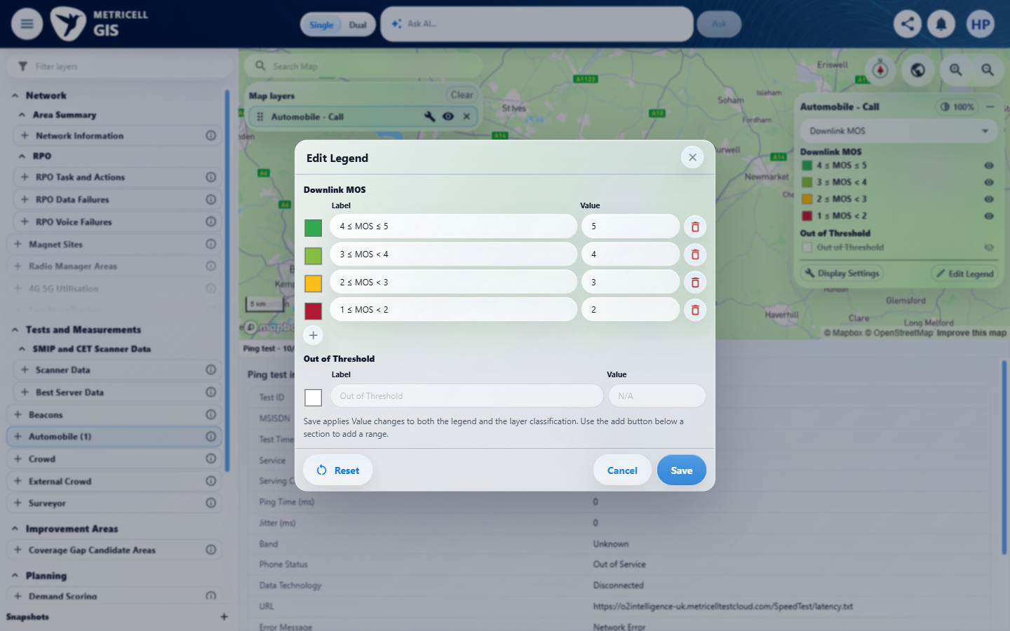 | E38 - After cancel downlink (criterion-7-after-cancel-downlink.png)  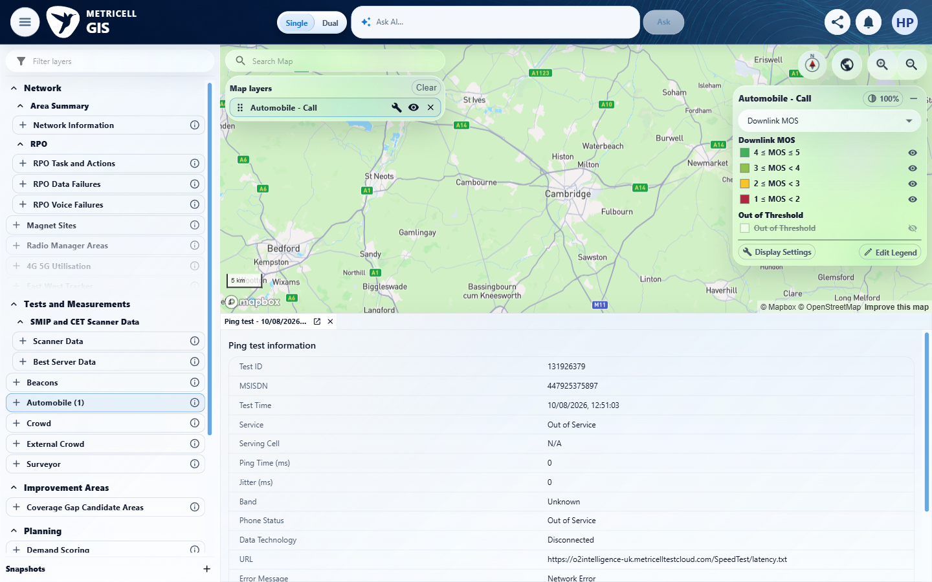

Criterion 7 continued: Each default MOS legend uses dark red #AE1A32 for 1–<2, yellow #FCBF1A for 2–<3, light green #86BE42 for 3–<4, and green #31AA4F for 4–5 inclusive; exact internal boundaries use the higher band.
Browser URL recorded after criterion: https://o2intelligence-v4-dev.metricell.com/gis
E39 - Before uplink (criterion-7-before-uplink.png)  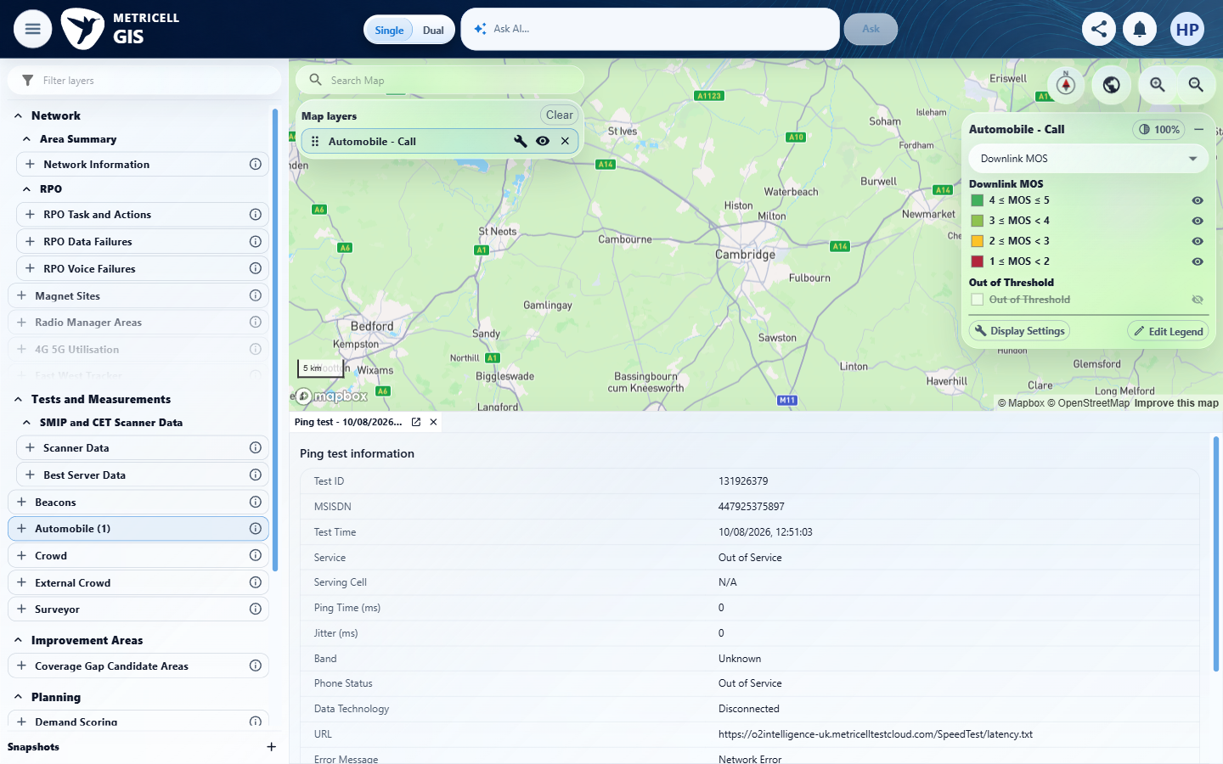 | E14 - Before uplink editor (criterion-7-before-uplink-editor.png)

Criterion 7 continued: Each default MOS legend uses dark red #AE1A32 for 1–<2, yellow #FCBF1A for 2–<3, light green #86BE42 for 3–<4, and green #31AA4F for 4–5 inclusive; exact internal boundaries use the higher band.
Browser URL recorded after criterion: https://o2intelligence-v4-dev.metricell.com/gis
E40 - Before cancel uplink (criterion-7-before-cancel-uplink.png)  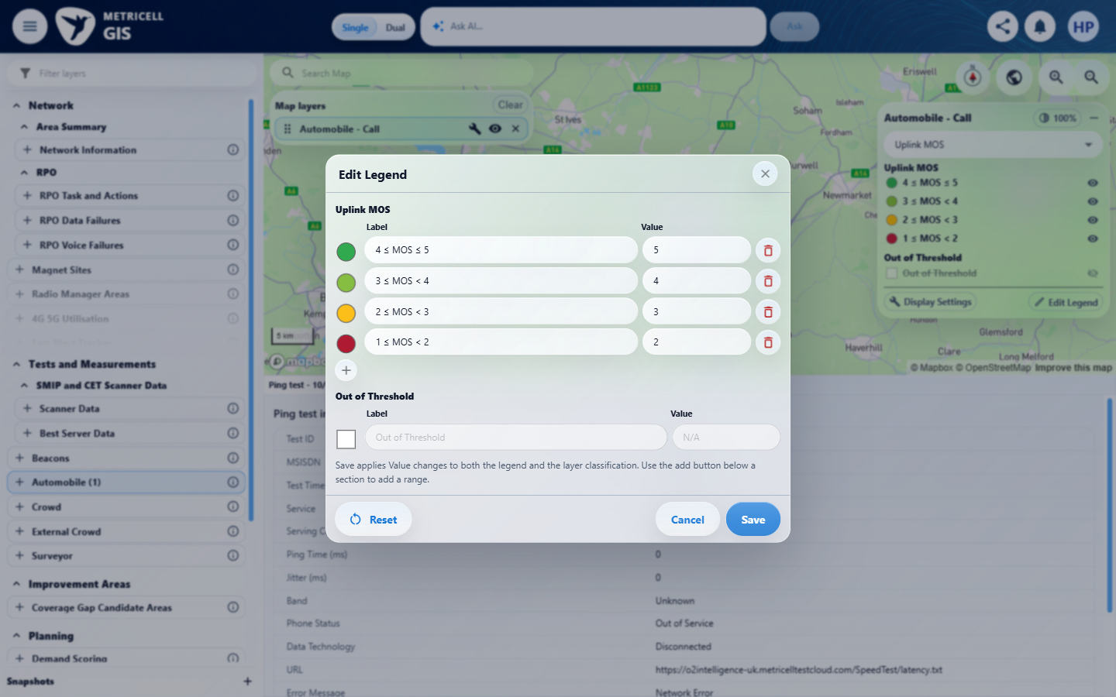 | E41 - Before estimated (criterion-7-before-estimated.png)  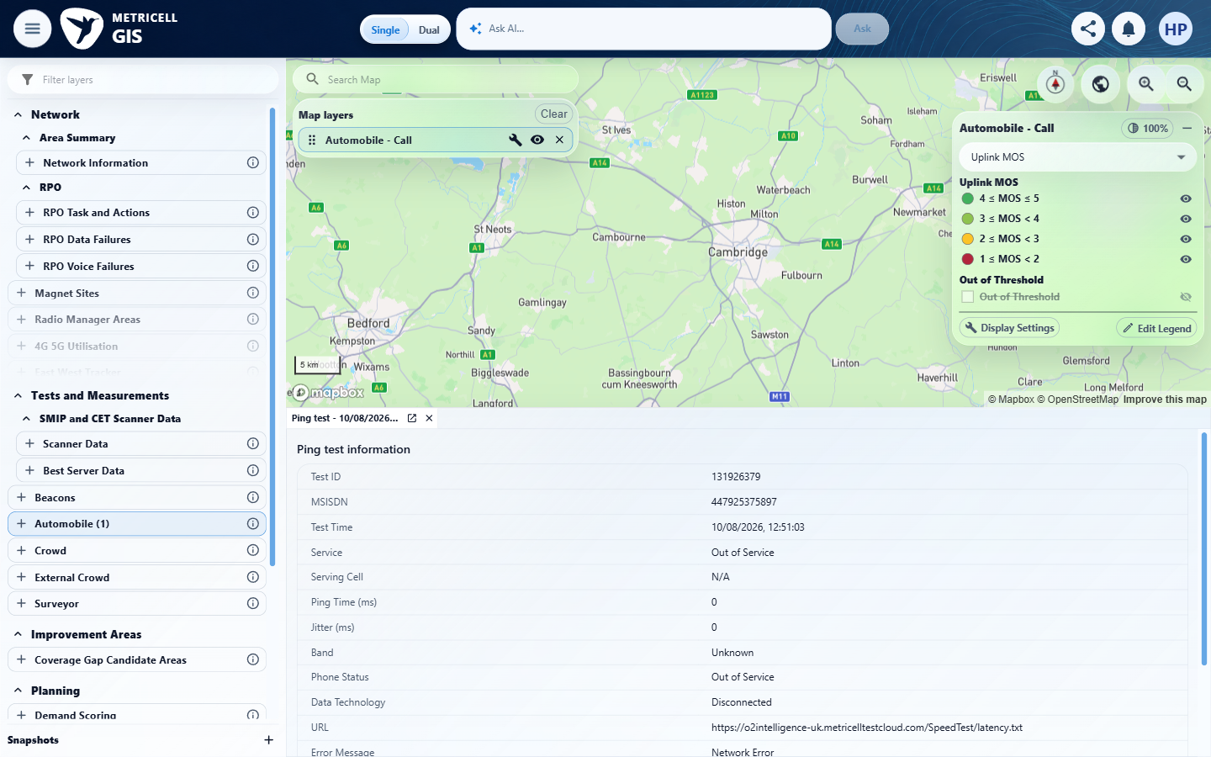

Criterion 7 continued: Each default MOS legend uses dark red #AE1A32 for 1–<2, yellow #FCBF1A for 2–<3, light green #86BE42 for 3–<4, and green #31AA4F for 4–5 inclusive; exact internal boundaries use the higher band.
Browser URL recorded after criterion: https://o2intelligence-v4-dev.metricell.com/gis
E42 - Before estimated editor (criterion-7-before-estimated-editor.png)  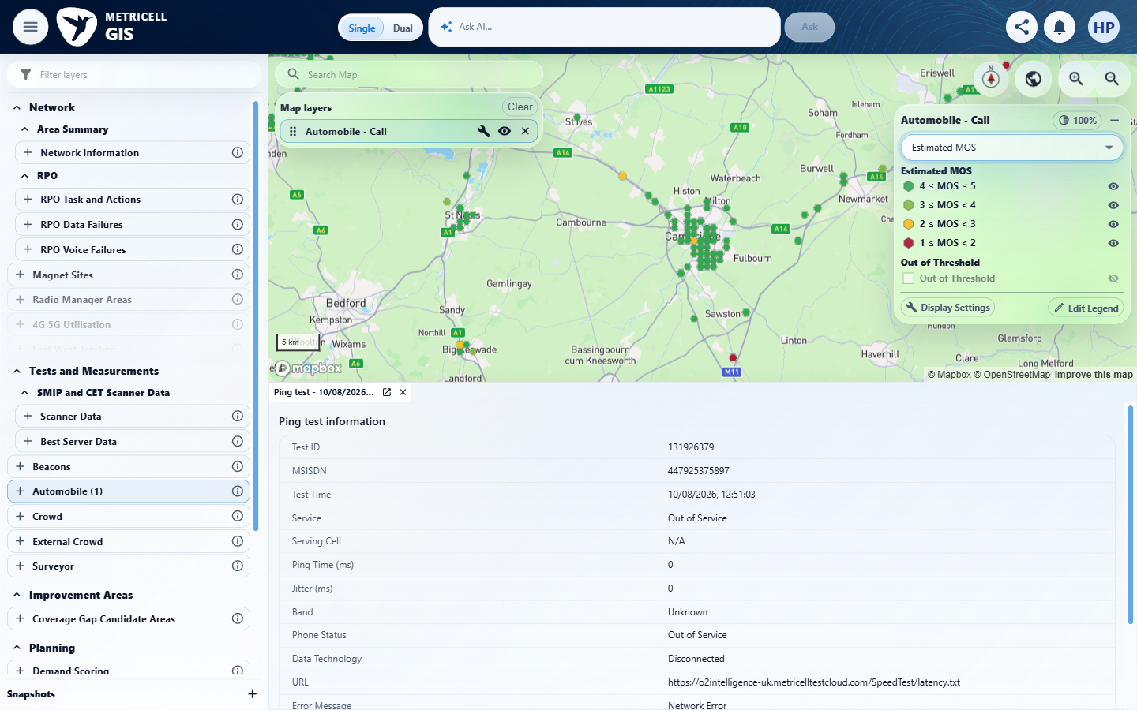 | E43 - Before cancel estimated (criterion-7-before-cancel-estimated.png)  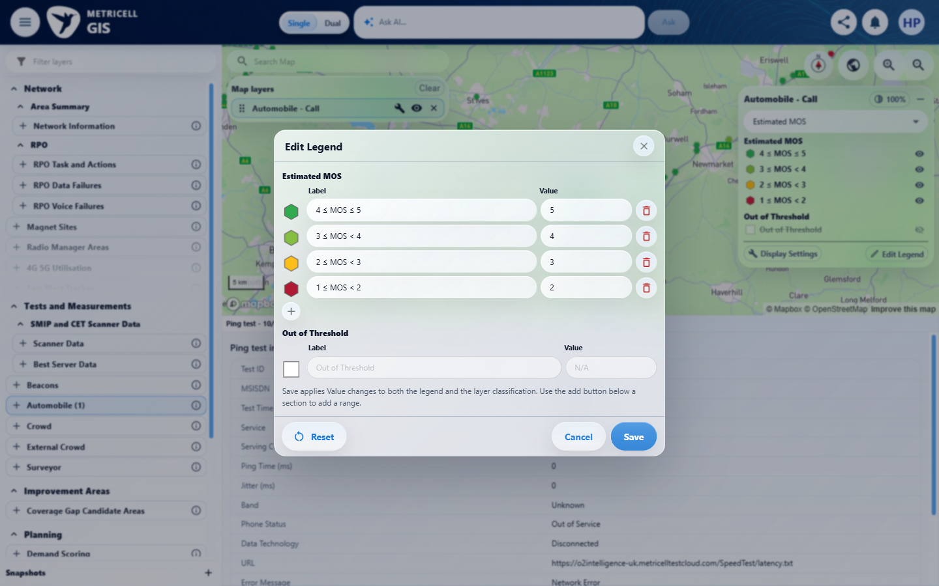

Criterion 7 continued: Each default MOS legend uses dark red #AE1A32 for 1–<2, yellow #FCBF1A for 2–<3, light green #86BE42 for 3–<4, and green #31AA4F for 4–5 inclusive; exact internal boundaries use the higher band.
Browser URL recorded after criterion: https://o2intelligence-v4-dev.metricell.com/gis
E44 - After cancel estimated (criterion-7-after-cancel-estimated.png)  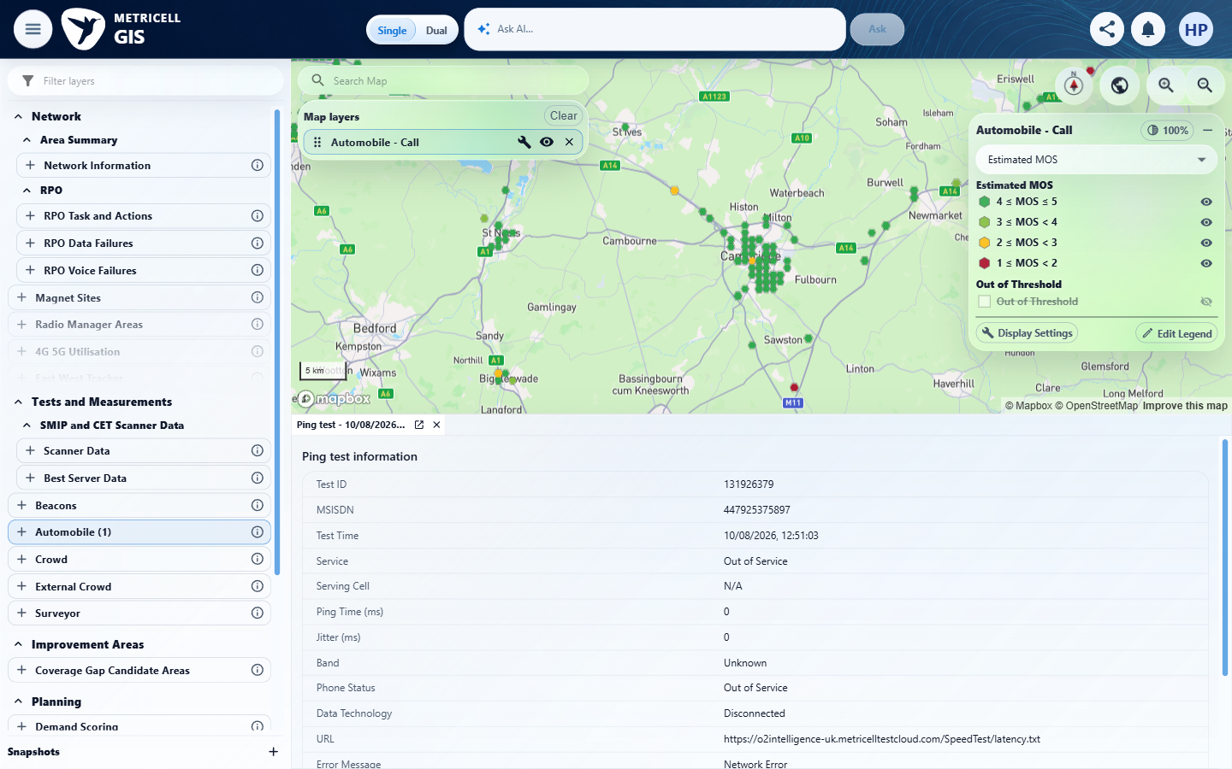 | E45 - Final (criterion-7-final.png)  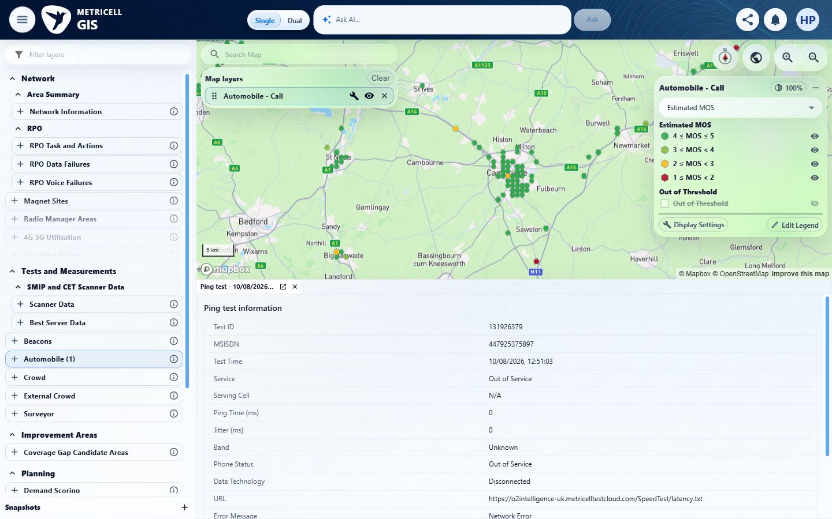

8.0.0 | When the selected MOS metric has no valid samples, it is unavailable rather than shown as zero or replaced by another metric; values outside its bands use the white, initially hidden Out of Threshold category, with no separate Not Tested category. | When the selected MOS metric has no valid samples, it is unavailable rather than shown as zero or replaced by another metric; values outside its bands use the white, initially hidden Out of Threshold category, with no separate Not Tested category. | criterion-8-missing-mos-details.png shows Downlink/Uplink N/A and Estimated MOS 4.4. The owned after-record-downlink.png, after-show-unavailable.png and after-restore-hidden.png sequence shows hidden/unhidden white markers without a Not Tested category; a known valid out-of-band MOS sample is absent, so that branch remains unverified.  Evidence: E01, E10, E02, E04, E35, E11, E12, E46, E16, E18, E47, E23, E48, E49, E50, E51 | Failed
Criterion 8 assessment: criterion-8-missing-mos-details.png shows Downlink/Uplink N/A and Estimated MOS 4.4. The owned after-record-downlink.png, after-show-unavailable.png and after-restore-hidden.png sequence shows hidden/unhidden white markers without a Not Tested category; a known valid out-of-band MOS sample is absent, so that branch remains unverified.
Testing notes: Selected Call record shows MOS Downlink and MOS Uplink N/A while Estimated MOS is 4.4. Downlink colouring hides the unavailable markers instead of displaying substituted values. Out of Threshold is white and initially hidden, and no Not Tested category appears. A known valid out-of-range MOS fixture was unavailable to verify that branch. Switched to Downlink; a click in its hidden-marker state opened no detail and the wait timed out.
Criterion 8 evidence: When the selected MOS metric has no valid samples, it is unavailable rather than shown as zero or replaced by another metric; values outside its bands use the white, initially hidden Out of Threshold category, with no separate Not Tested category.
Browser URL recorded after criterion: https://o2intelligence-v4-dev.metricell.com/gis
E01 - Gis (criterion-8-gis.png) | E10 - Before configuration (criterion-8-before-configuration.png)

Criterion 8 continued: When the selected MOS metric has no valid samples, it is unavailable rather than shown as zero or replaced by another metric; values outside its bands use the white, initially hidden Out of Threshold category, with no separate Not Tested category.
Browser URL recorded after criterion: https://o2intelligence-v4-dev.metricell.com/gis
E02 - Before call choice (criterion-8-before-call-choice.png) | E04 - Before apply call (criterion-8-before-apply-call.png)

Criterion 8 continued: When the selected MOS metric has no valid samples, it is unavailable rather than shown as zero or replaced by another metric; values outside its bands use the white, initially hidden Out of Threshold category, with no separate Not Tested category.
Browser URL recorded after criterion: https://o2intelligence-v4-dev.metricell.com/gis
E35 - After apply call (criterion-8-after-apply-call.png) | E11 - Before downlink (criterion-8-before-downlink.png)

Criterion 8 continued: When the selected MOS metric has no valid samples, it is unavailable rather than shown as zero or replaced by another metric; values outside its bands use the white, initially hidden Out of Threshold category, with no separate Not Tested category.
Browser URL recorded after criterion: https://o2intelligence-v4-dev.metricell.com/gis
E12 - Before open result (criterion-8-before-open-result.png) | E46 - Before csr for record (criterion-8-before-csr-for-record.png)  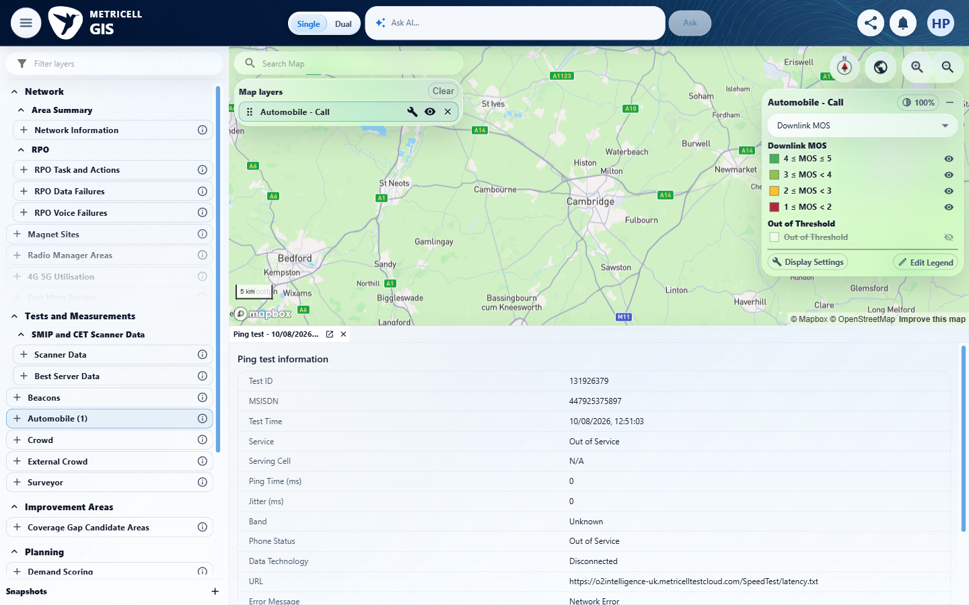

Criterion 8 continued: When the selected MOS metric has no valid samples, it is unavailable rather than shown as zero or replaced by another metric; values outside its bands use the white, initially hidden Out of Threshold category, with no separate Not Tested category.
Browser URL recorded after criterion: https://o2intelligence-v4-dev.metricell.com/gis
E16 - Before select record (criterion-8-before-select-record.png) | E18 - Before record downlink (criterion-8-before-record-downlink.png)

Criterion 8 continued: When the selected MOS metric has no valid samples, it is unavailable rather than shown as zero or replaced by another metric; values outside its bands use the white, initially hidden Out of Threshold category, with no separate Not Tested category.
Browser URL recorded after criterion: https://o2intelligence-v4-dev.metricell.com/gis
E47 - After record downlink (criterion-8-after-record-downlink.png)  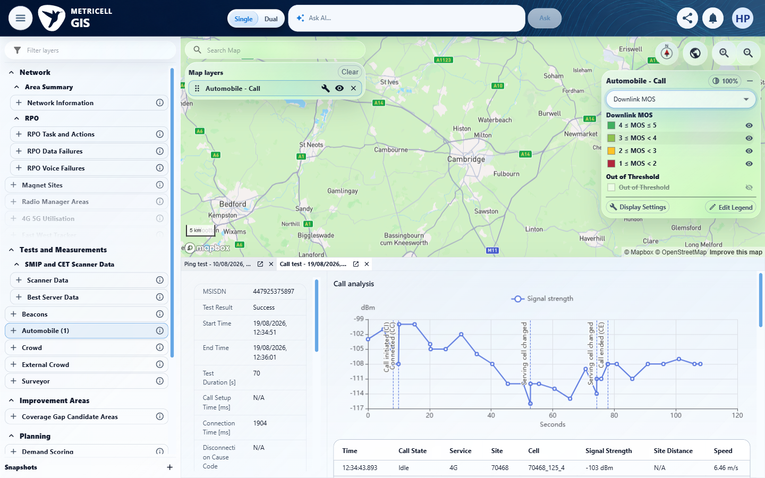 | E23 - Before show unavailable (criterion-8-before-show-unavailable.png)

Criterion 8 continued: When the selected MOS metric has no valid samples, it is unavailable rather than shown as zero or replaced by another metric; values outside its bands use the white, initially hidden Out of Threshold category, with no separate Not Tested category.
Browser URL recorded after criterion: https://o2intelligence-v4-dev.metricell.com/gis
E48 - After show unavailable (criterion-8-after-show-unavailable.png)  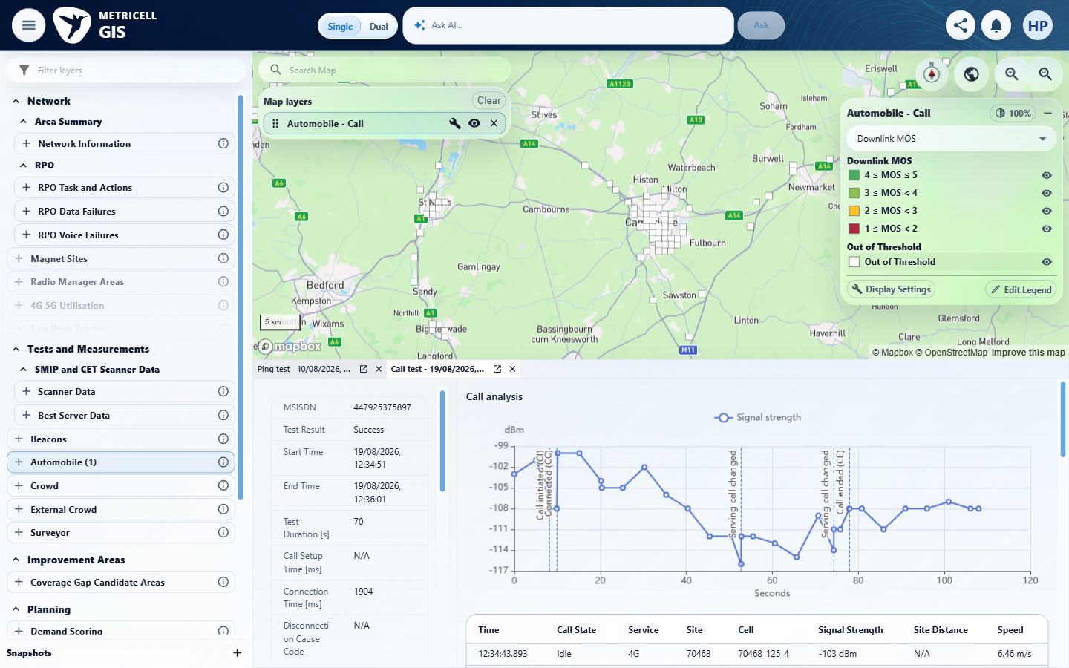 | E49 - Before restore hidden (criterion-8-before-restore-hidden.png)  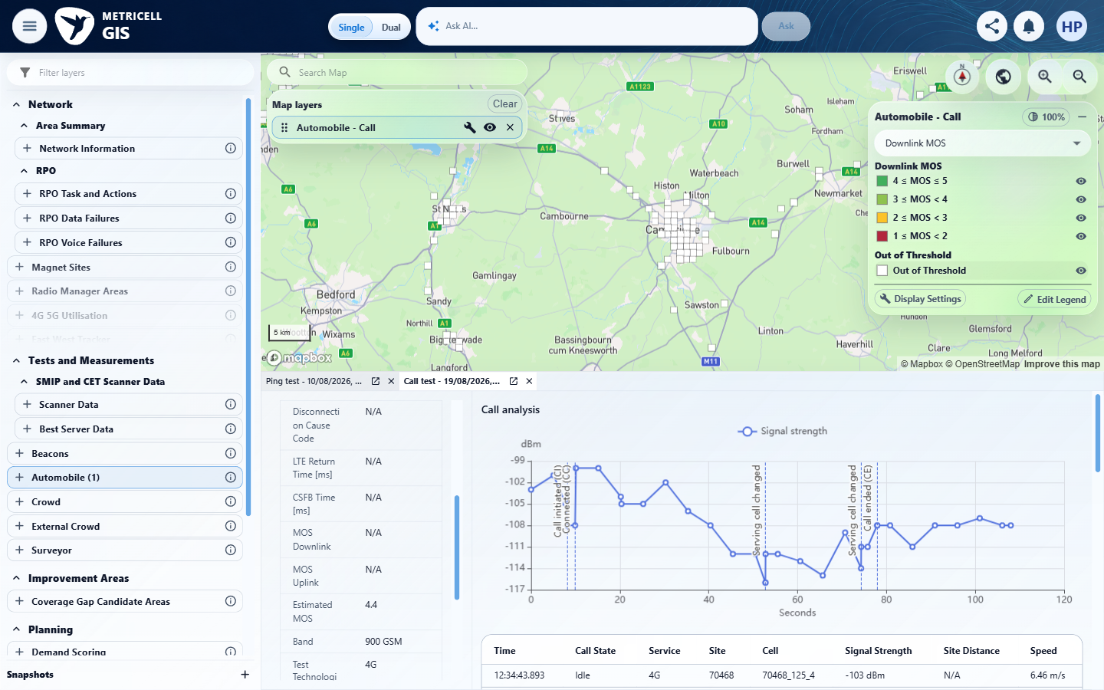

Criterion 8 continued: When the selected MOS metric has no valid samples, it is unavailable rather than shown as zero or replaced by another metric; values outside its bands use the white, initially hidden Out of Threshold category, with no separate Not Tested category.
Browser URL recorded after criterion: https://o2intelligence-v4-dev.metricell.com/gis
E50 - After restore hidden (criterion-8-after-restore-hidden.png)  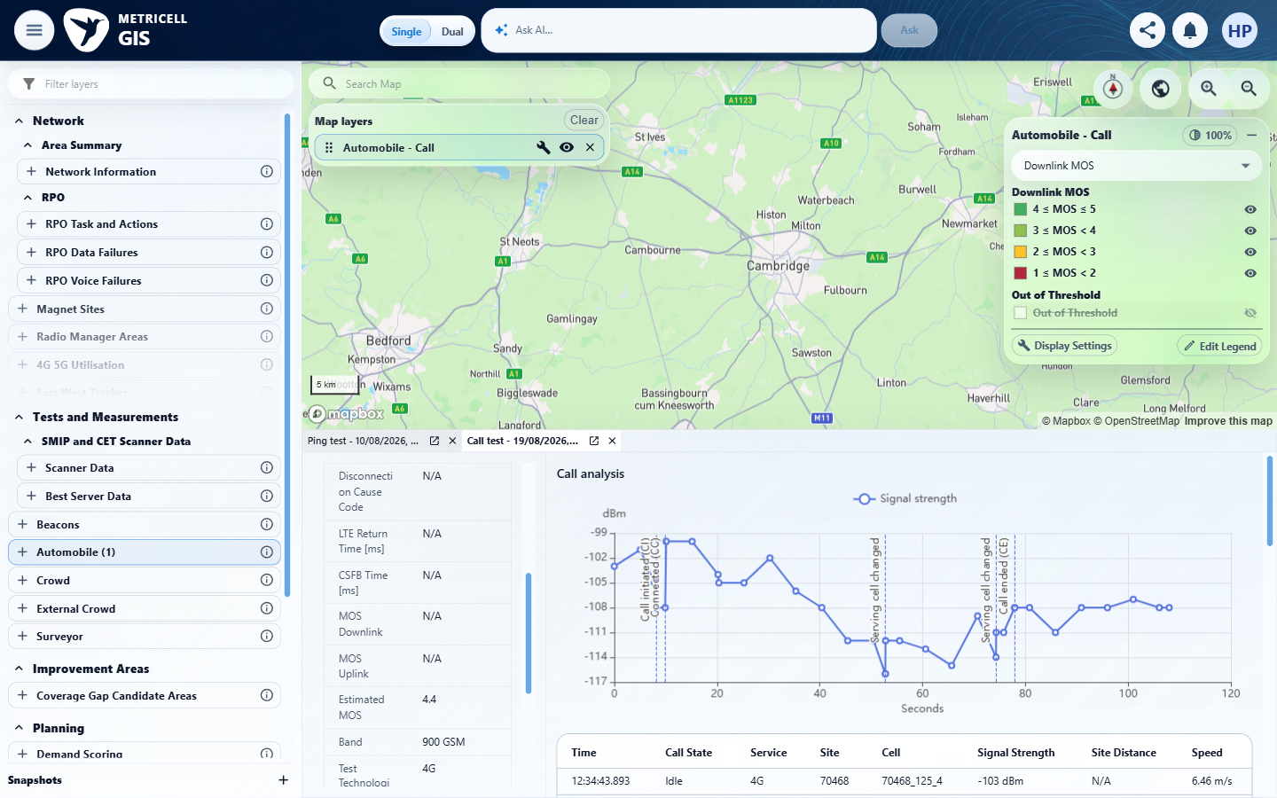 | E51 - Final (criterion-8-final.png)  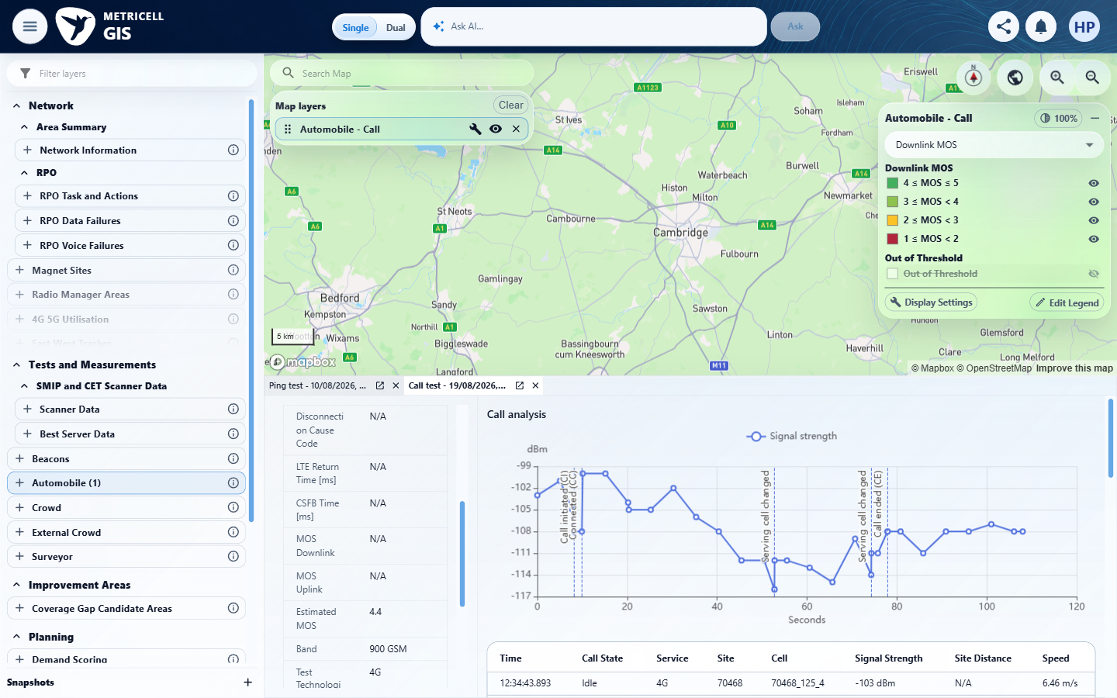

9.0.0 | The CSR legend shows 2G circles, 3G triangles, 4G diamonds, 5G SA pentagons, and a fixed black-square No Service category for generation 0; No Service is separate from CSR percentage bands. | The CSR legend shows 2G circles, 3G triangles, 4G diamonds, 5G SA pentagons, and a fixed black-square No Service category for generation 0; No Service is separate from CSR percentage bands. | criterion-9-after-shape-editor.png shows 2G circles, 3G triangles and a separate black-square No Service with greyed definition fields. criterion-9-5g-shapes.png and final.png show a 4G diamond and 5G SA pentagons. The additional NSA section is assessed under criterion 19.  Evidence: E01, E10, E17, E02, E52, E35, E11, E34, E53, E54, E55 | Passed
Criterion 9 assessment: criterion-9-after-shape-editor.png shows 2G circles, 3G triangles and a separate black-square No Service with greyed definition fields. criterion-9-5g-shapes.png and final.png show a 4G diamond and 5G SA pentagons. The additional NSA section is assessed under criterion 19.
Criterion 9 evidence: The CSR legend shows 2G circles, 3G triangles, 4G diamonds, 5G SA pentagons, and a fixed black-square No Service category for generation 0; No Service is separate from CSR percentage bands.
Browser URL recorded after criterion: https://o2intelligence-v4-dev.metricell.com/gis
E01 - Gis (criterion-9-gis.png) | E10 - Before configuration (criterion-9-before-configuration.png)

Criterion 9 continued: The CSR legend shows 2G circles, 3G triangles, 4G diamonds, 5G SA pentagons, and a fixed black-square No Service category for generation 0; No Service is separate from CSR percentage bands.
Browser URL recorded after criterion: https://o2intelligence-v4-dev.metricell.com/gis
E17 - After configuration (criterion-9-after-configuration.png) | E02 - Before call choice (criterion-9-before-call-choice.png)

Criterion 9 continued: The CSR legend shows 2G circles, 3G triangles, 4G diamonds, 5G SA pentagons, and a fixed black-square No Service category for generation 0; No Service is separate from CSR percentage bands.
Browser URL recorded after criterion: https://o2intelligence-v4-dev.metricell.com/gis
E52 - Before apply call (criterion-9-before-apply-call.png)  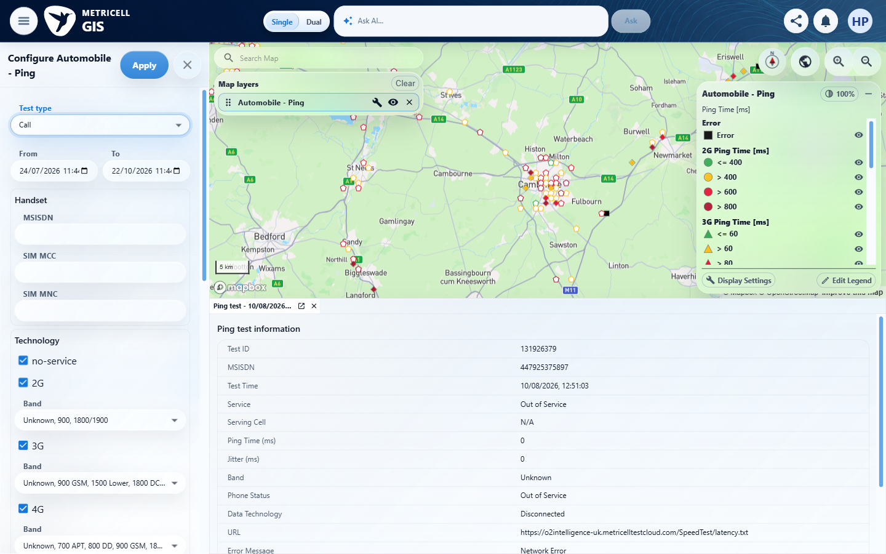 | E35 - After apply call (criterion-9-after-apply-call.png)

Criterion 9 continued: The CSR legend shows 2G circles, 3G triangles, 4G diamonds, 5G SA pentagons, and a fixed black-square No Service category for generation 0; No Service is separate from CSR percentage bands.
Browser URL recorded after criterion: https://o2intelligence-v4-dev.metricell.com/gis
E11 - Before shape editor (criterion-9-before-shape-editor.png) | E34 - After shape editor (criterion-9-after-shape-editor.png)

Criterion 9 continued: The CSR legend shows 2G circles, 3G triangles, 4G diamonds, 5G SA pentagons, and a fixed black-square No Service category for generation 0; No Service is separate from CSR percentage bands.
Browser URL recorded after criterion: https://o2intelligence-v4-dev.metricell.com/gis
E53 - 4g shapes (criterion-9-4g-shapes.png)  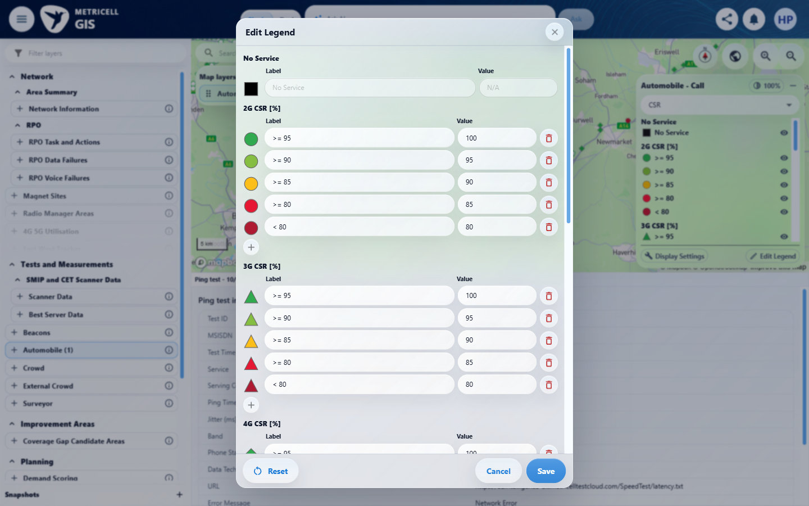 | E54 - 5g shapes (criterion-9-5g-shapes.png)  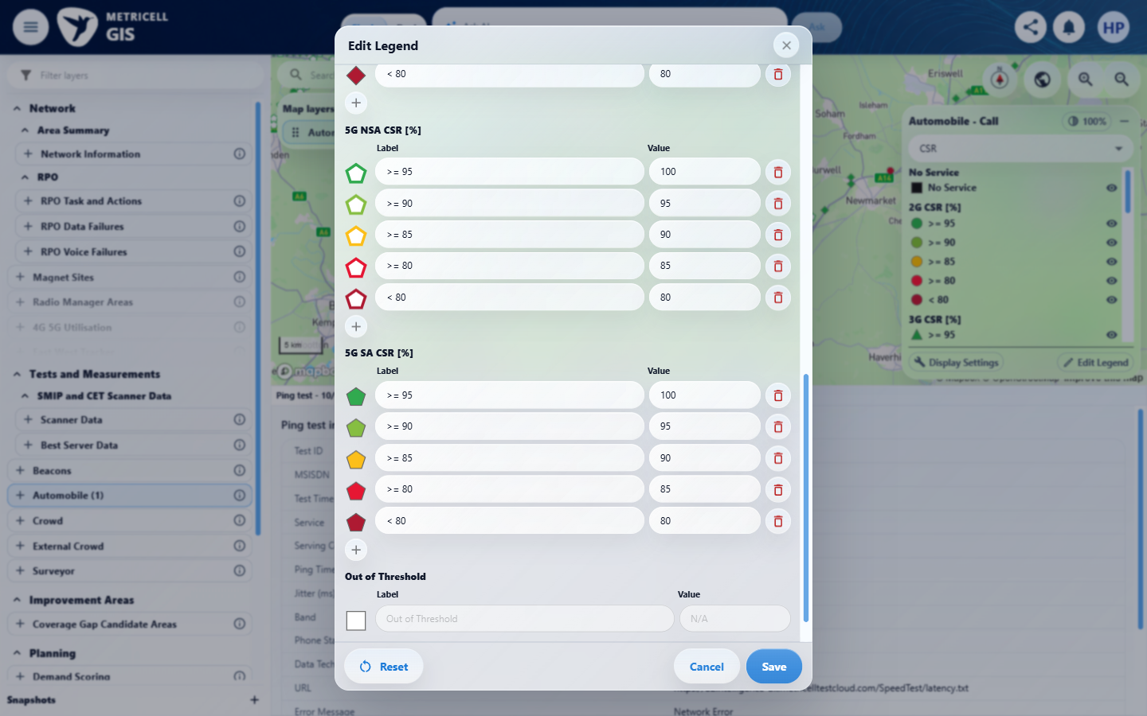

Criterion 9 continued: The CSR legend shows 2G circles, 3G triangles, 4G diamonds, 5G SA pentagons, and a fixed black-square No Service category for generation 0; No Service is separate from CSR percentage bands.
Browser URL recorded after criterion: https://o2intelligence-v4-dev.metricell.com/gis
E55 - Final (criterion-9-final.png)
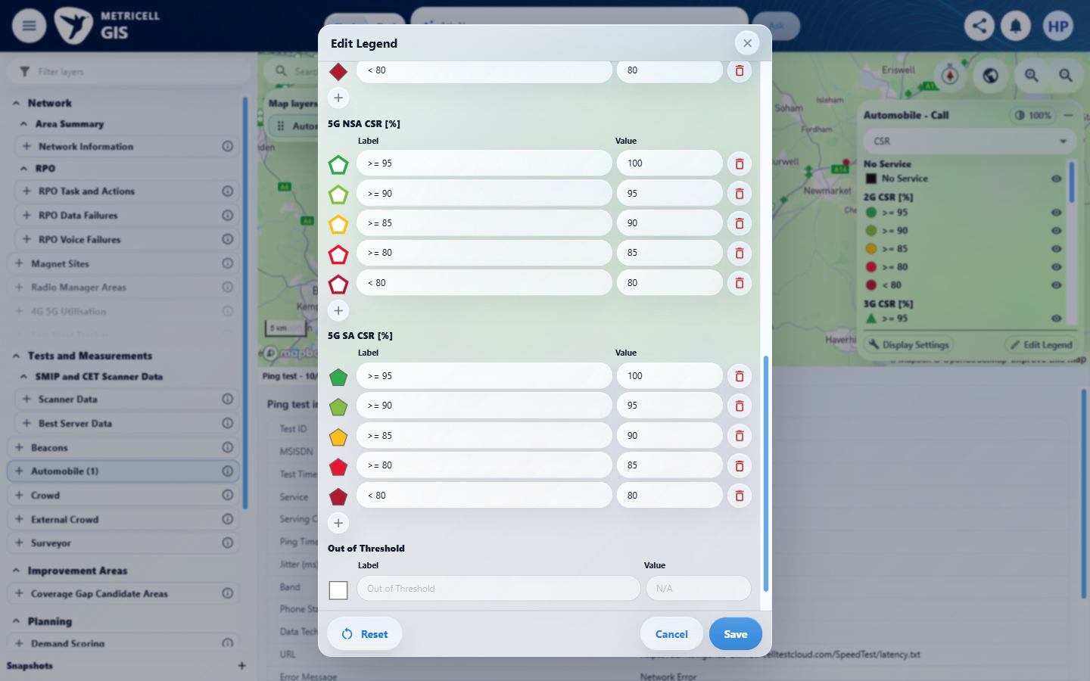

10.0.0 | The MOS legends use squares for Downlink MOS, circles for Uplink MOS, and hexagons for Estimated MOS, grouping by the selected metric. | The MOS legends use squares for Downlink MOS, circles for Uplink MOS, and hexagons for Estimated MOS, grouping by the selected metric. | criterion-10-after-downlink.png, after-uplink.png and after-estimated.png visibly show squares, circles and hexagons respectively, grouped by the chosen MOS metric.  Evidence: E01, E10, E02, E04, E35, E11, E12, E14, E56, E15, E42 | Passed
Criterion 10 assessment: criterion-10-after-downlink.png, after-uplink.png and after-estimated.png visibly show squares, circles and hexagons respectively, grouped by the chosen MOS metric.
Criterion 10 evidence: The MOS legends use squares for Downlink MOS, circles for Uplink MOS, and hexagons for Estimated MOS, grouping by the selected metric.
Browser URL recorded after criterion: https://o2intelligence-v4-dev.metricell.com/gis
E01 - Gis (criterion-10-gis.png) | E10 - Before configuration (criterion-10-before-configuration.png)

Criterion 10 continued: The MOS legends use squares for Downlink MOS, circles for Uplink MOS, and hexagons for Estimated MOS, grouping by the selected metric.
Browser URL recorded after criterion: https://o2intelligence-v4-dev.metricell.com/gis
E02 - Before call choice (criterion-10-before-call-choice.png) | E04 - Before apply call (criterion-10-before-apply-call.png)

Criterion 10 continued: The MOS legends use squares for Downlink MOS, circles for Uplink MOS, and hexagons for Estimated MOS, grouping by the selected metric.
Browser URL recorded after criterion: https://o2intelligence-v4-dev.metricell.com/gis
E35 - After apply call (criterion-10-after-apply-call.png) | E11 - Before downlink (criterion-10-before-downlink.png)

Criterion 10 continued: The MOS legends use squares for Downlink MOS, circles for Uplink MOS, and hexagons for Estimated MOS, grouping by the selected metric.
Browser URL recorded after criterion: https://o2intelligence-v4-dev.metricell.com/gis
E12 - Before uplink (criterion-10-before-uplink.png) | E14 - After uplink (criterion-10-after-uplink.png)
E12 detail enlargement - full screenshot above | E14 detail enlargement - full screenshot above

Criterion 10 continued: The MOS legends use squares for Downlink MOS, circles for Uplink MOS, and hexagons for Estimated MOS, grouping by the selected metric.
Browser URL recorded after criterion: https://o2intelligence-v4-dev.metricell.com/gis
E56 - Before estimated (criterion-10-before-estimated.png)  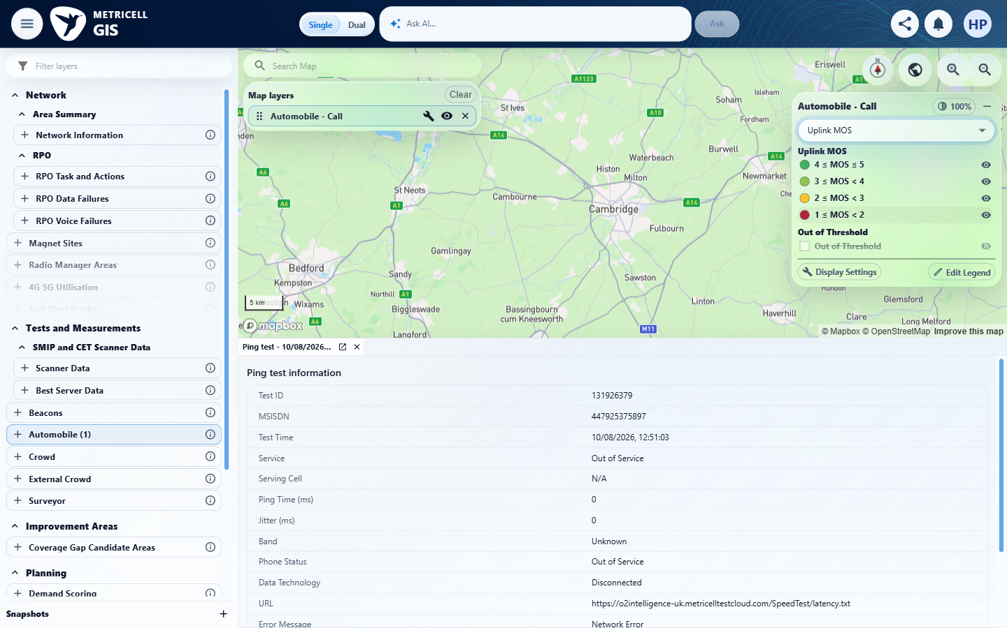 | E15 - After estimated (criterion-10-after-estimated.png)

Criterion 10 continued: The MOS legends use squares for Downlink MOS, circles for Uplink MOS, and hexagons for Estimated MOS, grouping by the selected metric.
Browser URL recorded after criterion: https://o2intelligence-v4-dev.metricell.com/gis
E42 - Final (criterion-10-final.png)

11.0.0 | Each Call legend includes a fixed white-square Out of Threshold category hidden by default; bands are ordered descending, with CSR limits 0–100 and MOS limits 1–5, and displayed labels match the boundary behaviour. | Each Call legend includes a fixed white-square Out of Threshold category hidden by default; bands are ordered descending, with CSR limits 0–100 and MOS limits 1–5, and displayed labels match the boundary behaviour. | criterion-11-csr-fixed-category.png and after-downlink-fixed.png, after-uplink-fixed.png and after-estimated-fixed.png show white-square Out of Threshold and greyed definition fields, with descending labelled bands. Default hidden state is visible in the owned legend captures, but exact runtime agreement with labels and numeric limits are not fully proven by screenshots.  Evidence: E57, E58, E02, E07, E11, E53, E59, E60, E12, E37, E38, E39, E14, E40, E41, E61, E42, E43, E44, E45 | Failed
Criterion 11 assessment: criterion-11-csr-fixed-category.png and after-downlink-fixed.png, after-uplink-fixed.png and after-estimated-fixed.png show white-square Out of Threshold and greyed definition fields, with descending labelled bands. Default hidden state is visible in the owned legend captures, but exact runtime agreement with labels and numeric limits are not fully proven by screenshots.
Testing notes: Each legend has a white-square Out of Threshold category initially hidden, with disabled category label/value controls. CSR limits are 0–100 and MOS 1–5, with descending bands and expected labels. Exact runtime boundary agreement remains unverified because the required boundary fixtures are unavailable.
Criterion 11 evidence: Each Call legend includes a fixed white-square Out of Threshold category hidden by default; bands are ordered descending, with CSR limits 0–100 and MOS limits 1–5, and displayed labels match the boundary behaviour.
Browser URL recorded after criterion: https://o2intelligence-v4-dev.metricell.com/gis
E57 - Gis (criterion-11-gis.png)  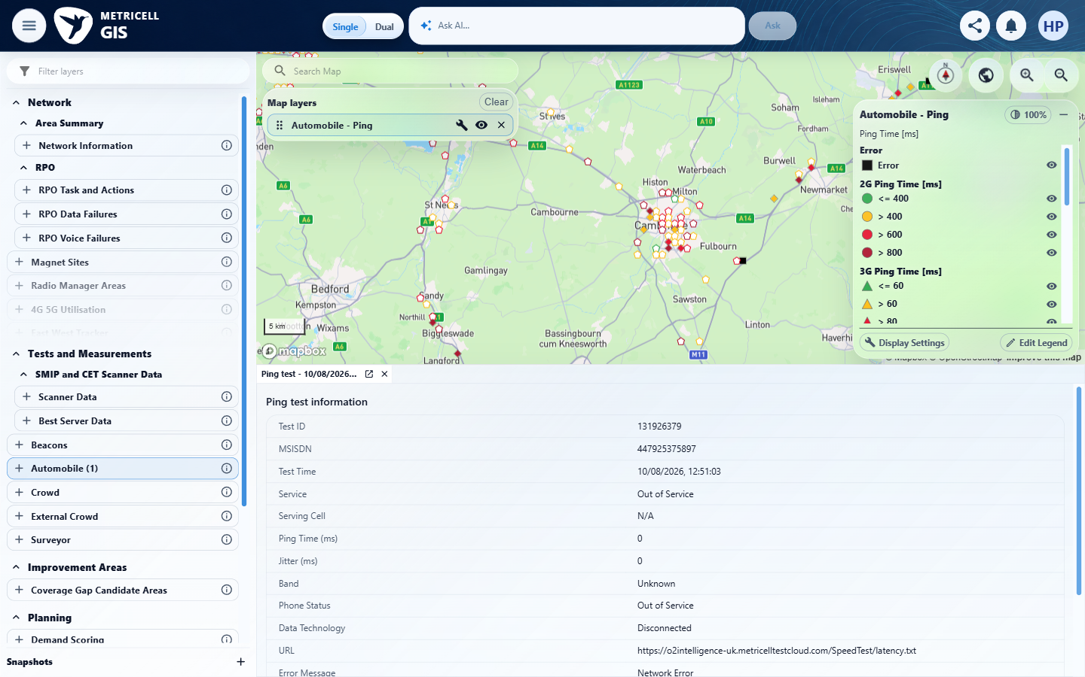 | E58 - Before configuration (criterion-11-before-configuration.png)  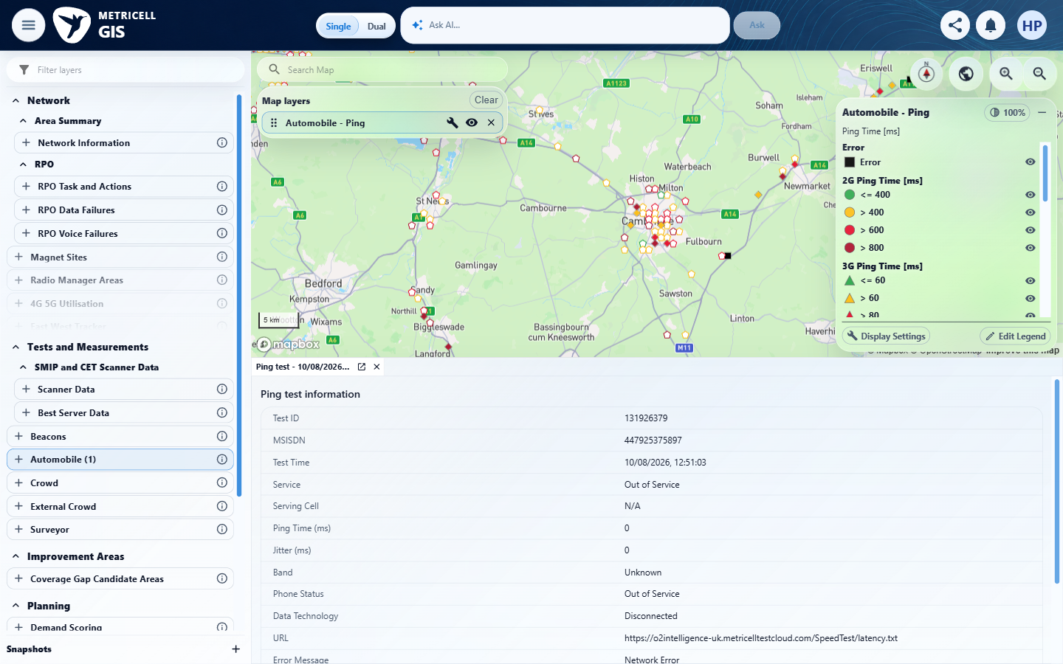

Criterion 11 continued: Each Call legend includes a fixed white-square Out of Threshold category hidden by default; bands are ordered descending, with CSR limits 0–100 and MOS limits 1–5, and displayed labels match the boundary behaviour.
Browser URL recorded after criterion: https://o2intelligence-v4-dev.metricell.com/gis
E02 - Before call choice (criterion-11-before-call-choice.png) | E07 - Before apply call (criterion-11-before-apply-call.png)

Criterion 11 continued: Each Call legend includes a fixed white-square Out of Threshold category hidden by default; bands are ordered descending, with CSR limits 0–100 and MOS limits 1–5, and displayed labels match the boundary behaviour.
Browser URL recorded after criterion: https://o2intelligence-v4-dev.metricell.com/gis
E11 - Before csr editor (criterion-11-before-csr-editor.png) | E53 - After csr editor (criterion-11-after-csr-editor.png)

Criterion 11 continued: Each Call legend includes a fixed white-square Out of Threshold category hidden by default; bands are ordered descending, with CSR limits 0–100 and MOS limits 1–5, and displayed labels match the boundary behaviour.
Browser URL recorded after criterion: https://o2intelligence-v4-dev.metricell.com/gis
E59 - Before cancel csr (criterion-11-before-cancel-csr.png)  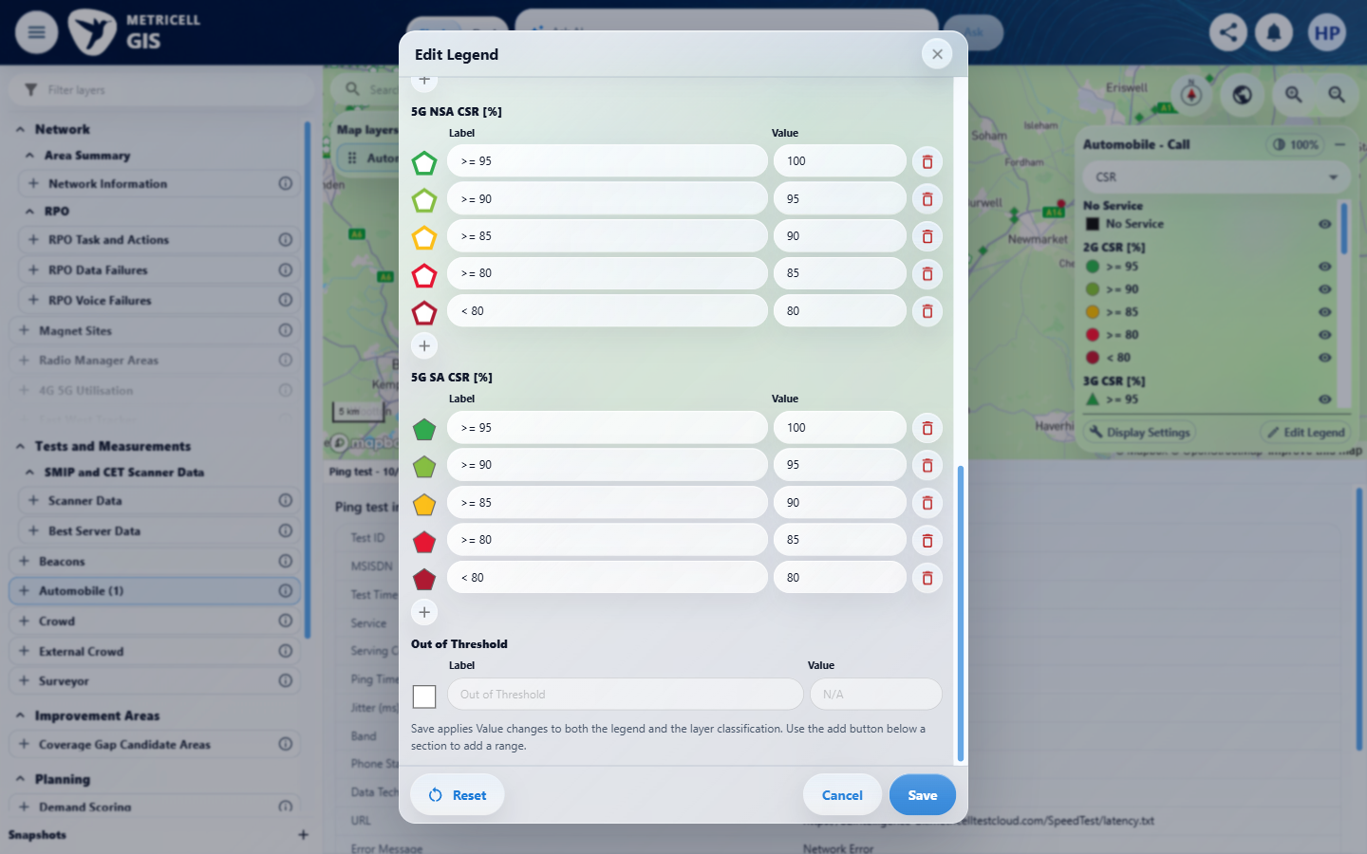 | E60 - Before downlink (criterion-11-before-downlink.png)  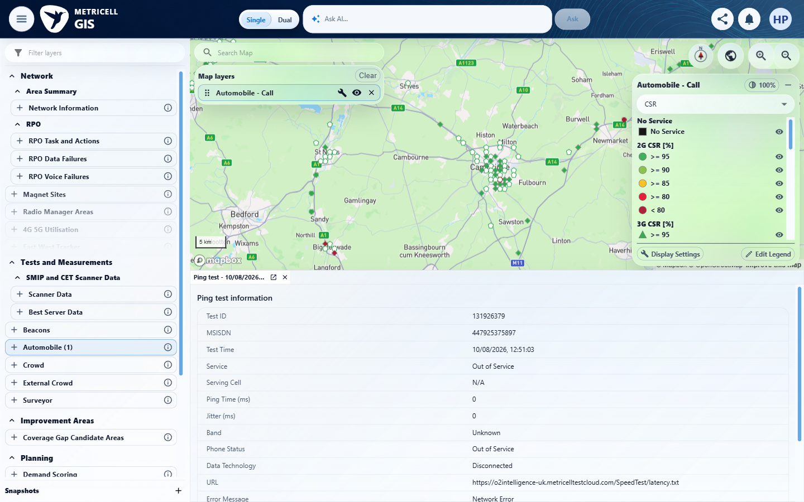

Criterion 11 continued: Each Call legend includes a fixed white-square Out of Threshold category hidden by default; bands are ordered descending, with CSR limits 0–100 and MOS limits 1–5, and displayed labels match the boundary behaviour.
Browser URL recorded after criterion: https://o2intelligence-v4-dev.metricell.com/gis
E12 - Before downlink fixed (criterion-11-before-downlink-fixed.png) | E37 - Before cancel downlink (criterion-11-before-cancel-downlink.png)

Criterion 11 continued: Each Call legend includes a fixed white-square Out of Threshold category hidden by default; bands are ordered descending, with CSR limits 0–100 and MOS limits 1–5, and displayed labels match the boundary behaviour.
Browser URL recorded after criterion: https://o2intelligence-v4-dev.metricell.com/gis
E38 - After cancel downlink (criterion-11-after-cancel-downlink.png) | E39 - Before uplink (criterion-11-before-uplink.png)

Criterion 11 continued: Each Call legend includes a fixed white-square Out of Threshold category hidden by default; bands are ordered descending, with CSR limits 0–100 and MOS limits 1–5, and displayed labels match the boundary behaviour.
Browser URL recorded after criterion: https://o2intelligence-v4-dev.metricell.com/gis
E14 - Before uplink fixed (criterion-11-before-uplink-fixed.png) | E40 - Before cancel uplink (criterion-11-before-cancel-uplink.png)

Criterion 11 continued: Each Call legend includes a fixed white-square Out of Threshold category hidden by default; bands are ordered descending, with CSR limits 0–100 and MOS limits 1–5, and displayed labels match the boundary behaviour.
Browser URL recorded after criterion: https://o2intelligence-v4-dev.metricell.com/gis
E41 - After cancel uplink (criterion-11-after-cancel-uplink.png) | E61 - Before estimated (criterion-11-before-estimated.png)  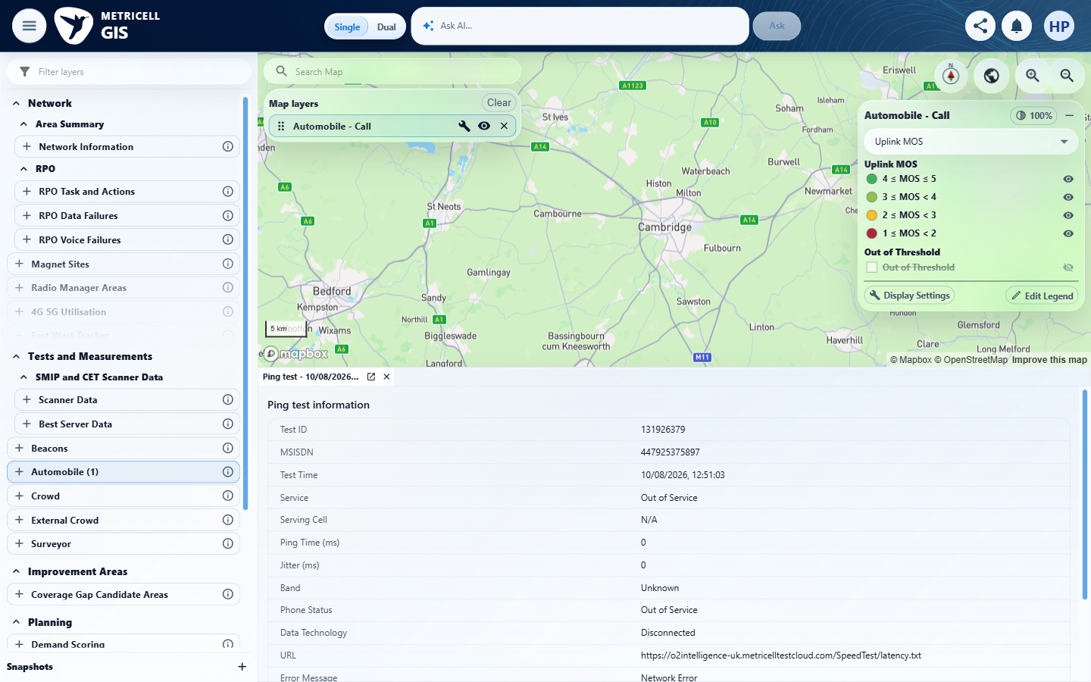

Criterion 11 continued: Each Call legend includes a fixed white-square Out of Threshold category hidden by default; bands are ordered descending, with CSR limits 0–100 and MOS limits 1–5, and displayed labels match the boundary behaviour.
Browser URL recorded after criterion: https://o2intelligence-v4-dev.metricell.com/gis
E42 - Before estimated fixed (criterion-11-before-estimated-fixed.png) | E43 - Before cancel estimated (criterion-11-before-cancel-estimated.png)

Criterion 11 continued: Each Call legend includes a fixed white-square Out of Threshold category hidden by default; bands are ordered descending, with CSR limits 0–100 and MOS limits 1–5, and displayed labels match the boundary behaviour.
Browser URL recorded after criterion: https://o2intelligence-v4-dev.metricell.com/gis
E44 - After cancel estimated (criterion-11-after-cancel-estimated.png) | E45 - Final (criterion-11-final.png)

12.0.0 | Editing a metric's customisable bands, labels, marker size, or category visibility updates its Call markers and remains specific to that metric and layer instance when Colour By changes; No Service and Out of Threshold definitions cannot be edited. | Editing a metric's customisable bands, labels, marker size, or category visibility updates its Call markers and remains specific to that metric and layer instance when Colour By changes; No Service and Out of Threshold definitions cannot be edited. | criterion-12-after-change-band-label.png -> save-not-applied.png -> after-close-saved-editor.png shows that Save did apply the label/band despite keeping the editor open. after-hide-category.png -> after-uplink.png -> after-return-estimated.png shows metric-specific persistence and hidden markers. after-display-settings.png shows only linked-site/cell options; a marker-size control was unavailable in inspected controls, and cross-instance isolation remains unverified.  Evidence: E62, E01, E29, E30, E07, E05, E63, E42, E43, E64, E65, E66, E67, E14, E68, E69, E70 | Blocked
Criterion 12 assessment: criterion-12-after-change-band-label.png -> save-not-applied.png -> after-close-saved-editor.png shows that Save did apply the label/band despite keeping the editor open. after-hide-category.png -> after-uplink.png -> after-return-estimated.png shows metric-specific persistence and hidden markers. after-display-settings.png shows only linked-site/cell options; a marker-size control was unavailable in inspected controls, and cross-instance isolation remains unverified.
Criterion 12 evidence: Editing a metric's customisable bands, labels, marker size, or category visibility updates its Call markers and remains specific to that metric and layer instance when Colour By changes; No Service and Out of Threshold definitions cannot be edited.
Browser URL recorded after criterion: https://o2intelligence-v4-dev.metricell.com/gis
E62 - Gis (criterion-12-gis.png)  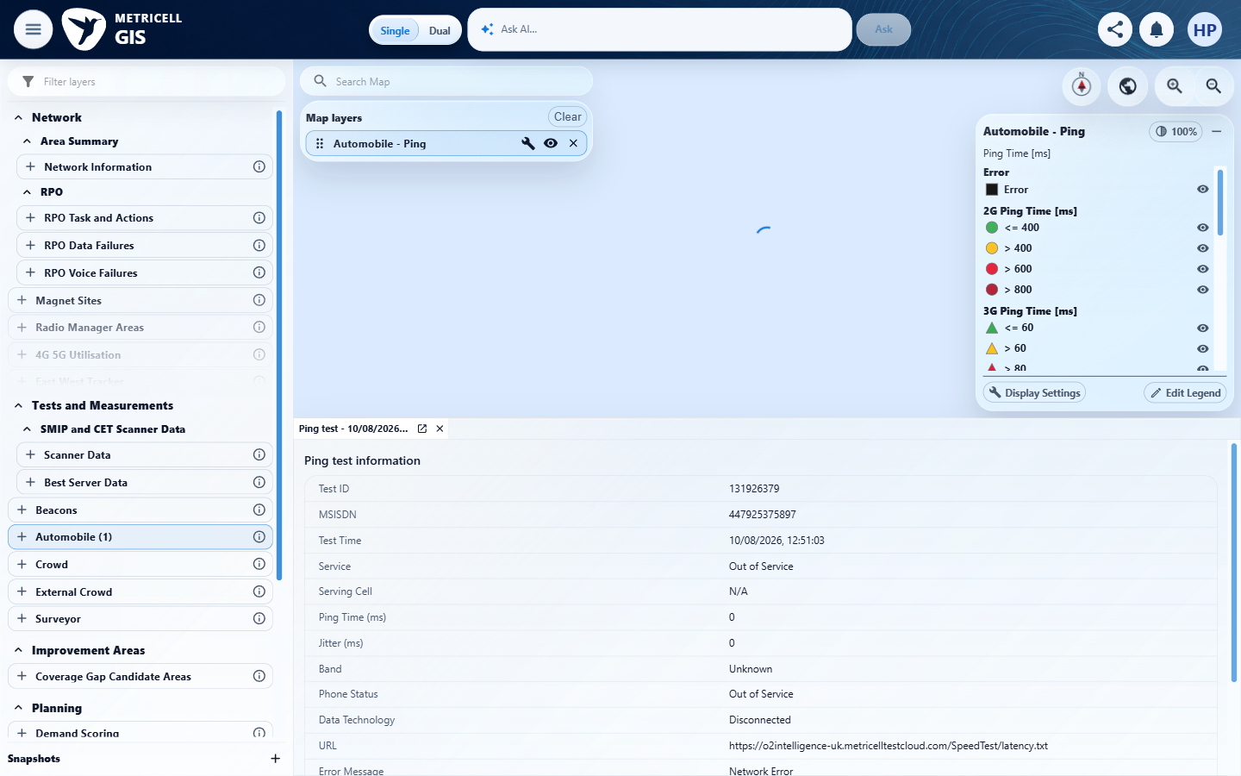 | E01 - Before configuration (criterion-12-before-configuration.png)

Criterion 12 continued: Editing a metric's customisable bands, labels, marker size, or category visibility updates its Call markers and remains specific to that metric and layer instance when Colour By changes; No Service and Out of Threshold definitions cannot be edited.
Browser URL recorded after criterion: https://o2intelligence-v4-dev.metricell.com/gis
E29 - After configuration (criterion-12-after-configuration.png) | E30 - Before call choice (criterion-12-before-call-choice.png)

Criterion 12 continued: Editing a metric's customisable bands, labels, marker size, or category visibility updates its Call markers and remains specific to that metric and layer instance when Colour By changes; No Service and Out of Threshold definitions cannot be edited.
Browser URL recorded after criterion: https://o2intelligence-v4-dev.metricell.com/gis
E07 - Before apply call (criterion-12-before-apply-call.png) | E05 - After apply call (criterion-12-after-apply-call.png)

Criterion 12 continued: Editing a metric's customisable bands, labels, marker size, or category visibility updates its Call markers and remains specific to that metric and layer instance when Colour By changes; No Service and Out of Threshold definitions cannot be edited.
Browser URL recorded after criterion: https://o2intelligence-v4-dev.metricell.com/gis
E63 - Before estimated (criterion-12-before-estimated.png)  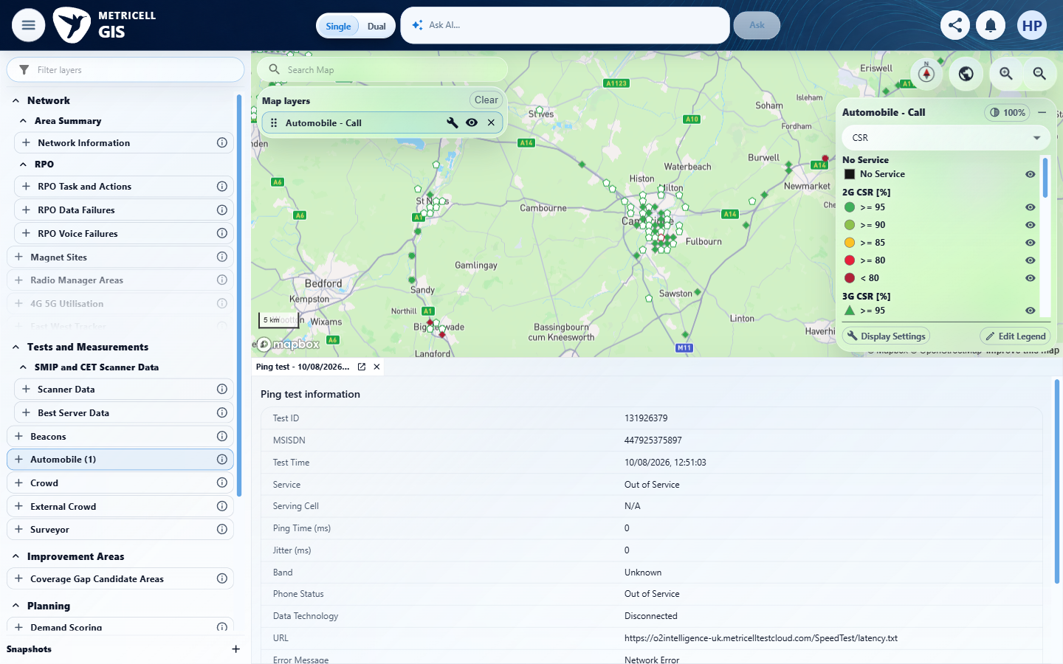 | E42 - Before edit estimated (criterion-12-before-edit-estimated.png)

Criterion 12 continued: Editing a metric's customisable bands, labels, marker size, or category visibility updates its Call markers and remains specific to that metric and layer instance when Colour By changes; No Service and Out of Threshold definitions cannot be edited.
Browser URL recorded after criterion: https://o2intelligence-v4-dev.metricell.com/gis
E43 - Before change band label (criterion-12-before-change-band-label.png) | E64 - Before save edits (criterion-12-before-save-edits.png)  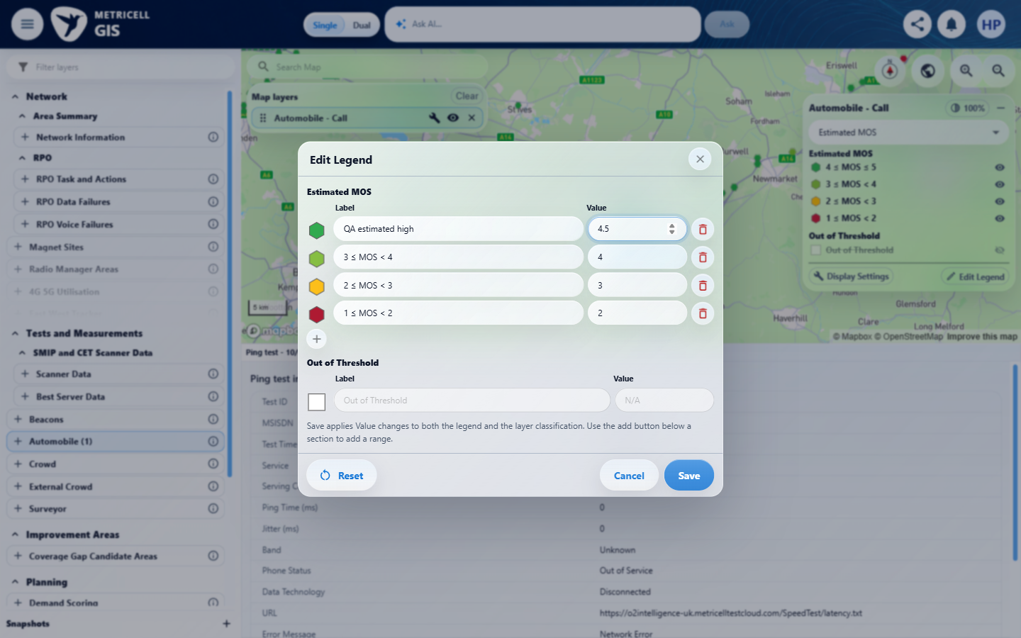

Criterion 12 continued: Editing a metric's customisable bands, labels, marker size, or category visibility updates its Call markers and remains specific to that metric and layer instance when Colour By changes; No Service and Out of Threshold definitions cannot be edited.
Browser URL recorded after criterion: https://o2intelligence-v4-dev.metricell.com/gis
E65 - Before close saved editor (criterion-12-before-close-saved-editor.png)  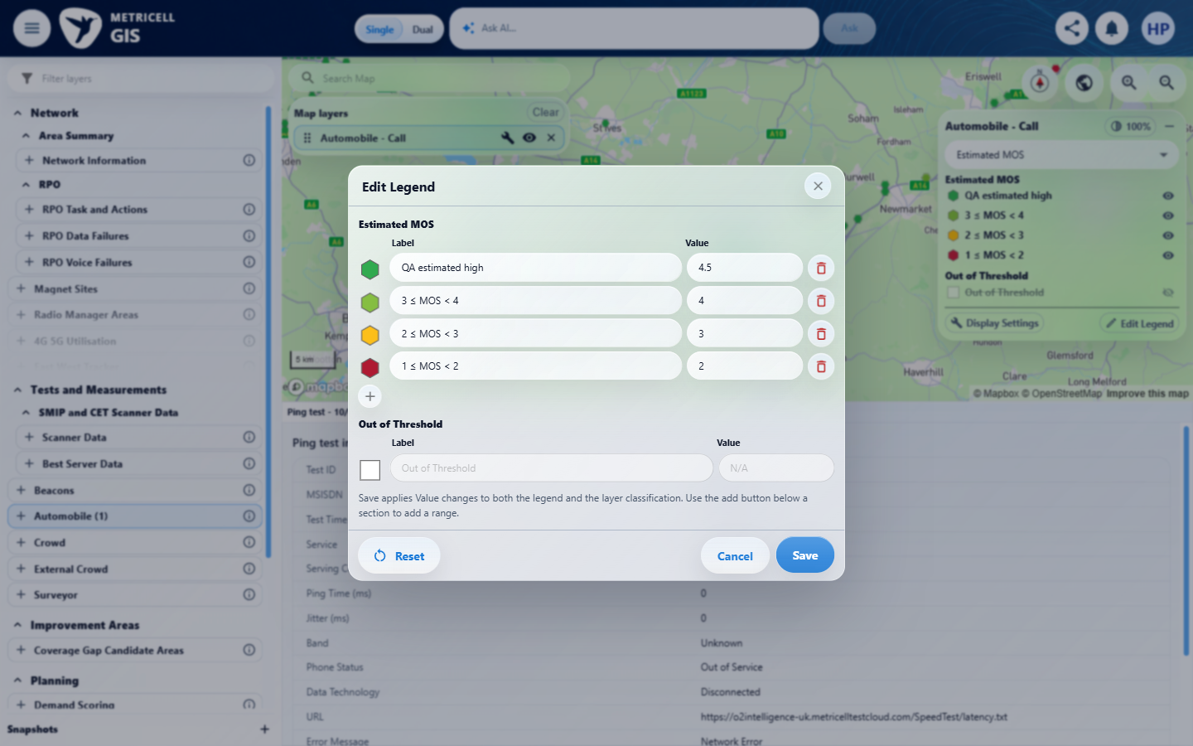 | E66 - Before hide category (criterion-12-before-hide-category.png)  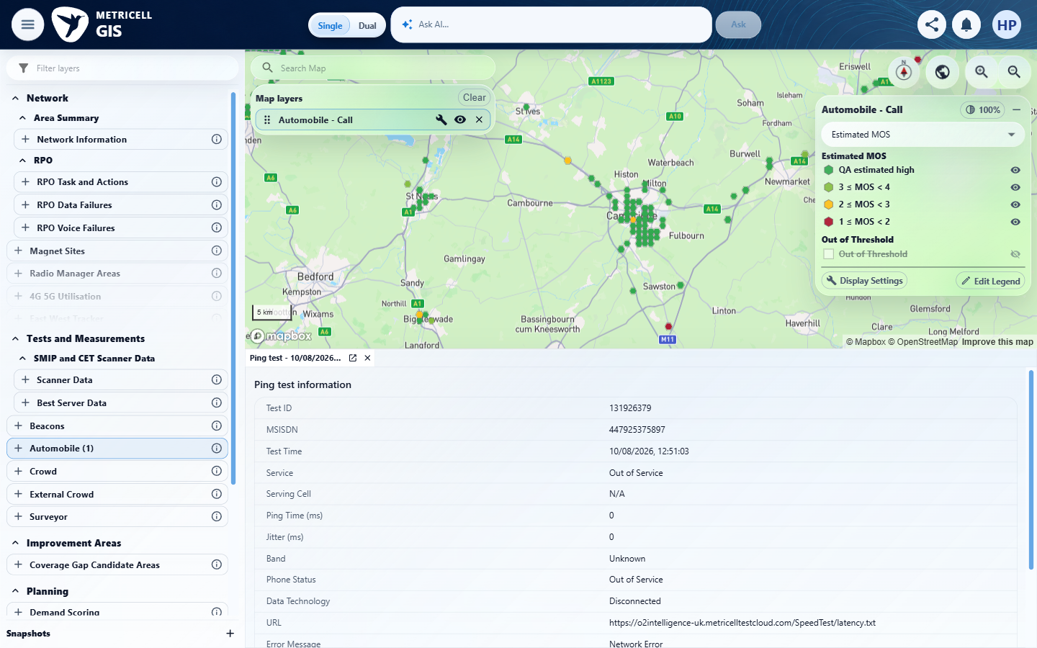

Criterion 12 continued: Editing a metric's customisable bands, labels, marker size, or category visibility updates its Call markers and remains specific to that metric and layer instance when Colour By changes; No Service and Out of Threshold definitions cannot be edited.
Browser URL recorded after criterion: https://o2intelligence-v4-dev.metricell.com/gis
E67 - Before uplink (criterion-12-before-uplink.png)  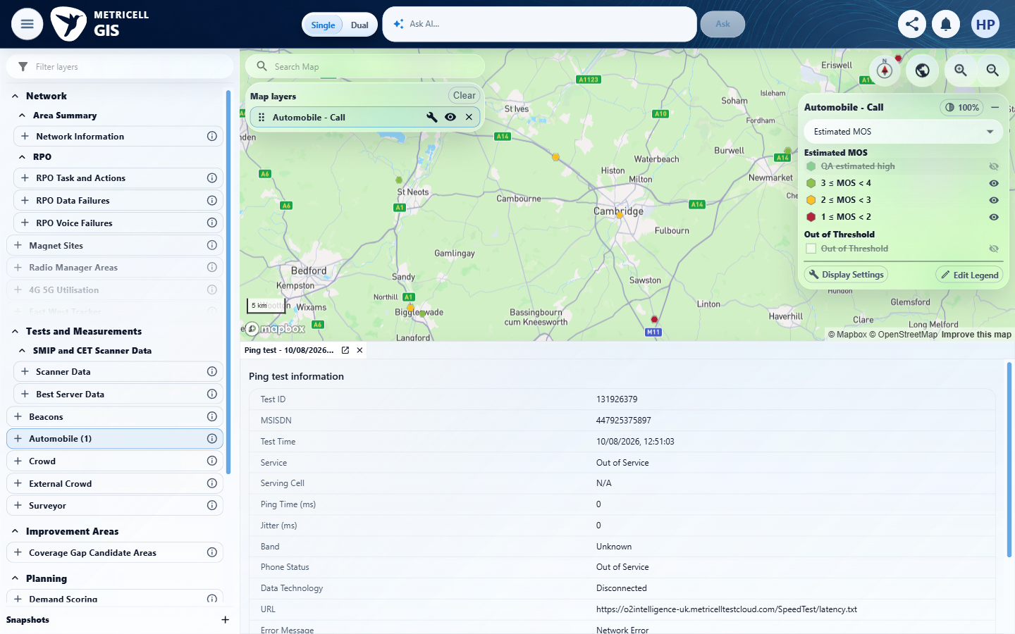 | E14 - Before return estimated (criterion-12-before-return-estimated.png)

Criterion 12 continued: Editing a metric's customisable bands, labels, marker size, or category visibility updates its Call markers and remains specific to that metric and layer instance when Colour By changes; No Service and Out of Threshold definitions cannot be edited.
Browser URL recorded after criterion: https://o2intelligence-v4-dev.metricell.com/gis
E68 - After return estimated (criterion-12-after-return-estimated.png)  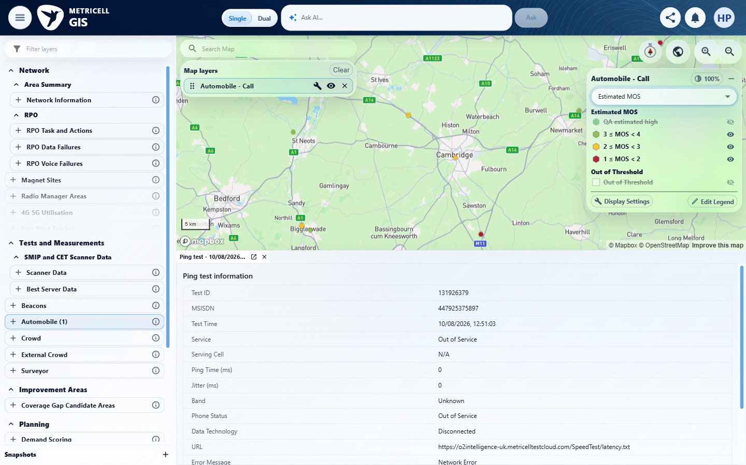 | E69 - Before display settings (criterion-12-before-display-settings.png)  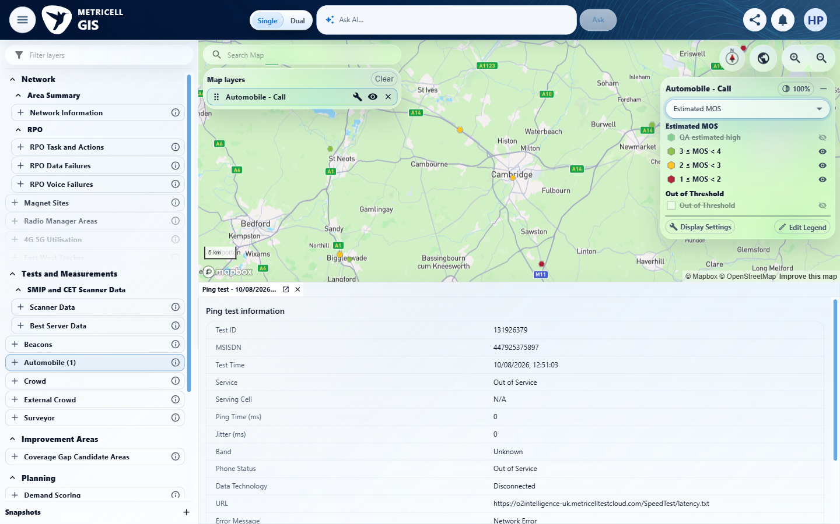

Criterion 12 continued: Editing a metric's customisable bands, labels, marker size, or category visibility updates its Call markers and remains specific to that metric and layer instance when Colour By changes; No Service and Out of Threshold definitions cannot be edited.
Browser URL recorded after criterion: https://o2intelligence-v4-dev.metricell.com/gis
E70 - Final (criterion-12-final.png)
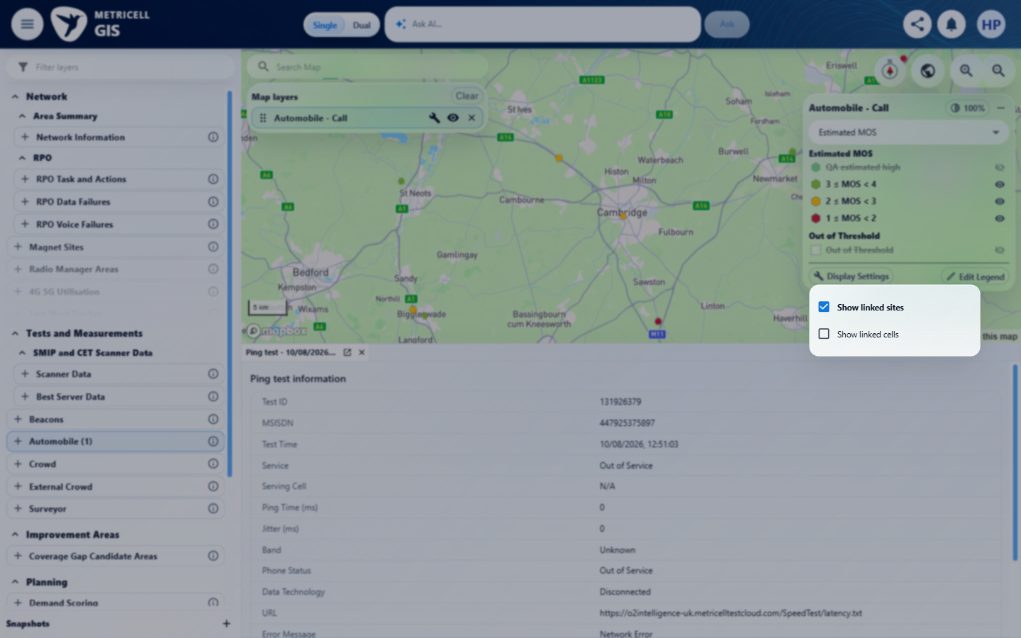

13.0.0 | Restoring a Call layer or saved GIS view restores its Colour By choice and associated legend settings; a saved configuration without a choice opens with CSR selected. | Restoring a Call layer or saved GIS view restores its Colour By choice and associated legend settings; a saved configuration without a choice opens with CSR selected. | criterion-13-after-edit-label.png is the saved Estimated MOS/custom-label baseline; restore-launcher.png records leaving GIS and restored-layer.png plus final.png prove the matching metric and label returned. Initial CSR configuration does not independently establish a restored saved configuration with its Colour By choice absent; that fallback branch remains unverified.  Evidence: E71, E01, E02, E07, E72, E35, E73, E15, E74, E75, E76, E77 | Failed
Criterion 13 assessment: criterion-13-after-edit-label.png is the saved Estimated MOS/custom-label baseline; restore-launcher.png records leaving GIS and restored-layer.png plus final.png prove the matching metric and label returned. Initial CSR configuration does not independently establish a restored saved configuration with its Colour By choice absent; that fallback branch remains unverified.
Criterion 13 evidence: Restoring a Call layer or saved GIS view restores its Colour By choice and associated legend settings; a saved configuration without a choice opens with CSR selected.
Browser URL recorded after criterion: https://o2intelligence-v4-dev.metricell.com/gis
E71 - Gis (criterion-13-gis.png)  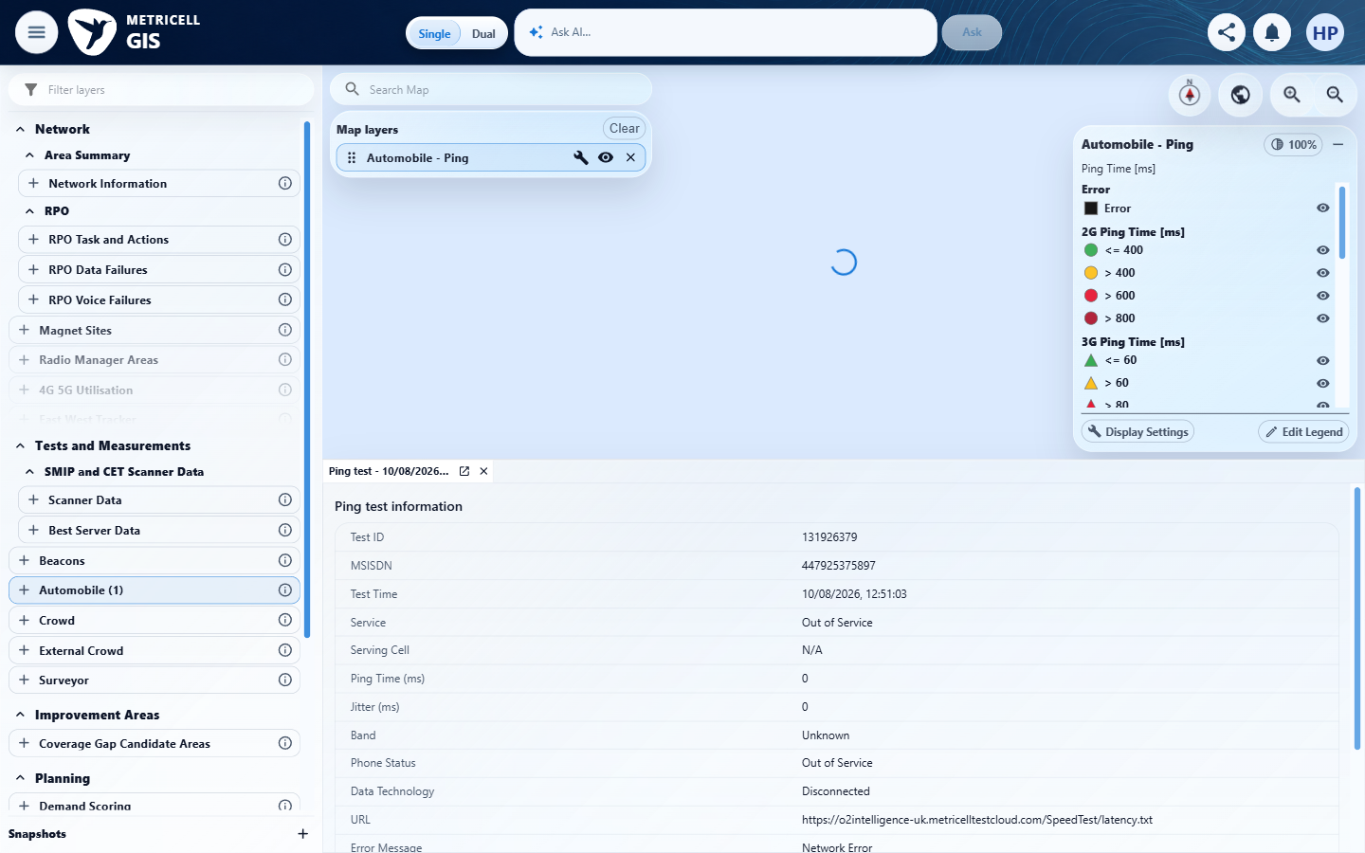 | E01 - Before configuration (criterion-13-before-configuration.png)

Criterion 13 continued: Restoring a Call layer or saved GIS view restores its Colour By choice and associated legend settings; a saved configuration without a choice opens with CSR selected.
Browser URL recorded after criterion: https://o2intelligence-v4-dev.metricell.com/gis
E02 - Before call choice (criterion-13-before-call-choice.png) | E07 - After call choice (criterion-13-after-call-choice.png)
E02 detail enlargement - full screenshot above | E07 detail enlargement - full screenshot above

Criterion 13 continued: Restoring a Call layer or saved GIS view restores its Colour By choice and associated legend settings; a saved configuration without a choice opens with CSR selected.
Browser URL recorded after criterion: https://o2intelligence-v4-dev.metricell.com/gis
E72 - Before apply call (criterion-13-before-apply-call.png)  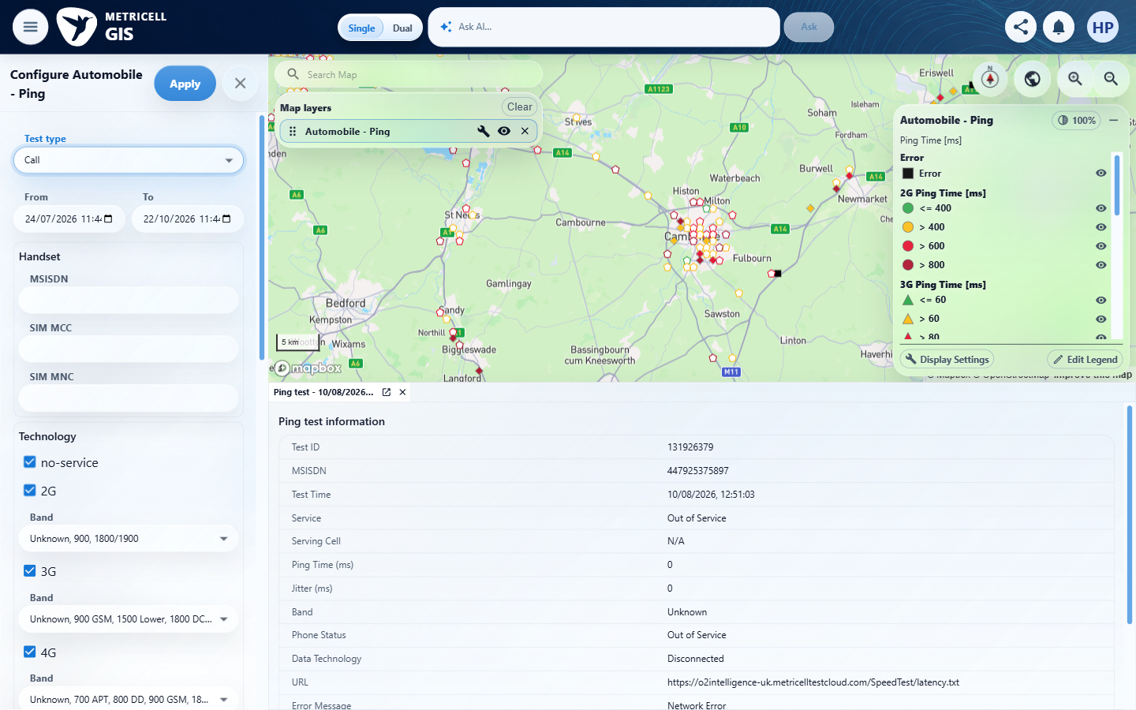 | E35 - After apply call (criterion-13-after-apply-call.png)

Criterion 13 continued: Restoring a Call layer or saved GIS view restores its Colour By choice and associated legend settings; a saved configuration without a choice opens with CSR selected.
Browser URL recorded after criterion: https://o2intelligence-v4-dev.metricell.com/gis
E73 - Before estimated (criterion-13-before-estimated.png)  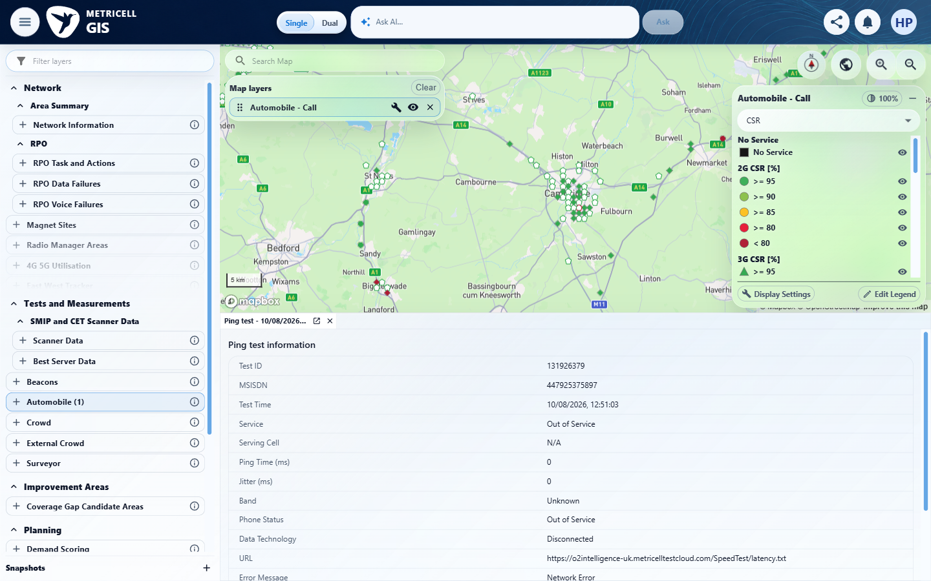 | E15 - Before edit label (criterion-13-before-edit-label.png)

Criterion 13 continued: Restoring a Call layer or saved GIS view restores its Colour By choice and associated legend settings; a saved configuration without a choice opens with CSR selected.
Browser URL recorded after criterion: https://o2intelligence-v4-dev.metricell.com/gis
E74 - Before restore (criterion-13-before-restore.png)  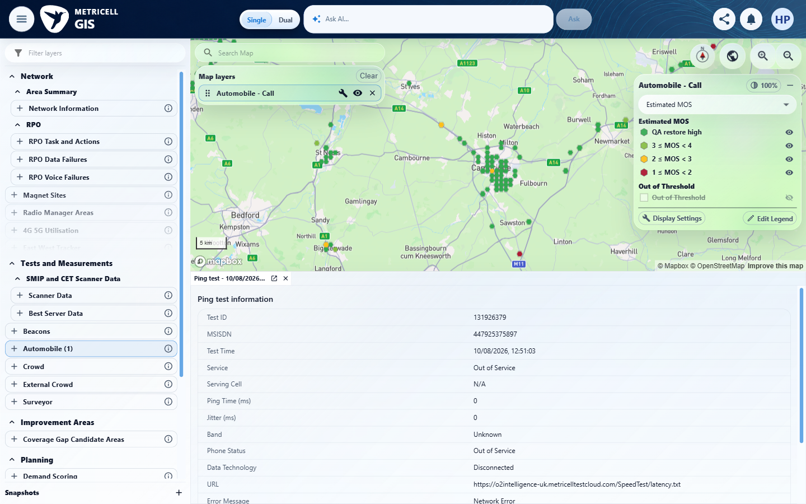 | E75 - Restore launcher (criterion-13-restore-launcher.png)  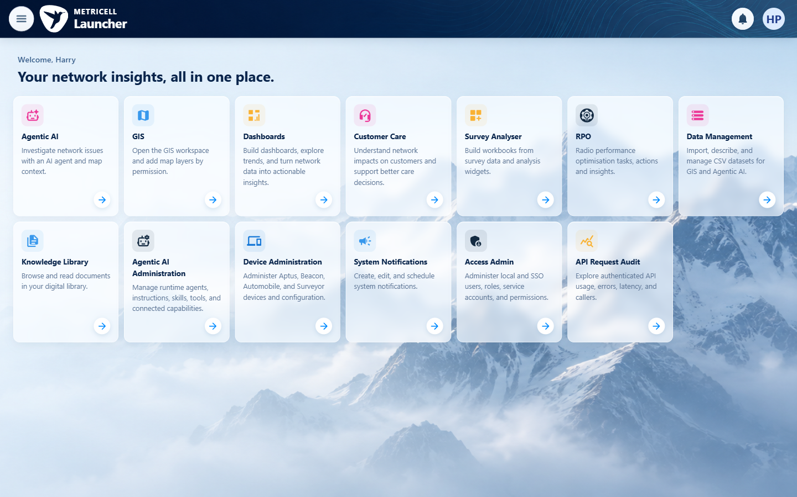

Criterion 13 continued: Restoring a Call layer or saved GIS view restores its Colour By choice and associated legend settings; a saved configuration without a choice opens with CSR selected.
Browser URL recorded after criterion: https://o2intelligence-v4-dev.metricell.com/gis
E76 - Restored layer (criterion-13-restored-layer.png)  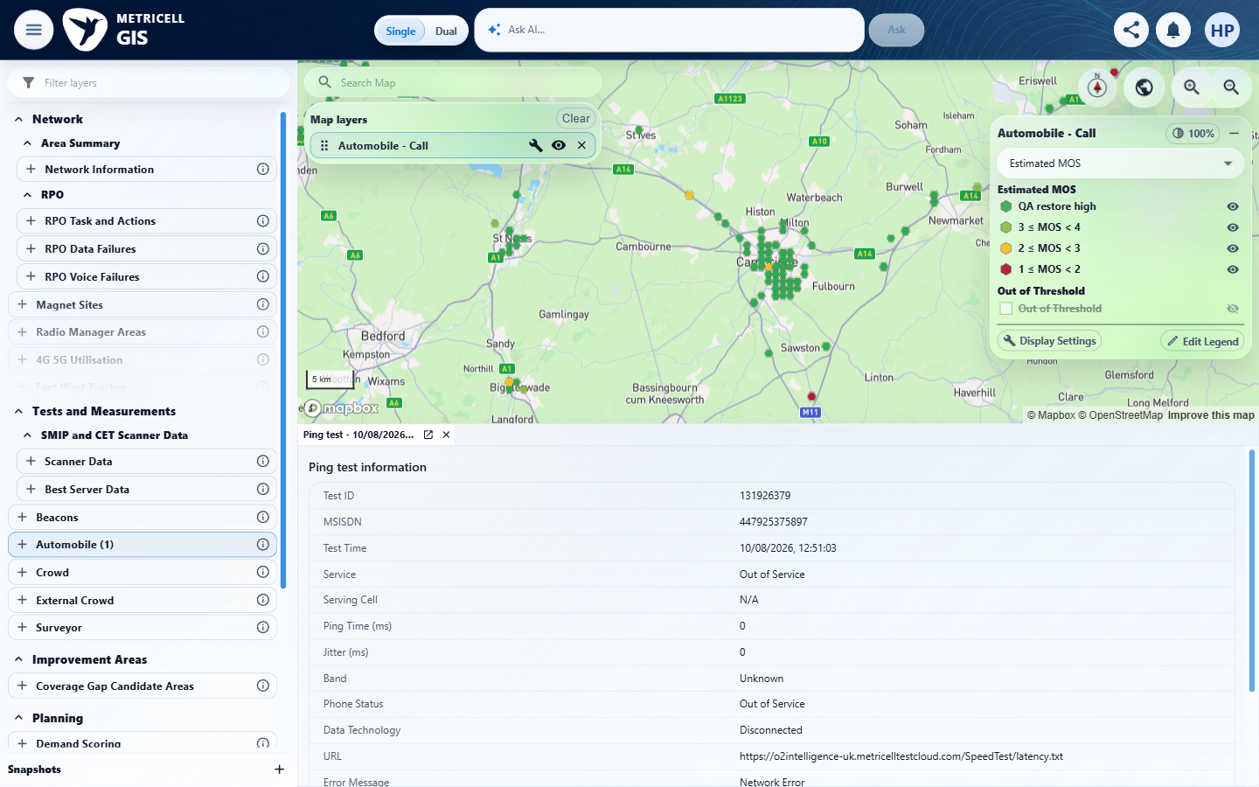 | E77 - Final (criterion-13-final.png)  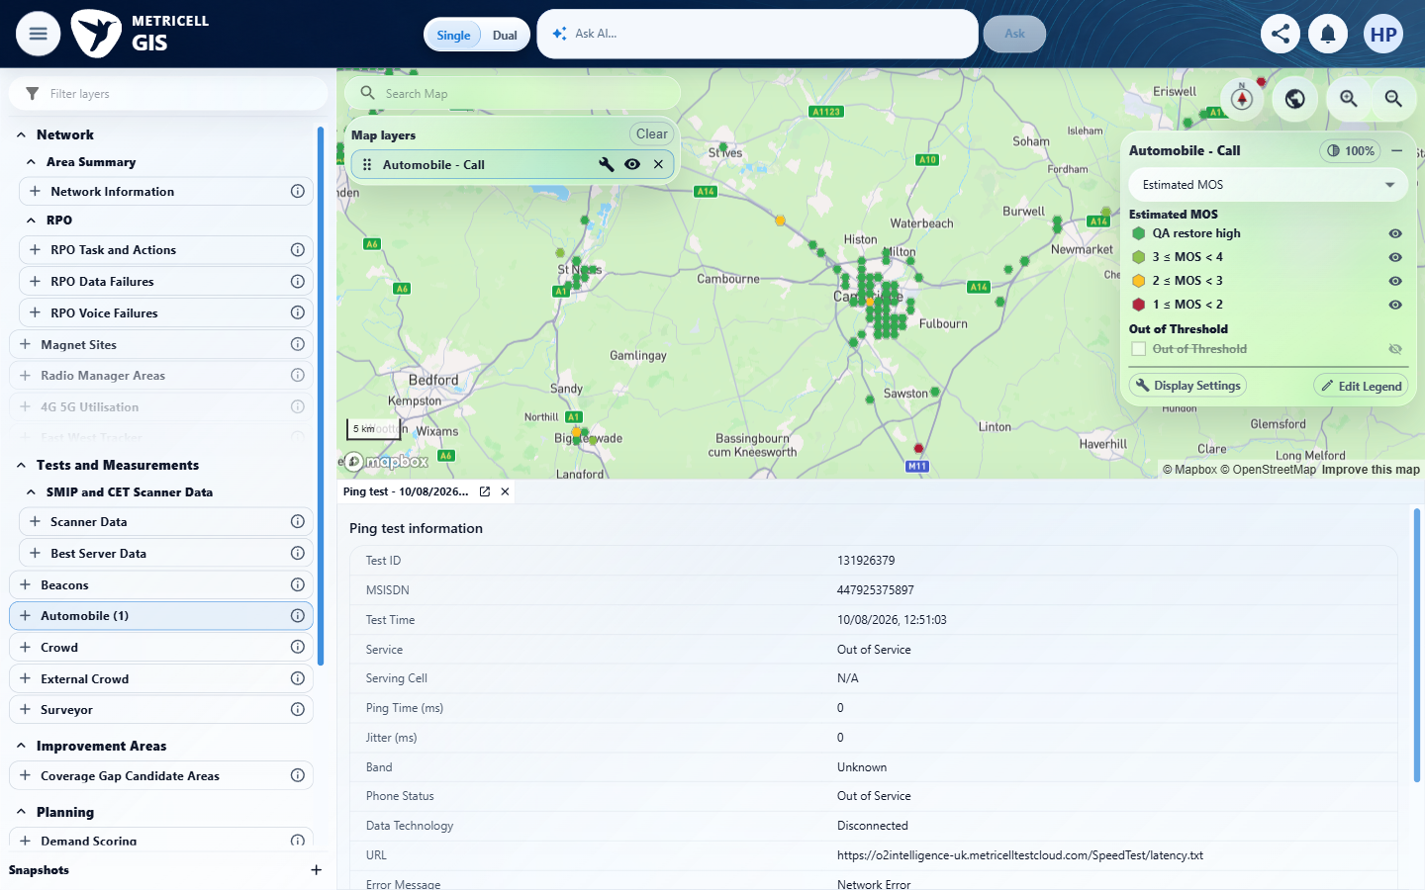

14.0.0 | Selecting a Call marker opens its Call detail tab directly when it represents one result, or opens a cluster results tab when it represents multiple results, following the HTTP and Download GIS workflow and existing group-based visibility. | Selecting a Call marker opens its Call detail tab directly when it represents one result, or opens a cluster results tab when it represents multiple results, following the HTTP and Download GIS workflow and existing group-based visibility. | criterion-14-after-single-point.png shows a direct Call detail tab; after-nearby-point.png and final.png show the two-row Automobile Call cluster retaining that tab. The single/cluster journey is evidenced, but the asserted existing group-based visibility is not independently demonstrated.  Evidence: E57, E78, E02, E07, E35, E05, E18, E79, E80 | Failed
Criterion 14 assessment: criterion-14-after-single-point.png shows a direct Call detail tab; after-nearby-point.png and final.png show the two-row Automobile Call cluster retaining that tab. The single/cluster journey is evidenced, but the asserted existing group-based visibility is not independently demonstrated.
Testing notes: A tool approval timeout interrupted the first cleanup call; the subsequent cleanup retry succeeded.
Criterion 14 evidence: Selecting a Call marker opens its Call detail tab directly when it represents one result, or opens a cluster results tab when it represents multiple results, following the HTTP and Download GIS workflow and existing group-based visibility.
Browser URL recorded after criterion: https://o2intelligence-v4-dev.metricell.com/gis
E57 - Gis (criterion-14-gis.png) | E78 - Before configuration (criterion-14-before-configuration.png)  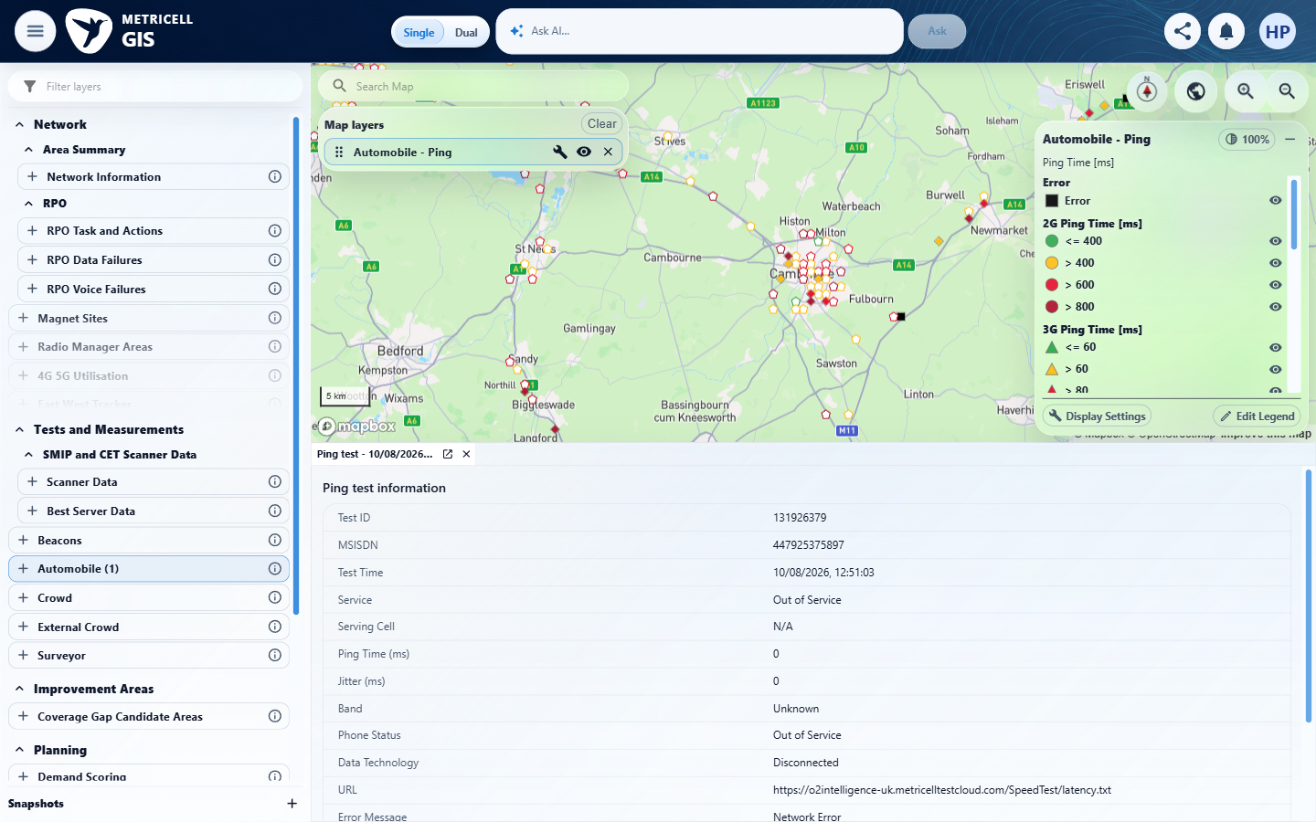

Criterion 14 continued: Selecting a Call marker opens its Call detail tab directly when it represents one result, or opens a cluster results tab when it represents multiple results, following the HTTP and Download GIS workflow and existing group-based visibility.
Browser URL recorded after criterion: https://o2intelligence-v4-dev.metricell.com/gis
E02 - Before call choice (criterion-14-before-call-choice.png) | E07 - Before apply call (criterion-14-before-apply-call.png)

Criterion 14 continued: Selecting a Call marker opens its Call detail tab directly when it represents one result, or opens a cluster results tab when it represents multiple results, following the HTTP and Download GIS workflow and existing group-based visibility.
Browser URL recorded after criterion: https://o2intelligence-v4-dev.metricell.com/gis
E35 - After apply call (criterion-14-after-apply-call.png) | E05 - Before single point (criterion-14-before-single-point.png)

Criterion 14 continued: Selecting a Call marker opens its Call detail tab directly when it represents one result, or opens a cluster results tab when it represents multiple results, following the HTTP and Download GIS workflow and existing group-based visibility.
Browser URL recorded after criterion: https://o2intelligence-v4-dev.metricell.com/gis
E18 - Before nearby point (criterion-14-before-nearby-point.png) | E79 - After nearby point (criterion-14-after-nearby-point.png)  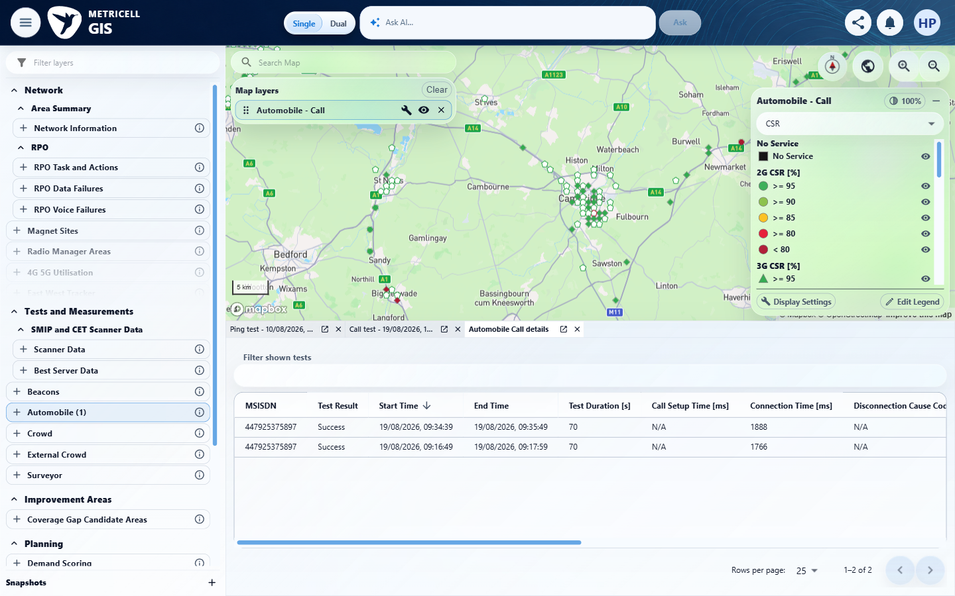

Criterion 14 continued: Selecting a Call marker opens its Call detail tab directly when it represents one result, or opens a cluster results tab when it represents multiple results, following the HTTP and Download GIS workflow and existing group-based visibility.
Browser URL recorded after criterion: https://o2intelligence-v4-dev.metricell.com/gis
E80 - Final (criterion-14-final.png)
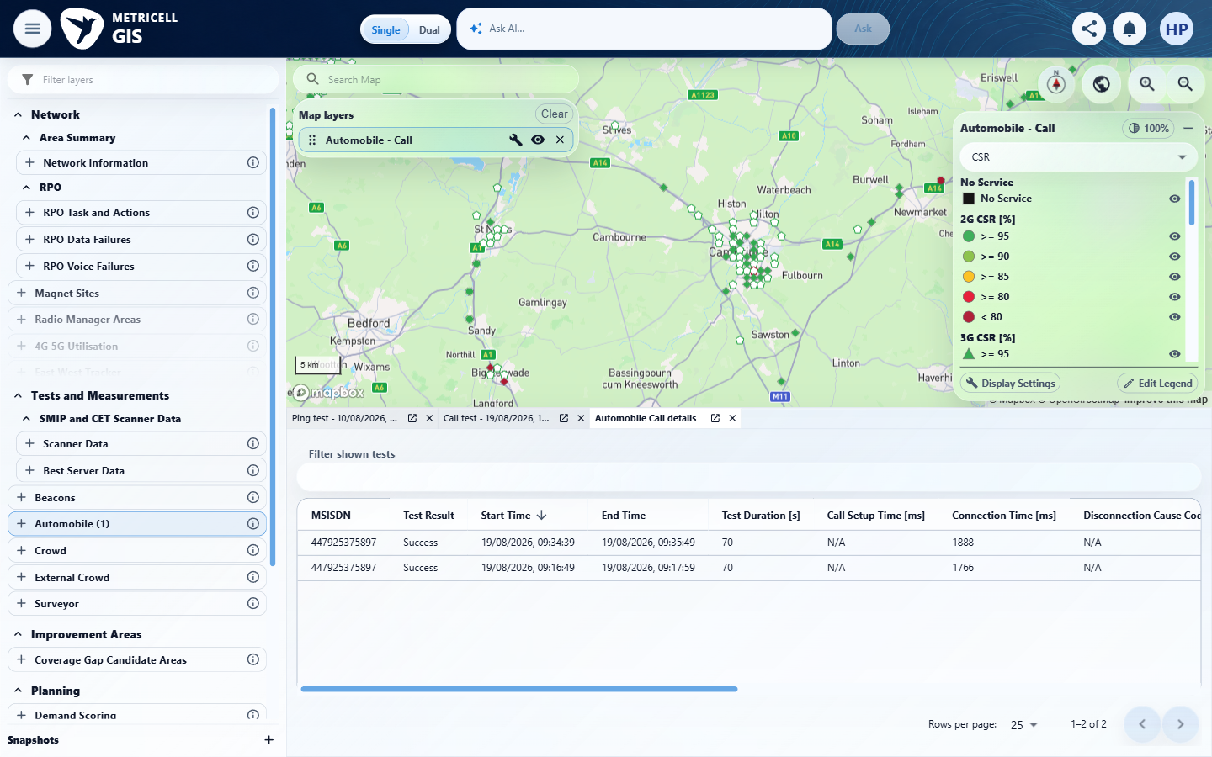

15.0.0 | The cluster results table displays MSISDN, Test Result, Start Time, End Time, Test Duration, Call Setup Time, Connection Time, Disconnection Cause Code, LTE Return Time, CSFB Time, MOS Downlink, MOS Uplink, Estimated MOS, Band, Test Technologies, Call End Service, and Call End Serving Cell. | The cluster results table displays MSISDN, Test Result, Start Time, End Time, Test Duration, Call Setup Time, Connection Time, Disconnection Cause Code, LTE Return Time, CSFB Time, MOS Downlink, MOS Uplink, Estimated MOS, Band, Test Technologies, Call End Service, and Call End Serving Cell. | criterion-15-after-cluster.png and middle-columns.png expose the first eight required headings through Disconnection Cause Code; last-columns.png and final.png expose LTE Return Time through Call End Serving Cell, covering all 17 fields. The middle-columns filename still shows the initial horizontal viewport.  Evidence: E81, E82, E02, E17, E04, E83, E05, E84, E85, E86, E87 | Passed
Criterion 15 assessment: criterion-15-after-cluster.png and middle-columns.png expose the first eight required headings through Disconnection Cause Code; last-columns.png and final.png expose LTE Return Time through Call End Serving Cell, covering all 17 fields. The middle-columns filename still shows the initial horizontal viewport.
Criterion 15 evidence: The cluster results table displays MSISDN, Test Result, Start Time, End Time, Test Duration, Call Setup Time, Connection Time, Disconnection Cause Code, LTE Return Time, CSFB Time, MOS Downlink, MOS Uplink, Estimated MOS, Band, Test Technologies, Call End Service, and Call End Serving Cell.
Browser URL recorded after criterion: https://o2intelligence-v4-dev.metricell.com/gis
E81 - Gis (criterion-15-gis.png)  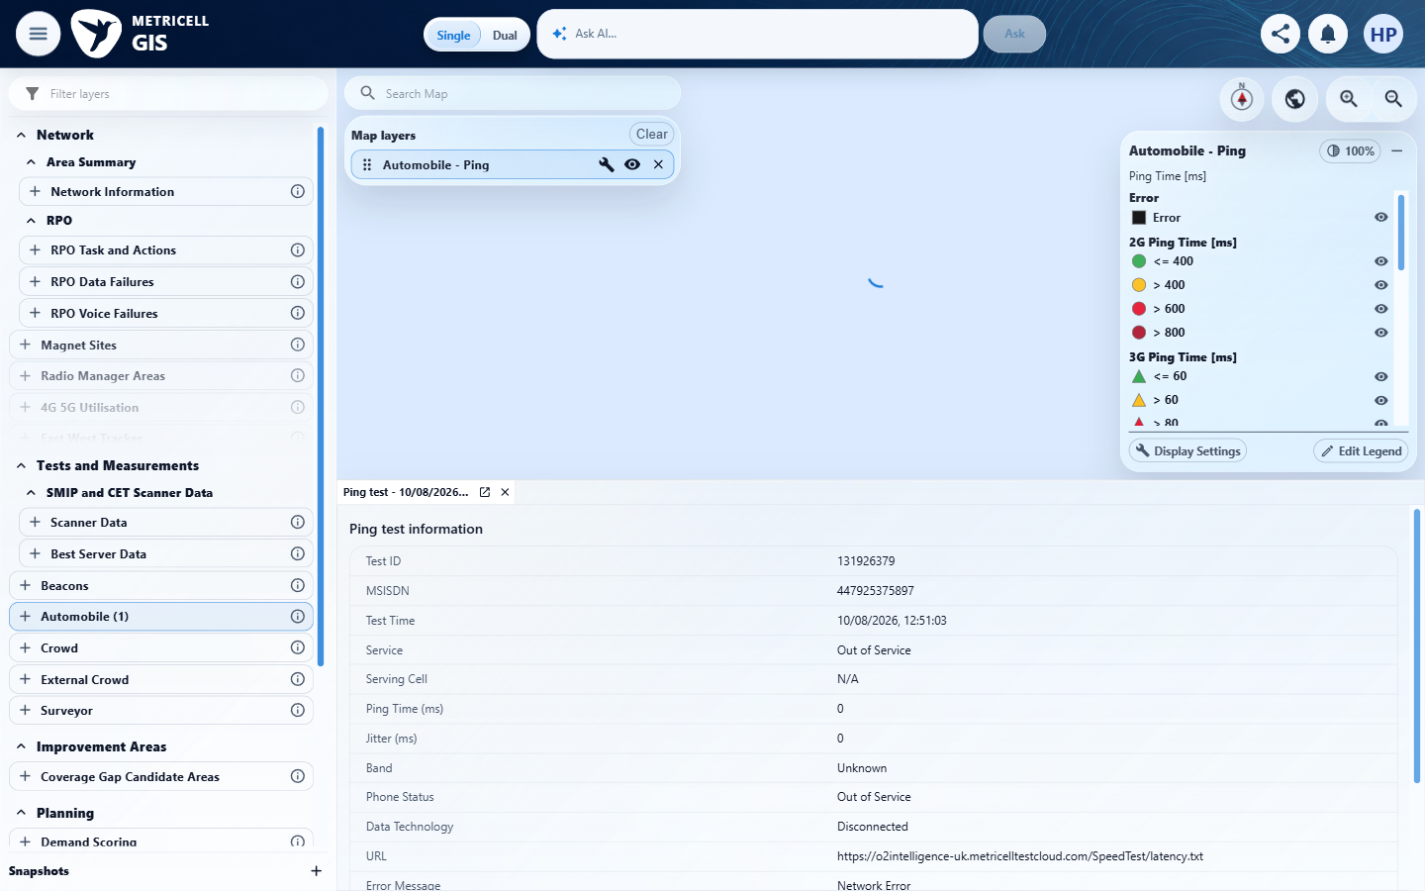 | E82 - Before configuration (criterion-15-before-configuration.png)  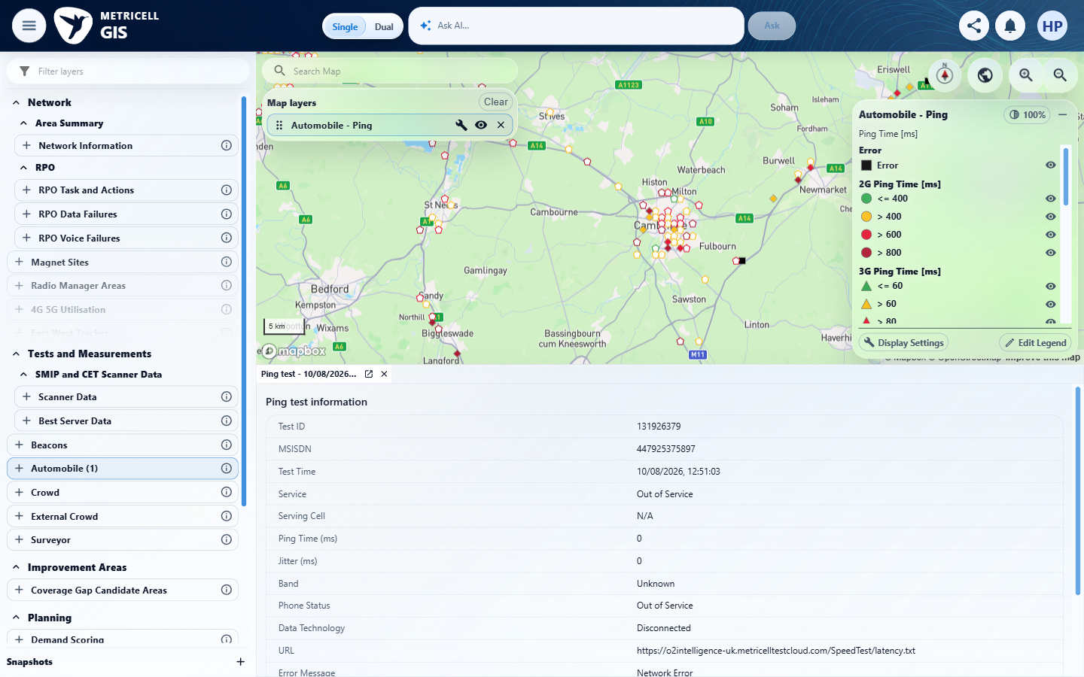

Criterion 15 continued: The cluster results table displays MSISDN, Test Result, Start Time, End Time, Test Duration, Call Setup Time, Connection Time, Disconnection Cause Code, LTE Return Time, CSFB Time, MOS Downlink, MOS Uplink, Estimated MOS, Band, Test Technologies, Call End Service, and Call End Serving Cell.
Browser URL recorded after criterion: https://o2intelligence-v4-dev.metricell.com/gis
E02 - After configuration (criterion-15-after-configuration.png) | E17 - Before call choice (criterion-15-before-call-choice.png)

Criterion 15 continued: The cluster results table displays MSISDN, Test Result, Start Time, End Time, Test Duration, Call Setup Time, Connection Time, Disconnection Cause Code, LTE Return Time, CSFB Time, MOS Downlink, MOS Uplink, Estimated MOS, Band, Test Technologies, Call End Service, and Call End Serving Cell.
Browser URL recorded after criterion: https://o2intelligence-v4-dev.metricell.com/gis
E04 - After call choice (criterion-15-after-call-choice.png) | E83 - Before apply call (criterion-15-before-apply-call.png)  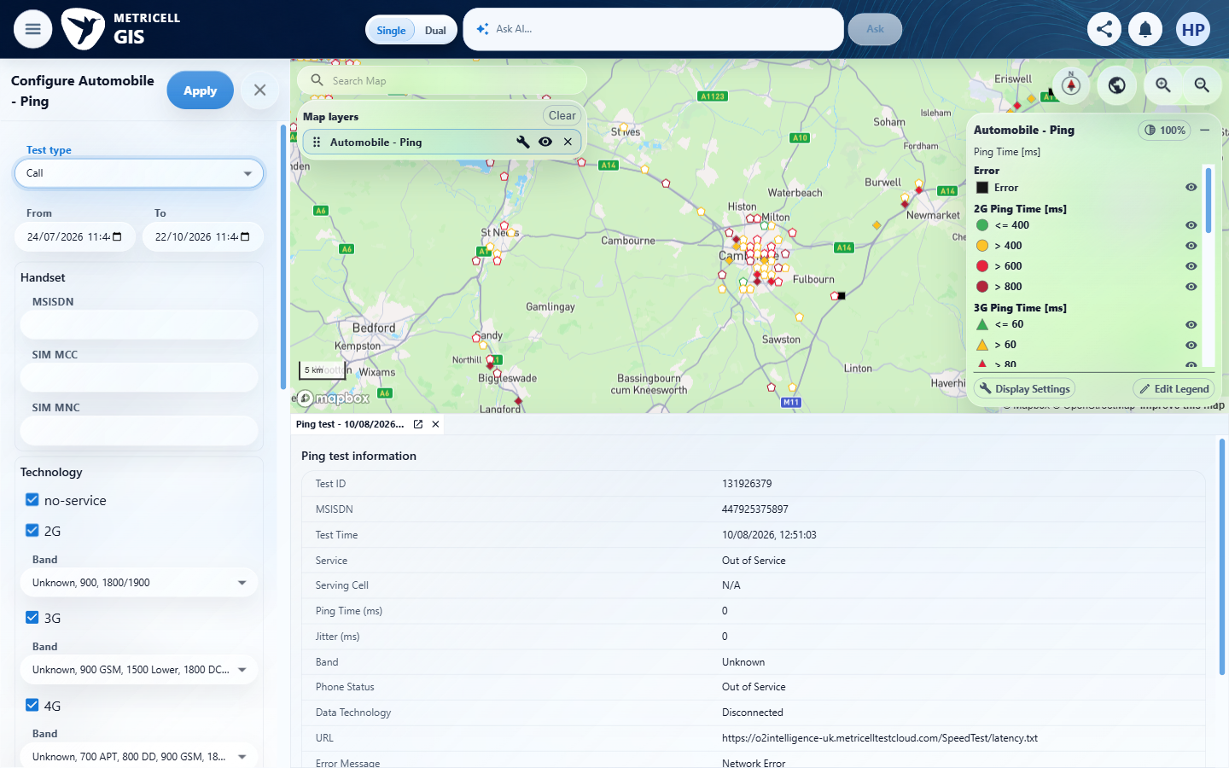

Criterion 15 continued: The cluster results table displays MSISDN, Test Result, Start Time, End Time, Test Duration, Call Setup Time, Connection Time, Disconnection Cause Code, LTE Return Time, CSFB Time, MOS Downlink, MOS Uplink, Estimated MOS, Band, Test Technologies, Call End Service, and Call End Serving Cell.
Browser URL recorded after criterion: https://o2intelligence-v4-dev.metricell.com/gis
E05 - Before cluster (criterion-15-before-cluster.png) | E84 - After cluster (criterion-15-after-cluster.png)  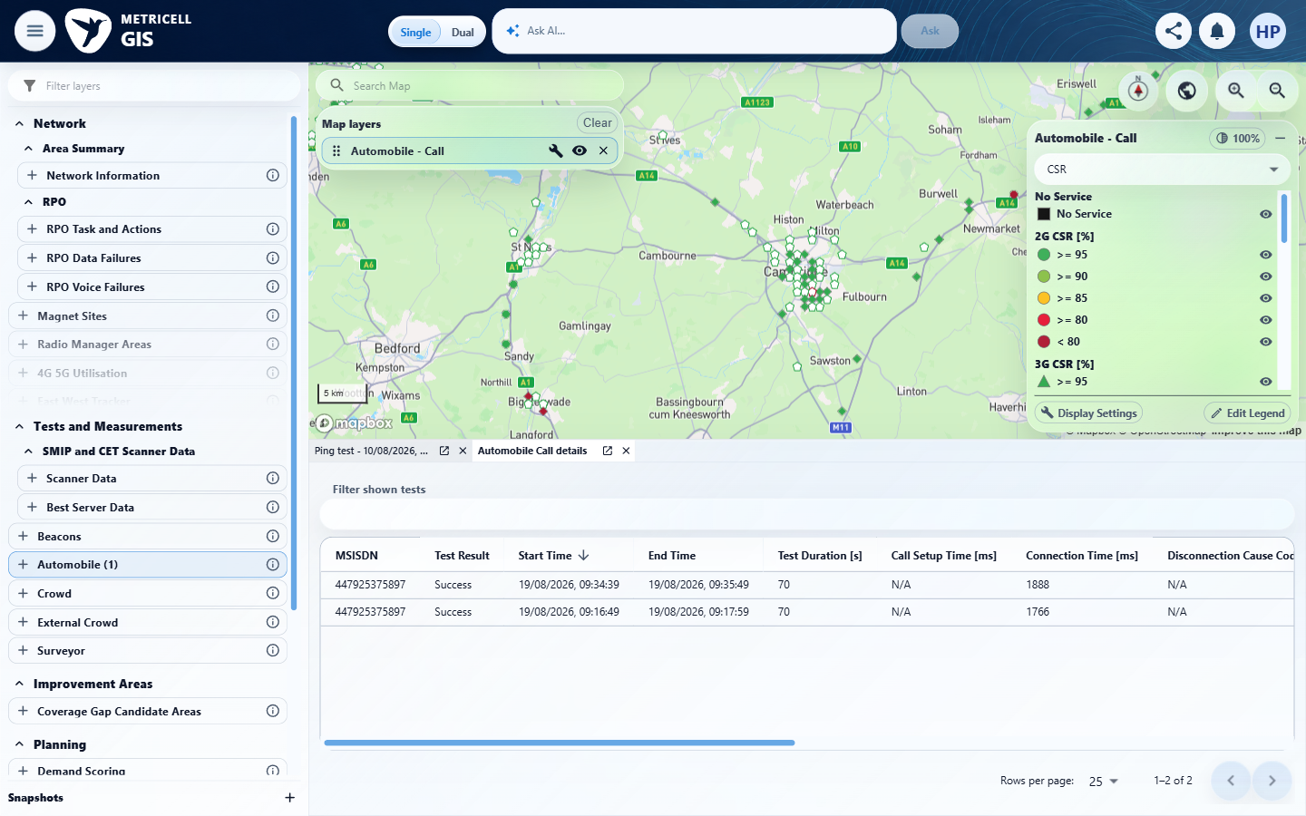

Criterion 15 continued: The cluster results table displays MSISDN, Test Result, Start Time, End Time, Test Duration, Call Setup Time, Connection Time, Disconnection Cause Code, LTE Return Time, CSFB Time, MOS Downlink, MOS Uplink, Estimated MOS, Band, Test Technologies, Call End Service, and Call End Serving Cell.
Browser URL recorded after criterion: https://o2intelligence-v4-dev.metricell.com/gis
E85 - Middle columns (criterion-15-middle-columns.png)  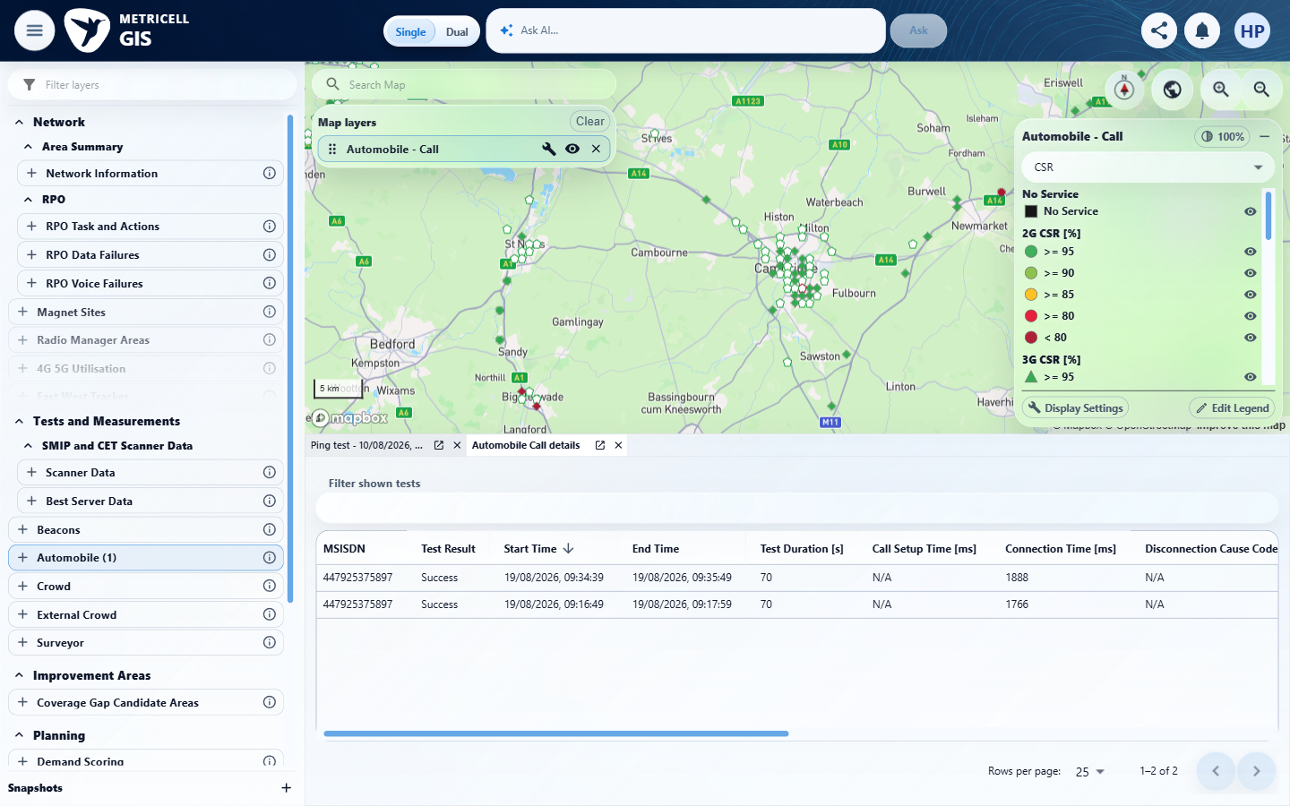 | E86 - Last columns (criterion-15-last-columns.png)  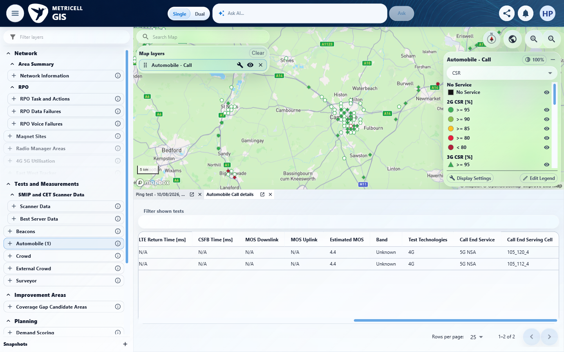

Criterion 15 continued: The cluster results table displays MSISDN, Test Result, Start Time, End Time, Test Duration, Call Setup Time, Connection Time, Disconnection Cause Code, LTE Return Time, CSFB Time, MOS Downlink, MOS Uplink, Estimated MOS, Band, Test Technologies, Call End Service, and Call End Serving Cell.
Browser URL recorded after criterion: https://o2intelligence-v4-dev.metricell.com/gis
E87 - Final (criterion-15-final.png)
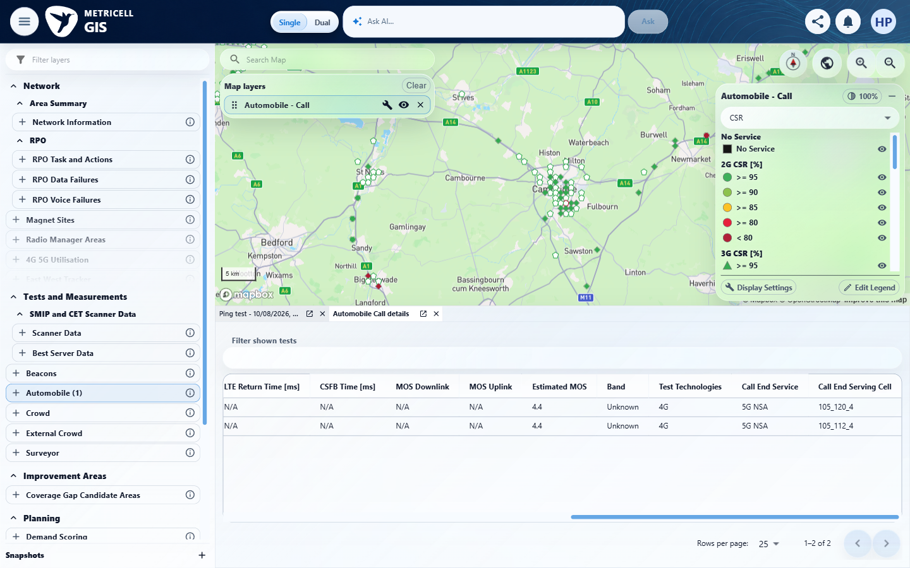

16.0.0 | Each available column in the cluster results table can be sorted. | Each available column in the cluster results table can be sorted. | criterion-16-before-sort-2.png through before-sort-17.png provide later settled ascending indicators for columns 1–16; many after-sort captures reset the horizontal viewport and cannot prove off-screen indicators. after-time-ascending.png and after-time-descending.png prove actual Start Time reversal. No later capture exposes the settled sort indicator/order for column 17, Call End Serving Cell, so all-column sorting is not fully evidenced; equal/N/A samples do not establish varied-value ordering.  Evidence: E88, E01, E02, E72, E07, E35, E05, E84, E89, E90, E91, E92, E93, E94, E95, E96, E97, E98, E99, E100, E101, E102, E103, E104, E105, E106, E107, E108, E109, E110, E111, E112, E113, E114, E115, E116, E117 | Failed
Criterion 16 assessment: criterion-16-before-sort-2.png through before-sort-17.png provide later settled ascending indicators for columns 1–16; many after-sort captures reset the horizontal viewport and cannot prove off-screen indicators. after-time-ascending.png and after-time-descending.png prove actual Start Time reversal. No later capture exposes the settled sort indicator/order for column 17, Call End Serving Cell, so all-column sorting is not fully evidenced; equal/N/A samples do not establish varied-value ordering.
Criterion 16 evidence: Each available column in the cluster results table can be sorted.
Browser URL recorded after criterion: https://o2intelligence-v4-dev.metricell.com/gis
E88 - Gis (criterion-16-gis.png)  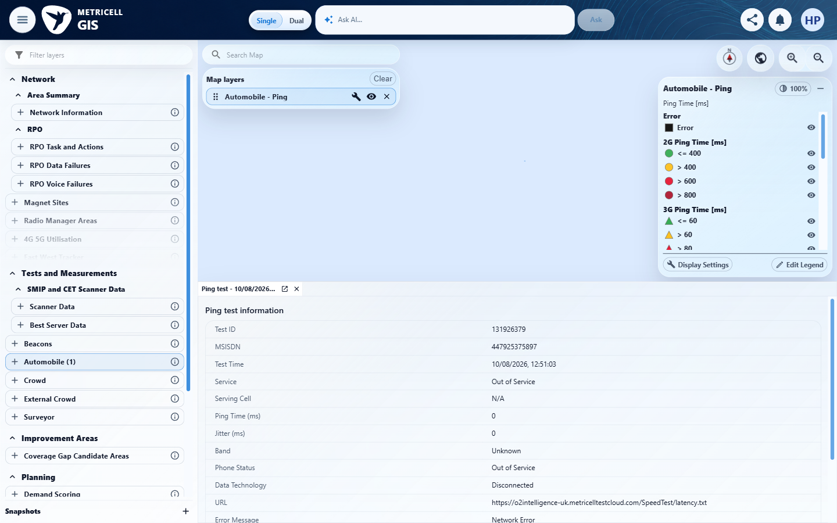 | E01 - Before configuration (criterion-16-before-configuration.png)

Criterion 16 continued: Each available column in the cluster results table can be sorted.
Browser URL recorded after criterion: https://o2intelligence-v4-dev.metricell.com/gis
E02 - Before call choice (criterion-16-before-call-choice.png) | E72 - After call choice (criterion-16-after-call-choice.png)
E02 detail enlargement - full screenshot above | E72 detail enlargement - full screenshot above

Criterion 16 continued: Each available column in the cluster results table can be sorted.
Browser URL recorded after criterion: https://o2intelligence-v4-dev.metricell.com/gis
E07 - Before apply call (criterion-16-before-apply-call.png) | E35 - After apply call (criterion-16-after-apply-call.png)

Criterion 16 continued: Each available column in the cluster results table can be sorted.
Browser URL recorded after criterion: https://o2intelligence-v4-dev.metricell.com/gis
E05 - Before cluster (criterion-16-before-cluster.png) | E84 - After cluster (criterion-16-after-cluster.png)

Criterion 16 continued: Each available column in the cluster results table can be sorted.
Browser URL recorded after criterion: https://o2intelligence-v4-dev.metricell.com/gis
E89 - Before sort 1 (criterion-16-before-sort-1.png)  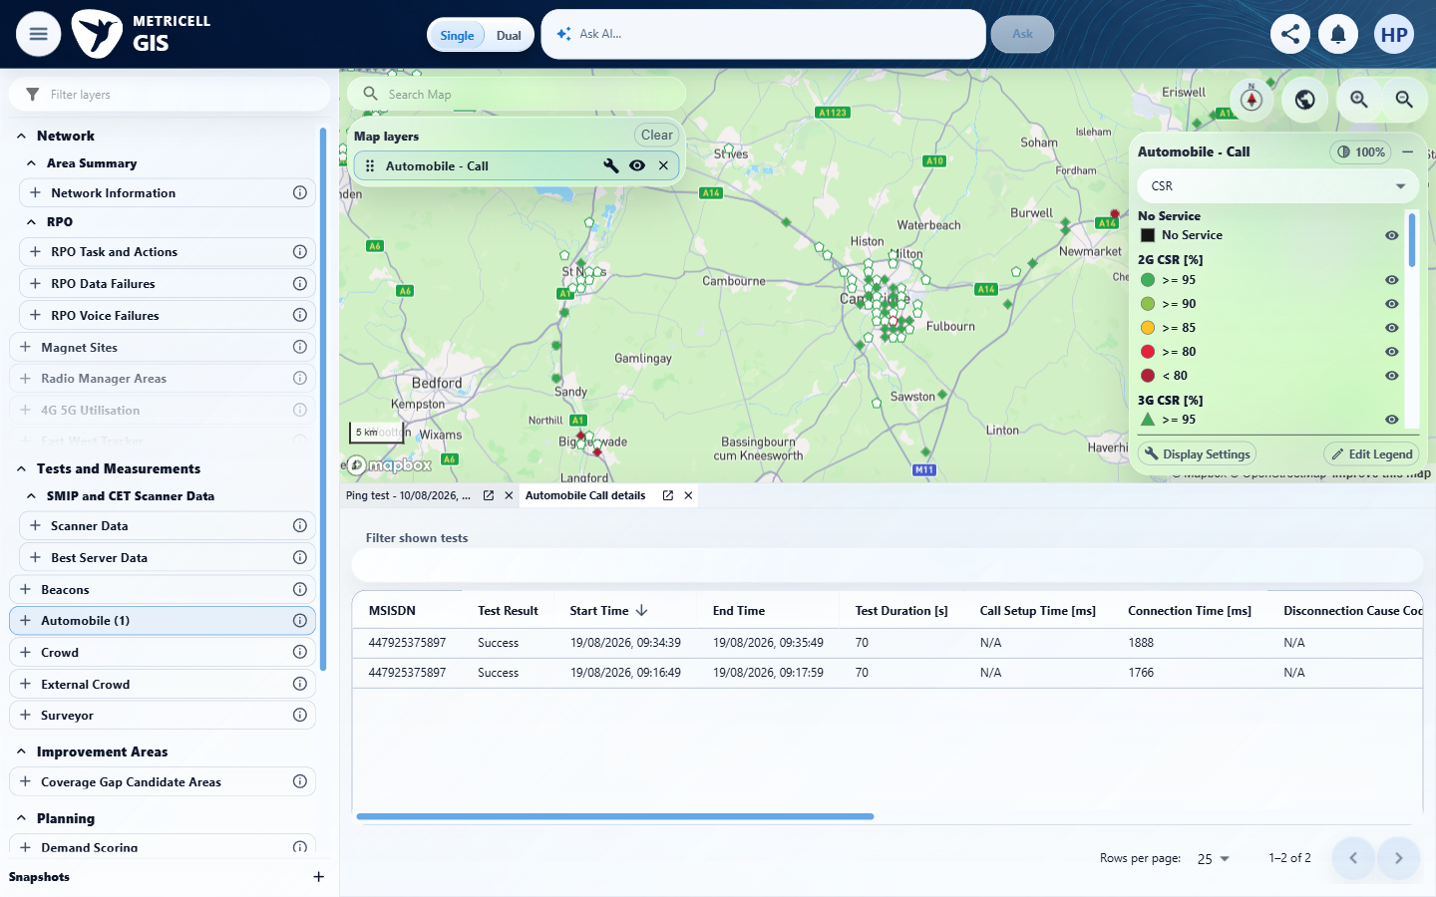 | E90 - After sort 1 (criterion-16-after-sort-1.png)  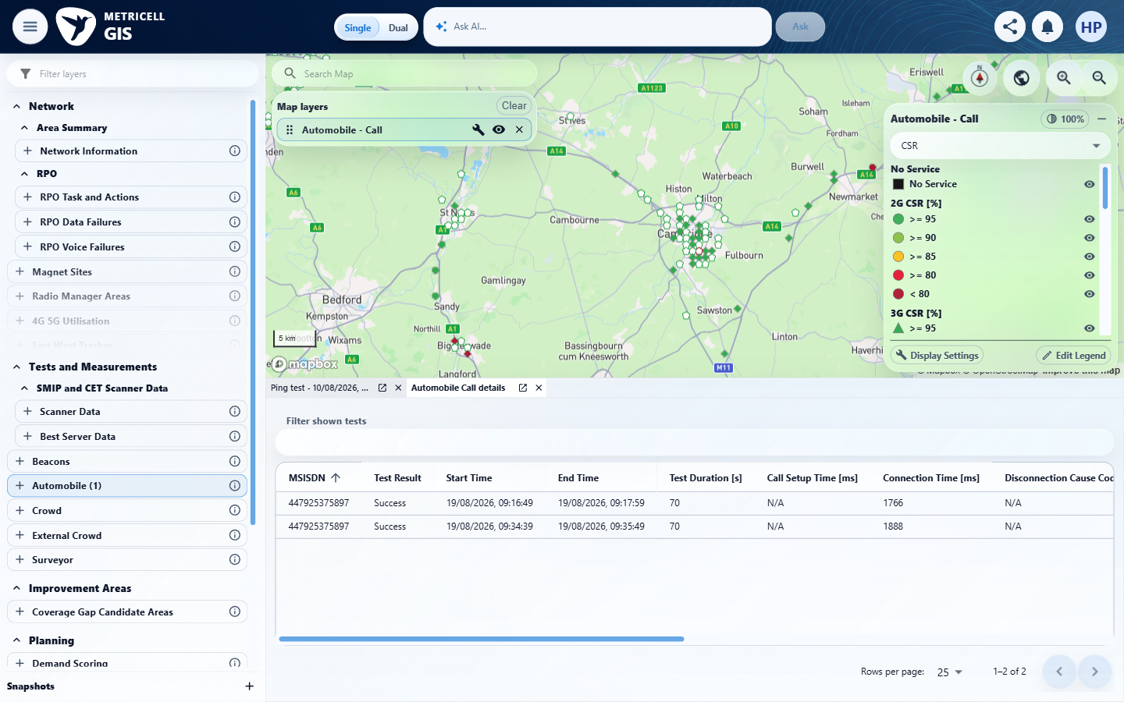
E89 detail enlargement - full screenshot above | E90 detail enlargement - full screenshot above

Criterion 16 continued: Each available column in the cluster results table can be sorted.
Browser URL recorded after criterion: https://o2intelligence-v4-dev.metricell.com/gis
E91 - Before sort 2 (criterion-16-before-sort-2.png)  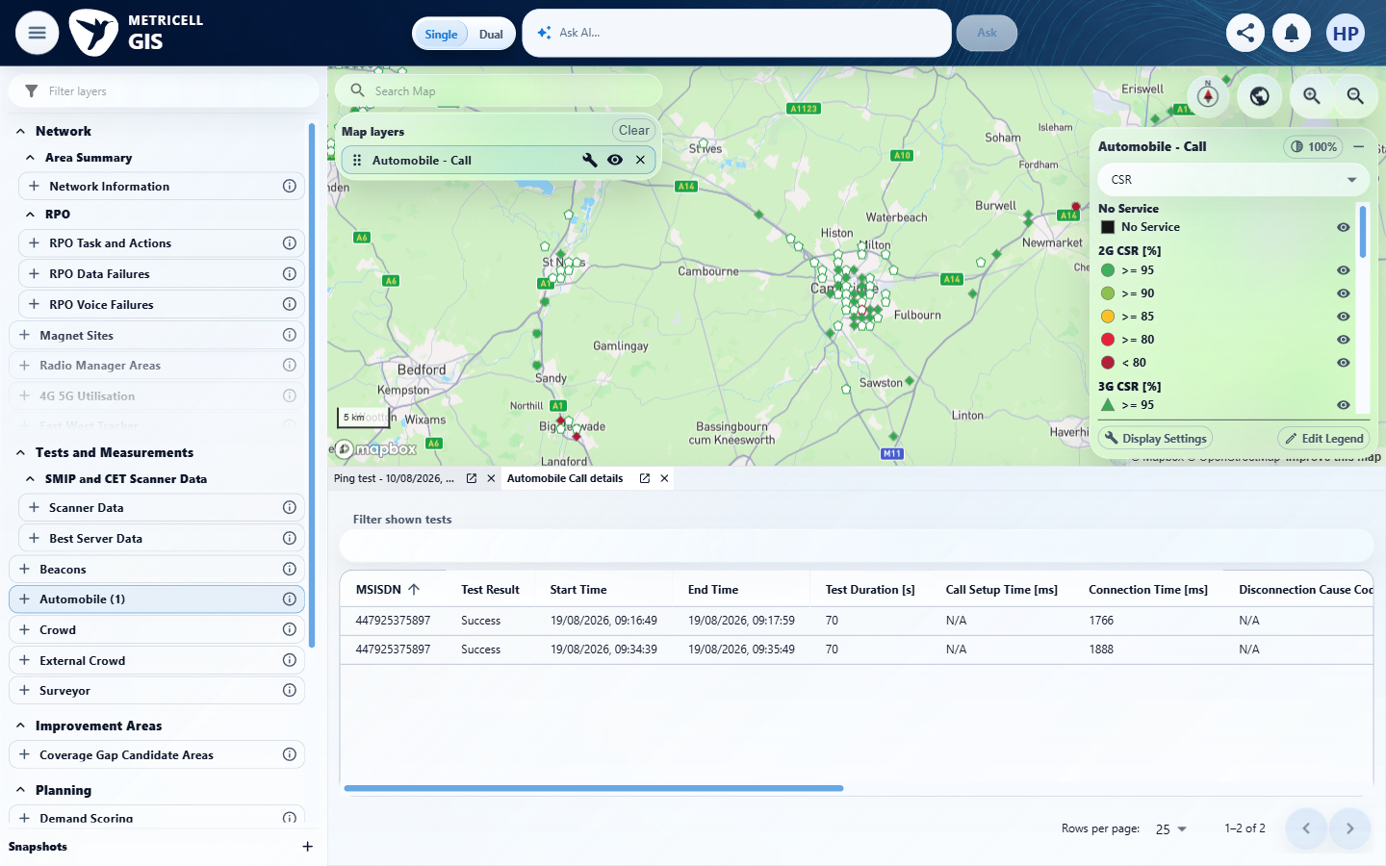 | E92 - After sort 2 (criterion-16-after-sort-2.png)  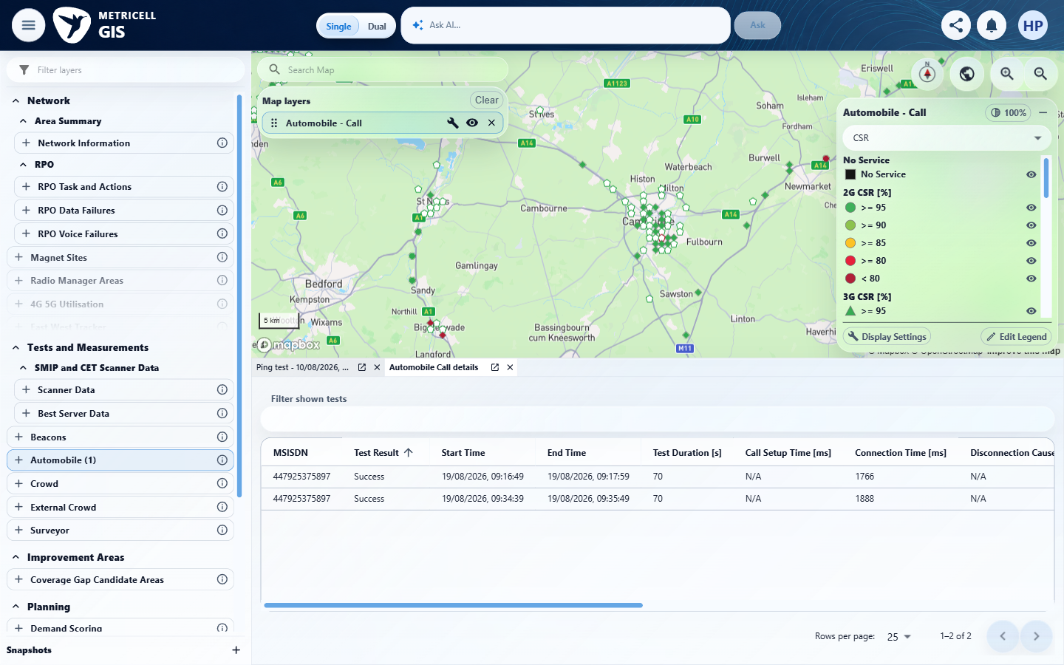

Criterion 16 continued: Each available column in the cluster results table can be sorted.
Browser URL recorded after criterion: https://o2intelligence-v4-dev.metricell.com/gis
E93 - Before sort 3 (criterion-16-before-sort-3.png)  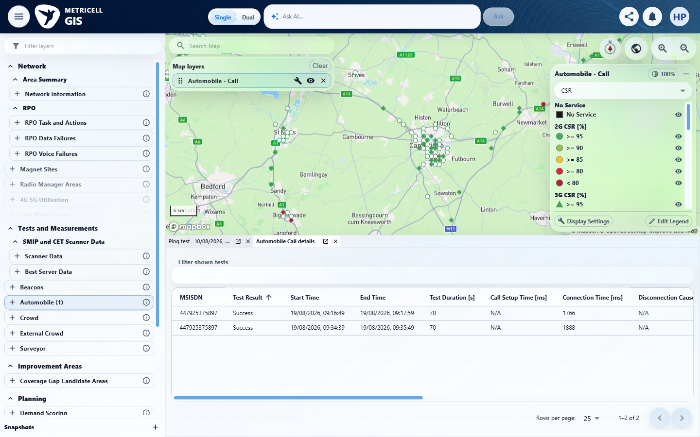 | E94 - Before sort 4 (criterion-16-before-sort-4.png)  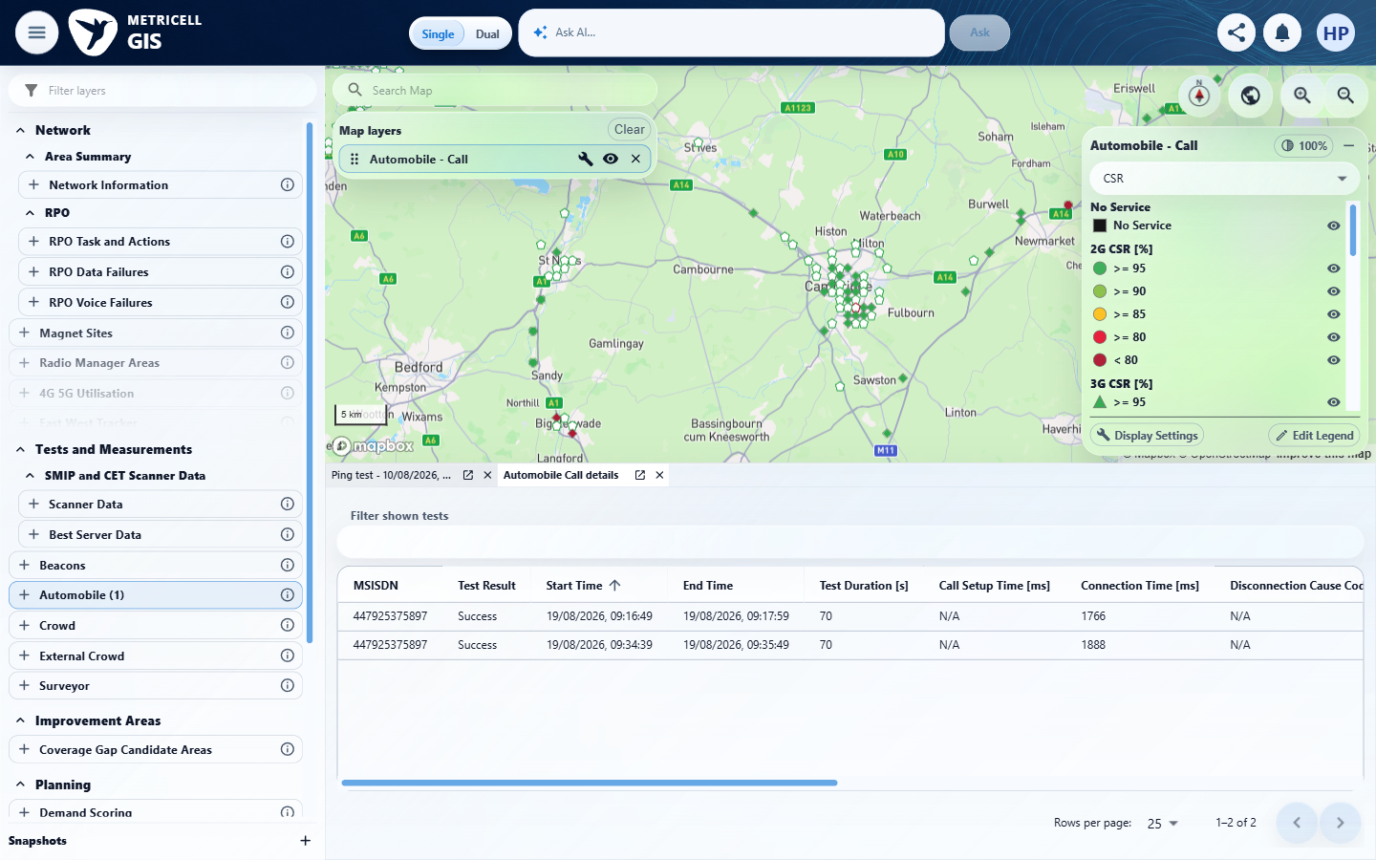

Criterion 16 continued: Each available column in the cluster results table can be sorted.
Browser URL recorded after criterion: https://o2intelligence-v4-dev.metricell.com/gis
E95 - After sort 4 (criterion-16-after-sort-4.png)  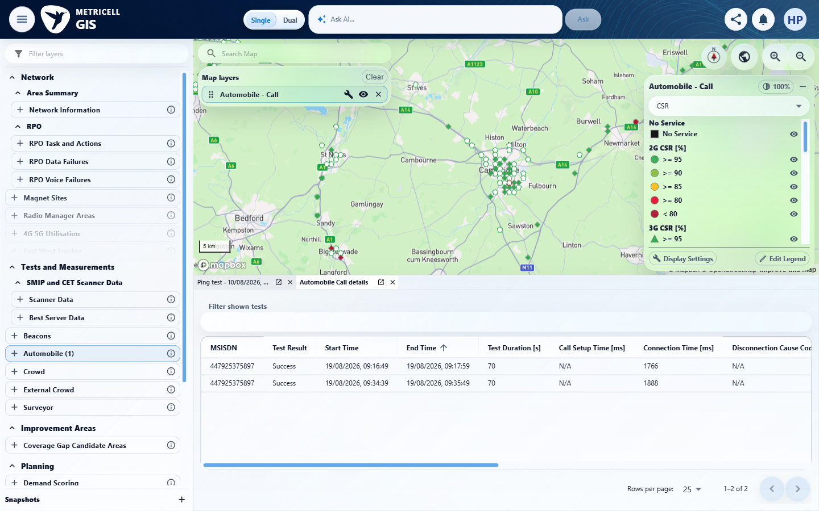 | E96 - Before sort 5 (criterion-16-before-sort-5.png)  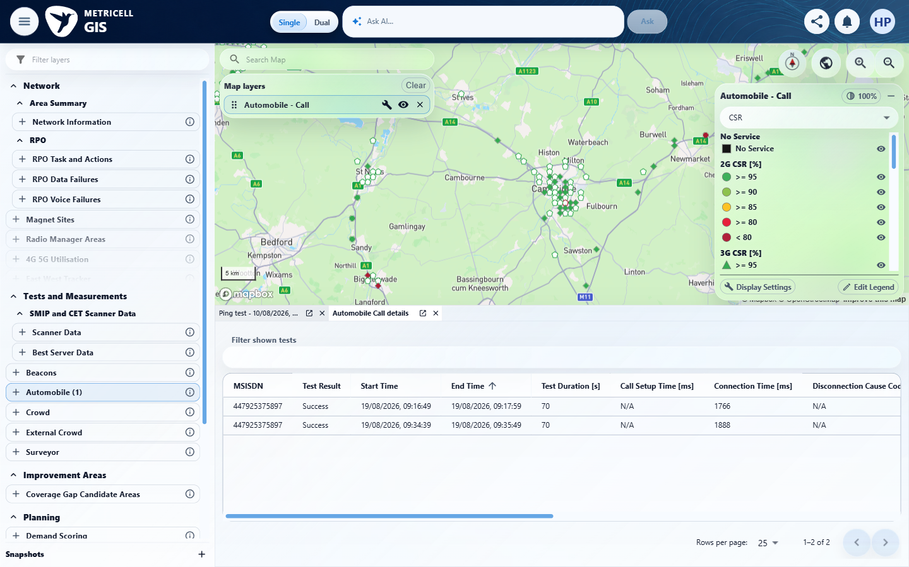

Criterion 16 continued: Each available column in the cluster results table can be sorted.
Browser URL recorded after criterion: https://o2intelligence-v4-dev.metricell.com/gis
E97 - Before sort 6 (criterion-16-before-sort-6.png)  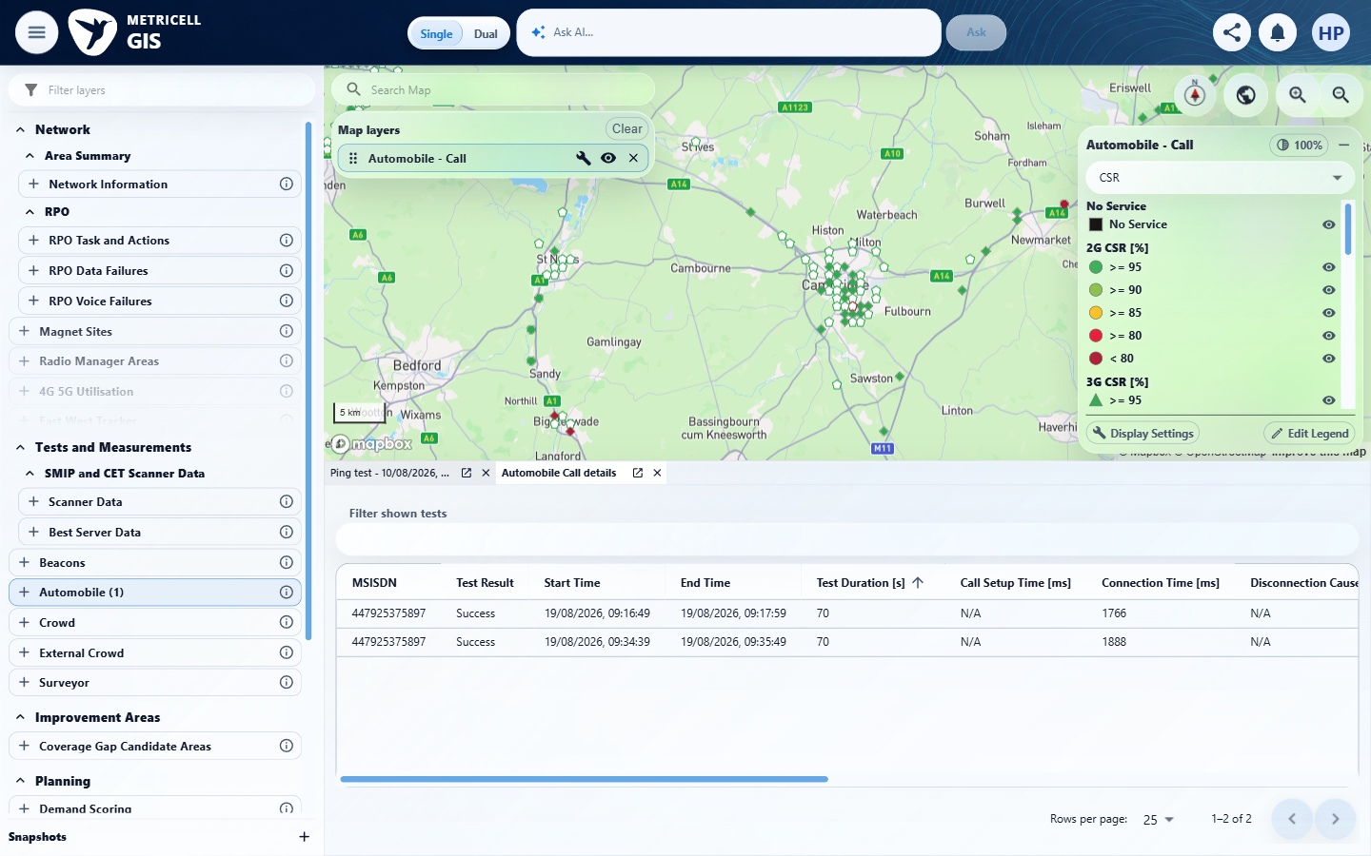 | E98 - Before sort 7 (criterion-16-before-sort-7.png)  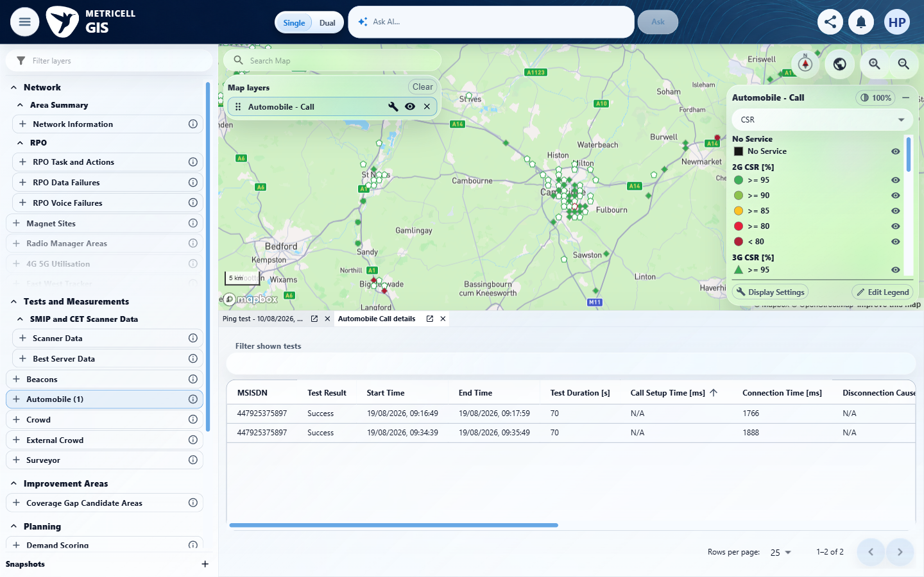

Criterion 16 continued: Each available column in the cluster results table can be sorted.
Browser URL recorded after criterion: https://o2intelligence-v4-dev.metricell.com/gis
E99 - After sort 7 (criterion-16-after-sort-7.png)  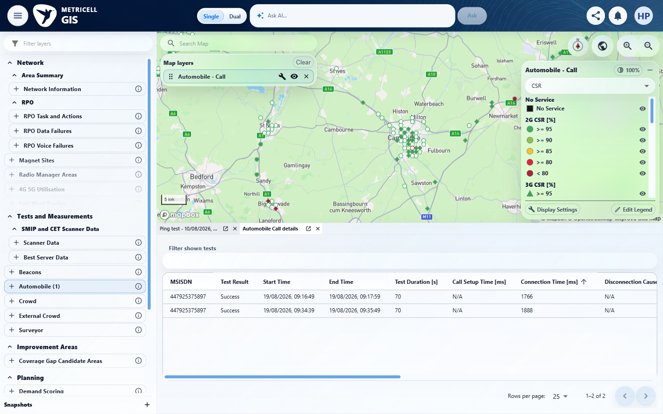 | E100 - Before sort 8 (criterion-16-before-sort-8.png)  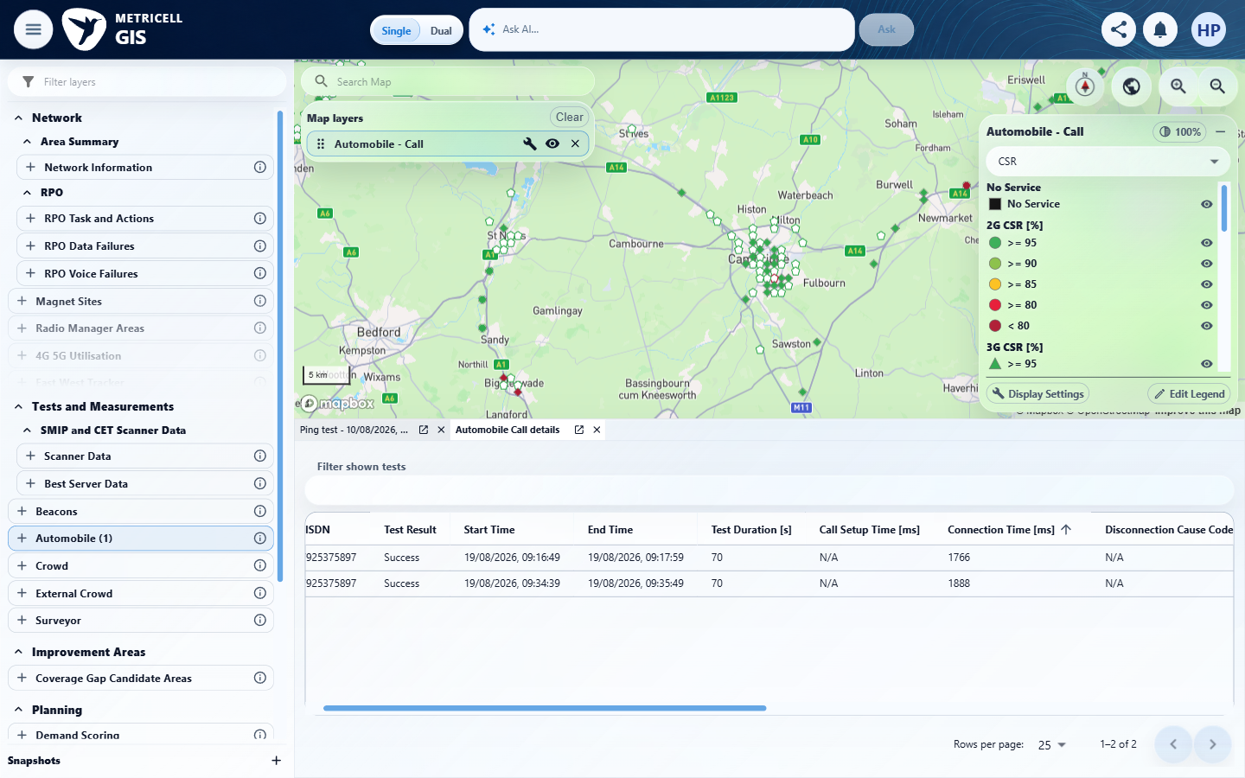

Criterion 16 continued: Each available column in the cluster results table can be sorted.
Browser URL recorded after criterion: https://o2intelligence-v4-dev.metricell.com/gis
E101 - After sort 8 (criterion-16-after-sort-8.png)  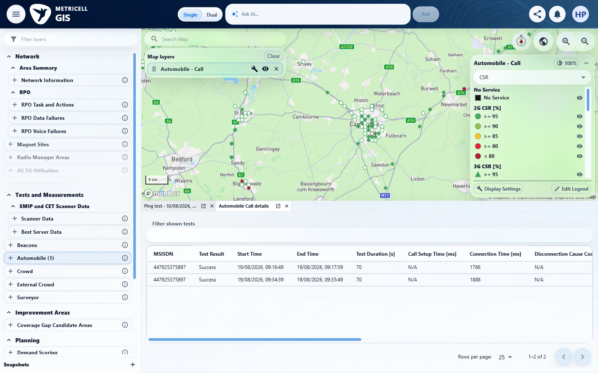 | E102 - Before sort 9 (criterion-16-before-sort-9.png)  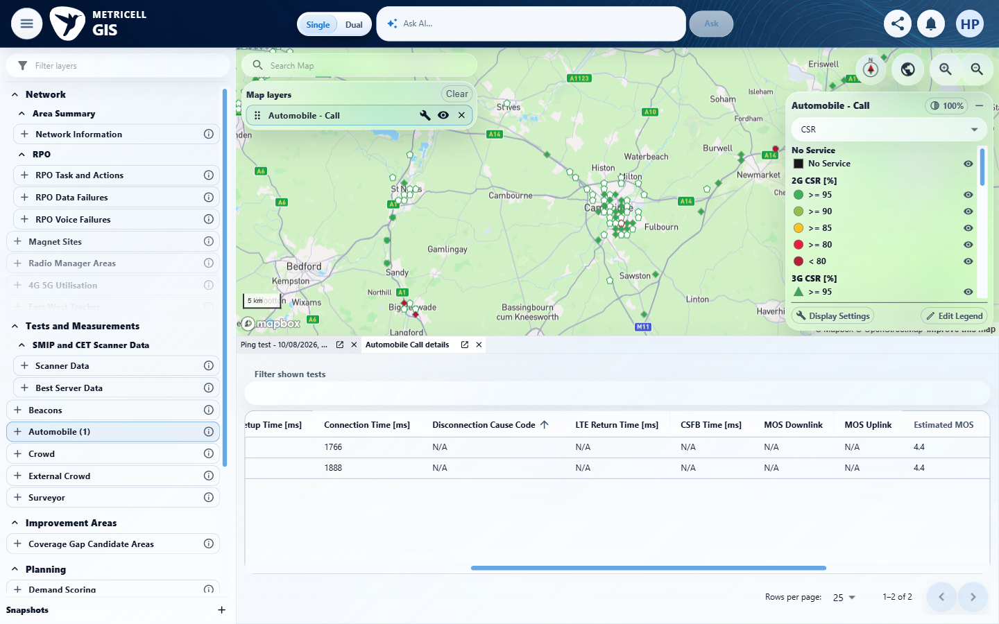

Criterion 16 continued: Each available column in the cluster results table can be sorted.
Browser URL recorded after criterion: https://o2intelligence-v4-dev.metricell.com/gis
E103 - After sort 9 (criterion-16-after-sort-9.png)  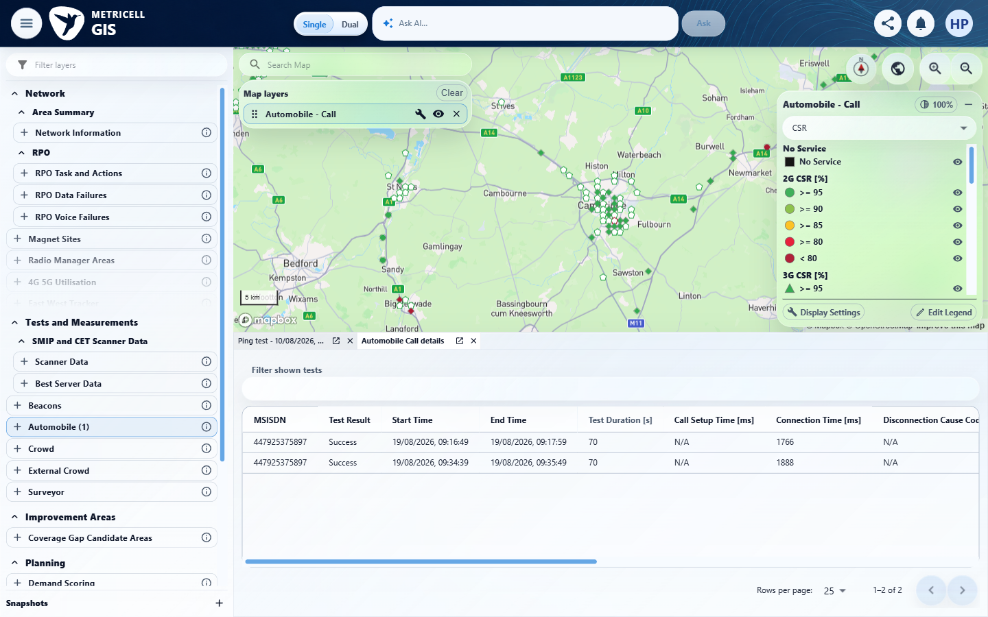 | E104 - Before sort 10 (criterion-16-before-sort-10.png)  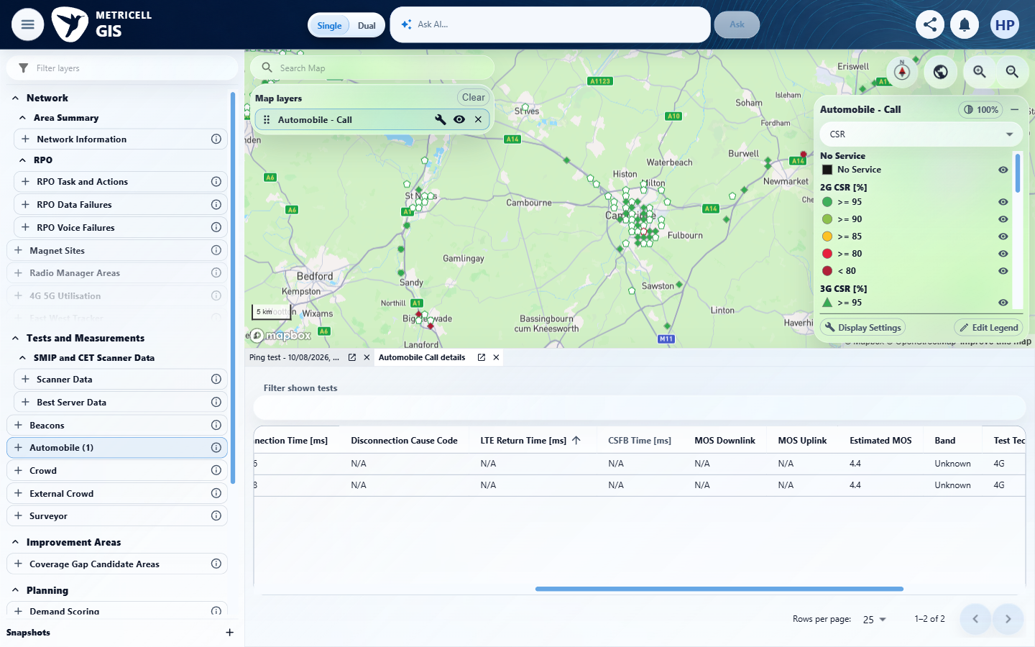

Criterion 16 continued: Each available column in the cluster results table can be sorted.
Browser URL recorded after criterion: https://o2intelligence-v4-dev.metricell.com/gis
E105 - After sort 10 (criterion-16-after-sort-10.png)  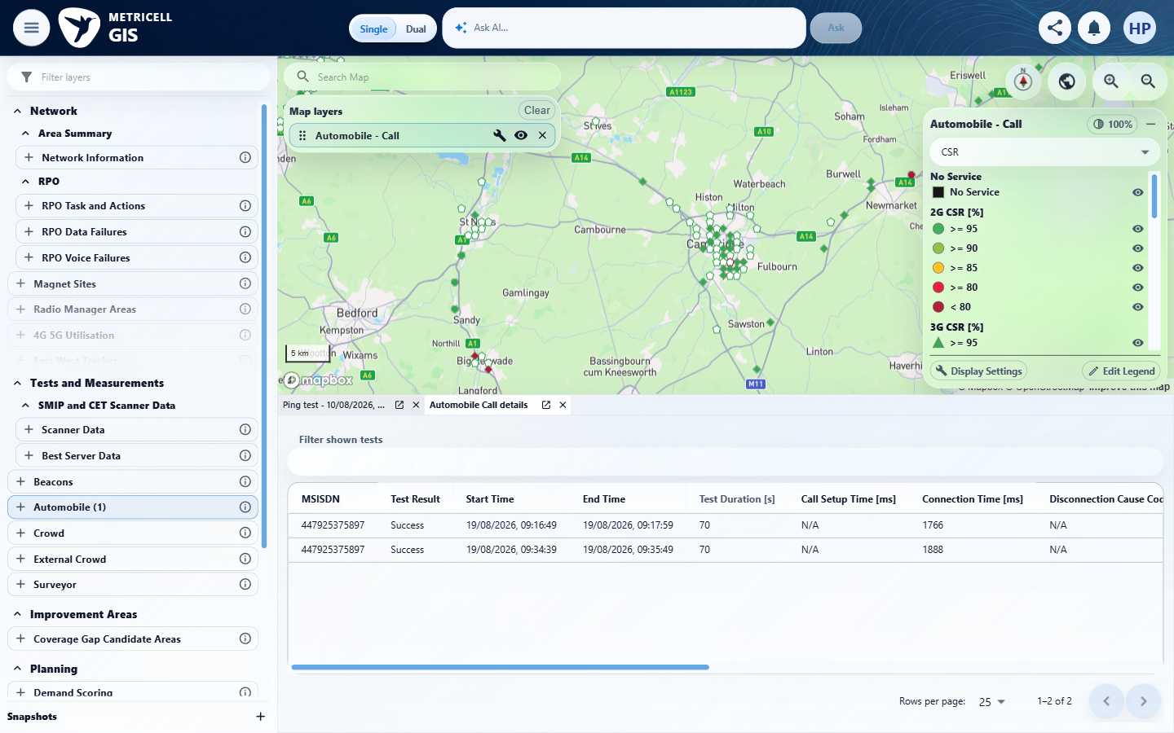 | E106 - Before sort 11 (criterion-16-before-sort-11.png)  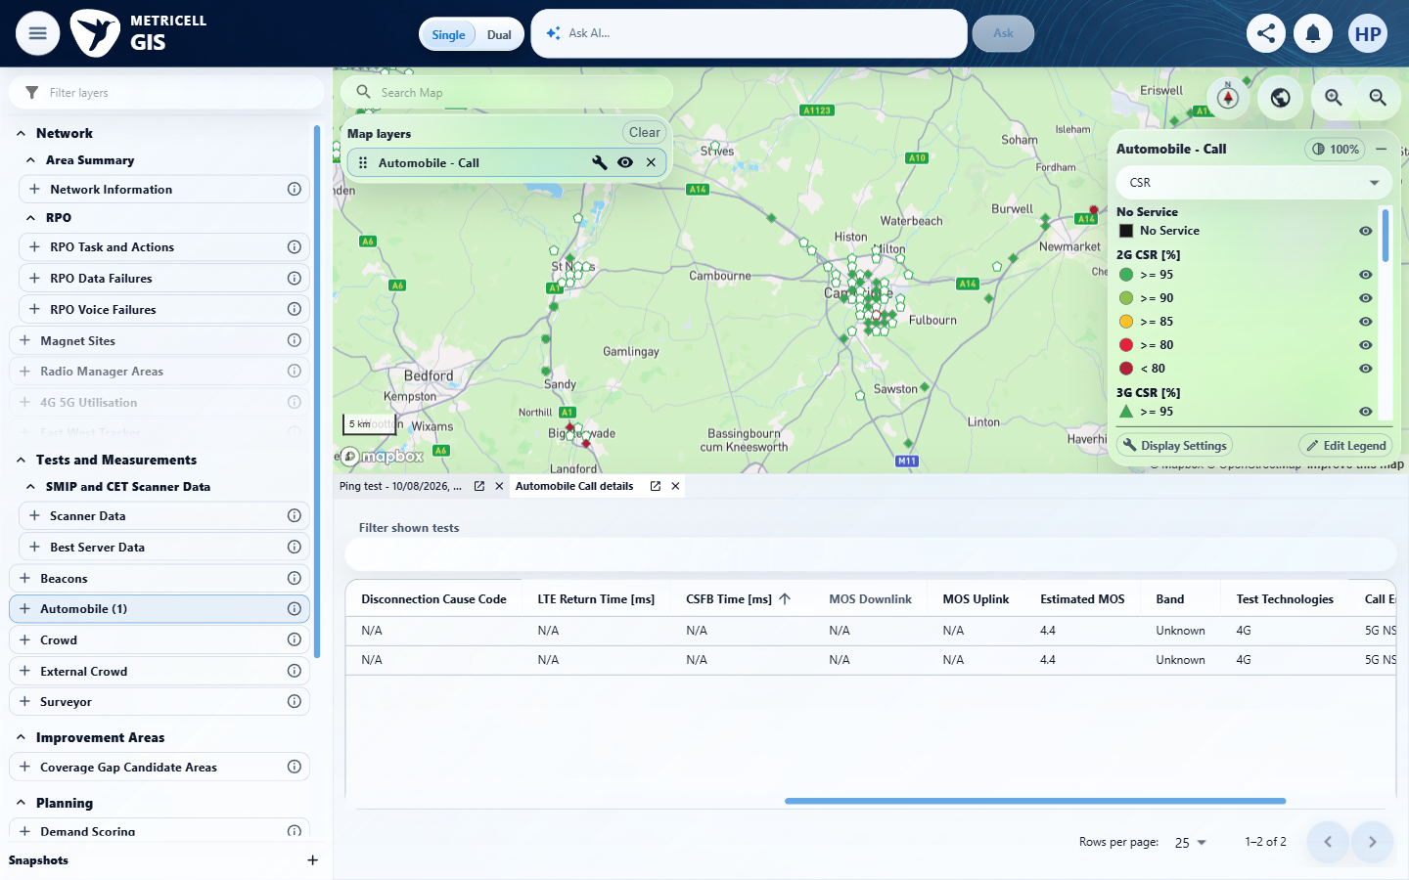

Criterion 16 continued: Each available column in the cluster results table can be sorted.
Browser URL recorded after criterion: https://o2intelligence-v4-dev.metricell.com/gis
E105 - After sort 11 (criterion-16-after-sort-11.png) | E107 - Before sort 12 (criterion-16-before-sort-12.png)  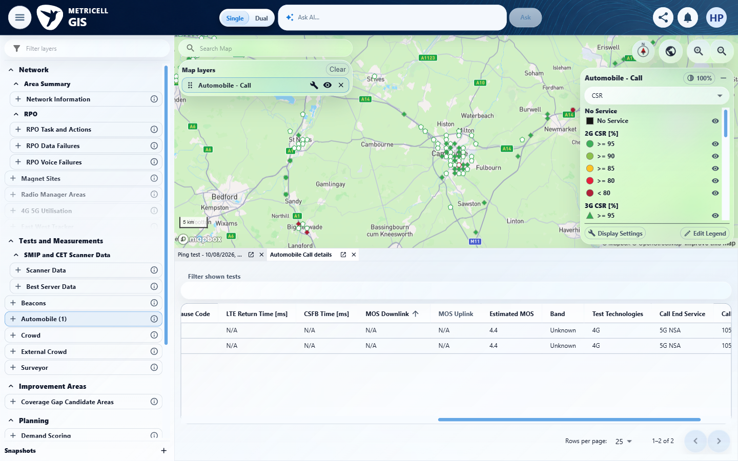

Criterion 16 continued: Each available column in the cluster results table can be sorted.
Browser URL recorded after criterion: https://o2intelligence-v4-dev.metricell.com/gis
E105 - After sort 12 (criterion-16-after-sort-12.png) | E108 - Before sort 13 (criterion-16-before-sort-13.png)  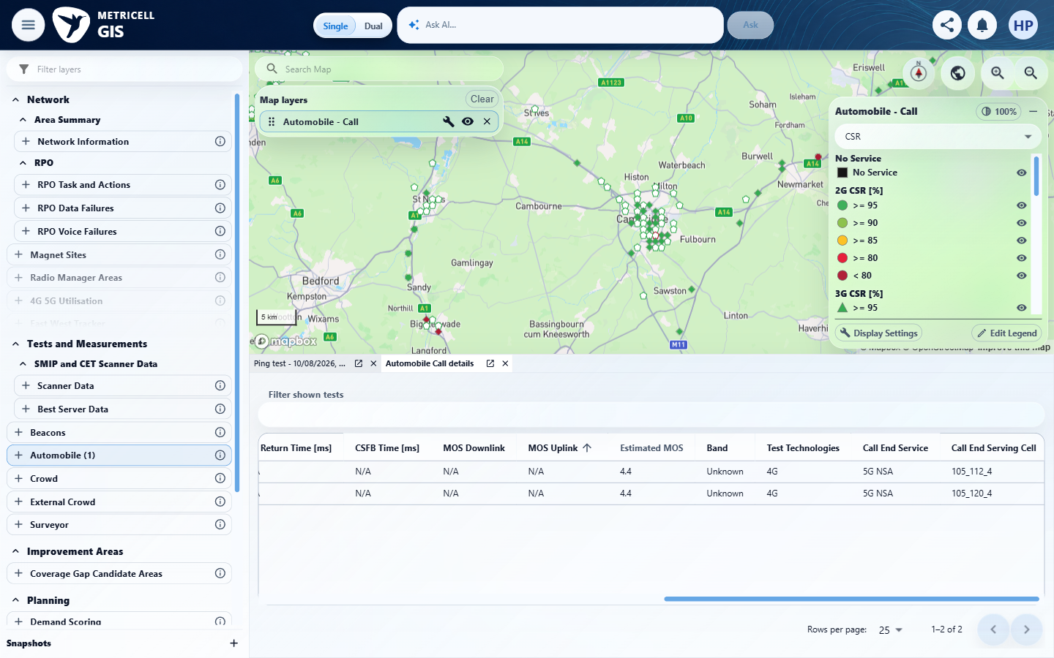

Criterion 16 continued: Each available column in the cluster results table can be sorted.
Browser URL recorded after criterion: https://o2intelligence-v4-dev.metricell.com/gis
E105 - After sort 13 (criterion-16-after-sort-13.png) | E109 - Before sort 14 (criterion-16-before-sort-14.png)  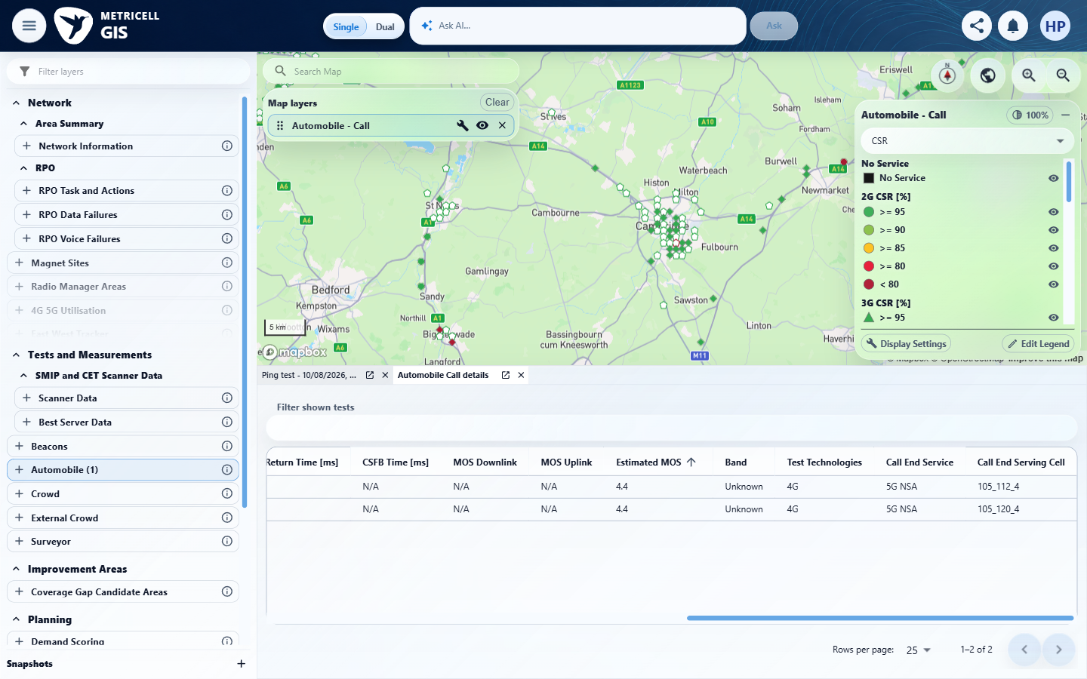

Criterion 16 continued: Each available column in the cluster results table can be sorted.
Browser URL recorded after criterion: https://o2intelligence-v4-dev.metricell.com/gis
E110 - After sort 14 (criterion-16-after-sort-14.png)  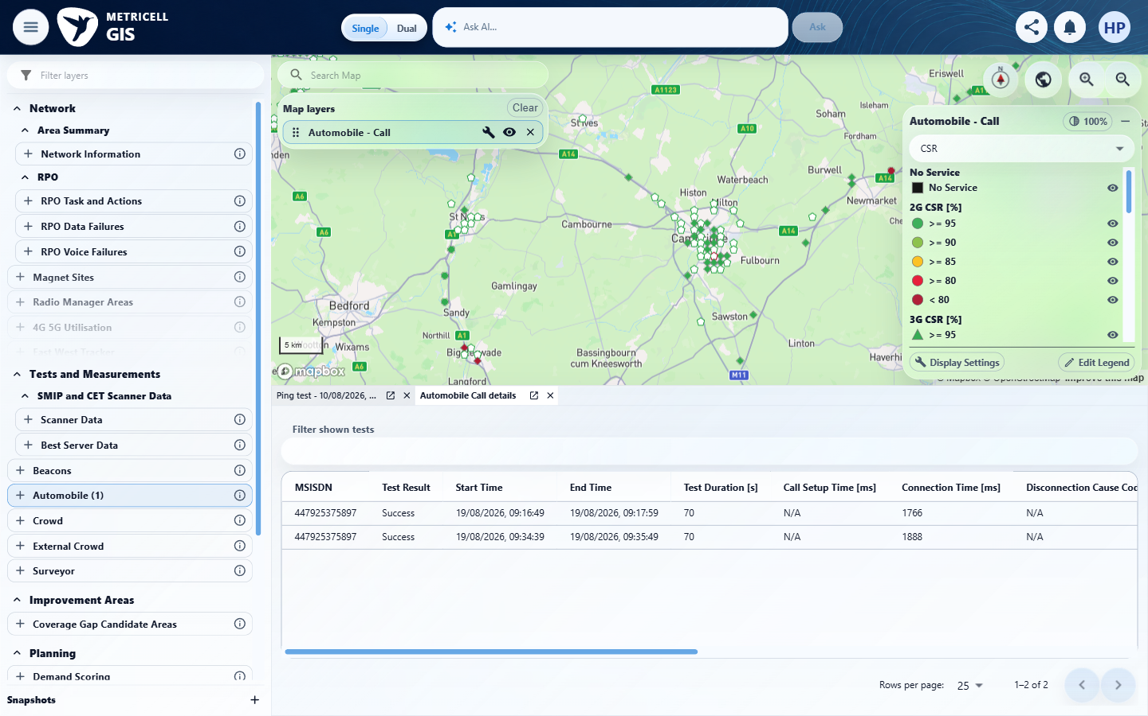 | E111 - Before sort 15 (criterion-16-before-sort-15.png)  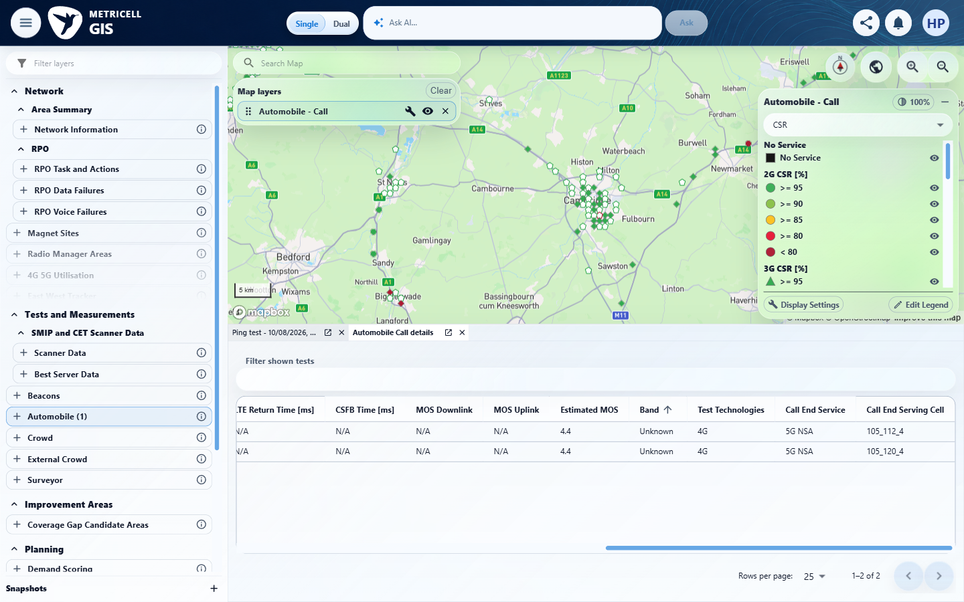

Criterion 16 continued: Each available column in the cluster results table can be sorted.
Browser URL recorded after criterion: https://o2intelligence-v4-dev.metricell.com/gis
E112 - After sort 15 (criterion-16-after-sort-15.png)  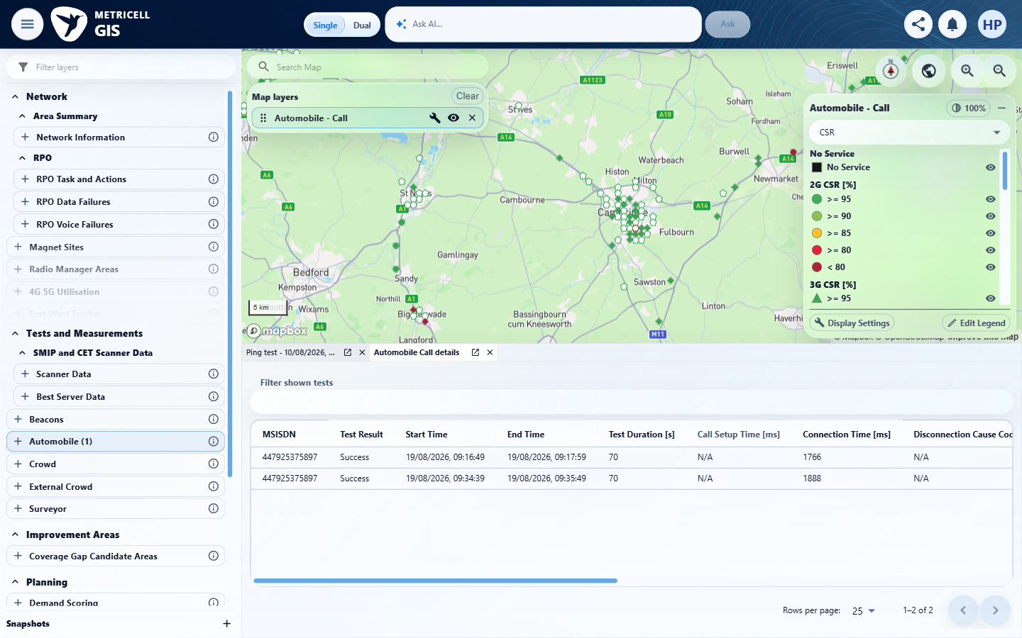 | E113 - Before sort 16 (criterion-16-before-sort-16.png)  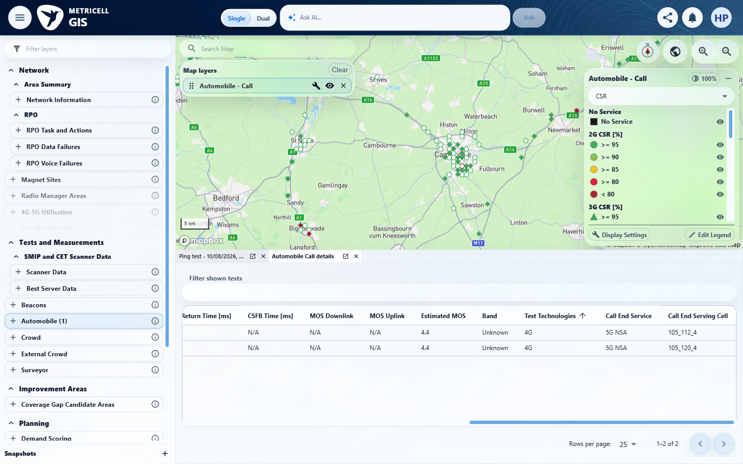

Criterion 16 continued: Each available column in the cluster results table can be sorted.
Browser URL recorded after criterion: https://o2intelligence-v4-dev.metricell.com/gis
E114 - After sort 16 (criterion-16-after-sort-16.png)  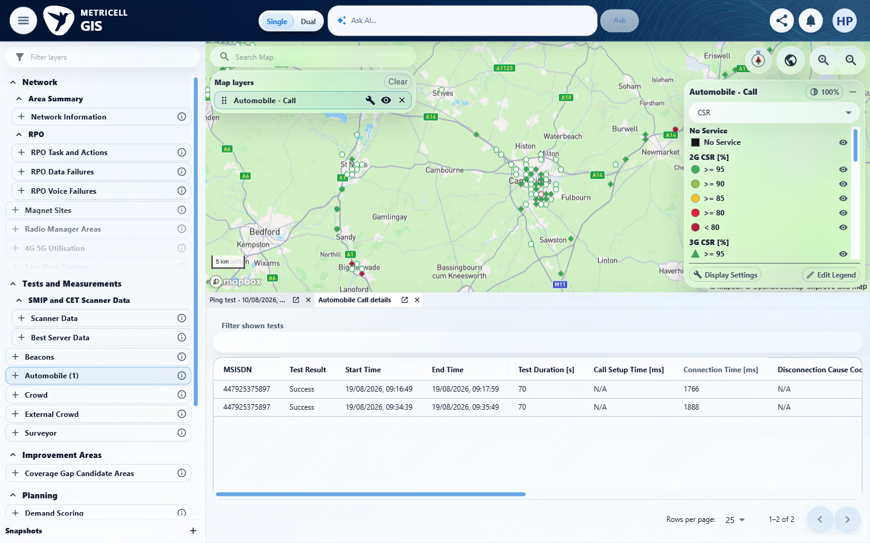 | E115 - Before sort 17 (criterion-16-before-sort-17.png)  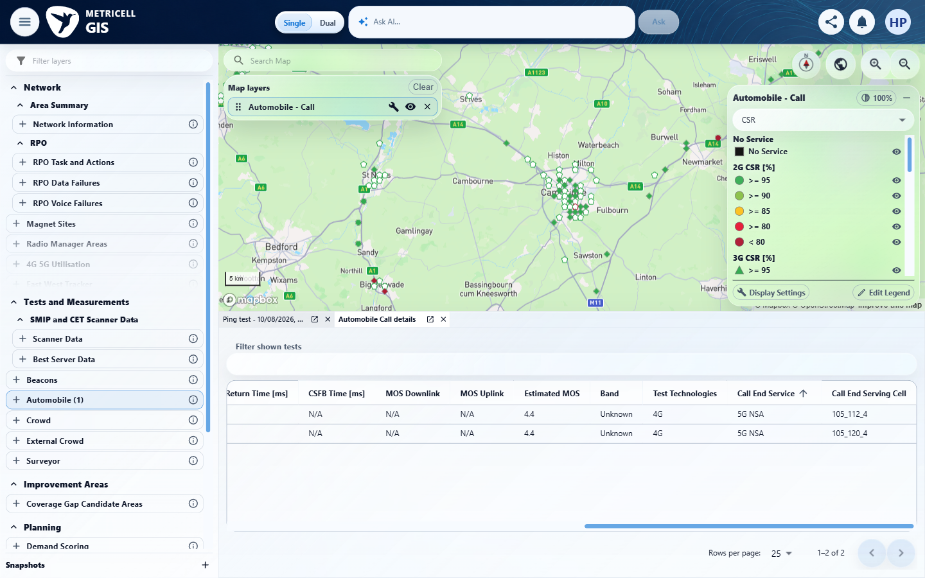

Criterion 16 continued: Each available column in the cluster results table can be sorted.
Browser URL recorded after criterion: https://o2intelligence-v4-dev.metricell.com/gis
E116 - After sort 17 (criterion-16-after-sort-17.png)  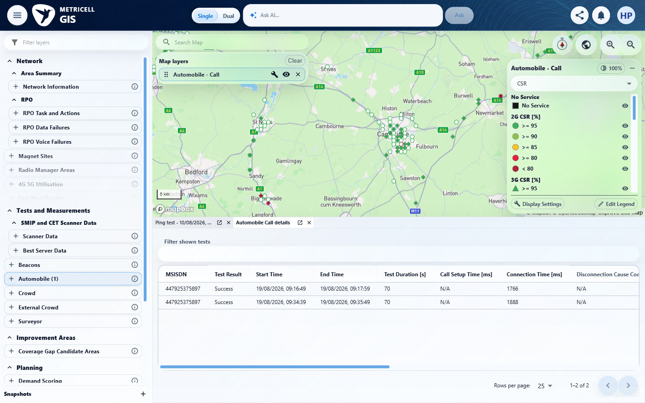 | E117 - Before time ascending (criterion-16-before-time-ascending.png)  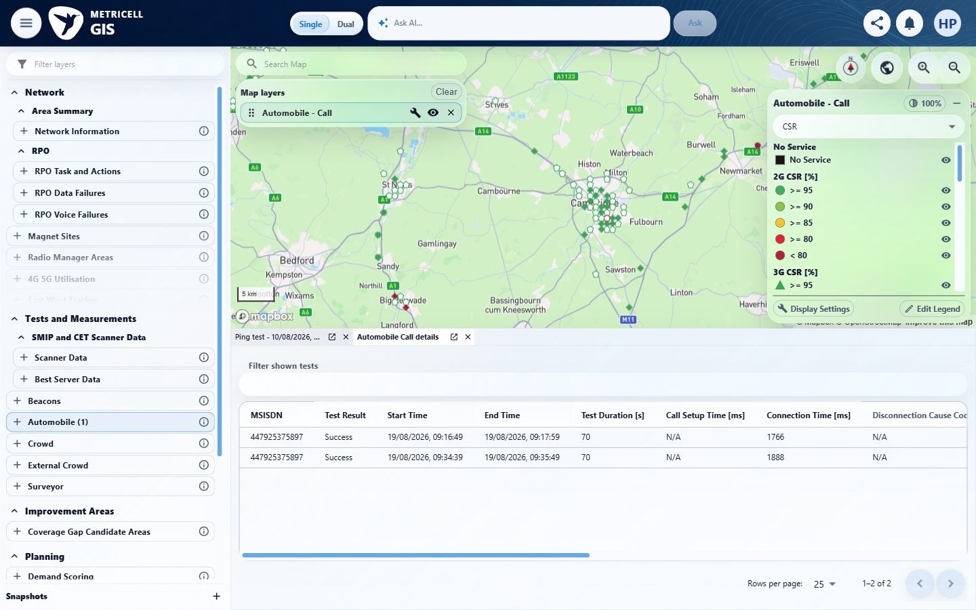

Criterion 16 continued: Each available column in the cluster results table can be sorted.
Browser URL recorded after criterion: https://o2intelligence-v4-dev.metricell.com/gis
E94 - Before time descending (criterion-16-before-time-descending.png) | E84 - Final (criterion-16-final.png)
E94 detail enlargement - full screenshot above | E84 detail enlargement - full screenshot above

17.0.0 | Selecting a cluster row opens a separate Call detail tab for that row's exact PointID and keeps the cluster tab open; reopening or restoring Call and Service tabs retains the relevant time and filter scope. | Selecting a cluster row opens a separate Call detail tab for that row's exact PointID and keeps the cluster tab open; reopening or restoring Call and Service tabs retains the relevant time and filter scope. | criterion-17-cluster.png -> selected-row.png -> restored-tabs.png/final.png shows row selection, retained cluster and restored Call identity. The tester reports exact PointID 132006263 in POST /api/platform/automobile/call/cluster-details with original scope. Related Service Details fixtures are unavailable (reported serviceDetails=null), preventing the required Service-tab reopening/restoration assessment; complete time/filter persistence is not directly visible.  Evidence: E118, E02, E119, E120, E05, E84, E121, E122, E123 | Blocked
Criterion 17 assessment: criterion-17-cluster.png -> selected-row.png -> restored-tabs.png/final.png shows row selection, retained cluster and restored Call identity. The tester reports exact PointID 132006263 in POST /api/platform/automobile/call/cluster-details with original scope. Related Service Details fixtures are unavailable (reported serviceDetails=null), preventing the required Service-tab reopening/restoration assessment; complete time/filter persistence is not directly visible.
Criterion 17 evidence: Selecting a cluster row opens a separate Call detail tab for that row's exact PointID and keeps the cluster tab open; reopening or restoring Call and Service tabs retains the relevant time and filter scope.
Browser URL recorded after criterion: https://o2intelligence-v4-dev.metricell.com/gis
E118 - Gis (criterion-17-gis.png)  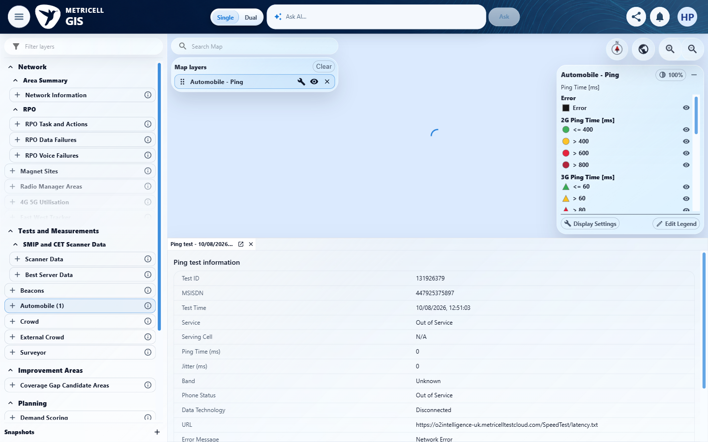 | E02 - Configuration (criterion-17-configuration.png)

Criterion 17 continued: Selecting a cluster row opens a separate Call detail tab for that row's exact PointID and keeps the cluster tab open; reopening or restoring Call and Service tabs retains the relevant time and filter scope.
Browser URL recorded after criterion: https://o2intelligence-v4-dev.metricell.com/gis
E119 - Test types (criterion-17-test-types.png)  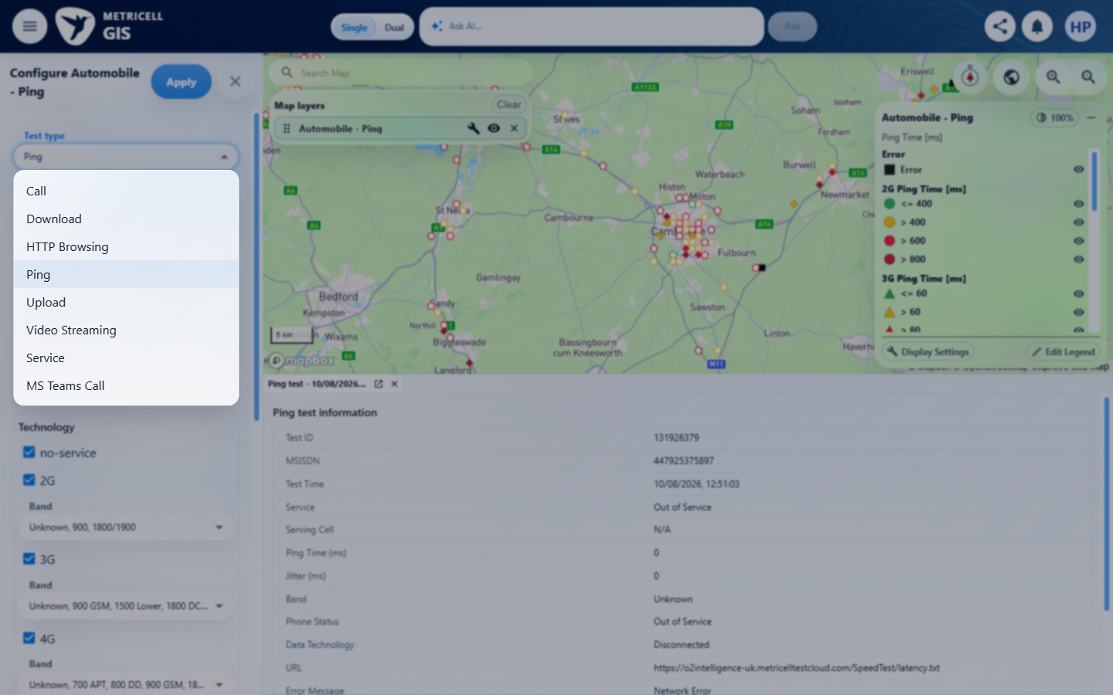 | E120 - Before apply (criterion-17-before-apply.png)  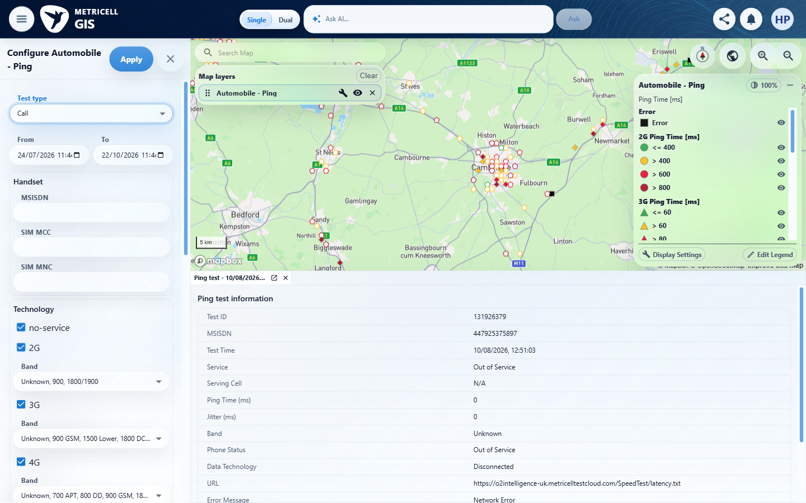

Criterion 17 continued: Selecting a cluster row opens a separate Call detail tab for that row's exact PointID and keeps the cluster tab open; reopening or restoring Call and Service tabs retains the relevant time and filter scope.
Browser URL recorded after criterion: https://o2intelligence-v4-dev.metricell.com/gis
E05 - Call map (criterion-17-call-map.png) | E84 - Cluster (criterion-17-cluster.png)

Criterion 17 continued: Selecting a cluster row opens a separate Call detail tab for that row's exact PointID and keeps the cluster tab open; reopening or restoring Call and Service tabs retains the relevant time and filter scope.
Browser URL recorded after criterion: https://o2intelligence-v4-dev.metricell.com/gis
E121 - Selected row (criterion-17-selected-row.png)  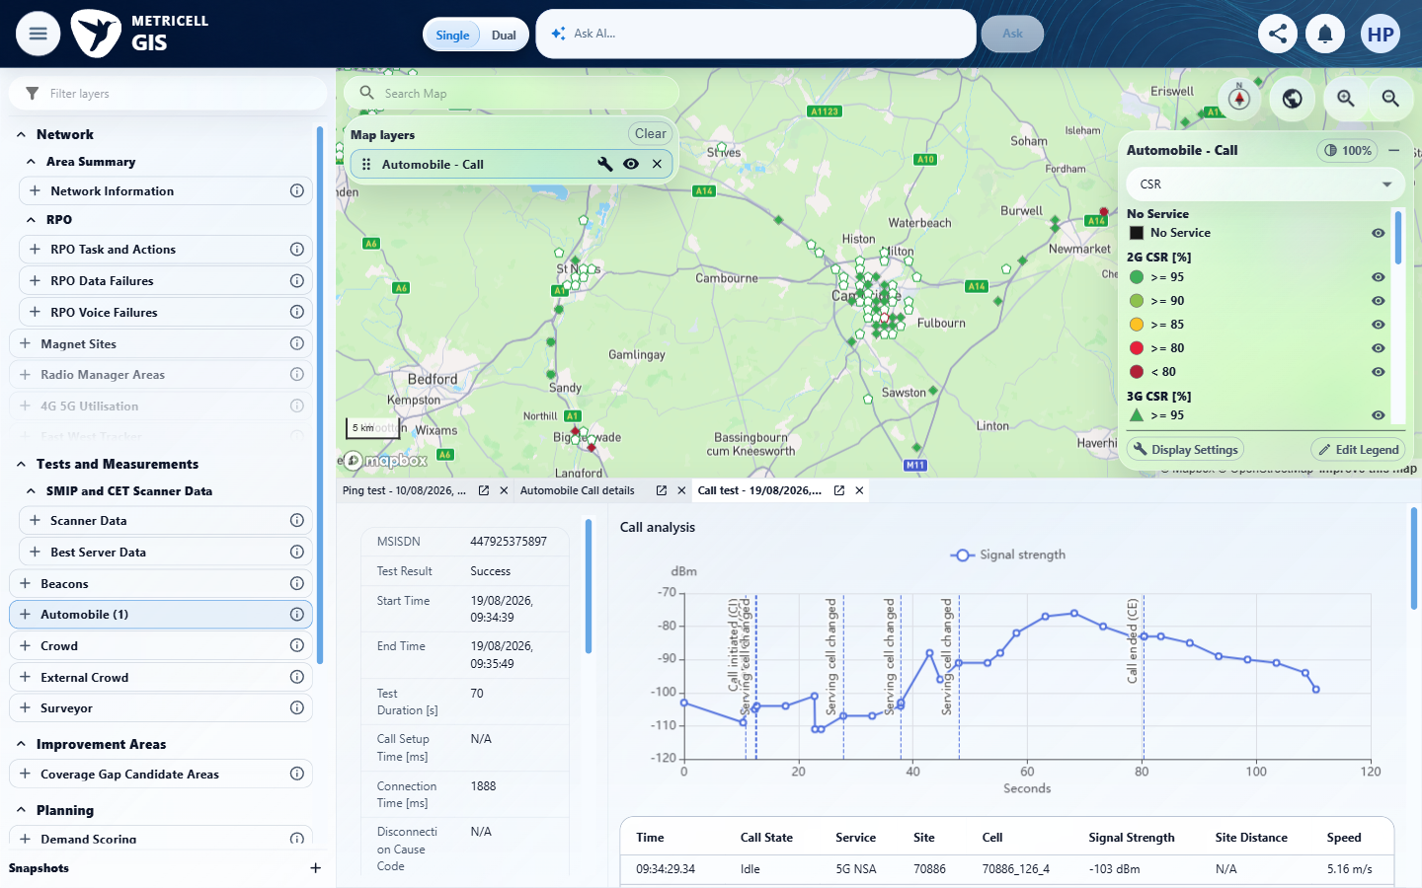 | E122 - Before reopen (criterion-17-before-reopen.png)  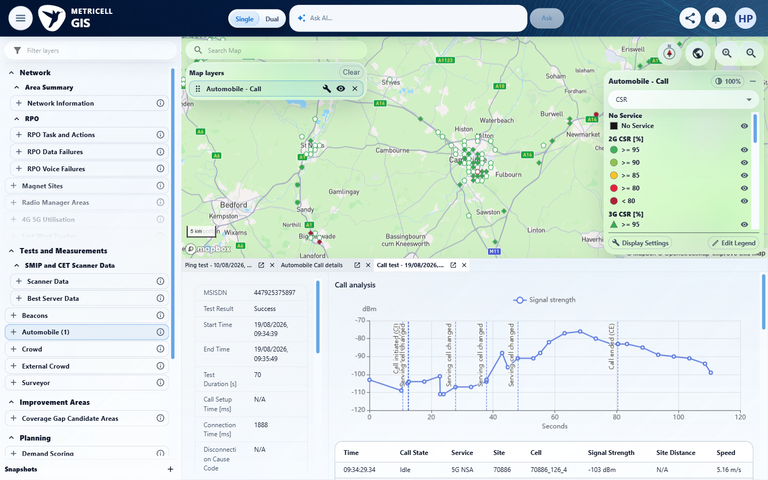

Criterion 17 continued: Selecting a cluster row opens a separate Call detail tab for that row's exact PointID and keeps the cluster tab open; reopening or restoring Call and Service tabs retains the relevant time and filter scope.
Browser URL recorded after criterion: https://o2intelligence-v4-dev.metricell.com/gis
E123 - Final (criterion-17-final.png)
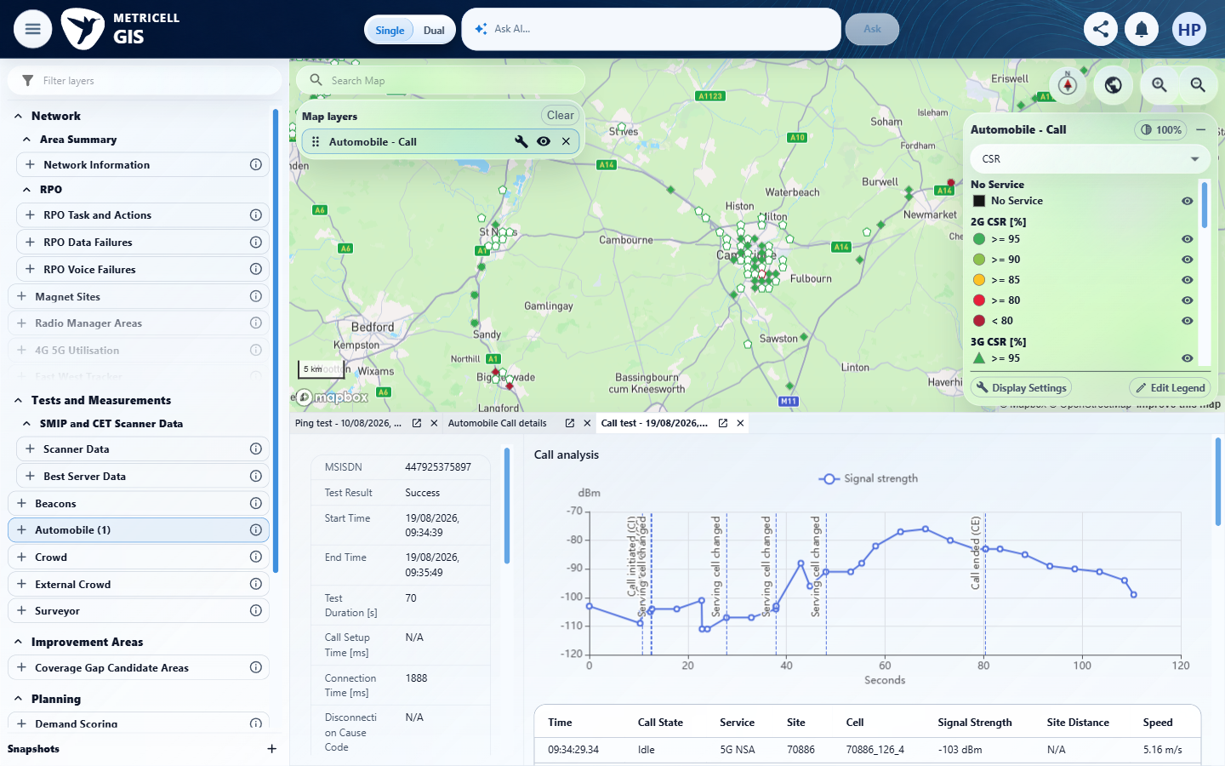

18.0.0 | When a selected result has related service information, its Service Details tab can be opened. | When a selected result has related service information, its Service Details tab can be opened. | Related-service prerequisite is unavailable: tester reports serviceDetails=null for the observed Call records. criterion-18-service-unavailable.png shows no related Service Details action; after-measurement-select.png and final-measurement-checked.png show a Call detail tab from a measurement, which does not demonstrate Service Details.  Evidence: E124, E02, E03, E04, E05, E125, E126 | Blocked
Criterion 18 assessment: Related-service prerequisite is unavailable: tester reports serviceDetails=null for the observed Call records. criterion-18-service-unavailable.png shows no related Service Details action; after-measurement-select.png and final-measurement-checked.png show a Call detail tab from a measurement, which does not demonstrate Service Details.
Testing notes: Related-service prerequisite unavailable: genuine Call record 132047844 has serviceDetails=null; cluster records 132006263 and 132005737 also have serviceDetails=null. No Service Details action was available. Selecting a Call measurement opens a separate Call detail tab, not a Service Details tab, so it is not a substitute for the required related-service fixture.
Criterion 18 evidence: When a selected result has related service information, its Service Details tab can be opened.
Browser URL recorded after criterion: https://o2intelligence-v4-dev.metricell.com/gis
E124 - Gis (criterion-18-gis.png)  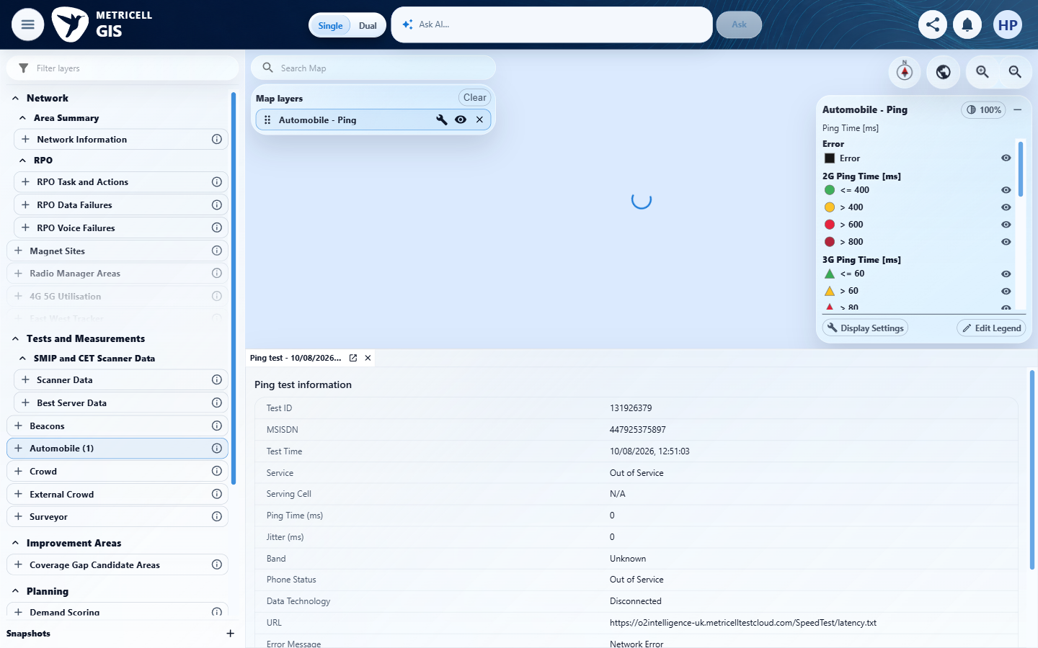 | E02 - Configuration (criterion-18-configuration.png)

Criterion 18 continued: When a selected result has related service information, its Service Details tab can be opened.
Browser URL recorded after criterion: https://o2intelligence-v4-dev.metricell.com/gis
E03 - Test types (criterion-18-test-types.png) | E04 - Before apply (criterion-18-before-apply.png)

Criterion 18 continued: When a selected result has related service information, its Service Details tab can be opened.
Browser URL recorded after criterion: https://o2intelligence-v4-dev.metricell.com/gis
E05 - Call map (criterion-18-call-map.png) | E125 - Selected result (criterion-18-selected-result.png)  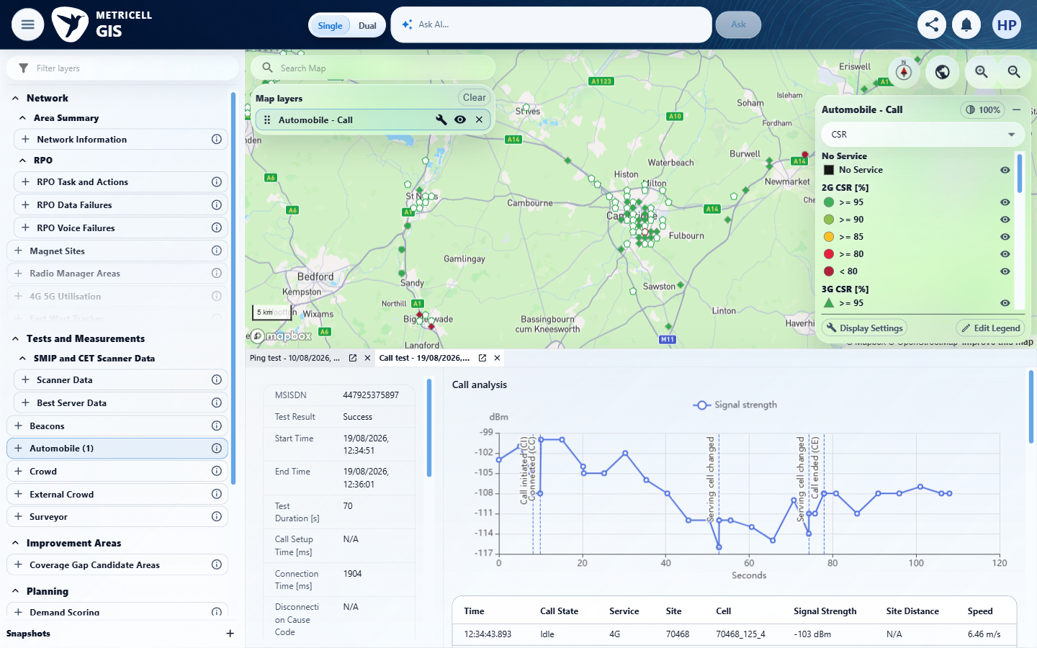

Criterion 18 continued: When a selected result has related service information, its Service Details tab can be opened.
Browser URL recorded after criterion: https://o2intelligence-v4-dev.metricell.com/gis
E126 - Final (criterion-18-final.png)
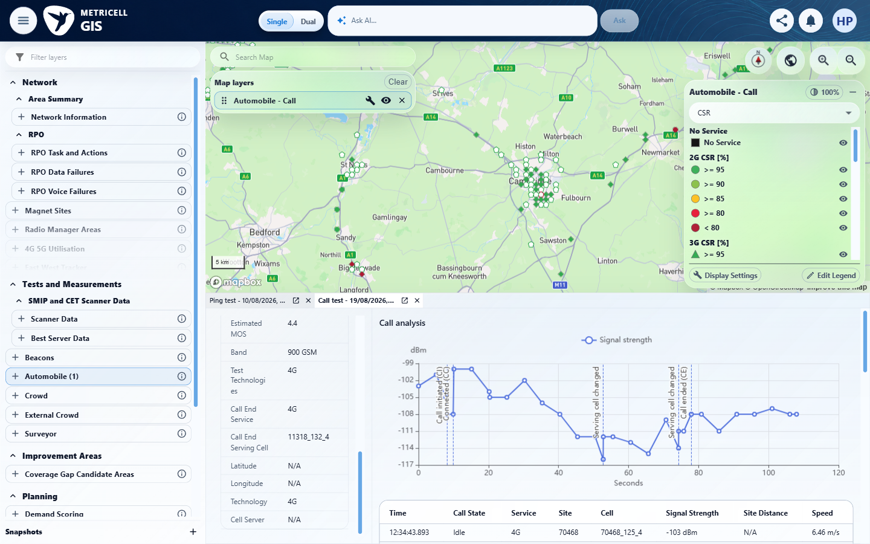

19.0.0 | Call technology legends and filters include 2G, 3G, 4G, and 5G SA and exclude 5G NSA. | Call technology legends and filters include 2G, 3G, 4G, and 5G SA and exclude 5G NSA. | criterion-19-forbidden-nsa-legend.png visibly shows 5G NSA CSR [%] on Automobile Call, directly contradicting exclusion. technology-filter.png and final.png show only the upper filter viewport through 4G; they do not visibly establish the claimed checked NSA filter, but the legend alone proves the failure.  Evidence: E127, E32, E119, E128, E73, E129, E130 | Failed
Criterion 19 assessment: criterion-19-forbidden-nsa-legend.png visibly shows 5G NSA CSR [%] on Automobile Call, directly contradicting exclusion. technology-filter.png and final.png show only the upper filter viewport through 4G; they do not visibly establish the claimed checked NSA filter, but the legend alone proves the failure.
Criterion 19 evidence: Call technology legends and filters include 2G, 3G, 4G, and 5G SA and exclude 5G NSA.
Browser URL recorded after criterion: https://o2intelligence-v4-dev.metricell.com/gis
E127 - Gis (criterion-19-gis.png)  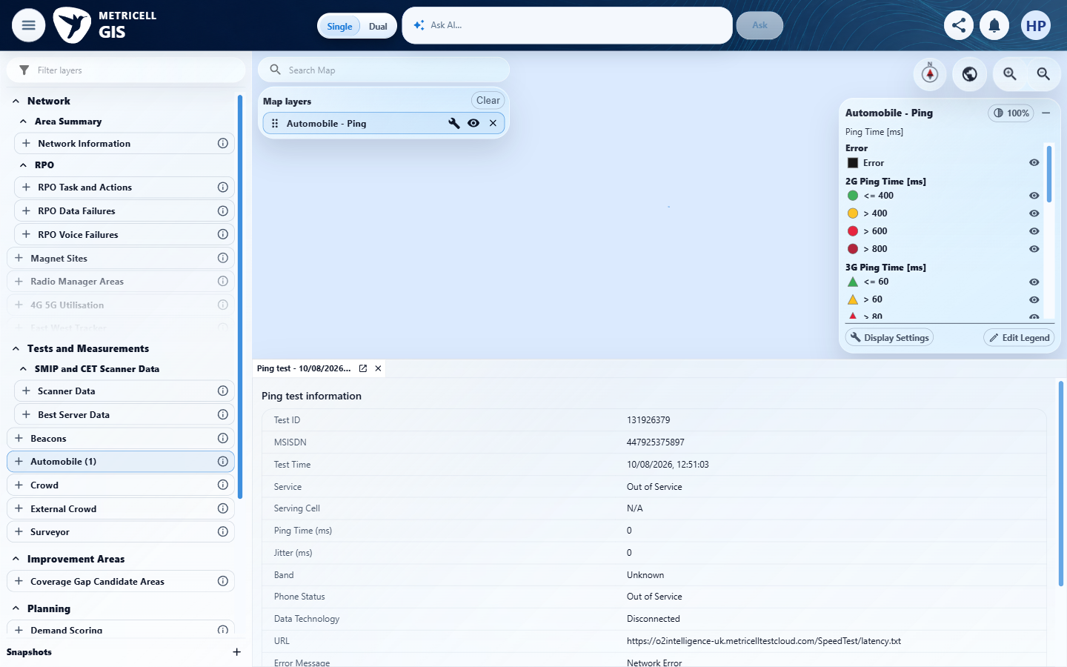 | E32 - Configuration (criterion-19-configuration.png)

Criterion 19 continued: Call technology legends and filters include 2G, 3G, 4G, and 5G SA and exclude 5G NSA.
Browser URL recorded after criterion: https://o2intelligence-v4-dev.metricell.com/gis
E119 - Test types (criterion-19-test-types.png) | E128 - Before apply (criterion-19-before-apply.png)  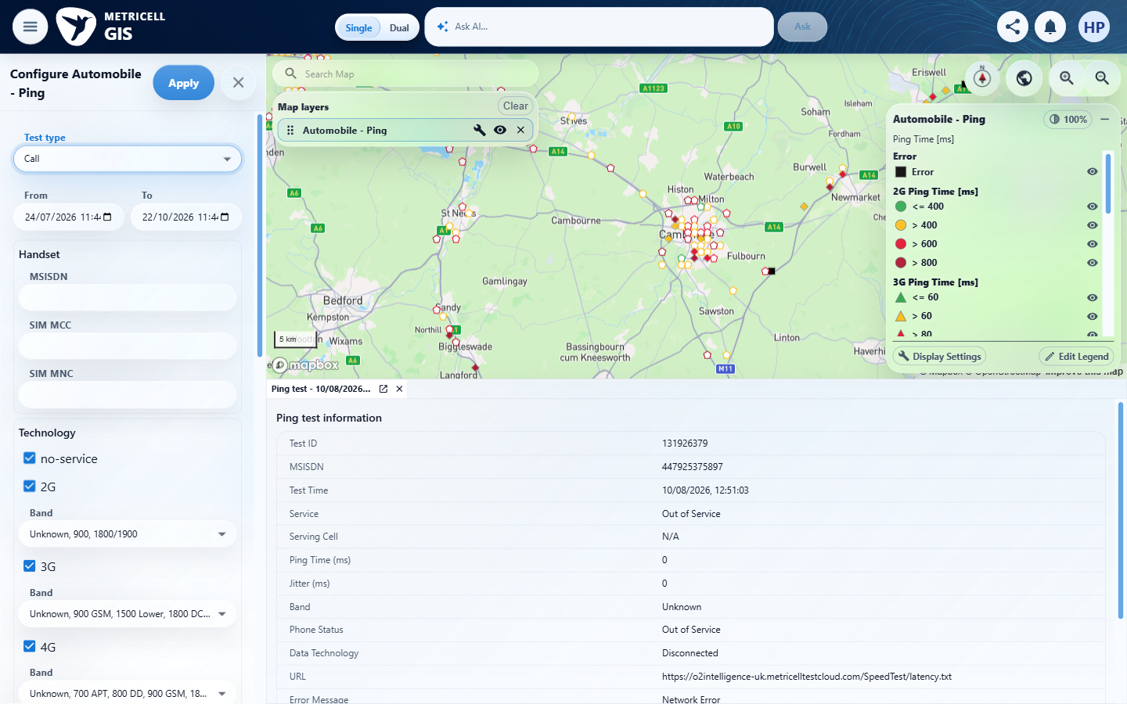

Criterion 19 continued: Call technology legends and filters include 2G, 3G, 4G, and 5G SA and exclude 5G NSA.
Browser URL recorded after criterion: https://o2intelligence-v4-dev.metricell.com/gis
E73 - Call map (criterion-19-call-map.png) | E129 - Forbidden nsa legend (criterion-19-forbidden-nsa-legend.png)  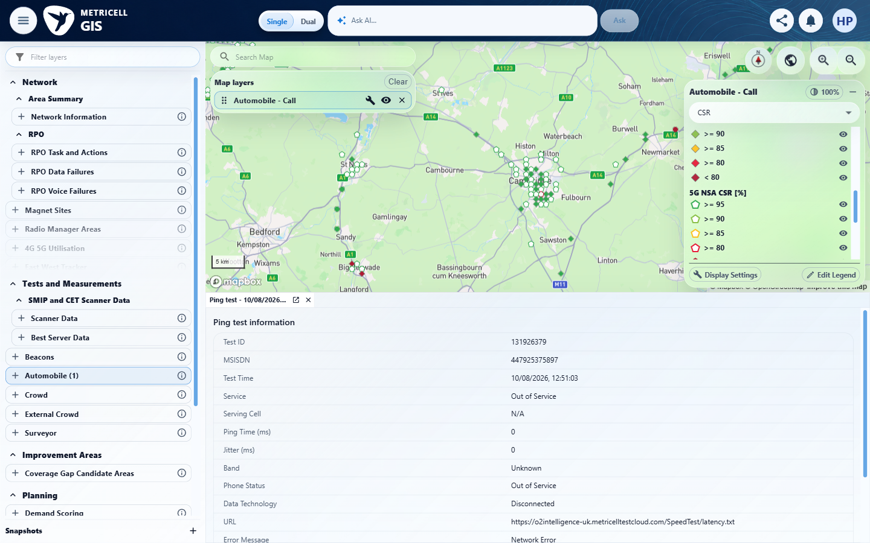

Criterion 19 continued: Call technology legends and filters include 2G, 3G, 4G, and 5G SA and exclude 5G NSA.
Browser URL recorded after criterion: https://o2intelligence-v4-dev.metricell.com/gis
E130 - Final (criterion-19-final.png)
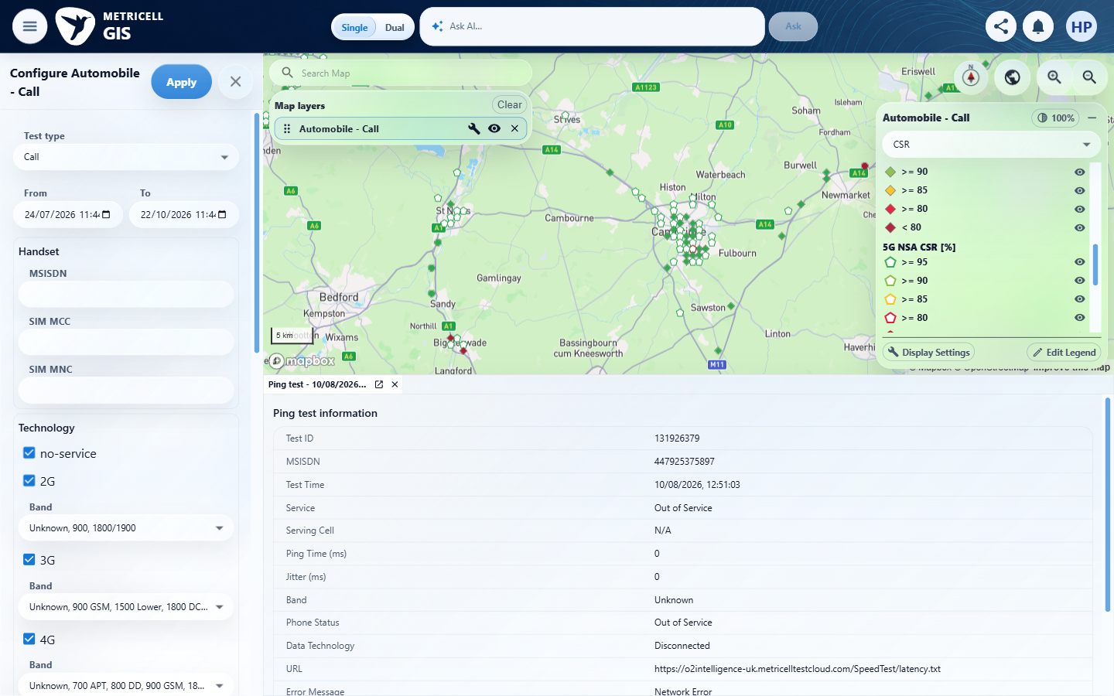

20.0.0 | Requesting details for a selected result with no duration displays a clear no-data message. | Requesting details for a selected result with no duration displays a clear no-data message. | criterion-20-no-service-selection.png, zero-duration.png and final.png show the selected Out Of Service Call with identical start/end time, Test Duration [s] 0 and a clear No data available message. The reported genuine Automobile Call detail response identifies PointID 131922311; no simulation was used.  Evidence: E131, E17, E132, E83, E05, E133, E134, E135, E136 | Passed
Criterion 20 assessment: criterion-20-no-service-selection.png, zero-duration.png and final.png show the selected Out Of Service Call with identical start/end time, Test Duration [s] 0 and a clear No data available message. The reported genuine Automobile Call detail response identifies PointID 131922311; no simulation was used.
Testing notes: Inspected one failed result (20.325 s), zoomed out once, then selected the actual No Service point using its observed coordinates and map centre/zoom.
Criterion 20 evidence: Requesting details for a selected result with no duration displays a clear no-data message.
Browser URL recorded after criterion: https://o2intelligence-v4-dev.metricell.com/gis
E131 - Gis (criterion-20-gis.png)  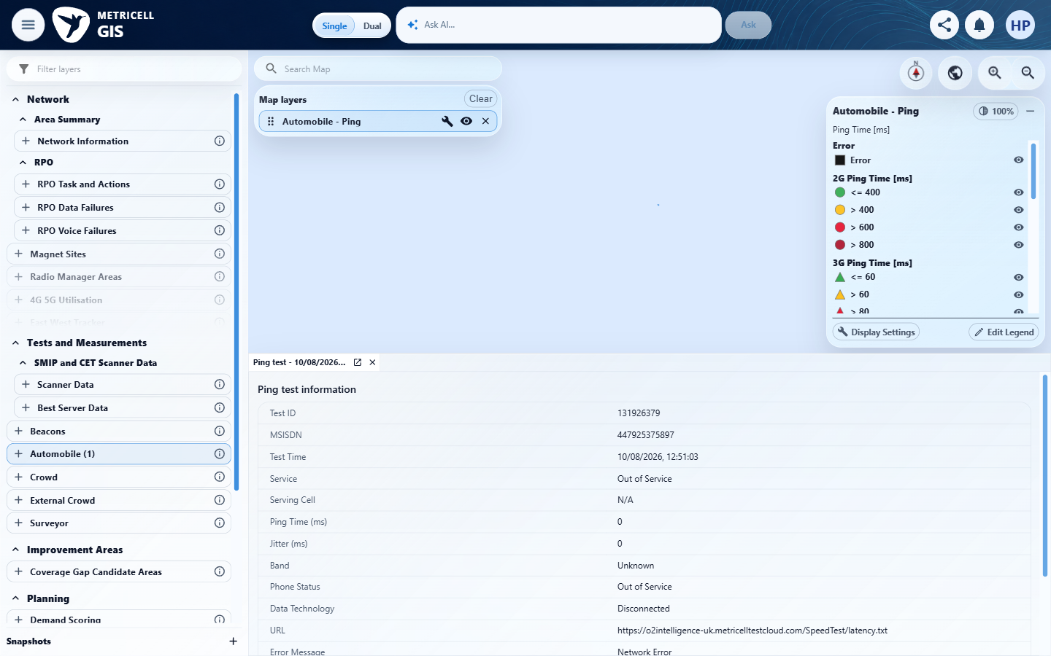 | E17 - Configuration (criterion-20-configuration.png)

Criterion 20 continued: Requesting details for a selected result with no duration displays a clear no-data message.
Browser URL recorded after criterion: https://o2intelligence-v4-dev.metricell.com/gis
E132 - Test types (criterion-20-test-types.png)  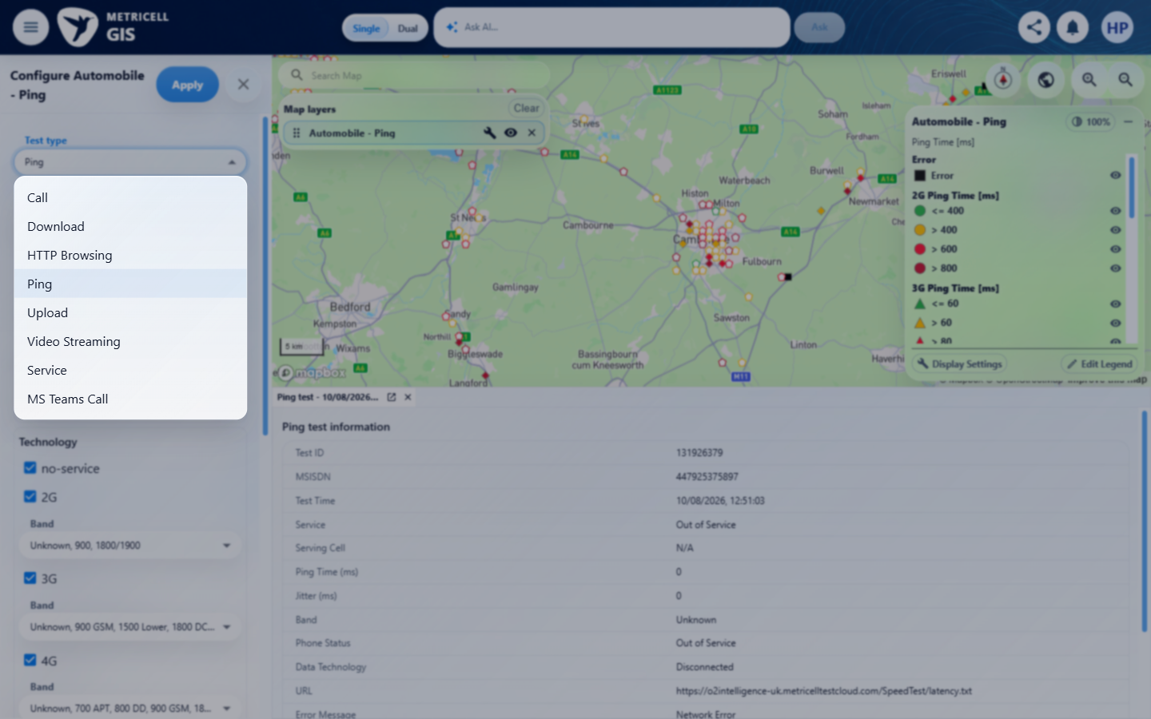 | E83 - Before apply (criterion-20-before-apply.png)

Criterion 20 continued: Requesting details for a selected result with no duration displays a clear no-data message.
Browser URL recorded after criterion: https://o2intelligence-v4-dev.metricell.com/gis
E05 - Call map (criterion-20-call-map.png) | E133 - Failed call selection (criterion-20-failed-call-selection.png)  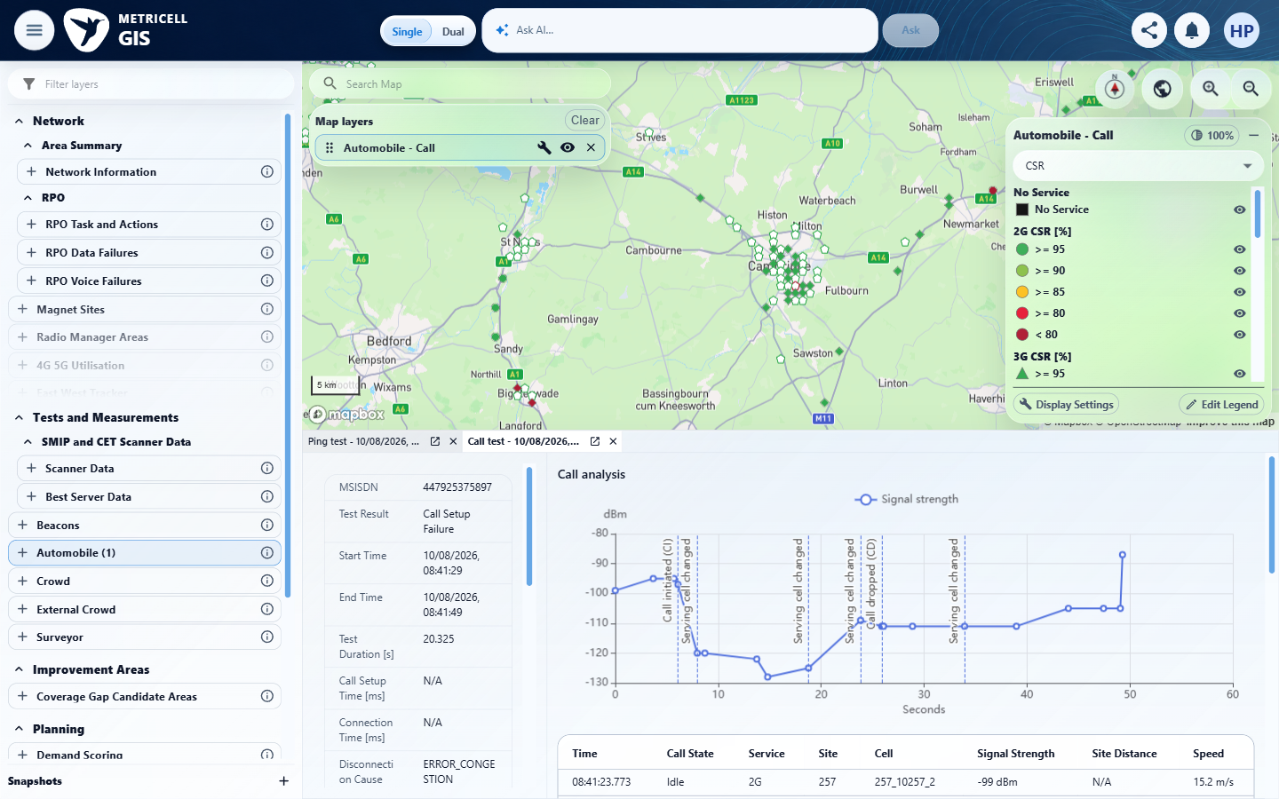

Criterion 20 continued: Requesting details for a selected result with no duration displays a clear no-data message.
Browser URL recorded after criterion: https://o2intelligence-v4-dev.metricell.com/gis
E134 - Before zoom out (criterion-20-before-zoom-out.png)  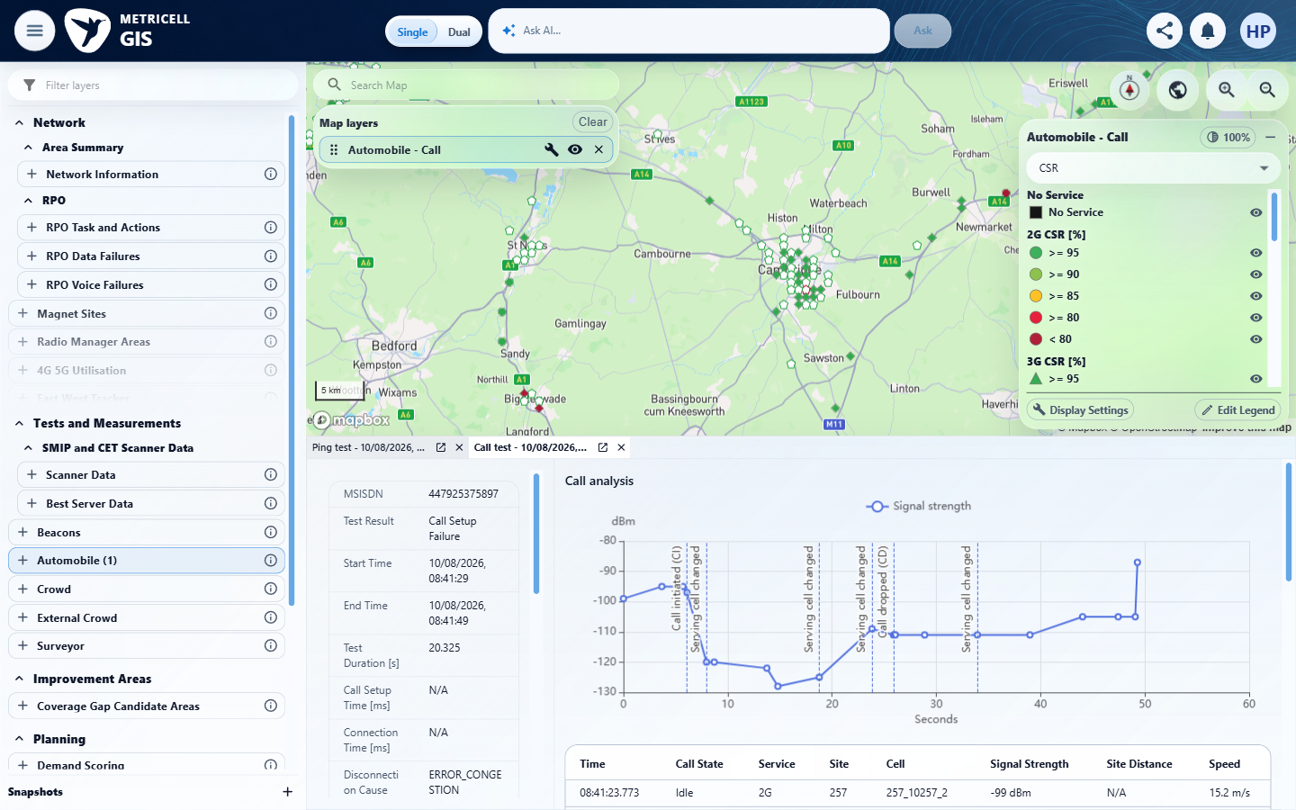 | E135 - After zoom out (criterion-20-after-zoom-out.png)  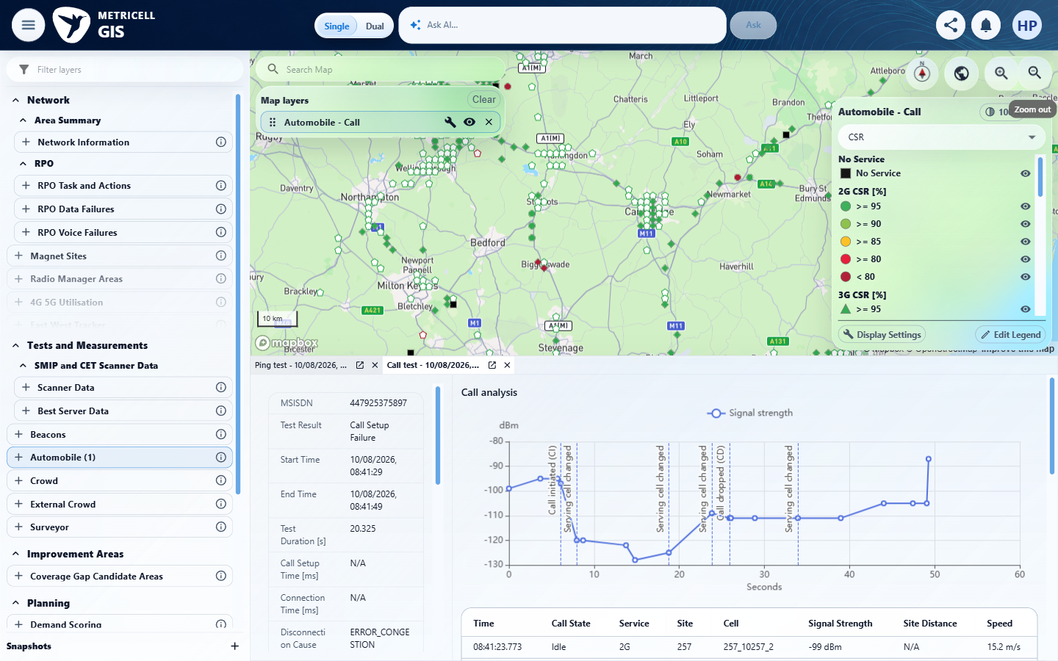

Criterion 20 continued: Requesting details for a selected result with no duration displays a clear no-data message.
Browser URL recorded after criterion: https://o2intelligence-v4-dev.metricell.com/gis
E136 - Final (criterion-20-final.png)
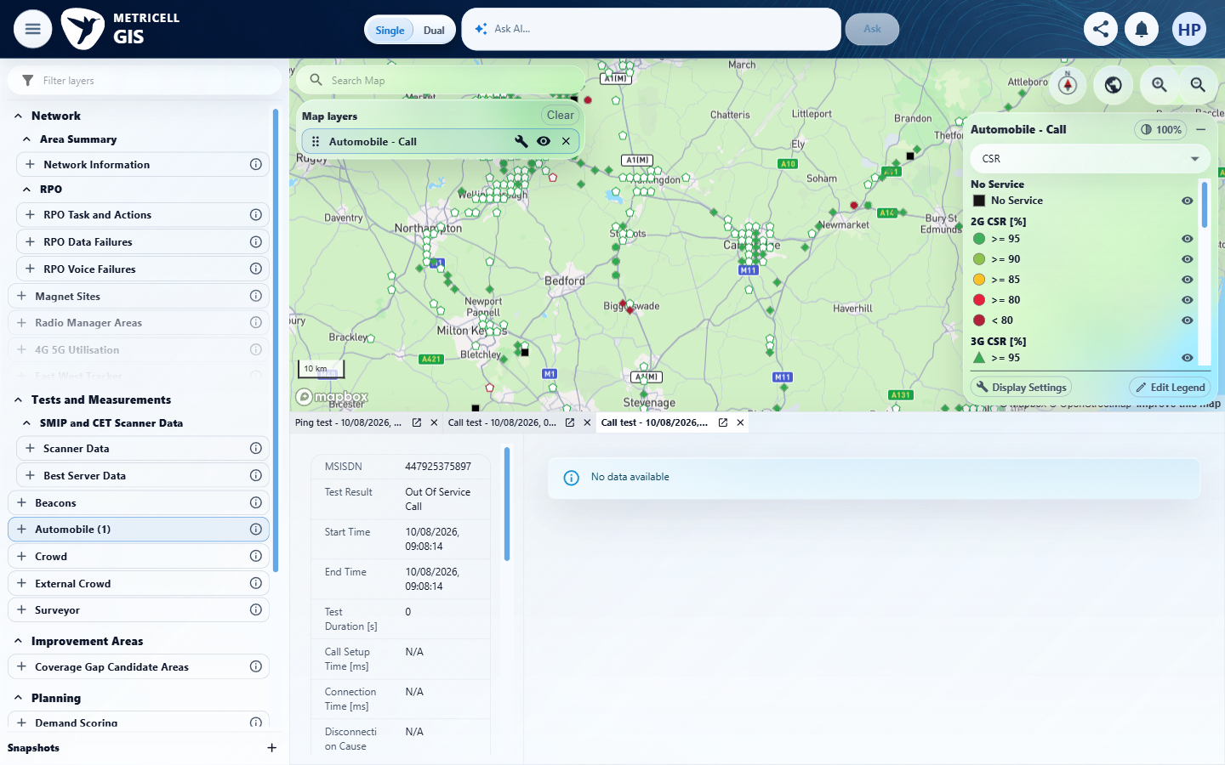

21.0.0 | When point or service details cannot be returned, the selected item does not show stale detail data. | When point or service details cannot be returned, the selected item does not show stale detail data. | SIMULATED UI STATE: criterion-21-genuine-target-loaded.png establishes the target Call; distinct-record-baseline.png shows a different previously loaded Call, synthetic-error.png/final.png shows Unable to load Call details without stale definitions, and genuine-recovery.png restores the target. Tester reports a scoped POST /api/platform/automobile/call/cluster-details HTTP 503 for pointId 132006263 on the configured development host after genuine HTTP 200 contract observation; unmatched requests fell through. Owned-handler removal in finally, one hit, zero pending requests and genuine HTTP 200 recovery are reported. This evidences only the simulated point-detail UI branch, not natural backend failure; the Service branch remains blocked by absent related-service fixtures.  Evidence: E137, E02, E138, E04, E35, E84, E139, E140, E141, E142, E143 | Blocked
Criterion 21 assessment: SIMULATED UI STATE: criterion-21-genuine-target-loaded.png establishes the target Call; distinct-record-baseline.png shows a different previously loaded Call, synthetic-error.png/final.png shows Unable to load Call details without stale definitions, and genuine-recovery.png restores the target. Tester reports a scoped POST /api/platform/automobile/call/cluster-details HTTP 503 for pointId 132006263 on the configured development host after genuine HTTP 200 contract observation; unmatched requests fell through. Owned-handler removal in finally, one hit, zero pending requests and genuine HTTP 200 recovery are reported. This evidences only the simulated point-detail UI branch, not natural backend failure; the Service branch remains blocked by absent related-service fixtures.
Criterion 21 evidence: When point or service details cannot be returned, the selected item does not show stale detail data.
SIMULATED UI STATE: browser-local condition; recovery uses the genuine service.
Browser URL recorded after criterion: https://o2intelligence-v4-dev.metricell.com/gis
E137 - Gis (criterion-21-gis.png)  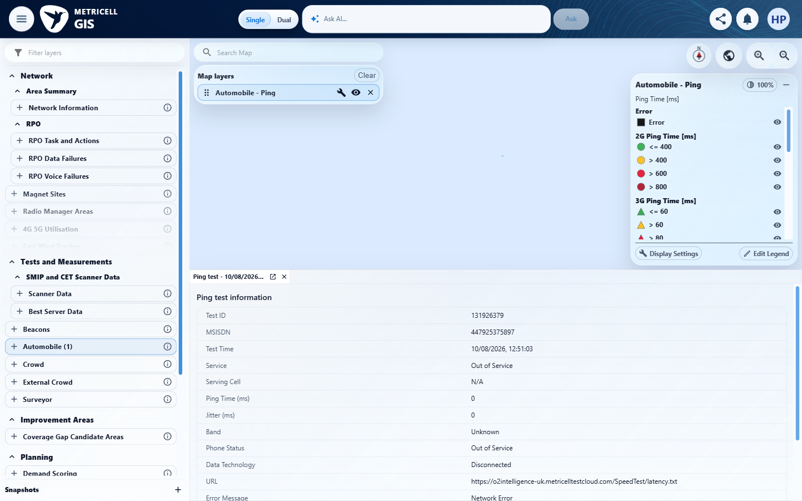 | E02 - Configuration (criterion-21-configuration.png)

Criterion 21 continued: When point or service details cannot be returned, the selected item does not show stale detail data.
SIMULATED UI STATE: browser-local condition; recovery uses the genuine service.
Browser URL recorded after criterion: https://o2intelligence-v4-dev.metricell.com/gis
E138 - Test types (criterion-21-test-types.png)  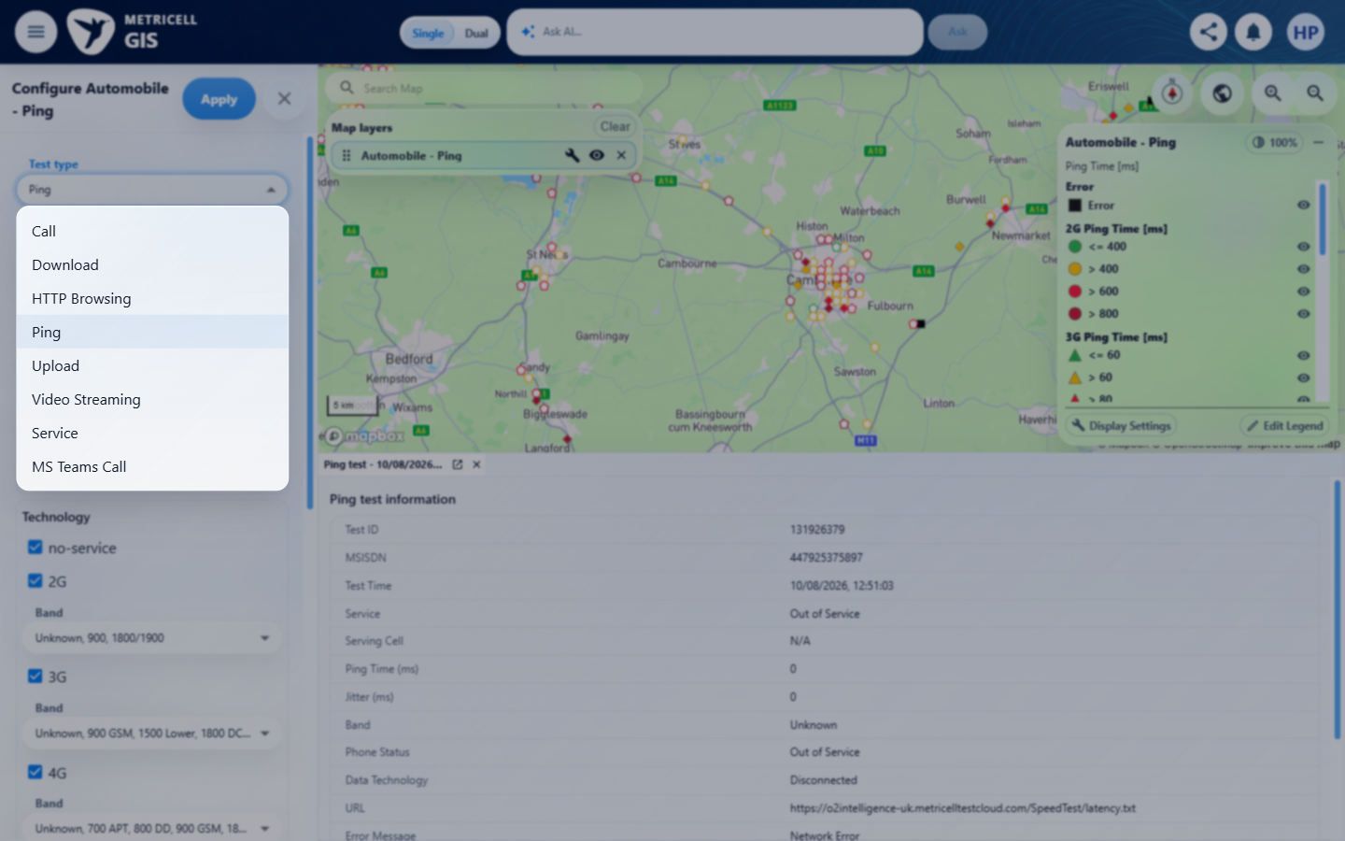 | E04 - Before apply (criterion-21-before-apply.png)

Criterion 21 continued: When point or service details cannot be returned, the selected item does not show stale detail data.
SIMULATED UI STATE: browser-local condition; recovery uses the genuine service.
Browser URL recorded after criterion: https://o2intelligence-v4-dev.metricell.com/gis
E35 - Call map (criterion-21-call-map.png) | E84 - Cluster baseline (criterion-21-cluster-baseline.png)

Criterion 21 continued: When point or service details cannot be returned, the selected item does not show stale detail data.
SIMULATED UI STATE: browser-local condition; recovery uses the genuine service.
Browser URL recorded after criterion: https://o2intelligence-v4-dev.metricell.com/gis
E139 - Genuine target loaded (criterion-21-genuine-target-loaded.png)  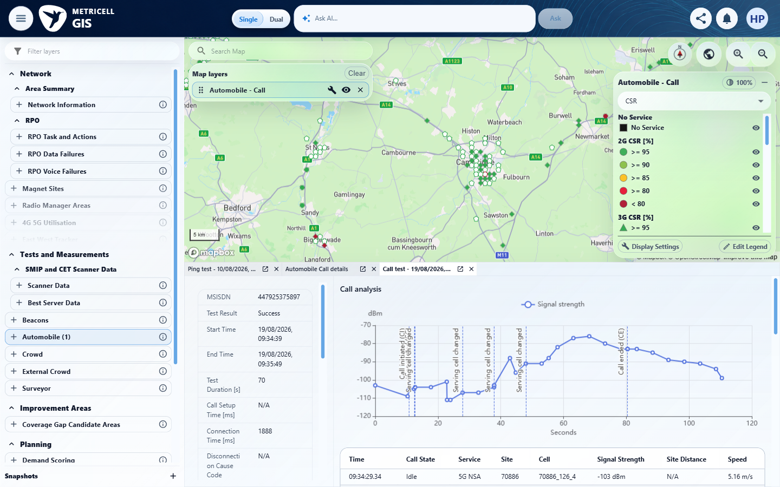 | E140 - Distinct record baseline (criterion-21-distinct-record-baseline.png)  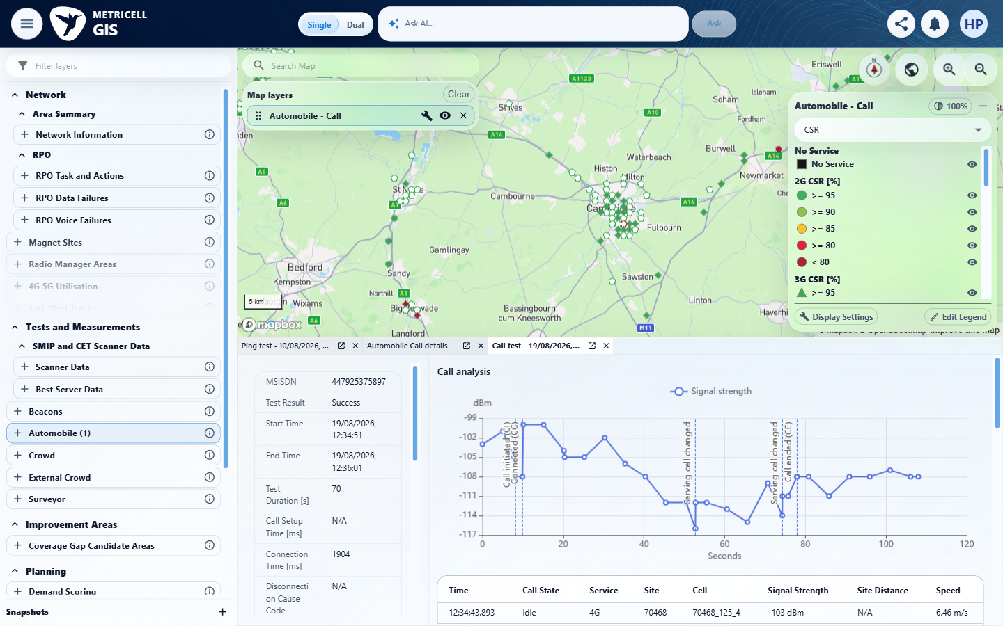

Criterion 21 continued: When point or service details cannot be returned, the selected item does not show stale detail data.
SIMULATED UI STATE: browser-local condition; recovery uses the genuine service.
Browser URL recorded after criterion: https://o2intelligence-v4-dev.metricell.com/gis
E141 - Before synthetic selection (criterion-21-before-synthetic-selection.png)  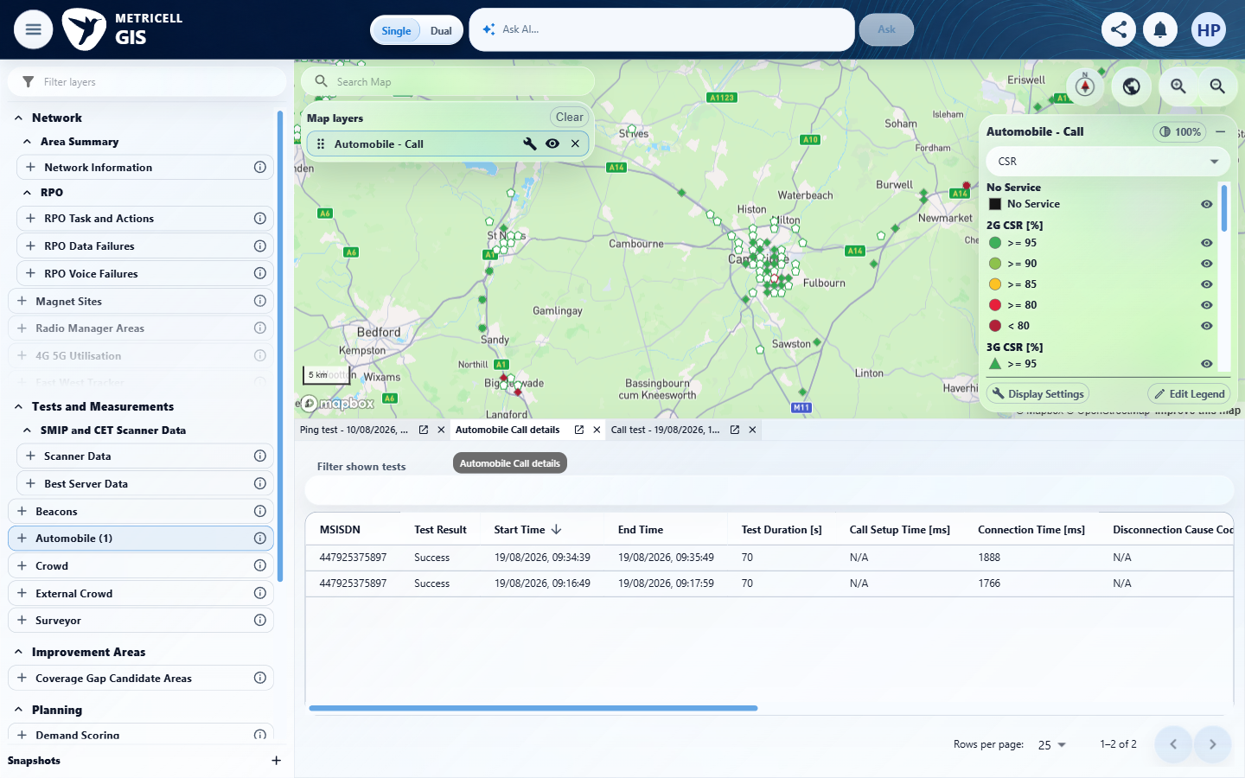 | E142 - Synthetic error (criterion-21-synthetic-error.png)  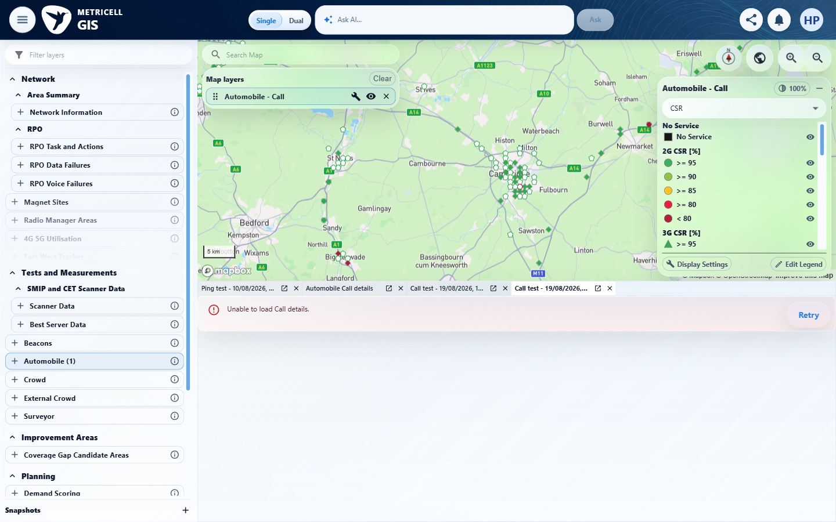

Criterion 21 continued: When point or service details cannot be returned, the selected item does not show stale detail data.
SIMULATED UI STATE: browser-local condition; recovery uses the genuine service.
Browser URL recorded after criterion: https://o2intelligence-v4-dev.metricell.com/gis
E143 - Final (criterion-21-final.png)
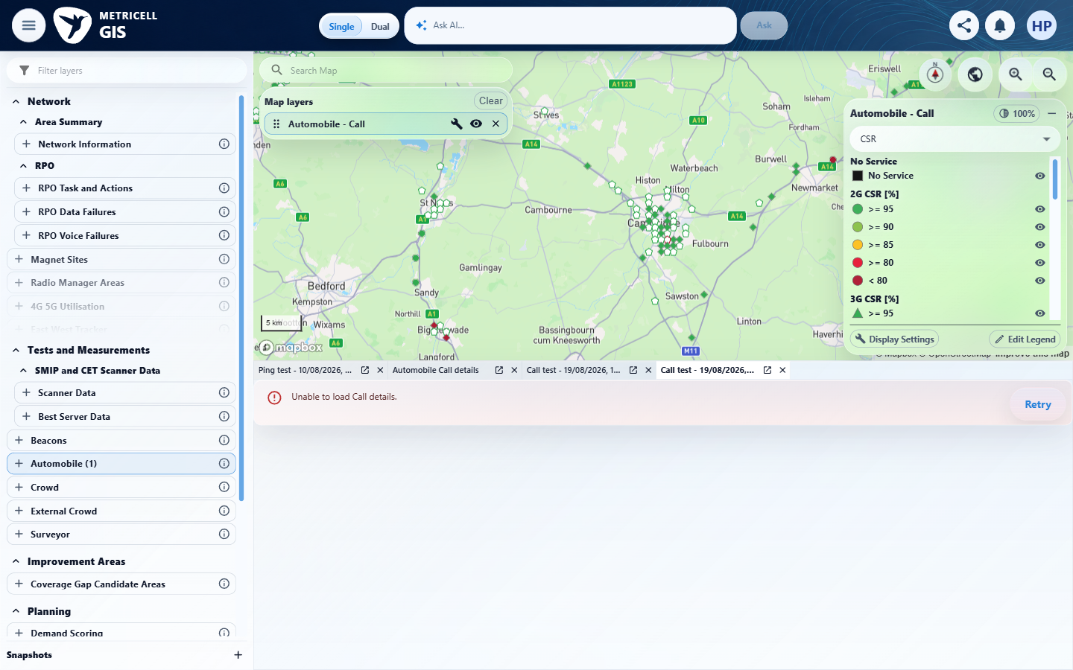

About Metricell

Metricell is on a mission to deliver connectivity. We work with our customers to design, deliver and manage wireless communication networks – with a shared ambition of achieving flawless network experience. We’ve been responsible for many first-to-market products, and our technology is characterised by the relentless pursuit of automation and digitalisation.

Our geospatial intelligence tools traverse a wide variety of business processes – from Test & Measurement to Customer Experience Management – and we’re pioneers in Crowdsourcing and Digital Self Care. Our technology is today in use by a range of customers; thousands of their personnel; and millions of subscribers worldwide.

Find out more at www.metricell.com




