

Automated Test Case Document
Jira Ticket: TEST2-83

Document Classification: | Company Confidential
Document Ref: | Automated Test Case Document
Version: | 1.0
Date: | 27/10/2026
Document Author: | Automated TEST2 Evidence Review
Document Owner: | Quality Assurance / Metricell




This document and its content is copyright of Metricell Limited @ 2026 all rights reserved. All information contained herein is the intellectual property of Metricell Limited and should be treated as confidential. Any external redistribution of reproduction of part or all of the contents in any form is prohibited unless expressly agreed with Metricell Limited in writing. Any reproduced content must include the following statement; “Part or all of the content contained herein is copyright of Metricell Limited @ 2026 all rights reserved”.
Table of Contents
1 Revision History 2
2 Test Cycle Information 3
3 Test Summary 3
4 Test Cases 4
About Metricell 12

Revision History

Version | Date | Revision Author | Summary of Changes
[1.0] | 27/10/2026 | TEST2 QA Automation | Generated from TEST2 evidence review

Test Cycle Information

Tester: | Automated
Jira Ticket: | TEST2-83
Environment: | o2intelligence-v4-dev.metricell.com
Browser Details: | Google Chrome 156.0.8078.48
Date of Test: | 27/10/2026
Limitations during Testing: | Blocked criterion(s): 3, 5, 6, 8. See the assessment below each criterion.  Criteria 7, 9 used simulated UI conditions; see their assessments.
Overall review outcome: | Blocked
Browser URL(s) recorded after criteria: | https://o2intelligence-v4-dev.metricell.com/gis

Test Summary

Area of test | Pass (Y/N) | Fail (Y/N) | Blocked (Y/N) | Defect No
1. Given a Service point's details have loaded in the shared point-detail dialog, the standard detail presentation shows the returned serving-cell information. | Y | N | N | 0
2. Given the loaded Service point details include neighbour-cell data, each returned neighbour appears in its own distinct section beneath the serving-cell information. | N | Y | N | 1
3. Given the loaded Service point details contain no neighbour-cell data, serving-cell information remains visible and no empty neighbour section appears. | N | N | Y | 0
4. Given displayed Service point detail rows are available, sorting the rows changes their visible order according to the selected sort, and filtering them shows only rows matching the selected filter. | Y | N | N | 0
5. Given a Service point's reported radio generation is 2G, 3G, 4G, 5G NSA, or 5G SA, the visible KPI names are appropriate to that generation. | N | N | Y | 0
6. Given 5G SA is selected and the user opens a Service point in the shared point-detail dialog, the Service point detail presentation loads without an error state. | N | N | Y | 0
7. Given Service point details are loading, the detail presentation shows a loading state without displaying incorrect detail data. | Y | N | N | 0
8. Given Service point details are unavailable, the detail presentation shows a no-data state without displaying incorrect detail data. | N | N | Y | 0
9. Given loading Service point details fails, the detail presentation shows an error state and does not show incorrect detail data. | Y | N | N | 0

Test Cases
Each test maps to a criterion and decisive browser evidence. Inconclusive results are reported as Failed.

Tests

Preconditions: | V4 access and ticket conditions. | Associated Requirements: | Ticket criteria below. | Automation Notes: | Screenshots below each criterion; full log retained locally.
ID / Criterion | Criteria Tested | Expected Result | Actual Result / Evidence Path | Outcome
1.0.0 | Given a Service point's details have loaded in the shared point-detail dialog, the standard detail presentation shows the returned serving-cell information. | Given a Service point's details have loaded in the shared point-detail dialog, the standard detail presentation shows the returned serving-cell information. | criterion-1-final.png, criterion-1-serving-280.png and criterion-1-serving-540.png show the loaded Automobile Service 4G point 131928136 and overlapping serving rows: serving cell 2592_130_4, PLMN 23410, location 52.20127/0.30414, site 2592, TAC 432, CI 153973122, PCI 468, EARFCN 6400, RSRP -116 dBm, RSRQ -20 and SINR -6. The decisive bottom state is also retained as criterion-1-final-complete-serving.png. These visible fields agree with the selected result's recorded serviceDetails response from POST /api/platform/automobile/service/cluster-details.  Evidence: E01, E02, E03, E04, E05, E06, E07, E08 | Passed
Criterion 1 evidence: Given a Service point's details have loaded in the shared point-detail dialog, the standard detail presentation shows the returned serving-cell information.
Browser URL recorded after criterion: https://o2intelligence-v4-dev.metricell.com/gis
E01 - Automobile configuration (criterion-1-automobile-configuration.png)  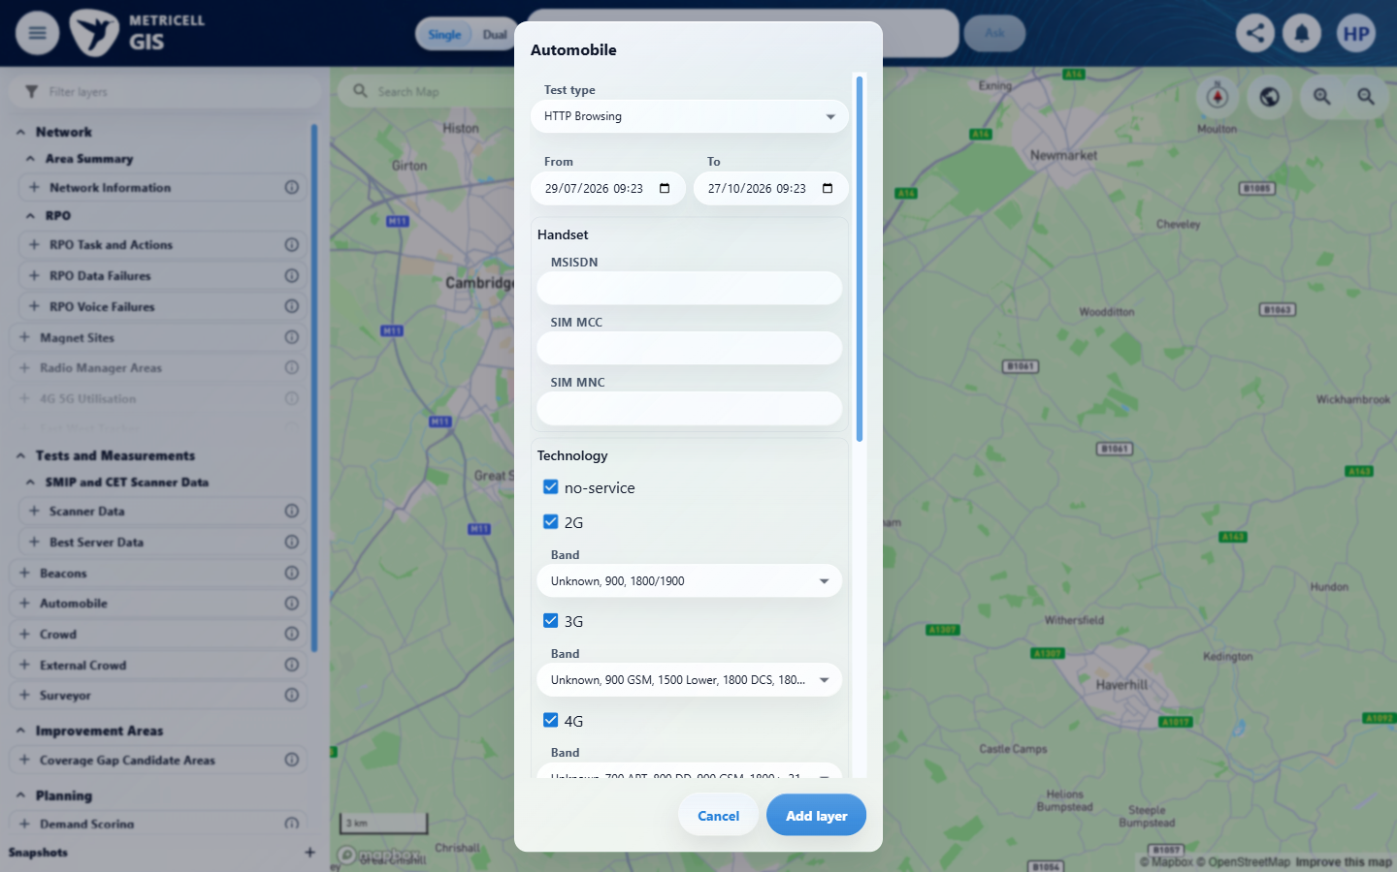 | E02 - Test type choices (criterion-1-test-type-choices.png)  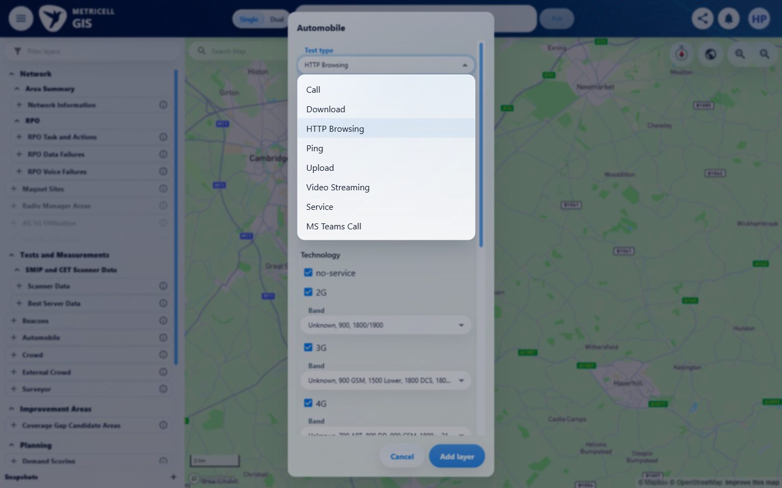

Criterion 1 continued: Given a Service point's details have loaded in the shared point-detail dialog, the standard detail presentation shows the returned serving-cell information.
Browser URL recorded after criterion: https://o2intelligence-v4-dev.metricell.com/gis
E03 - Service configuration (criterion-1-service-configuration.png)  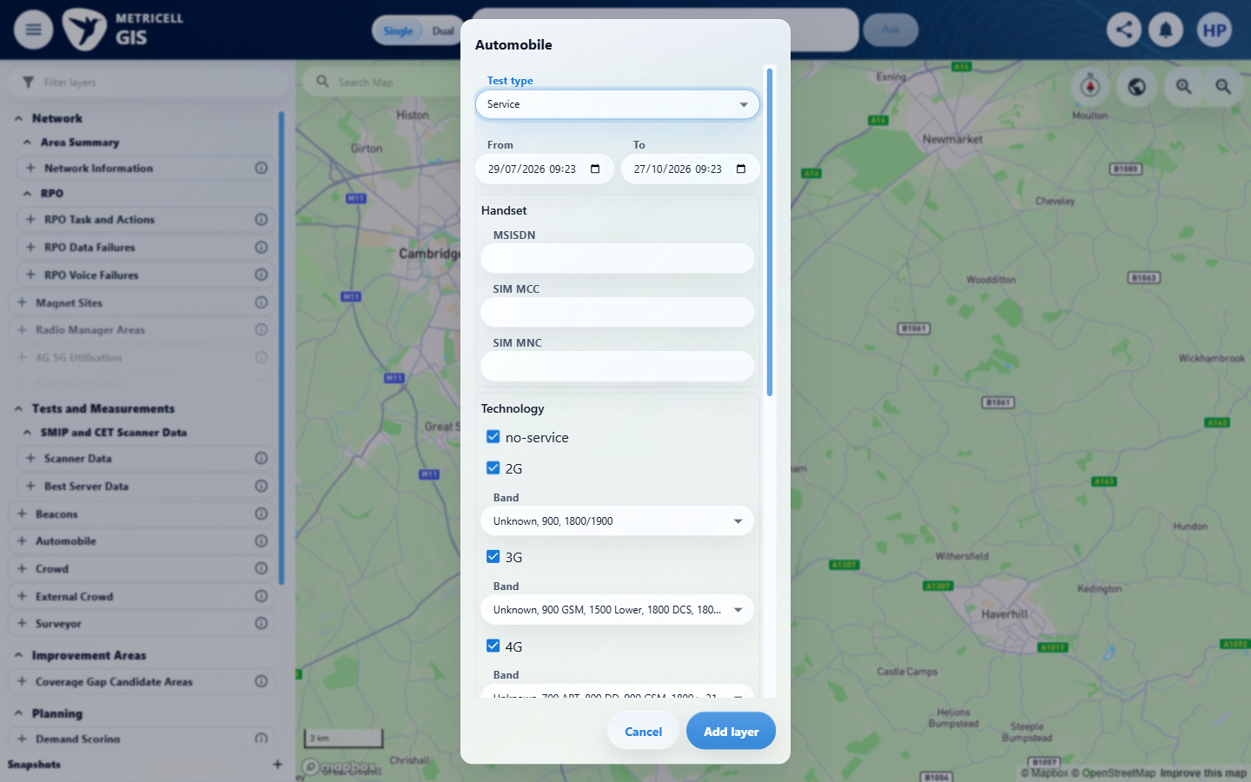 | E04 - Service loaded (criterion-1-service-loaded.png)  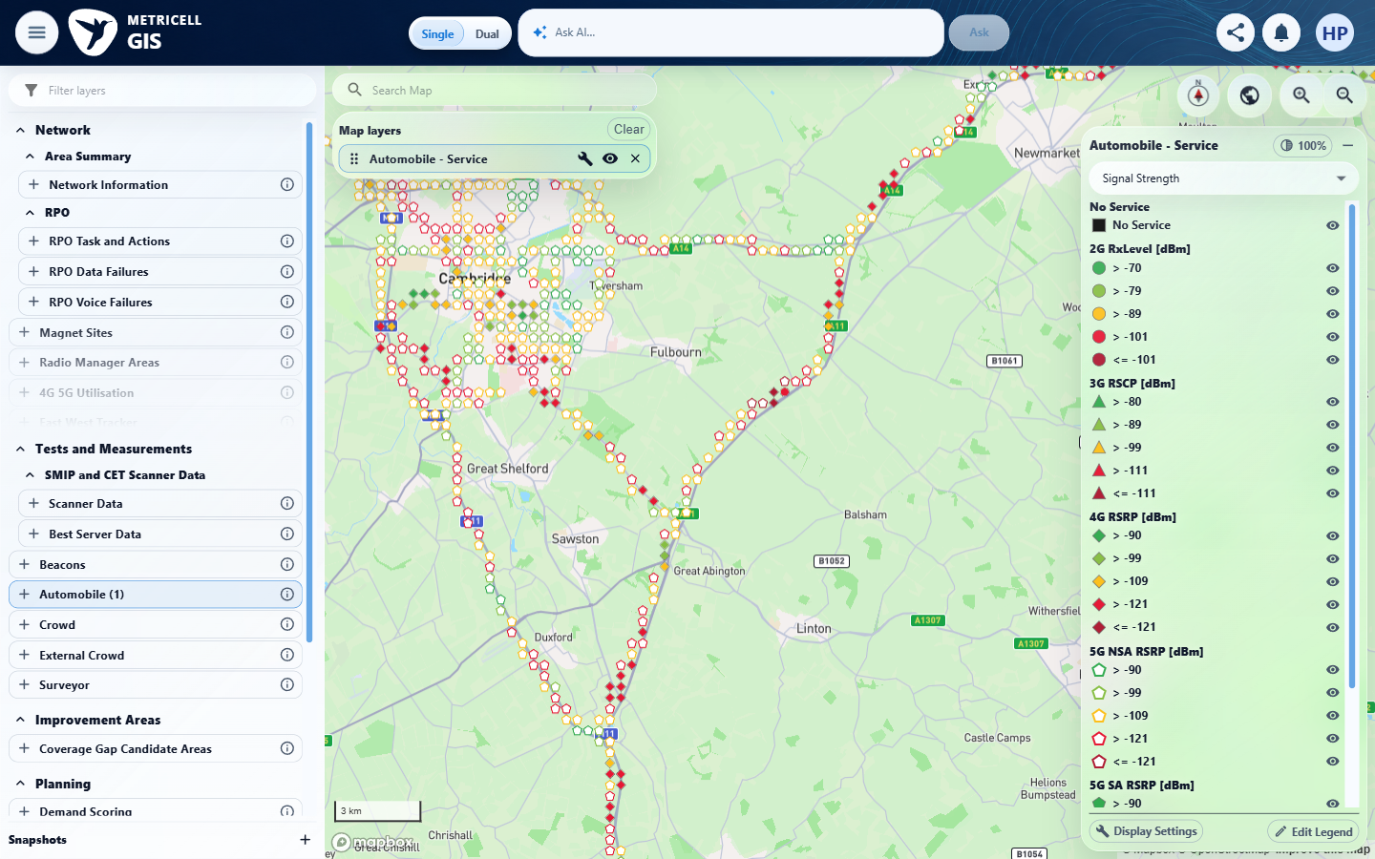

Criterion 1 continued: Given a Service point's details have loaded in the shared point-detail dialog, the standard detail presentation shows the returned serving-cell information.
Browser URL recorded after criterion: https://o2intelligence-v4-dev.metricell.com/gis
E05 - Before open record (criterion-1-before-open-record.png)  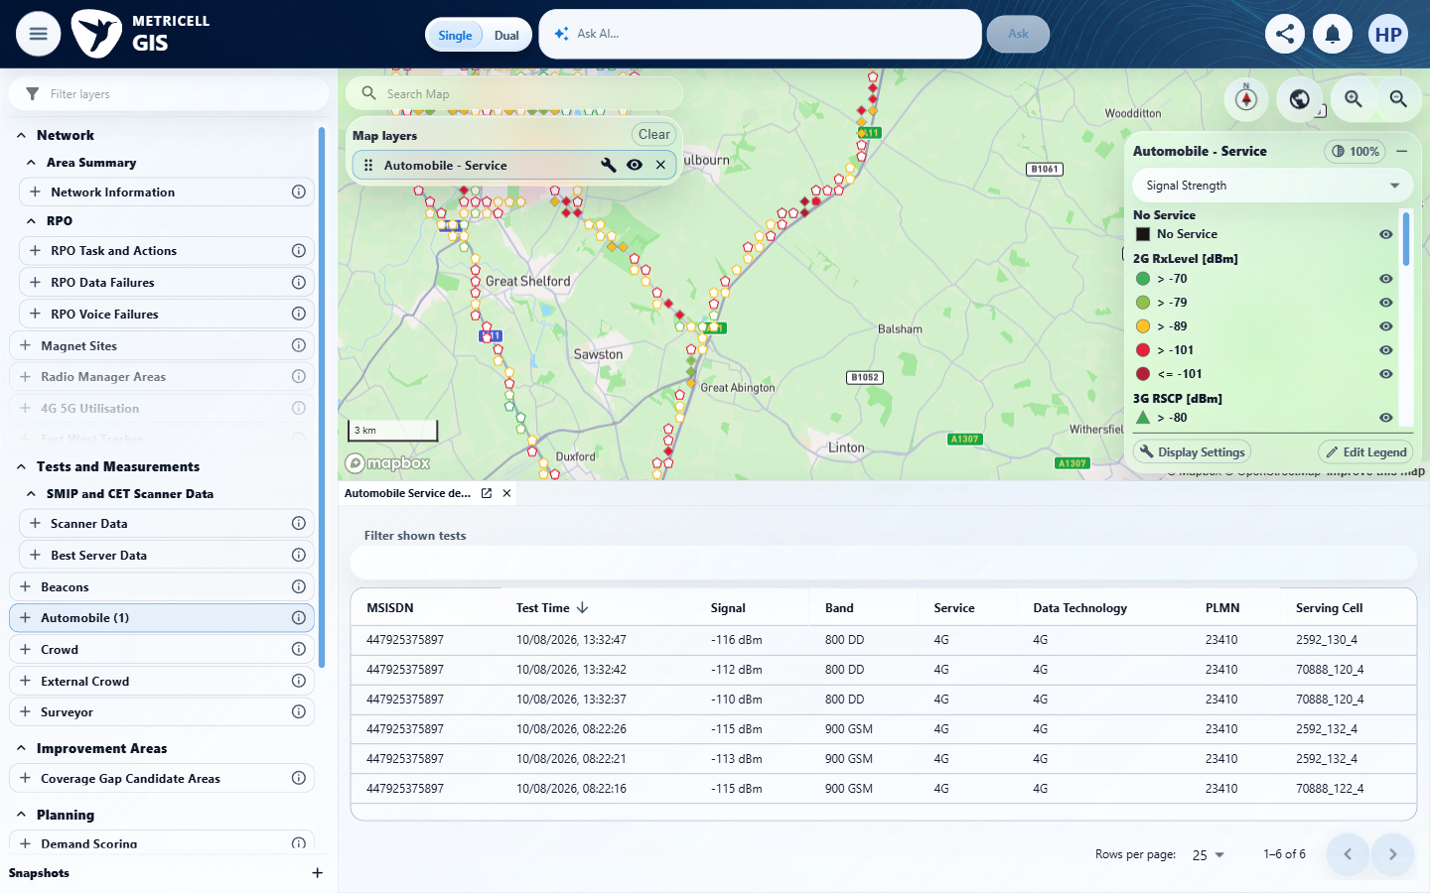 | E06 - Final (criterion-1-final.png)  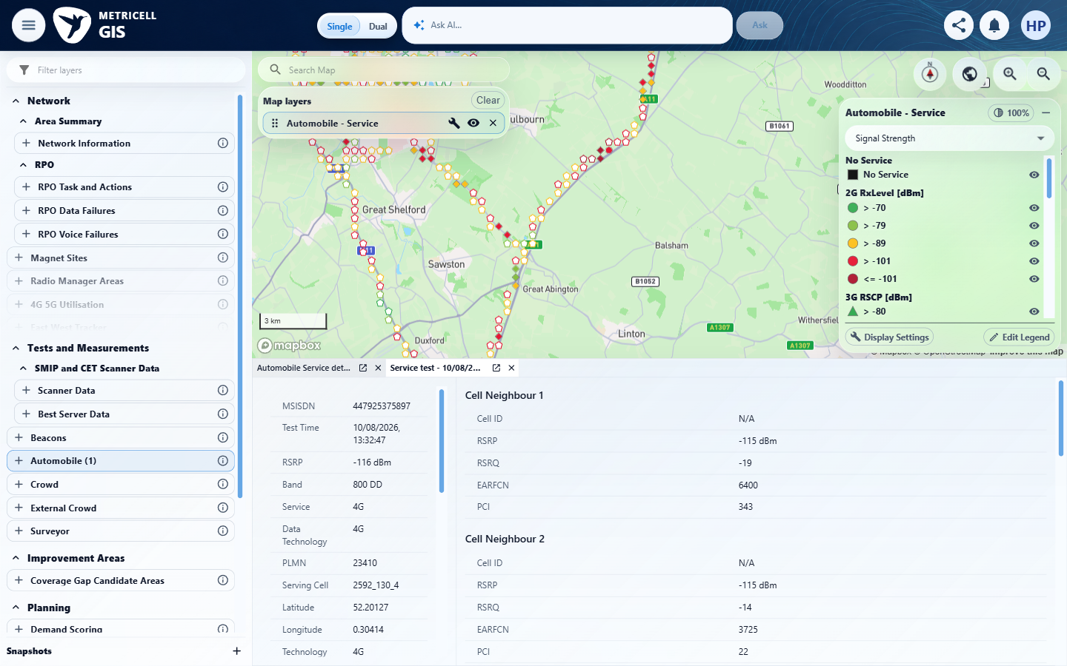

Criterion 1 continued: Given a Service point's details have loaded in the shared point-detail dialog, the standard detail presentation shows the returned serving-cell information.
Browser URL recorded after criterion: https://o2intelligence-v4-dev.metricell.com/gis
E07 - Serving 280 (criterion-1-serving-280.png)  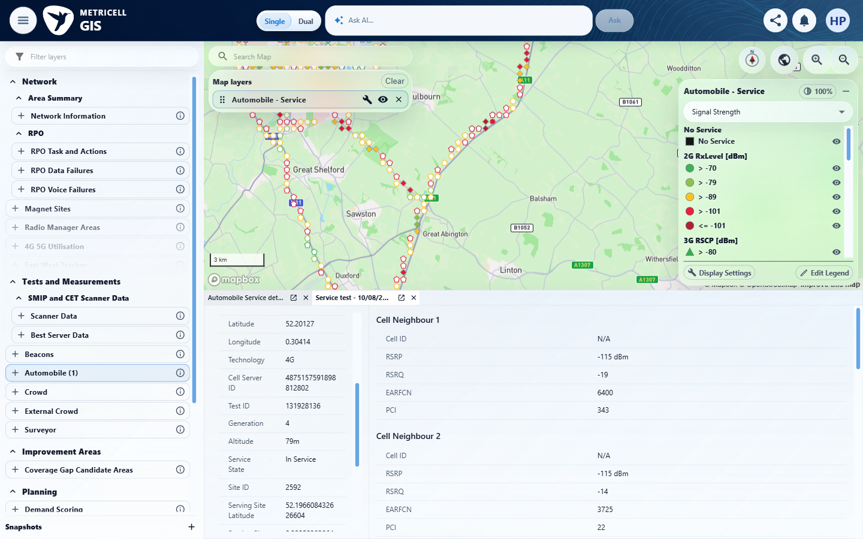 | E08 - Serving 540 (criterion-1-serving-540.png)  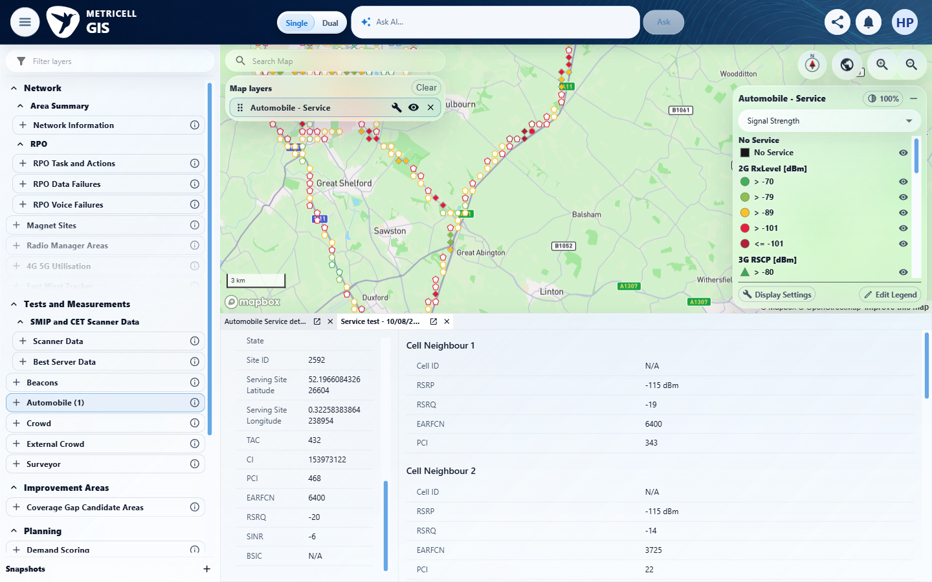

2.0.0 | Given the loaded Service point details include neighbour-cell data, each returned neighbour appears in its own distinct section beneath the serving-cell information. | Given the loaded Service point details include neighbour-cell data, each returned neighbour appears in its own distinct section beneath the serving-cell information. | criterion-2-neighbours-0.png, criterion-2-neighbours-280.png, criterion-2-neighbours-560.png, criterion-2-neighbours-840.png and criterion-2-neighbours-1000.png reconcile all seven returned neighbours for the selected point 131928136, using EARFCN/PCI and RSRP/RSRQ tuples. Each has a distinct section. The first capture directly contradicts placement beneath the serving information: neighbours occupy the separate right-hand column beside serving details. criterion-2-final.png retains the bottom of that layout.  Evidence: E09, E10, E11, E12, E13, E14, E15, E16, E17, E18, E19 | Failed
Criterion 2 assessment: Testing notes: Recorded the final GIS URL and inspected saved captures. Cleanup initially timed out after closing the cluster tab; inspected current UI, then closed the remaining owned detail tab and removed the layer before restarting criterion 3.
Criterion 2 evidence: Given the loaded Service point details include neighbour-cell data, each returned neighbour appears in its own distinct section beneath the serving-cell information.
Browser URL recorded after criterion: https://o2intelligence-v4-dev.metricell.com/gis
E09 - Setup 0 (criterion-2-setup-0.png)  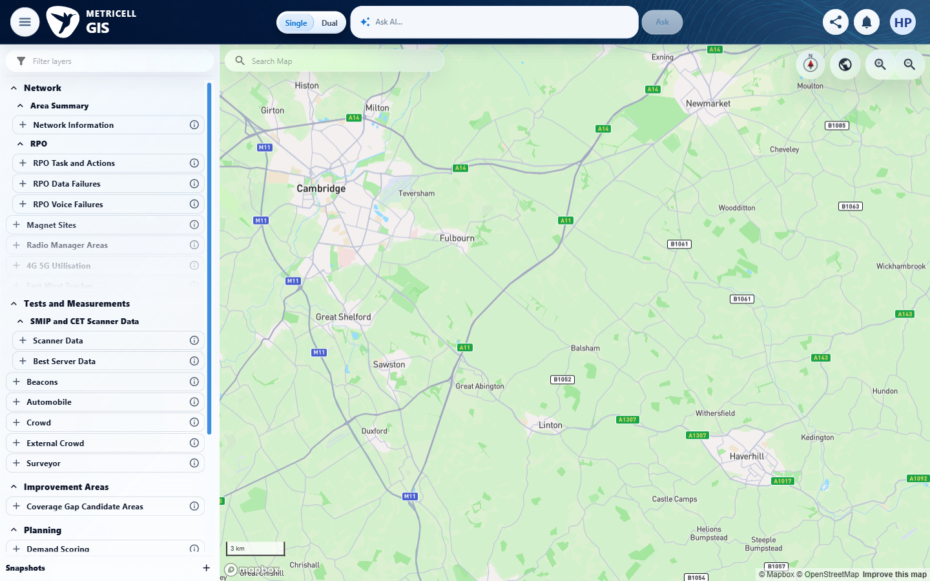 | E10 - Setup 1 (criterion-2-setup-1.png)  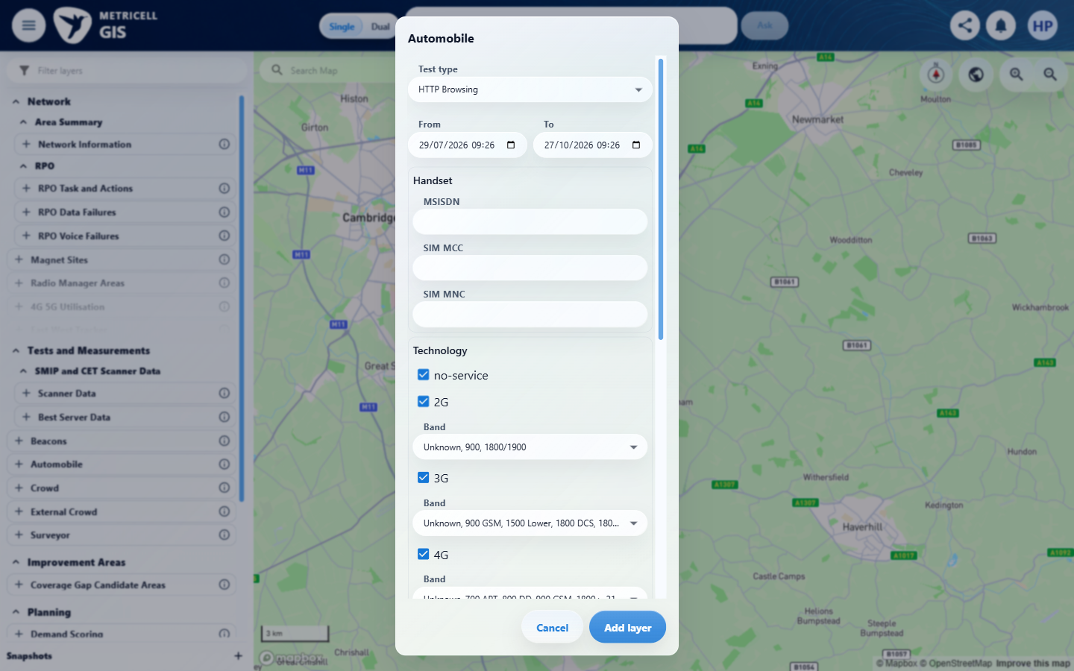

Criterion 2 continued: Given the loaded Service point details include neighbour-cell data, each returned neighbour appears in its own distinct section beneath the serving-cell information.
Browser URL recorded after criterion: https://o2intelligence-v4-dev.metricell.com/gis
E11 - Setup 2 (criterion-2-setup-2.png)  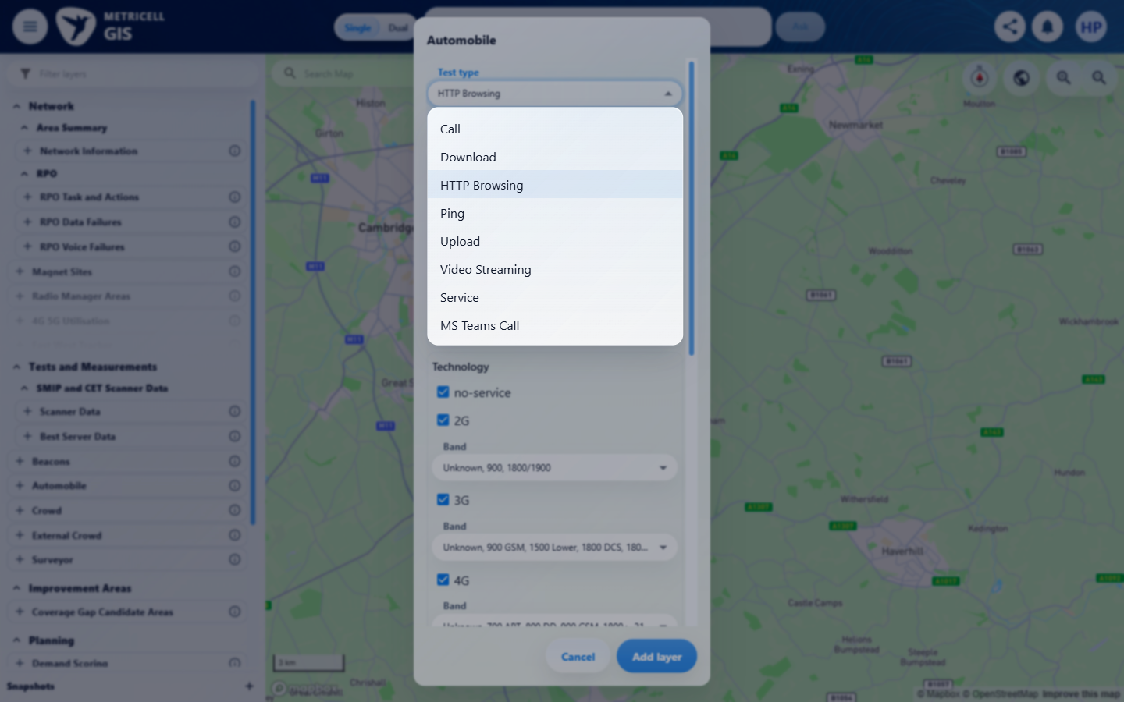 | E12 - Setup 3 (criterion-2-setup-3.png)  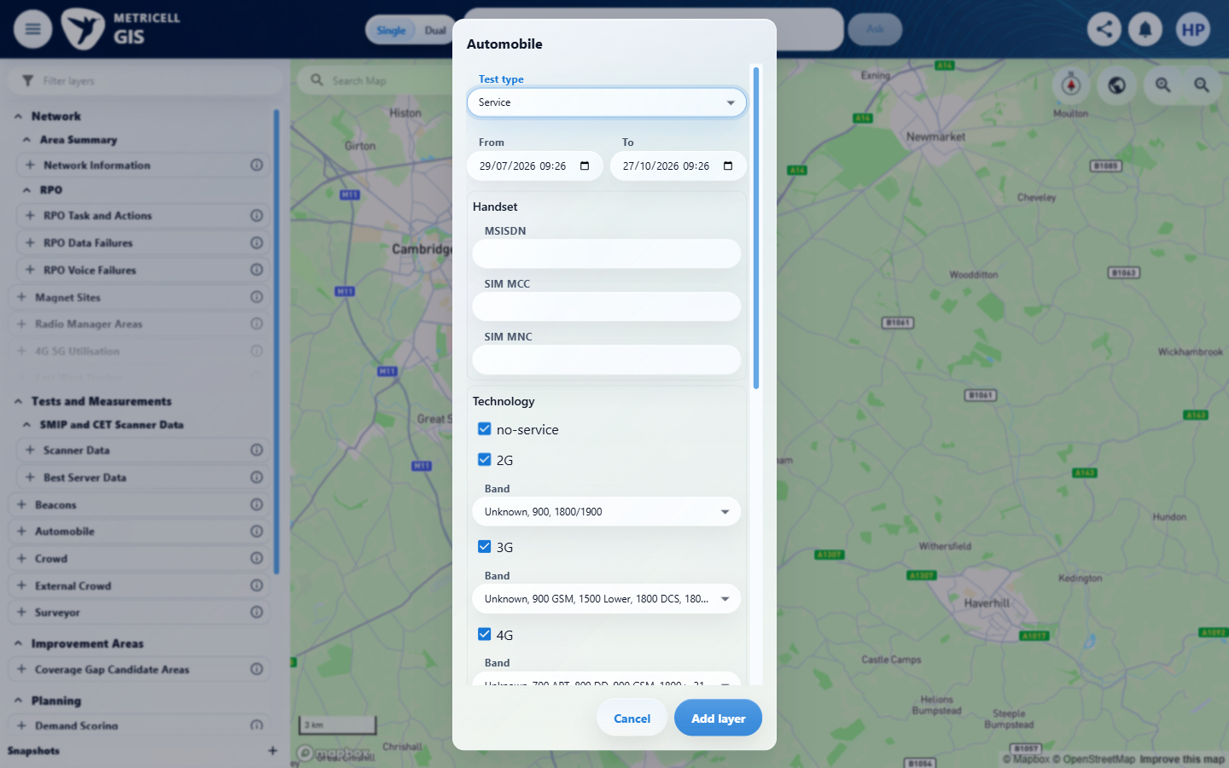

Criterion 2 continued: Given the loaded Service point details include neighbour-cell data, each returned neighbour appears in its own distinct section beneath the serving-cell information.
Browser URL recorded after criterion: https://o2intelligence-v4-dev.metricell.com/gis
E13 - Setup 4 (criterion-2-setup-4.png)  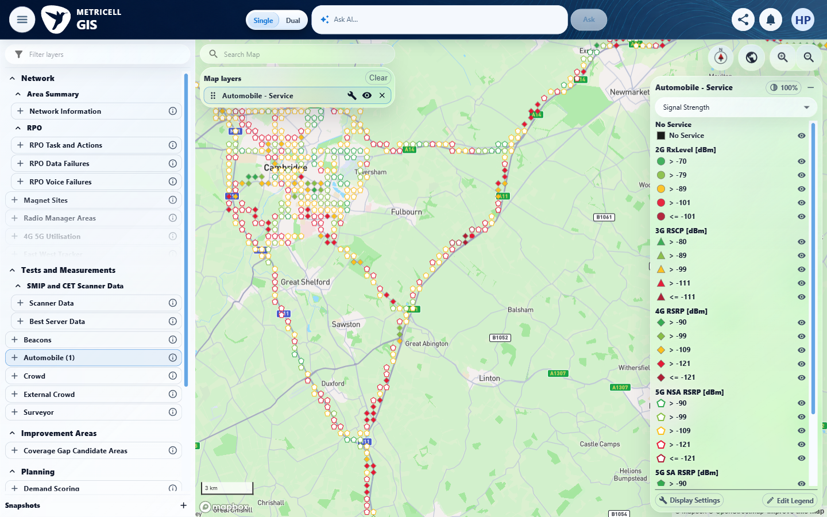 | E14 - Cluster (criterion-2-cluster.png)  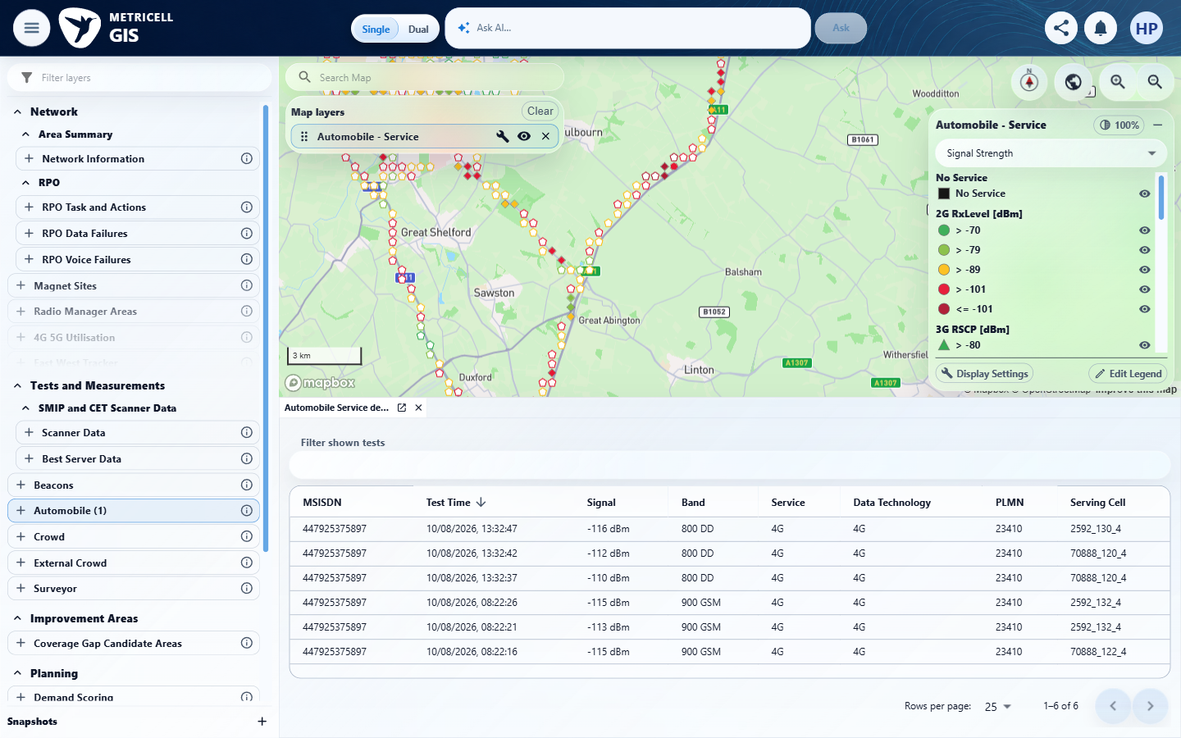

Criterion 2 continued: Given the loaded Service point details include neighbour-cell data, each returned neighbour appears in its own distinct section beneath the serving-cell information.
Browser URL recorded after criterion: https://o2intelligence-v4-dev.metricell.com/gis
E15 - Neighbours 0 (criterion-2-neighbours-0.png)  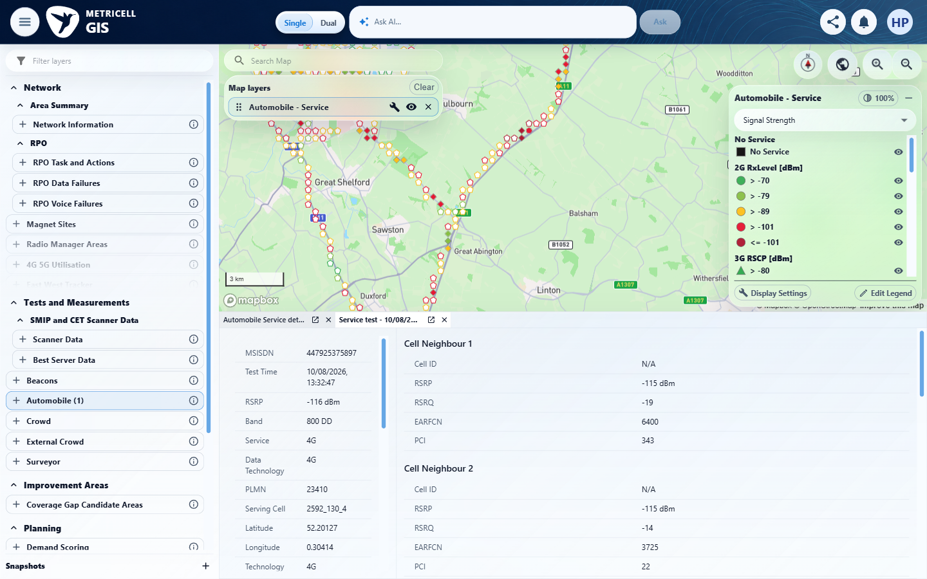 | E16 - Neighbours 280 (criterion-2-neighbours-280.png)  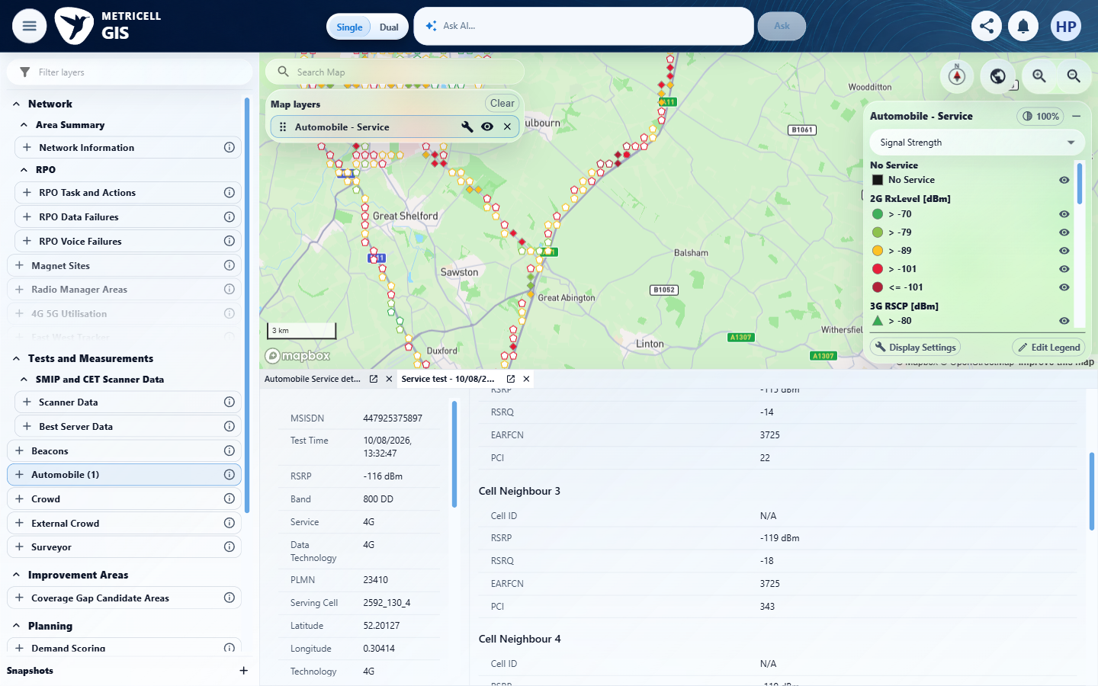

Criterion 2 continued: Given the loaded Service point details include neighbour-cell data, each returned neighbour appears in its own distinct section beneath the serving-cell information.
Browser URL recorded after criterion: https://o2intelligence-v4-dev.metricell.com/gis
E17 - Neighbours 560 (criterion-2-neighbours-560.png)  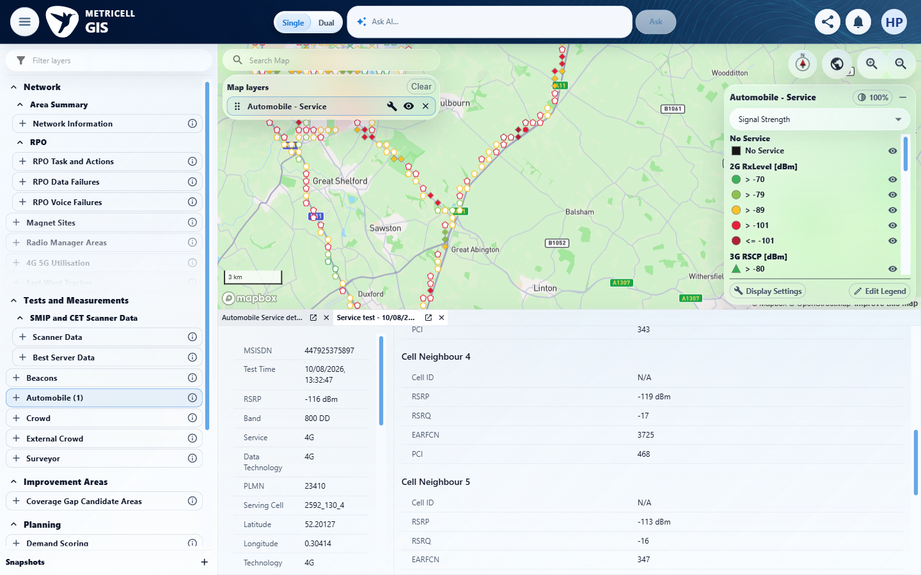 | E18 - Neighbours 840 (criterion-2-neighbours-840.png)  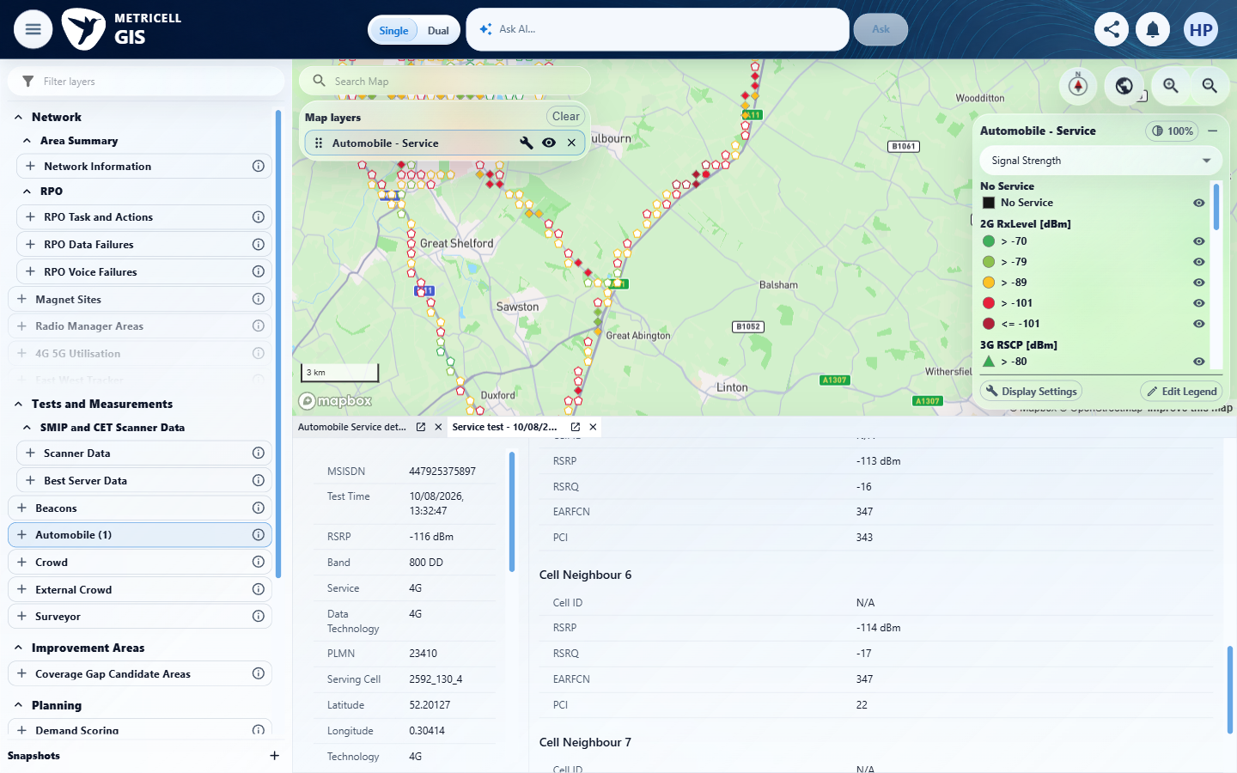

Criterion 2 continued: Given the loaded Service point details include neighbour-cell data, each returned neighbour appears in its own distinct section beneath the serving-cell information.
Browser URL recorded after criterion: https://o2intelligence-v4-dev.metricell.com/gis
E19 - Neighbours 1000 (criterion-2-neighbours-1000.png)  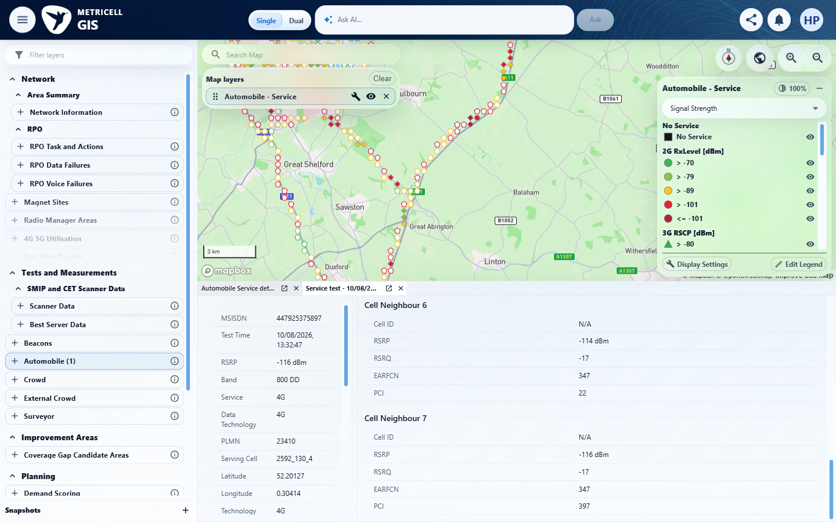 | E19 - Final (criterion-2-final.png)

3.0.0 | Given the loaded Service point details contain no neighbour-cell data, serving-cell information remains visible and no empty neighbour section appears. | Given the loaded Service point details contain no neighbour-cell data, serving-cell information remains visible and no empty neighbour section appears. | criterion-3-record-131928146.png and criterion-3-final.png show populated serving details and two neighbour sections for each inspected record (131928146 and 131921586). No qualifying no-neighbour detail fixture was established in this Automobile Service run, so serving-only rendering and absence of an empty neighbour section remain blocked. This is a fixture limitation, not evidence that the feature is unavailable or defective.  Evidence: E09, E20, E21, E22, E13, E14, E23, E24, E25 | Blocked
Criterion 3 assessment: Testing notes: Missing qualifying Automobile Service fixture with serving-cell details and no neighbour data. The sampled records both returned neighbours; absence of an empty section therefore cannot be tested. This is not a product failure.
Criterion 3 evidence: Given the loaded Service point details contain no neighbour-cell data, serving-cell information remains visible and no empty neighbour section appears.
Browser URL recorded after criterion: https://o2intelligence-v4-dev.metricell.com/gis
E09 - Restart setup 0 (criterion-3-restart-setup-0.png) | E20 - Restart setup 1 (criterion-3-restart-setup-1.png)  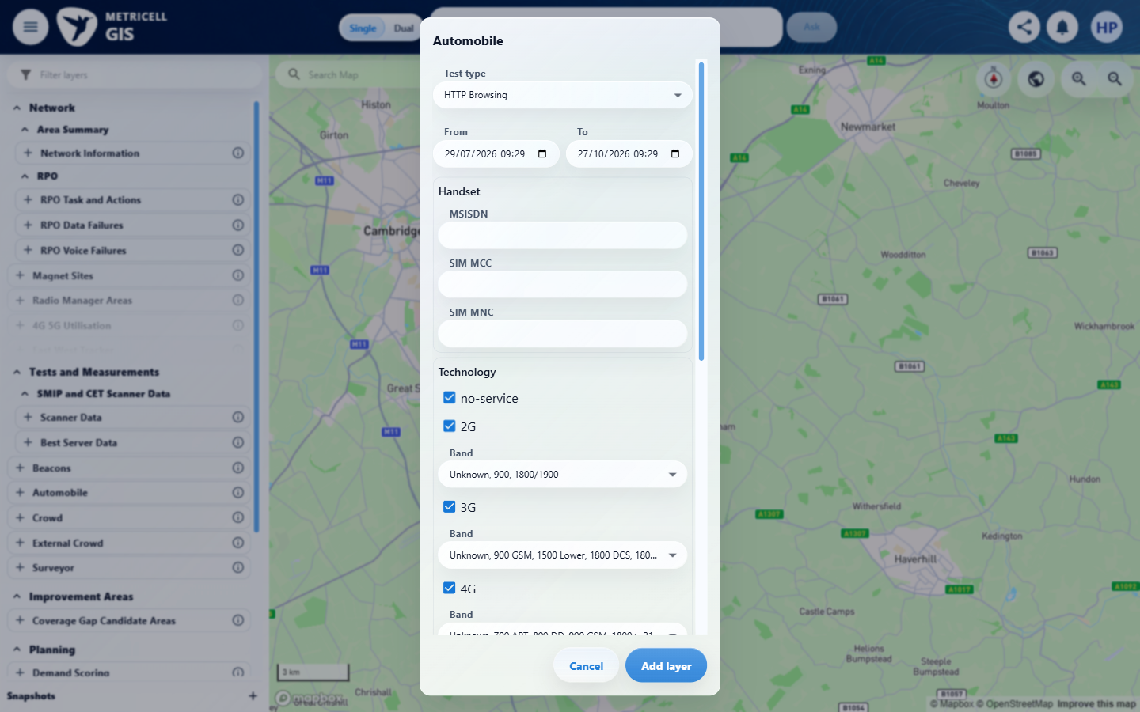

Criterion 3 continued: Given the loaded Service point details contain no neighbour-cell data, serving-cell information remains visible and no empty neighbour section appears.
Browser URL recorded after criterion: https://o2intelligence-v4-dev.metricell.com/gis
E21 - Restart setup 2 (criterion-3-restart-setup-2.png)  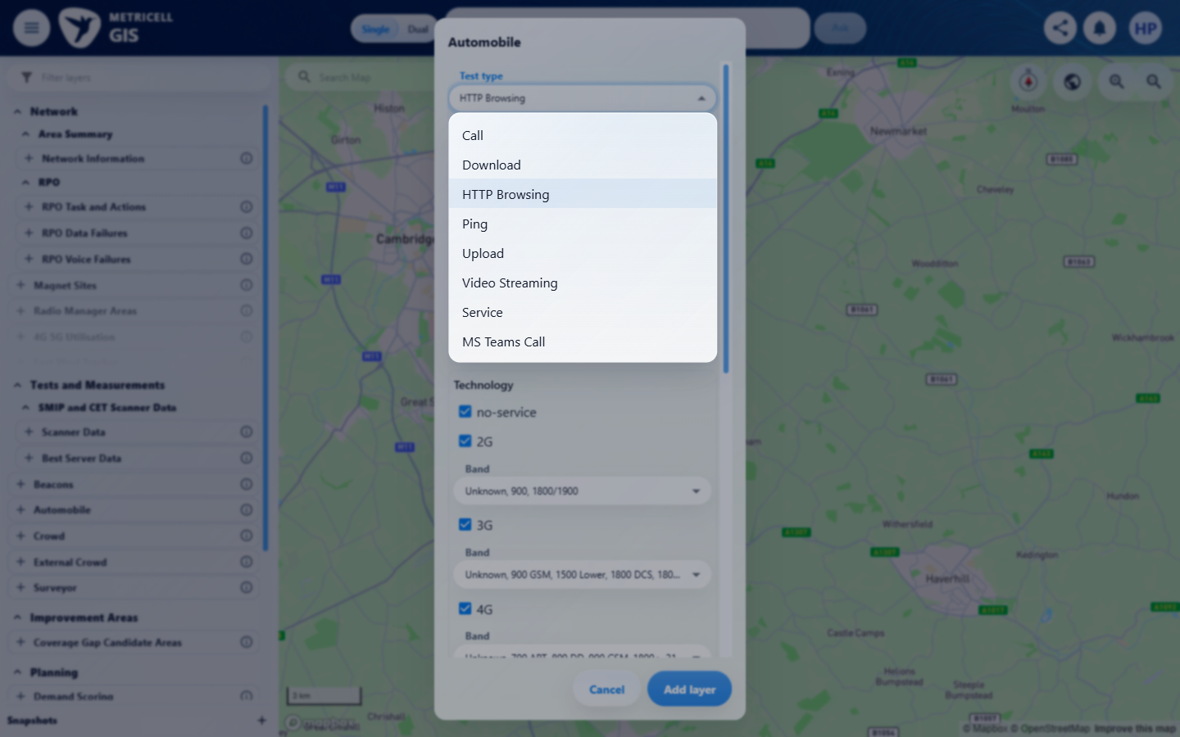 | E22 - Restart setup 3 (criterion-3-restart-setup-3.png)  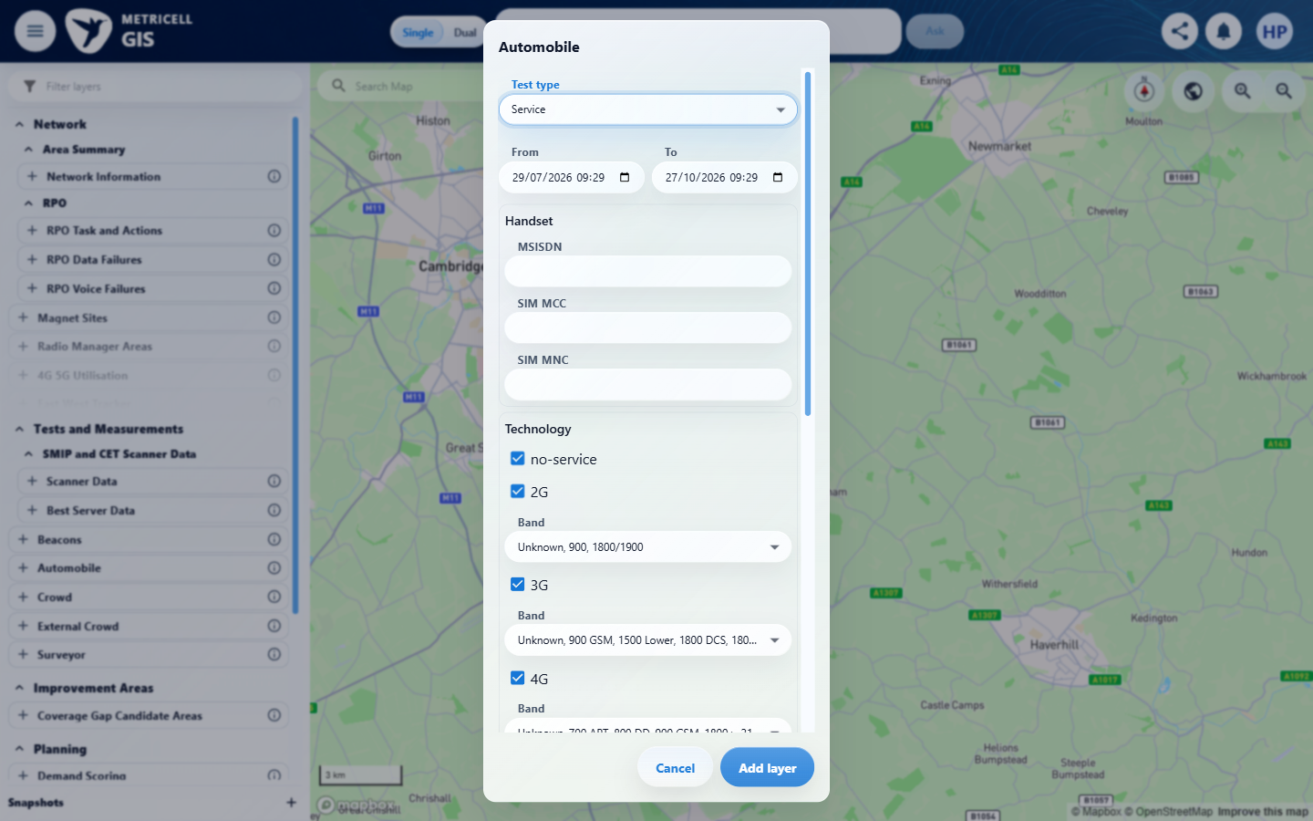

Criterion 3 continued: Given the loaded Service point details contain no neighbour-cell data, serving-cell information remains visible and no empty neighbour section appears.
Browser URL recorded after criterion: https://o2intelligence-v4-dev.metricell.com/gis
E13 - Restart setup 4 (criterion-3-restart-setup-4.png) | E14 - Cluster (criterion-3-cluster.png)

Criterion 3 continued: Given the loaded Service point details contain no neighbour-cell data, serving-cell information remains visible and no empty neighbour section appears.
Browser URL recorded after criterion: https://o2intelligence-v4-dev.metricell.com/gis
E23 - Record 131928146 (criterion-3-record-131928146.png)  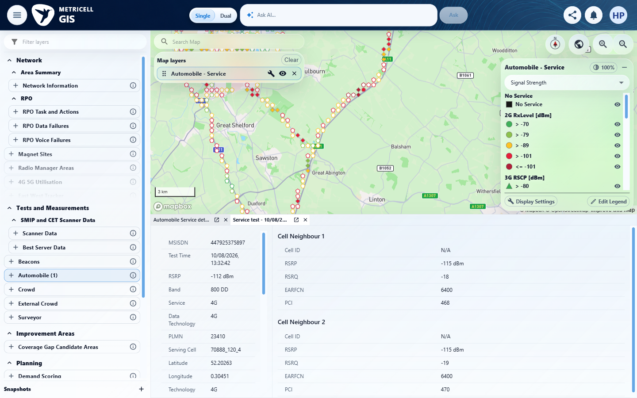 | E24 - Back to cluster (criterion-3-back-to-cluster.png)  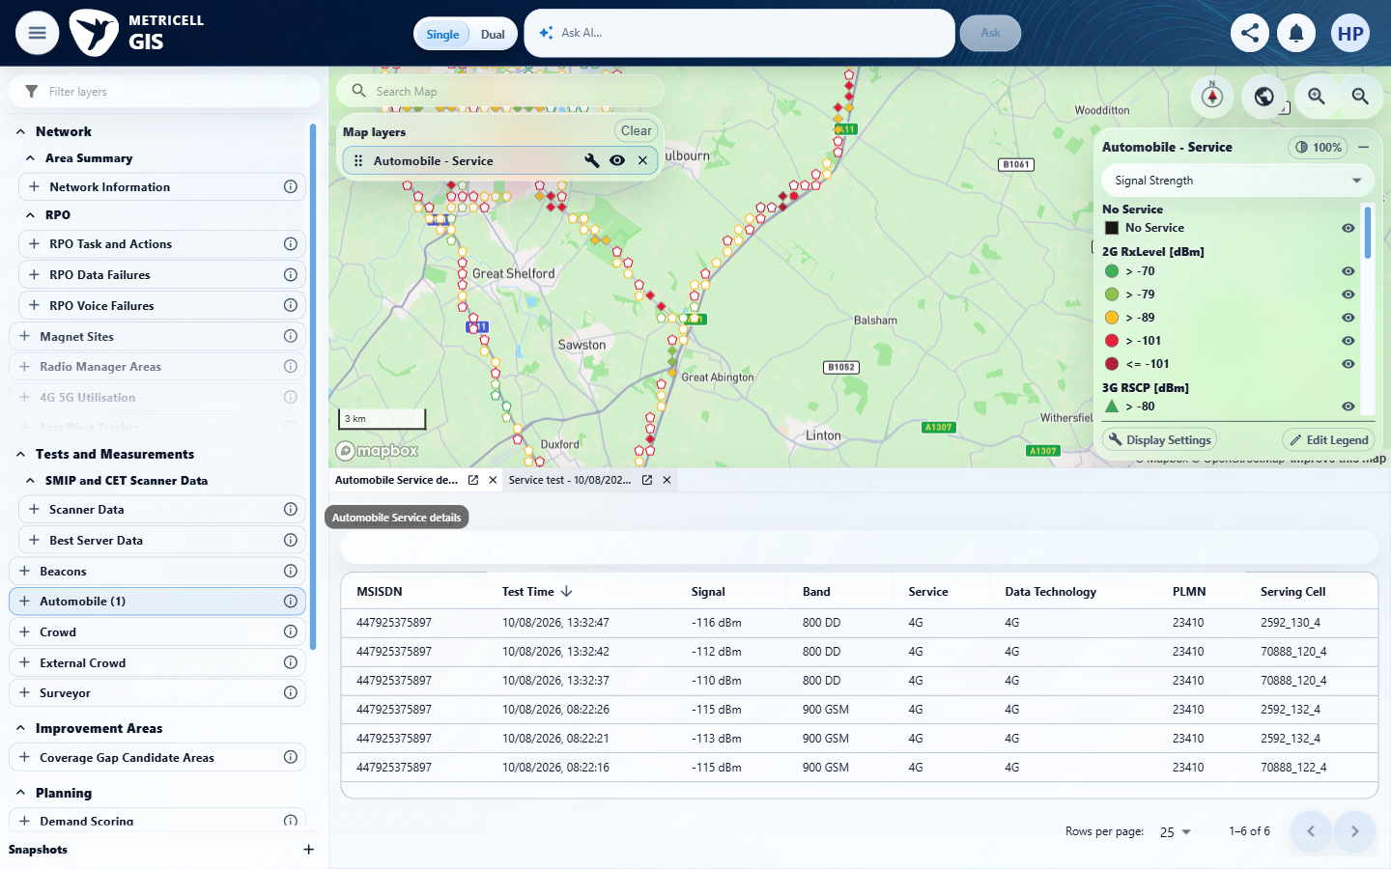

Criterion 3 continued: Given the loaded Service point details contain no neighbour-cell data, serving-cell information remains visible and no empty neighbour section appears.
Browser URL recorded after criterion: https://o2intelligence-v4-dev.metricell.com/gis
E25 - Final (criterion-3-final.png)
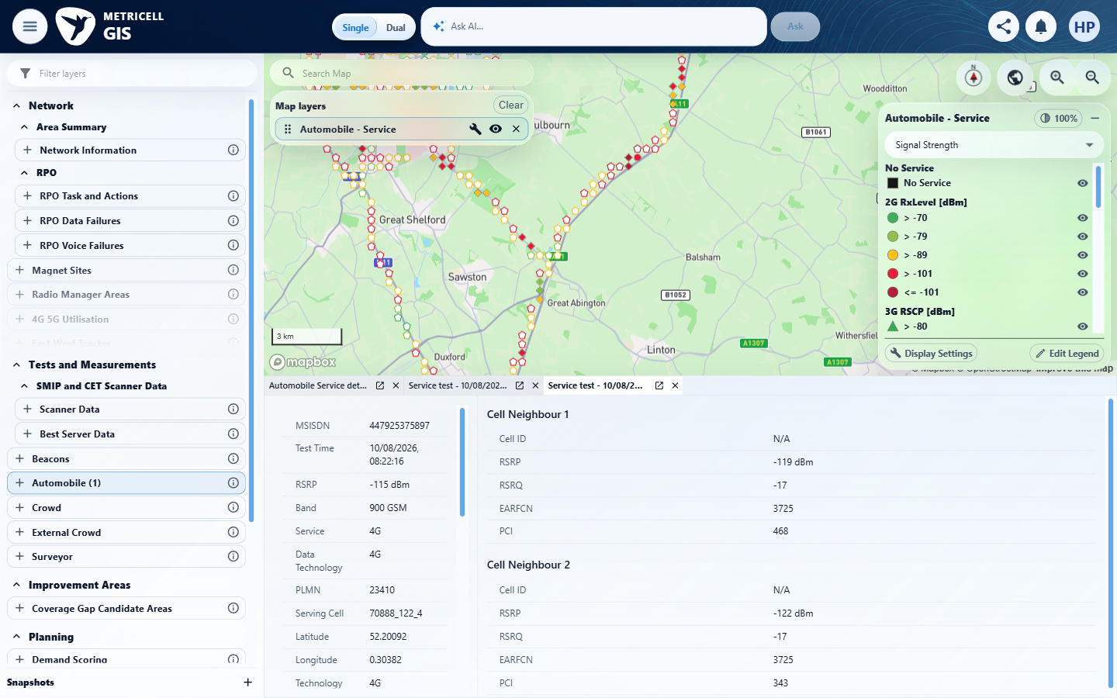

4.0.0 | Given displayed Service point detail rows are available, sorting the rows changes their visible order according to the selected sort, and filtering them shows only rows matching the selected filter. | Given displayed Service point detail rows are available, sorting the rows changes their visible order according to the selected sort, and filtering them shows only rows matching the selected filter. | criterion-4-baseline.png defines all six displayed Automobile Service rows (pagination 1-6 of 6). criterion-4-sorted-ascending.png shows the settled Signal upward indicator and -116, -115, -115, -113, -112, -110 dBm order; criterion-4-sorted-descending.png shows the downward indicator and reversed numeric order. criterion-4-final.png filters 900 GSM and retains exactly the three baseline matches at 08:22:21, 08:22:26 and 08:22:16, excluding all three 800 DD rows.  Evidence: E09, E26, E27, E28, E13, E14, E29, E30, E31 | Passed
Criterion 4 evidence: Given displayed Service point detail rows are available, sorting the rows changes their visible order according to the selected sort, and filtering them shows only rows matching the selected filter.
Browser URL recorded after criterion: https://o2intelligence-v4-dev.metricell.com/gis
E09 - Setup 0 (criterion-4-setup-0.png) | E26 - Setup 1 (criterion-4-setup-1.png)  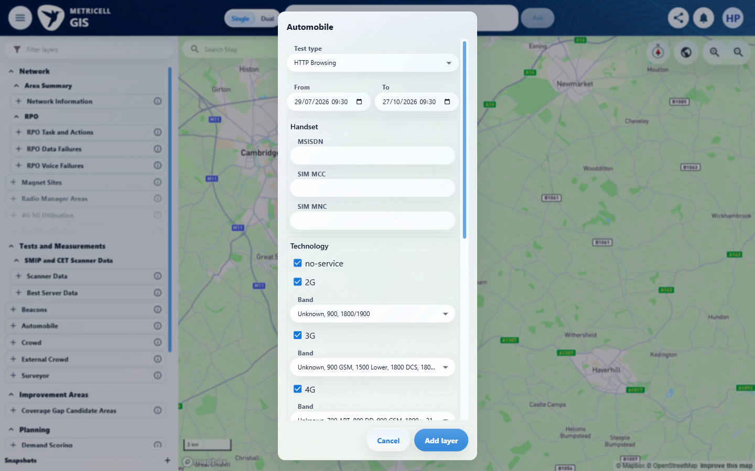

Criterion 4 continued: Given displayed Service point detail rows are available, sorting the rows changes their visible order according to the selected sort, and filtering them shows only rows matching the selected filter.
Browser URL recorded after criterion: https://o2intelligence-v4-dev.metricell.com/gis
E27 - Setup 2 (criterion-4-setup-2.png)  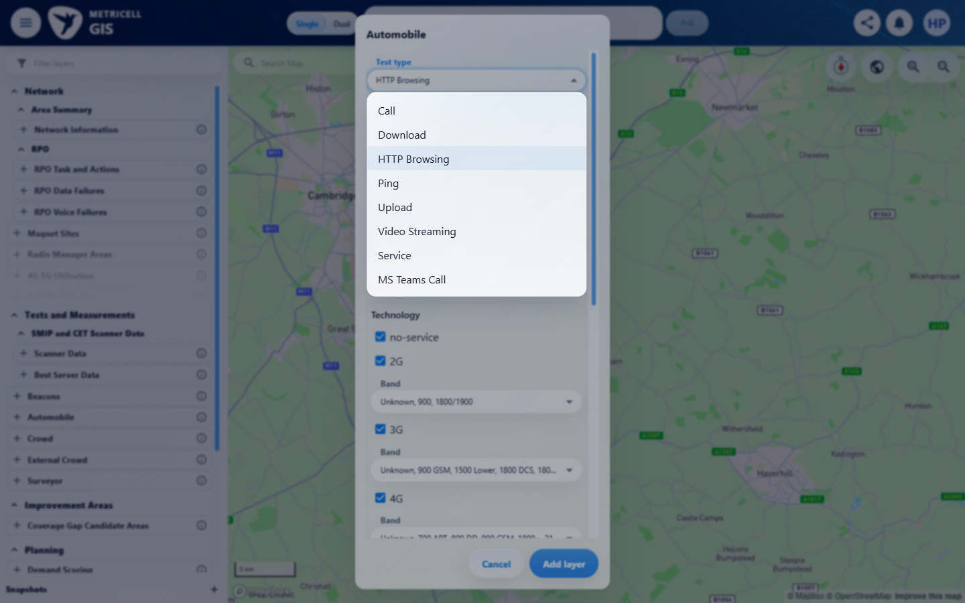 | E28 - Setup 3 (criterion-4-setup-3.png)  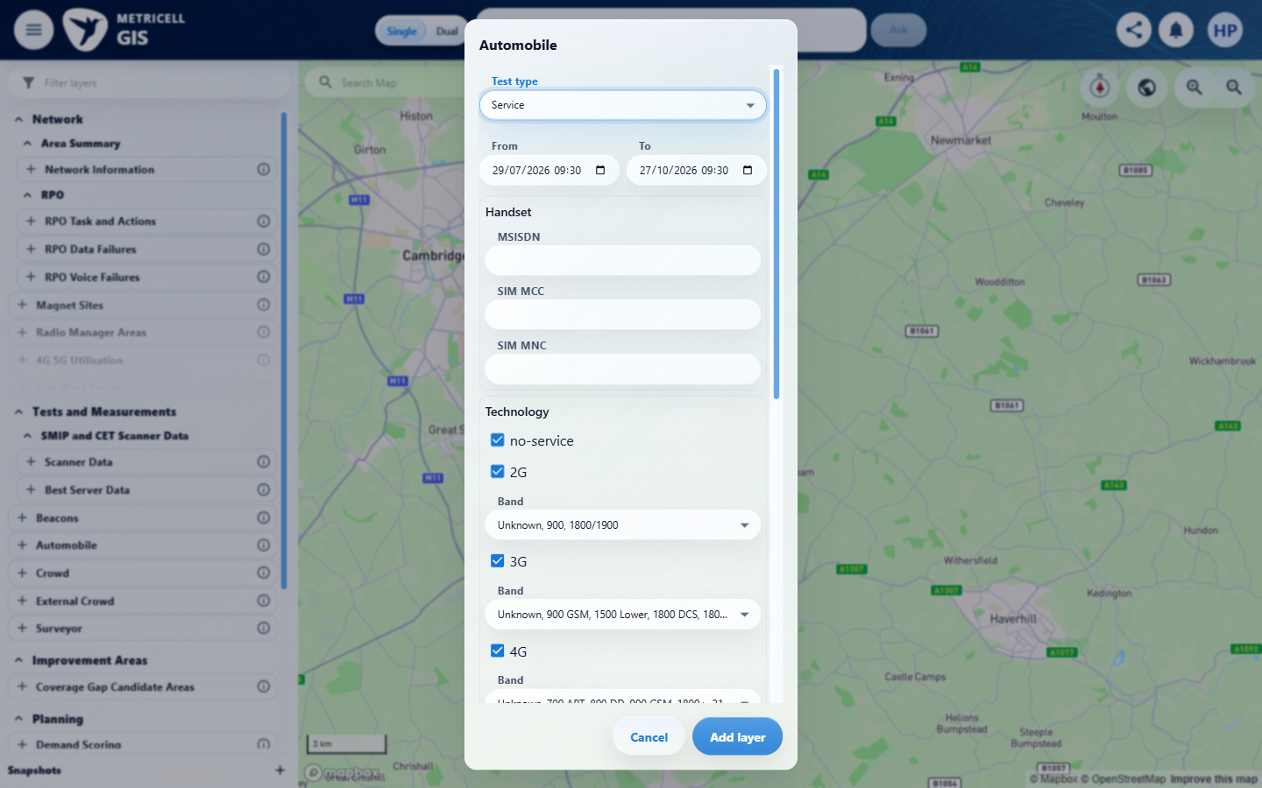

Criterion 4 continued: Given displayed Service point detail rows are available, sorting the rows changes their visible order according to the selected sort, and filtering them shows only rows matching the selected filter.
Browser URL recorded after criterion: https://o2intelligence-v4-dev.metricell.com/gis
E13 - Setup 4 (criterion-4-setup-4.png) | E14 - Baseline (criterion-4-baseline.png)

Criterion 4 continued: Given displayed Service point detail rows are available, sorting the rows changes their visible order according to the selected sort, and filtering them shows only rows matching the selected filter.
Browser URL recorded after criterion: https://o2intelligence-v4-dev.metricell.com/gis
E29 - Sorted ascending (criterion-4-sorted-ascending.png)  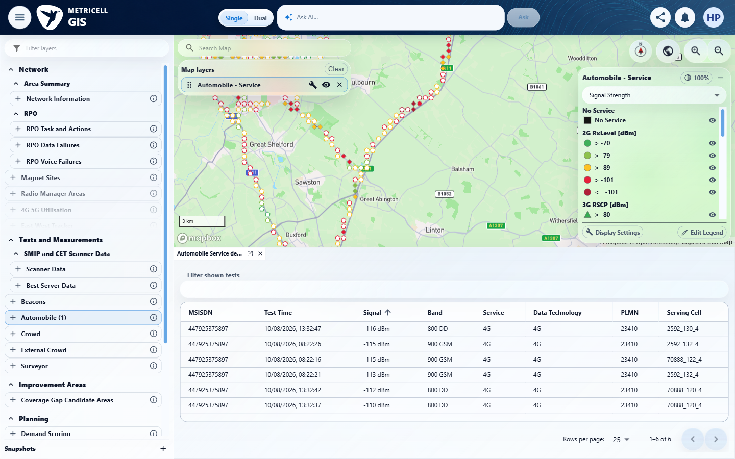 | E30 - Sorted descending (criterion-4-sorted-descending.png)  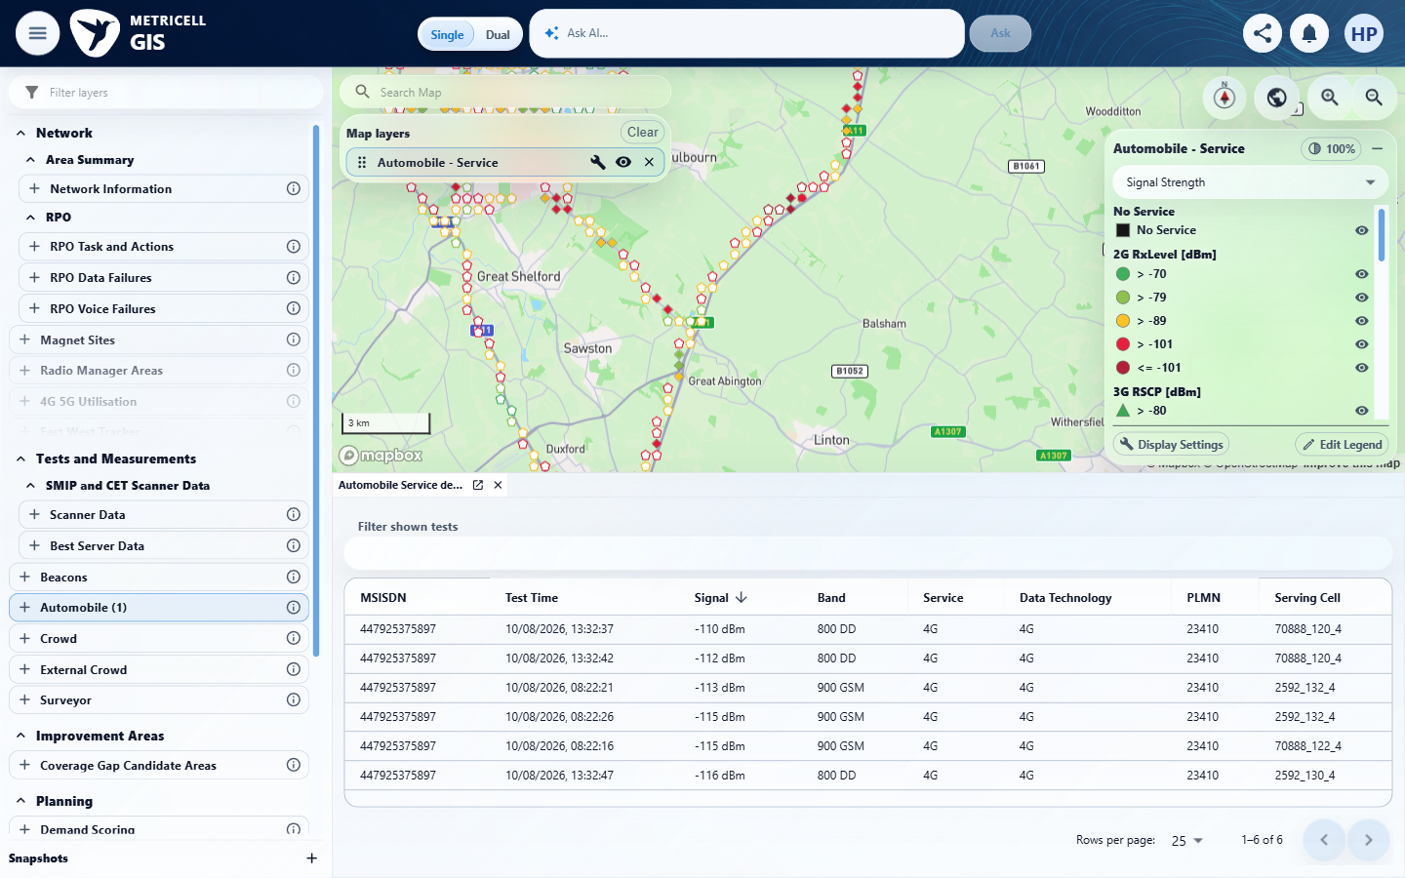

Criterion 4 continued: Given displayed Service point detail rows are available, sorting the rows changes their visible order according to the selected sort, and filtering them shows only rows matching the selected filter.
Browser URL recorded after criterion: https://o2intelligence-v4-dev.metricell.com/gis
E31 - Final (criterion-4-final.png)
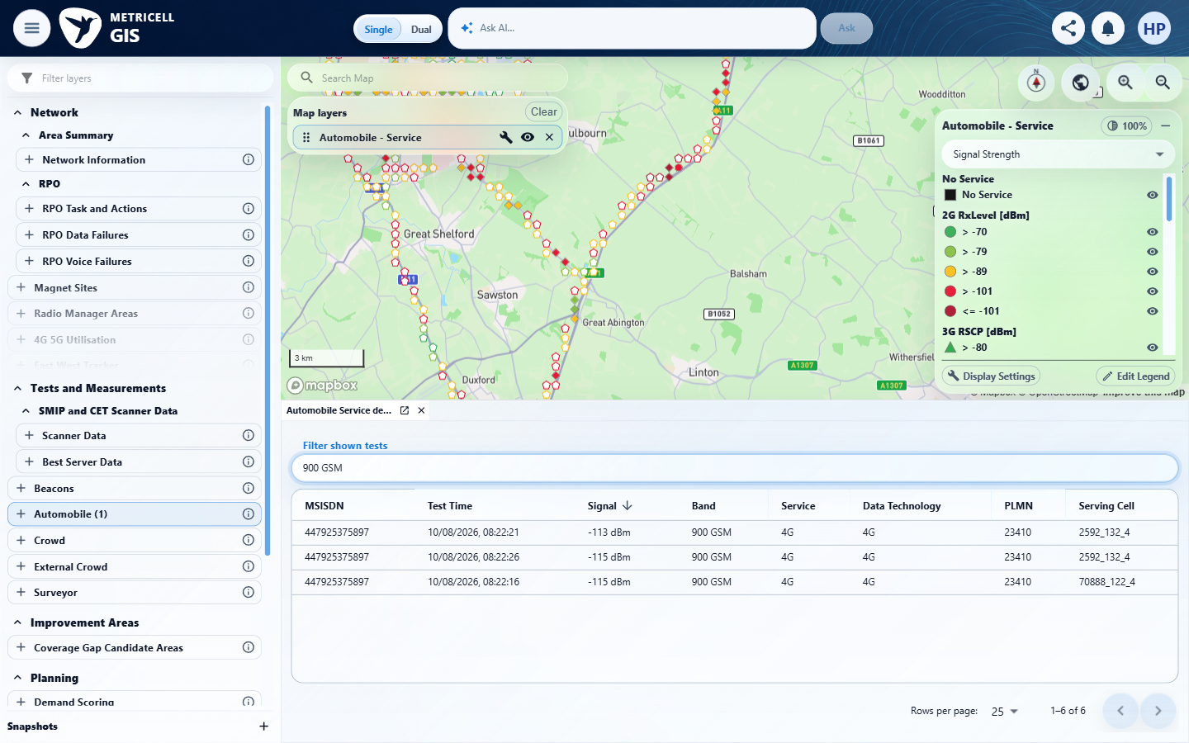

5.0.0 | Given a Service point's reported radio generation is 2G, 3G, 4G, 5G NSA, or 5G SA, the visible KPI names are appropriate to that generation. | Given a Service point's reported radio generation is 2G, 3G, 4G, 5G NSA, or 5G SA, the visible KPI names are appropriate to that generation. | criterion-5-2g-kpis-top.png and criterion-5-2g-kpis-bottom.png show reported 2G with RxLevel, RxQual, ARFCN and BSIC; criterion-5-4g-top.png and criterion-5-4g-kpis.png show 4G with RSRP, RSRQ, EARFCN and SINR; criterion-5-nsa-kpis-top.png and criterion-5-nsa-kpis-bottom.png show 5G NSA and its LTE-anchor labels. criterion-5-3g-configuration.png/criterion-5-3g-map.png and criterion-5-sa-configuration.png/criterion-5-final.png show exclusive generation selection followed by empty scoped maps. No 3G or 5G SA detail fixture was established in the inspected Cambridge/date scope; their KPI branches remain blocked, without asserting global data absence.  Evidence: E09, E32, E33, E34, E13, E14, E35, E36, E37, E38, E39, E40, E41, E42, E43, E44, E45, E46, E47, E48, E49, E50 | Blocked
Criterion 5 assessment: Testing notes: 2G, 4G and 5G NSA KPI labels were observed; 3G and 5G SA detail fixtures were unavailable in the inspected area/date scope. Map legend labels alone do not verify point detail labels. Used Configure Automobile - Service to select only 2G, applied, and selected a visible marker. It opened the individual point directly; the initial wait for a cluster table timed out, so inspected the current UI before proceeding. Record 131921613 reports 2G/generation 2, RxLevel, RxQual, ARFCN and BSIC.
Criterion 5 evidence: Given a Service point's reported radio generation is 2G, 3G, 4G, 5G NSA, or 5G SA, the visible KPI names are appropriate to that generation.
Browser URL recorded after criterion: https://o2intelligence-v4-dev.metricell.com/gis
E09 - Setup 0 (criterion-5-setup-0.png) | E32 - Setup 1 (criterion-5-setup-1.png)  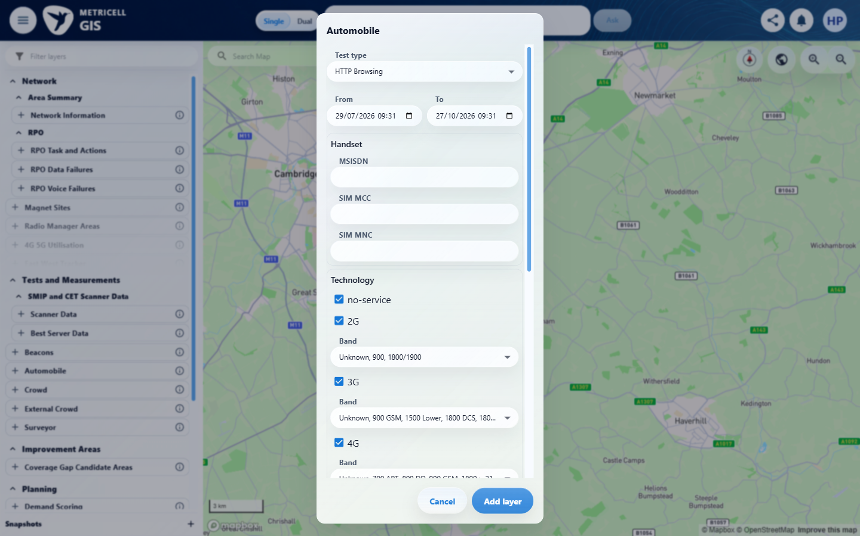

Criterion 5 continued: Given a Service point's reported radio generation is 2G, 3G, 4G, 5G NSA, or 5G SA, the visible KPI names are appropriate to that generation.
Browser URL recorded after criterion: https://o2intelligence-v4-dev.metricell.com/gis
E33 - Setup 2 (criterion-5-setup-2.png)  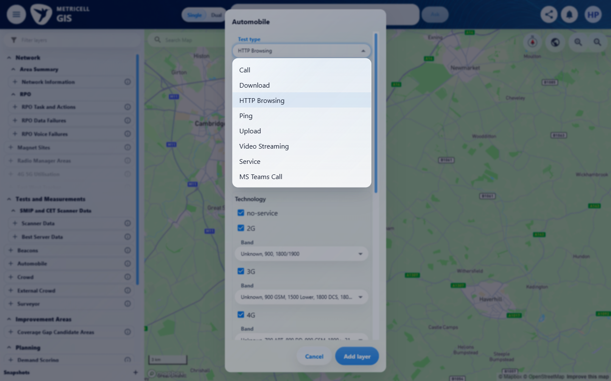 | E34 - Setup 3 (criterion-5-setup-3.png)  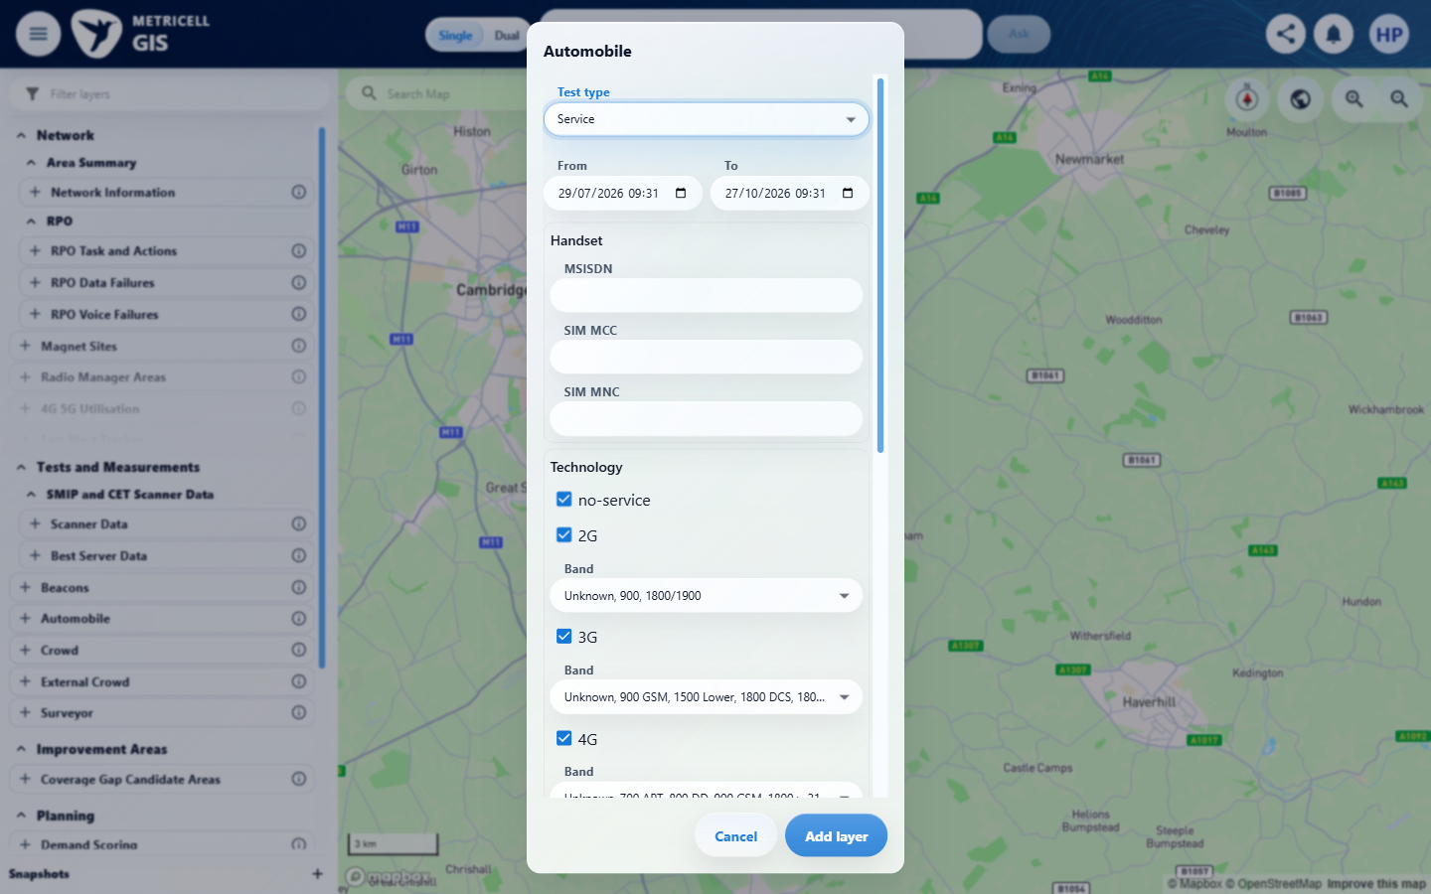

Criterion 5 continued: Given a Service point's reported radio generation is 2G, 3G, 4G, 5G NSA, or 5G SA, the visible KPI names are appropriate to that generation.
Browser URL recorded after criterion: https://o2intelligence-v4-dev.metricell.com/gis
E13 - Setup 4 (criterion-5-setup-4.png) | E14 - Cluster (criterion-5-cluster.png)

Criterion 5 continued: Given a Service point's reported radio generation is 2G, 3G, 4G, 5G NSA, or 5G SA, the visible KPI names are appropriate to that generation.
Browser URL recorded after criterion: https://o2intelligence-v4-dev.metricell.com/gis
E35 - 4g top (criterion-5-4g-top.png)  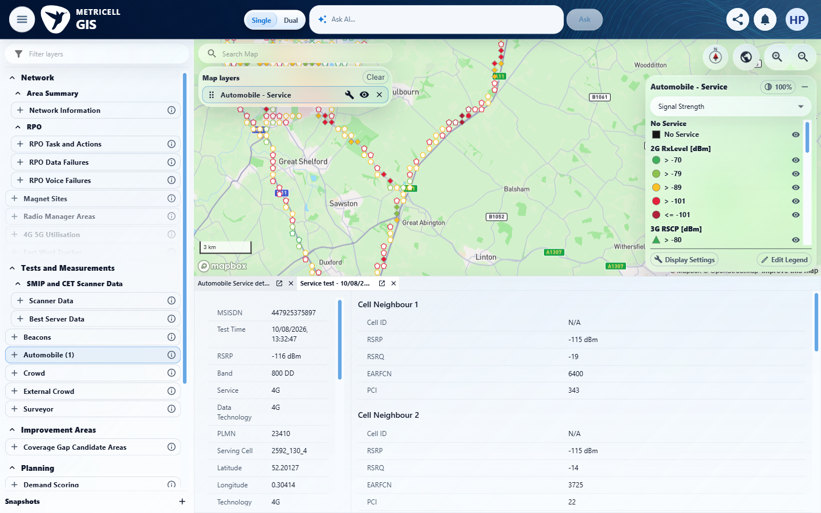 | E36 - 4g kpis (criterion-5-4g-kpis.png)  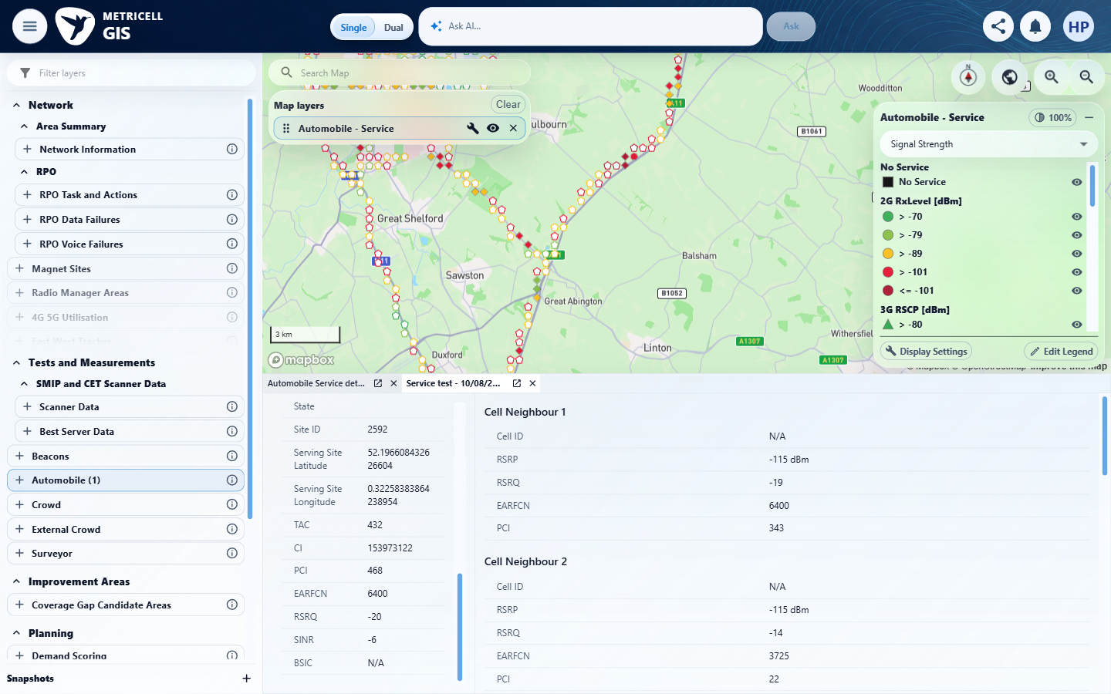

Criterion 5 continued: Given a Service point's reported radio generation is 2G, 3G, 4G, 5G NSA, or 5G SA, the visible KPI names are appropriate to that generation.
Browser URL recorded after criterion: https://o2intelligence-v4-dev.metricell.com/gis
E37 - Before generation filter (criterion-5-before-generation-filter.png)  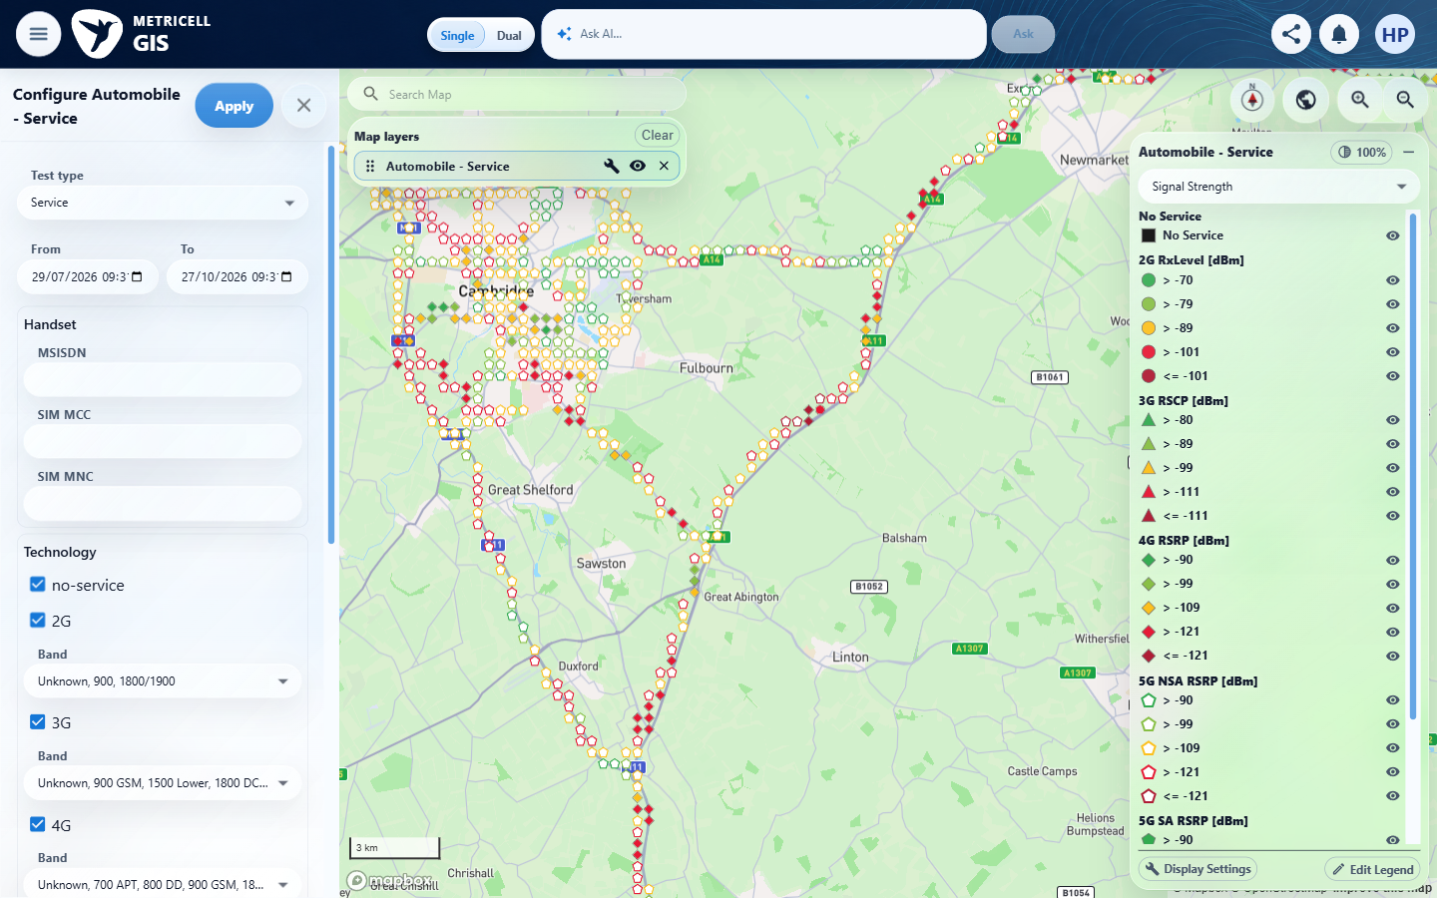 | E38 - 2g configuration (criterion-5-2g-configuration.png)  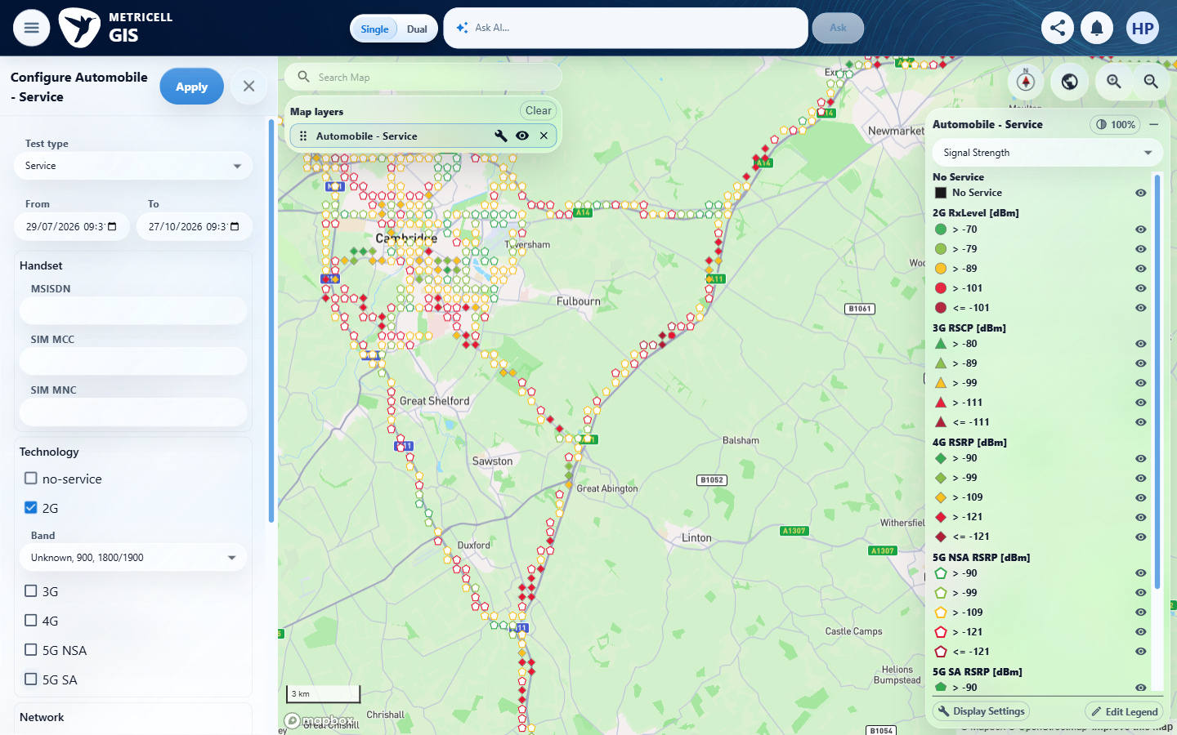

Criterion 5 continued: Given a Service point's reported radio generation is 2G, 3G, 4G, 5G NSA, or 5G SA, the visible KPI names are appropriate to that generation.
Browser URL recorded after criterion: https://o2intelligence-v4-dev.metricell.com/gis
E39 - 2g map (criterion-5-2g-map.png)  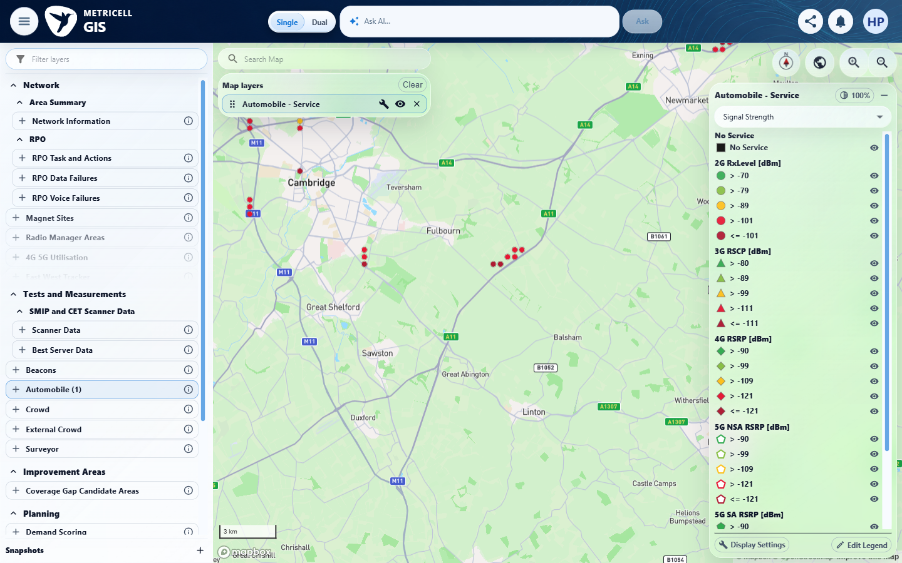 | E40 - 2g kpis top (criterion-5-2g-kpis-top.png)  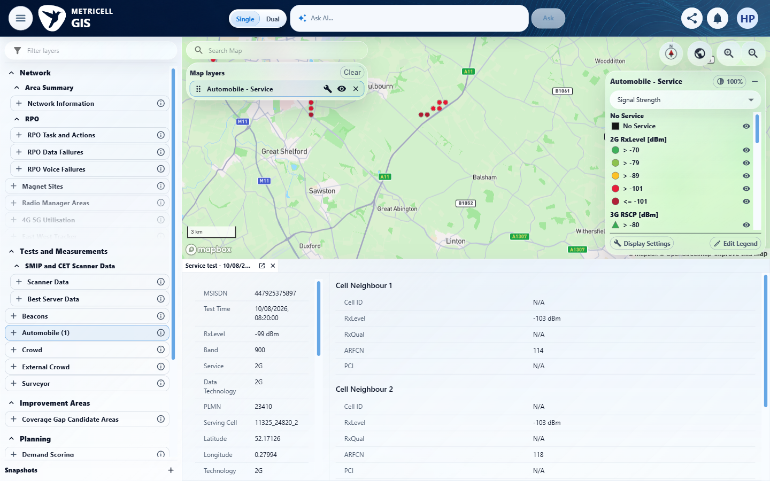

Criterion 5 continued: Given a Service point's reported radio generation is 2G, 3G, 4G, 5G NSA, or 5G SA, the visible KPI names are appropriate to that generation.
Browser URL recorded after criterion: https://o2intelligence-v4-dev.metricell.com/gis
E41 - 2g kpis bottom (criterion-5-2g-kpis-bottom.png)  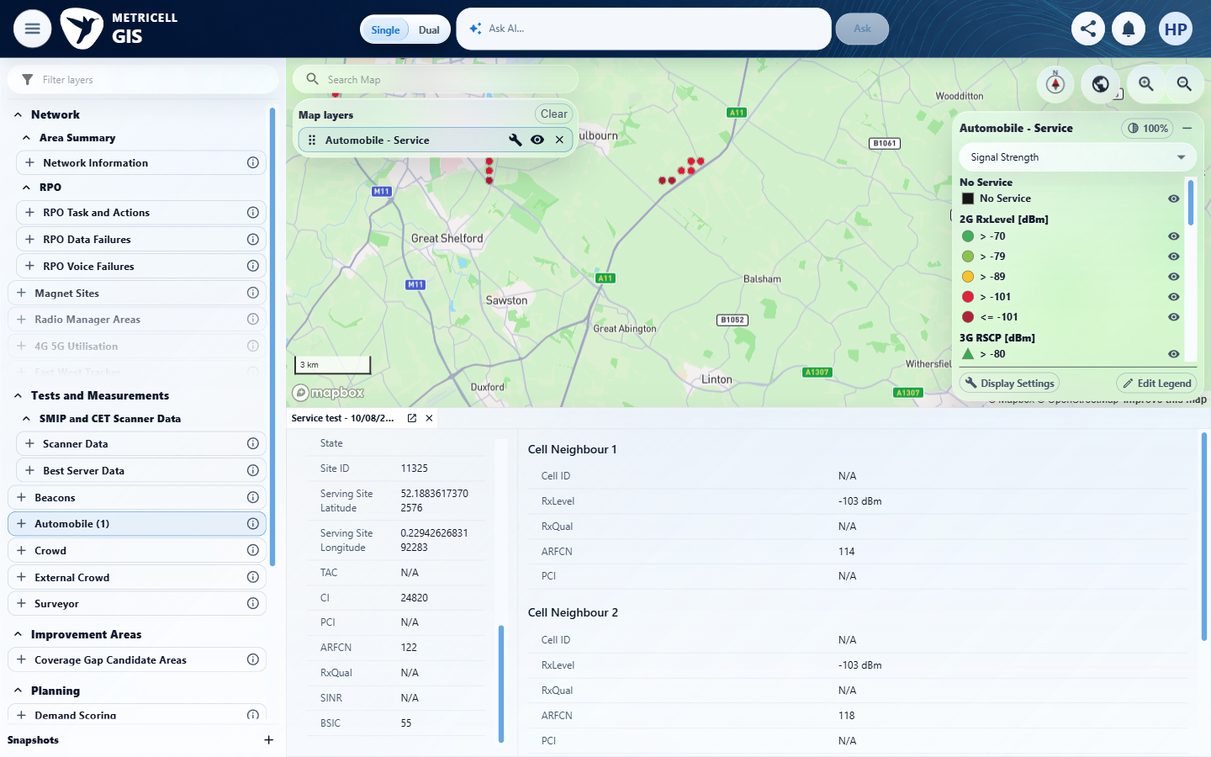 | E42 - 3g configuration (criterion-5-3g-configuration.png)  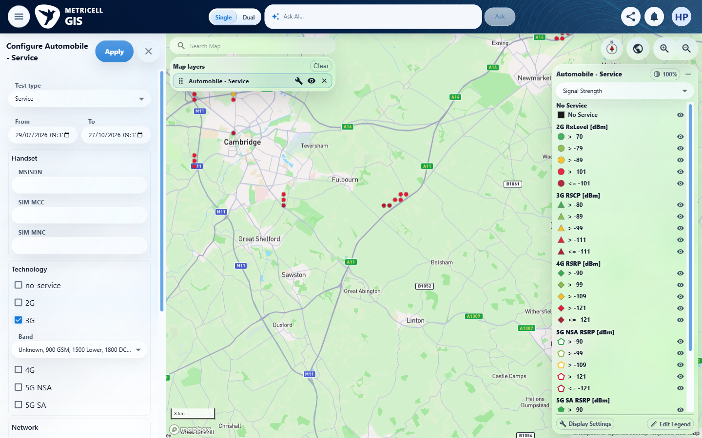

Criterion 5 continued: Given a Service point's reported radio generation is 2G, 3G, 4G, 5G NSA, or 5G SA, the visible KPI names are appropriate to that generation.
Browser URL recorded after criterion: https://o2intelligence-v4-dev.metricell.com/gis
E43 - 3g map (criterion-5-3g-map.png)  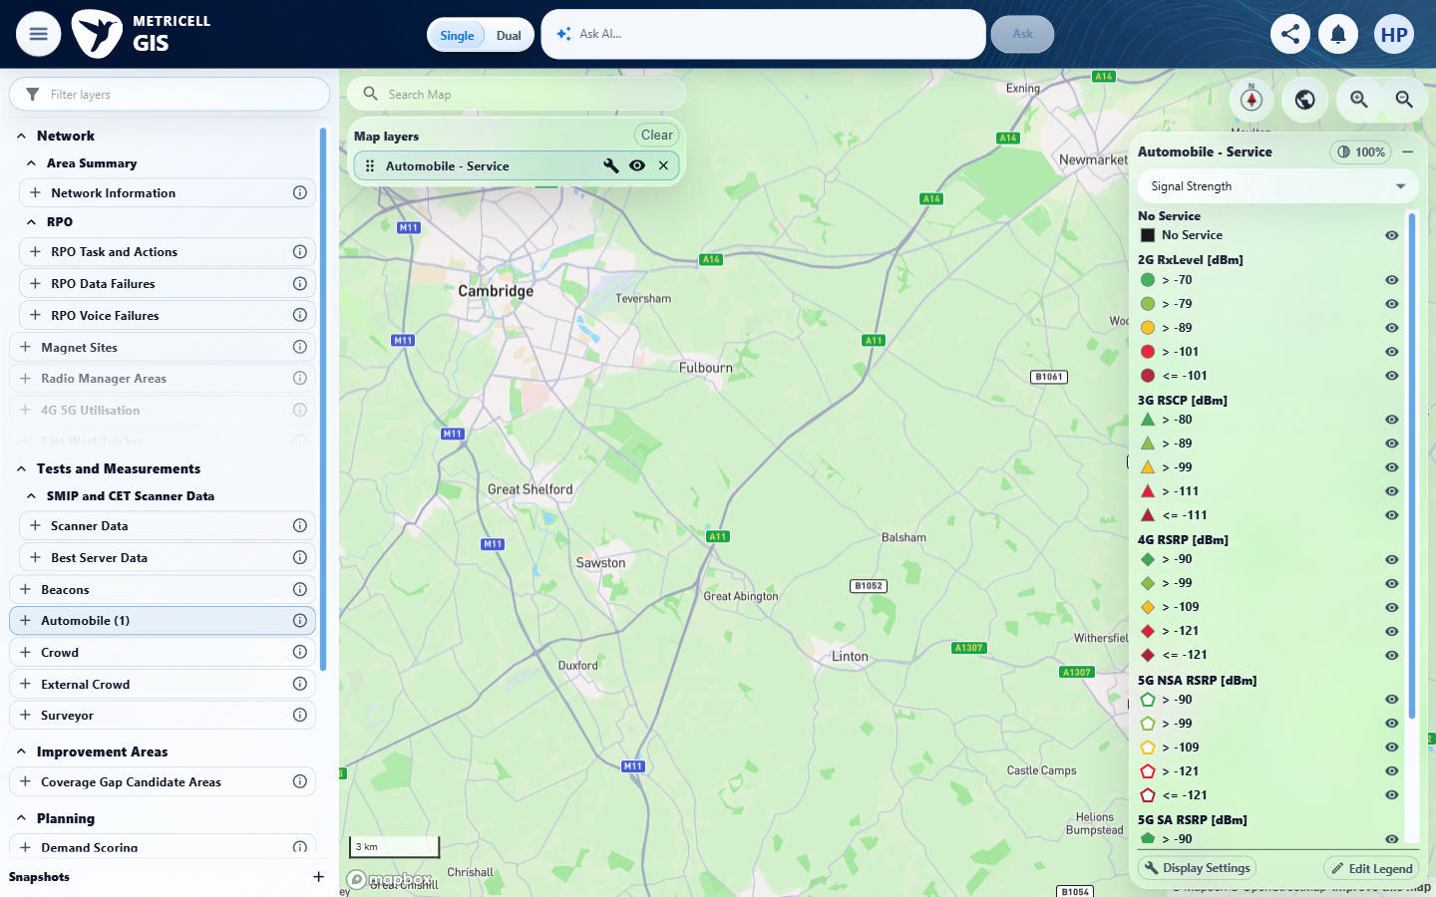 | E44 - Nsa configuration (criterion-5-nsa-configuration.png)  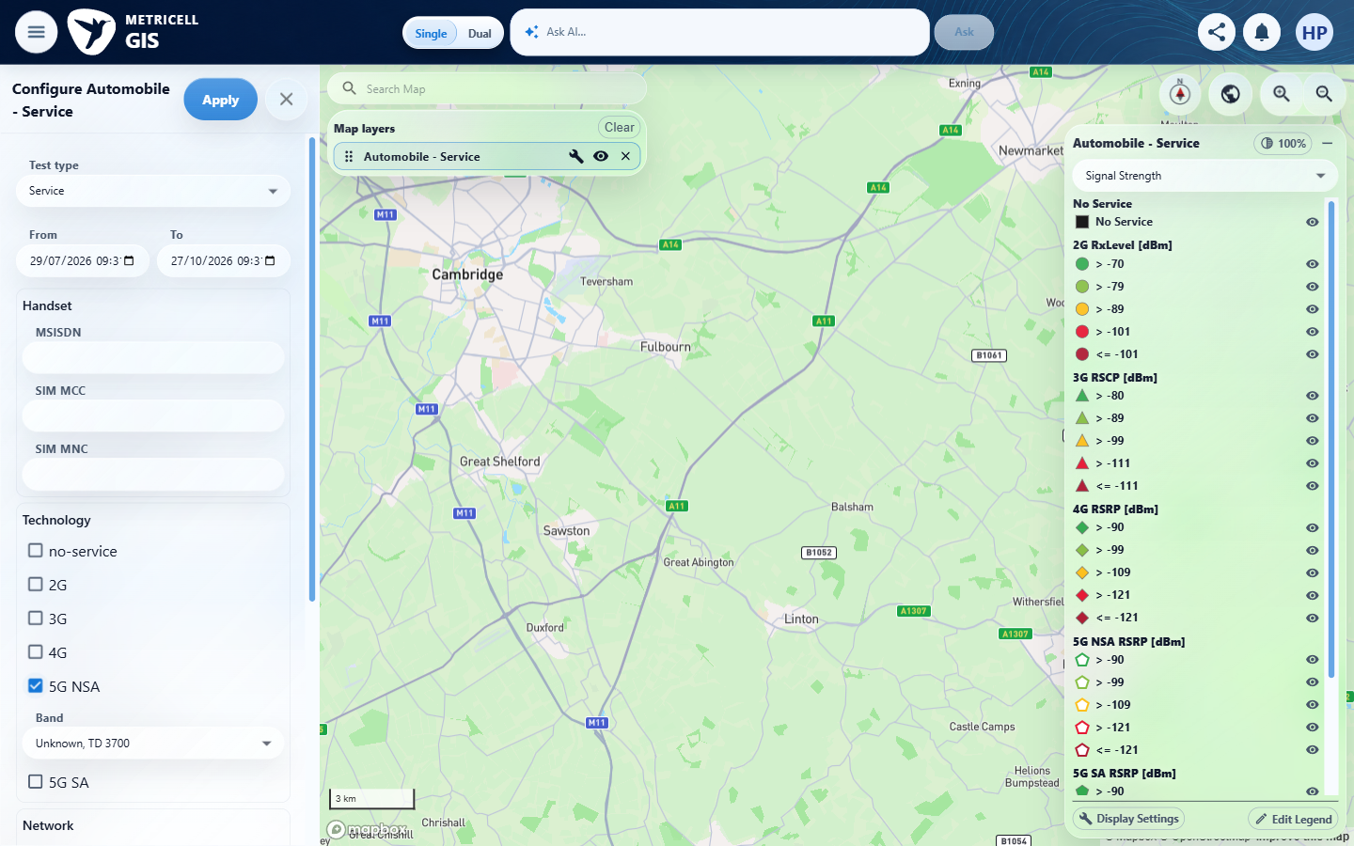

Criterion 5 continued: Given a Service point's reported radio generation is 2G, 3G, 4G, 5G NSA, or 5G SA, the visible KPI names are appropriate to that generation.
Browser URL recorded after criterion: https://o2intelligence-v4-dev.metricell.com/gis
E45 - Nsa map (criterion-5-nsa-map.png)  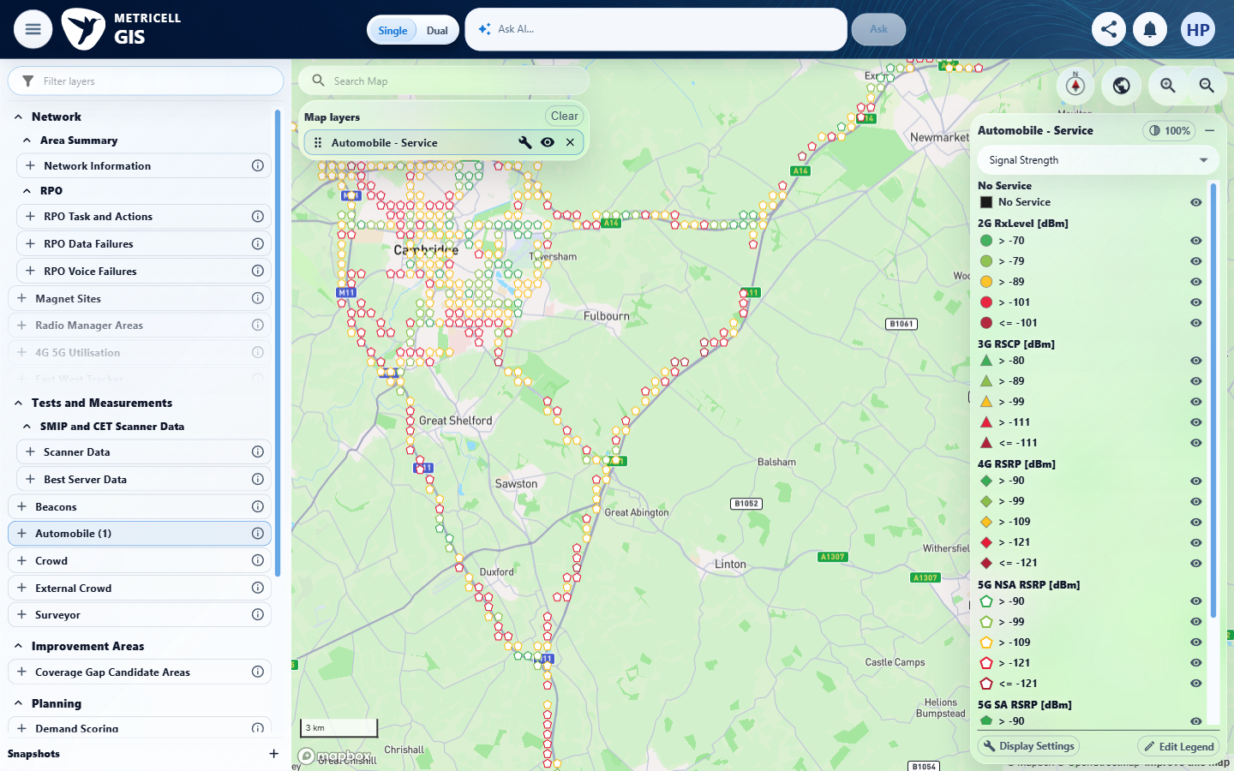 | E46 - Nsa cluster settled (criterion-5-nsa-cluster-settled.png)  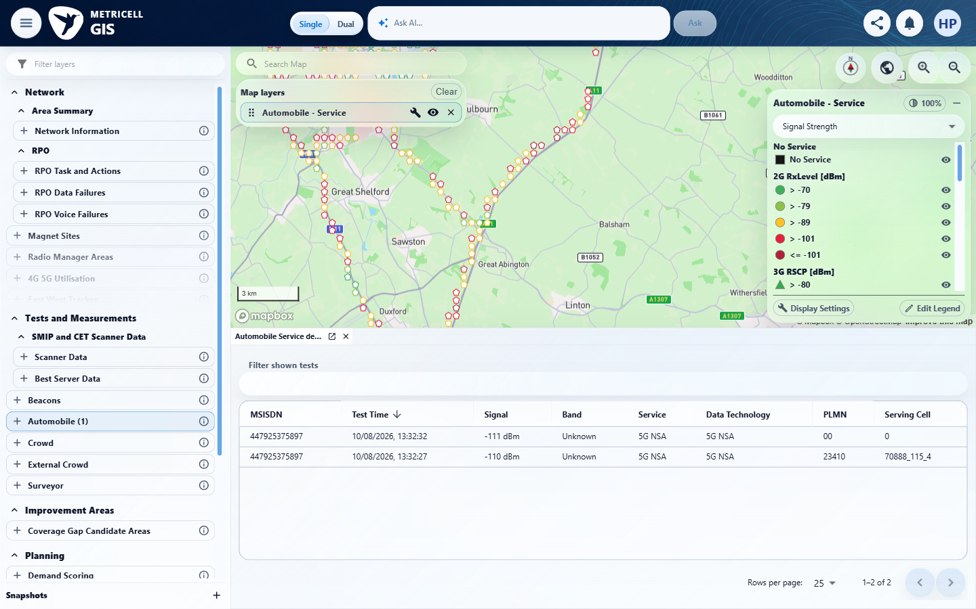

Criterion 5 continued: Given a Service point's reported radio generation is 2G, 3G, 4G, 5G NSA, or 5G SA, the visible KPI names are appropriate to that generation.
Browser URL recorded after criterion: https://o2intelligence-v4-dev.metricell.com/gis
E47 - Nsa kpis top (criterion-5-nsa-kpis-top.png)  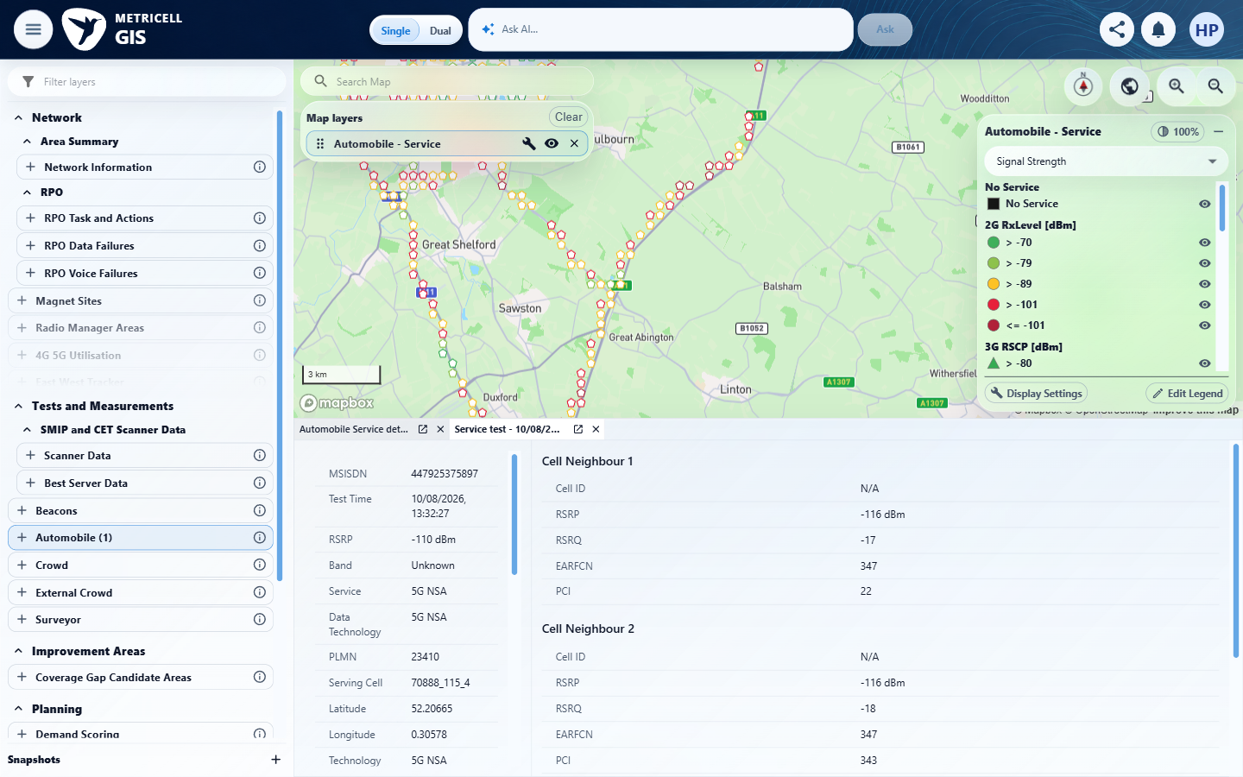 | E48 - Nsa kpis bottom (criterion-5-nsa-kpis-bottom.png)  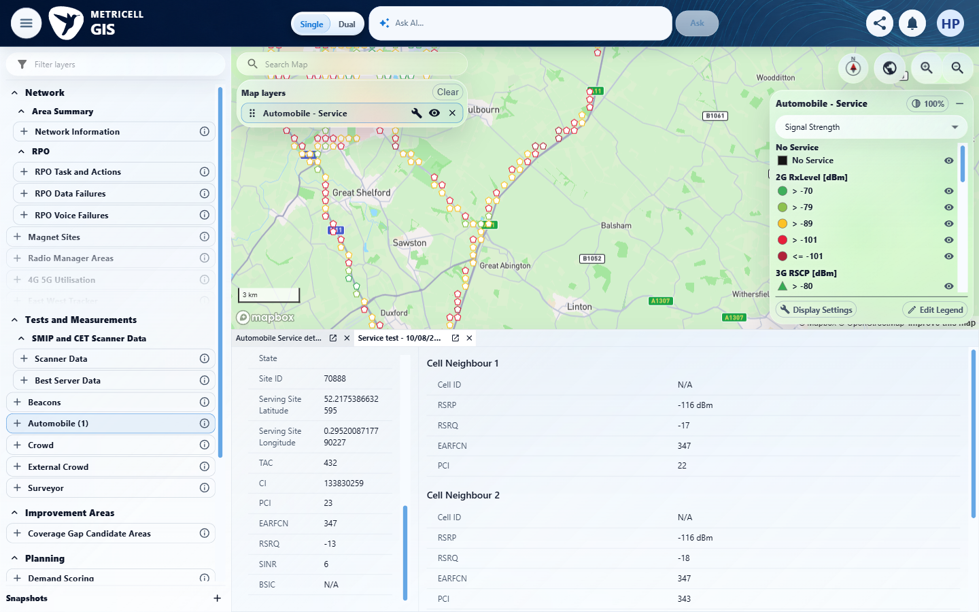

Criterion 5 continued: Given a Service point's reported radio generation is 2G, 3G, 4G, 5G NSA, or 5G SA, the visible KPI names are appropriate to that generation.
Browser URL recorded after criterion: https://o2intelligence-v4-dev.metricell.com/gis
E49 - Sa configuration (criterion-5-sa-configuration.png)  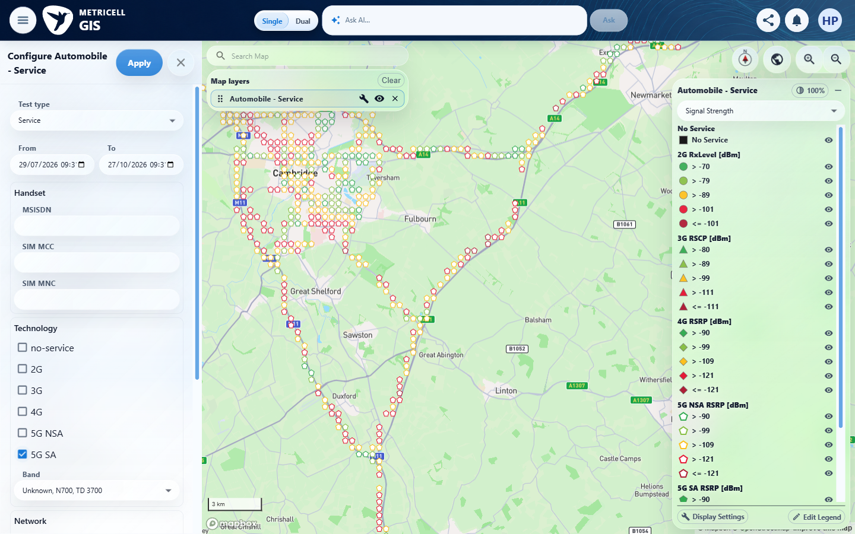 | E50 - Final (criterion-5-final.png)  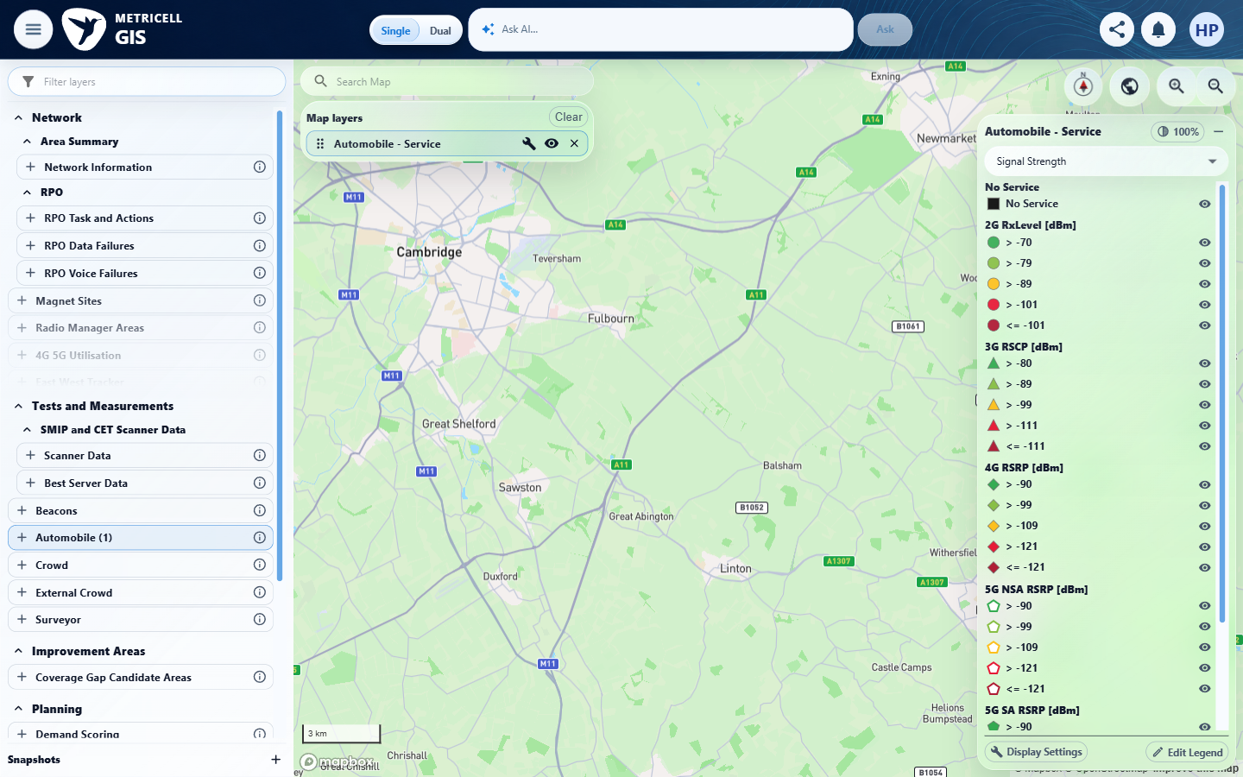

6.0.0 | Given 5G SA is selected and the user opens a Service point in the shared point-detail dialog, the Service point detail presentation loads without an error state. | Given 5G SA is selected and the user opens a Service point in the shared point-detail dialog, the Service point detail presentation loads without an error state. | criterion-6-sa-configuration.png shows only 5G SA selected for Automobile Service. criterion-6-final.png shows the settled scoped map without selectable points, consistent with the result's recorded technologies=5 point-list HTTP 200 empty responses. With no qualifying 5G SA point in the inspected Cambridge/date scope, opening it and observing a successful detail load are blocked; an empty map cannot prove either requirement.  Evidence: E09, E51, E52, E53, E54, E55 | Blocked
Criterion 6 evidence: Given 5G SA is selected and the user opens a Service point in the shared point-detail dialog, the Service point detail presentation loads without an error state.
Browser URL recorded after criterion: https://o2intelligence-v4-dev.metricell.com/gis
E09 - Setup 0 (criterion-6-setup-0.png) | E51 - Setup 1 (criterion-6-setup-1.png)  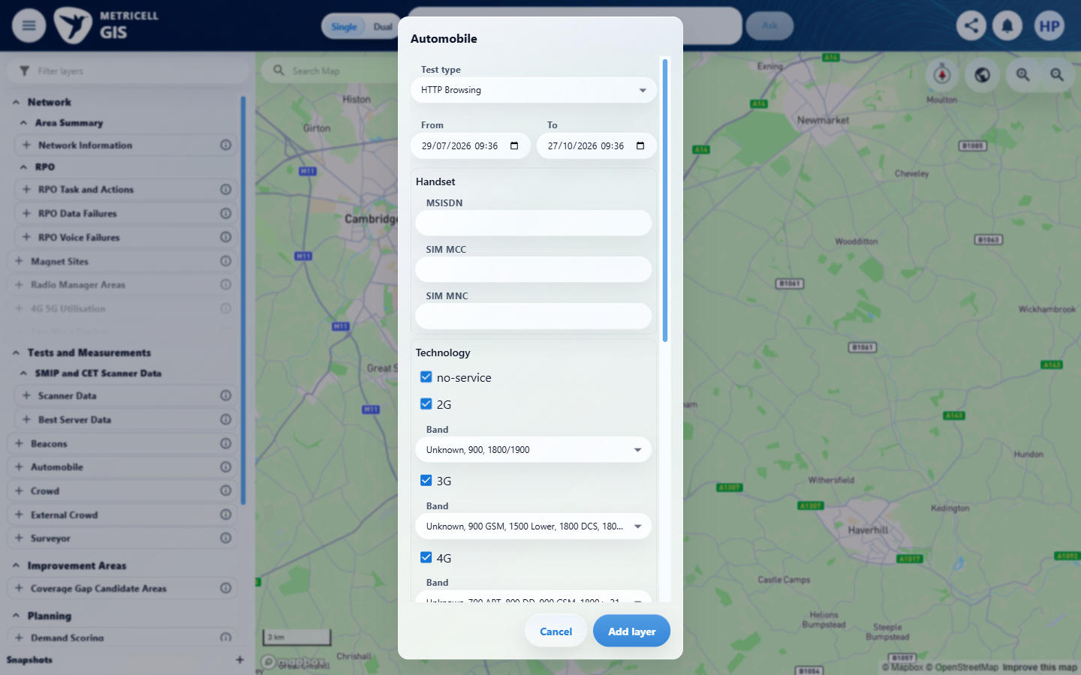

Criterion 6 continued: Given 5G SA is selected and the user opens a Service point in the shared point-detail dialog, the Service point detail presentation loads without an error state.
Browser URL recorded after criterion: https://o2intelligence-v4-dev.metricell.com/gis
E52 - Setup 2 (criterion-6-setup-2.png)  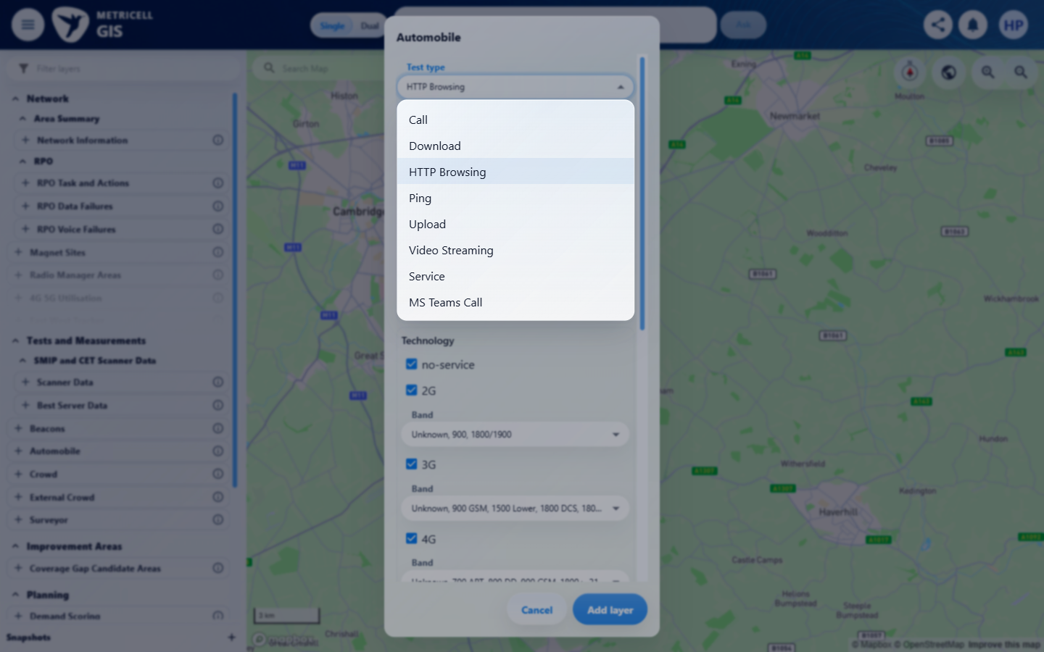 | E53 - Setup 3 (criterion-6-setup-3.png)  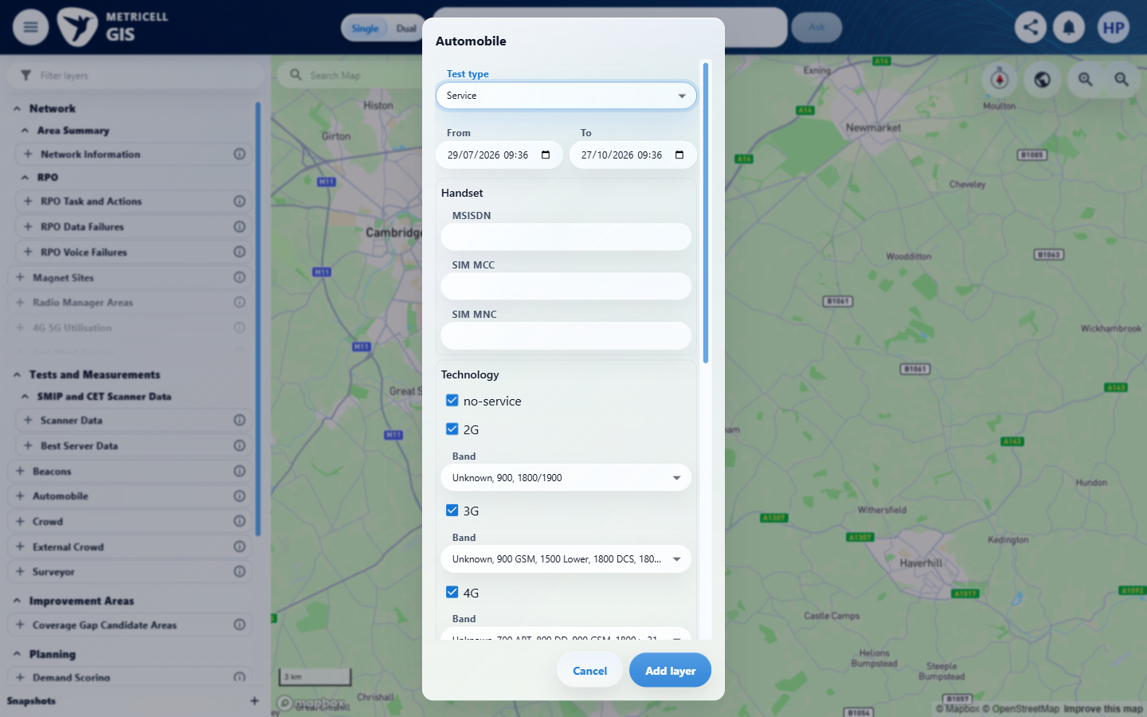

Criterion 6 continued: Given 5G SA is selected and the user opens a Service point in the shared point-detail dialog, the Service point detail presentation loads without an error state.
Browser URL recorded after criterion: https://o2intelligence-v4-dev.metricell.com/gis
E54 - Sa configuration (criterion-6-sa-configuration.png)  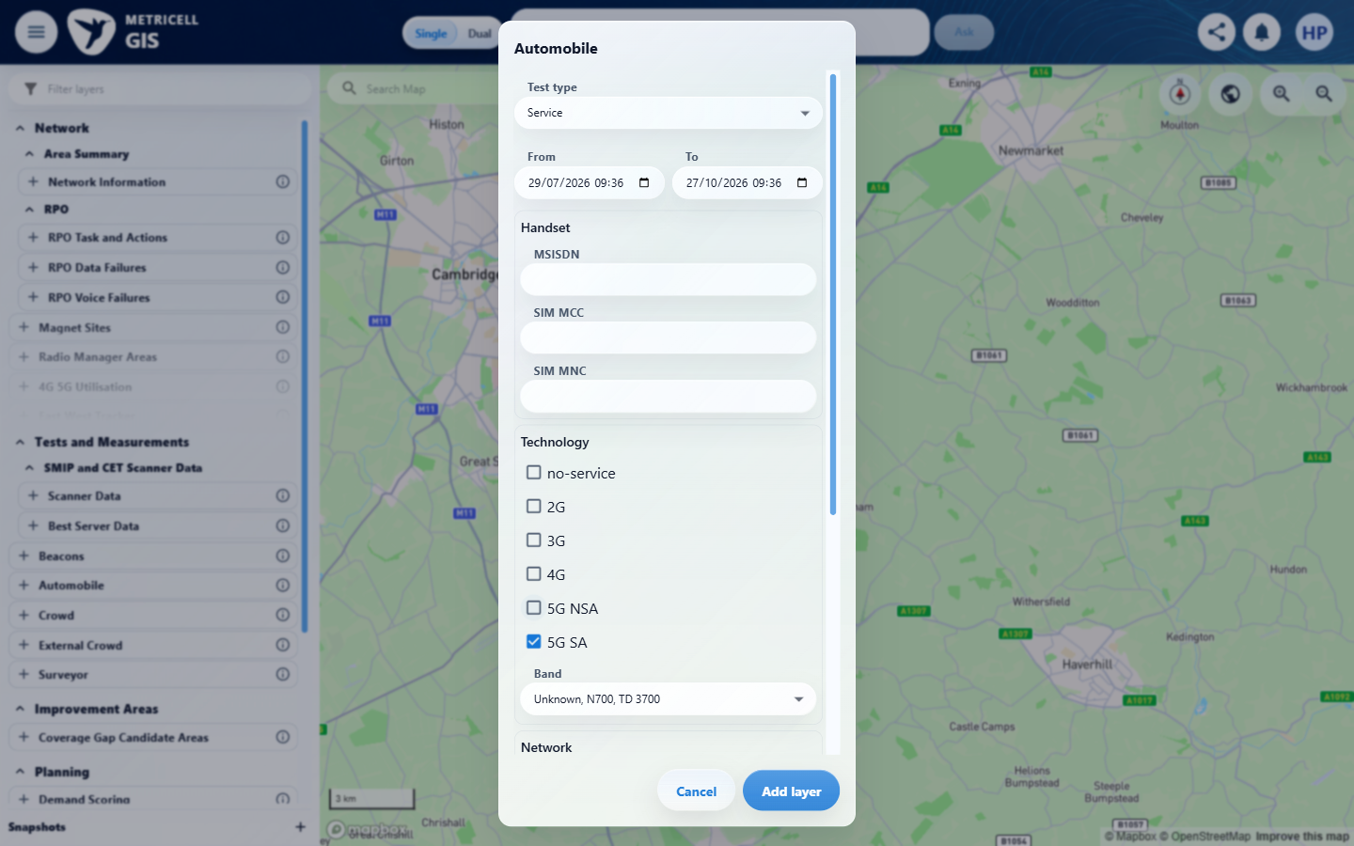 | E55 - Final (criterion-6-final.png)  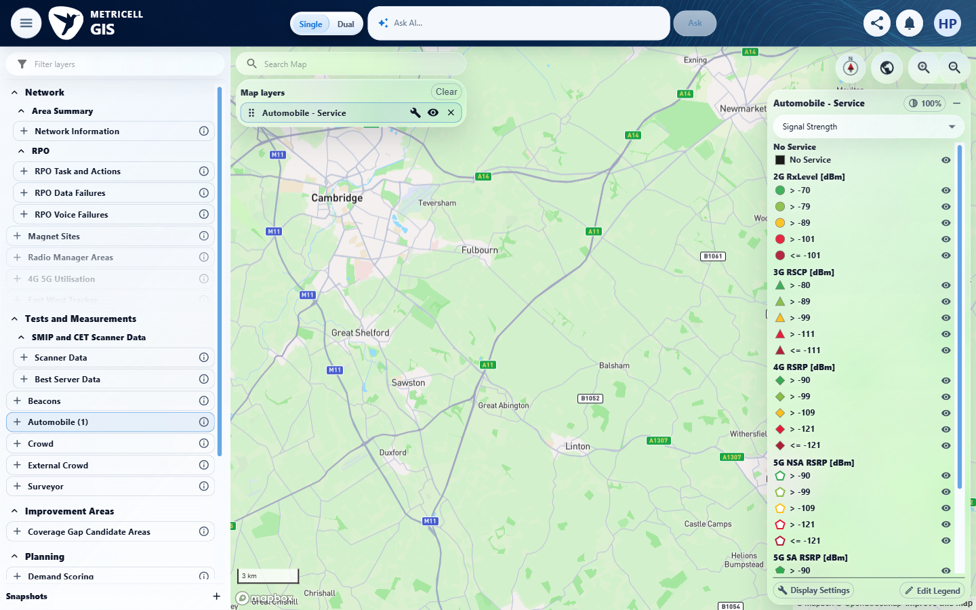

7.0.0 | Given Service point details are loading, the detail presentation shows a loading state without displaying incorrect detail data. | Given Service point details are loading, the detail presentation shows a loading state without displaying incorrect detail data. | The recorded check satisfied the criterion; see the assessment below.  Evidence: E56, E57, E58, E59, E60, E61 | Passed
Criterion 7 assessment: SIMULATED UI STATE: Delayed the selected detail request to check loading. The evidence shows only a loading spinner in the entire active detail presentation, without prior fields or neighbours.
Criterion 7 evidence: Given Service point details are loading, the detail presentation shows a loading state without displaying incorrect detail data.
Browser URL recorded after criterion: https://o2intelligence-v4-dev.metricell.com/gis
E56 - Final (criterion-7-final.png)  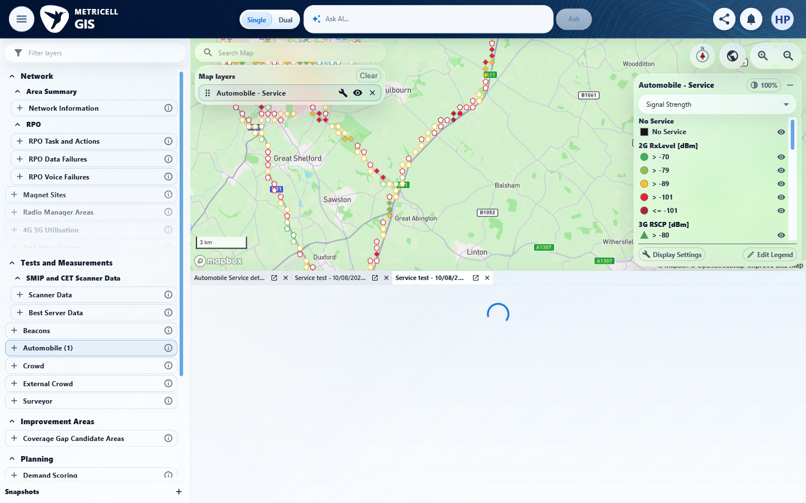 | E57 - Recovery (criterion-7-recovery.png)  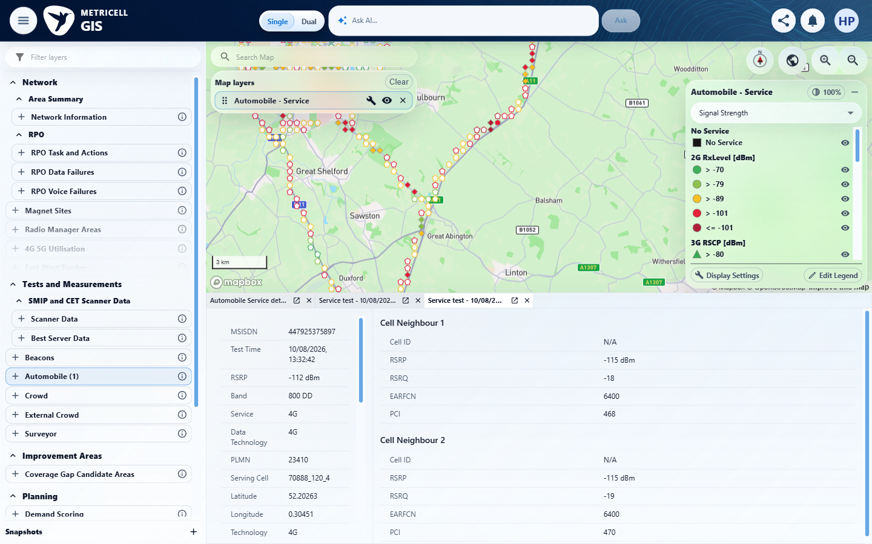

Criterion 7 continued: Given Service point details are loading, the detail presentation shows a loading state without displaying incorrect detail data.
Browser URL recorded after criterion: https://o2intelligence-v4-dev.metricell.com/gis
E58 - Target genuine baseline (criterion-7-target-genuine-baseline.png)  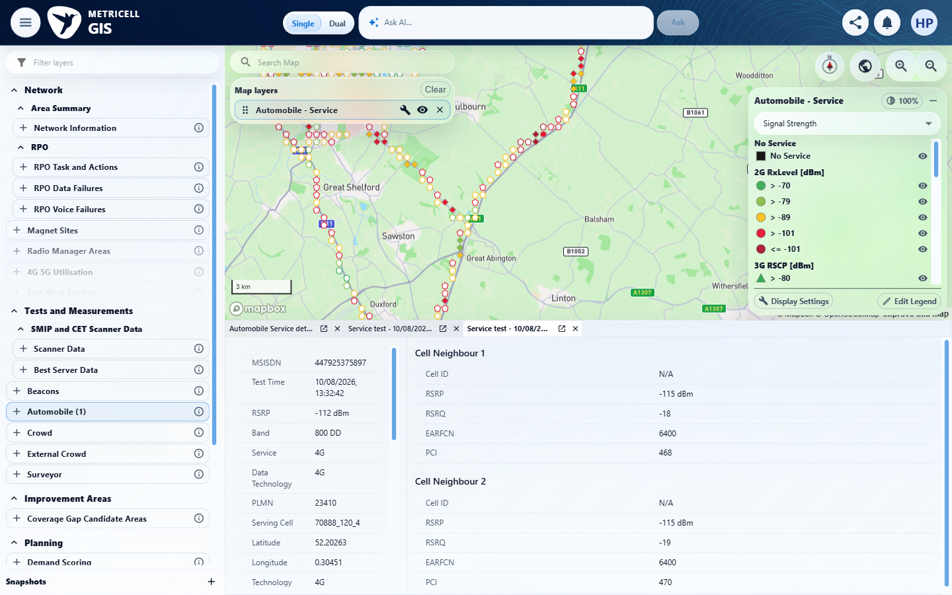 | E59 - Valid baseline (criterion-7-valid-baseline.png)  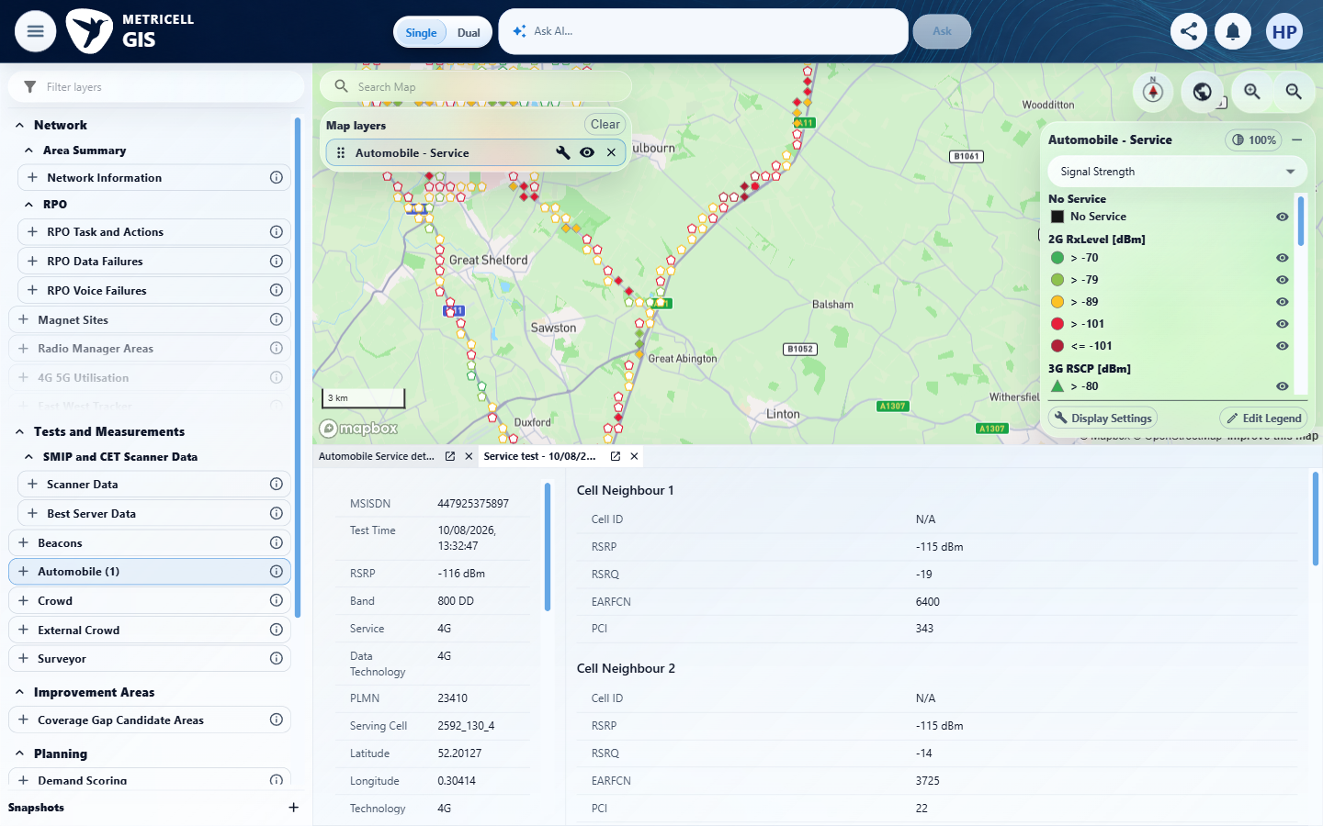

Criterion 7 continued: Given Service point details are loading, the detail presentation shows a loading state without displaying incorrect detail data.
Browser URL recorded after criterion: https://o2intelligence-v4-dev.metricell.com/gis
E60 - Before held load (criterion-7-before-held-load.png)  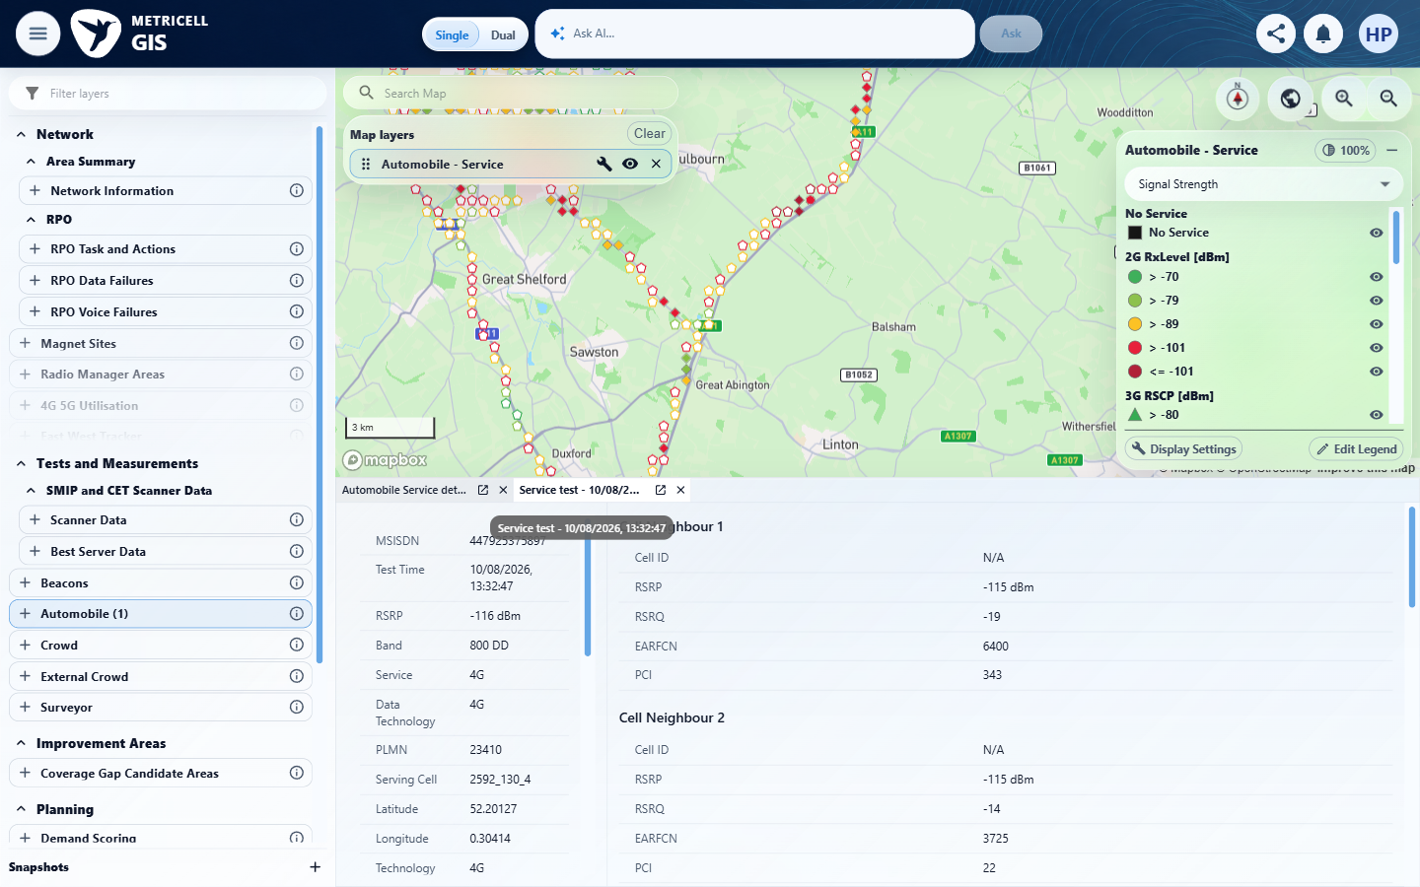 | E61 - Before target selection (criterion-7-before-target-selection.png)  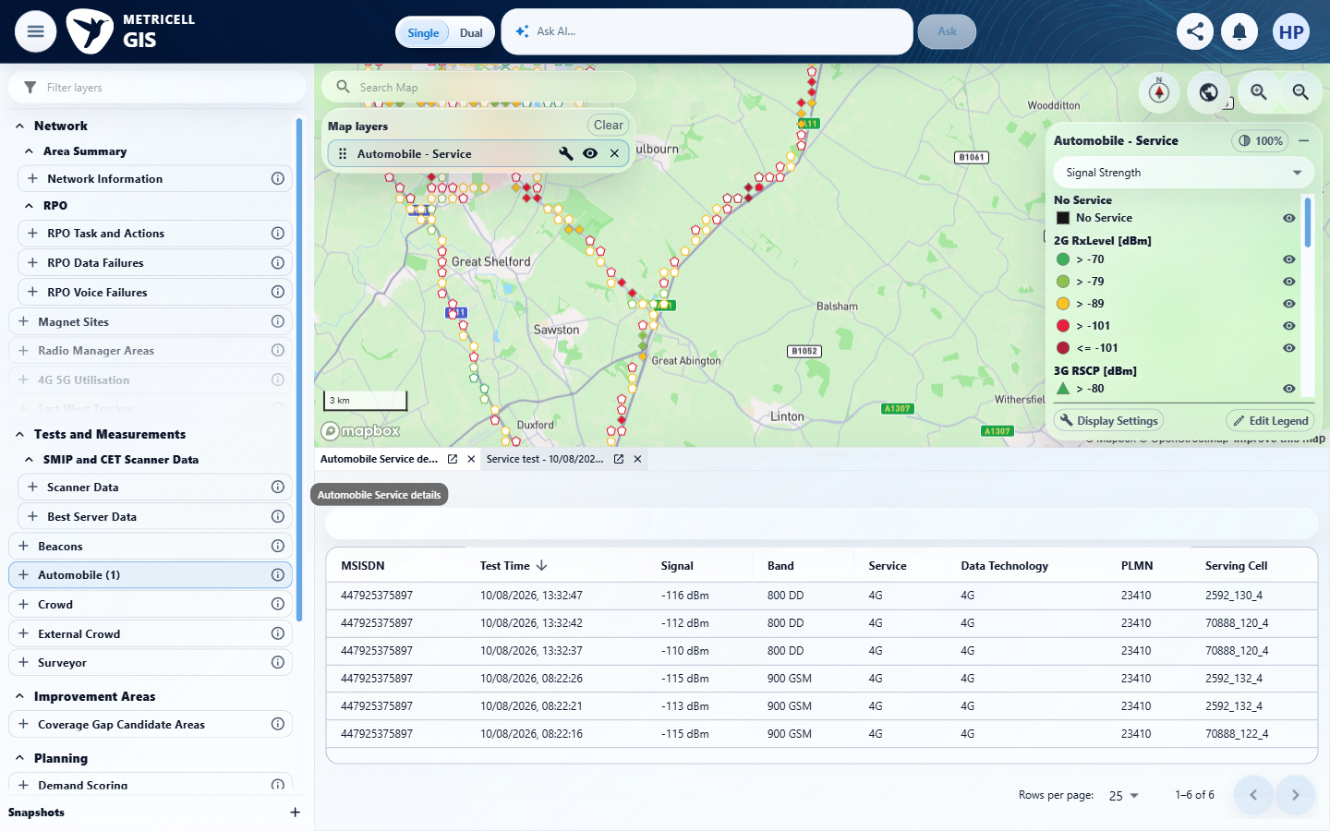

8.0.0 | Given Service point details are unavailable, the detail presentation shows a no-data state without displaying incorrect detail data. | Given Service point details are unavailable, the detail presentation shows a no-data state without displaying incorrect detail data. | No genuine unavailable-detail fixture or authoritative empty-response contract for POST /api/platform/automobile/service/cluster-details was established. criterion-8-final.png instead shows the selected point 131928117 loaded with serving information and two neighbours. An empty point-list response is a different endpoint/state. The no-data presentation and exclusion of stale details are blocked pending the required fixture or contract; no fabricated empty detail response is accepted.  Evidence: E62, E63, E64, E65, E04, E66, E67 | Blocked
Criterion 8 assessment: Testing notes: No genuine unavailable-detail fixture or authoritative empty response contract for the individual Service detail request was established. The no-data UI branch and incorrect-data exclusion cannot be decided safely. Inspected the genuine POST /api/platform/automobile/service/cluster-details HTTP 200 response: it contained populated serving details and two neighbours. It was not an unavailable-details fixture. No authoritative empty-detail response contract or genuine unavailable-detail response was supplied or established. Empty map point-list responses are a different endpoint/state.
Criterion 8 evidence: Given Service point details are unavailable, the detail presentation shows a no-data state without displaying incorrect detail data.
Browser URL recorded after criterion: https://o2intelligence-v4-dev.metricell.com/gis
E62 - Setup 0 (criterion-8-setup-0.png)  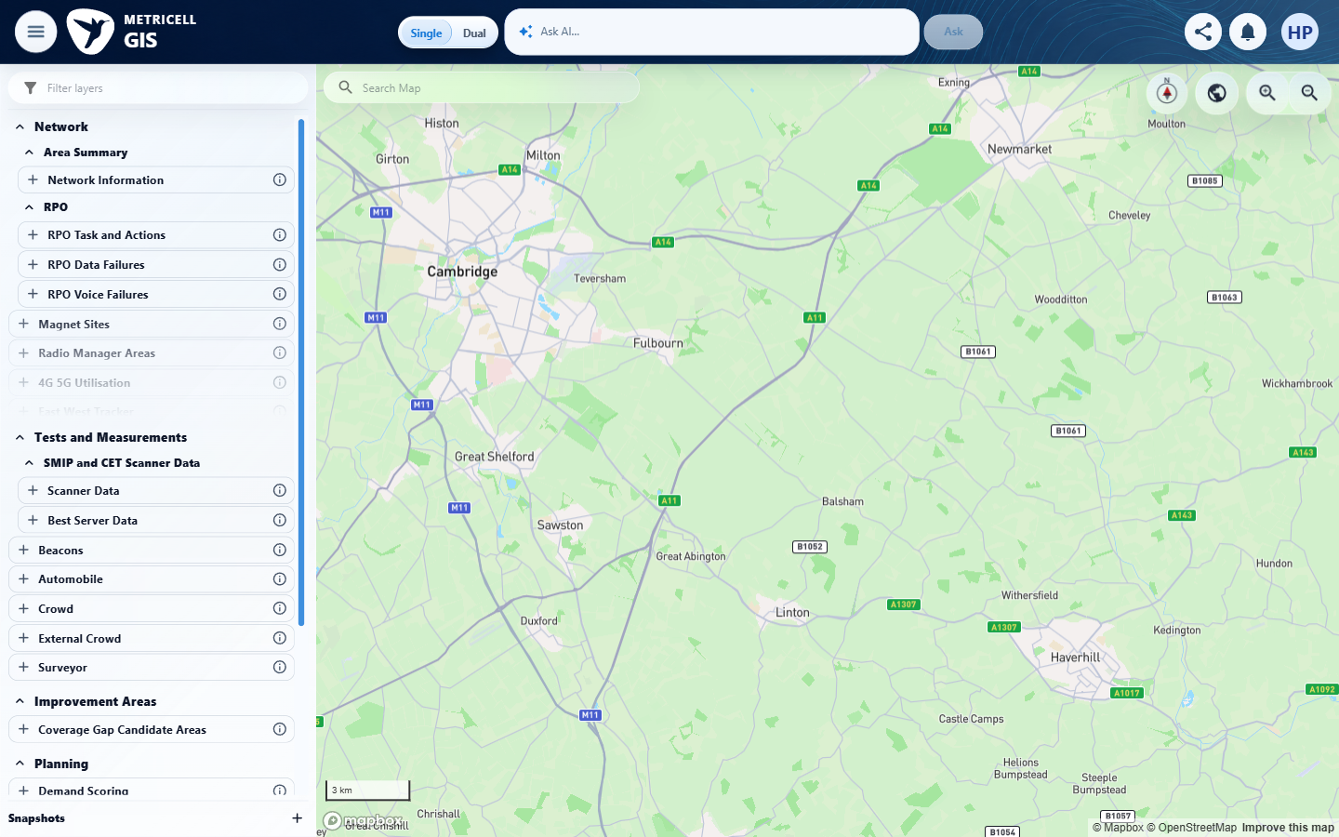 | E63 - Setup 1 (criterion-8-setup-1.png)  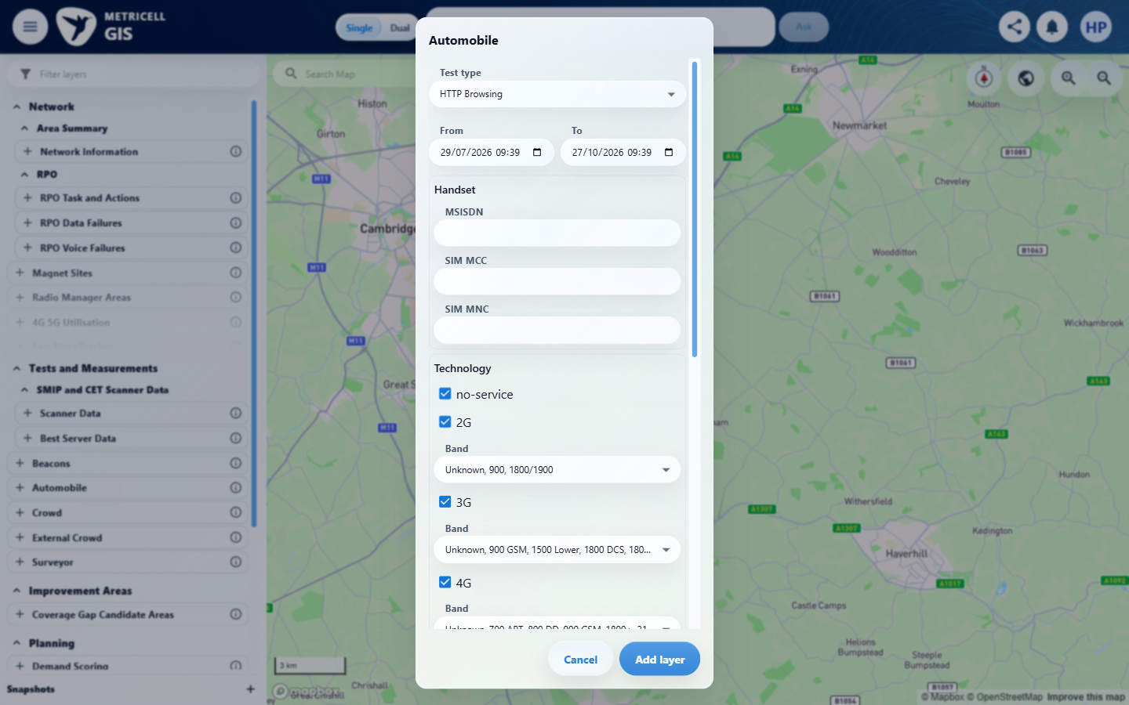

Criterion 8 continued: Given Service point details are unavailable, the detail presentation shows a no-data state without displaying incorrect detail data.
Browser URL recorded after criterion: https://o2intelligence-v4-dev.metricell.com/gis
E64 - Setup 2 (criterion-8-setup-2.png)  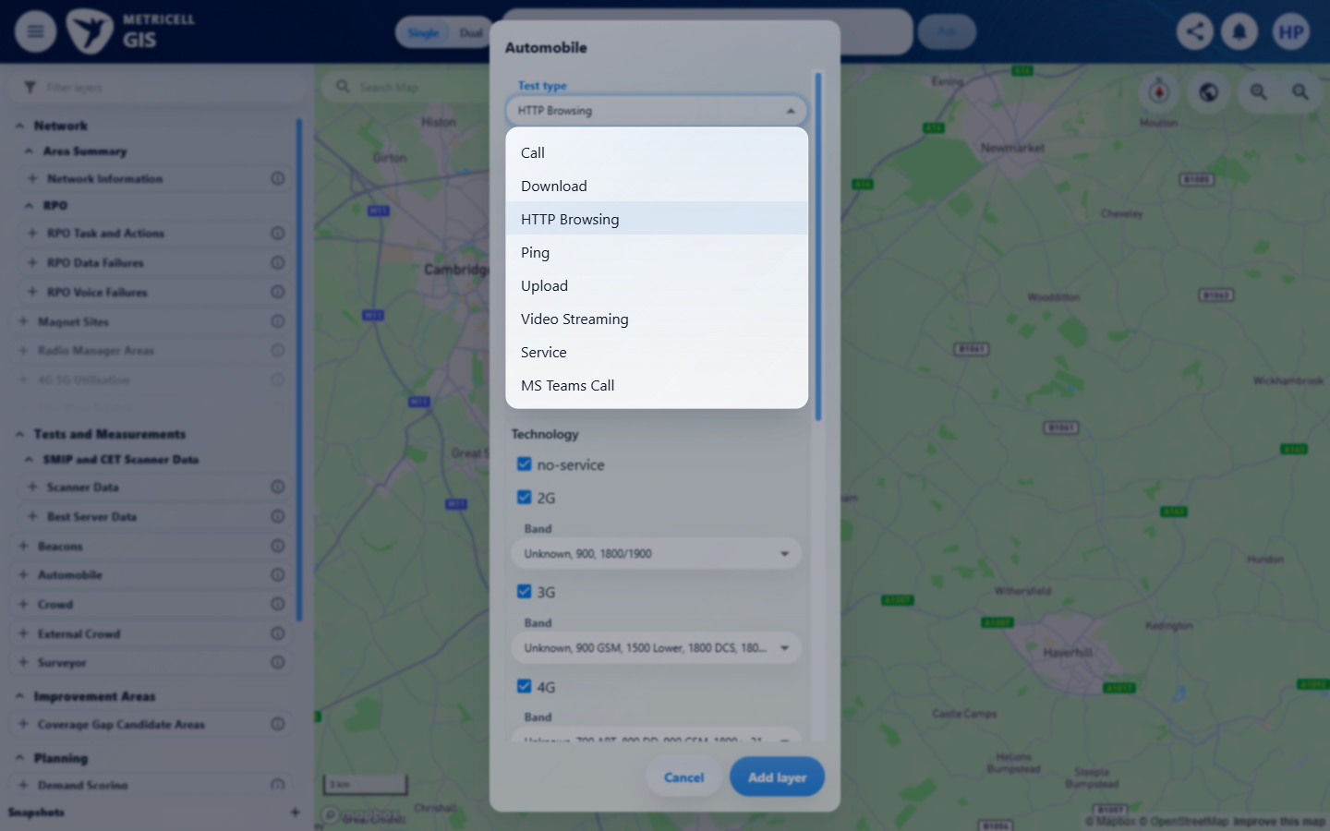 | E65 - Setup 3 (criterion-8-setup-3.png)  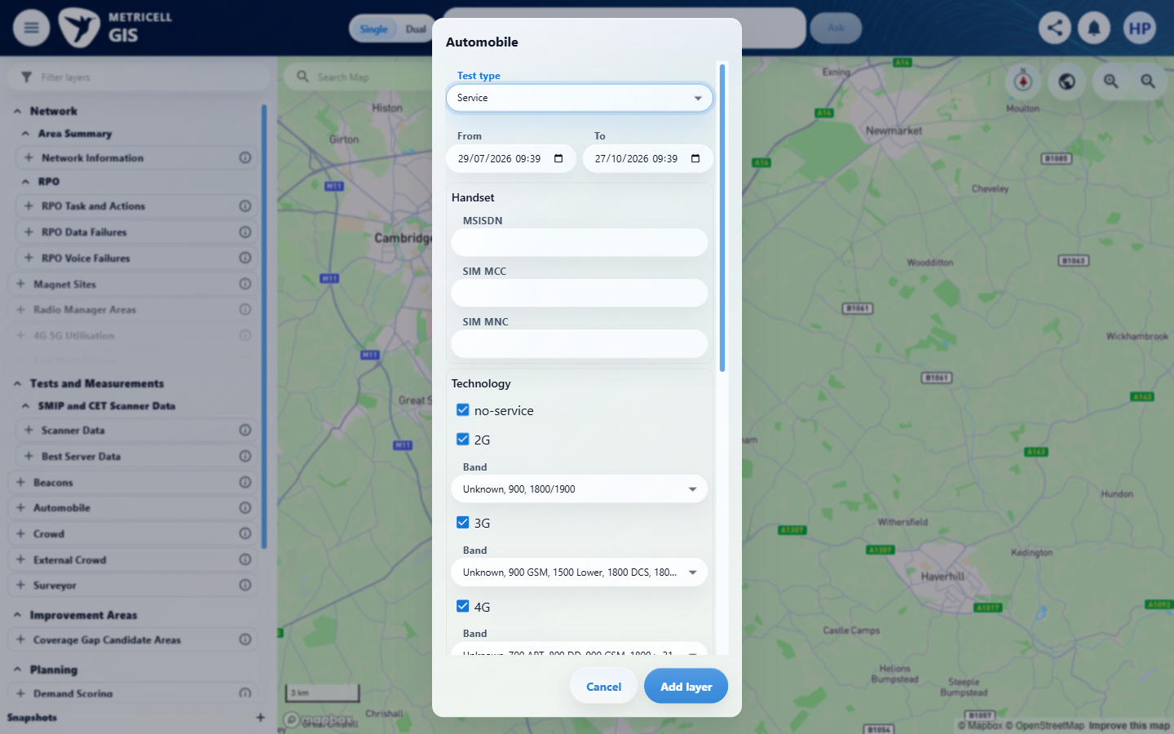

Criterion 8 continued: Given Service point details are unavailable, the detail presentation shows a no-data state without displaying incorrect detail data.
Browser URL recorded after criterion: https://o2intelligence-v4-dev.metricell.com/gis
E04 - Setup 4 (criterion-8-setup-4.png) | E66 - Cluster (criterion-8-cluster.png)  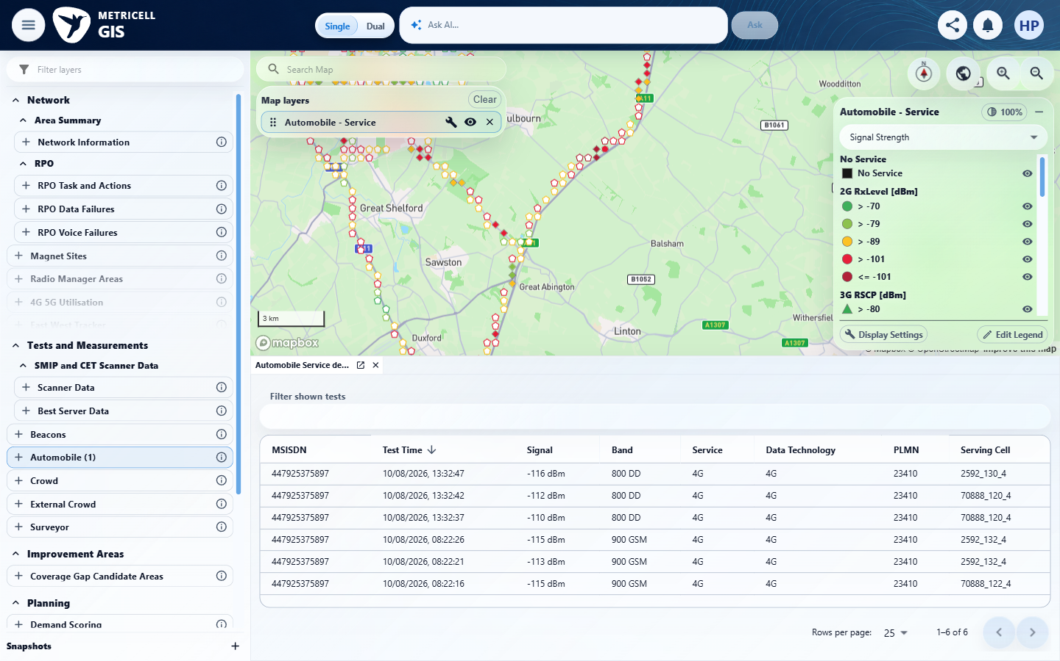

Criterion 8 continued: Given Service point details are unavailable, the detail presentation shows a no-data state without displaying incorrect detail data.
Browser URL recorded after criterion: https://o2intelligence-v4-dev.metricell.com/gis
E67 - Final (criterion-8-final.png)
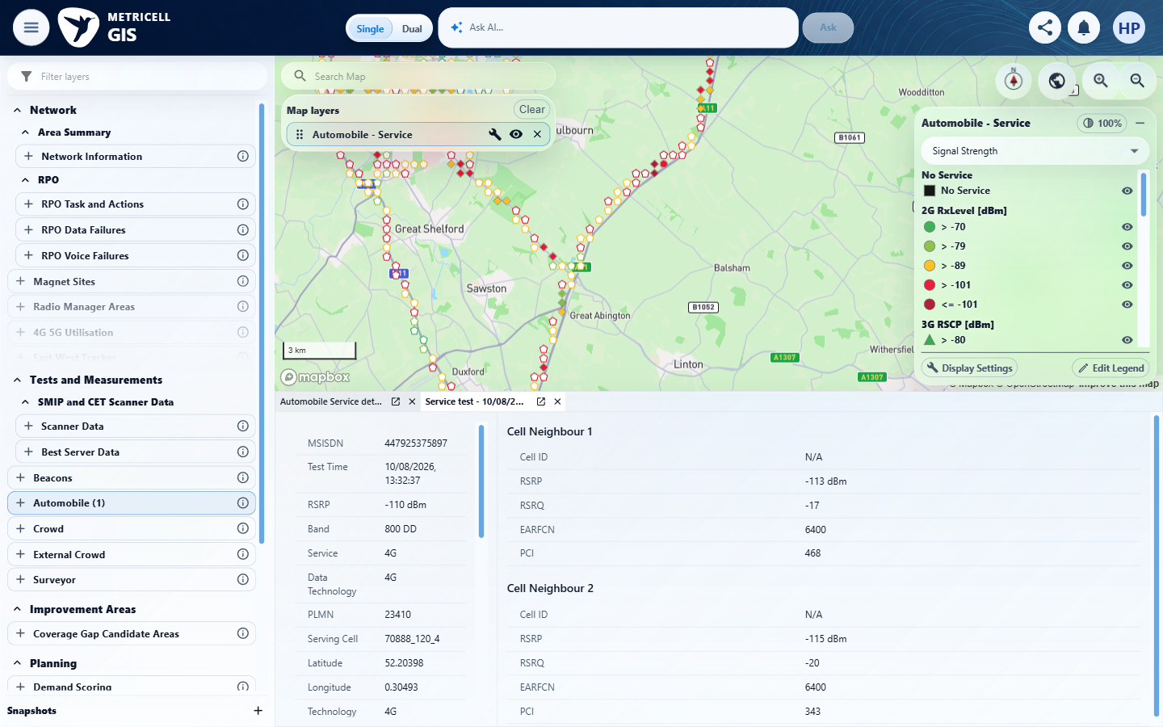

9.0.0 | Given loading Service point details fails, the detail presentation shows an error state and does not show incorrect detail data. | Given loading Service point details fails, the detail presentation shows an error state and does not show incorrect detail data. | The recorded check satisfied the criterion; see the assessment below.  Evidence: E68, E69, E70, E71, E72 | Passed
Criterion 9 assessment: SIMULATED UI STATE: Returned HTTP 503 for the selected detail request to check error handling. The evidence shows 'Unable to load point details.' and Retry with no stale serving fields or neighbours in the active presentation.
Criterion 9 evidence: Given loading Service point details fails, the detail presentation shows an error state and does not show incorrect detail data.
Browser URL recorded after criterion: https://o2intelligence-v4-dev.metricell.com/gis
E68 - Restart final (criterion-9-restart-final.png)  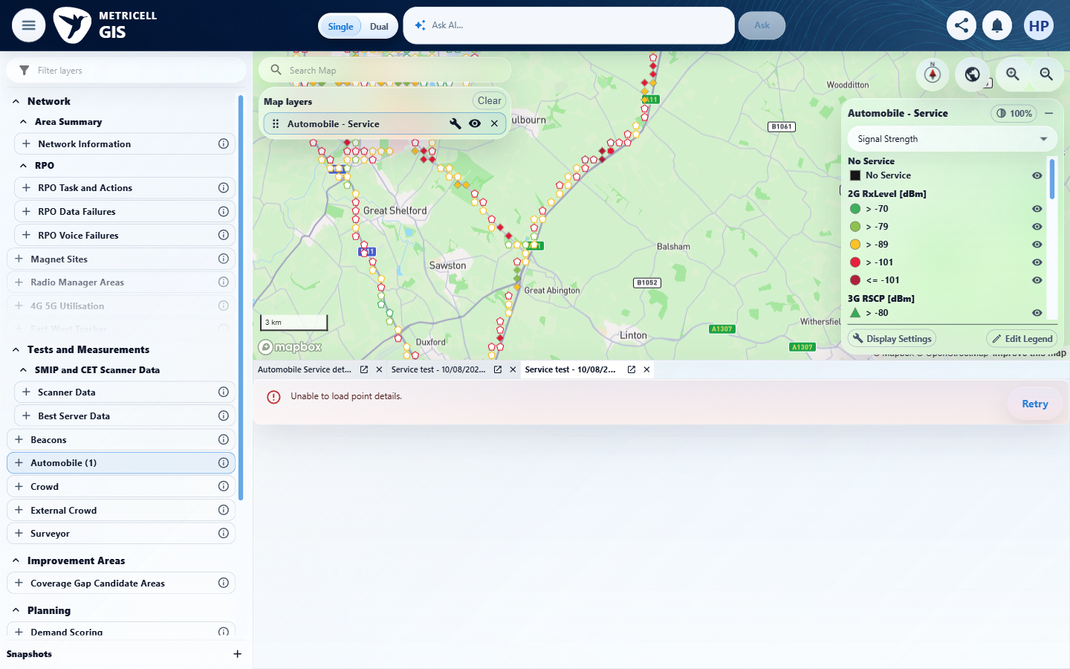 | E69 - Restart recovery (criterion-9-restart-recovery.png)  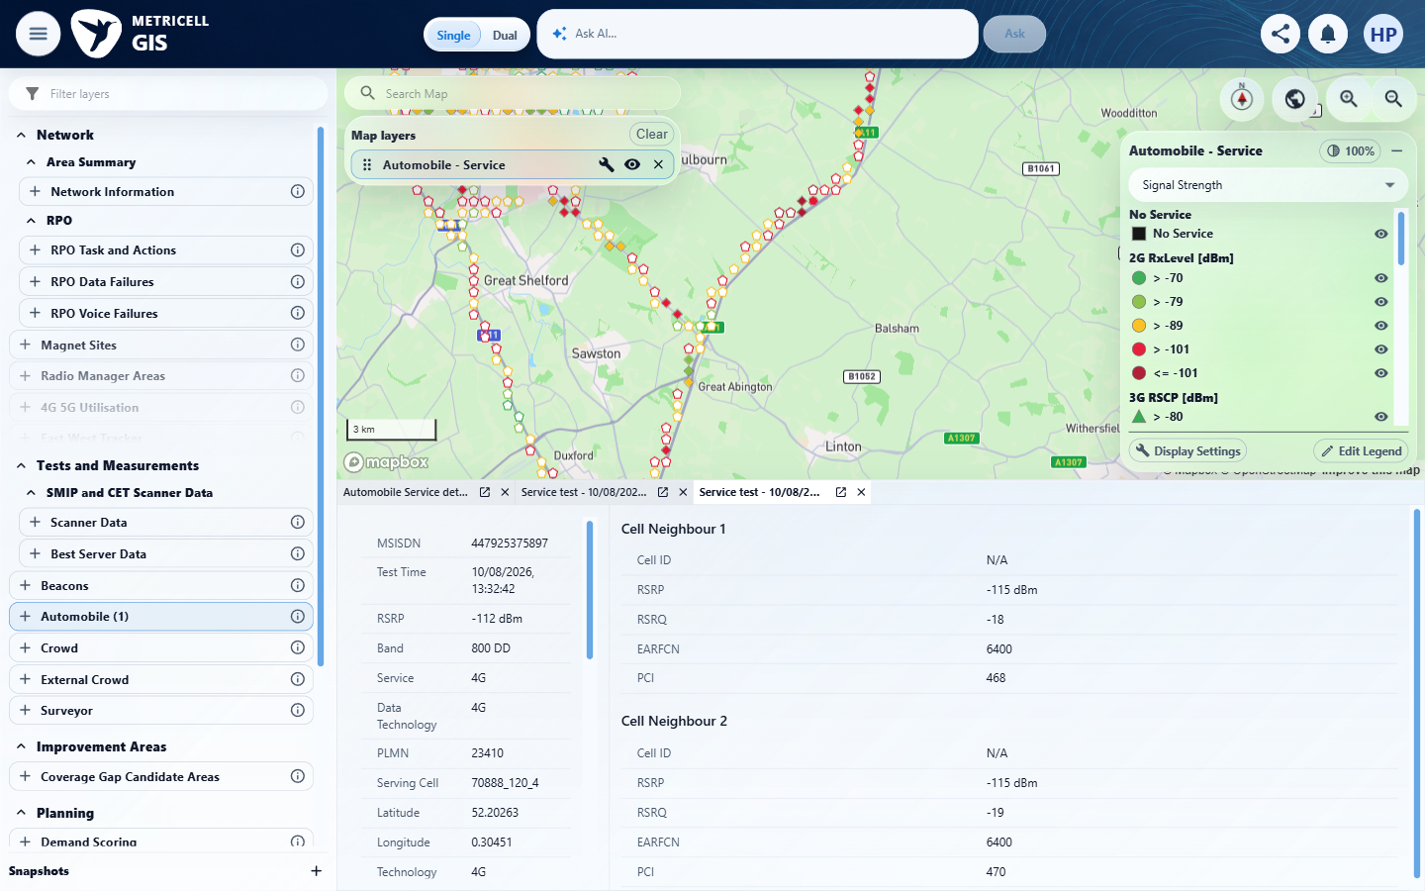

Criterion 9 continued: Given loading Service point details fails, the detail presentation shows an error state and does not show incorrect detail data.
Browser URL recorded after criterion: https://o2intelligence-v4-dev.metricell.com/gis
E70 - Restart target genuine (criterion-9-restart-target-genuine.png)  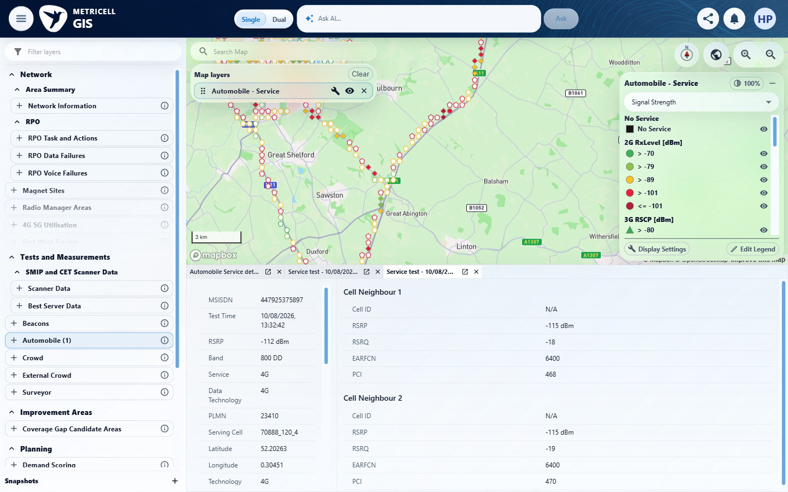 | E71 - Restart before error (criterion-9-restart-before-error.png)  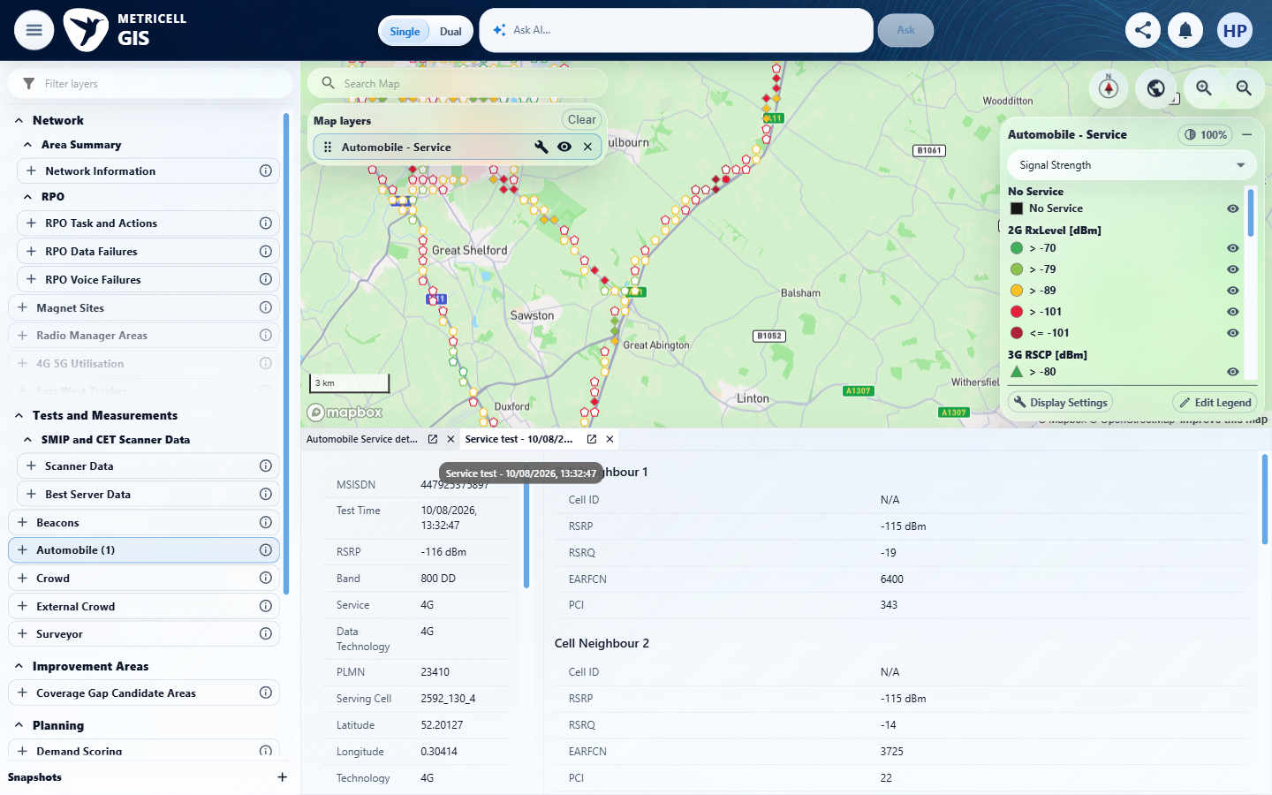

Criterion 9 continued: Given loading Service point details fails, the detail presentation shows an error state and does not show incorrect detail data.
Browser URL recorded after criterion: https://o2intelligence-v4-dev.metricell.com/gis
E72 - Restart before target (criterion-9-restart-before-target.png)
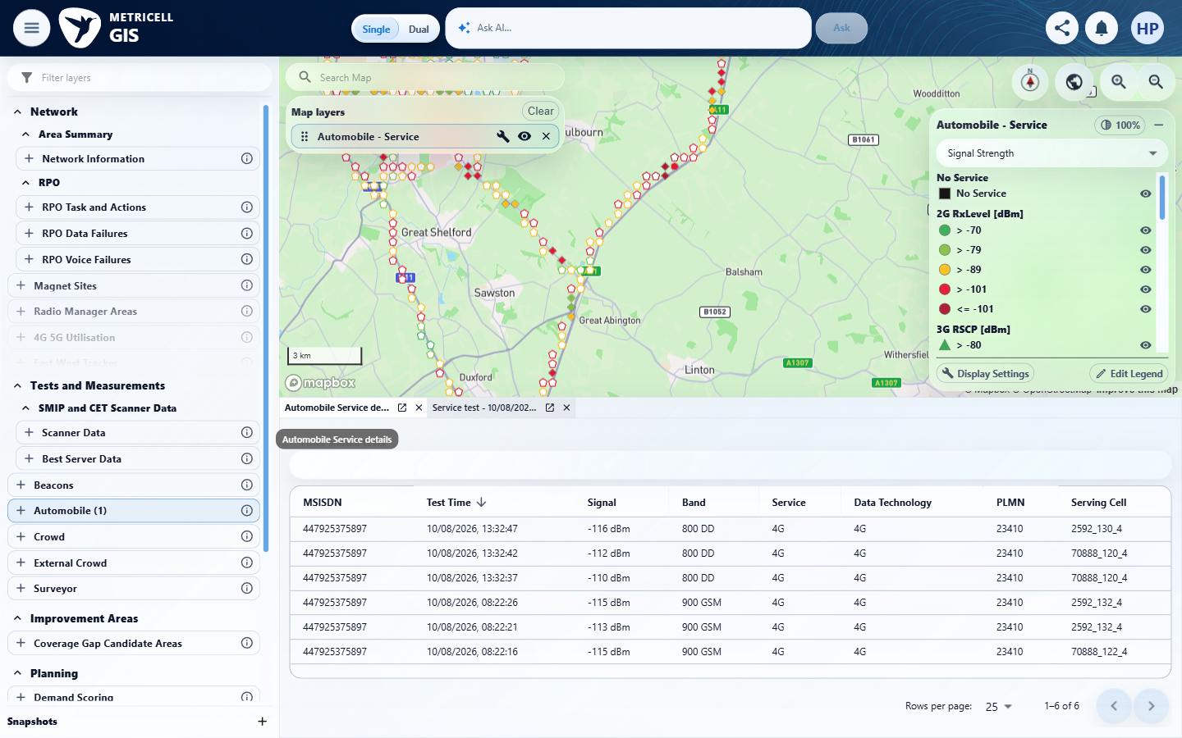

About Metricell

Metricell is on a mission to deliver connectivity. We work with our customers to design, deliver and manage wireless communication networks – with a shared ambition of achieving flawless network experience. We’ve been responsible for many first-to-market products, and our technology is characterised by the relentless pursuit of automation and digitalisation.

Our geospatial intelligence tools traverse a wide variety of business processes – from Test & Measurement to Customer Experience Management – and we’re pioneers in Crowdsourcing and Digital Self Care. Our technology is today in use by a range of customers; thousands of their personnel; and millions of subscribers worldwide.

Find out more at www.metricell.com




