

Automated Test Case Document
Jira Ticket: TEST2-92

Document Classification: | Company Confidential
Document Ref: | Automated Test Case Document
Version: | 1.0
Date: | 28/10/2026
Document Author: | Automated TEST2 Evidence Review
Document Owner: | Quality Assurance / Metricell




This document and its content is copyright of Metricell Limited @ 2026 all rights reserved. All information contained herein is the intellectual property of Metricell Limited and should be treated as confidential. Any external redistribution of reproduction of part or all of the contents in any form is prohibited unless expressly agreed with Metricell Limited in writing. Any reproduced content must include the following statement; “Part or all of the content contained herein is copyright of Metricell Limited @ 2026 all rights reserved”.
Table of Contents
1 Revision History 2
2 Test Cycle Information 3
3 Test Summary 3
4 Test Cases 4
About Metricell 12

Revision History

Version | Date | Revision Author | Summary of Changes
[1.0] | 28/10/2026 | TEST2 QA Automation | Generated from TEST2 evidence review

Test Cycle Information

Tester: | Automated
Jira Ticket: | TEST2-92
Environment: | o2intelligence-v4-dev.metricell.com
Browser Details: | Google Chrome 156.0.8078.48
Date of Test: | 28/10/2026
Limitations during Testing: | Blocked criterion(s): 1, 5, 6, 8, 9, 12, 15. See the assessment below each criterion.  Unverified criterion(s): 4, 7, 10, 13. See the assessment below each criterion. Inconclusive evidence is reported as Failed, but is not a confirmed application defect.
Overall review outcome: | Blocked
Browser URL(s) recorded after criteria: | https://o2intelligence-v4-dev.metricell.com/gis

Test Summary

Area of test | Pass (Y/N) | Fail (Y/N) | Blocked (Y/N) | Defect No
1. With a standard Automobile layer active, the legend shows the titled groups and items defined by that layer’s selected legend section, using the configured categories, thresholds, colours, shapes and outlines. | N | N | Y | 0
2. When a visible legend item is selected, matching points in the active layer are hidden and the item is visibly muted; selecting it again restores the points and normal item appearance. | Y | N | N | 0
3. When a legend item is double-clicked, that item remains visible and all other items in its group are hidden; items in other groups retain their visibility. | N | Y | N | 1
4. Legend filtering and legend edits change only the active layer’s presentation; other layers, underlying data, and form-based filters retain their prior state. | N | Y | N | 0
5. When a layer supplies one Colour By field, its title is displayed as a label; when it supplies multiple fields, a dropdown displays exactly those fields. | N | N | Y | 0
6. When Colour By changes on a consuming layer that supplies multiple fields and measurements, the displayed groups, map classification, markers and linked-context visibility follow the selected field, form filters remain unchanged, and the same points are not fetched again. This end-to-end behavior requires a multi-field consuming layer; current Automobile types provide only one field. | N | N | Y | 0
7. Restoring a layer’s state restores its selected Colour By field and that field’s saved overrides independently of other layers. | N | Y | N | 0
8. In Edit Legend, changing labels, colours or numeric boundaries creates drafts for the active field only; the map remains unchanged until Save, while Cancel or Close discards drafts. After Save, refreshed values remain visible in the open dialog. | N | N | Y | 0
9. After a valid legend edit is saved, the legend and cached map points use the same labels, colours and classification; saved overrides for other fields and layers remain unchanged. | N | N | Y | 0
10. In a numeric generation group, the add control below the marker column adds a range row, eligible rows have delete controls, at least one range remains, and editing a value does not reorder Automobile rows. | N | Y | N | 0
11. Numeric Value fields use number inputs. Empty, non-finite, out-of-limit or incorrectly ordered boundary values show an inline error immediately and disable Save. HTTP Browsing boundaries accept 0–10,000; Ping and Video Streaming boundaries have a minimum of zero and no additional maximum. Video Streaming categories cannot be changed. | N | Y | N | 1
12. Reset displays default labels, colours, boundaries, categories and visibility as drafts; saving applies defaults to the active field only, preserving other fields and layers. | N | N | Y | 0
13. Linked-site and linked-cell display settings use the shared Network context and follow visible result categories; linked cells are disabled when linked sites are off, and settings persist per layer. | N | Y | N | 0
14. With or without a details tab, the legend remains scrollable when the map pane is resized and does not overlap Reset North or other map controls. | N | Y | N | 1
15. For existing consumers of the shared legend, established markers, visibility, editor actions and default behavior remain unchanged unless a consumer opts into the new options. | N | N | Y | 0

Test Cases
Each test maps to a criterion and decisive browser evidence. Inconclusive results are reported as Failed.

Tests

Preconditions: | V4 access and ticket conditions. | Associated Requirements: | Ticket criteria below. | Automation Notes: | Screenshots below each criterion; full log retained locally.
ID / Criterion | Criteria Tested | Expected Result | Actual Result / Evidence Path | Outcome
1.0.0 | With a standard Automobile layer active, the legend shows the titled groups and items defined by that layer’s selected legend section, using the configured categories, thresholds, colours, shapes and outlines. | With a standard Automobile layer active, the legend shows the titled groups and items defined by that layer’s selected legend section, using the configured categories, thresholds, colours, shapes and outlines. | No independent versioned expected definition identifies the HTTP/Ping/Video groups, categories, thresholds, exact colours, shapes or outlines. criterion-1-final.png shows the current HTTP lower groups, not their correctness against configuration. Our criteria issue: checklist item 1 omits the source's explicit changed-versioned-definition/deployment comparison; that required branch is also Blocked without identified before/after versions and deployment evidence. The current application cannot serve as its own independent baseline.  Evidence: E01, E02, E03, E04 | Blocked
Criterion 1 assessment: Testing notes: Inspected Load Time [s], Error, 2G/3G/4G/5G NSA/5G SA and Out of Threshold groups through scroll captures. No independent versioned baseline in the authoritative inputs. Final browser URL https://o2intelligence-v4-dev.metricell.com/gis.
Criterion 1 evidence: With a standard Automobile layer active, the legend shows the titled groups and items defined by that layer’s selected legend section, using the configured categories, thresholds, colours, shapes and outlines.
Browser URL recorded after criterion: https://o2intelligence-v4-dev.metricell.com/gis
E01 - Http config (criterion-1-http-config.png)  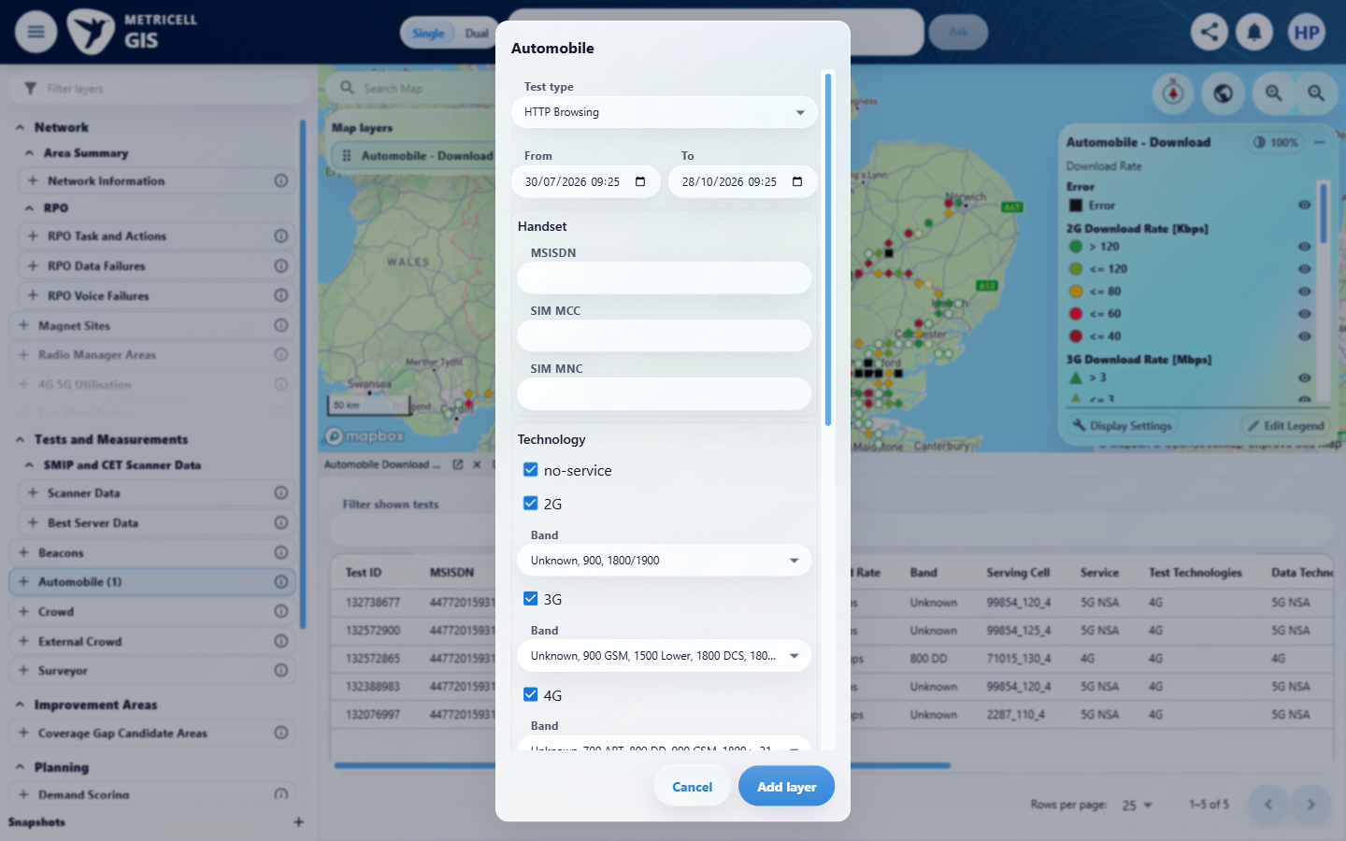 | E02 - Types (criterion-1-types.png)  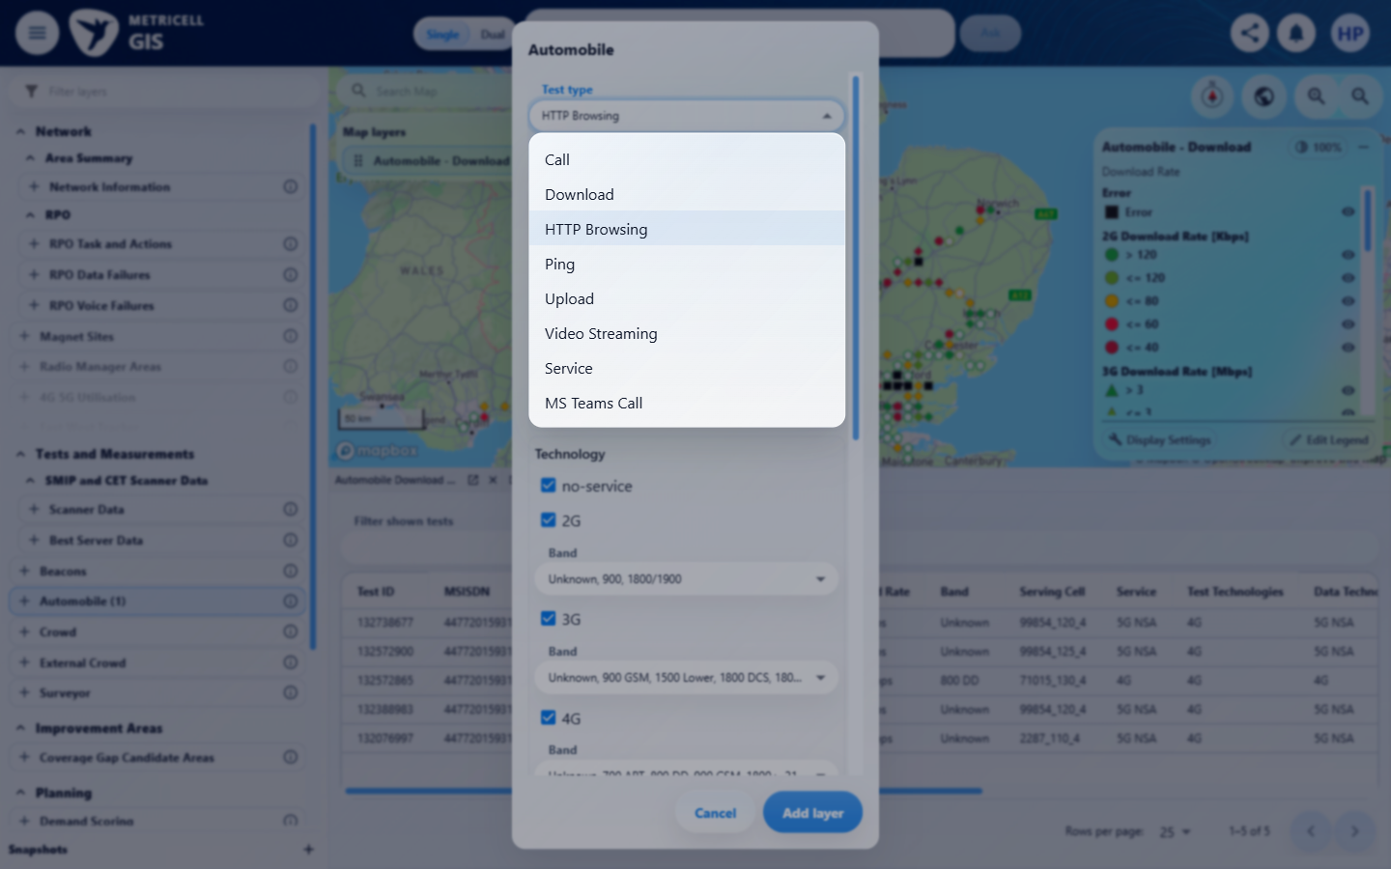

Criterion 1 continued: With a standard Automobile layer active, the legend shows the titled groups and items defined by that layer’s selected legend section, using the configured categories, thresholds, colours, shapes and outlines.
Browser URL recorded after criterion: https://o2intelligence-v4-dev.metricell.com/gis
E03 - Middle groups (criterion-1-middle-groups.png)  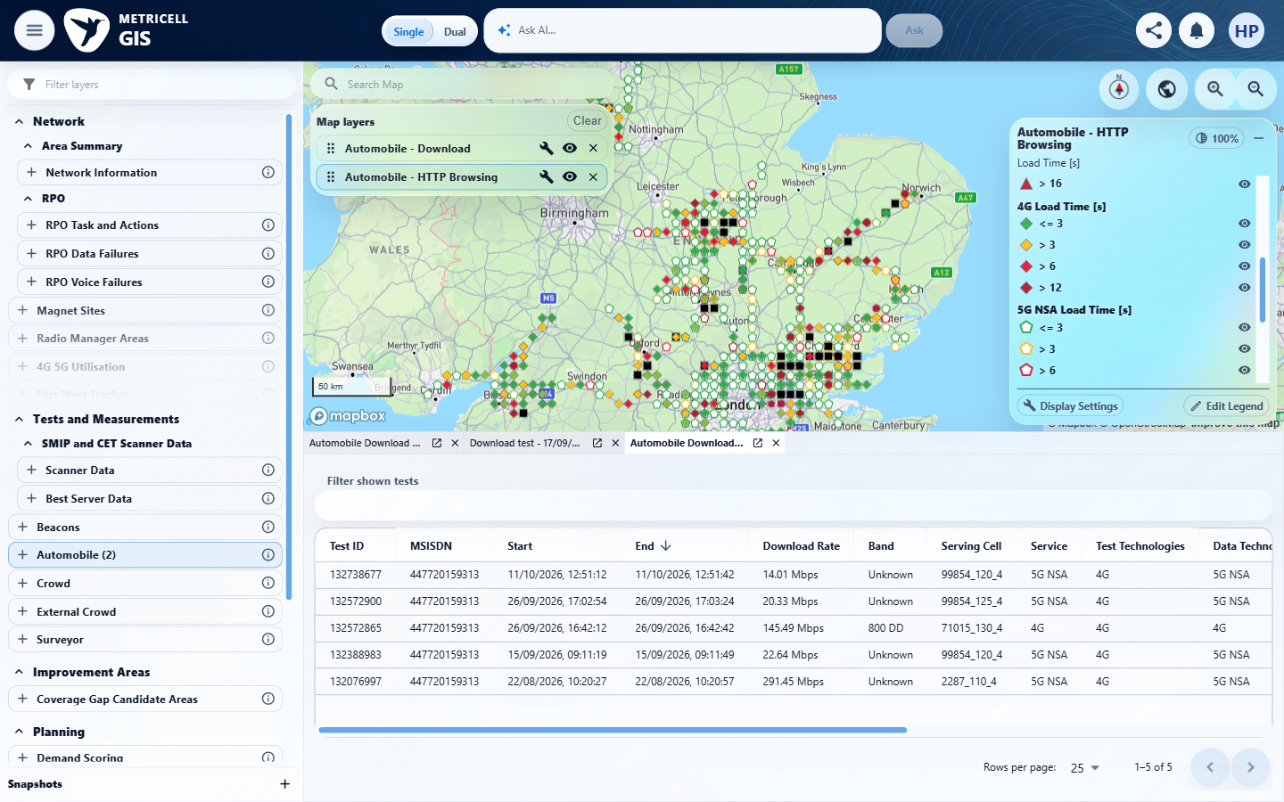 | E04 - Final (criterion-1-final.png)  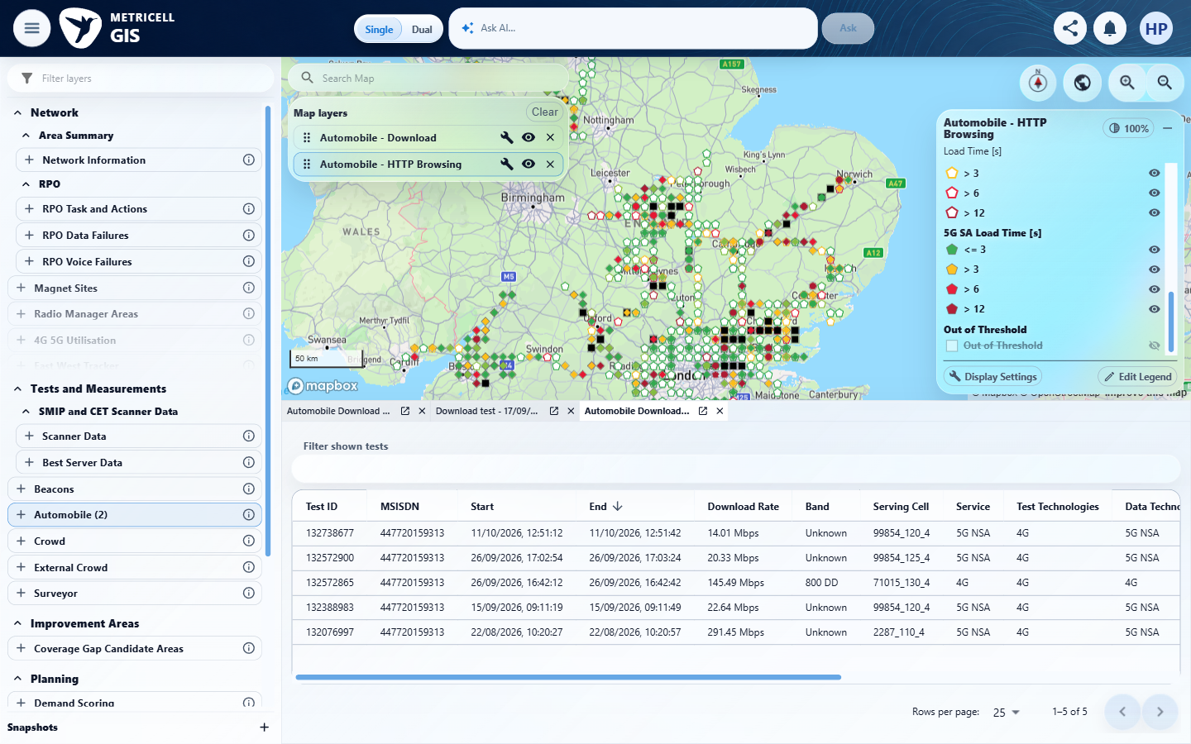

2.0.0 | When a visible legend item is selected, matching points in the active layer are hidden and the item is visibly muted; selecting it again restores the points and normal item appearance. | When a visible legend item is selected, matching points in the active layer are hidden and the item is visibly muted; selecting it again restores the points and normal item appearance. | HTTP Browsing Error toggle is supported by criterion-2-repair-before-hide.png, criterion-2-repair-after-hide.png and criterion-2-repair-final.png: the item mutes and identifiable black HTTP error squares disappear, then return with normal item appearance. Some underlying symbols remain from the pre-existing Service layer; that excluded consumer is incidental background and supplies no acceptance verdict. Assessment is limited to this HTTP sequence.  Evidence: E05, E06, E07, E08 | Passed
Criterion 2 assessment: Testing notes: Fresh HTTP Browsing sequence showed black error markers disappear and the Error item mute; selecting again restored markers and appearance. Captured baseline, selected Hide Error and waited for visible muted item and black HTTP markers to disappear; selected Show Error and waited for markers and normal item appearance to return.
Criterion 2 evidence: When a visible legend item is selected, matching points in the active layer are hidden and the item is visibly muted; selecting it again restores the points and normal item appearance.
Browser URL recorded after criterion: https://o2intelligence-v4-dev.metricell.com/gis
E05 - Repair config (criterion-2-repair-config.png)  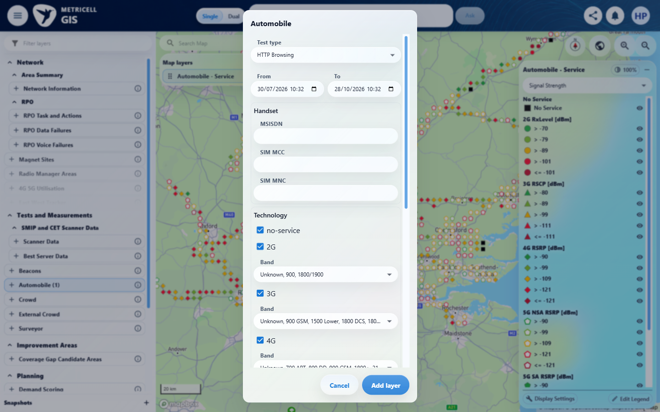 | E06 - Repair before hide (criterion-2-repair-before-hide.png)  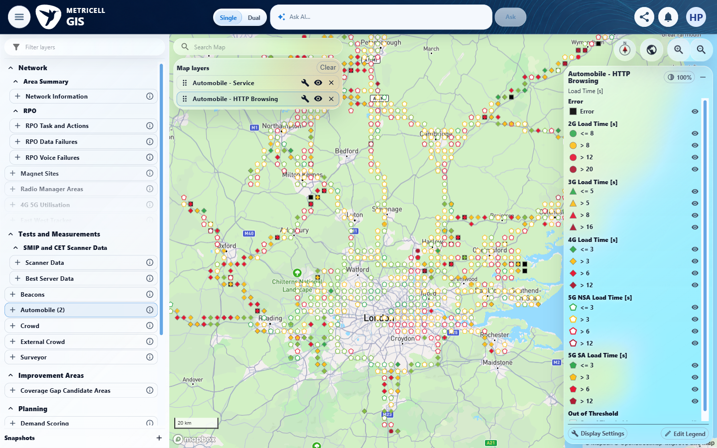

Criterion 2 continued: When a visible legend item is selected, matching points in the active layer are hidden and the item is visibly muted; selecting it again restores the points and normal item appearance.
Browser URL recorded after criterion: https://o2intelligence-v4-dev.metricell.com/gis
E07 - Repair after hide (criterion-2-repair-after-hide.png)  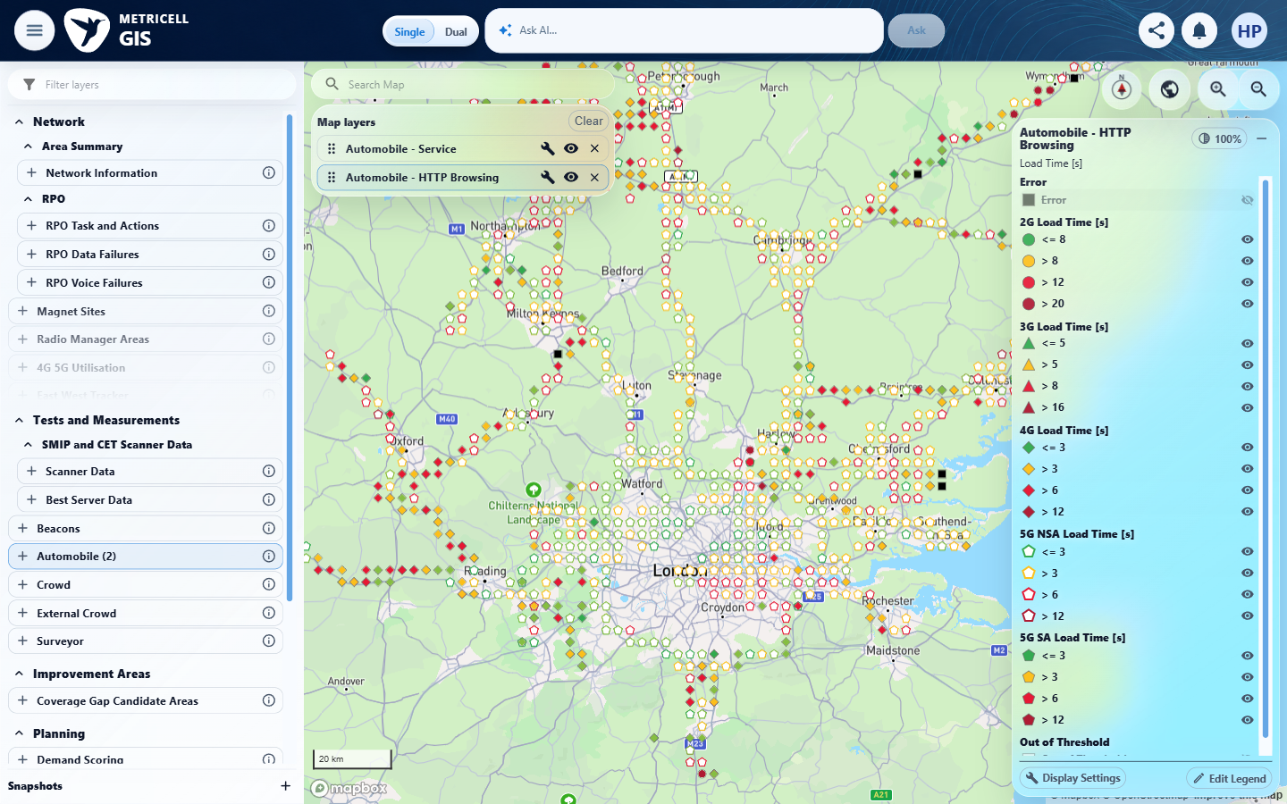 | E08 - Repair final (criterion-2-repair-final.png)  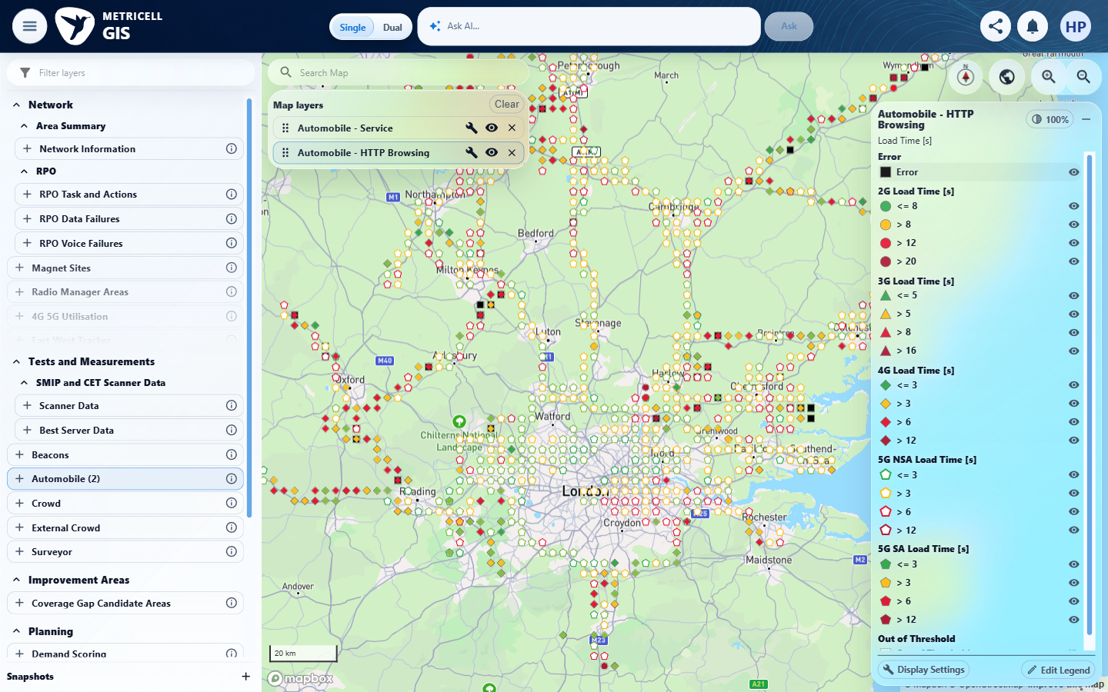

3.0.0 | When a legend item is double-clicked, that item remains visible and all other items in its group are hidden; items in other groups retain their visibility. | When a legend item is double-clicked, that item remains visible and all other items in its group are hidden; items in other groups retain their visibility. | criterion-3-http-before-isolate.png and criterion-3-decisive-final.png show HTTP 2G <=8 remaining visible after the recorded normal double-click, while >8, >12 and >20 also retain open-eye appearance: sibling isolation fails. Visible 3G/4G/5G groups look unchanged, but the complete other-group scope, including the lower Out of Threshold state, is not captured before and after; that branch is Unverified.  Evidence: E09, E10, E11 | Failed
Criterion 3 assessment: Testing notes: The supplied browser workspace reverted to pre-existing Download on launcher navigation; initial destination attempt found no HTTP legend. Inspected current state after timeout and added own Automobile HTTP Browsing through actual test-type configuration.
Criterion 3 evidence: When a legend item is double-clicked, that item remains visible and all other items in its group are hidden; items in other groups retain their visibility.
Browser URL recorded after criterion: https://o2intelligence-v4-dev.metricell.com/gis
E09 - Http config (criterion-3-http-config.png)  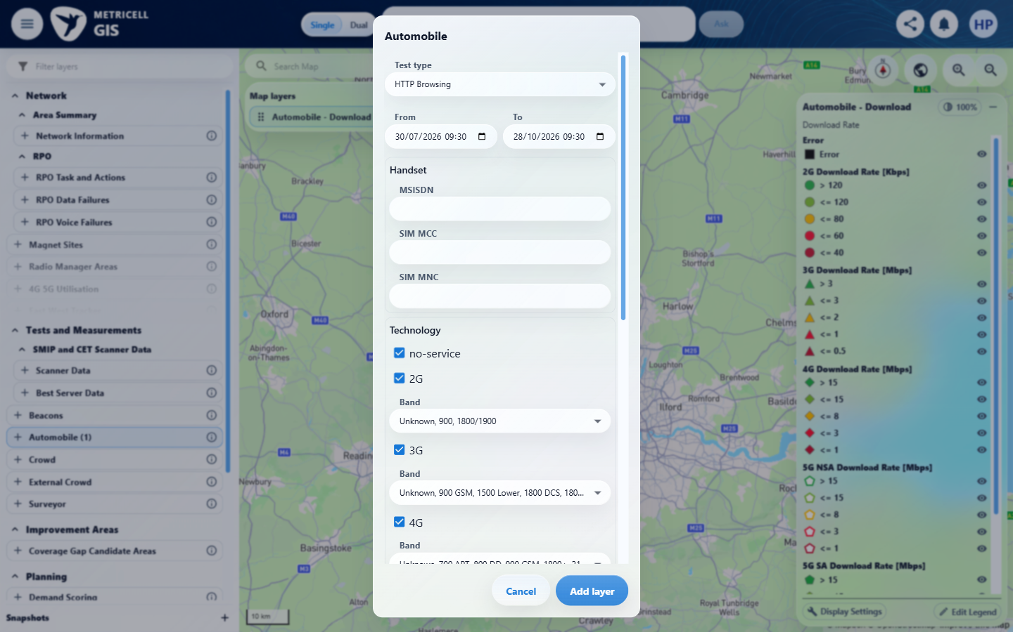 | E10 - Http before isolate (criterion-3-http-before-isolate.png)  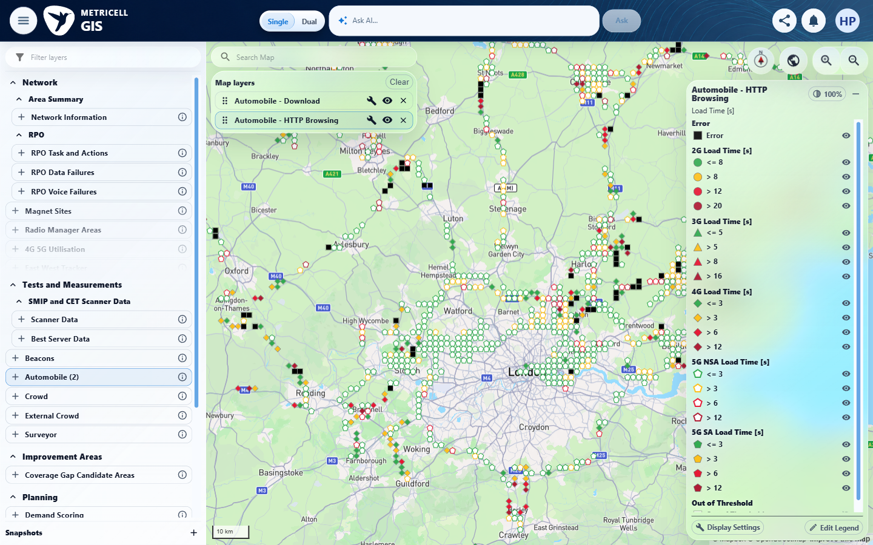

Criterion 3 continued: When a legend item is double-clicked, that item remains visible and all other items in its group are hidden; items in other groups retain their visibility.
Browser URL recorded after criterion: https://o2intelligence-v4-dev.metricell.com/gis
E11 - Decisive final (criterion-3-decisive-final.png)
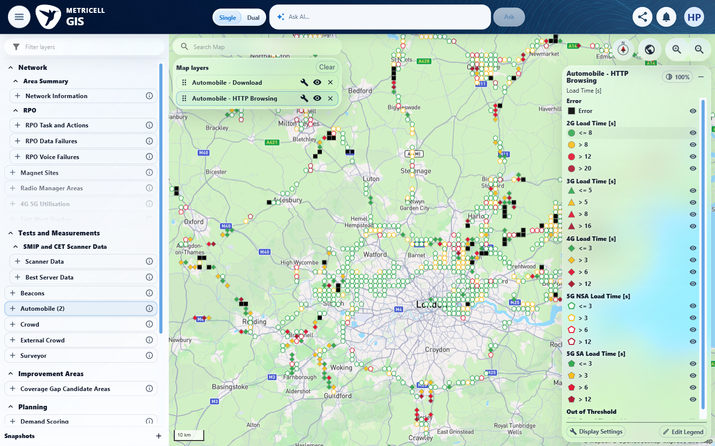

4.0.0 | Legend filtering and legend edits change only the active layer’s presentation; other layers, underlying data, and form-based filters retain their prior state. | Legend filtering and legend edits change only the active layer’s presentation; other layers, underlying data, and form-based filters retain their prior state. | criterion-4-before-edit.png, criterion-4-editor-baseline.png, criterion-4-draft.png, criterion-4-after-save.png and criterion-4-filtered-edited.png show the HTTP Error rename and subsequent hiding. criterion-4-http-filter-baseline.png versus criterion-4-after-filters.png supports the readable handset, time-window and technology subset only; lower filters and clipped values lack complete comparisons. criterion-4-other-layer-final.png shows the incidental Download legend, without a complete independent other-layer baseline. Underlying-data reconciliation is absent. These are coverage gaps, not demonstrated data/layer defects.  Evidence: E12, E10, E13, E14, E15, E16, E17, E18 | Failed
Criterion 4 assessment: Testing notes: Opened editor, changed Error label to QA isolation error, captured draft and saved-open dialog, closed then hid the renamed Error category. Selected pre-existing Download layer and captured its unchanged Error label and categories; complete independent before baseline for that layer and underlying data reconciliation missing. Final URL https://o2intelligence-v4-dev.metricell.com/gis. Removed own HTTP layer; pre-existing Download retained. Configuration-inspection locator timeout did not change filters.
Criterion 4 evidence: Legend filtering and legend edits change only the active layer’s presentation; other layers, underlying data, and form-based filters retain their prior state.
Browser URL recorded after criterion: https://o2intelligence-v4-dev.metricell.com/gis
E12 - Http filter baseline (criterion-4-http-filter-baseline.png)  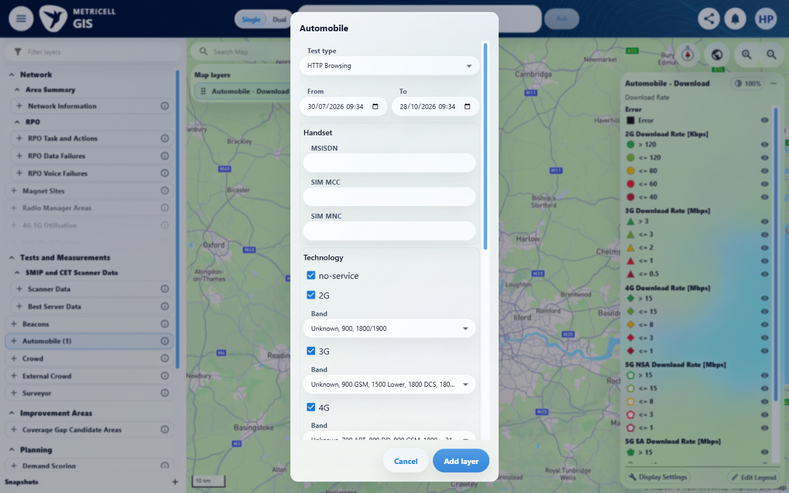 | E10 - Before edit (criterion-4-before-edit.png)

Criterion 4 continued: Legend filtering and legend edits change only the active layer’s presentation; other layers, underlying data, and form-based filters retain their prior state.
Browser URL recorded after criterion: https://o2intelligence-v4-dev.metricell.com/gis
E13 - Editor baseline (criterion-4-editor-baseline.png)  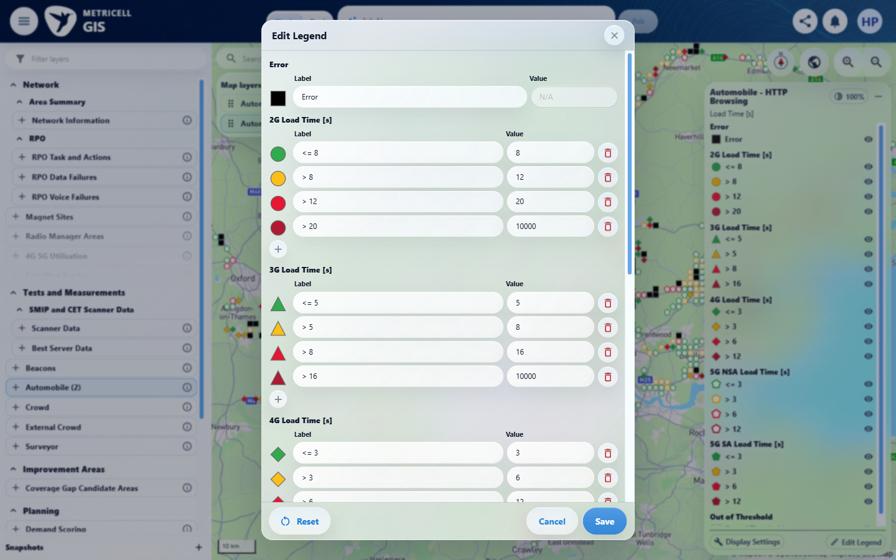 | E14 - Draft (criterion-4-draft.png)  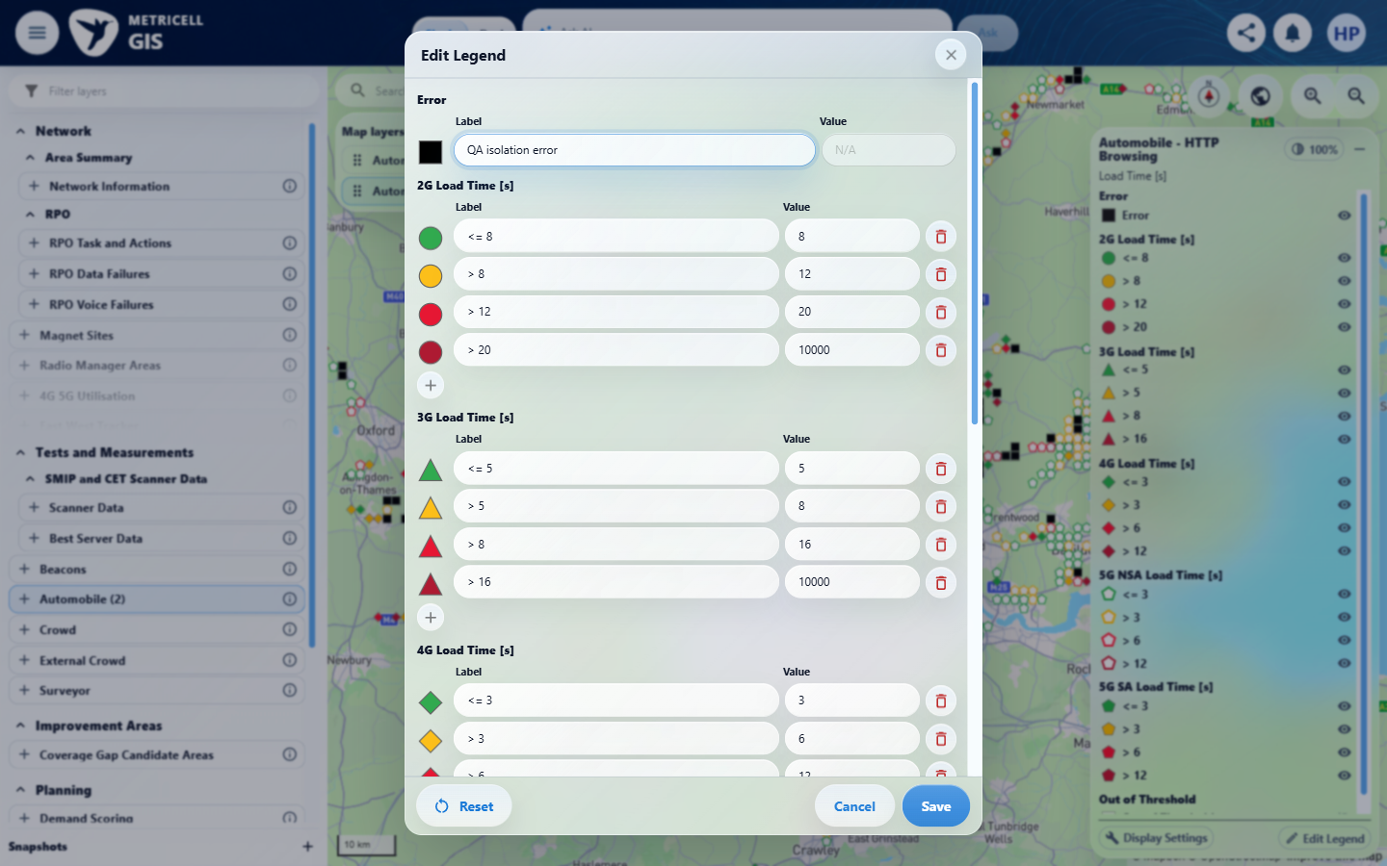

Criterion 4 continued: Legend filtering and legend edits change only the active layer’s presentation; other layers, underlying data, and form-based filters retain their prior state.
Browser URL recorded after criterion: https://o2intelligence-v4-dev.metricell.com/gis
E15 - After save (criterion-4-after-save.png)  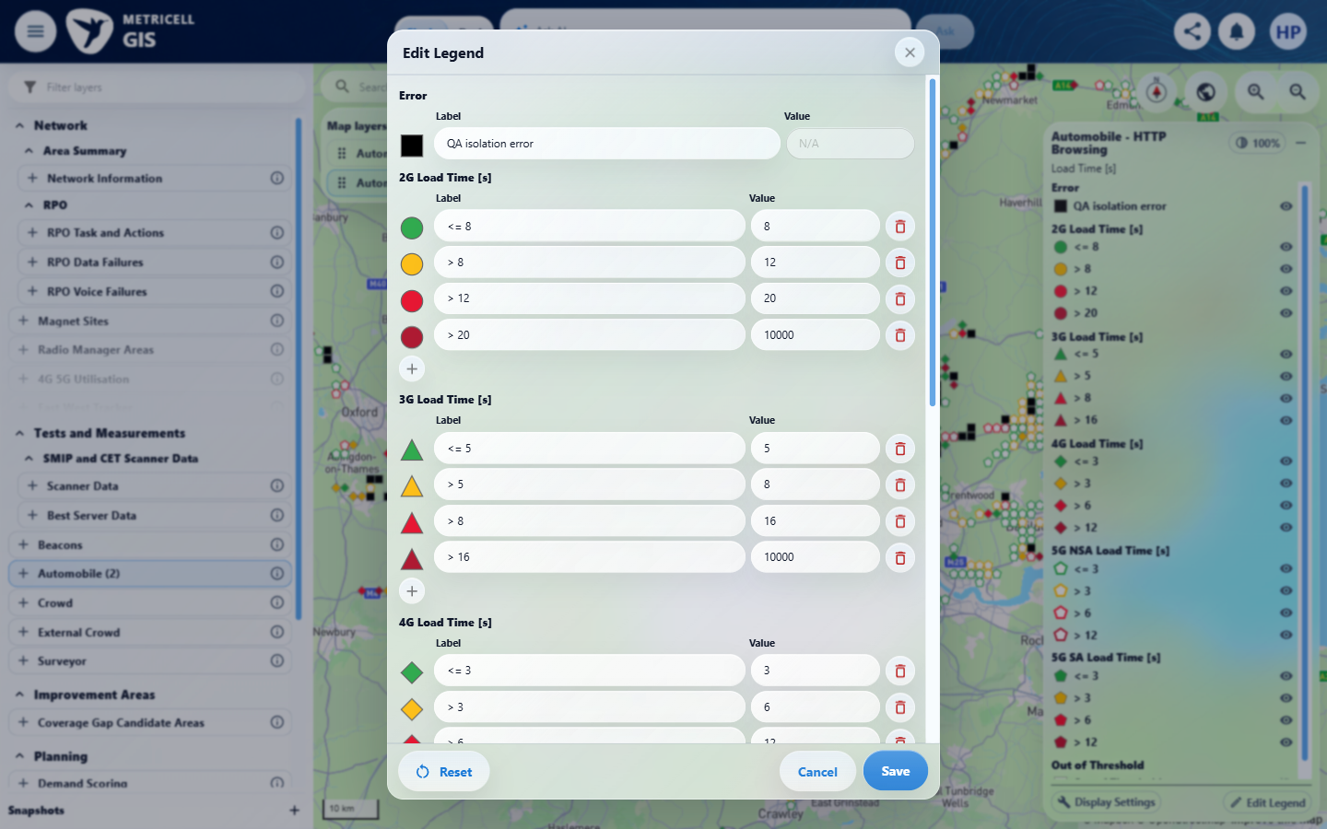 | E16 - Filtered edited (criterion-4-filtered-edited.png)  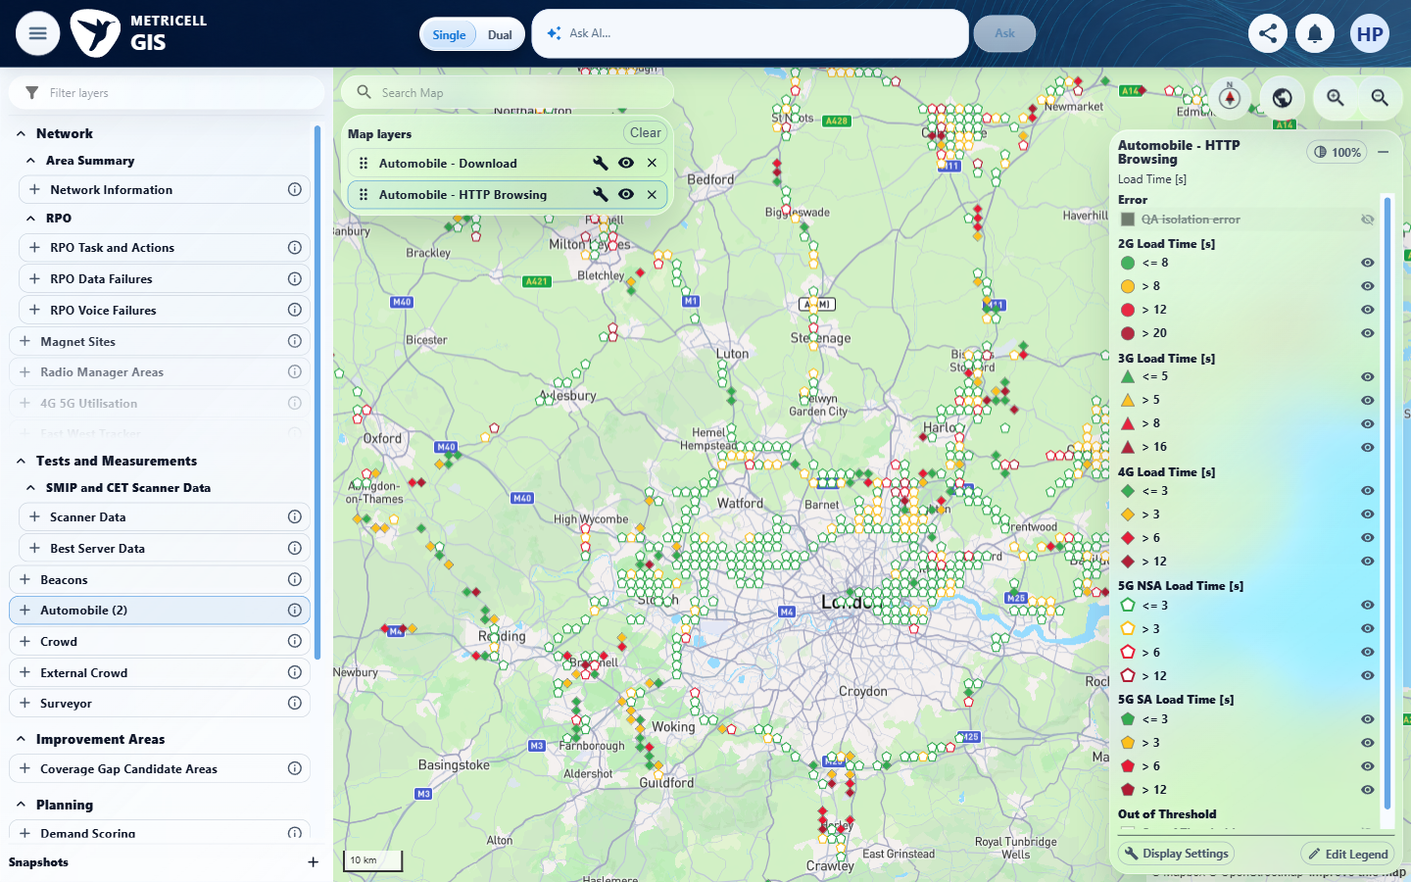

Criterion 4 continued: Legend filtering and legend edits change only the active layer’s presentation; other layers, underlying data, and form-based filters retain their prior state.
Browser URL recorded after criterion: https://o2intelligence-v4-dev.metricell.com/gis
E17 - After filters (criterion-4-after-filters.png)  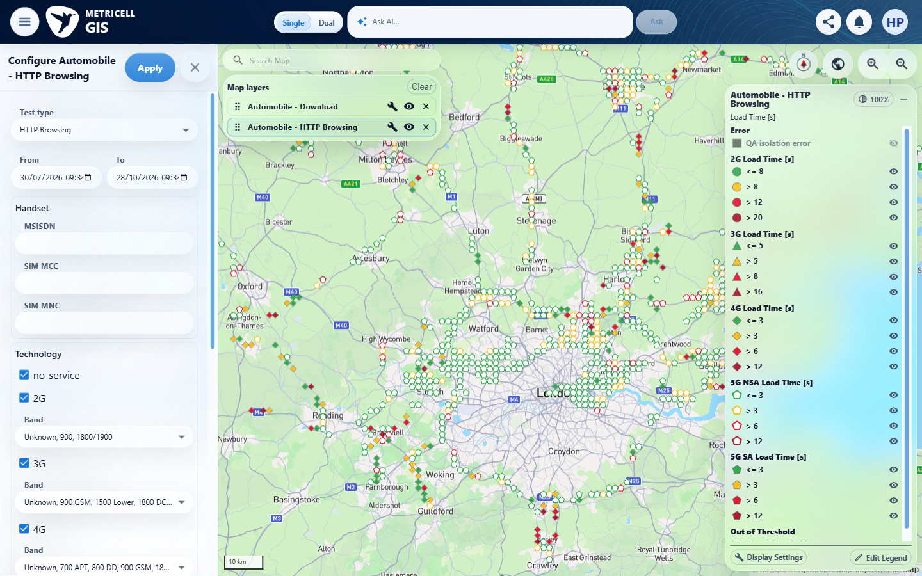 | E18 - Other layer final (criterion-4-other-layer-final.png)  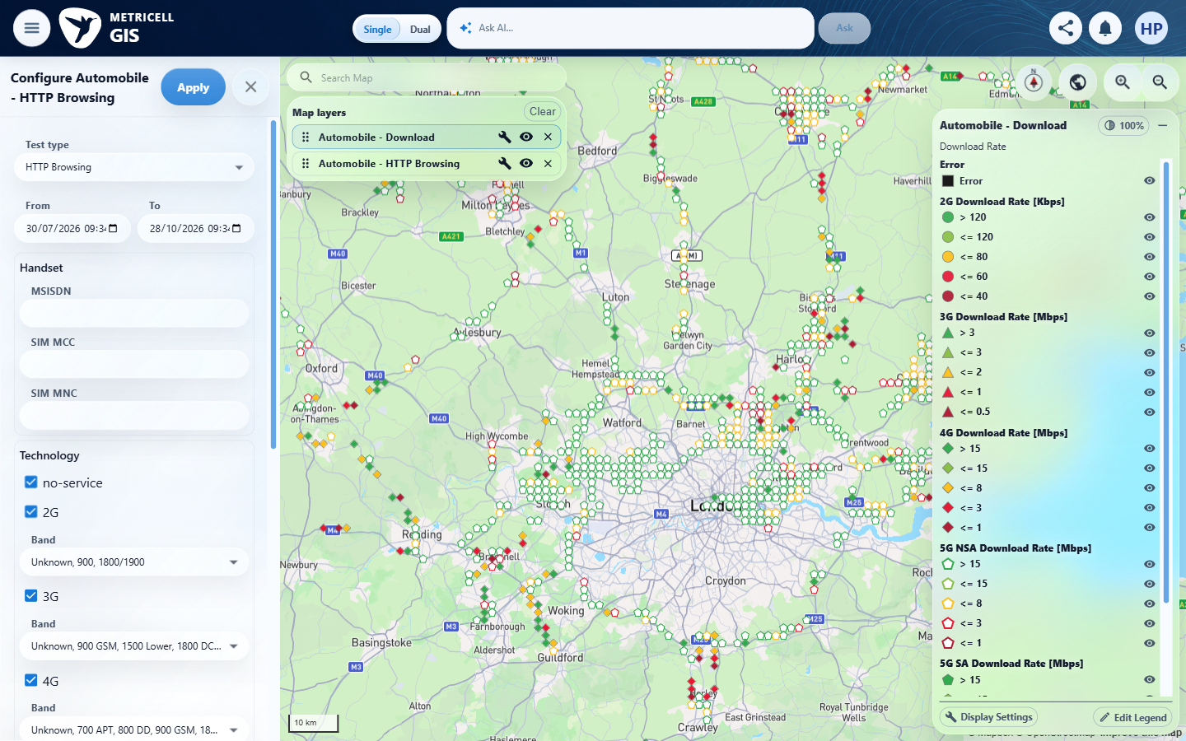

5.0.0 | When a layer supplies one Colour By field, its title is displayed as a label; when it supplies multiple fields, a dropdown displays exactly those fields. | When a layer supplies one Colour By field, its title is displayed as a label; when it supplies multiple fields, a dropdown displays exactly those fields. | criterion-5-http-label.png, criterion-5-ping-label.png and criterion-5-final.png show plain Load Time [s], Ping Time [ms] and Rebuffer Count labels in the three supported Automobile consumers. The multi-option dropdown/exact-options branch is Blocked: source and context identify these as single-field consumers and supply no identified multi-field consumer or authoritative option set.  Evidence: E19, E10, E20, E21, E22, E23 | Blocked
Criterion 5 evidence: When a layer supplies one Colour By field, its title is displayed as a label; when it supplies multiple fields, a dropdown displays exactly those fields.
Browser URL recorded after criterion: https://o2intelligence-v4-dev.metricell.com/gis
E19 - Http config (criterion-5-http-config.png)  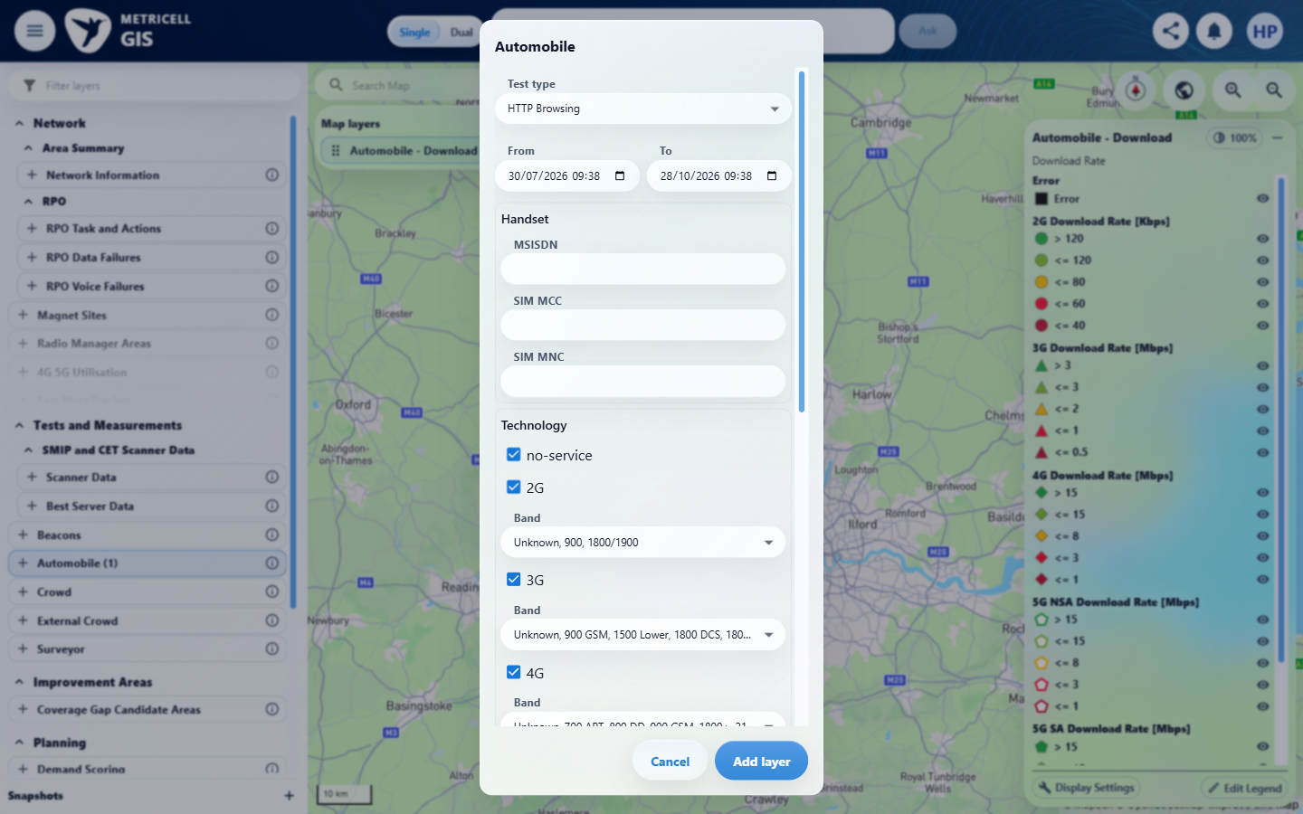 | E10 - Http label (criterion-5-http-label.png)

Criterion 5 continued: When a layer supplies one Colour By field, its title is displayed as a label; when it supplies multiple fields, a dropdown displays exactly those fields.
Browser URL recorded after criterion: https://o2intelligence-v4-dev.metricell.com/gis
E20 - Ping config (criterion-5-ping-config.png)  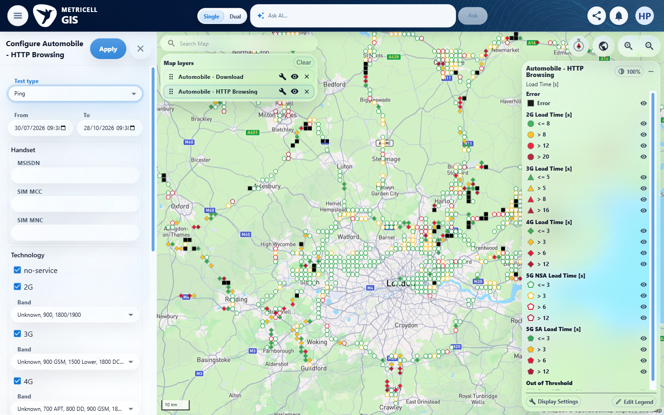 | E21 - Ping label (criterion-5-ping-label.png)  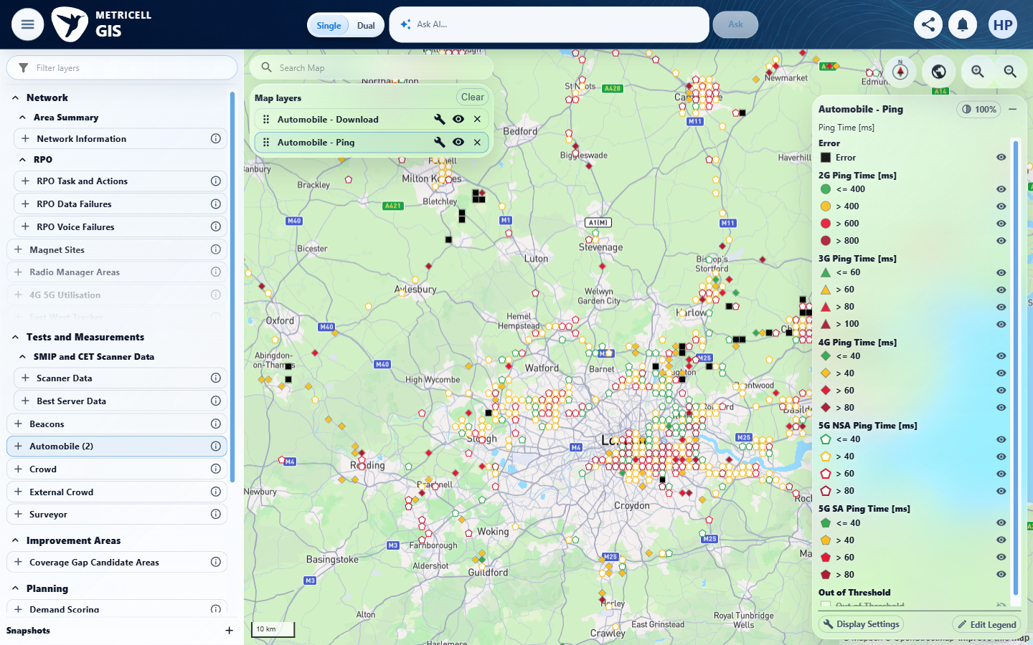

Criterion 5 continued: When a layer supplies one Colour By field, its title is displayed as a label; when it supplies multiple fields, a dropdown displays exactly those fields.
Browser URL recorded after criterion: https://o2intelligence-v4-dev.metricell.com/gis
E22 - Video config (criterion-5-video-config.png)  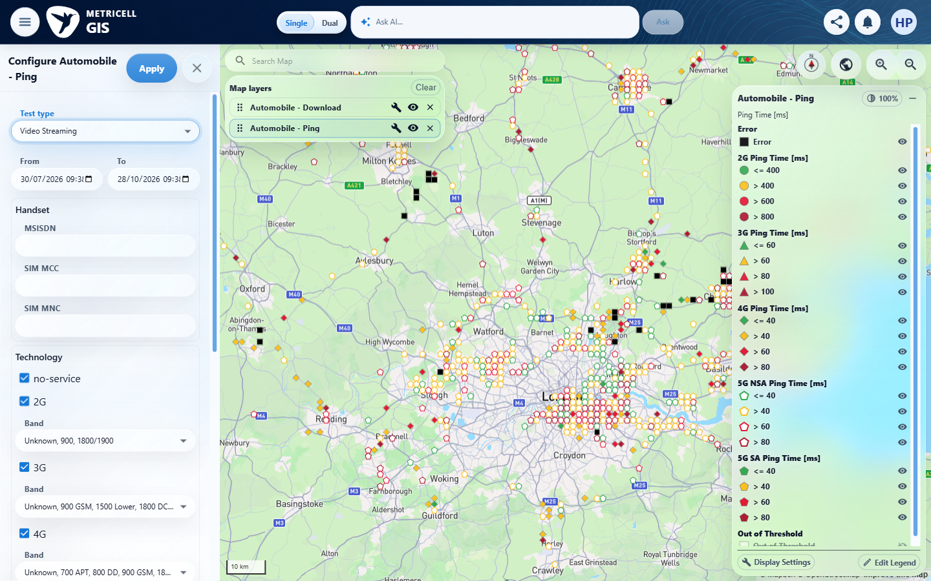 | E23 - Final (criterion-5-final.png)  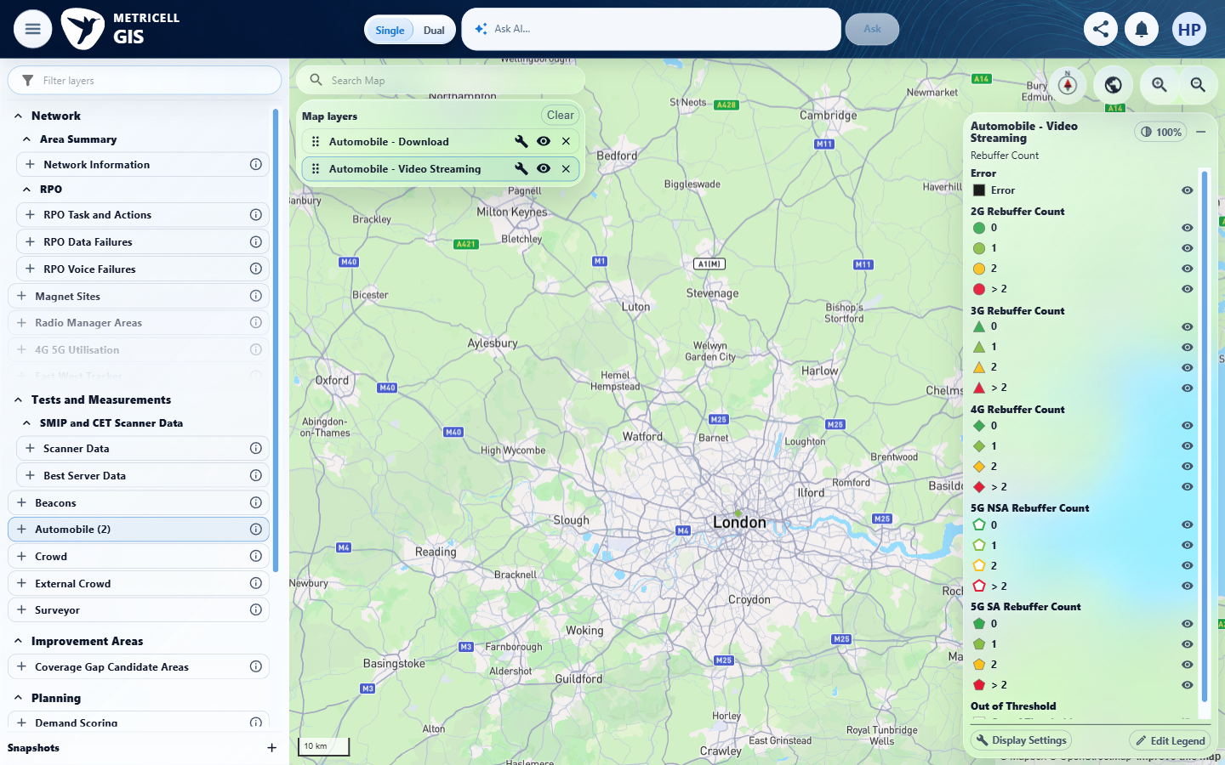

6.0.0 | When Colour By changes on a consuming layer that supplies multiple fields and measurements, the displayed groups, map classification, markers and linked-context visibility follow the selected field, form filters remain unchanged, and the same points are not fetched again. This end-to-end behavior requires a multi-field consuming layer; current Automobile types provide only one field. | When Colour By changes on a consuming layer that supplies multiple fields and measurements, the displayed groups, map classification, markers and linked-context visibility follow the selected field, form filters remain unchanged, and the same points are not fetched again. This end-to-end behavior requires a multi-field consuming layer; current Automobile types provide only one field. | No identified multi-field consuming fixture with its measurements is supplied. Source/context explicitly makes this a reusable component contract and says current HTTP/Ping/Video types are single-field. criterion-6-final.png shows HTTP Load Time [s], not a field-switch sequence; groups, classification, markers, linked context, unchanged form filters and no-refetch branches cannot be exercised from it.  Evidence: E24, E25 | Blocked
Criterion 6 evidence: When Colour By changes on a consuming layer that supplies multiple fields and measurements, the displayed groups, map classification, markers and linked-context visibility follow the selected field, form filters remain unchanged, and the same points are not fetched again. This end-to-end behavior requires a multi-field consuming layer; current Automobile types provide only one field.
Browser URL recorded after criterion: https://o2intelligence-v4-dev.metricell.com/gis
E24 - Http config (criterion-6-http-config.png)  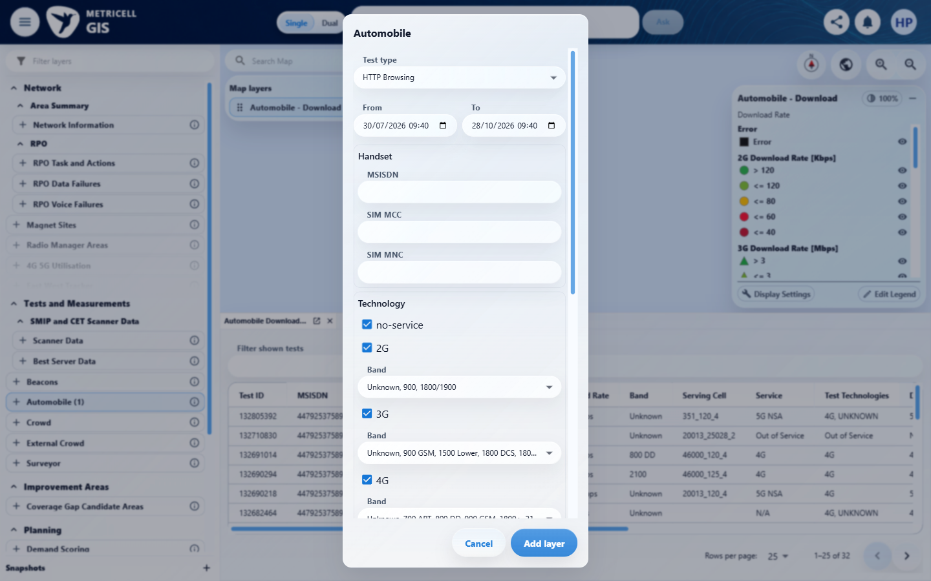 | E25 - Final (criterion-6-final.png)  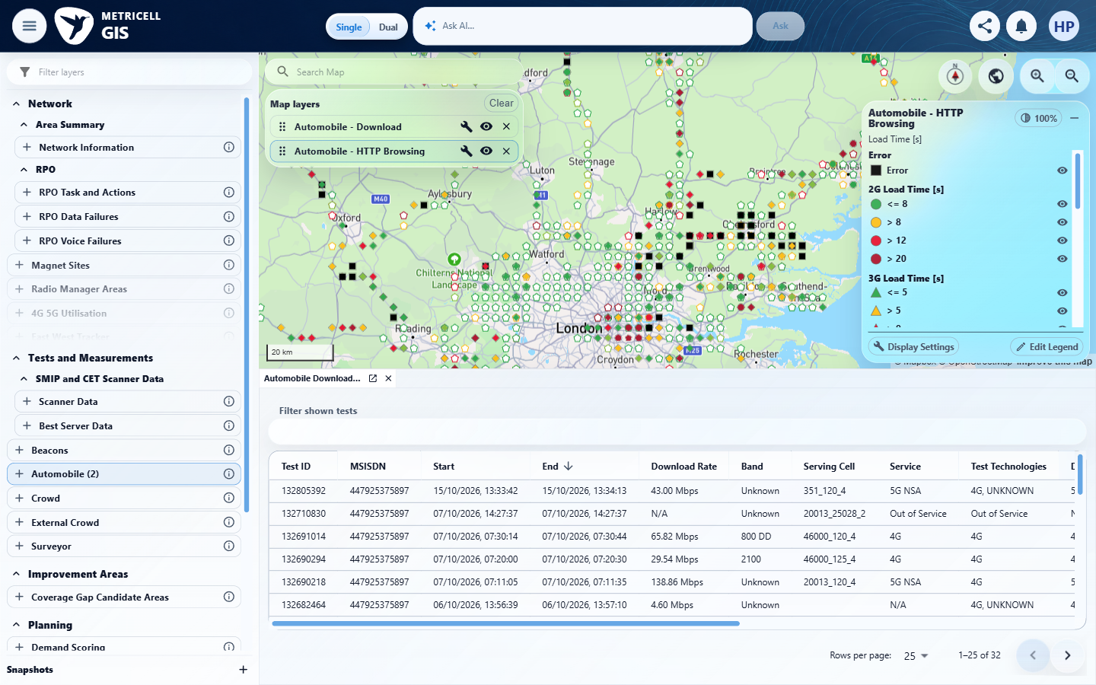

7.0.0 | Restoring a layer’s state restores its selected Colour By field and that field’s saved overrides independently of other layers. | Restoring a layer’s state restores its selected Colour By field and that field’s saved overrides independently of other layers. | criterion-7-final.png shows an HTTP Load Time [s] label, but contains no saved-override baseline, restoration action or reopened restored state, and no independent other-layer comparison. A single field does not prevent testing that field's saved overrides and restoration, so these reachable missing sequences are Unverified rather than a blanket multi-field fixture blocker.  Evidence: E26, E25 | Failed
Criterion 7 evidence: Restoring a layer’s state restores its selected Colour By field and that field’s saved overrides independently of other layers.
Browser URL recorded after criterion: https://o2intelligence-v4-dev.metricell.com/gis
E26 - Config (criterion-7-config.png)  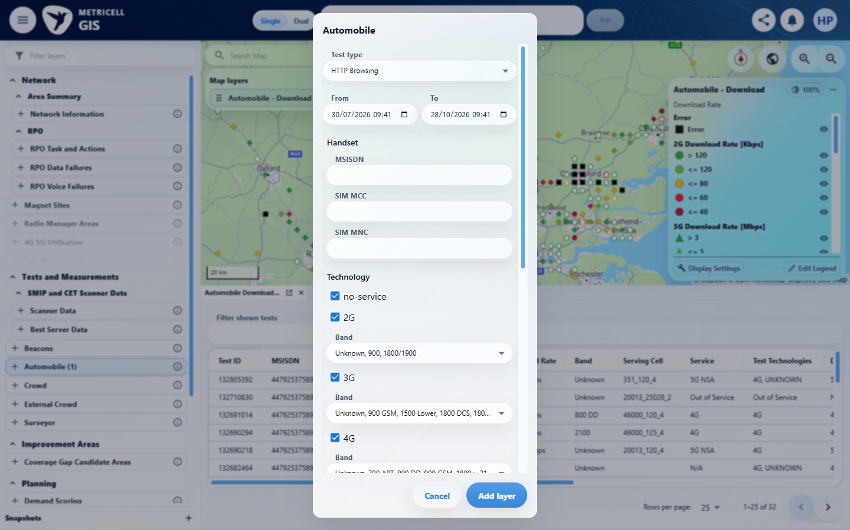 | E25 - Final (criterion-7-final.png)

8.0.0 | In Edit Legend, changing labels, colours or numeric boundaries creates drafts for the active field only; the map remains unchanged until Save, while Cancel or Close discards drafts. After Save, refreshed values remain visible in the open dialog. | In Edit Legend, changing labels, colours or numeric boundaries creates drafts for the active field only; the map remains unchanged until Save, while Cancel or Close discards drafts. After Save, refreshed values remain visible in the open dialog. | HTTP baseline criterion-8-first-editor-baseline.png -> criterion-8-first-value-draft.png -> criterion-8-first-after-cancel.png -> criterion-8-first-reopen.png supports label/colour/boundary drafts and Cancel restoring <=8, green, 8. The separate Close sequence criterion-8-second-value-draft.png -> criterion-8-second-after-close.png -> criterion-8-second-reopen.png restores those same baseline values. criterion-8-final-value-draft.png -> criterion-8-final.png shows QA saved range, blue swatch and 7 saved in the still-open refreshed dialog, with underlying legend updated. No exact hex is visibly proven. Complete map preservation before Save is inconclusive behind the overlay. Cross-field draft discard remains Blocked without an identified multi-field consumer.  Evidence: E27, E28, E29, E30, E31, E32, E33, E34, E35, E36, E37, E38, E39, E40 | Blocked
Criterion 8 evidence: In Edit Legend, changing labels, colours or numeric boundaries creates drafts for the active field only; the map remains unchanged until Save, while Cancel or Close discards drafts. After Save, refreshed values remain visible in the open dialog.
Browser URL recorded after criterion: https://o2intelligence-v4-dev.metricell.com/gis
E27 - Config (criterion-8-config.png)  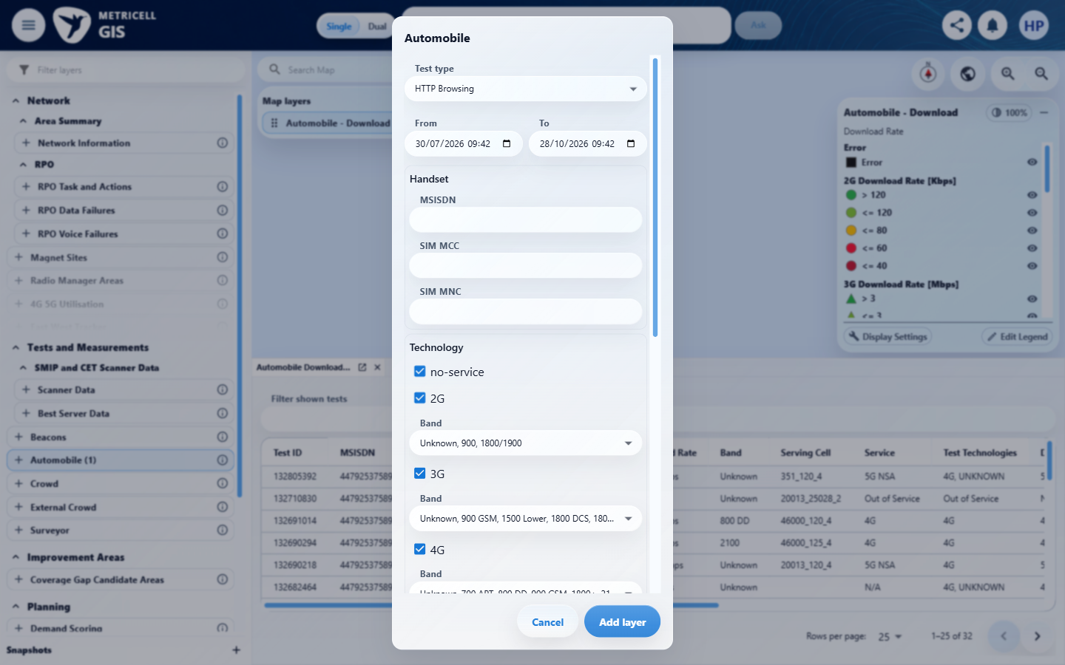 | E28 - Map baseline (criterion-8-map-baseline.png)  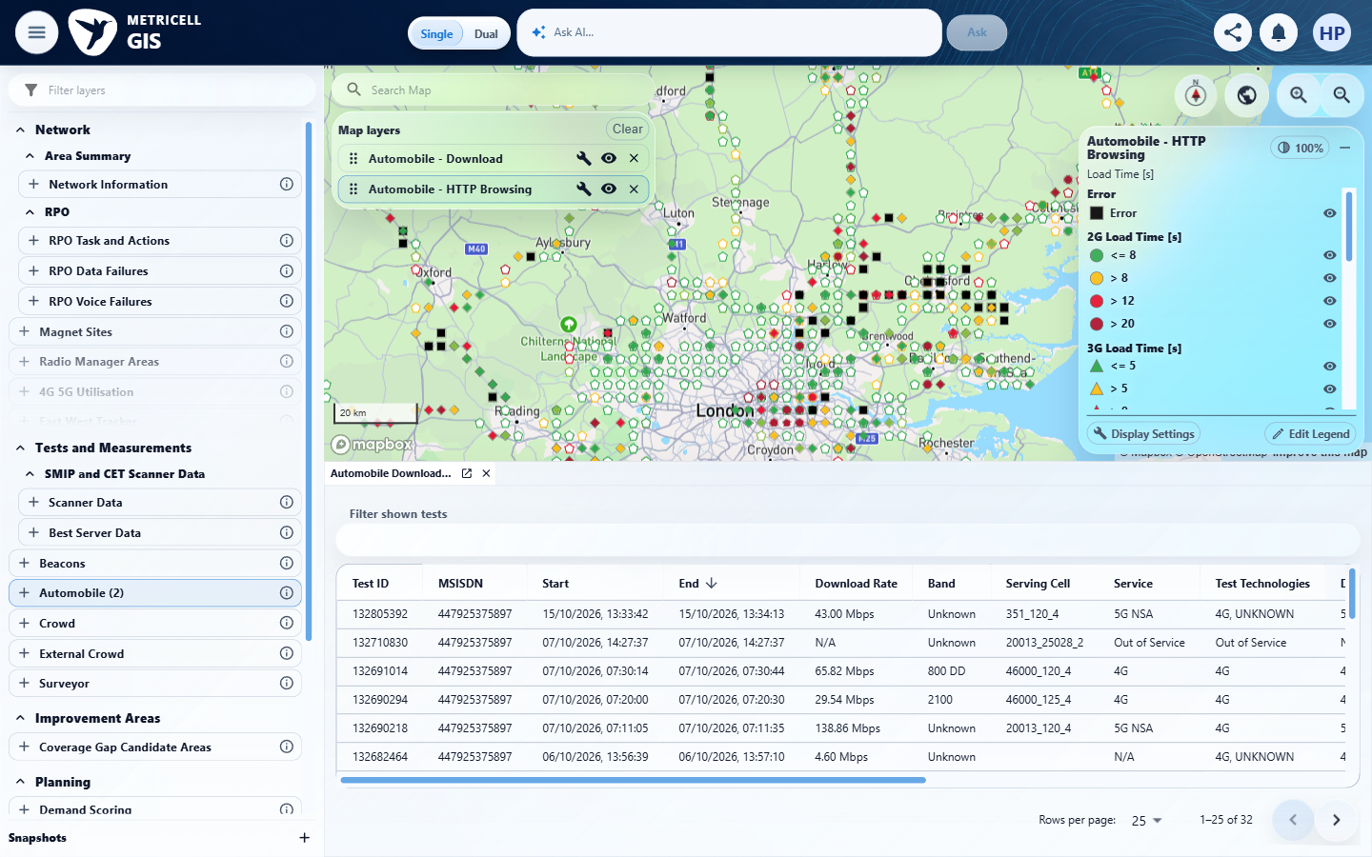

Criterion 8 continued: In Edit Legend, changing labels, colours or numeric boundaries creates drafts for the active field only; the map remains unchanged until Save, while Cancel or Close discards drafts. After Save, refreshed values remain visible in the open dialog.
Browser URL recorded after criterion: https://o2intelligence-v4-dev.metricell.com/gis
E29 - First editor baseline (criterion-8-first-editor-baseline.png)  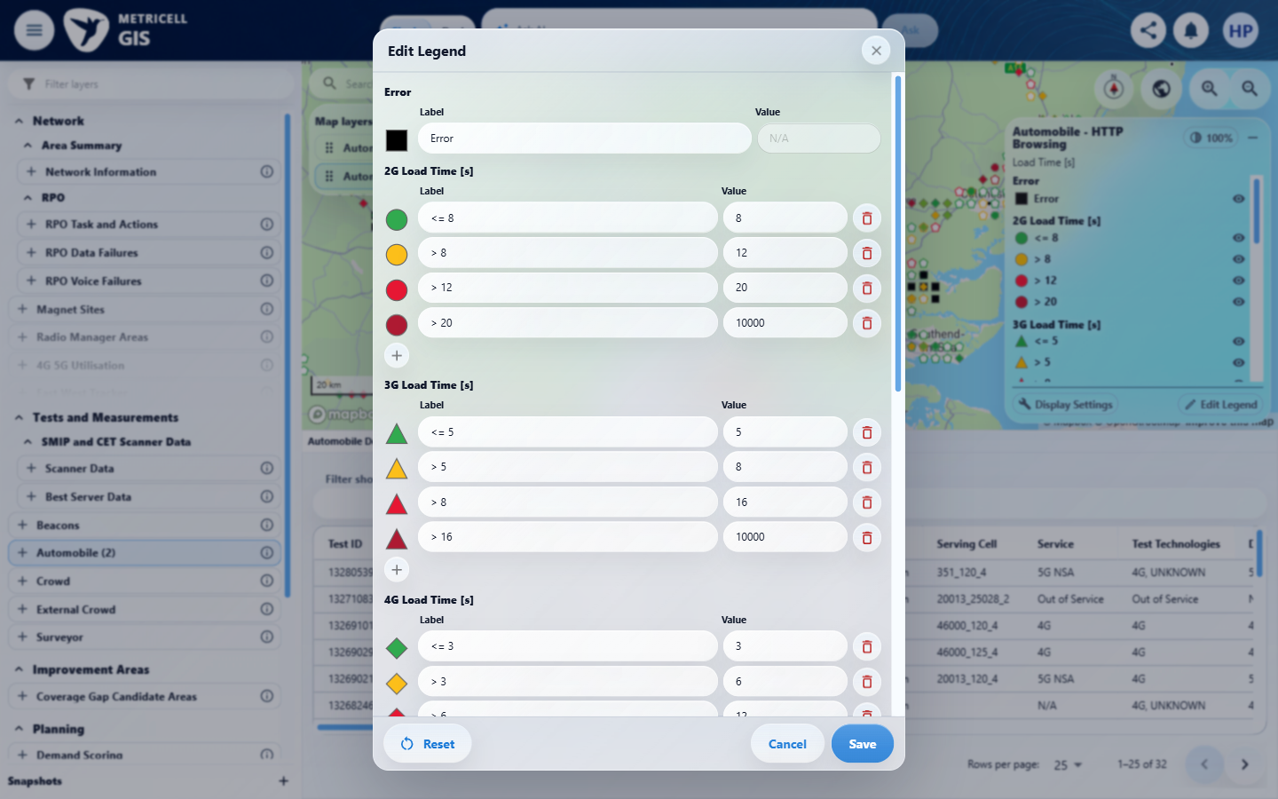 | E30 - First label draft (criterion-8-first-label-draft.png)  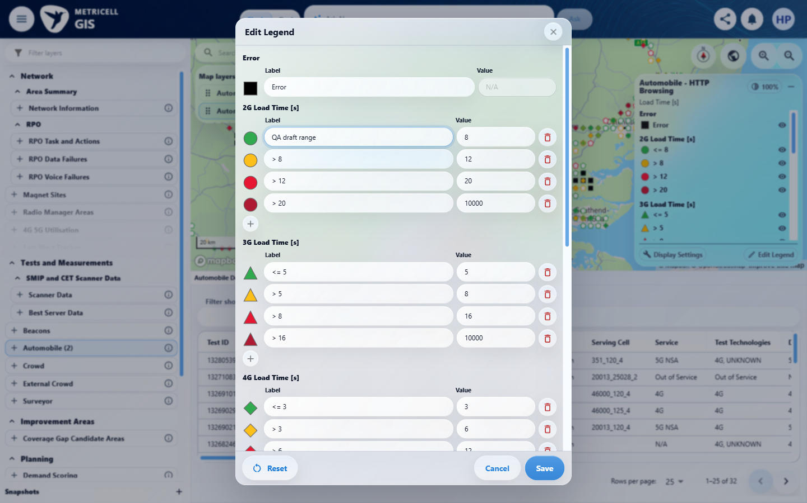

Criterion 8 continued: In Edit Legend, changing labels, colours or numeric boundaries creates drafts for the active field only; the map remains unchanged until Save, while Cancel or Close discards drafts. After Save, refreshed values remain visible in the open dialog.
Browser URL recorded after criterion: https://o2intelligence-v4-dev.metricell.com/gis
E31 - First colour draft (criterion-8-first-colour-draft.png)  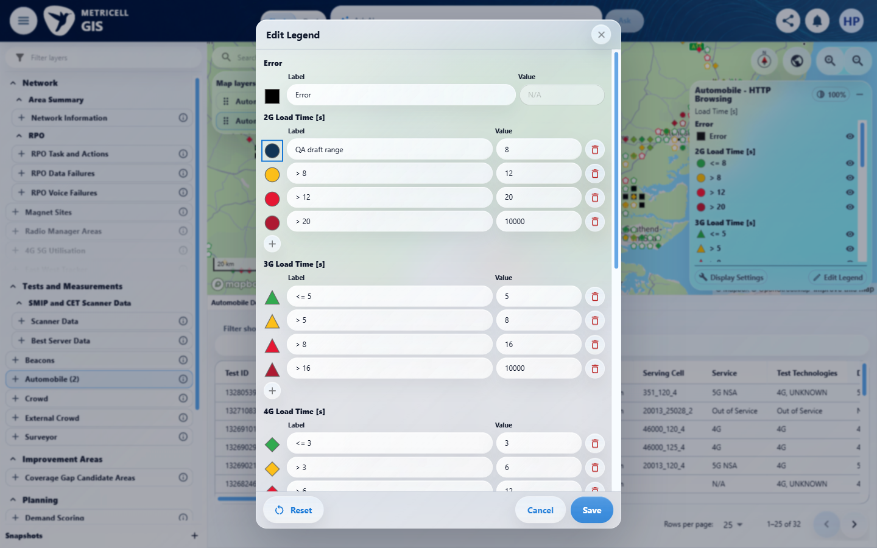 | E32 - First value draft (criterion-8-first-value-draft.png)  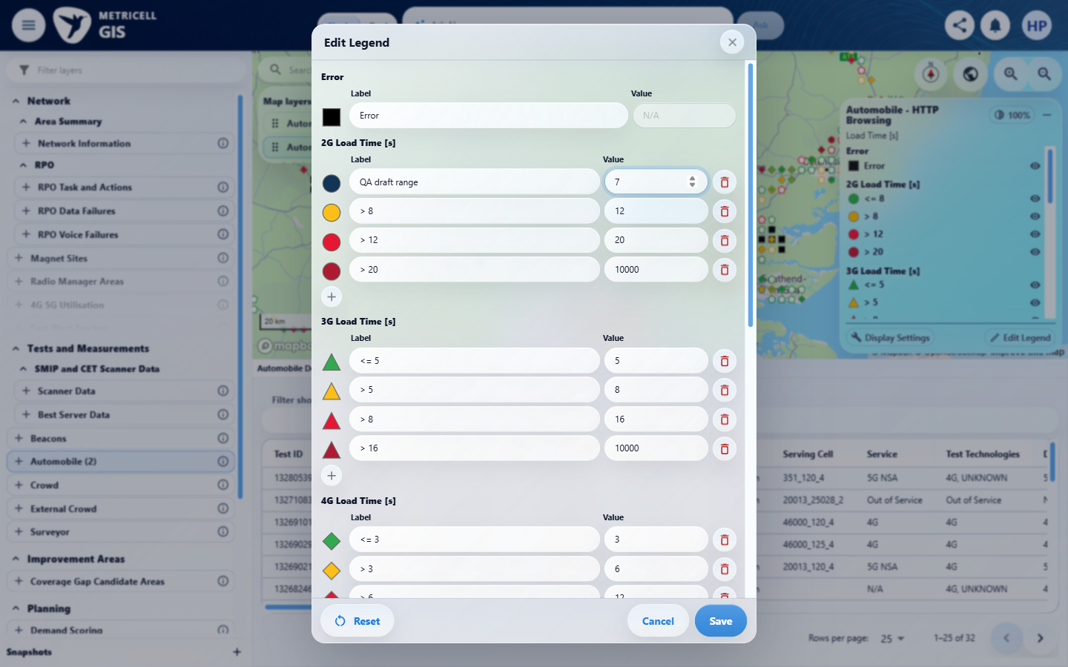

Criterion 8 continued: In Edit Legend, changing labels, colours or numeric boundaries creates drafts for the active field only; the map remains unchanged until Save, while Cancel or Close discards drafts. After Save, refreshed values remain visible in the open dialog.
Browser URL recorded after criterion: https://o2intelligence-v4-dev.metricell.com/gis
E28 - First after cancel (criterion-8-first-after-cancel.png) | E33 - First reopen (criterion-8-first-reopen.png)  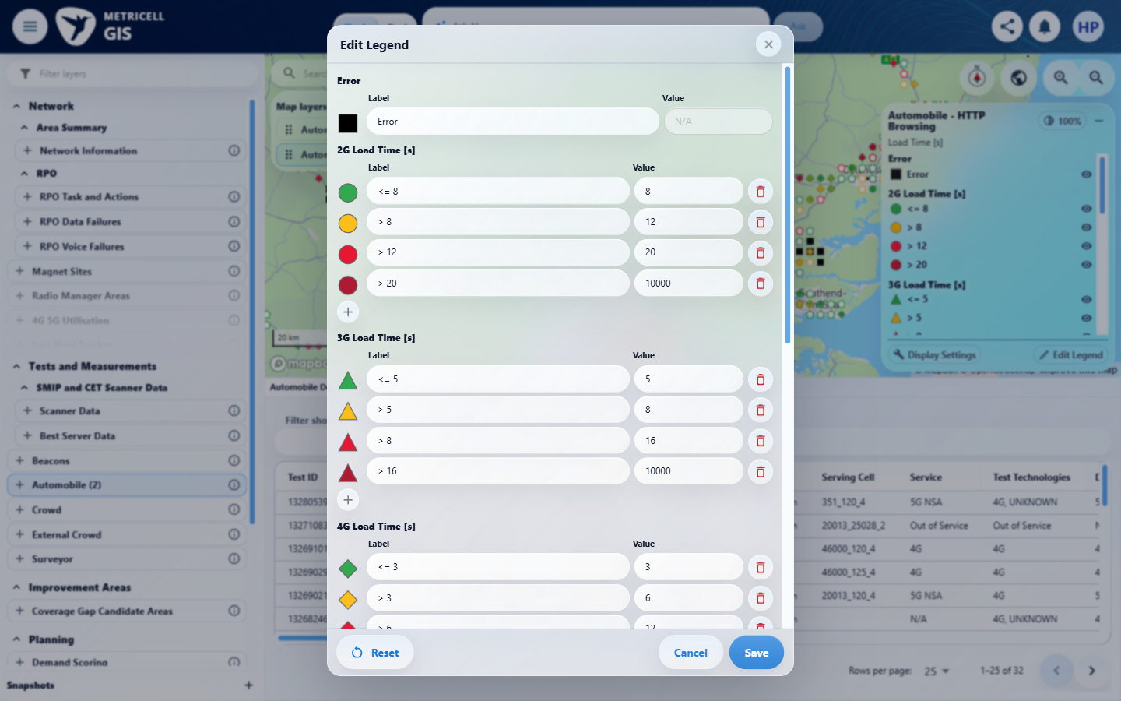

Criterion 8 continued: In Edit Legend, changing labels, colours or numeric boundaries creates drafts for the active field only; the map remains unchanged until Save, while Cancel or Close discards drafts. After Save, refreshed values remain visible in the open dialog.
Browser URL recorded after criterion: https://o2intelligence-v4-dev.metricell.com/gis
E34 - Second label draft (criterion-8-second-label-draft.png)  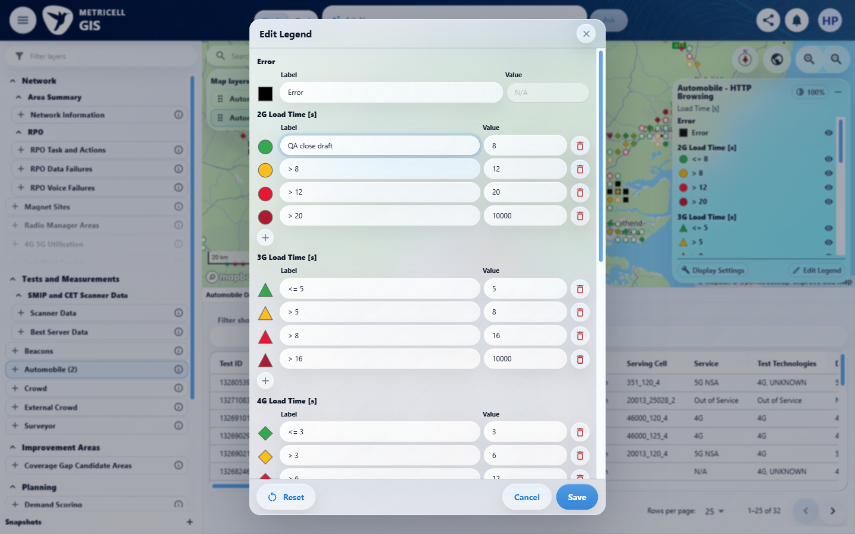 | E35 - Second colour draft (criterion-8-second-colour-draft.png)  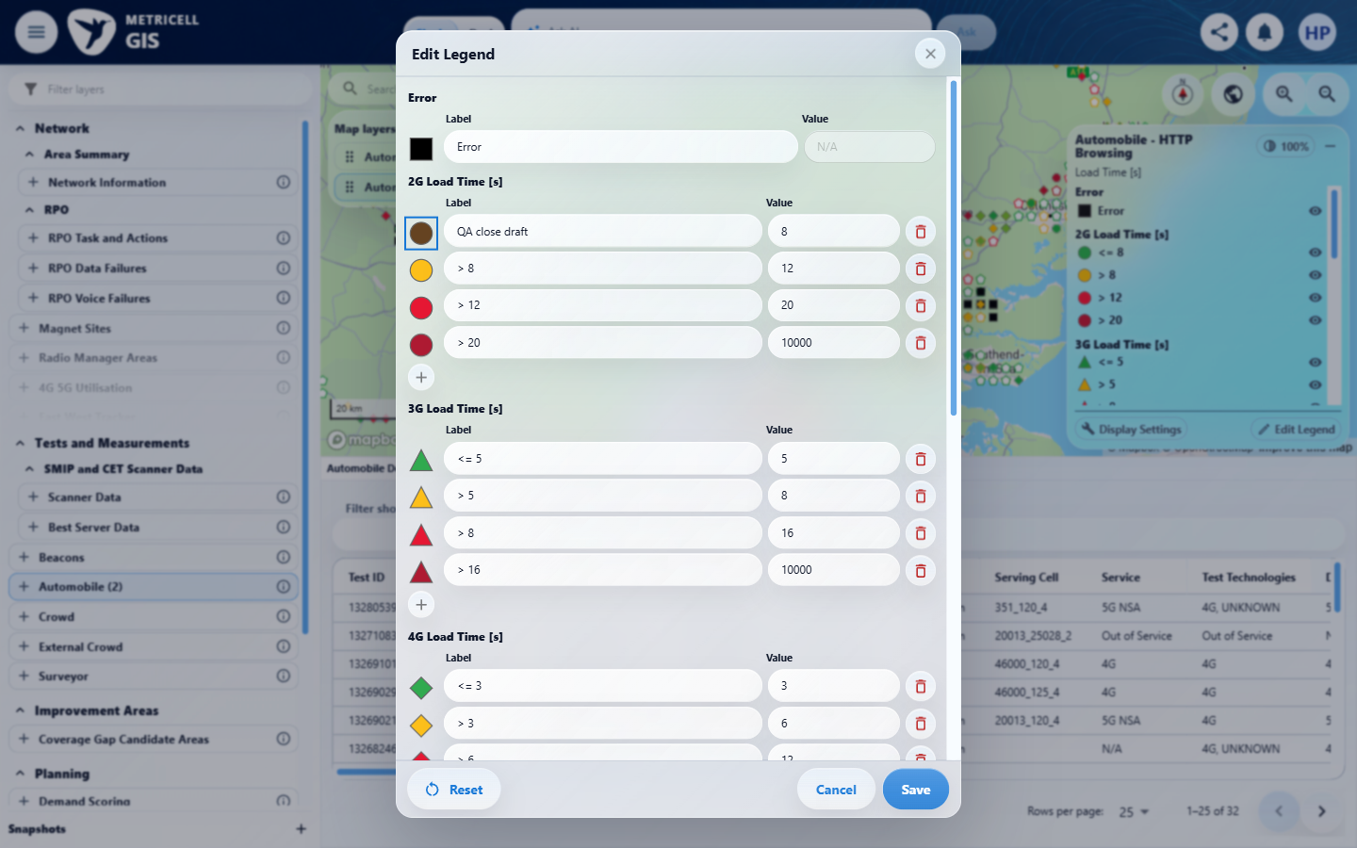

Criterion 8 continued: In Edit Legend, changing labels, colours or numeric boundaries creates drafts for the active field only; the map remains unchanged until Save, while Cancel or Close discards drafts. After Save, refreshed values remain visible in the open dialog.
Browser URL recorded after criterion: https://o2intelligence-v4-dev.metricell.com/gis
E36 - Second value draft (criterion-8-second-value-draft.png)  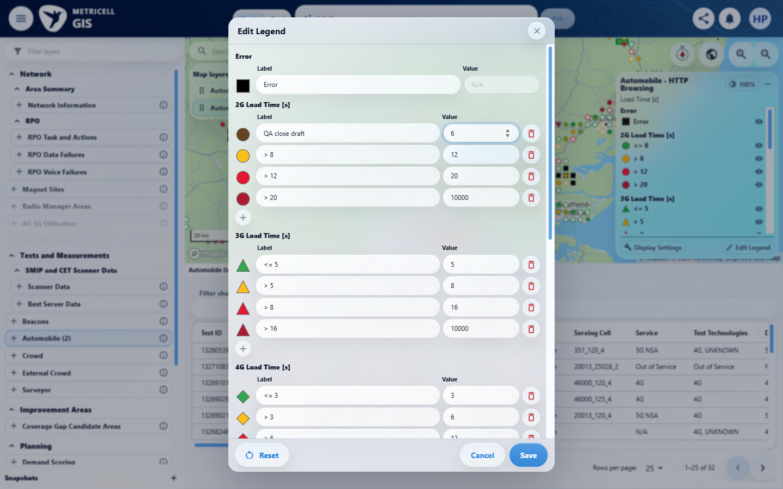 | E28 - Second after close (criterion-8-second-after-close.png)

Criterion 8 continued: In Edit Legend, changing labels, colours or numeric boundaries creates drafts for the active field only; the map remains unchanged until Save, while Cancel or Close discards drafts. After Save, refreshed values remain visible in the open dialog.
Browser URL recorded after criterion: https://o2intelligence-v4-dev.metricell.com/gis
E33 - Second reopen (criterion-8-second-reopen.png) | E37 - Final label draft (criterion-8-final-label-draft.png)  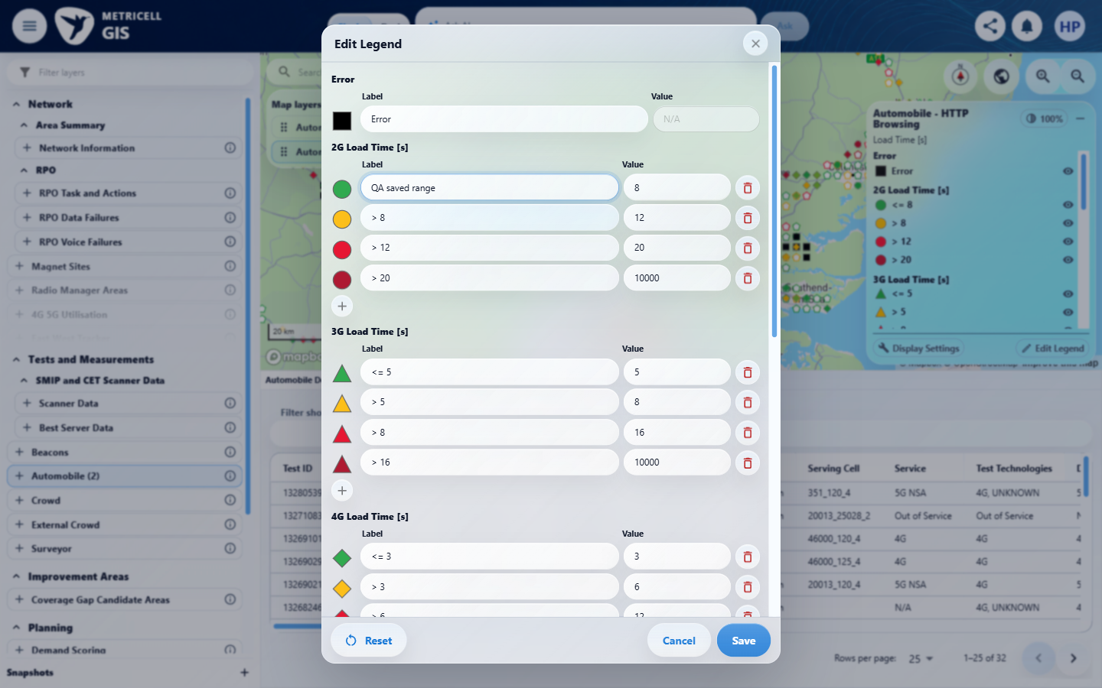

Criterion 8 continued: In Edit Legend, changing labels, colours or numeric boundaries creates drafts for the active field only; the map remains unchanged until Save, while Cancel or Close discards drafts. After Save, refreshed values remain visible in the open dialog.
Browser URL recorded after criterion: https://o2intelligence-v4-dev.metricell.com/gis
E38 - Final colour draft (criterion-8-final-colour-draft.png)  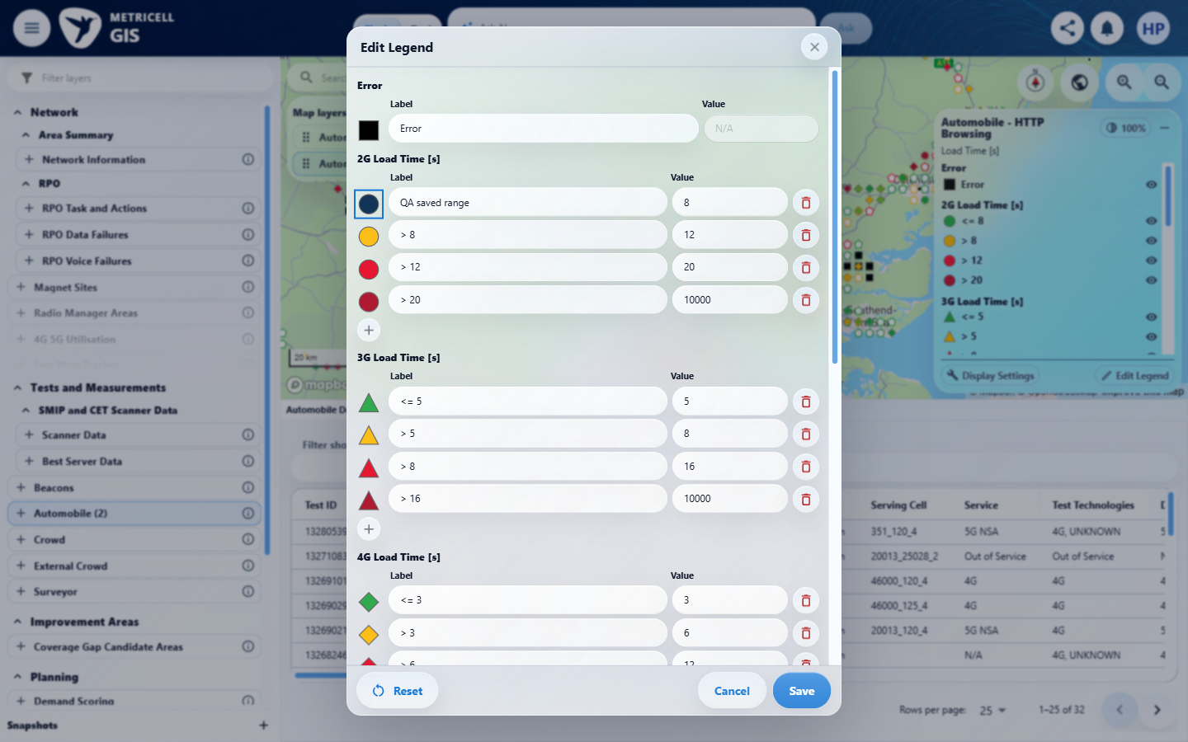 | E39 - Final value draft (criterion-8-final-value-draft.png)  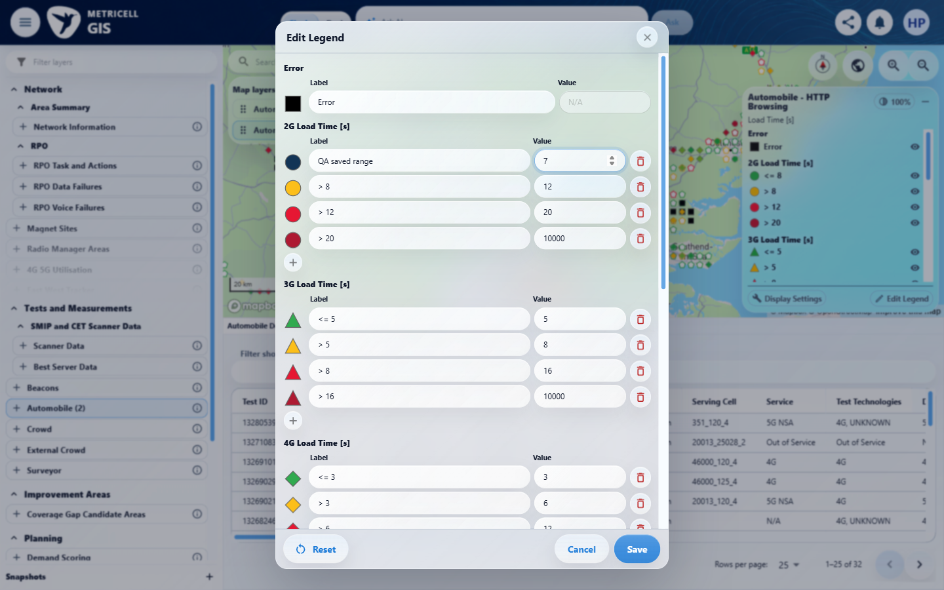

Criterion 8 continued: In Edit Legend, changing labels, colours or numeric boundaries creates drafts for the active field only; the map remains unchanged until Save, while Cancel or Close discards drafts. After Save, refreshed values remain visible in the open dialog.
Browser URL recorded after criterion: https://o2intelligence-v4-dev.metricell.com/gis
E40 - Final (criterion-8-final.png)
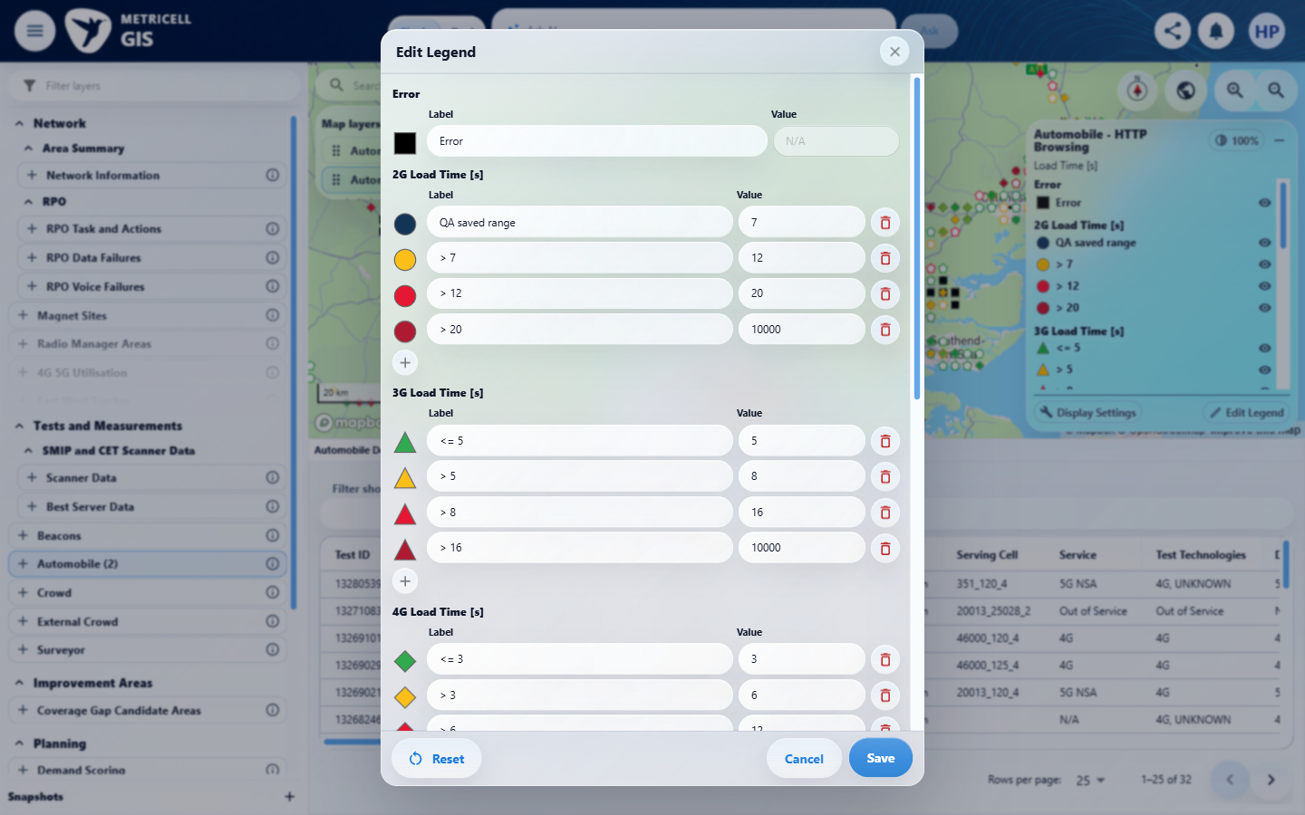

9.0.0 | After a valid legend edit is saved, the legend and cached map points use the same labels, colours and classification; saved overrides for other fields and layers remain unchanged. | After a valid legend edit is saved, the legend and cached map points use the same labels, colours and classification; saved overrides for other fields and layers remain unchanged. | criterion-9-after-save.png and criterion-9-final.png visibly show QA saved error in the HTTP legend and magenta map squares replacing some black squares from criterion-9-map-baseline.png. Exact assigned colour value is not readable in criterion-9-colour-draft.png; the reported #ff00ff/SVG value is supporting narrative, not visible exact-value proof. criterion-9-value-draft.png shows boundary 7, but no known measurement-to-category reconciliation. Cache reuse is reported, without a reviewable request trace proving no refetch. Cross-field preservation is Blocked without a multi-field fixture; other-layer saved-override preservation lacks a before/after sequence.  Evidence: E41, E28, E29, E42, E43, E44, E45, E46 | Blocked
Criterion 9 assessment: Testing notes: Saved Error label/colour (#FF00FF) appeared in legend and map squares without another HTTP points fetch. Exact boundary sample classification was not independently reconciled, and no multi-field fixture with saved other-field overrides was supplied for isolation. Drafted Error label QA saved error, colour #ff00ff and first 2G boundary 7; captured each transition. Saved and captured refreshed editor; closed editor and captured magenta map squares and QA saved error legend. Legend SVG fill observed #FF00FF.
Criterion 9 evidence: After a valid legend edit is saved, the legend and cached map points use the same labels, colours and classification; saved overrides for other fields and layers remain unchanged.
Browser URL recorded after criterion: https://o2intelligence-v4-dev.metricell.com/gis
E41 - Config (criterion-9-config.png)  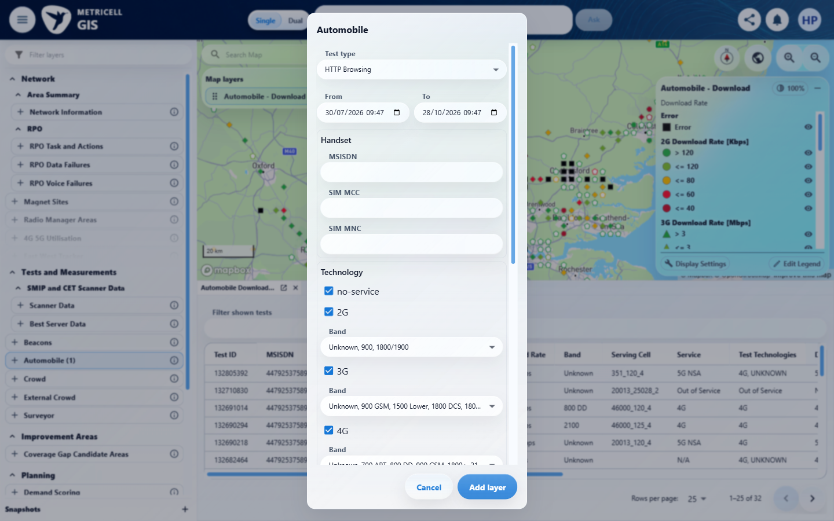 | E28 - Map baseline (criterion-9-map-baseline.png)

Criterion 9 continued: After a valid legend edit is saved, the legend and cached map points use the same labels, colours and classification; saved overrides for other fields and layers remain unchanged.
Browser URL recorded after criterion: https://o2intelligence-v4-dev.metricell.com/gis
E29 - Editor baseline (criterion-9-editor-baseline.png) | E42 - Label draft (criterion-9-label-draft.png)  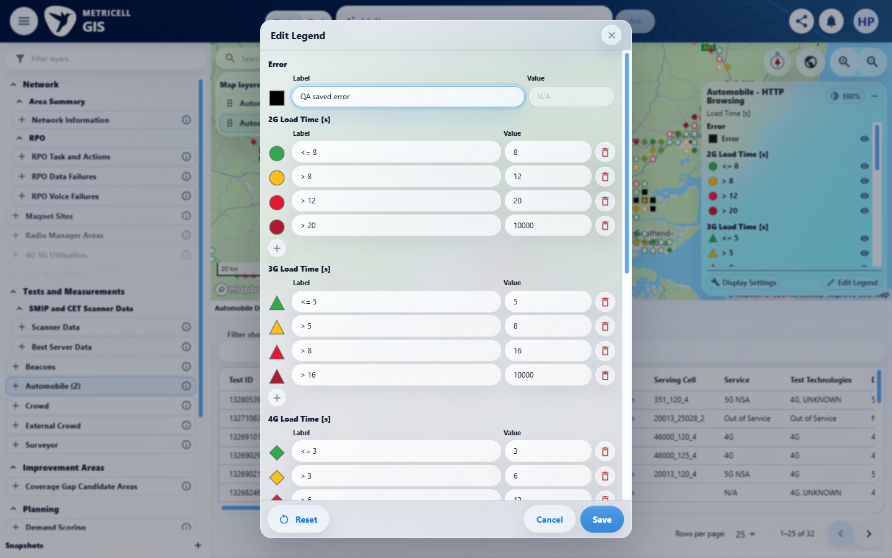

Criterion 9 continued: After a valid legend edit is saved, the legend and cached map points use the same labels, colours and classification; saved overrides for other fields and layers remain unchanged.
Browser URL recorded after criterion: https://o2intelligence-v4-dev.metricell.com/gis
E43 - Colour draft (criterion-9-colour-draft.png)  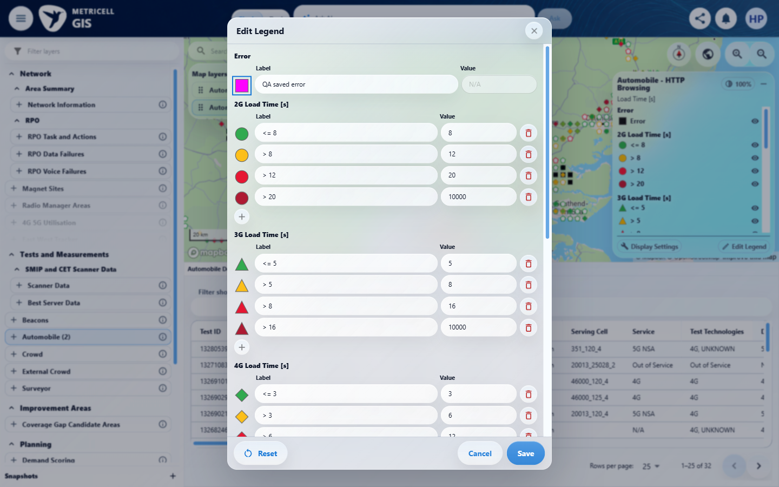 | E44 - Value draft (criterion-9-value-draft.png)  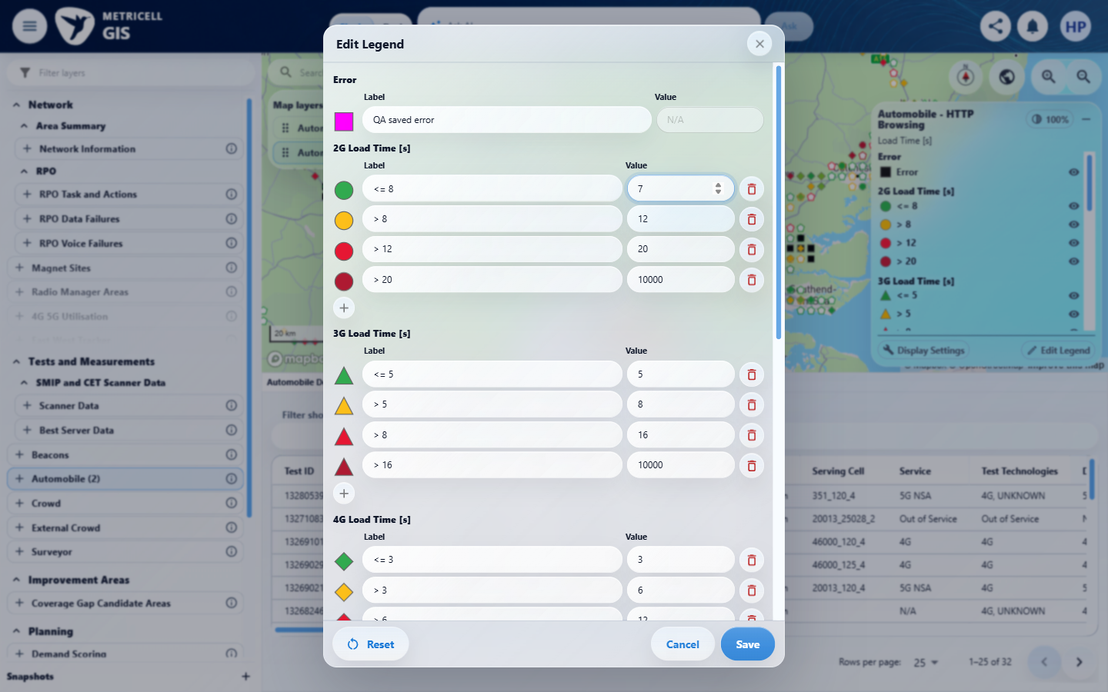

Criterion 9 continued: After a valid legend edit is saved, the legend and cached map points use the same labels, colours and classification; saved overrides for other fields and layers remain unchanged.
Browser URL recorded after criterion: https://o2intelligence-v4-dev.metricell.com/gis
E45 - After save (criterion-9-after-save.png)  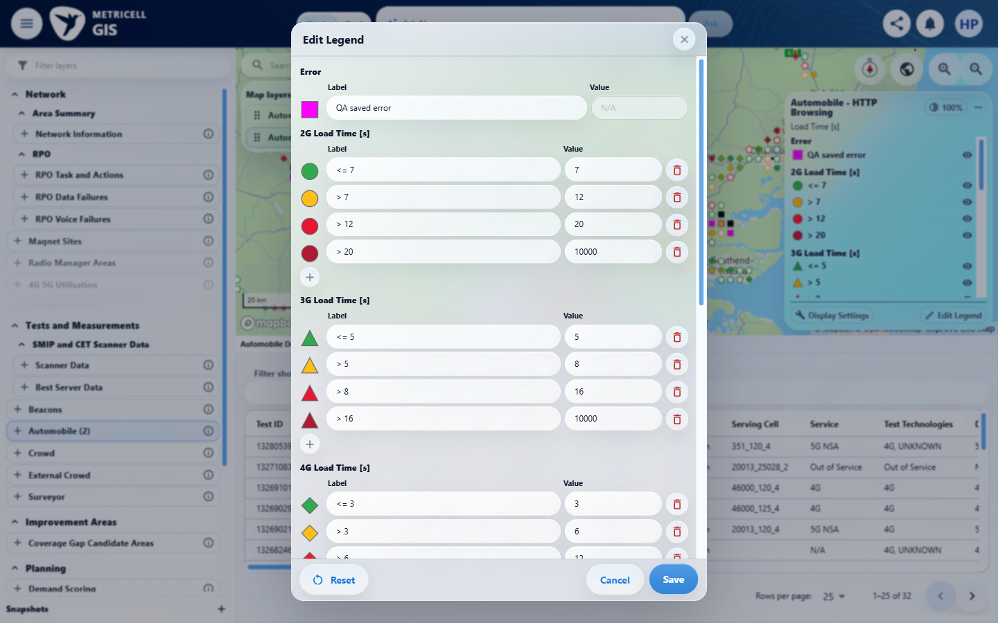 | E46 - Final (criterion-9-final.png)  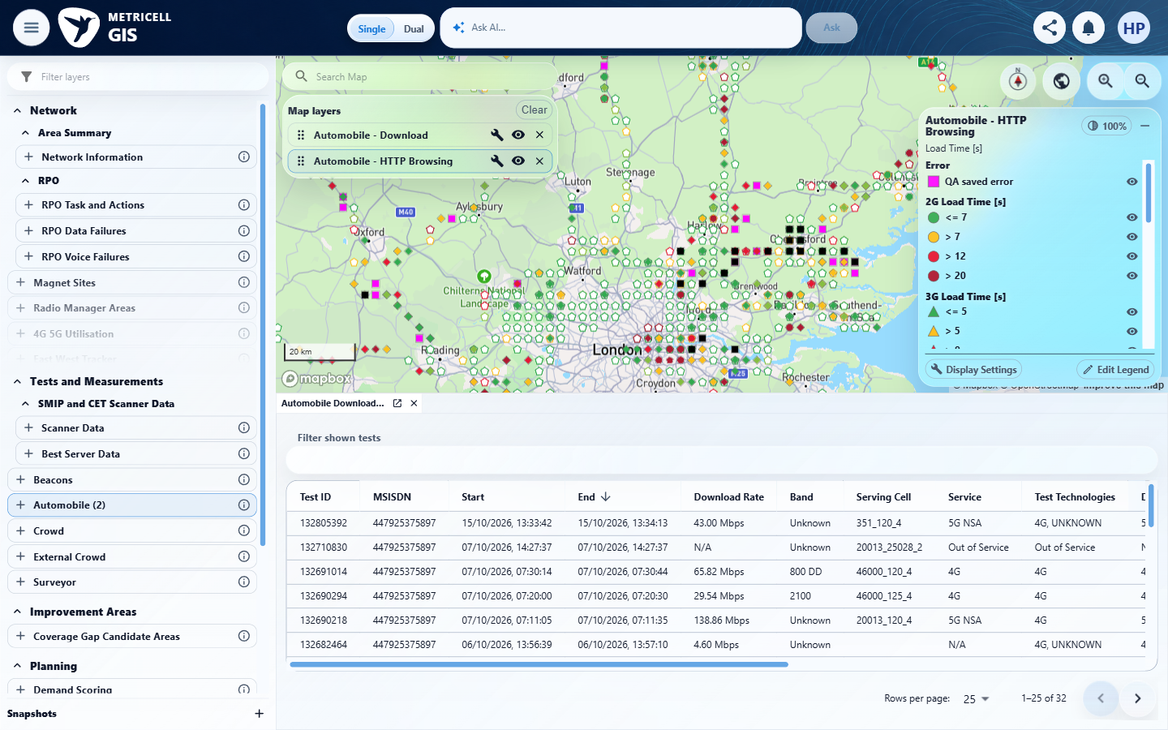

10.0.0 | In a numeric generation group, the add control below the marker column adds a range row, eligible rows have delete controls, at least one range remains, and editing a value does not reorder Automobile rows. | In a numeric generation group, the add control below the marker column adds a range row, eligible rows have delete controls, at least one range remains, and editing a value does not reorder Automobile rows. | criterion-10-before-add.png -> criterion-10-after-add.png -> criterion-10-after-delete-added.png shows the add icon below the HTTP 2G marker column creating an editable New range row and its deletion. criterion-10-after-delete-first.png and criterion-10-after-delete-second.png show existing-row deletion. criterion-10-out-of-order-edit.png -> criterion-10-restored-value.png keeps the first remaining row before 10000 when edited to 10001 and back to 20. criterion-10-final.png shows one remaining range and a grey Delete control, but no recorded normal pointer activation or applicable keyboard activation followed by a settled unchanged state. Therefore prevention of deleting the last range is Unverified, not Passed from disabled appearance.  Evidence: E47, E28, E29, E48, E49, E50, E51, E52, E53, E54, E55 | Failed
Criterion 10 assessment: Testing notes: HTTP Browsing 2G range add/delete controls worked, last remaining range could not be deleted, and editing across another row's value did not reorder the rows. With remaining rows20,10000, changed first to10001; it stayed before10000 and showed max error. Restored20; deleted that eligible row.
Criterion 10 evidence: In a numeric generation group, the add control below the marker column adds a range row, eligible rows have delete controls, at least one range remains, and editing a value does not reorder Automobile rows.
Browser URL recorded after criterion: https://o2intelligence-v4-dev.metricell.com/gis
E47 - Config (criterion-10-config.png)  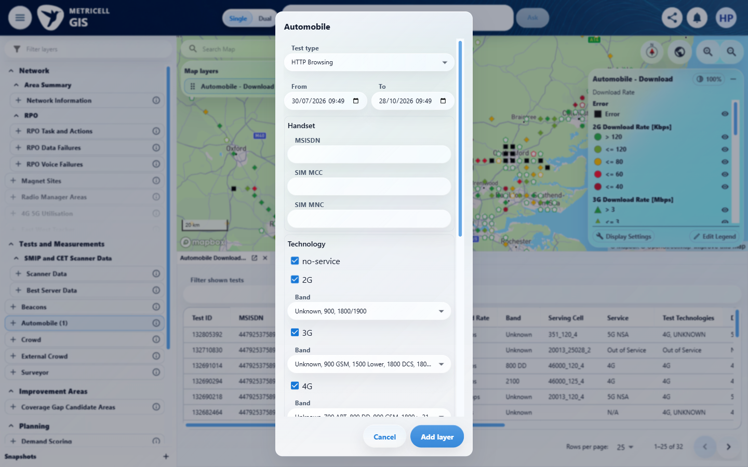 | E28 - Map (criterion-10-map.png)

Criterion 10 continued: In a numeric generation group, the add control below the marker column adds a range row, eligible rows have delete controls, at least one range remains, and editing a value does not reorder Automobile rows.
Browser URL recorded after criterion: https://o2intelligence-v4-dev.metricell.com/gis
E29 - Before add (criterion-10-before-add.png) | E48 - After add (criterion-10-after-add.png)  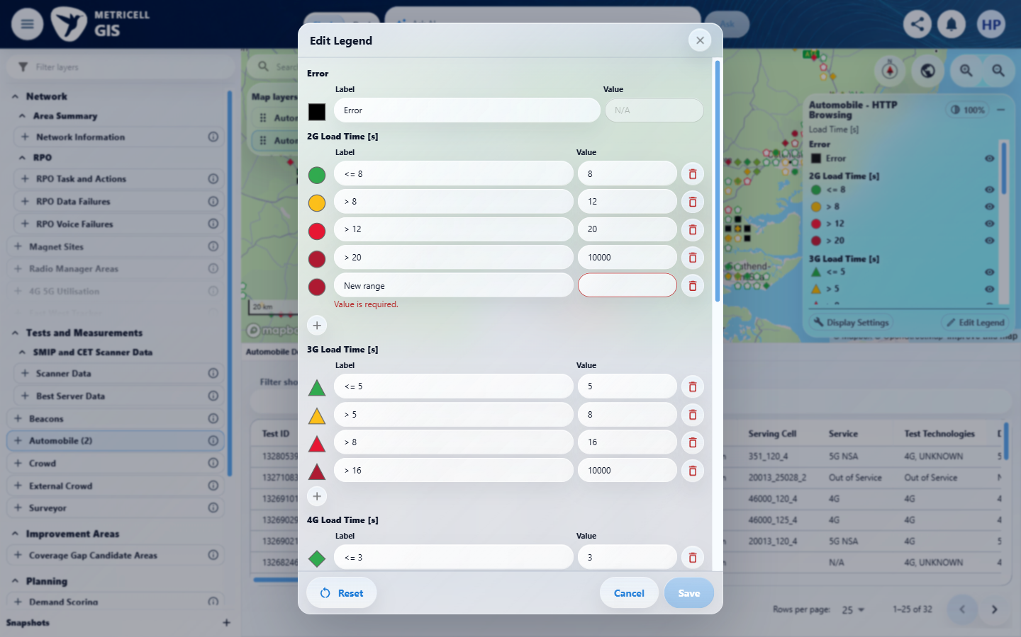
E29 detail enlargement - full screenshot above | E48 detail enlargement - full screenshot above

Criterion 10 continued: In a numeric generation group, the add control below the marker column adds a range row, eligible rows have delete controls, at least one range remains, and editing a value does not reorder Automobile rows.
Browser URL recorded after criterion: https://o2intelligence-v4-dev.metricell.com/gis
E49 - After value edit (criterion-10-after-value-edit.png)  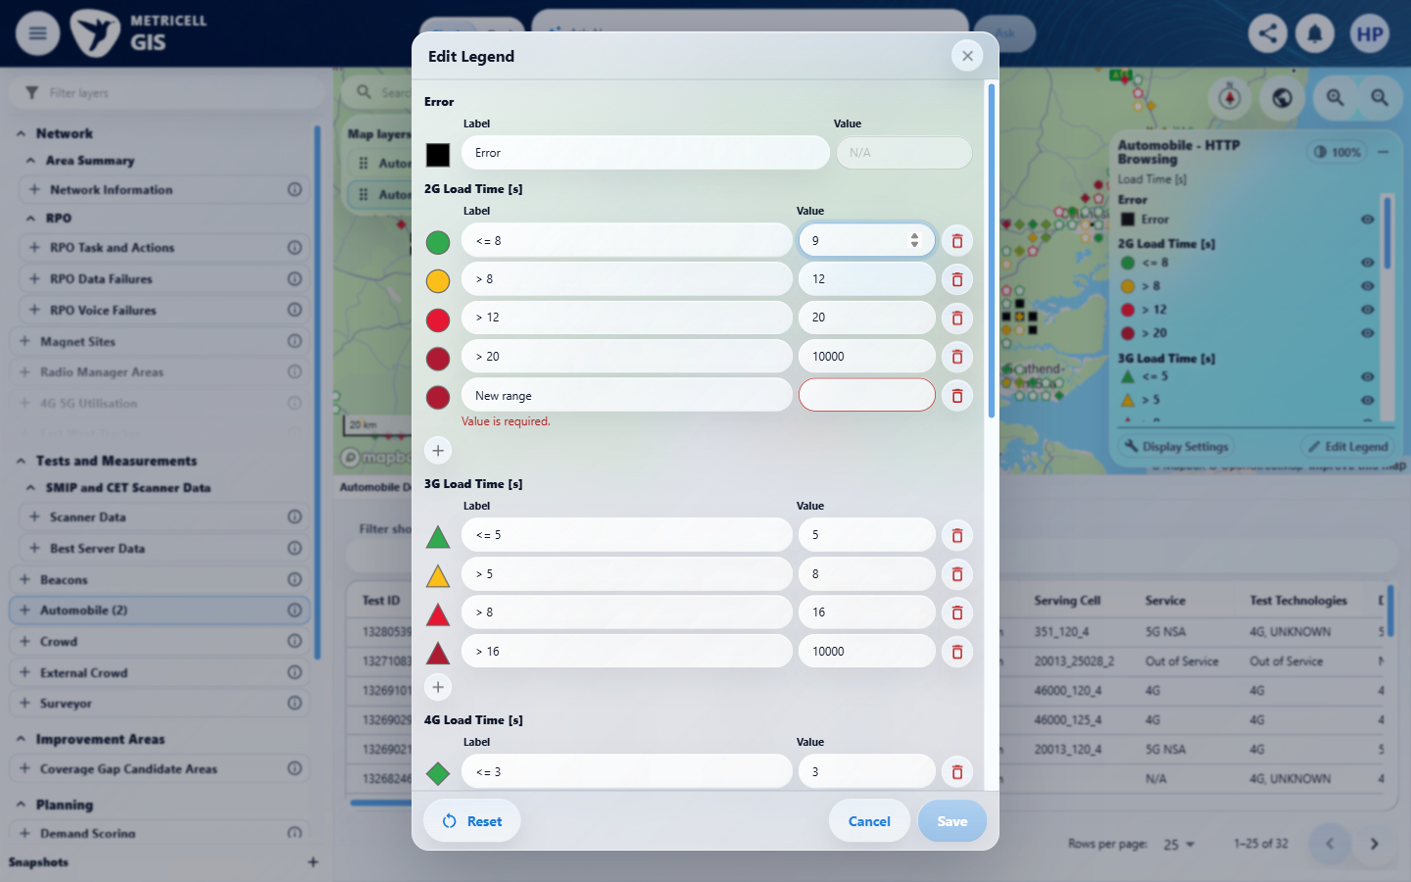 | E50 - After delete added (criterion-10-after-delete-added.png)  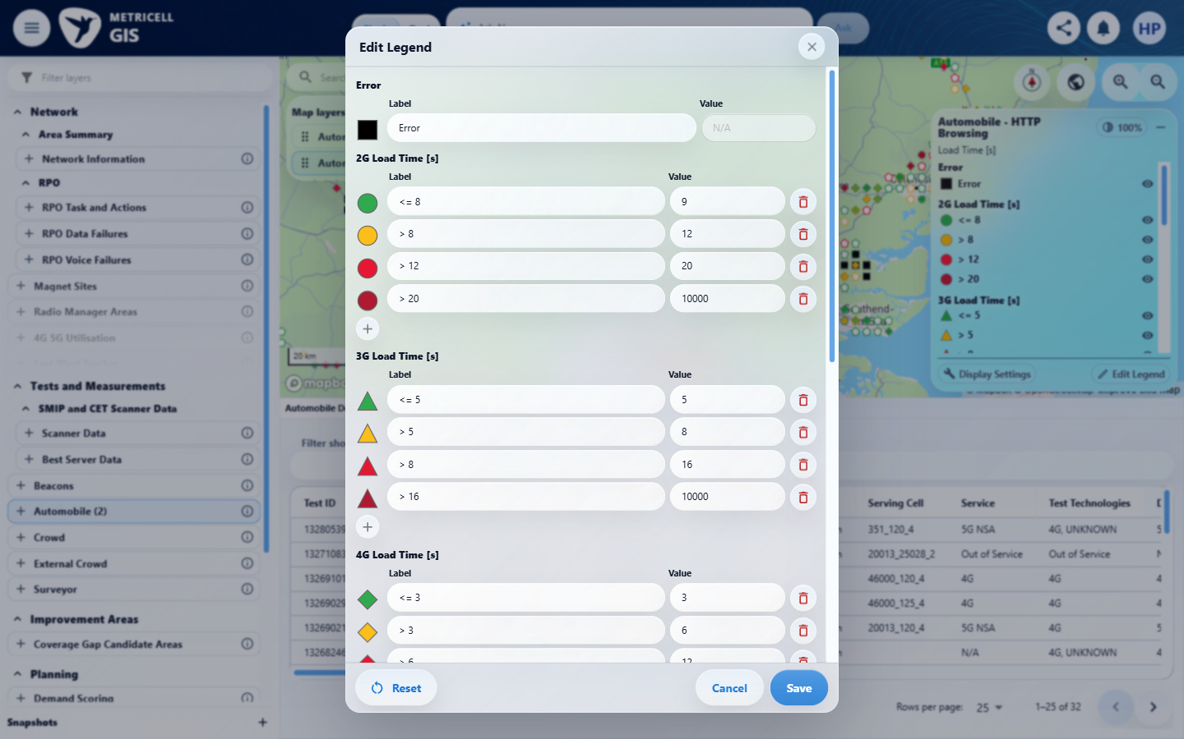

Criterion 10 continued: In a numeric generation group, the add control below the marker column adds a range row, eligible rows have delete controls, at least one range remains, and editing a value does not reorder Automobile rows.
Browser URL recorded after criterion: https://o2intelligence-v4-dev.metricell.com/gis
E51 - After delete first (criterion-10-after-delete-first.png)  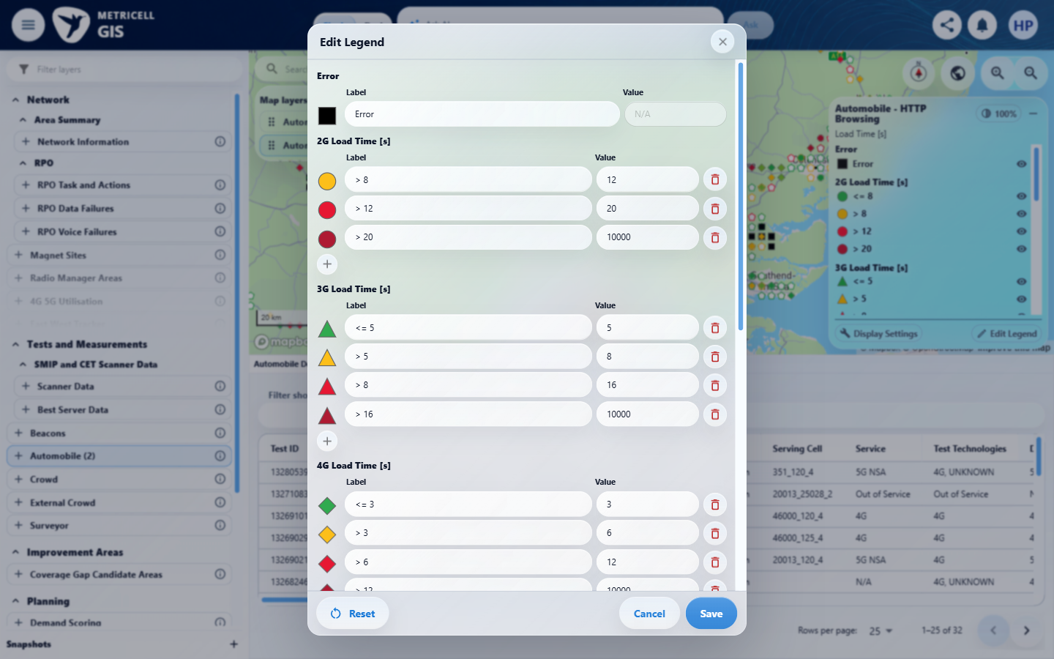 | E52 - After delete second (criterion-10-after-delete-second.png)  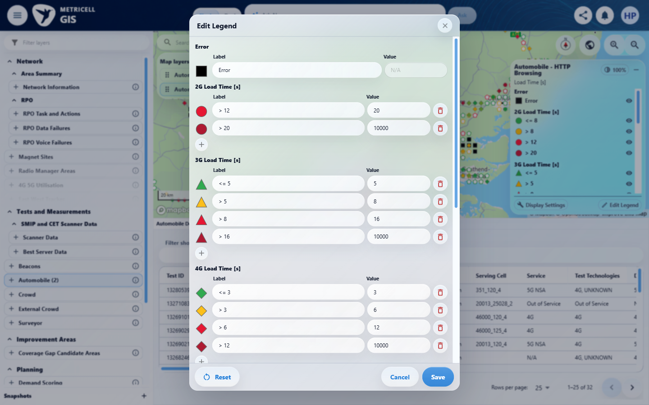

Criterion 10 continued: In a numeric generation group, the add control below the marker column adds a range row, eligible rows have delete controls, at least one range remains, and editing a value does not reorder Automobile rows.
Browser URL recorded after criterion: https://o2intelligence-v4-dev.metricell.com/gis
E53 - Out of order edit (criterion-10-out-of-order-edit.png)  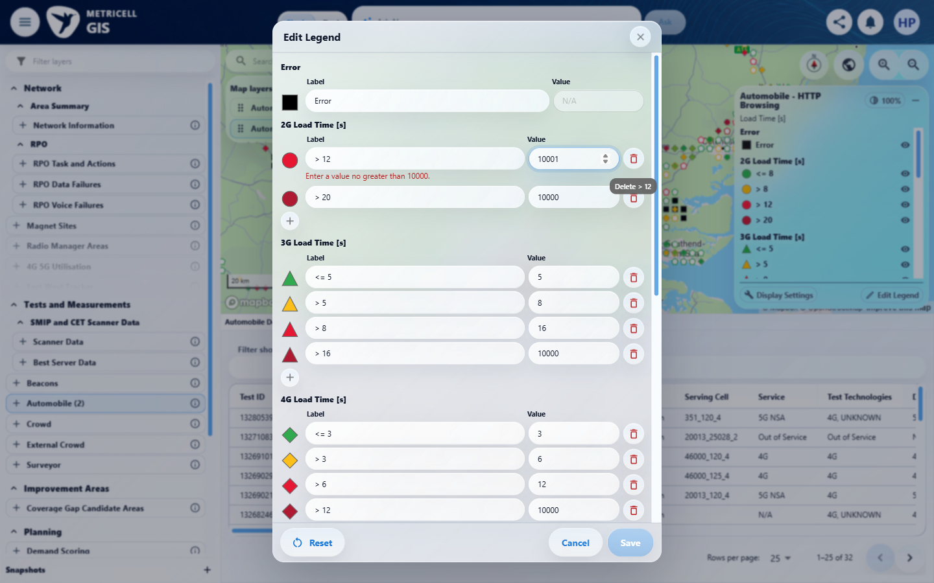 | E54 - Restored value (criterion-10-restored-value.png)  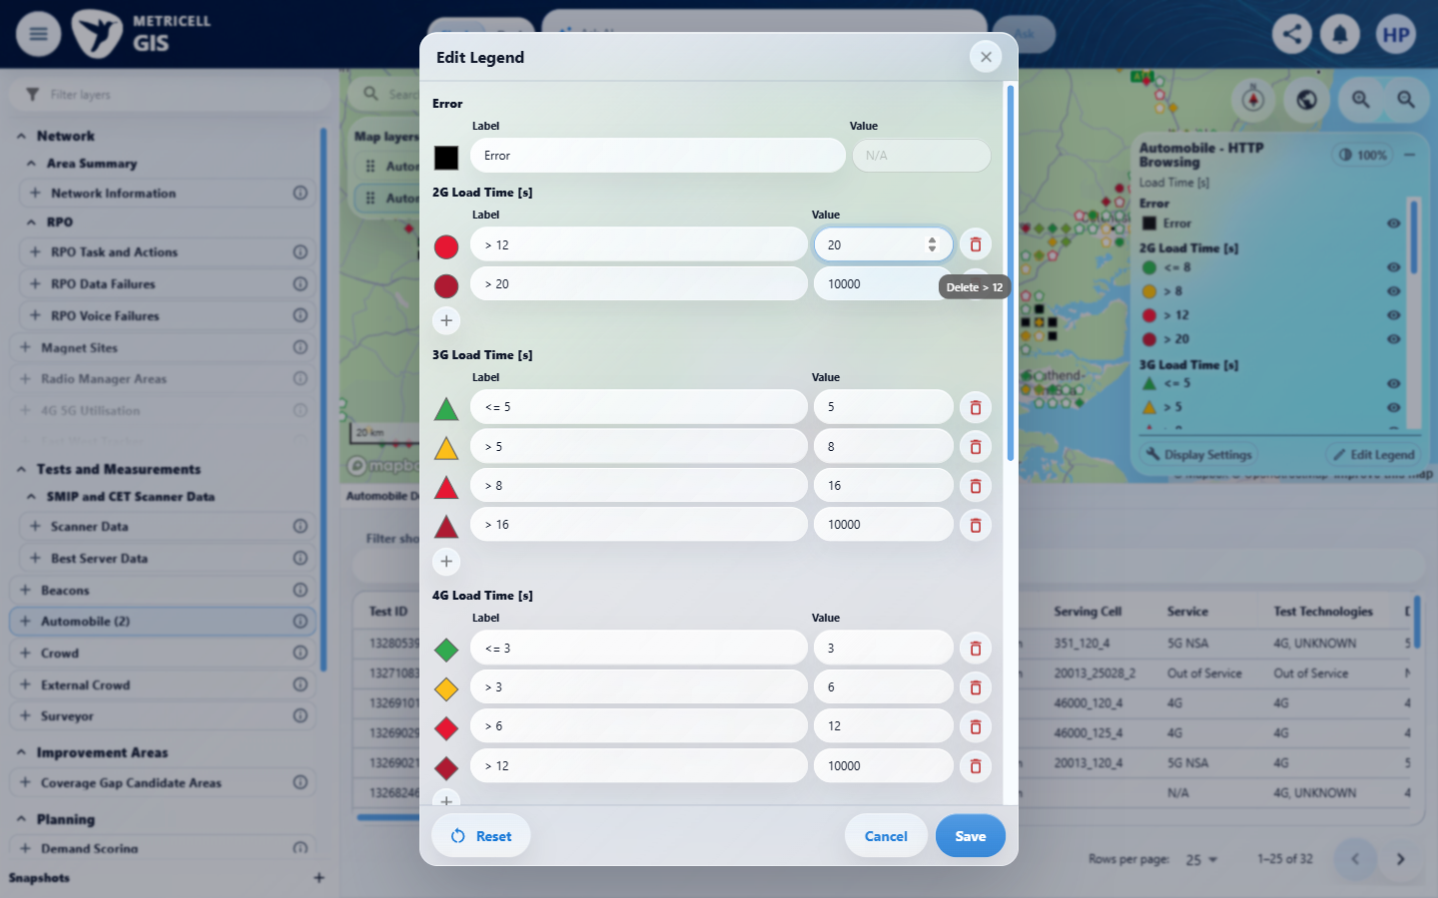

Criterion 10 continued: In a numeric generation group, the add control below the marker column adds a range row, eligible rows have delete controls, at least one range remains, and editing a value does not reorder Automobile rows.
Browser URL recorded after criterion: https://o2intelligence-v4-dev.metricell.com/gis
E55 - Final (criterion-10-final.png)
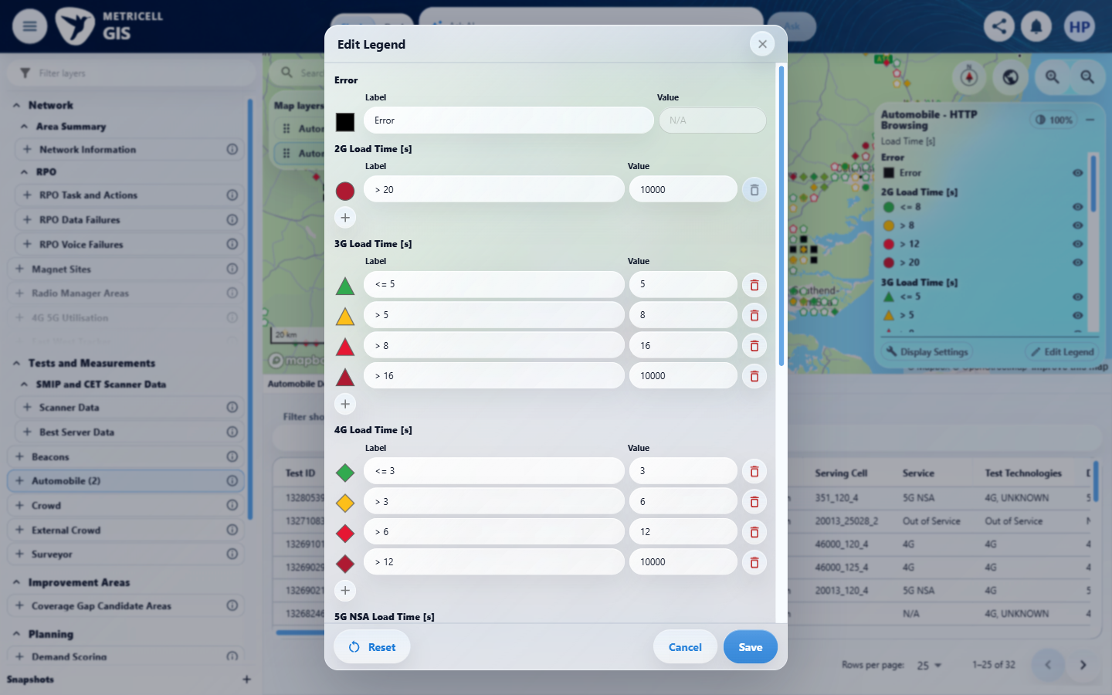

11.0.0 | Numeric Value fields use number inputs. Empty, non-finite, out-of-limit or incorrectly ordered boundary values show an inline error immediately and disable Save. HTTP Browsing boundaries accept 0–10,000; Ping and Video Streaming boundaries have a minimum of zero and no additional maximum. Video Streaming categories cannot be changed. | Numeric Value fields use number inputs. Empty, non-finite, out-of-limit or incorrectly ordered boundary values show an inline error immediately and disable Save. HTTP Browsing boundaries accept 0–10,000; Ping and Video Streaming boundaries have a minimum of zero and no additional maximum. Video Streaming categories cannot be changed. | HTTP criterion-11-http-order-settled.png directly shows first boundary 13 before next boundary 12, without an inline ordering error; Save appears enabled. Video criterion-11-video-editor.png -> criterion-11-video-category-draft.png -> criterion-11-final.png directly shows exact category 1 edited and saved as 1.5 in both editor and legend, contradicting fixed categories. HTTP empty, 1e999, -1 and 10001 captures show required/minimum/maximum messages and muted Save; Ping/Video -1 captures show minimum-zero messages. Their blocked-Save claims lack normal pointer/applicable keyboard activation and settled after-state proof. Numeric spinner controls are visible. Boundary acceptance and unlimited maxima are only partially exercised: Ping/Video 1000000 accepted-looking drafts do not alone establish absence of every additional cap, and HTTP valid endpoint acceptance lacks its own captures.  Evidence: E56, E28, E29, E57, E58, E59, E60, E61, E62, E63, E64, E65, E66, E67, E68, E69, E70, E71, E72, E73, E74, E75 | Failed
Criterion 11 assessment: Testing notes: HTTP 2G first boundary13 before next12 showed no inline ordering error and left Save enabled after settlement. Video Streaming exact category1 was editable and saved as1.5, changing the legend; source explicitly requires fixed categories. Started launcher; initial setup tool timed out after120s and restored Download workspace. Rechecked own lease and live browser state, closed untouched Download editor, restarted at launcher with criterion-11-restart-initial.png. Excluded Download setup captures from acceptance proof. HTTP first boundary: empty produced Value is required and disabled Save; 1e999 remained visibly non-finite but native inputValue empty and required error/disabled Save; -1 produced min0 error;10001 produced max10000 error. Each captured immediately. Changed first boundary to13 while next remained12: after settled recapture no alerts, Save enabled. Did not save bad ordering. Zero was rejected as equal to initial lower boundary0, recorded as ordering context rather than a standalone min-limit failure.
Criterion 11 evidence: Numeric Value fields use number inputs. Empty, non-finite, out-of-limit or incorrectly ordered boundary values show an inline error immediately and disable Save. HTTP Browsing boundaries accept 0–10,000; Ping and Video Streaming boundaries have a minimum of zero and no additional maximum. Video Streaming categories cannot be changed.
Browser URL recorded after criterion: https://o2intelligence-v4-dev.metricell.com/gis
E56 - Http actual config (criterion-11-http-actual-config.png)  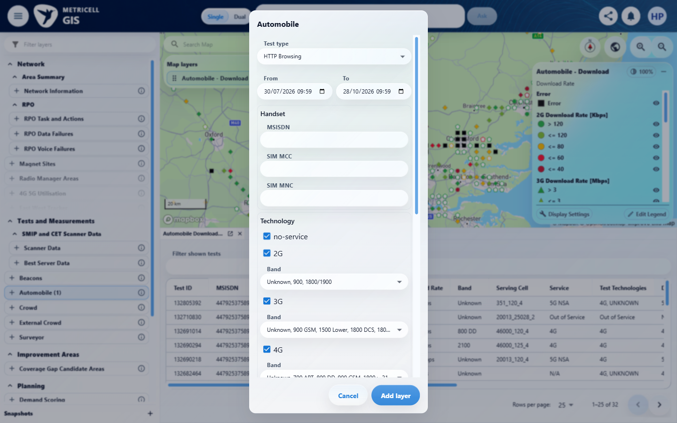 | E28 - Http actual map (criterion-11-http-actual-map.png)

Criterion 11 continued: Numeric Value fields use number inputs. Empty, non-finite, out-of-limit or incorrectly ordered boundary values show an inline error immediately and disable Save. HTTP Browsing boundaries accept 0–10,000; Ping and Video Streaming boundaries have a minimum of zero and no additional maximum. Video Streaming categories cannot be changed.
Browser URL recorded after criterion: https://o2intelligence-v4-dev.metricell.com/gis
E29 - Http actual editor (criterion-11-http-actual-editor.png) | E57 - Http empty (criterion-11-http-empty.png)  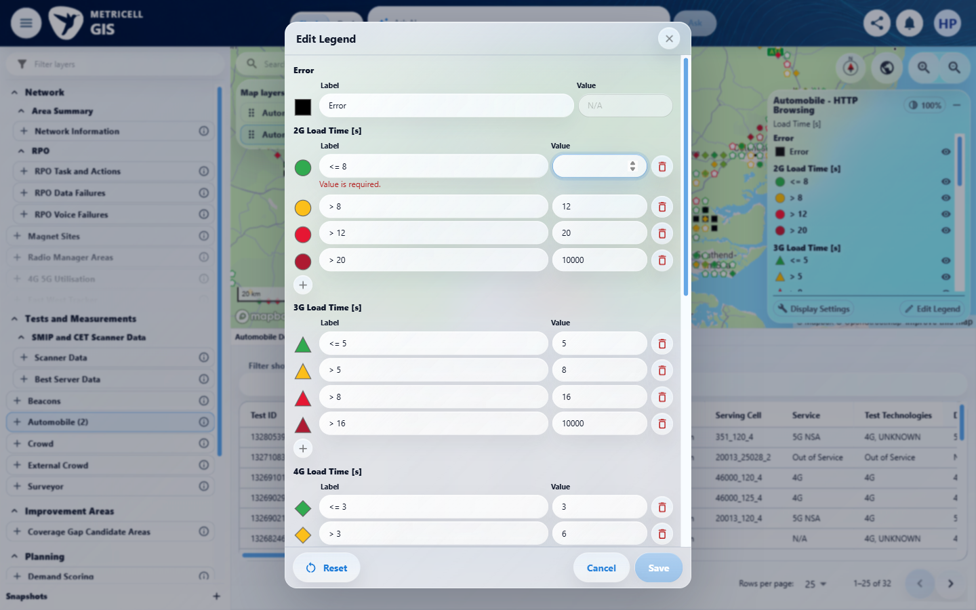

Criterion 11 continued: Numeric Value fields use number inputs. Empty, non-finite, out-of-limit or incorrectly ordered boundary values show an inline error immediately and disable Save. HTTP Browsing boundaries accept 0–10,000; Ping and Video Streaming boundaries have a minimum of zero and no additional maximum. Video Streaming categories cannot be changed.
Browser URL recorded after criterion: https://o2intelligence-v4-dev.metricell.com/gis
E58 - Http non finite (criterion-11-http-non-finite.png)  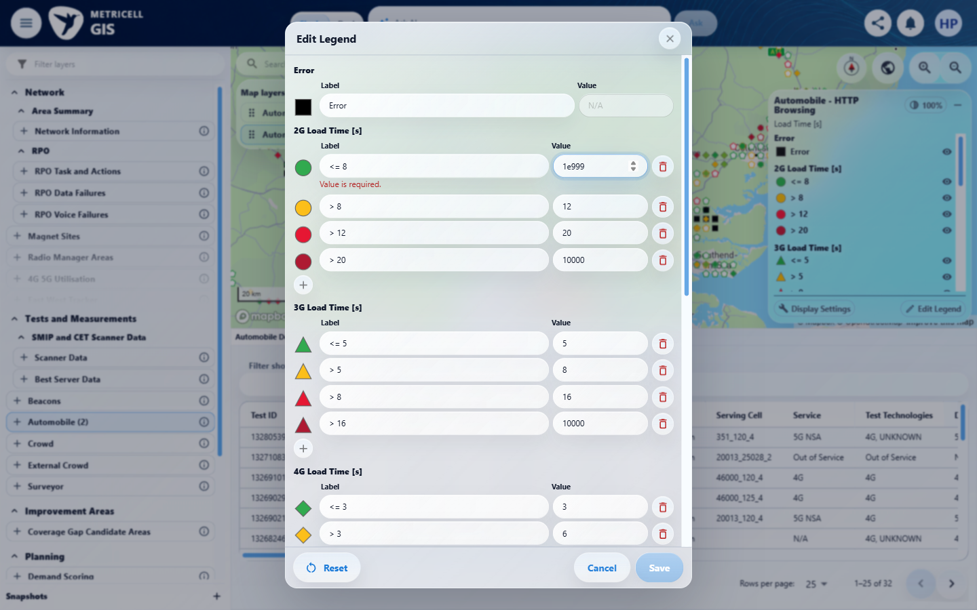 | E59 - Http below min (criterion-11-http-below-min.png)  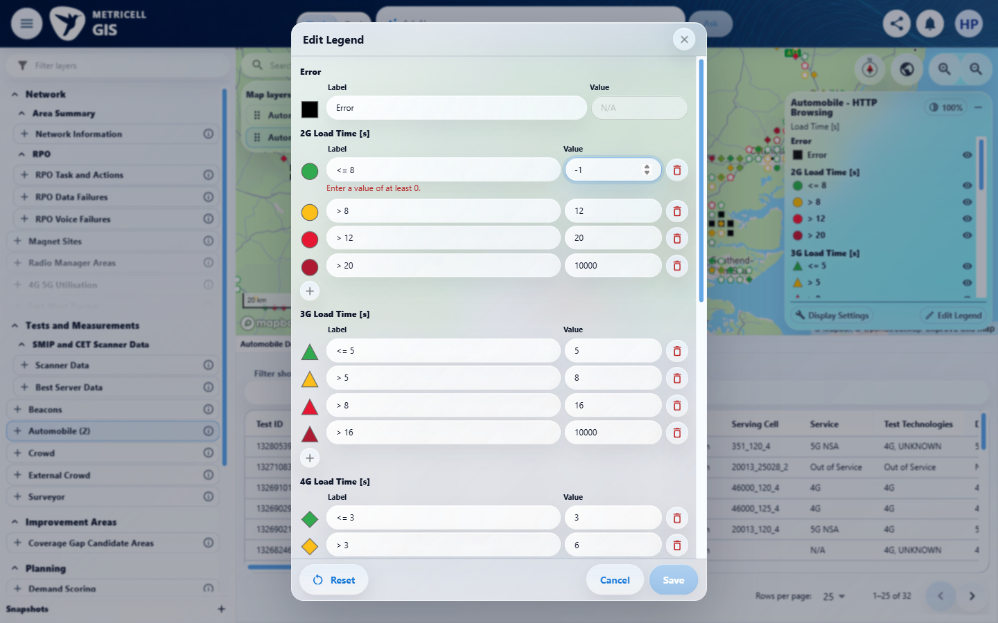

Criterion 11 continued: Numeric Value fields use number inputs. Empty, non-finite, out-of-limit or incorrectly ordered boundary values show an inline error immediately and disable Save. HTTP Browsing boundaries accept 0–10,000; Ping and Video Streaming boundaries have a minimum of zero and no additional maximum. Video Streaming categories cannot be changed.
Browser URL recorded after criterion: https://o2intelligence-v4-dev.metricell.com/gis
E60 - Http above max (criterion-11-http-above-max.png)  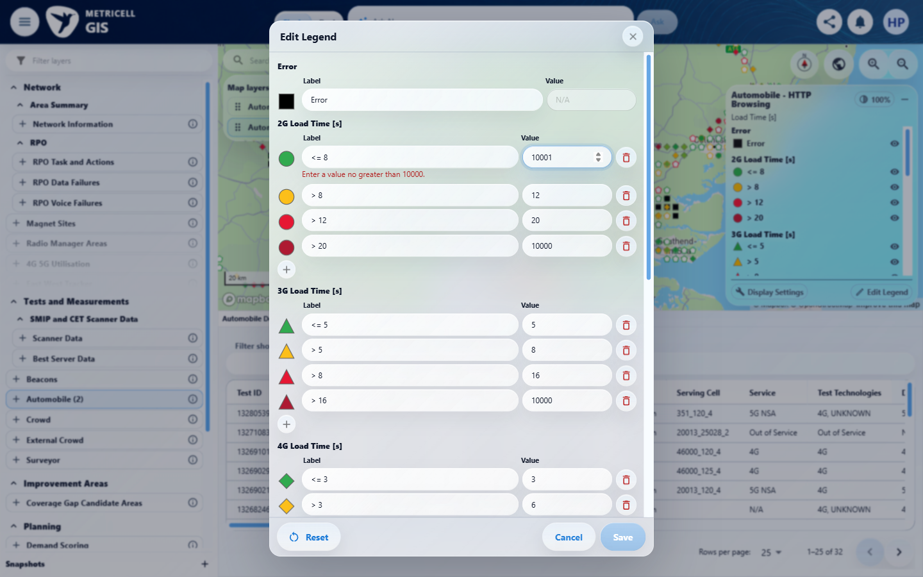 | E61 - Http order settled (criterion-11-http-order-settled.png)  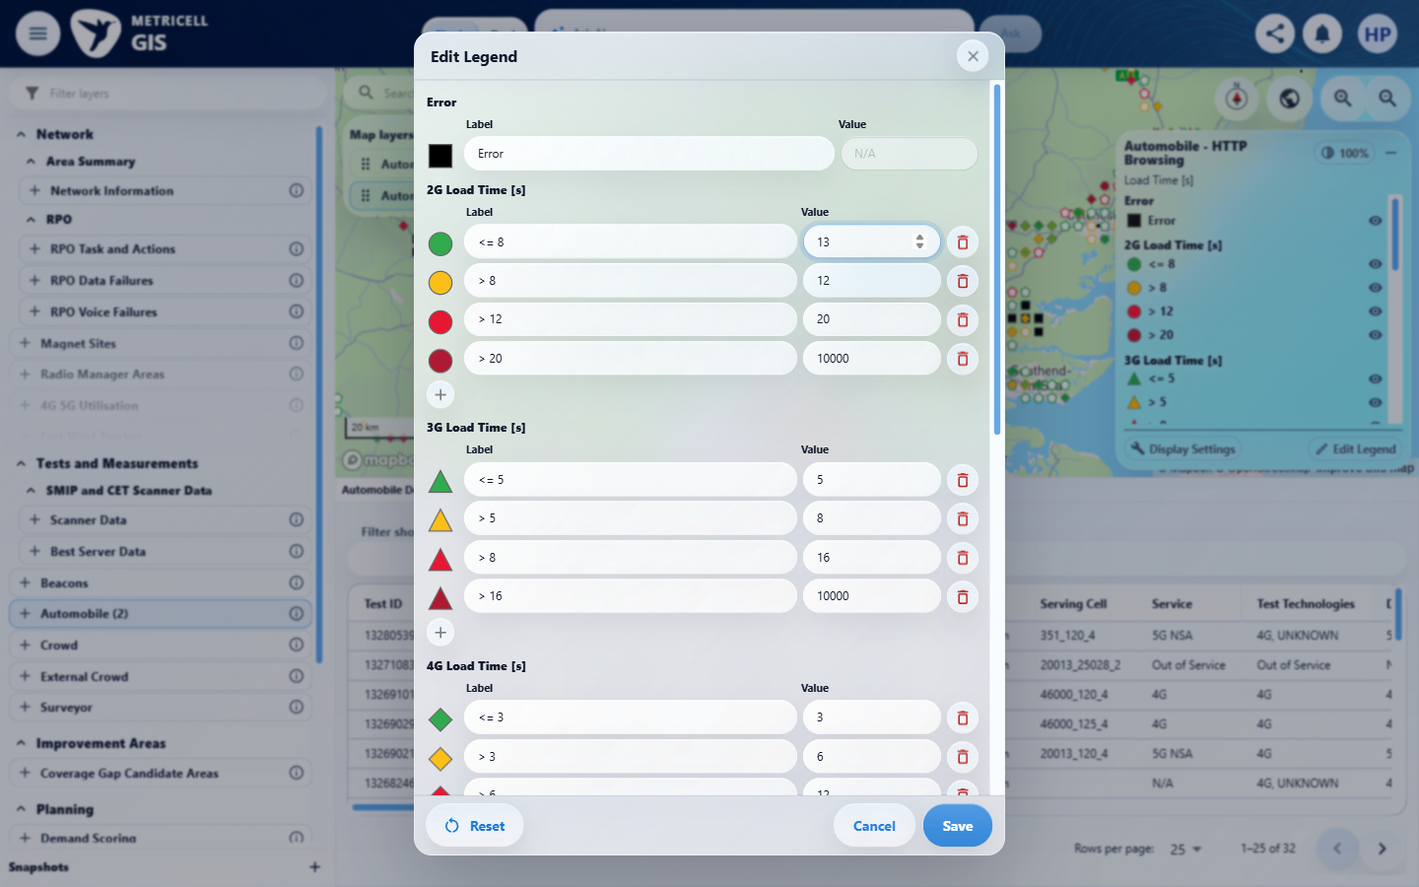

Criterion 11 continued: Numeric Value fields use number inputs. Empty, non-finite, out-of-limit or incorrectly ordered boundary values show an inline error immediately and disable Save. HTTP Browsing boundaries accept 0–10,000; Ping and Video Streaming boundaries have a minimum of zero and no additional maximum. Video Streaming categories cannot be changed.
Browser URL recorded after criterion: https://o2intelligence-v4-dev.metricell.com/gis
E62 - Ping config (criterion-11-ping-config.png)  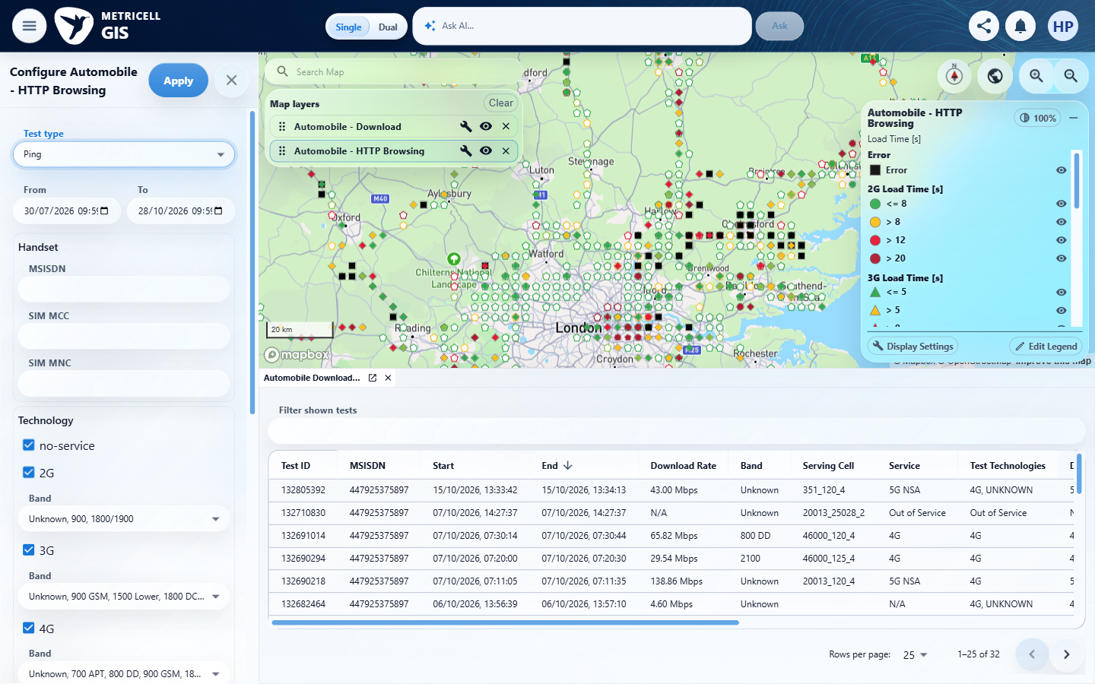 | E63 - Ping map (criterion-11-ping-map.png)  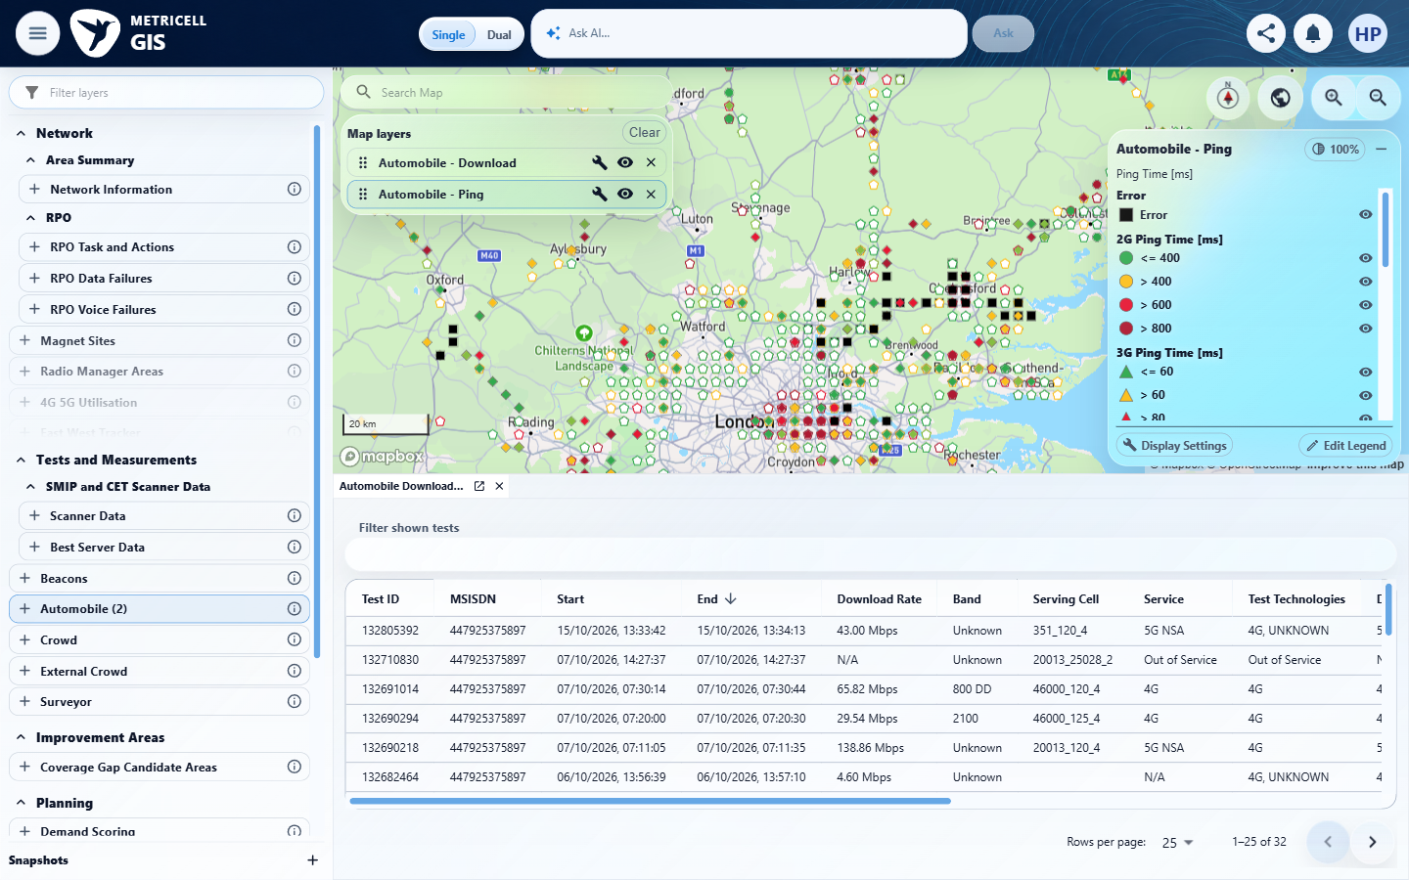

Criterion 11 continued: Numeric Value fields use number inputs. Empty, non-finite, out-of-limit or incorrectly ordered boundary values show an inline error immediately and disable Save. HTTP Browsing boundaries accept 0–10,000; Ping and Video Streaming boundaries have a minimum of zero and no additional maximum. Video Streaming categories cannot be changed.
Browser URL recorded after criterion: https://o2intelligence-v4-dev.metricell.com/gis
E64 - Ping editor (criterion-11-ping-editor.png)  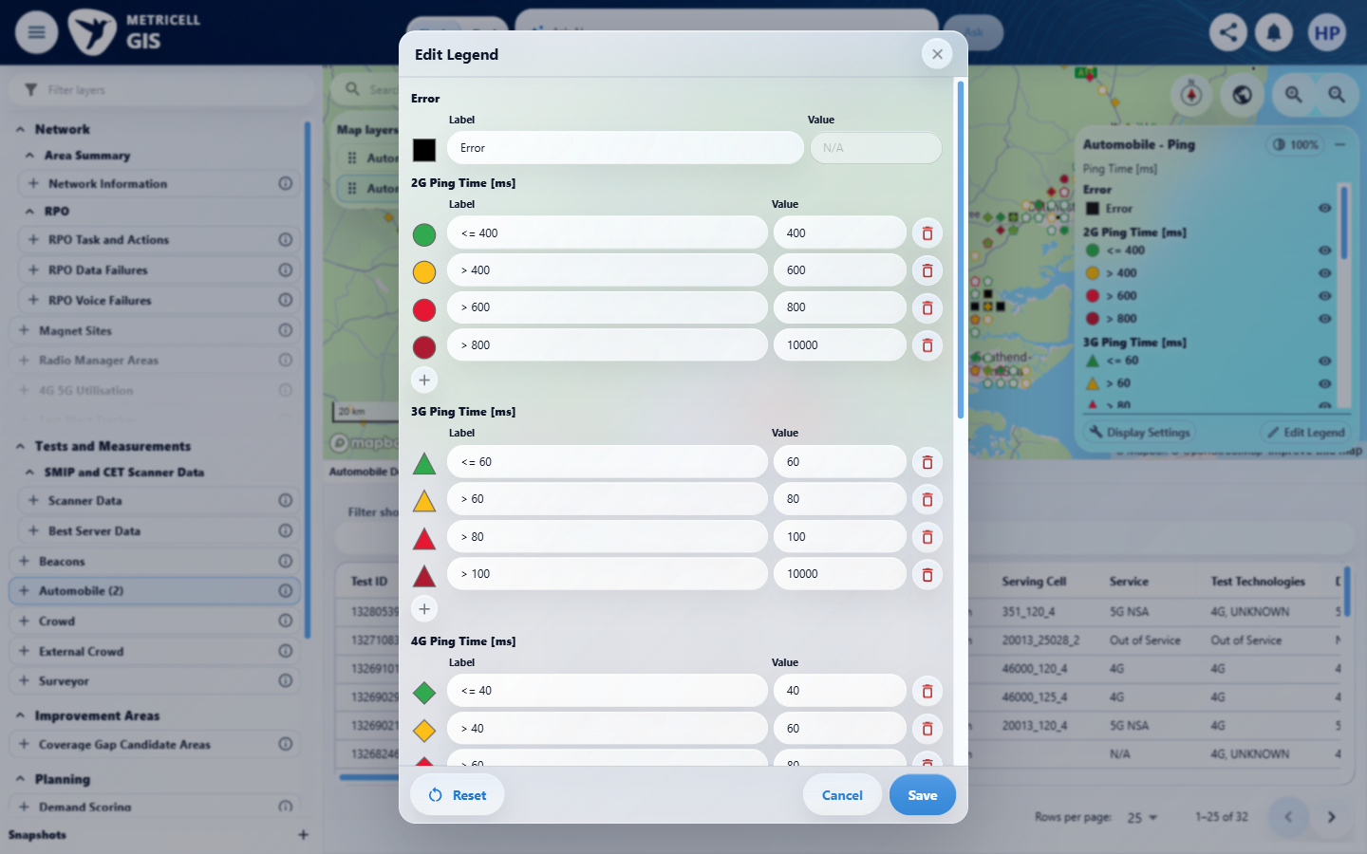 | E65 - Ping below min (criterion-11-ping-below-min.png)  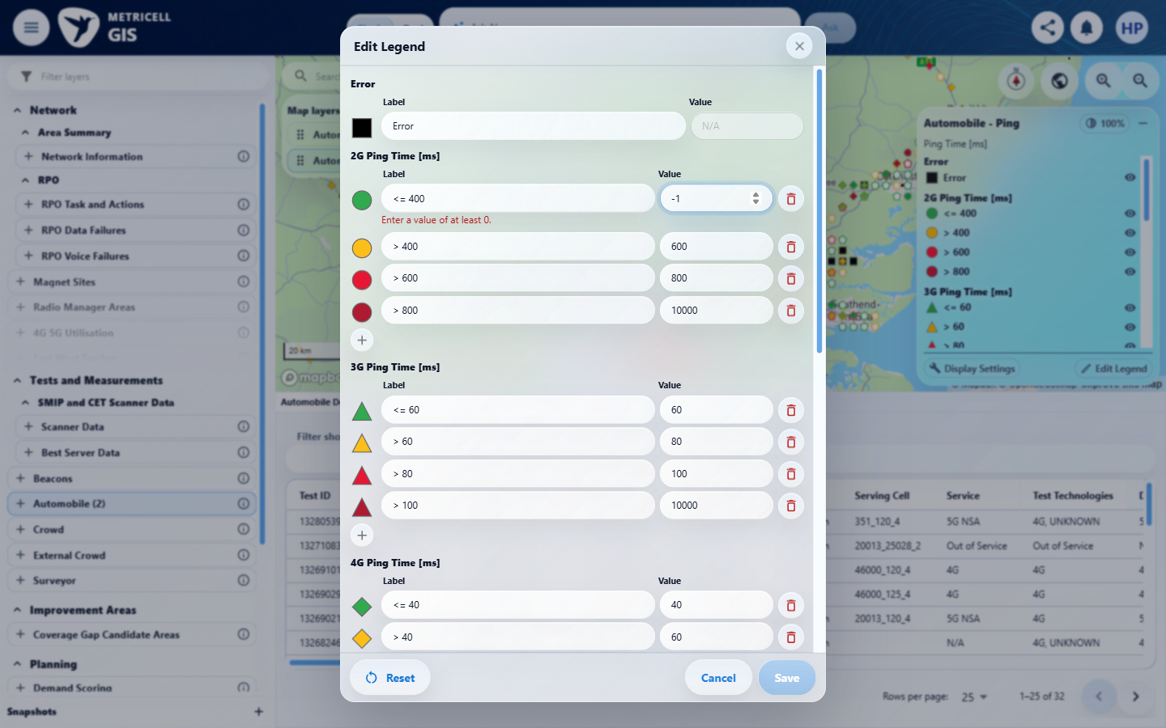

Criterion 11 continued: Numeric Value fields use number inputs. Empty, non-finite, out-of-limit or incorrectly ordered boundary values show an inline error immediately and disable Save. HTTP Browsing boundaries accept 0–10,000; Ping and Video Streaming boundaries have a minimum of zero and no additional maximum. Video Streaming categories cannot be changed.
Browser URL recorded after criterion: https://o2intelligence-v4-dev.metricell.com/gis
E66 - Ping restored (criterion-11-ping-restored.png)  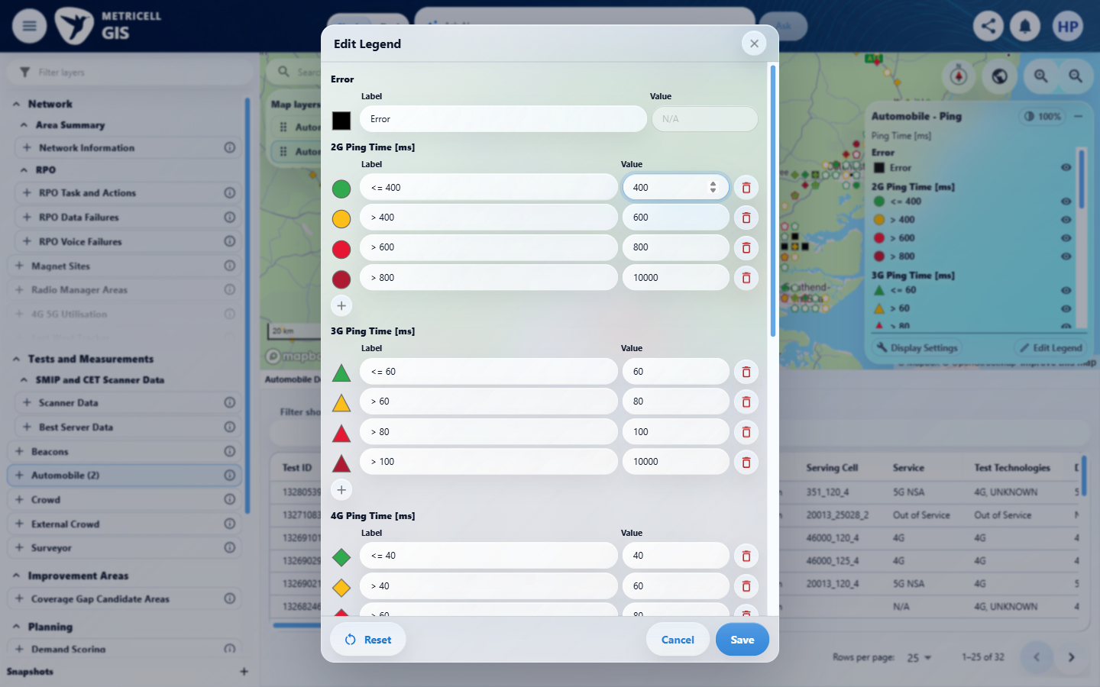 | E67 - Ping no max (criterion-11-ping-no-max.png)  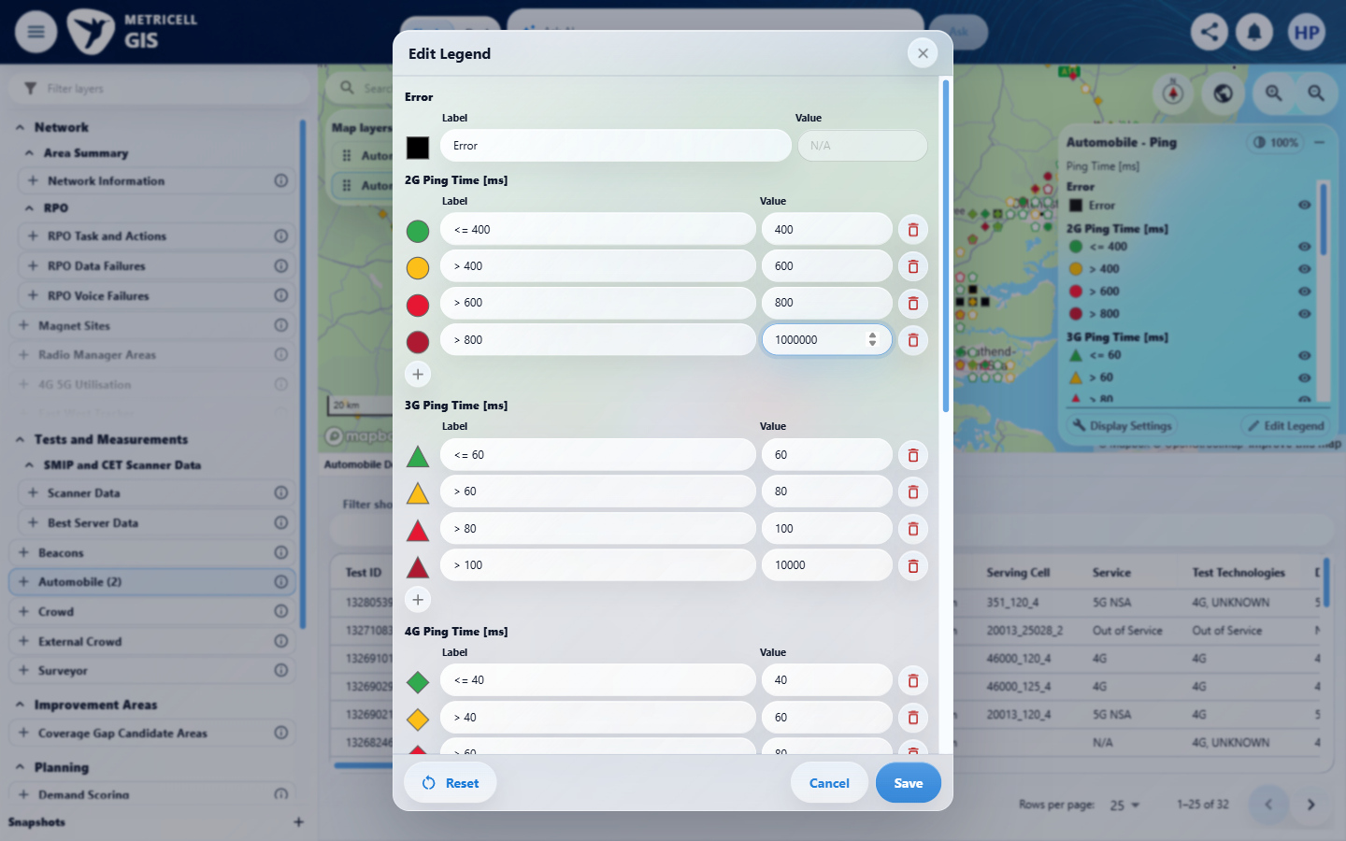

Criterion 11 continued: Numeric Value fields use number inputs. Empty, non-finite, out-of-limit or incorrectly ordered boundary values show an inline error immediately and disable Save. HTTP Browsing boundaries accept 0–10,000; Ping and Video Streaming boundaries have a minimum of zero and no additional maximum. Video Streaming categories cannot be changed.
Browser URL recorded after criterion: https://o2intelligence-v4-dev.metricell.com/gis
E68 - Video config (criterion-11-video-config.png)  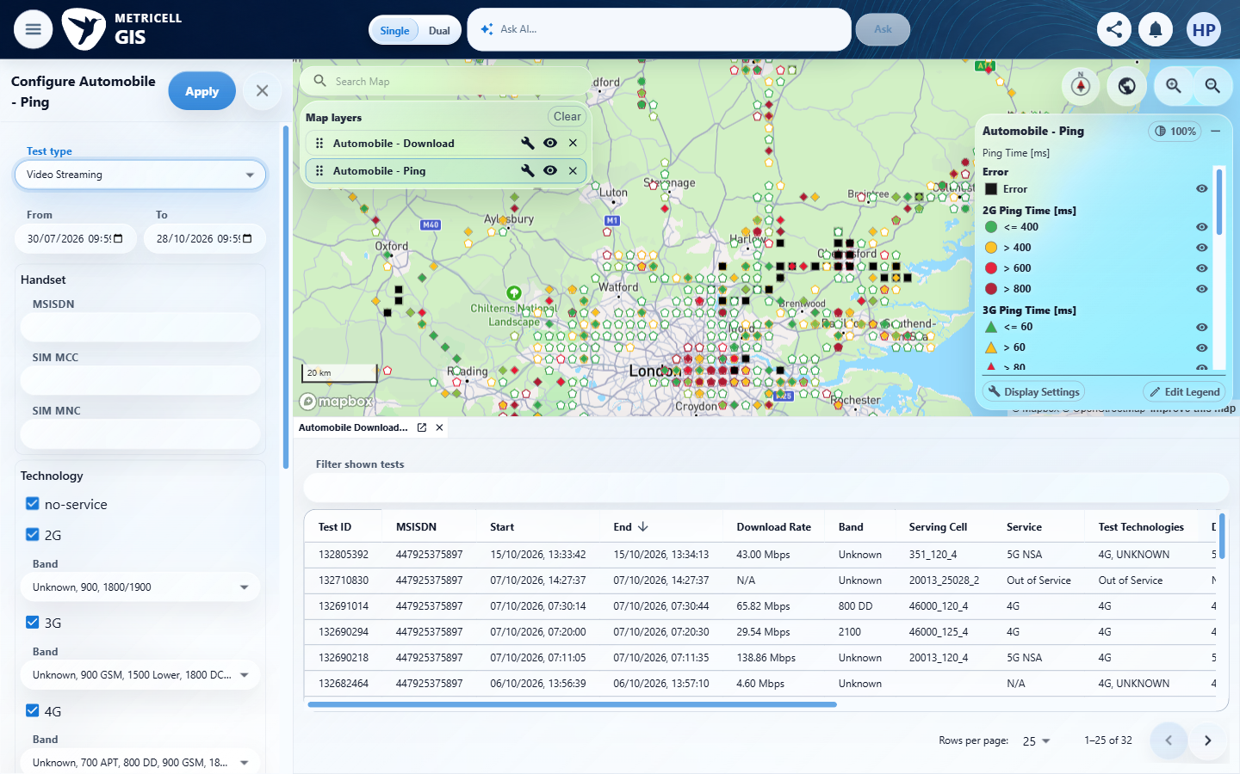 | E69 - Video map (criterion-11-video-map.png)  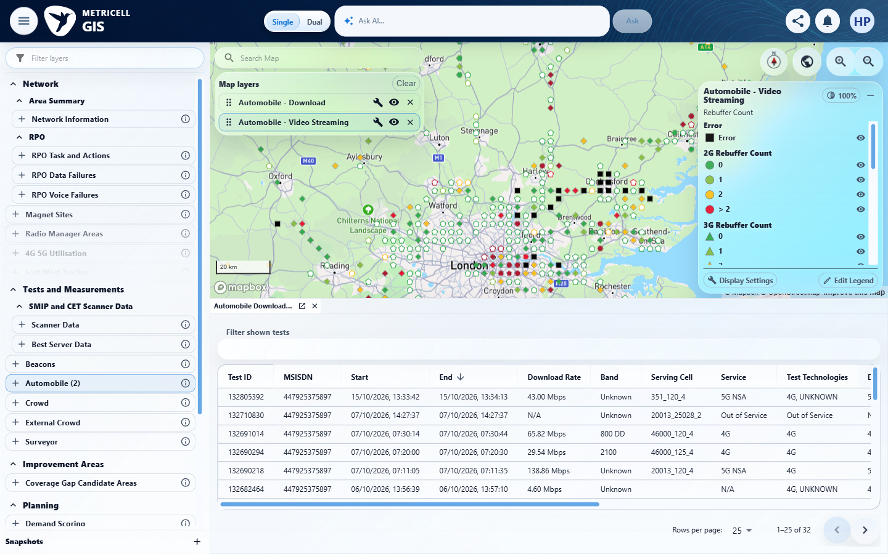

Criterion 11 continued: Numeric Value fields use number inputs. Empty, non-finite, out-of-limit or incorrectly ordered boundary values show an inline error immediately and disable Save. HTTP Browsing boundaries accept 0–10,000; Ping and Video Streaming boundaries have a minimum of zero and no additional maximum. Video Streaming categories cannot be changed.
Browser URL recorded after criterion: https://o2intelligence-v4-dev.metricell.com/gis
E70 - Video editor (criterion-11-video-editor.png)  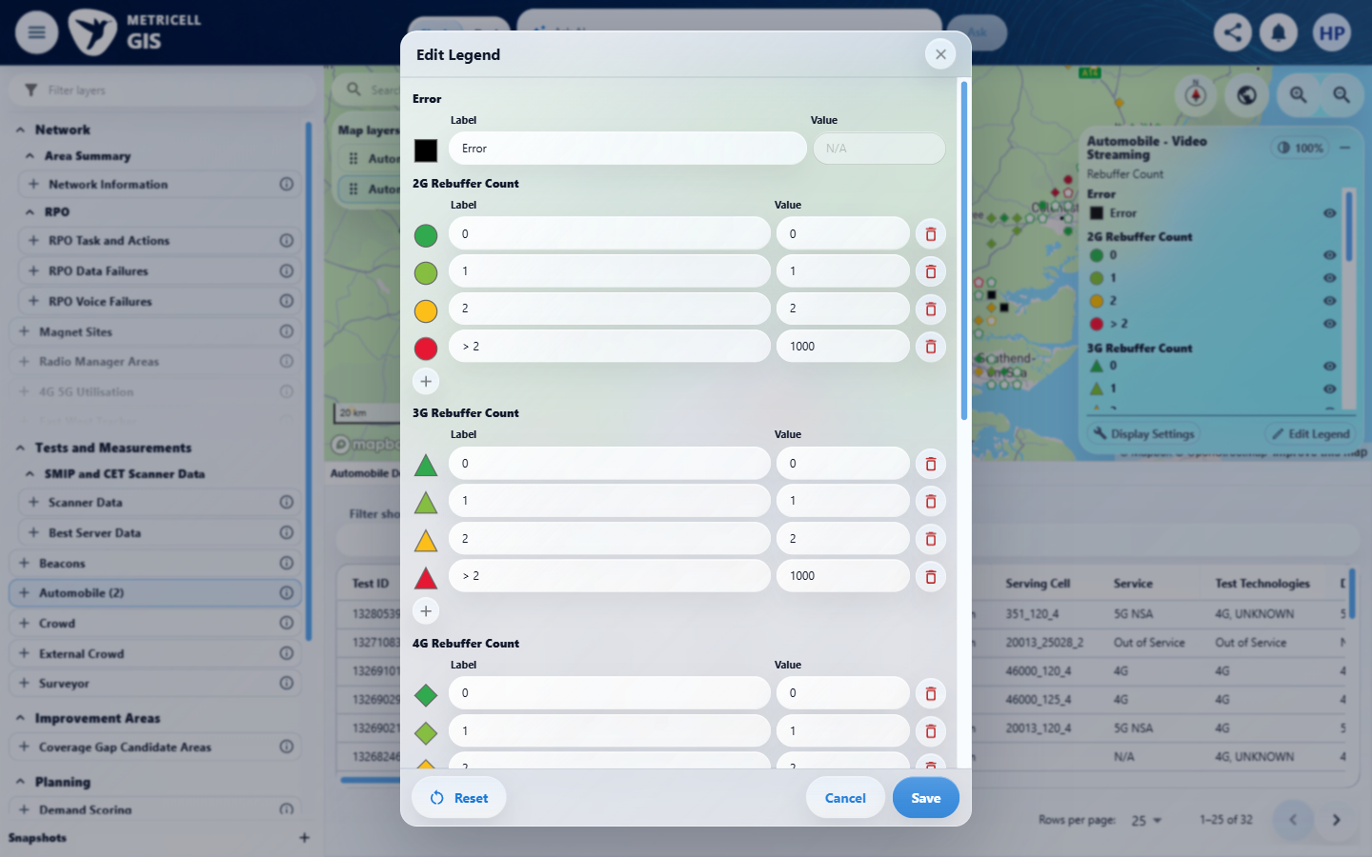 | E71 - Video below min (criterion-11-video-below-min.png)  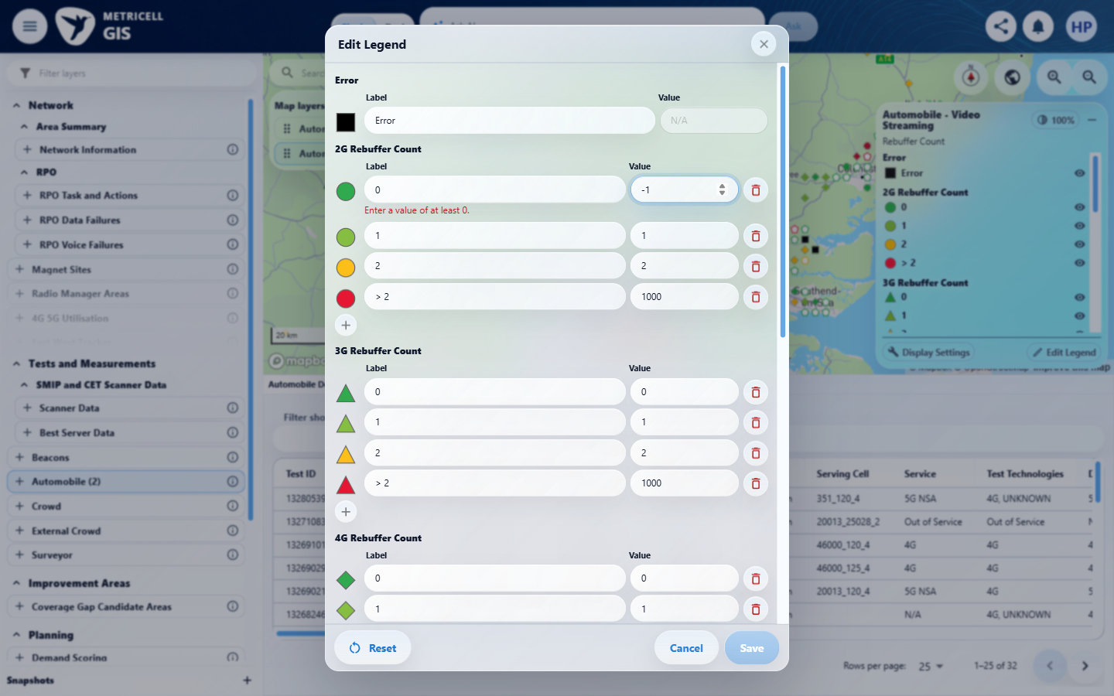

Criterion 11 continued: Numeric Value fields use number inputs. Empty, non-finite, out-of-limit or incorrectly ordered boundary values show an inline error immediately and disable Save. HTTP Browsing boundaries accept 0–10,000; Ping and Video Streaming boundaries have a minimum of zero and no additional maximum. Video Streaming categories cannot be changed.
Browser URL recorded after criterion: https://o2intelligence-v4-dev.metricell.com/gis
E72 - Video restore zero (criterion-11-video-restore-zero.png)  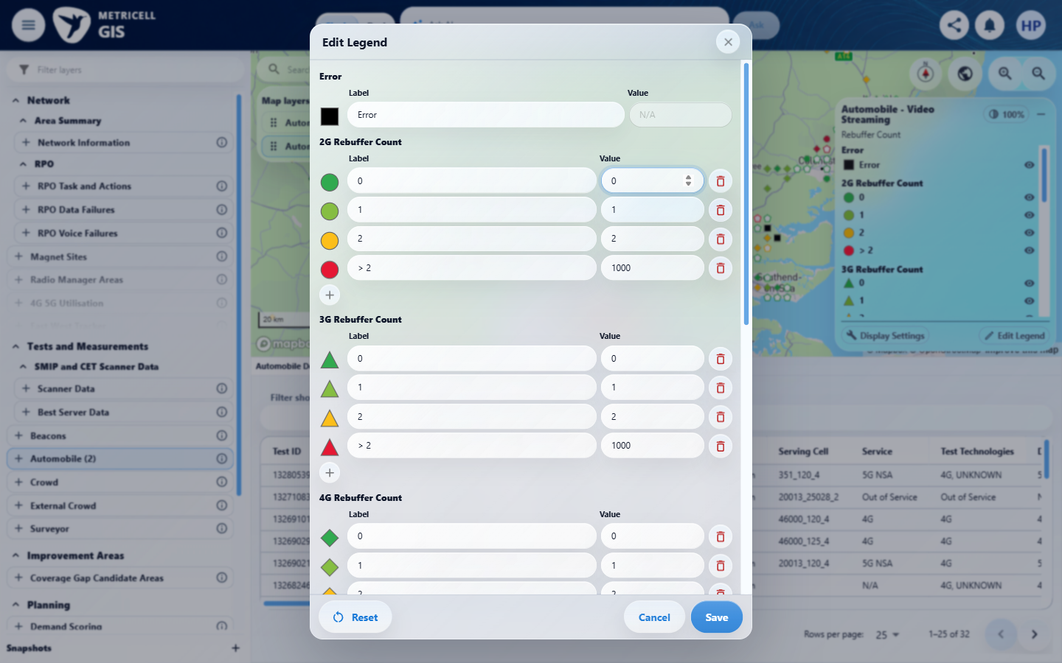 | E73 - Video no max (criterion-11-video-no-max.png)  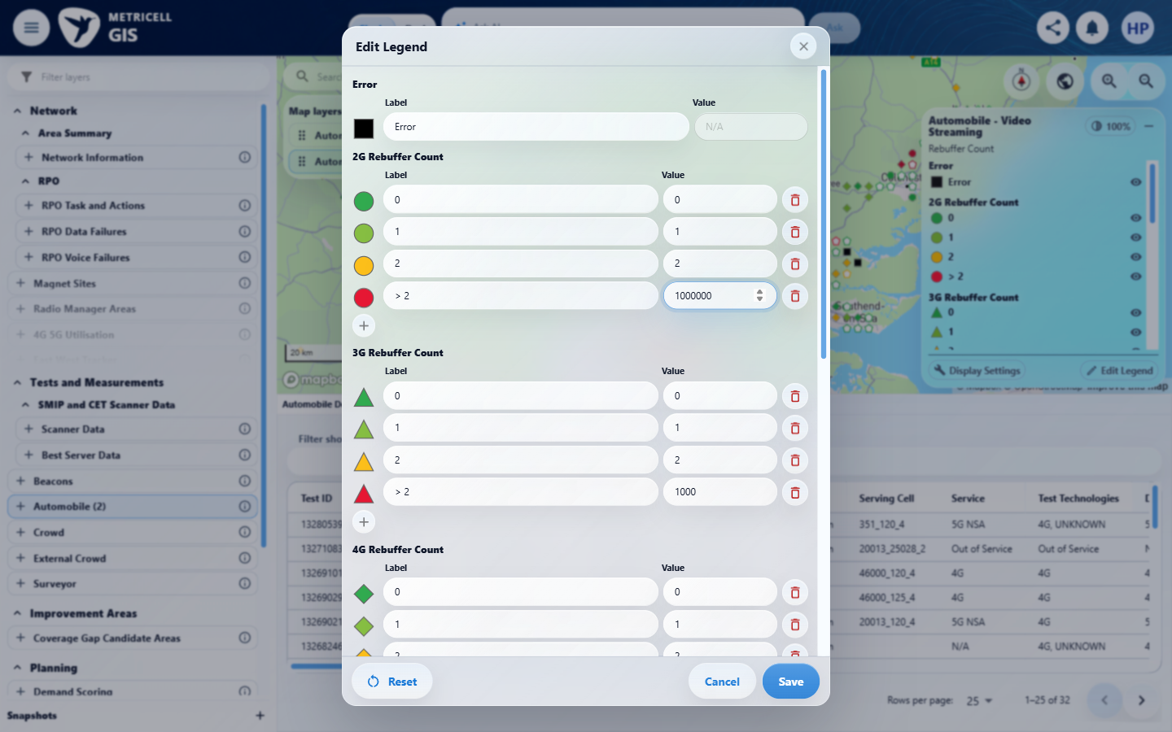

Criterion 11 continued: Numeric Value fields use number inputs. Empty, non-finite, out-of-limit or incorrectly ordered boundary values show an inline error immediately and disable Save. HTTP Browsing boundaries accept 0–10,000; Ping and Video Streaming boundaries have a minimum of zero and no additional maximum. Video Streaming categories cannot be changed.
Browser URL recorded after criterion: https://o2intelligence-v4-dev.metricell.com/gis
E74 - Video category draft (criterion-11-video-category-draft.png)  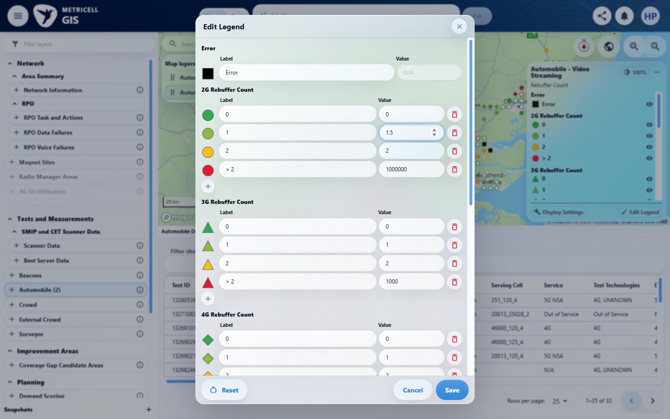 | E75 - Final (criterion-11-final.png)  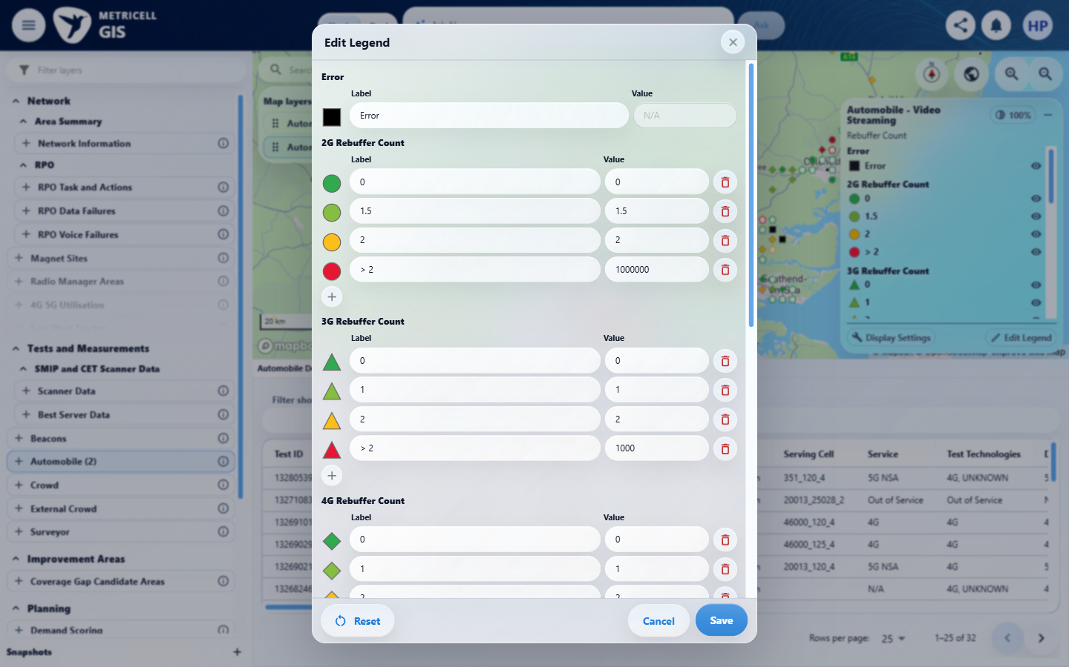

12.0.0 | Reset displays default labels, colours, boundaries, categories and visibility as drafts; saving applies defaults to the active field only, preserving other fields and layers. | Reset displays default labels, colours, boundaries, categories and visibility as drafts; saving applies defaults to the active field only, preserving other fields and layers. | criterion-12-editor-baseline.png -> criterion-12-before-reset.png -> criterion-12-reset-drafts.png -> criterion-12-reset-saved.png -> criterion-12-final.png shows the runtime baseline, modified Error label/colour, boundary 7 and deleted row, Reset drafts restoring Error/black/8 and four rows while the underlying legend retains the modified state, then saved restoration. criterion-12-hidden-category.png supplies the hidden Error baseline. However, no independent versioned expected defaults establish correct labels, colours, boundaries, categories or default visibility; those assertions remain Blocked. Other-field overrides need a multi-field fixture, and other-layer overrides lack their own preservation comparison. The runtime sequence is supported without treating the current UI as authoritative configuration.  Evidence: E76, E77, E78, E79, E80, E81, E82, E83, E84, E85, E86, E87, E88, E89 | Blocked
Criterion 12 assessment: Testing notes: Changed Error label to QA reset error, colour#ff00ff, 2G first boundary8 to7 and deleted >20 range. Saved and closed; hid renamed Error item. Reopened editor, selected Reset: drafts restored Error, #000000, boundary8 and deleted >20 range while background legend retained saved overrides and muted category. Save applied defaults; closed editor. Error became visible aria-pressed true, black markers returned, <=8 and >20 categories restored. Final URL https://o2intelligence-v4-dev.metricell.com/gis.
Criterion 12 evidence: Reset displays default labels, colours, boundaries, categories and visibility as drafts; saving applies defaults to the active field only, preserving other fields and layers.
Browser URL recorded after criterion: https://o2intelligence-v4-dev.metricell.com/gis
E76 - Config (criterion-12-config.png)  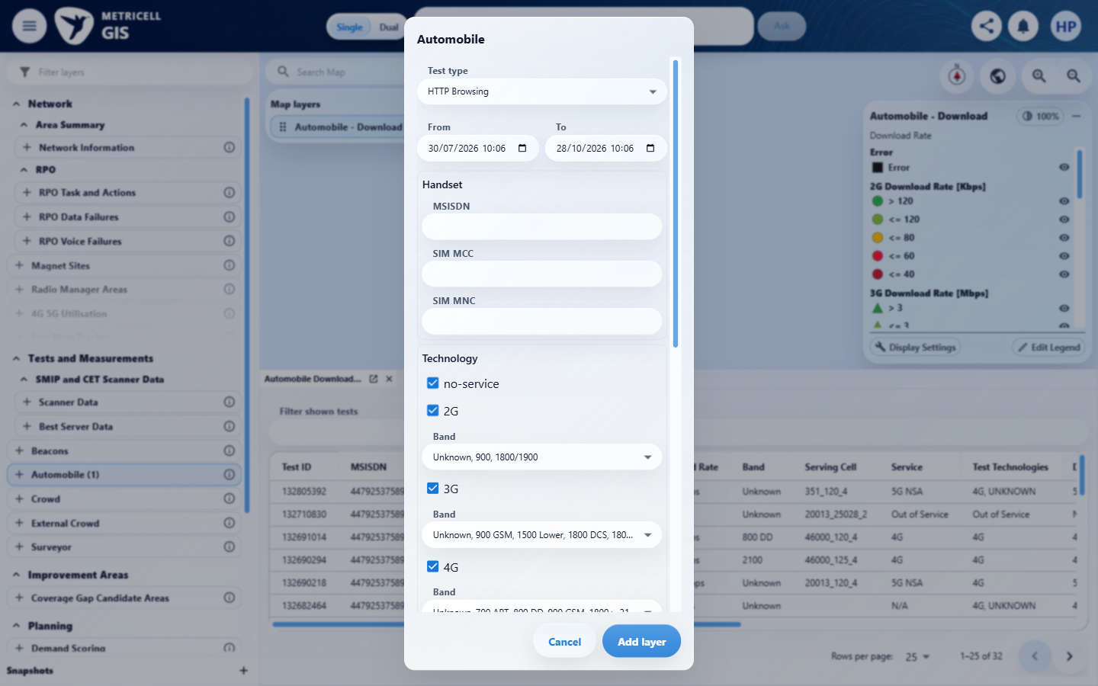 | E77 - Map baseline (criterion-12-map-baseline.png)  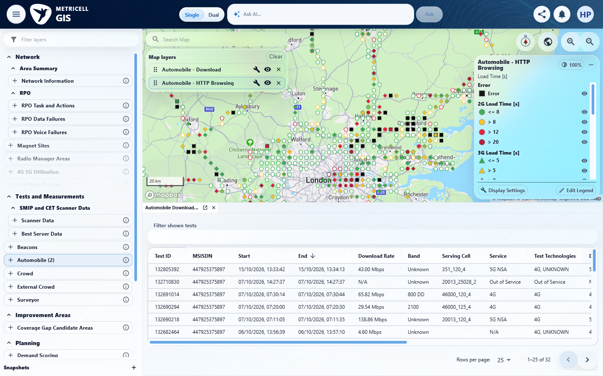

Criterion 12 continued: Reset displays default labels, colours, boundaries, categories and visibility as drafts; saving applies defaults to the active field only, preserving other fields and layers.
Browser URL recorded after criterion: https://o2intelligence-v4-dev.metricell.com/gis
E78 - Editor baseline (criterion-12-editor-baseline.png)  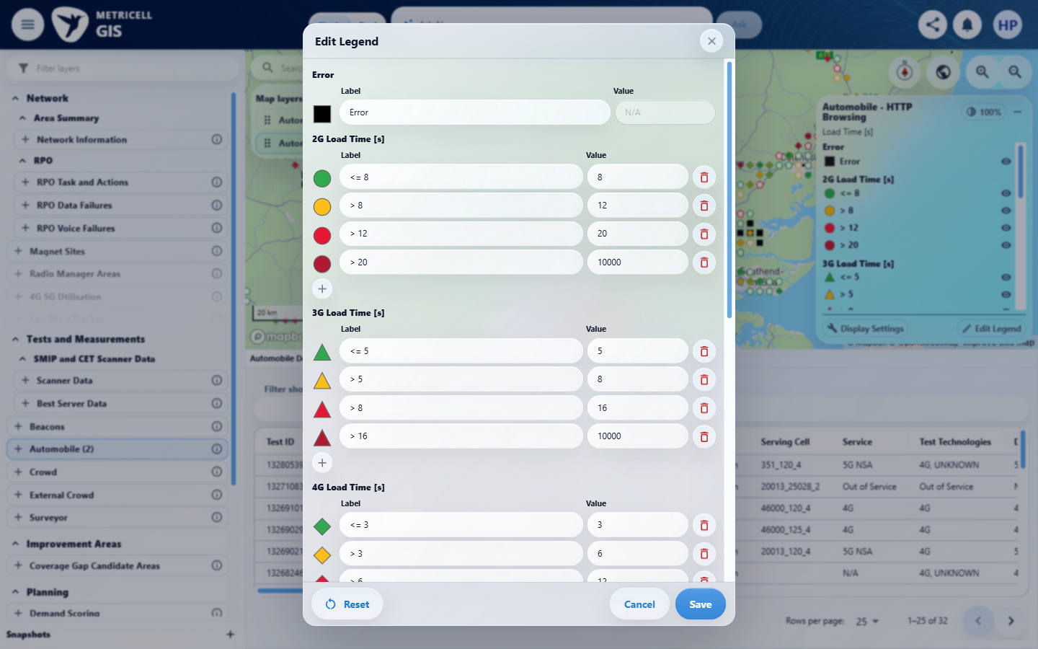 | E79 - Label draft (criterion-12-label-draft.png)  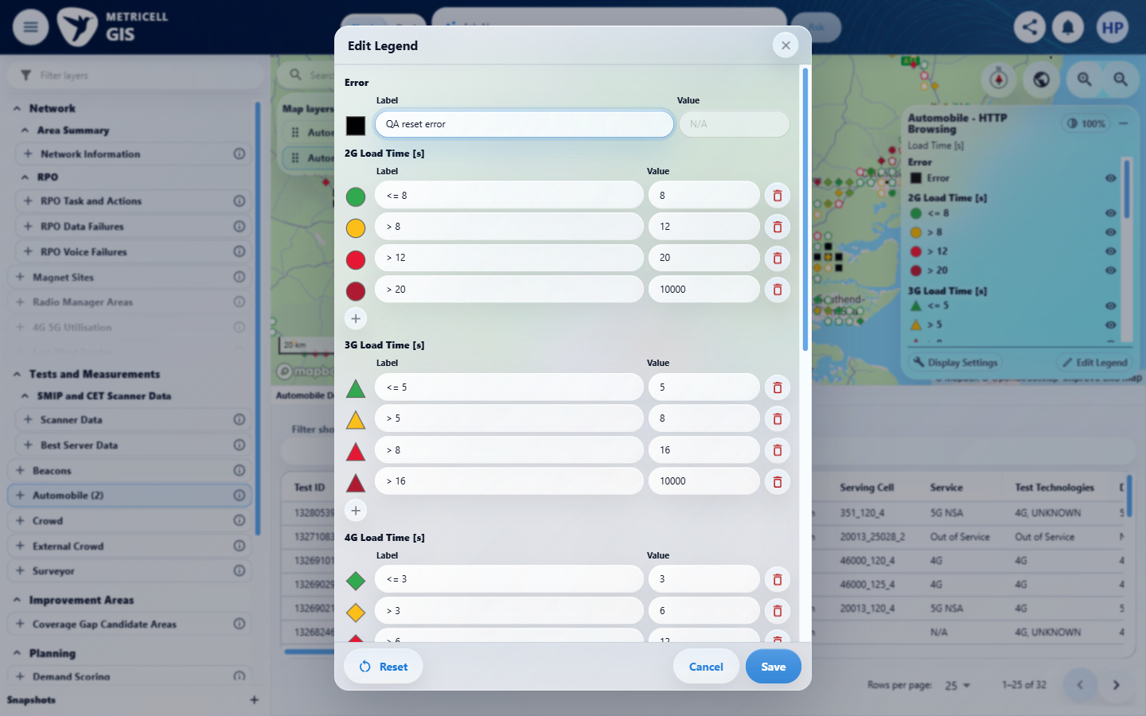

Criterion 12 continued: Reset displays default labels, colours, boundaries, categories and visibility as drafts; saving applies defaults to the active field only, preserving other fields and layers.
Browser URL recorded after criterion: https://o2intelligence-v4-dev.metricell.com/gis
E80 - Colour draft (criterion-12-colour-draft.png)  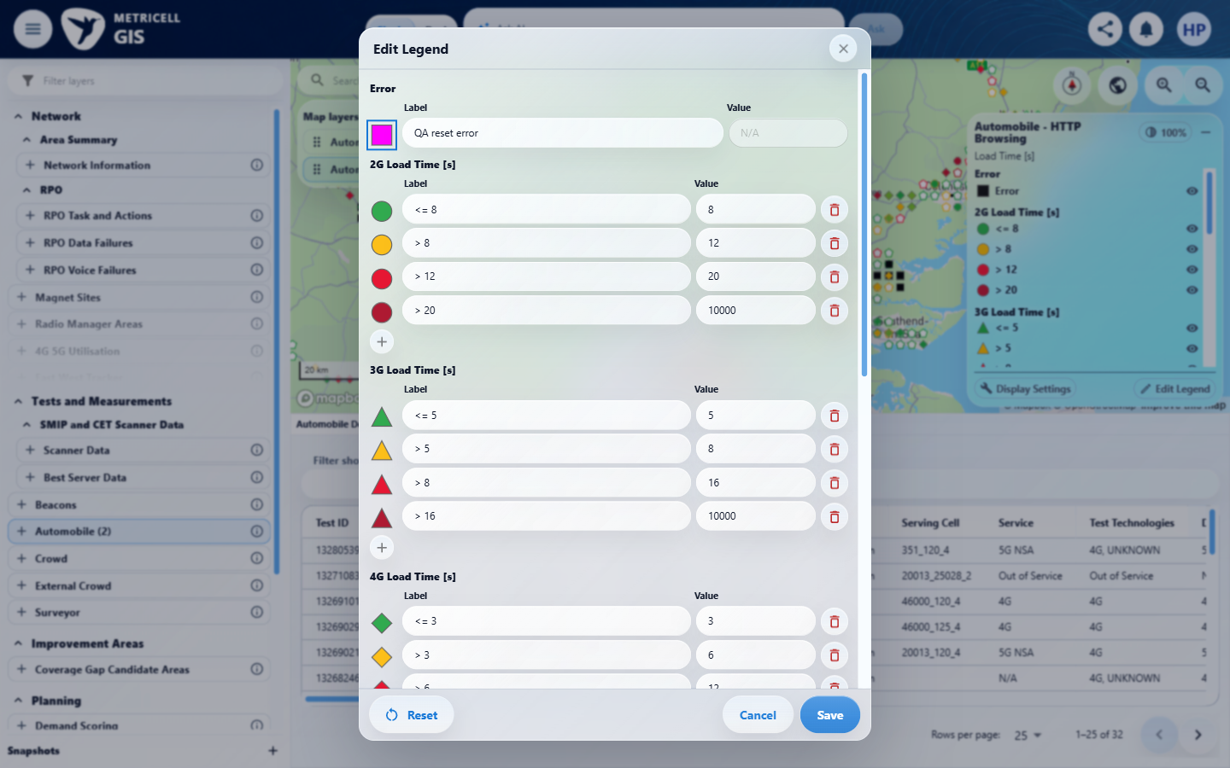 | E81 - Boundary draft (criterion-12-boundary-draft.png)  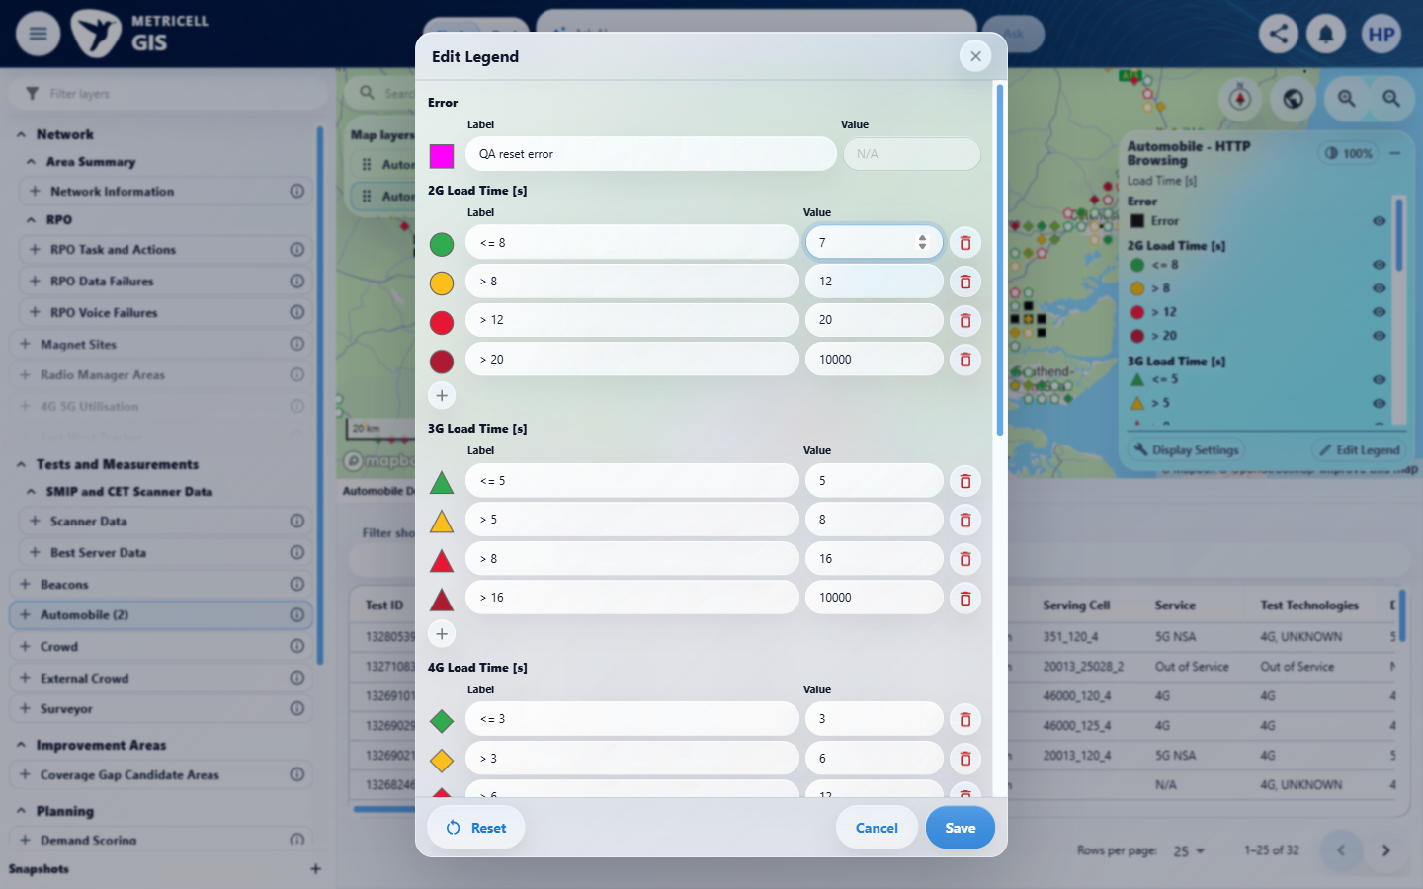

Criterion 12 continued: Reset displays default labels, colours, boundaries, categories and visibility as drafts; saving applies defaults to the active field only, preserving other fields and layers.
Browser URL recorded after criterion: https://o2intelligence-v4-dev.metricell.com/gis
E82 - Category draft (criterion-12-category-draft.png)  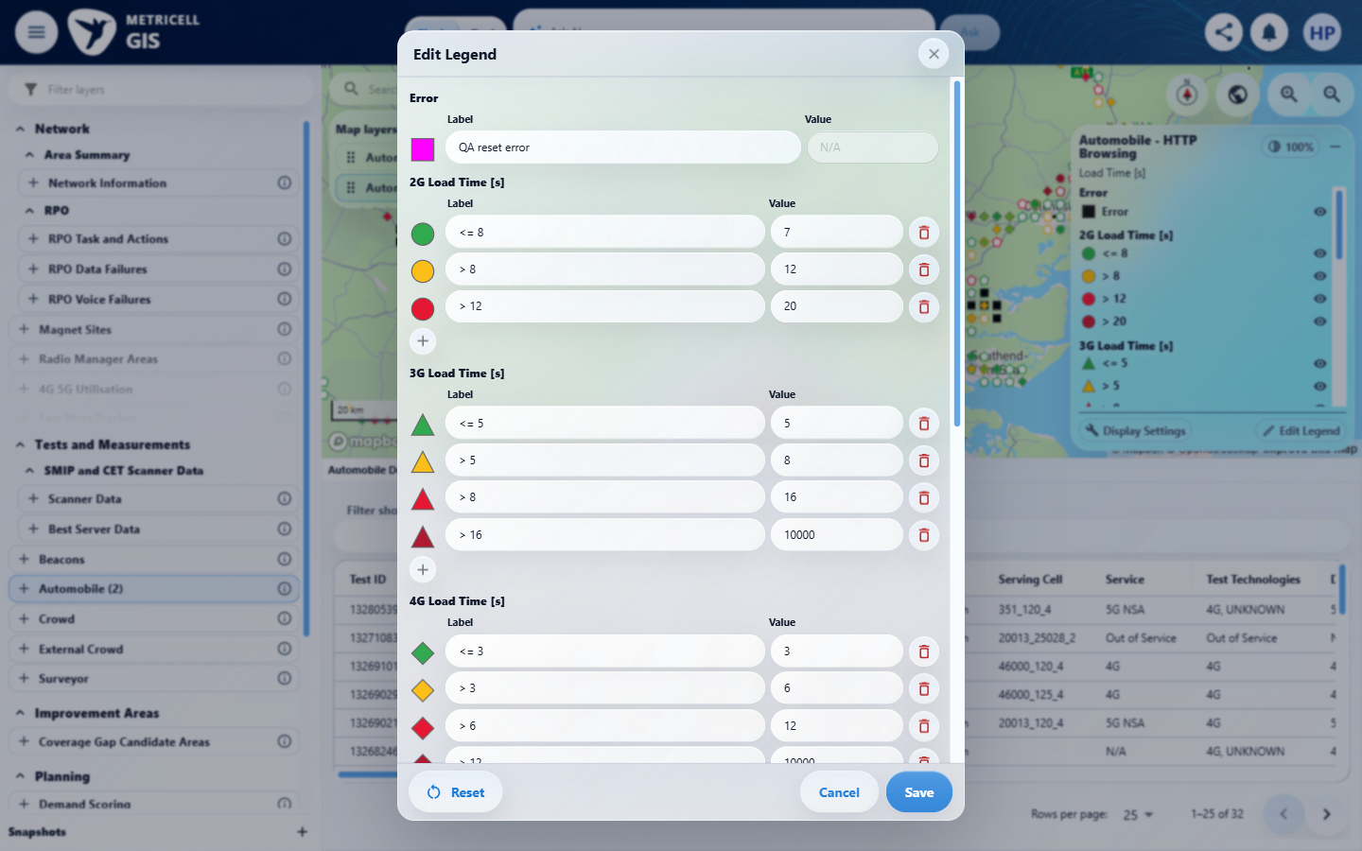 | E83 - Saved overrides (criterion-12-saved-overrides.png)  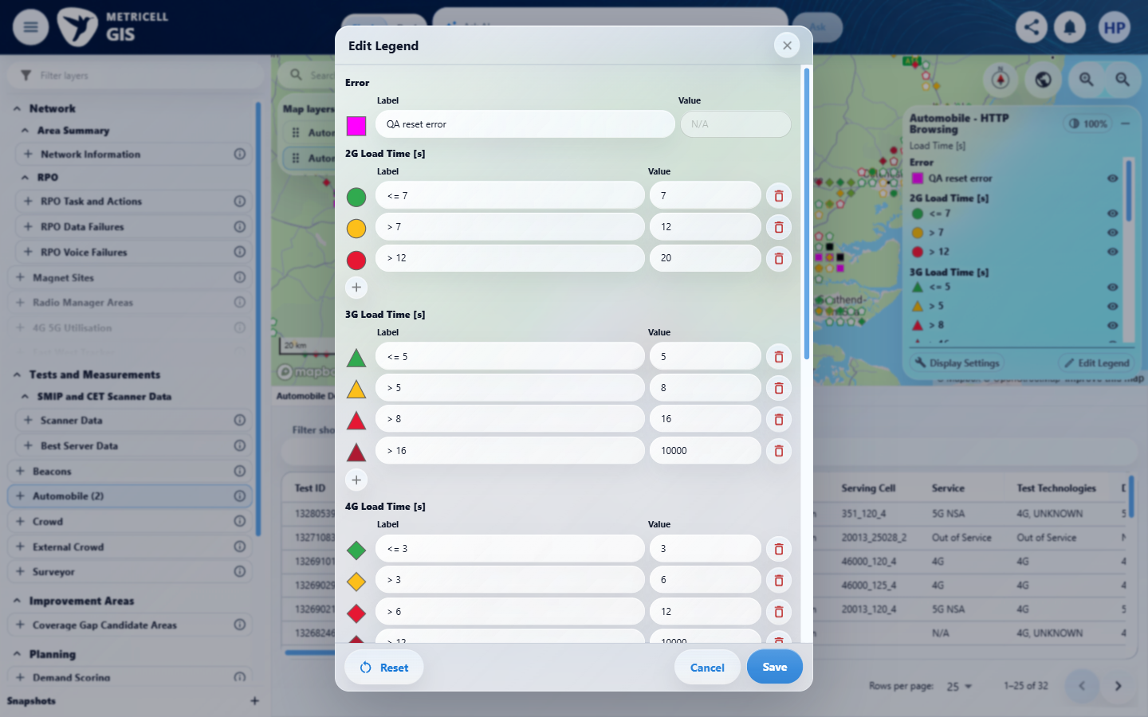

Criterion 12 continued: Reset displays default labels, colours, boundaries, categories and visibility as drafts; saving applies defaults to the active field only, preserving other fields and layers.
Browser URL recorded after criterion: https://o2intelligence-v4-dev.metricell.com/gis
E84 - Overrides map (criterion-12-overrides-map.png)  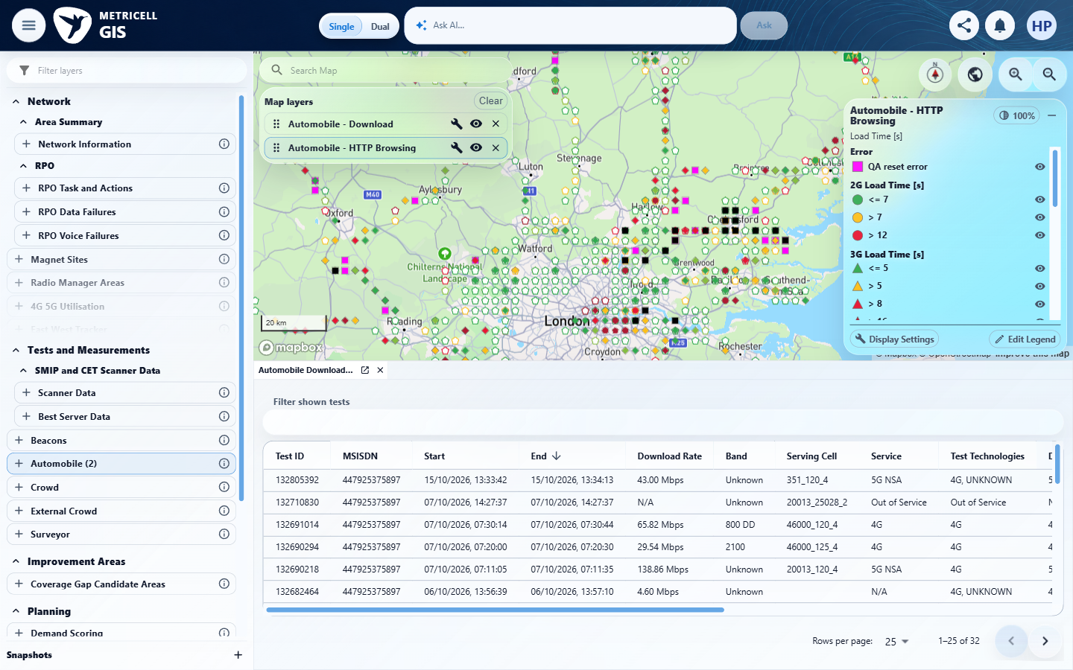 | E85 - Hidden category (criterion-12-hidden-category.png)  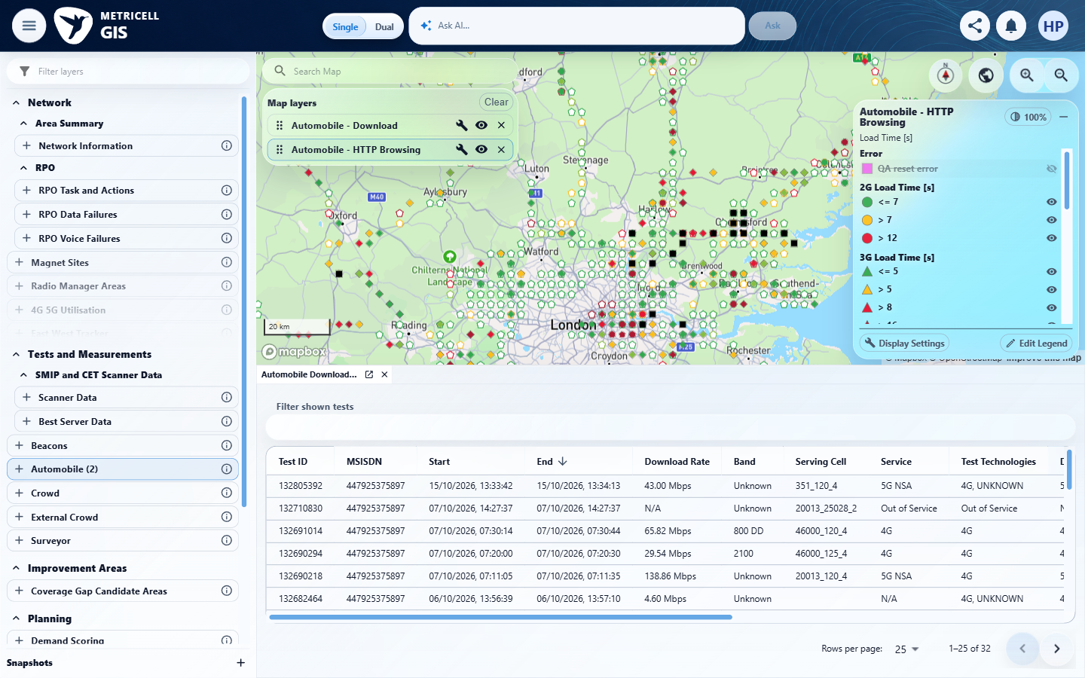

Criterion 12 continued: Reset displays default labels, colours, boundaries, categories and visibility as drafts; saving applies defaults to the active field only, preserving other fields and layers.
Browser URL recorded after criterion: https://o2intelligence-v4-dev.metricell.com/gis
E86 - Before reset (criterion-12-before-reset.png)  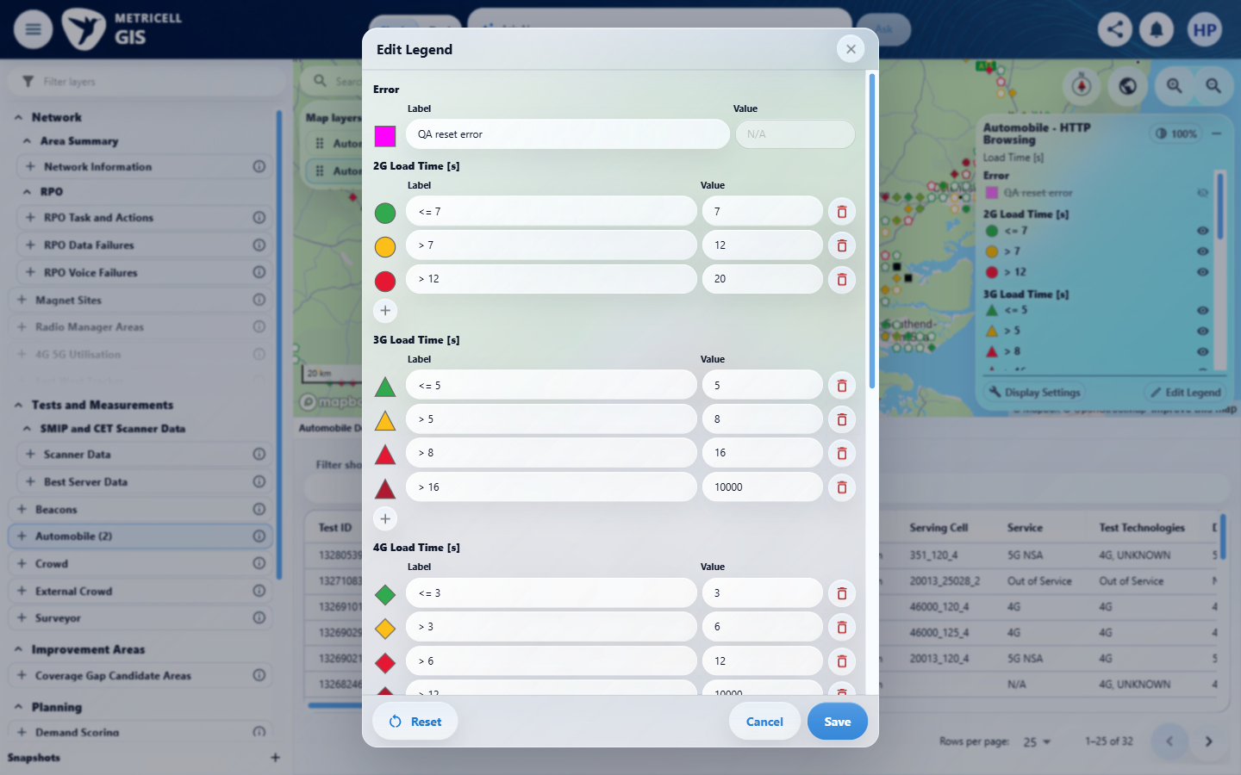 | E87 - Reset drafts (criterion-12-reset-drafts.png)  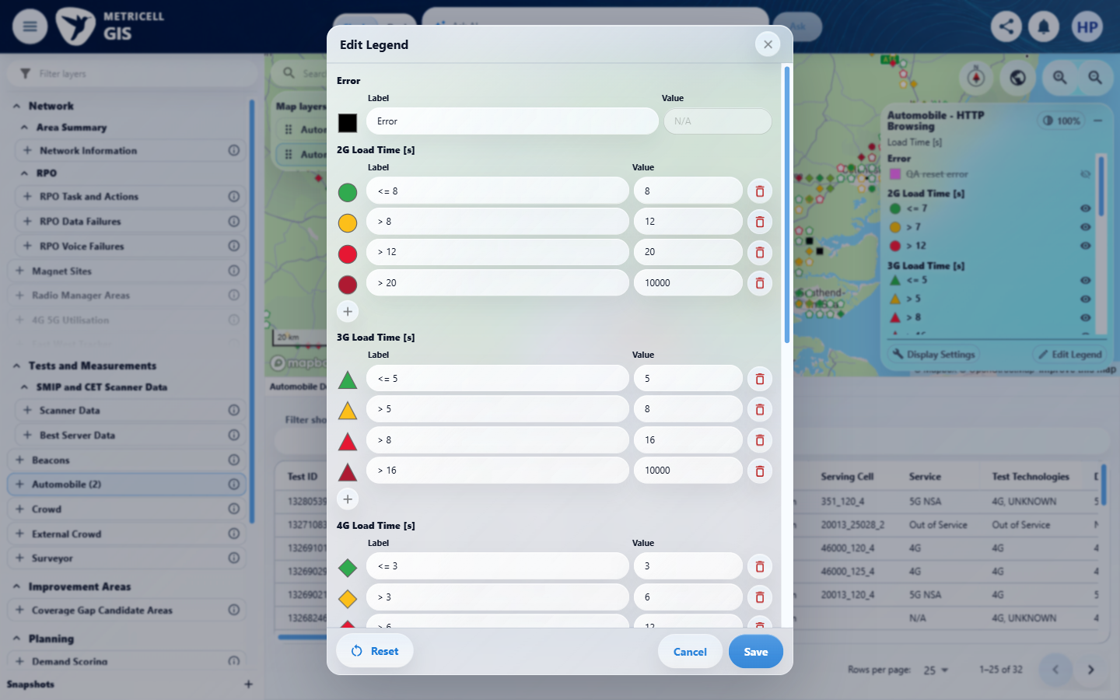

Criterion 12 continued: Reset displays default labels, colours, boundaries, categories and visibility as drafts; saving applies defaults to the active field only, preserving other fields and layers.
Browser URL recorded after criterion: https://o2intelligence-v4-dev.metricell.com/gis
E88 - Reset saved (criterion-12-reset-saved.png)  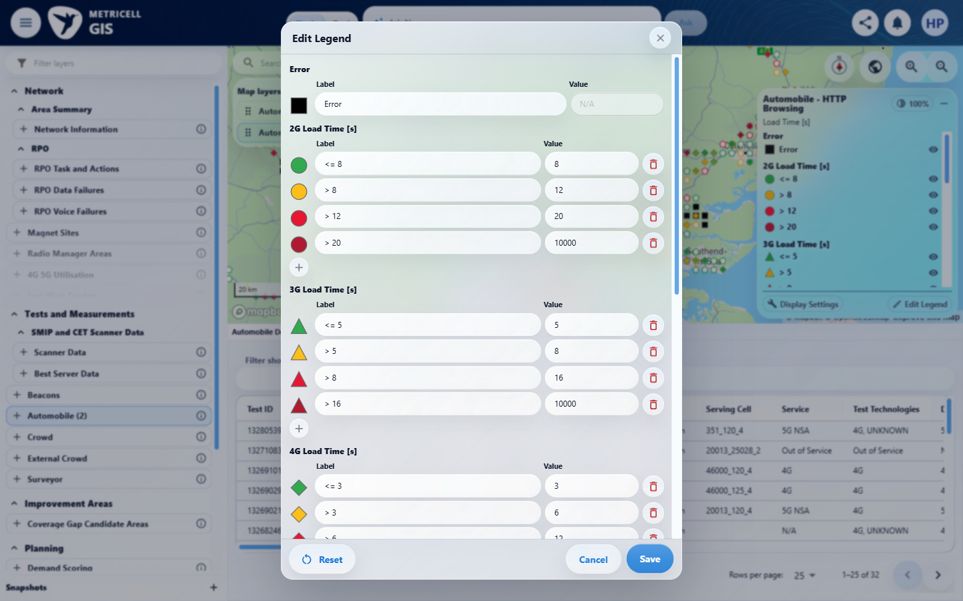 | E89 - Final (criterion-12-final.png)  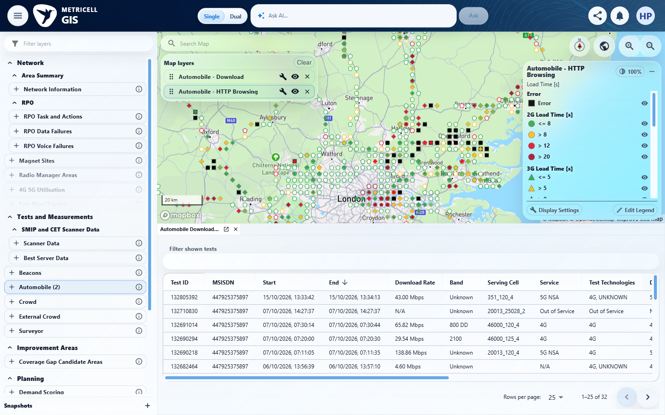

13.0.0 | Linked-site and linked-cell display settings use the shared Network context and follow visible result categories; linked cells are disabled when linked sites are off, and settings persist per layer. | Linked-site and linked-cell display settings use the shared Network context and follow visible result categories; linked cells are disabled when linked sites are off, and settings persist per layer. | criterion-13-settings-baseline.png -> criterion-13-sites-off.png -> criterion-13-sites-on.png -> criterion-13-cells-on.png shows the sites/cells state changes, but the grey cells control when sites are off lacks normal pointer/applicable keyboard activation with a settled unchanged after capture; prevention remains Unverified. criterion-13-cells-on.png, criterion-13-persist-reopen.png, criterion-13-ping-independent.png and criterion-13-final.png support HTTP true/true persisting independently of Ping true/false when reselecting layers. criterion-13-zoom-4.png versus criterion-13-filter-error.png does not identify and reconcile linked site/cell markers to every affected result category or establish shared Network context. Reported linkable response data makes this incomplete verification, not missing-data unavailability.  Evidence: E90, E77, E91, E92, E93, E94, E95, E96, E97, E98, E99, E100, E101, E102, E103, E104, E105, E106, E107 | Failed
Criterion 13 assessment: Testing notes: Hid Error and captured map, then restored Error; did not reconcile every linked marker/category or establish internal shared Network context from visible UI.
Criterion 13 evidence: Linked-site and linked-cell display settings use the shared Network context and follow visible result categories; linked cells are disabled when linked sites are off, and settings persist per layer.
Browser URL recorded after criterion: https://o2intelligence-v4-dev.metricell.com/gis
E90 - Config (criterion-13-config.png)  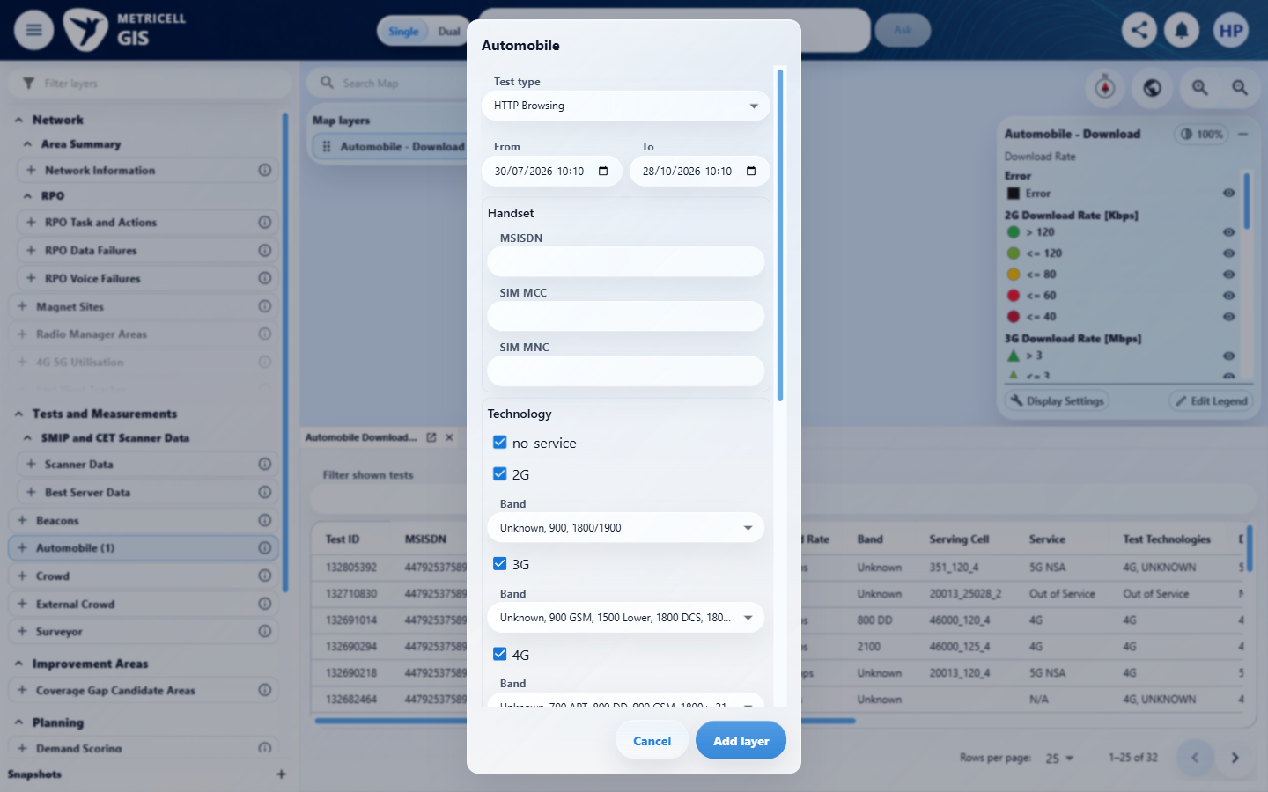 | E77 - Map baseline (criterion-13-map-baseline.png)

Criterion 13 continued: Linked-site and linked-cell display settings use the shared Network context and follow visible result categories; linked cells are disabled when linked sites are off, and settings persist per layer.
Browser URL recorded after criterion: https://o2intelligence-v4-dev.metricell.com/gis
E91 - Settings baseline (criterion-13-settings-baseline.png)  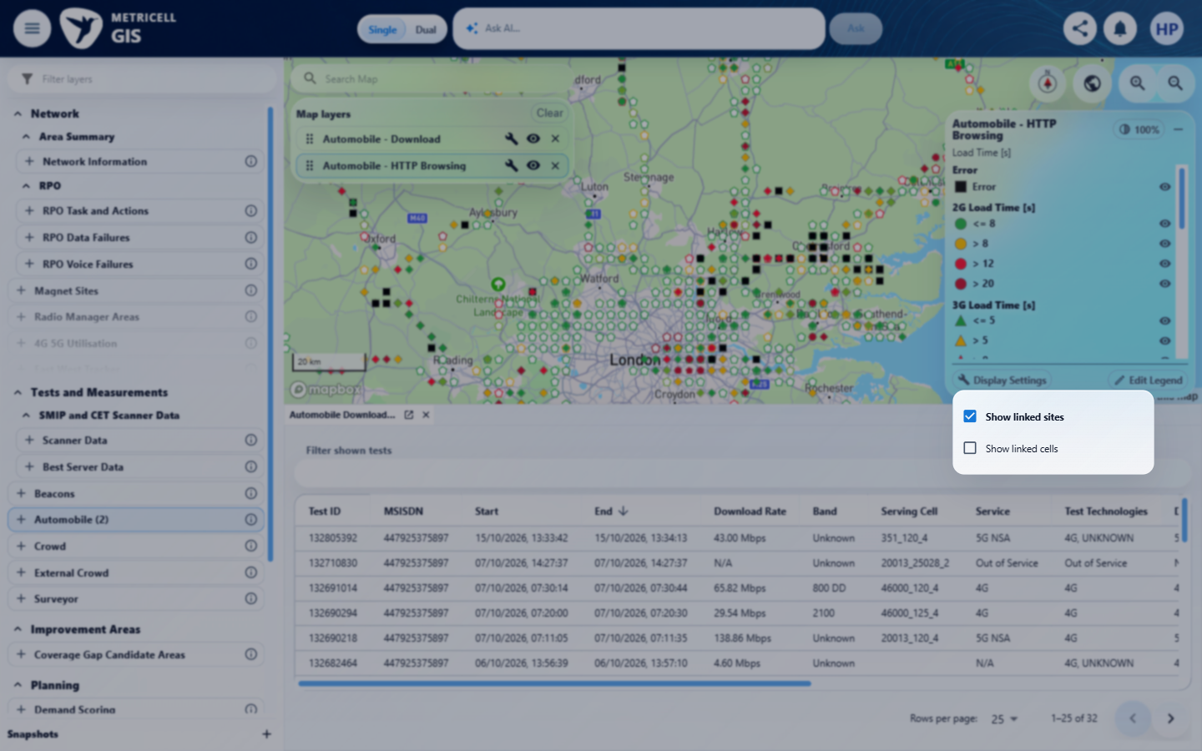 | E92 - Sites off (criterion-13-sites-off.png)  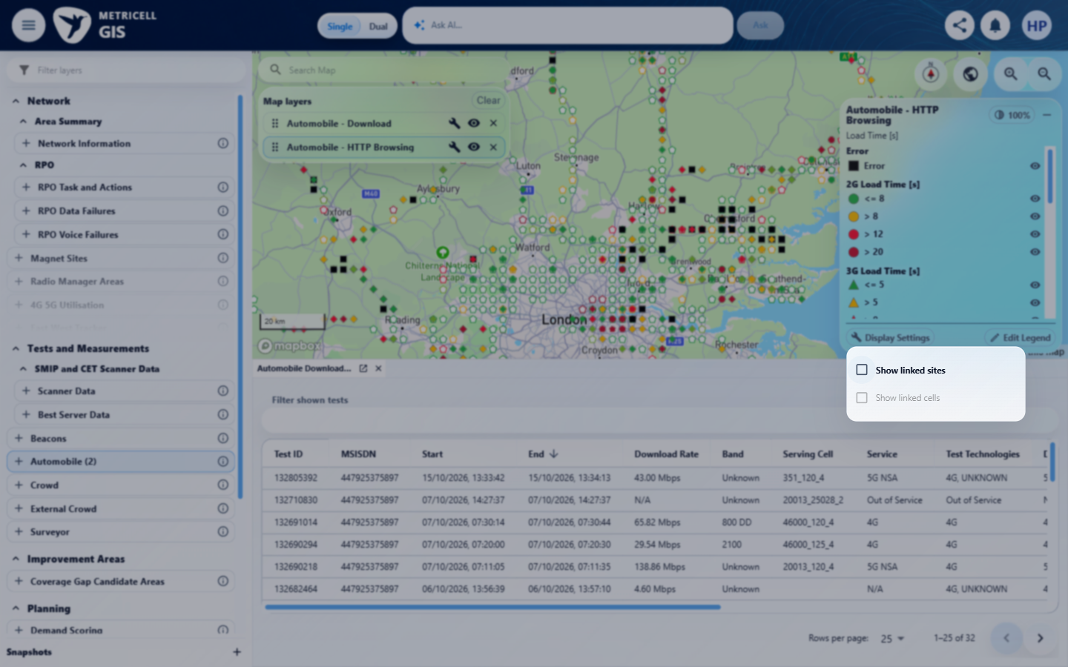

Criterion 13 continued: Linked-site and linked-cell display settings use the shared Network context and follow visible result categories; linked cells are disabled when linked sites are off, and settings persist per layer.
Browser URL recorded after criterion: https://o2intelligence-v4-dev.metricell.com/gis
E93 - Sites on (criterion-13-sites-on.png)  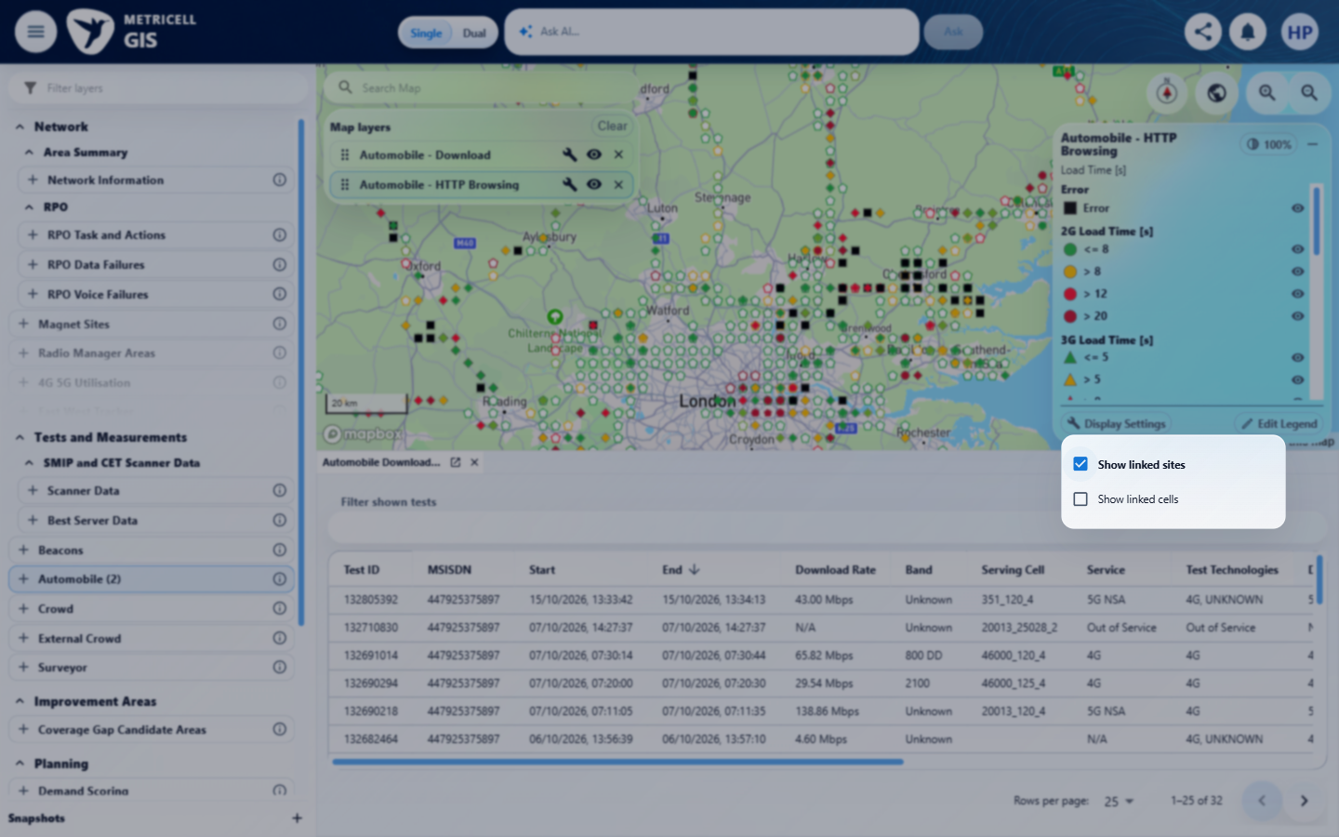 | E94 - Cells on (criterion-13-cells-on.png)  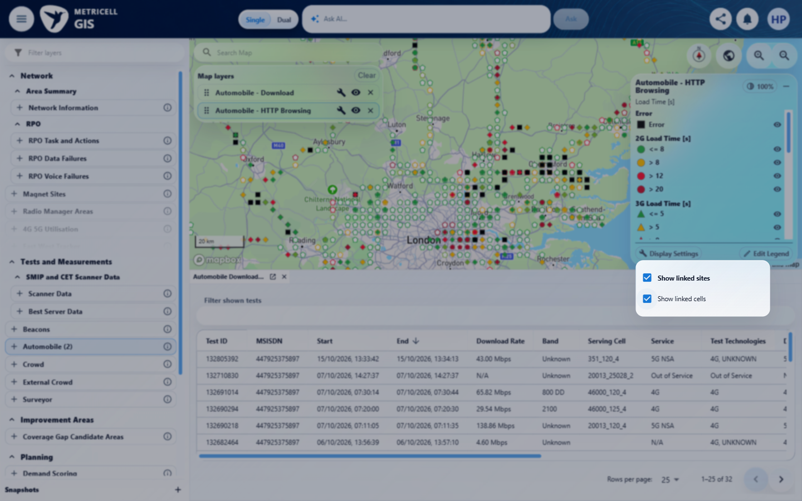

Criterion 13 continued: Linked-site and linked-cell display settings use the shared Network context and follow visible result categories; linked cells are disabled when linked sites are off, and settings persist per layer.
Browser URL recorded after criterion: https://o2intelligence-v4-dev.metricell.com/gis
E95 - Before zoom (criterion-13-before-zoom.png)  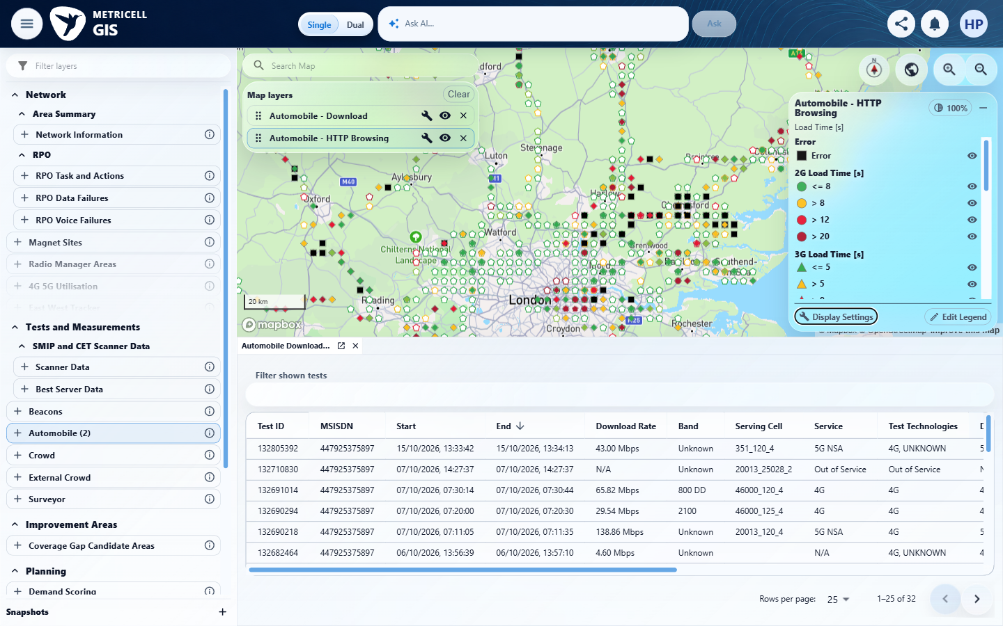 | E96 - Zoom 1 (criterion-13-zoom-1.png)  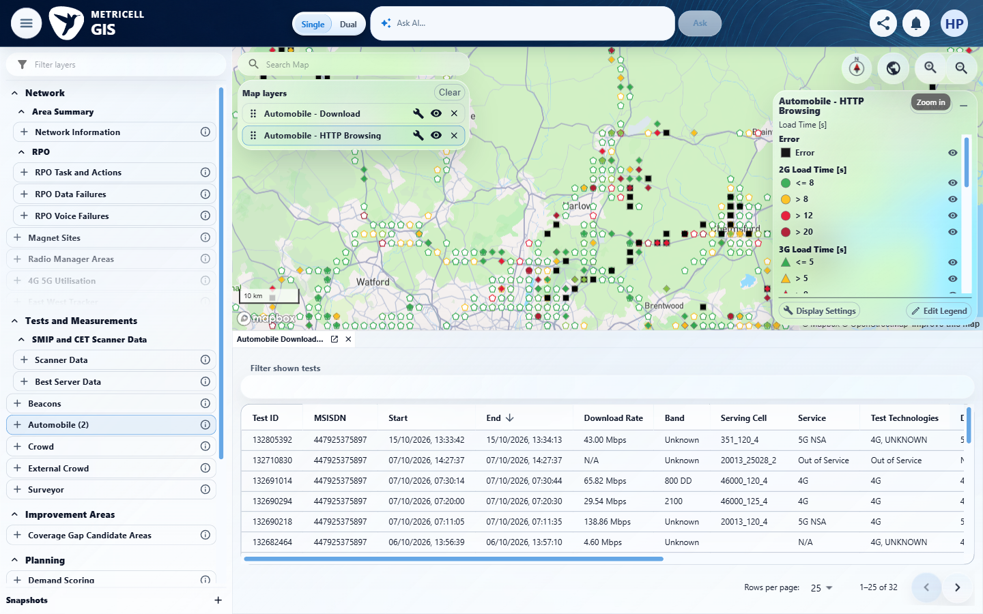

Criterion 13 continued: Linked-site and linked-cell display settings use the shared Network context and follow visible result categories; linked cells are disabled when linked sites are off, and settings persist per layer.
Browser URL recorded after criterion: https://o2intelligence-v4-dev.metricell.com/gis
E97 - Zoom 2 (criterion-13-zoom-2.png)  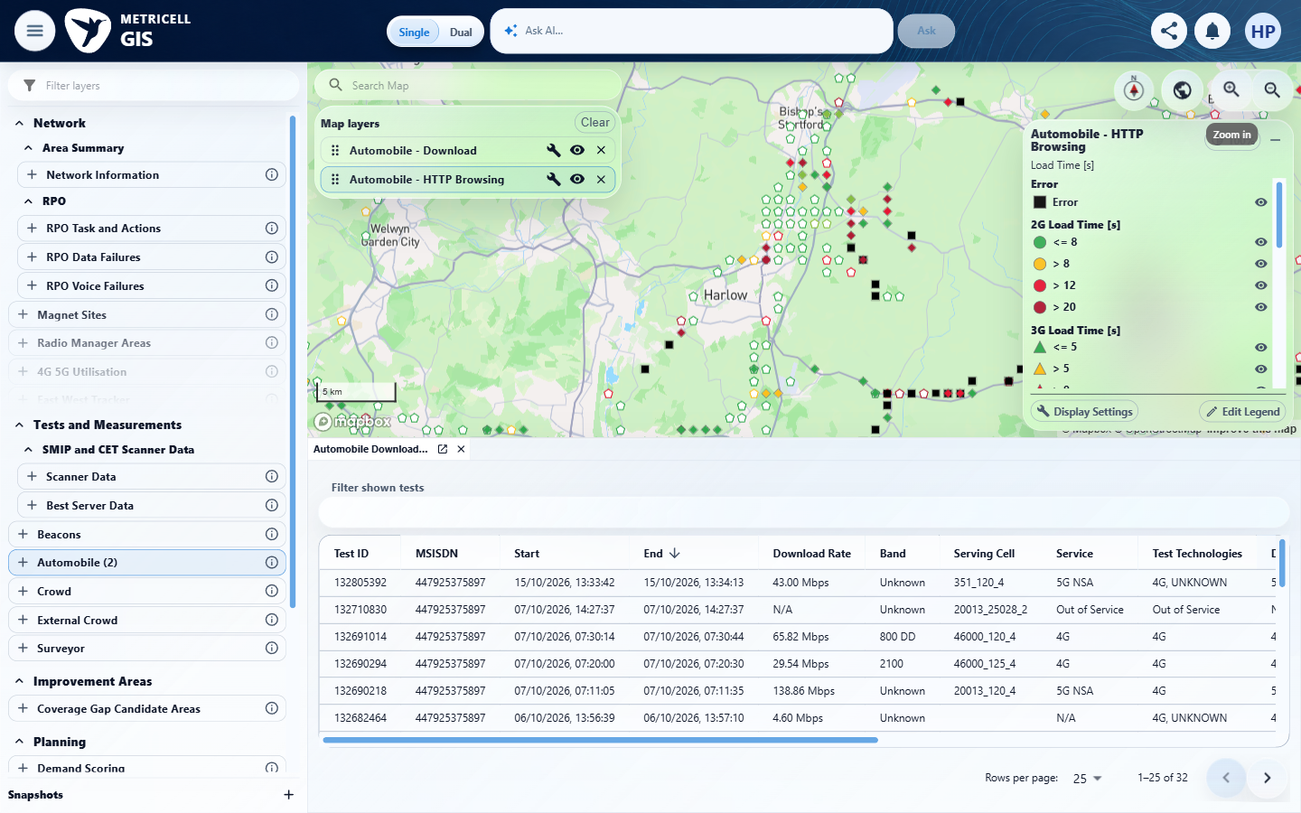 | E98 - Zoom 3 (criterion-13-zoom-3.png)  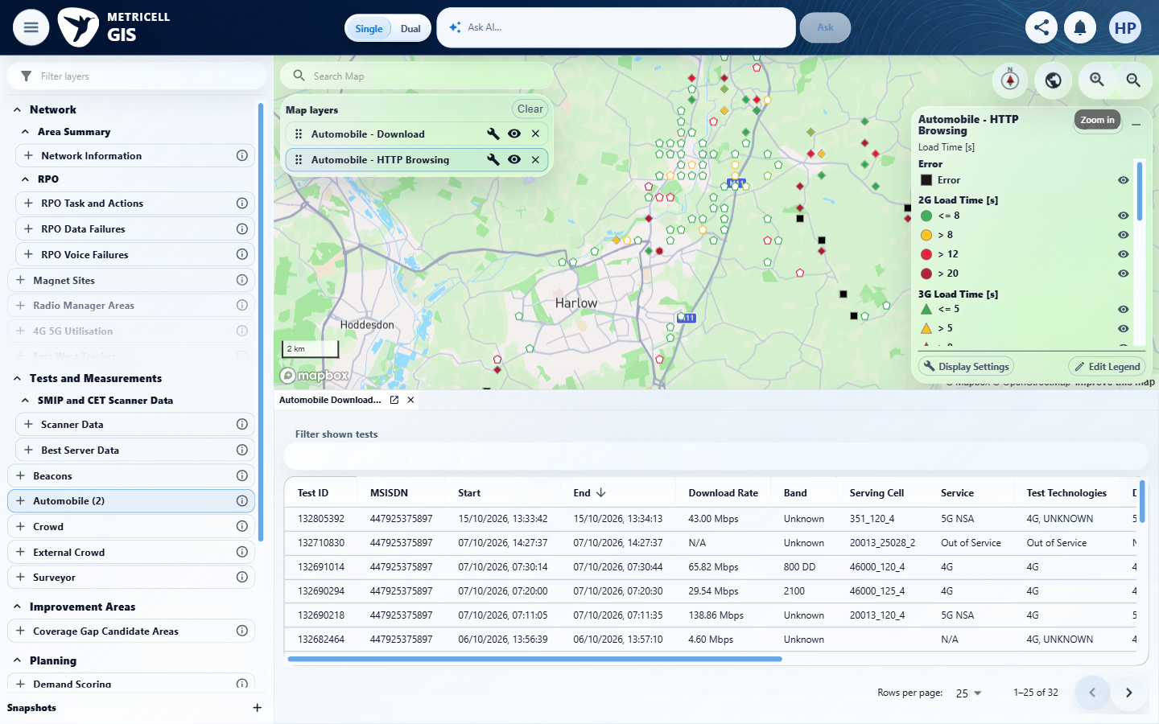

Criterion 13 continued: Linked-site and linked-cell display settings use the shared Network context and follow visible result categories; linked cells are disabled when linked sites are off, and settings persist per layer.
Browser URL recorded after criterion: https://o2intelligence-v4-dev.metricell.com/gis
E99 - Zoom 4 (criterion-13-zoom-4.png)  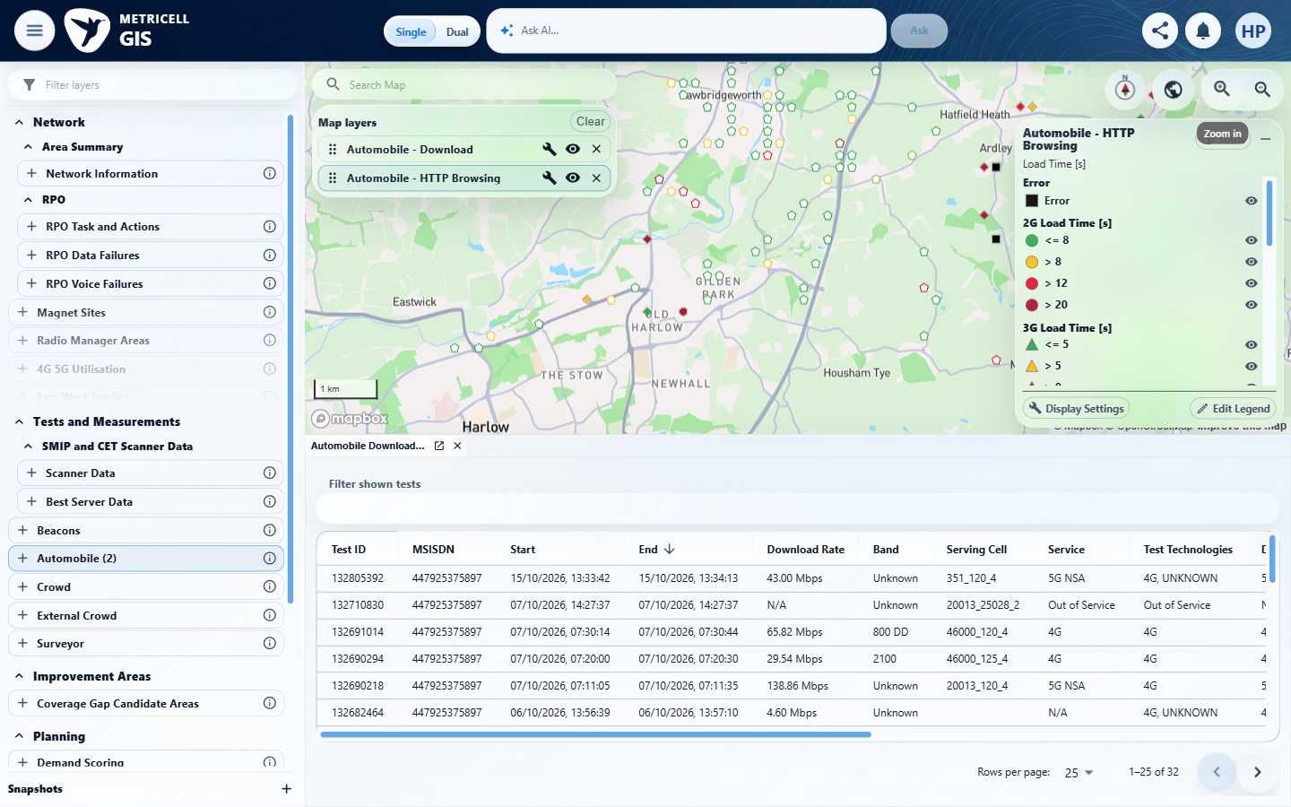 | E100 - Persist reopen (criterion-13-persist-reopen.png)  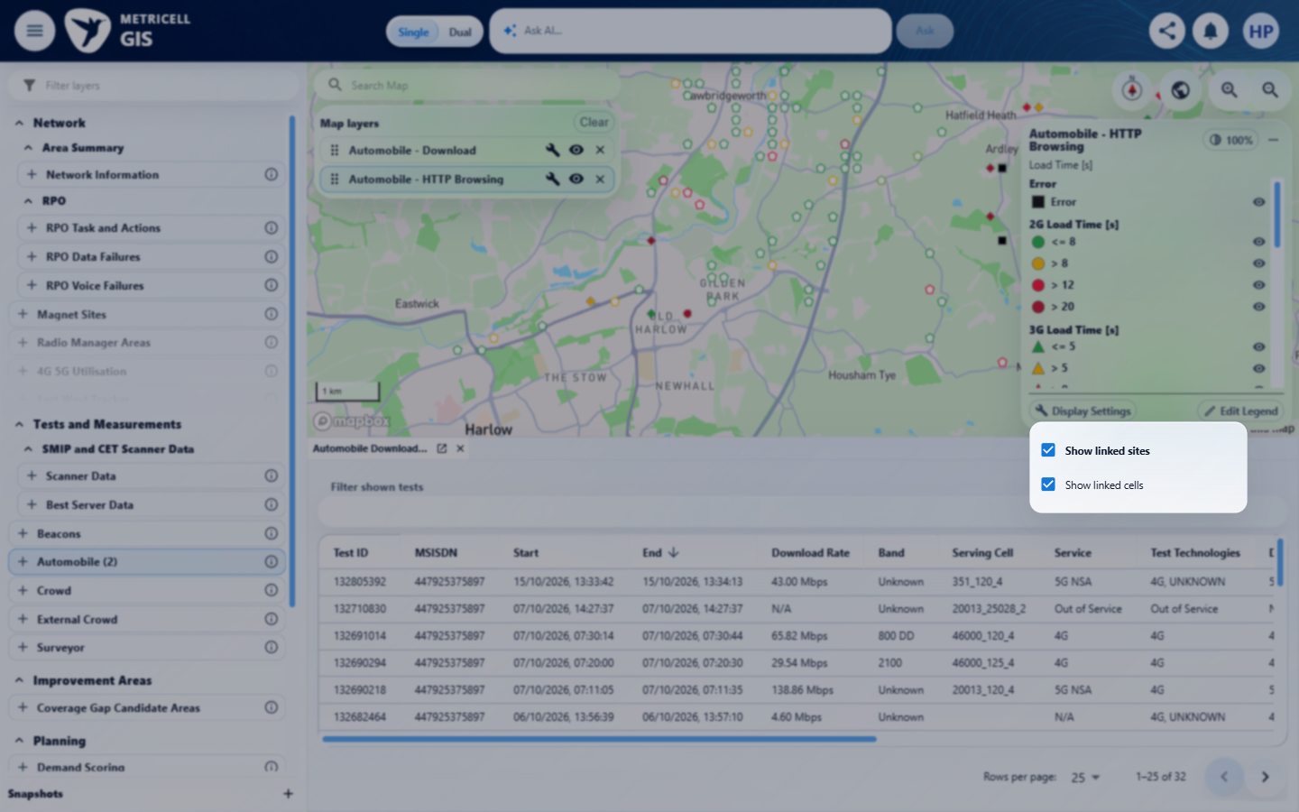

Criterion 13 continued: Linked-site and linked-cell display settings use the shared Network context and follow visible result categories; linked cells are disabled when linked sites are off, and settings persist per layer.
Browser URL recorded after criterion: https://o2intelligence-v4-dev.metricell.com/gis
E101 - Filter error (criterion-13-filter-error.png)  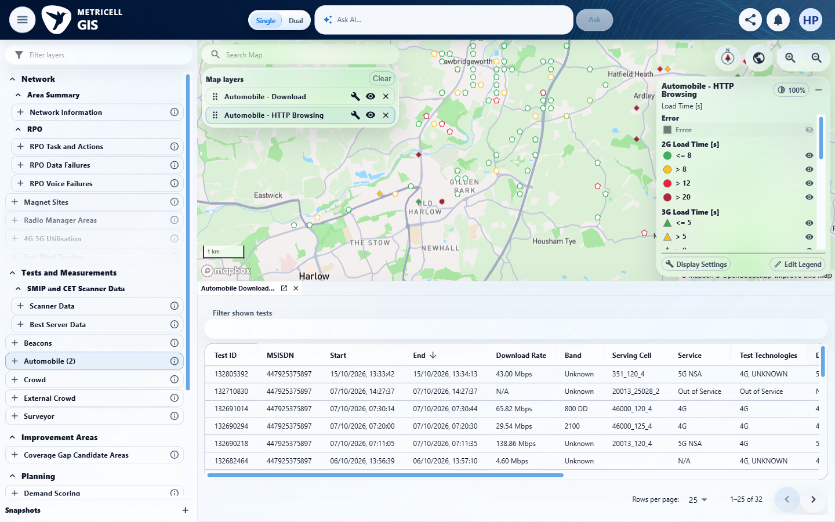 | E102 - Before second layer (criterion-13-before-second-layer.png)  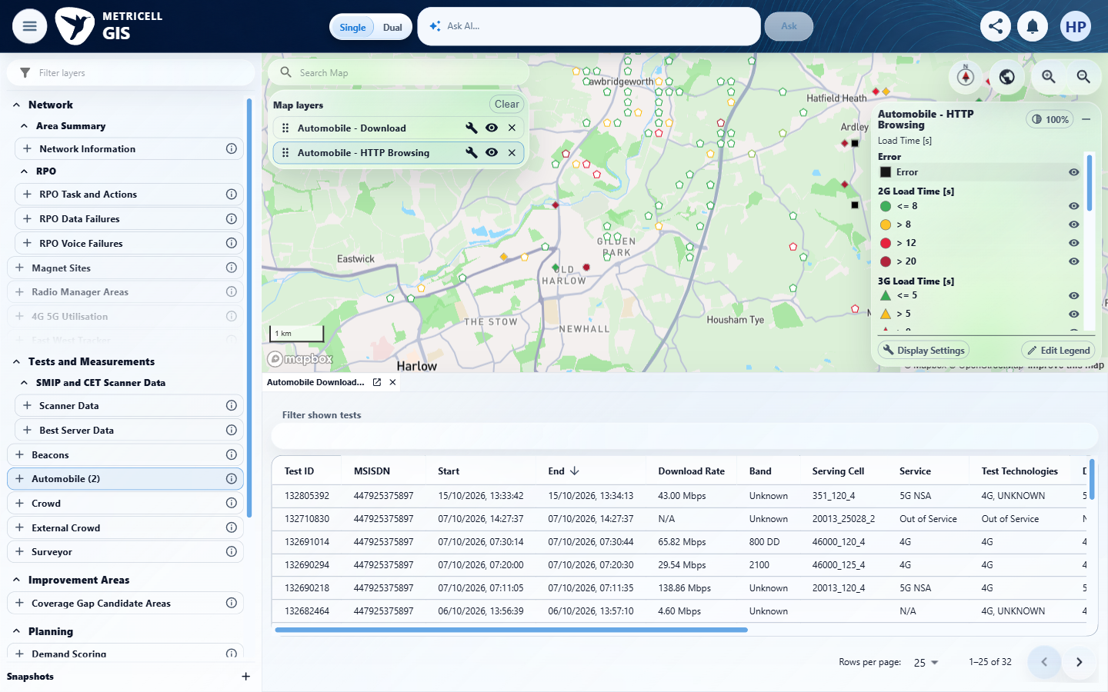

Criterion 13 continued: Linked-site and linked-cell display settings use the shared Network context and follow visible result categories; linked cells are disabled when linked sites are off, and settings persist per layer.
Browser URL recorded after criterion: https://o2intelligence-v4-dev.metricell.com/gis
E103 - Ping config (criterion-13-ping-config.png)  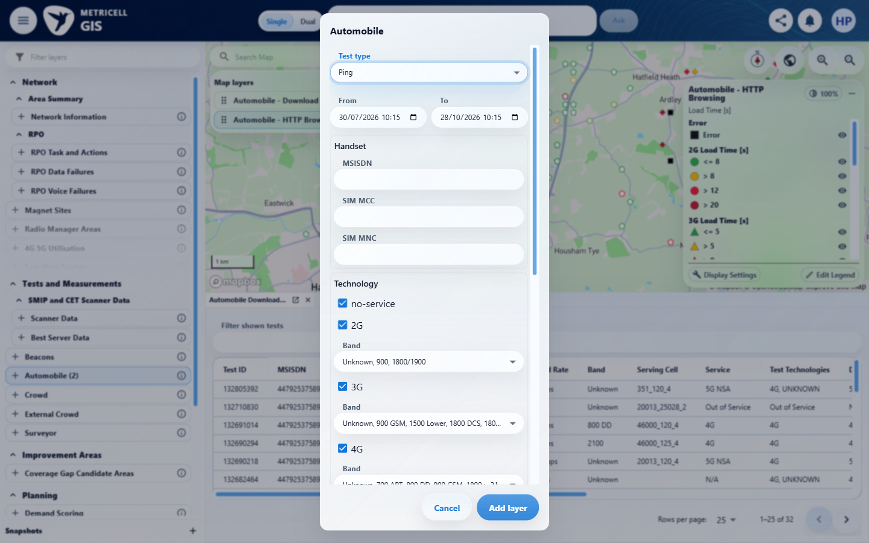 | E104 - Ping map (criterion-13-ping-map.png)  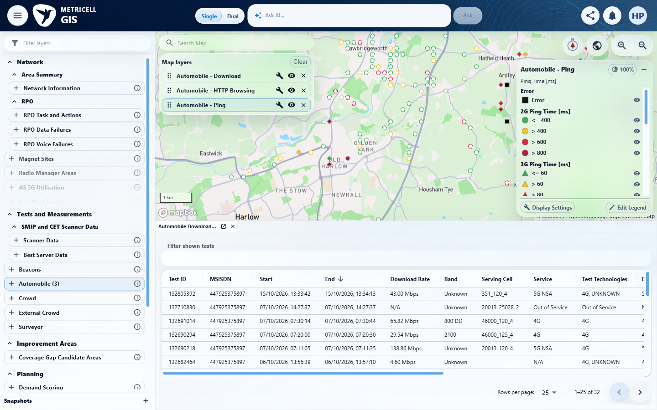

Criterion 13 continued: Linked-site and linked-cell display settings use the shared Network context and follow visible result categories; linked cells are disabled when linked sites are off, and settings persist per layer.
Browser URL recorded after criterion: https://o2intelligence-v4-dev.metricell.com/gis
E105 - Ping independent (criterion-13-ping-independent.png)  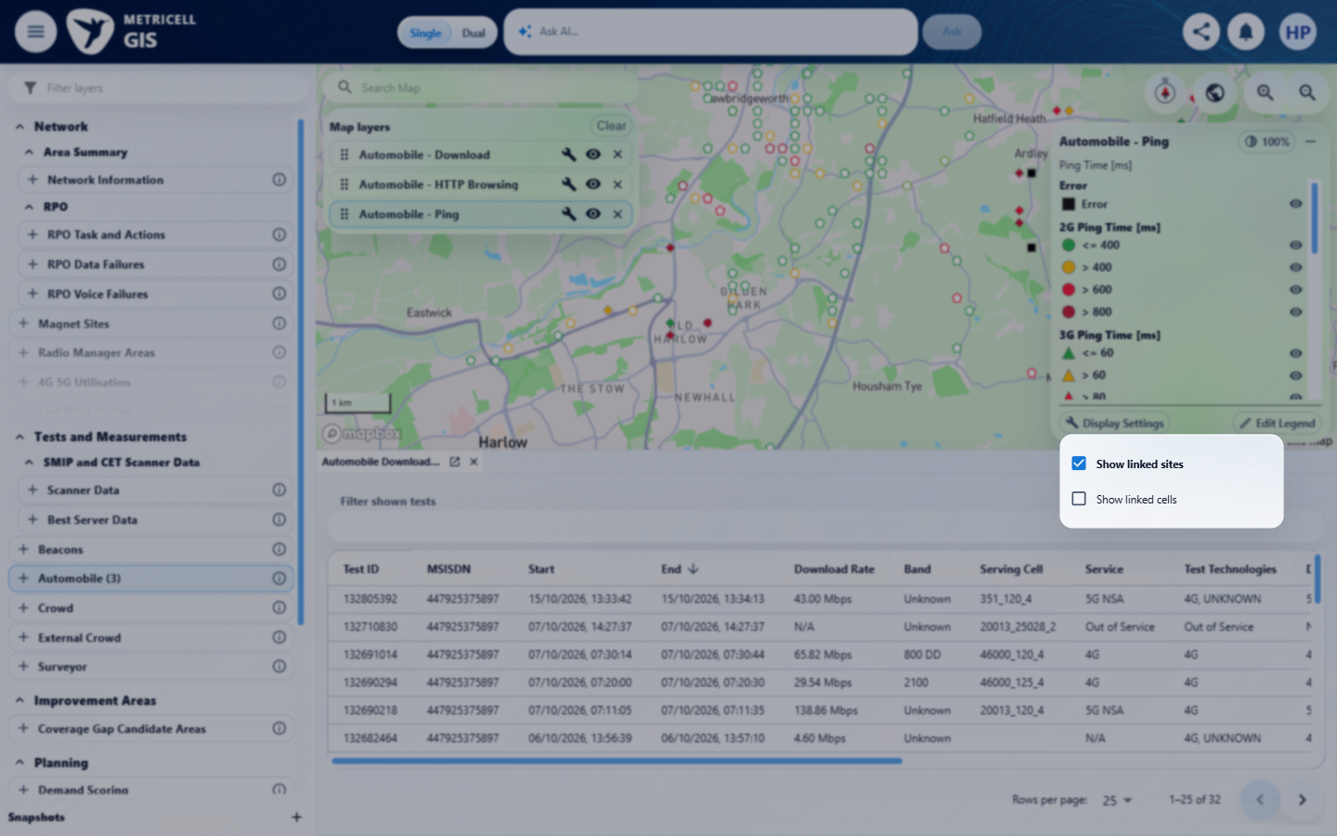 | E106 - Return http (criterion-13-return-http.png)  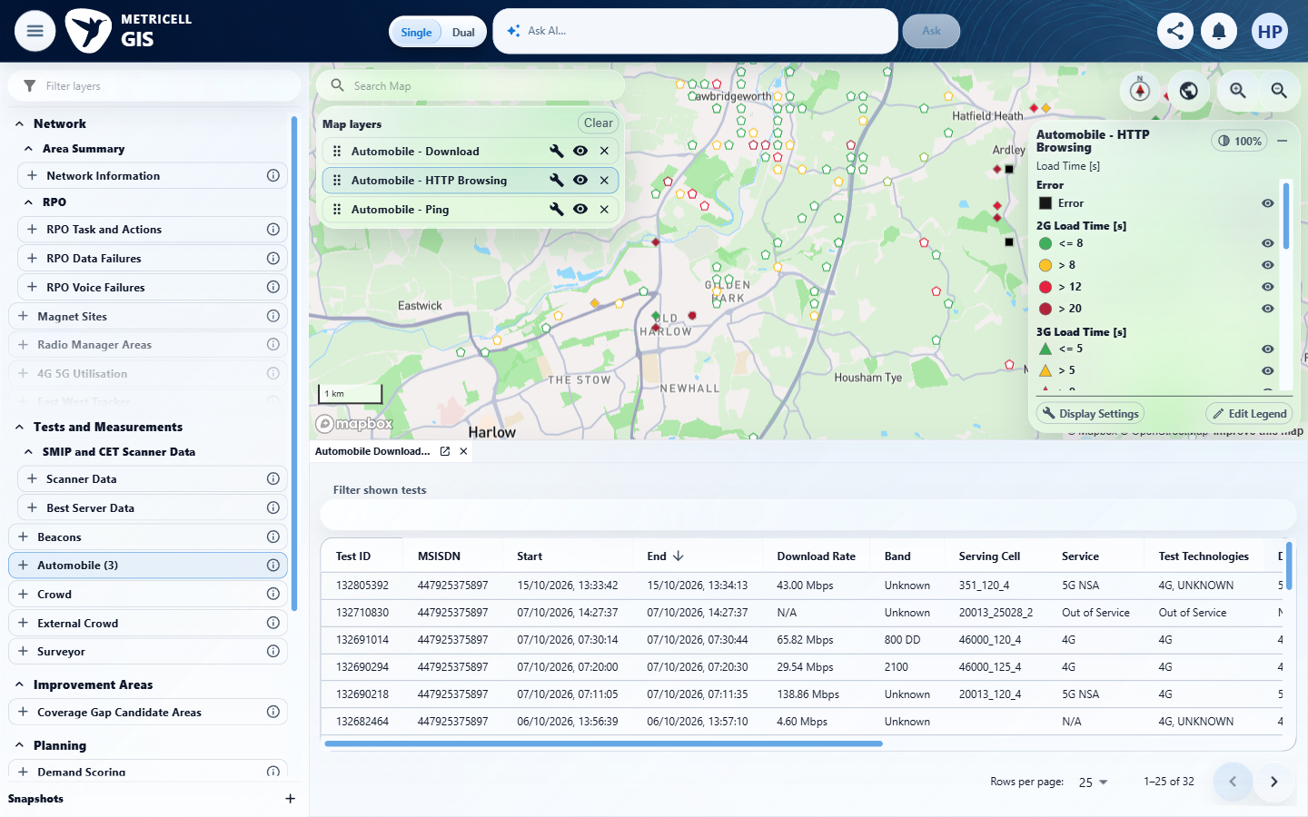

Criterion 13 continued: Linked-site and linked-cell display settings use the shared Network context and follow visible result categories; linked cells are disabled when linked sites are off, and settings persist per layer.
Browser URL recorded after criterion: https://o2intelligence-v4-dev.metricell.com/gis
E107 - Final (criterion-13-final.png)
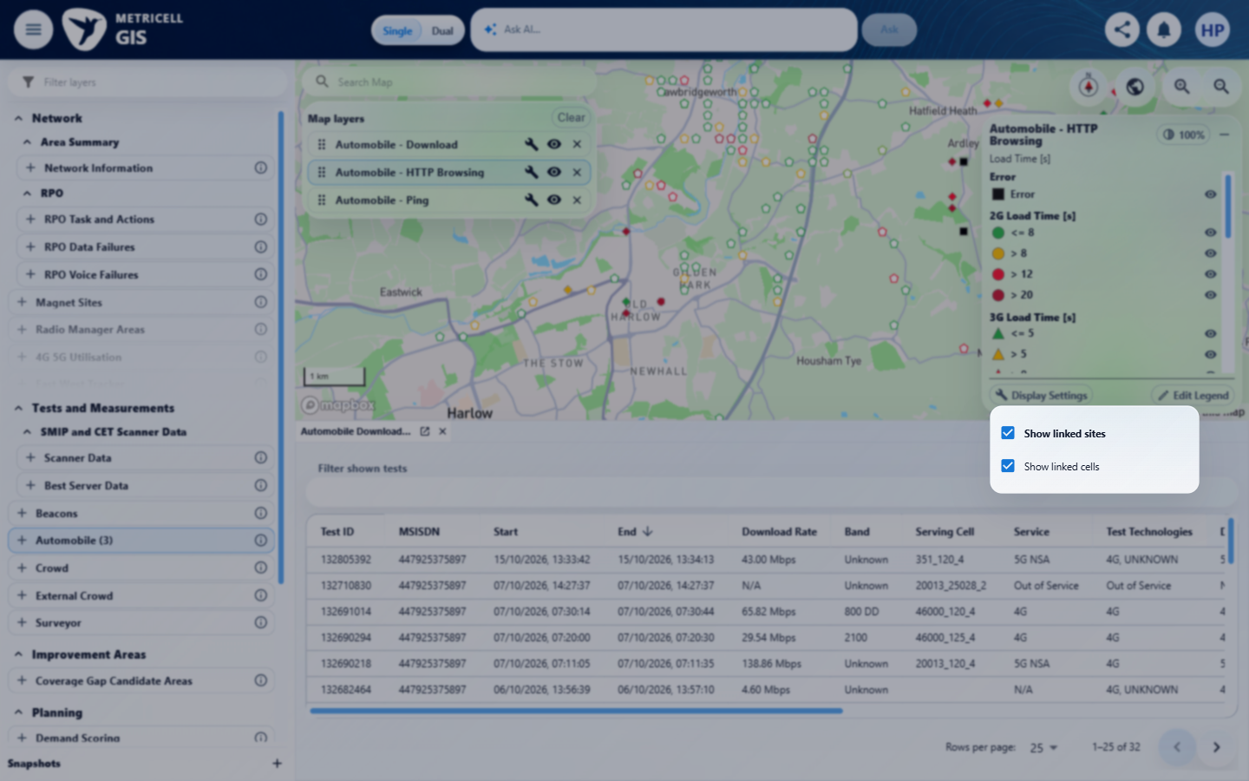

14.0.0 | With or without a details tab, the legend remains scrollable when the map pane is resized and does not overlap Reset North or other map controls. | With or without a details tab, the legend remains scrollable when the map pane is resized and does not overlap Reset North or other map controls. | criterion-14-with-details-baseline.png -> criterion-14-details-resized-top.png -> criterion-14-details-resized-bottom.png shows HTTP scrolling after resize with a details tab. criterion-14-map-b-actual-baseline.png -> criterion-14-map-b-resized-top.png -> criterion-14-decisive-final.png shows scrolling in the fully visible second map without a details tab. Compass/Reset North, style and zoom remain separate. In criterion-14-map-b-actual-baseline.png and criterion-14-decisive-final.png the legend visibly covers the right-hand Map layers controls in the narrow dual panes, contradicting avoidance of other controls. The recorded remove-click interception corroborates this visible overlap; timeout alone is not the defect evidence.  Evidence: E108, E77, E109, E110, E111, E112, E113, E114, E115, E116 | Failed
Criterion 14 assessment: Testing notes: Legends remained scrollable and clear of compass/style/zoom controls, but in550px-wide dual map panes the HTTP legend overlapped Map layers controls and intercepted configure/remove clicks. A normal Remove from selected click timed out with the legend subtree intercepting pointer events. Restored1440x900 then Dual; mapA pane550 wide with detail, mapB empty and no details. Used actual Add to map B menu and own HTTP configuration to add second own HTTP layer. Initial menu permission review timed out; current state/lease rechecked, one retry succeeded. At550px width legend covered Map layers configure/remove controls; normal remove click was intercepted by legend subtree and timed out. Narrow1100 dual viewport captures were offscreen for mapB and excluded as no-details acceptance proof; repaired at1440x720 before finishing.
Criterion 14 evidence: With or without a details tab, the legend remains scrollable when the map pane is resized and does not overlap Reset North or other map controls.
Browser URL recorded after criterion: https://o2intelligence-v4-dev.metricell.com/gis
E108 - Config (criterion-14-config.png)  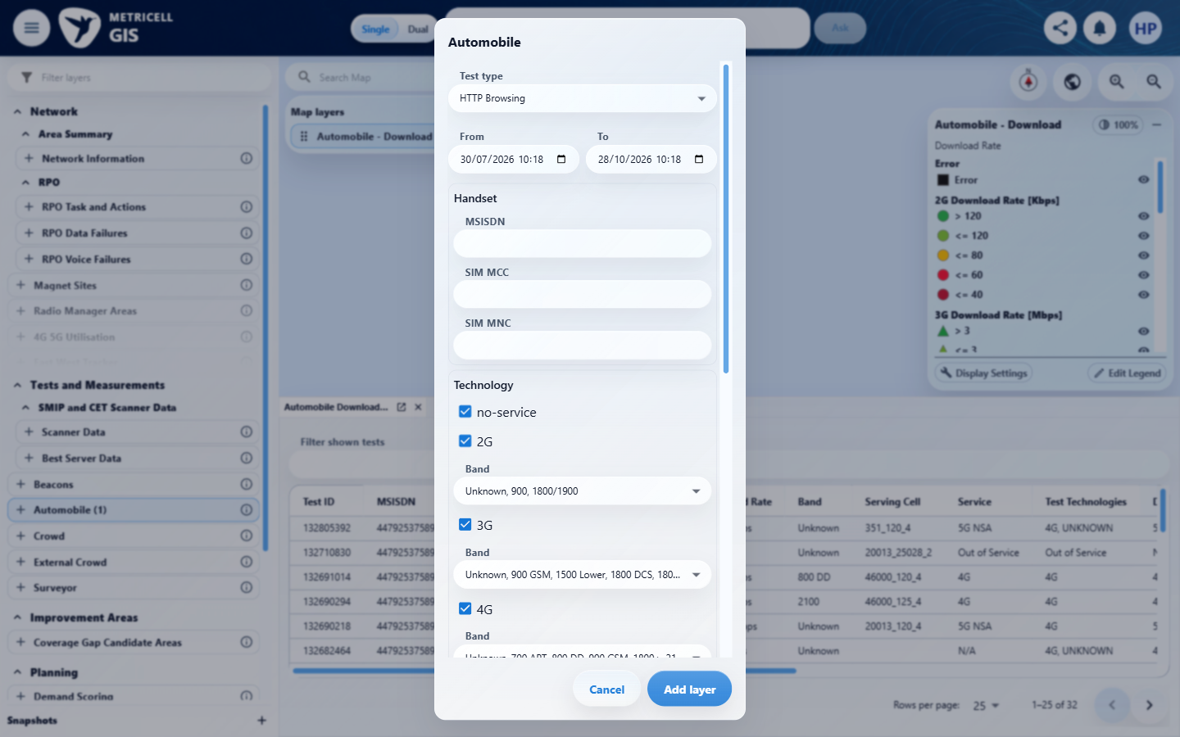 | E77 - With details baseline (criterion-14-with-details-baseline.png)

Criterion 14 continued: With or without a details tab, the legend remains scrollable when the map pane is resized and does not overlap Reset North or other map controls.
Browser URL recorded after criterion: https://o2intelligence-v4-dev.metricell.com/gis
E109 - Details resized top (criterion-14-details-resized-top.png)  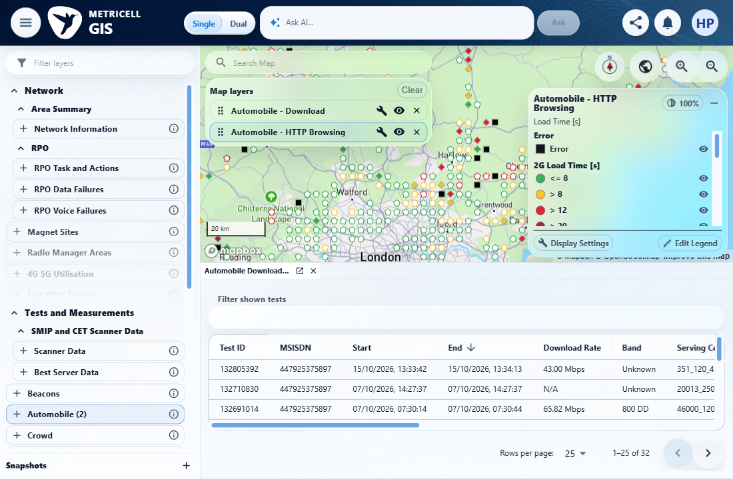 | E110 - Details resized bottom (criterion-14-details-resized-bottom.png)  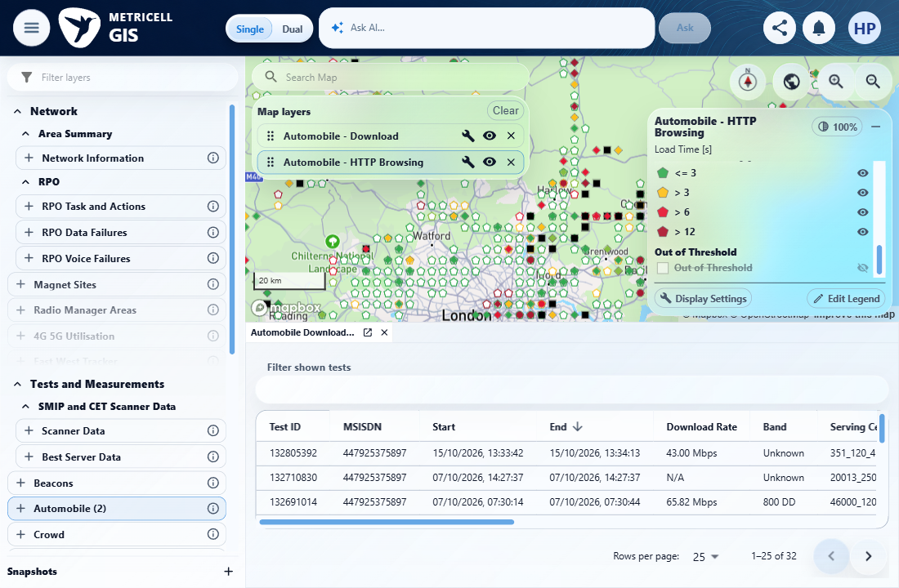

Criterion 14 continued: With or without a details tab, the legend remains scrollable when the map pane is resized and does not overlap Reset North or other map controls.
Browser URL recorded after criterion: https://o2intelligence-v4-dev.metricell.com/gis
E111 - Before dual (criterion-14-before-dual.png)  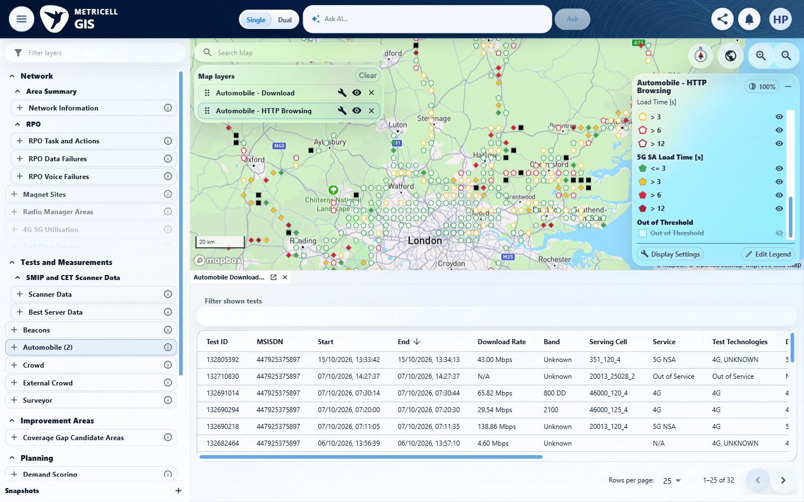 | E112 - Dual (criterion-14-dual.png)  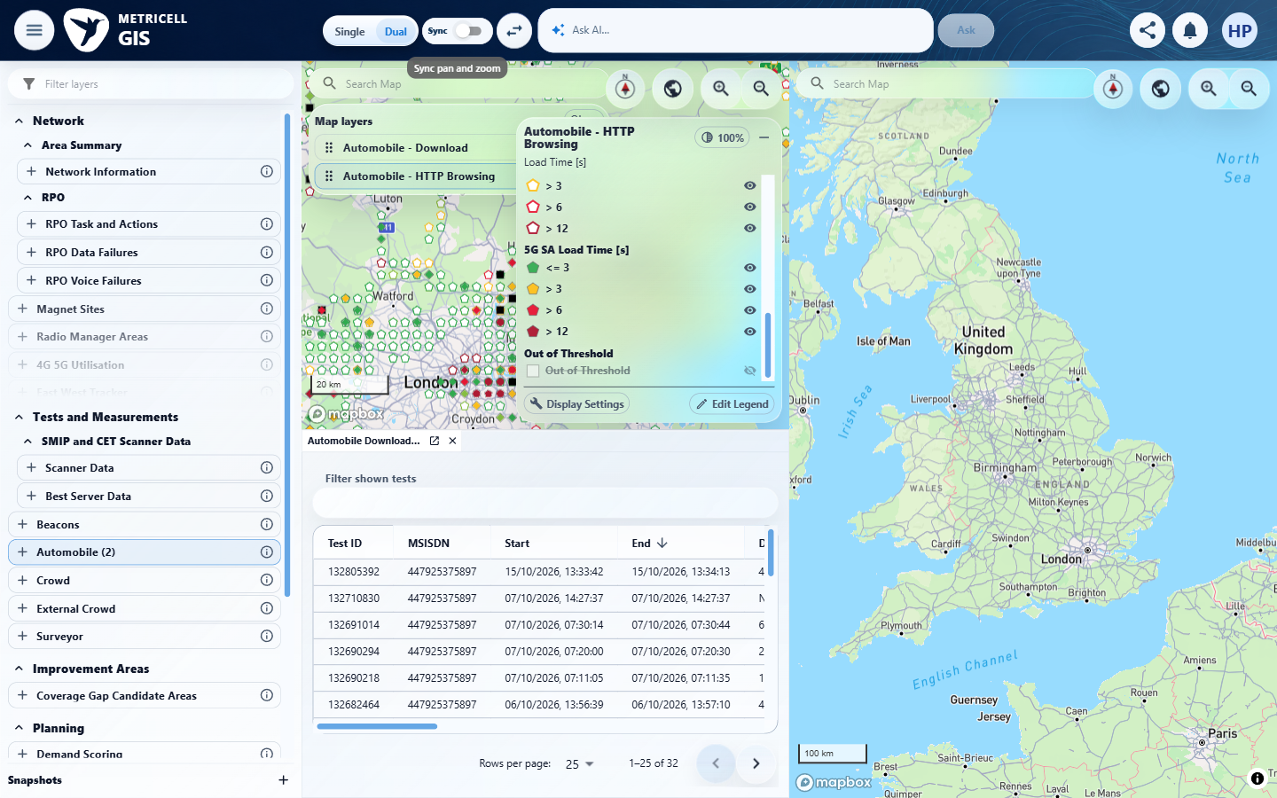

Criterion 14 continued: With or without a details tab, the legend remains scrollable when the map pane is resized and does not overlap Reset North or other map controls.
Browser URL recorded after criterion: https://o2intelligence-v4-dev.metricell.com/gis
E113 - Map b actual config (criterion-14-map-b-actual-config.png)  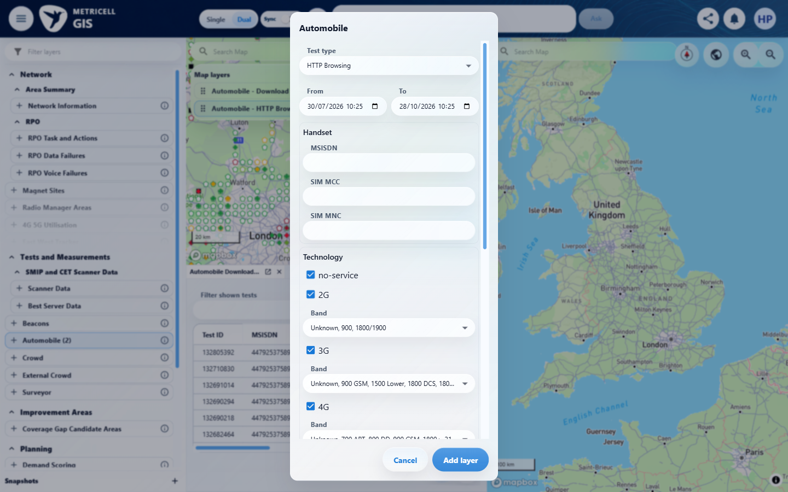 | E114 - Map b actual baseline (criterion-14-map-b-actual-baseline.png)  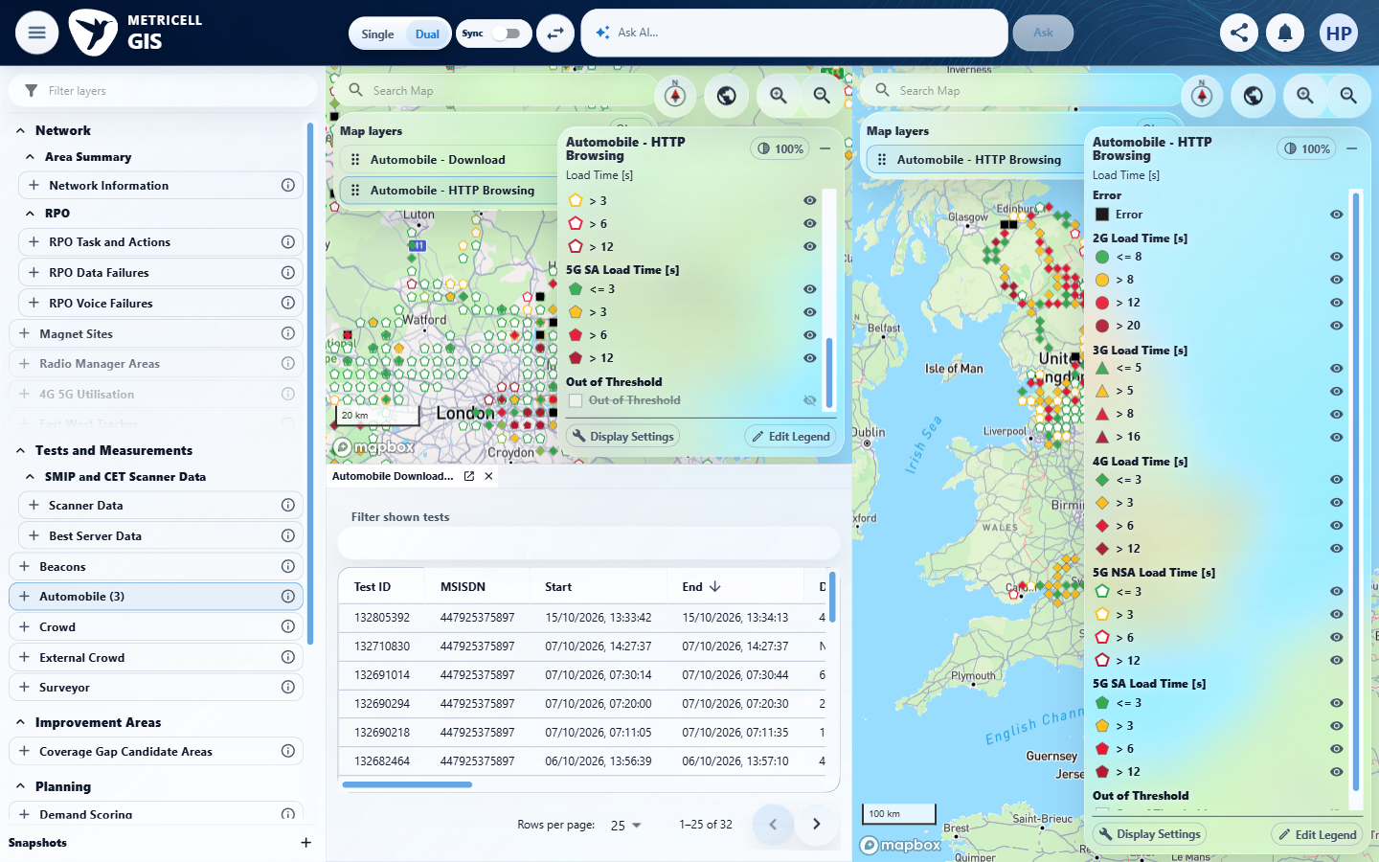

Criterion 14 continued: With or without a details tab, the legend remains scrollable when the map pane is resized and does not overlap Reset North or other map controls.
Browser URL recorded after criterion: https://o2intelligence-v4-dev.metricell.com/gis
E115 - Map b resized top (criterion-14-map-b-resized-top.png)  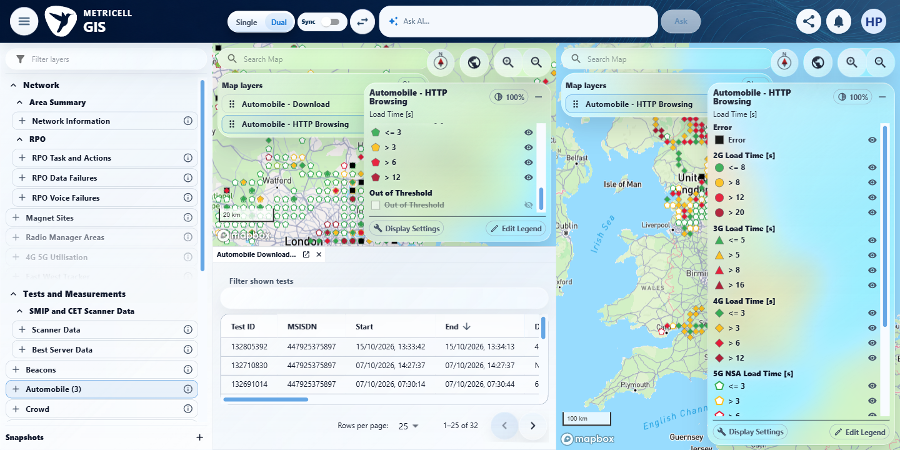 | E116 - Decisive final (criterion-14-decisive-final.png)  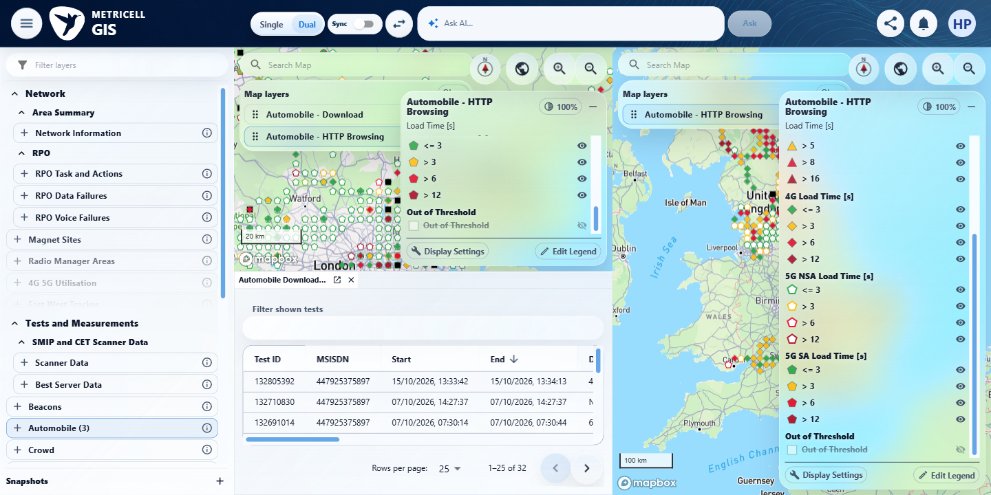

15.0.0 | For existing consumers of the shared legend, established markers, visibility, editor actions and default behavior remain unchanged unless a consumer opts into the new options. | For existing consumers of the shared legend, established markers, visibility, editor actions and default behavior remain unchanged unless a consumer opts into the new options. | No identified independent versioned pre-change baseline, existing-consumer fixture set or opt-in matrix is supplied. criterion-15-final.png shows the current HTTP editor only; it cannot establish unchanged historical markers, visibility, editor actions or defaults, or which consumers opted in. Incidental Download/Service layers are excluded as substitute acceptance consumers.  Evidence: E117, E77, E118 | Blocked
Criterion 15 evidence: For existing consumers of the shared legend, established markers, visibility, editor actions and default behavior remain unchanged unless a consumer opts into the new options.
Browser URL recorded after criterion: https://o2intelligence-v4-dev.metricell.com/gis
E117 - Config (criterion-15-config.png)  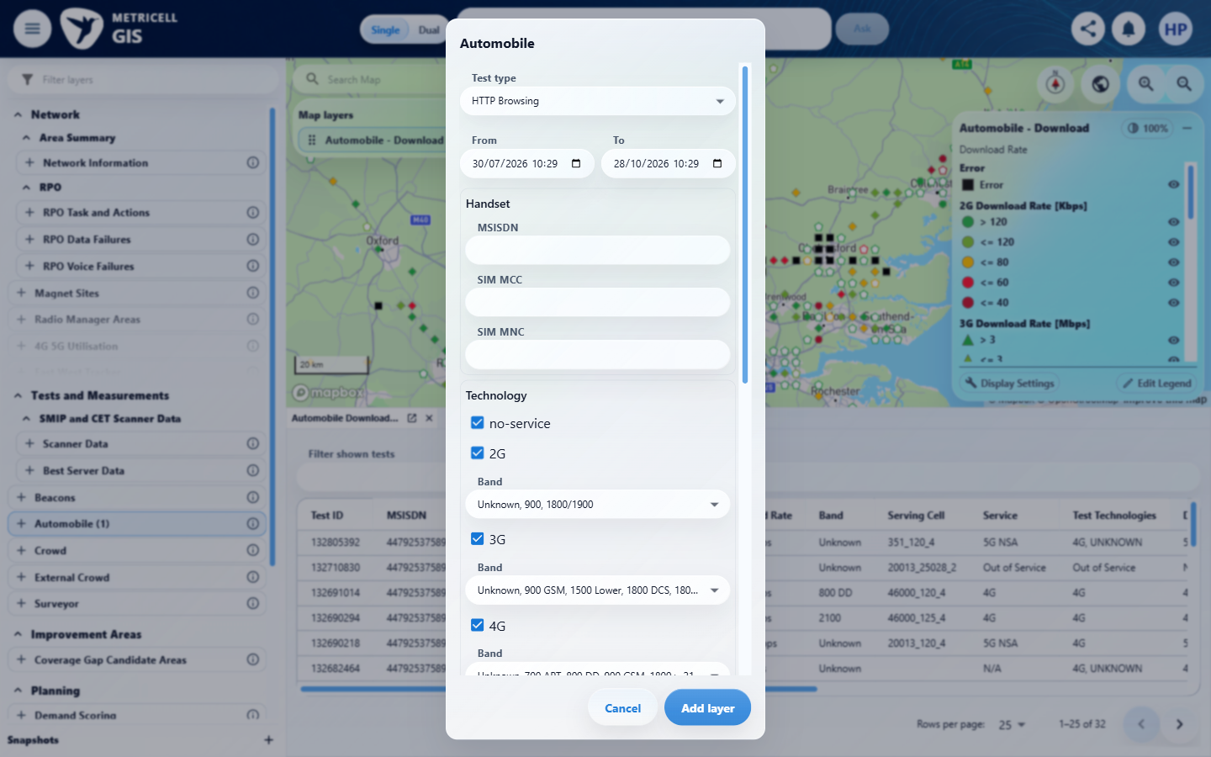 | E77 - Current consumer (criterion-15-current-consumer.png)

Criterion 15 continued: For existing consumers of the shared legend, established markers, visibility, editor actions and default behavior remain unchanged unless a consumer opts into the new options.
Browser URL recorded after criterion: https://o2intelligence-v4-dev.metricell.com/gis
E118 - Final (criterion-15-final.png)
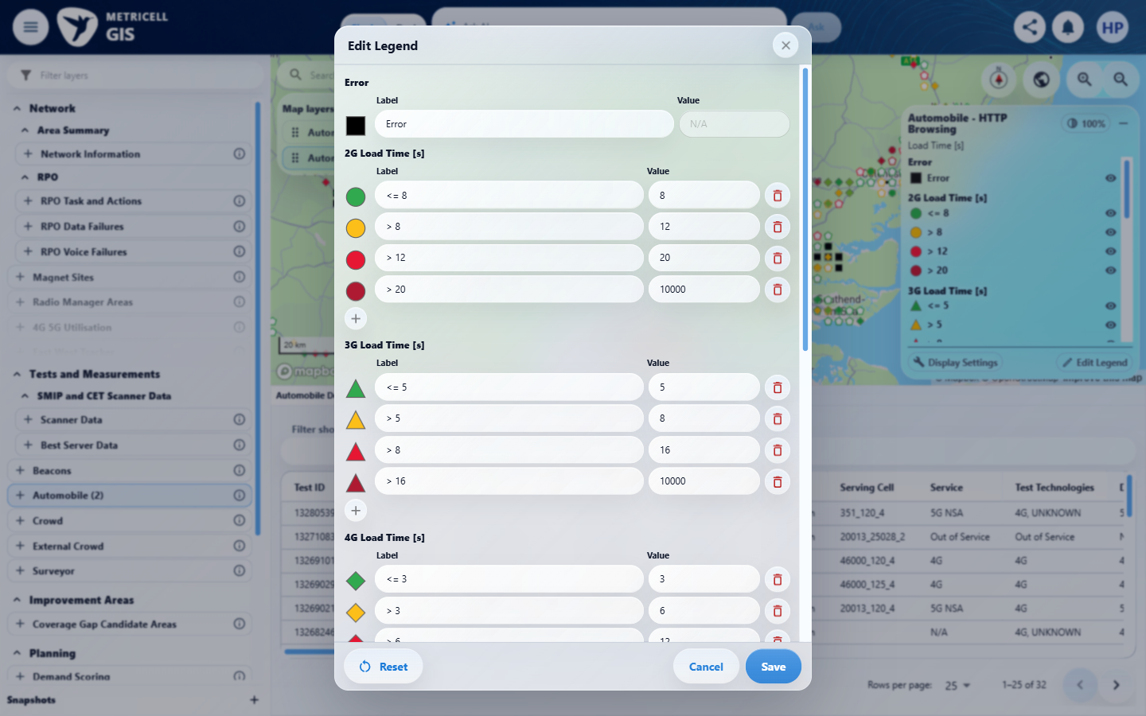

About Metricell

Metricell is on a mission to deliver connectivity. We work with our customers to design, deliver and manage wireless communication networks – with a shared ambition of achieving flawless network experience. We’ve been responsible for many first-to-market products, and our technology is characterised by the relentless pursuit of automation and digitalisation.

Our geospatial intelligence tools traverse a wide variety of business processes – from Test & Measurement to Customer Experience Management – and we’re pioneers in Crowdsourcing and Digital Self Care. Our technology is today in use by a range of customers; thousands of their personnel; and millions of subscribers worldwide.

Find out more at www.metricell.com




