

Automated Test Case Document
Jira Ticket: TEST2-81

Document Classification: | Company Confidential
Document Ref: | Automated Test Case Document
Version: | 1.0
Date: | 28/10/2026
Document Author: | Automated TEST2 Evidence Review
Document Owner: | Quality Assurance / Metricell




This document and its content is copyright of Metricell Limited @ 2026 all rights reserved. All information contained herein is the intellectual property of Metricell Limited and should be treated as confidential. Any external redistribution of reproduction of part or all of the contents in any form is prohibited unless expressly agreed with Metricell Limited in writing. Any reproduced content must include the following statement; “Part or all of the content contained herein is copyright of Metricell Limited @ 2026 all rights reserved”.
Table of Contents
1 Revision History 2
2 Test Cycle Information 3
3 Test Summary 3
4 Test Cases 4
About Metricell 12

Revision History

Version | Date | Revision Author | Summary of Changes
[1.0] | 28/10/2026 | TEST2 QA Automation | Generated from TEST2 evidence review

Test Cycle Information

Tester: | Automated
Jira Ticket: | TEST2-81
Environment: | o2intelligence-v4-dev.metricell.com
Browser Details: | Google Chrome 156.0.8078.48
Date of Test: | 28/10/2026
Limitations during Testing: | Criteria 9 used simulated UI conditions; see their assessments.
Overall review outcome: | Passed
Browser URL(s) recorded after criteria: | https://o2intelligence-v4-dev.metricell.com/gis

Test Summary

Area of test | Pass (Y/N) | Fail (Y/N) | Blocked (Y/N) | Defect No
1. Given HTTP Browsing results are available, when the HTTP Browsing layer is selected, each supplied result is displayed as a selectable point on the map. | Y | N | N | 0
2. Given Ping results are available, when the Ping layer is selected, each supplied result is displayed as a selectable point on the map. | Y | N | N | 0
3. Given Video Streaming results are available, when the Video Streaming layer is selected, each supplied result is displayed as a selectable point on the map. | Y | N | N | 0
4. Given details are available for a result point, when the point is selected, a new detail dialog opens for that same result and displays its test type, result time, location, and available network technology/context. | Y | N | N | 0
5. Given an HTTP Browsing point is selected and its details are available, the dialog displays that result’s Page Load Time. | Y | N | N | 0
6. Given a Ping point is selected and its details are available, the dialog displays that result’s Ping Time. | Y | N | N | 0
7. Given a Video Streaming point is selected and its details are available, the dialog displays that result’s Rebuffer Count. | Y | N | N | 0
8. Given an HTTP Browsing result ends in error, when its point is displayed, it is visually distinct from a successful result; a zero Page Load Time on the failed result is not coloured as success. | Y | N | N | 0
9. Given details cannot be returned for a selected point, the user sees a clear no-data or error message and no stale details are displayed. | Y | N | N | 0

Test Cases
Each test maps to a criterion and decisive browser evidence. Inconclusive results are reported as Failed.

Tests

Preconditions: | V4 access and ticket conditions. | Associated Requirements: | Ticket criteria below. | Automation Notes: | Screenshots below each criterion; full log retained locally.
ID / Criterion | Criteria Tested | Expected Result | Actual Result / Evidence Path | Outcome
1.0.0 | Given HTTP Browsing results are available, when the HTTP Browsing layer is selected, each supplied result is displayed as a selectable point on the map. | Given HTTP Browsing results are available, when the HTTP Browsing layer is selected, each supplied result is displayed as a selectable point on the map. | criterion-1-selected-http.png and criterion-1-http-current-scope.png establish Automobile HTTP Browsing selection. criterion-1-london-settled.png shows its point in the bounded central London viewport; criterion-1-final.png shows the new detail for member 132714574. The recorded genuine GET contains one aggregate 1441292517047095807 and its POST contains one member; the single visible point was selected, reconciling 1/1 aggregates and 1/1 members for 8 October 00:00–23:59 local with default technologies and no handset/cell restriction. This pass applies to that explicitly bounded supplied dataset.  Evidence: E01, E02, E03, E04, E05, E06, E07, E08 | Passed
Criterion 1 evidence: Given HTTP Browsing results are available, when the HTTP Browsing layer is selected, each supplied result is displayed as a selectable point on the map.
Browser URL recorded after criterion: https://o2intelligence-v4-dev.metricell.com/gis
E01 - Before test type (criterion-1-before-test-type.png)  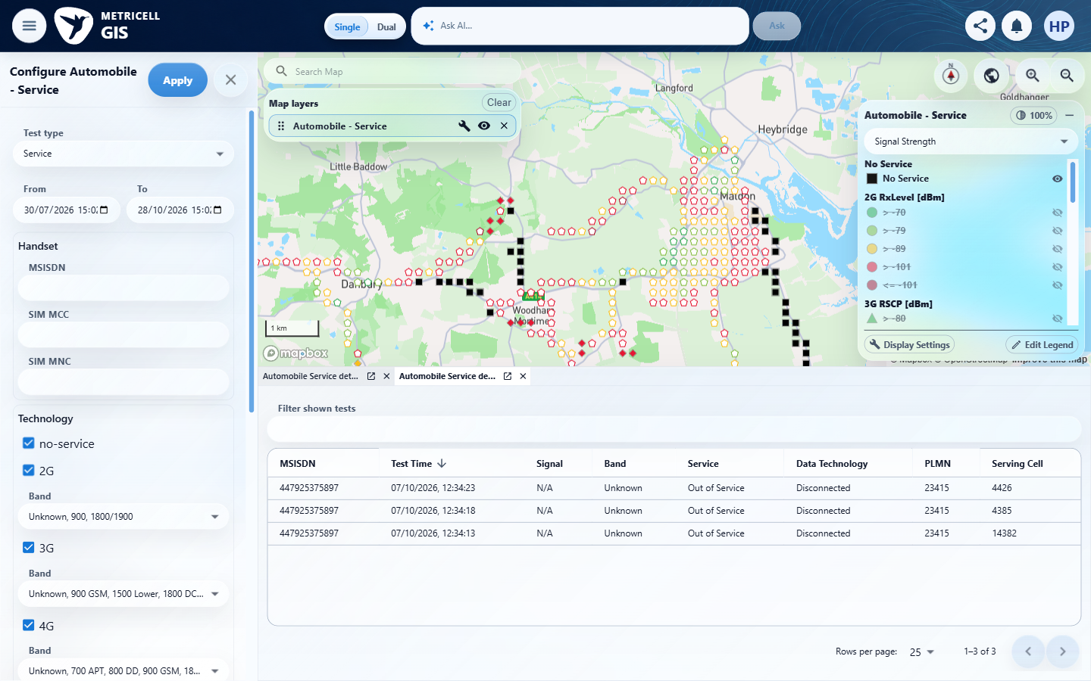 | E02 - Selected http (criterion-1-selected-http.png)  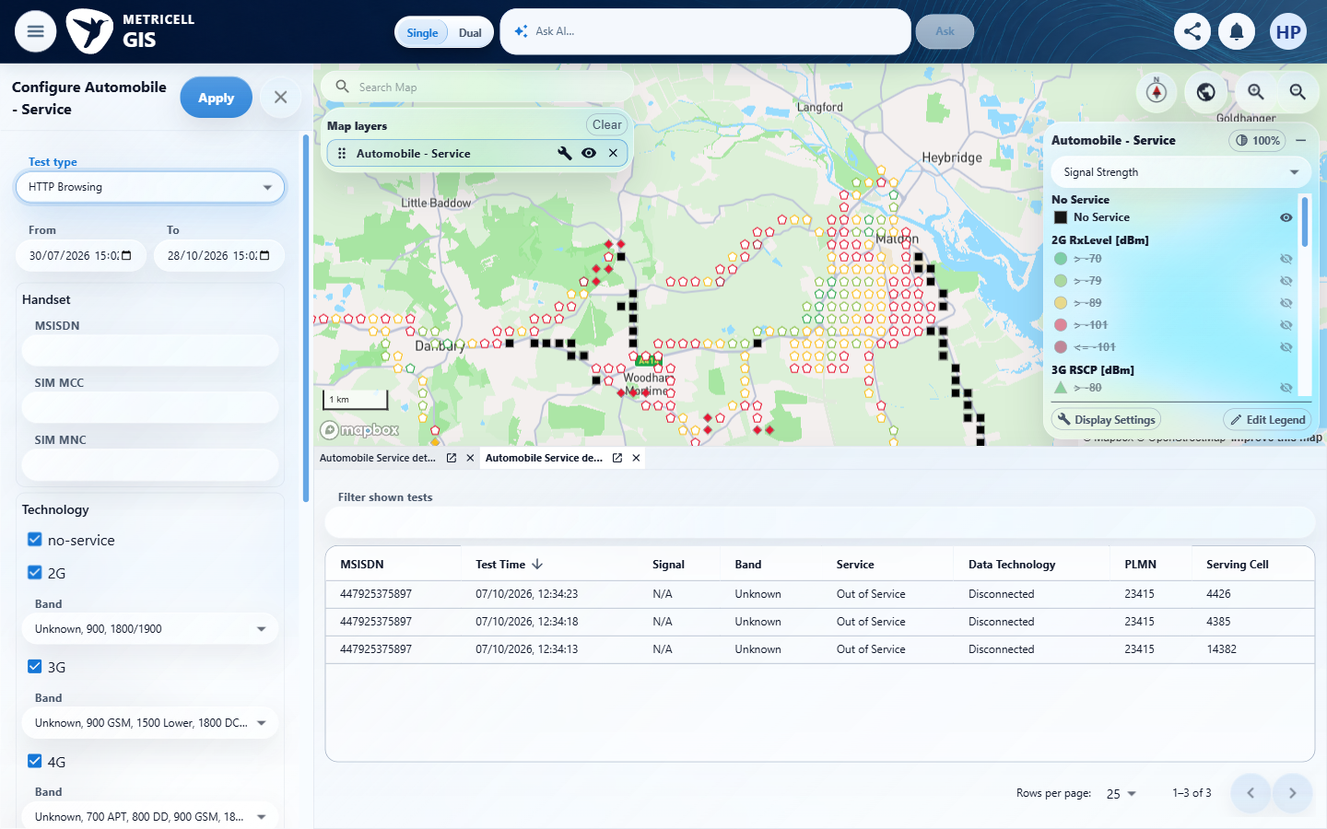

Criterion 1 continued: Given HTTP Browsing results are available, when the HTTP Browsing layer is selected, each supplied result is displayed as a selectable point on the map.
Browser URL recorded after criterion: https://o2intelligence-v4-dev.metricell.com/gis
E03 - Http current scope (criterion-1-http-current-scope.png)  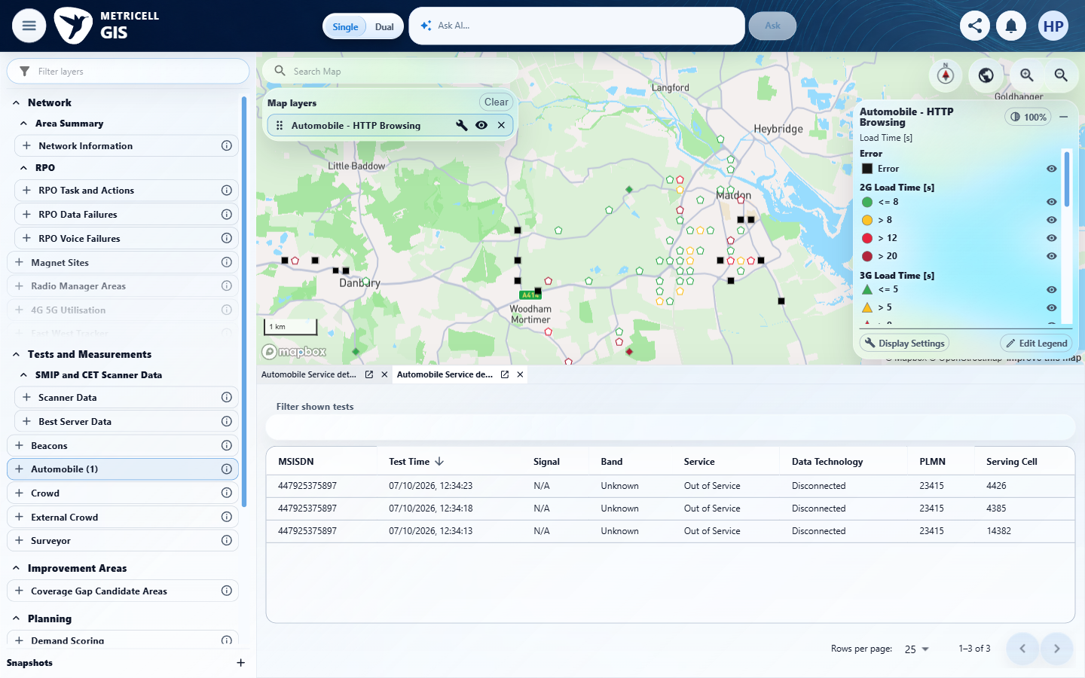 | E04 - Bounded date applied (criterion-1-bounded-date-applied.png)  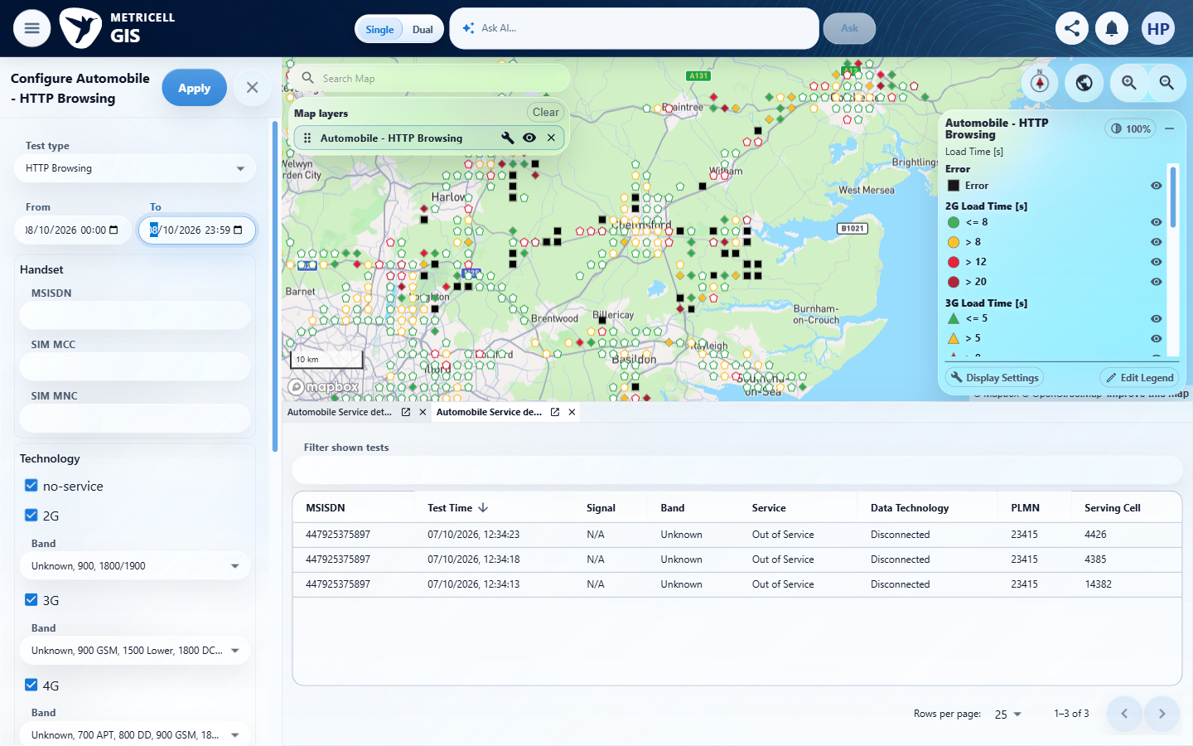

Criterion 1 continued: Given HTTP Browsing results are available, when the HTTP Browsing layer is selected, each supplied result is displayed as a selectable point on the map.
Browser URL recorded after criterion: https://o2intelligence-v4-dev.metricell.com/gis
E05 - Bounded map (criterion-1-bounded-map.png)  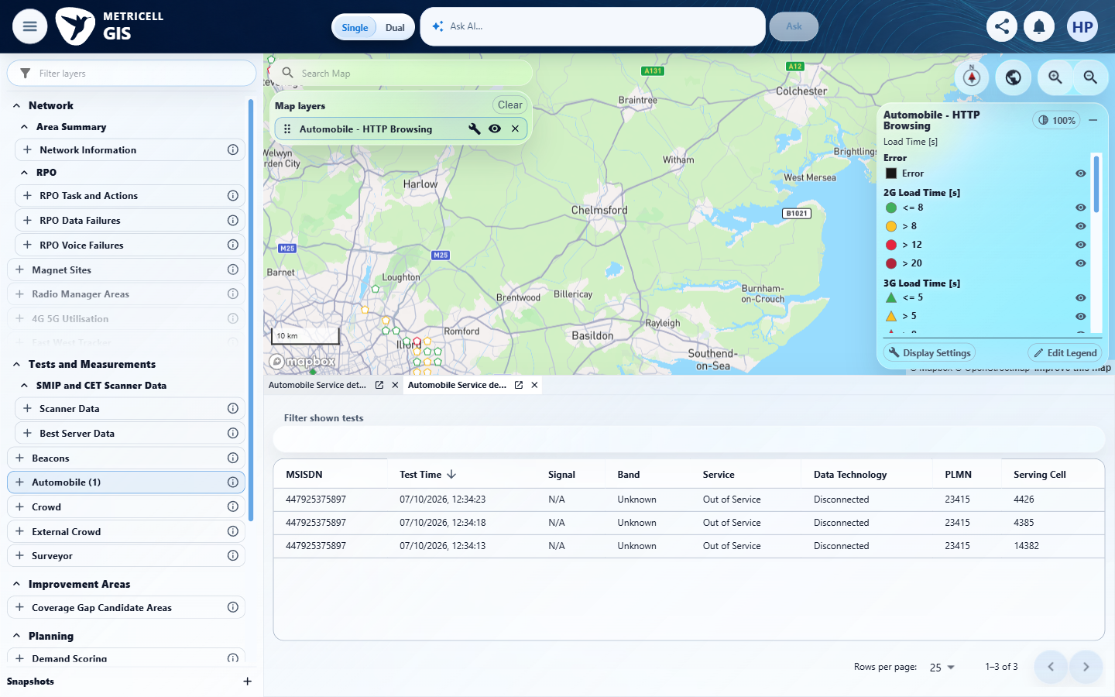 | E06 - Search london (criterion-1-search-london.png)  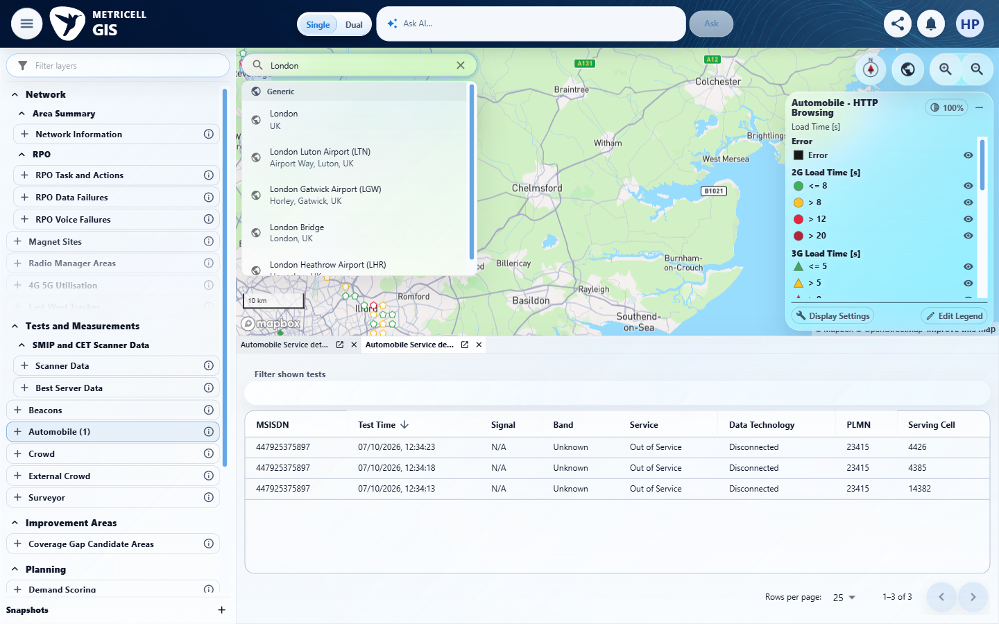

Criterion 1 continued: Given HTTP Browsing results are available, when the HTTP Browsing layer is selected, each supplied result is displayed as a selectable point on the map.
Browser URL recorded after criterion: https://o2intelligence-v4-dev.metricell.com/gis
E07 - London settled (criterion-1-london-settled.png)  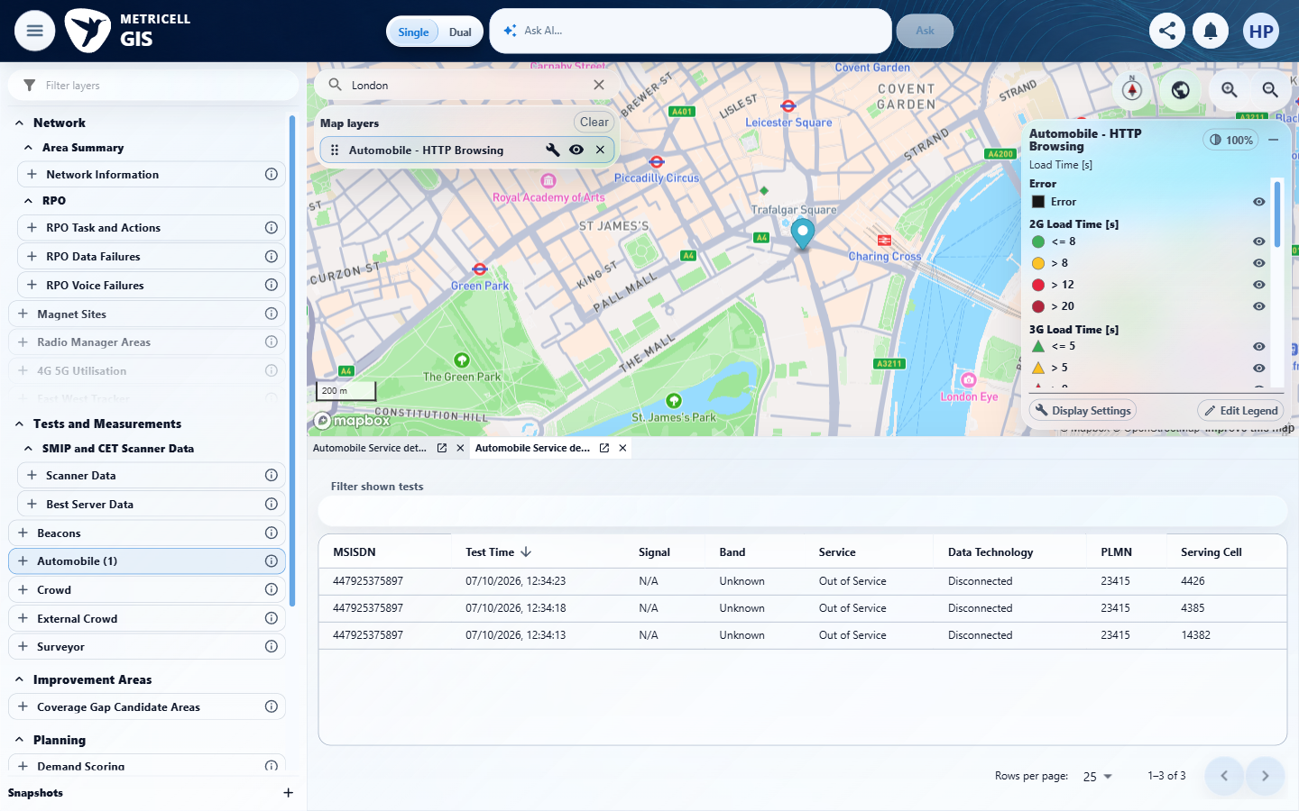 | E08 - Final (criterion-1-final.png)  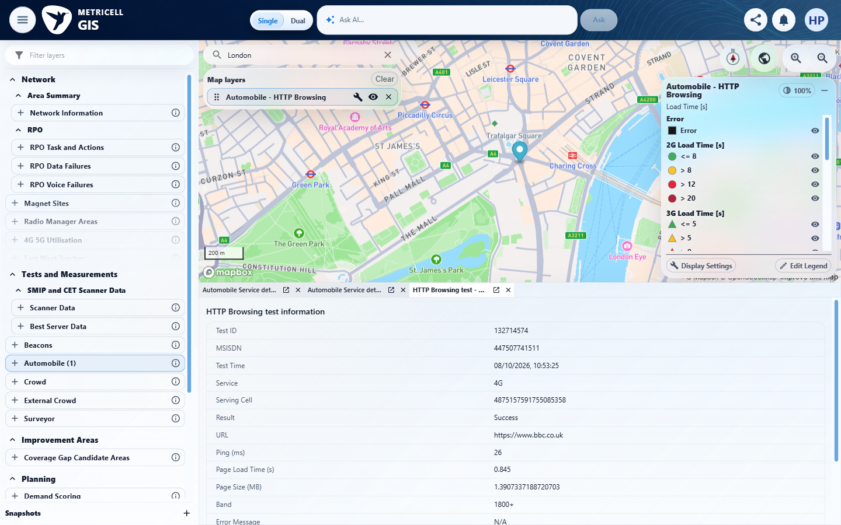

2.0.0 | Given Ping results are available, when the Ping layer is selected, each supplied result is displayed as a selectable point on the map. | Given Ping results are available, when the Ping layer is selected, each supplied result is displayed as a selectable point on the map. | criterion-2-configured-ping.png records the 8 October date/filter scope and Ping selection; criterion-2-bounded-map.png shows the settled Automobile Ping layer and its point. criterion-2-final.png shows the newly opened Ping member 132714573. The recorded genuine GET/POST reconciliation is one aggregate 1441292517315531264 and one member, with 1/1 selected in the bounded central London viewport; no wider dataset claim is made.  Evidence: E09, E10, E11 | Passed
Criterion 2 evidence: Given Ping results are available, when the Ping layer is selected, each supplied result is displayed as a selectable point on the map.
Browser URL recorded after criterion: https://o2intelligence-v4-dev.metricell.com/gis
E09 - Configured ping (criterion-2-configured-ping.png)  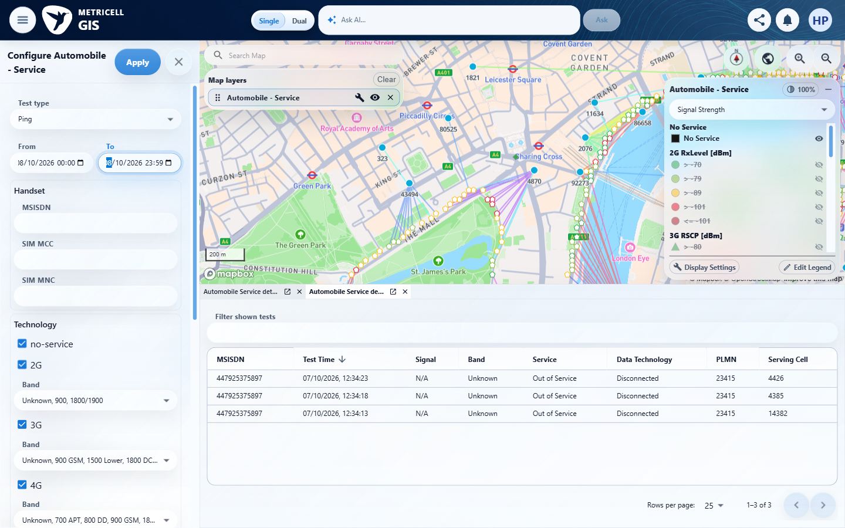 | E10 - Bounded map (criterion-2-bounded-map.png)  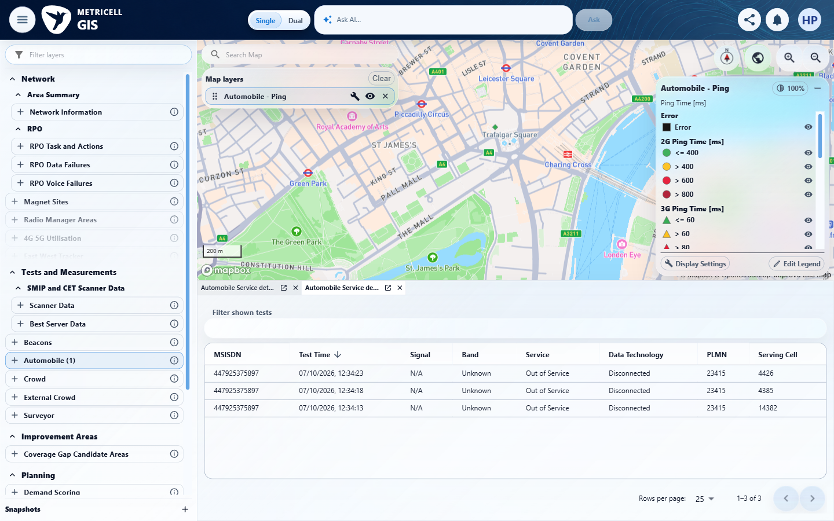

Criterion 2 continued: Given Ping results are available, when the Ping layer is selected, each supplied result is displayed as a selectable point on the map.
Browser URL recorded after criterion: https://o2intelligence-v4-dev.metricell.com/gis
E11 - Final (criterion-2-final.png)
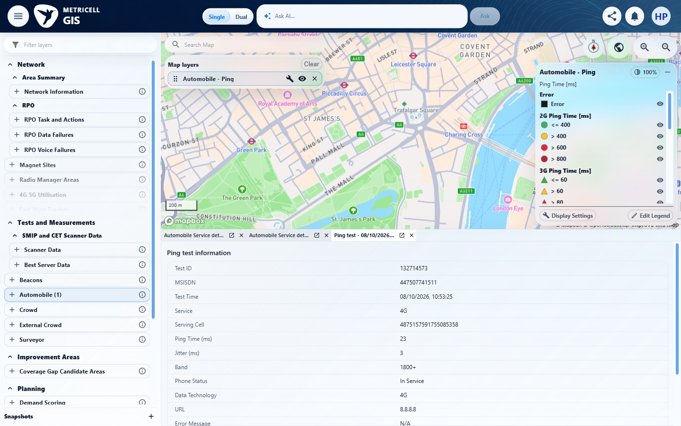

3.0.0 | Given Video Streaming results are available, when the Video Streaming layer is selected, each supplied result is displayed as a selectable point on the map. | Given Video Streaming results are available, when the Video Streaming layer is selected, each supplied result is displayed as a selectable point on the map. | criterion-3-configured-video.png records Video Streaming selection and the 8 October scope; criterion-3-bounded-map.png shows its settled Automobile layer and point. criterion-3-final.png shows newly opened member 132714575. The recorded genuine responses identify exactly one aggregate 1441292517047095806 and one member, reconciled 1/1 with the visible selectable presentation in the bounded central London viewport.  Evidence: E12, E13, E14 | Passed
Criterion 3 evidence: Given Video Streaming results are available, when the Video Streaming layer is selected, each supplied result is displayed as a selectable point on the map.
Browser URL recorded after criterion: https://o2intelligence-v4-dev.metricell.com/gis
E12 - Configured video (criterion-3-configured-video.png)  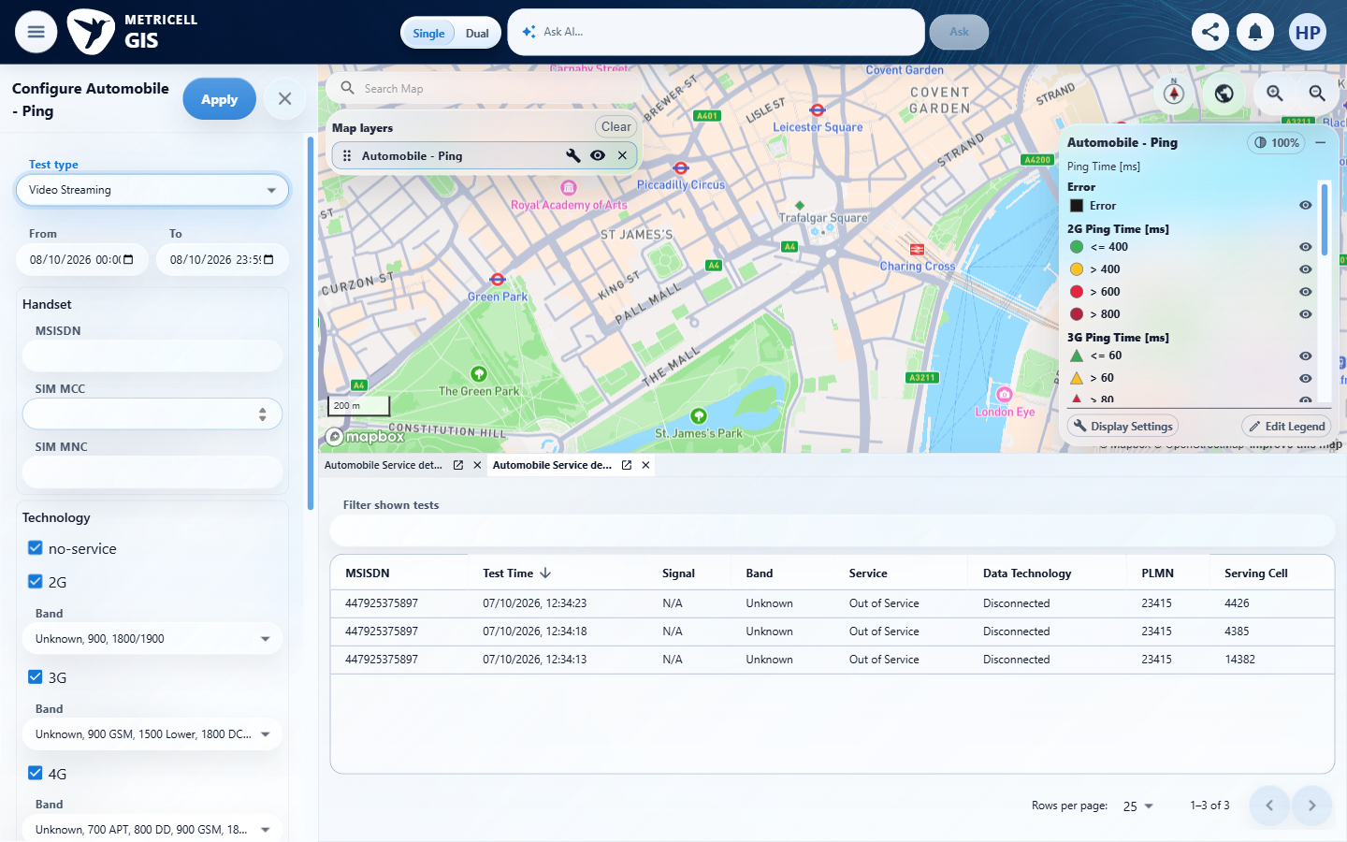 | E13 - Bounded map (criterion-3-bounded-map.png)  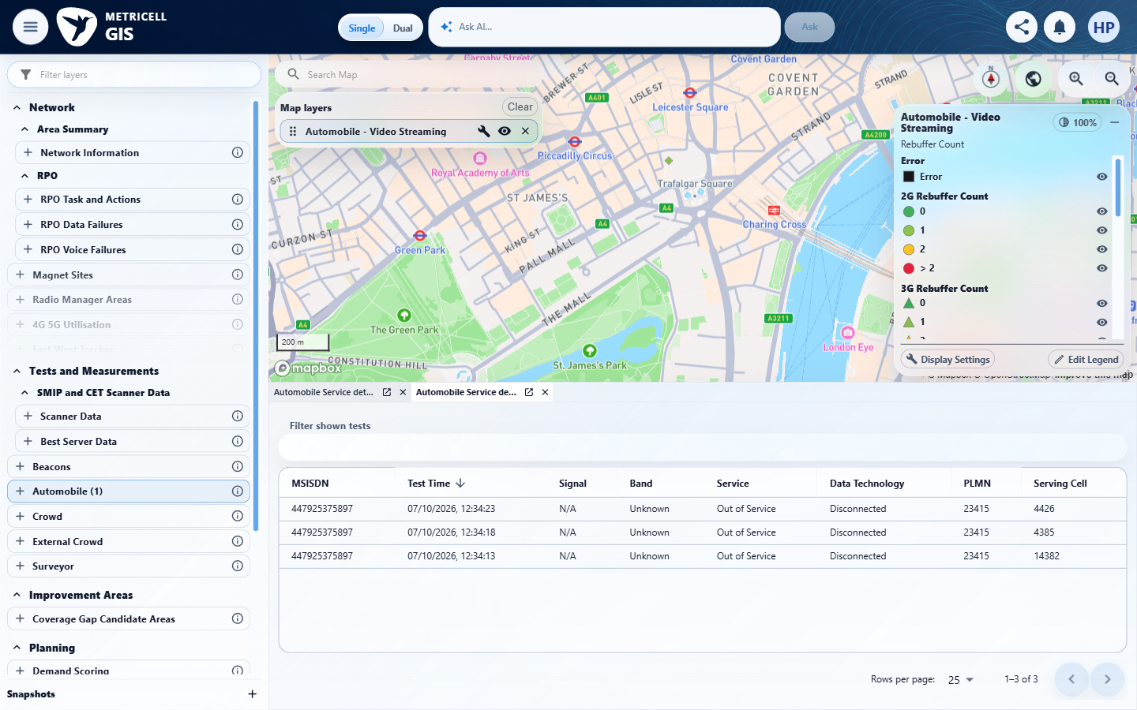

Criterion 3 continued: Given Video Streaming results are available, when the Video Streaming layer is selected, each supplied result is displayed as a selectable point on the map.
Browser URL recorded after criterion: https://o2intelligence-v4-dev.metricell.com/gis
E14 - Final (criterion-3-final.png)
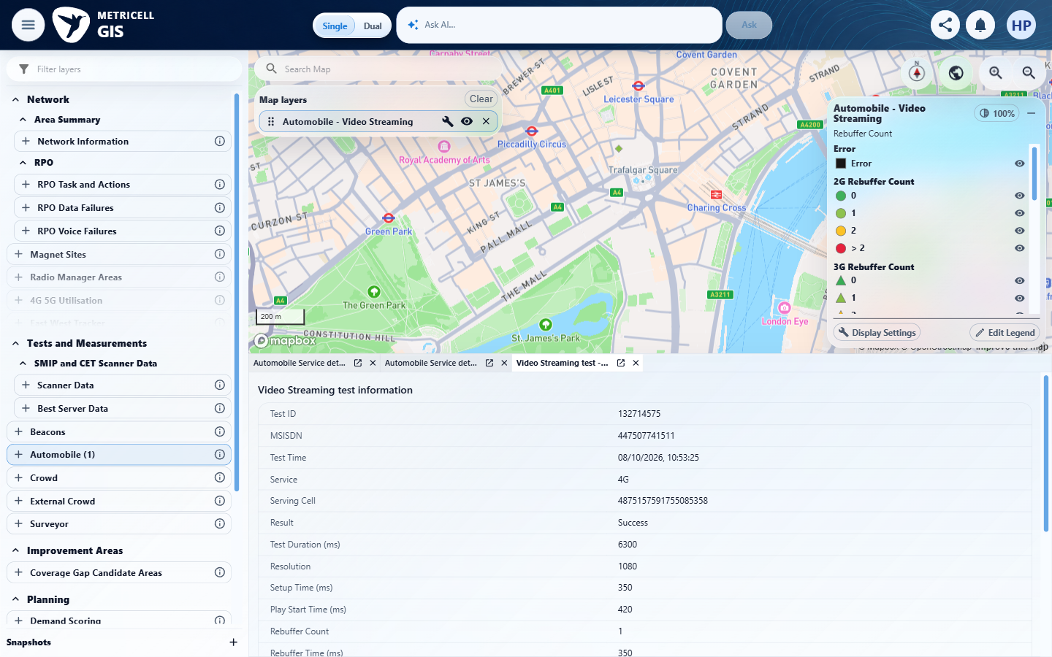

4.0.0 | Given details are available for a result point, when the point is selected, a new detail dialog opens for that same result and displays its test type, result time, location, and available network technology/context. | Given details are available for a result point, when the point is selected, a new detail dialog opens for that same result and displays its test type, result time, location, and available network technology/context. | criterion-4-before-select.png, criterion-4-http-before-select.png and criterion-4-ping-before-select.png show each type's point before its new detail tab opens. The corresponding video-top/bottom, http-top/bottom and ping-top/final captures display Video 132714575, HTTP 132714574 and Ping 132714573, each at 08/10/2026 10:53:25 UI precision. Overlapping captures show respective latitude/longitude (51.50901/-0.12941, 51.5089/-0.1293, 51.50866/-0.12906), 4G service, LTE technology, band 1800+ and serving-cell context. Recorded genuine responses support point/member correlation; readable UI fields and separate new tabs provide the visible proof. No hidden millisecond precision is assumed.  Evidence: E15, E14, E16, E17, E18, E19, E20, E21, E22, E23, E24 | Passed
Criterion 4 evidence: Given details are available for a result point, when the point is selected, a new detail dialog opens for that same result and displays its test type, result time, location, and available network technology/context.
Browser URL recorded after criterion: https://o2intelligence-v4-dev.metricell.com/gis
E15 - Before select (criterion-4-before-select.png)  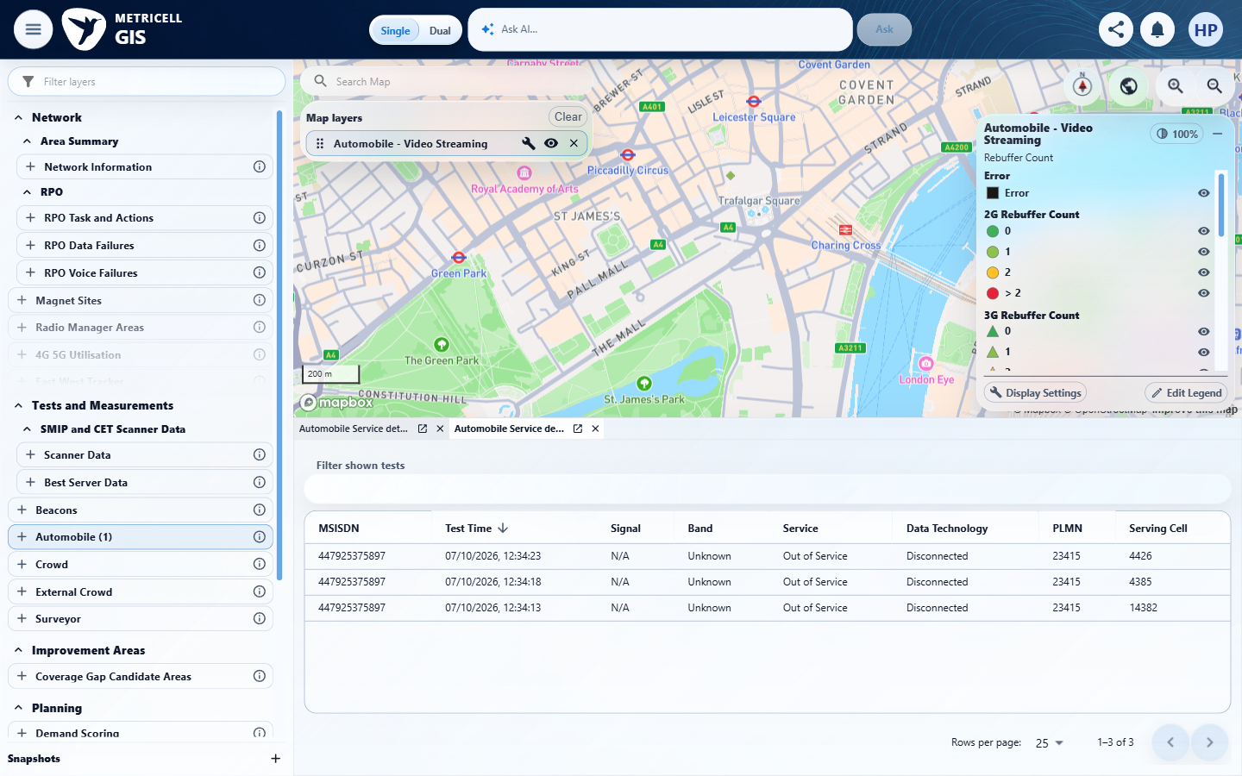 | E14 - Video top (criterion-4-video-top.png)

Criterion 4 continued: Given details are available for a result point, when the point is selected, a new detail dialog opens for that same result and displays its test type, result time, location, and available network technology/context.
Browser URL recorded after criterion: https://o2intelligence-v4-dev.metricell.com/gis
E16 - Video bottom (criterion-4-video-bottom.png)  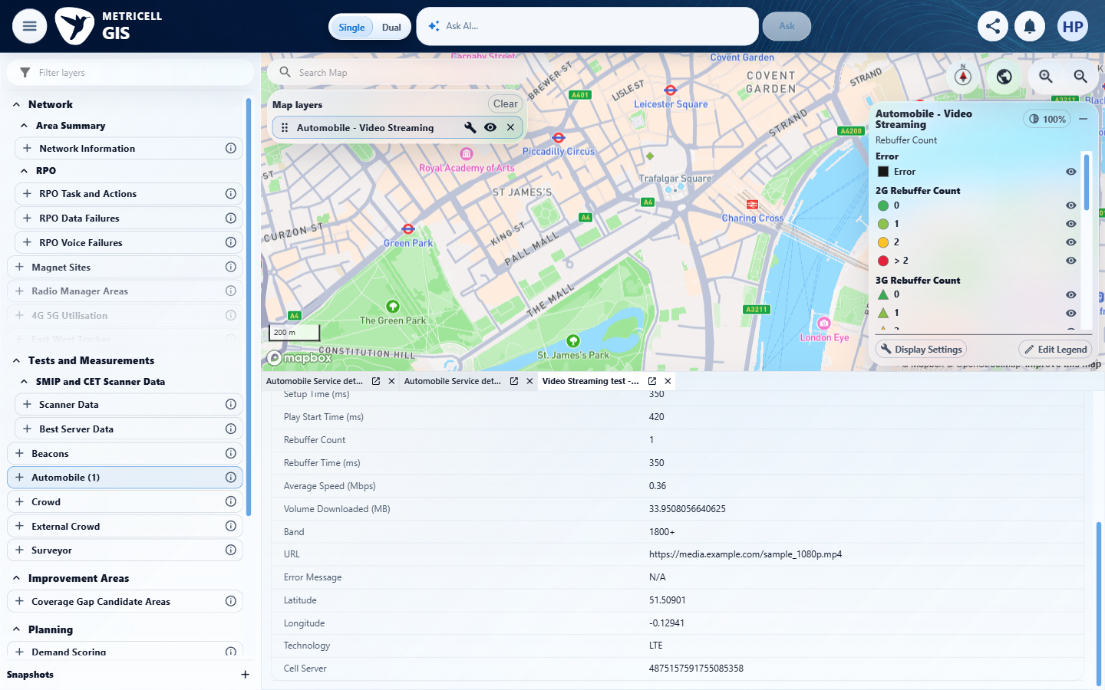 | E17 - Http configuration (criterion-4-http-configuration.png)  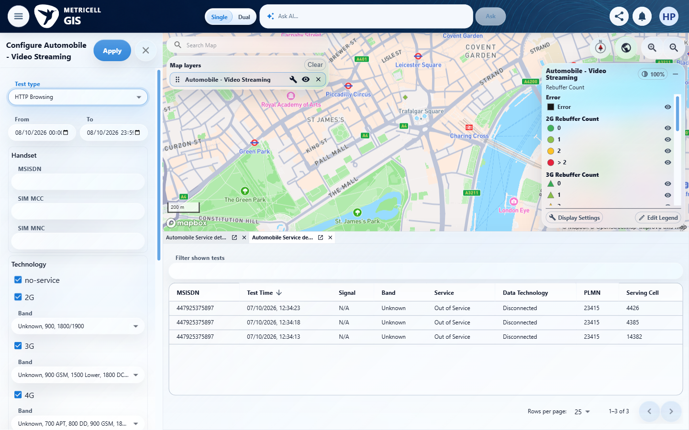

Criterion 4 continued: Given details are available for a result point, when the point is selected, a new detail dialog opens for that same result and displays its test type, result time, location, and available network technology/context.
Browser URL recorded after criterion: https://o2intelligence-v4-dev.metricell.com/gis
E18 - Http before select (criterion-4-http-before-select.png)  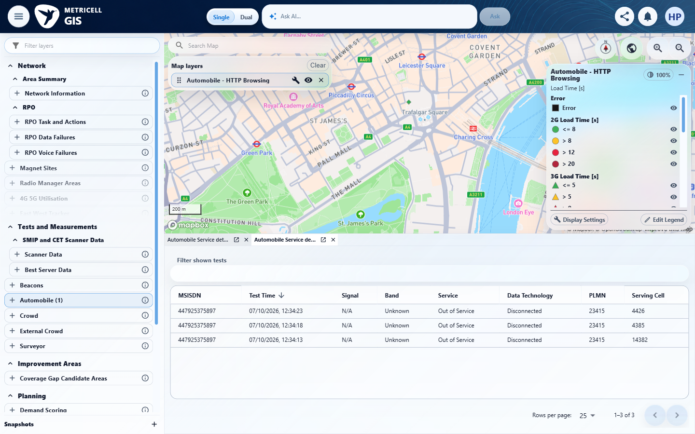 | E19 - Http top (criterion-4-http-top.png)  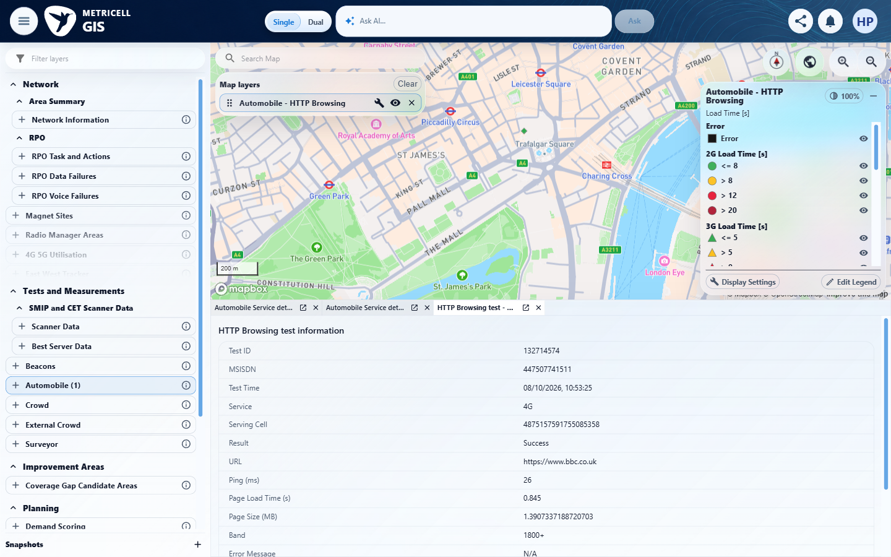

Criterion 4 continued: Given details are available for a result point, when the point is selected, a new detail dialog opens for that same result and displays its test type, result time, location, and available network technology/context.
Browser URL recorded after criterion: https://o2intelligence-v4-dev.metricell.com/gis
E20 - Http bottom (criterion-4-http-bottom.png)  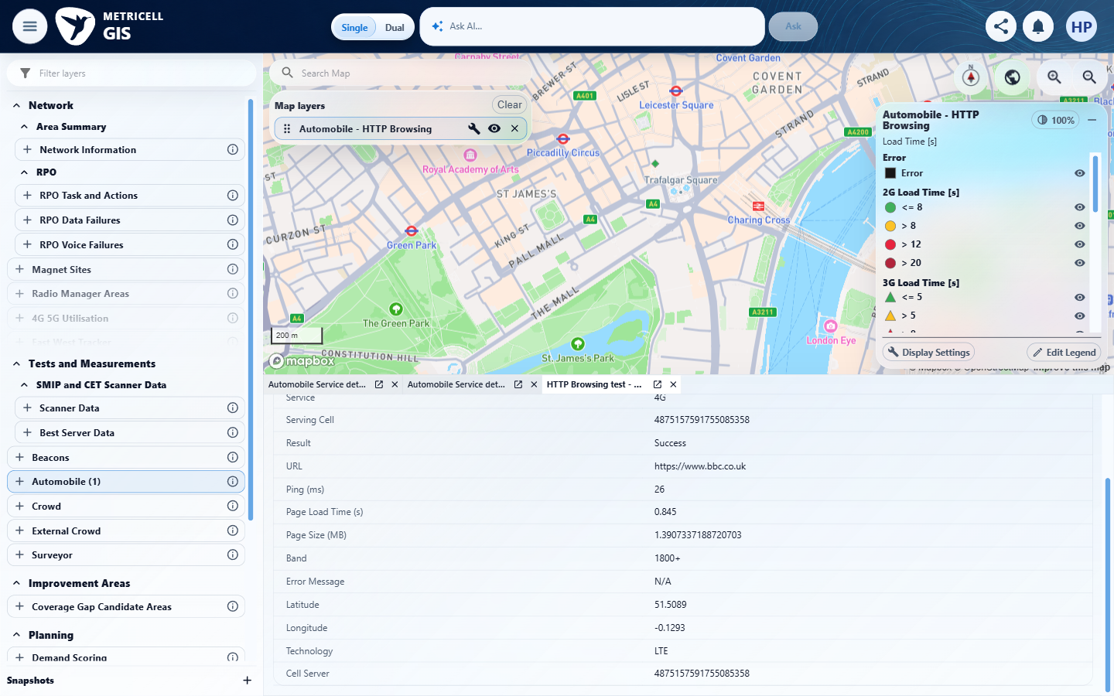 | E21 - Ping configuration (criterion-4-ping-configuration.png)  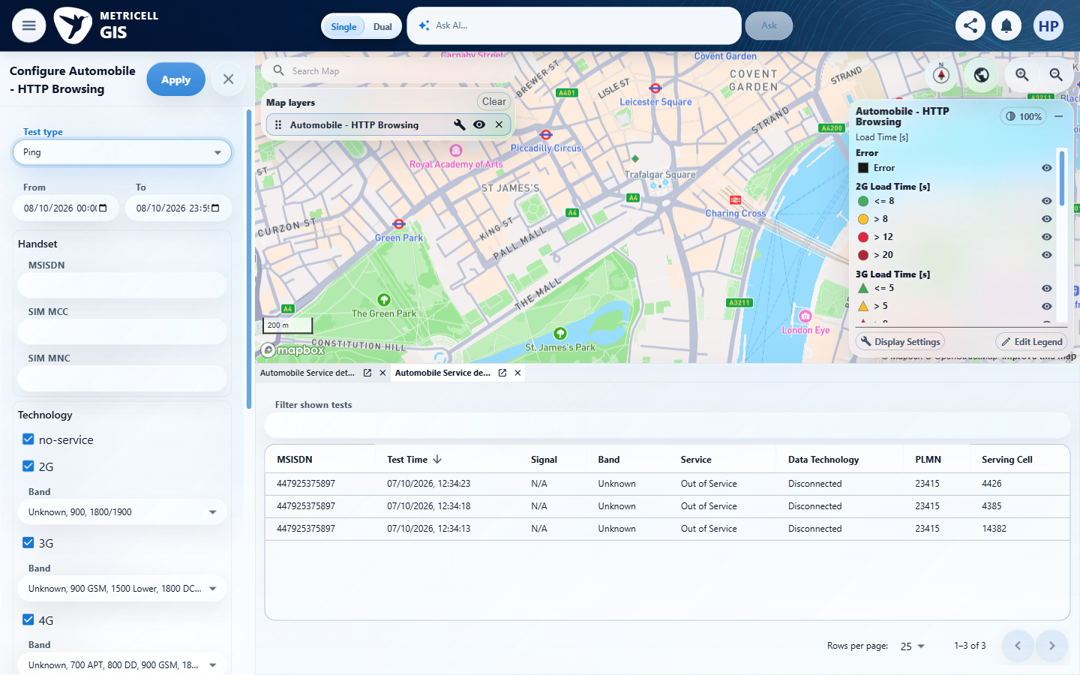

Criterion 4 continued: Given details are available for a result point, when the point is selected, a new detail dialog opens for that same result and displays its test type, result time, location, and available network technology/context.
Browser URL recorded after criterion: https://o2intelligence-v4-dev.metricell.com/gis
E22 - Ping before select (criterion-4-ping-before-select.png)  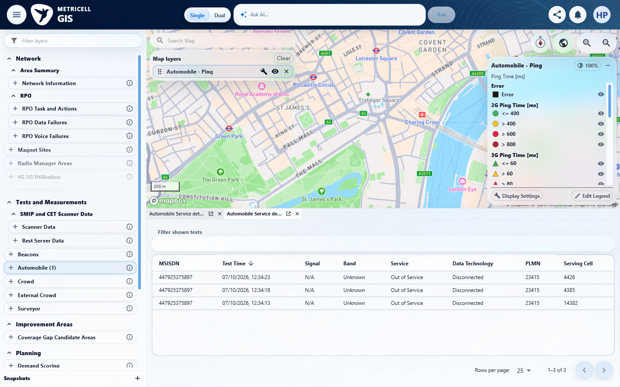 | E23 - Ping top (criterion-4-ping-top.png)  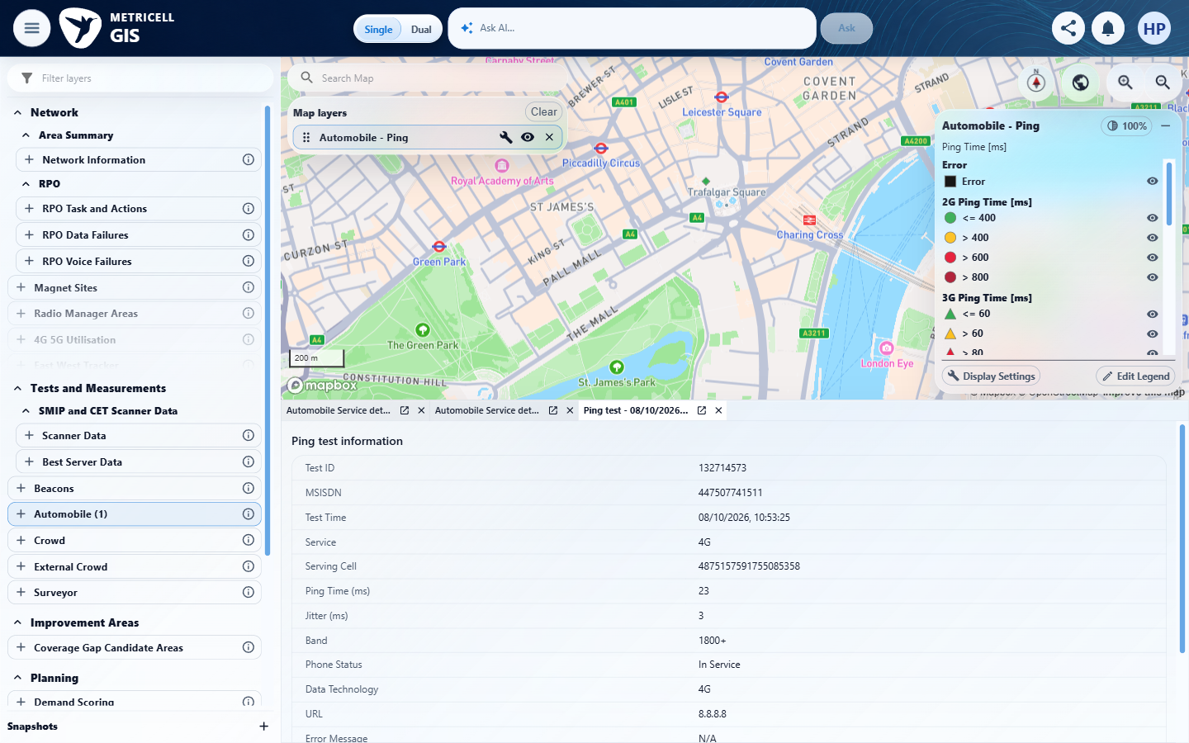

Criterion 4 continued: Given details are available for a result point, when the point is selected, a new detail dialog opens for that same result and displays its test type, result time, location, and available network technology/context.
Browser URL recorded after criterion: https://o2intelligence-v4-dev.metricell.com/gis
E24 - Final (criterion-4-final.png)
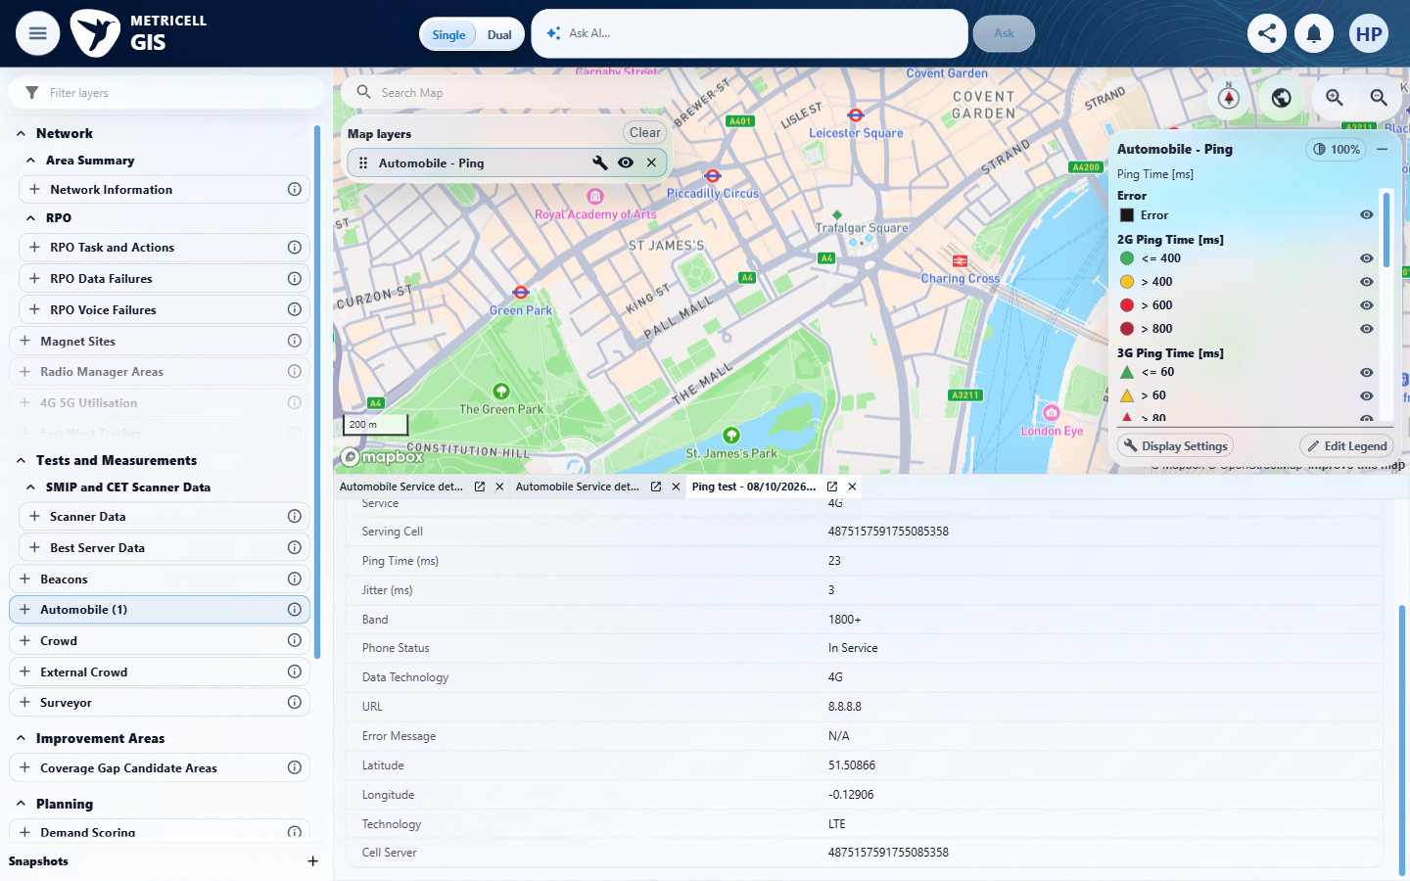

5.0.0 | Given an HTTP Browsing point is selected and its details are available, the dialog displays that result’s Page Load Time. | Given an HTTP Browsing point is selected and its details are available, the dialog displays that result’s Page Load Time. | criterion-5-before-select.png shows the HTTP Browsing point before selection, and criterion-5-final.png shows its new detail with Test ID 132714574 and Page Load Time (s) 0.845. The separate Ping (ms) field is 26; it is not mistaken for Page Load Time. Configuration and final captures retain the Automobile HTTP scope and selected record identity.  Evidence: E25, E18, E26 | Passed
Criterion 5 evidence: Given an HTTP Browsing point is selected and its details are available, the dialog displays that result’s Page Load Time.
Browser URL recorded after criterion: https://o2intelligence-v4-dev.metricell.com/gis
E25 - Configuration (criterion-5-configuration.png)  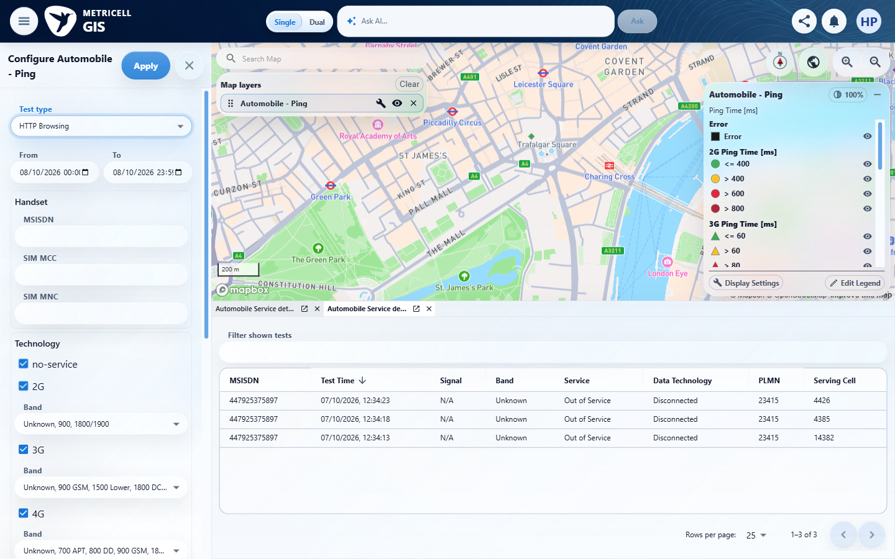 | E18 - Before select (criterion-5-before-select.png)

Criterion 5 continued: Given an HTTP Browsing point is selected and its details are available, the dialog displays that result’s Page Load Time.
Browser URL recorded after criterion: https://o2intelligence-v4-dev.metricell.com/gis
E26 - Final (criterion-5-final.png)
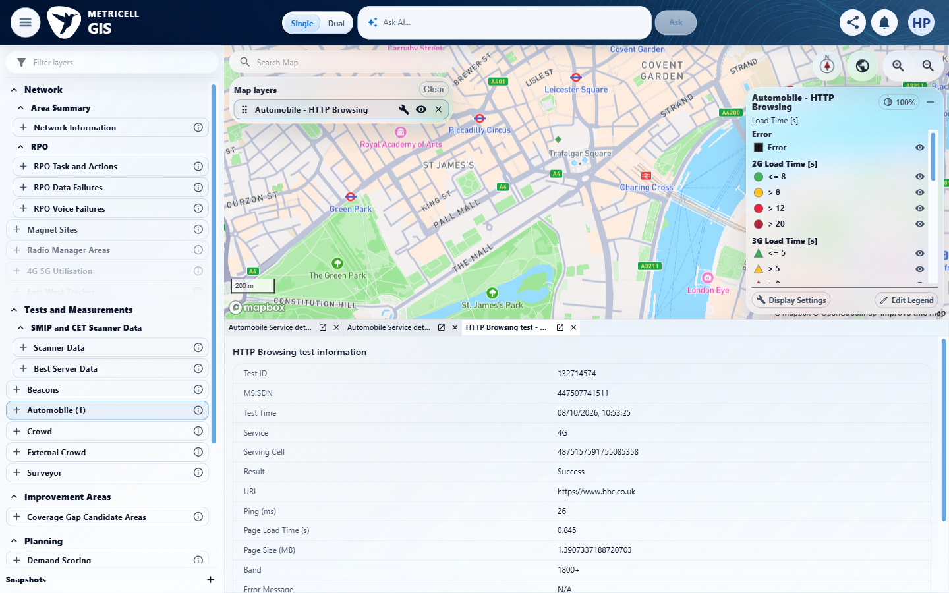

6.0.0 | Given a Ping point is selected and its details are available, the dialog displays that result’s Ping Time. | Given a Ping point is selected and its details are available, the dialog displays that result’s Ping Time. | criterion-6-configuration.png and criterion-6-before-select.png establish the Automobile Ping scope and point. criterion-6-final.png shows the new detail for Test ID 132714573 with readable Ping Time (ms) 23; the separately labelled Jitter value is 3. The displayed identity/value agree with the recorded genuine selected member.  Evidence: E27, E22, E28 | Passed
Criterion 6 evidence: Given a Ping point is selected and its details are available, the dialog displays that result’s Ping Time.
Browser URL recorded after criterion: https://o2intelligence-v4-dev.metricell.com/gis
E27 - Configuration (criterion-6-configuration.png)  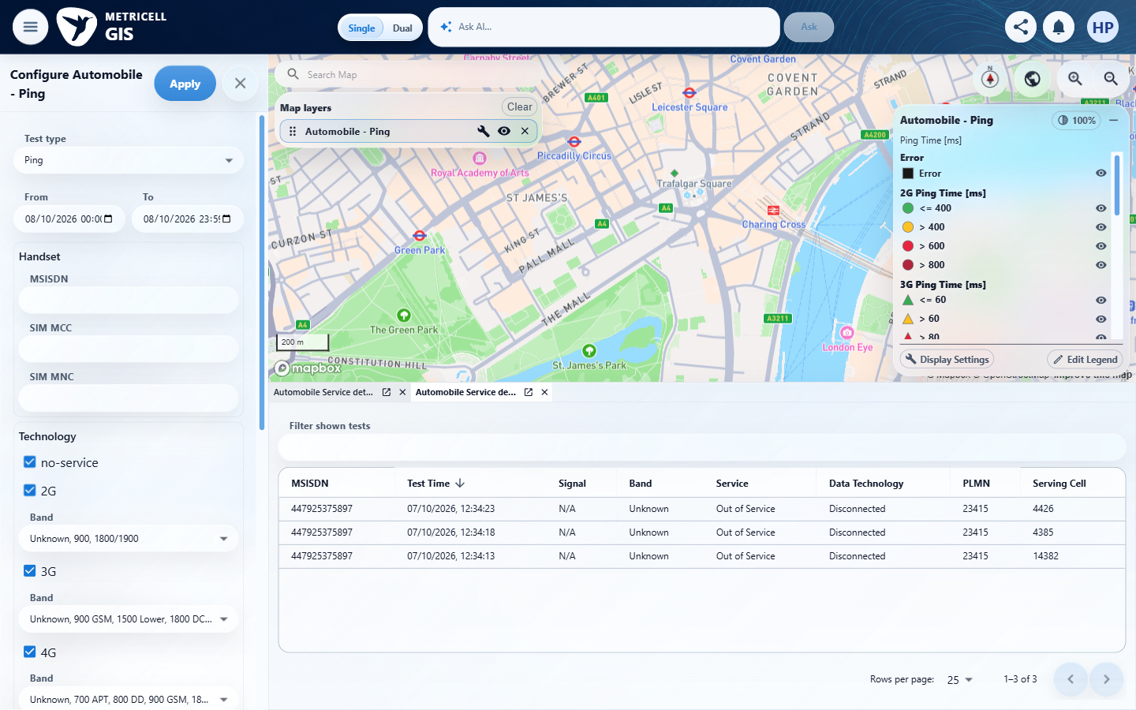 | E22 - Before select (criterion-6-before-select.png)

Criterion 6 continued: Given a Ping point is selected and its details are available, the dialog displays that result’s Ping Time.
Browser URL recorded after criterion: https://o2intelligence-v4-dev.metricell.com/gis
E28 - Final (criterion-6-final.png)
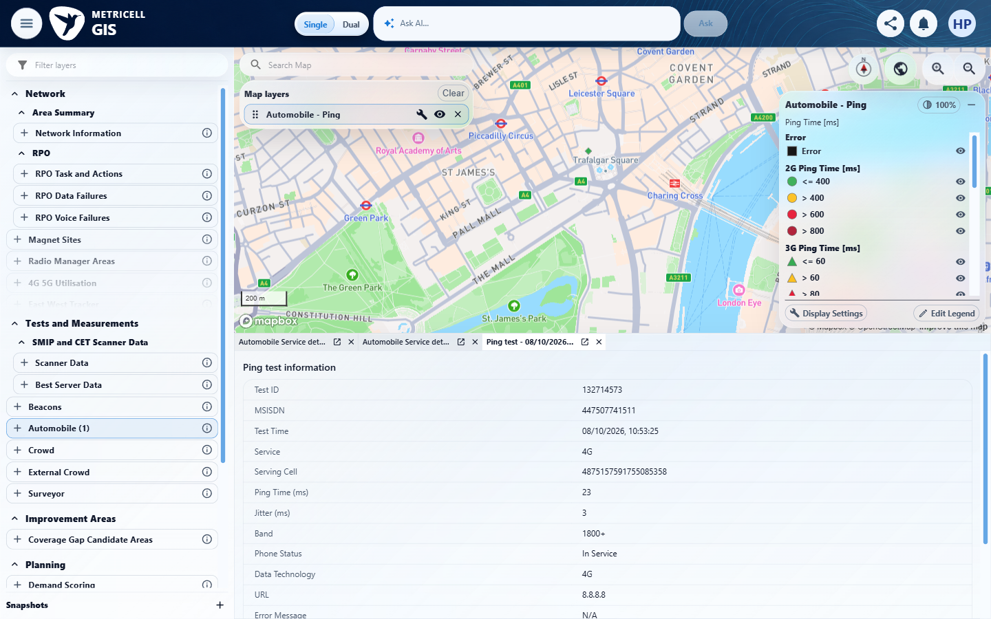

7.0.0 | Given a Video Streaming point is selected and its details are available, the dialog displays that result’s Rebuffer Count. | Given a Video Streaming point is selected and its details are available, the dialog displays that result’s Rebuffer Count. | criterion-7-configuration.png and criterion-7-before-select.png establish Automobile Video Streaming selection and its point. criterion-7-final.png shows Test ID 132714575 with readable Rebuffer Count 1; Rebuffer Time (ms) 350 is separately labelled. The selected record and value agree with the recorded genuine response.  Evidence: E12, E15, E29 | Passed
Criterion 7 evidence: Given a Video Streaming point is selected and its details are available, the dialog displays that result’s Rebuffer Count.
Browser URL recorded after criterion: https://o2intelligence-v4-dev.metricell.com/gis
E12 - Configuration (criterion-7-configuration.png) | E15 - Before select (criterion-7-before-select.png)

Criterion 7 continued: Given a Video Streaming point is selected and its details are available, the dialog displays that result’s Rebuffer Count.
Browser URL recorded after criterion: https://o2intelligence-v4-dev.metricell.com/gis
E29 - Final (criterion-7-final.png)
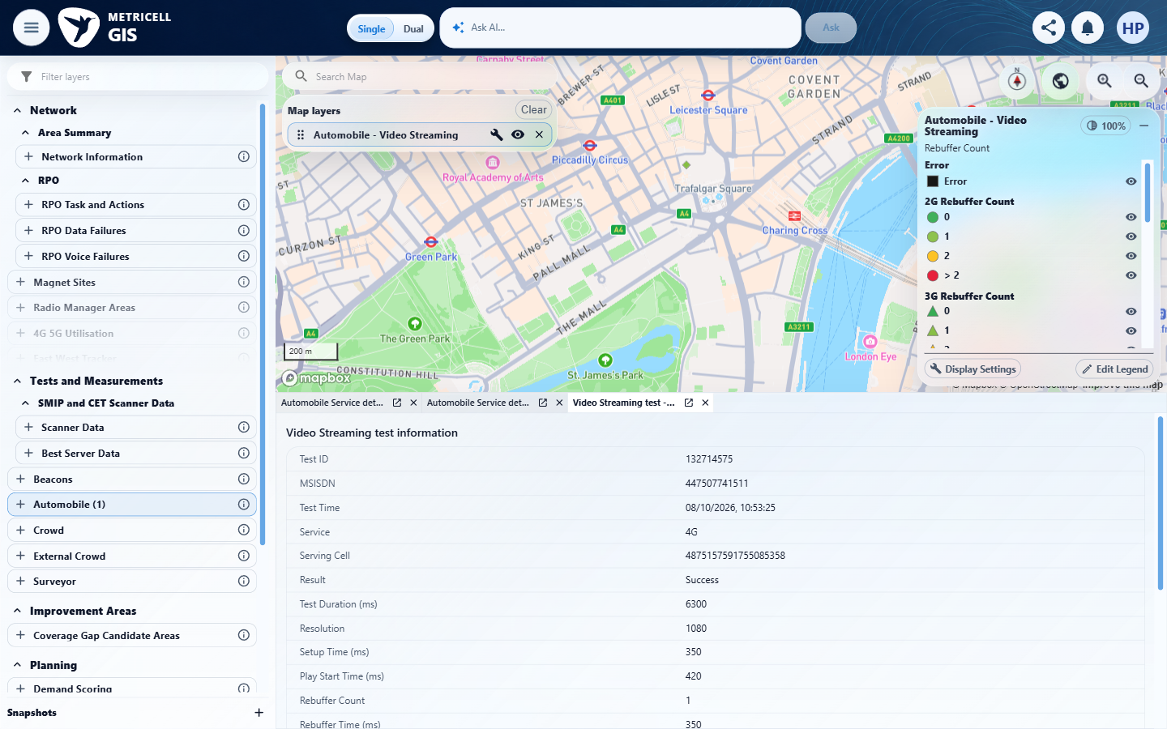

8.0.0 | Given an HTTP Browsing result ends in error, when its point is displayed, it is visually distinct from a successful result; a zero Page Load Time on the failed result is not coloured as success. | Given an HTTP Browsing result ends in error, when its point is displayed, it is visually distinct from a successful result; a zero Page Load Time on the failed result is not coloured as success. | criterion-8-success-point.png and criterion-8-success-detail.png establish a genuine successful green HTTP point, member 132714574 with Page Load Time 0.845 s. After the normal scope expansion, criterion-8-chelmsford-settled.png shows the northeast black Error square and its Error legend. criterion-8-final.png shows the selected genuine failed member 131937714, Page Load Time 0 and WebView Error. The black Error square is visibly distinct from the green successful point despite the failed result's zero value. No synthetic response was used for this criterion.  Evidence: E18, E26, E30, E31, E32 | Passed
Criterion 8 assessment: Testing notes: Within this criterion established genuine successful London HTTP record 132714574, Page Load Time 0.845 s and green diamond. Expanded normal UI date range to 30 July–28 October, searched Chelmsford and waited for settled map. Clicked black square at the northeast of the map: genuine response and detail identify record 131937714, 11 August 2026 11:21:32.307, Failed/WebView Error, Page Load Time 0, No service. Its black Error square is visibly distinct from the successful green point and matches Error legend, despite zero load time. No synthetic response used. Cleanup: owned detail tabs were closed; original Automobile Service type, original date values, technology/filter settings and two original Service detail tabs were retained/restored. Original exact map viewport was not restored; final view remains near Chelmsford after the bounded searches. No backend, Jira, credentials or authentication changes were made. Searched Chelmsford UK and waited for the settled map; captured the black square and Error legend before selection. Clicked the visible northeast black square; opened genuine record 131937714, 11 August 11:21:32.307 response / second-precision visible time, Failed, WebView Error, Page Load Time 0.
Criterion 8 evidence: Given an HTTP Browsing result ends in error, when its point is displayed, it is visually distinct from a successful result; a zero Page Load Time on the failed result is not coloured as success.
Browser URL recorded after criterion: https://o2intelligence-v4-dev.metricell.com/gis
E18 - Success point (criterion-8-success-point.png) | E26 - Success detail (criterion-8-success-detail.png)

Criterion 8 continued: Given an HTTP Browsing result ends in error, when its point is displayed, it is visually distinct from a successful result; a zero Page Load Time on the failed result is not coloured as success.
Browser URL recorded after criterion: https://o2intelligence-v4-dev.metricell.com/gis
E30 - Expanded scope (criterion-8-expanded-scope.png)  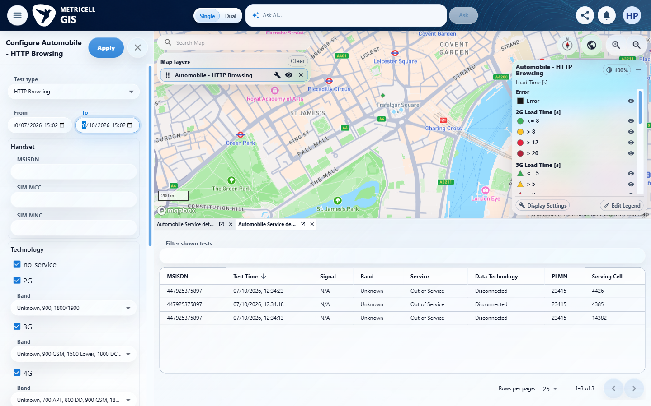 | E31 - Chelmsford settled (criterion-8-chelmsford-settled.png)  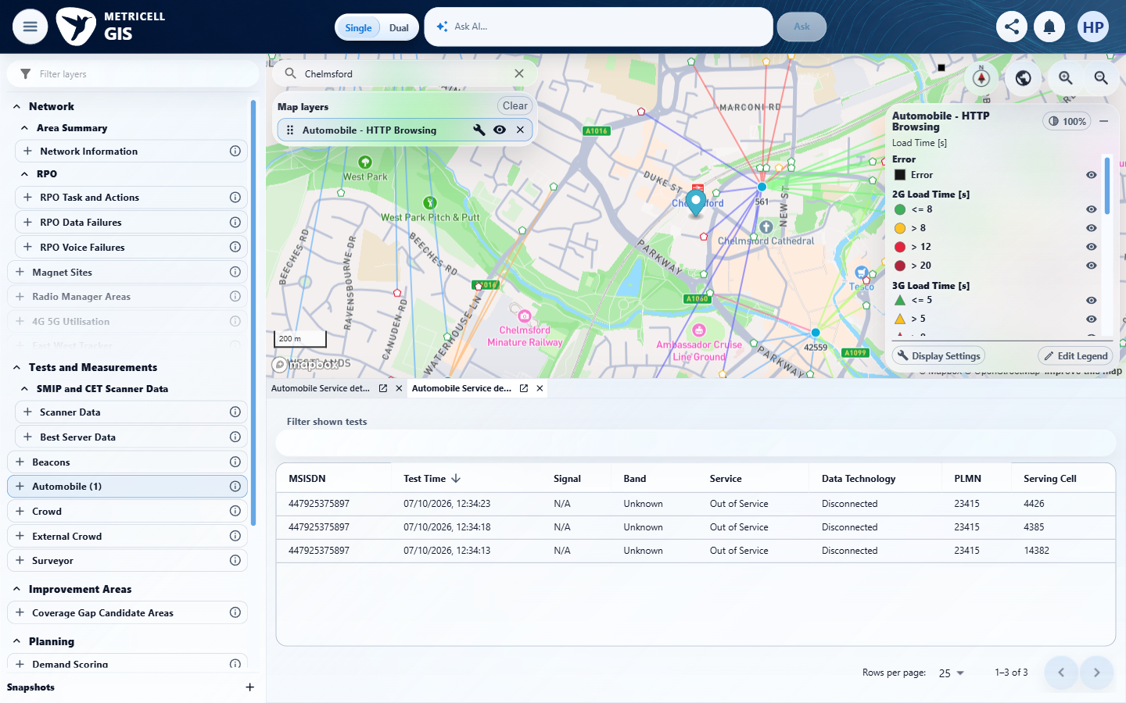

Criterion 8 continued: Given an HTTP Browsing result ends in error, when its point is displayed, it is visually distinct from a successful result; a zero Page Load Time on the failed result is not coloured as success.
Browser URL recorded after criterion: https://o2intelligence-v4-dev.metricell.com/gis
E32 - Final (criterion-8-final.png)
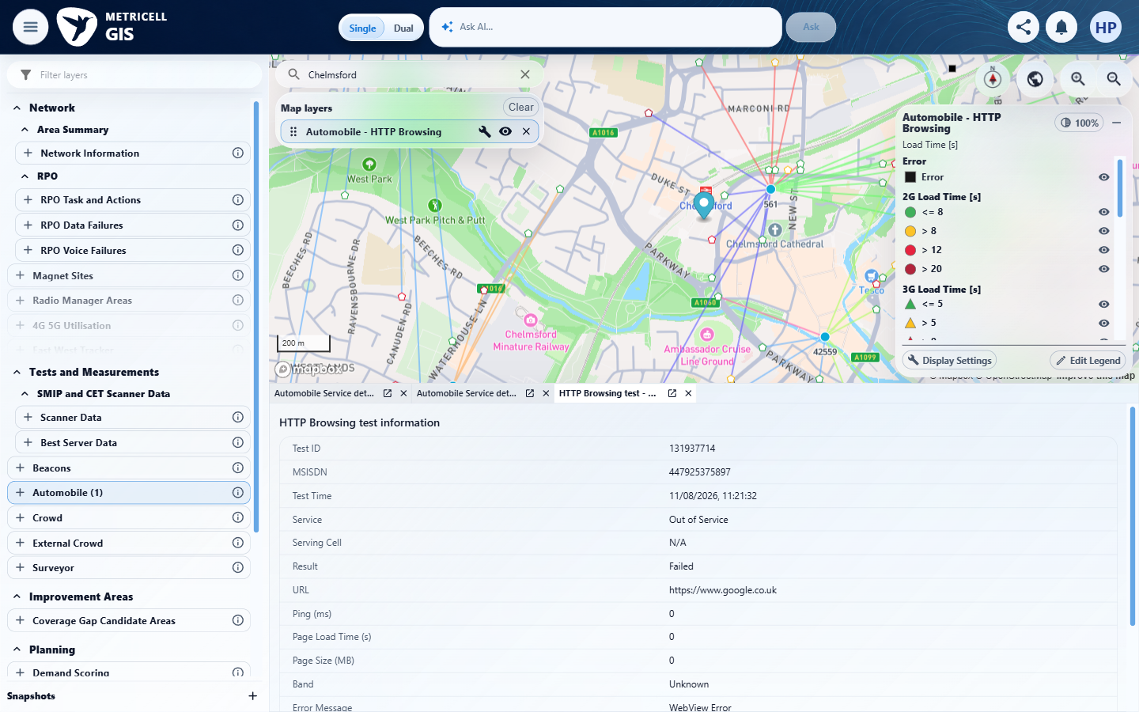

9.0.0 | Given details cannot be returned for a selected point, the user sees a clear no-data or error message and no stale details are displayed. | Given details cannot be returned for a selected point, the user sees a clear no-data or error message and no stale details are displayed. | The recorded check satisfied the criterion; see the assessment below.  Evidence: E33, E34, E35, E36, E37, E38 | Passed
Criterion 9 assessment: SIMULATED UI STATE: Delayed the selected detail request to check loading. The evidence visibly shows Unable to load point details and Retry in the active target view, with neither prior Ping detail nor target success fields; retained unrelated tabs are inactive.
Criterion 9 evidence: Given details cannot be returned for a selected point, the user sees a clear no-data or error message and no stale details are displayed.
Browser URL recorded after criterion: https://o2intelligence-v4-dev.metricell.com/gis
E33 - Final (criterion-9-final.png)  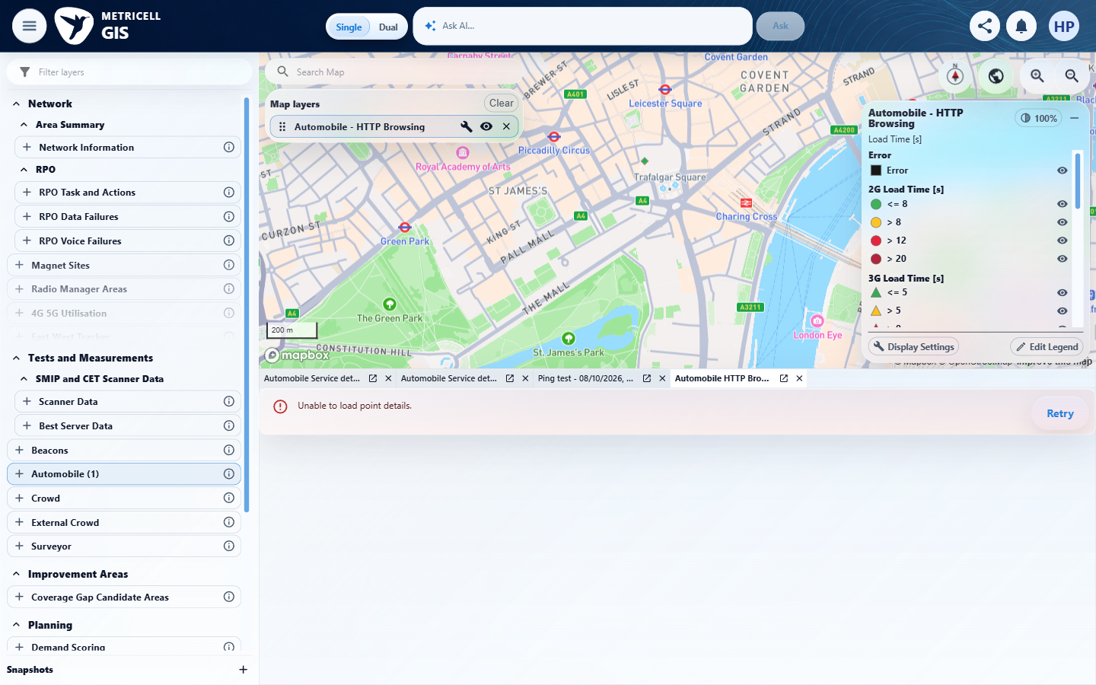 | E34 - Genuine recovery (criterion-9-genuine-recovery.png)  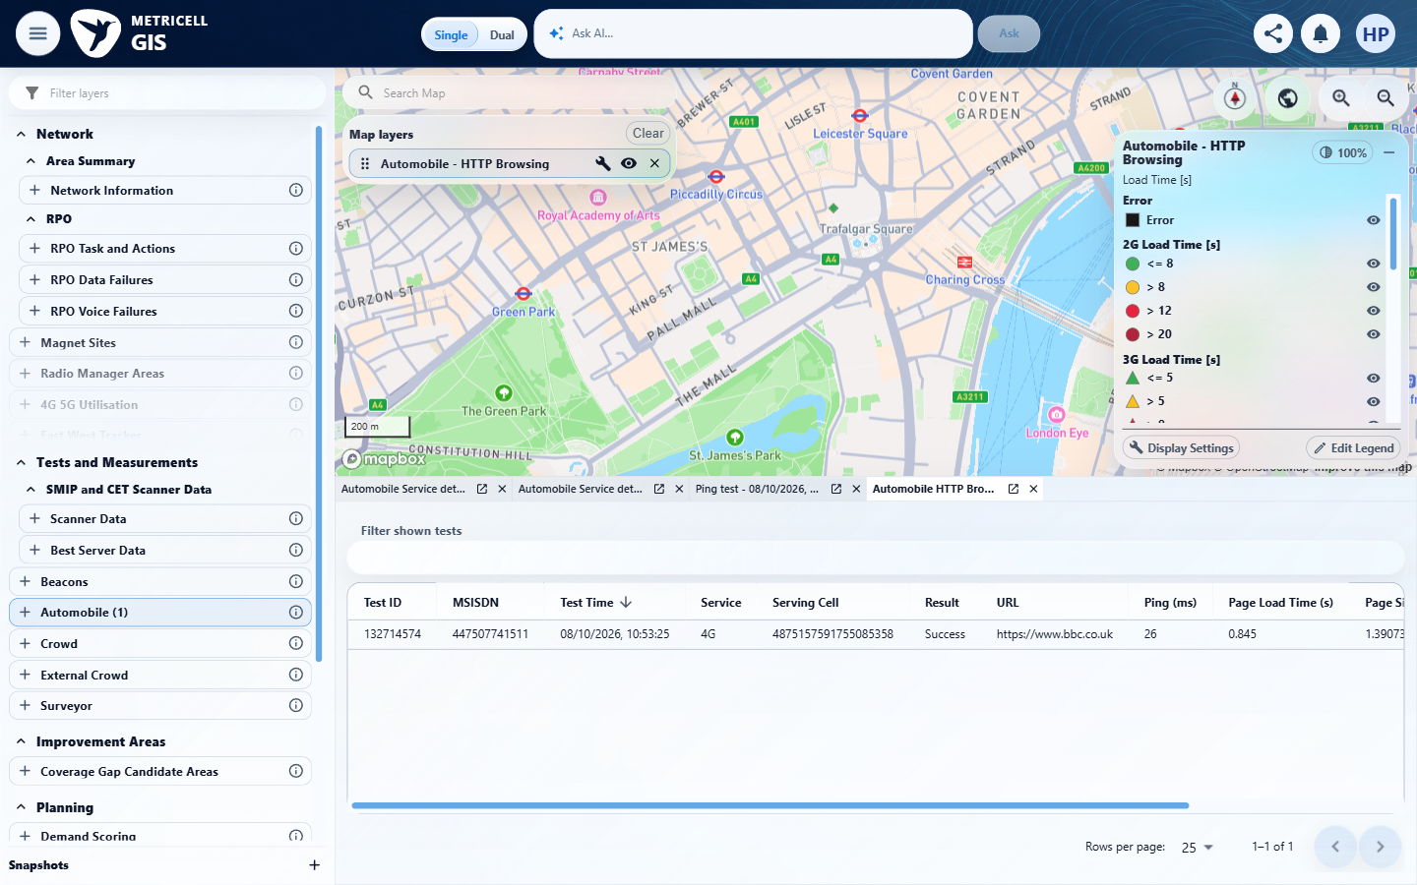

Criterion 9 continued: Given details cannot be returned for a selected point, the user sees a clear no-data or error message and no stale details are displayed.
Browser URL recorded after criterion: https://o2intelligence-v4-dev.metricell.com/gis
E35 - Distinct valid baseline (criterion-9-distinct-valid-baseline.png)  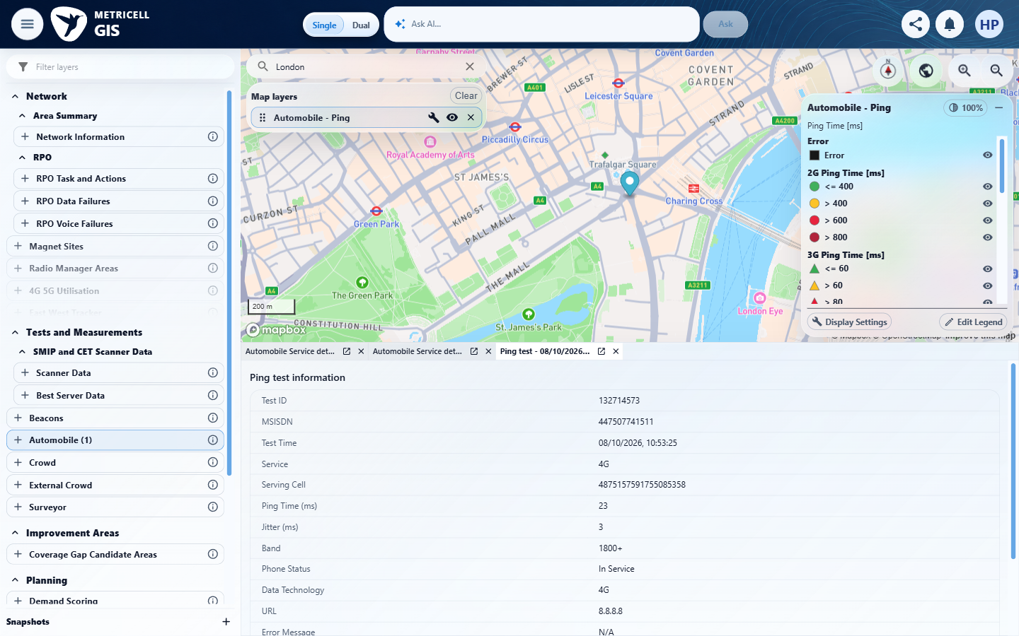 | E36 - Genuine target (criterion-9-genuine-target.png)  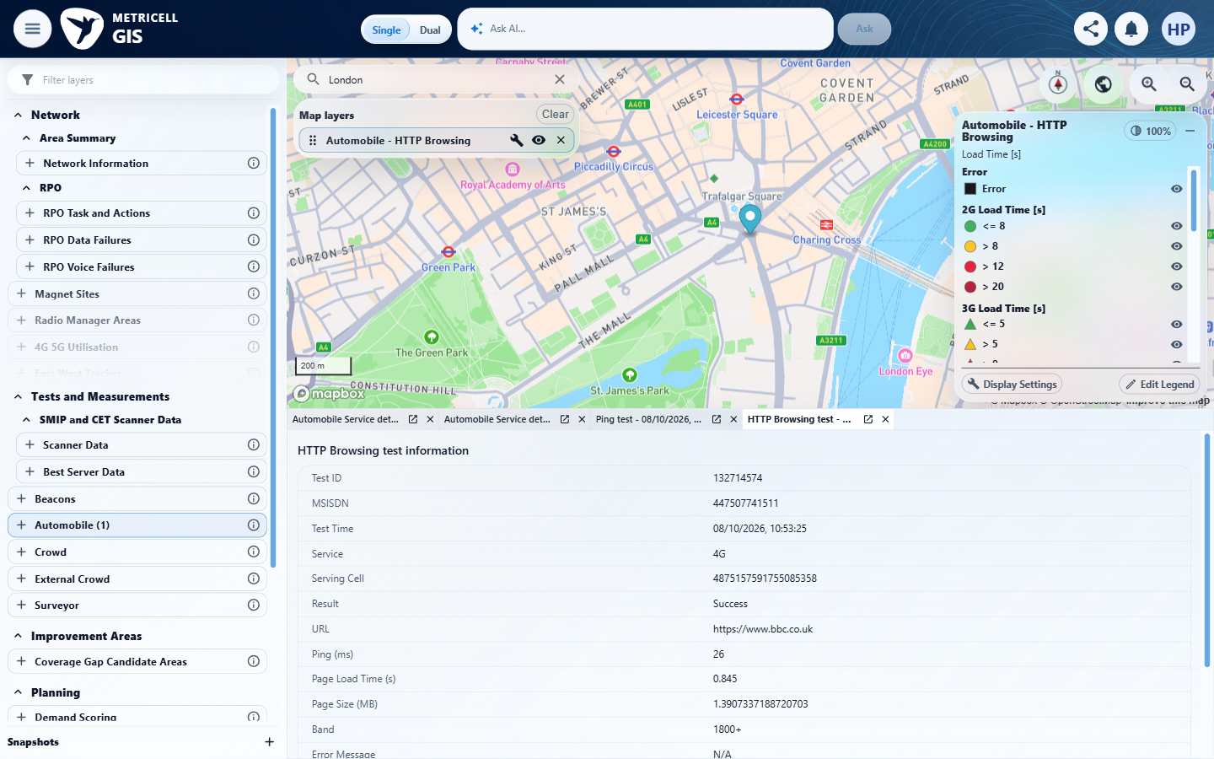

Criterion 9 continued: Given details cannot be returned for a selected point, the user sees a clear no-data or error message and no stale details are displayed.
Browser URL recorded after criterion: https://o2intelligence-v4-dev.metricell.com/gis
E37 - Before simulated error (criterion-9-before-simulated-error.png)  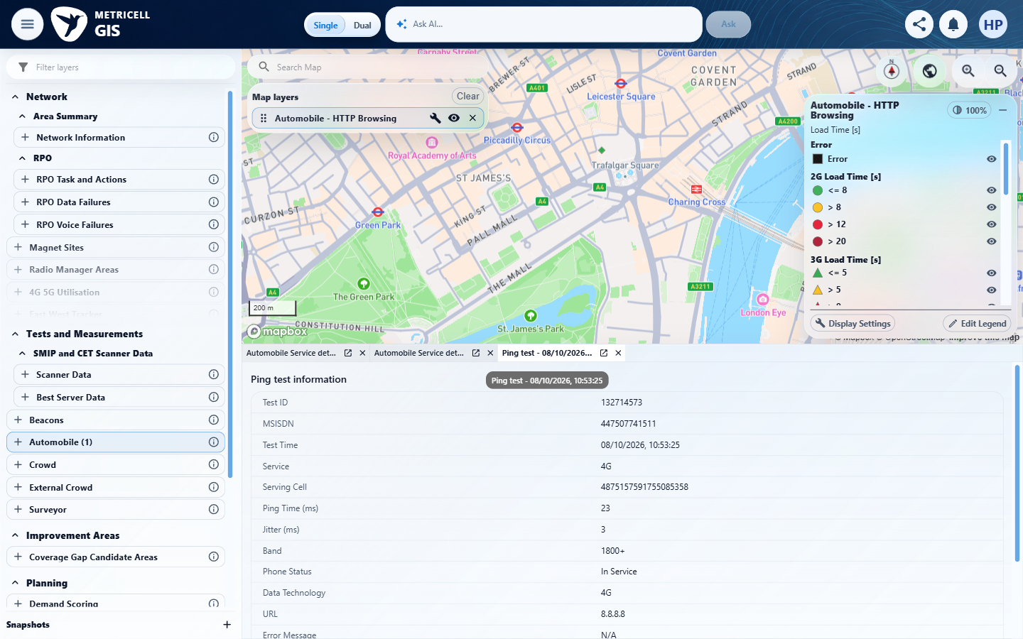 | E38 - Recovered detail (criterion-9-recovered-detail.png)  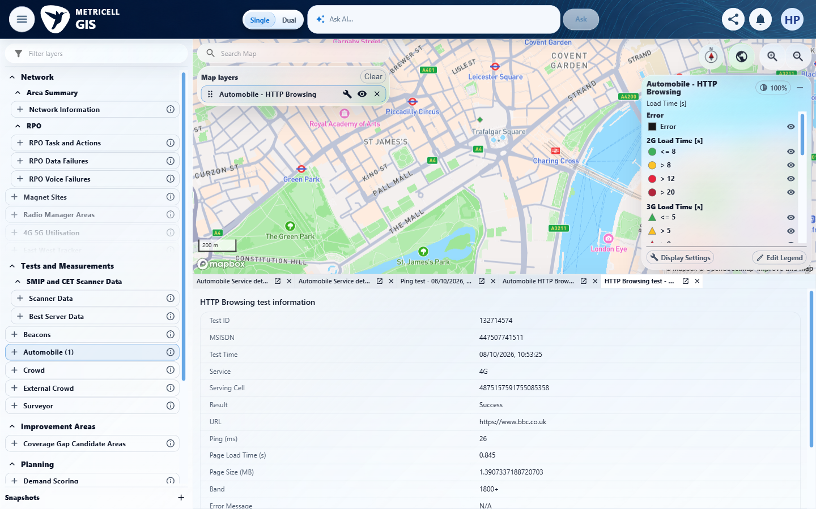

About Metricell

Metricell is on a mission to deliver connectivity. We work with our customers to design, deliver and manage wireless communication networks – with a shared ambition of achieving flawless network experience. We’ve been responsible for many first-to-market products, and our technology is characterised by the relentless pursuit of automation and digitalisation.

Our geospatial intelligence tools traverse a wide variety of business processes – from Test & Measurement to Customer Experience Management – and we’re pioneers in Crowdsourcing and Digital Self Care. Our technology is today in use by a range of customers; thousands of their personnel; and millions of subscribers worldwide.

Find out more at www.metricell.com




