

Automated Test Case Document
Jira Ticket: TEST2-89

Document Classification: | Company Confidential
Document Ref: | Automated Test Case Document
Version: | 1.0
Date: | 23/10/2026
Document Author: | Automated TEST2 Evidence Review
Document Owner: | Quality Assurance / Metricell




This document and its content is copyright of Metricell Limited @ 2026 all rights reserved. All information contained herein is the intellectual property of Metricell Limited and should be treated as confidential. Any external redistribution of reproduction of part or all of the contents in any form is prohibited unless expressly agreed with Metricell Limited in writing. Any reproduced content must include the following statement; “Part or all of the content contained herein is copyright of Metricell Limited @ 2026 all rights reserved”.
Table of Contents
1 Revision History 2
2 Test Cycle Information 3
3 Test Summary 3
4 Test Cases 4
About Metricell 12

Revision History

Version | Date | Revision Author | Summary of Changes
[1.0] | 23/10/2026 | TEST2 QA Automation | Generated from TEST2 evidence review

Test Cycle Information

Tester: | Automated
Jira Ticket: | TEST2-89
Environment: | o2intelligence-v4-dev.metricell.com
Browser Details: | Google Chrome 156.0.8078.48
Date of Test: | 23/10/2026
Limitations during Testing: | Blocked criterion(s): 2, 3, 4, 5, 6, 7, 8, 9, 10, 11, 12, 13, 14. See the assessment below each criterion. Pass, Fail and Blocked use Y/N. Defect No counts directly contradicted criteria, not unique Jira bugs; blockers and inconclusive evidence count as zero.
Overall review outcome: | Blocked
Browser URL(s) recorded after criteria: | https://o2intelligence-v4-dev.metricell.com/gis

Test Summary

Area of test | Pass (Y/N) | Fail (Y/N) | Blocked (Y/N) | Defect No
1. Before selecting the MS Teams Call layer, the map shows no MS Teams Call test-result points. | Y | N | N | 0
2. When the user selects the MS Teams Call layer and authorised matching results are available, each matching result is shown as a selectable map point. | N | N | Y | 0
3. For a displayed MS Teams Call point with Poor Quality 0–0.99, its map colour is Green. | N | N | Y | 0
4. For a displayed MS Teams Call point with Poor Quality 1–9.99, its map colour is Yellow. | N | N | Y | 0
5. For a displayed MS Teams Call point with Poor Quality 10–24.99, its map colour is Amber. | N | N | Y | 0
6. For a displayed MS Teams Call point with Poor Quality 25 or greater, its map colour is Red. | N | N | Y | 0
7. When the user selects a map point and its details load successfully, the details dialog displays Test ID, Test Result, Connection Time, Call Duration, Poor Quality, MSISDN and Test Technologies. | N | N | Y | 0
8. When the user selects a map point and its details load successfully, the details dialog displays signal and download charts and shows handover markers when available. | N | N | Y | 0
9. When the user selects a map point and its details load successfully, the details dialog displays a detailed-sample table that omits label, latitude, longitude and handover-only columns. | N | N | Y | 0
10. When detailed samples are displayed, sorting a supported column changes their displayed order to match the selected sort. | N | N | Y | 0
11. When detailed samples are displayed, filtering a supported column limits the displayed samples to those matching the filter. | N | N | Y | 0
12. When the user exports a selected test as CSV, the exported CSV contains data for that selected test. | N | N | Y | 0
13. When a zero-duration result is selected, its details dialog does not display stale or misleading data. | N | N | Y | 0
14. When details for a selected result fail to load, the dialog does not display stale or misleading data. | N | N | Y | 0

Test Cases
Each test maps to a criterion and decisive browser evidence. Inconclusive results are reported as Failed.

Tests

Preconditions: | V4 access and ticket conditions. | Associated Requirements: | Ticket criteria below. | Automation Notes: | Screenshots below each criterion; full log retained locally.
ID / Criterion | Criteria Tested | Expected Result | Actual Result / Evidence Path | Outcome
1.0.0 | Before selecting the MS Teams Call layer, the map shows no MS Teams Call test-result points. | Before selecting the MS Teams Call layer, the map shows no MS Teams Call test-result points. | criterion-1-before-configure.png and criterion-1-final.png show the sole active layer Automobile - Ping, its Ping legend and Ping test 131926379; no MS Teams Call points are displayed. criterion-1-choices.png shows MS Teams Call as a separate nested Automobile test type, still unselected.  Evidence: E01, E02, E03, E04 | Passed
Criterion 1 assessment: criterion-1-before-configure.png and criterion-1-final.png show the sole active layer Automobile - Ping, its Ping legend and Ping test 131926379; no MS Teams Call points are displayed. criterion-1-choices.png shows MS Teams Call as a separate nested Automobile test type, still unselected.
Criterion 1 evidence: Before selecting the MS Teams Call layer, the map shows no MS Teams Call test-result points.
Browser URL recorded after criterion: https://o2intelligence-v4-dev.metricell.com/gis
E01 - Before configure (criterion-1-before-configure.png)  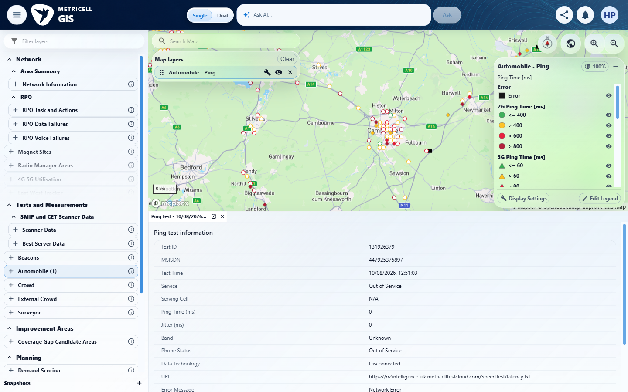 | E02 - Configuration (criterion-1-configuration.png)  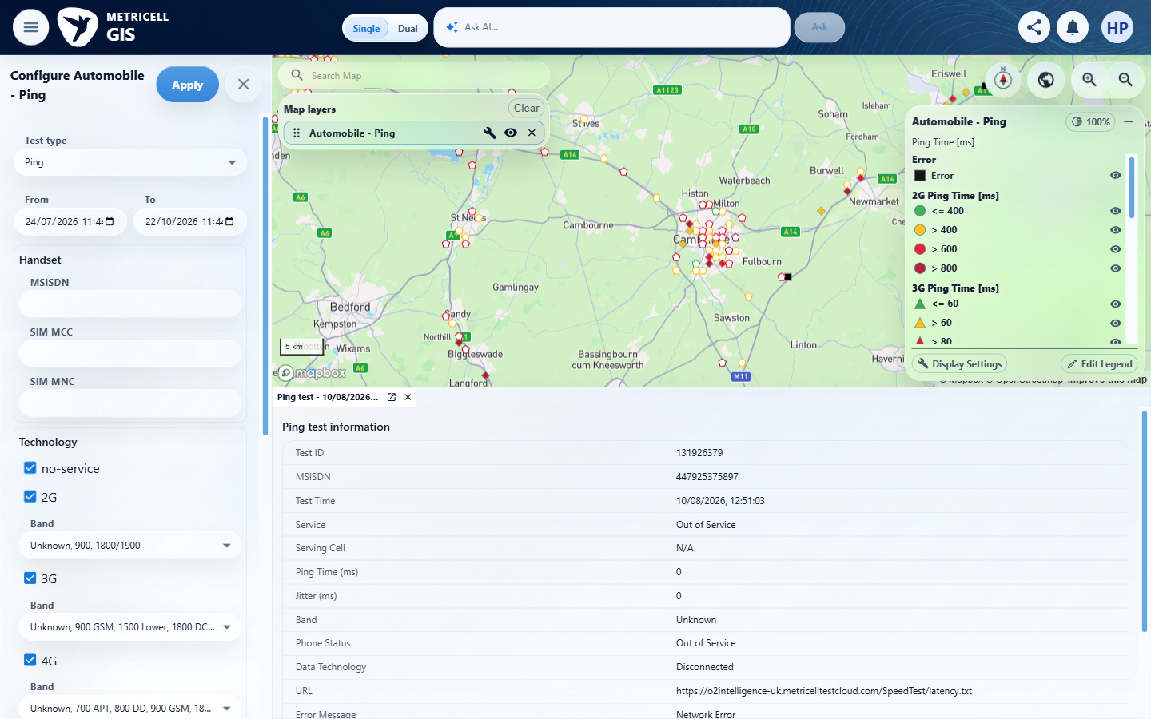

Criterion 1 continued: Before selecting the MS Teams Call layer, the map shows no MS Teams Call test-result points.
Browser URL recorded after criterion: https://o2intelligence-v4-dev.metricell.com/gis
E03 - Choices (criterion-1-choices.png)  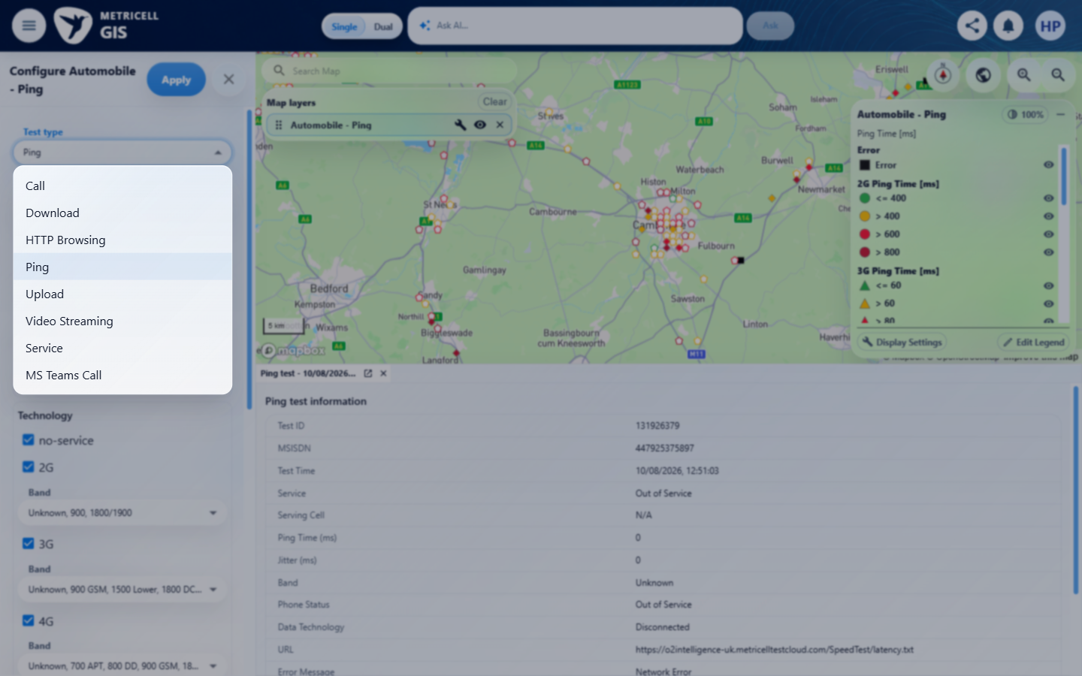 | E04 - Final (criterion-1-final.png)  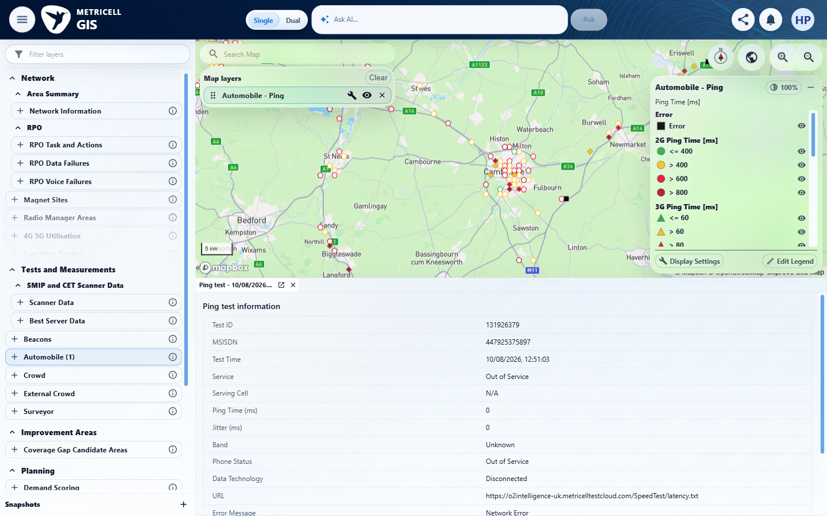

2.0.0 | When the user selects the MS Teams Call layer and authorised matching results are available, each matching result is shown as a selectable map point. | When the user selects the MS Teams Call layer and authorised matching results are available, each matching result is shown as a selectable map point. | criterion-2-before-apply.png shows MS Teams Call selected in Automobile configuration; criterion-2-final.png shows the applied Automobile - MS Teams Call layer and no plotted results. Tester records GET /api/platform/automobile/ms-teams-call/points returning HTTP 200 with [] for the Cambridge/St Neots/Bedford/Sandy viewport and 24 July–22 October 2026 filters. No matching record was available to exercise each-result selection or reconcile populated points/cluster members; availability outside this scope is unknown.  Evidence: E05, E06, E07, E08, E09 | Blocked
Criterion 2 assessment: criterion-2-before-apply.png shows MS Teams Call selected in Automobile configuration; criterion-2-final.png shows the applied Automobile - MS Teams Call layer and no plotted results. Tester records GET /api/platform/automobile/ms-teams-call/points returning HTTP 200 with [] for the Cambridge/St Neots/Bedford/Sandy viewport and 24 July–22 October 2026 filters. No matching record was available to exercise each-result selection or reconcile populated points/cluster members; availability outside this scope is unknown.
Testing notes: GET /api/platform/automobile/ms-teams-call/points completed with HTTP 200 and body [] in the inspected scope. This is a settled empty dataset, not an HTTP error or missing module. No matching MS Teams Call test identity was available to select. Existing Cambridge/St Neots/Bedford/Sandy map viewport (centre approximately 0.1355,52.2242; zoom 9.04), ten requested tiles; From 2026-07-24T10:44:00.000Z to 2026-10-22T10:44:00.000Z (UI 11:44 BST). Existing handset/network filters retained, MSISDN/SIM MCC/SIM MNC/MCC/MNC/LAC/CI/site/cell blank, all existing technology/band selections retained; deviceGroupAll=false. Records outside this scope were not established. The pre-existing tab is explicitly Ping test 131926379 and was preserved, not treated as MS Teams evidence.
Criterion 2 evidence: When the user selects the MS Teams Call layer and authorised matching results are available, each matching result is shown as a selectable map point.
Browser URL recorded after criterion: https://o2intelligence-v4-dev.metricell.com/gis
E05 - Before configure (criterion-2-before-configure.png)  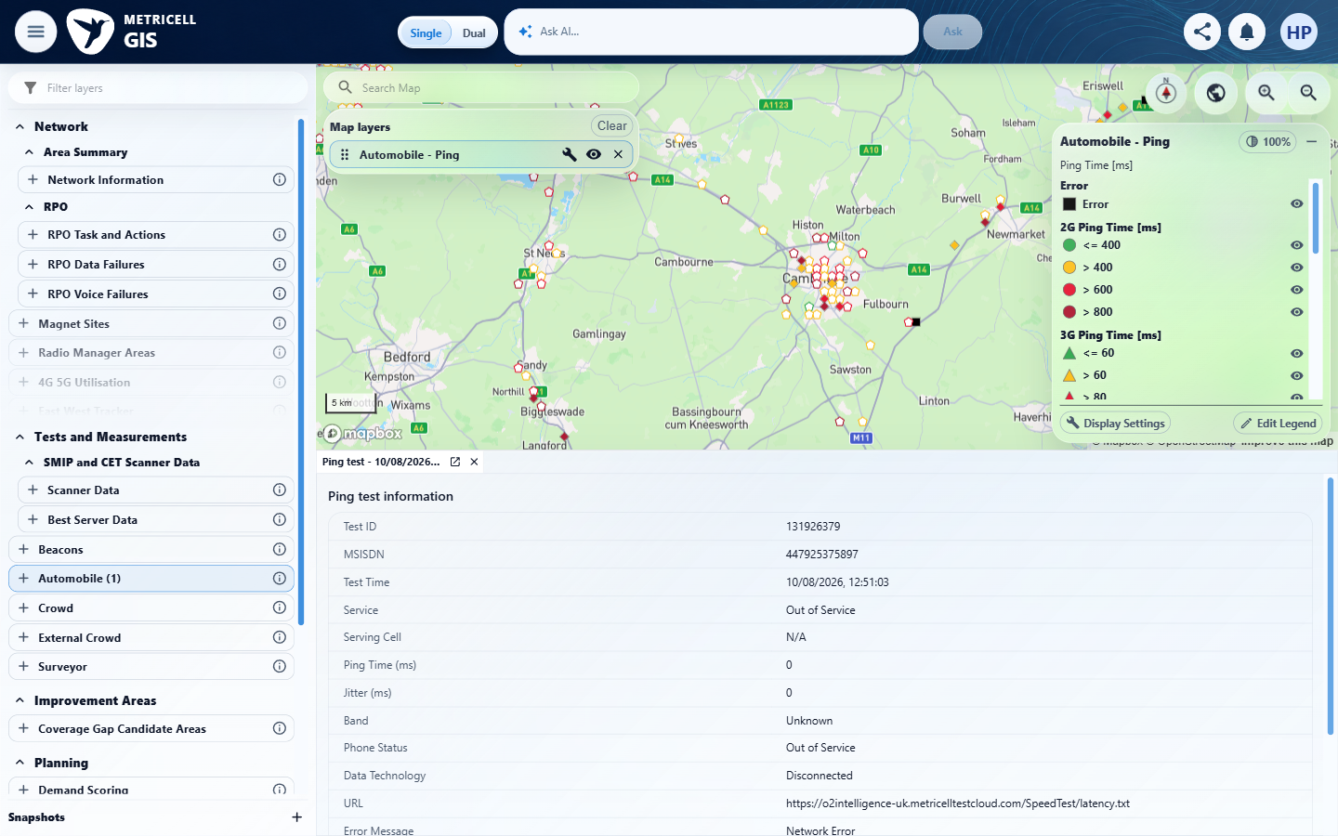 | E06 - Configuration (criterion-2-configuration.png)  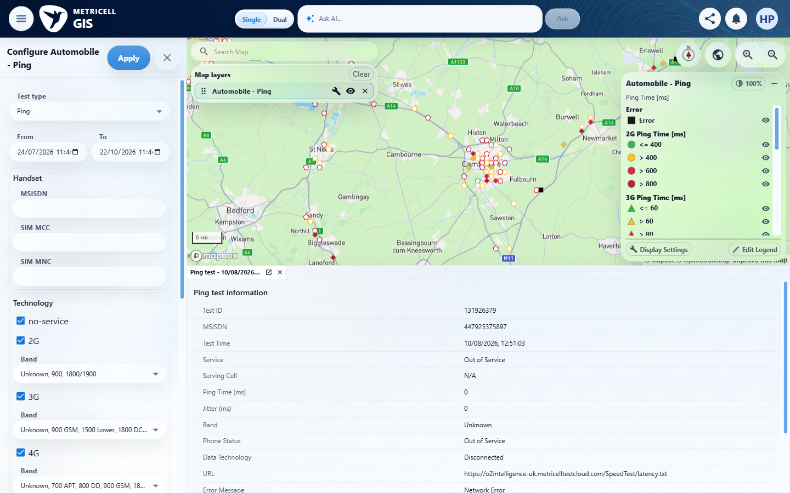

Criterion 2 continued: When the user selects the MS Teams Call layer and authorised matching results are available, each matching result is shown as a selectable map point.
Browser URL recorded after criterion: https://o2intelligence-v4-dev.metricell.com/gis
E07 - Choices (criterion-2-choices.png)  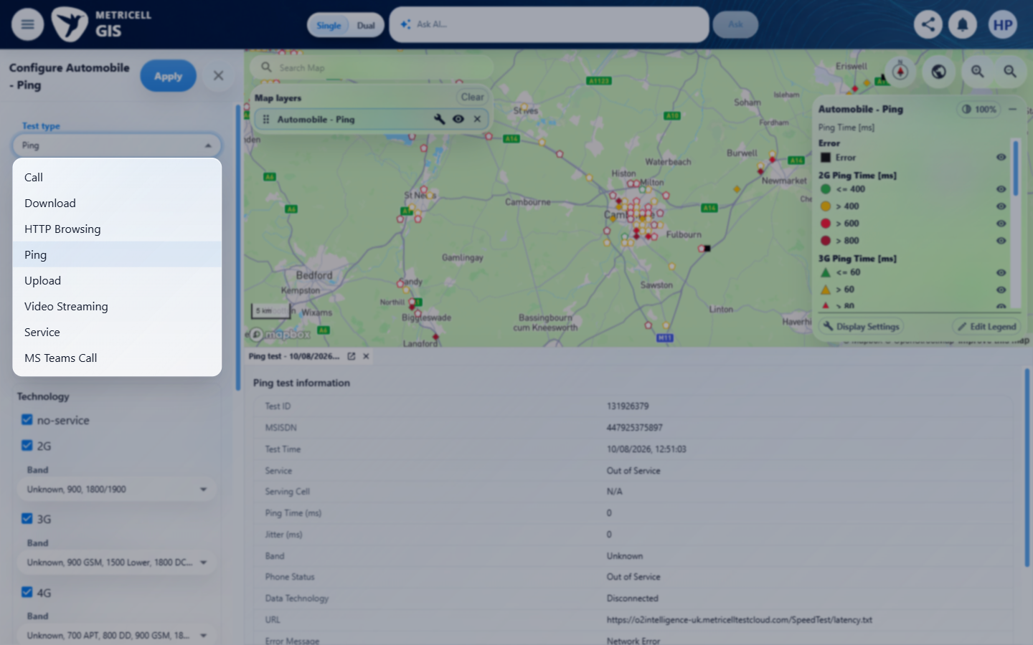 | E08 - Before apply (criterion-2-before-apply.png)  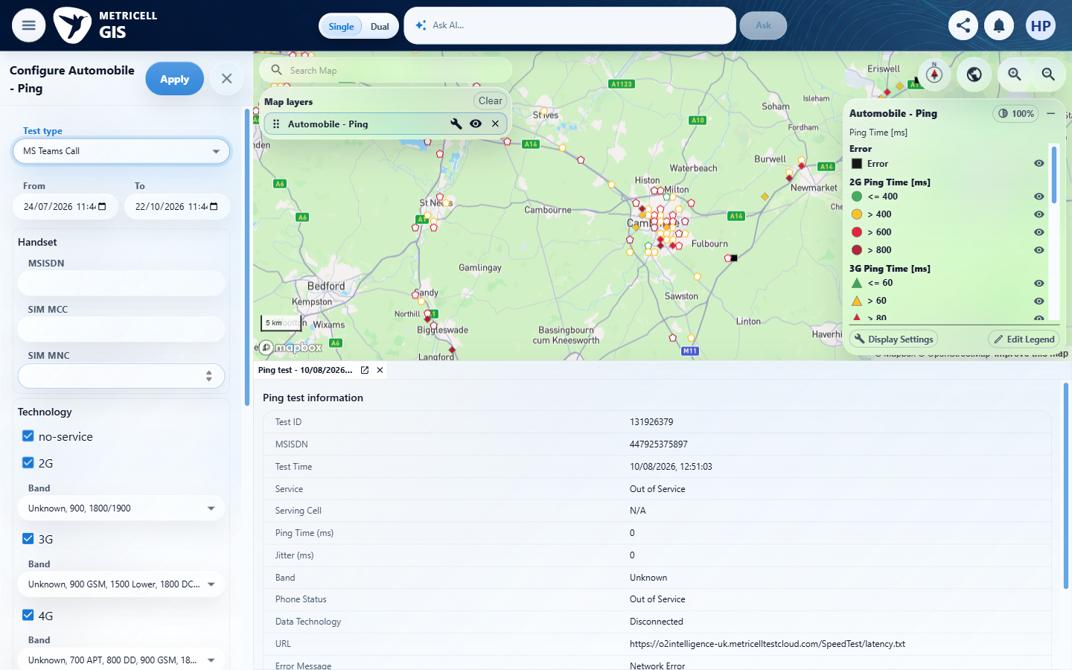

Criterion 2 continued: When the user selects the MS Teams Call layer and authorised matching results are available, each matching result is shown as a selectable map point.
Browser URL recorded after criterion: https://o2intelligence-v4-dev.metricell.com/gis
E09 - Final (criterion-2-final.png)
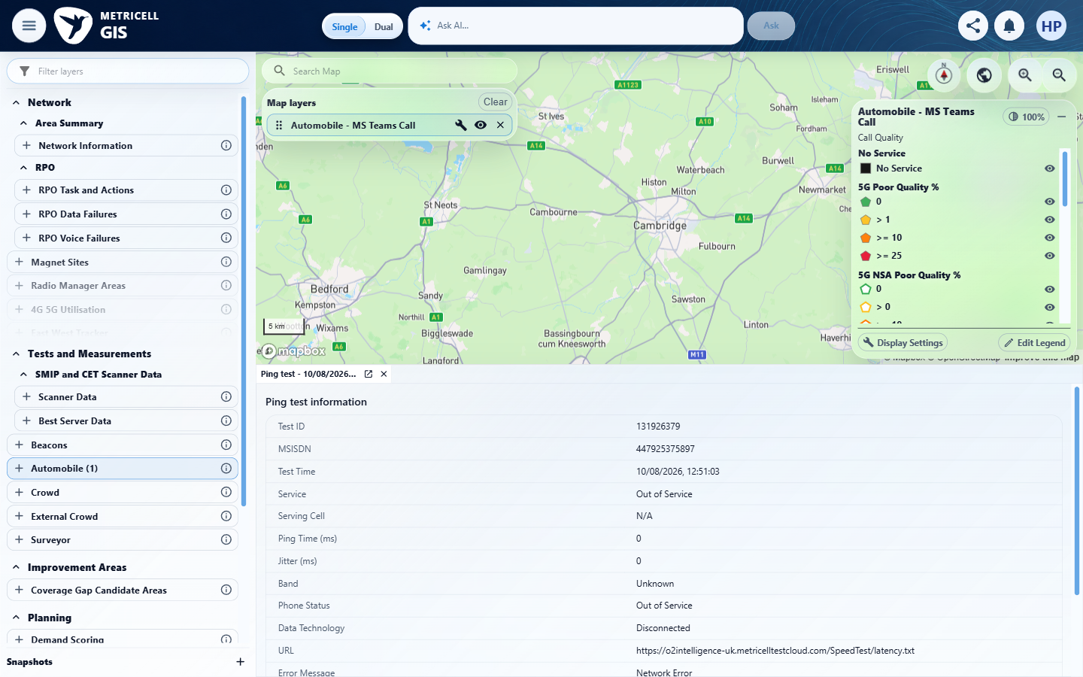

3.0.0 | For a displayed MS Teams Call point with Poor Quality 0–0.99, its map colour is Green. | For a displayed MS Teams Call point with Poor Quality 0–0.99, its map colour is Green. | criterion-3-final.png shows the Automobile - MS Teams Call layer without plotted results. Tester records HTTP 200 with [] in the inspected Cambridge-area viewport and 24 July–22 October 2026 filters. No known Poor Quality 0–0.99 result is available to verify Green on an actual map point; the legend alone does not establish the criterion.  Evidence: E10, E11, E12, E08, E13 | Blocked
Criterion 3 assessment: criterion-3-final.png shows the Automobile - MS Teams Call layer without plotted results. Tester records HTTP 200 with [] in the inspected Cambridge-area viewport and 24 July–22 October 2026 filters. No known Poor Quality 0–0.99 result is available to verify Green on an actual map point; the legend alone does not establish the criterion.
Testing notes: GET /api/platform/automobile/ms-teams-call/points completed with HTTP 200 and body [] in the inspected scope. This is a settled empty dataset, not an HTTP error or missing module. No matching MS Teams Call test identity was available to select. Existing Cambridge/St Neots/Bedford/Sandy map viewport (centre approximately 0.1355,52.2242; zoom 9.04), ten requested tiles; From 2026-07-24T10:44:00.000Z to 2026-10-22T10:44:00.000Z (UI 11:44 BST). Existing handset/network filters retained, MSISDN/SIM MCC/SIM MNC/MCC/MNC/LAC/CI/site/cell blank, all existing technology/band selections retained; deviceGroupAll=false. Records outside this scope were not established. The pre-existing tab is explicitly Ping test 131926379 and was preserved, not treated as MS Teams evidence.
Criterion 3 evidence: For a displayed MS Teams Call point with Poor Quality 0–0.99, its map colour is Green.
Browser URL recorded after criterion: https://o2intelligence-v4-dev.metricell.com/gis
E10 - Before configure (criterion-3-before-configure.png)  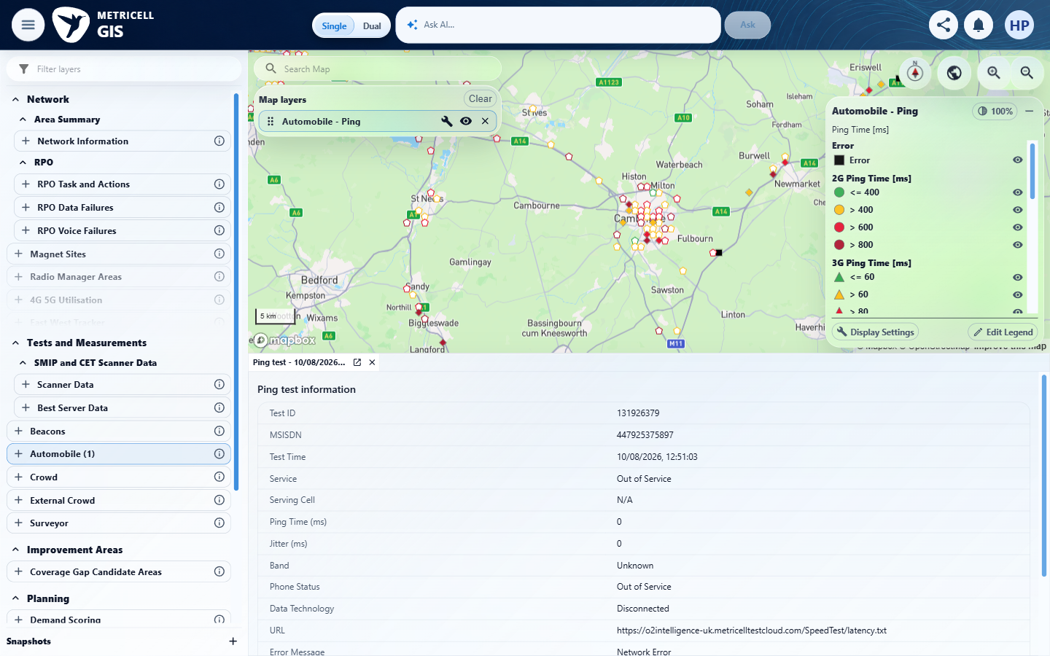 | E11 - Configuration (criterion-3-configuration.png)  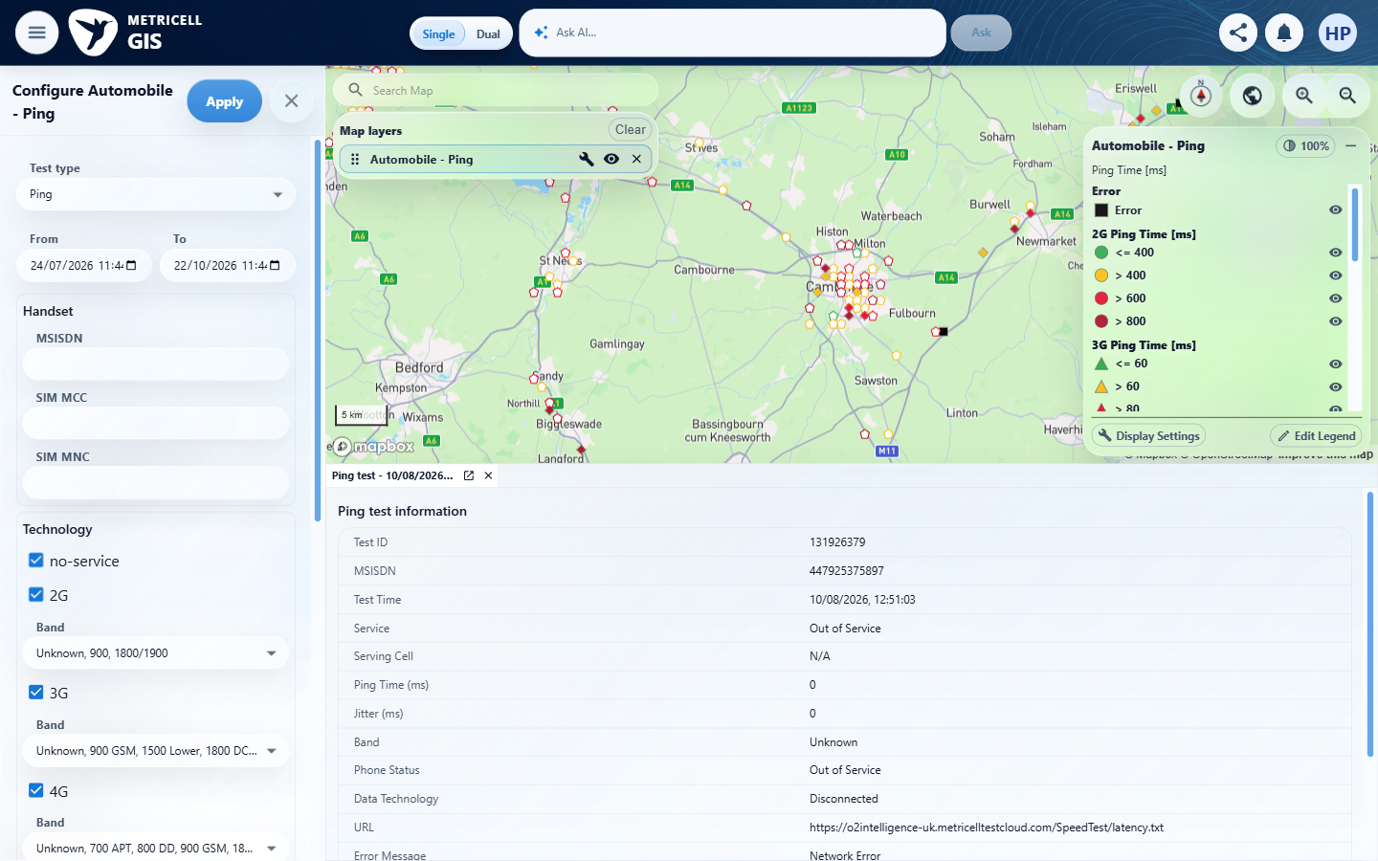

Criterion 3 continued: For a displayed MS Teams Call point with Poor Quality 0–0.99, its map colour is Green.
Browser URL recorded after criterion: https://o2intelligence-v4-dev.metricell.com/gis
E12 - Choices (criterion-3-choices.png)  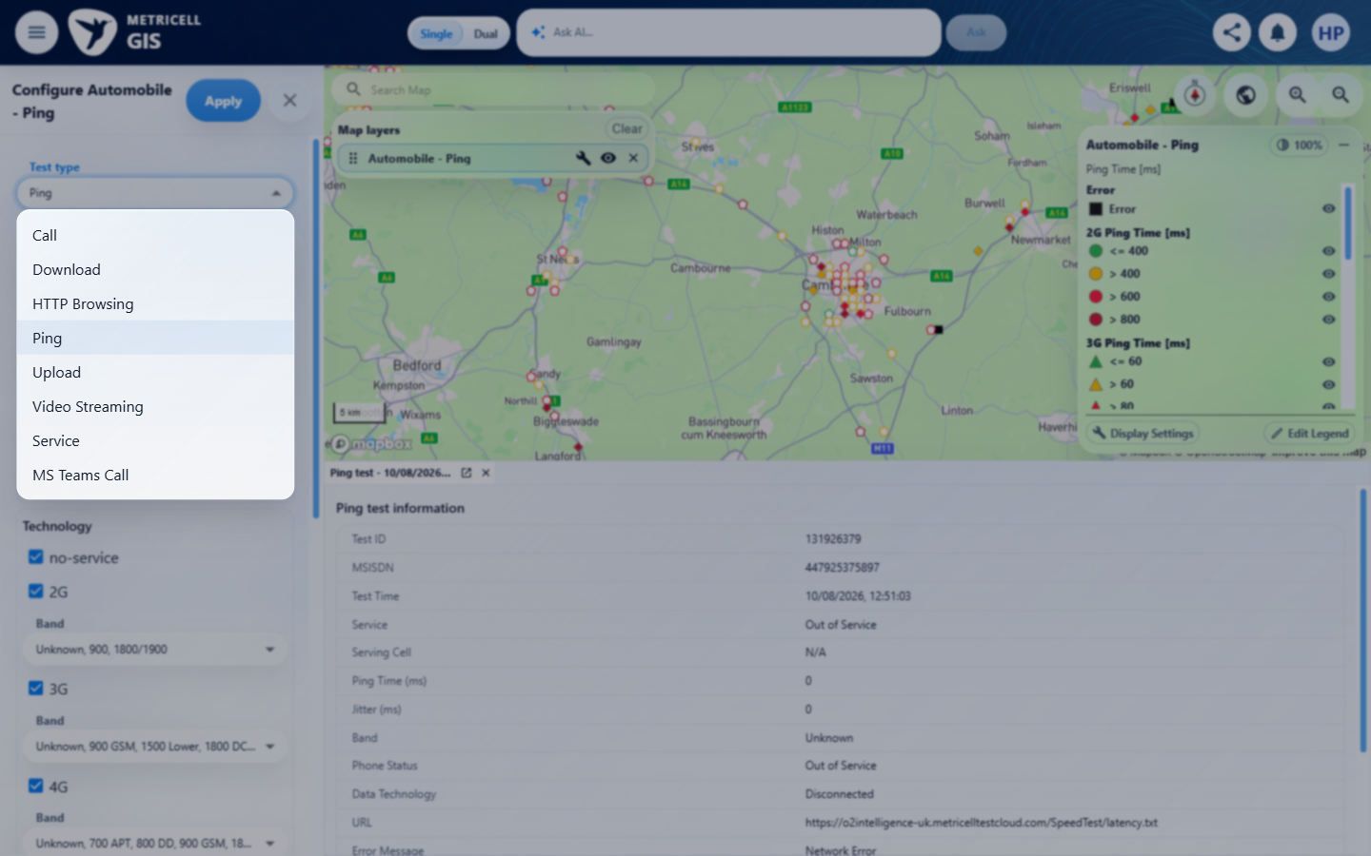 | E08 - Before apply (criterion-3-before-apply.png)

Criterion 3 continued: For a displayed MS Teams Call point with Poor Quality 0–0.99, its map colour is Green.
Browser URL recorded after criterion: https://o2intelligence-v4-dev.metricell.com/gis
E13 - Final (criterion-3-final.png)
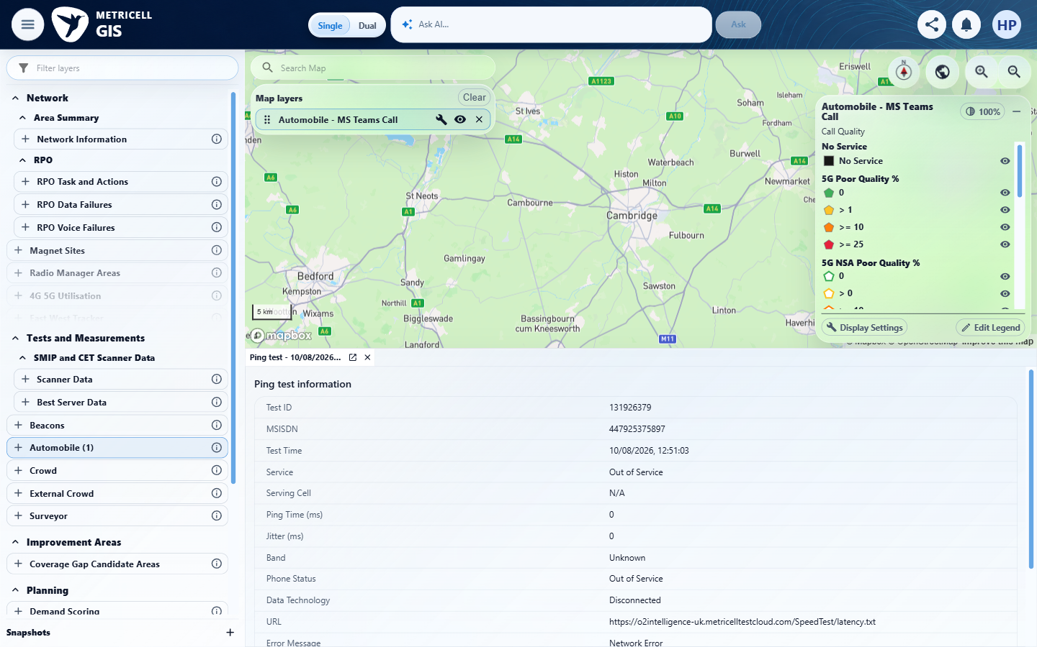

4.0.0 | For a displayed MS Teams Call point with Poor Quality 1–9.99, its map colour is Yellow. | For a displayed MS Teams Call point with Poor Quality 1–9.99, its map colour is Yellow. | criterion-4-final.png shows the Automobile - MS Teams Call layer without plotted results. Tester records HTTP 200 with [] in the inspected Cambridge-area viewport and 24 July–22 October 2026 filters. No known Poor Quality 1–9.99 result is available to verify Yellow on an actual map point; the legend alone does not establish the criterion.  Evidence: E14, E15, E12, E16, E09 | Blocked
Criterion 4 assessment: criterion-4-final.png shows the Automobile - MS Teams Call layer without plotted results. Tester records HTTP 200 with [] in the inspected Cambridge-area viewport and 24 July–22 October 2026 filters. No known Poor Quality 1–9.99 result is available to verify Yellow on an actual map point; the legend alone does not establish the criterion.
Testing notes: GET /api/platform/automobile/ms-teams-call/points completed with HTTP 200 and body [] in the inspected scope. This is a settled empty dataset, not an HTTP error or missing module. No matching MS Teams Call test identity was available to select. Existing Cambridge/St Neots/Bedford/Sandy map viewport (centre approximately 0.1355,52.2242; zoom 9.04), ten requested tiles; From 2026-07-24T10:44:00.000Z to 2026-10-22T10:44:00.000Z (UI 11:44 BST). Existing handset/network filters retained, MSISDN/SIM MCC/SIM MNC/MCC/MNC/LAC/CI/site/cell blank, all existing technology/band selections retained; deviceGroupAll=false. Records outside this scope were not established. The pre-existing tab is explicitly Ping test 131926379 and was preserved, not treated as MS Teams evidence.
Criterion 4 evidence: For a displayed MS Teams Call point with Poor Quality 1–9.99, its map colour is Yellow.
Browser URL recorded after criterion: https://o2intelligence-v4-dev.metricell.com/gis
E14 - Before configure (criterion-4-before-configure.png)  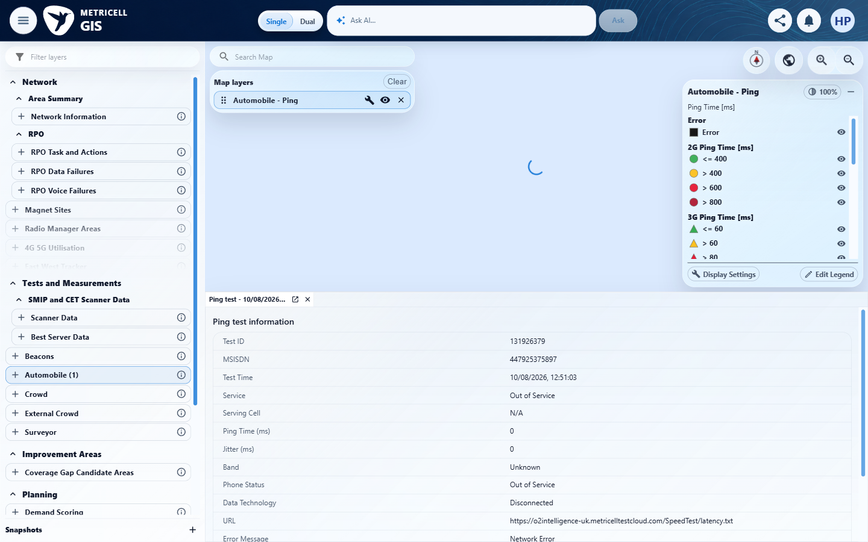 | E15 - Configuration (criterion-4-configuration.png)  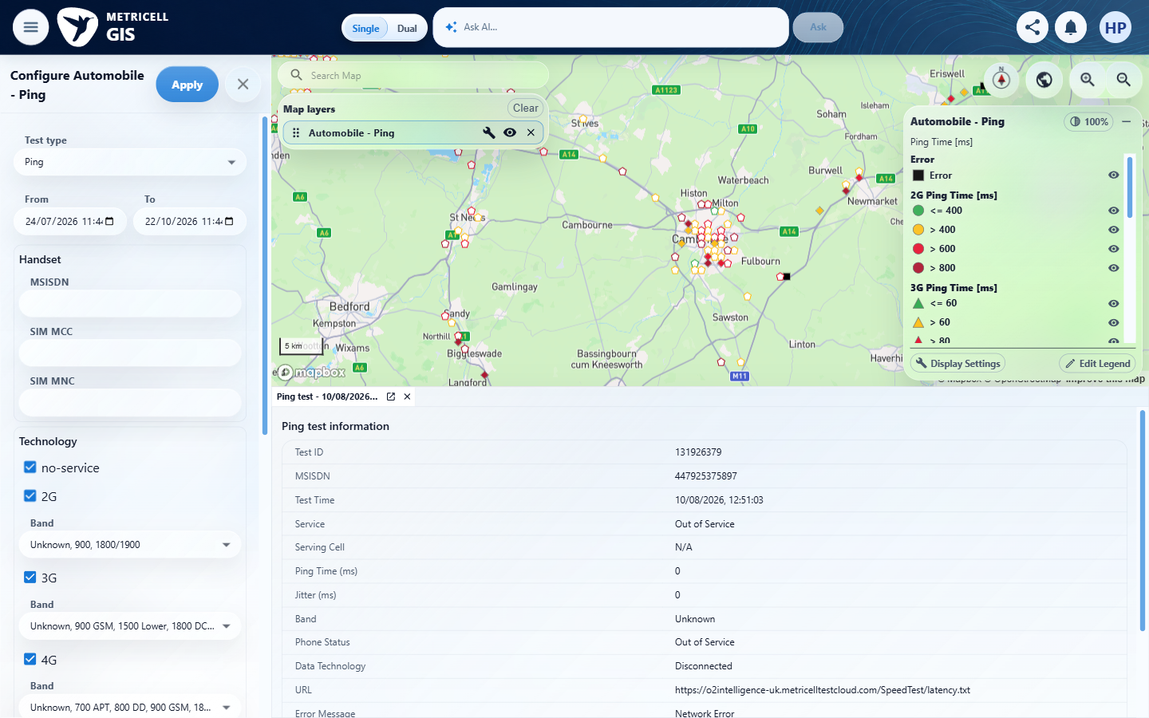

Criterion 4 continued: For a displayed MS Teams Call point with Poor Quality 1–9.99, its map colour is Yellow.
Browser URL recorded after criterion: https://o2intelligence-v4-dev.metricell.com/gis
E12 - Choices (criterion-4-choices.png) | E16 - Before apply (criterion-4-before-apply.png)  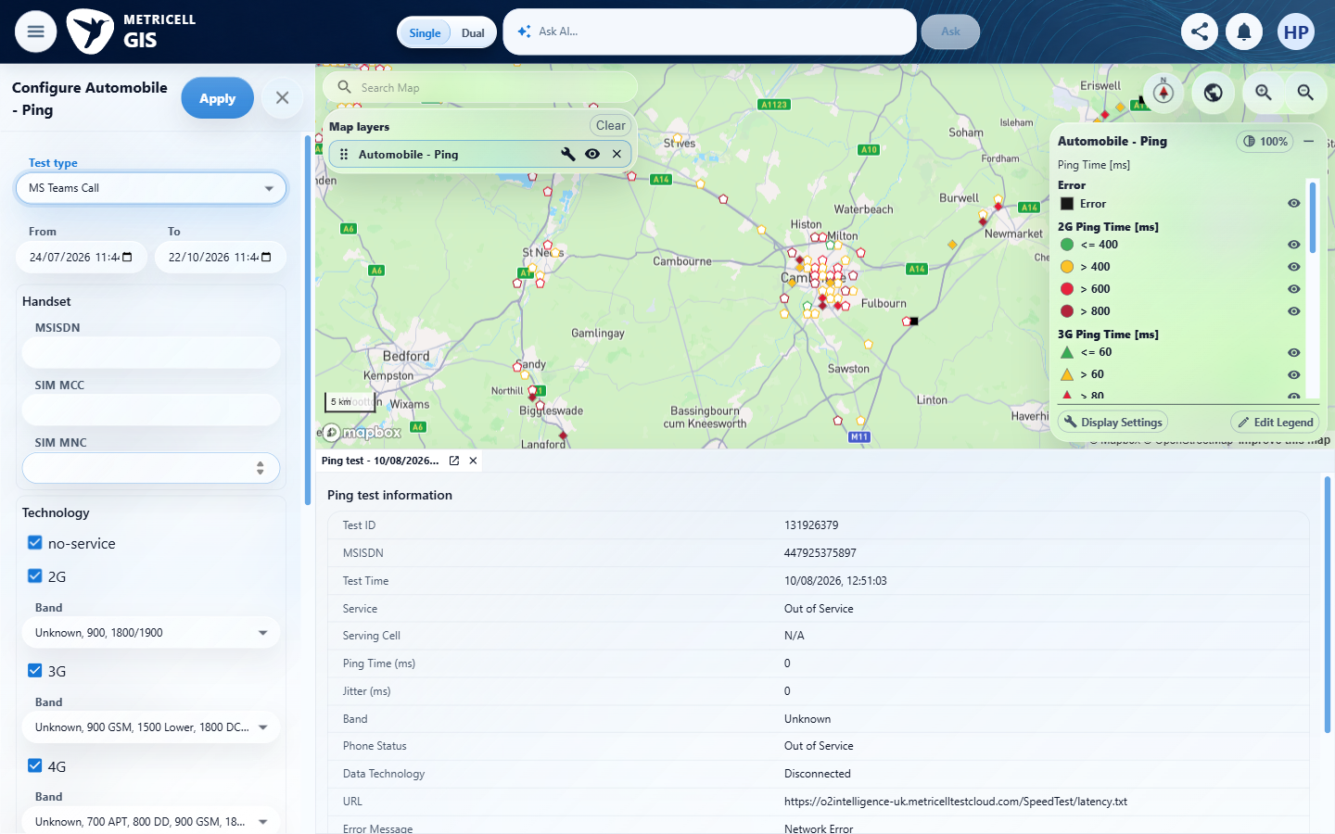

Criterion 4 continued: For a displayed MS Teams Call point with Poor Quality 1–9.99, its map colour is Yellow.
Browser URL recorded after criterion: https://o2intelligence-v4-dev.metricell.com/gis
E09 - Final (criterion-4-final.png)

5.0.0 | For a displayed MS Teams Call point with Poor Quality 10–24.99, its map colour is Amber. | For a displayed MS Teams Call point with Poor Quality 10–24.99, its map colour is Amber. | criterion-5-final.png shows the Automobile - MS Teams Call layer without plotted results. Tester records HTTP 200 with [] in the inspected Cambridge-area viewport and 24 July–22 October 2026 filters. No known Poor Quality 10–24.99 result is available to verify Amber on an actual map point; the legend alone does not establish the criterion.  Evidence: E17, E15, E18, E16, E19 | Blocked
Criterion 5 assessment: criterion-5-final.png shows the Automobile - MS Teams Call layer without plotted results. Tester records HTTP 200 with [] in the inspected Cambridge-area viewport and 24 July–22 October 2026 filters. No known Poor Quality 10–24.99 result is available to verify Amber on an actual map point; the legend alone does not establish the criterion.
Testing notes: GET /api/platform/automobile/ms-teams-call/points completed with HTTP 200 and body [] in the inspected scope. This is a settled empty dataset, not an HTTP error or missing module. No matching MS Teams Call test identity was available to select. Existing Cambridge/St Neots/Bedford/Sandy map viewport (centre approximately 0.1355,52.2242; zoom 9.04), ten requested tiles; From 2026-07-24T10:44:00.000Z to 2026-10-22T10:44:00.000Z (UI 11:44 BST). Existing handset/network filters retained, MSISDN/SIM MCC/SIM MNC/MCC/MNC/LAC/CI/site/cell blank, all existing technology/band selections retained; deviceGroupAll=false. Records outside this scope were not established. The pre-existing tab is explicitly Ping test 131926379 and was preserved, not treated as MS Teams evidence.
Criterion 5 evidence: For a displayed MS Teams Call point with Poor Quality 10–24.99, its map colour is Amber.
Browser URL recorded after criterion: https://o2intelligence-v4-dev.metricell.com/gis
E17 - Before configure (criterion-5-before-configure.png)  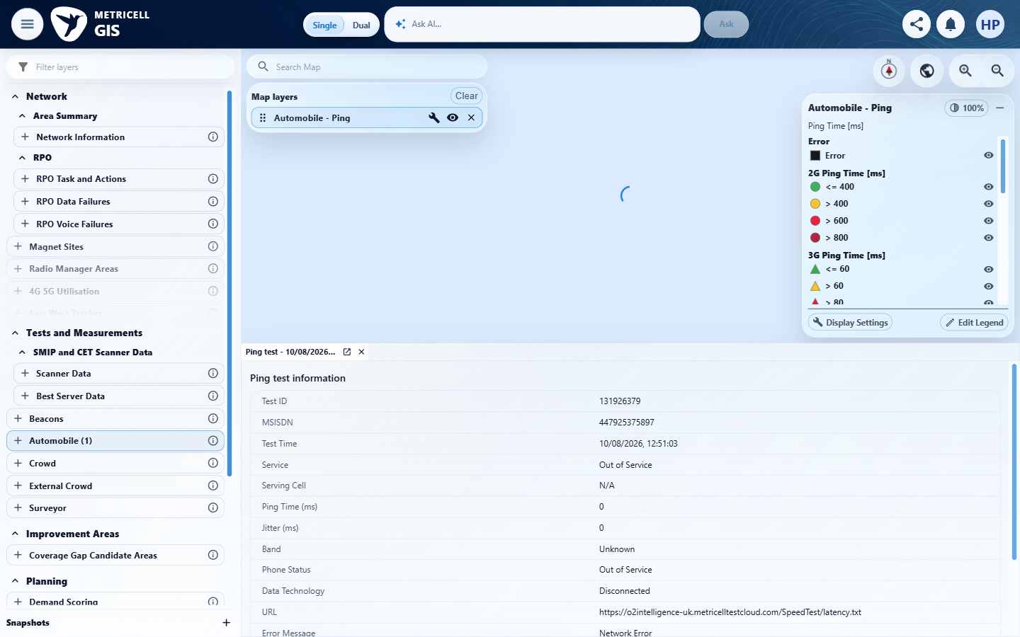 | E15 - Configuration (criterion-5-configuration.png)

Criterion 5 continued: For a displayed MS Teams Call point with Poor Quality 10–24.99, its map colour is Amber.
Browser URL recorded after criterion: https://o2intelligence-v4-dev.metricell.com/gis
E18 - Choices (criterion-5-choices.png)  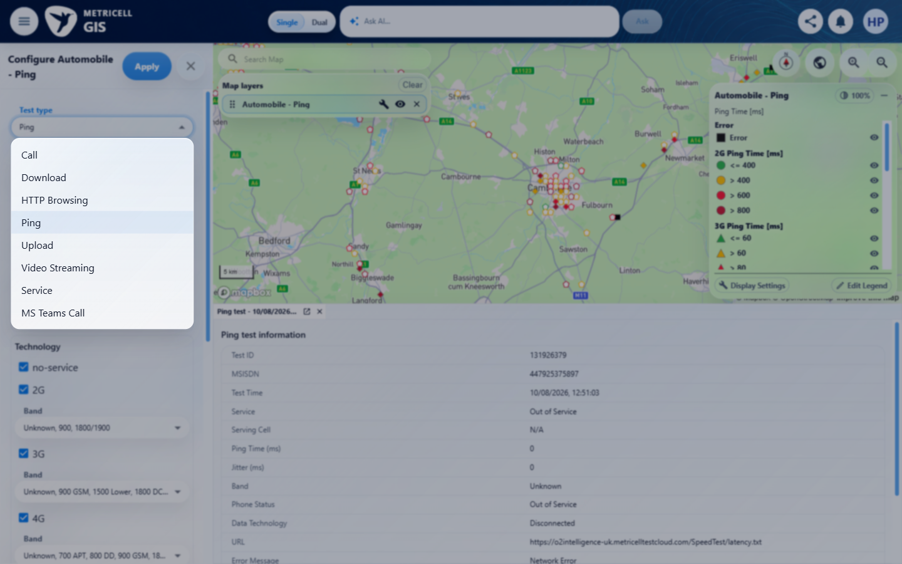 | E16 - Before apply (criterion-5-before-apply.png)

Criterion 5 continued: For a displayed MS Teams Call point with Poor Quality 10–24.99, its map colour is Amber.
Browser URL recorded after criterion: https://o2intelligence-v4-dev.metricell.com/gis
E19 - Final (criterion-5-final.png)
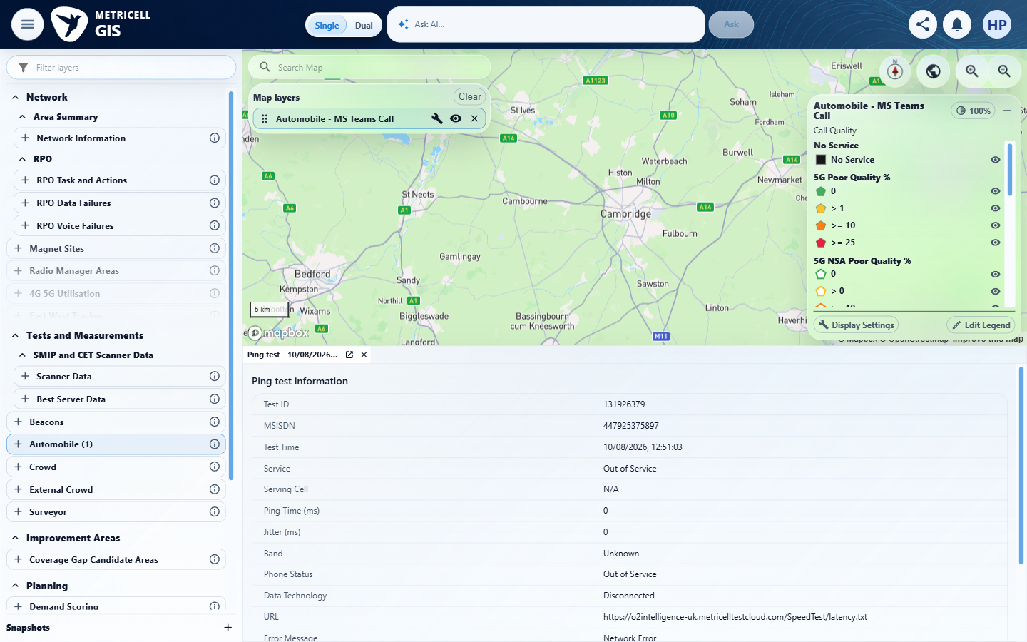

6.0.0 | For a displayed MS Teams Call point with Poor Quality 25 or greater, its map colour is Red. | For a displayed MS Teams Call point with Poor Quality 25 or greater, its map colour is Red. | criterion-6-final.png shows the Automobile - MS Teams Call layer without plotted results. Tester records HTTP 200 with [] in the inspected Cambridge-area viewport and 24 July–22 October 2026 filters. No known Poor Quality 25 or greater result is available to verify Red on an actual map point; the legend alone does not establish the criterion.  Evidence: E20, E06, E12, E08, E21 | Blocked
Criterion 6 assessment: criterion-6-final.png shows the Automobile - MS Teams Call layer without plotted results. Tester records HTTP 200 with [] in the inspected Cambridge-area viewport and 24 July–22 October 2026 filters. No known Poor Quality 25 or greater result is available to verify Red on an actual map point; the legend alone does not establish the criterion.
Testing notes: GET /api/platform/automobile/ms-teams-call/points completed with HTTP 200 and body [] in the inspected scope. This is a settled empty dataset, not an HTTP error or missing module. No matching MS Teams Call test identity was available to select. Existing Cambridge/St Neots/Bedford/Sandy map viewport (centre approximately 0.1355,52.2242; zoom 9.04), ten requested tiles; From 2026-07-24T10:44:00.000Z to 2026-10-22T10:44:00.000Z (UI 11:44 BST). Existing handset/network filters retained, MSISDN/SIM MCC/SIM MNC/MCC/MNC/LAC/CI/site/cell blank, all existing technology/band selections retained; deviceGroupAll=false. Records outside this scope were not established. The pre-existing tab is explicitly Ping test 131926379 and was preserved, not treated as MS Teams evidence.
Criterion 6 evidence: For a displayed MS Teams Call point with Poor Quality 25 or greater, its map colour is Red.
Browser URL recorded after criterion: https://o2intelligence-v4-dev.metricell.com/gis
E20 - Before configure (criterion-6-before-configure.png)  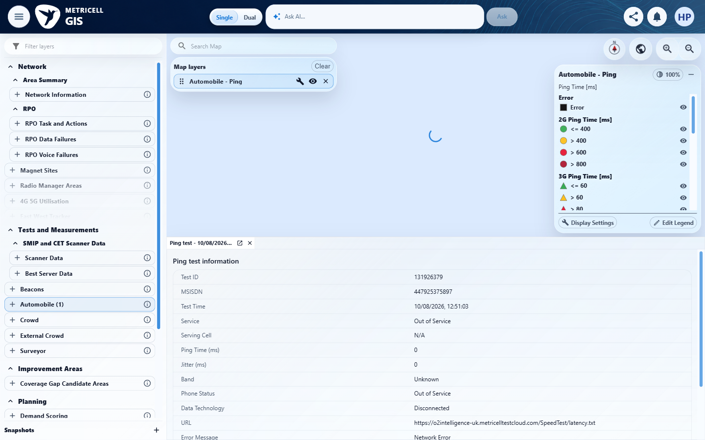 | E06 - Configuration (criterion-6-configuration.png)

Criterion 6 continued: For a displayed MS Teams Call point with Poor Quality 25 or greater, its map colour is Red.
Browser URL recorded after criterion: https://o2intelligence-v4-dev.metricell.com/gis
E12 - Choices (criterion-6-choices.png) | E08 - Before apply (criterion-6-before-apply.png)

Criterion 6 continued: For a displayed MS Teams Call point with Poor Quality 25 or greater, its map colour is Red.
Browser URL recorded after criterion: https://o2intelligence-v4-dev.metricell.com/gis
E21 - Final (criterion-6-final.png)
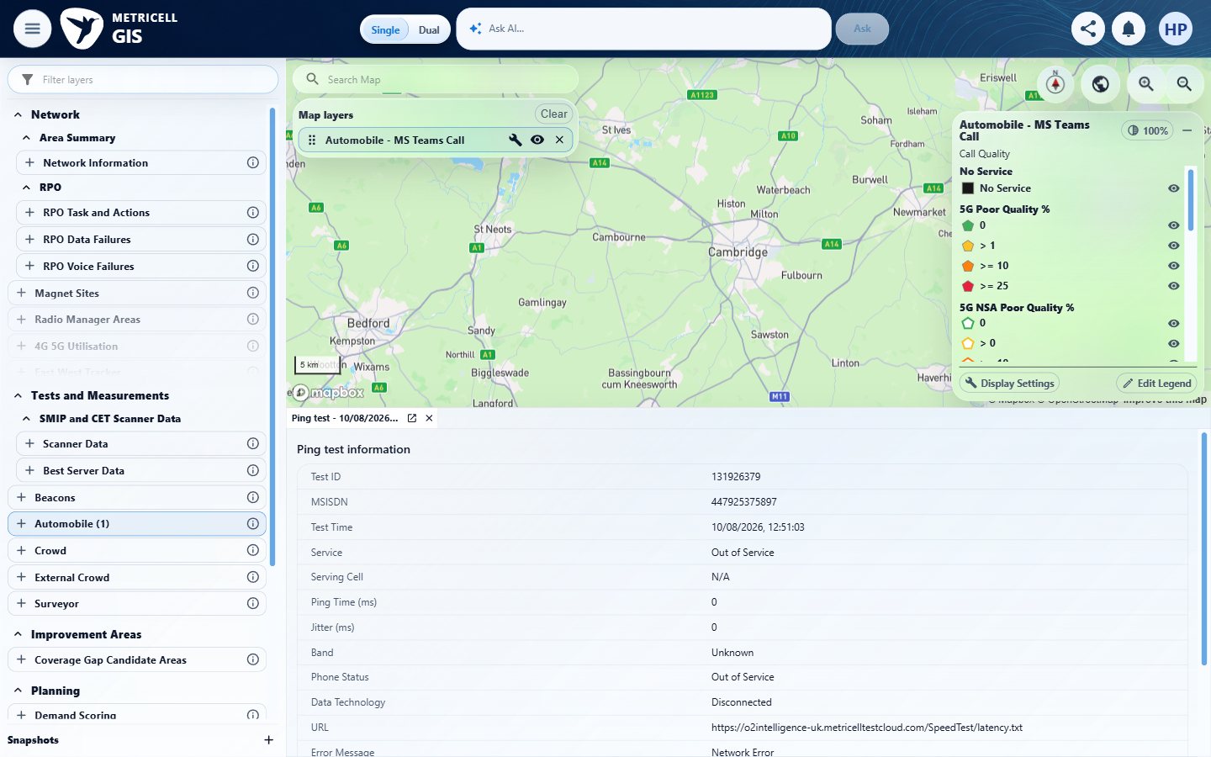

7.0.0 | When the user selects a map point and its details load successfully, the details dialog displays Test ID, Test Result, Connection Time, Call Duration, Poor Quality, MSISDN and Test Technologies. | When the user selects a map point and its details load successfully, the details dialog displays Test ID, Test Result, Connection Time, Call Duration, Poor Quality, MSISDN and Test Technologies. | criterion-7-final.png shows the selected Automobile - MS Teams Call layer without results; the open detail tab is explicitly the pre-existing Ping test 131926379. With no matching MS Teams record in the reported empty response, none of the seven required MS Teams summary fields could be checked.  Evidence: E10, E06, E12, E22, E23 | Blocked
Criterion 7 assessment: criterion-7-final.png shows the selected Automobile - MS Teams Call layer without results; the open detail tab is explicitly the pre-existing Ping test 131926379. With no matching MS Teams record in the reported empty response, none of the seven required MS Teams summary fields could be checked.
Testing notes: GET /api/platform/automobile/ms-teams-call/points completed with HTTP 200 and body [] in the inspected scope. This is a settled empty dataset, not an HTTP error or missing module. No matching MS Teams Call test identity was available to select. Existing Cambridge/St Neots/Bedford/Sandy map viewport (centre approximately 0.1355,52.2242; zoom 9.04), ten requested tiles; From 2026-07-24T10:44:00.000Z to 2026-10-22T10:44:00.000Z (UI 11:44 BST). Existing handset/network filters retained, MSISDN/SIM MCC/SIM MNC/MCC/MNC/LAC/CI/site/cell blank, all existing technology/band selections retained; deviceGroupAll=false. Records outside this scope were not established. The pre-existing tab is explicitly Ping test 131926379 and was preserved, not treated as MS Teams evidence.
Criterion 7 evidence: When the user selects a map point and its details load successfully, the details dialog displays Test ID, Test Result, Connection Time, Call Duration, Poor Quality, MSISDN and Test Technologies.
Browser URL recorded after criterion: https://o2intelligence-v4-dev.metricell.com/gis
E10 - Before configure (criterion-7-before-configure.png) | E06 - Configuration (criterion-7-configuration.png)

Criterion 7 continued: When the user selects a map point and its details load successfully, the details dialog displays Test ID, Test Result, Connection Time, Call Duration, Poor Quality, MSISDN and Test Technologies.
Browser URL recorded after criterion: https://o2intelligence-v4-dev.metricell.com/gis
E12 - Choices (criterion-7-choices.png) | E22 - Before apply (criterion-7-before-apply.png)  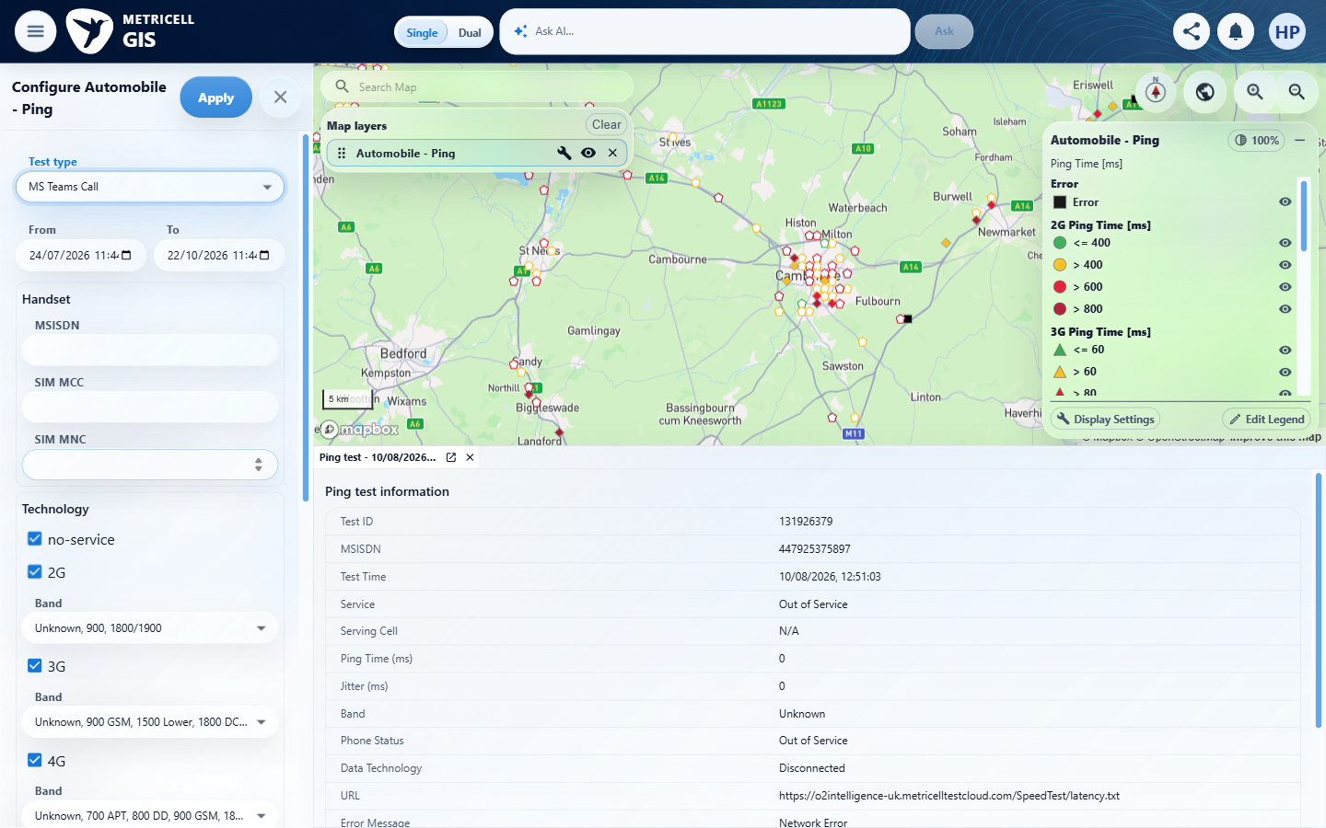

Criterion 7 continued: When the user selects a map point and its details load successfully, the details dialog displays Test ID, Test Result, Connection Time, Call Duration, Poor Quality, MSISDN and Test Technologies.
Browser URL recorded after criterion: https://o2intelligence-v4-dev.metricell.com/gis
E23 - Final (criterion-7-final.png)
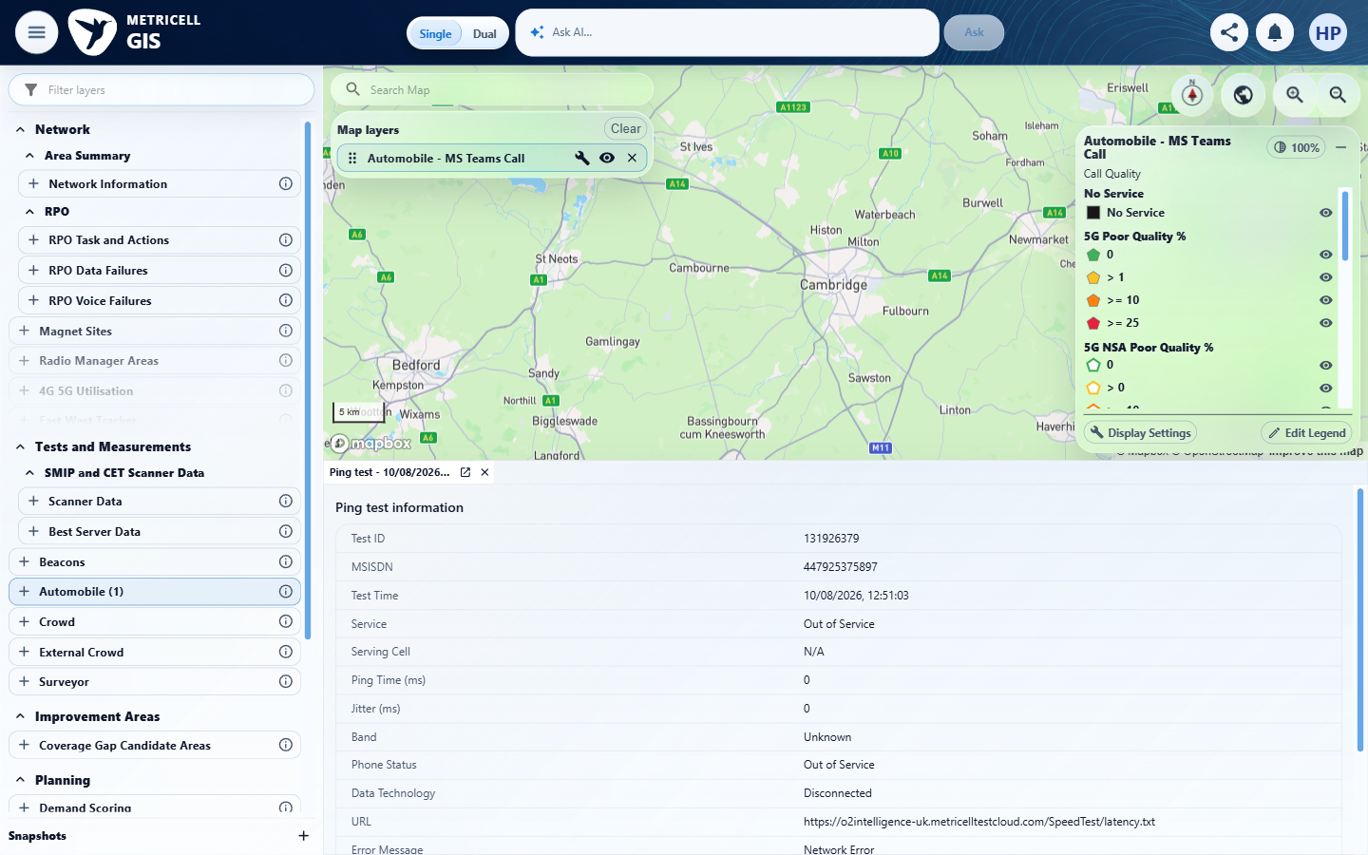

8.0.0 | When the user selects a map point and its details load successfully, the details dialog displays signal and download charts and shows handover markers when available. | When the user selects a map point and its details load successfully, the details dialog displays signal and download charts and shows handover markers when available. | criterion-8-final.png shows Automobile - MS Teams Call without results and an unrelated original Ping tab. The reported empty matching dataset prevents opening MS Teams details to assess signal/download charts and available handover markers.  Evidence: E10, E06, E12, E22, E23 | Blocked
Criterion 8 assessment: criterion-8-final.png shows Automobile - MS Teams Call without results and an unrelated original Ping tab. The reported empty matching dataset prevents opening MS Teams details to assess signal/download charts and available handover markers.
Testing notes: GET /api/platform/automobile/ms-teams-call/points completed with HTTP 200 and body [] in the inspected scope. This is a settled empty dataset, not an HTTP error or missing module. No matching MS Teams Call test identity was available to select. Existing Cambridge/St Neots/Bedford/Sandy map viewport (centre approximately 0.1355,52.2242; zoom 9.04), ten requested tiles; From 2026-07-24T10:44:00.000Z to 2026-10-22T10:44:00.000Z (UI 11:44 BST). Existing handset/network filters retained, MSISDN/SIM MCC/SIM MNC/MCC/MNC/LAC/CI/site/cell blank, all existing technology/band selections retained; deviceGroupAll=false. Records outside this scope were not established. The pre-existing tab is explicitly Ping test 131926379 and was preserved, not treated as MS Teams evidence.
Criterion 8 evidence: When the user selects a map point and its details load successfully, the details dialog displays signal and download charts and shows handover markers when available.
Browser URL recorded after criterion: https://o2intelligence-v4-dev.metricell.com/gis
E10 - Before configure (criterion-8-before-configure.png) | E06 - Configuration (criterion-8-configuration.png)

Criterion 8 continued: When the user selects a map point and its details load successfully, the details dialog displays signal and download charts and shows handover markers when available.
Browser URL recorded after criterion: https://o2intelligence-v4-dev.metricell.com/gis
E12 - Choices (criterion-8-choices.png) | E22 - Before apply (criterion-8-before-apply.png)

Criterion 8 continued: When the user selects a map point and its details load successfully, the details dialog displays signal and download charts and shows handover markers when available.
Browser URL recorded after criterion: https://o2intelligence-v4-dev.metricell.com/gis
E23 - Final (criterion-8-final.png)

9.0.0 | When the user selects a map point and its details load successfully, the details dialog displays a detailed-sample table that omits label, latitude, longitude and handover-only columns. | When the user selects a map point and its details load successfully, the details dialog displays a detailed-sample table that omits label, latitude, longitude and handover-only columns. | criterion-9-final.png shows Automobile - MS Teams Call without results and an unrelated Ping tab. No matching MS Teams detail/sample table was available, so table presence and omission of label, latitude, longitude and handover-only columns remain blocked.  Evidence: E10, E06, E12, E22, E23 | Blocked
Criterion 9 assessment: criterion-9-final.png shows Automobile - MS Teams Call without results and an unrelated Ping tab. No matching MS Teams detail/sample table was available, so table presence and omission of label, latitude, longitude and handover-only columns remain blocked.
Testing notes: GET /api/platform/automobile/ms-teams-call/points completed with HTTP 200 and body [] in the inspected scope. This is a settled empty dataset, not an HTTP error or missing module. No matching MS Teams Call test identity was available to select. Existing Cambridge/St Neots/Bedford/Sandy map viewport (centre approximately 0.1355,52.2242; zoom 9.04), ten requested tiles; From 2026-07-24T10:44:00.000Z to 2026-10-22T10:44:00.000Z (UI 11:44 BST). Existing handset/network filters retained, MSISDN/SIM MCC/SIM MNC/MCC/MNC/LAC/CI/site/cell blank, all existing technology/band selections retained; deviceGroupAll=false. Records outside this scope were not established. The pre-existing tab is explicitly Ping test 131926379 and was preserved, not treated as MS Teams evidence.
Criterion 9 evidence: When the user selects a map point and its details load successfully, the details dialog displays a detailed-sample table that omits label, latitude, longitude and handover-only columns.
Browser URL recorded after criterion: https://o2intelligence-v4-dev.metricell.com/gis
E10 - Before configure (criterion-9-before-configure.png) | E06 - Configuration (criterion-9-configuration.png)

Criterion 9 continued: When the user selects a map point and its details load successfully, the details dialog displays a detailed-sample table that omits label, latitude, longitude and handover-only columns.
Browser URL recorded after criterion: https://o2intelligence-v4-dev.metricell.com/gis
E12 - Choices (criterion-9-choices.png) | E22 - Before apply (criterion-9-before-apply.png)

Criterion 9 continued: When the user selects a map point and its details load successfully, the details dialog displays a detailed-sample table that omits label, latitude, longitude and handover-only columns.
Browser URL recorded after criterion: https://o2intelligence-v4-dev.metricell.com/gis
E23 - Final (criterion-9-final.png)

10.0.0 | When detailed samples are displayed, sorting a supported column changes their displayed order to match the selected sort. | When detailed samples are displayed, sorting a supported column changes their displayed order to match the selected sort. | criterion-10-final.png shows Automobile - MS Teams Call without results; the reported empty matching dataset provides no detailed samples with differing values for a supported-column sort and ordering comparison.  Evidence: E10, E06, E12, E22, E23 | Blocked
Criterion 10 assessment: criterion-10-final.png shows Automobile - MS Teams Call without results; the reported empty matching dataset provides no detailed samples with differing values for a supported-column sort and ordering comparison.
Testing notes: GET /api/platform/automobile/ms-teams-call/points completed with HTTP 200 and body [] in the inspected scope. This is a settled empty dataset, not an HTTP error or missing module. No matching MS Teams Call test identity was available to select. Existing Cambridge/St Neots/Bedford/Sandy map viewport (centre approximately 0.1355,52.2242; zoom 9.04), ten requested tiles; From 2026-07-24T10:44:00.000Z to 2026-10-22T10:44:00.000Z (UI 11:44 BST). Existing handset/network filters retained, MSISDN/SIM MCC/SIM MNC/MCC/MNC/LAC/CI/site/cell blank, all existing technology/band selections retained; deviceGroupAll=false. Records outside this scope were not established. The pre-existing tab is explicitly Ping test 131926379 and was preserved, not treated as MS Teams evidence.
Criterion 10 evidence: When detailed samples are displayed, sorting a supported column changes their displayed order to match the selected sort.
Browser URL recorded after criterion: https://o2intelligence-v4-dev.metricell.com/gis
E10 - Before configure (criterion-10-before-configure.png) | E06 - Configuration (criterion-10-configuration.png)

Criterion 10 continued: When detailed samples are displayed, sorting a supported column changes their displayed order to match the selected sort.
Browser URL recorded after criterion: https://o2intelligence-v4-dev.metricell.com/gis
E12 - Choices (criterion-10-choices.png) | E22 - Before apply (criterion-10-before-apply.png)

Criterion 10 continued: When detailed samples are displayed, sorting a supported column changes their displayed order to match the selected sort.
Browser URL recorded after criterion: https://o2intelligence-v4-dev.metricell.com/gis
E23 - Final (criterion-10-final.png)

11.0.0 | When detailed samples are displayed, filtering a supported column limits the displayed samples to those matching the filter. | When detailed samples are displayed, filtering a supported column limits the displayed samples to those matching the filter. | criterion-11-final.png shows Automobile - MS Teams Call without results; the reported empty matching dataset provides no detailed samples for a supported-column filter and reconciliation of matching rows.  Evidence: E10, E06, E12, E22, E23 | Blocked
Criterion 11 assessment: criterion-11-final.png shows Automobile - MS Teams Call without results; the reported empty matching dataset provides no detailed samples for a supported-column filter and reconciliation of matching rows.
Testing notes: GET /api/platform/automobile/ms-teams-call/points completed with HTTP 200 and body [] in the inspected scope. This is a settled empty dataset, not an HTTP error or missing module. No matching MS Teams Call test identity was available to select. Existing Cambridge/St Neots/Bedford/Sandy map viewport (centre approximately 0.1355,52.2242; zoom 9.04), ten requested tiles; From 2026-07-24T10:44:00.000Z to 2026-10-22T10:44:00.000Z (UI 11:44 BST). Existing handset/network filters retained, MSISDN/SIM MCC/SIM MNC/MCC/MNC/LAC/CI/site/cell blank, all existing technology/band selections retained; deviceGroupAll=false. Records outside this scope were not established. The pre-existing tab is explicitly Ping test 131926379 and was preserved, not treated as MS Teams evidence.
Criterion 11 evidence: When detailed samples are displayed, filtering a supported column limits the displayed samples to those matching the filter.
Browser URL recorded after criterion: https://o2intelligence-v4-dev.metricell.com/gis
E10 - Before configure (criterion-11-before-configure.png) | E06 - Configuration (criterion-11-configuration.png)

Criterion 11 continued: When detailed samples are displayed, filtering a supported column limits the displayed samples to those matching the filter.
Browser URL recorded after criterion: https://o2intelligence-v4-dev.metricell.com/gis
E12 - Choices (criterion-11-choices.png) | E22 - Before apply (criterion-11-before-apply.png)

Criterion 11 continued: When detailed samples are displayed, filtering a supported column limits the displayed samples to those matching the filter.
Browser URL recorded after criterion: https://o2intelligence-v4-dev.metricell.com/gis
E23 - Final (criterion-11-final.png)

12.0.0 | When the user exports a selected test as CSV, the exported CSV contains data for that selected test. | When the user exports a selected test as CSV, the exported CSV contains data for that selected test. | criterion-12-final.png shows Automobile - MS Teams Call without results and the original Ping tab. No matching MS Teams record was available to select/export; no CSV or selected-test data comparison was produced.  Evidence: E10, E06, E12, E22, E23 | Blocked
Criterion 12 assessment: criterion-12-final.png shows Automobile - MS Teams Call without results and the original Ping tab. No matching MS Teams record was available to select/export; no CSV or selected-test data comparison was produced.
Testing notes: GET /api/platform/automobile/ms-teams-call/points completed with HTTP 200 and body [] in the inspected scope. This is a settled empty dataset, not an HTTP error or missing module. No matching MS Teams Call test identity was available to select. Existing Cambridge/St Neots/Bedford/Sandy map viewport (centre approximately 0.1355,52.2242; zoom 9.04), ten requested tiles; From 2026-07-24T10:44:00.000Z to 2026-10-22T10:44:00.000Z (UI 11:44 BST). Existing handset/network filters retained, MSISDN/SIM MCC/SIM MNC/MCC/MNC/LAC/CI/site/cell blank, all existing technology/band selections retained; deviceGroupAll=false. Records outside this scope were not established. The pre-existing tab is explicitly Ping test 131926379 and was preserved, not treated as MS Teams evidence.
Criterion 12 evidence: When the user exports a selected test as CSV, the exported CSV contains data for that selected test.
Browser URL recorded after criterion: https://o2intelligence-v4-dev.metricell.com/gis
E10 - Before configure (criterion-12-before-configure.png) | E06 - Configuration (criterion-12-configuration.png)

Criterion 12 continued: When the user exports a selected test as CSV, the exported CSV contains data for that selected test.
Browser URL recorded after criterion: https://o2intelligence-v4-dev.metricell.com/gis
E12 - Choices (criterion-12-choices.png) | E22 - Before apply (criterion-12-before-apply.png)

Criterion 12 continued: When the user exports a selected test as CSV, the exported CSV contains data for that selected test.
Browser URL recorded after criterion: https://o2intelligence-v4-dev.metricell.com/gis
E23 - Final (criterion-12-final.png)

13.0.0 | When a zero-duration result is selected, its details dialog does not display stale or misleading data. | When a zero-duration result is selected, its details dialog does not display stale or misleading data. | criterion-13-final.png shows Automobile - MS Teams Call without results and the original Ping tab. No zero-duration MS Teams record or distinct valid MS Teams baseline was available; absence of stale/misleading details was not exercised.  Evidence: E10, E06, E12, E22, E23 | Blocked
Criterion 13 assessment: criterion-13-final.png shows Automobile - MS Teams Call without results and the original Ping tab. No zero-duration MS Teams record or distinct valid MS Teams baseline was available; absence of stale/misleading details was not exercised.
Testing notes: GET /api/platform/automobile/ms-teams-call/points completed with HTTP 200 and body [] in the inspected scope. This is a settled empty dataset, not an HTTP error or missing module. No matching MS Teams Call test identity was available to select. Existing Cambridge/St Neots/Bedford/Sandy map viewport (centre approximately 0.1355,52.2242; zoom 9.04), ten requested tiles; From 2026-07-24T10:44:00.000Z to 2026-10-22T10:44:00.000Z (UI 11:44 BST). Existing handset/network filters retained, MSISDN/SIM MCC/SIM MNC/MCC/MNC/LAC/CI/site/cell blank, all existing technology/band selections retained; deviceGroupAll=false. Records outside this scope were not established. The pre-existing tab is explicitly Ping test 131926379 and was preserved, not treated as MS Teams evidence.
Criterion 13 evidence: When a zero-duration result is selected, its details dialog does not display stale or misleading data.
Browser URL recorded after criterion: https://o2intelligence-v4-dev.metricell.com/gis
E10 - Before configure (criterion-13-before-configure.png) | E06 - Configuration (criterion-13-configuration.png)

Criterion 13 continued: When a zero-duration result is selected, its details dialog does not display stale or misleading data.
Browser URL recorded after criterion: https://o2intelligence-v4-dev.metricell.com/gis
E12 - Choices (criterion-13-choices.png) | E22 - Before apply (criterion-13-before-apply.png)

Criterion 13 continued: When a zero-duration result is selected, its details dialog does not display stale or misleading data.
Browser URL recorded after criterion: https://o2intelligence-v4-dev.metricell.com/gis
E23 - Final (criterion-13-final.png)

14.0.0 | When details for a selected result fail to load, the dialog does not display stale or misleading data. | When details for a selected result fail to load, the dialog does not display stale or misleading data. | criterion-14-final.png shows Automobile - MS Teams Call without results and the original Ping tab. No real MS Teams record/detail request or distinct valid MS Teams baseline was available to exercise failed-detail behaviour, misleading/stale-data comparisons or recovery. No simulation was installed.  Evidence: E10, E06, E12, E22, E13 | Blocked
Criterion 14 assessment: criterion-14-final.png shows Automobile - MS Teams Call without results and the original Ping tab. No real MS Teams record/detail request or distinct valid MS Teams baseline was available to exercise failed-detail behaviour, misleading/stale-data comparisons or recovery. No simulation was installed.
Testing notes: GET /api/platform/automobile/ms-teams-call/points completed with HTTP 200 and body [] in the inspected scope. This is a settled empty dataset, not an HTTP error or missing module. No matching MS Teams Call test identity was available to select. Existing Cambridge/St Neots/Bedford/Sandy map viewport (centre approximately 0.1355,52.2242; zoom 9.04), ten requested tiles; From 2026-07-24T10:44:00.000Z to 2026-10-22T10:44:00.000Z (UI 11:44 BST). Existing handset/network filters retained, MSISDN/SIM MCC/SIM MNC/MCC/MNC/LAC/CI/site/cell blank, all existing technology/band selections retained; deviceGroupAll=false. Records outside this scope were not established. The pre-existing tab is explicitly Ping test 131926379 and was preserved, not treated as MS Teams evidence.
Criterion 14 evidence: When details for a selected result fail to load, the dialog does not display stale or misleading data.
Browser URL recorded after criterion: https://o2intelligence-v4-dev.metricell.com/gis
E10 - Before configure (criterion-14-before-configure.png) | E06 - Configuration (criterion-14-configuration.png)

Criterion 14 continued: When details for a selected result fail to load, the dialog does not display stale or misleading data.
Browser URL recorded after criterion: https://o2intelligence-v4-dev.metricell.com/gis
E12 - Choices (criterion-14-choices.png) | E22 - Before apply (criterion-14-before-apply.png)

Criterion 14 continued: When details for a selected result fail to load, the dialog does not display stale or misleading data.
Browser URL recorded after criterion: https://o2intelligence-v4-dev.metricell.com/gis
E13 - Final (criterion-14-final.png)

About Metricell

Metricell is on a mission to deliver connectivity. We work with our customers to design, deliver and manage wireless communication networks – with a shared ambition of achieving flawless network experience. We’ve been responsible for many first-to-market products, and our technology is characterised by the relentless pursuit of automation and digitalisation.

Our geospatial intelligence tools traverse a wide variety of business processes – from Test & Measurement to Customer Experience Management – and we’re pioneers in Crowdsourcing and Digital Self Care. Our technology is today in use by a range of customers; thousands of their personnel; and millions of subscribers worldwide.

Find out more at www.metricell.com




