

Automated Test Case Document
Jira Ticket: TEST2-89

Document Classification: | Company Confidential
Document Ref: | Automated Test Case Document
Version: | 1.0
Date: | 30/10/2026
Document Author: | Automated TEST2 Evidence Review
Document Owner: | Quality Assurance / Metricell




This document and its content is copyright of Metricell Limited @ 2026 all rights reserved. All information contained herein is the intellectual property of Metricell Limited and should be treated as confidential. Any external redistribution of reproduction of part or all of the contents in any form is prohibited unless expressly agreed with Metricell Limited in writing. Any reproduced content must include the following statement; “Part or all of the content contained herein is copyright of Metricell Limited @ 2026 all rights reserved”.
Table of Contents
1 Revision History 2
2 Test Cycle Information 3
3 Test Summary 3
4 Test Cases 4
About Metricell 12

Revision History

Version | Date | Revision Author | Summary of Changes
[1.0] | 30/10/2026 | TEST2 QA Automation | Generated from TEST2 evidence review

Test Cycle Information

Tester: | Automated
Jira Ticket: | TEST2-89
Environment: | o2intelligence-v4-dev.metricell.com
Browser Details: | Google Chrome 156.0.8078.48
Date of Test: | 30/10/2026
Limitations during Testing: | Blocked criterion(s): 2, 3, 4, 5, 6, 7, 8, 9, 10, 11, 12, 13, 14. See the assessment below each criterion.  Some source URLs were not recorded.
Overall review outcome: | Blocked
Browser URL(s) recorded after criteria: | https://o2intelligence-v4-dev.metricell.com/gis

Test Summary

Area of test | Pass (Y/N) | Fail (Y/N) | Blocked (Y/N) | Defect No
1. Before selecting the MS Teams Call layer, the map shows no MS Teams Call test-result points. | Y | N | N | 0
2. When the user selects the MS Teams Call layer and authorised matching results are available, each matching result is shown as a selectable map point. | N | N | Y | 0
3. For a displayed MS Teams Call point with Poor Quality 0–0.99, its map colour is Green. | N | N | Y | 0
4. For a displayed MS Teams Call point with Poor Quality 1–9.99, its map colour is Yellow. | N | N | Y | 0
5. For a displayed MS Teams Call point with Poor Quality 10–24.99, its map colour is Amber. | N | N | Y | 0
6. For a displayed MS Teams Call point with Poor Quality 25 or greater, its map colour is Red. | N | N | Y | 0
7. When the user selects a map point and its details load successfully, the details dialog displays Test ID, Test Result, Connection Time, Call Duration, Poor Quality, MSISDN and Test Technologies. | N | N | Y | 0
8. When the user selects a map point and its details load successfully, the details dialog displays signal and download charts and shows handover markers when available. | N | N | Y | 0
9. When the user selects a map point and its details load successfully, the details dialog displays a detailed-sample table that omits label, latitude, longitude and handover-only columns. | N | N | Y | 0
10. When detailed samples are displayed, sorting a supported column changes their displayed order to match the selected sort. | N | N | Y | 0
11. When detailed samples are displayed, filtering a supported column limits the displayed samples to those matching the filter. | N | N | Y | 0
12. When the user exports a selected test as CSV, the exported CSV contains data for that selected test. | N | N | Y | 0
13. When a zero-duration result is selected, its details dialog does not display stale or misleading data. | N | N | Y | 0
14. When details for a selected result fail to load, the dialog does not display stale or misleading data. | N | N | Y | 0

Test Cases
Each test maps to a criterion and decisive browser evidence. Inconclusive results are reported as Failed.

Tests

Preconditions: | V4 access and ticket conditions. | Associated Requirements: | Ticket criteria below. | Automation Notes: | Screenshots below each criterion; full log retained locally.
ID / Criterion | Criteria Tested | Expected Result | Actual Result / Evidence Path | Outcome
1.0.0 | Before selecting the MS Teams Call layer, the map shows no MS Teams Call test-result points. | Before selecting the MS Teams Call layer, the map shows no MS Teams Call test-result points. | criterion-1-before-configure.png shows only Automobile - Call and its plotted Call symbols; criterion-1-configuration.png and criterion-1-nested-test-types.png establish Call selected and MS Teams Call unselected. criterion-1-final.png retains that Call configuration and map, with no MS Teams Call result layer shown. The final capture still has configuration open; it is not a closed-panel capture.  Evidence: E01, E02, E03, E04 | Passed
Criterion 1 evidence: Before selecting the MS Teams Call layer, the map shows no MS Teams Call test-result points.
Browser URL recorded after criterion: https://o2intelligence-v4-dev.metricell.com/gis
E01 - Before configure (criterion-1-before-configure.png)  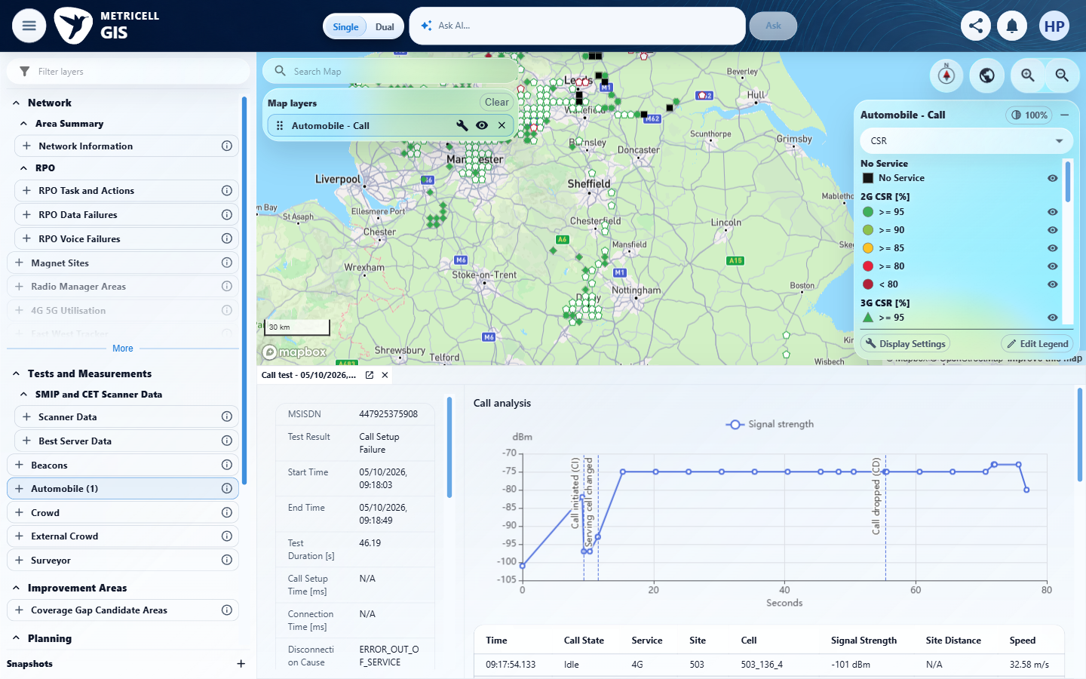 | E02 - Configuration (criterion-1-configuration.png)  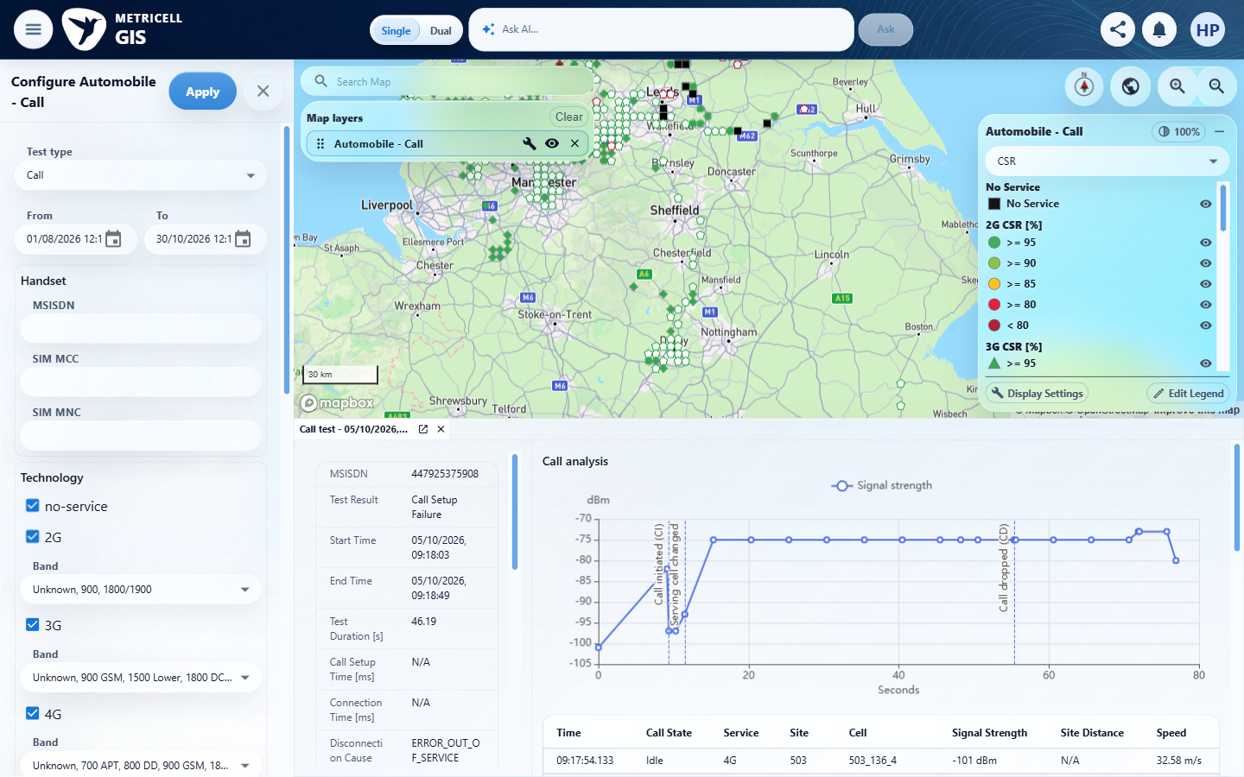

Criterion 1 continued: Before selecting the MS Teams Call layer, the map shows no MS Teams Call test-result points.
Browser URL recorded after criterion: https://o2intelligence-v4-dev.metricell.com/gis
E03 - Nested test types (criterion-1-nested-test-types.png)  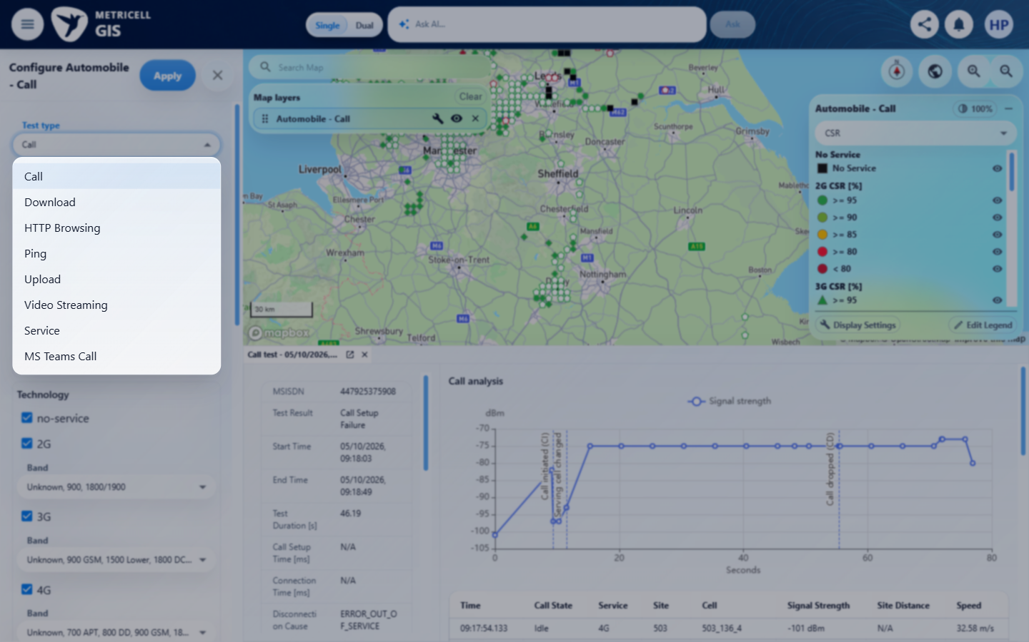 | E04 - Final (criterion-1-final.png)  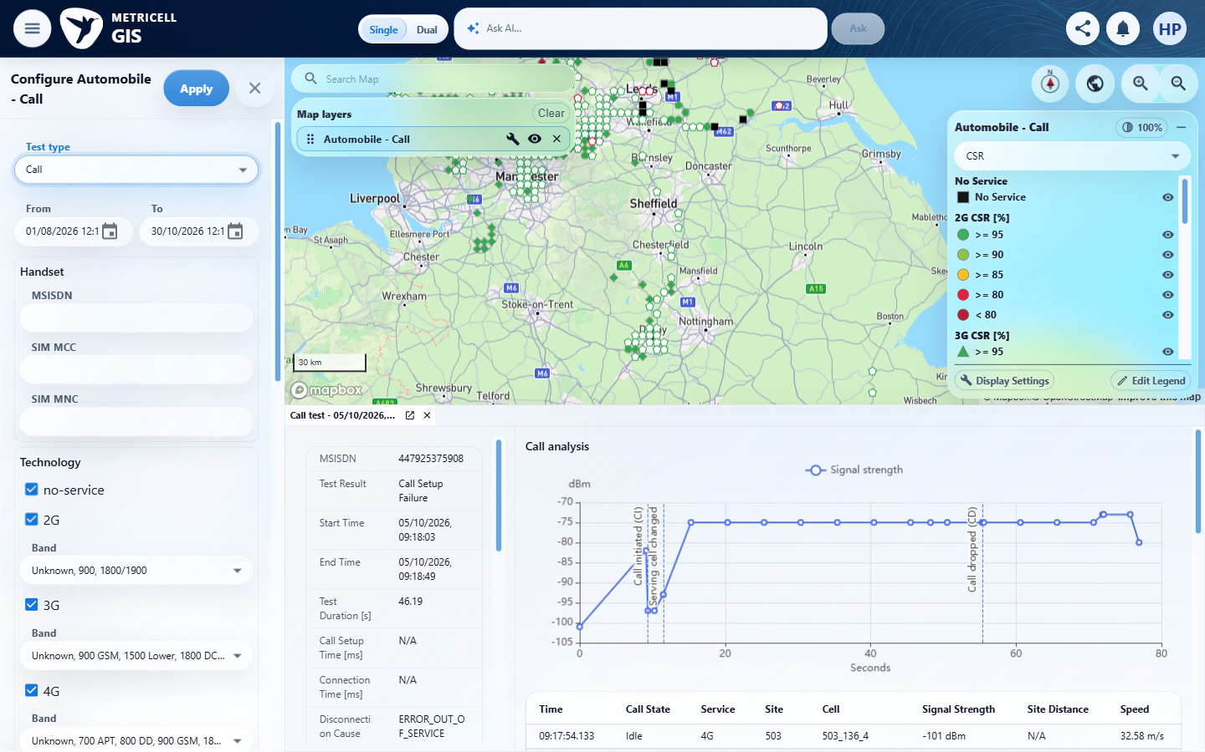

2.0.0 | When the user selects the MS Teams Call layer and authorised matching results are available, each matching result is shown as a selectable map point. | When the user selects the MS Teams Call layer and authorised matching results are available, each matching result is shown as a selectable map point. | criterion-2-selected-configuration.png shows MS Teams Call chosen before Apply; criterion-2-after-select.png shows Automobile - MS Teams Call and actual plotted result symbols. Recorded /api/platform/automobile/ms-teams-call/points requests support the module/layer identity (239 broad-scope aggregates, then 12 aggregates for the recorded 25/08/2026 12:28–12:29 local filter). criterion-2-narrowed-configuration.png precedes application of that filter; criterion-2-bounded-map.png and criterion-2-final.png show its later settled Derby/Nottingham symbols, not opened MS Teams details. The selected-test 132123874 detail capture was overwritten at criterion-2-final.png; criterion-2-before-date-narrow.png also shows only pre-existing Call details, so no saved image establishes the selected MS Teams test identity or selectability. Repair was unavailable after the execution-host interruption: this check is Blocked. Reconciliation of every result/aggregate member remains independently Unverified; aggregate counts and sampled selection notes do not prove completeness. The broad map does not establish the later narrow dataset.  Evidence: E05, E06, E07, E08, E09, E10 | Blocked
Criterion 2 evidence: When the user selects the MS Teams Call layer and authorised matching results are available, each matching result is shown as a selectable map point.
Browser URL recorded after criterion: https://o2intelligence-v4-dev.metricell.com/gis
E05 - Before select (criterion-2-before-select.png)  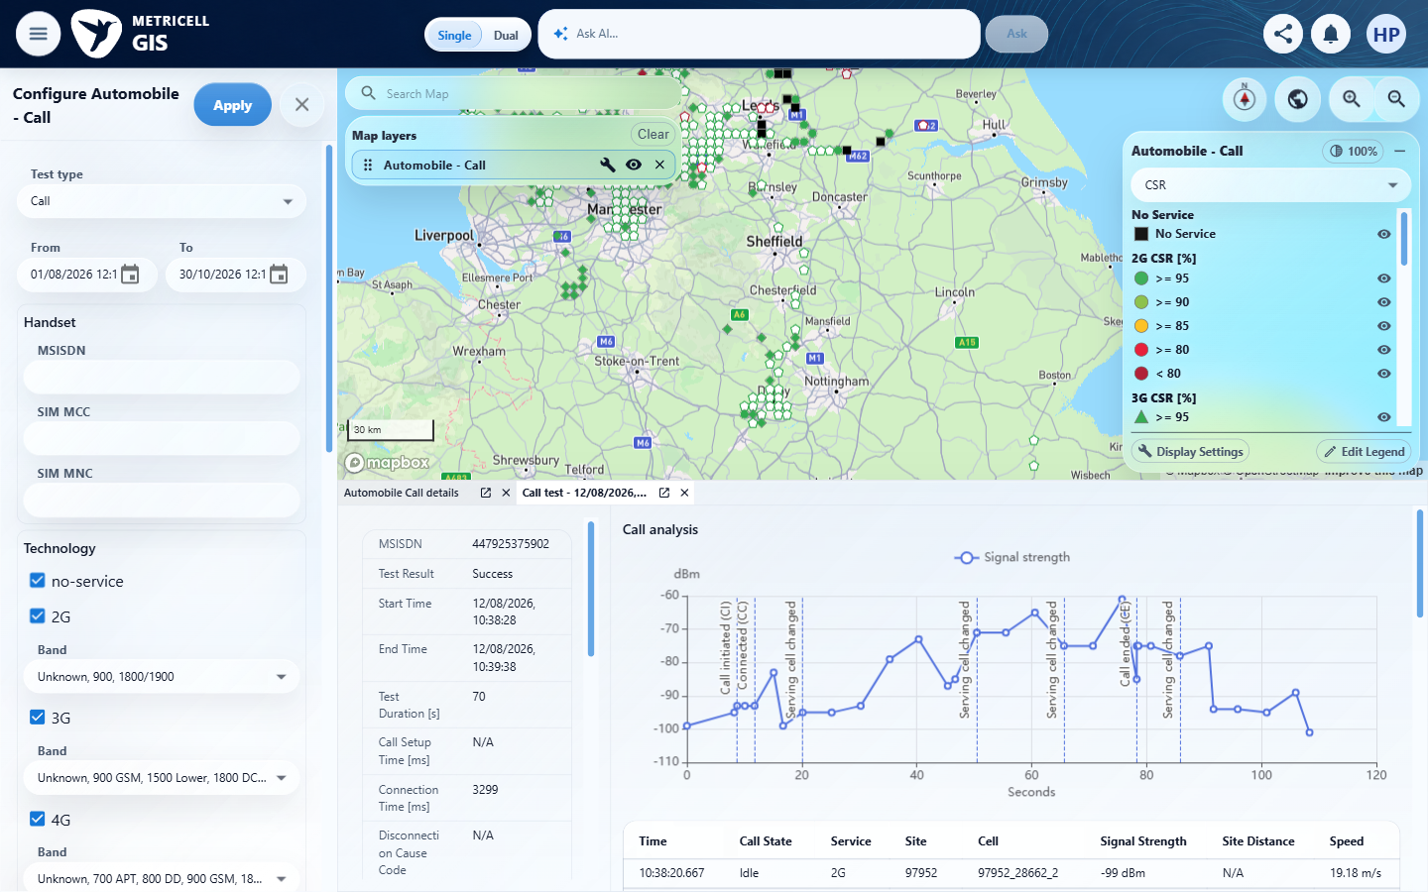 | E06 - Selected configuration (criterion-2-selected-configuration.png)  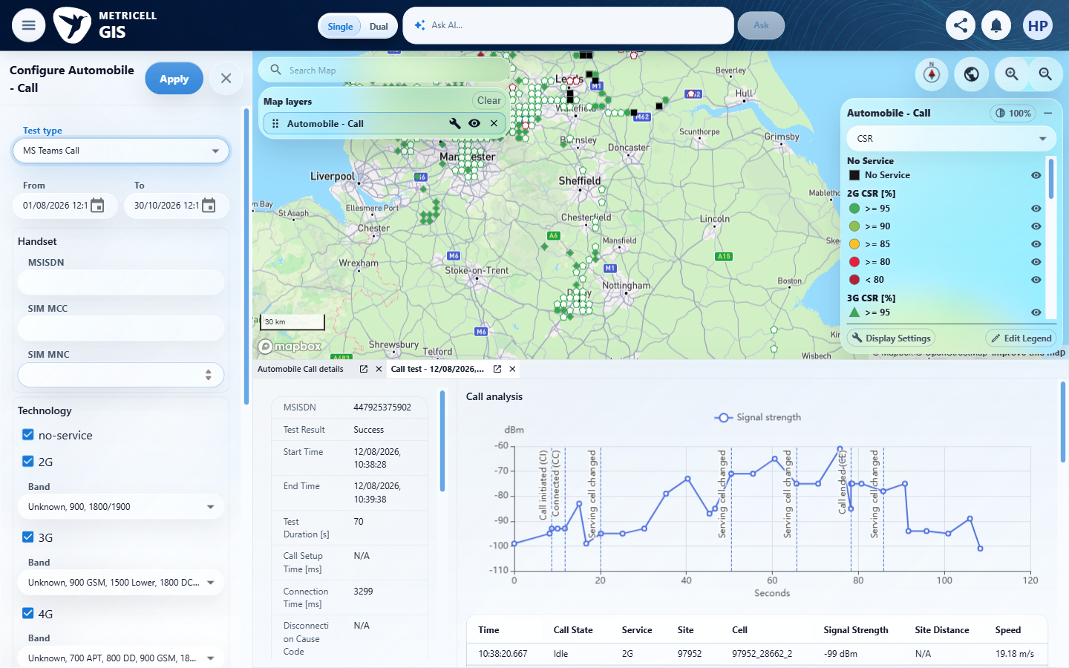

Criterion 2 continued: When the user selects the MS Teams Call layer and authorised matching results are available, each matching result is shown as a selectable map point.
Browser URL recorded after criterion: https://o2intelligence-v4-dev.metricell.com/gis
E07 - After select (criterion-2-after-select.png)  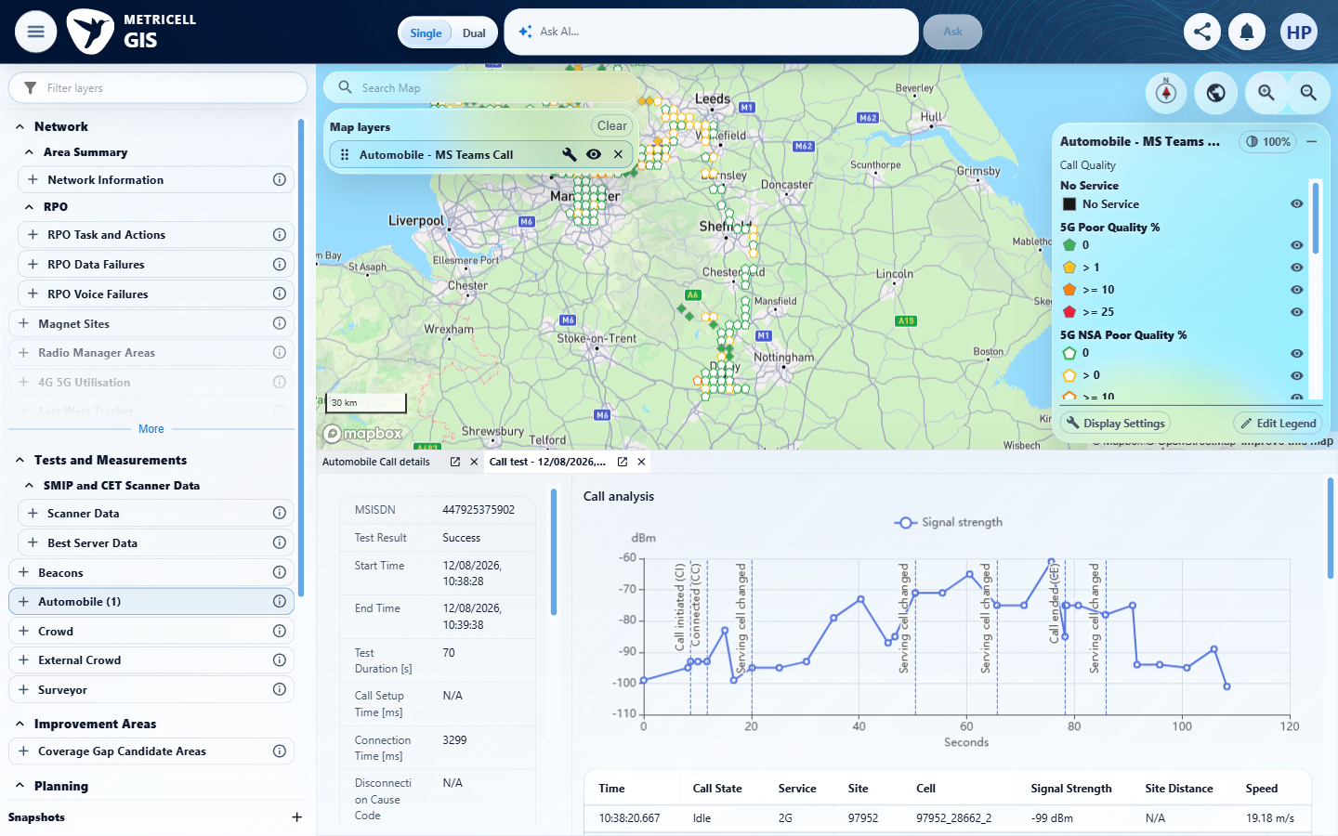 | E08 - Before date narrow (criterion-2-before-date-narrow.png)  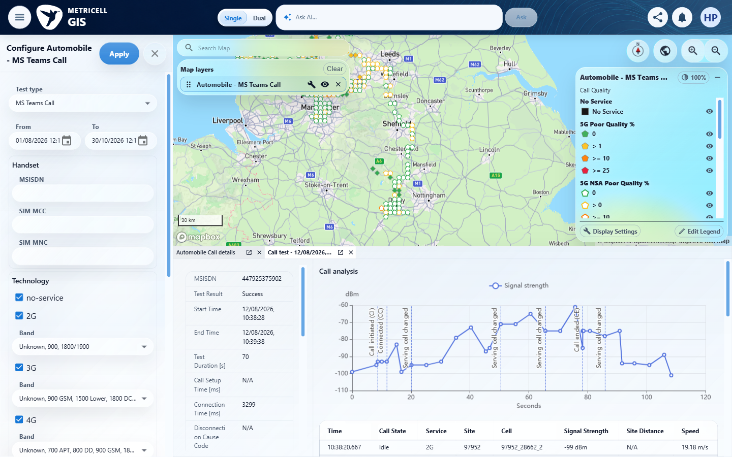

Criterion 2 continued: When the user selects the MS Teams Call layer and authorised matching results are available, each matching result is shown as a selectable map point.
Browser URL recorded after criterion: https://o2intelligence-v4-dev.metricell.com/gis
E09 - Narrowed configuration (criterion-2-narrowed-configuration.png)  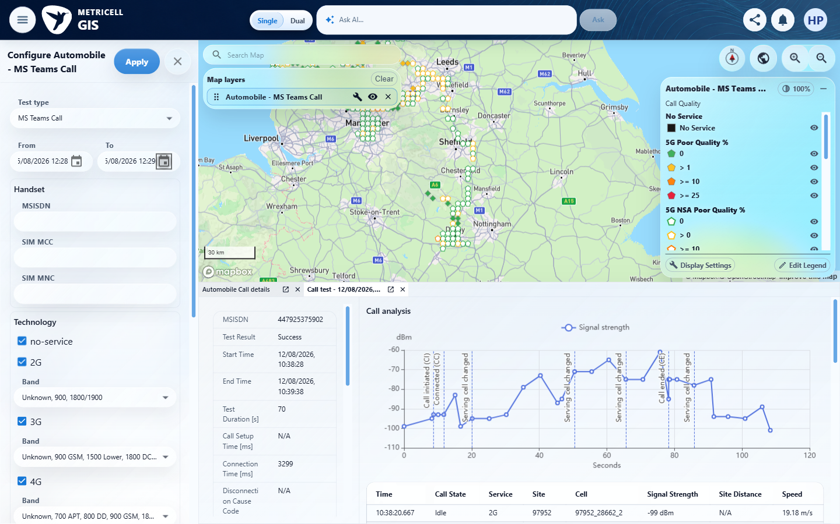 | E10 - Bounded map (criterion-2-bounded-map.png)  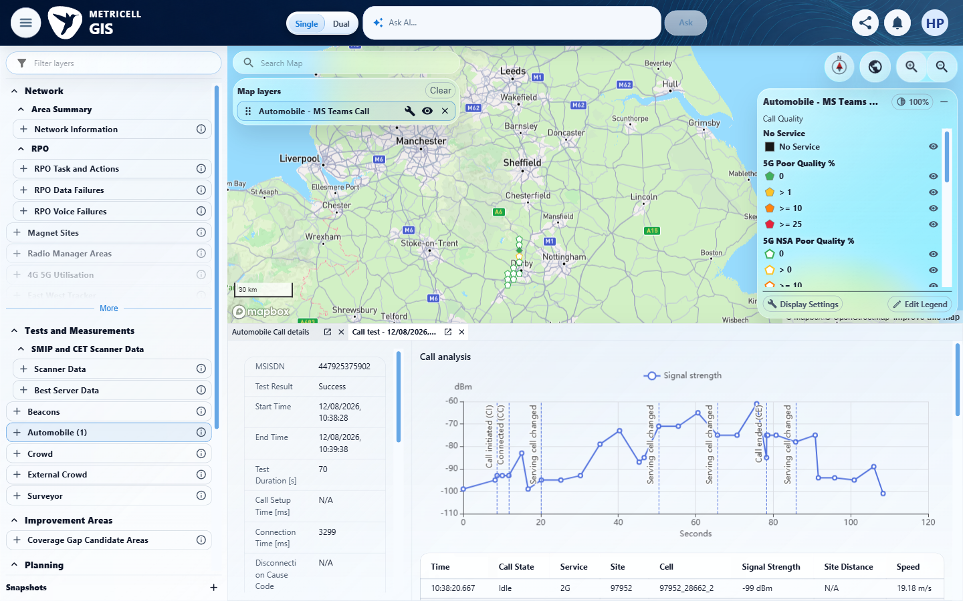

Criterion 2 continued: When the user selects the MS Teams Call layer and authorised matching results are available, each matching result is shown as a selectable map point.
Browser URL recorded after criterion: https://o2intelligence-v4-dev.metricell.com/gis
E10 - Final (criterion-2-final.png)

3.0.0 | For a displayed MS Teams Call point with Poor Quality 0–0.99, its map colour is Green. | For a displayed MS Teams Call point with Poor Quality 0–0.99, its map colour is Green. | criterion-3-initial.png shows only the launcher. No criterion-owned settled MS Teams map, genuine Poor Quality 0–0.99 value or same-point Green comparison was captured. Testing could not be completed after 'code-mode host timed out waiting for wait response' and 'cell g10:35 belongs to a stale code-mode host generation'. Pending GIS/configuration completion and final browser state are unknown; browser work stopped for coordinator reconciliation, with the lease retained and no interception handler reported installed.  Evidence: E11 | Blocked
Criterion 3 assessment: Testing notes: Execution capability interruption, not an observed product failure. Actual errors: 'code-mode host timed out waiting for wait response'; then 'cell g10:35 belongs to a stale code-mode host generation'. Browser work stopped immediately. Only this criterion's initial launcher capture is confirmed; the pending GIS/configuration operation may have changed the UI. Final browser URL is unknown. Shared browser lease retained for coordinator reconciliation under the brief's interrupted-execution rule. No interception handler was installed. Browser identity is the once-observed Google Chrome 156.0.8078.48 from earlier in this same attempt, not a new read. Waiting returned 'code-mode host timed out waiting for wait response'. A subsequent wait returned 'cell g10:35 belongs to a stale code-mode host generation'. Stopped all browser work as required by the brief. No quality-band action, plotted-map capture, tooltip inspection, final capture, or URL read completed with a confirmed result.
Criterion 3 evidence: For a displayed MS Teams Call point with Poor Quality 0–0.99, its map colour is Green.
Browser URL recorded after criterion: Not recorded
E11 - Initial (criterion-3-initial.png)
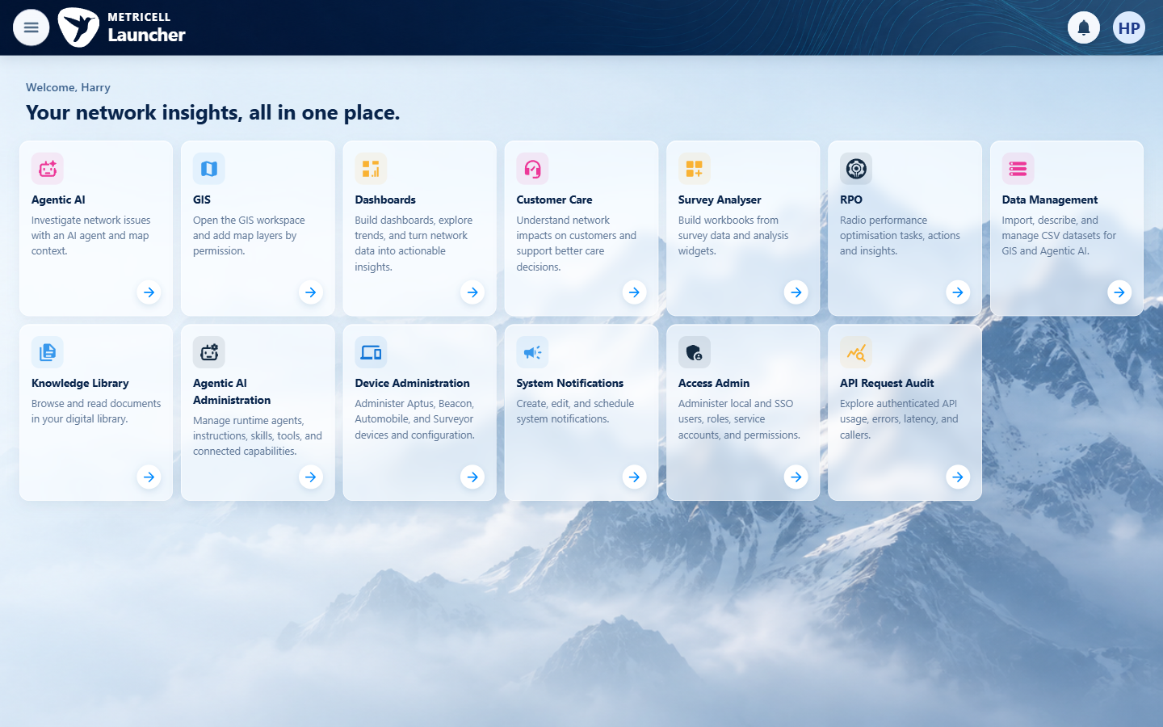

4.0.0 | For a displayed MS Teams Call point with Poor Quality 1–9.99, its map colour is Yellow. | For a displayed MS Teams Call point with Poor Quality 1–9.99, its map colour is Yellow. | Browser testing could not begin for this criterion after the execution interruption: 'code-mode host timed out waiting for wait response', followed by 'cell g10:35 belongs to a stale code-mode host generation'. No criterion-owned browser evidence was captured to establish the 1–9.99 Poor Quality target and its Yellow plotted symbol. Browser work stopped pending coordinator reconciliation; the browser lease was retained, final UI remained unknown and no interception handler was reported installed. This is an unavailable execution prerequisite, with no demonstrated product defect.  Evidence: Unavailable  Browser URL recorded after criterion: Not recorded | Blocked
Criterion 4 assessment: Testing notes: Execution capability interruption, not an observed product failure. Actual errors: 'code-mode host timed out waiting for wait response'; then 'cell g10:35 belongs to a stale code-mode host generation'. Browser work stopped immediately. This independent criterion could not begin and has no PNG because browser work must remain stopped pending reconciliation. Shared browser lease retained for coordinator reconciliation under the brief's interrupted-execution rule. No interception handler was installed. Browser identity is the once-observed Google Chrome 156.0.8078.48 from earlier in this same attempt, not a new read.
5.0.0 | For a displayed MS Teams Call point with Poor Quality 10–24.99, its map colour is Amber. | For a displayed MS Teams Call point with Poor Quality 10–24.99, its map colour is Amber. | Browser testing could not begin for this criterion after the execution interruption: 'code-mode host timed out waiting for wait response', followed by 'cell g10:35 belongs to a stale code-mode host generation'. No criterion-owned browser evidence was captured to establish the 10–24.99 Poor Quality target and its Amber plotted symbol. Browser work stopped pending coordinator reconciliation; the browser lease was retained, final UI remained unknown and no interception handler was reported installed. This is an unavailable execution prerequisite, with no demonstrated product defect.  Evidence: Unavailable  Browser URL recorded after criterion: Not recorded | Blocked
Criterion 5 assessment: Testing notes: Execution capability interruption, not an observed product failure. Actual errors: 'code-mode host timed out waiting for wait response'; then 'cell g10:35 belongs to a stale code-mode host generation'. Browser work stopped immediately. This independent criterion could not begin and has no PNG because browser work must remain stopped pending reconciliation. Shared browser lease retained for coordinator reconciliation under the brief's interrupted-execution rule. No interception handler was installed. Browser identity is the once-observed Google Chrome 156.0.8078.48 from earlier in this same attempt, not a new read.
6.0.0 | For a displayed MS Teams Call point with Poor Quality 25 or greater, its map colour is Red. | For a displayed MS Teams Call point with Poor Quality 25 or greater, its map colour is Red. | Browser testing could not begin for this criterion after the execution interruption: 'code-mode host timed out waiting for wait response', followed by 'cell g10:35 belongs to a stale code-mode host generation'. No criterion-owned browser evidence was captured to establish the 25+ Poor Quality target and its Red plotted symbol. Browser work stopped pending coordinator reconciliation; the browser lease was retained, final UI remained unknown and no interception handler was reported installed. This is an unavailable execution prerequisite, with no demonstrated product defect.  Evidence: Unavailable  Browser URL recorded after criterion: Not recorded | Blocked
Criterion 6 assessment: Testing notes: Execution capability interruption, not an observed product failure. Actual errors: 'code-mode host timed out waiting for wait response'; then 'cell g10:35 belongs to a stale code-mode host generation'. Browser work stopped immediately. This independent criterion could not begin and has no PNG because browser work must remain stopped pending reconciliation. Shared browser lease retained for coordinator reconciliation under the brief's interrupted-execution rule. No interception handler was installed. Browser identity is the once-observed Google Chrome 156.0.8078.48 from earlier in this same attempt, not a new read.
7.0.0 | When the user selects a map point and its details load successfully, the details dialog displays Test ID, Test Result, Connection Time, Call Duration, Poor Quality, MSISDN and Test Technologies. | When the user selects a map point and its details load successfully, the details dialog displays Test ID, Test Result, Connection Time, Call Duration, Poor Quality, MSISDN and Test Technologies. | Browser testing could not begin for this criterion after the execution interruption: 'code-mode host timed out waiting for wait response', followed by 'cell g10:35 belongs to a stale code-mode host generation'. No criterion-owned browser evidence was captured to establish successful selected-result identity and readable Test ID, Test Result, Connection Time, Call Duration, Poor Quality, MSISDN and Test Technologies. Browser work stopped pending coordinator reconciliation; the browser lease was retained, final UI remained unknown and no interception handler was reported installed. This is an unavailable execution prerequisite, with no demonstrated product defect.  Evidence: Unavailable  Browser URL recorded after criterion: Not recorded | Blocked
Criterion 7 assessment: Testing notes: Execution capability interruption, not an observed product failure. Actual errors: 'code-mode host timed out waiting for wait response'; then 'cell g10:35 belongs to a stale code-mode host generation'. Browser work stopped immediately. This independent criterion could not begin and has no PNG because browser work must remain stopped pending reconciliation. Shared browser lease retained for coordinator reconciliation under the brief's interrupted-execution rule. No interception handler was installed. Browser identity is the once-observed Google Chrome 156.0.8078.48 from earlier in this same attempt, not a new read.
8.0.0 | When the user selects a map point and its details load successfully, the details dialog displays signal and download charts and shows handover markers when available. | When the user selects a map point and its details load successfully, the details dialog displays signal and download charts and shows handover markers when available. | Browser testing could not begin for this criterion after the execution interruption: 'code-mode host timed out waiting for wait response', followed by 'cell g10:35 belongs to a stale code-mode host generation'. No criterion-owned browser evidence was captured to establish successful selected MS Teams details, visible signal/download charts and availability/display of handover markers. Browser work stopped pending coordinator reconciliation; the browser lease was retained, final UI remained unknown and no interception handler was reported installed. This is an unavailable execution prerequisite, with no demonstrated product defect.  Evidence: Unavailable  Browser URL recorded after criterion: Not recorded | Blocked
Criterion 8 assessment: Testing notes: Execution capability interruption, not an observed product failure. Actual errors: 'code-mode host timed out waiting for wait response'; then 'cell g10:35 belongs to a stale code-mode host generation'. Browser work stopped immediately. This independent criterion could not begin and has no PNG because browser work must remain stopped pending reconciliation. Shared browser lease retained for coordinator reconciliation under the brief's interrupted-execution rule. No interception handler was installed. Browser identity is the once-observed Google Chrome 156.0.8078.48 from earlier in this same attempt, not a new read.
9.0.0 | When the user selects a map point and its details load successfully, the details dialog displays a detailed-sample table that omits label, latitude, longitude and handover-only columns. | When the user selects a map point and its details load successfully, the details dialog displays a detailed-sample table that omits label, latitude, longitude and handover-only columns. | Browser testing could not begin for this criterion after the execution interruption: 'code-mode host timed out waiting for wait response', followed by 'cell g10:35 belongs to a stale code-mode host generation'. No criterion-owned browser evidence was captured to establish the selected result's detailed-sample table and exclusion of label, latitude, longitude and handover-only columns. Browser work stopped pending coordinator reconciliation; the browser lease was retained, final UI remained unknown and no interception handler was reported installed. This is an unavailable execution prerequisite, with no demonstrated product defect.  Evidence: Unavailable  Browser URL recorded after criterion: Not recorded | Blocked
Criterion 9 assessment: Testing notes: Execution capability interruption, not an observed product failure. Actual errors: 'code-mode host timed out waiting for wait response'; then 'cell g10:35 belongs to a stale code-mode host generation'. Browser work stopped immediately. This independent criterion could not begin and has no PNG because browser work must remain stopped pending reconciliation. Shared browser lease retained for coordinator reconciliation under the brief's interrupted-execution rule. No interception handler was installed. Browser identity is the once-observed Google Chrome 156.0.8078.48 from earlier in this same attempt, not a new read.
10.0.0 | When detailed samples are displayed, sorting a supported column changes their displayed order to match the selected sort. | When detailed samples are displayed, sorting a supported column changes their displayed order to match the selected sort. | Browser testing could not begin for this criterion after the execution interruption: 'code-mode host timed out waiting for wait response', followed by 'cell g10:35 belongs to a stale code-mode host generation'. No criterion-owned browser evidence was captured to establish a supported column's baseline, sorting action and settled detailed-sample order (tester assertions about all columns and both directions are retained, but the source requires sorting a supported column). Browser work stopped pending coordinator reconciliation; the browser lease was retained, final UI remained unknown and no interception handler was reported installed. This is an unavailable execution prerequisite, with no demonstrated product defect.  Evidence: Unavailable  Browser URL recorded after criterion: Not recorded | Blocked
Criterion 10 assessment: Testing notes: Execution capability interruption, not an observed product failure. Actual errors: 'code-mode host timed out waiting for wait response'; then 'cell g10:35 belongs to a stale code-mode host generation'. Browser work stopped immediately. This independent criterion could not begin and has no PNG because browser work must remain stopped pending reconciliation. Shared browser lease retained for coordinator reconciliation under the brief's interrupted-execution rule. No interception handler was installed. Browser identity is the once-observed Google Chrome 156.0.8078.48 from earlier in this same attempt, not a new read.
11.0.0 | When detailed samples are displayed, filtering a supported column limits the displayed samples to those matching the filter. | When detailed samples are displayed, filtering a supported column limits the displayed samples to those matching the filter. | Browser testing could not begin for this criterion after the execution interruption: 'code-mode host timed out waiting for wait response', followed by 'cell g10:35 belongs to a stale code-mode host generation'. No criterion-owned browser evidence was captured to establish a supported detailed-sample column's filter controls, applied filter and matching displayed samples. Browser work stopped pending coordinator reconciliation; the browser lease was retained, final UI remained unknown and no interception handler was reported installed. This is an unavailable execution prerequisite, with no demonstrated product defect.  Evidence: Unavailable  Browser URL recorded after criterion: Not recorded | Blocked
Criterion 11 assessment: Testing notes: Execution capability interruption, not an observed product failure. Actual errors: 'code-mode host timed out waiting for wait response'; then 'cell g10:35 belongs to a stale code-mode host generation'. Browser work stopped immediately. This independent criterion could not begin and has no PNG because browser work must remain stopped pending reconciliation. Shared browser lease retained for coordinator reconciliation under the brief's interrupted-execution rule. No interception handler was installed. Browser identity is the once-observed Google Chrome 156.0.8078.48 from earlier in this same attempt, not a new read.
12.0.0 | When the user exports a selected test as CSV, the exported CSV contains data for that selected test. | When the user exports a selected test as CSV, the exported CSV contains data for that selected test. | Browser testing could not begin for this criterion after the execution interruption: 'code-mode host timed out waiting for wait response', followed by 'cell g10:35 belongs to a stale code-mode host generation'. No criterion-owned browser evidence was captured to establish selected-test identity, completed CSV export and readable exported data correlated to that test. Browser work stopped pending coordinator reconciliation; the browser lease was retained, final UI remained unknown and no interception handler was reported installed. This is an unavailable execution prerequisite, with no demonstrated product defect.  Evidence: Unavailable  Browser URL recorded after criterion: Not recorded | Blocked
Criterion 12 assessment: Testing notes: Execution capability interruption, not an observed product failure. Actual errors: 'code-mode host timed out waiting for wait response'; then 'cell g10:35 belongs to a stale code-mode host generation'. Browser work stopped immediately. This independent criterion could not begin and has no PNG because browser work must remain stopped pending reconciliation. Shared browser lease retained for coordinator reconciliation under the brief's interrupted-execution rule. No interception handler was installed. Browser identity is the once-observed Google Chrome 156.0.8078.48 from earlier in this same attempt, not a new read.
13.0.0 | When a zero-duration result is selected, its details dialog does not display stale or misleading data. | When a zero-duration result is selected, its details dialog does not display stale or misleading data. | Browser testing could not begin for this criterion after the execution interruption: 'code-mode host timed out waiting for wait response', followed by 'cell g10:35 belongs to a stale code-mode host generation'. No criterion-owned browser evidence was captured to establish a genuine zero-duration target, distinct prior-detail baseline and resulting dialog state; normal pointer/keyboard activation evidence is relevant only where the application exposes those paths. Browser work stopped pending coordinator reconciliation; the browser lease was retained, final UI remained unknown and no interception handler was reported installed. This is an unavailable execution prerequisite, with no demonstrated product defect.  Evidence: Unavailable  Browser URL recorded after criterion: Not recorded | Blocked
Criterion 13 assessment: Testing notes: Execution capability interruption, not an observed product failure. Actual errors: 'code-mode host timed out waiting for wait response'; then 'cell g10:35 belongs to a stale code-mode host generation'. Browser work stopped immediately. This independent criterion could not begin and has no PNG because browser work must remain stopped pending reconciliation. Shared browser lease retained for coordinator reconciliation under the brief's interrupted-execution rule. No interception handler was installed. Browser identity is the once-observed Google Chrome 156.0.8078.48 from earlier in this same attempt, not a new read.
14.0.0 | When details for a selected result fail to load, the dialog does not display stale or misleading data. | When details for a selected result fail to load, the dialog does not display stale or misleading data. | Browser testing could not begin for this criterion after the execution interruption: 'code-mode host timed out waiting for wait response', followed by 'cell g10:35 belongs to a stale code-mode host generation'. No criterion-owned browser evidence was captured to establish a selected MS Teams detail-load failure, distinct prior-detail baseline, resulting absence of stale/misleading details and recovery; no simulation was performed. Browser work stopped pending coordinator reconciliation; the browser lease was retained, final UI remained unknown and no interception handler was reported installed. This is an unavailable execution prerequisite, with no demonstrated product defect.  Evidence: Unavailable  Browser URL recorded after criterion: Not recorded | Blocked
Criterion 14 assessment: Testing notes: Execution capability interruption, not an observed product failure. Actual errors: 'code-mode host timed out waiting for wait response'; then 'cell g10:35 belongs to a stale code-mode host generation'. Browser work stopped immediately. This independent criterion could not begin and has no PNG because browser work must remain stopped pending reconciliation. Shared browser lease retained for coordinator reconciliation under the brief's interrupted-execution rule. No interception handler was installed. Browser identity is the once-observed Google Chrome 156.0.8078.48 from earlier in this same attempt, not a new read.

About Metricell

Metricell is on a mission to deliver connectivity. We work with our customers to design, deliver and manage wireless communication networks – with a shared ambition of achieving flawless network experience. We’ve been responsible for many first-to-market products, and our technology is characterised by the relentless pursuit of automation and digitalisation.

Our geospatial intelligence tools traverse a wide variety of business processes – from Test & Measurement to Customer Experience Management – and we’re pioneers in Crowdsourcing and Digital Self Care. Our technology is today in use by a range of customers; thousands of their personnel; and millions of subscribers worldwide.

Find out more at www.metricell.com




