

Automated Test Case Document
Jira Ticket: TEST2-89

Document Classification: | Company Confidential
Document Ref: | Automated Test Case Document
Version: | 1.0
Date: | 29/10/2026
Document Author: | Automated TEST2 Evidence Review
Document Owner: | Quality Assurance / Metricell




This document and its content is copyright of Metricell Limited @ 2026 all rights reserved. All information contained herein is the intellectual property of Metricell Limited and should be treated as confidential. Any external redistribution of reproduction of part or all of the contents in any form is prohibited unless expressly agreed with Metricell Limited in writing. Any reproduced content must include the following statement; “Part or all of the content contained herein is copyright of Metricell Limited @ 2026 all rights reserved”.
Table of Contents
1 Revision History 2
2 Test Cycle Information 3
3 Test Summary 3
4 Test Cases 4
About Metricell 12

Revision History

Version | Date | Revision Author | Summary of Changes
[1.0] | 29/10/2026 | TEST2 QA Automation | Generated from TEST2 evidence review

Test Cycle Information

Tester: | Automated
Jira Ticket: | TEST2-89
Environment: | o2intelligence-v4-dev.metricell.com
Browser Details: | Google Chrome 156.0.8078.48
Date of Test: | 29/10/2026
Limitations during Testing: | Blocked criterion(s): 5, 6, 7, 8, 9, 10, 11, 12, 13, 14. See the assessment below each criterion.  Unverified criterion(s): 2, 3, 4. See the assessment below each criterion.  Some source URLs were not recorded. Inconclusive evidence is reported as Failed, but is not a confirmed application defect.
Overall review outcome: | Blocked
Browser URL(s) recorded after criteria: | https://o2intelligence-v4-dev.metricell.com/gis

Test Summary

Area of test | Pass (Y/N) | Fail (Y/N) | Blocked (Y/N) | Defect No
1. Before selecting the MS Teams Call layer, the map shows no MS Teams Call test-result points. | Y | N | N | 0
2. When the user selects the MS Teams Call layer and authorised matching results are available, each matching result is shown as a selectable map point. | N | Y | N | 0
3. For a displayed MS Teams Call point with Poor Quality 0–0.99, its map colour is Green. | N | Y | N | 0
4. For a displayed MS Teams Call point with Poor Quality 1–9.99, its map colour is Yellow. | N | Y | N | 0
5. For a displayed MS Teams Call point with Poor Quality 10–24.99, its map colour is Amber. | N | N | Y | 0
6. For a displayed MS Teams Call point with Poor Quality 25 or greater, its map colour is Red. | N | N | Y | 0
7. When the user selects a map point and its details load successfully, the details dialog displays Test ID, Test Result, Connection Time, Call Duration, Poor Quality, MSISDN and Test Technologies. | N | N | Y | 0
8. When the user selects a map point and its details load successfully, the details dialog displays signal and download charts and shows handover markers when available. | N | N | Y | 0
9. When the user selects a map point and its details load successfully, the details dialog displays a detailed-sample table that omits label, latitude, longitude and handover-only columns. | N | N | Y | 0
10. When detailed samples are displayed, sorting a supported column changes their displayed order to match the selected sort. | N | N | Y | 0
11. When detailed samples are displayed, filtering a supported column limits the displayed samples to those matching the filter. | N | N | Y | 0
12. When the user exports a selected test as CSV, the exported CSV contains data for that selected test. | N | N | Y | 0
13. When a zero-duration result is selected, its details dialog does not display stale or misleading data. | N | N | Y | 0
14. When details for a selected result fail to load, the dialog does not display stale or misleading data. | N | N | Y | 0

Test Cases
Each test maps to a criterion and decisive browser evidence. Inconclusive results are reported as Failed.

Tests

Preconditions: | V4 access and ticket conditions. | Associated Requirements: | Ticket criteria below. | Automation Notes: | Screenshots below each criterion; full log retained locally.
ID / Criterion | Criteria Tested | Expected Result | Actual Result / Evidence Path | Outcome
1.0.0 | Before selecting the MS Teams Call layer, the map shows no MS Teams Call test-result points. | Before selecting the MS Teams Call layer, the map shows no MS Teams Call test-result points. | criterion-1-map-before-selection.png and criterion-1-final.png show the complete three-entry map-layer list (HTTP Browsing, Ping and Video Streaming, all hidden), no MS Teams Call layer, and no MS Teams Call result points in the settled Lancaster-area viewport. criterion-1-initial.png shows the settled launcher. This establishes absence before selection for the displayed scope.  Evidence: E01, E02 | Passed
Criterion 1 evidence: Before selecting the MS Teams Call layer, the map shows no MS Teams Call test-result points.
Browser URL recorded after criterion: https://o2intelligence-v4-dev.metricell.com/gis
E01 - Initial (criterion-1-initial.png)  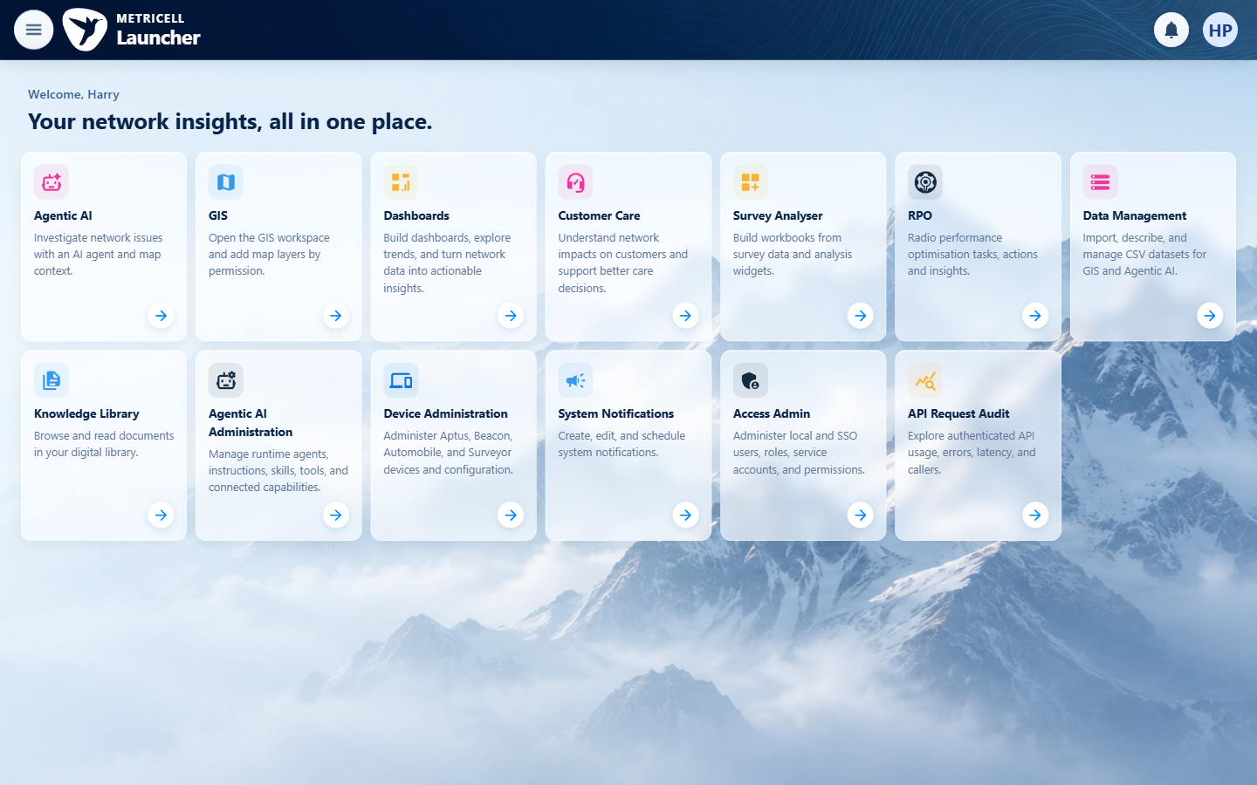 | E02 - Map before selection (criterion-1-map-before-selection.png)  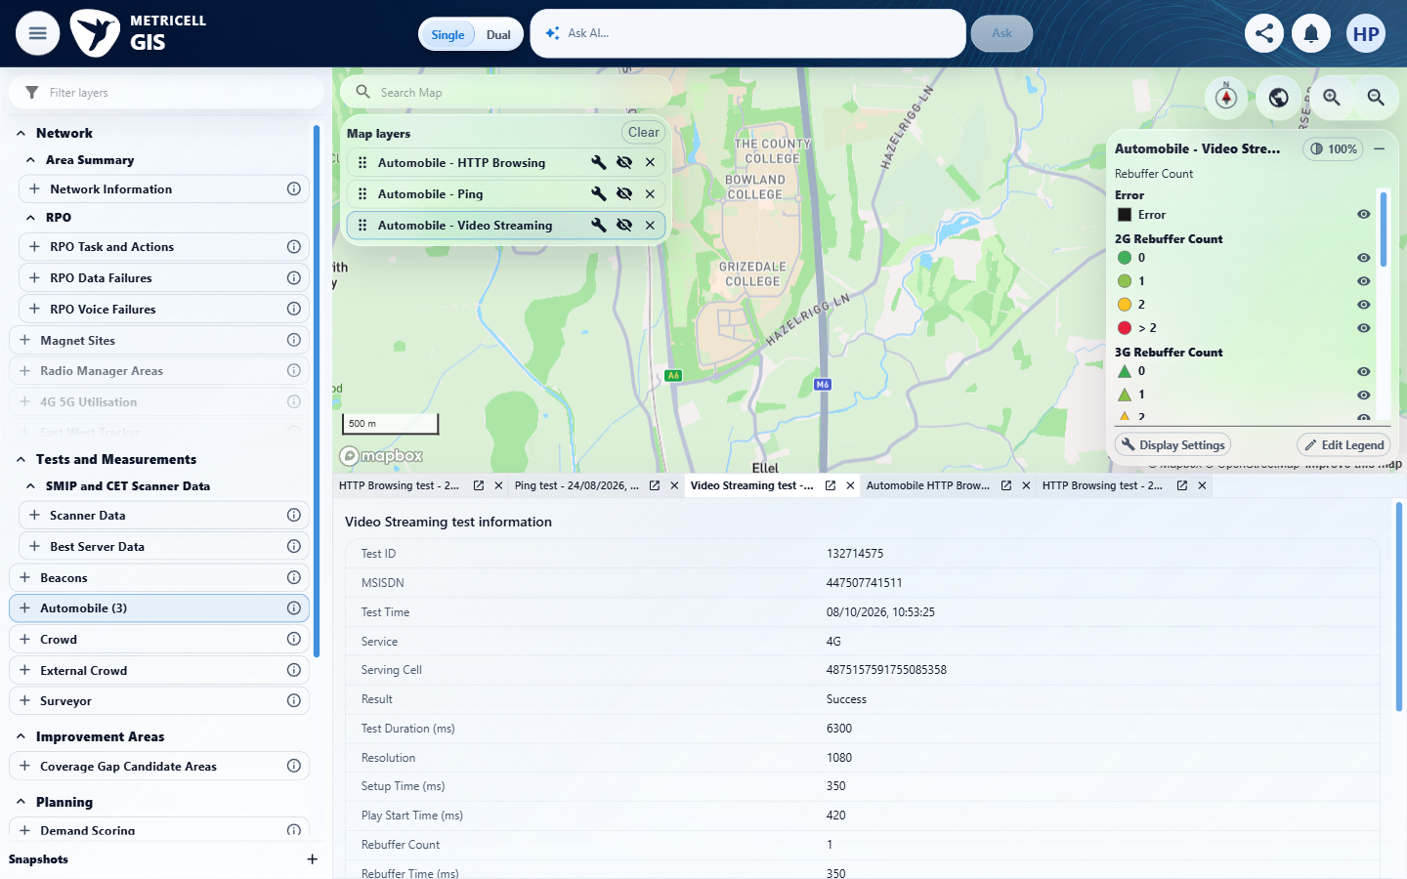

Criterion 1 continued: Before selecting the MS Teams Call layer, the map shows no MS Teams Call test-result points.
Browser URL recorded after criterion: https://o2intelligence-v4-dev.metricell.com/gis
E02 - Final (criterion-1-final.png)

2.0.0 | When the user selects the MS Teams Call layer and authorised matching results are available, each matching result is shown as a selectable map point. | When the user selects the MS Teams Call layer and authorised matching results are available, each matching result is shown as a selectable map point. | criterion-2-automobile-test-types.png and criterion-2-selected-config.png establish Automobile > MS Teams Call, with 31 July–29 October scope. criterion-2-wide-scope.png shows populated matching-layer markers; criterion-2-cluster-members.png shows four MS Teams rows and criterion-2-final.png shows an opened result with matching first-row MSISDN, start/end time and duration. Reported GET /api/platform/automobile/ms-teams-call/points and POST /api/platform/automobile/ms-teams-call/cluster-details support module provenance. Complete reconciliation of supplied aggregates and members against selectable matching authorised results is absent. criterion-2-initial.png shows Loading Launcher; this missing settled setup capture is Unverified, not an unavailable prerequisite or product defect. A settled launcher is a tester workflow assertion, not an added source acceptance condition.  Evidence: E03, E04, E05, E06, E07, E08, E09 | Failed
Criterion 2 assessment: Testing notes: Required own launcher baseline criterion-2-initial.png was inspected and shows Loading Launcher rather than the settled visible launcher. This evidence defect could not be repaired after the subsequent shared-browser state interruption. A genuine aggregate opens four matching tests and test 132060307 is selectable. Complete reconciliation of every supplied aggregate/member against selectable map presentation was not established; each matching result assertion remains Unverified.
Criterion 2 evidence: When the user selects the MS Teams Call layer and authorised matching results are available, each matching result is shown as a selectable map point.
Browser URL recorded after criterion: https://o2intelligence-v4-dev.metricell.com/gis
E03 - Initial (criterion-2-initial.png)  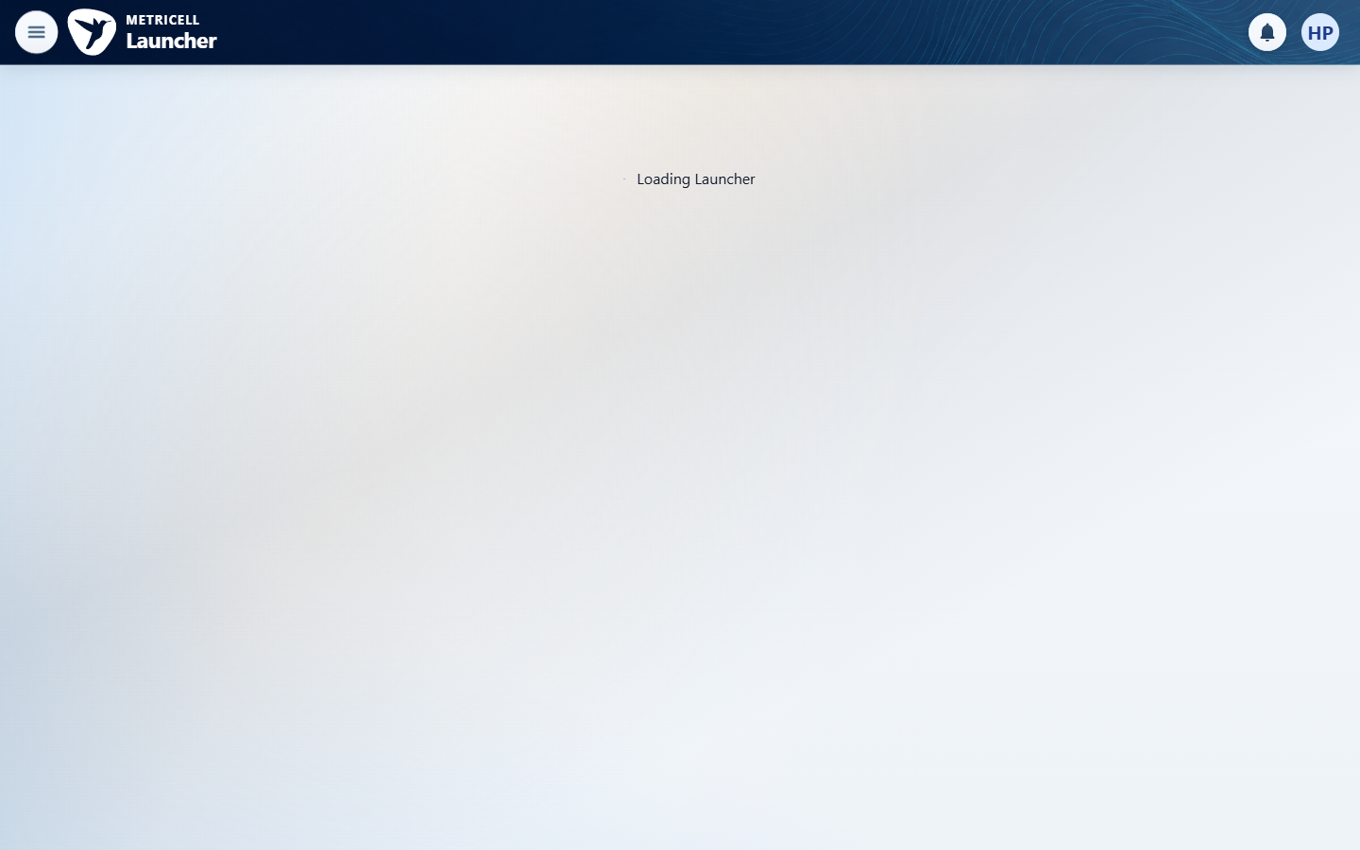 | E04 - Automobile test types (criterion-2-automobile-test-types.png)  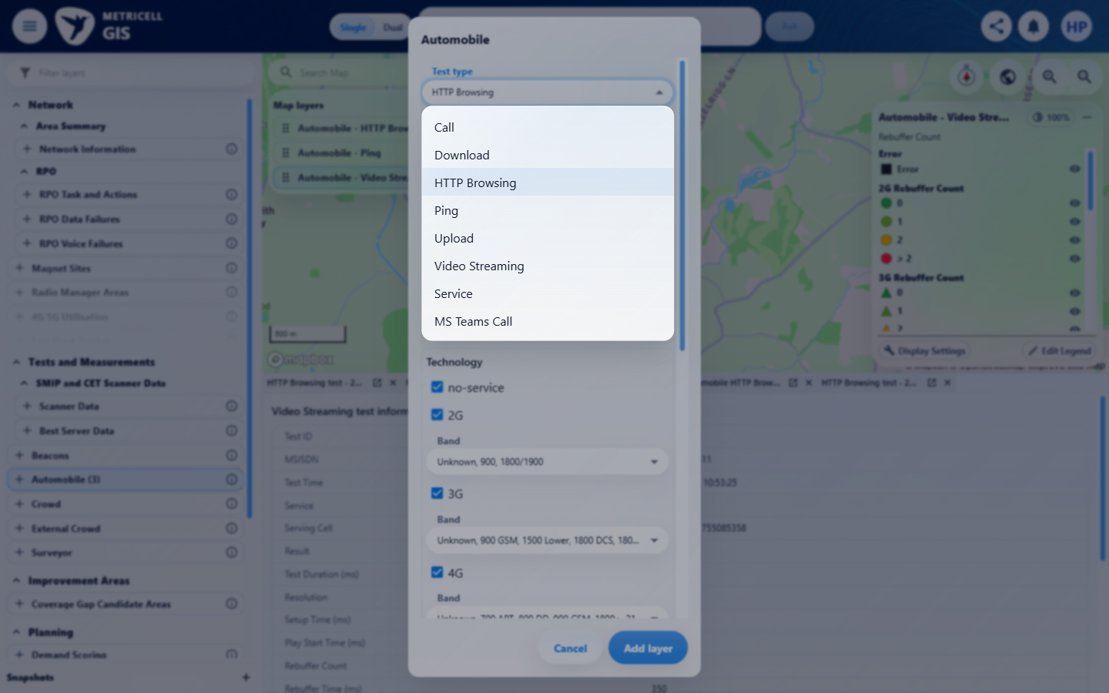

Criterion 2 continued: When the user selects the MS Teams Call layer and authorised matching results are available, each matching result is shown as a selectable map point.
Browser URL recorded after criterion: https://o2intelligence-v4-dev.metricell.com/gis
E05 - Selected config (criterion-2-selected-config.png)  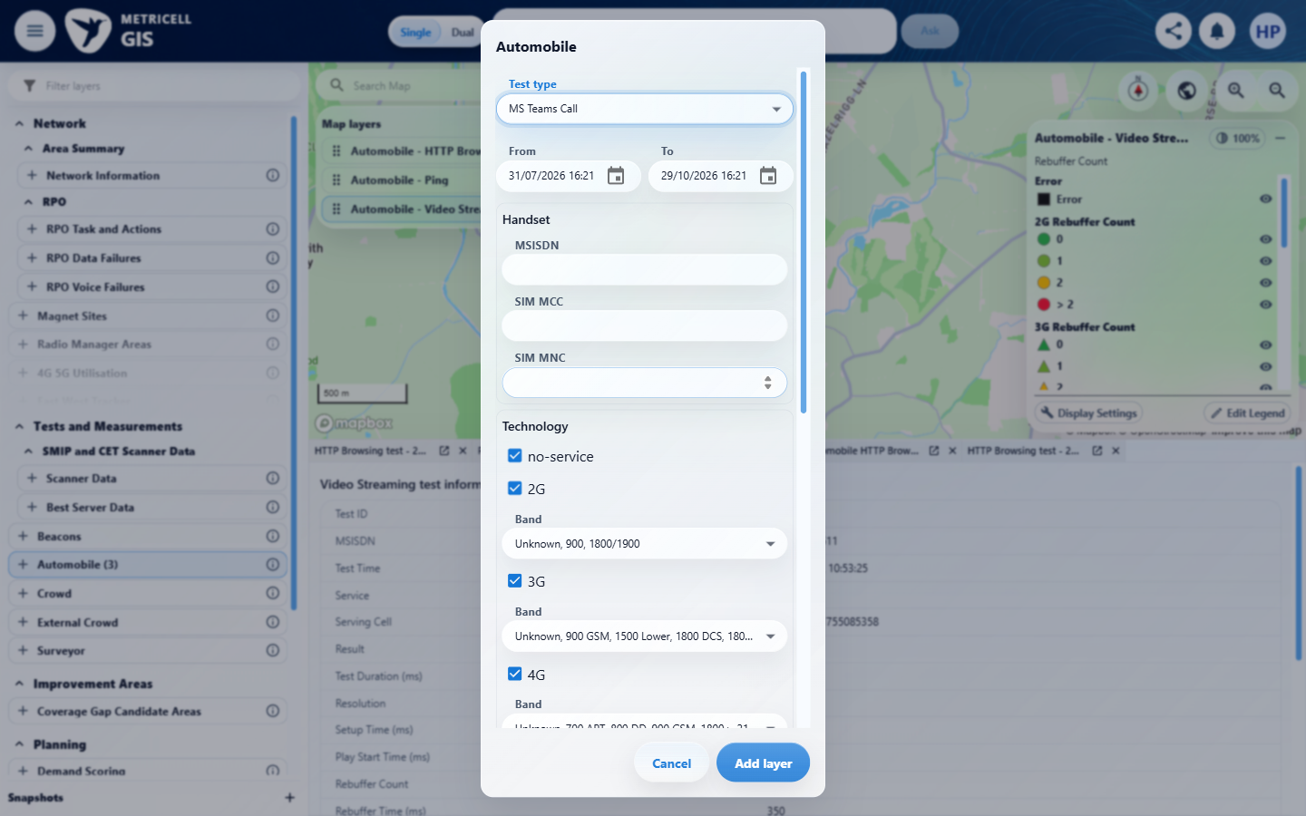 | E06 - After add (criterion-2-after-add.png)  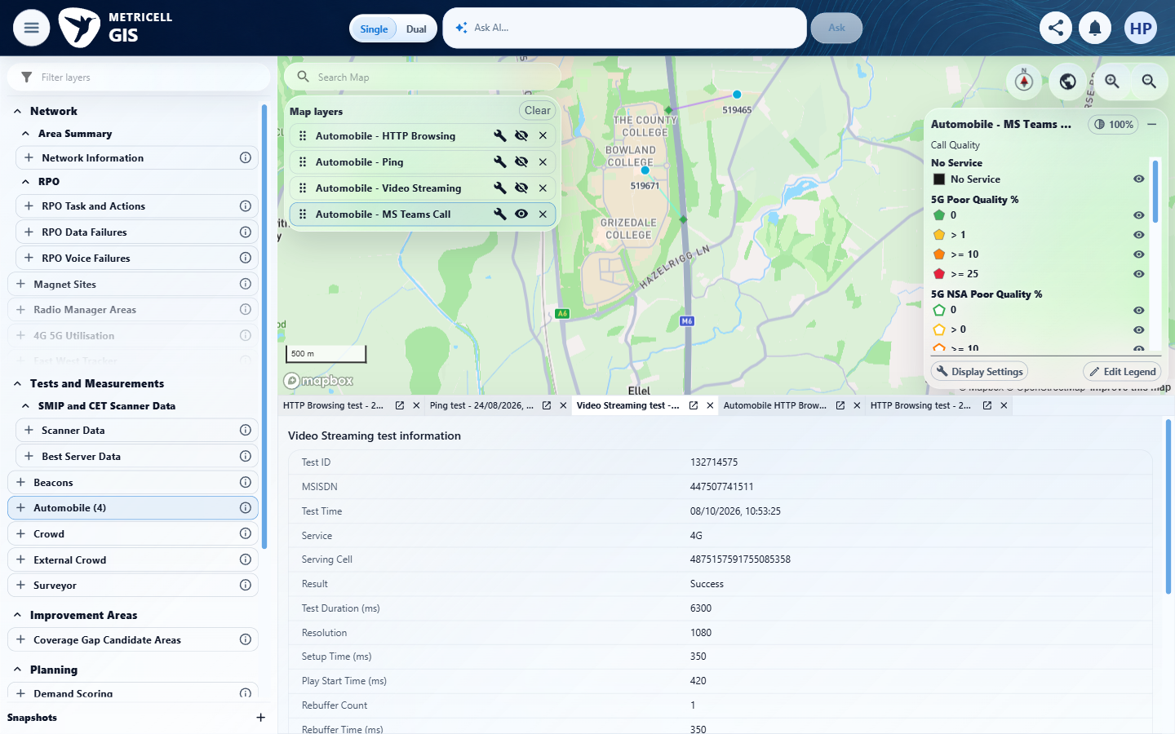

Criterion 2 continued: When the user selects the MS Teams Call layer and authorised matching results are available, each matching result is shown as a selectable map point.
Browser URL recorded after criterion: https://o2intelligence-v4-dev.metricell.com/gis
E07 - Wide scope (criterion-2-wide-scope.png)  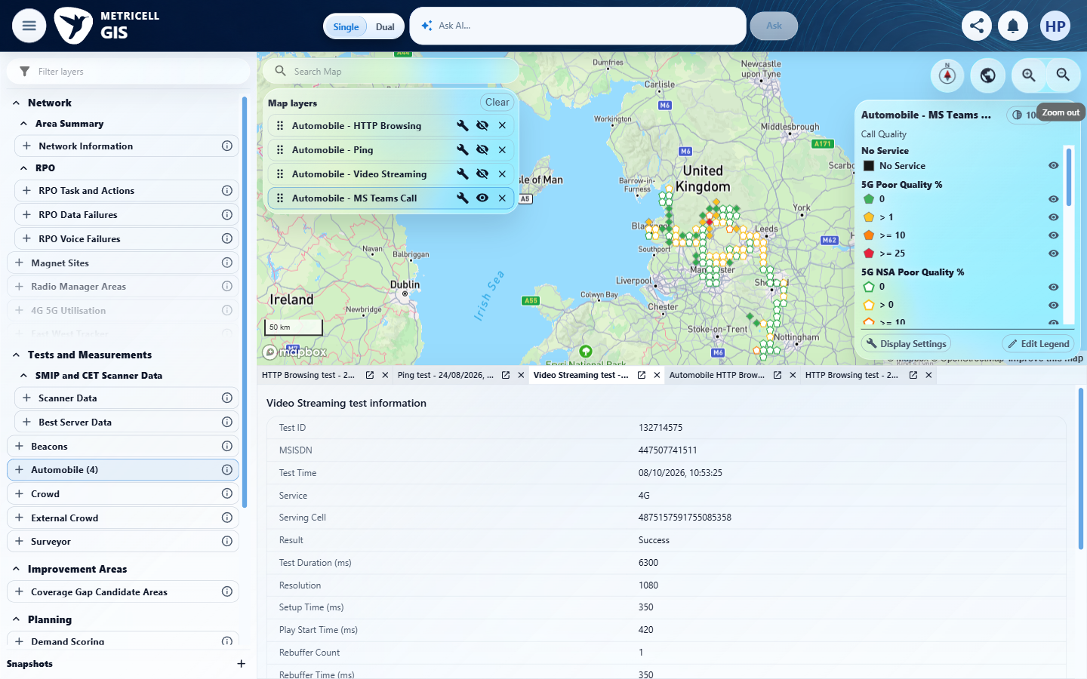 | E08 - Cluster members (criterion-2-cluster-members.png)  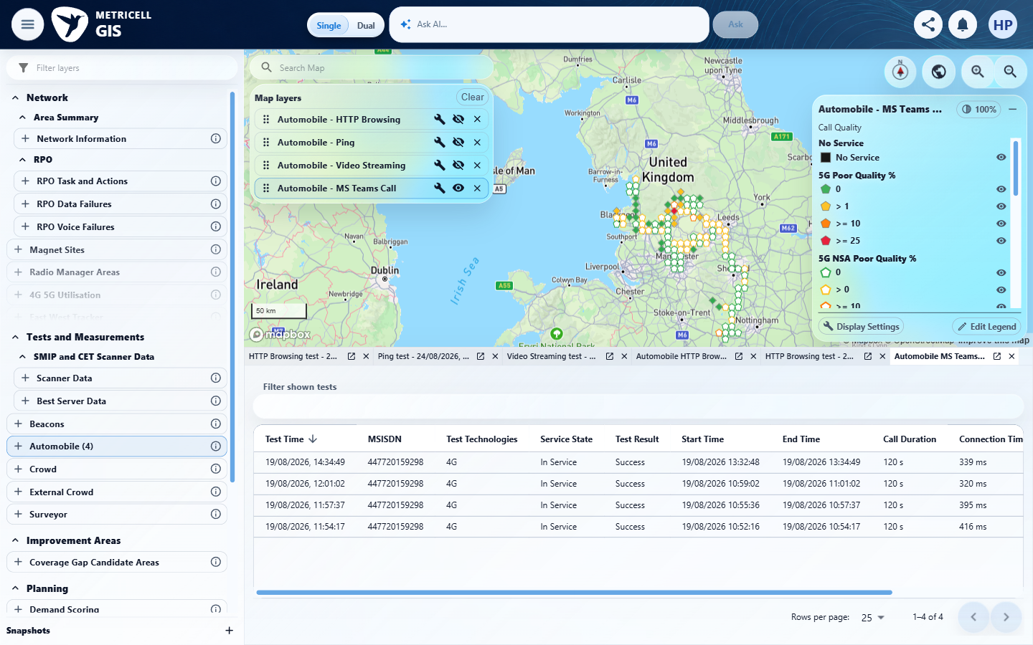

Criterion 2 continued: When the user selects the MS Teams Call layer and authorised matching results are available, each matching result is shown as a selectable map point.
Browser URL recorded after criterion: https://o2intelligence-v4-dev.metricell.com/gis
E09 - Final (criterion-2-final.png)
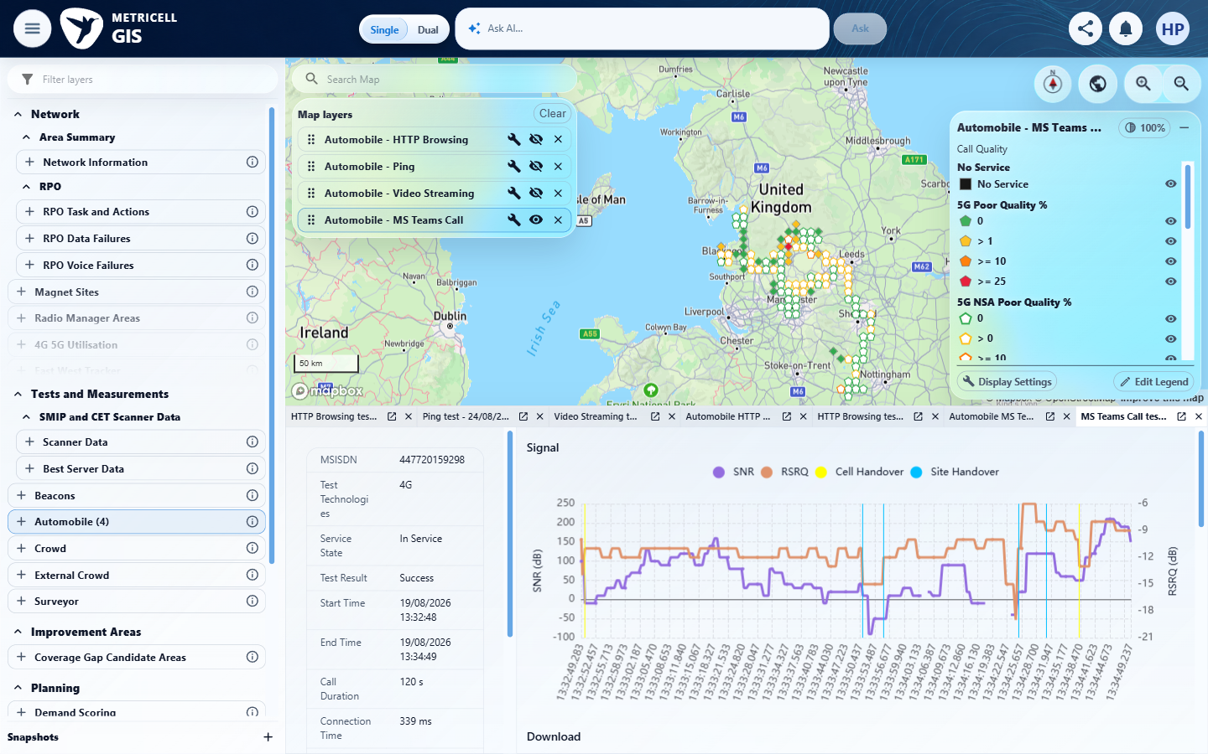

3.0.0 | For a displayed MS Teams Call point with Poor Quality 0–0.99, its map colour is Green. | For a displayed MS Teams Call point with Poor Quality 0–0.99, its map colour is Green. | criterion-3-green-configuration.png visibly shows the green 4G swatch and endpoint 1, but no readable hexadecimal colour code. criterion-3-map.png shows mixed markers; criterion-3-final.png shows a four-row cluster-member test list with Poor Quality off-screen. Neither capture identifies a particular rendered point and its readable 0–0.99 value together. The narrated 0.89%/0% values and #31aa4f cannot establish this pass. Exact colour codes and an independent saved configuration baseline are not source requirements; the missing proof is the qualifying point/value/Green pairing.  Evidence: E10, E11, E12 | Failed
Criterion 3 evidence: For a displayed MS Teams Call point with Poor Quality 0–0.99, its map colour is Green.
Browser URL recorded after criterion: https://o2intelligence-v4-dev.metricell.com/gis
E10 - Map (criterion-3-map.png)  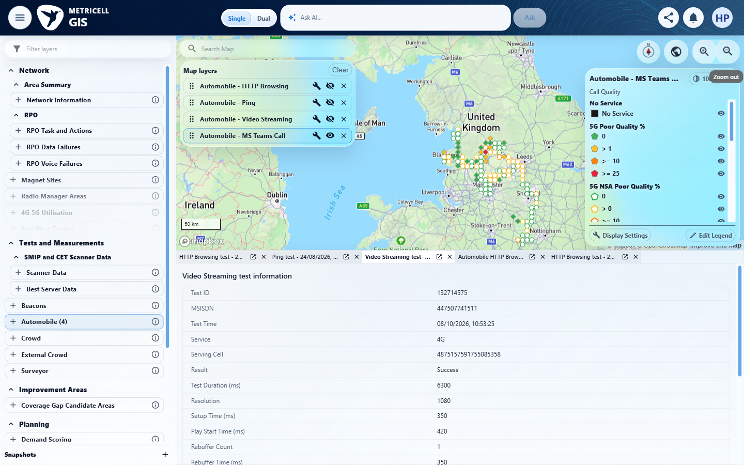 | E11 - Green configuration (criterion-3-green-configuration.png)  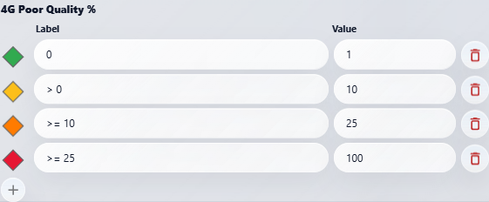

Criterion 3 continued: For a displayed MS Teams Call point with Poor Quality 0–0.99, its map colour is Green.
Browser URL recorded after criterion: https://o2intelligence-v4-dev.metricell.com/gis
E12 - Final (criterion-3-final.png)
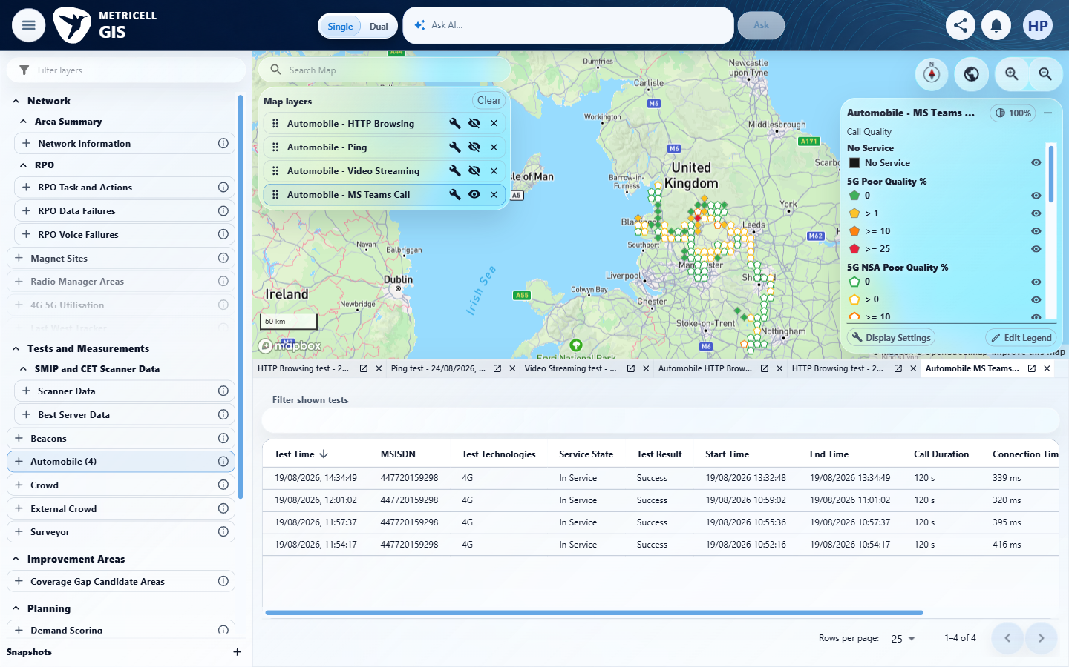

4.0.0 | For a displayed MS Teams Call point with Poor Quality 1–9.99, its map colour is Yellow. | For a displayed MS Teams Call point with Poor Quality 1–9.99, its map colour is Yellow. | criterion-4-map-before-selection.png shows MS Teams markers; criterion-4-yellow-configuration.png shows a yellow 4G swatch with endpoints 1 and 10, but no readable #fcbf1a. criterion-4-final.png shows three cluster-member tests; the later criterion-4-final-values.png is the decisive readable value capture: 131982033 at 1.57%, 131981760 at 0.00%, and 131981704 at 3.60%. The supplied images do not visibly identify which particular map marker corresponds to a qualifying value and establish its Yellow rendering. Reported aggregate 864691668815709477/value 1.720269259536275 is supporting narrative, not visible point/value pairing. criterion-4-initial.png shows Initializing / Preparing modules; this setup gap is Unverified, not a source-required launcher branch or product defect. Exact hex codes are not source acceptance requirements.  Evidence: E13, E14, E15, E16, E17, E18, E19, E20 | Failed
Criterion 4 assessment: Testing notes: Required own launcher baseline criterion-4-initial.png was inspected and shows Initializing / Preparing modules rather than the settled visible launcher. This evidence defect could not be repaired after the subsequent shared-browser state interruption. Yellow configuration #fcbf1a with band endpoints 1 and 10 was inspected; genuine aggregate 864691668815709477 had Poor Quality 1.720269259536275. Its projected normal map click opened matching tests, but direct visible point/value/colour pairing remains inconclusive.
Criterion 4 evidence: For a displayed MS Teams Call point with Poor Quality 1–9.99, its map colour is Yellow.
Browser URL recorded after criterion: https://o2intelligence-v4-dev.metricell.com/gis
E13 - Initial (criterion-4-initial.png)  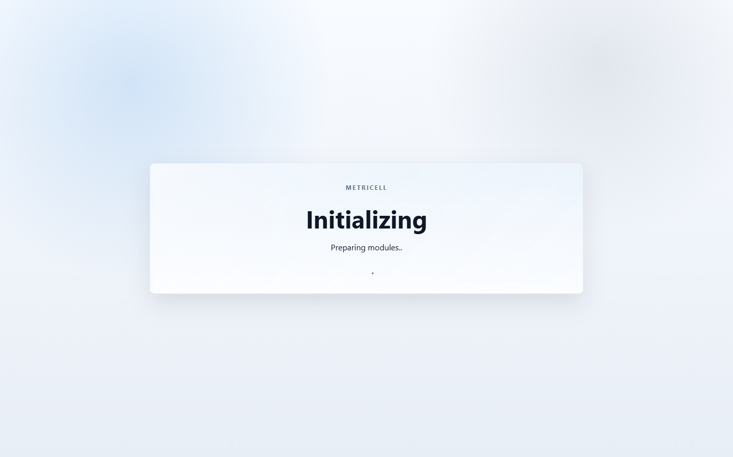 | E14 - Config (criterion-4-config.png)  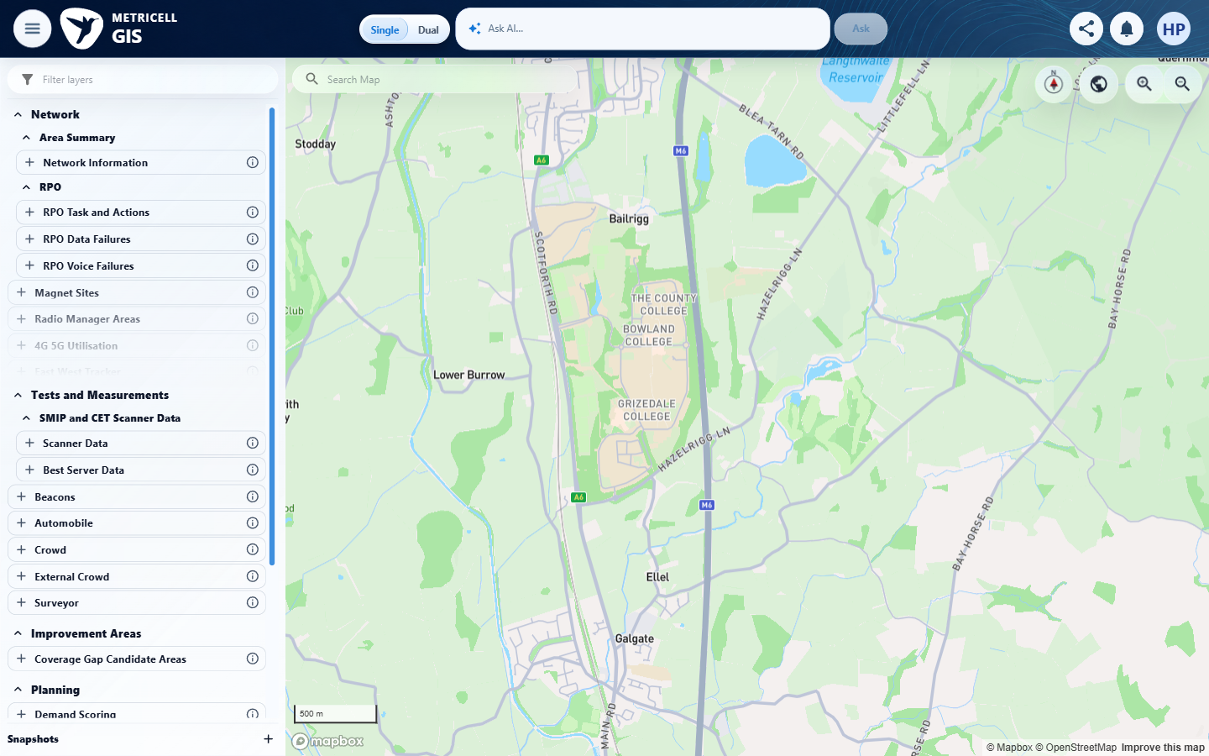

Criterion 4 continued: For a displayed MS Teams Call point with Poor Quality 1–9.99, its map colour is Yellow.
Browser URL recorded after criterion: https://o2intelligence-v4-dev.metricell.com/gis
E15 - Selected config (criterion-4-selected-config.png)  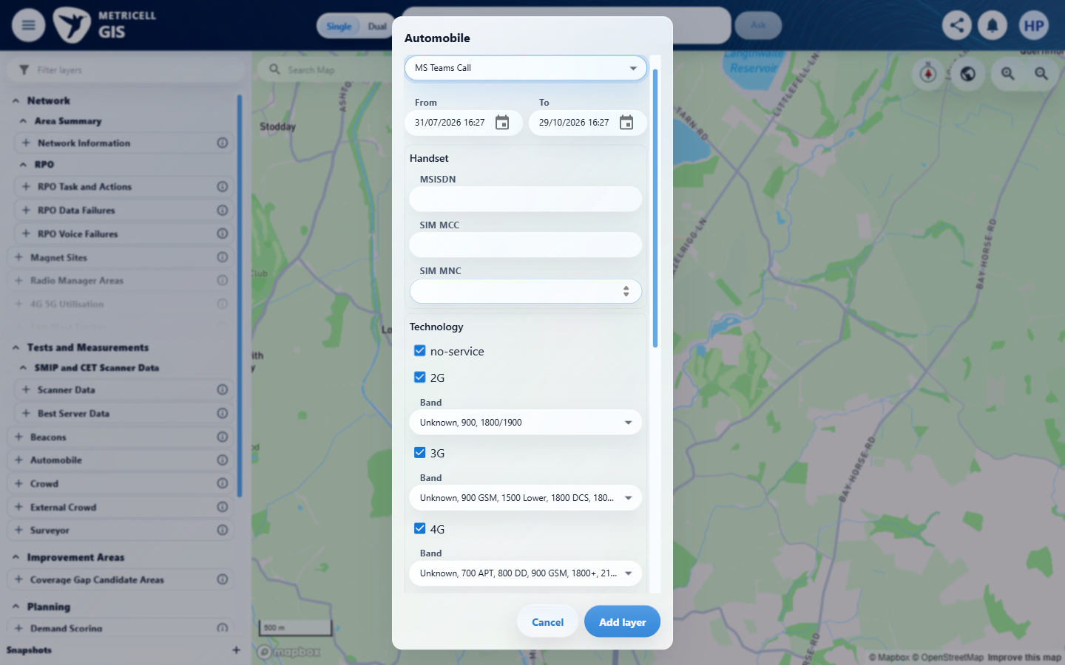 | E16 - Map before selection (criterion-4-map-before-selection.png)  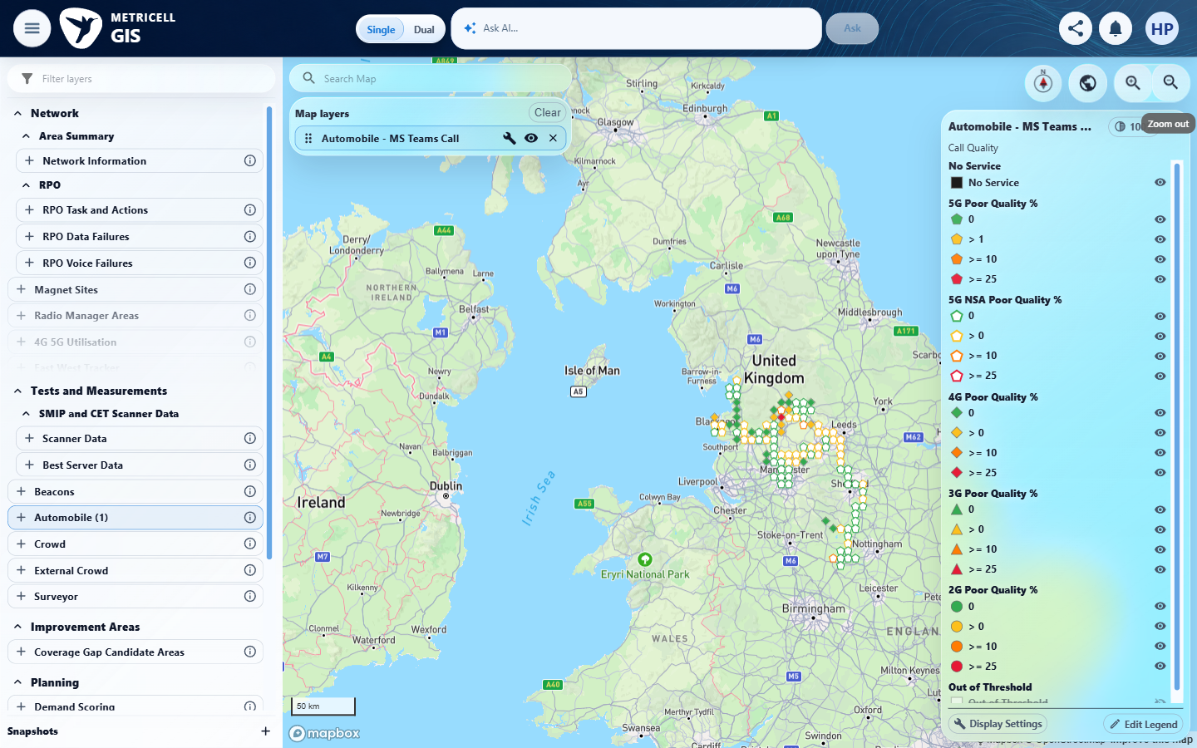

Criterion 4 continued: For a displayed MS Teams Call point with Poor Quality 1–9.99, its map colour is Yellow.
Browser URL recorded after criterion: https://o2intelligence-v4-dev.metricell.com/gis
E17 - Selected members (criterion-4-selected-members.png)  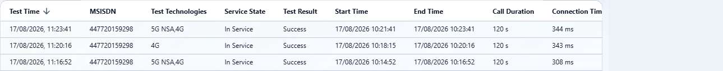 | E18 - Yellow configuration (criterion-4-yellow-configuration.png)  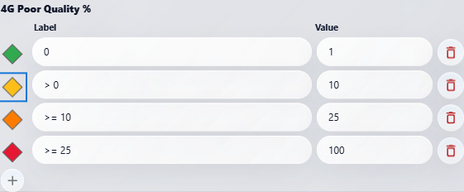

Criterion 4 continued: For a displayed MS Teams Call point with Poor Quality 1–9.99, its map colour is Yellow.
Browser URL recorded after criterion: https://o2intelligence-v4-dev.metricell.com/gis
E19 - Final (criterion-4-final.png)  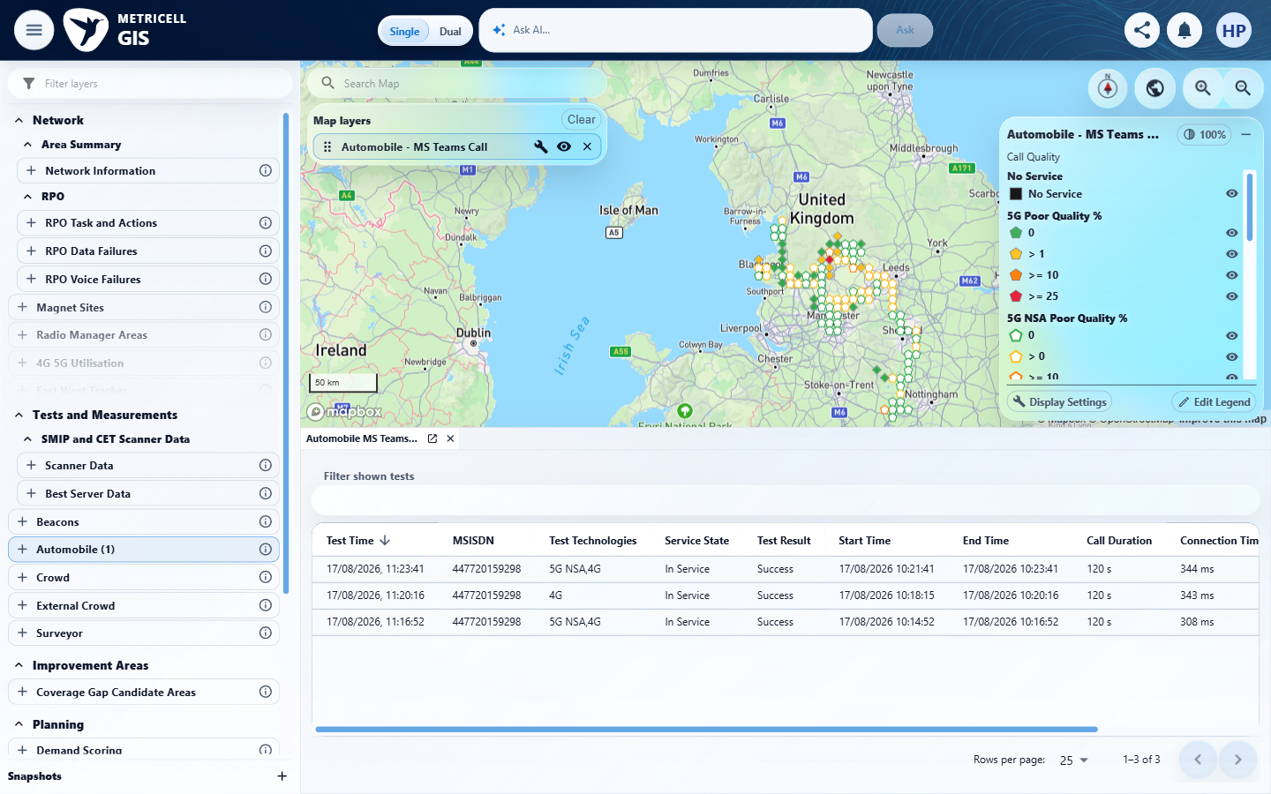 | E20 - Final values (criterion-4-final-values.png)  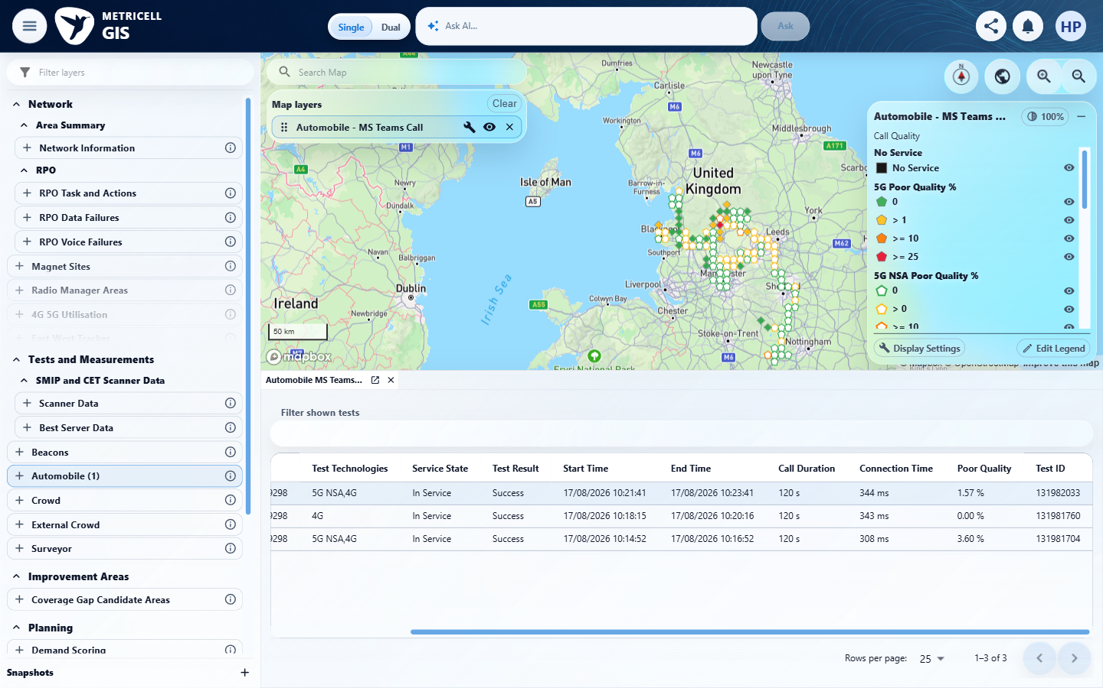

5.0.0 | For a displayed MS Teams Call point with Poor Quality 10–24.99, its map colour is Amber. | For a displayed MS Teams Call point with Poor Quality 10–24.99, its map colour is Amber. | criterion-5-initial.png shows the settled launcher, but criterion-5-selected-config.png and criterion-5-map.png both show Automobile - Service, not MS Teams Call. No criterion-owned qualifying MS Teams point or 10–24.99 value was established. The tester reports unreconciled shared-browser ownership/state, a setup timeout, no MS Teams points request and stopping browser work with the lease retained for coordinator reconciliation. This actual environment/scope blocker prevents assessment; Service evidence cannot establish MS Teams behaviour or a defect. Configured colour-code/independent-baseline wording in the retained tester assertion exceeds the source's Amber rendering requirement.  Evidence: E21, E22 | Blocked
Criterion 5 assessment: Testing notes: Shared-browser state could not be reconciled: on the criterion 5 launcher-to-GIS start, Automobile - Service and a zoomed Lancaster map appeared, although this run had not selected Service or navigated to that view. The attempted Automobile setup locator timed out; current UI was re-inspected instead of assuming success. No request for MS Teams points was observed in this criterion. The browser lease still belongs to this handoff. Browser work stopped and the lease is retained for coordinator ownership/state reconciliation. Cause is unknown; this is not classified as a product failure or transient retry. Own captures show the unexpected layer state. Opened GIS. Expected Automobile setup locator timed out. Inspected current UI: Automobile (1), Automobile - Service selected, map near Lancaster; no action by this run selected Service.
Criterion 5 evidence: For a displayed MS Teams Call point with Poor Quality 10–24.99, its map colour is Amber.
Browser URL recorded after criterion: https://o2intelligence-v4-dev.metricell.com/gis
E21 - Initial (criterion-5-initial.png)  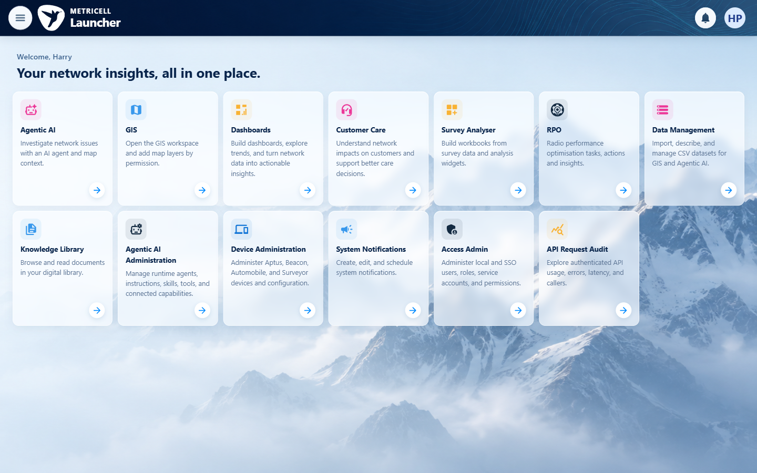 | E22 - Selected config (criterion-5-selected-config.png)  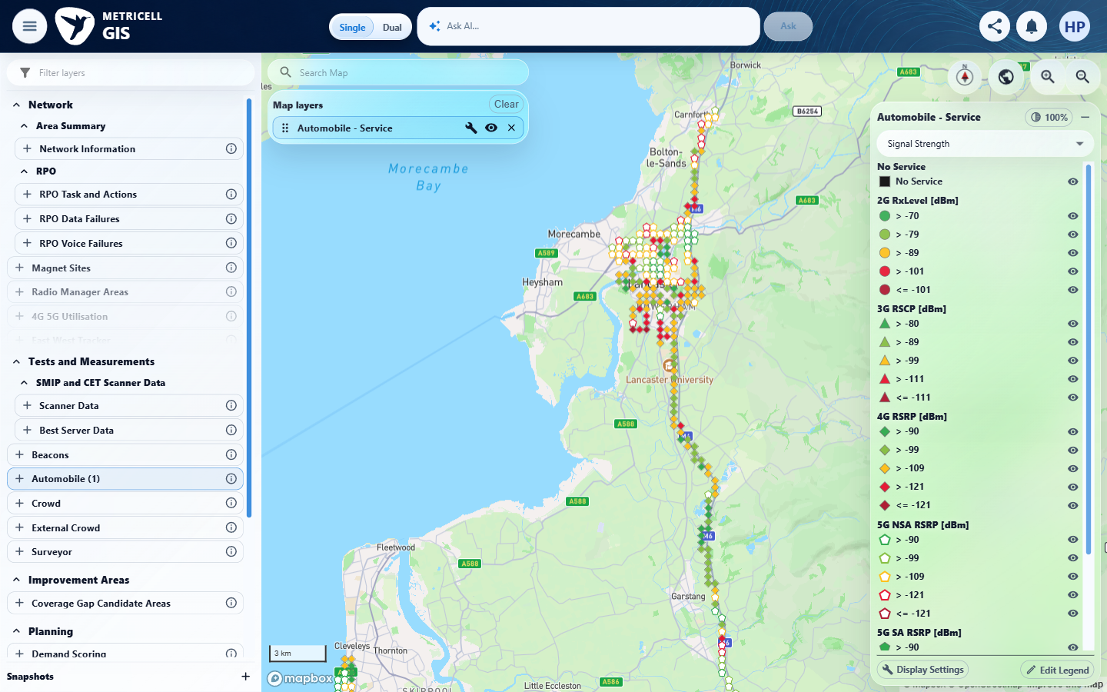

Criterion 5 continued: For a displayed MS Teams Call point with Poor Quality 10–24.99, its map colour is Amber.
Browser URL recorded after criterion: https://o2intelligence-v4-dev.metricell.com/gis
E22 - Map (criterion-5-map.png)

6.0.0 | For a displayed MS Teams Call point with Poor Quality 25 or greater, its map colour is Red. | For a displayed MS Teams Call point with Poor Quality 25 or greater, its map colour is Red. | Testing could not be completed: the tester stopped after criterion 5 because shared-browser ownership/state was unreconciled and Automobile Service appeared without a corresponding action from this run. No criterion-owned browser evidence was captured for Red point/value pairing. The MS Teams prerequisite and interaction sequence were not established independently; earlier criteria and Service captures are not reused. Cause remains unknown; no product failure is established.  Evidence: Unavailable  Browser URL recorded after criterion: Not recorded | Blocked
Criterion 6 assessment: Testing notes: Shared-browser state could not be reconciled: on the criterion 5 launcher-to-GIS start, Automobile - Service and a zoomed Lancaster map appeared, although this run had not selected Service or navigated to that view. The attempted Automobile setup locator timed out; current UI was re-inspected instead of assuming success. No request for MS Teams points was observed in this criterion. The browser lease still belongs to this handoff. Browser work stopped and the lease is retained for coordinator ownership/state reconciliation. Cause is unknown; this is not classified as a product failure or transient retry. No criterion-owned PNG was possible after the browser interruption; no URL was observed for this unstarted criterion.
7.0.0 | When the user selects a map point and its details load successfully, the details dialog displays Test ID, Test Result, Connection Time, Call Duration, Poor Quality, MSISDN and Test Technologies. | When the user selects a map point and its details load successfully, the details dialog displays Test ID, Test Result, Connection Time, Call Duration, Poor Quality, MSISDN and Test Technologies. | Testing could not be completed: the tester stopped after criterion 5 because shared-browser ownership/state was unreconciled and Automobile Service appeared without a corresponding action from this run. No criterion-owned browser evidence was captured for all seven mandatory summary fields. The MS Teams prerequisite and interaction sequence were not established independently; earlier criteria and Service captures are not reused. Cause remains unknown; no product failure is established.  Evidence: Unavailable  Browser URL recorded after criterion: Not recorded | Blocked
Criterion 7 assessment: Testing notes: Shared-browser state could not be reconciled: on the criterion 5 launcher-to-GIS start, Automobile - Service and a zoomed Lancaster map appeared, although this run had not selected Service or navigated to that view. The attempted Automobile setup locator timed out; current UI was re-inspected instead of assuming success. No request for MS Teams points was observed in this criterion. The browser lease still belongs to this handoff. Browser work stopped and the lease is retained for coordinator ownership/state reconciliation. Cause is unknown; this is not classified as a product failure or transient retry. No criterion-owned PNG was possible after the browser interruption; no URL was observed for this unstarted criterion.
8.0.0 | When the user selects a map point and its details load successfully, the details dialog displays signal and download charts and shows handover markers when available. | When the user selects a map point and its details load successfully, the details dialog displays signal and download charts and shows handover markers when available. | Testing could not be completed: the tester stopped after criterion 5 because shared-browser ownership/state was unreconciled and Automobile Service appeared without a corresponding action from this run. No criterion-owned browser evidence was captured for signal/download charts and available handover markers. The MS Teams prerequisite and interaction sequence were not established independently; earlier criteria and Service captures are not reused. Cause remains unknown; no product failure is established. Relevant tooltips in retained tester assertions are not an additional source requirement; actual chart series and conditional handover coverage remain untested.  Evidence: Unavailable  Browser URL recorded after criterion: Not recorded | Blocked
Criterion 8 assessment: Testing notes: Shared-browser state could not be reconciled: on the criterion 5 launcher-to-GIS start, Automobile - Service and a zoomed Lancaster map appeared, although this run had not selected Service or navigated to that view. The attempted Automobile setup locator timed out; current UI was re-inspected instead of assuming success. No request for MS Teams points was observed in this criterion. The browser lease still belongs to this handoff. Browser work stopped and the lease is retained for coordinator ownership/state reconciliation. Cause is unknown; this is not classified as a product failure or transient retry. No criterion-owned PNG was possible after the browser interruption; no URL was observed for this unstarted criterion.
9.0.0 | When the user selects a map point and its details load successfully, the details dialog displays a detailed-sample table that omits label, latitude, longitude and handover-only columns. | When the user selects a map point and its details load successfully, the details dialog displays a detailed-sample table that omits label, latitude, longitude and handover-only columns. | Testing could not be completed: the tester stopped after criterion 5 because shared-browser ownership/state was unreconciled and Automobile Service appeared without a corresponding action from this run. No criterion-owned browser evidence was captured for the selected result's own detailed-sample table and excluded columns. The MS Teams prerequisite and interaction sequence were not established independently; earlier criteria and Service captures are not reused. Cause remains unknown; no product failure is established.  Evidence: Unavailable  Browser URL recorded after criterion: Not recorded | Blocked
Criterion 9 assessment: Testing notes: Shared-browser state could not be reconciled: on the criterion 5 launcher-to-GIS start, Automobile - Service and a zoomed Lancaster map appeared, although this run had not selected Service or navigated to that view. The attempted Automobile setup locator timed out; current UI was re-inspected instead of assuming success. No request for MS Teams points was observed in this criterion. The browser lease still belongs to this handoff. Browser work stopped and the lease is retained for coordinator ownership/state reconciliation. Cause is unknown; this is not classified as a product failure or transient retry. No criterion-owned PNG was possible after the browser interruption; no URL was observed for this unstarted criterion.
10.0.0 | When detailed samples are displayed, sorting a supported column changes their displayed order to match the selected sort. | When detailed samples are displayed, sorting a supported column changes their displayed order to match the selected sort. | Testing could not be completed: the tester stopped after criterion 5 because shared-browser ownership/state was unreconciled and Automobile Service appeared without a corresponding action from this run. No criterion-owned browser evidence was captured for supported detailed-sample sorting. The MS Teams prerequisite and interaction sequence were not established independently; earlier criteria and Service captures are not reused. Cause remains unknown; no product failure is established. The source requires sorting a supported sample column; it does not independently require every tester-listed named column and both directions. Those assertions are retained for audit, not treated as new mandatory acceptance scope.  Evidence: Unavailable  Browser URL recorded after criterion: Not recorded | Blocked
Criterion 10 assessment: Testing notes: Shared-browser state could not be reconciled: on the criterion 5 launcher-to-GIS start, Automobile - Service and a zoomed Lancaster map appeared, although this run had not selected Service or navigated to that view. The attempted Automobile setup locator timed out; current UI was re-inspected instead of assuming success. No request for MS Teams points was observed in this criterion. The browser lease still belongs to this handoff. Browser work stopped and the lease is retained for coordinator ownership/state reconciliation. Cause is unknown; this is not classified as a product failure or transient retry. No criterion-owned PNG was possible after the browser interruption; no URL was observed for this unstarted criterion.
11.0.0 | When detailed samples are displayed, filtering a supported column limits the displayed samples to those matching the filter. | When detailed samples are displayed, filtering a supported column limits the displayed samples to those matching the filter. | Testing could not be completed: the tester stopped after criterion 5 because shared-browser ownership/state was unreconciled and Automobile Service appeared without a corresponding action from this run. No criterion-owned browser evidence was captured for supported detailed-sample filtering. The MS Teams prerequisite and interaction sequence were not established independently; earlier criteria and Service captures are not reused. Cause remains unknown; no product failure is established. Filter clearing in the retained tester assertion is supplementary; the canonical matching-subset operation itself was not tested.  Evidence: Unavailable  Browser URL recorded after criterion: Not recorded | Blocked
Criterion 11 assessment: Testing notes: Shared-browser state could not be reconciled: on the criterion 5 launcher-to-GIS start, Automobile - Service and a zoomed Lancaster map appeared, although this run had not selected Service or navigated to that view. The attempted Automobile setup locator timed out; current UI was re-inspected instead of assuming success. No request for MS Teams points was observed in this criterion. The browser lease still belongs to this handoff. Browser work stopped and the lease is retained for coordinator ownership/state reconciliation. Cause is unknown; this is not classified as a product failure or transient retry. No criterion-owned PNG was possible after the browser interruption; no URL was observed for this unstarted criterion.
12.0.0 | When the user exports a selected test as CSV, the exported CSV contains data for that selected test. | When the user exports a selected test as CSV, the exported CSV contains data for that selected test. | Testing could not be completed: the tester stopped after criterion 5 because shared-browser ownership/state was unreconciled and Automobile Service appeared without a corresponding action from this run. No criterion-owned browser evidence was captured for selected-test CSV export and contents. The MS Teams prerequisite and interaction sequence were not established independently; earlier criteria and Service captures are not reused. Cause remains unknown; no product failure is established.  Evidence: Unavailable  Browser URL recorded after criterion: Not recorded | Blocked
Criterion 12 assessment: Testing notes: Shared-browser state could not be reconciled: on the criterion 5 launcher-to-GIS start, Automobile - Service and a zoomed Lancaster map appeared, although this run had not selected Service or navigated to that view. The attempted Automobile setup locator timed out; current UI was re-inspected instead of assuming success. No request for MS Teams points was observed in this criterion. The browser lease still belongs to this handoff. Browser work stopped and the lease is retained for coordinator ownership/state reconciliation. Cause is unknown; this is not classified as a product failure or transient retry. No criterion-owned PNG was possible after the browser interruption; no URL was observed for this unstarted criterion.
13.0.0 | When a zero-duration result is selected, its details dialog does not display stale or misleading data. | When a zero-duration result is selected, its details dialog does not display stale or misleading data. | Testing could not be completed: the tester stopped after criterion 5 because shared-browser ownership/state was unreconciled and Automobile Service appeared without a corresponding action from this run. No criterion-owned browser evidence was captured for genuine zero-duration handling without stale or misleading data. The MS Teams prerequisite and interaction sequence were not established independently; earlier criteria and Service captures are not reused. Cause remains unknown; no product failure is established. No qualifying zero-duration fixture or normal activation sequence was captured; this is not a disabled-control pass.  Evidence: Unavailable  Browser URL recorded after criterion: Not recorded | Blocked
Criterion 13 assessment: Testing notes: Shared-browser state could not be reconciled: on the criterion 5 launcher-to-GIS start, Automobile - Service and a zoomed Lancaster map appeared, although this run had not selected Service or navigated to that view. The attempted Automobile setup locator timed out; current UI was re-inspected instead of assuming success. No request for MS Teams points was observed in this criterion. The browser lease still belongs to this handoff. Browser work stopped and the lease is retained for coordinator ownership/state reconciliation. Cause is unknown; this is not classified as a product failure or transient retry. No criterion-owned PNG was possible after the browser interruption; no URL was observed for this unstarted criterion.
14.0.0 | When details for a selected result fail to load, the dialog does not display stale or misleading data. | When details for a selected result fail to load, the dialog does not display stale or misleading data. | Testing could not be completed: the tester stopped after criterion 5 because shared-browser ownership/state was unreconciled and Automobile Service appeared without a corresponding action from this run. No criterion-owned browser evidence was captured for failed detail loading without stale or misleading data. The MS Teams prerequisite and interaction sequence were not established independently; earlier criteria and Service captures are not reused. Cause remains unknown; no product failure is established. No genuine failure or browser-local simulation was exercised, and no simulation handler was reported installed; recovery/cleanup assertions do not establish backend behaviour.  Evidence: Unavailable  Browser URL recorded after criterion: Not recorded | Blocked
Criterion 14 assessment: Testing notes: Shared-browser state could not be reconciled: on the criterion 5 launcher-to-GIS start, Automobile - Service and a zoomed Lancaster map appeared, although this run had not selected Service or navigated to that view. The attempted Automobile setup locator timed out; current UI was re-inspected instead of assuming success. No request for MS Teams points was observed in this criterion. The browser lease still belongs to this handoff. Browser work stopped and the lease is retained for coordinator ownership/state reconciliation. Cause is unknown; this is not classified as a product failure or transient retry. No criterion-owned PNG was possible after the browser interruption; no URL was observed for this unstarted criterion.

About Metricell

Metricell is on a mission to deliver connectivity. We work with our customers to design, deliver and manage wireless communication networks – with a shared ambition of achieving flawless network experience. We’ve been responsible for many first-to-market products, and our technology is characterised by the relentless pursuit of automation and digitalisation.

Our geospatial intelligence tools traverse a wide variety of business processes – from Test & Measurement to Customer Experience Management – and we’re pioneers in Crowdsourcing and Digital Self Care. Our technology is today in use by a range of customers; thousands of their personnel; and millions of subscribers worldwide.

Find out more at www.metricell.com




