

Automated Test Case Document
Jira Ticket: TEST2-80

Document Classification: | Company Confidential
Document Ref: | Automated Test Case Document
Version: | 1.0
Date: | 22/10/2026
Document Author: | Automated TEST2 Evidence Review
Document Owner: | Quality Assurance / Metricell




This document and its content is copyright of Metricell Limited @ 2026 all rights reserved. All information contained herein is the intellectual property of Metricell Limited and should be treated as confidential. Any external redistribution of reproduction of part or all of the contents in any form is prohibited unless expressly agreed with Metricell Limited in writing. Any reproduced content must include the following statement; “Part or all of the content contained herein is copyright of Metricell Limited @ 2026 all rights reserved”.
Table of Contents
1 Revision History 2
2 Test Cycle Information 3
3 Test Summary 3
4 Test Cases 4
About Metricell 12

Revision History

Version | Date | Revision Author | Summary of Changes
[1.0] | 22/10/2026 | TEST2 QA Automation | Generated from TEST2 evidence review

Test Cycle Information

Tester: | Automated
Jira Ticket: | TEST2-80
Environment: | o2intelligence-v4-dev.metricell.com
Browser Details: | Google Chrome 156.0.8078.48
Date of Test: | 22/10/2026
Limitations during Testing: | SIMULATED UI STATE: criterion(s) 8, 9 use browser-local conditions, not backend integration tests. Method and recovery are disclosed with their evidence. Pass, Fail and Blocked use Y/N. Defect No counts directly contradicted criteria, not unique Jira bugs; blockers and inconclusive evidence count as zero.
Overall review outcome: | Passed
Browser URL(s) recorded after criteria: | https://o2intelligence-v4-dev.metricell.com/gis

Test Summary

Area of test | Pass (Y/N) | Fail (Y/N) | Blocked (Y/N) | Defect No
1. The map layer selector includes Service as a selectable layer. | Y | N | N | 0
2. With Service unselected, the map displays no Service test-result points. | Y | N | N | 0
3. When the user selects Service and matching authorised results are available, each matching result is displayed as a selectable map point. | Y | N | N | 0
4. When the user selects a Service result point and its details load successfully, a Service details dialog displays MSISDN, Test Time, Signal, Band, Service, Data Technology, PLMN and Serving Cell. | Y | N | N | 0
5. With the Service details table displayed, sorting a supported column reorders the displayed rows according to that column. | Y | N | N | 0
6. With the Service details table displayed, filtering a supported column limits the displayed rows to those matching the filter. | Y | N | N | 0
7. When returned details include cell-neighbour data, the dialog displays each neighbour in its own labelled details table. | Y | N | N | 0
8. While Service details are loading, the dialog displays a loading state. | Y | N | N | 0
9. If Service details cannot be retrieved, the dialog displays an error state and does not display stale details. | Y | N | N | 0

Test Cases
Each test maps to a criterion and decisive browser evidence. Inconclusive results are reported as Failed.

Tests

Preconditions: | V4 access and ticket conditions. | Associated Requirements: | Ticket criteria below. | Automation Notes: | Screenshots below each criterion; full log retained locally.
ID / Criterion | Criteria Tested | Expected Result | Actual Result / Evidence Path | Outcome
1.0.0 | The map layer selector includes Service as a selectable layer. | The map layer selector includes Service as a selectable layer. | criterion-1-automobile-config.png, criterion-1-service-choice.png and criterion-1-final.png show Service offered and selected within Automobile Test type.  Evidence: E01, E02, E03, E04 | Passed
Criterion 1 assessment: criterion-1-automobile-config.png, criterion-1-service-choice.png and criterion-1-final.png show Service offered and selected within Automobile Test type.
Criterion 1 evidence: The map layer selector includes Service as a selectable layer.
Browser URL recorded after criterion: https://o2intelligence-v4-dev.metricell.com/gis
E01 - Before automobile (criterion-1-before-automobile.png)  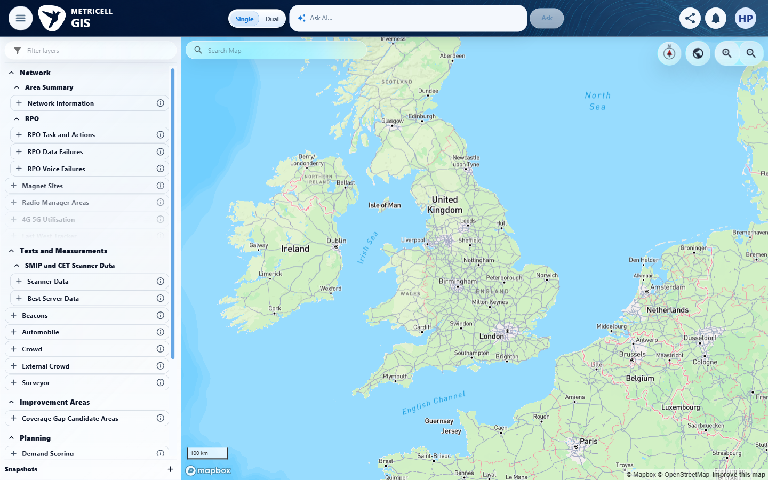 | E02 - Automobile config (criterion-1-automobile-config.png)  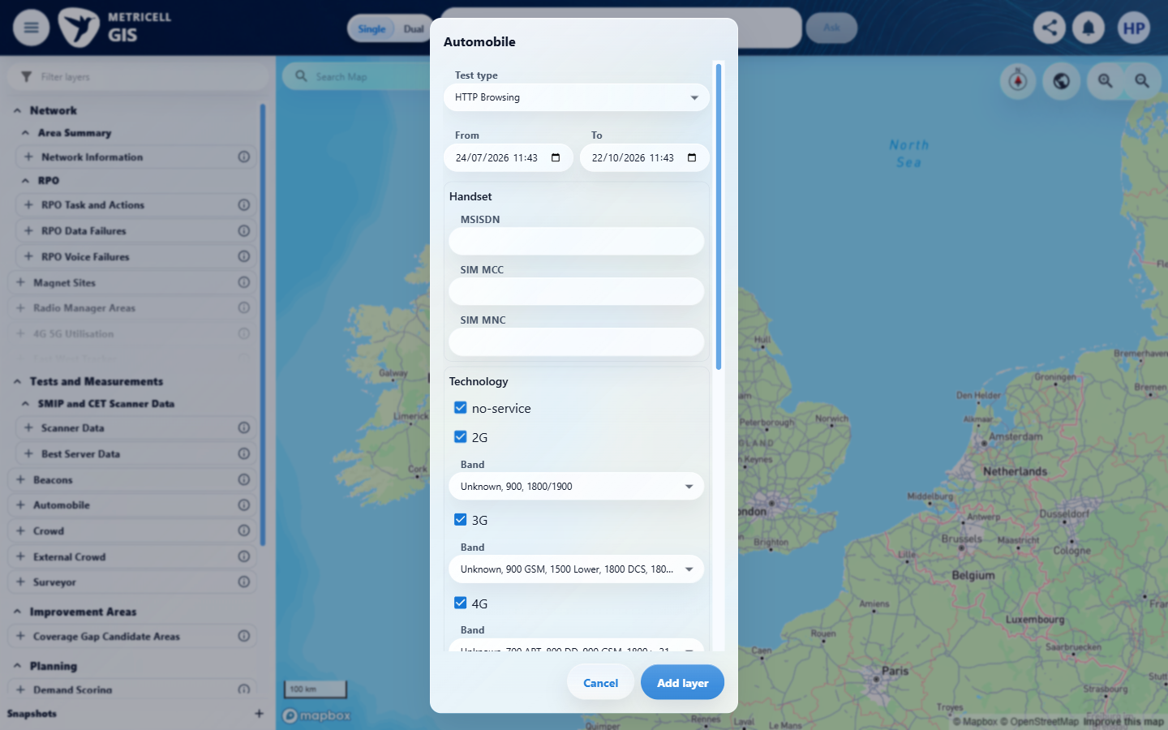

Criterion 1 continued: The map layer selector includes Service as a selectable layer.
Browser URL recorded after criterion: https://o2intelligence-v4-dev.metricell.com/gis
E03 - Service choice (criterion-1-service-choice.png)  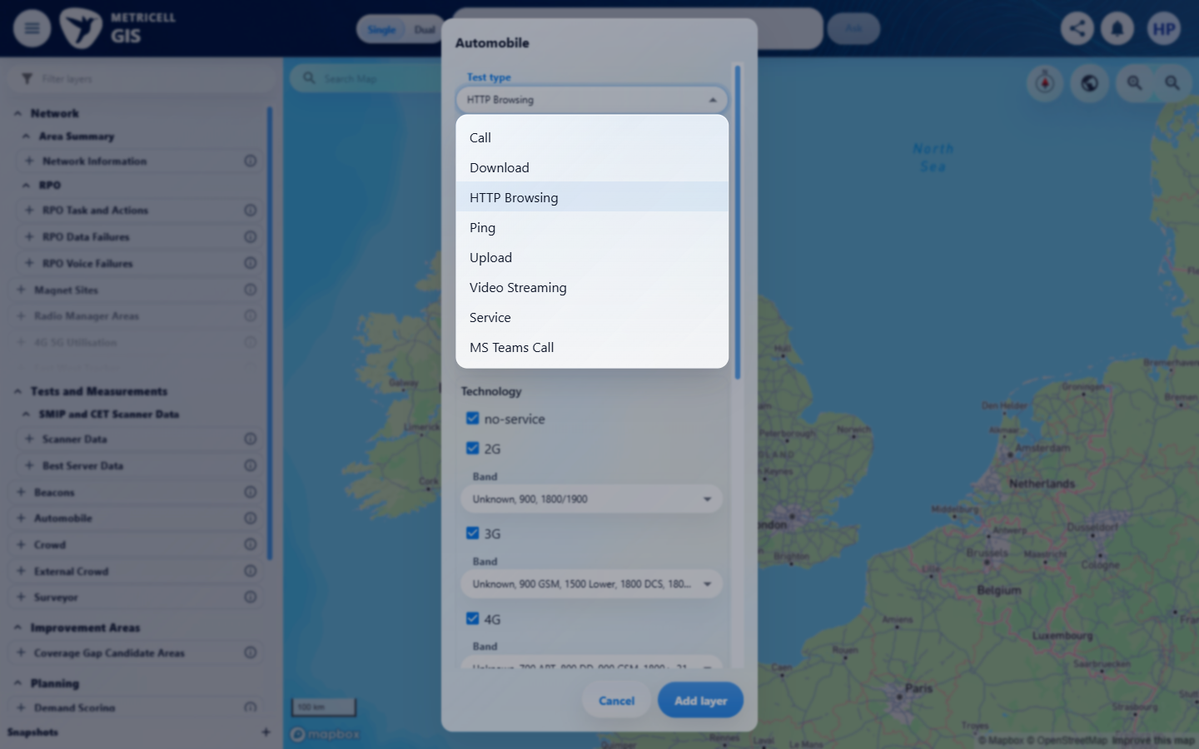 | E04 - Final (criterion-1-final.png)  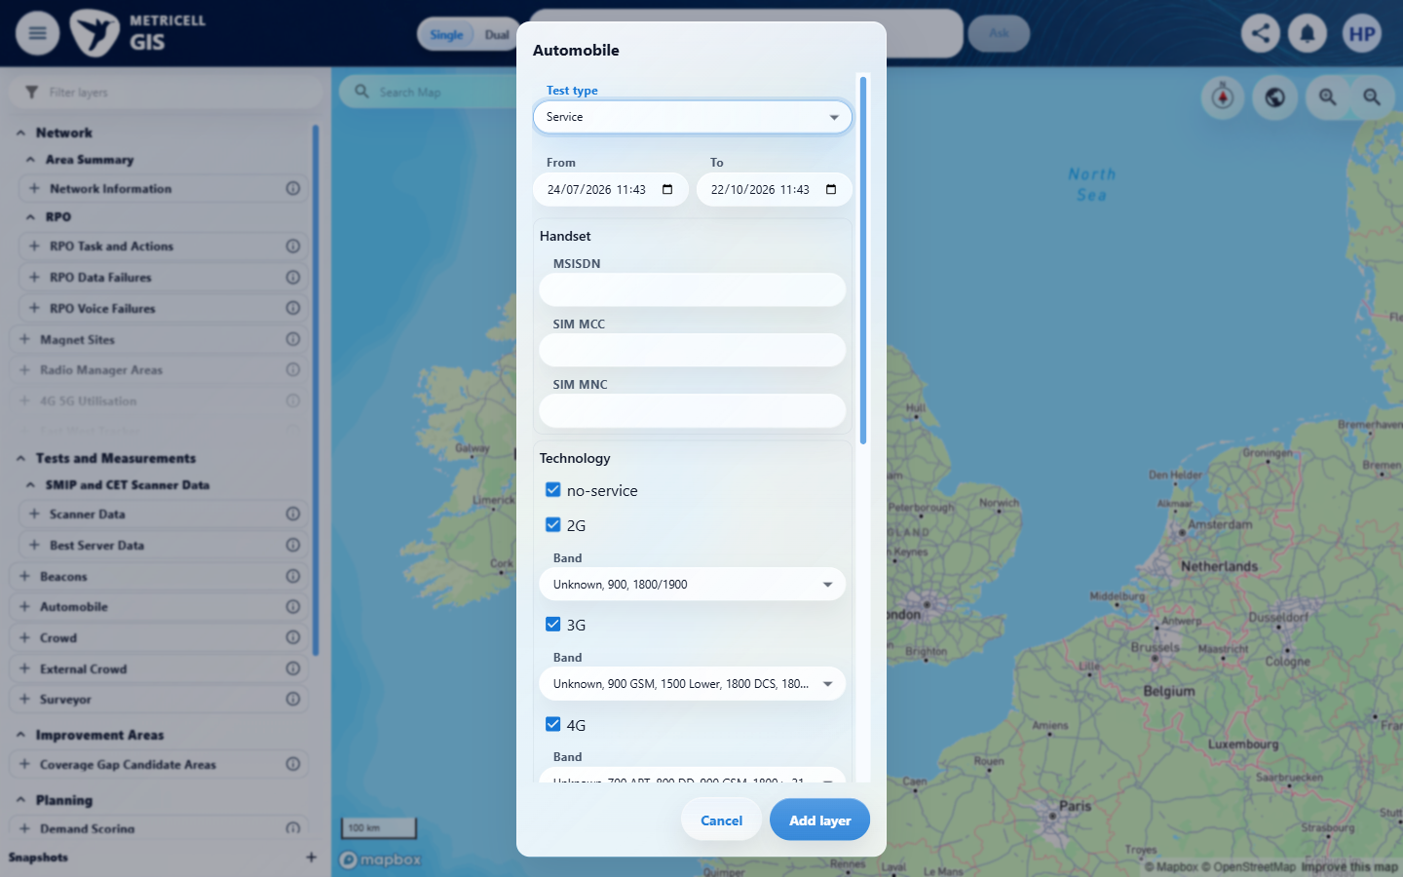

2.0.0 | With Service unselected, the map displays no Service test-result points. | With Service unselected, the map displays no Service test-result points. | criterion-2-service-unselected.png and criterion-2-final.png show the settled map with only Automobile - Ping selected and its legend; no Service layer or Service result points are displayed in the visible viewport. Existing HTTP Browsing details are unrelated.  Evidence: E05, E06 | Passed
Criterion 2 assessment: criterion-2-service-unselected.png and criterion-2-final.png show the settled map with only Automobile - Ping selected and its legend; no Service layer or Service result points are displayed in the visible viewport. Existing HTTP Browsing details are unrelated.
Criterion 2 evidence: With Service unselected, the map displays no Service test-result points.
Browser URL recorded after criterion: https://o2intelligence-v4-dev.metricell.com/gis
E05 - Service unselected (criterion-2-service-unselected.png)  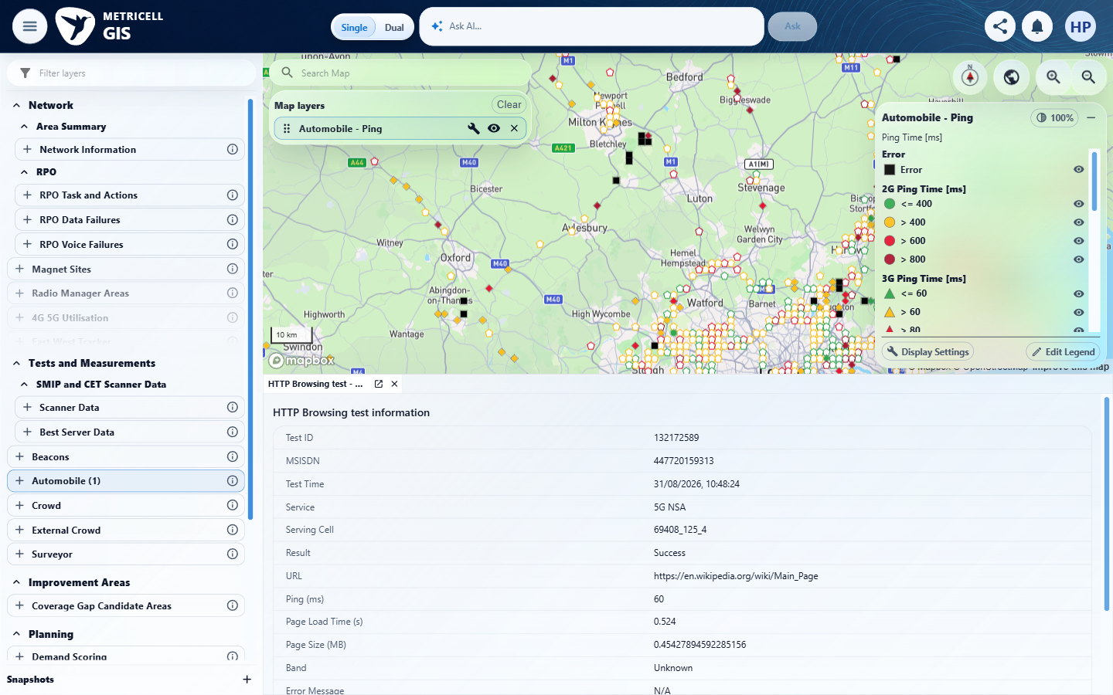 | E06 - Final (criterion-2-final.png)  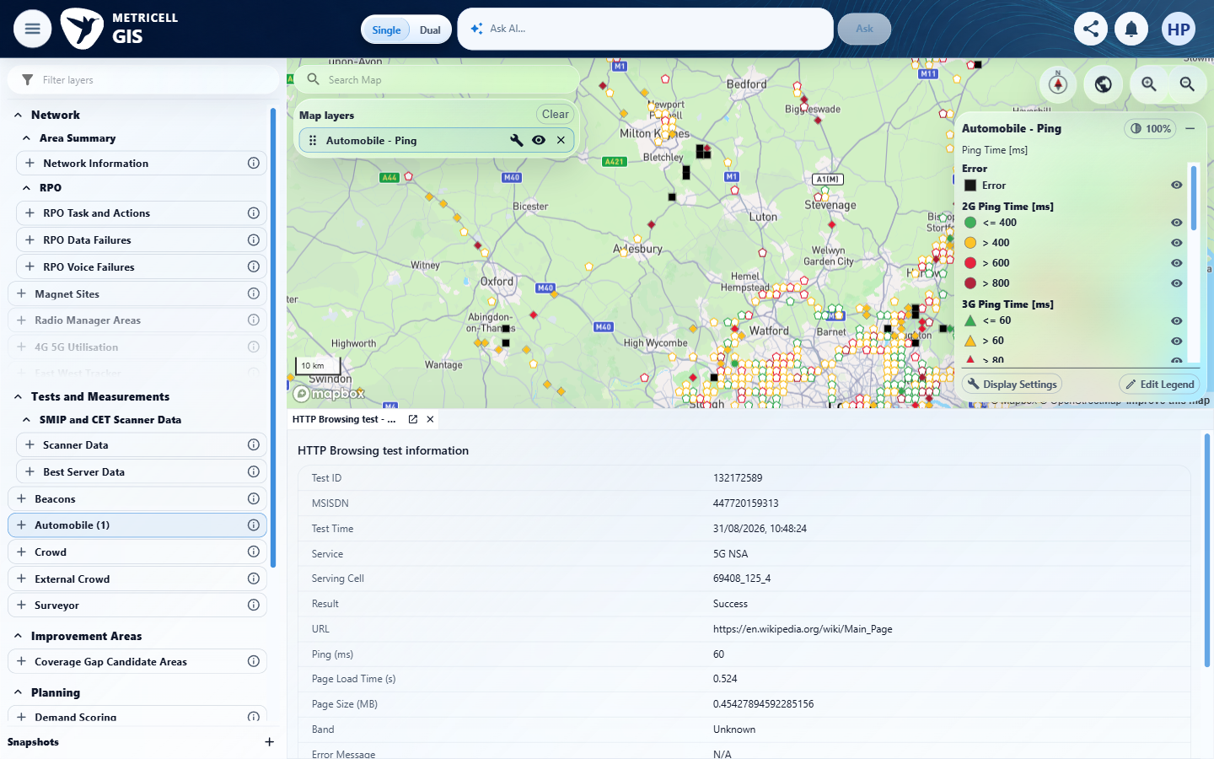

3.0.0 | When the user selects Service and matching authorised results are available, each matching result is displayed as a selectable map point. | When the user selects Service and matching authorised results are available, each matching result is displayed as a selectable map point. | criterion-3-before-add-service.png shows Automobile Service selection; criterion-3-final.png shows the added Service layer, legend and populated markers; criterion-3-final-selected.png shows marker selection opening Service tests. Recorded GET /api/platform/automobile/service/points and POST /api/platform/automobile/service/cluster-details returned 200. Evidence samples the visible viewport.  Evidence: E07, E08, E09 | Passed
Criterion 3 assessment: criterion-3-before-add-service.png shows Automobile Service selection; criterion-3-final.png shows the added Service layer, legend and populated markers; criterion-3-final-selected.png shows marker selection opening Service tests. Recorded GET /api/platform/automobile/service/points and POST /api/platform/automobile/service/cluster-details returned 200. Evidence samples the visible viewport.
Testing notes: Initial exact Automobile text locator timed out because catalogue label was Automobile (1); inspected current snapshot and opened that actual parent item.
Criterion 3 evidence: When the user selects Service and matching authorised results are available, each matching result is displayed as a selectable map point.
Browser URL recorded after criterion: https://o2intelligence-v4-dev.metricell.com/gis
E07 - Before automobile (criterion-3-before-automobile.png)  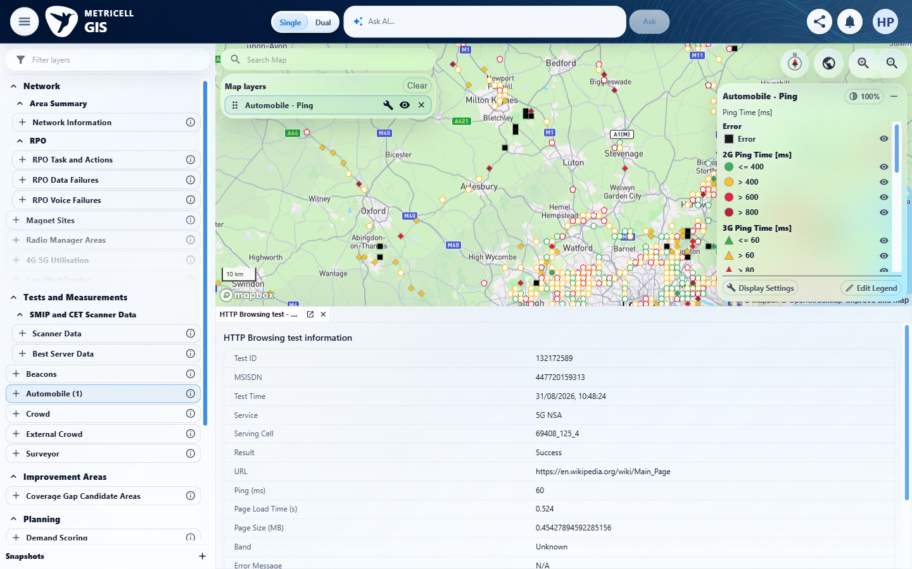 | E08 - Actual automobile config (criterion-3-actual-automobile-config.png)  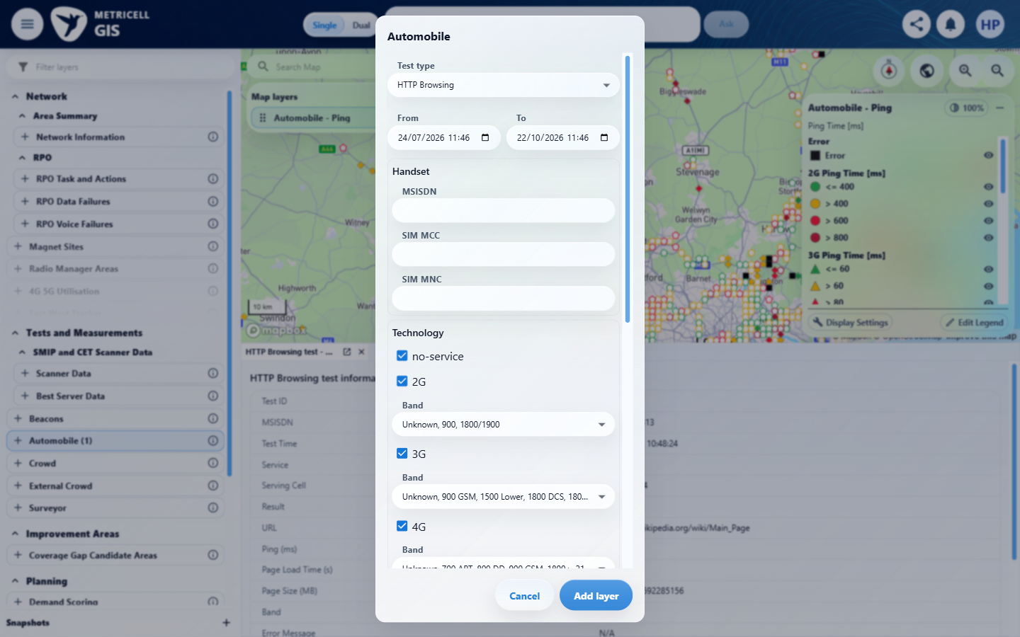

Criterion 3 continued: When the user selects Service and matching authorised results are available, each matching result is displayed as a selectable map point.
Browser URL recorded after criterion: https://o2intelligence-v4-dev.metricell.com/gis
E09 - Final (criterion-3-final.png)
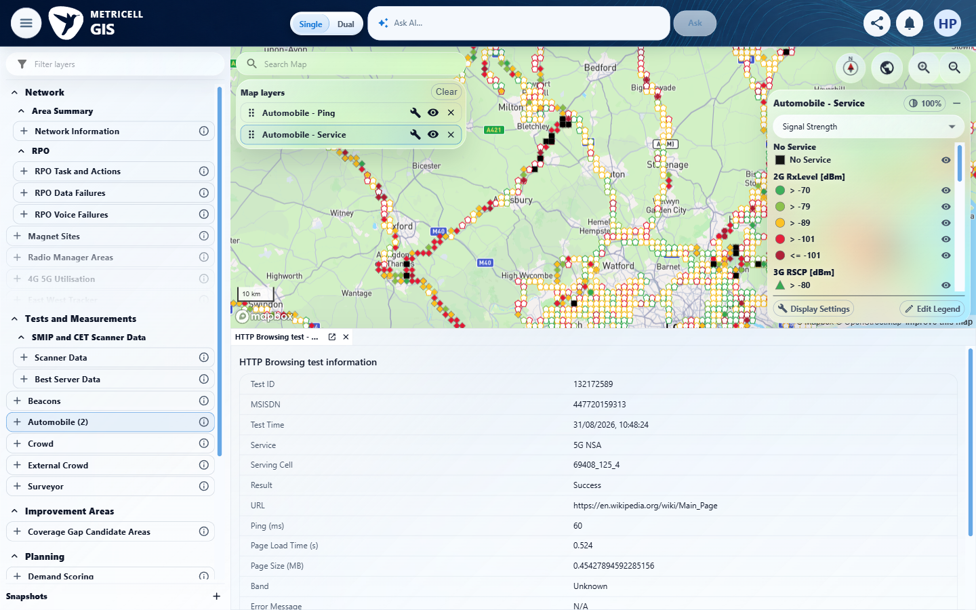

4.0.0 | When the user selects a Service result point and its details load successfully, a Service details dialog displays MSISDN, Test Time, Signal, Band, Service, Data Technology, PLMN and Serving Cell. | When the user selects a Service result point and its details load successfully, a Service details dialog displays MSISDN, Test Time, Signal, Band, Service, Data Technology, PLMN and Serving Cell. | criterion-4-before-select-point.png and criterion-4-final.png show Service marker selection opening a docked details table containing all eight required headings and returned rows. Signal, PLMN and Serving Cell are N/A for the sampled out-of-service records; details are presented in a docked panel.  Evidence: E09, E10 | Passed
Criterion 4 assessment: criterion-4-before-select-point.png and criterion-4-final.png show Service marker selection opening a docked details table containing all eight required headings and returned rows. Signal, PLMN and Serving Cell are N/A for the sampled out-of-service records; details are presented in a docked panel.
Criterion 4 evidence: When the user selects a Service result point and its details load successfully, a Service details dialog displays MSISDN, Test Time, Signal, Band, Service, Data Technology, PLMN and Serving Cell.
Browser URL recorded after criterion: https://o2intelligence-v4-dev.metricell.com/gis
E09 - Before select point (criterion-4-before-select-point.png) | E10 - Final (criterion-4-final.png)  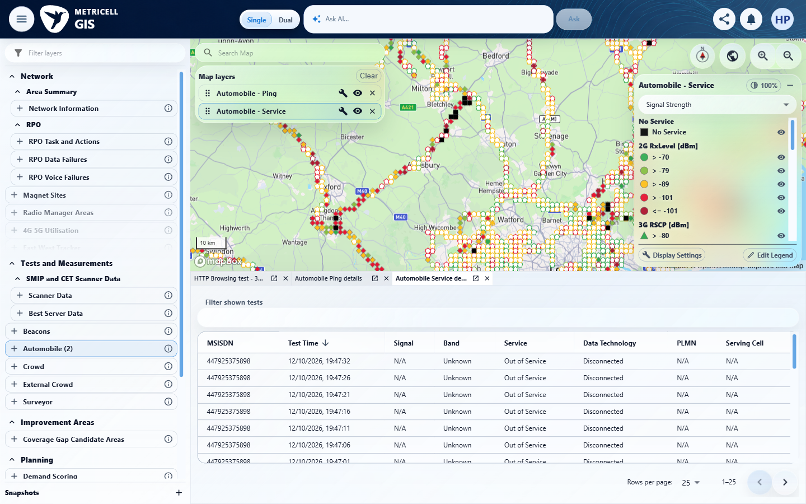

5.0.0 | With the Service details table displayed, sorting a supported column reorders the displayed rows according to that column. | With the Service details table displayed, sorting a supported column reorders the displayed rows according to that column. | criterion-5-before-sort.png shows descending Test Time rows from 12/10/2026 19:47:32; criterion-5-final.png shows the ascending indicator and increasing rows from 15/08/2026 15:37:13, 15:37:19 and 15:37:24. The criterion-owned comparison demonstrates reordering.  Evidence: E11, E10, E12 | Passed
Criterion 5 assessment: criterion-5-before-sort.png shows descending Test Time rows from 12/10/2026 19:47:32; criterion-5-final.png shows the ascending indicator and increasing rows from 15/08/2026 15:37:13, 15:37:19 and 15:37:24. The criterion-owned comparison demonstrates reordering.
Criterion 5 evidence: With the Service details table displayed, sorting a supported column reorders the displayed rows according to that column.
Browser URL recorded after criterion: https://o2intelligence-v4-dev.metricell.com/gis
E11 - Before select point (criterion-5-before-select-point.png)  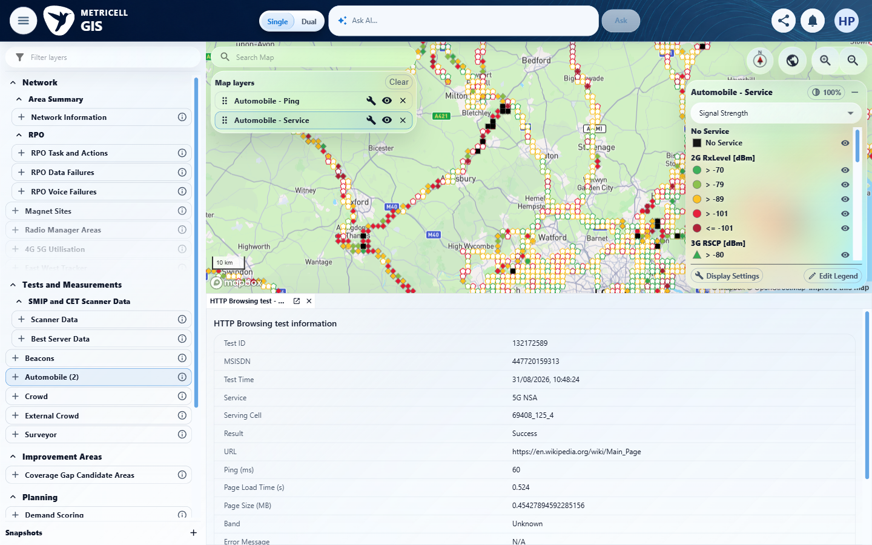 | E10 - Before sort (criterion-5-before-sort.png)

Criterion 5 continued: With the Service details table displayed, sorting a supported column reorders the displayed rows according to that column.
Browser URL recorded after criterion: https://o2intelligence-v4-dev.metricell.com/gis
E12 - Final (criterion-5-final.png)
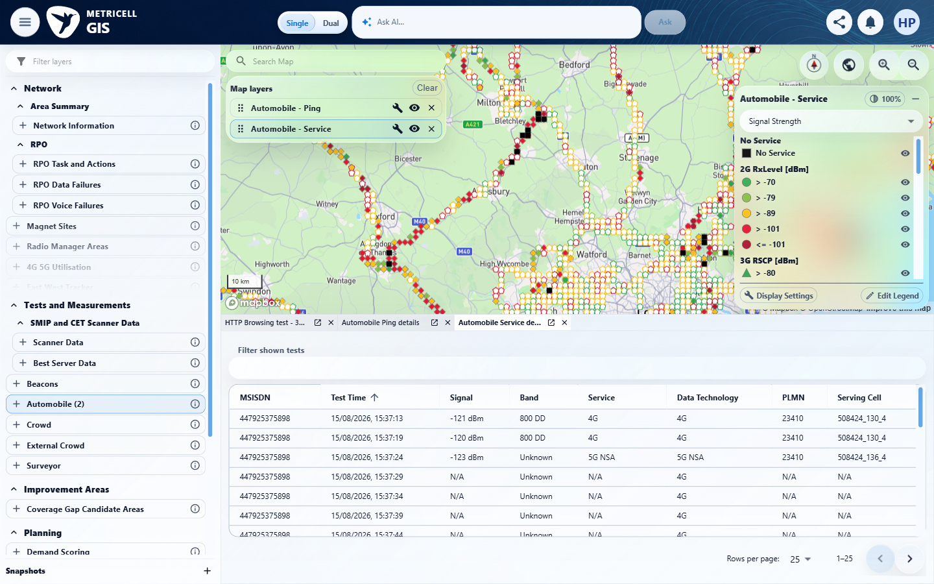

6.0.0 | With the Service details table displayed, filtering a supported column limits the displayed rows to those matching the filter. | With the Service details table displayed, filtering a supported column limits the displayed rows to those matching the filter. | criterion-6-before-filter.png shows multiple Service rows with differing Test Times; criterion-6-final.png shows filter 19:47:32 and only the matching 12/10/2026 19:47:32 row. The provided table-wide filter matches the supported Test Time column.  Evidence: E13, E10, E14 | Passed
Criterion 6 assessment: criterion-6-before-filter.png shows multiple Service rows with differing Test Times; criterion-6-final.png shows filter 19:47:32 and only the matching 12/10/2026 19:47:32 row. The provided table-wide filter matches the supported Test Time column.
Criterion 6 evidence: With the Service details table displayed, filtering a supported column limits the displayed rows to those matching the filter.
Browser URL recorded after criterion: https://o2intelligence-v4-dev.metricell.com/gis
E13 - Before select point (criterion-6-before-select-point.png)  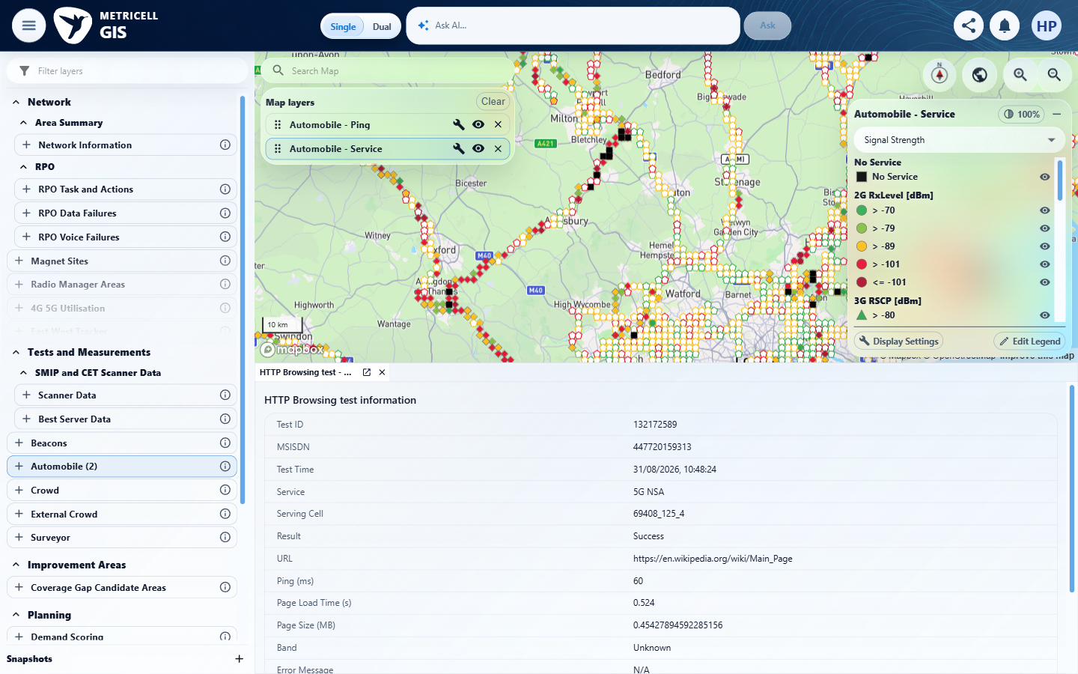 | E10 - Before filter (criterion-6-before-filter.png)

Criterion 6 continued: With the Service details table displayed, filtering a supported column limits the displayed rows to those matching the filter.
Browser URL recorded after criterion: https://o2intelligence-v4-dev.metricell.com/gis
E14 - Final (criterion-6-final.png)
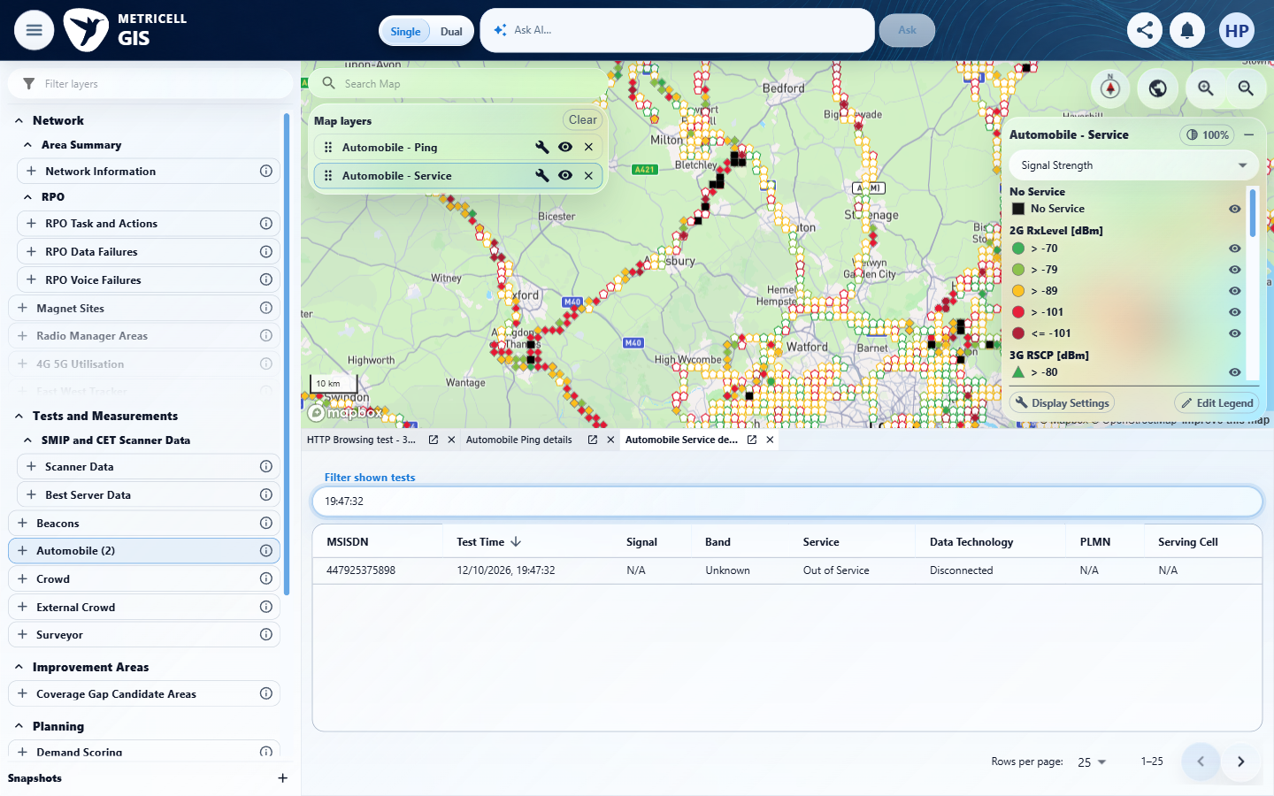

7.0.0 | When returned details include cell-neighbour data, the dialog displays each neighbour in its own labelled details table. | When returned details include cell-neighbour data, the dialog displays each neighbour in its own labelled details table. | criterion-7-before-earliest-record.png shows the selected 15/08/2026 15:37:13 record. criterion-7-final-earliest-record.png and criterion-7-final-all-neighbours.png together show separately labelled Cell Neighbour 1, 2 and 3 tables, matching the three returned neighbours recorded for 131974812: RSRP -120/-118/-128 dBm, RSRQ -18/-16/-20, EARFCN 6400/6400/39448, PCI 117/272/62.  Evidence: E15, E16, E17, E18, E19 | Passed
Criterion 7 assessment: criterion-7-before-earliest-record.png shows the selected 15/08/2026 15:37:13 record. criterion-7-final-earliest-record.png and criterion-7-final-all-neighbours.png together show separately labelled Cell Neighbour 1, 2 and 3 tables, matching the three returned neighbours recorded for 131974812: RSRP -120/-118/-128 dBm, RSRQ -18/-16/-20, EARFCN 6400/6400/39448, PCI 117/272/62.
Criterion 7 evidence: When returned details include cell-neighbour data, the dialog displays each neighbour in its own labelled details table.
Browser URL recorded after criterion: https://o2intelligence-v4-dev.metricell.com/gis
E15 - Before select point (criterion-7-before-select-point.png)  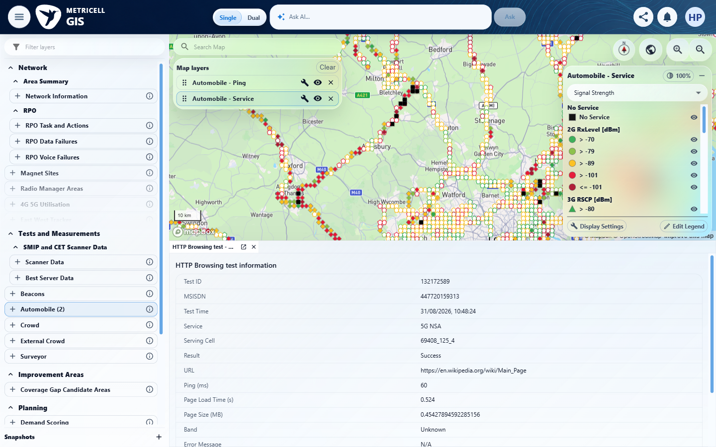 | E16 - Before earliest record sort (criterion-7-before-earliest-record-sort.png)  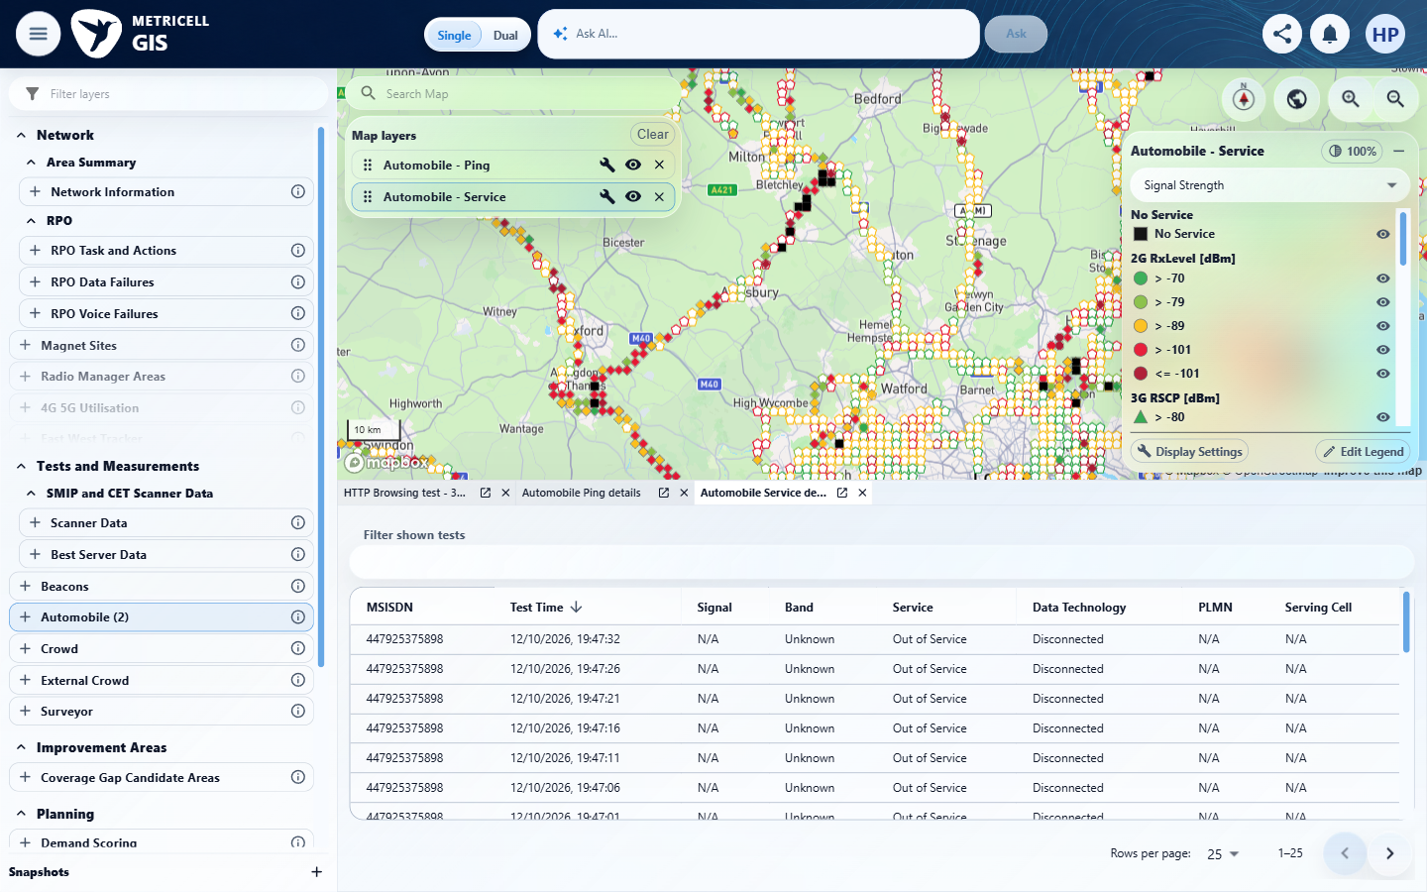

Criterion 7 continued: When returned details include cell-neighbour data, the dialog displays each neighbour in its own labelled details table.
Browser URL recorded after criterion: https://o2intelligence-v4-dev.metricell.com/gis
E17 - Before earliest record (criterion-7-before-earliest-record.png)  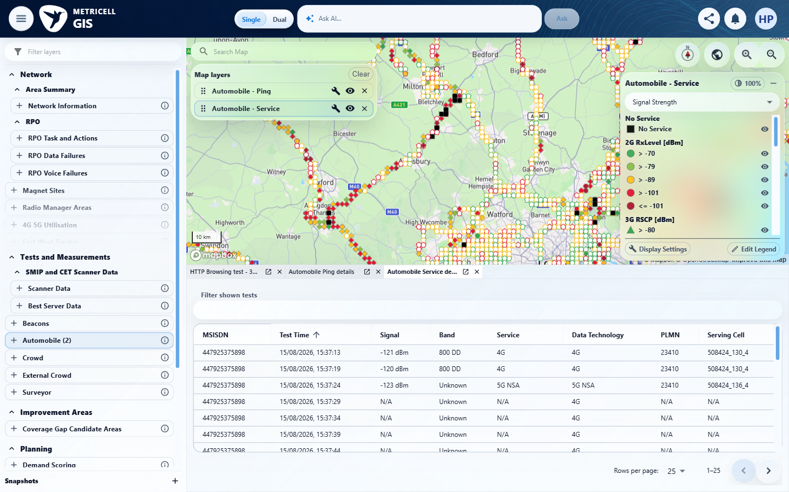 | E18 - Final earliest record (criterion-7-final-earliest-record.png)  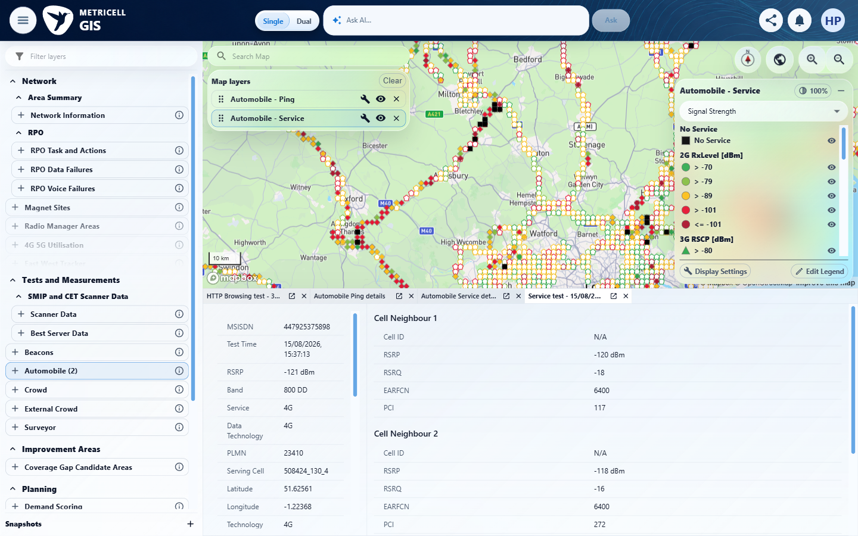

Criterion 7 continued: When returned details include cell-neighbour data, the dialog displays each neighbour in its own labelled details table.
Browser URL recorded after criterion: https://o2intelligence-v4-dev.metricell.com/gis
E19 - Final all neighbours (criterion-7-final-all-neighbours.png)
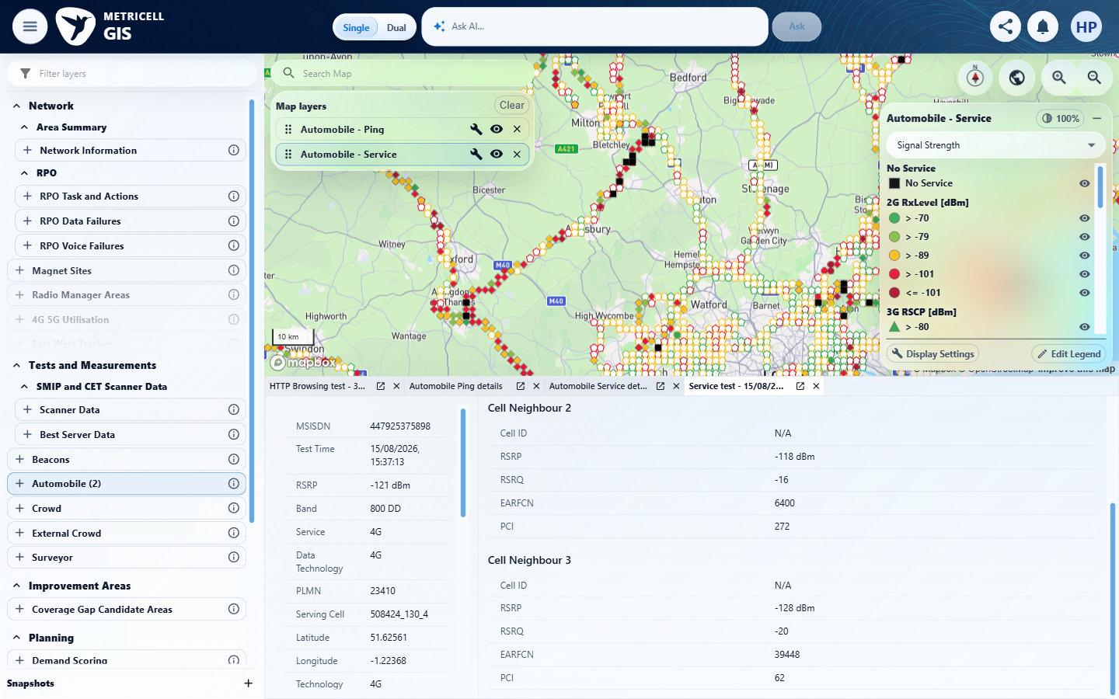

8.0.0 | While Service details are loading, the dialog displays a loading state. | While Service details are loading, the dialog displays a loading state. | SIMULATED UI STATE: The original development-host POST https://o2intelligence-v4-dev.metricell.com/api/platform/automobile/service/cluster-details read for pointId 132762383 / mercatorKey 1008808500521866559 was held and released, using its genuine 200 baseline as endpoint provenance. criterion-8-genuine-baseline.png and criterion-8-before-delayed-reopen.png establish loaded and closed states; criterion-8-final.png visibly shows a small blue loading spinner in the selected Service detail panel, rather than visible Loading point details text. criterion-8-recovery.png shows the same 19:47:32 record restored. Results document exact owned-handler removal and settled pending work. This proves the explicit loading UI only, not backend performance or manufactured backend success.  Evidence: E20, E21, E22 | Passed
Criterion 8 assessment: SIMULATED UI STATE: The original development-host POST https://o2intelligence-v4-dev.metricell.com/api/platform/automobile/service/cluster-details read for pointId 132762383 / mercatorKey 1008808500521866559 was held and released, using its genuine 200 baseline as endpoint provenance. criterion-8-genuine-baseline.png and criterion-8-before-delayed-reopen.png establish loaded and closed states; criterion-8-final.png visibly shows a small blue loading spinner in the selected Service detail panel, rather than visible Loading point details text. criterion-8-recovery.png shows the same 19:47:32 record restored. Results document exact owned-handler removal and settled pending work. This proves the explicit loading UI only, not backend performance or manufactured backend success.
Criterion 8 evidence: While Service details are loading, the dialog displays a loading state.
SIMULATED UI STATE: browser-local condition; recovery uses the genuine service.
Browser URL recorded after criterion: https://o2intelligence-v4-dev.metricell.com/gis
E20 - Final (criterion-8-final.png)  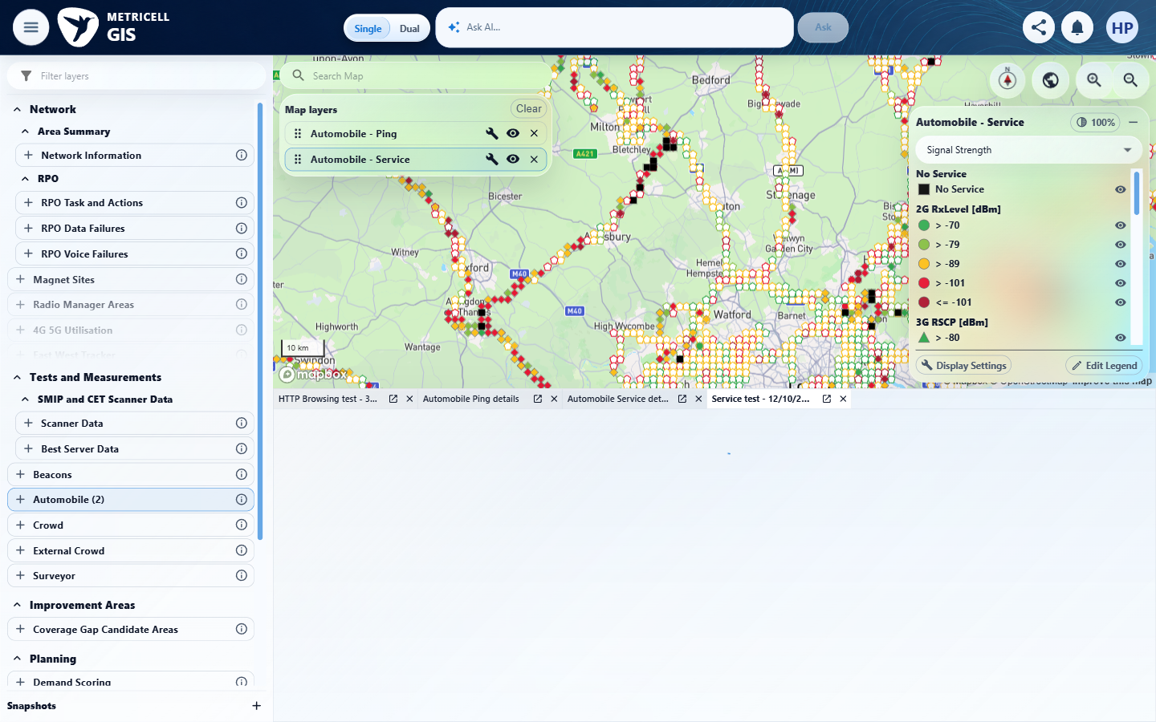 | E21 - Recovery (criterion-8-recovery.png)  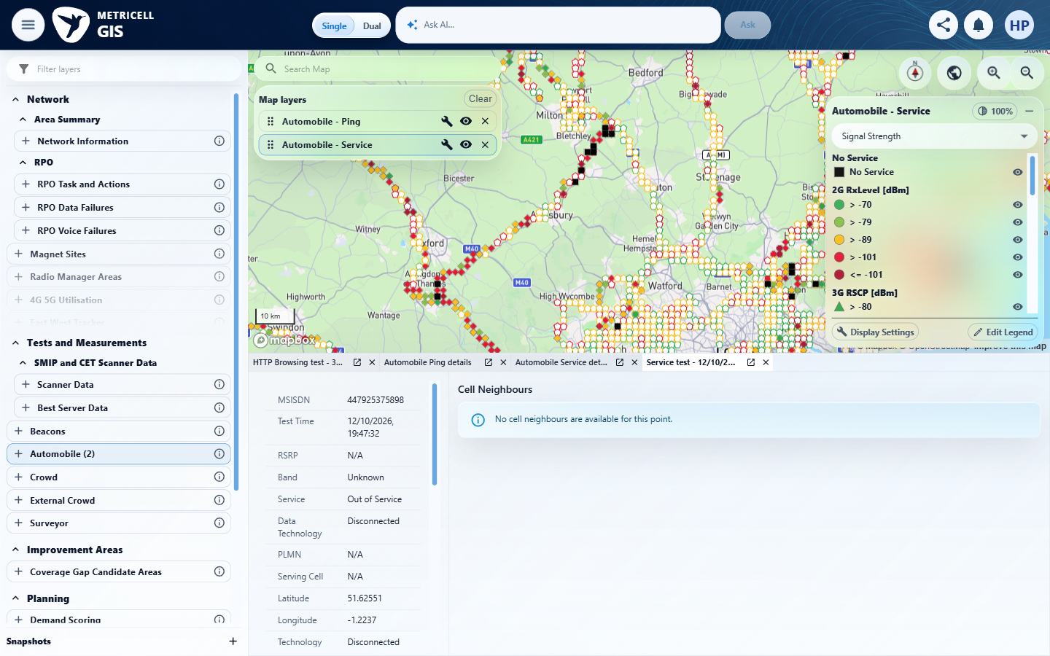

Criterion 8 continued: While Service details are loading, the dialog displays a loading state.
SIMULATED UI STATE: browser-local condition; recovery uses the genuine service.
Browser URL recorded after criterion: https://o2intelligence-v4-dev.metricell.com/gis
E22 - Genuine baseline (criterion-8-genuine-baseline.png)
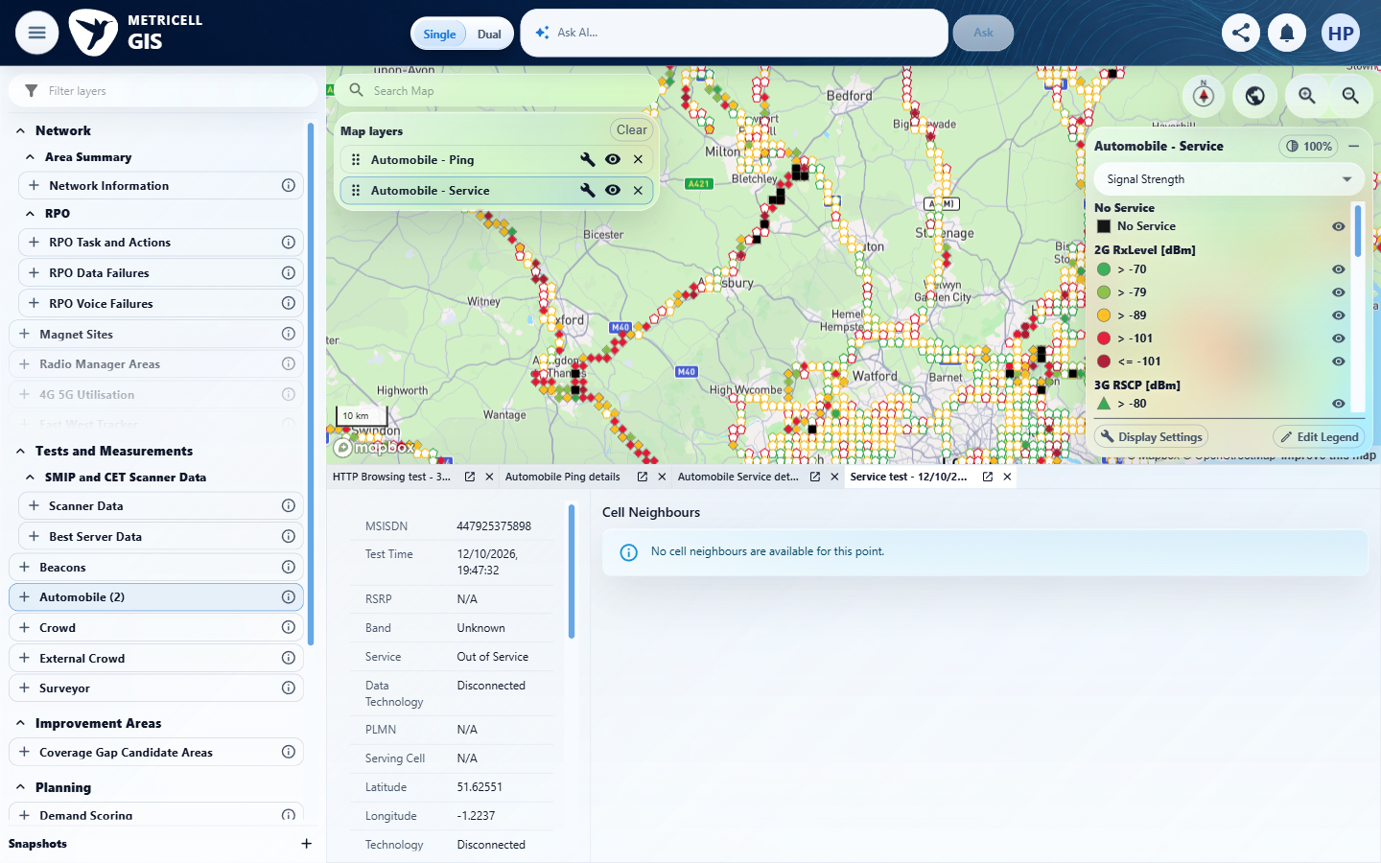

9.0.0 | If Service details cannot be retrieved, the dialog displays an error state and does not display stale details. | If Service details cannot be retrieved, the dialog displays an error state and does not display stale details. | SIMULATED UI STATE: A browser-local HTTP 503 application/problem+json response was injected only for the previously genuine development-host POST https://o2intelligence-v4-dev.metricell.com/api/platform/automobile/service/cluster-details read, pointId 132762383 / mercatorKey 1008808500521866559. criterion-9-target-genuine-baseline.png shows target 19:47:32; criterion-9-distinct-record-baseline.png shows prior record 132762320 at 19:47:26; criterion-9-before-failing-target.png returns to the list. criterion-9-final.png shows Unable to load point details and Retry with no prior details in the active target panel; the prior record is an inactive tab. criterion-9-recovery.png restores target 19:47:32 after Retry. Results document exact handler removal and settled work; criterion-9-cleanup.png shows restored Ping/HTTP Browsing state. This proves synthetic error UI handling only, not a real backend outage.  Evidence: E23, E24, E25 | Passed
Criterion 9 assessment: SIMULATED UI STATE: A browser-local HTTP 503 application/problem+json response was injected only for the previously genuine development-host POST https://o2intelligence-v4-dev.metricell.com/api/platform/automobile/service/cluster-details read, pointId 132762383 / mercatorKey 1008808500521866559. criterion-9-target-genuine-baseline.png shows target 19:47:32; criterion-9-distinct-record-baseline.png shows prior record 132762320 at 19:47:26; criterion-9-before-failing-target.png returns to the list. criterion-9-final.png shows Unable to load point details and Retry with no prior details in the active target panel; the prior record is an inactive tab. criterion-9-recovery.png restores target 19:47:32 after Retry. Results document exact handler removal and settled work; criterion-9-cleanup.png shows restored Ping/HTTP Browsing state. This proves synthetic error UI handling only, not a real backend outage.
Criterion 9 evidence: If Service details cannot be retrieved, the dialog displays an error state and does not display stale details.
SIMULATED UI STATE: browser-local condition; recovery uses the genuine service.
Browser URL recorded after criterion: https://o2intelligence-v4-dev.metricell.com/gis
E23 - Final (criterion-9-final.png)  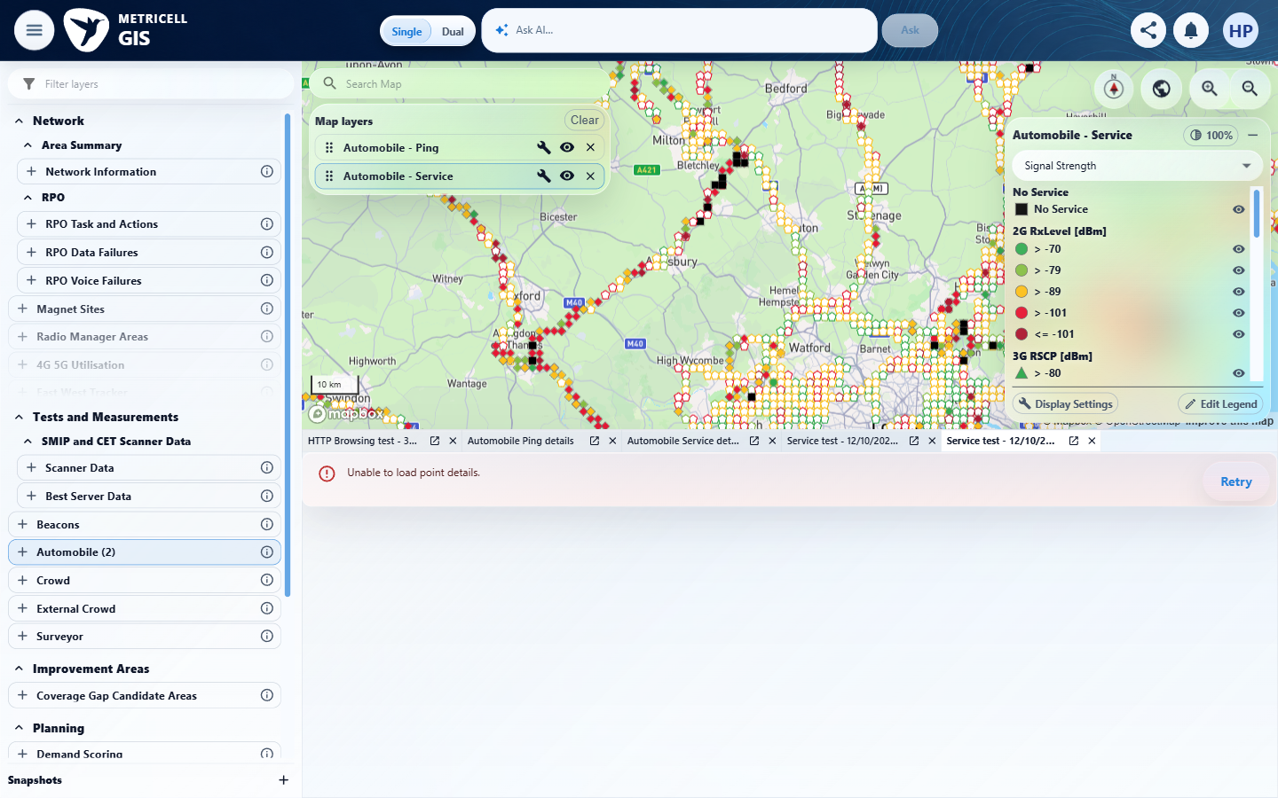 | E24 - Recovery (criterion-9-recovery.png)  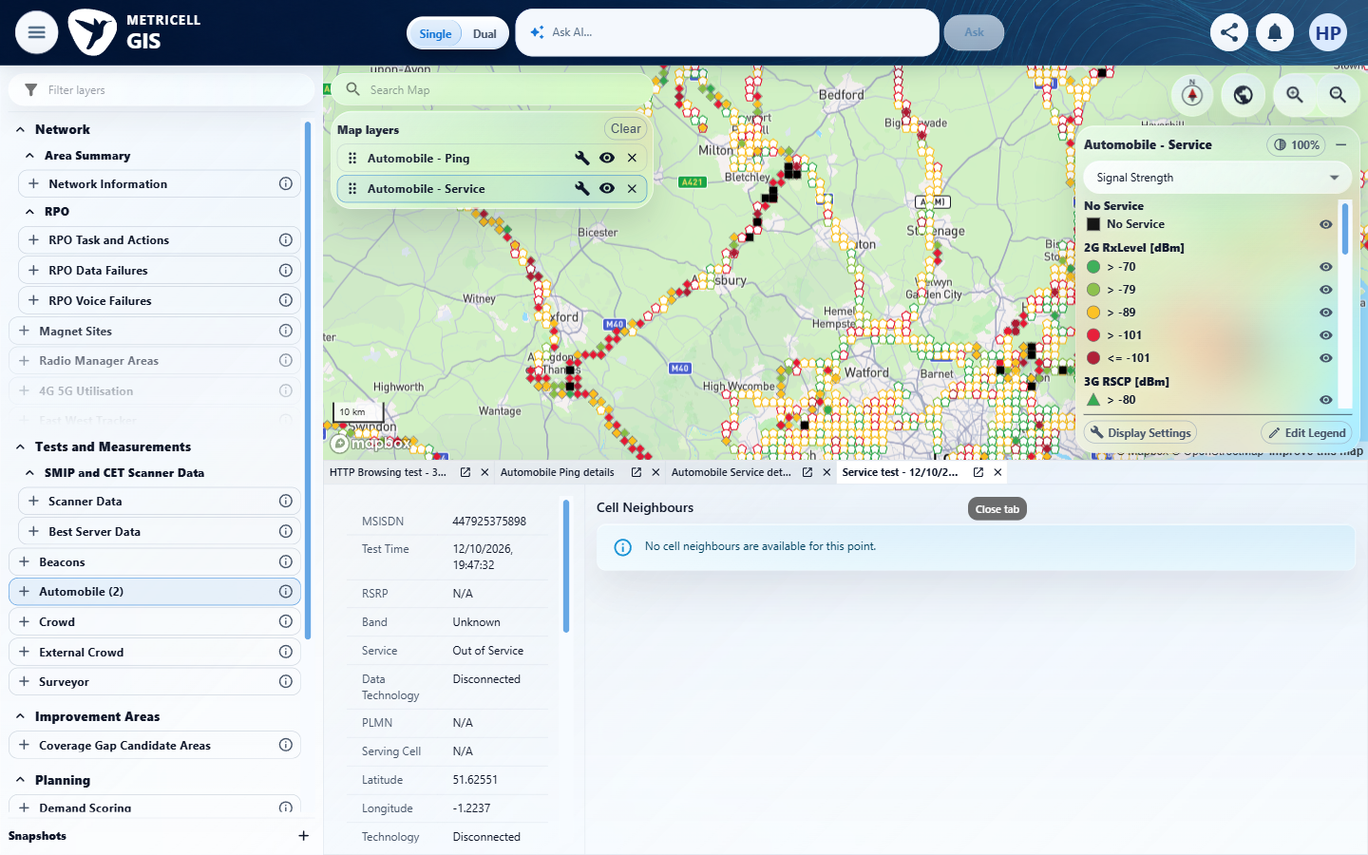

Criterion 9 continued: If Service details cannot be retrieved, the dialog displays an error state and does not display stale details.
SIMULATED UI STATE: browser-local condition; recovery uses the genuine service.
Browser URL recorded after criterion: https://o2intelligence-v4-dev.metricell.com/gis
E25 - Target genuine baseline (criterion-9-target-genuine-baseline.png)
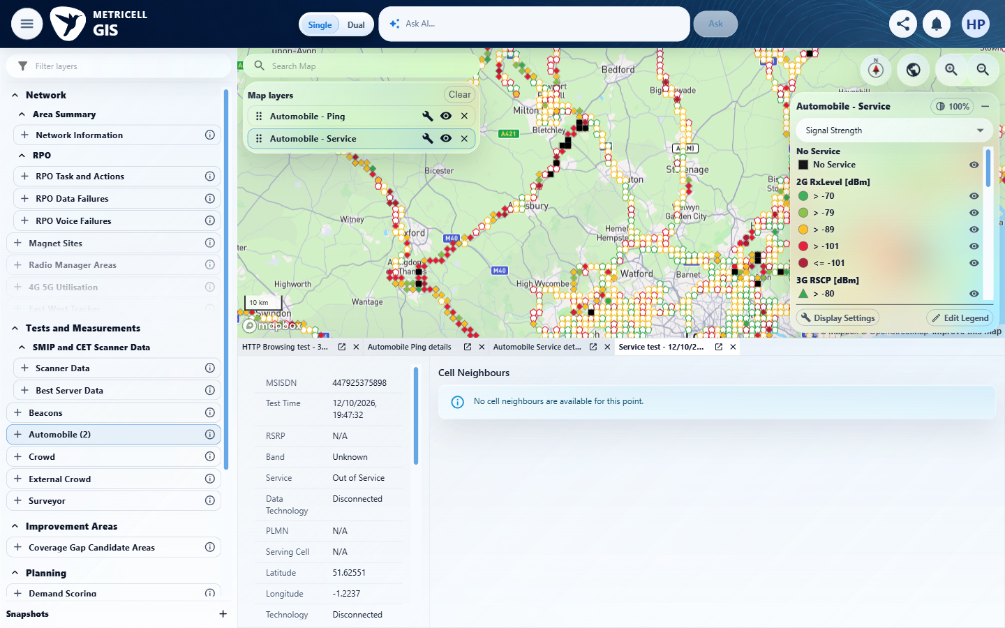

About Metricell

Metricell is on a mission to deliver connectivity. We work with our customers to design, deliver and manage wireless communication networks – with a shared ambition of achieving flawless network experience. We’ve been responsible for many first-to-market products, and our technology is characterised by the relentless pursuit of automation and digitalisation.

Our geospatial intelligence tools traverse a wide variety of business processes – from Test & Measurement to Customer Experience Management – and we’re pioneers in Crowdsourcing and Digital Self Care. Our technology is today in use by a range of customers; thousands of their personnel; and millions of subscribers worldwide.

Find out more at www.metricell.com




