

Automated Test Case Document
Jira Ticket: TEST2-84

Document Classification: | Company Confidential
Document Ref: | Automated Test Case Document
Version: | 1.0
Date: | 21/10/2026
Document Author: | Automated TEST2 Evidence Review
Document Owner: | Quality Assurance / Metricell




This document and its content is copyright of Metricell Limited @ 2026 all rights reserved. All information contained herein is the intellectual property of Metricell Limited and should be treated as confidential. Any external redistribution of reproduction of part or all of the contents in any form is prohibited unless expressly agreed with Metricell Limited in writing. Any reproduced content must include the following statement; “Part or all of the content contained herein is copyright of Metricell Limited @ 2026 all rights reserved”.
Table of Contents
1 Revision History 2
2 Test Cycle Information 3
3 Test Summary 3
4 Test Cases 4
About Metricell 12

Revision History

Version | Date | Revision Author | Summary of Changes
[1.0] | 21/10/2026 | TEST2 QA Automation | Generated from TEST2 evidence review

Test Cycle Information

Tester: | Automated
Jira Ticket: | TEST2-84
Environment: | o2intelligence-v4-dev.metricell.com
Browser Details: | Google Chrome 155.0.8059.85
Date of Test: | 21/10/2026
Limitations during Testing: | Blocked criterion(s): 1, 2, 3, 4, 5, 6, 7, 8, 9, 10. See the assessment below each criterion. Defects (No.) counts directly contradicted criteria, not unique Jira bugs; blockers and inconclusive evidence count as zero.
Overall review outcome: | Blocked
Browser URL(s) recorded after criteria: | https://o2intelligence-v4-dev.metricell.com/gis

Test Summary

Area of test | Outcome | Fail | Defects (No.)
1. Selecting one Building point opens a separate dashboard for that building once its details load. | Blocked | N | 0
2. When multiple Building points are selected at one map location, the user can choose which building dashboard to open. | Blocked | N | 0
3. When the selection contains too many Building points to identify a building, the user is prompted to zoom in or apply filters, and no ambiguous building dashboard opens. | Blocked | N | 0
4. When building information is available, the dashboard shows building and floorplan summary information in sortable and filterable tables. | Blocked | N | 0
5. When the building has floorplans, the dashboard displays their images and lets the user select a floorplan. | Blocked | N | 0
6. Selecting a floorplan displays its image with the associated survey points overlaid. | Blocked | N | 0
7. When the building has no floorplans, the dashboard displays available building details without an empty floorplan image area. | Blocked | N | 0
8. While Building data is loading, a loading state is displayed. | Blocked | N | 0
9. When Building data is unavailable, a no-data state is displayed. | Blocked | N | 0
10. When Building data fails to load, an error state is displayed without incorrect building data. | Blocked | N | 0

Test Cases
Each test maps to a criterion and decisive browser evidence. Inconclusive results are reported as Failed.

Tests

Preconditions: | V4 access and ticket conditions. | Associated Requirements: | Ticket criteria below. | Automation Notes: | Screenshots below each criterion; full log retained locally.
ID / Criterion | Criteria Tested | Expected Result | Actual Result / Evidence Path | Outcome
1.0.0 | Selecting one Building point opens a separate dashboard for that building once its details load. | Selecting one Building point opens a separate dashboard for that building once its details load. | criterion-1-service-config.png and criterion-1-active-config.png show Automobile Service; criterion-1-final.png shows its complete eight-option Test type list with no Building entry. The required Automobile Building point/dashboard could not be established, so single-building selection was not exercised. Reported GET /api/platform/automobile/service/points HTTP 500 concerns Service points and does not establish a Building detail defect.  Evidence: E01, E02, E03, E04, E05 | Blocked
Criterion 1 assessment: criterion-1-service-config.png and criterion-1-active-config.png show Automobile Service; criterion-1-final.png shows its complete eight-option Test type list with no Building entry. The required Automobile Building point/dashboard could not be established, so single-building selection was not exercised. Reported GET /api/platform/automobile/service/points HTTP 500 concerns Service points and does not establish a Building detail defect.
Testing notes: Automobile pre-add and active Service configuration offer Call, Download, HTTP Browsing, Ping, Upload, Video Streaming, Service and MS Teams Call, with no Building layer/test type. Required Building point/dashboard is unavailable in the human-confirmed module. Service points HTTP 500 is a separate observed retrieval error, not proof of empty Building data or Building detail failure. No substitution or simulation performed. Restarted from launcher after recovering a missing screenshot directory and an incorrect navigation; captured a fresh initial state. No Building choice was available. Automobile Service points GET /api/platform/automobile/service/points returned HTTP 500 in three tile batches; this is not a Building detail error.
Criterion 1 evidence: Selecting one Building point opens a separate dashboard for that building once its details load.
Browser URL recorded after criterion: https://o2intelligence-v4-dev.metricell.com/gis
E01 - Gis (criterion-1-gis.png)  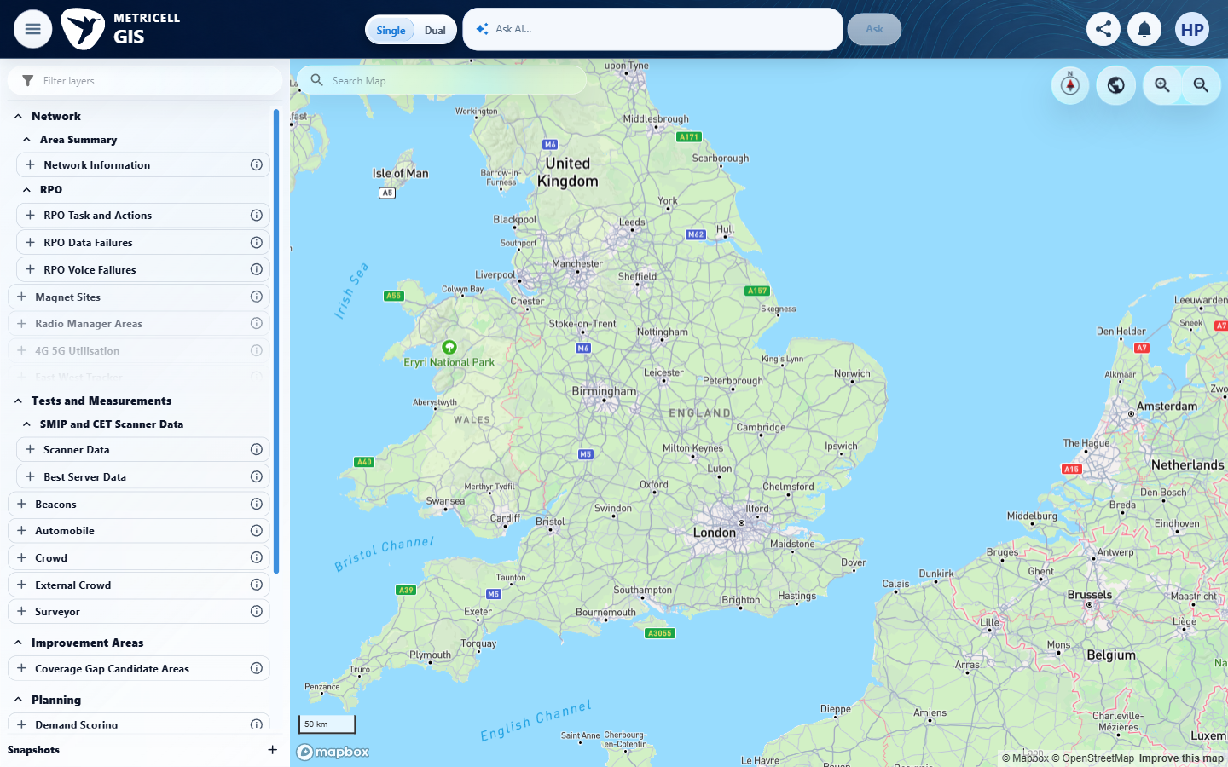 | E02 - Automobile config (criterion-1-automobile-config.png)  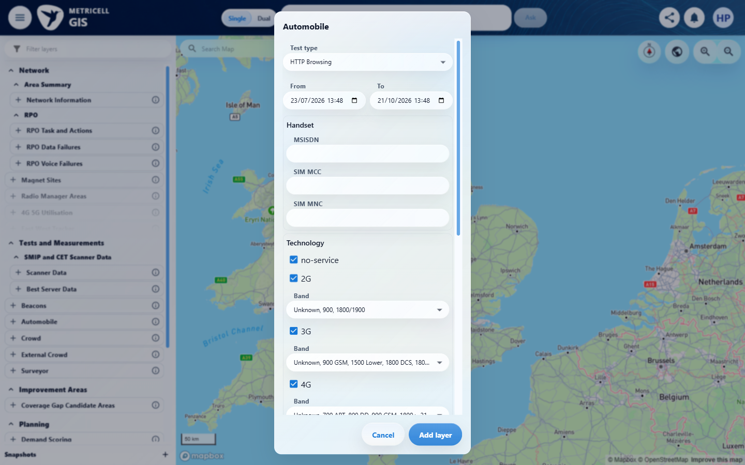

Criterion 1 continued: Selecting one Building point opens a separate dashboard for that building once its details load.
Browser URL recorded after criterion: https://o2intelligence-v4-dev.metricell.com/gis
E03 - Service layer (criterion-1-service-layer.png)  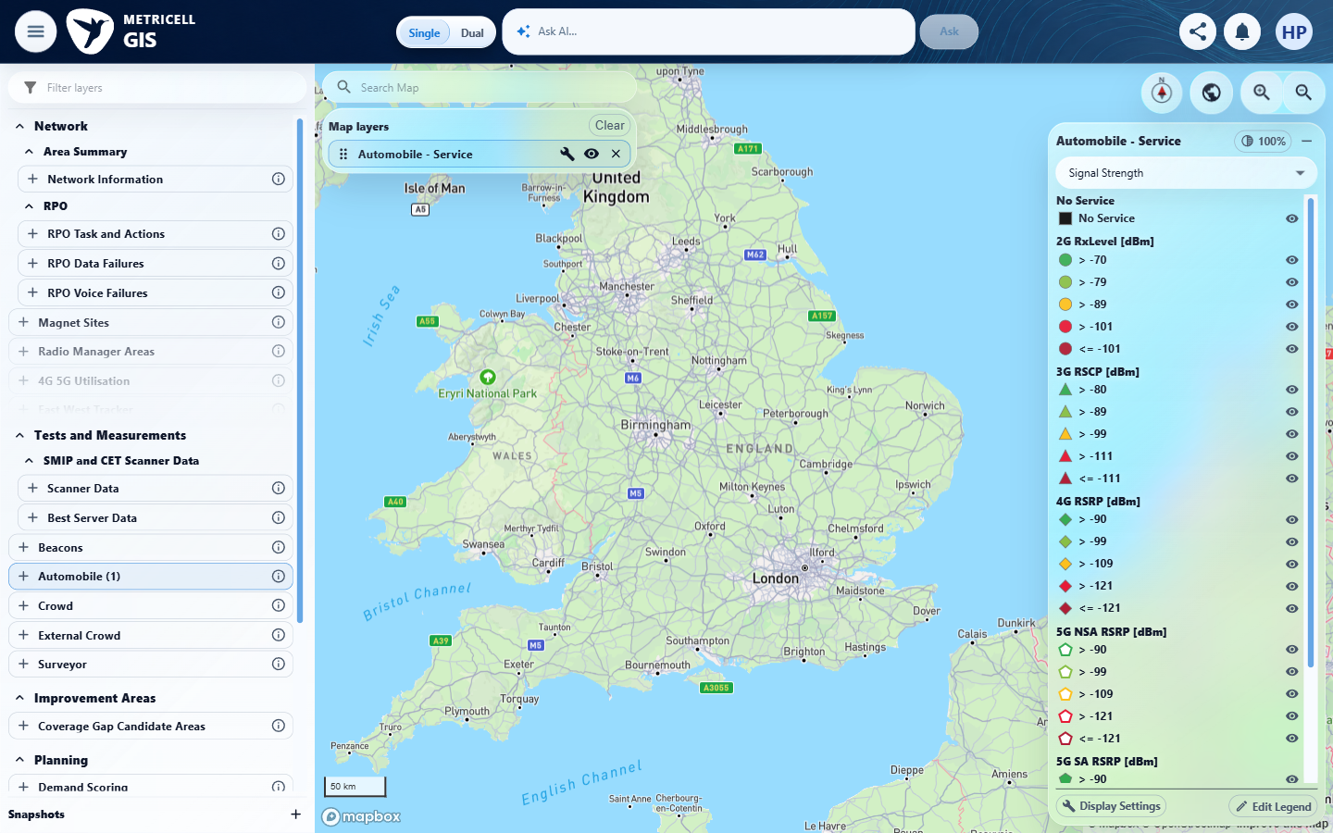 | E04 - Active config (criterion-1-active-config.png)  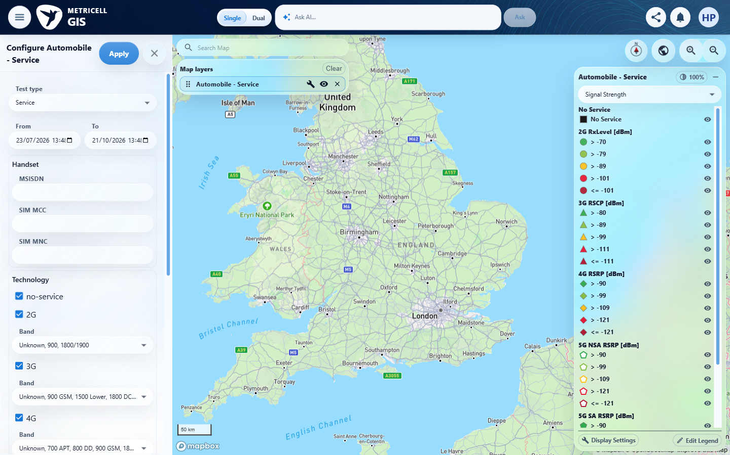

Criterion 1 continued: Selecting one Building point opens a separate dashboard for that building once its details load.
Browser URL recorded after criterion: https://o2intelligence-v4-dev.metricell.com/gis
E05 - Final (criterion-1-final.png)
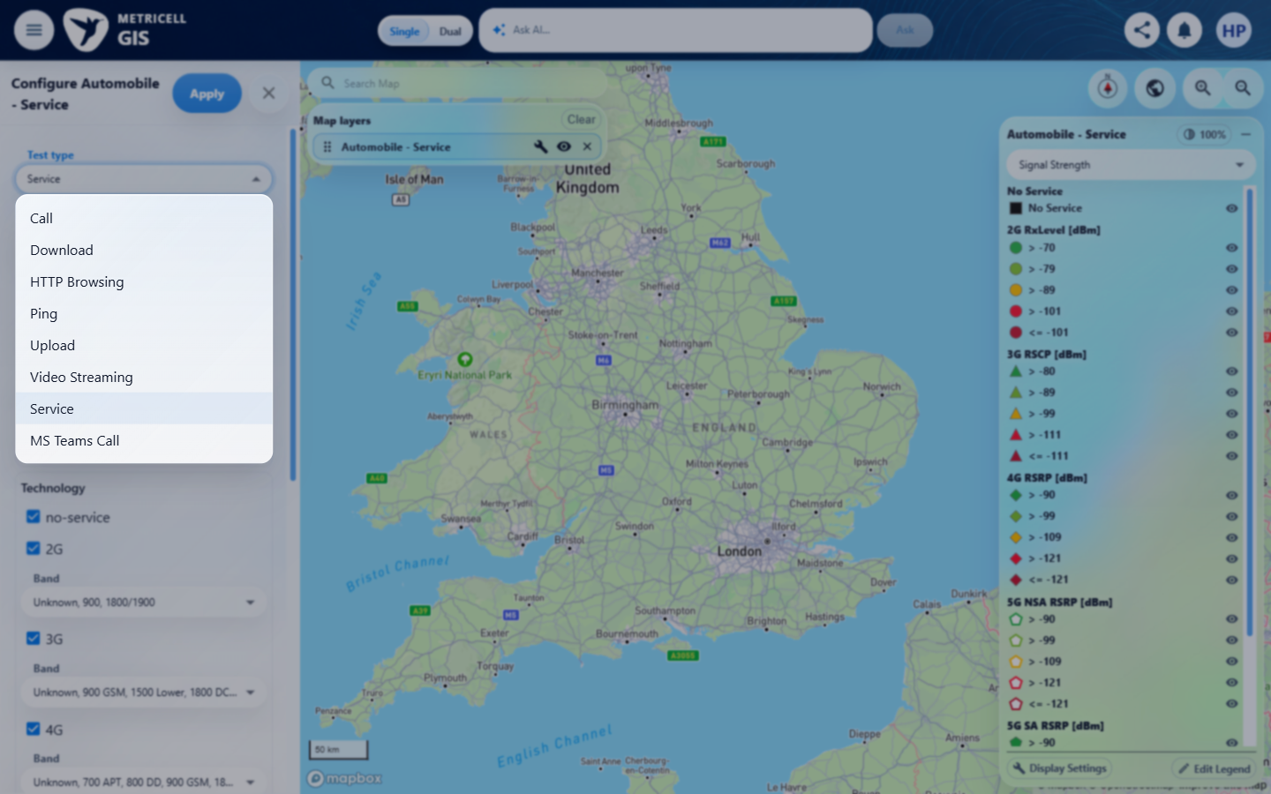

2.0.0 | When multiple Building points are selected at one map location, the user can choose which building dashboard to open. | When multiple Building points are selected at one map location, the user can choose which building dashboard to open. | criterion-2-automobile-config.png identifies Automobile; criterion-2-final.png shows all eight nested Test type choices, with no Building entry. The required Building prerequisite is unavailable through the inspected configuration, preventing selection among multiple Building points. No Building dashboard or floorplan behaviour was exercised.  Evidence: E01, E06, E07 | Blocked
Criterion 2 assessment: criterion-2-automobile-config.png identifies Automobile; criterion-2-final.png shows all eight nested Test type choices, with no Building entry. The required Building prerequisite is unavailable through the inspected configuration, preventing selection among multiple Building points. No Building dashboard or floorplan behaviour was exercised.
Testing notes: Required Automobile Building layer/point/dashboard is unavailable through the inspected parent configuration; no Building entry among all eight Test type choices. Cannot exercise: When multiple Building points are selected at one map location, the user can choose which building dashboard to open. This criterion has independent launcher/configuration/choice captures. No Building record or Building detail request could be established, so no exception-state simulation was appropriate. No Surveyor substitution performed.
Criterion 2 evidence: When multiple Building points are selected at one map location, the user can choose which building dashboard to open.
Browser URL recorded after criterion: https://o2intelligence-v4-dev.metricell.com/gis
E01 - Gis (criterion-2-gis.png) | E06 - Automobile config (criterion-2-automobile-config.png)  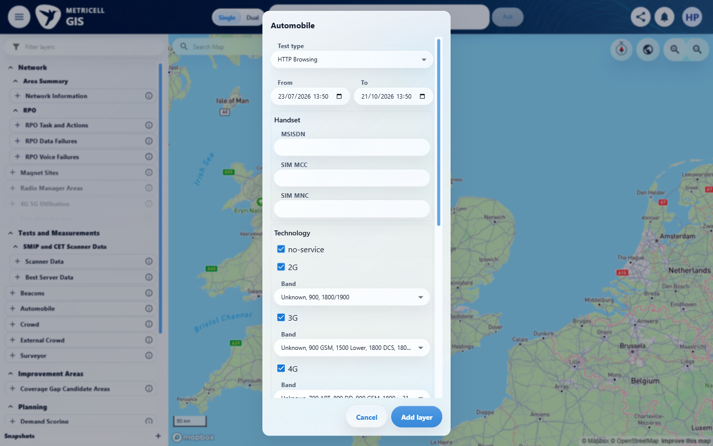

Criterion 2 continued: When multiple Building points are selected at one map location, the user can choose which building dashboard to open.
Browser URL recorded after criterion: https://o2intelligence-v4-dev.metricell.com/gis
E07 - Final (criterion-2-final.png)
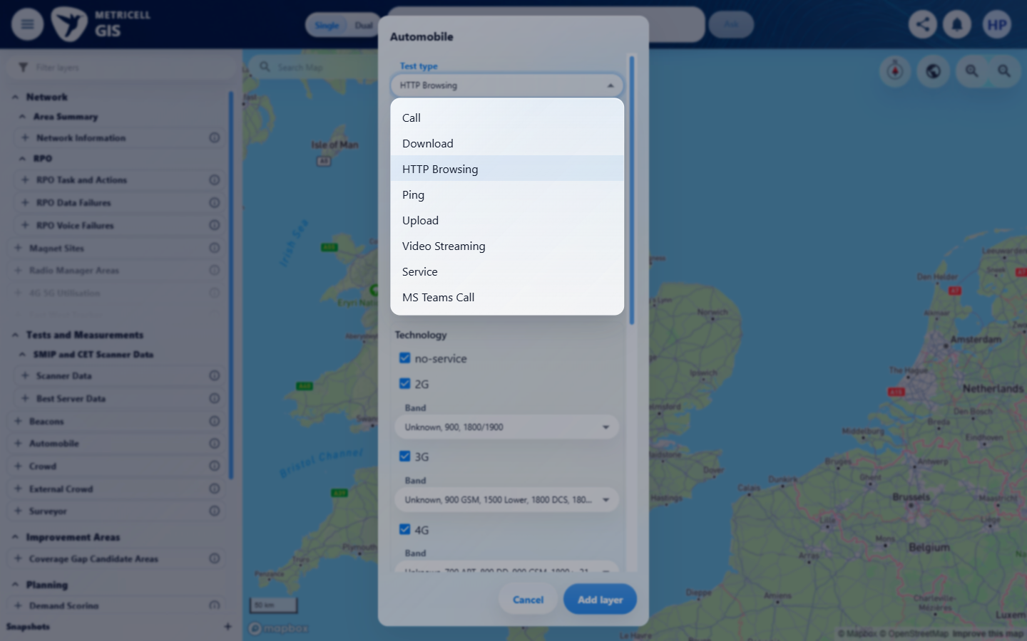

3.0.0 | When the selection contains too many Building points to identify a building, the user is prompted to zoom in or apply filters, and no ambiguous building dashboard opens. | When the selection contains too many Building points to identify a building, the user is prompted to zoom in or apply filters, and no ambiguous building dashboard opens. | criterion-3-automobile-config.png identifies Automobile; criterion-3-final.png shows all eight nested Test type choices, with no Building entry. The required Building prerequisite is unavailable through the inspected configuration, preventing the excessive Building selection prompt. No Building dashboard or floorplan behaviour was exercised.  Evidence: E01, E08, E09 | Blocked
Criterion 3 assessment: criterion-3-automobile-config.png identifies Automobile; criterion-3-final.png shows all eight nested Test type choices, with no Building entry. The required Building prerequisite is unavailable through the inspected configuration, preventing the excessive Building selection prompt. No Building dashboard or floorplan behaviour was exercised.
Testing notes: Required Automobile Building layer/point/dashboard is unavailable through the inspected parent configuration; no Building entry among all eight Test type choices. Cannot exercise: When the selection contains too many Building points to identify a building, the user is prompted to zoom in or apply filters, and no ambiguous building dashboard opens. This criterion has independent launcher/configuration/choice captures. No Building record or Building detail request could be established, so no exception-state simulation was appropriate. No Surveyor substitution performed.
Criterion 3 evidence: When the selection contains too many Building points to identify a building, the user is prompted to zoom in or apply filters, and no ambiguous building dashboard opens.
Browser URL recorded after criterion: https://o2intelligence-v4-dev.metricell.com/gis
E01 - Gis (criterion-3-gis.png) | E08 - Automobile config (criterion-3-automobile-config.png)  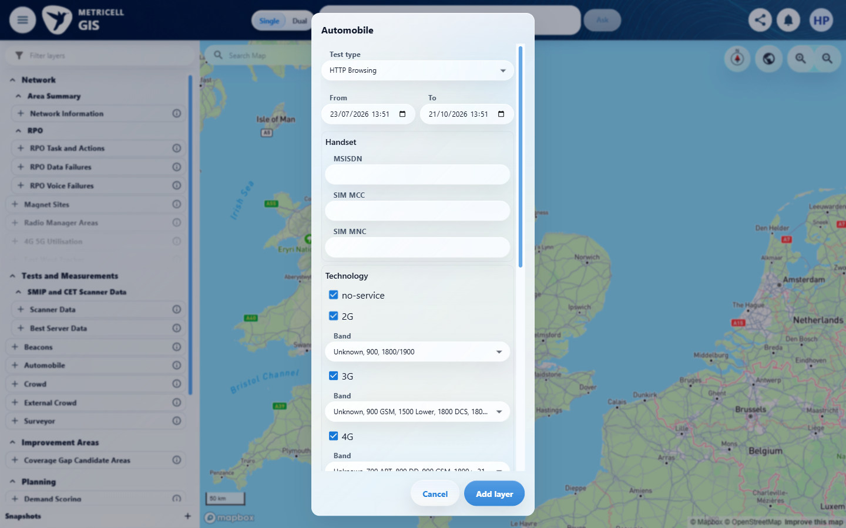

Criterion 3 continued: When the selection contains too many Building points to identify a building, the user is prompted to zoom in or apply filters, and no ambiguous building dashboard opens.
Browser URL recorded after criterion: https://o2intelligence-v4-dev.metricell.com/gis
E09 - Final (criterion-3-final.png)
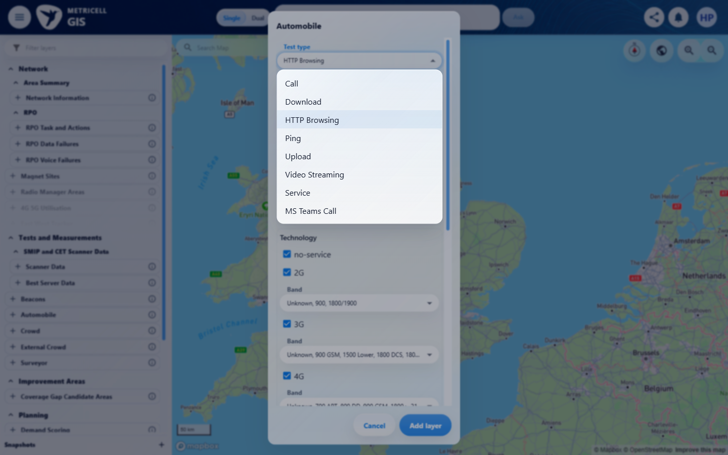

4.0.0 | When building information is available, the dashboard shows building and floorplan summary information in sortable and filterable tables. | When building information is available, the dashboard shows building and floorplan summary information in sortable and filterable tables. | criterion-4-automobile-config.png identifies Automobile; criterion-4-final.png shows all eight nested Test type choices, with no Building entry. The required Building prerequisite is unavailable through the inspected configuration, preventing Building/floorplan summary sorting and filtering. No Building dashboard or floorplan behaviour was exercised.  Evidence: E01, E10, E09 | Blocked
Criterion 4 assessment: criterion-4-automobile-config.png identifies Automobile; criterion-4-final.png shows all eight nested Test type choices, with no Building entry. The required Building prerequisite is unavailable through the inspected configuration, preventing Building/floorplan summary sorting and filtering. No Building dashboard or floorplan behaviour was exercised.
Testing notes: Required Automobile Building layer/point/dashboard is unavailable through the inspected parent configuration; no Building entry among all eight Test type choices. Cannot exercise: When building information is available, the dashboard shows building and floorplan summary information in sortable and filterable tables. This criterion has independent launcher/configuration/choice captures. No Building record or Building detail request could be established, so no exception-state simulation was appropriate. No Surveyor substitution performed.
Criterion 4 evidence: When building information is available, the dashboard shows building and floorplan summary information in sortable and filterable tables.
Browser URL recorded after criterion: https://o2intelligence-v4-dev.metricell.com/gis
E01 - Gis (criterion-4-gis.png) | E10 - Automobile config (criterion-4-automobile-config.png)  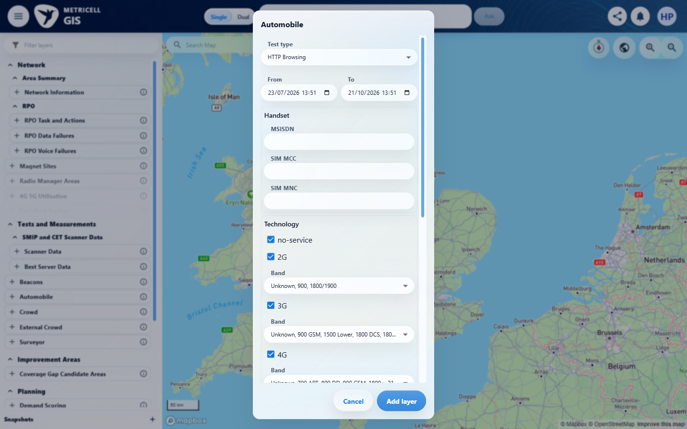

Criterion 4 continued: When building information is available, the dashboard shows building and floorplan summary information in sortable and filterable tables.
Browser URL recorded after criterion: https://o2intelligence-v4-dev.metricell.com/gis
E09 - Final (criterion-4-final.png)

5.0.0 | When the building has floorplans, the dashboard displays their images and lets the user select a floorplan. | When the building has floorplans, the dashboard displays their images and lets the user select a floorplan. | criterion-5-automobile-config.png identifies Automobile; criterion-5-final.png shows all eight nested Test type choices, with no Building entry. The required Building prerequisite is unavailable through the inspected configuration, preventing floorplan images and selection. No Building dashboard or floorplan behaviour was exercised.  Evidence: E01, E11, E12 | Blocked
Criterion 5 assessment: criterion-5-automobile-config.png identifies Automobile; criterion-5-final.png shows all eight nested Test type choices, with no Building entry. The required Building prerequisite is unavailable through the inspected configuration, preventing floorplan images and selection. No Building dashboard or floorplan behaviour was exercised.
Testing notes: Required Automobile Building layer/point/dashboard is unavailable through the inspected parent configuration; no Building entry among all eight Test type choices. Cannot exercise: When the building has floorplans, the dashboard displays their images and lets the user select a floorplan. This criterion has independent launcher/configuration/choice captures. No Building record or Building detail request could be established, so no exception-state simulation was appropriate. No Surveyor substitution performed.
Criterion 5 evidence: When the building has floorplans, the dashboard displays their images and lets the user select a floorplan.
Browser URL recorded after criterion: https://o2intelligence-v4-dev.metricell.com/gis
E01 - Gis (criterion-5-gis.png) | E11 - Automobile config (criterion-5-automobile-config.png)  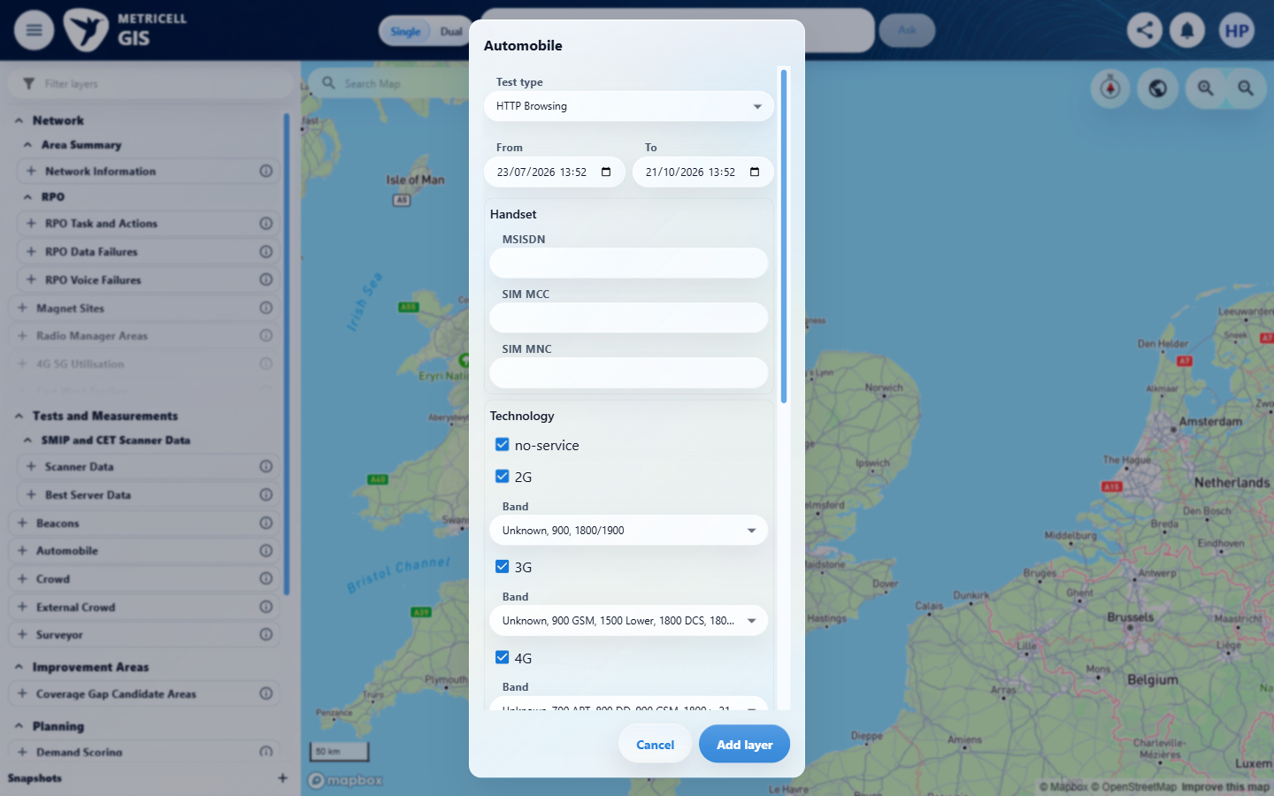

Criterion 5 continued: When the building has floorplans, the dashboard displays their images and lets the user select a floorplan.
Browser URL recorded after criterion: https://o2intelligence-v4-dev.metricell.com/gis
E12 - Final (criterion-5-final.png)
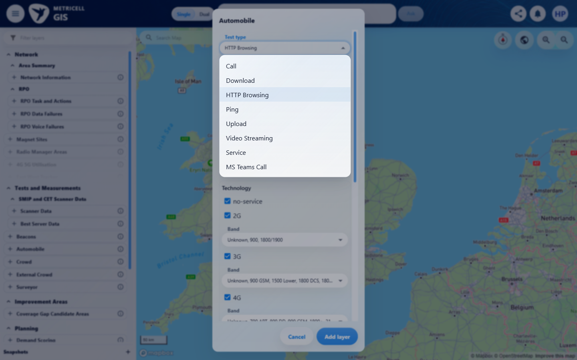

6.0.0 | Selecting a floorplan displays its image with the associated survey points overlaid. | Selecting a floorplan displays its image with the associated survey points overlaid. | criterion-6-automobile-config.png identifies Automobile; criterion-6-final.png shows all eight nested Test type choices, with no Building entry. The required Building prerequisite is unavailable through the inspected configuration, preventing a selected floorplan with survey point overlays. No Building dashboard or floorplan behaviour was exercised.  Evidence: E01, E11, E12 | Blocked
Criterion 6 assessment: criterion-6-automobile-config.png identifies Automobile; criterion-6-final.png shows all eight nested Test type choices, with no Building entry. The required Building prerequisite is unavailable through the inspected configuration, preventing a selected floorplan with survey point overlays. No Building dashboard or floorplan behaviour was exercised.
Testing notes: Required Automobile Building layer/point/dashboard is unavailable through the inspected parent configuration; no Building entry among all eight Test type choices. Cannot exercise: Selecting a floorplan displays its image with the associated survey points overlaid. This criterion has independent launcher/configuration/choice captures. No Building record or Building detail request could be established, so no exception-state simulation was appropriate. No Surveyor substitution performed.
Criterion 6 evidence: Selecting a floorplan displays its image with the associated survey points overlaid.
Browser URL recorded after criterion: https://o2intelligence-v4-dev.metricell.com/gis
E01 - Gis (criterion-6-gis.png) | E11 - Automobile config (criterion-6-automobile-config.png)

Criterion 6 continued: Selecting a floorplan displays its image with the associated survey points overlaid.
Browser URL recorded after criterion: https://o2intelligence-v4-dev.metricell.com/gis
E12 - Final (criterion-6-final.png)

7.0.0 | When the building has no floorplans, the dashboard displays available building details without an empty floorplan image area. | When the building has no floorplans, the dashboard displays available building details without an empty floorplan image area. | criterion-7-automobile-config.png identifies Automobile; criterion-7-final.png shows all eight nested Test type choices, with no Building entry. The required Building prerequisite is unavailable through the inspected configuration, preventing building details for a building without floorplans. No Building dashboard or floorplan behaviour was exercised.  Evidence: E01, E13, E14 | Blocked
Criterion 7 assessment: criterion-7-automobile-config.png identifies Automobile; criterion-7-final.png shows all eight nested Test type choices, with no Building entry. The required Building prerequisite is unavailable through the inspected configuration, preventing building details for a building without floorplans. No Building dashboard or floorplan behaviour was exercised.
Testing notes: Required Automobile Building layer/point/dashboard is unavailable through the inspected parent configuration; no Building entry among all eight Test type choices. Cannot exercise: When the building has no floorplans, the dashboard displays available building details without an empty floorplan image area. This criterion has independent launcher/configuration/choice captures. No Building record or Building detail request could be established, so no exception-state simulation was appropriate. No Surveyor substitution performed.
Criterion 7 evidence: When the building has no floorplans, the dashboard displays available building details without an empty floorplan image area.
Browser URL recorded after criterion: https://o2intelligence-v4-dev.metricell.com/gis
E01 - Gis (criterion-7-gis.png) | E13 - Automobile config (criterion-7-automobile-config.png)  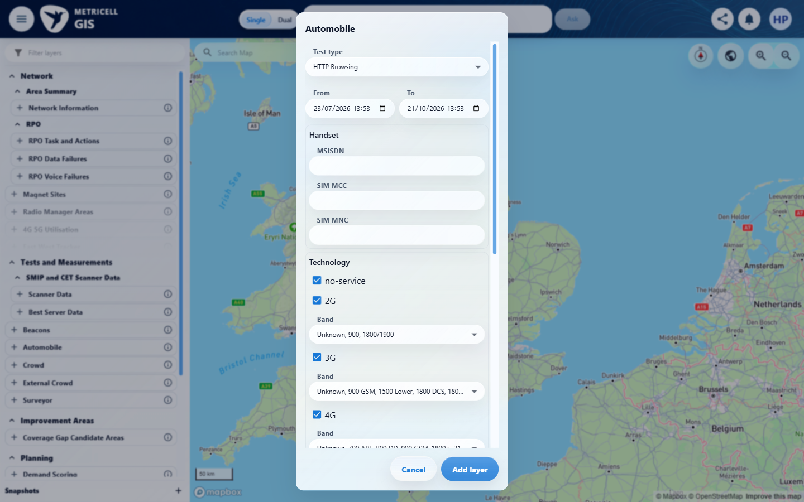

Criterion 7 continued: When the building has no floorplans, the dashboard displays available building details without an empty floorplan image area.
Browser URL recorded after criterion: https://o2intelligence-v4-dev.metricell.com/gis
E14 - Final (criterion-7-final.png)
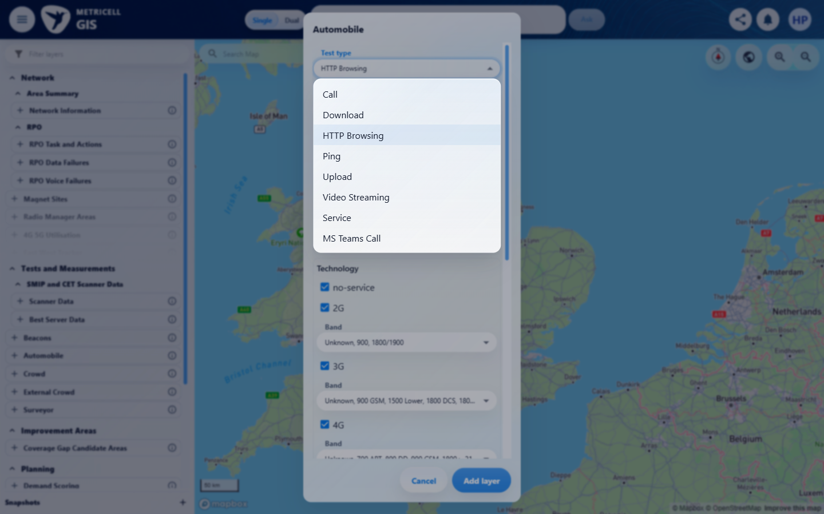

8.0.0 | While Building data is loading, a loading state is displayed. | While Building data is loading, a loading state is displayed. | criterion-8-automobile-config.png identifies Automobile; criterion-8-final.png shows all eight nested Test type choices, with no Building entry. The required Building prerequisite is unavailable through the inspected configuration, preventing Building loading and recovery. No Building record/request was established; these captures do not exercise a Building exception state.  Evidence: E01, E13, E14 | Blocked
Criterion 8 assessment: criterion-8-automobile-config.png identifies Automobile; criterion-8-final.png shows all eight nested Test type choices, with no Building entry. The required Building prerequisite is unavailable through the inspected configuration, preventing Building loading and recovery. No Building record/request was established; these captures do not exercise a Building exception state.
Testing notes: Required Automobile Building layer/point/dashboard is unavailable through the inspected parent configuration; no Building entry among all eight Test type choices. Cannot exercise: While Building data is loading, a loading state is displayed. This criterion has independent launcher/configuration/choice captures. No Building record or Building detail request could be established, so no exception-state simulation was appropriate. No Surveyor substitution performed.
Criterion 8 evidence: While Building data is loading, a loading state is displayed.
Browser URL recorded after criterion: https://o2intelligence-v4-dev.metricell.com/gis
E01 - Gis (criterion-8-gis.png) | E13 - Automobile config (criterion-8-automobile-config.png)

Criterion 8 continued: While Building data is loading, a loading state is displayed.
Browser URL recorded after criterion: https://o2intelligence-v4-dev.metricell.com/gis
E14 - Final (criterion-8-final.png)

9.0.0 | When Building data is unavailable, a no-data state is displayed. | When Building data is unavailable, a no-data state is displayed. | criterion-9-automobile-config.png identifies Automobile; criterion-9-final.png shows all eight nested Test type choices, with no Building entry. The required Building prerequisite is unavailable through the inspected configuration, preventing the Building no-data state. No Building record/request was established; these captures do not exercise a Building exception state.  Evidence: E01, E15, E16 | Blocked
Criterion 9 assessment: criterion-9-automobile-config.png identifies Automobile; criterion-9-final.png shows all eight nested Test type choices, with no Building entry. The required Building prerequisite is unavailable through the inspected configuration, preventing the Building no-data state. No Building record/request was established; these captures do not exercise a Building exception state.
Testing notes: Required Automobile Building layer/point/dashboard is unavailable through the inspected parent configuration; no Building entry among all eight Test type choices. Cannot exercise: When Building data is unavailable, a no-data state is displayed. This criterion has independent launcher/configuration/choice captures. No Building record or Building detail request could be established, so no exception-state simulation was appropriate. No Surveyor substitution performed.
Criterion 9 evidence: When Building data is unavailable, a no-data state is displayed.
Browser URL recorded after criterion: https://o2intelligence-v4-dev.metricell.com/gis
E01 - Gis (criterion-9-gis.png) | E15 - Automobile config (criterion-9-automobile-config.png)  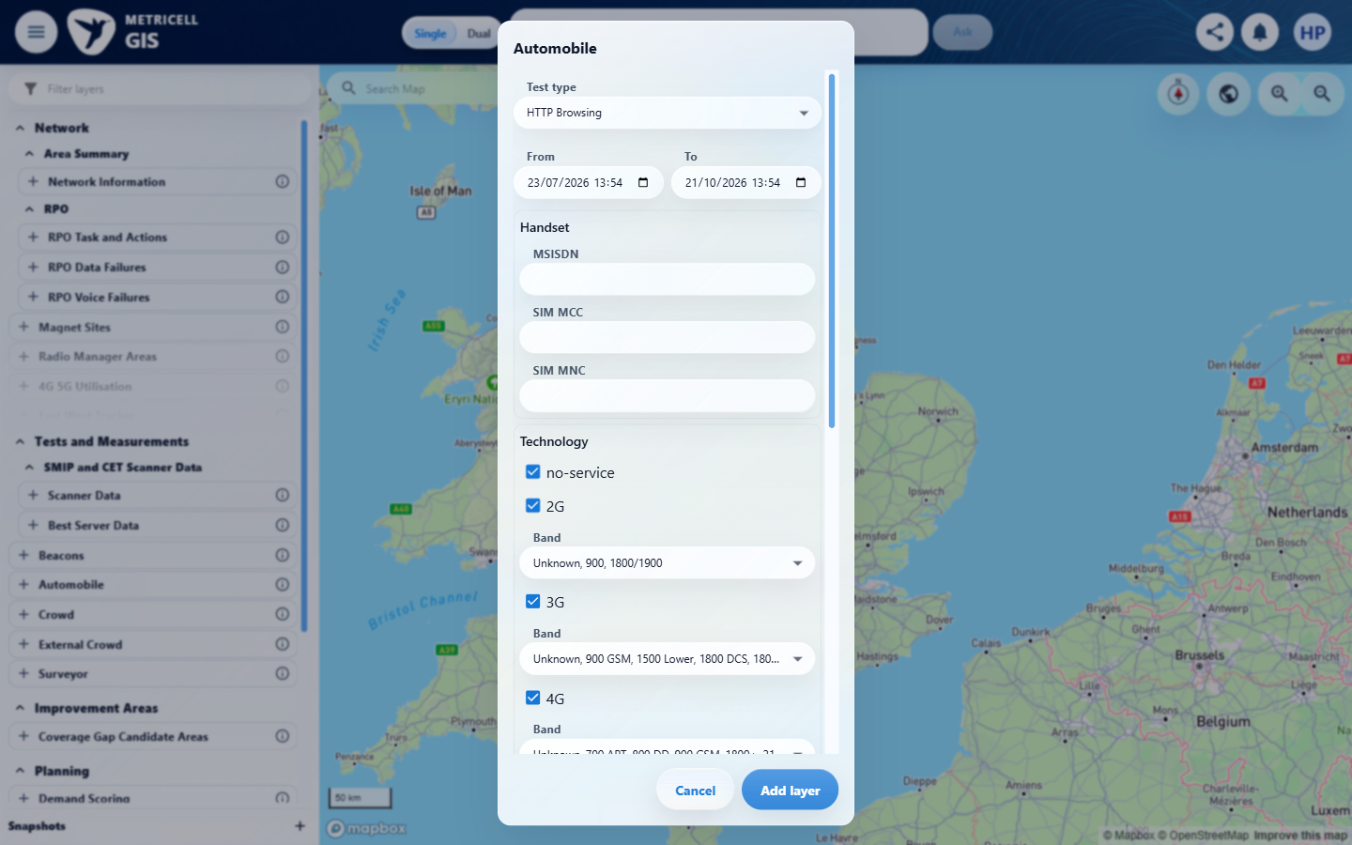

Criterion 9 continued: When Building data is unavailable, a no-data state is displayed.
Browser URL recorded after criterion: https://o2intelligence-v4-dev.metricell.com/gis
E16 - Final (criterion-9-final.png)
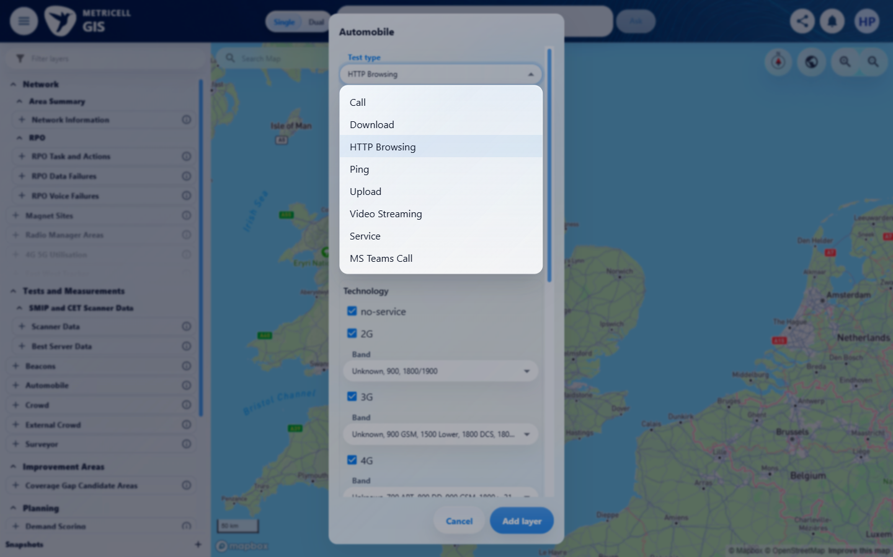

10.0.0 | When Building data fails to load, an error state is displayed without incorrect building data. | When Building data fails to load, an error state is displayed without incorrect building data. | criterion-10-automobile-config.png identifies Automobile; criterion-10-final.png shows all eight nested Test type choices, with no Building entry. The required Building prerequisite is unavailable through the inspected configuration, preventing the Building error state and absence of incorrect data. No Building record/request was established; these captures do not exercise a Building exception state.  Evidence: E01, E15, E16 | Blocked
Criterion 10 assessment: criterion-10-automobile-config.png identifies Automobile; criterion-10-final.png shows all eight nested Test type choices, with no Building entry. The required Building prerequisite is unavailable through the inspected configuration, preventing the Building error state and absence of incorrect data. No Building record/request was established; these captures do not exercise a Building exception state.
Testing notes: Required Automobile Building layer/point/dashboard is unavailable through the inspected parent configuration; no Building entry among all eight Test type choices. Cannot exercise: When Building data fails to load, an error state is displayed without incorrect building data. This criterion has independent launcher/configuration/choice captures. No Building record or Building detail request could be established, so no exception-state simulation was appropriate. No Surveyor substitution performed.
Criterion 10 evidence: When Building data fails to load, an error state is displayed without incorrect building data.
Browser URL recorded after criterion: https://o2intelligence-v4-dev.metricell.com/gis
E01 - Gis (criterion-10-gis.png) | E15 - Automobile config (criterion-10-automobile-config.png)

Criterion 10 continued: When Building data fails to load, an error state is displayed without incorrect building data.
Browser URL recorded after criterion: https://o2intelligence-v4-dev.metricell.com/gis
E16 - Final (criterion-10-final.png)

Supporting setup captures - full attempt evidence remains in the local evidence folder
E17 - Service config (criterion-1-service-config.png)
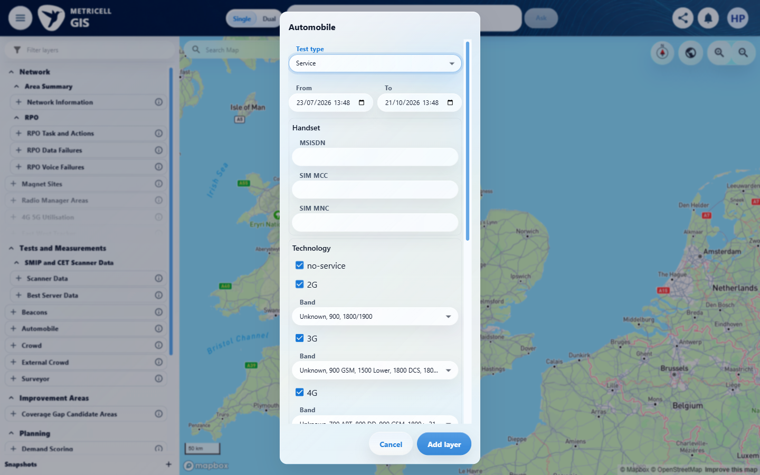

About Metricell

Metricell is on a mission to deliver connectivity. We work with our customers to design, deliver and manage wireless communication networks – with a shared ambition of achieving flawless network experience. We’ve been responsible for many first-to-market products, and our technology is characterised by the relentless pursuit of automation and digitalisation.

Our geospatial intelligence tools traverse a wide variety of business processes – from Test & Measurement to Customer Experience Management – and we’re pioneers in Crowdsourcing and Digital Self Care. Our technology is today in use by a range of customers; thousands of their personnel; and millions of subscribers worldwide.

Find out more at www.metricell.com




