

Automated Test Case Document
Jira Ticket: TEST2-85

Document Classification: | Company Confidential
Document Ref: | Automated Test Case Document
Version: | 1.0
Date: | 21/10/2026
Document Author: | Automated TEST2 Evidence Review
Document Owner: | Quality Assurance / Metricell




This document and its content is copyright of Metricell Limited @ 2026 all rights reserved. All information contained herein is the intellectual property of Metricell Limited and should be treated as confidential. Any external redistribution of reproduction of part or all of the contents in any form is prohibited unless expressly agreed with Metricell Limited in writing. Any reproduced content must include the following statement; “Part or all of the content contained herein is copyright of Metricell Limited @ 2026 all rights reserved”.
Table of Contents
1 Revision History 2
2 Test Cycle Information 3
3 Test Summary 3
4 Test Cases 4
About Metricell 12

Revision History

Version | Date | Revision Author | Summary of Changes
[1.0] | 21/10/2026 | TEST2 QA Automation | Generated from TEST2 evidence review

Test Cycle Information

Tester: | Automated
Jira Ticket: | TEST2-85
Environment: | o2intelligence-v4-dev.metricell.com
Browser Details: | Google Chrome 155.0.8059.85
Date of Test: | 21/10/2026
Limitations during Testing: | Blocked criterion(s): 1, 2, 3, 4, 5, 6, 7, 8, 9, 10. See the assessment below each criterion. Defects (No.) counts directly contradicted criteria, not unique Jira bugs; blockers and inconclusive evidence count as zero.
Overall review outcome: | Blocked
Browser URL(s) recorded after criteria: | https://o2intelligence-v4-dev.metricell.com/gis

Test Summary

Area of test | Outcome | Fail | Defects (No.)
1. Given a completed Download test is selected and its details have loaded, the summary shows the reported technology, user, handset, service, serving cell, duration, tested technologies, indoor/outdoor status, Download Rate, and Wi-Fi connection status. | Blocked | N | 0
2. Given Download samples are available, a time-series chart shows Signal Strength in dBm and Download Rate in Mbps across the test duration. | Blocked | N | 0
3. Given per-sample Download data is available, each returned sample is shown in a table with its relevant units. | Blocked | N | 0
4. Given the per-sample table contains multiple rows, sorting by a displayed column changes their visible order according to that column. | Blocked | N | 0
5. Given per-sample data is available, filtering the table shows only rows matching the selected filter. | Blocked | N | 0
6. Given average signal metrics are returned, Average Signal Strength, Average Signal Quality, and Average SNR appear in the summary immediately after Download Rate. | Blocked | N | 0
7. Given the selected Download point has no measurable duration, the detail presentation shows the standard no-data state instead of an empty detail view. | Blocked | N | 0
8. Given Download details are loading, the detail presentation shows a loading state. | Blocked | N | 0
9. Given Download details are unavailable, the detail presentation shows a no-data state. | Blocked | N | 0
10. Given loading Download details fails, the detail presentation shows an error state and does not display incorrect data. | Blocked | N | 0

Test Cases
Each test maps to a criterion and decisive browser evidence. Inconclusive results are reported as Failed.

Tests

Preconditions: | V4 access and ticket conditions. | Associated Requirements: | Ticket criteria below. | Automation Notes: | Screenshots below each criterion; full log retained locally.
ID / Criterion | Criteria Tested | Expected Result | Actual Result / Evidence Path | Outcome
1.0.0 | Given a completed Download test is selected and its details have loaded, the summary shows the reported technology, user, handset, service, serving cell, duration, tested technologies, indoor/outdoor status, Download Rate, and Wi-Fi connection status. | Given a completed Download test is selected and its details have loaded, the summary shows the reported technology, user, handset, service, serving cell, duration, tested technologies, indoor/outdoor status, Download Rate, and Wi-Fi connection status. | criterion-1-test-type-choices.png and criterion-1-download-config.png show Automobile's Download option selected; criterion-1-after-add-download.png and criterion-1-final.png show the added Automobile - Download layer without a selected point or details. The tester reports GET /api/platform/automobile/download/points returned HTTP 500 on both initial and fresh loads; the completed record and loaded summary were unavailable. The visible Error legend is not an HTTP error message, settled no-data response or detail failure.  Evidence: E01, E02, E03, E04 | Blocked
Criterion 1 assessment: criterion-1-test-type-choices.png and criterion-1-download-config.png show Automobile's Download option selected; criterion-1-after-add-download.png and criterion-1-final.png show the added Automobile - Download layer without a selected point or details. The tester reports GET /api/platform/automobile/download/points returned HTTP 500 on both initial and fresh loads; the completed record and loaded summary were unavailable. The visible Error legend is not an HTTP error message, settled no-data response or detail failure.
Testing notes: Automobile exposes Download in its actual Test type choices. GET /api/platform/automobile/download/points returned HTTP 500 on the initial load and on one controlled fresh launcher-to-GIS load. GET /api/platform/automobile/filter-options returned 200. No Download point could be retrieved or selected, so a completed Download record and loaded summary could not be established. This is a point-retrieval service blocker, not a settled empty response or an observed detail-view failure. The map's Error legend entry is not an on-screen HTTP error message. No business data was created and no response was simulated.
Criterion 1 evidence: Given a completed Download test is selected and its details have loaded, the summary shows the reported technology, user, handset, service, serving cell, duration, tested technologies, indoor/outdoor status, Download Rate, and Wi-Fi connection status.
Browser URL recorded after criterion: https://o2intelligence-v4-dev.metricell.com/gis
E01 - Automobile config (criterion-1-automobile-config.png)  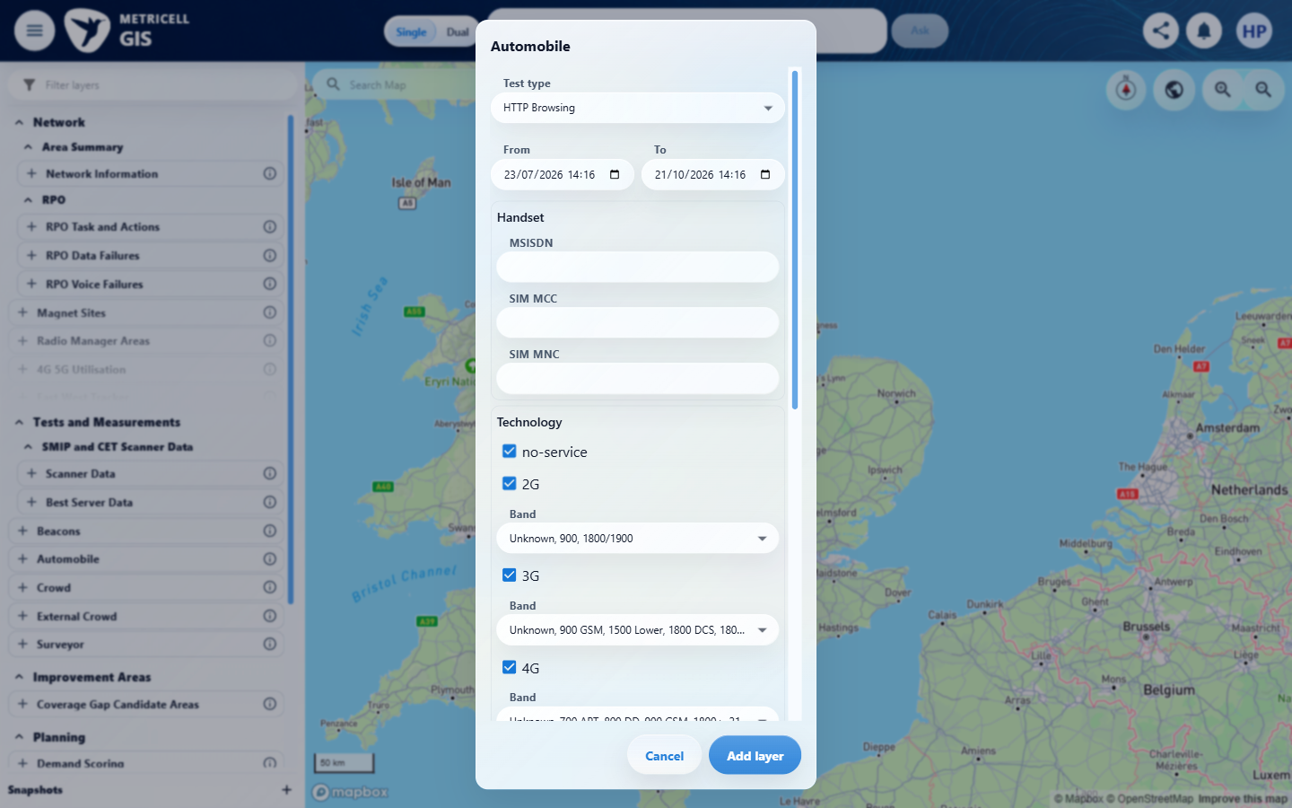 | E02 - Test type choices (criterion-1-test-type-choices.png)  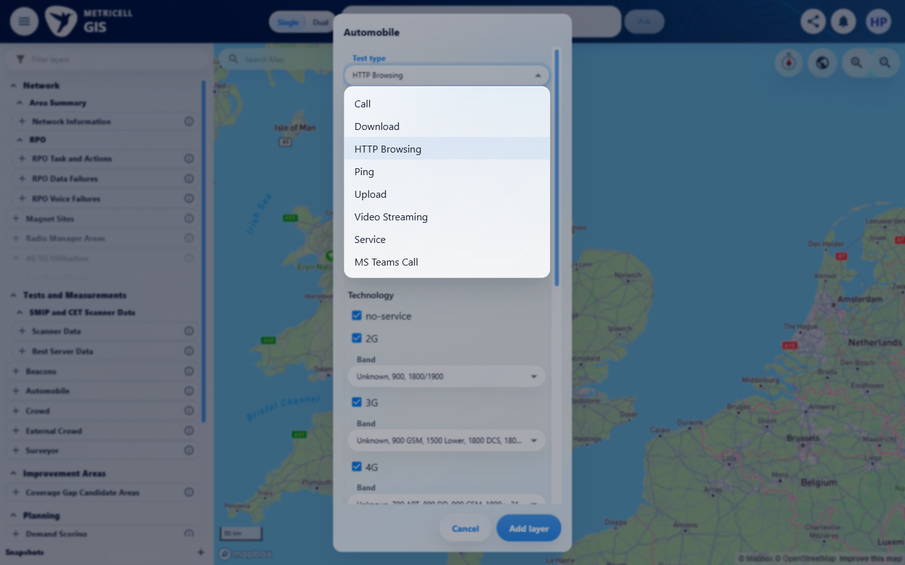

Criterion 1 continued: Given a completed Download test is selected and its details have loaded, the summary shows the reported technology, user, handset, service, serving cell, duration, tested technologies, indoor/outdoor status, Download Rate, and Wi-Fi connection status.
Browser URL recorded after criterion: https://o2intelligence-v4-dev.metricell.com/gis
E03 - Download config (criterion-1-download-config.png)  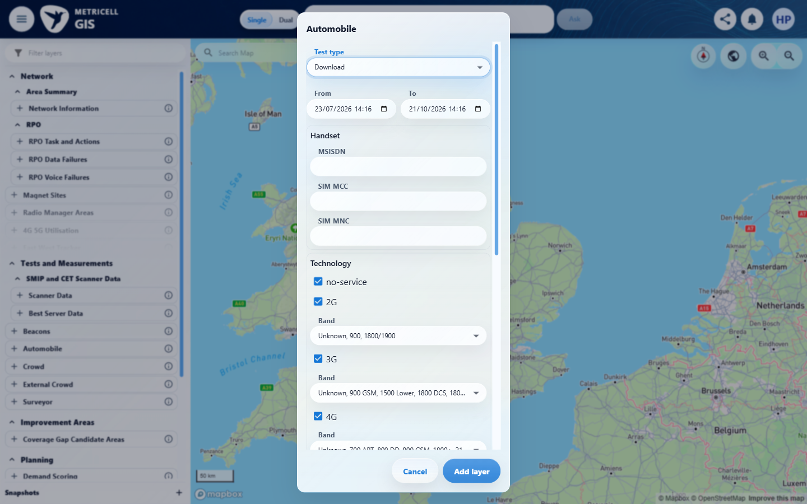 | E04 - Final (criterion-1-final.png)  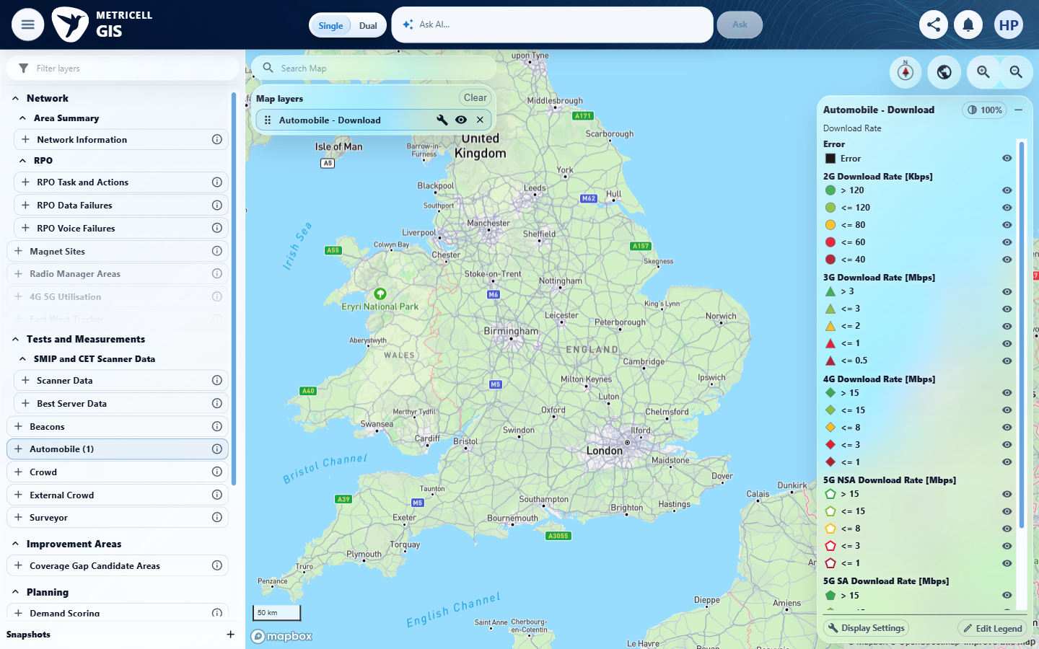

2.0.0 | Given Download samples are available, a time-series chart shows Signal Strength in dBm and Download Rate in Mbps across the test duration. | Given Download samples are available, a time-series chart shows Signal Strength in dBm and Download Rate in Mbps across the test duration. | criterion-2-test-type-choices.png and criterion-2-download-config.png show Automobile's Download option selected; criterion-2-after-add-download.png and criterion-2-final.png show the added Automobile - Download layer without a selected point or details. The tester reports GET /api/platform/automobile/download/points returned HTTP 500 on both initial and fresh loads; Download samples and the time-series chart were unavailable. The visible Error legend is not an HTTP error message, settled no-data response or detail failure.  Evidence: E05, E06, E07, E08 | Blocked
Criterion 2 assessment: criterion-2-test-type-choices.png and criterion-2-download-config.png show Automobile's Download option selected; criterion-2-after-add-download.png and criterion-2-final.png show the added Automobile - Download layer without a selected point or details. The tester reports GET /api/platform/automobile/download/points returned HTTP 500 on both initial and fresh loads; Download samples and the time-series chart were unavailable. The visible Error legend is not an HTTP error message, settled no-data response or detail failure.
Testing notes: Automobile exposes Download in its actual Test type choices. GET /api/platform/automobile/download/points returned HTTP 500 on the initial load and on one controlled fresh launcher-to-GIS load. GET /api/platform/automobile/filter-options returned 200. No Download point could be retrieved or selected, so Download samples and a time-series chart could not be established. This is a point-retrieval service blocker, not a settled empty response or an observed detail-view failure. The map's Error legend entry is not an on-screen HTTP error message. No business data was created and no response was simulated.
Criterion 2 evidence: Given Download samples are available, a time-series chart shows Signal Strength in dBm and Download Rate in Mbps across the test duration.
Browser URL recorded after criterion: https://o2intelligence-v4-dev.metricell.com/gis
E05 - Automobile config (criterion-2-automobile-config.png)  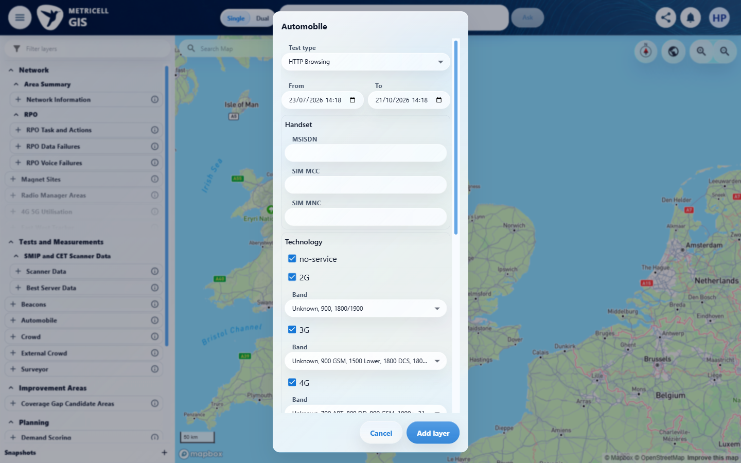 | E06 - Test type choices (criterion-2-test-type-choices.png)  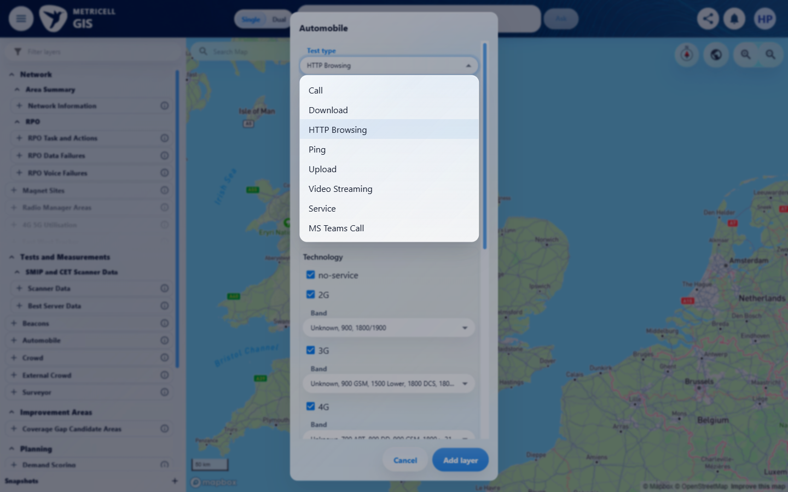

Criterion 2 continued: Given Download samples are available, a time-series chart shows Signal Strength in dBm and Download Rate in Mbps across the test duration.
Browser URL recorded after criterion: https://o2intelligence-v4-dev.metricell.com/gis
E07 - Download config (criterion-2-download-config.png)  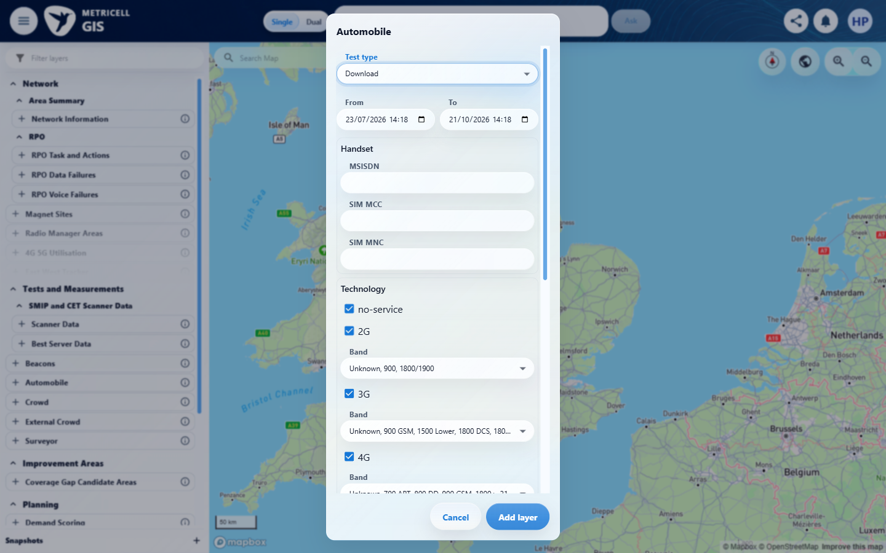 | E08 - Final (criterion-2-final.png)  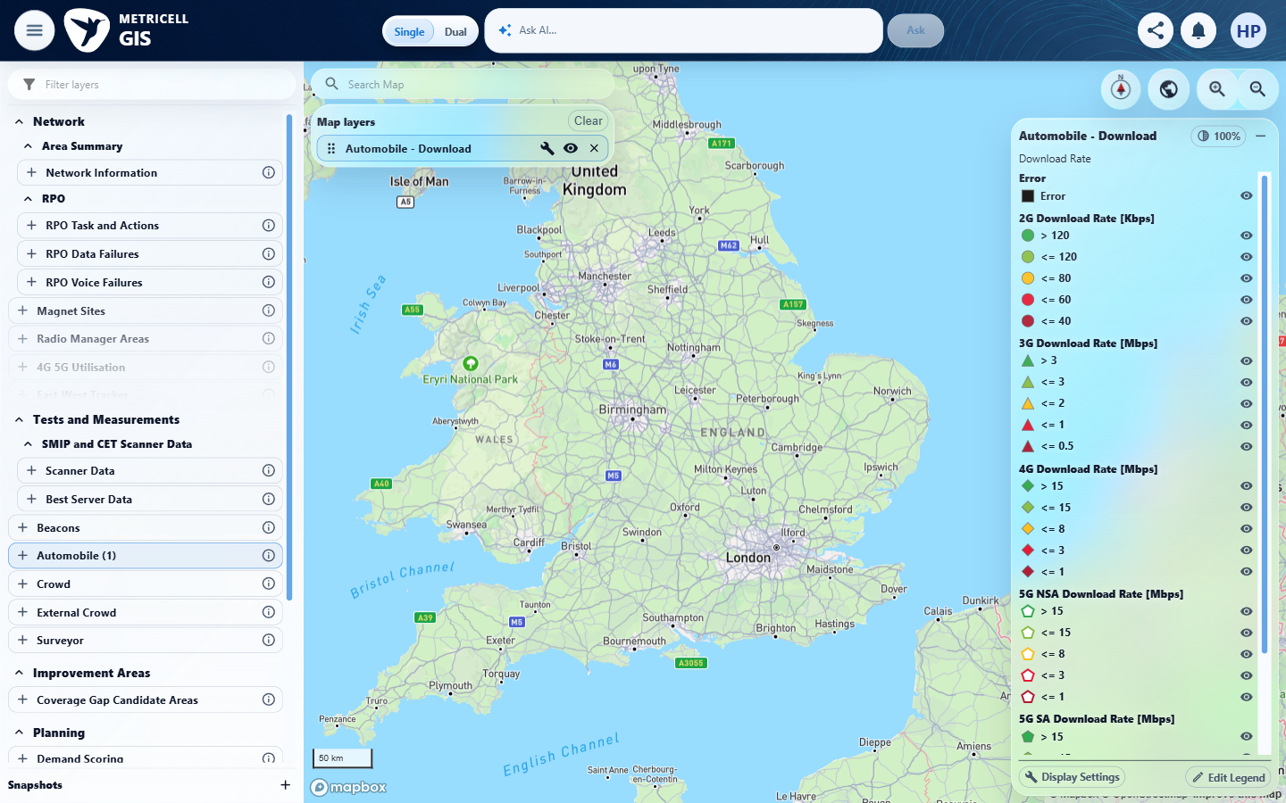

3.0.0 | Given per-sample Download data is available, each returned sample is shown in a table with its relevant units. | Given per-sample Download data is available, each returned sample is shown in a table with its relevant units. | criterion-3-test-type-choices.png shows Download within Automobile; criterion-3-final.png shows Download configuration, with no selected record or detail presentation. Testing stopped after the two reported HTTP 500 responses from GET /api/platform/automobile/download/points in criteria 1 and 2; returned samples and their table units were unavailable.  Evidence: E09, E10, E11, E12 | Blocked
Criterion 3 assessment: criterion-3-test-type-choices.png shows Download within Automobile; criterion-3-final.png shows Download configuration, with no selected record or detail presentation. Testing stopped after the two reported HTTP 500 responses from GET /api/platform/automobile/download/points in criteria 1 and 2; returned samples and their table units were unavailable.
Testing notes: Automobile exposes Download in its actual Test type choices. GET /api/platform/automobile/download/points returned HTTP 500 on the initial load and on one controlled fresh launcher-to-GIS load. GET /api/platform/automobile/filter-options returned 200. No Download point could be retrieved or selected, so returned per-sample Download data could not be established. This is a point-retrieval service blocker, not a settled empty response or an observed detail-view failure. The map's Error legend entry is not an on-screen HTTP error message. No business data was created and no response was simulated. Stopped at the Download configuration because the same point-retrieval prerequisite had already failed twice; did not issue the failing request again or substitute another module.
Criterion 3 evidence: Given per-sample Download data is available, each returned sample is shown in a table with its relevant units.
Browser URL recorded after criterion: https://o2intelligence-v4-dev.metricell.com/gis
E09 - Before open automobile (criterion-3-before-open-automobile.png)  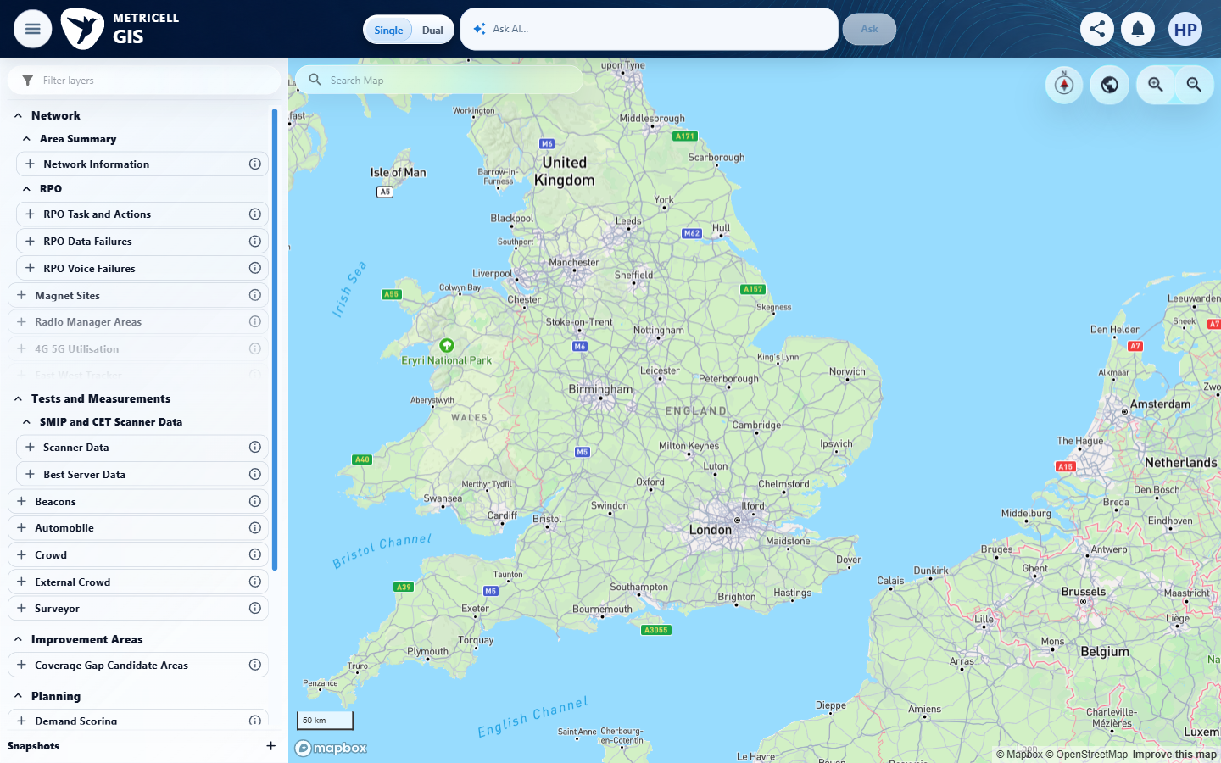 | E10 - Automobile config (criterion-3-automobile-config.png)  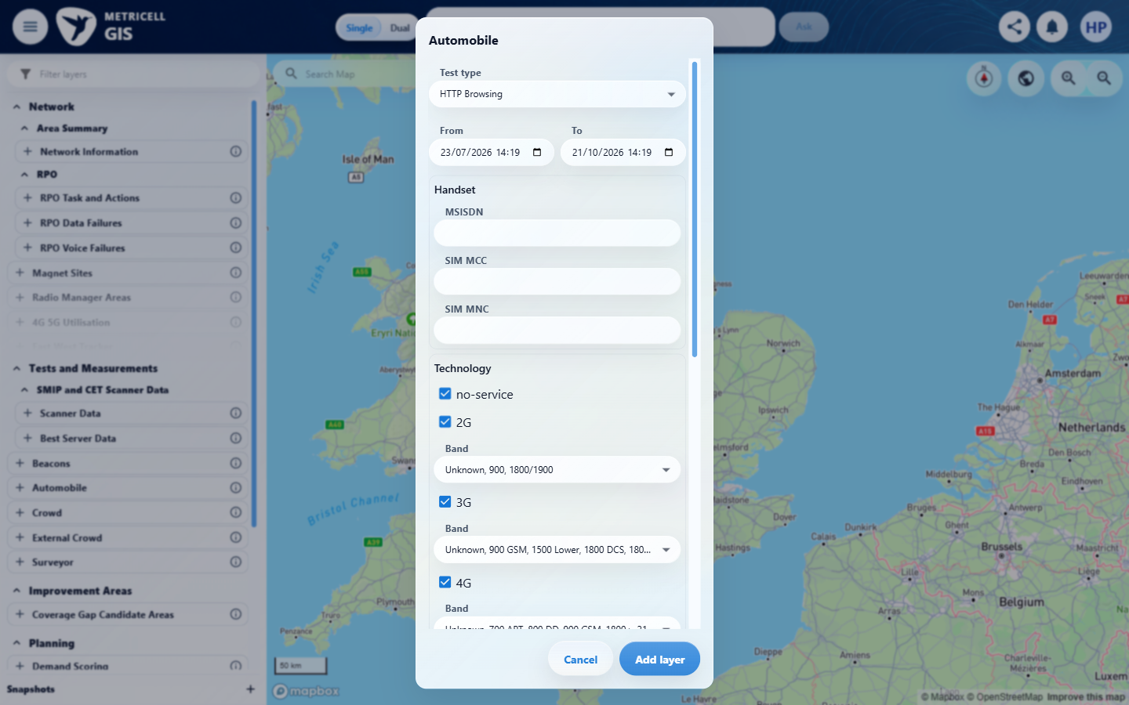

Criterion 3 continued: Given per-sample Download data is available, each returned sample is shown in a table with its relevant units.
Browser URL recorded after criterion: https://o2intelligence-v4-dev.metricell.com/gis
E11 - Test type choices (criterion-3-test-type-choices.png)  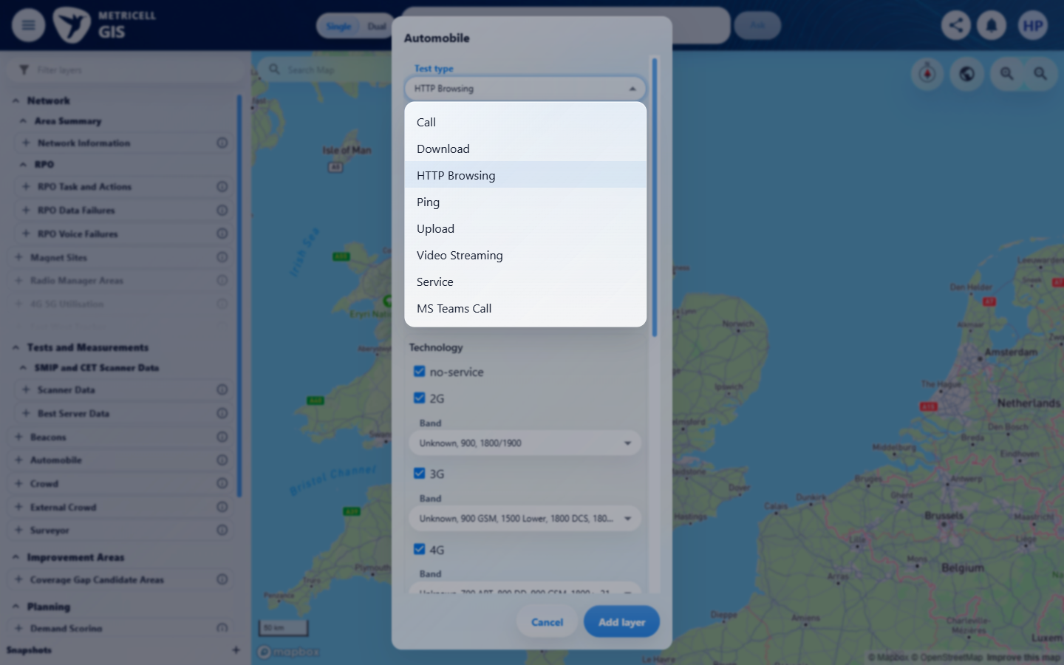 | E12 - Final (criterion-3-final.png)  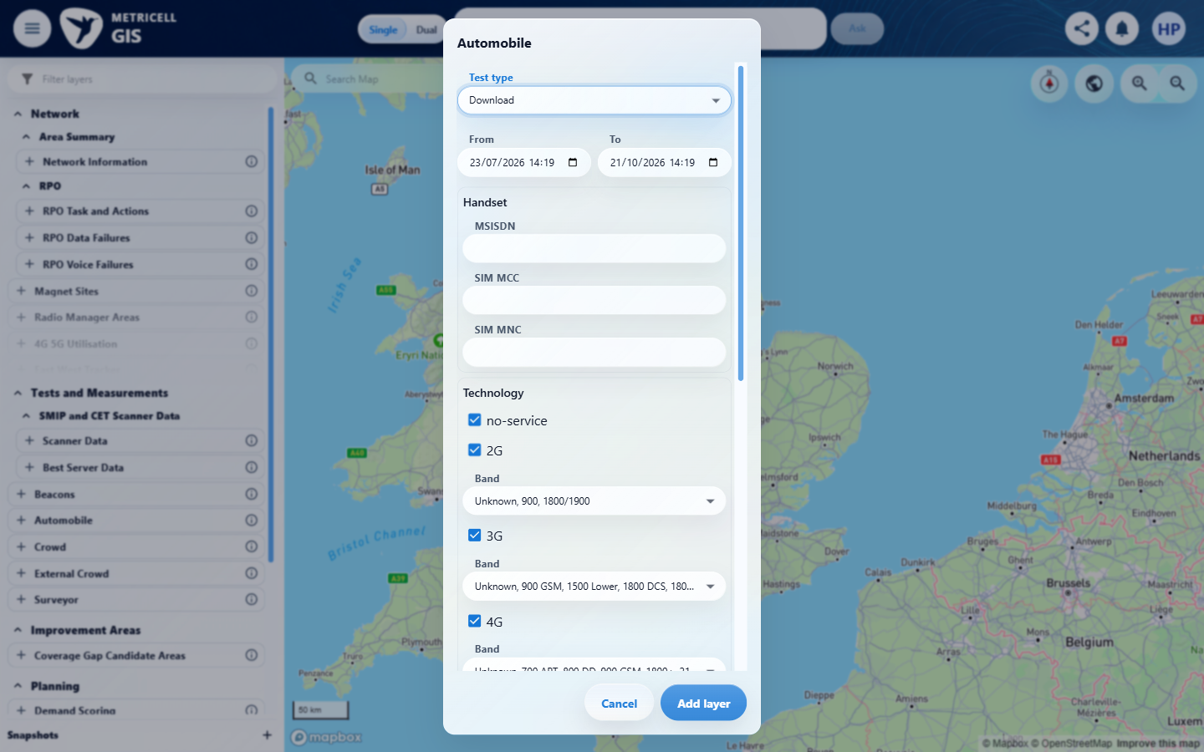

4.0.0 | Given the per-sample table contains multiple rows, sorting by a displayed column changes their visible order according to that column. | Given the per-sample table contains multiple rows, sorting by a displayed column changes their visible order according to that column. | criterion-4-test-type-choices.png shows Download within Automobile; criterion-4-final.png shows Download configuration, with no selected record or detail presentation. Testing stopped after the two reported HTTP 500 responses from GET /api/platform/automobile/download/points in criteria 1 and 2; a populated table and sorting sequence were unavailable.  Evidence: E09, E13, E14, E15 | Blocked
Criterion 4 assessment: criterion-4-test-type-choices.png shows Download within Automobile; criterion-4-final.png shows Download configuration, with no selected record or detail presentation. Testing stopped after the two reported HTTP 500 responses from GET /api/platform/automobile/download/points in criteria 1 and 2; a populated table and sorting sequence were unavailable.
Testing notes: Automobile exposes Download in its actual Test type choices. GET /api/platform/automobile/download/points returned HTTP 500 on the initial load and on one controlled fresh launcher-to-GIS load. GET /api/platform/automobile/filter-options returned 200. No Download point could be retrieved or selected, so multiple rows in the per-sample table could not be established. This is a point-retrieval service blocker, not a settled empty response or an observed detail-view failure. The map's Error legend entry is not an on-screen HTTP error message. No business data was created and no response was simulated. Stopped at the Download configuration because the same point-retrieval prerequisite had already failed twice; did not issue the failing request again or substitute another module.
Criterion 4 evidence: Given the per-sample table contains multiple rows, sorting by a displayed column changes their visible order according to that column.
Browser URL recorded after criterion: https://o2intelligence-v4-dev.metricell.com/gis
E09 - Before open automobile (criterion-4-before-open-automobile.png) | E13 - Automobile config (criterion-4-automobile-config.png)  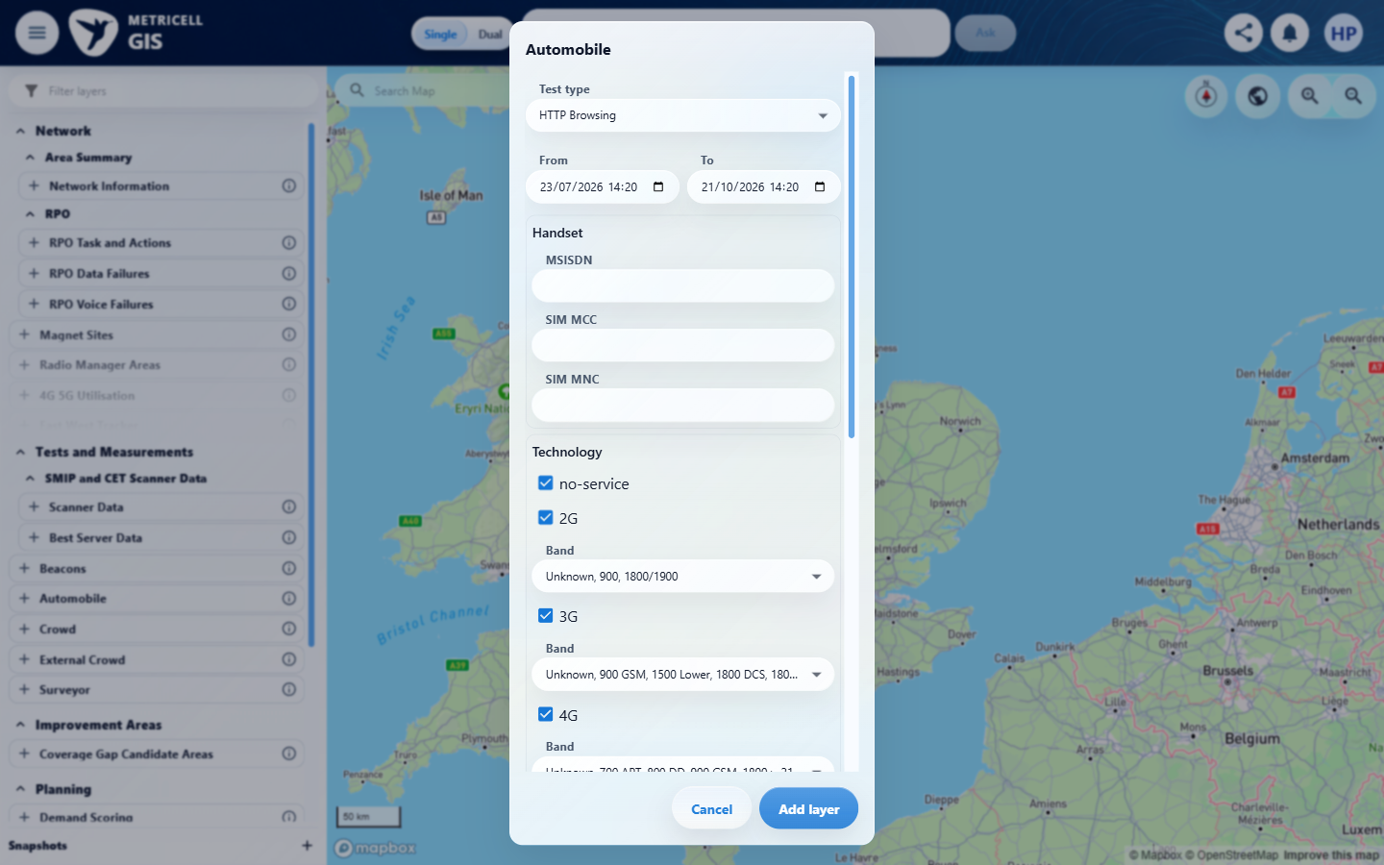

Criterion 4 continued: Given the per-sample table contains multiple rows, sorting by a displayed column changes their visible order according to that column.
Browser URL recorded after criterion: https://o2intelligence-v4-dev.metricell.com/gis
E14 - Test type choices (criterion-4-test-type-choices.png)  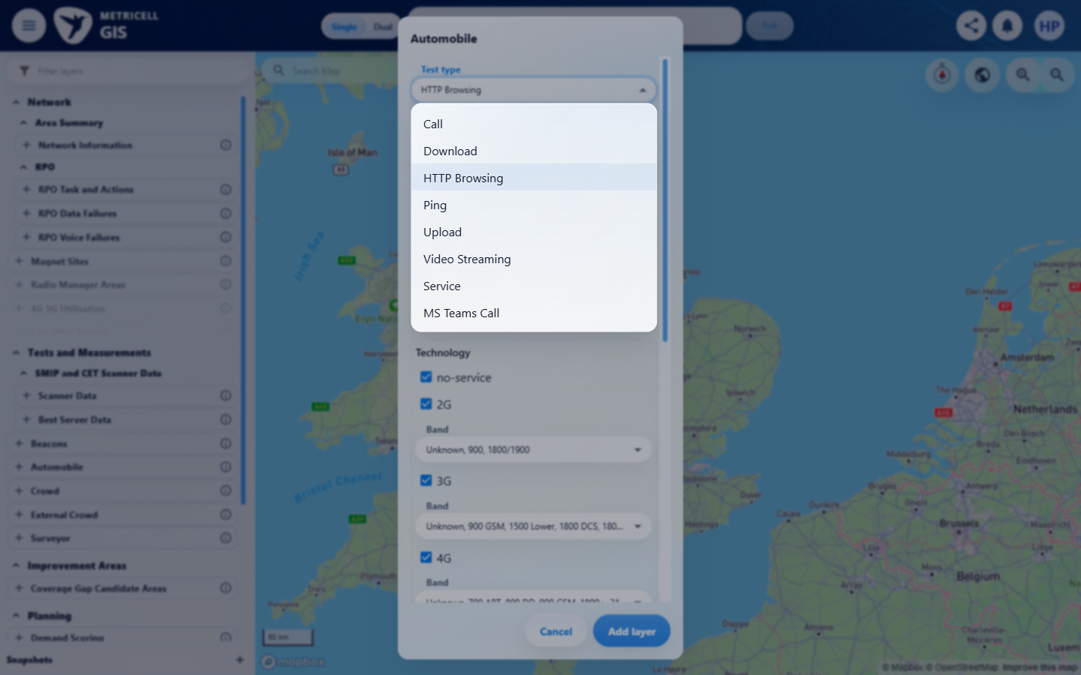 | E15 - Final (criterion-4-final.png)  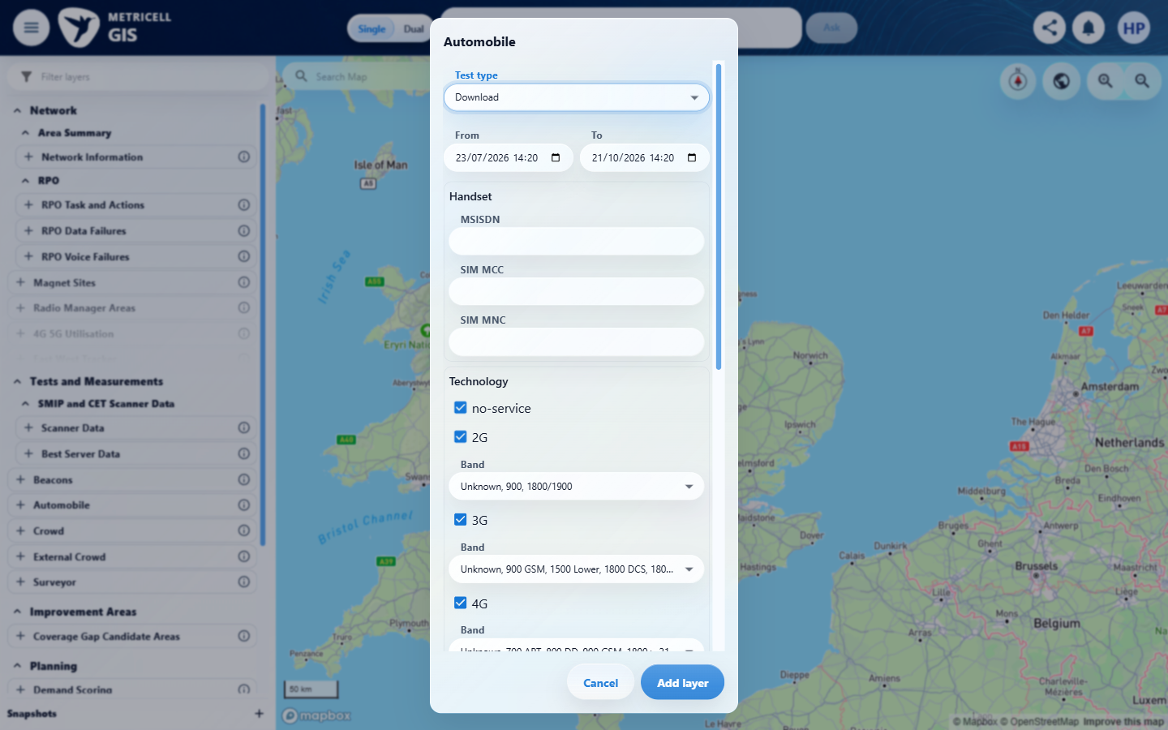

5.0.0 | Given per-sample data is available, filtering the table shows only rows matching the selected filter. | Given per-sample data is available, filtering the table shows only rows matching the selected filter. | criterion-5-test-type-choices.png shows Download within Automobile; criterion-5-final.png shows Download configuration, with no selected record or detail presentation. Testing stopped after the two reported HTTP 500 responses from GET /api/platform/automobile/download/points in criteria 1 and 2; per-sample rows and the filtering sequence were unavailable.  Evidence: E09, E13, E14, E15 | Blocked
Criterion 5 assessment: criterion-5-test-type-choices.png shows Download within Automobile; criterion-5-final.png shows Download configuration, with no selected record or detail presentation. Testing stopped after the two reported HTTP 500 responses from GET /api/platform/automobile/download/points in criteria 1 and 2; per-sample rows and the filtering sequence were unavailable.
Testing notes: Automobile exposes Download in its actual Test type choices. GET /api/platform/automobile/download/points returned HTTP 500 on the initial load and on one controlled fresh launcher-to-GIS load. GET /api/platform/automobile/filter-options returned 200. No Download point could be retrieved or selected, so per-sample rows and a filter could not be established. This is a point-retrieval service blocker, not a settled empty response or an observed detail-view failure. The map's Error legend entry is not an on-screen HTTP error message. No business data was created and no response was simulated. Stopped at the Download configuration because the same point-retrieval prerequisite had already failed twice; did not issue the failing request again or substitute another module.
Criterion 5 evidence: Given per-sample data is available, filtering the table shows only rows matching the selected filter.
Browser URL recorded after criterion: https://o2intelligence-v4-dev.metricell.com/gis
E09 - Before open automobile (criterion-5-before-open-automobile.png) | E13 - Automobile config (criterion-5-automobile-config.png)

Criterion 5 continued: Given per-sample data is available, filtering the table shows only rows matching the selected filter.
Browser URL recorded after criterion: https://o2intelligence-v4-dev.metricell.com/gis
E14 - Test type choices (criterion-5-test-type-choices.png) | E15 - Final (criterion-5-final.png)

6.0.0 | Given average signal metrics are returned, Average Signal Strength, Average Signal Quality, and Average SNR appear in the summary immediately after Download Rate. | Given average signal metrics are returned, Average Signal Strength, Average Signal Quality, and Average SNR appear in the summary immediately after Download Rate. | criterion-6-test-type-choices.png shows Download within Automobile; criterion-6-final.png shows Download configuration, with no selected record or detail presentation. Testing stopped after the two reported HTTP 500 responses from GET /api/platform/automobile/download/points in criteria 1 and 2; returned average metrics and their summary position were unavailable.  Evidence: E09, E16, E17, E18 | Blocked
Criterion 6 assessment: criterion-6-test-type-choices.png shows Download within Automobile; criterion-6-final.png shows Download configuration, with no selected record or detail presentation. Testing stopped after the two reported HTTP 500 responses from GET /api/platform/automobile/download/points in criteria 1 and 2; returned average metrics and their summary position were unavailable.
Testing notes: Automobile exposes Download in its actual Test type choices. GET /api/platform/automobile/download/points returned HTTP 500 on the initial load and on one controlled fresh launcher-to-GIS load. GET /api/platform/automobile/filter-options returned 200. No Download point could be retrieved or selected, so returned average signal metrics could not be established. This is a point-retrieval service blocker, not a settled empty response or an observed detail-view failure. The map's Error legend entry is not an on-screen HTTP error message. No business data was created and no response was simulated. Stopped at the Download configuration because the same point-retrieval prerequisite had already failed twice; did not issue the failing request again or substitute another module.
Criterion 6 evidence: Given average signal metrics are returned, Average Signal Strength, Average Signal Quality, and Average SNR appear in the summary immediately after Download Rate.
Browser URL recorded after criterion: https://o2intelligence-v4-dev.metricell.com/gis
E09 - Before open automobile (criterion-6-before-open-automobile.png) | E16 - Automobile config (criterion-6-automobile-config.png)  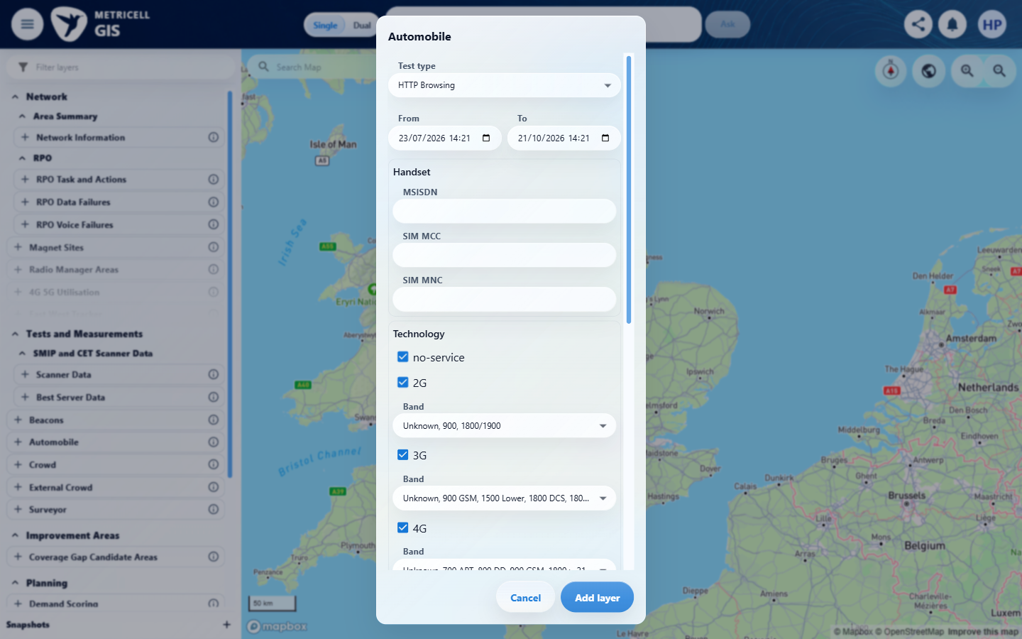

Criterion 6 continued: Given average signal metrics are returned, Average Signal Strength, Average Signal Quality, and Average SNR appear in the summary immediately after Download Rate.
Browser URL recorded after criterion: https://o2intelligence-v4-dev.metricell.com/gis
E17 - Test type choices (criterion-6-test-type-choices.png)  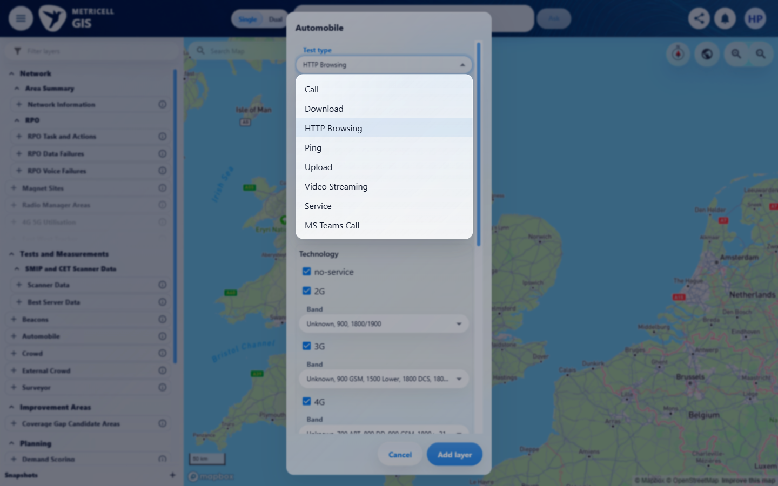 | E18 - Final (criterion-6-final.png)  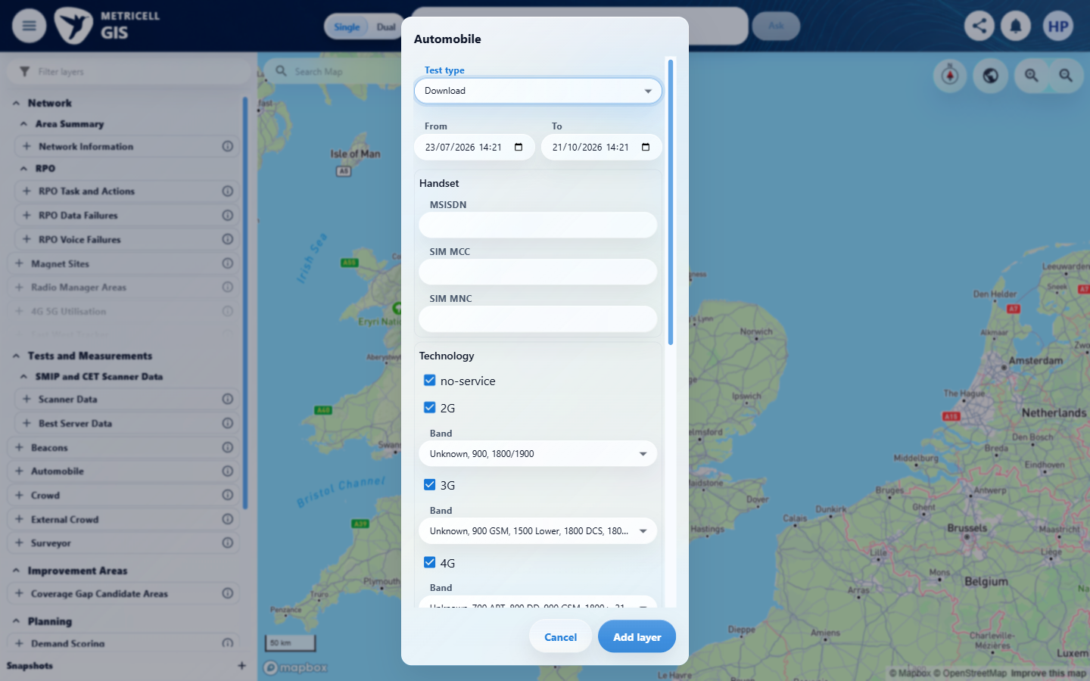

7.0.0 | Given the selected Download point has no measurable duration, the detail presentation shows the standard no-data state instead of an empty detail view. | Given the selected Download point has no measurable duration, the detail presentation shows the standard no-data state instead of an empty detail view. | criterion-7-test-type-choices.png shows Download within Automobile; criterion-7-final.png shows Download configuration, with no selected record or detail presentation. Testing stopped after the two reported HTTP 500 responses from GET /api/platform/automobile/download/points in criteria 1 and 2; a selected record with no measurable duration and its no-data presentation were unavailable.  Evidence: E09, E16, E17, E18 | Blocked
Criterion 7 assessment: criterion-7-test-type-choices.png shows Download within Automobile; criterion-7-final.png shows Download configuration, with no selected record or detail presentation. Testing stopped after the two reported HTTP 500 responses from GET /api/platform/automobile/download/points in criteria 1 and 2; a selected record with no measurable duration and its no-data presentation were unavailable.
Testing notes: Automobile exposes Download in its actual Test type choices. GET /api/platform/automobile/download/points returned HTTP 500 on the initial load and on one controlled fresh launcher-to-GIS load. GET /api/platform/automobile/filter-options returned 200. No Download point could be retrieved or selected, so a selected Download record with no measurable duration could not be established. This is a point-retrieval service blocker, not a settled empty response or an observed detail-view failure. The map's Error legend entry is not an on-screen HTTP error message. No business data was created and no response was simulated. Stopped at the Download configuration because the same point-retrieval prerequisite had already failed twice; did not issue the failing request again or substitute another module.
Criterion 7 evidence: Given the selected Download point has no measurable duration, the detail presentation shows the standard no-data state instead of an empty detail view.
Browser URL recorded after criterion: https://o2intelligence-v4-dev.metricell.com/gis
E09 - Before open automobile (criterion-7-before-open-automobile.png) | E16 - Automobile config (criterion-7-automobile-config.png)

Criterion 7 continued: Given the selected Download point has no measurable duration, the detail presentation shows the standard no-data state instead of an empty detail view.
Browser URL recorded after criterion: https://o2intelligence-v4-dev.metricell.com/gis
E17 - Test type choices (criterion-7-test-type-choices.png) | E18 - Final (criterion-7-final.png)

8.0.0 | Given Download details are loading, the detail presentation shows a loading state. | Given Download details are loading, the detail presentation shows a loading state. | criterion-8-test-type-choices.png shows Download within Automobile; criterion-8-final.png shows Download configuration, with no selected record or detail presentation. Testing stopped after the two reported HTTP 500 responses from GET /api/platform/automobile/download/points in criteria 1 and 2; a selected record and genuine detail-loading transition were unavailable. No exception simulation was performed; the point-retrieval failure does not exercise a detail loading/no-data/error state.  Evidence: E09, E19, E20, E21 | Blocked
Criterion 8 assessment: criterion-8-test-type-choices.png shows Download within Automobile; criterion-8-final.png shows Download configuration, with no selected record or detail presentation. Testing stopped after the two reported HTTP 500 responses from GET /api/platform/automobile/download/points in criteria 1 and 2; a selected record and genuine detail-loading transition were unavailable. No exception simulation was performed; the point-retrieval failure does not exercise a detail loading/no-data/error state.
Testing notes: Automobile exposes Download in its actual Test type choices. GET /api/platform/automobile/download/points returned HTTP 500 on the initial load and on one controlled fresh launcher-to-GIS load. GET /api/platform/automobile/filter-options returned 200. No Download point could be retrieved or selected, so the selected record's genuine Download detail read request could not be established. This is a point-retrieval service blocker, not a settled empty response or an observed detail-view failure. The map's Error legend entry is not an on-screen HTTP error message. No business data was created and no response was simulated. Browser-only exception simulation was not eligible: no selected record or genuine detail request was established. Stopped at the Download configuration because the same point-retrieval prerequisite had already failed twice; did not issue the failing request again or substitute another module.
Criterion 8 evidence: Given Download details are loading, the detail presentation shows a loading state.
Browser URL recorded after criterion: https://o2intelligence-v4-dev.metricell.com/gis
E09 - Before open automobile (criterion-8-before-open-automobile.png) | E19 - Automobile config (criterion-8-automobile-config.png)  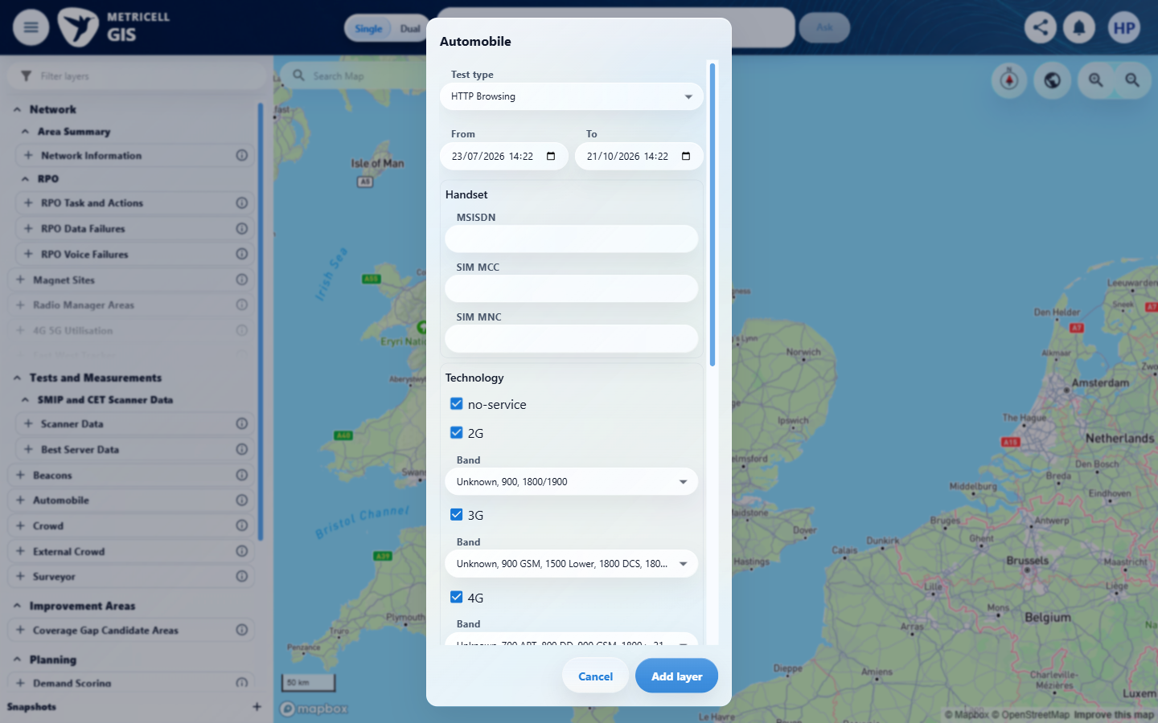

Criterion 8 continued: Given Download details are loading, the detail presentation shows a loading state.
Browser URL recorded after criterion: https://o2intelligence-v4-dev.metricell.com/gis
E20 - Test type choices (criterion-8-test-type-choices.png)  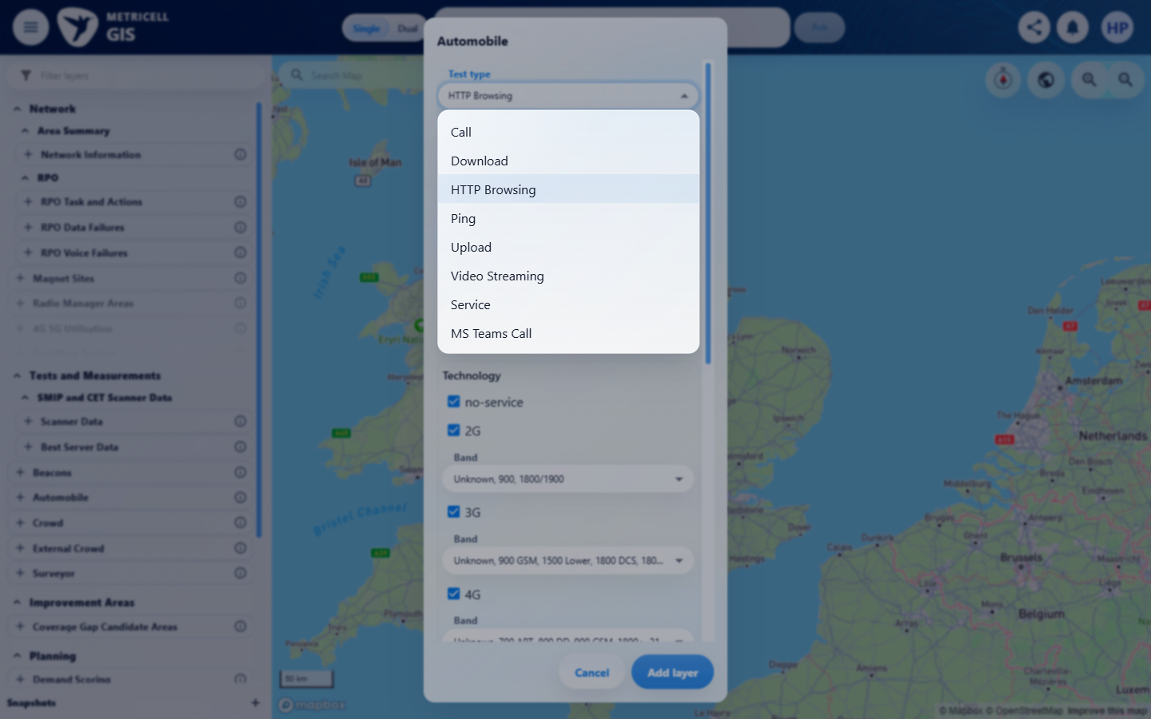 | E21 - Final (criterion-8-final.png)  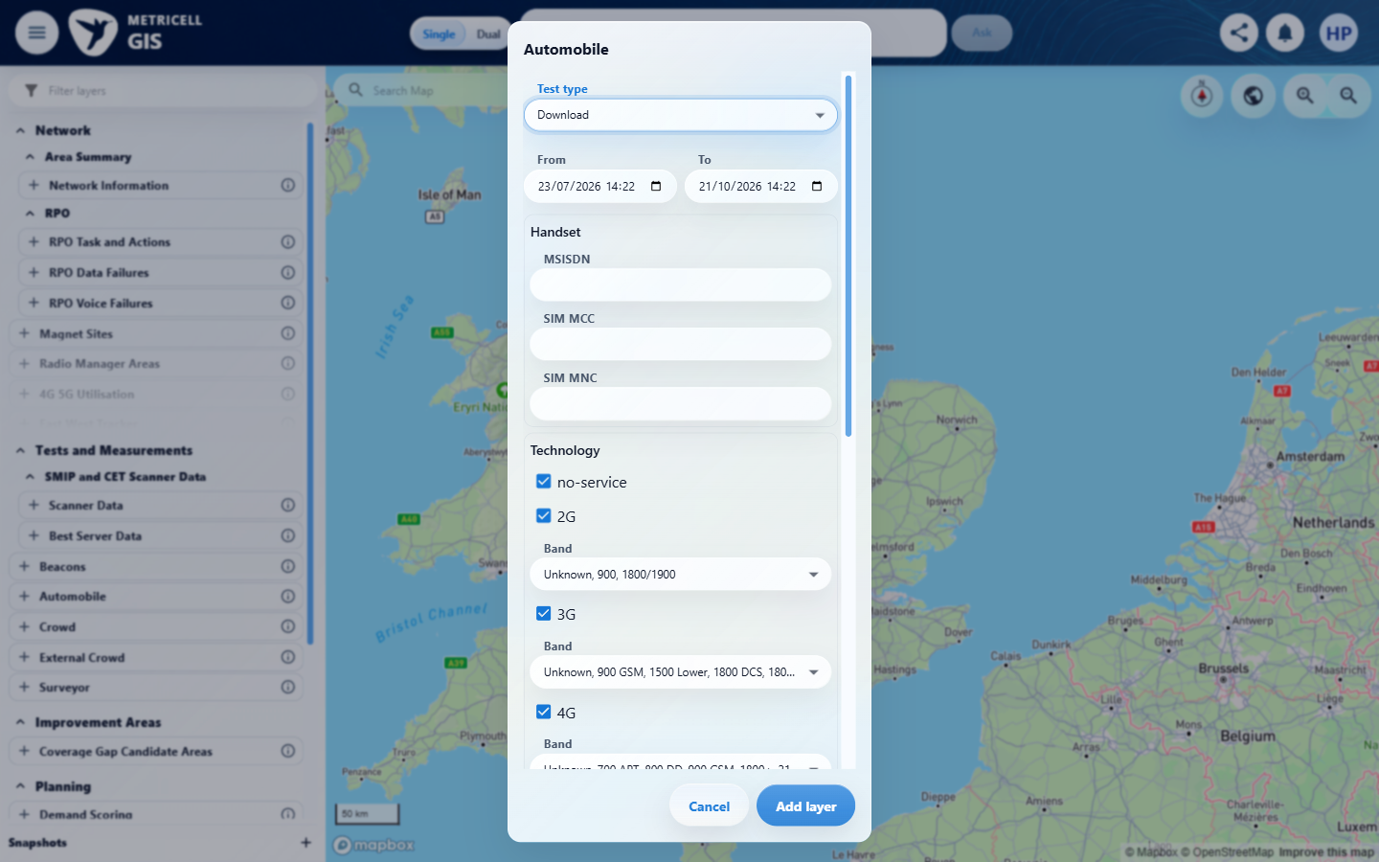

9.0.0 | Given Download details are unavailable, the detail presentation shows a no-data state. | Given Download details are unavailable, the detail presentation shows a no-data state. | criterion-9-test-type-choices.png shows Download within Automobile; criterion-9-final.png shows Download configuration, with no selected record or detail presentation. Testing stopped after the two reported HTTP 500 responses from GET /api/platform/automobile/download/points in criteria 1 and 2; a selected record, unavailable-detail response and no-data presentation were unavailable. No exception simulation was performed; the point-retrieval failure does not exercise a detail loading/no-data/error state.  Evidence: E09, E22, E23, E24 | Blocked
Criterion 9 assessment: criterion-9-test-type-choices.png shows Download within Automobile; criterion-9-final.png shows Download configuration, with no selected record or detail presentation. Testing stopped after the two reported HTTP 500 responses from GET /api/platform/automobile/download/points in criteria 1 and 2; a selected record, unavailable-detail response and no-data presentation were unavailable. No exception simulation was performed; the point-retrieval failure does not exercise a detail loading/no-data/error state.
Testing notes: Automobile exposes Download in its actual Test type choices. GET /api/platform/automobile/download/points returned HTTP 500 on the initial load and on one controlled fresh launcher-to-GIS load. GET /api/platform/automobile/filter-options returned 200. No Download point could be retrieved or selected, so an actual unavailable-detail response or authoritative empty-response contract could not be established. This is a point-retrieval service blocker, not a settled empty response or an observed detail-view failure. The map's Error legend entry is not an on-screen HTTP error message. No business data was created and no response was simulated. Browser-only exception simulation was not eligible: no selected record or genuine detail request was established. Stopped at the Download configuration because the same point-retrieval prerequisite had already failed twice; did not issue the failing request again or substitute another module.
Criterion 9 evidence: Given Download details are unavailable, the detail presentation shows a no-data state.
Browser URL recorded after criterion: https://o2intelligence-v4-dev.metricell.com/gis
E09 - Before open automobile (criterion-9-before-open-automobile.png) | E22 - Automobile config (criterion-9-automobile-config.png)  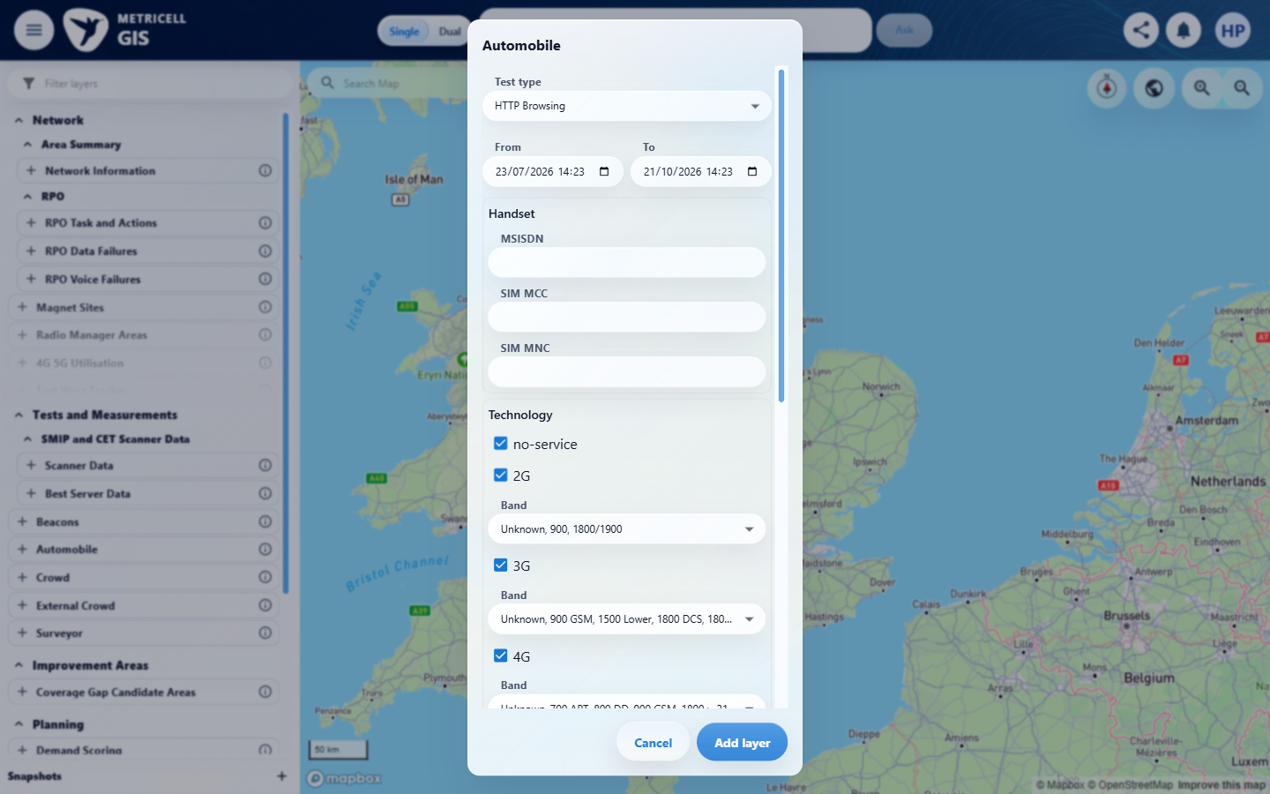

Criterion 9 continued: Given Download details are unavailable, the detail presentation shows a no-data state.
Browser URL recorded after criterion: https://o2intelligence-v4-dev.metricell.com/gis
E23 - Test type choices (criterion-9-test-type-choices.png)  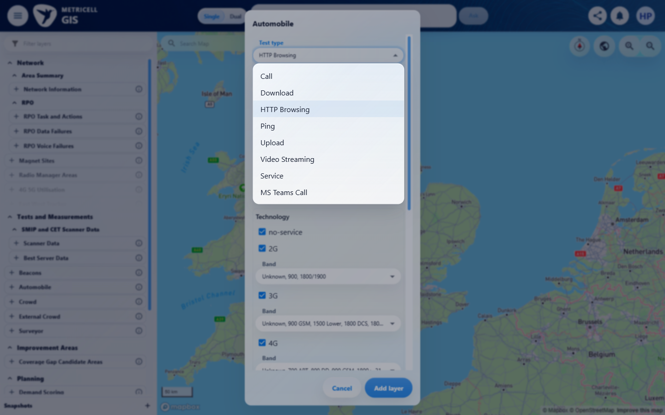 | E24 - Final (criterion-9-final.png)  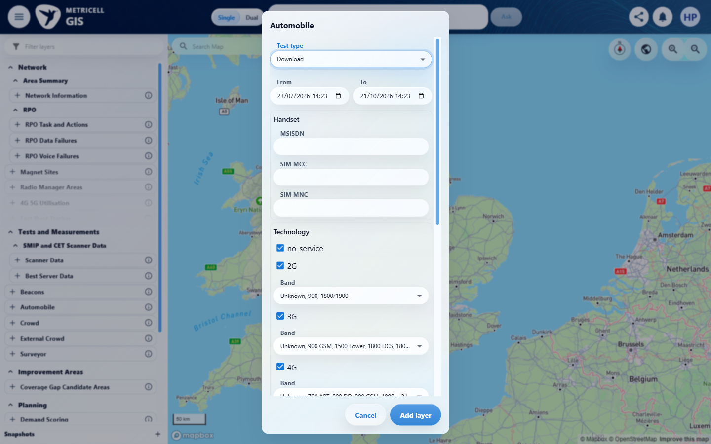

10.0.0 | Given loading Download details fails, the detail presentation shows an error state and does not display incorrect data. | Given loading Download details fails, the detail presentation shows an error state and does not display incorrect data. | criterion-10-test-type-choices.png shows Download within Automobile; criterion-10-final.png shows Download configuration, with no selected record or detail presentation. Testing stopped after the two reported HTTP 500 responses from GET /api/platform/automobile/download/points in criteria 1 and 2; a selected record and failing detail request were unavailable, so error handling and absence of incorrect data could not be assessed. No exception simulation was performed; the point-retrieval failure does not exercise a detail loading/no-data/error state.  Evidence: E09, E22, E23, E24 | Blocked
Criterion 10 assessment: criterion-10-test-type-choices.png shows Download within Automobile; criterion-10-final.png shows Download configuration, with no selected record or detail presentation. Testing stopped after the two reported HTTP 500 responses from GET /api/platform/automobile/download/points in criteria 1 and 2; a selected record and failing detail request were unavailable, so error handling and absence of incorrect data could not be assessed. No exception simulation was performed; the point-retrieval failure does not exercise a detail loading/no-data/error state.
Testing notes: Automobile exposes Download in its actual Test type choices. GET /api/platform/automobile/download/points returned HTTP 500 on the initial load and on one controlled fresh launcher-to-GIS load. GET /api/platform/automobile/filter-options returned 200. No Download point could be retrieved or selected, so the selected record's genuine failing detail request could not be established. This is a point-retrieval service blocker, not a settled empty response or an observed detail-view failure. The map's Error legend entry is not an on-screen HTTP error message. No business data was created and no response was simulated. Browser-only exception simulation was not eligible: no selected record or genuine detail request was established. Stopped at the Download configuration because the same point-retrieval prerequisite had already failed twice; did not issue the failing request again or substitute another module.
Criterion 10 evidence: Given loading Download details fails, the detail presentation shows an error state and does not display incorrect data.
Browser URL recorded after criterion: https://o2intelligence-v4-dev.metricell.com/gis
E09 - Before open automobile (criterion-10-before-open-automobile.png) | E22 - Automobile config (criterion-10-automobile-config.png)

Criterion 10 continued: Given loading Download details fails, the detail presentation shows an error state and does not display incorrect data.
Browser URL recorded after criterion: https://o2intelligence-v4-dev.metricell.com/gis
E23 - Test type choices (criterion-10-test-type-choices.png) | E24 - Final (criterion-10-final.png)

About Metricell

Metricell is on a mission to deliver connectivity. We work with our customers to design, deliver and manage wireless communication networks – with a shared ambition of achieving flawless network experience. We’ve been responsible for many first-to-market products, and our technology is characterised by the relentless pursuit of automation and digitalisation.

Our geospatial intelligence tools traverse a wide variety of business processes – from Test & Measurement to Customer Experience Management – and we’re pioneers in Crowdsourcing and Digital Self Care. Our technology is today in use by a range of customers; thousands of their personnel; and millions of subscribers worldwide.

Find out more at www.metricell.com




