

Automated Test Case Document
Jira Ticket: TEST2-87

Document Classification: | Company Confidential
Document Ref: | Automated Test Case Document
Version: | 1.0
Date: | 21/10/2026
Document Author: | Automated TEST2 Evidence Review
Document Owner: | Quality Assurance / Metricell




This document and its content is copyright of Metricell Limited @ 2026 all rights reserved. All information contained herein is the intellectual property of Metricell Limited and should be treated as confidential. Any external redistribution of reproduction of part or all of the contents in any form is prohibited unless expressly agreed with Metricell Limited in writing. Any reproduced content must include the following statement; “Part or all of the content contained herein is copyright of Metricell Limited @ 2026 all rights reserved”.
Table of Contents
1 Revision History 2
2 Test Cycle Information 3
3 Test Summary 3
4 Test Cases 4
About Metricell 12

Revision History

Version | Date | Revision Author | Summary of Changes
[1.0] | 21/10/2026 | TEST2 QA Automation | Generated from TEST2 evidence review

Test Cycle Information

Tester: | Automated
Jira Ticket: | TEST2-87
Environment: | o2intelligence-v4-dev.metricell.com
Browser Details: | Google Chrome 155.0.8059.85
Date of Test: | 21/10/2026
Limitations during Testing: | Blocked criterion(s): 1, 2, 3, 4, 5, 6, 7. See the assessment below each criterion. Defects (No.) counts directly contradicted criteria, not unique Jira bugs; blockers and inconclusive evidence count as zero.
Overall review outcome: | Blocked
Browser URL(s) recorded after criteria: | https://o2intelligence-v4-dev.metricell.com/gis

Test Summary

Area of test | Outcome | Fail | Defects (No.)
1. When a completed Call test is opened in the shared point-detail dialog, its summary shows the available duration, test result, connection time, start time, end time, handset, and disconnection cause. | Blocked | N | 0
2. When Call samples are returned, the timeline chart shows call state, service technology, and signal strength across the test duration. | Blocked | N | 0
3. When Call samples are returned, the dialog displays them in a table whose columns can be sorted and filtered. | Blocked | N | 0
4. For each displayed Call sample, the Serving Cell column shows the known serving site/cell when available; when it is unavailable, it shows that sample’s CGI. | Blocked | N | 0
5. Selecting a displayed Call sample opens the related Service details for the selected sample’s point in time. | Blocked | N | 0
6. When the selected Call point has no measurable duration, the dialog shows the standard no-data state instead of an empty detail view. | Blocked | N | 0
7. While Call details are loading, the dialog shows the standard loading state; when details are unavailable, it shows the standard no-data state; when loading fails, it shows the standard error state, with no incorrect Call data displayed. | Blocked | N | 0

Test Cases
Each test maps to a criterion and decisive browser evidence. Inconclusive results are reported as Failed.

Tests

Preconditions: | V4 access and ticket conditions. | Associated Requirements: | Ticket criteria below. | Automation Notes: | Screenshots below each criterion; full log retained locally.
ID / Criterion | Criteria Tested | Expected Result | Actual Result / Evidence Path | Outcome
1.0.0 | When a completed Call test is opened in the shared point-detail dialog, its summary shows the available duration, test result, connection time, start time, end time, handset, and disconnection cause. | When a completed Call test is opened in the shared point-detail dialog, its summary shows the available duration, test result, connection time, start time, end time, handset, and disconnection cause. | criterion-1-call-config.png confirms Automobile > Call; criterion-1-final.png shows the Automobile - Call layer and legend without visible Call points or a detail dialog. Results record GET /api/platform/automobile/call/points HTTP 500, reproduced on a fresh load; this is unavailable point retrieval, not a settled empty response. Completed-record selection and summary fields could not be tested.  Evidence: E01, E02, E03, E04 | Blocked
Criterion 1 assessment: criterion-1-call-config.png confirms Automobile > Call; criterion-1-final.png shows the Automobile - Call layer and legend without visible Call points or a detail dialog. Results record GET /api/platform/automobile/call/points HTTP 500, reproduced on a fresh load; this is unavailable point retrieval, not a settled empty response. Completed-record selection and summary fields could not be tested.
Testing notes: GET /api/platform/automobile/call/points returned HTTP 500 on the first normal load and again after a controlled fresh launcher/GIS load with Automobile > Call selected and the default 90-day range. This is a point-retrieval error, not a settled empty response or a Call detail-request failure. The map displayed the Automobile - Call layer and legend without selectable Call points; no on-screen HTTP error message was observed. Required Call records could not be obtained. No completed Call record was selectable, so the shared detail dialog and summary fields could not be checked.
Criterion 1 evidence: When a completed Call test is opened in the shared point-detail dialog, its summary shows the available duration, test result, connection time, start time, end time, handset, and disconnection cause.
Browser URL recorded after criterion: https://o2intelligence-v4-dev.metricell.com/gis
E01 - Automobile config (criterion-1-automobile-config.png)  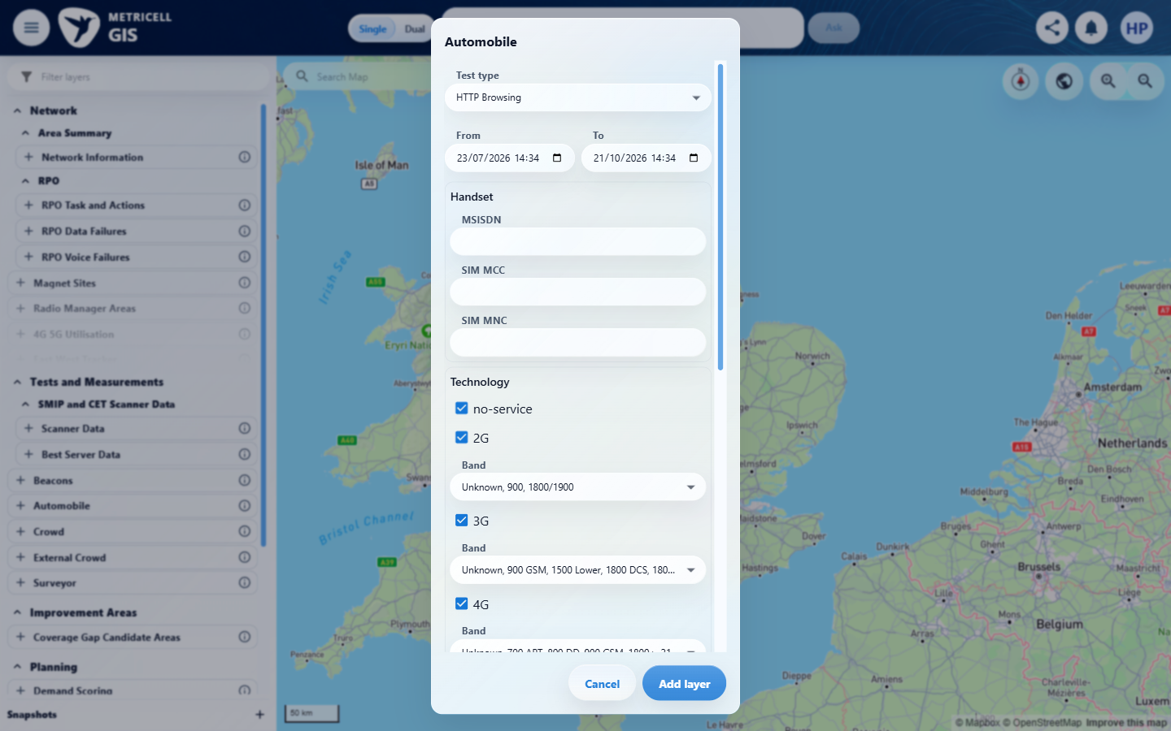 | E02 - Test type choices (criterion-1-test-type-choices.png)  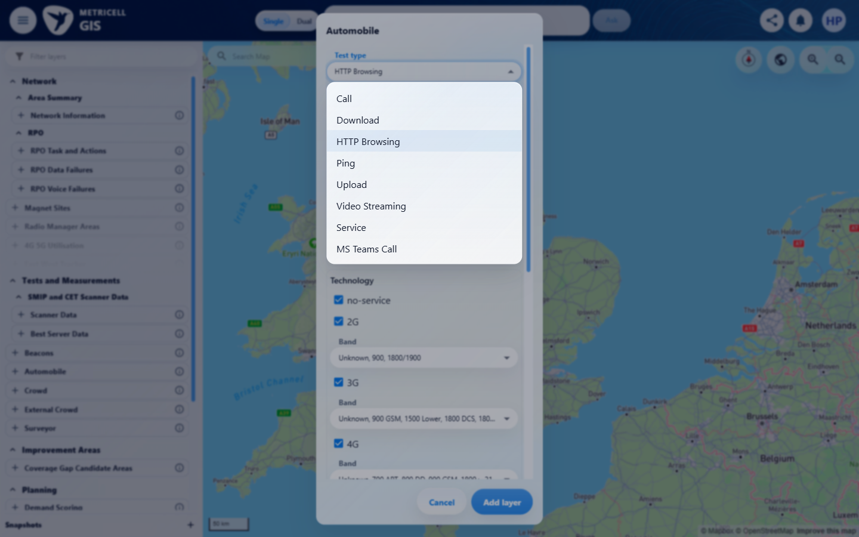

Criterion 1 continued: When a completed Call test is opened in the shared point-detail dialog, its summary shows the available duration, test result, connection time, start time, end time, handset, and disconnection cause.
Browser URL recorded after criterion: https://o2intelligence-v4-dev.metricell.com/gis
E03 - Call config (criterion-1-call-config.png)  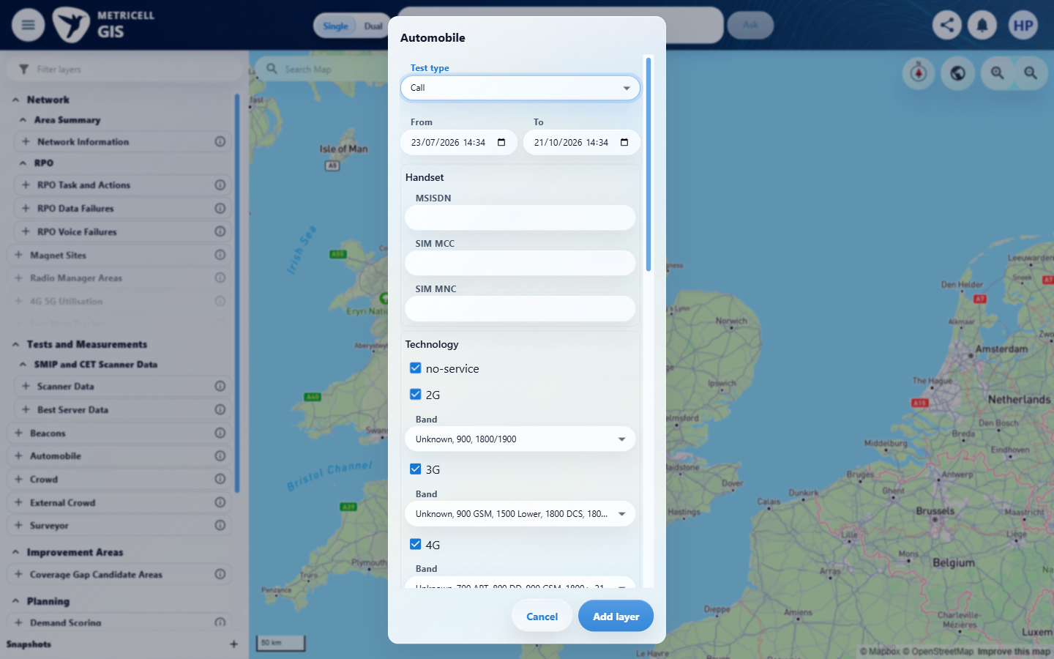 | E04 - Final (criterion-1-final.png)  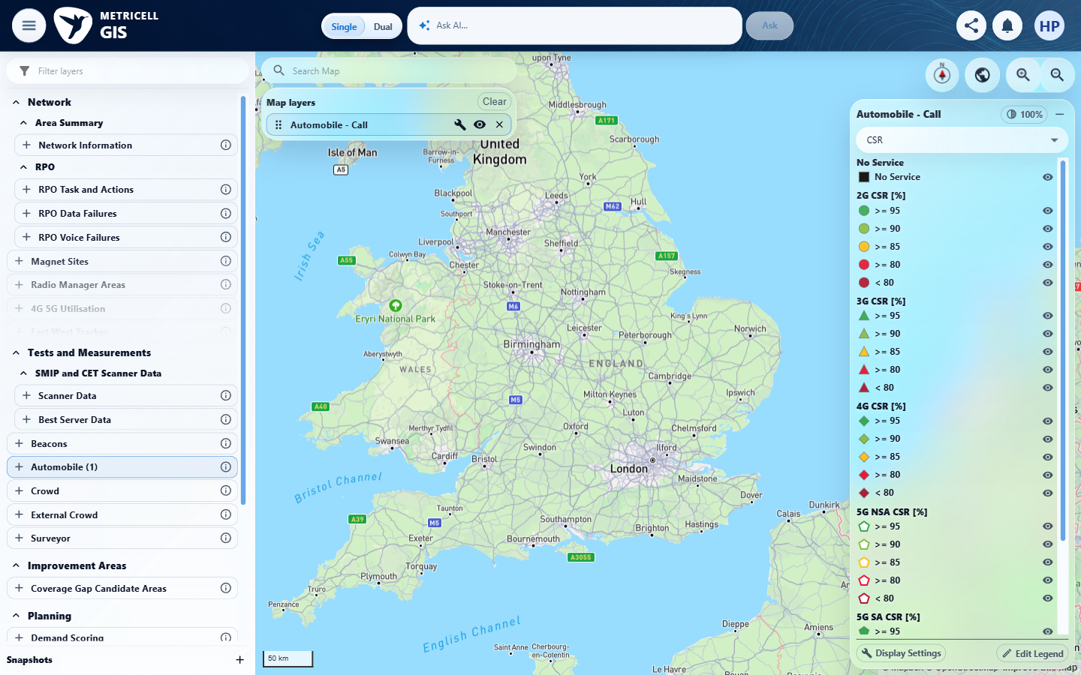

2.0.0 | When Call samples are returned, the timeline chart shows call state, service technology, and signal strength across the test duration. | When Call samples are returned, the timeline chart shows call state, service technology, and signal strength across the test duration. | criterion-2-call-config-selected.png confirms Automobile > Call; criterion-2-final.png shows the Automobile - Call layer and legend without visible Call points or a detail dialog. Results record GET /api/platform/automobile/call/points HTTP 500, reproduced on a fresh load; this is unavailable point retrieval, not a settled empty response. No record or samples were available to test timeline state, technology or signal strength.  Evidence: E05, E06, E07, E04 | Blocked
Criterion 2 assessment: criterion-2-call-config-selected.png confirms Automobile > Call; criterion-2-final.png shows the Automobile - Call layer and legend without visible Call points or a detail dialog. Results record GET /api/platform/automobile/call/points HTTP 500, reproduced on a fresh load; this is unavailable point retrieval, not a settled empty response. No record or samples were available to test timeline state, technology or signal strength.
Testing notes: GET /api/platform/automobile/call/points returned HTTP 500 on the first normal load and again after a controlled fresh launcher/GIS load with Automobile > Call selected and the default 90-day range. This is a point-retrieval error, not a settled empty response or a Call detail-request failure. The map displayed the Automobile - Call layer and legend without selectable Call points; no on-screen HTTP error message was observed. Required Call records could not be obtained. No Call record or samples could be retrieved, so the timeline could not be checked.
Criterion 2 evidence: When Call samples are returned, the timeline chart shows call state, service technology, and signal strength across the test duration.
Browser URL recorded after criterion: https://o2intelligence-v4-dev.metricell.com/gis
E05 - Automobile config (criterion-2-automobile-config.png)  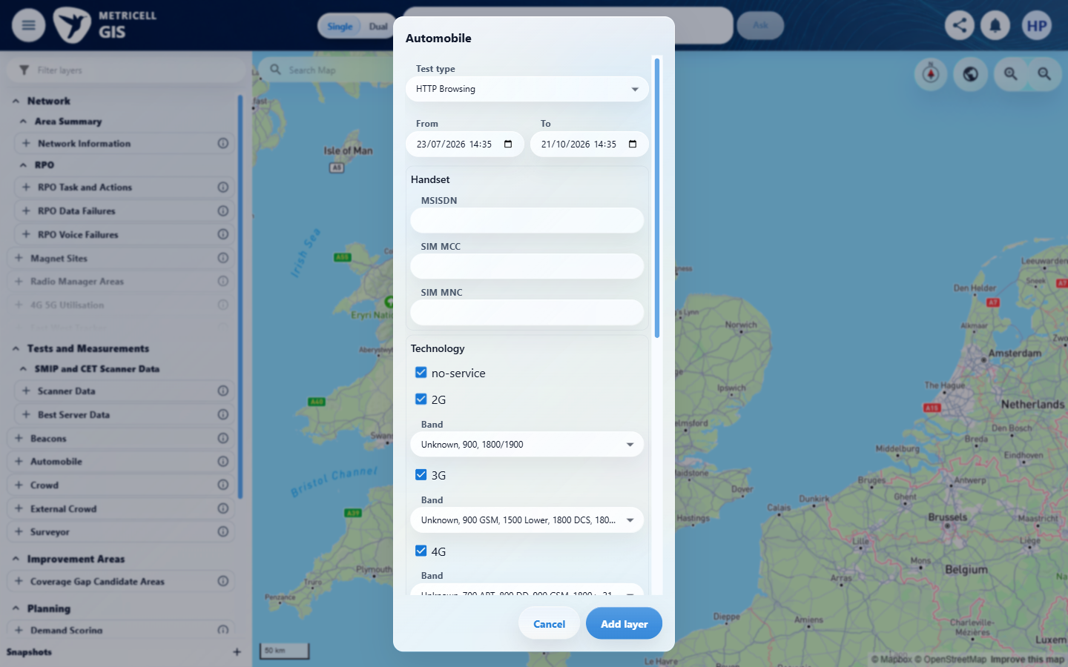 | E06 - Test type choices (criterion-2-test-type-choices.png)  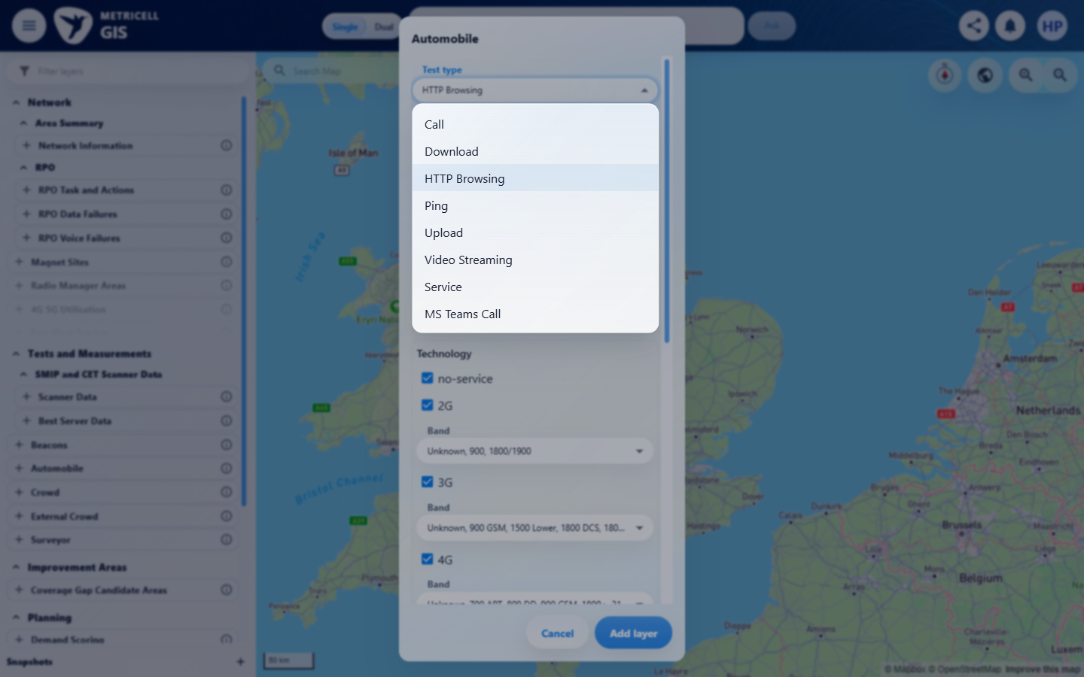

Criterion 2 continued: When Call samples are returned, the timeline chart shows call state, service technology, and signal strength across the test duration.
Browser URL recorded after criterion: https://o2intelligence-v4-dev.metricell.com/gis
E07 - Call config selected (criterion-2-call-config-selected.png)  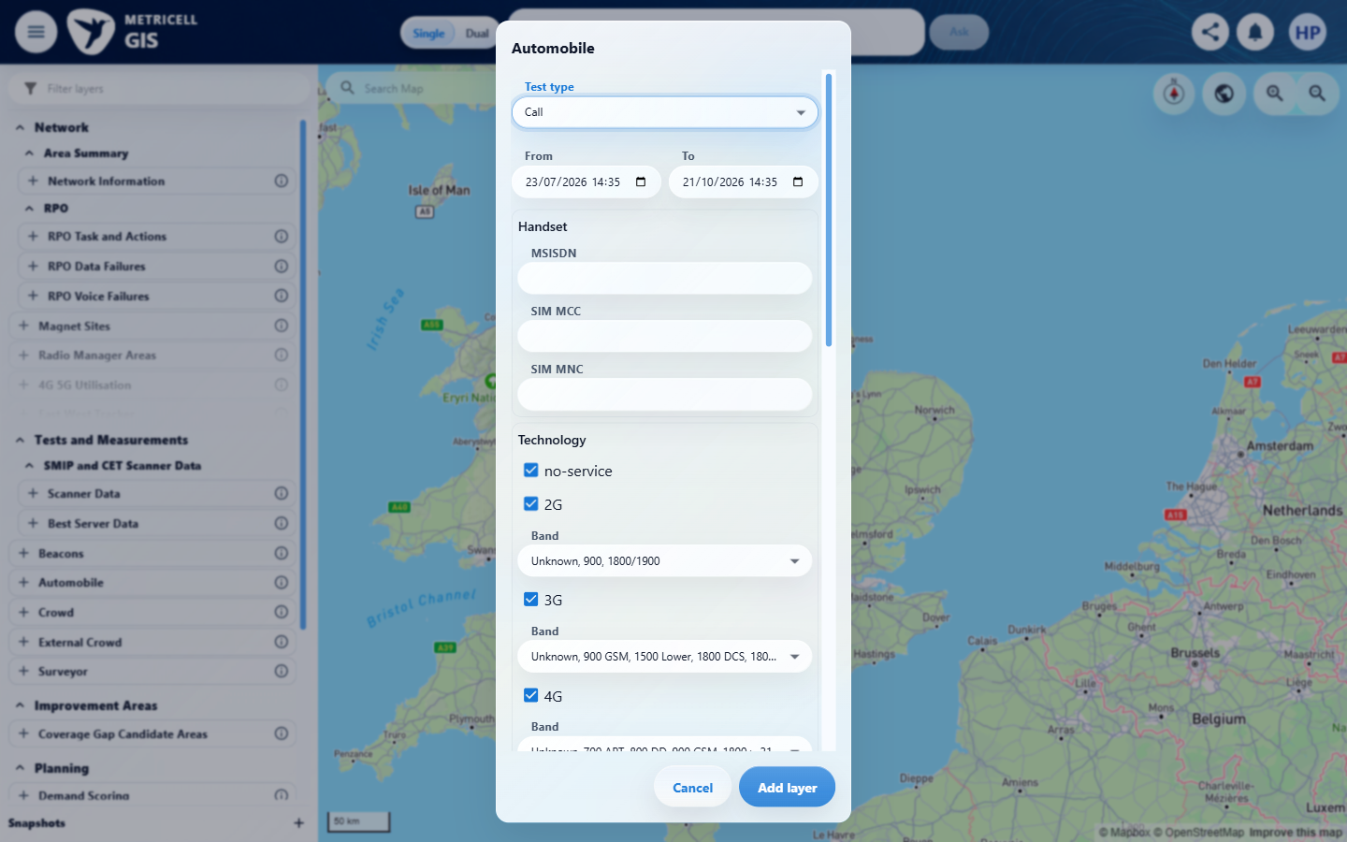 | E04 - Final (criterion-2-final.png)

3.0.0 | When Call samples are returned, the dialog displays them in a table whose columns can be sorted and filtered. | When Call samples are returned, the dialog displays them in a table whose columns can be sorted and filtered. | criterion-3-final.png confirms Automobile > Call configuration, not a detail dialog. Testing stopped at the shared prerequisite: results record GET /api/platform/automobile/call/points HTTP 500 on the first and controlled fresh loads. No samples were available to exercise table sorting and filtering.  Evidence: E08, E09, E10 | Blocked
Criterion 3 assessment: criterion-3-final.png confirms Automobile > Call configuration, not a detail dialog. Testing stopped at the shared prerequisite: results record GET /api/platform/automobile/call/points HTTP 500 on the first and controlled fresh loads. No samples were available to exercise table sorting and filtering.
Testing notes: GET /api/platform/automobile/call/points returned HTTP 500 on the first normal load and again after a controlled fresh launcher/GIS load with Automobile > Call selected and the default 90-day range. This is a point-retrieval error, not a settled empty response or a Call detail-request failure. The map displayed the Automobile - Call layer and legend without selectable Call points; no on-screen HTTP error message was observed. Required Call records could not be obtained. No Call record or samples could be retrieved, so table sorting/filtering could not be exercised. The final PNG records the inspected Automobile > Call scope at the blocked boundary; it does not show a detail dialog.
Criterion 3 evidence: When Call samples are returned, the dialog displays them in a table whose columns can be sorted and filtered.
Browser URL recorded after criterion: https://o2intelligence-v4-dev.metricell.com/gis
E08 - Before automobile config (criterion-3-before-automobile-config.png)  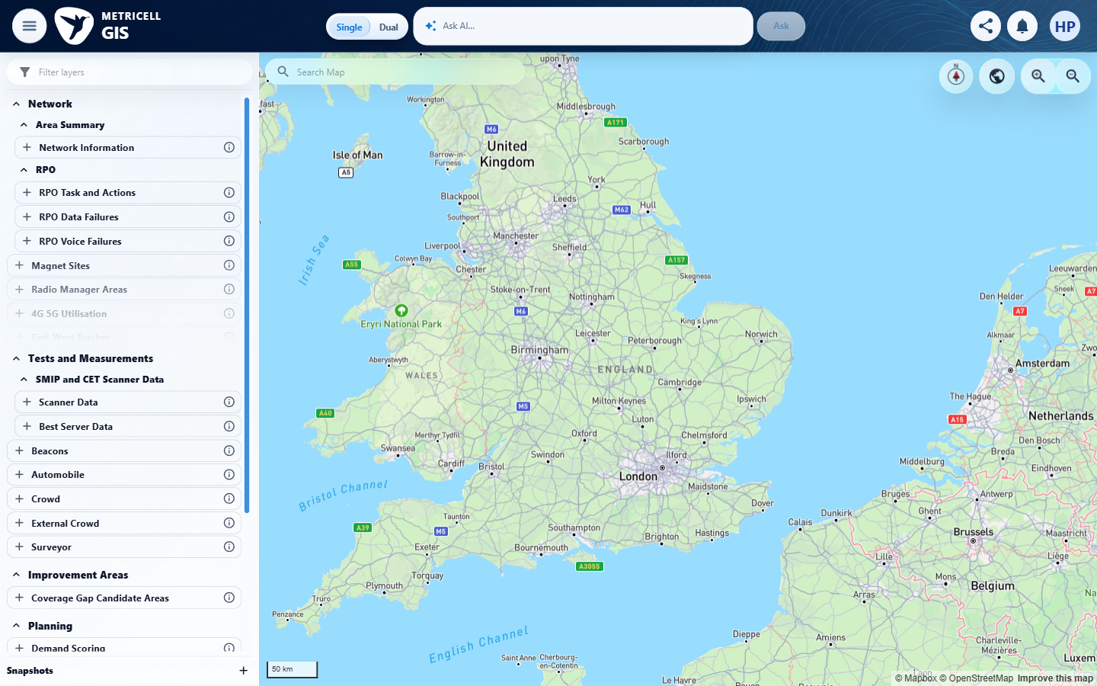 | E09 - Automobile config (criterion-3-automobile-config.png)  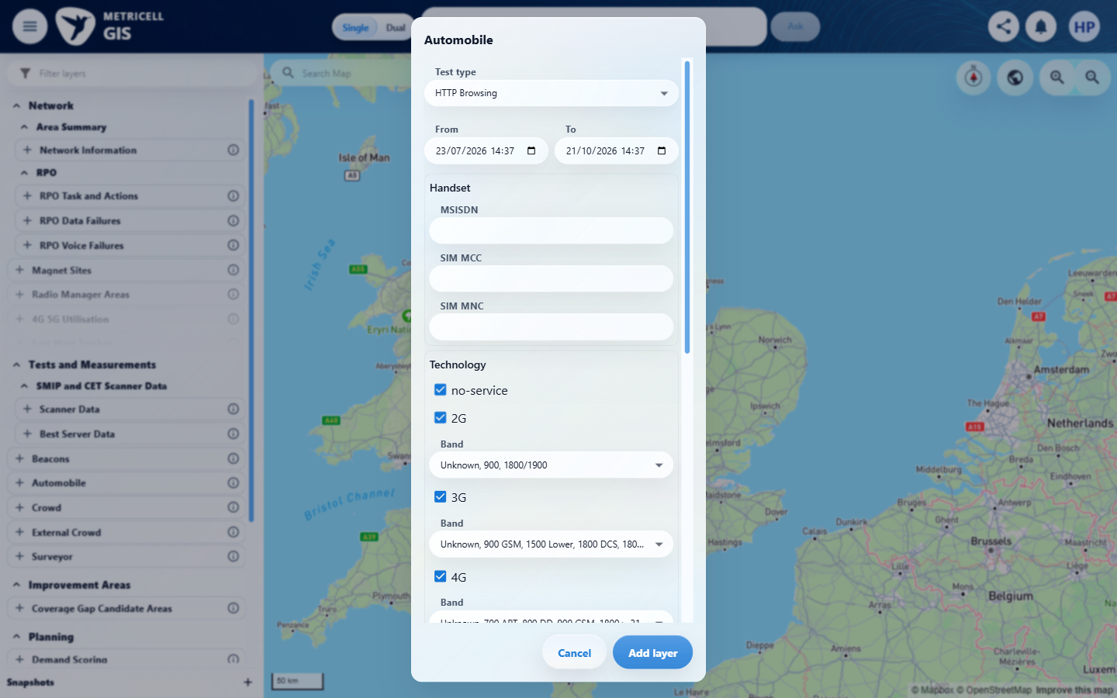

Criterion 3 continued: When Call samples are returned, the dialog displays them in a table whose columns can be sorted and filtered.
Browser URL recorded after criterion: https://o2intelligence-v4-dev.metricell.com/gis
E10 - Final (criterion-3-final.png)
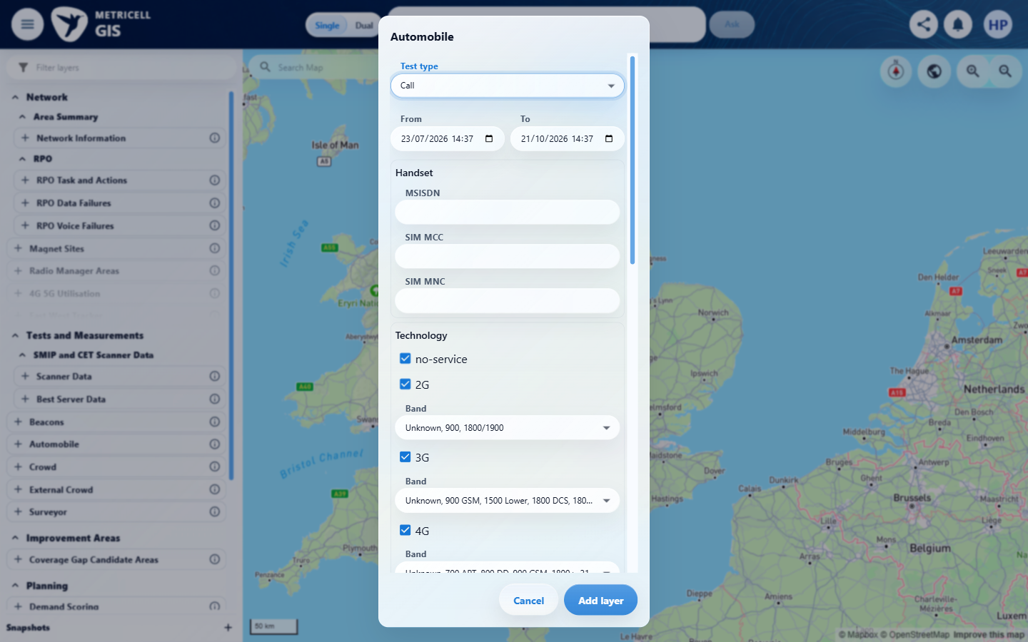

4.0.0 | For each displayed Call sample, the Serving Cell column shows the known serving site/cell when available; when it is unavailable, it shows that sample’s CGI. | For each displayed Call sample, the Serving Cell column shows the known serving site/cell when available; when it is unavailable, it shows that sample’s CGI. | criterion-4-final.png confirms Automobile > Call configuration, not a detail dialog. Testing stopped at the shared prerequisite: results record GET /api/platform/automobile/call/points HTTP 500 on the first and controlled fresh loads. No samples were available to check known Serving Cell values or CGI fallback. The before-configuration capture still shows GIS loading; later configuration captures show the map, not a Call detail state.  Evidence: E11, E09, E10 | Blocked
Criterion 4 assessment: criterion-4-final.png confirms Automobile > Call configuration, not a detail dialog. Testing stopped at the shared prerequisite: results record GET /api/platform/automobile/call/points HTTP 500 on the first and controlled fresh loads. No samples were available to check known Serving Cell values or CGI fallback. The before-configuration capture still shows GIS loading; later configuration captures show the map, not a Call detail state.
Testing notes: GET /api/platform/automobile/call/points returned HTTP 500 on the first normal load and again after a controlled fresh launcher/GIS load with Automobile > Call selected and the default 90-day range. This is a point-retrieval error, not a settled empty response or a Call detail-request failure. The map displayed the Automobile - Call layer and legend without selectable Call points; no on-screen HTTP error message was observed. Required Call records could not be obtained. No Call samples could be retrieved, so known Serving Cell and CGI fallback values could not be checked. The final PNG records the inspected Automobile > Call scope at the blocked boundary; it does not show a detail dialog.
Criterion 4 evidence: For each displayed Call sample, the Serving Cell column shows the known serving site/cell when available; when it is unavailable, it shows that sample’s CGI.
Browser URL recorded after criterion: https://o2intelligence-v4-dev.metricell.com/gis
E11 - Before automobile config (criterion-4-before-automobile-config.png)  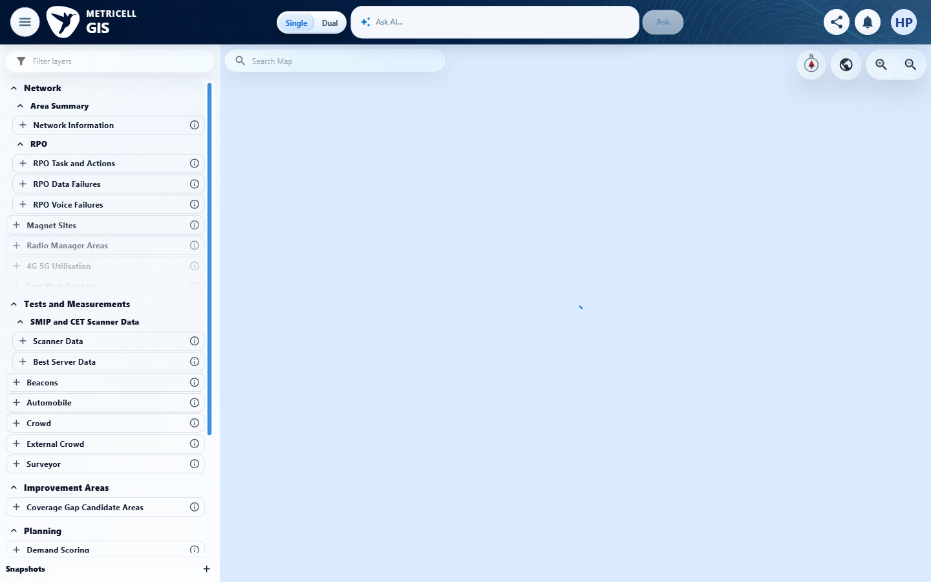 | E09 - Automobile config (criterion-4-automobile-config.png)

Criterion 4 continued: For each displayed Call sample, the Serving Cell column shows the known serving site/cell when available; when it is unavailable, it shows that sample’s CGI.
Browser URL recorded after criterion: https://o2intelligence-v4-dev.metricell.com/gis
E10 - Final (criterion-4-final.png)

5.0.0 | Selecting a displayed Call sample opens the related Service details for the selected sample’s point in time. | Selecting a displayed Call sample opens the related Service details for the selected sample’s point in time. | criterion-5-final.png confirms Automobile > Call configuration, not a detail dialog. Testing stopped at the shared prerequisite: results record GET /api/platform/automobile/call/points HTTP 500 on the first and controlled fresh loads. No sample could be selected to verify Service details at its timestamp.  Evidence: E08, E12, E13 | Blocked
Criterion 5 assessment: criterion-5-final.png confirms Automobile > Call configuration, not a detail dialog. Testing stopped at the shared prerequisite: results record GET /api/platform/automobile/call/points HTTP 500 on the first and controlled fresh loads. No sample could be selected to verify Service details at its timestamp.
Testing notes: GET /api/platform/automobile/call/points returned HTTP 500 on the first normal load and again after a controlled fresh launcher/GIS load with Automobile > Call selected and the default 90-day range. This is a point-retrieval error, not a settled empty response or a Call detail-request failure. The map displayed the Automobile - Call layer and legend without selectable Call points; no on-screen HTTP error message was observed. Required Call records could not be obtained. No Call sample could be selected, so related Automobile Service details at its timestamp could not be opened. The final PNG records the inspected Automobile > Call scope at the blocked boundary; it does not show a detail dialog.
Criterion 5 evidence: Selecting a displayed Call sample opens the related Service details for the selected sample’s point in time.
Browser URL recorded after criterion: https://o2intelligence-v4-dev.metricell.com/gis
E08 - Before automobile config (criterion-5-before-automobile-config.png) | E12 - Automobile config (criterion-5-automobile-config.png)  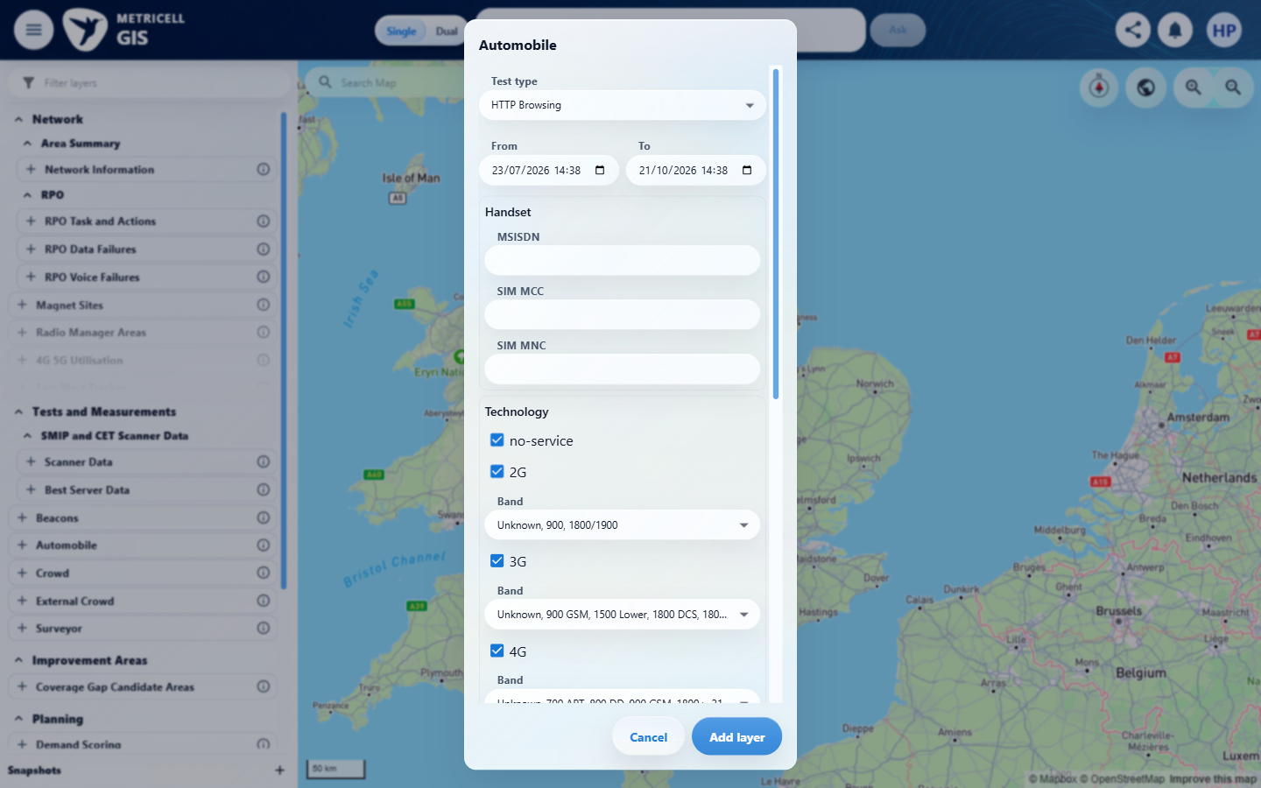

Criterion 5 continued: Selecting a displayed Call sample opens the related Service details for the selected sample’s point in time.
Browser URL recorded after criterion: https://o2intelligence-v4-dev.metricell.com/gis
E13 - Final (criterion-5-final.png)
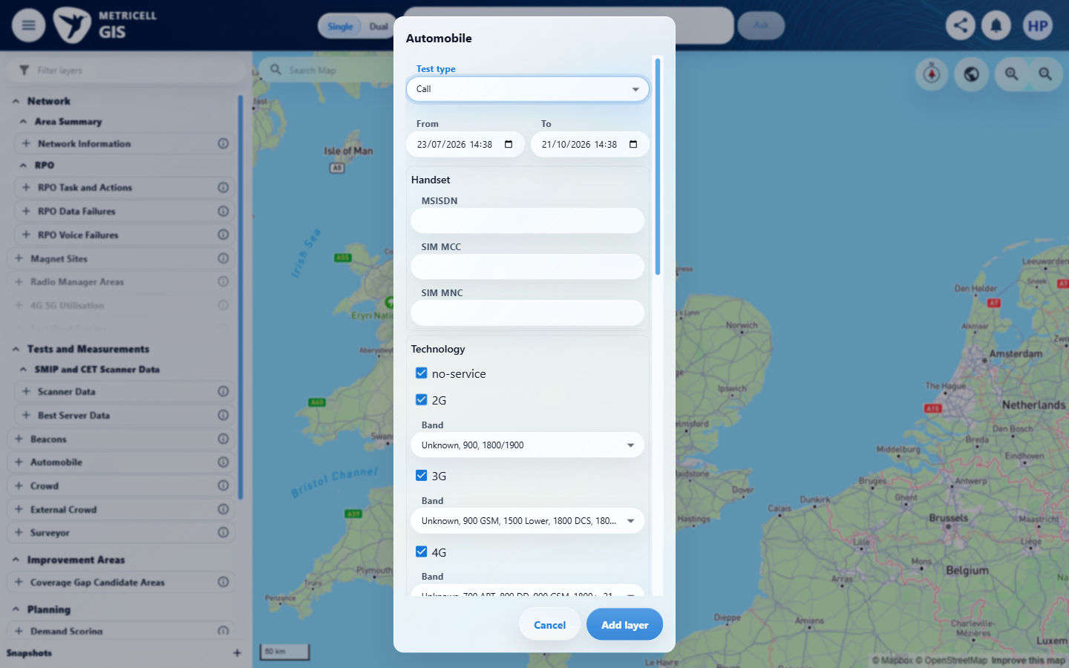

6.0.0 | When the selected Call point has no measurable duration, the dialog shows the standard no-data state instead of an empty detail view. | When the selected Call point has no measurable duration, the dialog shows the standard no-data state instead of an empty detail view. | criterion-6-final.png confirms Automobile > Call configuration, not a detail dialog. Testing stopped at the shared prerequisite: results record GET /api/platform/automobile/call/points HTTP 500 on the first and controlled fresh loads. No zero-duration record could be selected to verify the dialog's no-data state. The before-configuration capture still shows GIS loading; later configuration captures show the map, not a Call detail state.  Evidence: E14, E15, E16 | Blocked
Criterion 6 assessment: criterion-6-final.png confirms Automobile > Call configuration, not a detail dialog. Testing stopped at the shared prerequisite: results record GET /api/platform/automobile/call/points HTTP 500 on the first and controlled fresh loads. No zero-duration record could be selected to verify the dialog's no-data state. The before-configuration capture still shows GIS loading; later configuration captures show the map, not a Call detail state.
Testing notes: GET /api/platform/automobile/call/points returned HTTP 500 on the first normal load and again after a controlled fresh launcher/GIS load with Automobile > Call selected and the default 90-day range. This is a point-retrieval error, not a settled empty response or a Call detail-request failure. The map displayed the Automobile - Call layer and legend without selectable Call points; no on-screen HTTP error message was observed. Required Call records could not be obtained. No zero-duration Call record could be selected, so the detail dialog's no-data behavior could not be checked. The final PNG records the inspected Automobile > Call scope at the blocked boundary; it does not show a detail dialog.
Criterion 6 evidence: When the selected Call point has no measurable duration, the dialog shows the standard no-data state instead of an empty detail view.
Browser URL recorded after criterion: https://o2intelligence-v4-dev.metricell.com/gis
E14 - Before automobile config (criterion-6-before-automobile-config.png)  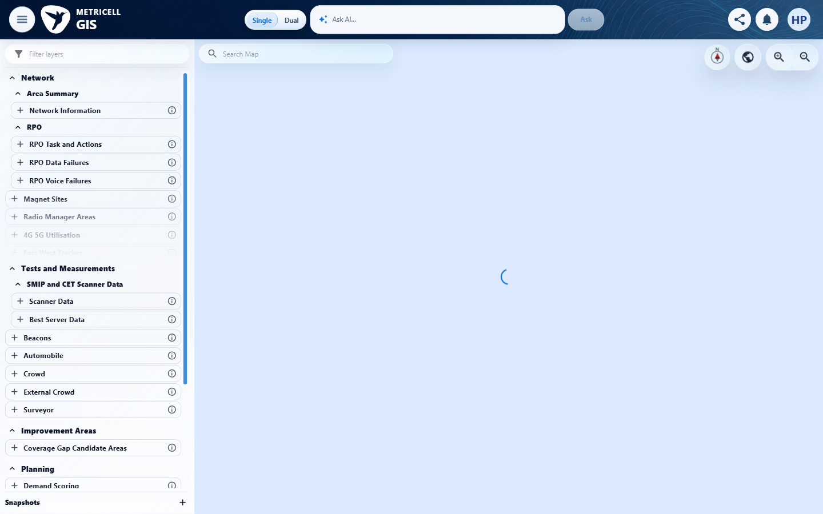 | E15 - Automobile config (criterion-6-automobile-config.png)  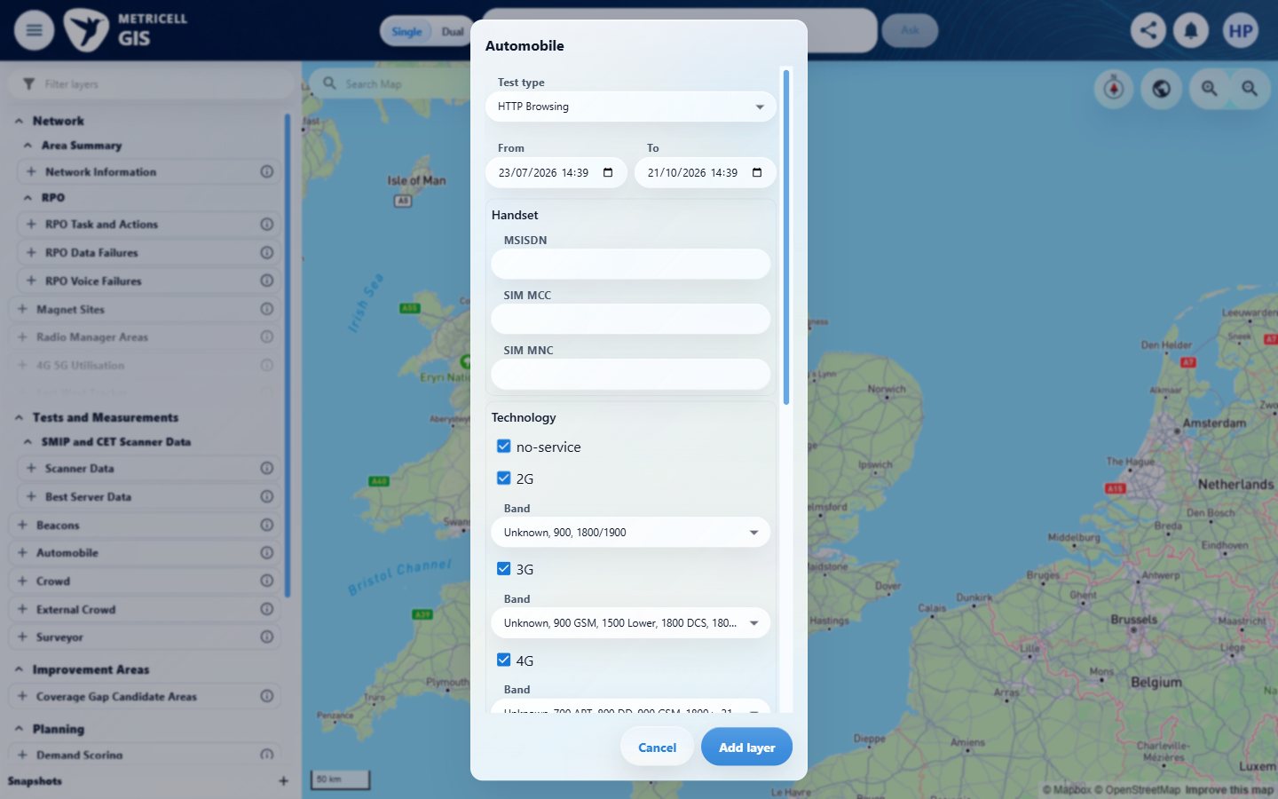

Criterion 6 continued: When the selected Call point has no measurable duration, the dialog shows the standard no-data state instead of an empty detail view.
Browser URL recorded after criterion: https://o2intelligence-v4-dev.metricell.com/gis
E16 - Final (criterion-6-final.png)
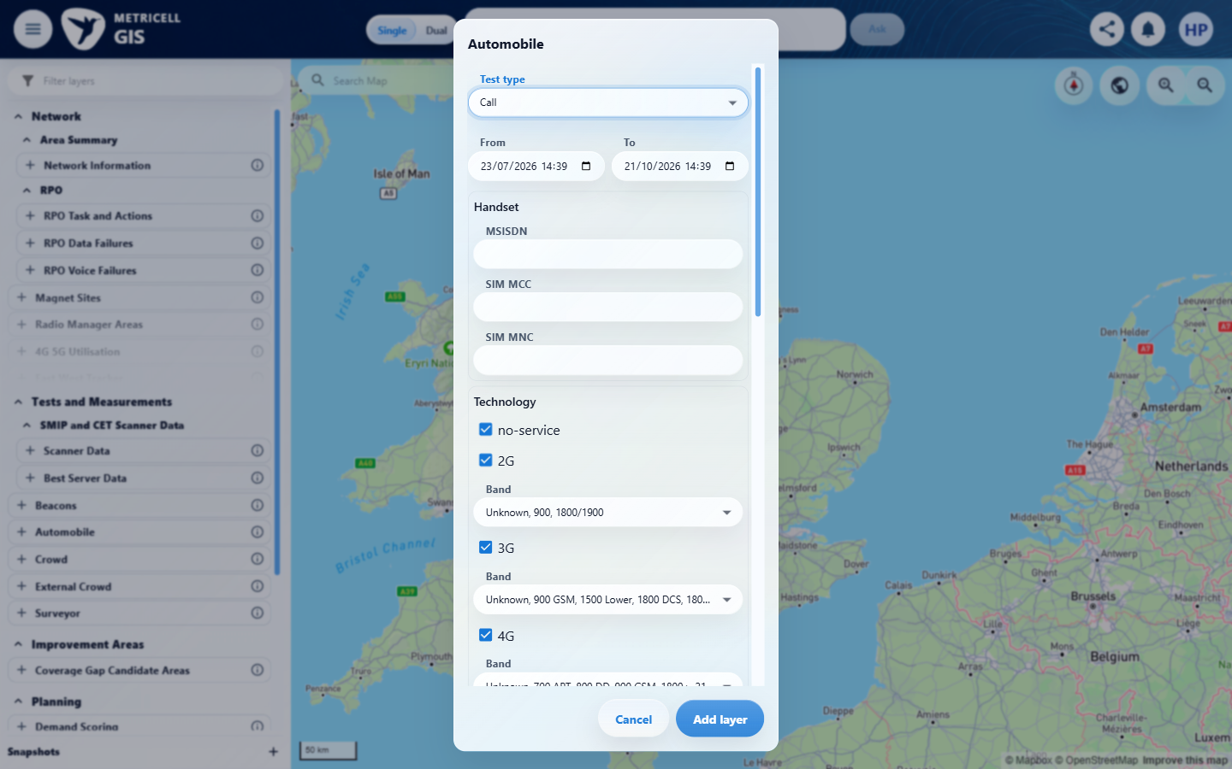

7.0.0 | While Call details are loading, the dialog shows the standard loading state; when details are unavailable, it shows the standard no-data state; when loading fails, it shows the standard error state, with no incorrect Call data displayed. | While Call details are loading, the dialog shows the standard loading state; when details are unavailable, it shows the standard no-data state; when loading fails, it shows the standard error state, with no incorrect Call data displayed. | criterion-7-final.png confirms Automobile > Call configuration, not a detail dialog. Testing stopped at the shared prerequisite: results record GET /api/platform/automobile/call/points HTTP 500 on the first and controlled fresh loads. No detail request was established to test loading, no-data, error or stale-data handling; the points failure does not prove a detail-error state. No simulation was used. The before-configuration capture still shows GIS loading; later configuration captures show the map, not a Call detail state.  Evidence: E17, E15, E16 | Blocked
Criterion 7 assessment: criterion-7-final.png confirms Automobile > Call configuration, not a detail dialog. Testing stopped at the shared prerequisite: results record GET /api/platform/automobile/call/points HTTP 500 on the first and controlled fresh loads. No detail request was established to test loading, no-data, error or stale-data handling; the points failure does not prove a detail-error state. No simulation was used. The before-configuration capture still shows GIS loading; later configuration captures show the map, not a Call detail state.
Testing notes: GET /api/platform/automobile/call/points returned HTTP 500 on the first normal load and again after a controlled fresh launcher/GIS load with Automobile > Call selected and the default 90-day range. This is a point-retrieval error, not a settled empty response or a Call detail-request failure. The map displayed the Automobile - Call layer and legend without selectable Call points; no on-screen HTTP error message was observed. Required Call records could not be obtained. No Call record/detail request could be established, so detail loading, unavailable and error states could not be tested. The failing points request is not the detail endpoint. No simulation was installed. The final PNG records the inspected Automobile > Call scope at the blocked boundary; it does not show a detail dialog.
Criterion 7 evidence: While Call details are loading, the dialog shows the standard loading state; when details are unavailable, it shows the standard no-data state; when loading fails, it shows the standard error state, with no incorrect Call data displayed.
Browser URL recorded after criterion: https://o2intelligence-v4-dev.metricell.com/gis
E17 - Before automobile config (criterion-7-before-automobile-config.png)  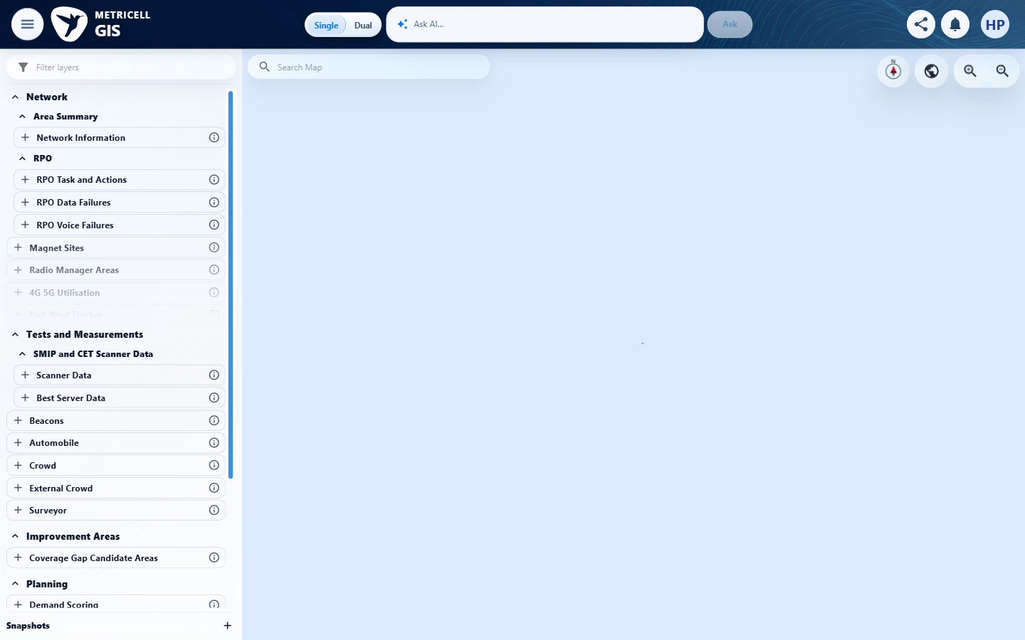 | E15 - Automobile config (criterion-7-automobile-config.png)

Criterion 7 continued: While Call details are loading, the dialog shows the standard loading state; when details are unavailable, it shows the standard no-data state; when loading fails, it shows the standard error state, with no incorrect Call data displayed.
Browser URL recorded after criterion: https://o2intelligence-v4-dev.metricell.com/gis
E16 - Final (criterion-7-final.png)

About Metricell

Metricell is on a mission to deliver connectivity. We work with our customers to design, deliver and manage wireless communication networks – with a shared ambition of achieving flawless network experience. We’ve been responsible for many first-to-market products, and our technology is characterised by the relentless pursuit of automation and digitalisation.

Our geospatial intelligence tools traverse a wide variety of business processes – from Test & Measurement to Customer Experience Management – and we’re pioneers in Crowdsourcing and Digital Self Care. Our technology is today in use by a range of customers; thousands of their personnel; and millions of subscribers worldwide.

Find out more at www.metricell.com




