

Automated Test Case Document
Jira Ticket: TEST2-91

Document Classification: | Company Confidential
Document Ref: | Automated Test Case Document
Version: | 1.0
Date: | 20/10/2026
Document Author: | Automated TEST2 Evidence Review
Document Owner: | Quality Assurance / Metricell




This document and its content is copyright of Metricell Limited @ 2026 all rights reserved. All information contained herein is the intellectual property of Metricell Limited and should be treated as confidential. Any external redistribution of reproduction of part or all of the contents in any form is prohibited unless expressly agreed with Metricell Limited in writing. Any reproduced content must include the following statement; “Part or all of the content contained herein is copyright of Metricell Limited @ 2026 all rights reserved”.
Table of Contents
1 Revision History 2
2 Test Cycle Information 3
3 Test Summary 3
4 Test Cases 4
About Metricell 12

Revision History

Version | Date | Revision Author | Summary of Changes
[1.0] | 20/10/2026 | TEST2 QA Automation | Generated from TEST2 evidence review

Test Cycle Information

Tester: | Automated
Jira Ticket: | TEST2-91
Environment: | o2intelligence-v4-dev.metricell.com
Browser Details: | Google Chrome 155.0.8059.85
Date of Test: | 20/10/2026
Limitations during Testing: | 3 blocked; 2 inconclusive criterion(s). Completed independent screenshot assessment of all 12 canonical criteria in attempt-002; restricted device-group access, failed filtered-data retrieval and unavailable Route Replay block completion. Criterion 9: Site 17279 exists in this criterion's baseline. Applying Site=17279 caused GET /api/platform/automobile/http-browsing/points to return HTTP 500; a controlled fresh launcher/GIS load and recreated layer reproduced HTTP 500. Baseline points returned HTTP 200. Filtered point retrieval failed, preventing matching/authorised-result checks. The map cleared points without an on-screen HTTP error message; this is not a settled empty response. Test layers removed. Criterion 12: Started at launcher, inspected navigation, entered GIS and searched the layer catalogue for Route. No Route Replay module or layer is offered; the settled catalogue says No layers match this search. Could not activate Route Replay to inspect its controls. Search was cleared; no data created. Criterion 12: Captured the final unavailable-layer state and browser URL, then cleared Filter layers and saved cleanup. Inconclusive evidence is reported as Failed, but is not a confirmed application defect. Defects (No.) counts directly contradicted criteria, not unique Jira bugs; blockers and inconclusive evidence count as zero.
Overall review outcome: | Blocked
Browser URL(s) recorded after criteria: | https://o2intelligence-v4-dev.metricell.com/gis

Test Summary

Area of test | Pass | Fail | Defects (No.)
1. On a standard Automobile map layer, opening filters shows a time filter for a rolling 90-day range. | Y | N | 0
2. On a standard Automobile map layer, opening filters shows handset fields for MSISDN, SIM MNC, and SIM MCC. | Y | N | 0
3. On a standard Automobile map layer, opening filters shows technology choices for Unknown, 2G, 3G, 4G, 5G NSA, and 5G SA. | N | Y | 1
4. On a standard Automobile map layer, the frequency filter offers the frequencies supplied by the application configuration. | N | Y | 0
5. On a standard Automobile map layer, opening filters shows network fields for MCC, MNC, LAC, CI, Site, and Cell. | Y | N | 0
6. On a standard Automobile map layer, the device-group filter offers the groups supplied by the application configuration. | N | N | 0
7. When SIM MCC, SIM MNC, MCC, MNC, or LAC is edited, each field accepts numeric digits only. | N | Y | 1
8. When MSISDN, CI, Site, or Cell is edited, each field accepts text input. | Y | N | 0
9. When one or more filters are applied on a standard Automobile map layer, the displayed map results match the active filter values and are within the user's authorised results. | N | N | 0
10. On a Call layer, the technology filter does not offer 5G NSA. | N | Y | 1
11. When device groups are shown, restricted device-segregation options are not offered. | N | Y | 0
12. On Route Replay, the standard Automobile map filter controls described in this ticket are not available. | N | N | 0

Test Cases
Each test maps to a criterion and decisive browser evidence. Inconclusive results are reported as Failed.

Tests

Preconditions: | V4 access and ticket conditions. | Associated Requirements: | Ticket criteria below. | Automation Notes: | Screenshots below each criterion; full log retained locally.
ID / Criterion | Criteria Tested | Expected Result | Actual Result / Evidence Path | Outcome
1.0.0 | On a standard Automobile map layer, opening filters shows a time filter for a rolling 90-day range. | On a standard Automobile map layer, opening filters shows a time filter for a rolling 90-day range. | criterion-1-after-automobile.png shows untouched From 22/07/2026 12:54 and To 20/10/2026 12:54, 90 days apart; criterion-1-final.png retains that range in active HTTP Browsing filters.  Evidence: E01, E02, E03, E04 | Passed
Criterion 1 evidence: On a standard Automobile map layer, opening filters shows a time filter for a rolling 90-day range.
Browser URL recorded after criterion: https://o2intelligence-v4-dev.metricell.com/gis
E01 - Before automobile (criterion-1-before-automobile.png)  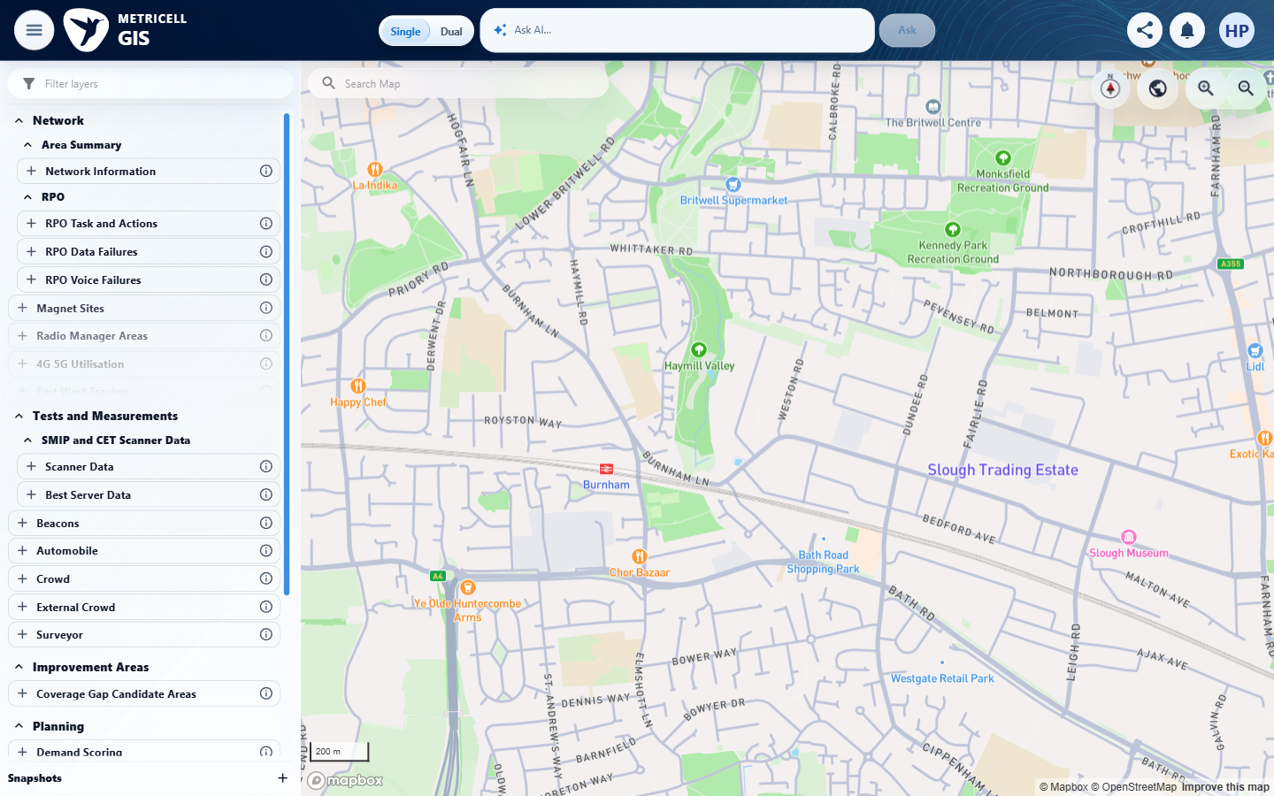 | E02 - After automobile (criterion-1-after-automobile.png)  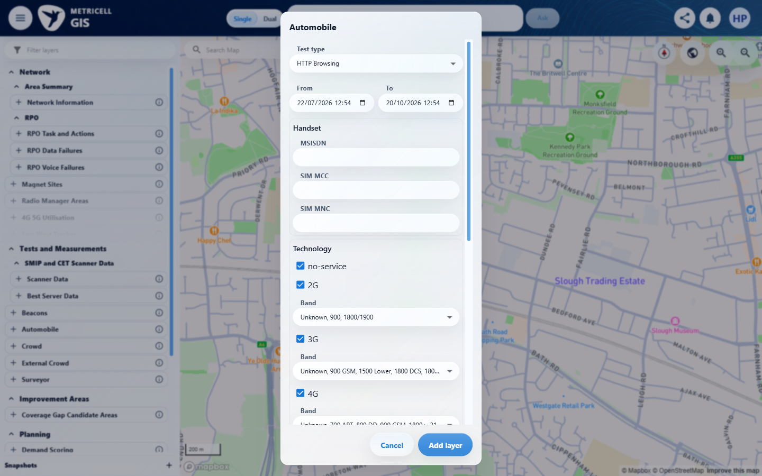

Criterion 1 continued: On a standard Automobile map layer, opening filters shows a time filter for a rolling 90-day range.
Browser URL recorded after criterion: https://o2intelligence-v4-dev.metricell.com/gis
E03 - Layer active (criterion-1-layer-active.png)  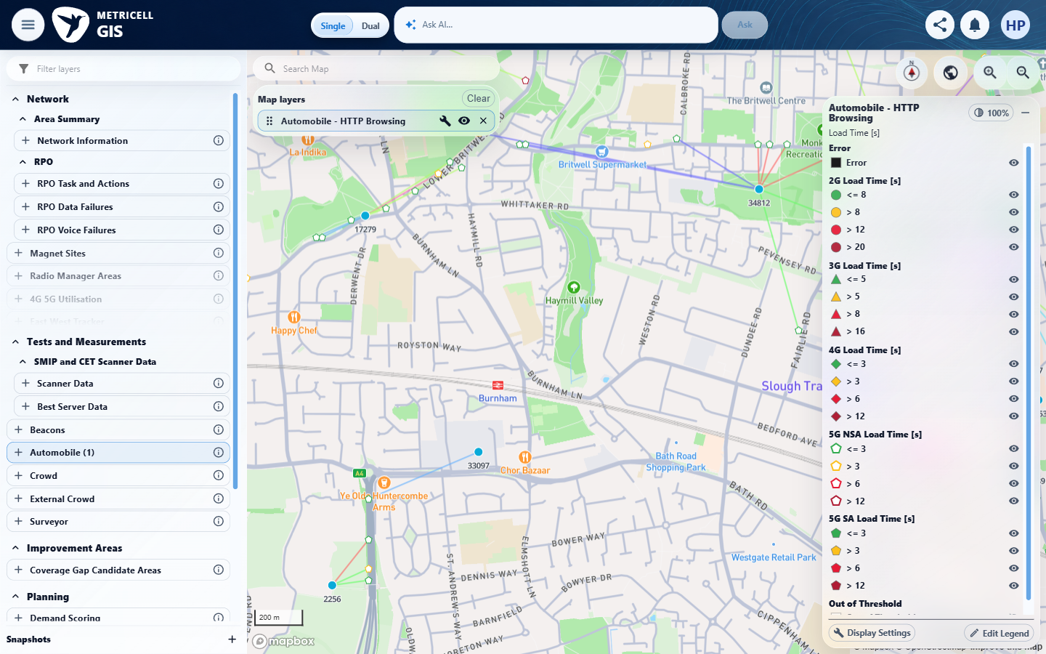 | E04 - Final (criterion-1-final.png)  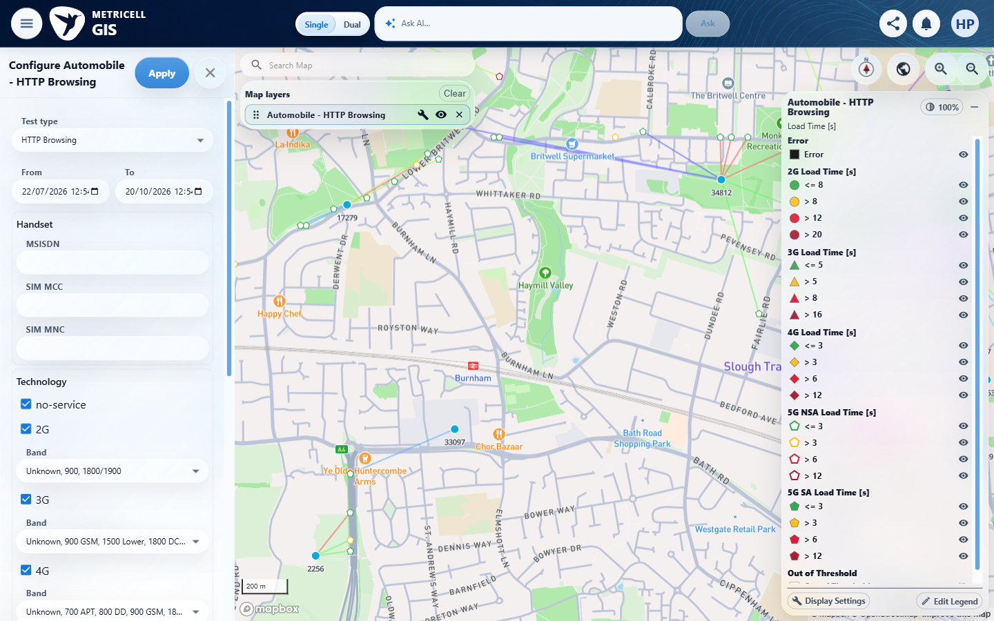

2.0.0 | On a standard Automobile map layer, opening filters shows handset fields for MSISDN, SIM MNC, and SIM MCC. | On a standard Automobile map layer, opening filters shows handset fields for MSISDN, SIM MNC, and SIM MCC. | criterion-2-final.png directly shows MSISDN, SIM MCC and SIM MNC fields in the active HTTP Browsing Handset section.  Evidence: E01, E05, E06, E07 | Passed
Criterion 2 evidence: On a standard Automobile map layer, opening filters shows handset fields for MSISDN, SIM MNC, and SIM MCC.
Browser URL recorded after criterion: https://o2intelligence-v4-dev.metricell.com/gis
E01 - Before automobile (criterion-2-before-automobile.png) | E05 - After automobile (criterion-2-after-automobile.png)  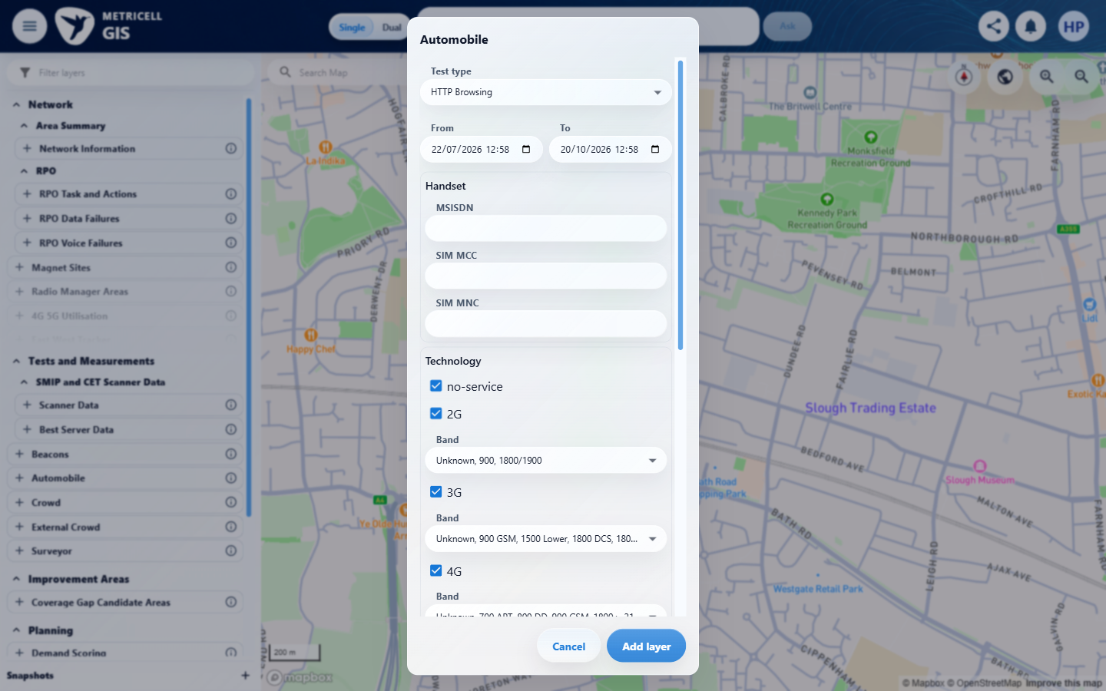

Criterion 2 continued: On a standard Automobile map layer, opening filters shows handset fields for MSISDN, SIM MNC, and SIM MCC.
Browser URL recorded after criterion: https://o2intelligence-v4-dev.metricell.com/gis
E06 - Layer active (criterion-2-layer-active.png)  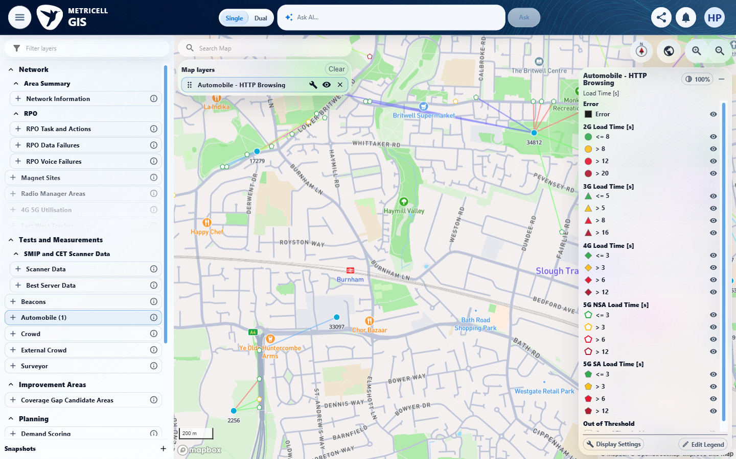 | E07 - Final (criterion-2-final.png)  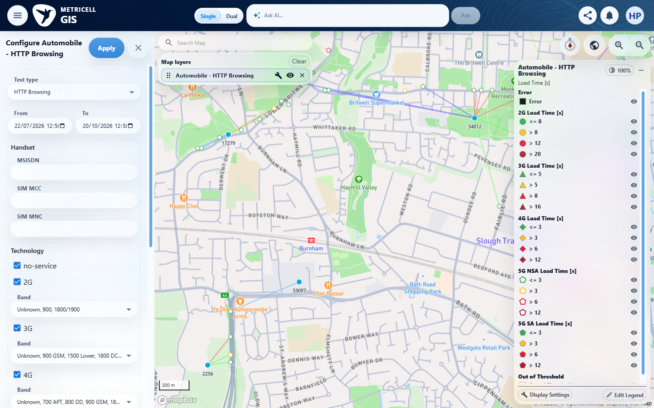

3.0.0 | On a standard Automobile map layer, opening filters shows technology choices for Unknown, 2G, 3G, 4G, 5G NSA, and 5G SA. | On a standard Automobile map layer, opening filters shows technology choices for Unknown, 2G, 3G, 4G, 5G NSA, and 5G SA. | criterion-3-final.png shows no-service as the technology choice alongside 2G/3G/4G, rather than the required Unknown technology choice. Unknown in a Band summary is a frequency option, not the missing technology choice.  Evidence: E01, E08, E09, E10 | Failed
Criterion 3 evidence: On a standard Automobile map layer, opening filters shows technology choices for Unknown, 2G, 3G, 4G, 5G NSA, and 5G SA.
Browser URL recorded after criterion: https://o2intelligence-v4-dev.metricell.com/gis
E01 - Before automobile (criterion-3-before-automobile.png) | E08 - After automobile (criterion-3-after-automobile.png)  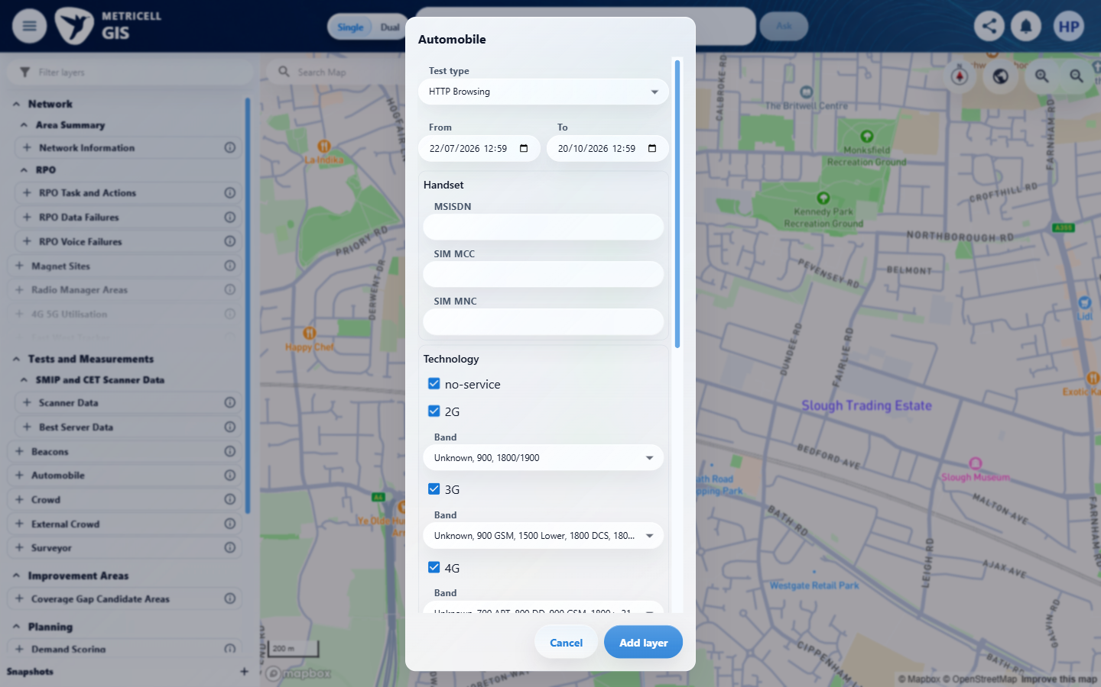

Criterion 3 continued: On a standard Automobile map layer, opening filters shows technology choices for Unknown, 2G, 3G, 4G, 5G NSA, and 5G SA.
Browser URL recorded after criterion: https://o2intelligence-v4-dev.metricell.com/gis
E09 - Layer active (criterion-3-layer-active.png)  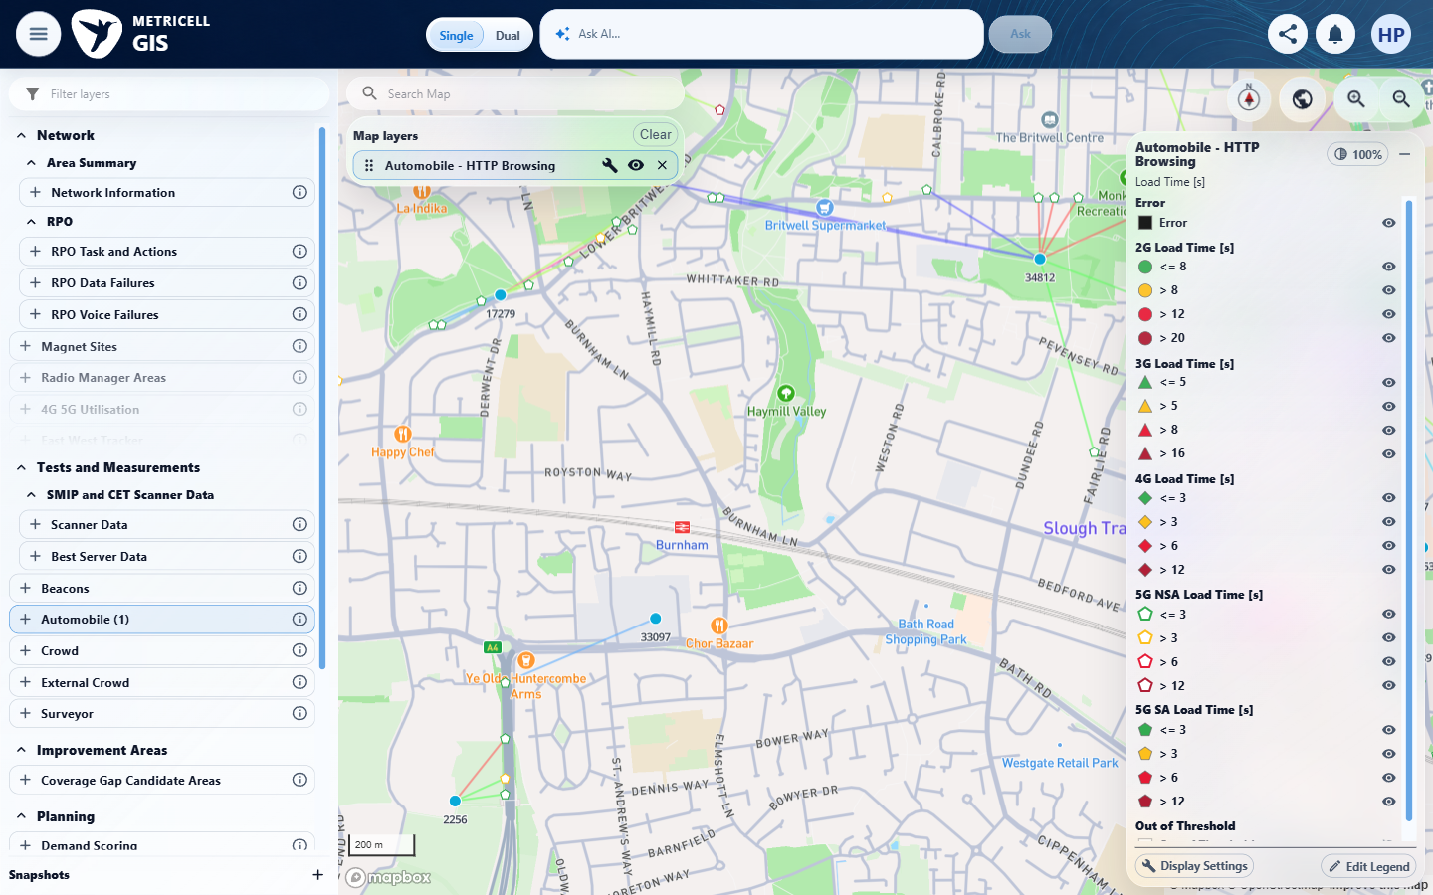 | E10 - Final (criterion-3-final.png)  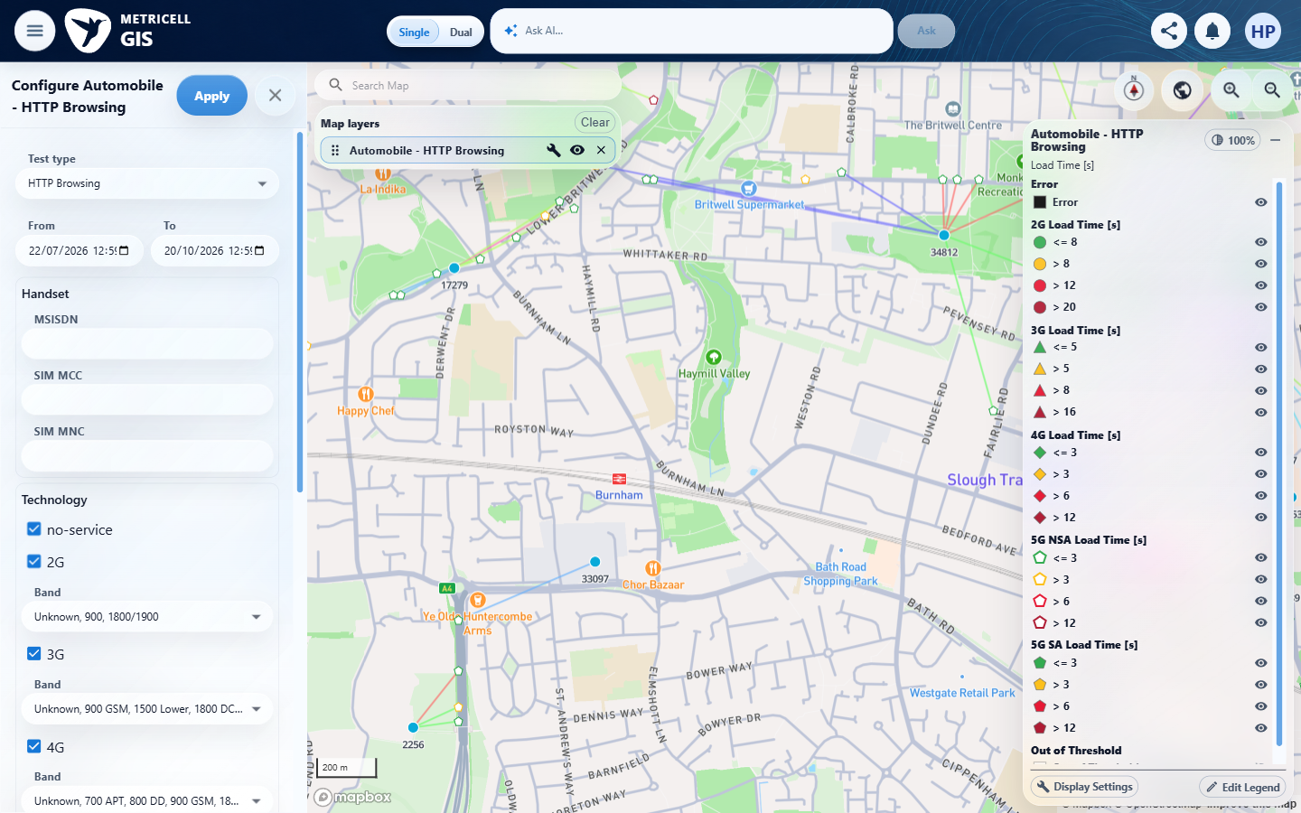

4.0.0 | On a standard Automobile map layer, the frequency filter offers the frequencies supplied by the application configuration. | On a standard Automobile map layer, the frequency filter offers the frequencies supplied by the application configuration. | criterion-4-band-0-options.png through criterion-4-band-3-options.png and criterion-4-final.png show technology-specific frequency choices. The claimed configuration response is described only in results notes; no independent captured configuration baseline establishes that these are the supplied frequencies.  Evidence: E11, E12, E13, E01, E14, E15, E16, E17, E18, E19, E20, E21, E22, E23, E24, E25, E26, E27, E28, E29, E30 | Failed
Criterion 4 evidence: On a standard Automobile map layer, the frequency filter offers the frequencies supplied by the application configuration.
Browser URL recorded after criterion: https://o2intelligence-v4-dev.metricell.com/gis
E11 - Before automobile (criterion-4-before-automobile.png)  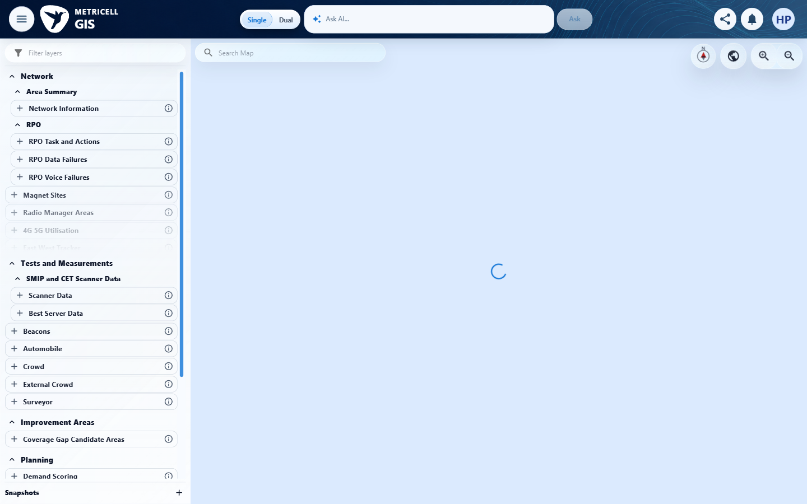 | E12 - After automobile (criterion-4-after-automobile.png)  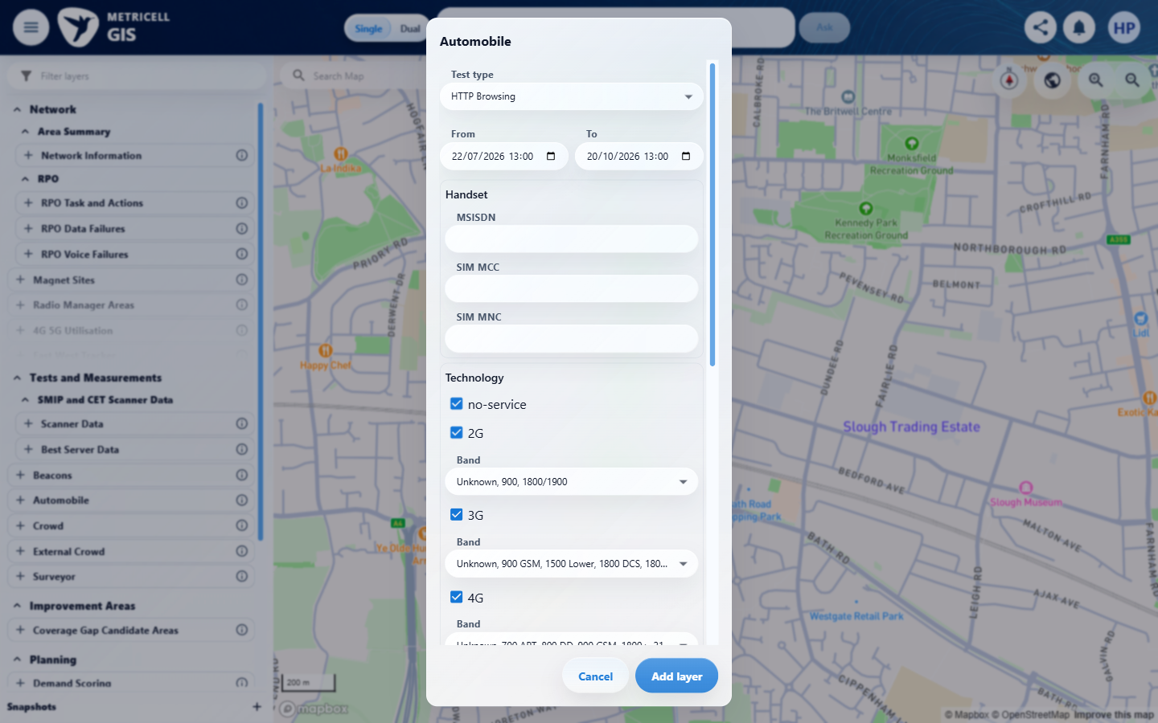

Criterion 4 continued: On a standard Automobile map layer, the frequency filter offers the frequencies supplied by the application configuration.
Browser URL recorded after criterion: https://o2intelligence-v4-dev.metricell.com/gis
E13 - Layer active (criterion-4-layer-active.png)  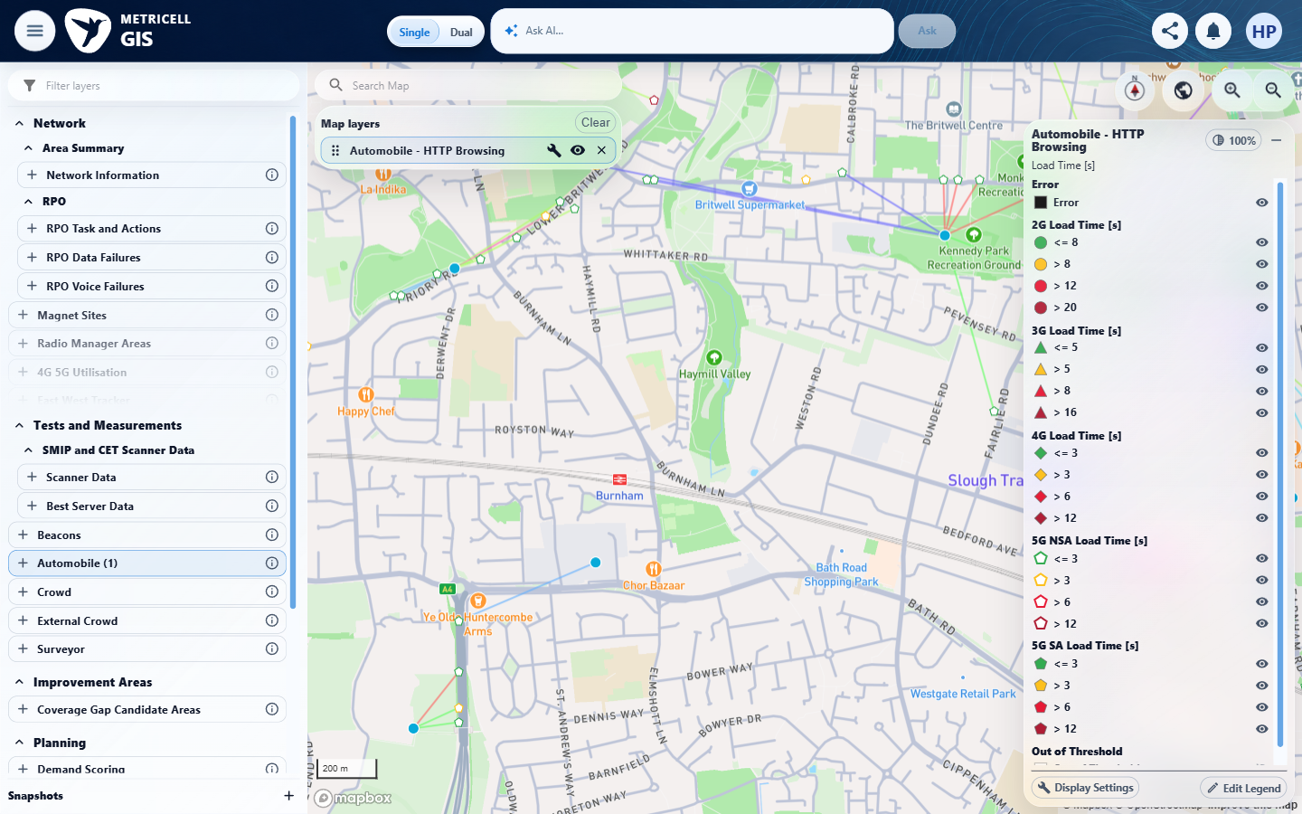 | E01 - Recheck before automobile (criterion-4-recheck-before-automobile.png)

Criterion 4 continued: On a standard Automobile map layer, the frequency filter offers the frequencies supplied by the application configuration.
Browser URL recorded after criterion: https://o2intelligence-v4-dev.metricell.com/gis
E14 - Recheck after automobile (criterion-4-recheck-after-automobile.png)  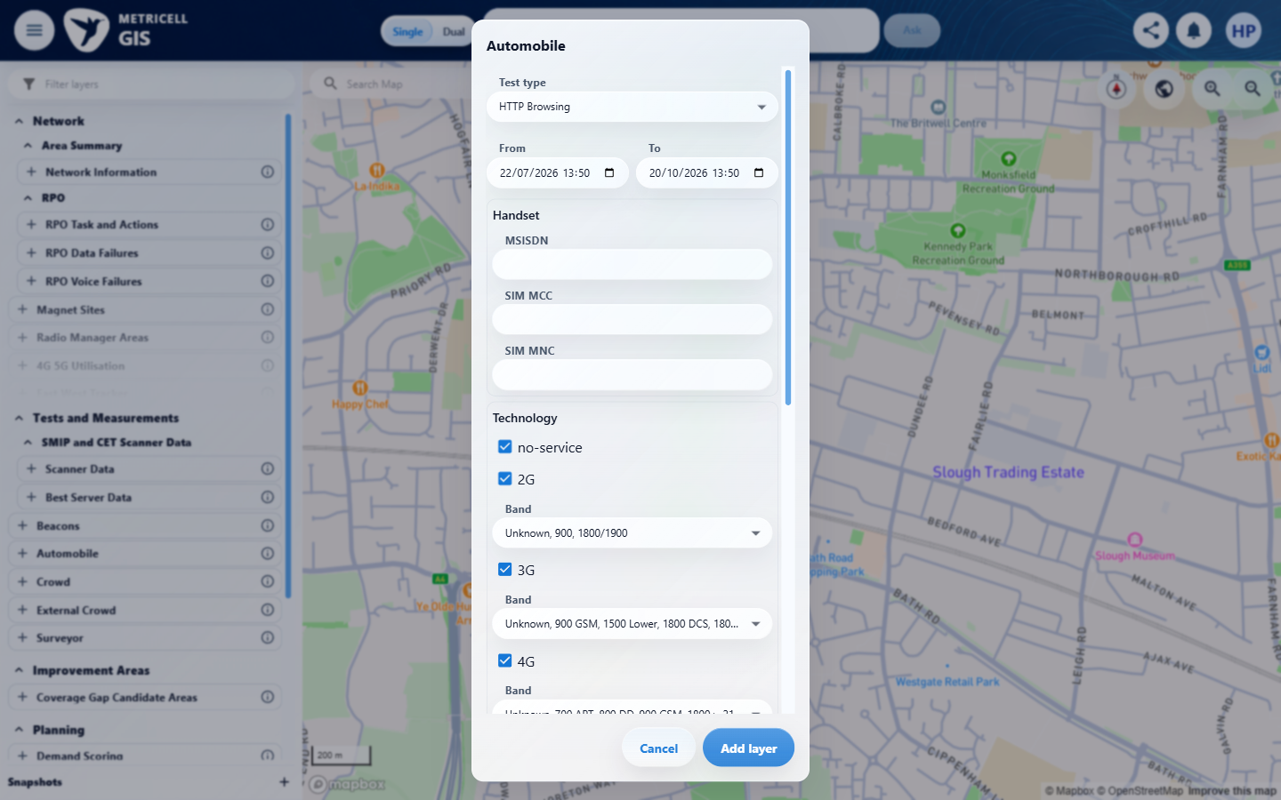 | E15 - Recheck layer active (criterion-4-recheck-layer-active.png)  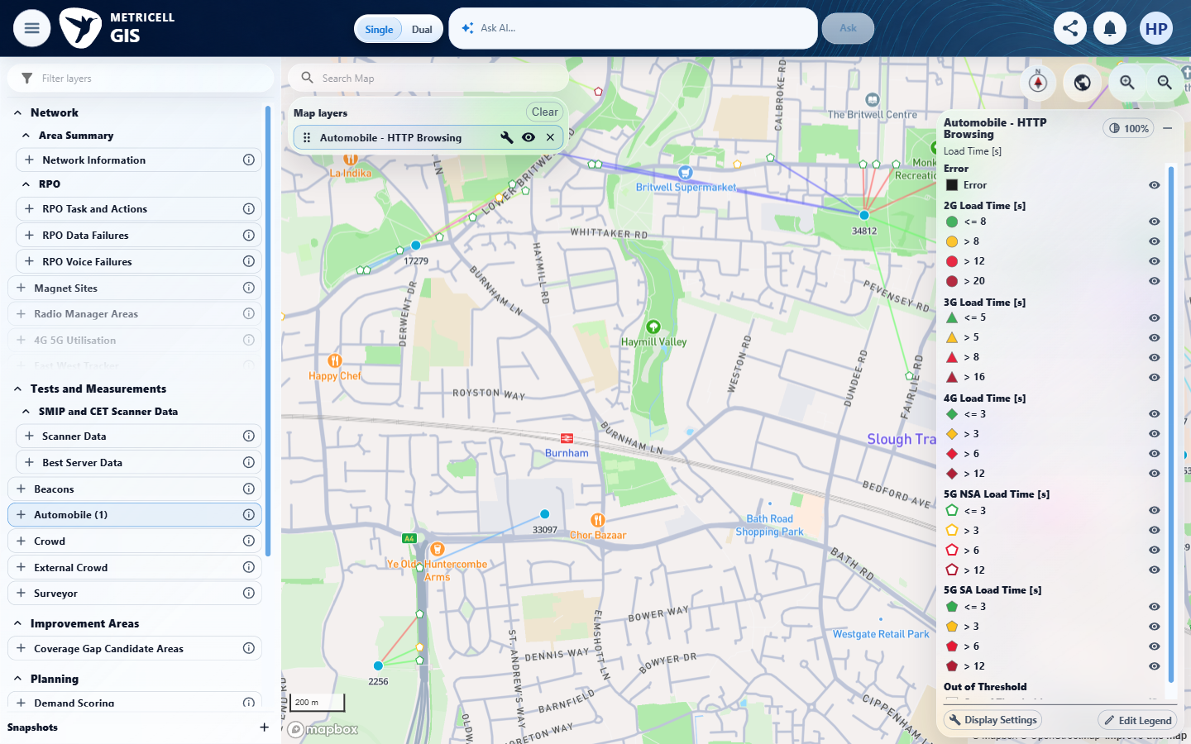

Criterion 4 continued: On a standard Automobile map layer, the frequency filter offers the frequencies supplied by the application configuration.
Browser URL recorded after criterion: https://o2intelligence-v4-dev.metricell.com/gis
E16 - Before band 0 (criterion-4-before-band-0.png)  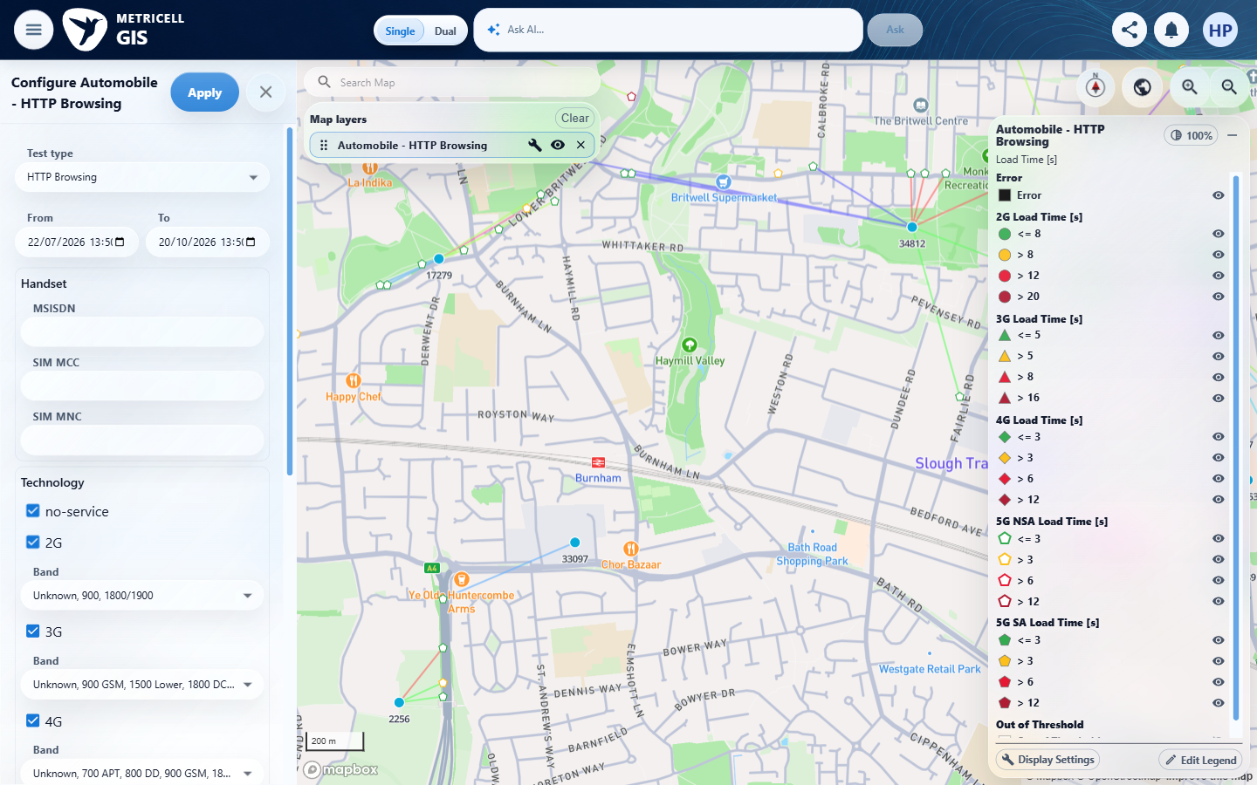 | E17 - Band 0 options (criterion-4-band-0-options.png)  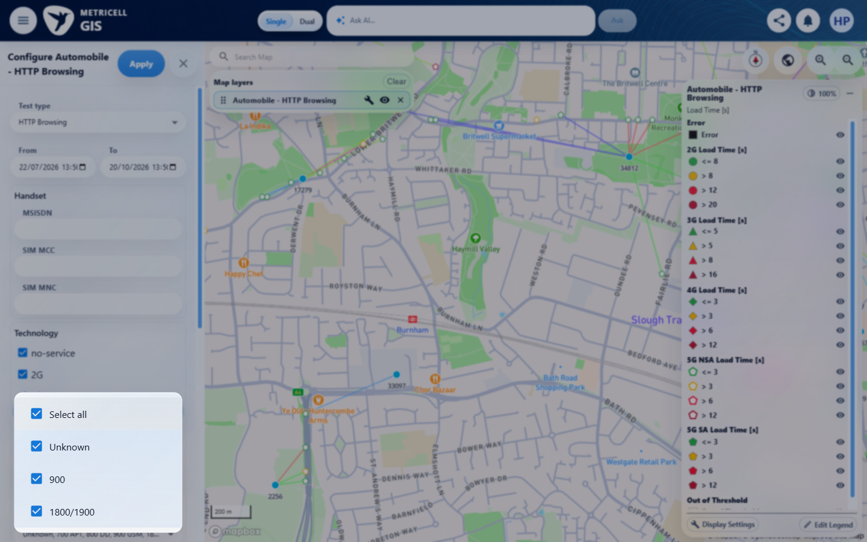

Criterion 4 continued: On a standard Automobile map layer, the frequency filter offers the frequencies supplied by the application configuration.
Browser URL recorded after criterion: https://o2intelligence-v4-dev.metricell.com/gis
E18 - Band 0 closed (criterion-4-band-0-closed.png)  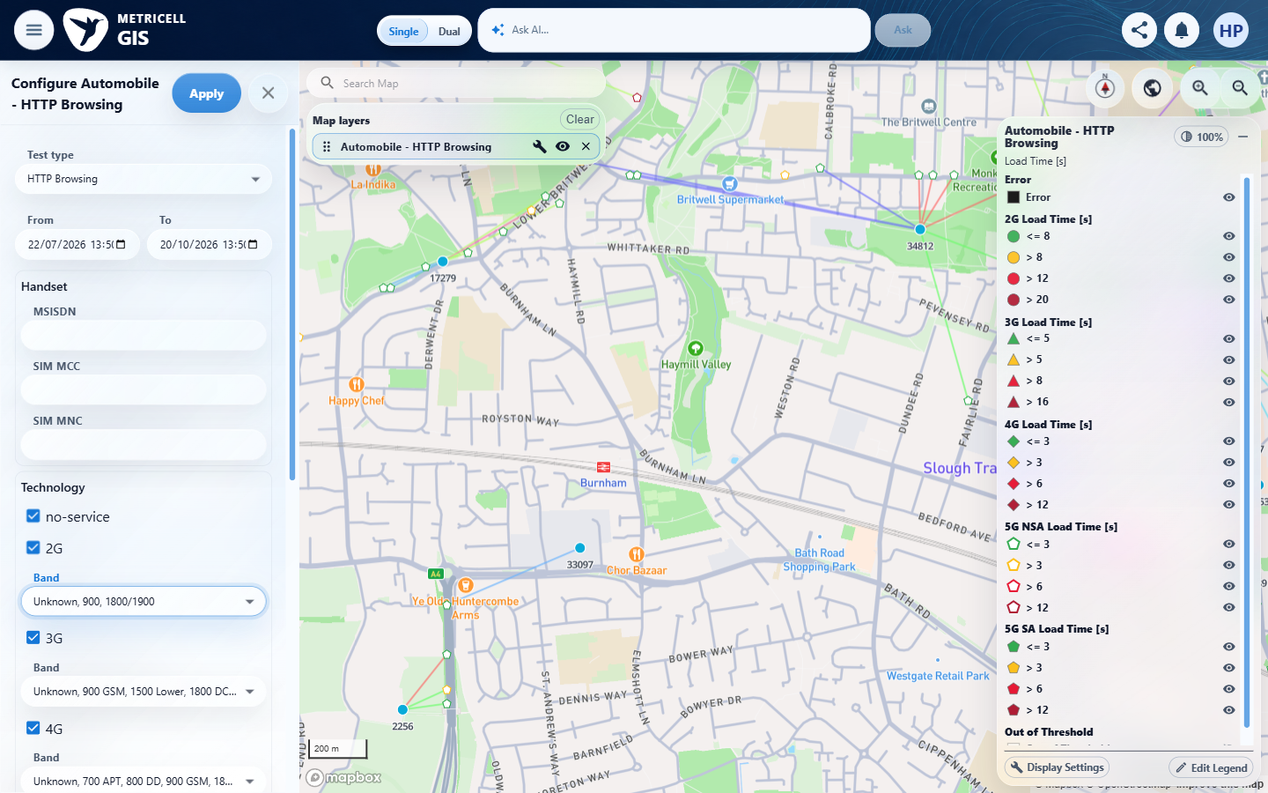 | E19 - Before band 1 (criterion-4-before-band-1.png)  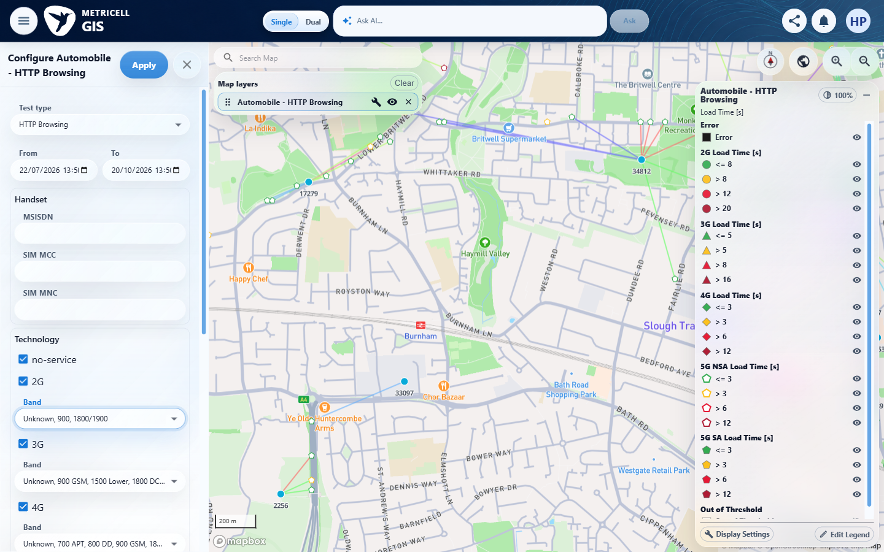

Criterion 4 continued: On a standard Automobile map layer, the frequency filter offers the frequencies supplied by the application configuration.
Browser URL recorded after criterion: https://o2intelligence-v4-dev.metricell.com/gis
E20 - Band 1 options (criterion-4-band-1-options.png)  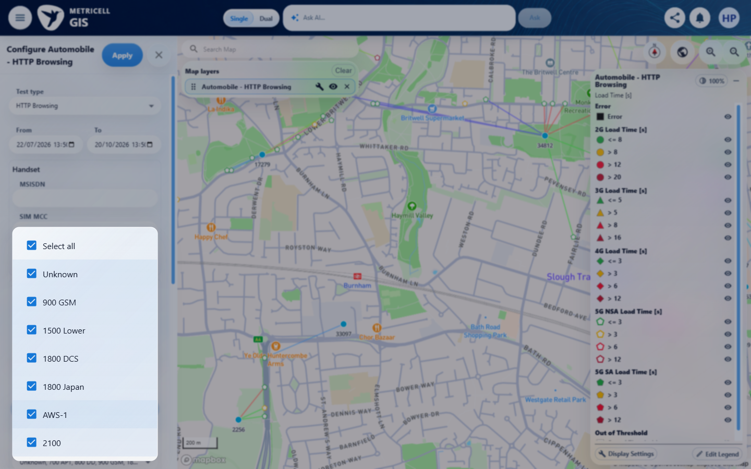 | E21 - Band 1 closed (criterion-4-band-1-closed.png)  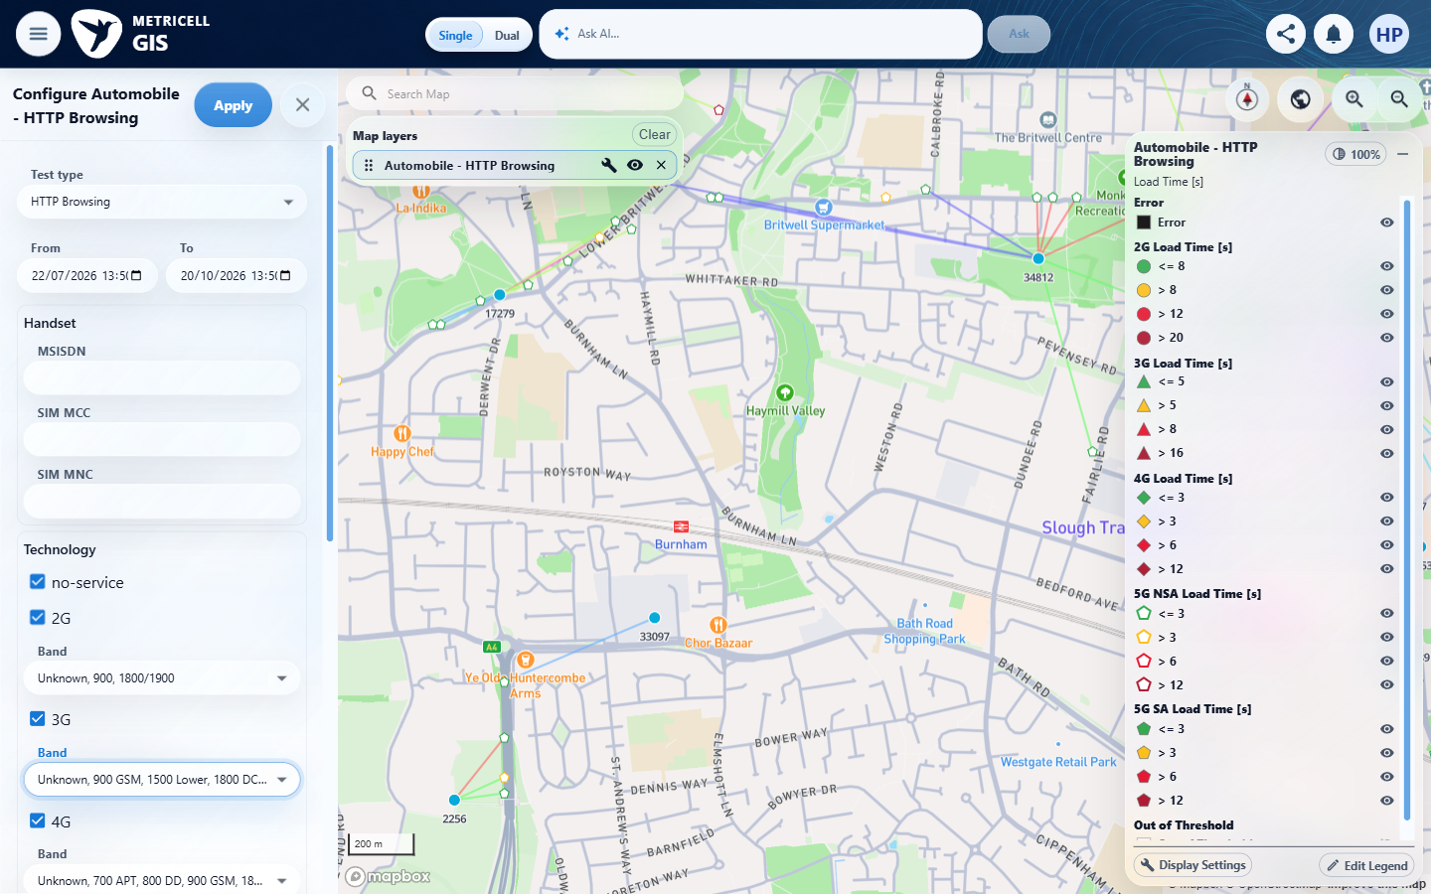

Criterion 4 continued: On a standard Automobile map layer, the frequency filter offers the frequencies supplied by the application configuration.
Browser URL recorded after criterion: https://o2intelligence-v4-dev.metricell.com/gis
E22 - Before band 2 (criterion-4-before-band-2.png)  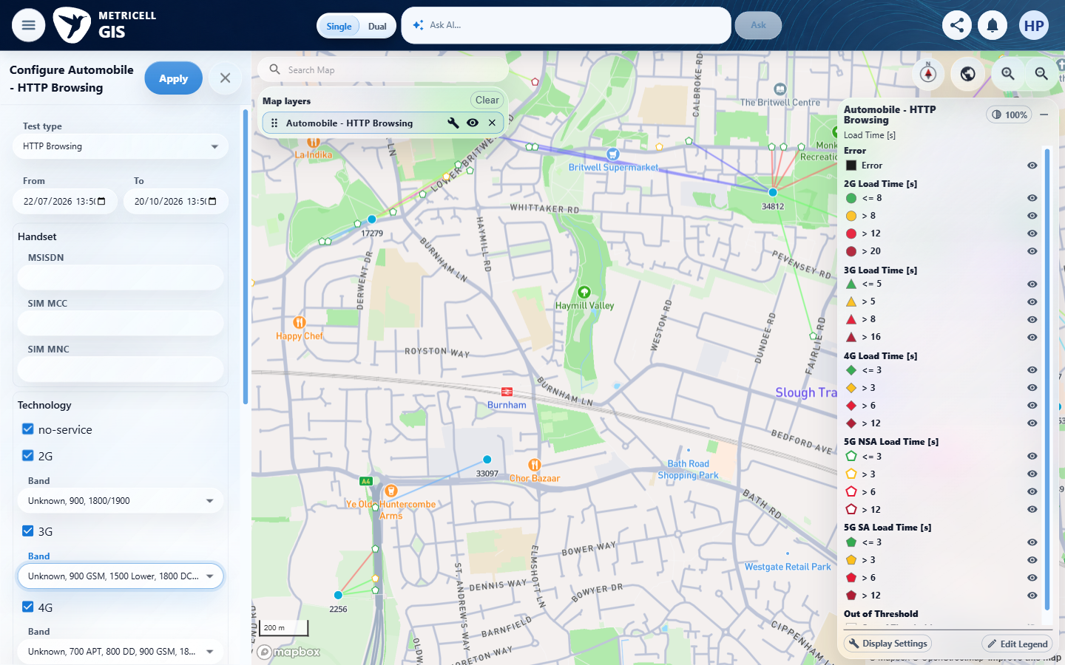 | E23 - Band 2 options (criterion-4-band-2-options.png)  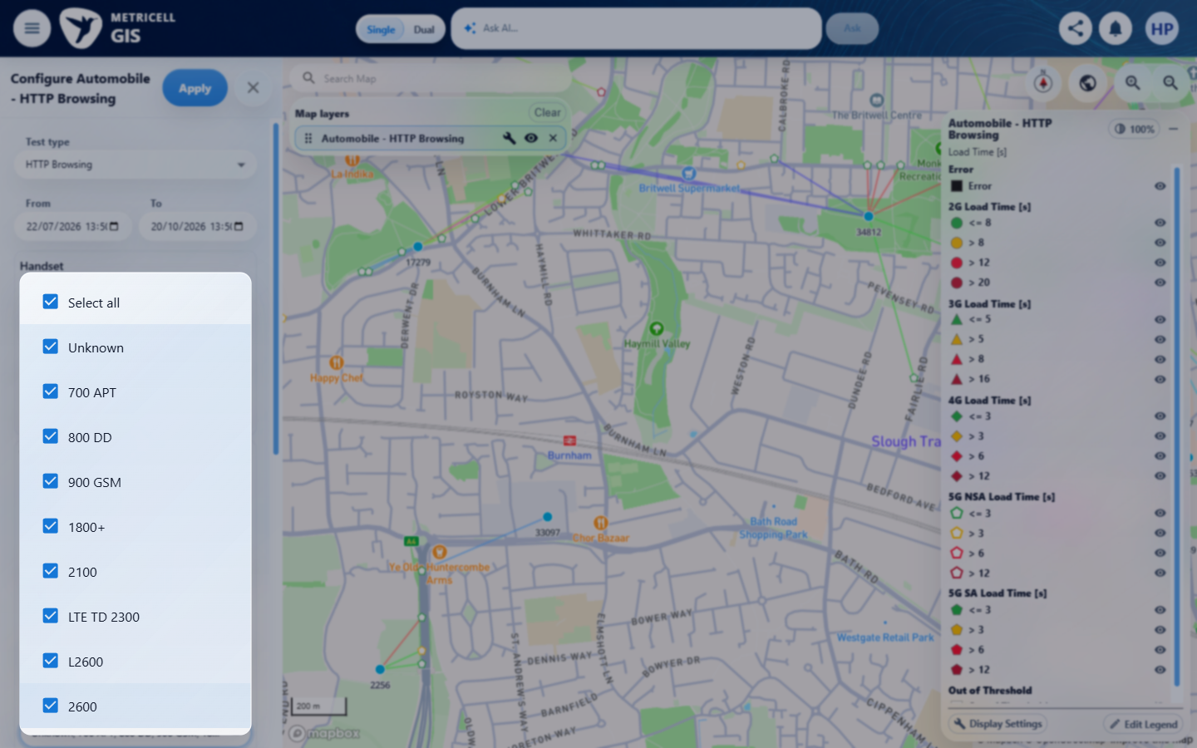

Criterion 4 continued: On a standard Automobile map layer, the frequency filter offers the frequencies supplied by the application configuration.
Browser URL recorded after criterion: https://o2intelligence-v4-dev.metricell.com/gis
E24 - Band 2 closed (criterion-4-band-2-closed.png)  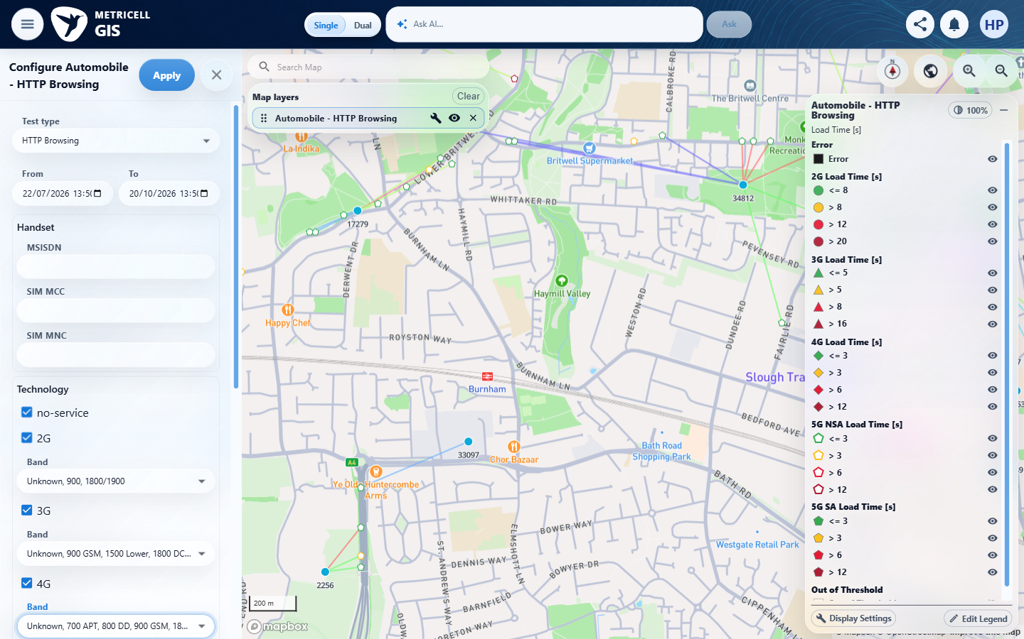 | E25 - Before band 3 (criterion-4-before-band-3.png)  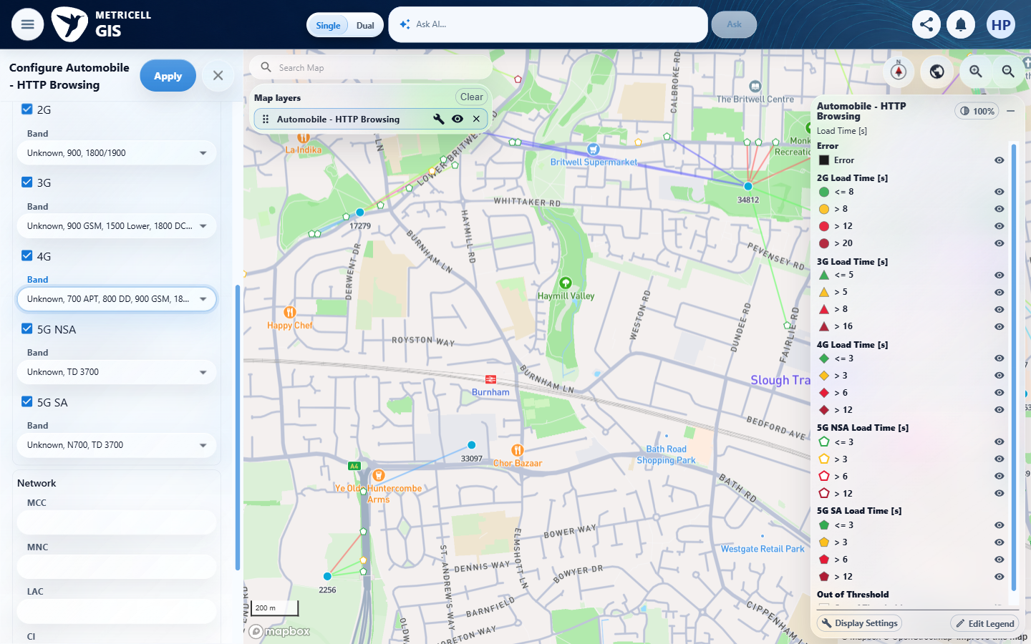

Criterion 4 continued: On a standard Automobile map layer, the frequency filter offers the frequencies supplied by the application configuration.
Browser URL recorded after criterion: https://o2intelligence-v4-dev.metricell.com/gis
E26 - Band 3 options (criterion-4-band-3-options.png)  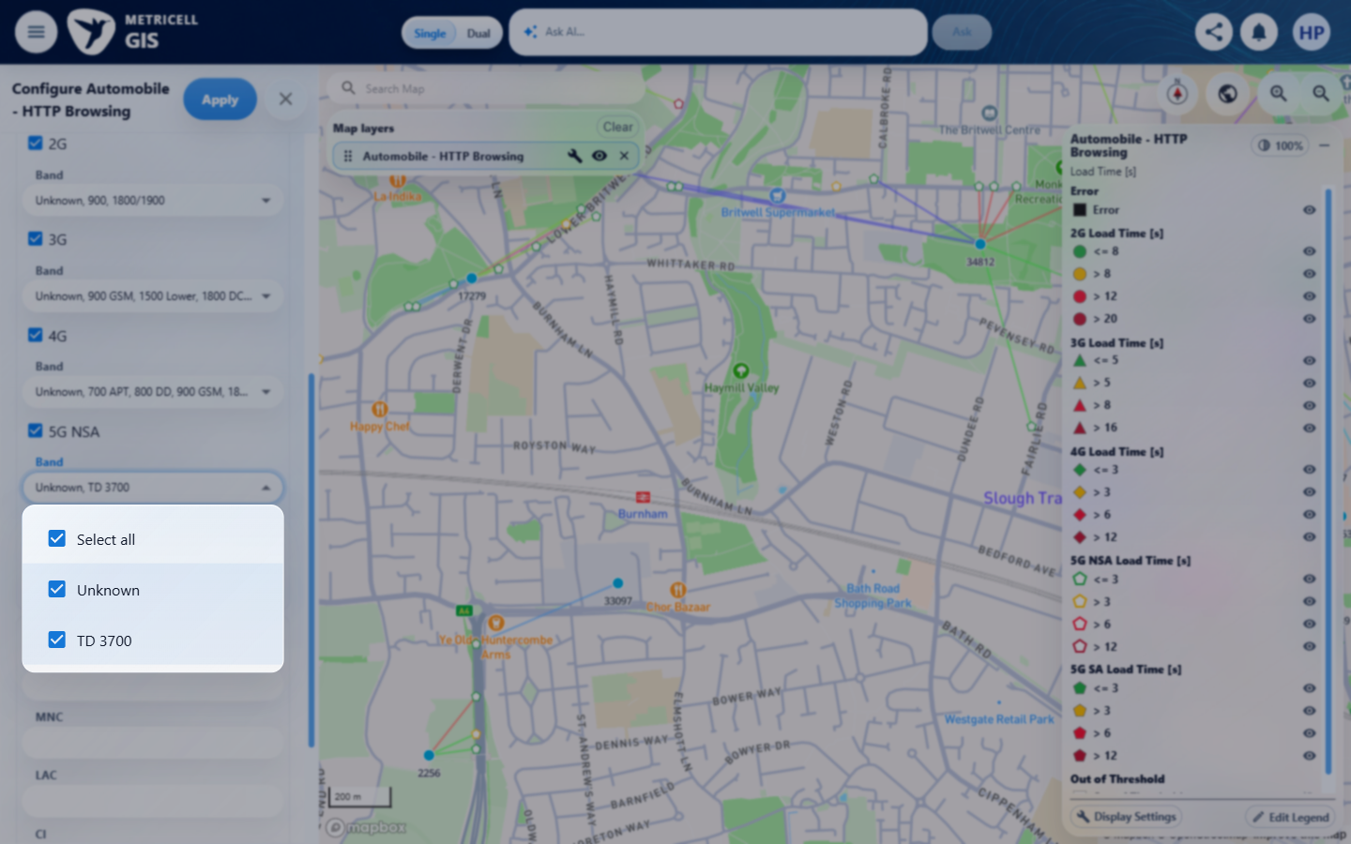 | E27 - Band 3 closed (criterion-4-band-3-closed.png)  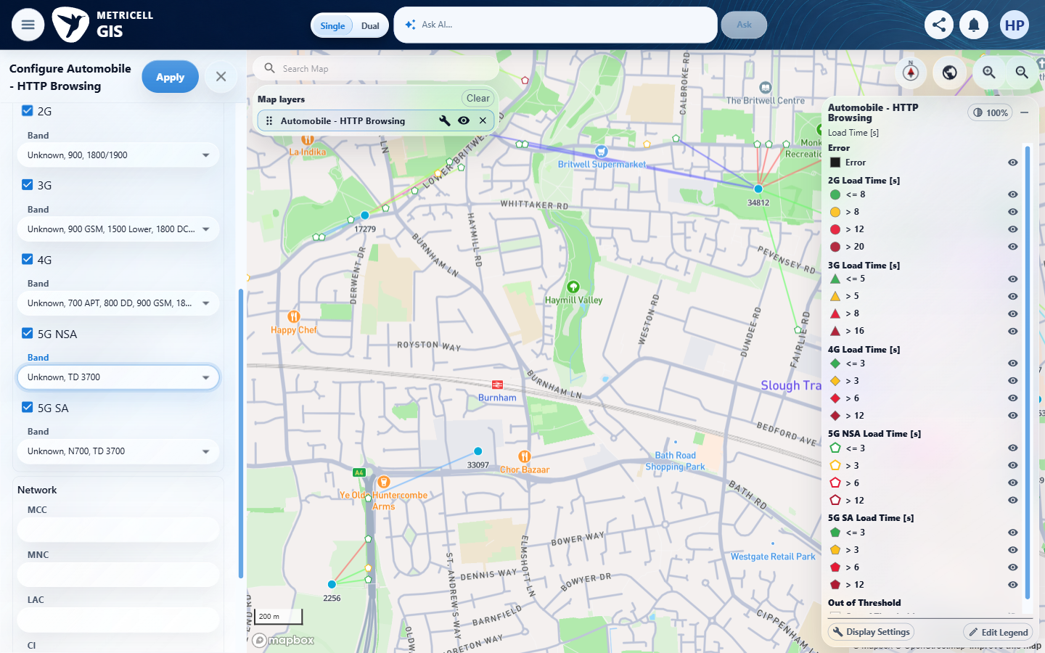

Criterion 4 continued: On a standard Automobile map layer, the frequency filter offers the frequencies supplied by the application configuration.
Browser URL recorded after criterion: https://o2intelligence-v4-dev.metricell.com/gis
E28 - Before band 4 (criterion-4-before-band-4.png)  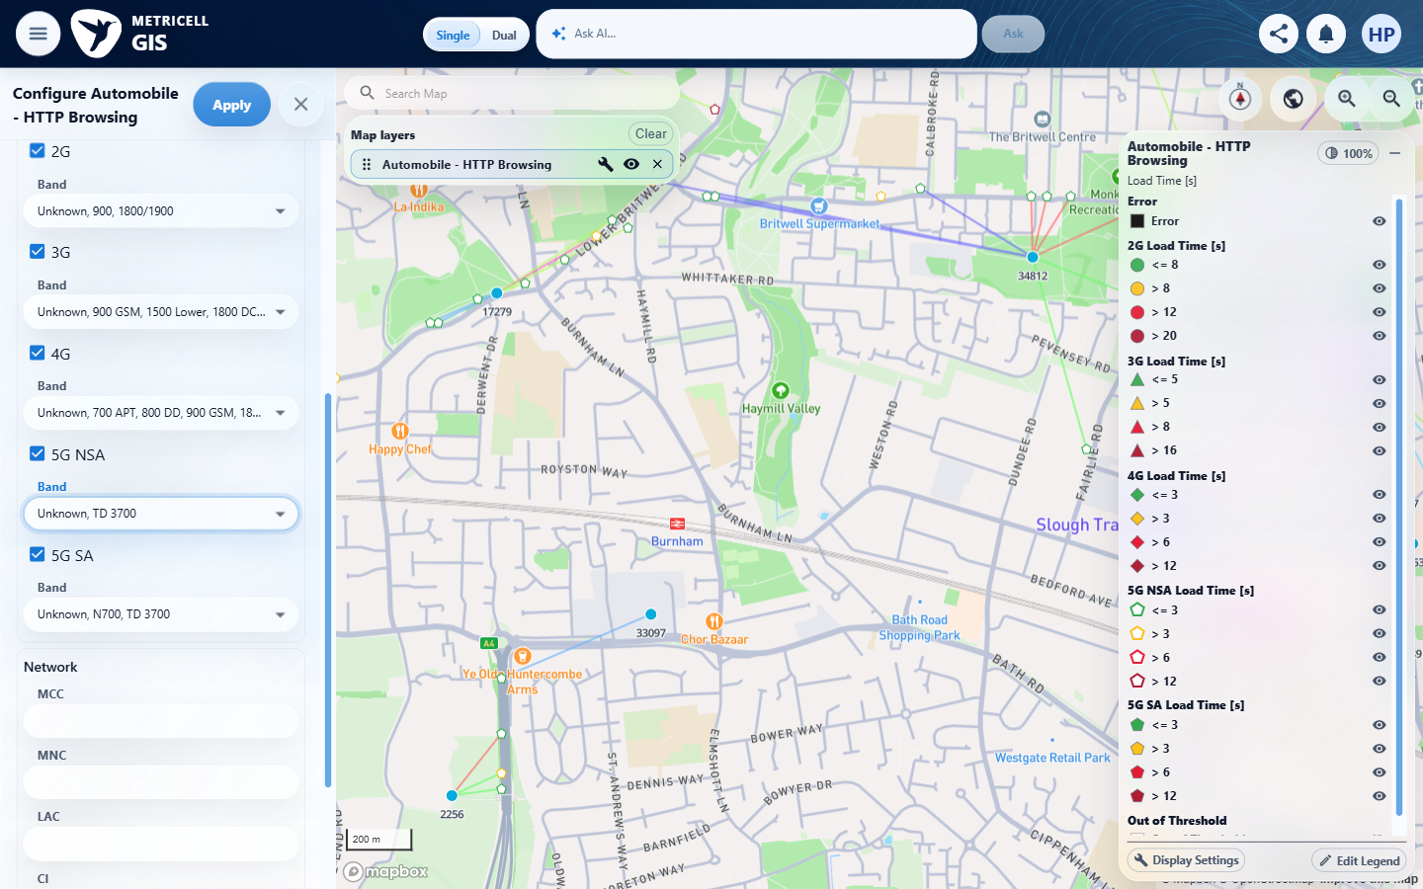 | E29 - Band 4 options (criterion-4-band-4-options.png)  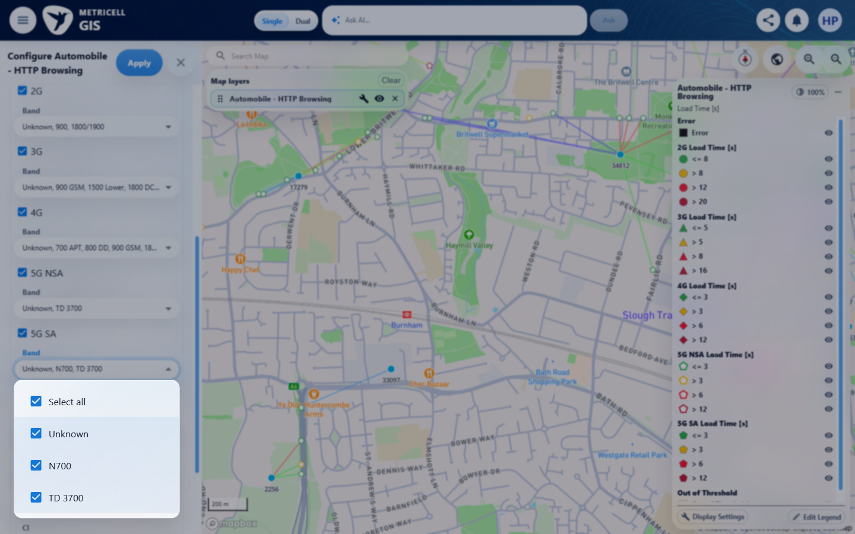

Criterion 4 continued: On a standard Automobile map layer, the frequency filter offers the frequencies supplied by the application configuration.
Browser URL recorded after criterion: https://o2intelligence-v4-dev.metricell.com/gis
E30 - Final (criterion-4-final.png)
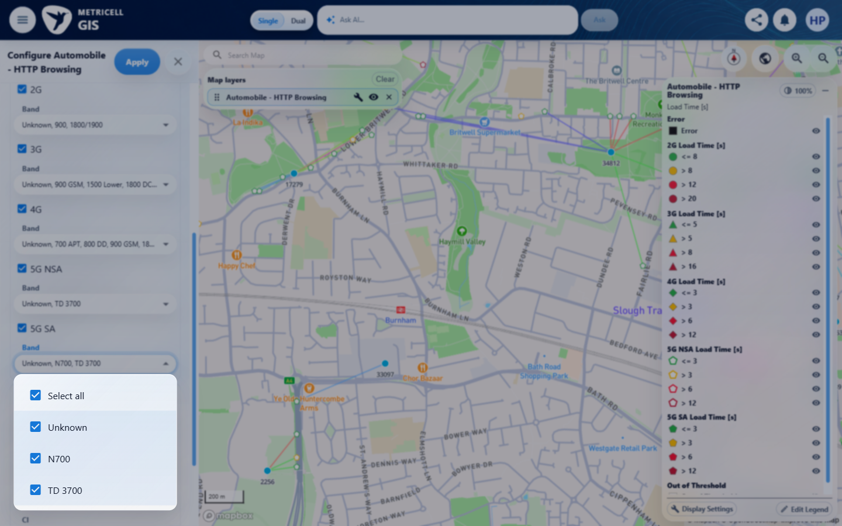

5.0.0 | On a standard Automobile map layer, opening filters shows network fields for MCC, MNC, LAC, CI, Site, and Cell. | On a standard Automobile map layer, opening filters shows network fields for MCC, MNC, LAC, CI, Site, and Cell. | criterion-5-final.png directly shows all six Network fields: MCC, MNC, LAC, CI, Site and Cell.  Evidence: E01, E31, E06, E32 | Passed
Criterion 5 evidence: On a standard Automobile map layer, opening filters shows network fields for MCC, MNC, LAC, CI, Site, and Cell.
Browser URL recorded after criterion: https://o2intelligence-v4-dev.metricell.com/gis
E01 - Before automobile (criterion-5-before-automobile.png) | E31 - After automobile (criterion-5-after-automobile.png)  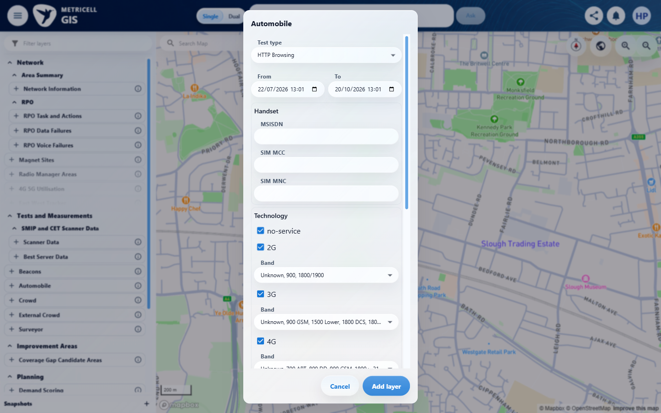

Criterion 5 continued: On a standard Automobile map layer, opening filters shows network fields for MCC, MNC, LAC, CI, Site, and Cell.
Browser URL recorded after criterion: https://o2intelligence-v4-dev.metricell.com/gis
E06 - Layer active (criterion-5-layer-active.png) | E32 - Final (criterion-5-final.png)  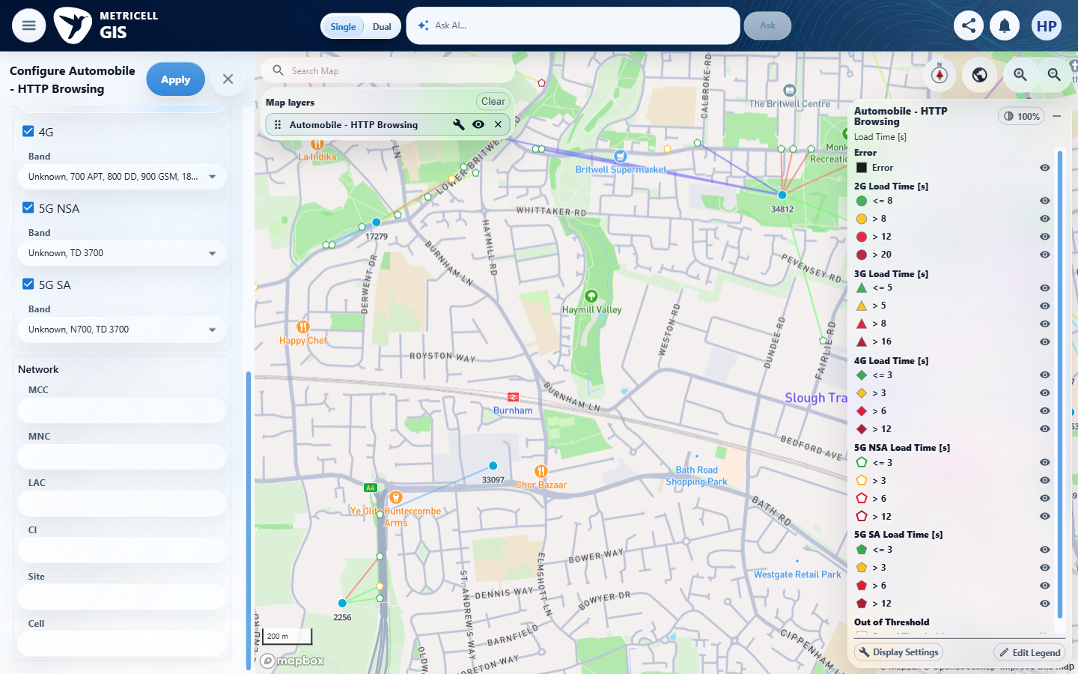

6.0.0 | On a standard Automobile map layer, the device-group filter offers the groups supplied by the application configuration. | On a standard Automobile map layer, the device-group filter offers the groups supplied by the application configuration. | The results report deviceSegregationRestricted:true and nine configured groups, requiring an authorised unrestricted user to inspect group choices. criterion-6-after-automobile.png and criterion-6-final.png show the available form portions without a device-group control; configured-group choices cannot be assessed in this restricted environment.  Evidence: E01, E33, E06, E34 | Blocked
Criterion 6 evidence: On a standard Automobile map layer, the device-group filter offers the groups supplied by the application configuration.
Browser URL recorded after criterion: https://o2intelligence-v4-dev.metricell.com/gis
E01 - Before automobile (criterion-6-before-automobile.png) | E33 - After automobile (criterion-6-after-automobile.png)  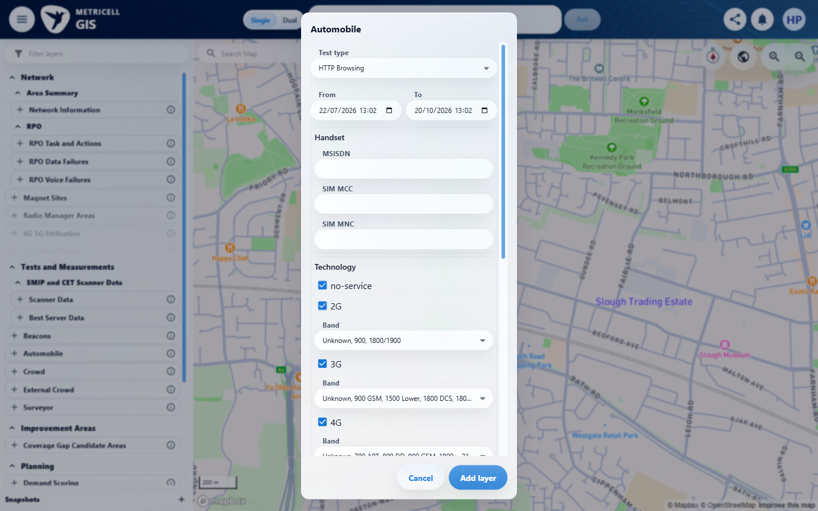

Criterion 6 continued: On a standard Automobile map layer, the device-group filter offers the groups supplied by the application configuration.
Browser URL recorded after criterion: https://o2intelligence-v4-dev.metricell.com/gis
E06 - Layer active (criterion-6-layer-active.png) | E34 - Final (criterion-6-final.png)  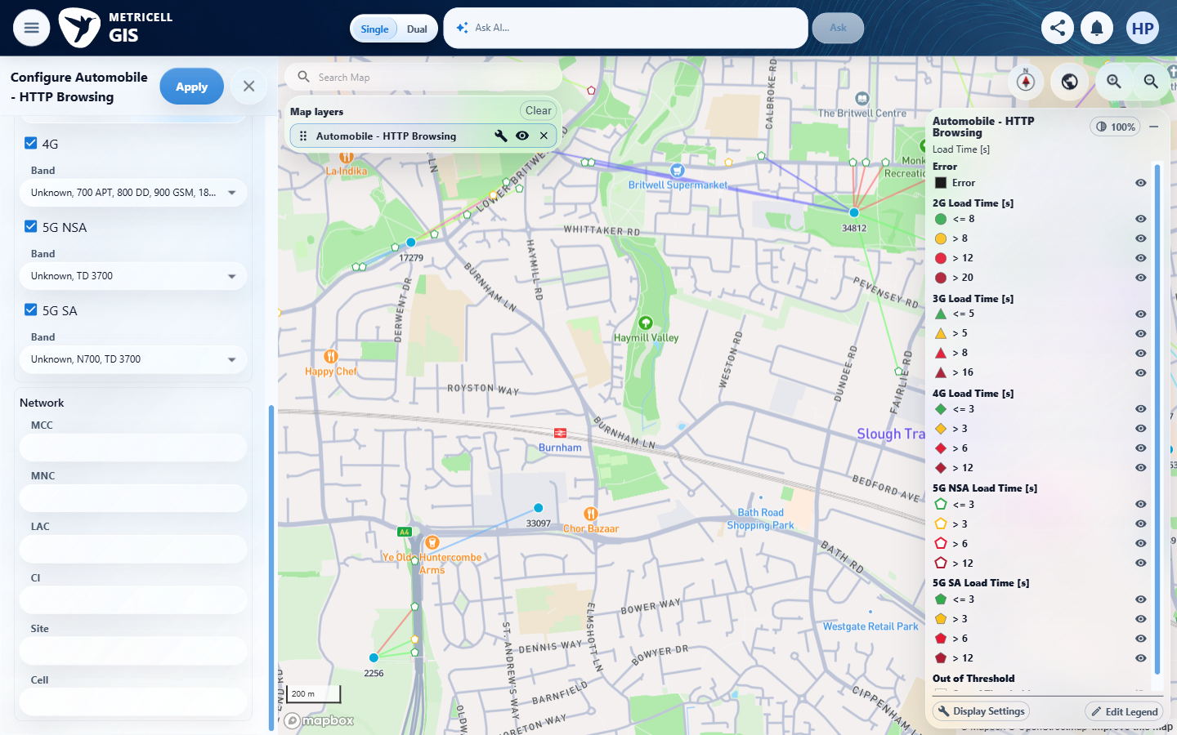

7.0.0 | When SIM MCC, SIM MNC, MCC, MNC, or LAC is edited, each field accepts numeric digits only. | When SIM MCC, SIM MNC, MCC, MNC, or LAC is edited, each field accepts numeric digits only. | criterion-7-after-sim-mcc-digits.png shows 123 accepted; criterion-7-after-sim-mcc-invalid.png, criterion-7-after-sim-mnc-invalid.png, criterion-7-after-mcc-invalid.png, criterion-7-after-mnc-invalid.png and criterion-7-after-lac-invalid.png each visibly retain 123.-e, contradicting digits-only entry.  Evidence: E01, E35, E06, E36, E37, E38, E39, E40, E41, E34, E42, E43, E44, E45, E46, E47, E48, E49 | Failed
Criterion 7 evidence: When SIM MCC, SIM MNC, MCC, MNC, or LAC is edited, each field accepts numeric digits only.
Browser URL recorded after criterion: https://o2intelligence-v4-dev.metricell.com/gis
E01 - Before automobile (criterion-7-before-automobile.png) | E35 - After automobile (criterion-7-after-automobile.png)  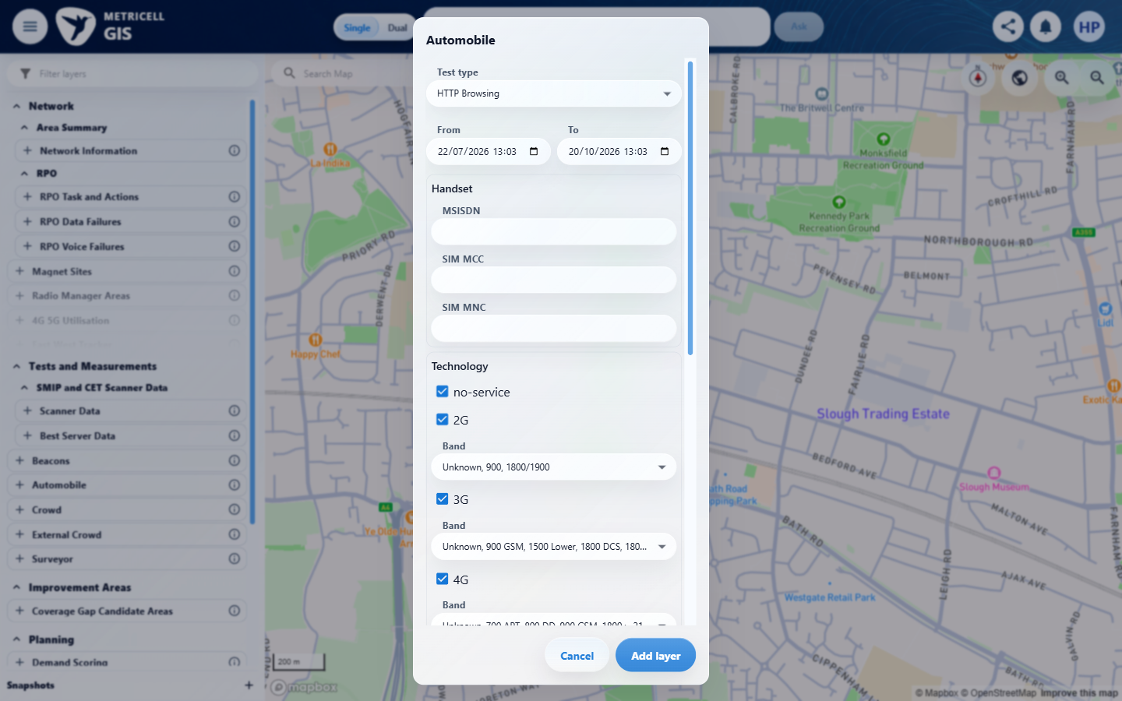

Criterion 7 continued: When SIM MCC, SIM MNC, MCC, MNC, or LAC is edited, each field accepts numeric digits only.
Browser URL recorded after criterion: https://o2intelligence-v4-dev.metricell.com/gis
E06 - Layer active (criterion-7-layer-active.png) | E36 - Before sim mcc (criterion-7-before-sim-mcc.png)  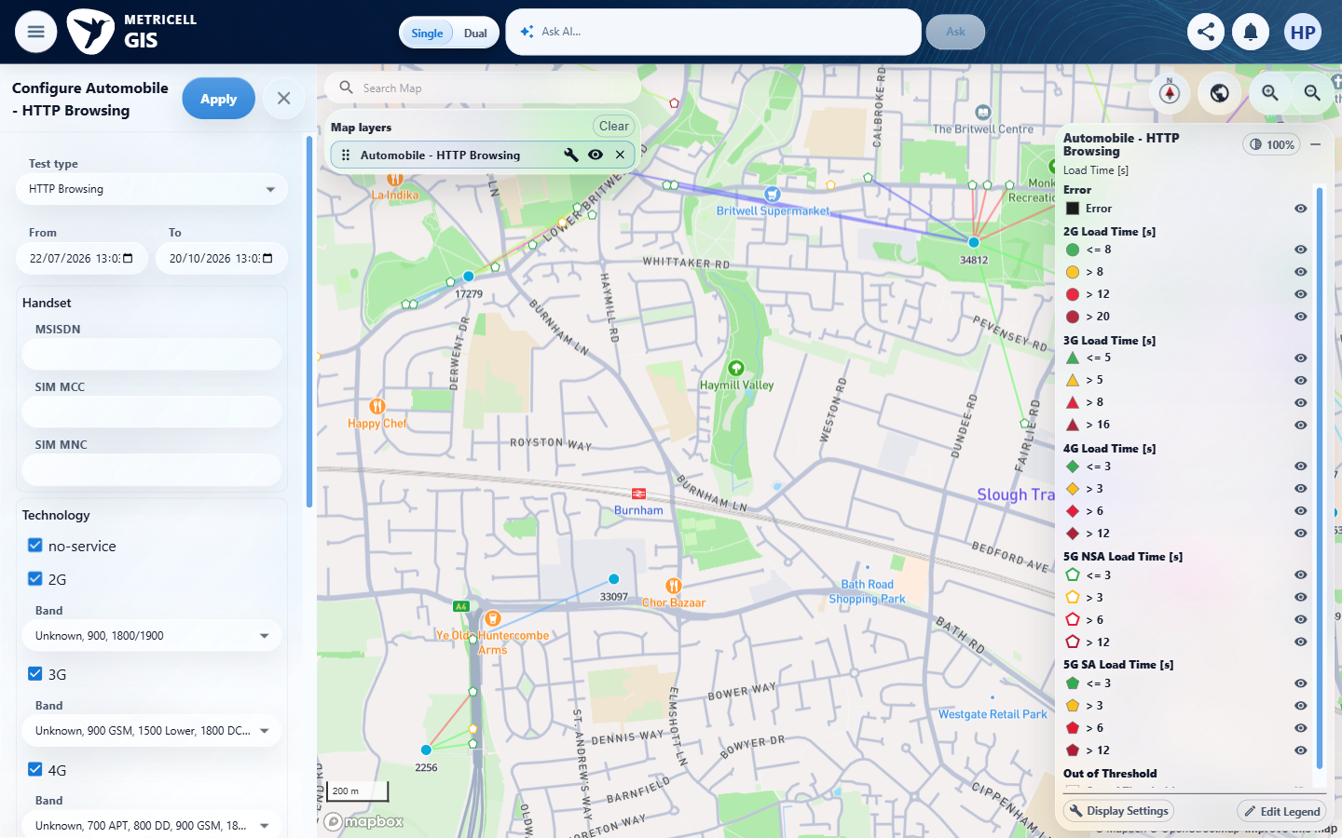

Criterion 7 continued: When SIM MCC, SIM MNC, MCC, MNC, or LAC is edited, each field accepts numeric digits only.
Browser URL recorded after criterion: https://o2intelligence-v4-dev.metricell.com/gis
E37 - Before sim mcc digits (criterion-7-before-sim-mcc-digits.png)  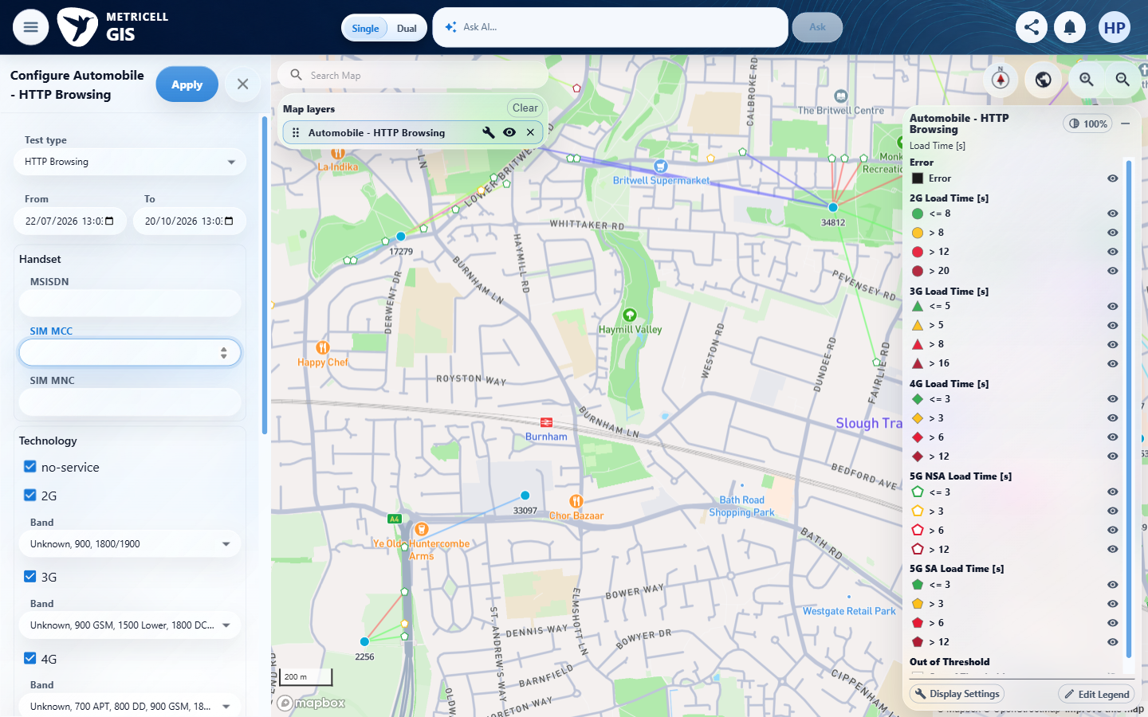 | E38 - After sim mcc digits (criterion-7-after-sim-mcc-digits.png)  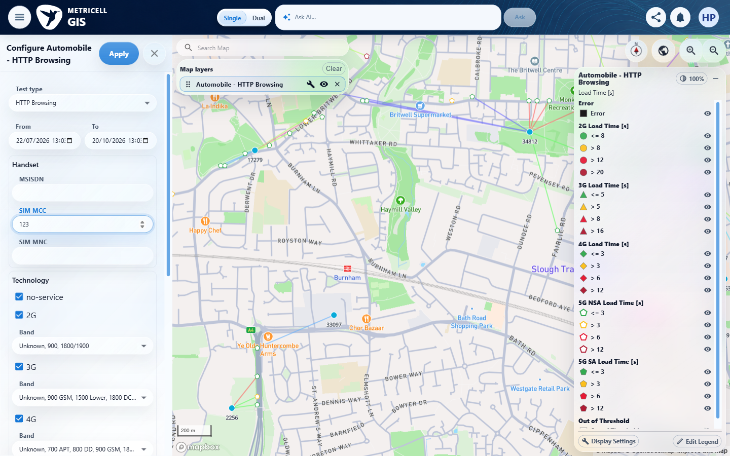
E37 detail enlargement - full screenshot above | E38 detail enlargement - full screenshot above

Criterion 7 continued: When SIM MCC, SIM MNC, MCC, MNC, or LAC is edited, each field accepts numeric digits only.
Browser URL recorded after criterion: https://o2intelligence-v4-dev.metricell.com/gis
E39 - Before sim mnc digits (criterion-7-before-sim-mnc-digits.png)  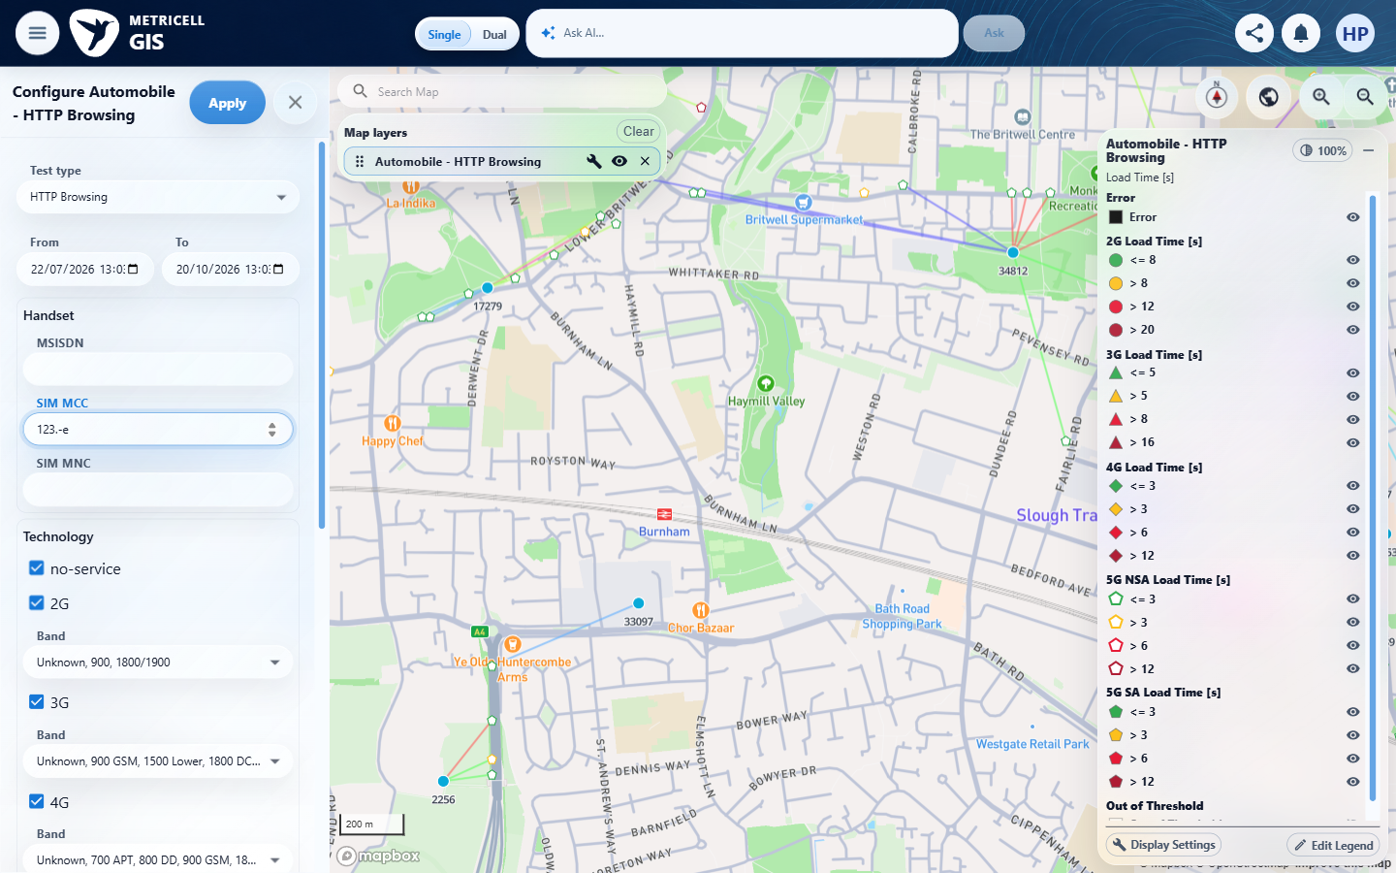 | E40 - After sim mnc digits (criterion-7-after-sim-mnc-digits.png)  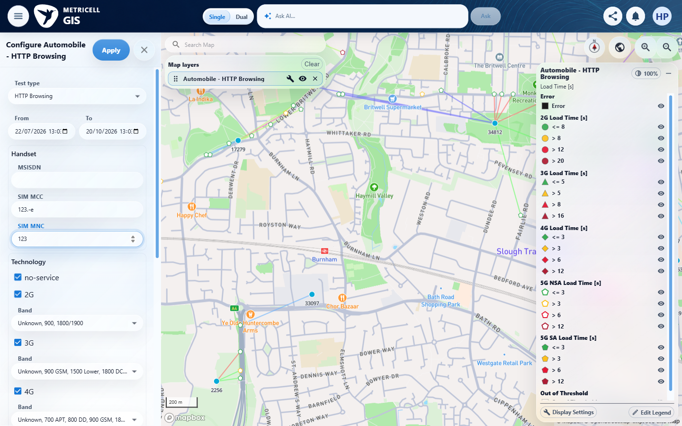
E39 detail enlargement - full screenshot above | E40 detail enlargement - full screenshot above

Criterion 7 continued: When SIM MCC, SIM MNC, MCC, MNC, or LAC is edited, each field accepts numeric digits only.
Browser URL recorded after criterion: https://o2intelligence-v4-dev.metricell.com/gis
E41 - After sim mnc invalid (criterion-7-after-sim-mnc-invalid.png)  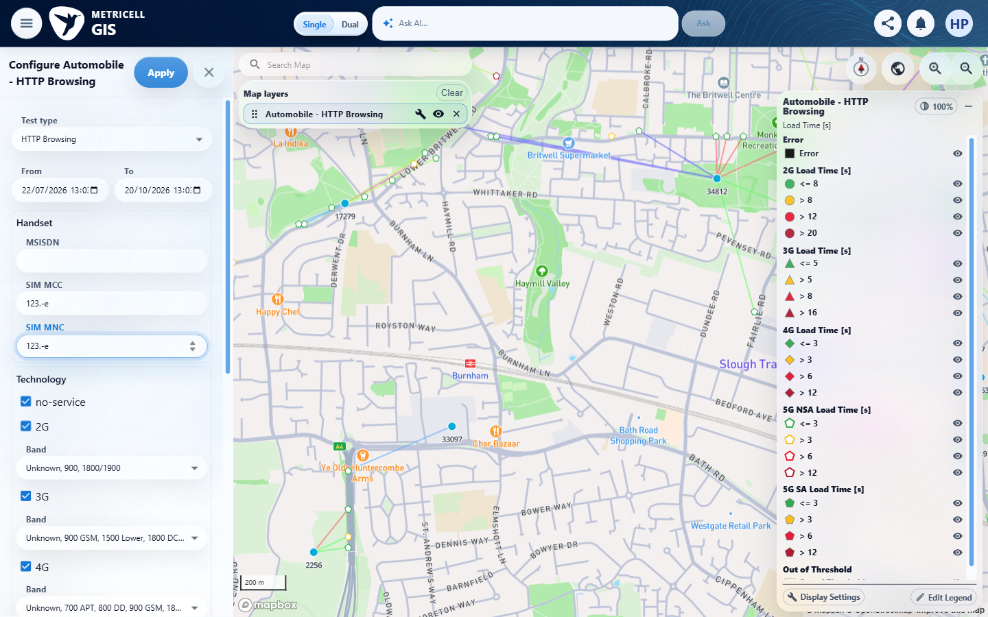 | E34 - Before mcc digits (criterion-7-before-mcc-digits.png)

Criterion 7 continued: When SIM MCC, SIM MNC, MCC, MNC, or LAC is edited, each field accepts numeric digits only.
Browser URL recorded after criterion: https://o2intelligence-v4-dev.metricell.com/gis
E42 - After mcc digits (criterion-7-after-mcc-digits.png)  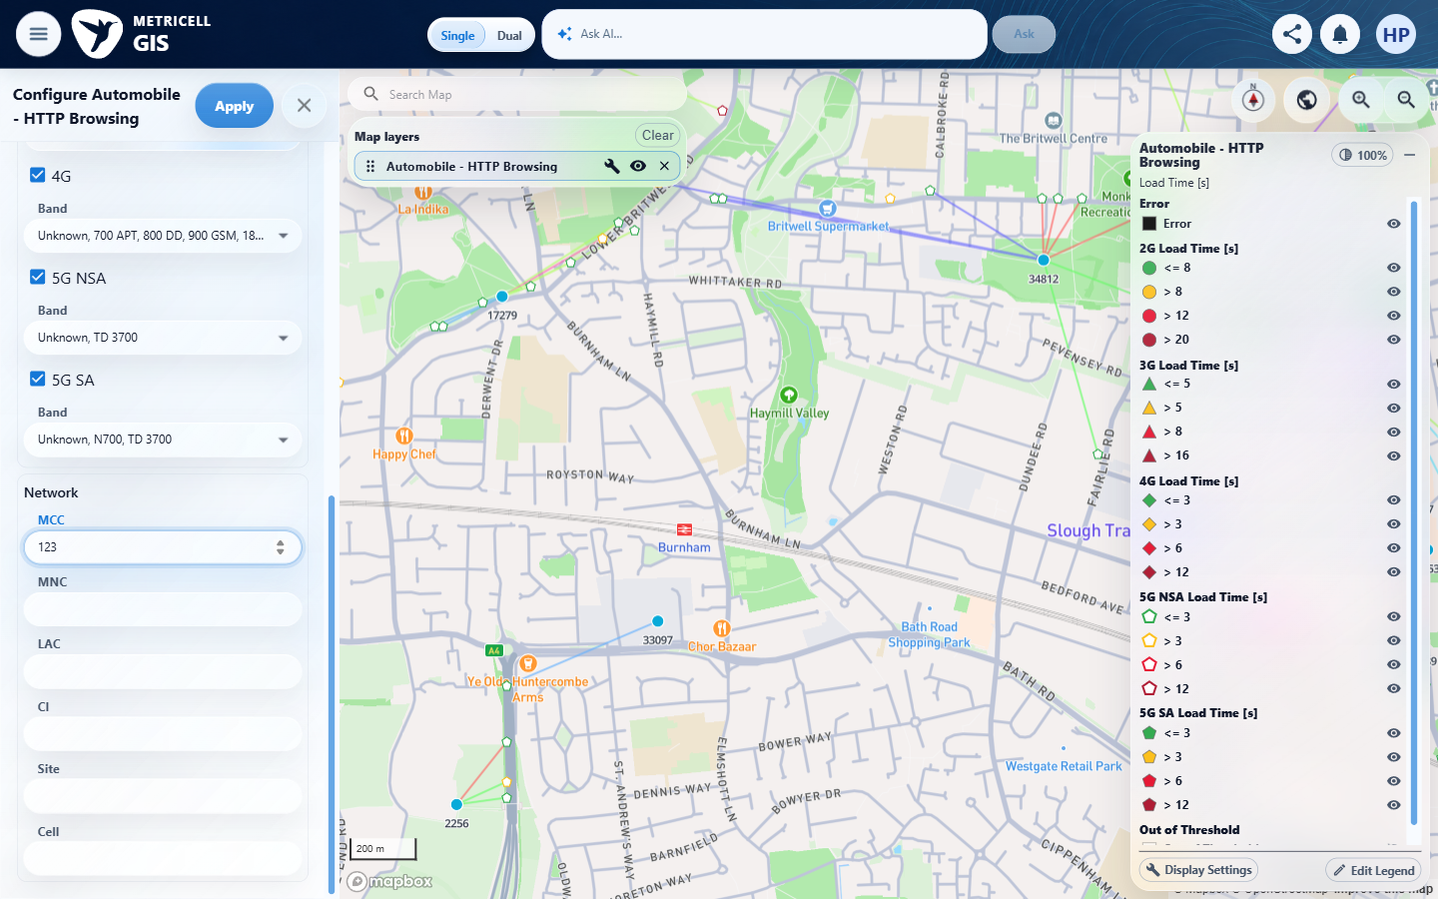 | E43 - After mcc invalid (criterion-7-after-mcc-invalid.png)  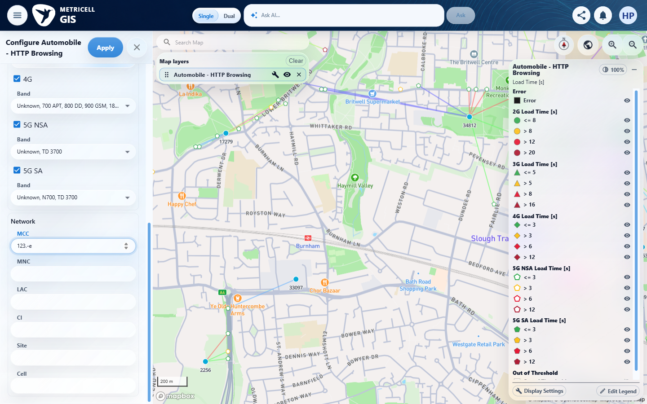

Criterion 7 continued: When SIM MCC, SIM MNC, MCC, MNC, or LAC is edited, each field accepts numeric digits only.
Browser URL recorded after criterion: https://o2intelligence-v4-dev.metricell.com/gis
E44 - Before mnc digits (criterion-7-before-mnc-digits.png)  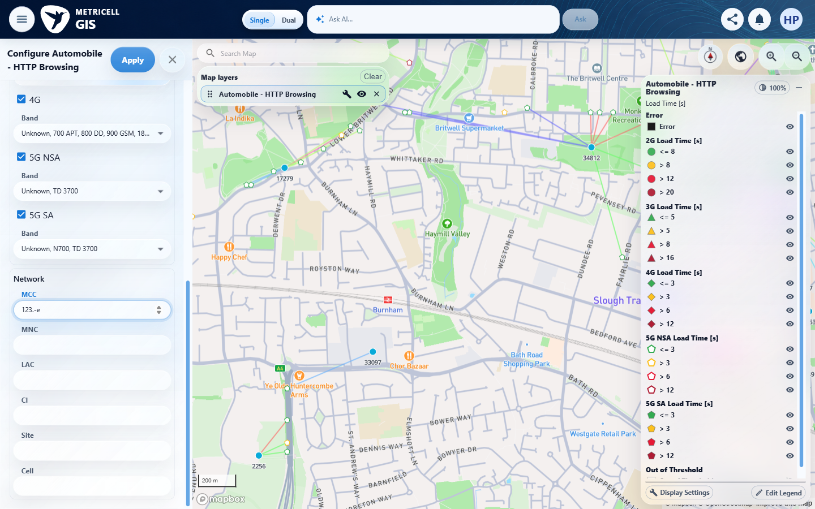 | E45 - After mnc digits (criterion-7-after-mnc-digits.png)  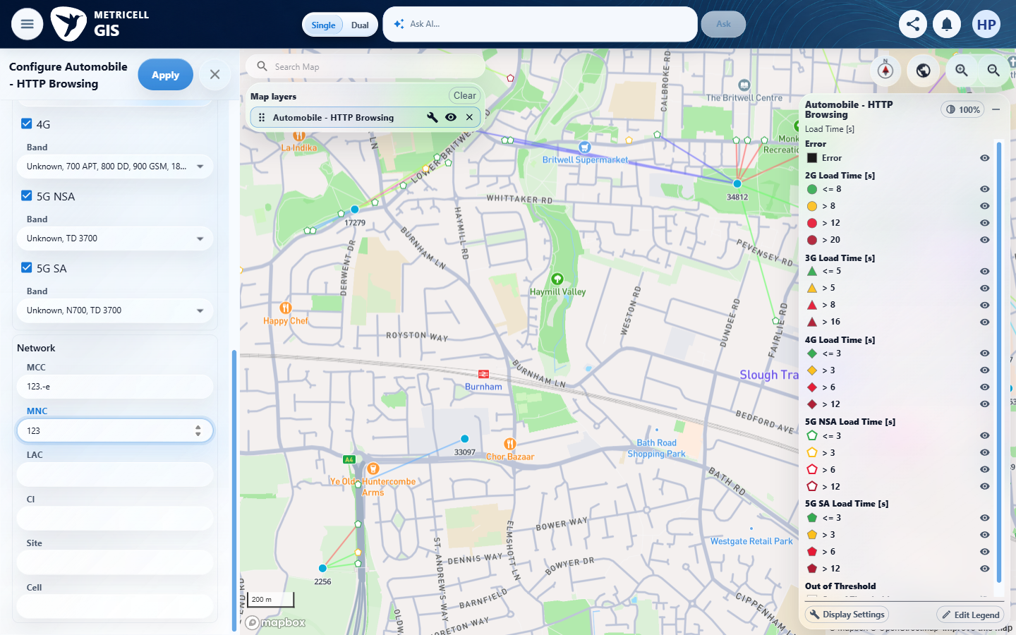
E44 detail enlargement - full screenshot above | E45 detail enlargement - full screenshot above

Criterion 7 continued: When SIM MCC, SIM MNC, MCC, MNC, or LAC is edited, each field accepts numeric digits only.
Browser URL recorded after criterion: https://o2intelligence-v4-dev.metricell.com/gis
E46 - After mnc invalid (criterion-7-after-mnc-invalid.png)  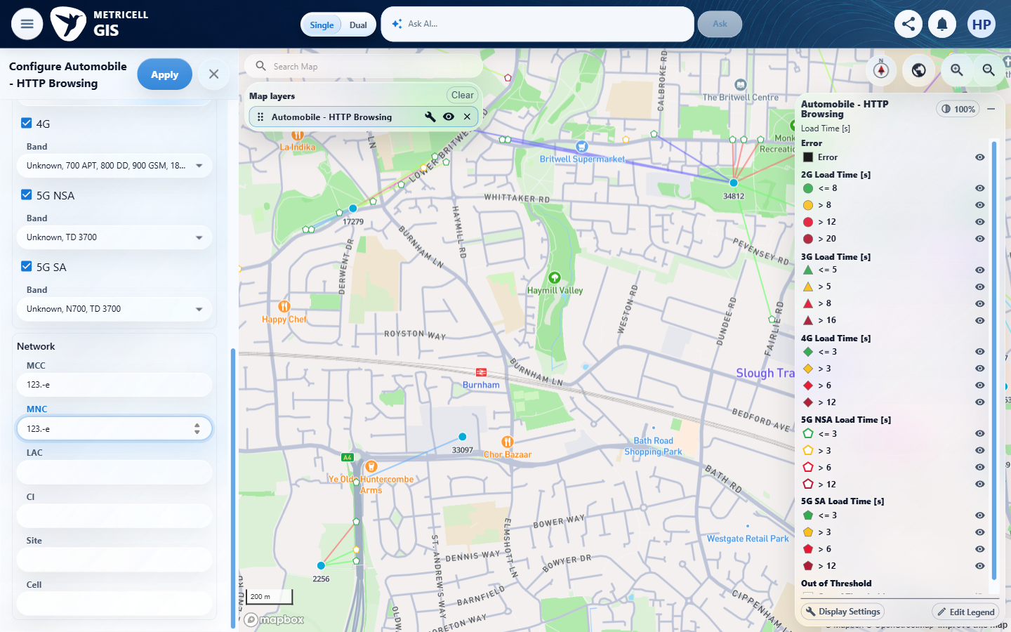 | E47 - Before lac digits (criterion-7-before-lac-digits.png)  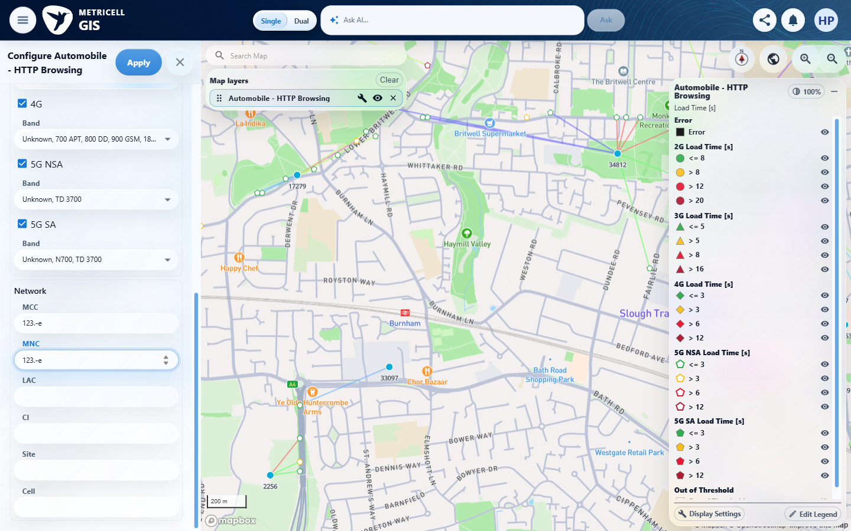

Criterion 7 continued: When SIM MCC, SIM MNC, MCC, MNC, or LAC is edited, each field accepts numeric digits only.
Browser URL recorded after criterion: https://o2intelligence-v4-dev.metricell.com/gis
E48 - After lac digits (criterion-7-after-lac-digits.png)  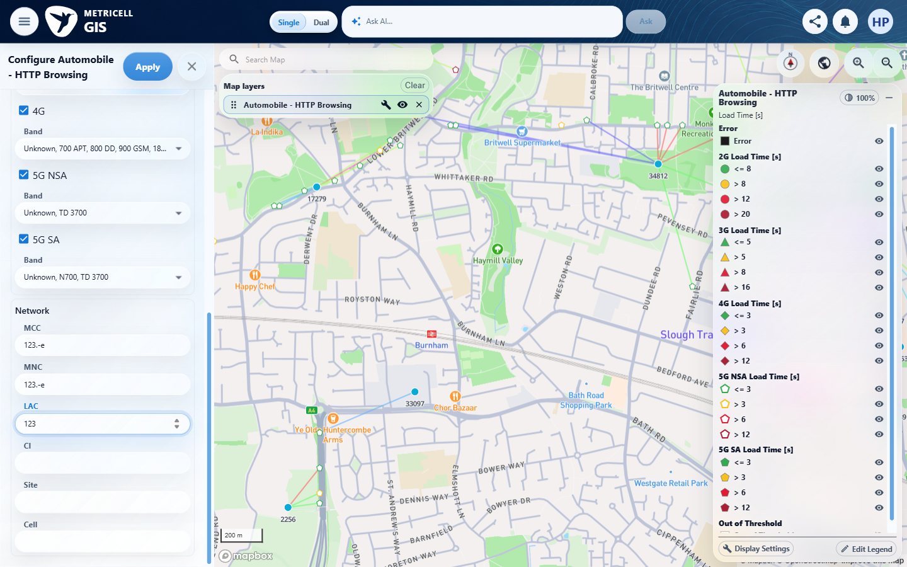 | E49 - Final (criterion-7-final.png)  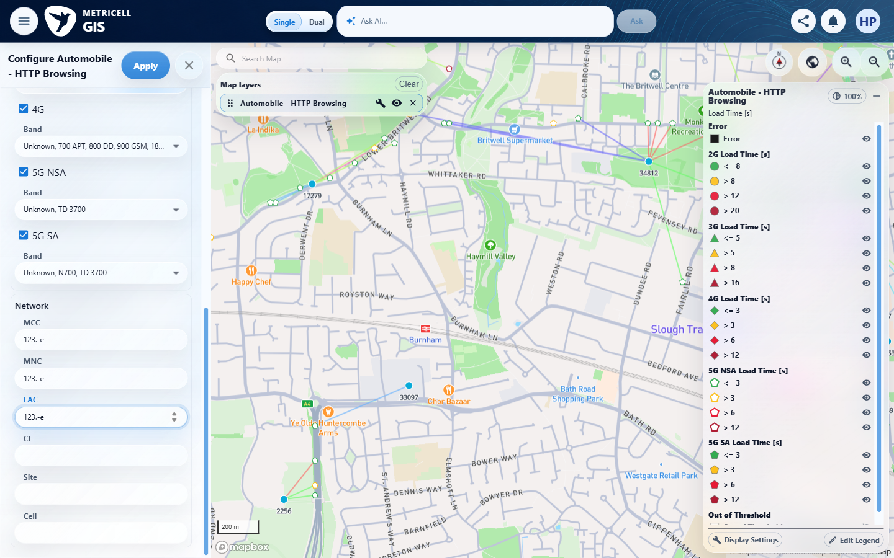

8.0.0 | When MSISDN, CI, Site, or Cell is edited, each field accepts text input. | When MSISDN, CI, Site, or Cell is edited, each field accepts text input. | criterion-8-before-msisdn.png and criterion-8-after-msisdn.png show empty MSISDN becoming QA-text_91; criterion-8-before-ci.png, criterion-8-after-ci.png, criterion-8-after-site.png and criterion-8-final.png show CI, Site and Cell each accepting QA-text_91.  Evidence: E01, E50, E06, E51, E52, E53, E54, E55, E56, E57 | Passed
Criterion 8 evidence: When MSISDN, CI, Site, or Cell is edited, each field accepts text input.
Browser URL recorded after criterion: https://o2intelligence-v4-dev.metricell.com/gis
E01 - Before automobile (criterion-8-before-automobile.png) | E50 - After automobile (criterion-8-after-automobile.png)  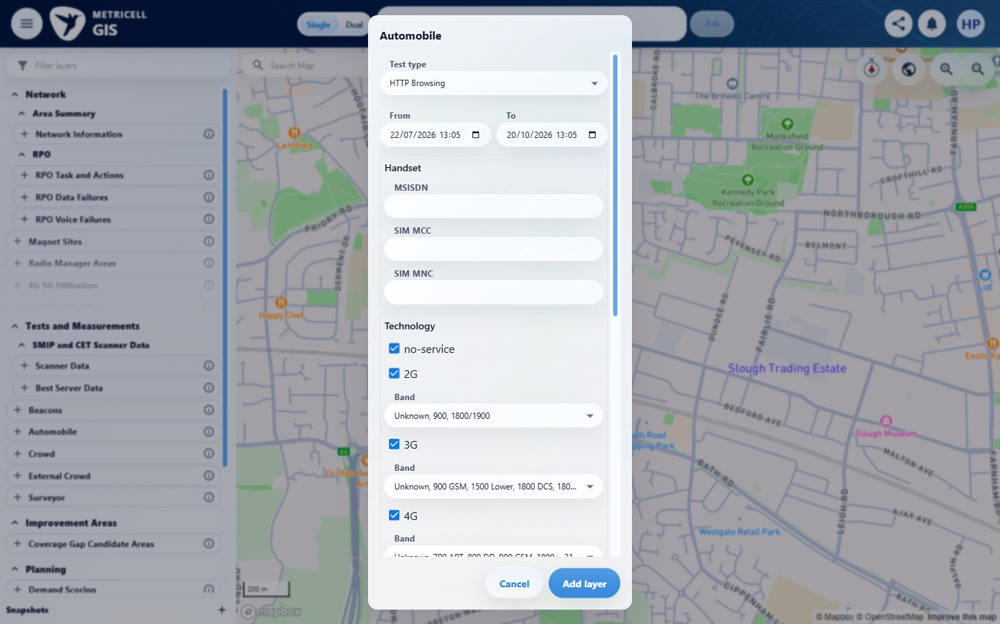

Criterion 8 continued: When MSISDN, CI, Site, or Cell is edited, each field accepts text input.
Browser URL recorded after criterion: https://o2intelligence-v4-dev.metricell.com/gis
E06 - Layer active (criterion-8-layer-active.png) | E51 - Before msisdn (criterion-8-before-msisdn.png)  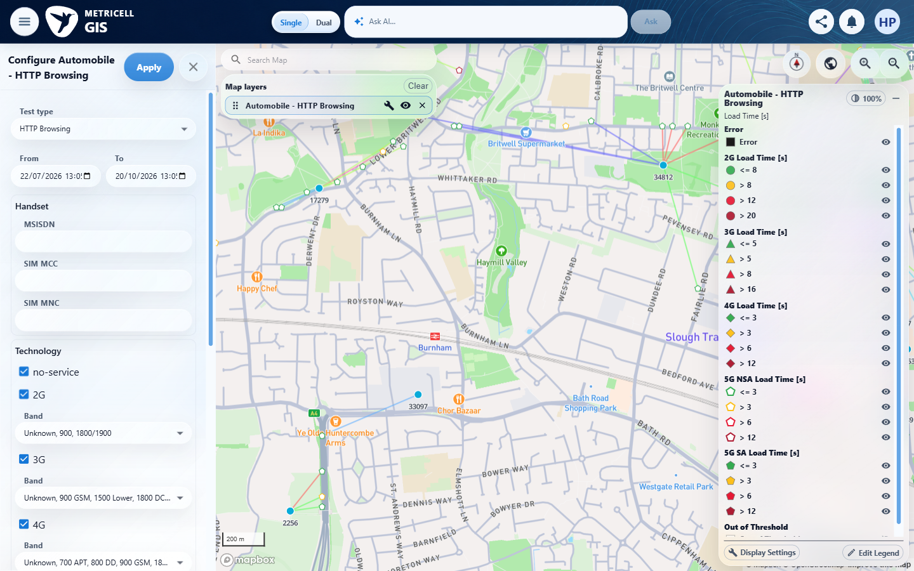

Criterion 8 continued: When MSISDN, CI, Site, or Cell is edited, each field accepts text input.
Browser URL recorded after criterion: https://o2intelligence-v4-dev.metricell.com/gis
E52 - After msisdn (criterion-8-after-msisdn.png)  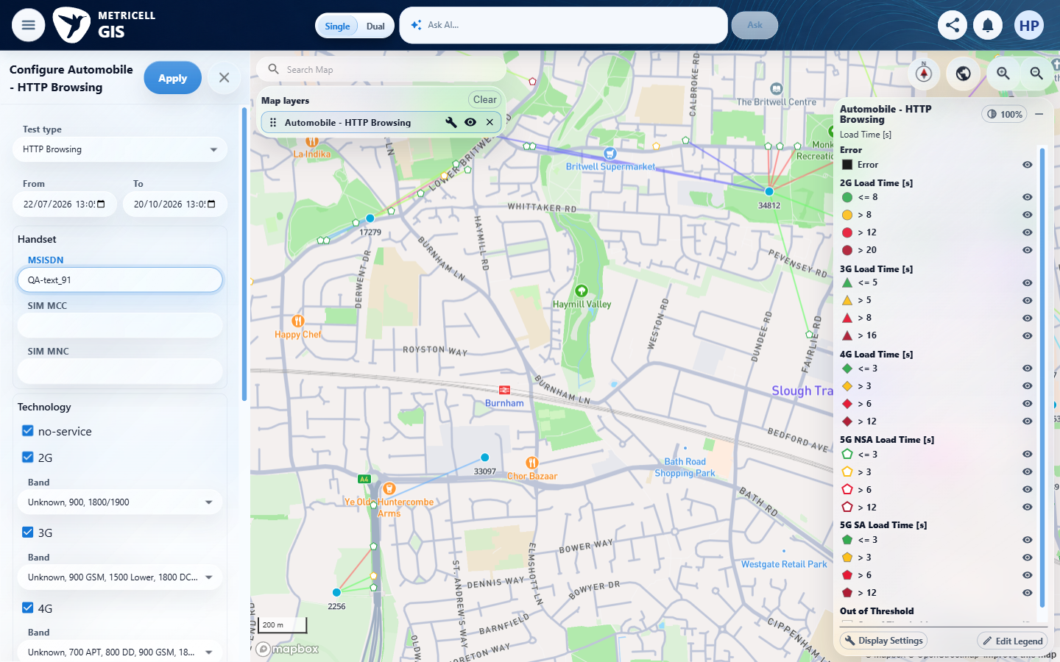 | E53 - Before ci (criterion-8-before-ci.png)  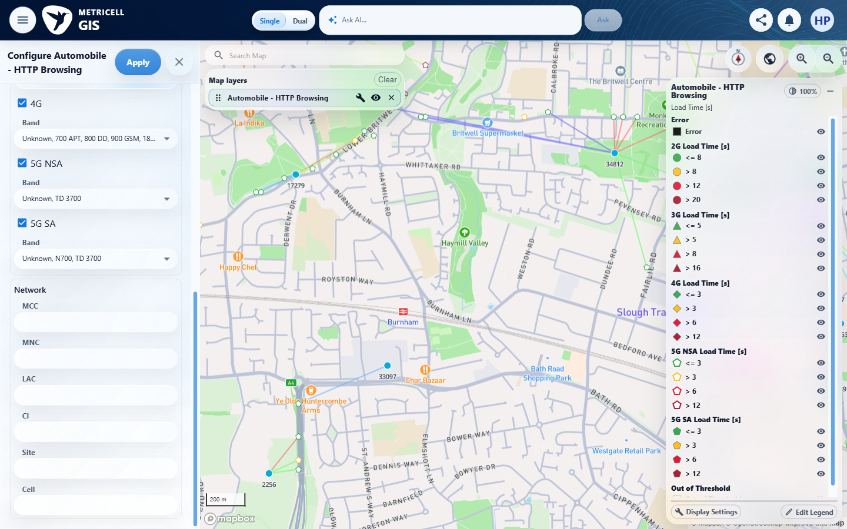

Criterion 8 continued: When MSISDN, CI, Site, or Cell is edited, each field accepts text input.
Browser URL recorded after criterion: https://o2intelligence-v4-dev.metricell.com/gis
E54 - Before site (criterion-8-before-site.png)  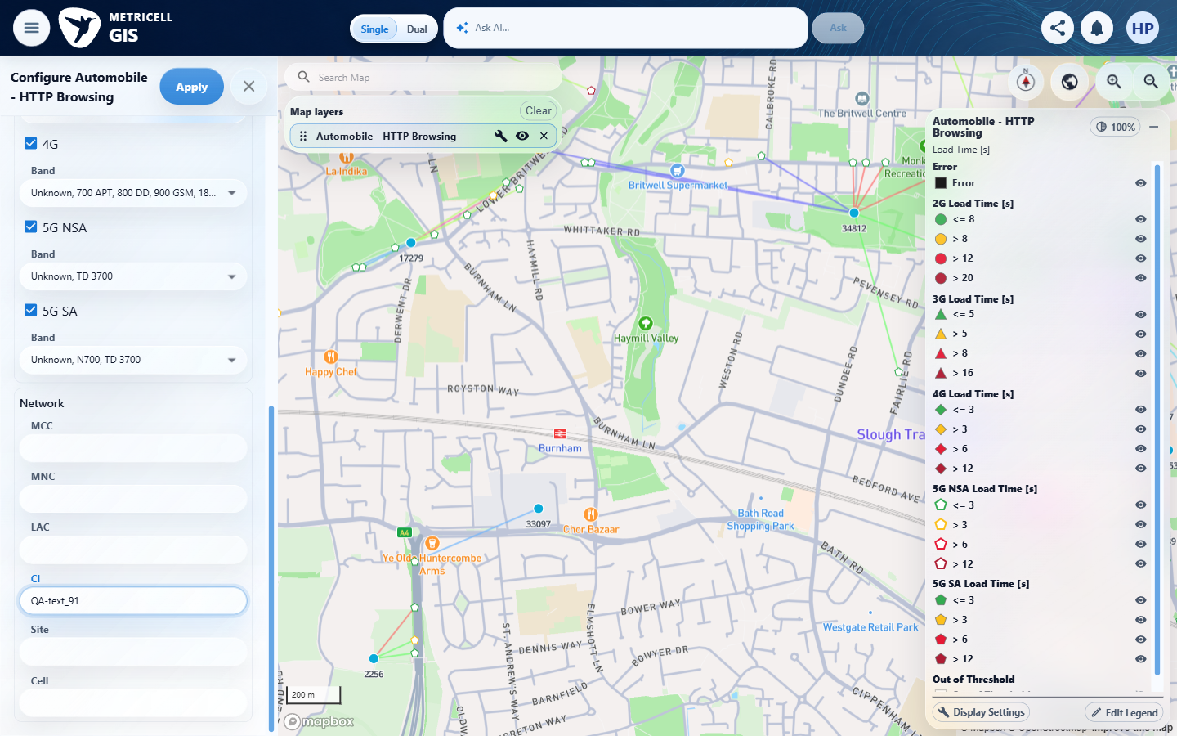 | E55 - Before cell (criterion-8-before-cell.png)  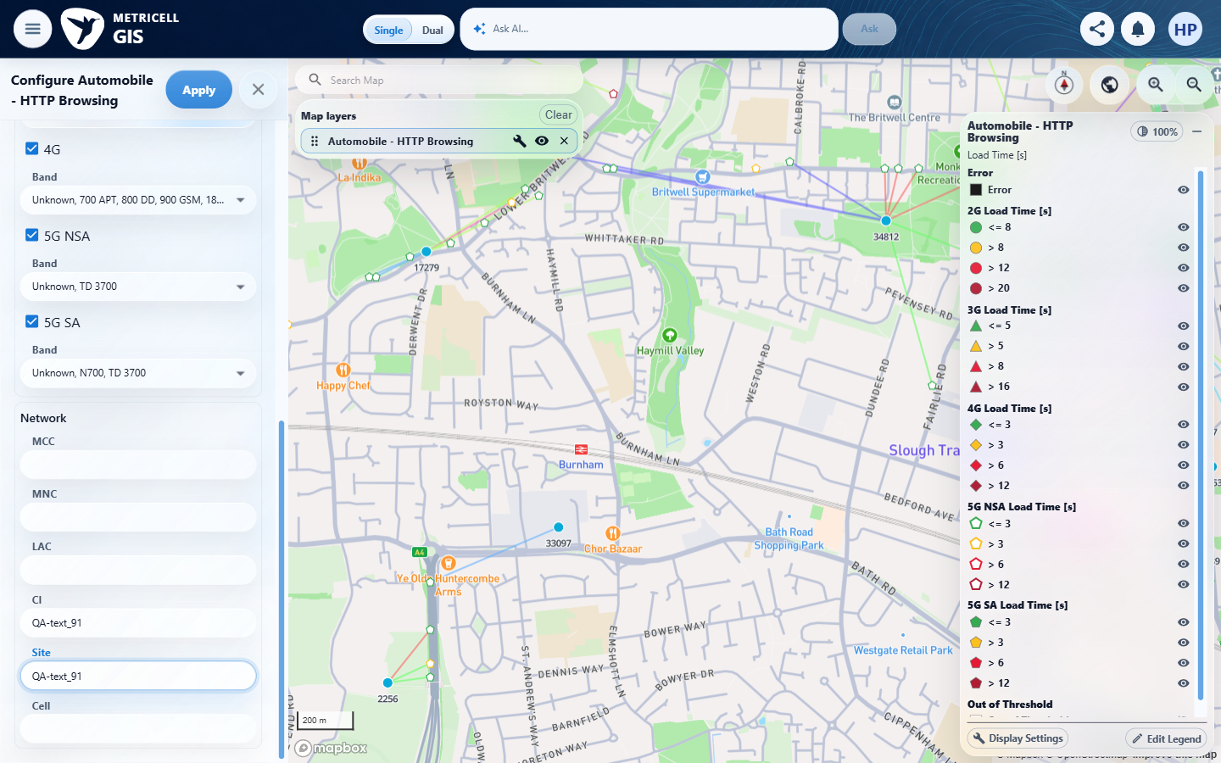

Criterion 8 continued: When MSISDN, CI, Site, or Cell is edited, each field accepts text input.
Browser URL recorded after criterion: https://o2intelligence-v4-dev.metricell.com/gis
E56 - After cell (criterion-8-after-cell.png)  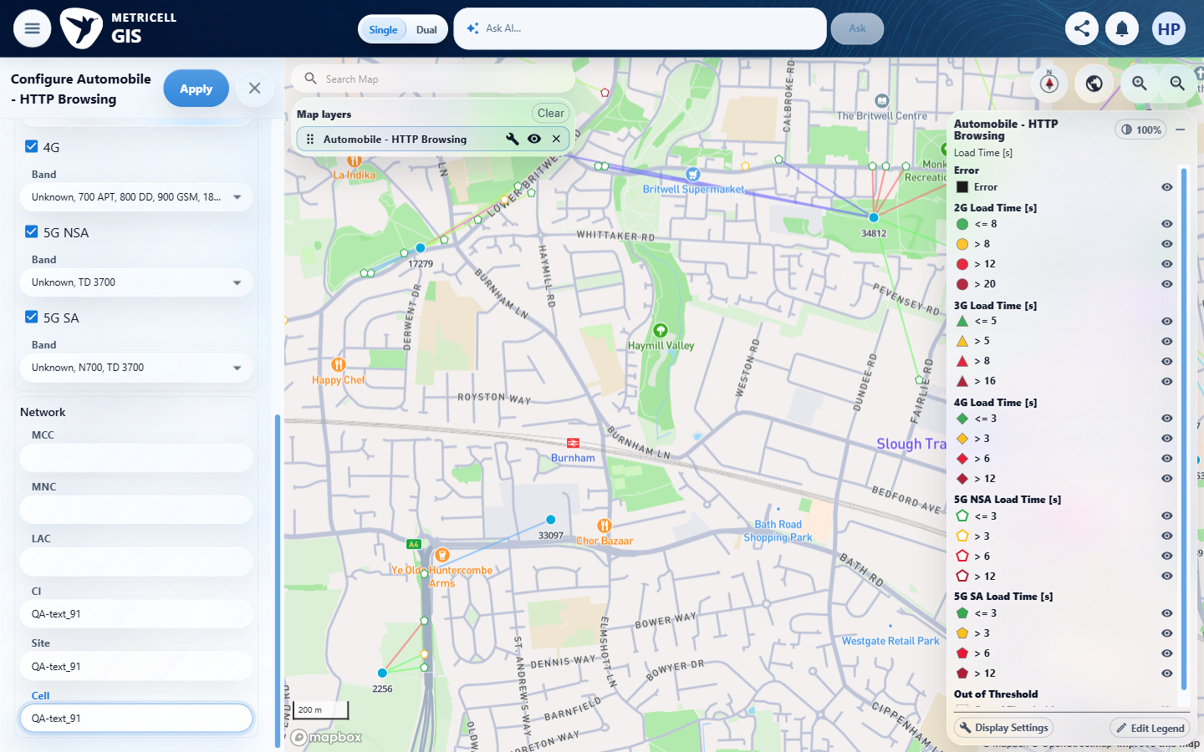 | E57 - Final (criterion-8-final.png)  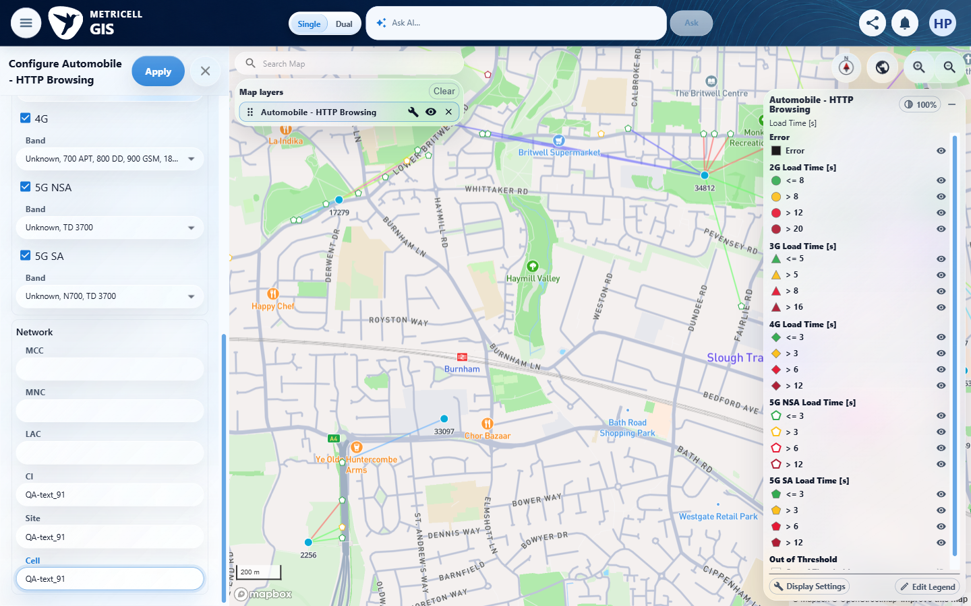

9.0.0 | When one or more filters are applied on a standard Automobile map layer, the displayed map results match the active filter values and are within the user's authorised results. | When one or more filters are applied on a standard Automobile map layer, the displayed map results match the active filter values and are within the user's authorised results. | criterion-9-layer-active.png shows baseline points including Site 17279; criterion-9-after-site-filter.png enters 17279 and criterion-9-after-apply.png shows points cleared. The same criterion's reload sequence, criterion-9-reload-after-site.png to criterion-9-final.png, repeats that state. Results report HTTP 500 on both filtered requests despite HTTP 200 baseline retrieval; unavailable filtered data prevents matching and authorised-result checks, and the cleared map is not proof of a successful empty response.  Evidence: E58, E59, E06, E34, E60, E61, E62, E63, E64, E65 | Blocked
Criterion 9 evidence: When one or more filters are applied on a standard Automobile map layer, the displayed map results match the active filter values and are within the user's authorised results.
Browser URL recorded after criterion: https://o2intelligence-v4-dev.metricell.com/gis
E58 - Before automobile (criterion-9-before-automobile.png)  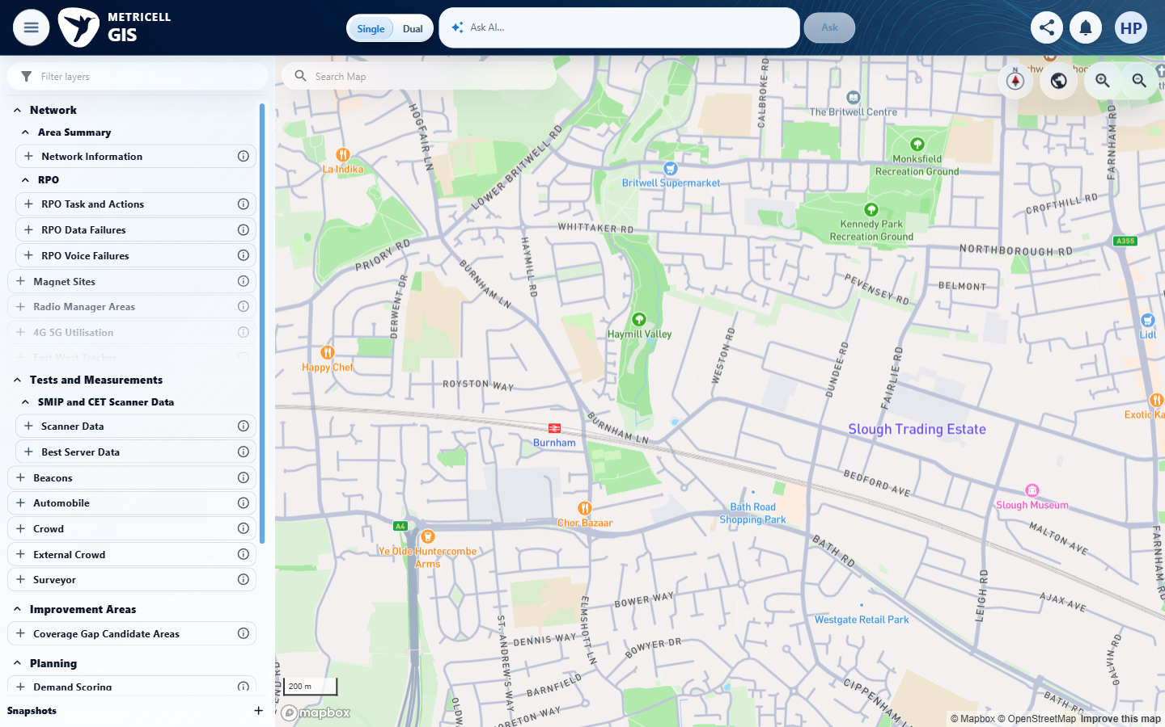 | E59 - After automobile (criterion-9-after-automobile.png)  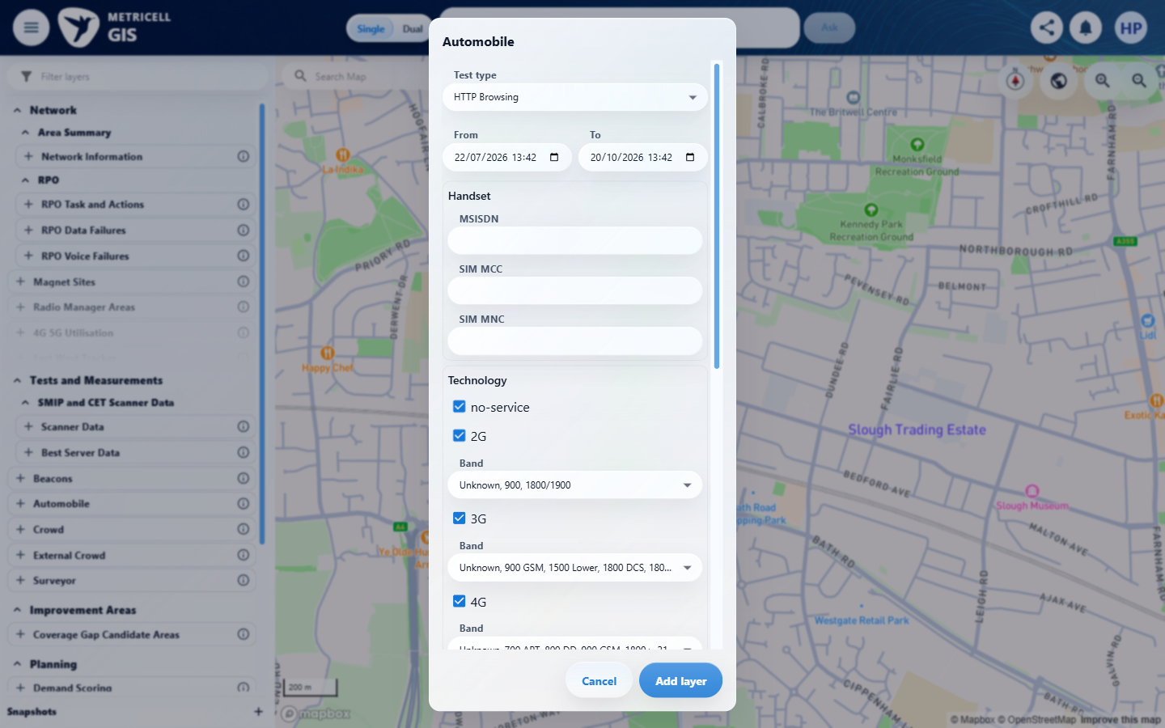

Criterion 9 continued: When one or more filters are applied on a standard Automobile map layer, the displayed map results match the active filter values and are within the user's authorised results.
Browser URL recorded after criterion: https://o2intelligence-v4-dev.metricell.com/gis
E06 - Layer active (criterion-9-layer-active.png) | E34 - Before site filter (criterion-9-before-site-filter.png)

Criterion 9 continued: When one or more filters are applied on a standard Automobile map layer, the displayed map results match the active filter values and are within the user's authorised results.
Browser URL recorded after criterion: https://o2intelligence-v4-dev.metricell.com/gis
E60 - After site filter (criterion-9-after-site-filter.png)  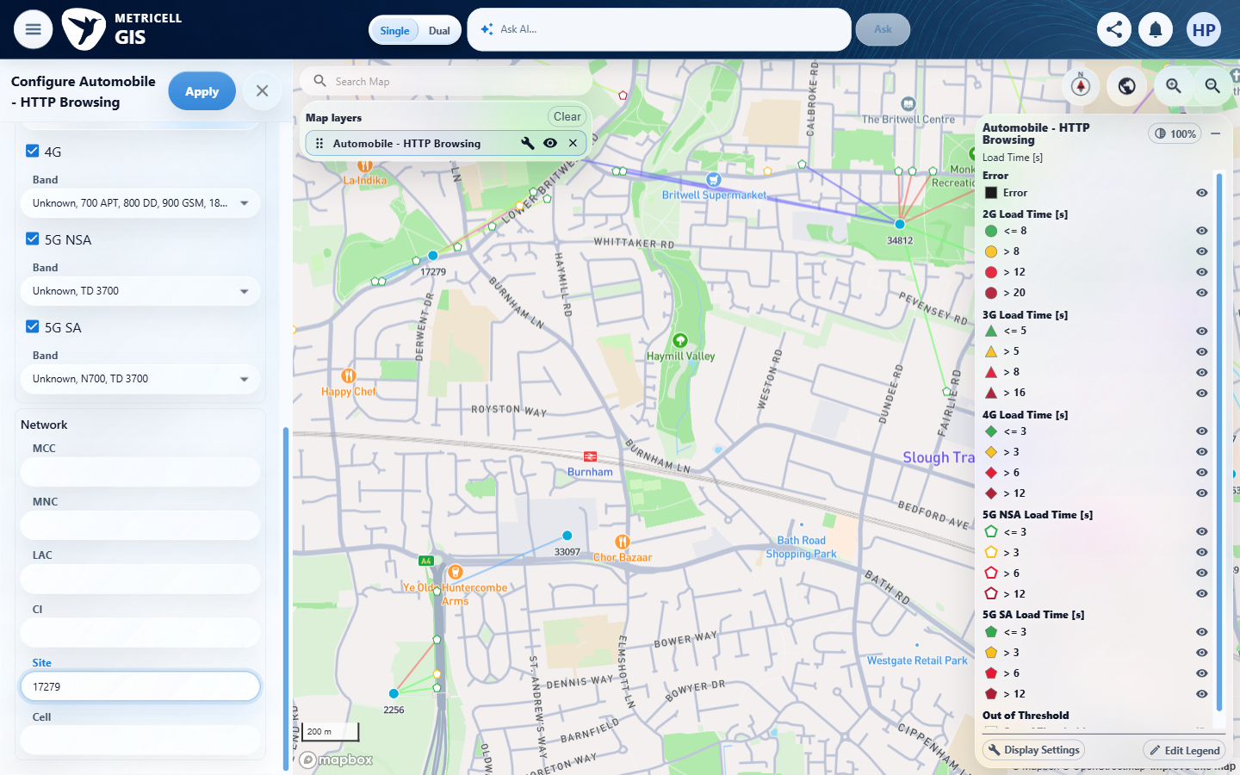 | E61 - After apply (criterion-9-after-apply.png)  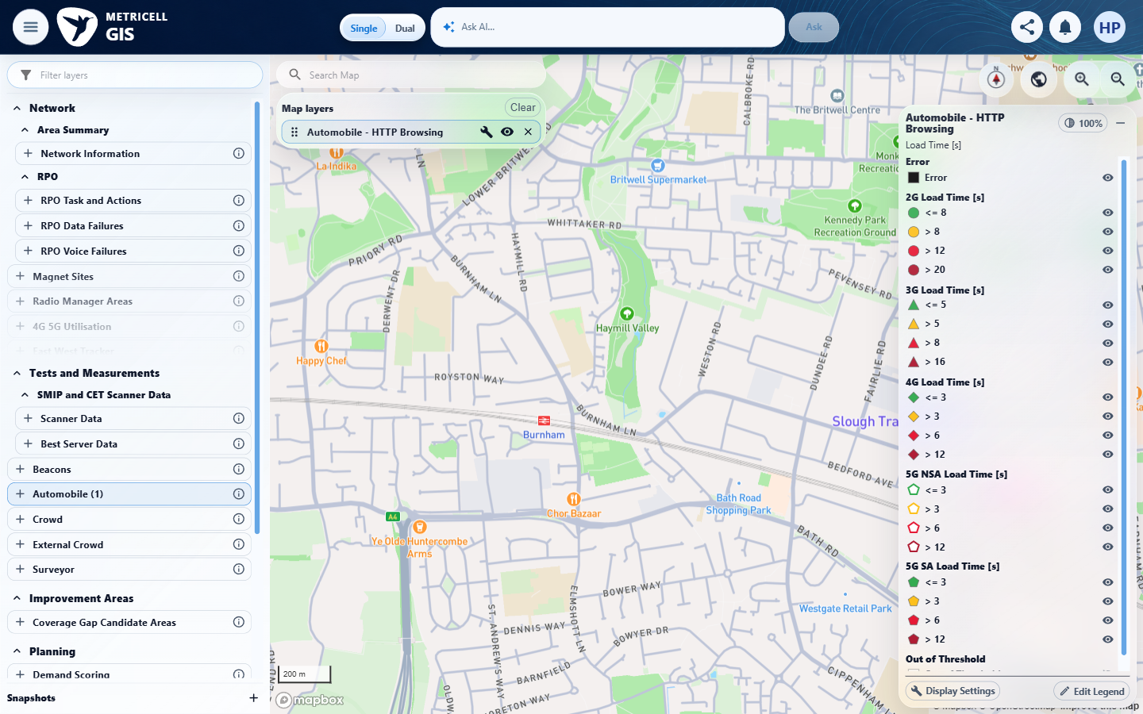

Criterion 9 continued: When one or more filters are applied on a standard Automobile map layer, the displayed map results match the active filter values and are within the user's authorised results.
Browser URL recorded after criterion: https://o2intelligence-v4-dev.metricell.com/gis
E58 - Reload before automobile (criterion-9-reload-before-automobile.png) | E62 - Reload after automobile (criterion-9-reload-after-automobile.png)  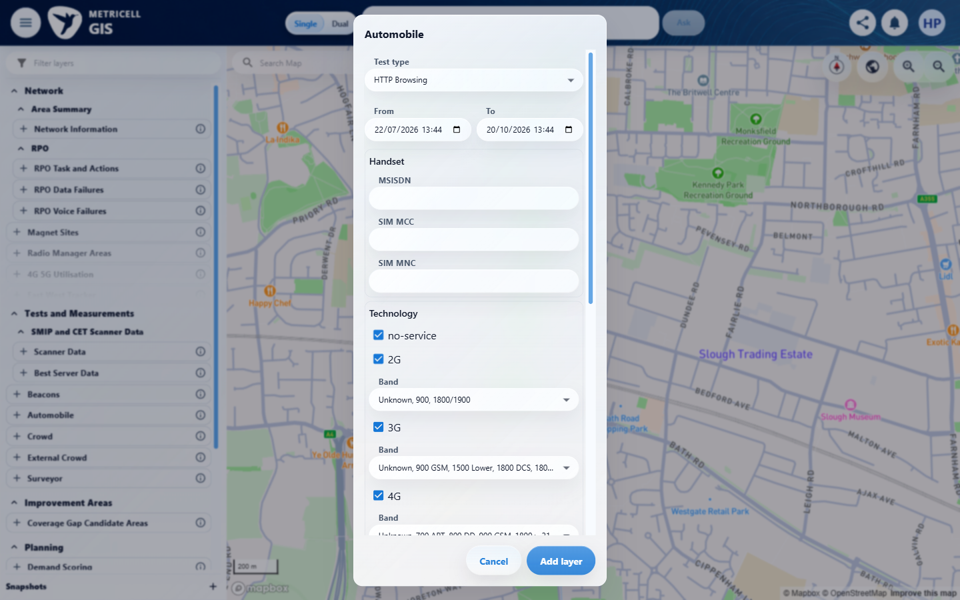

Criterion 9 continued: When one or more filters are applied on a standard Automobile map layer, the displayed map results match the active filter values and are within the user's authorised results.
Browser URL recorded after criterion: https://o2intelligence-v4-dev.metricell.com/gis
E06 - Reload layer active (criterion-9-reload-layer-active.png) | E34 - Reload before site (criterion-9-reload-before-site.png)

Criterion 9 continued: When one or more filters are applied on a standard Automobile map layer, the displayed map results match the active filter values and are within the user's authorised results.
Browser URL recorded after criterion: https://o2intelligence-v4-dev.metricell.com/gis
E63 - Reload after site (criterion-9-reload-after-site.png)  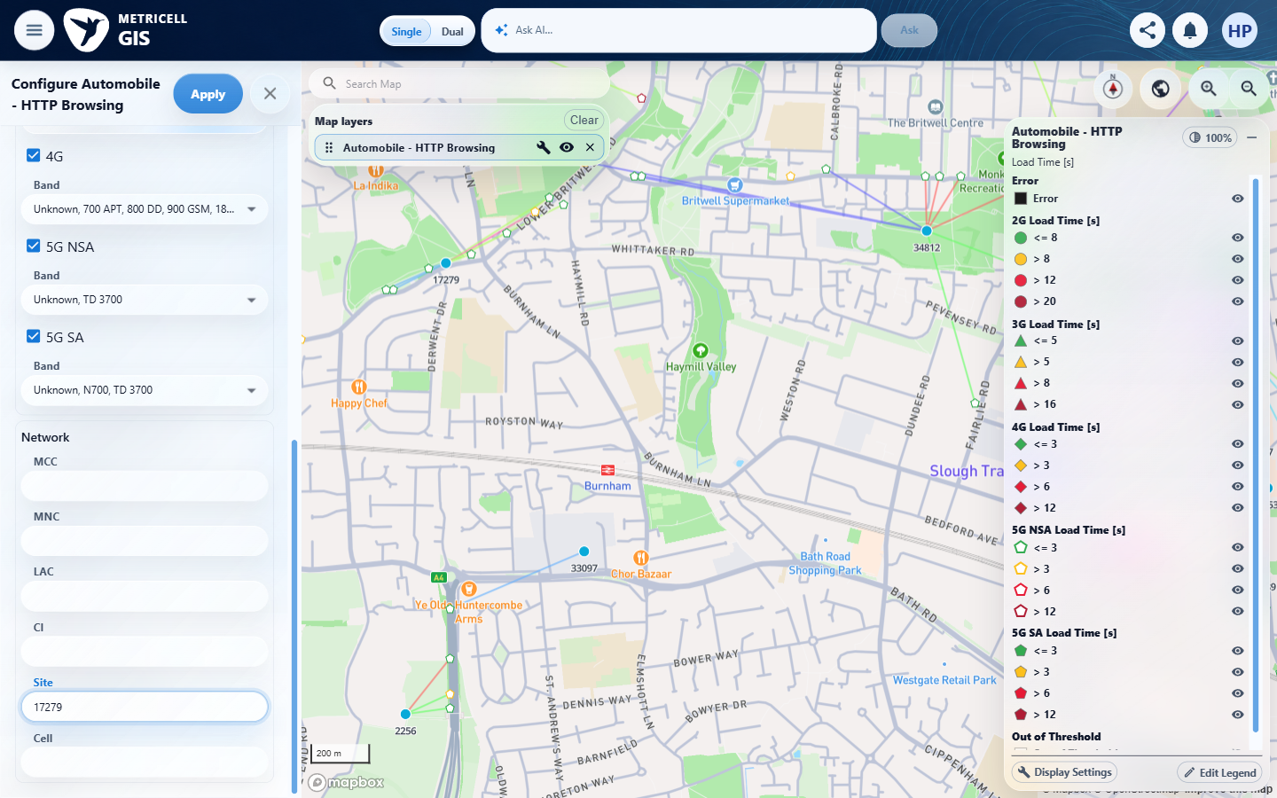 | E64 - Reload after apply (criterion-9-reload-after-apply.png)  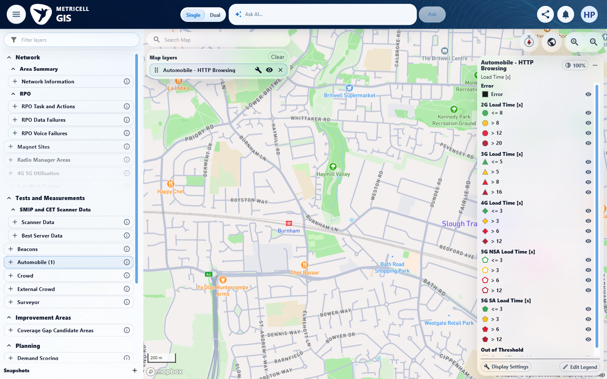

Criterion 9 continued: When one or more filters are applied on a standard Automobile map layer, the displayed map results match the active filter values and are within the user's authorised results.
Browser URL recorded after criterion: https://o2intelligence-v4-dev.metricell.com/gis
E65 - Final (criterion-9-final.png)
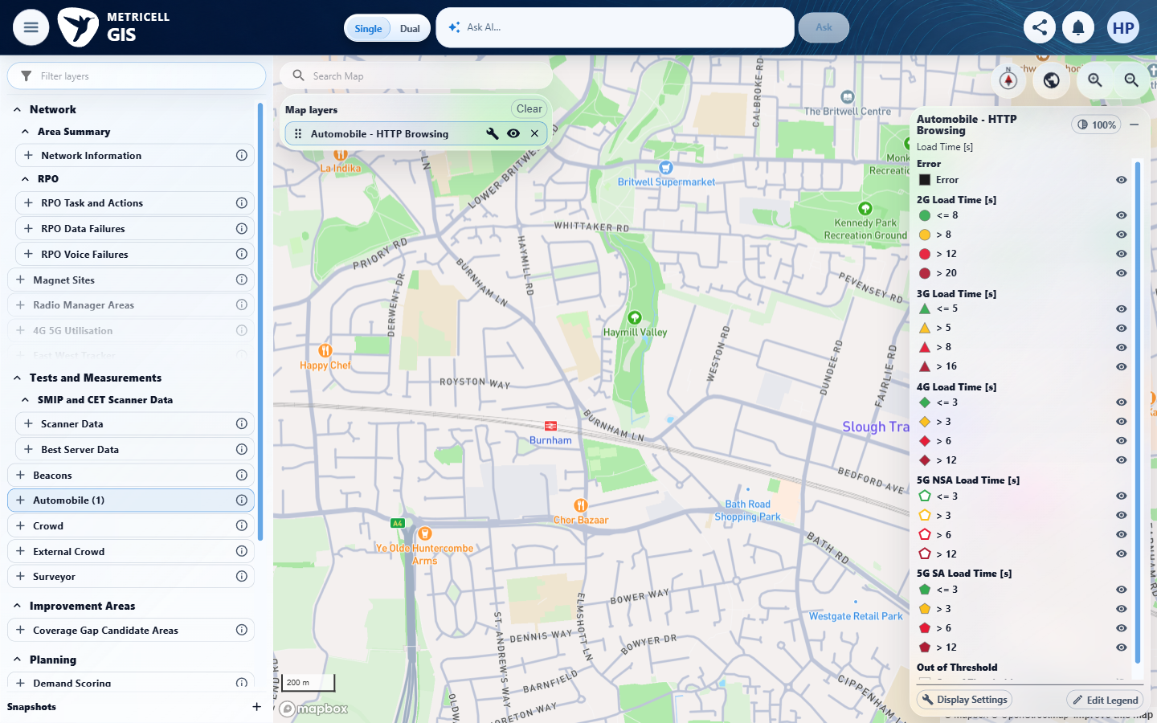

10.0.0 | On a Call layer, the technology filter does not offer 5G NSA. | On a Call layer, the technology filter does not offer 5G NSA. | criterion-10-final.png directly shows Configure Automobile - Call with 5G NSA offered and checked, contradicting its required absence.  Evidence: E01, E66, E67, E68, E69, E70, E71, E72, E73 | Failed
Criterion 10 evidence: On a Call layer, the technology filter does not offer 5G NSA.
Browser URL recorded after criterion: https://o2intelligence-v4-dev.metricell.com/gis
E01 - Before automobile (criterion-10-before-automobile.png) | E66 - After automobile (criterion-10-after-automobile.png)  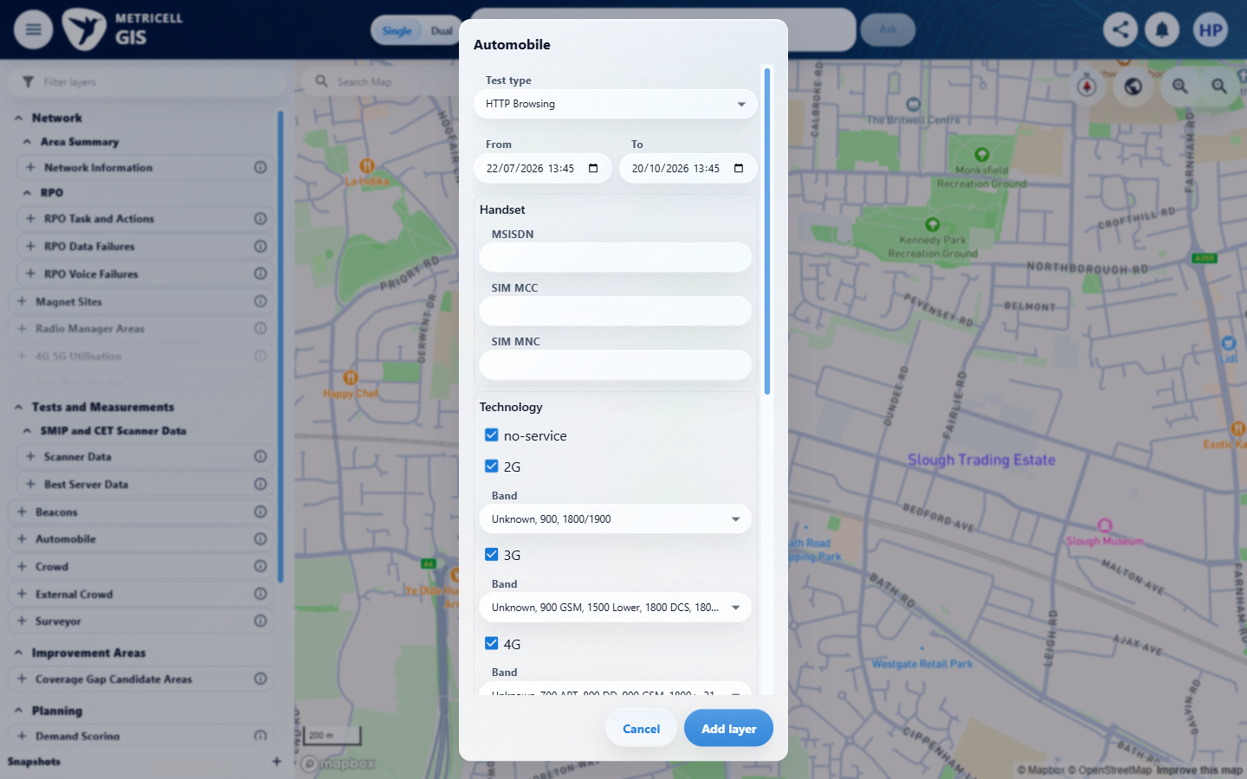

Criterion 10 continued: On a Call layer, the technology filter does not offer 5G NSA.
Browser URL recorded after criterion: https://o2intelligence-v4-dev.metricell.com/gis
E67 - Before call (criterion-10-before-call.png)  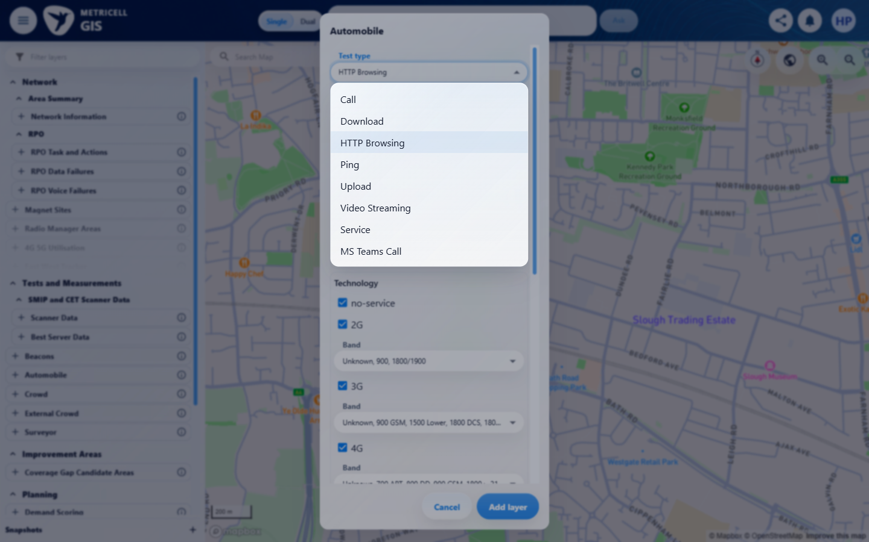 | E68 - After call (criterion-10-after-call.png)  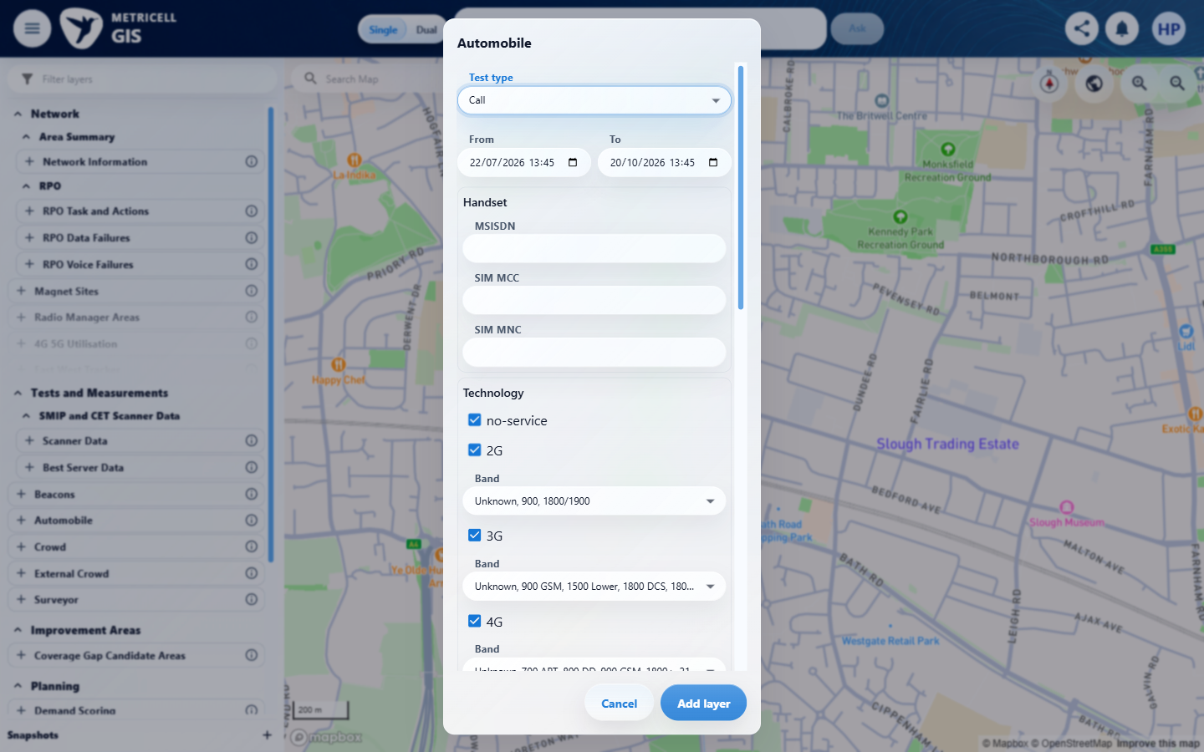

Criterion 10 continued: On a Call layer, the technology filter does not offer 5G NSA.
Browser URL recorded after criterion: https://o2intelligence-v4-dev.metricell.com/gis
E69 - Layer active (criterion-10-layer-active.png)  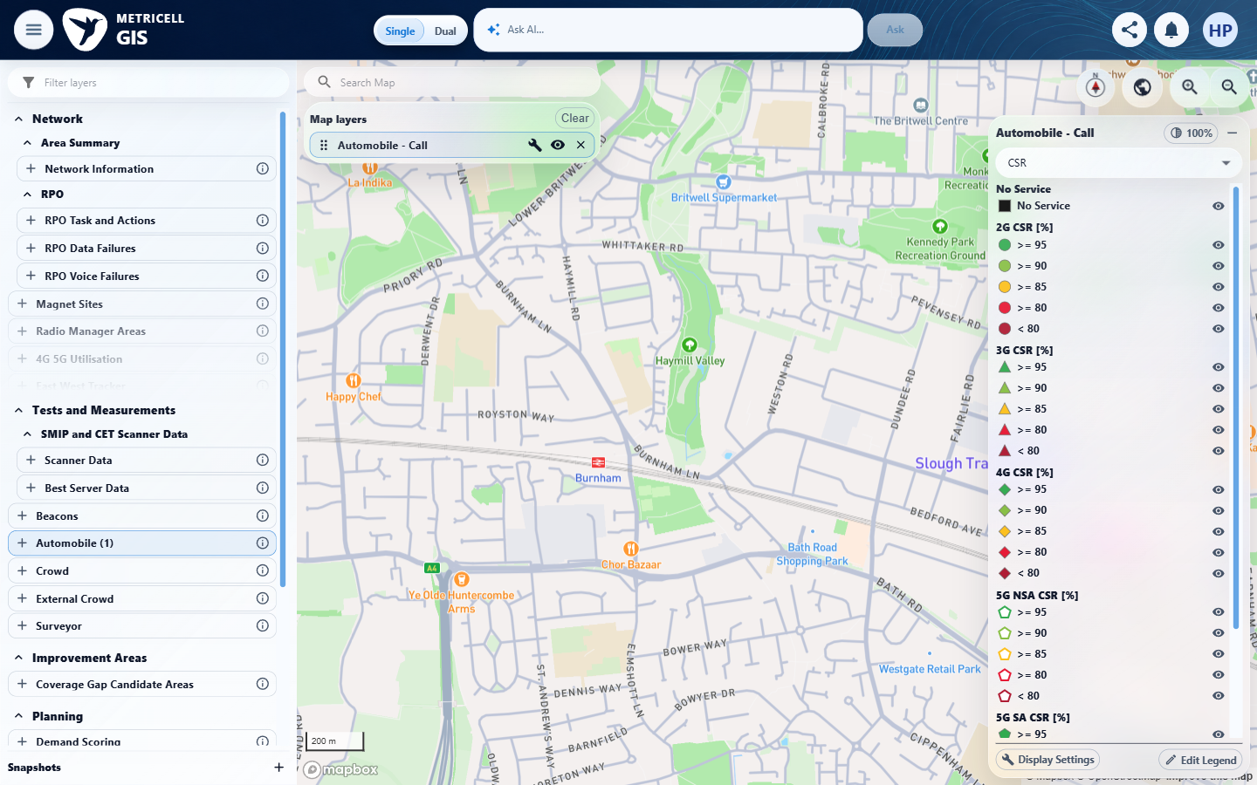 | E01 - Recheck before automobile (criterion-10-recheck-before-automobile.png)

Criterion 10 continued: On a Call layer, the technology filter does not offer 5G NSA.
Browser URL recorded after criterion: https://o2intelligence-v4-dev.metricell.com/gis
E70 - Recheck after automobile (criterion-10-recheck-after-automobile.png)  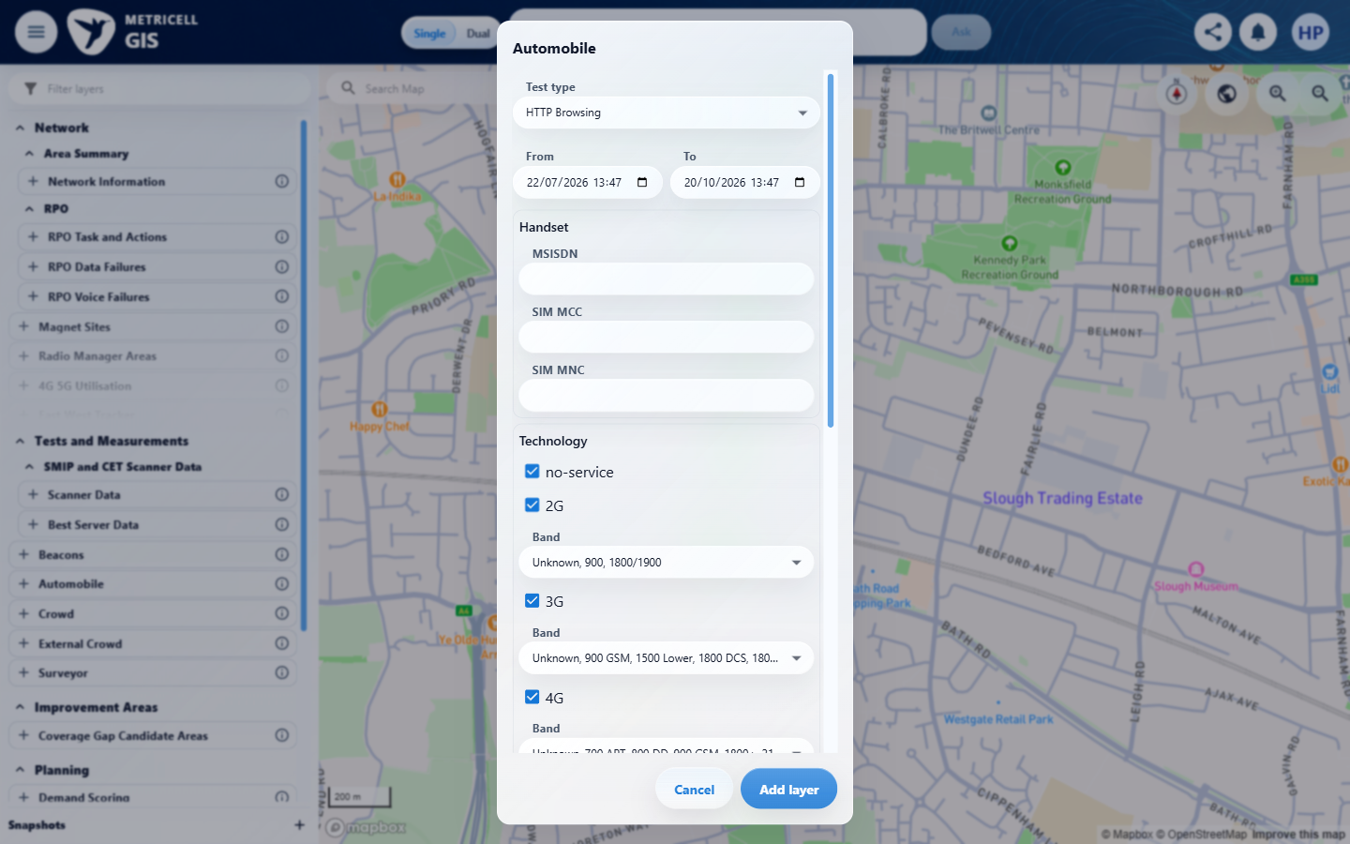 | E71 - Recheck before call (criterion-10-recheck-before-call.png)  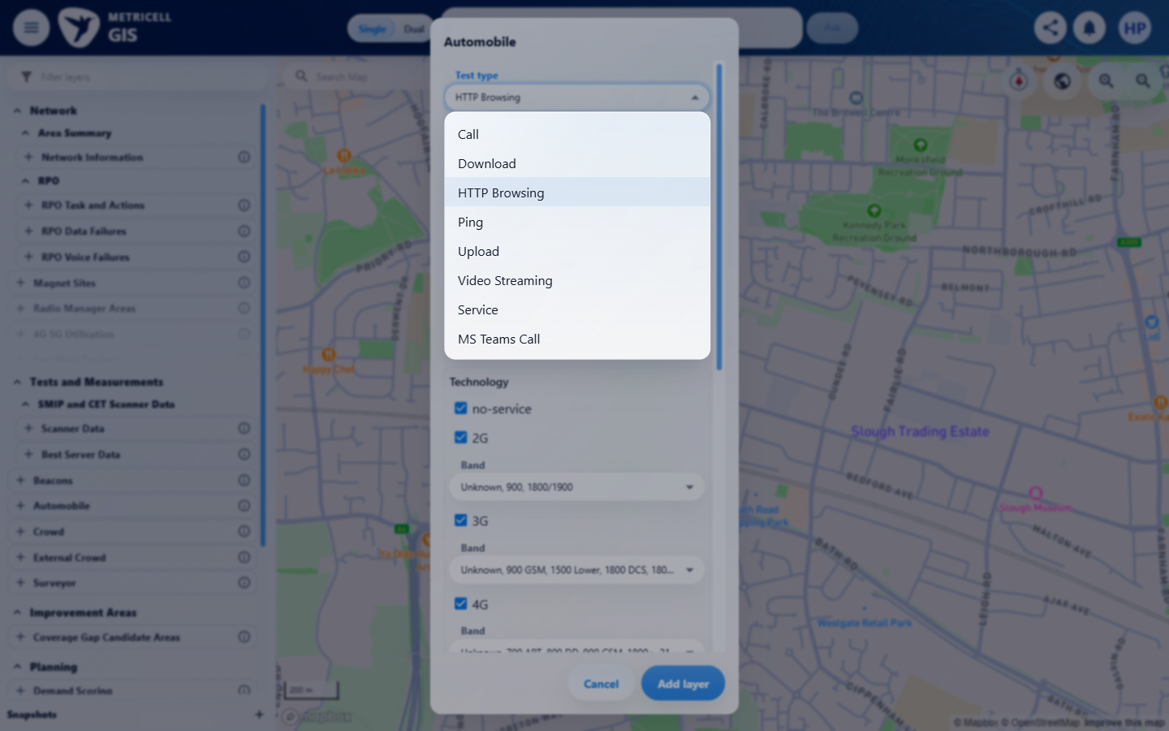

Criterion 10 continued: On a Call layer, the technology filter does not offer 5G NSA.
Browser URL recorded after criterion: https://o2intelligence-v4-dev.metricell.com/gis
E72 - Recheck after call (criterion-10-recheck-after-call.png)  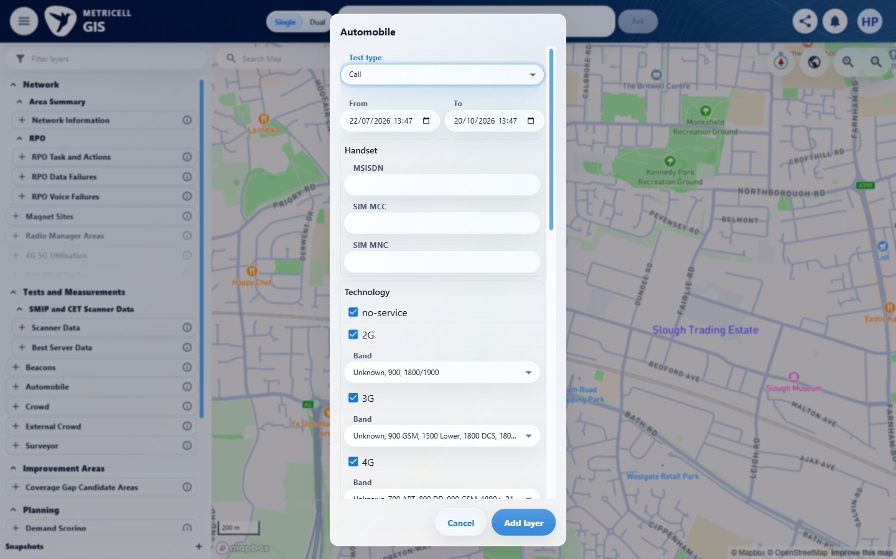 | E69 - Recheck layer active (criterion-10-recheck-layer-active.png)

Criterion 10 continued: On a Call layer, the technology filter does not offer 5G NSA.
Browser URL recorded after criterion: https://o2intelligence-v4-dev.metricell.com/gis
E73 - Final (criterion-10-final.png)
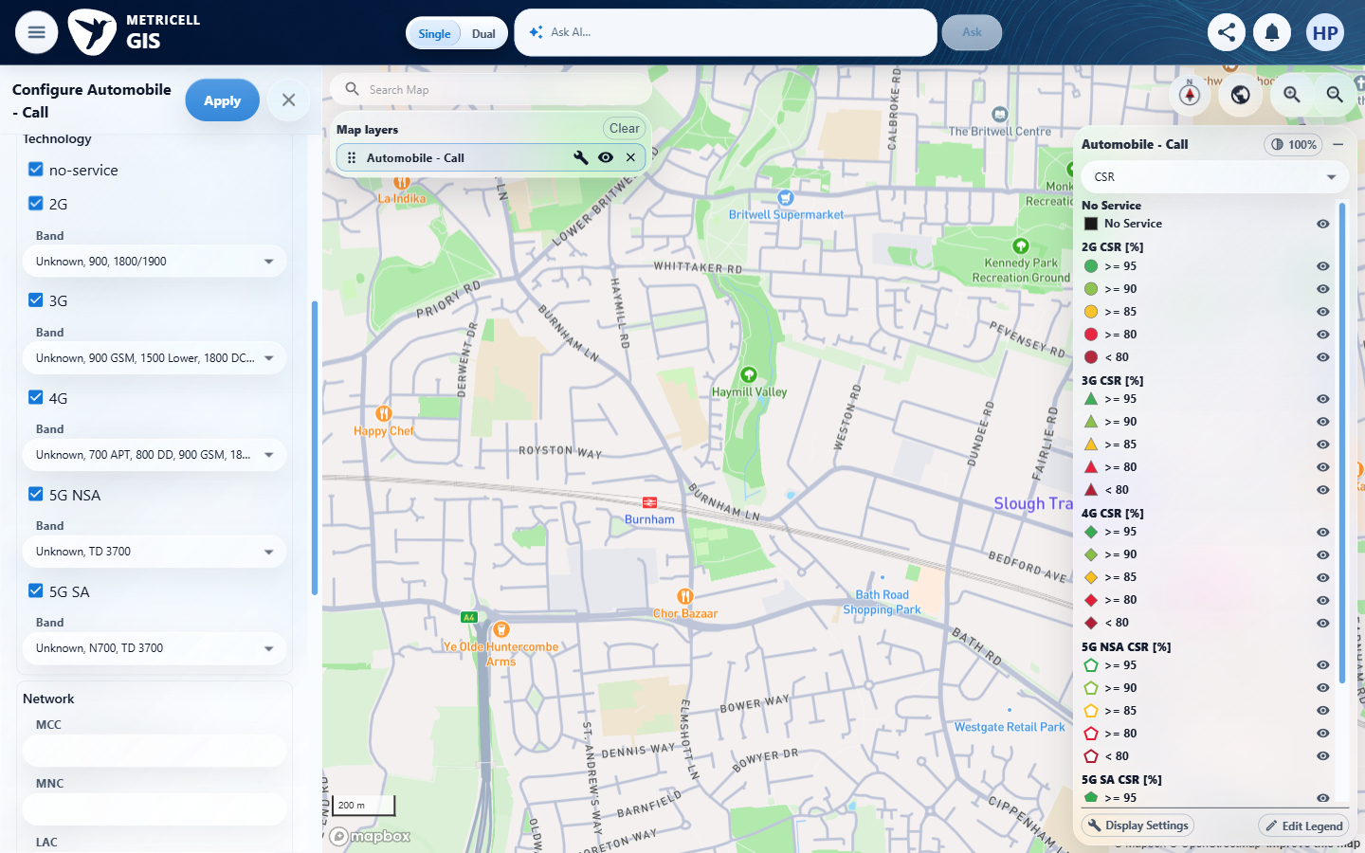

11.0.0 | When device groups are shown, restricted device-segregation options are not offered. | When device groups are shown, restricted device-segregation options are not offered. | criterion-11-after-automobile.png shows the add form's upper portion and criterion-11-final.png shows the active form's bottom; criterion-11-layer-active.png has no filter panel. No captured state shows device groups displayed, and the complete active form is not captured, so these images do not establish restricted-option exclusion when groups are shown.  Evidence: E01, E74, E06, E34 | Failed
Criterion 11 evidence: When device groups are shown, restricted device-segregation options are not offered.
Browser URL recorded after criterion: https://o2intelligence-v4-dev.metricell.com/gis
E01 - Before automobile (criterion-11-before-automobile.png) | E74 - After automobile (criterion-11-after-automobile.png)  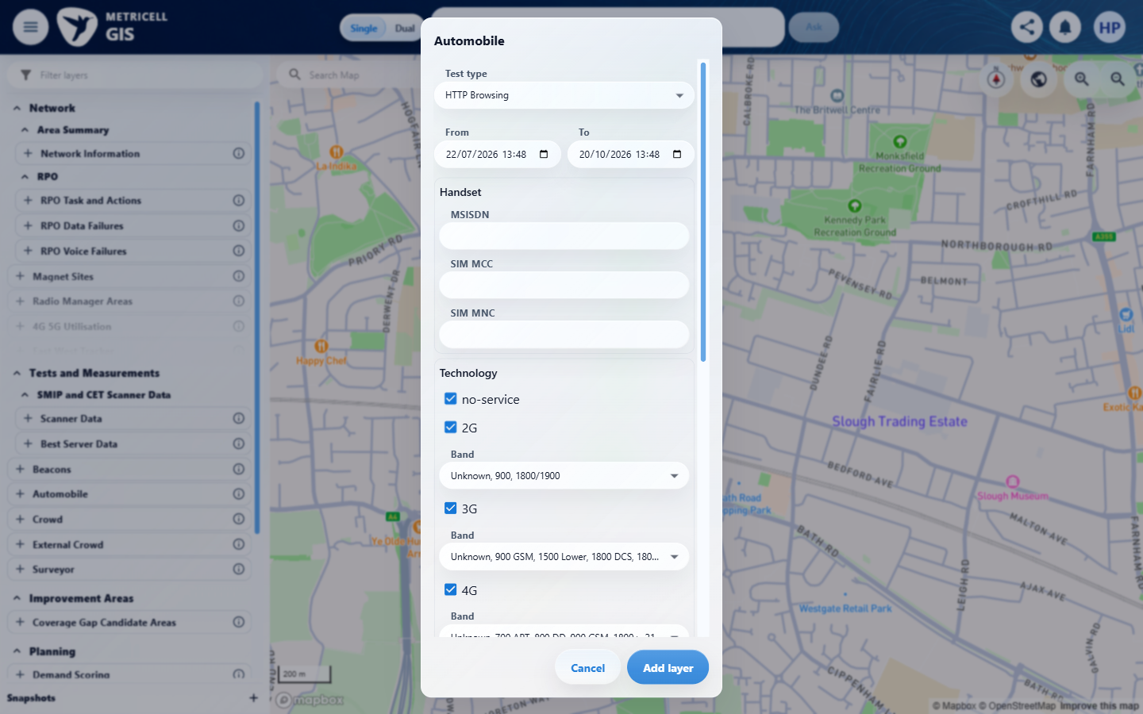

Criterion 11 continued: When device groups are shown, restricted device-segregation options are not offered.
Browser URL recorded after criterion: https://o2intelligence-v4-dev.metricell.com/gis
E06 - Layer active (criterion-11-layer-active.png) | E34 - Final (criterion-11-final.png)

12.0.0 | On Route Replay, the standard Automobile map filter controls described in this ticket are not available. | On Route Replay, the standard Automobile map filter controls described in this ticket are not available. | criterion-12-initial.png and criterion-12-navigation.png show no Route Replay entry; criterion-12-before-route-search.png to criterion-12-final.png shows Route search settling at No layers match this search. Route Replay could not be activated in the available environment to inspect its controls.  Evidence: E75, E76, E77 | Blocked
Criterion 12 evidence: On Route Replay, the standard Automobile map filter controls described in this ticket are not available.
Browser URL recorded after criterion: https://o2intelligence-v4-dev.metricell.com/gis
E75 - Navigation (criterion-12-navigation.png)  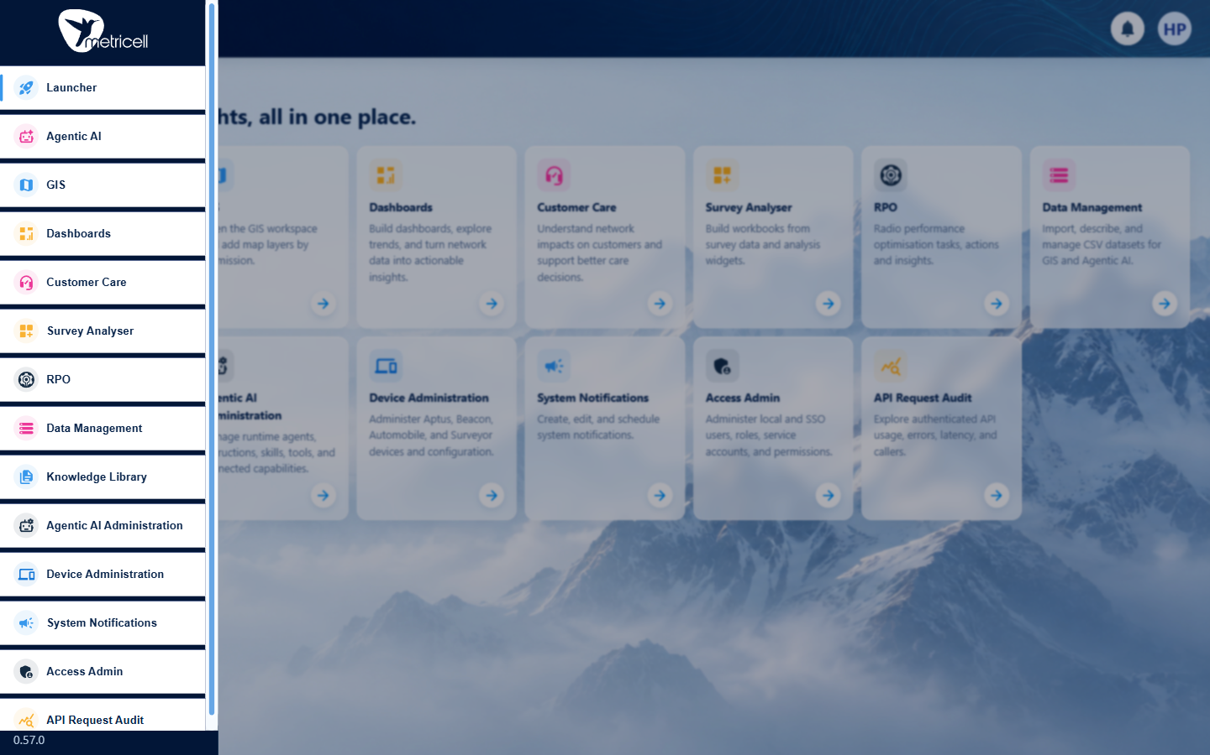 | E76 - Before route search (criterion-12-before-route-search.png)  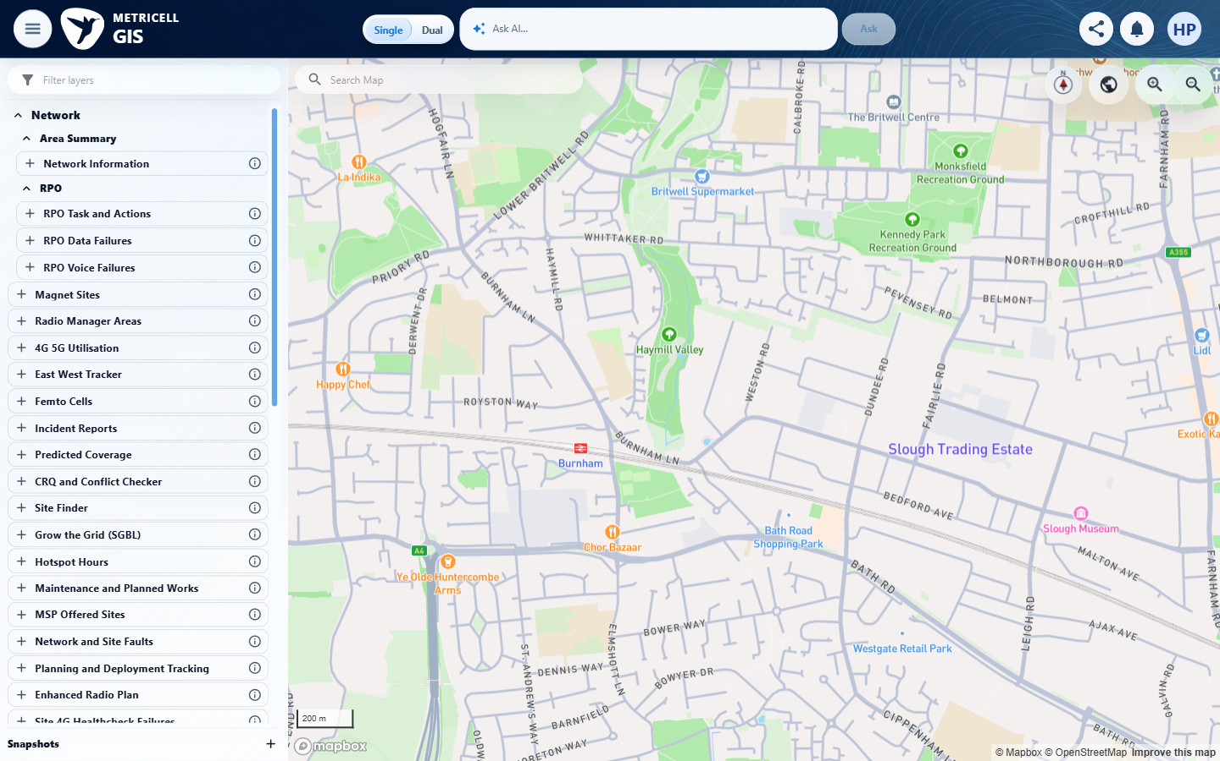

Criterion 12 continued: On Route Replay, the standard Automobile map filter controls described in this ticket are not available.
Browser URL recorded after criterion: https://o2intelligence-v4-dev.metricell.com/gis
E77 - Final (criterion-12-final.png)
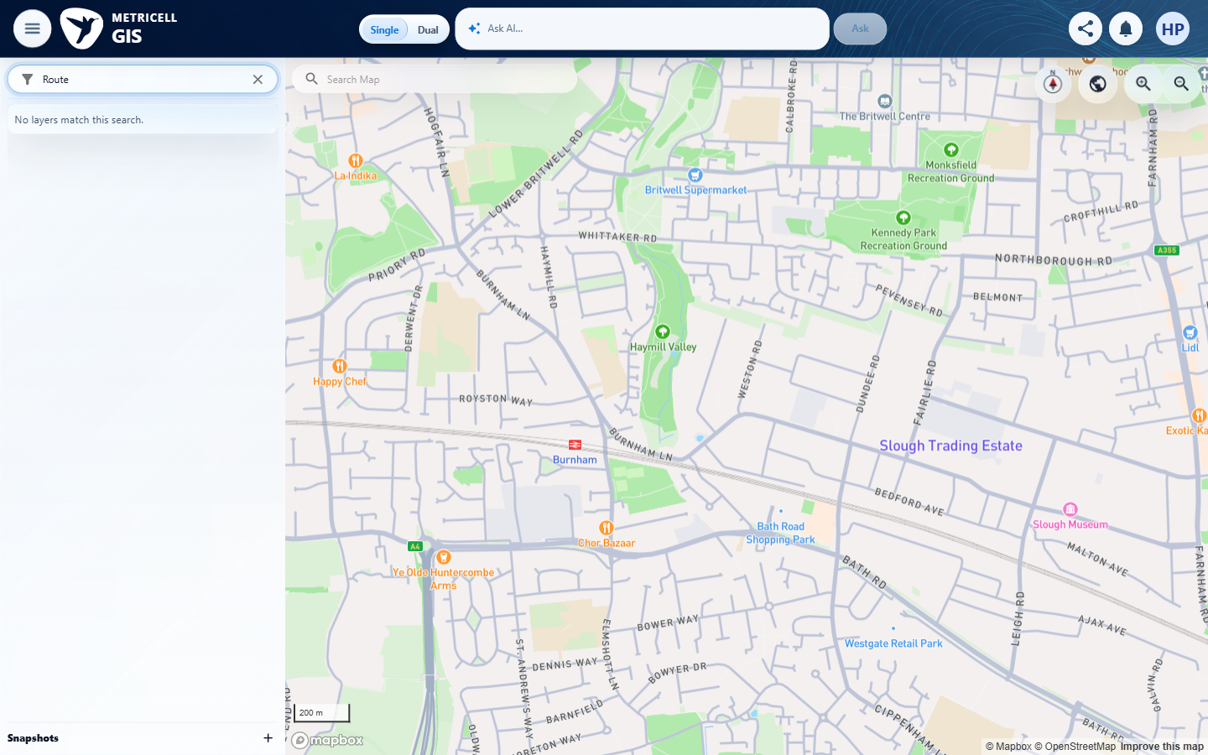

About Metricell

Metricell is on a mission to deliver connectivity. We work with our customers to design, deliver and manage wireless communication networks – with a shared ambition of achieving flawless network experience. We’ve been responsible for many first-to-market products, and our technology is characterised by the relentless pursuit of automation and digitalisation.

Our geospatial intelligence tools traverse a wide variety of business processes – from Test & Measurement to Customer Experience Management – and we’re pioneers in Crowdsourcing and Digital Self Care. Our technology is today in use by a range of customers; thousands of their personnel; and millions of subscribers worldwide.

Find out more at www.metricell.com




