

Automated Test Case Document
Jira Ticket: TEST2-79

Document Classification: | Company Confidential
Document Ref: | Automated Test Case Document
Version: | 1.0
Date: | 22/10/2026
Document Author: | Automated TEST2 Evidence Review
Document Owner: | Quality Assurance / Metricell




This document and its content is copyright of Metricell Limited @ 2026 all rights reserved. All information contained herein is the intellectual property of Metricell Limited and should be treated as confidential. Any external redistribution of reproduction of part or all of the contents in any form is prohibited unless expressly agreed with Metricell Limited in writing. Any reproduced content must include the following statement; “Part or all of the content contained herein is copyright of Metricell Limited @ 2026 all rights reserved”.
Table of Contents
1 Revision History 2
2 Test Cycle Information 3
3 Test Summary 3
4 Test Cases 4
About Metricell 12

Revision History

Version | Date | Revision Author | Summary of Changes
[1.0] | 22/10/2026 | TEST2 QA Automation | Generated from TEST2 evidence review

Test Cycle Information

Tester: | Automated
Jira Ticket: | TEST2-79
Environment: | o2intelligence-v4-dev.metricell.com
Browser Details: | Google Chrome 156.0.8078.48
Date of Test: | 22/10/2026
Limitations during Testing: | Blocked criterion(s): 7, 8, 9, 10, 11, 12, 13, 14, 15, 16. See the assessment below each criterion.  Unverified criterion(s): 1, 4. See the assessment below each criterion.  Some source URLs were not recorded. Inconclusive evidence is reported as Failed, but is not a confirmed application defect. Pass, Fail and Blocked use Y/N. Defect No counts directly contradicted criteria, not unique Jira bugs; blockers and inconclusive evidence count as zero.
Overall review outcome: | Blocked
Browser URL(s) recorded after criteria: | https://o2intelligence-v4-dev.metricell.com/gis

Test Summary

Area of test | Pass (Y/N) | Fail (Y/N) | Blocked (Y/N) | Defect No
1. With neither layer selected, the map shows no Download or Upload test-result points. | N | Y | N | 0
2. After selecting Download, the map shows selectable points for matching authorised Download results only. | Y | N | N | 0
3. After selecting Upload, the map shows selectable points for matching authorised Upload results only. | Y | N | N | 0
4. Selecting a Download result point opens its details dialog with Data Technology, MSISDN, Service, Serving Cell, Test Duration, Test Technologies, Download Rate, and Wi-Fi Connected. | N | Y | N | 0
5. Selecting an Upload result point opens its details dialog with Data Technology, MSISDN, Service, Serving Cell, Test Duration, Test Technologies, Upload Rate, and Wi-Fi Connected. | Y | N | N | 0
6. The Download result details chart plots Signal Strength in dBm and Download Rate in Mbps over time. | Y | N | N | 0
7. The Upload result details chart plots Signal Strength in dBm and Upload Rate in Mbps over time. | N | N | Y | 0
8. The Download details table displays MSISDN, Start Time, End Time, Download Rate, Band, Serving Cell, Service, Test Technologies, Data Technology, Wi-Fi Connected, URL, and Error Message. | N | N | Y | 0
9. The Upload details table displays MSISDN, Start Time, End Time, Upload Rate, Band, Serving Cell, Service, Test Technologies, Data Technology, Wi-Fi Connected, URL, and Error Message. | N | N | Y | 0
10. Where signal strength or rate values are shown, each value includes its applicable unit (dBm or Mbps). | N | N | Y | 0
11. For a result whose Error Message is null, the details table displays “No Error”. | N | N | Y | 0
12. Sorting a supported Download or Upload details-table column changes the displayed row order to match the selected sort. | N | N | Y | 0
13. Filtering a supported Download or Upload details-table column displays rows matching the applied filter. | N | N | Y | 0
14. Requesting details for a zero-duration test does not open a details dialog. | N | N | Y | 0
15. While result details are loading, the interface shows a loading state without stale or misleading detail data. | N | N | Y | 0
16. If result details fail to load, the interface shows an error state without stale or misleading detail data. | N | N | Y | 0

Test Cases
Each test maps to a criterion and decisive browser evidence. Inconclusive results are reported as Failed.

Tests

Preconditions: | V4 access and ticket conditions. | Associated Requirements: | Ticket criteria below. | Automation Notes: | Screenshots below each criterion; full log retained locally.
ID / Criterion | Criteria Tested | Expected Result | Actual Result / Evidence Path | Outcome
1.0.0 | With neither layer selected, the map shows no Download or Upload test-result points. | With neither layer selected, the map shows no Download or Upload test-result points. | criterion-1-before-configure.png, criterion-1-test-types.png and criterion-1-final.png show Automobile - Ping as the sole selected layer, but do not independently identify every visible marker to establish absence of Download/Upload results.  Evidence: E01, E02, E03, E04 | Failed
Criterion 1 assessment: criterion-1-before-configure.png, criterion-1-test-types.png and criterion-1-final.png show Automobile - Ping as the sole selected layer, but do not independently identify every visible marker to establish absence of Download/Upload results.
Testing notes: Download and Upload were not selected; Automobile - Ping was the sole selected layer. Map was visible, but absence of every Download/Upload result could not be established independently by marker identity from the viewport evidence. No product failure claimed.
Criterion 1 evidence: With neither layer selected, the map shows no Download or Upload test-result points.
Browser URL recorded after criterion: https://o2intelligence-v4-dev.metricell.com/gis
E01 - Before configure (criterion-1-before-configure.png)  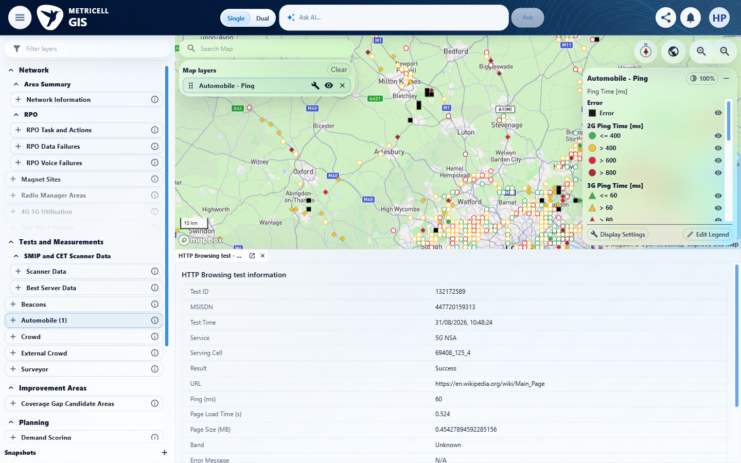 | E02 - Configuration (criterion-1-configuration.png)  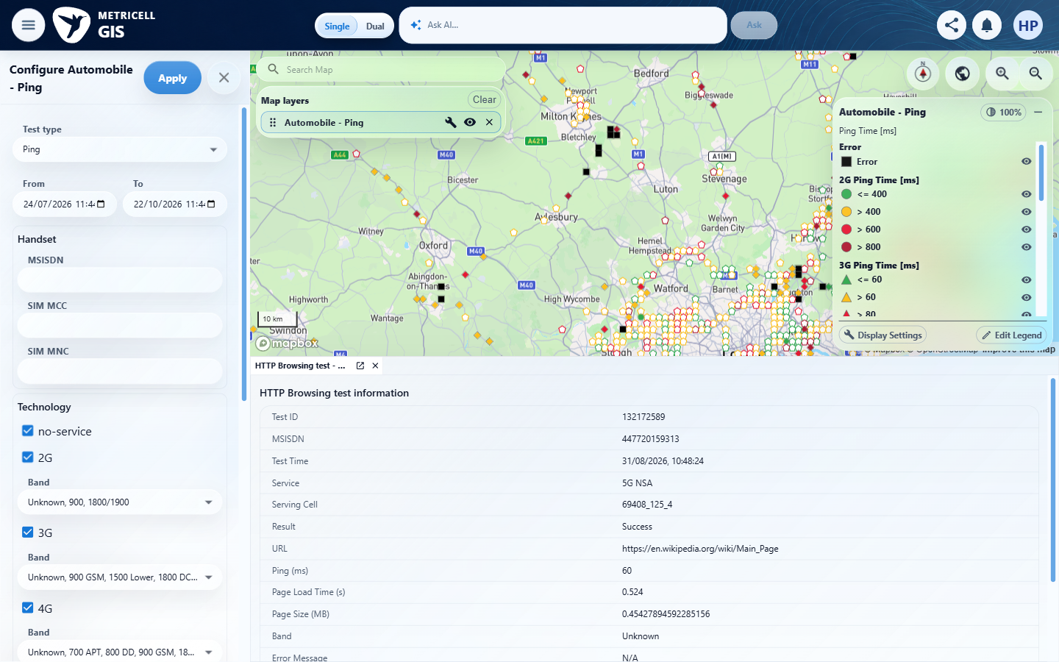

Criterion 1 continued: With neither layer selected, the map shows no Download or Upload test-result points.
Browser URL recorded after criterion: https://o2intelligence-v4-dev.metricell.com/gis
E03 - Test types (criterion-1-test-types.png)  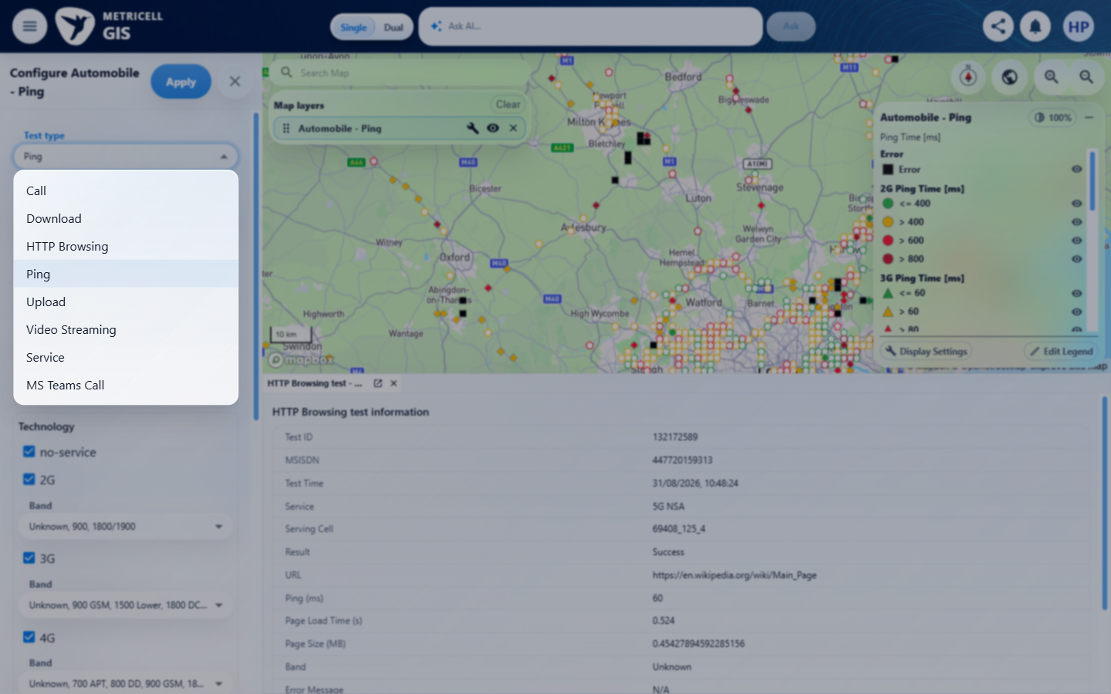 | E04 - Final (criterion-1-final.png)  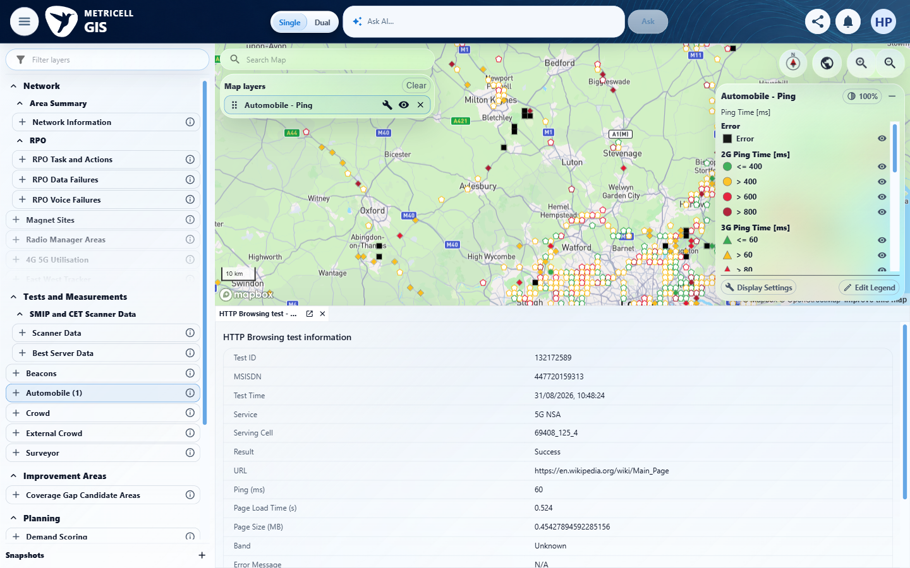

2.0.0 | After selecting Download, the map shows selectable points for matching authorised Download results only. | After selecting Download, the map shows selectable points for matching authorised Download results only. | criterion-2-before-apply.png selects Download; criterion-2-after-apply.png shows Automobile - Download markers and legend; criterion-2-final.png shows selected Download result 132363237. Recorded /api/platform/automobile/download/points, /cluster-details and /test-analysis requests match this module and current authorised session.  Evidence: E05, E03, E06, E07, E08 | Passed
Criterion 2 assessment: criterion-2-before-apply.png selects Download; criterion-2-after-apply.png shows Automobile - Download markers and legend; criterion-2-final.png shows selected Download result 132363237. Recorded /api/platform/automobile/download/points, /cluster-details and /test-analysis requests match this module and current authorised session.
Criterion 2 evidence: After selecting Download, the map shows selectable points for matching authorised Download results only.
Browser URL recorded after criterion: https://o2intelligence-v4-dev.metricell.com/gis
E05 - Before configure (criterion-2-before-configure.png)  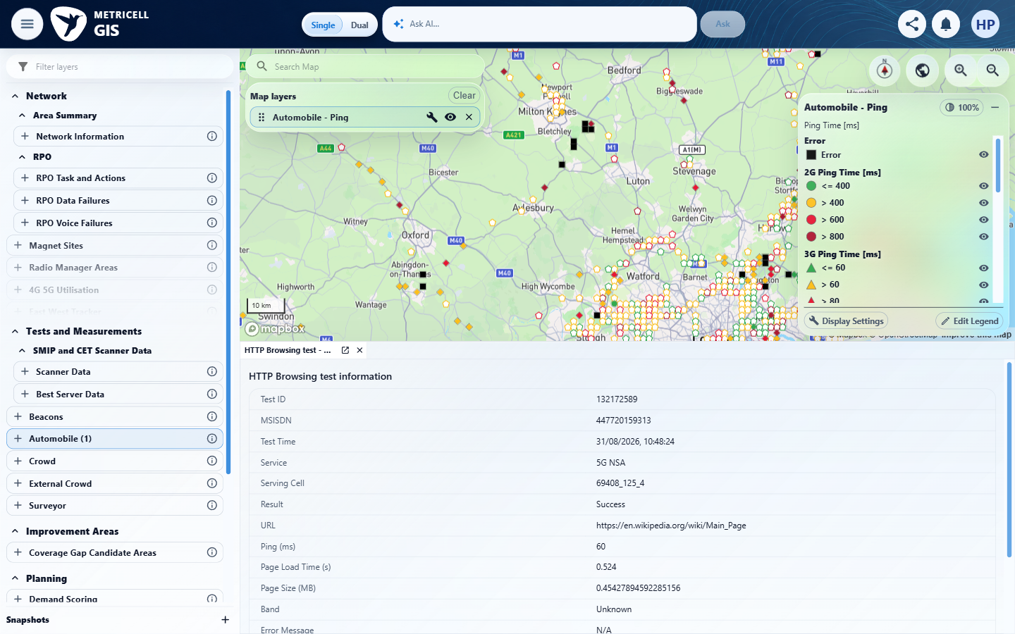 | E03 - Before download (criterion-2-before-download.png)

Criterion 2 continued: After selecting Download, the map shows selectable points for matching authorised Download results only.
Browser URL recorded after criterion: https://o2intelligence-v4-dev.metricell.com/gis
E06 - Before apply (criterion-2-before-apply.png)  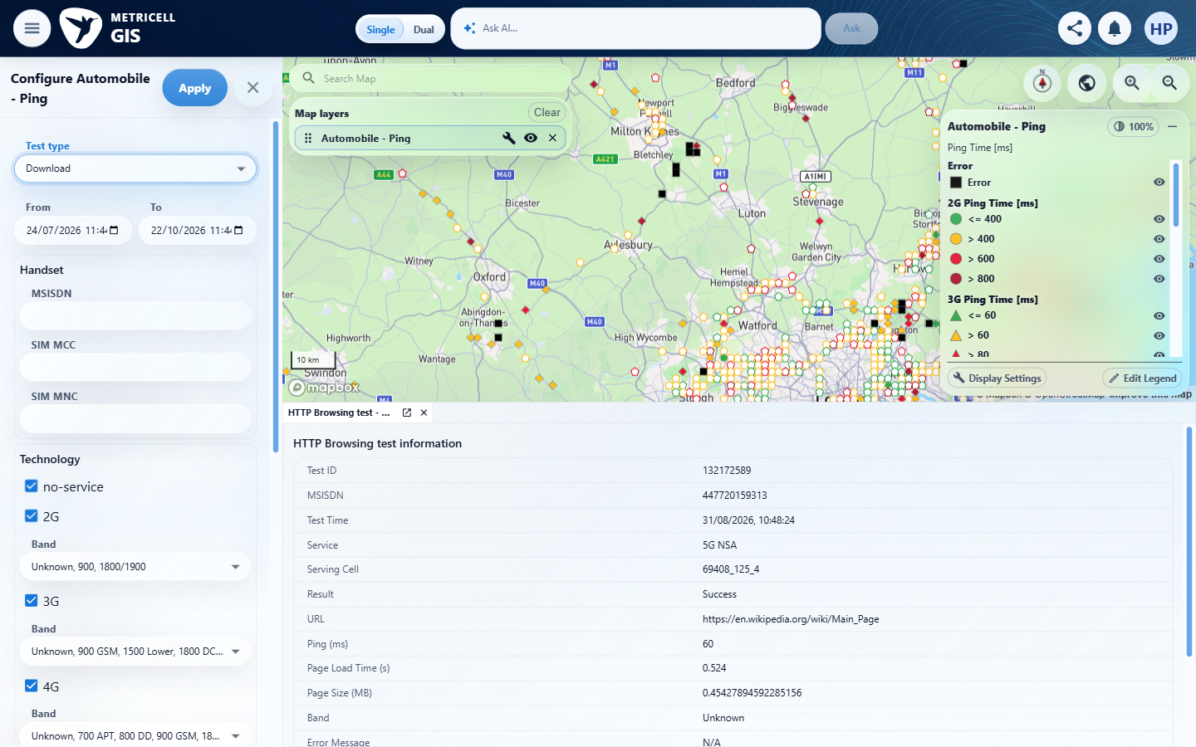 | E07 - After apply (criterion-2-after-apply.png)  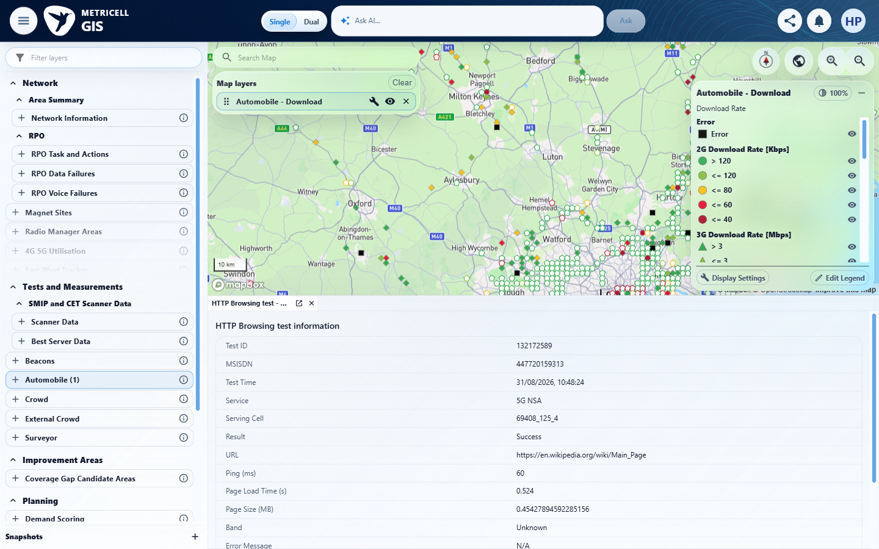

Criterion 2 continued: After selecting Download, the map shows selectable points for matching authorised Download results only.
Browser URL recorded after criterion: https://o2intelligence-v4-dev.metricell.com/gis
E08 - Final (criterion-2-final.png)
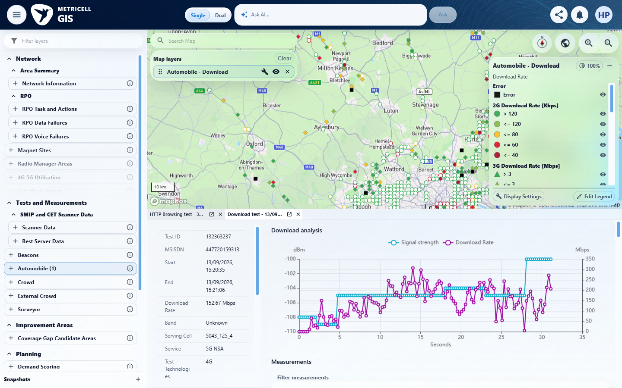

3.0.0 | After selecting Upload, the map shows selectable points for matching authorised Upload results only. | After selecting Upload, the map shows selectable points for matching authorised Upload results only. | criterion-3-before-apply.png selects Upload; criterion-3-map.png shows Automobile - Upload markers and legend; criterion-3-final.png shows selected Upload result 132363116 with Upload Rate 11.38 Mbps. Recorded /api/platform/automobile/upload/points request matches the tested module and current authorised session.  Evidence: E09, E02, E03, E10, E11, E12 | Passed
Criterion 3 assessment: criterion-3-before-apply.png selects Upload; criterion-3-map.png shows Automobile - Upload markers and legend; criterion-3-final.png shows selected Upload result 132363116 with Upload Rate 11.38 Mbps. Recorded /api/platform/automobile/upload/points request matches the tested module and current authorised session.
Criterion 3 evidence: After selecting Upload, the map shows selectable points for matching authorised Upload results only.
Browser URL recorded after criterion: https://o2intelligence-v4-dev.metricell.com/gis
E09 - Before configure (criterion-3-before-configure.png)  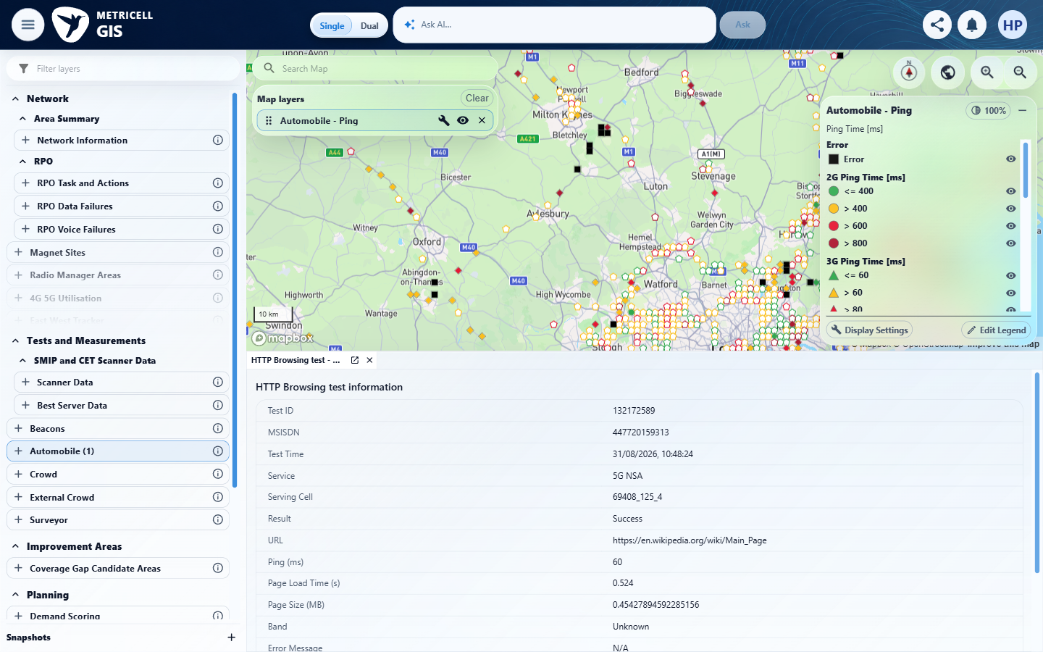 | E02 - Configuration (criterion-3-configuration.png)

Criterion 3 continued: After selecting Upload, the map shows selectable points for matching authorised Upload results only.
Browser URL recorded after criterion: https://o2intelligence-v4-dev.metricell.com/gis
E03 - Test types (criterion-3-test-types.png) | E10 - Before apply (criterion-3-before-apply.png)  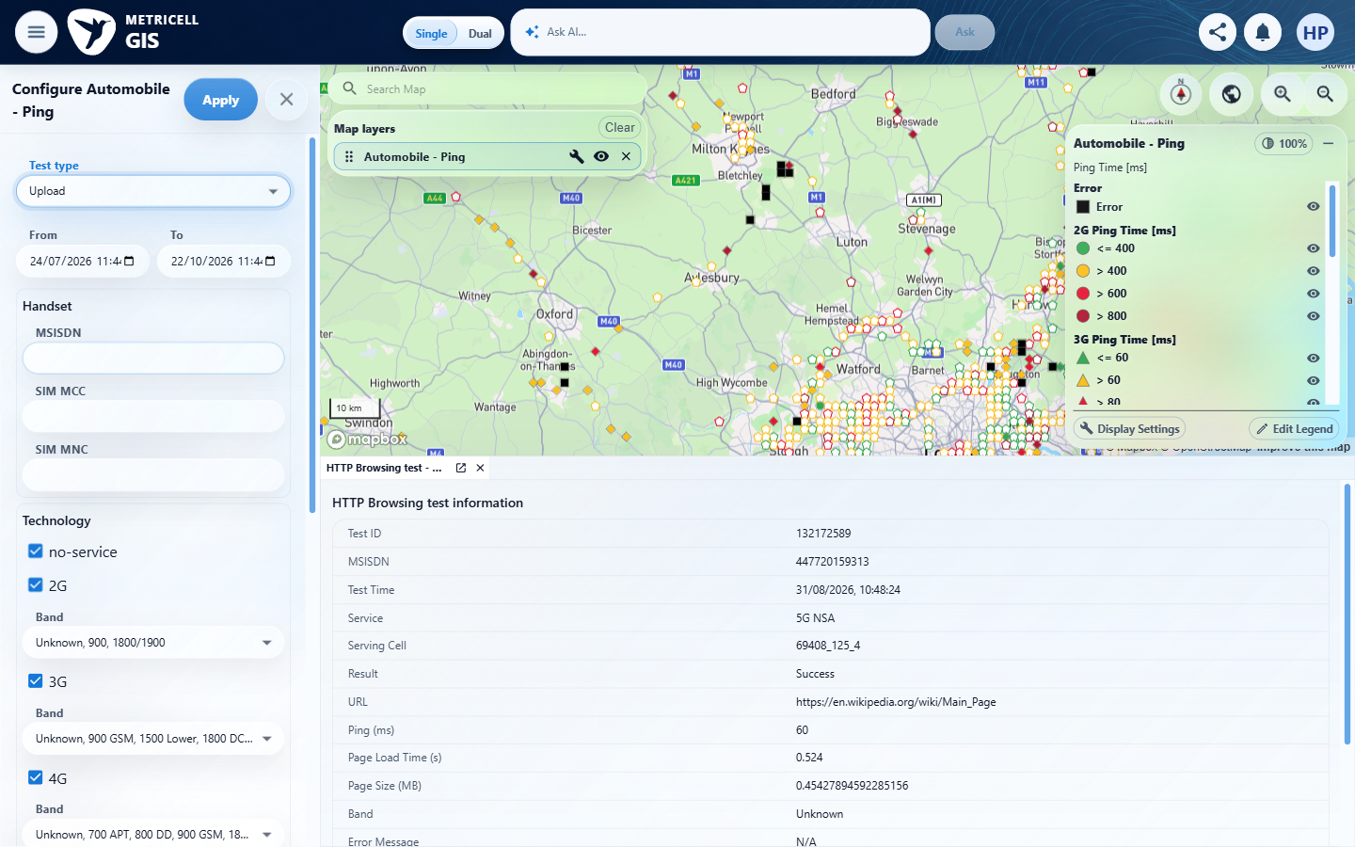

Criterion 3 continued: After selecting Upload, the map shows selectable points for matching authorised Upload results only.
Browser URL recorded after criterion: https://o2intelligence-v4-dev.metricell.com/gis
E11 - Map (criterion-3-map.png)  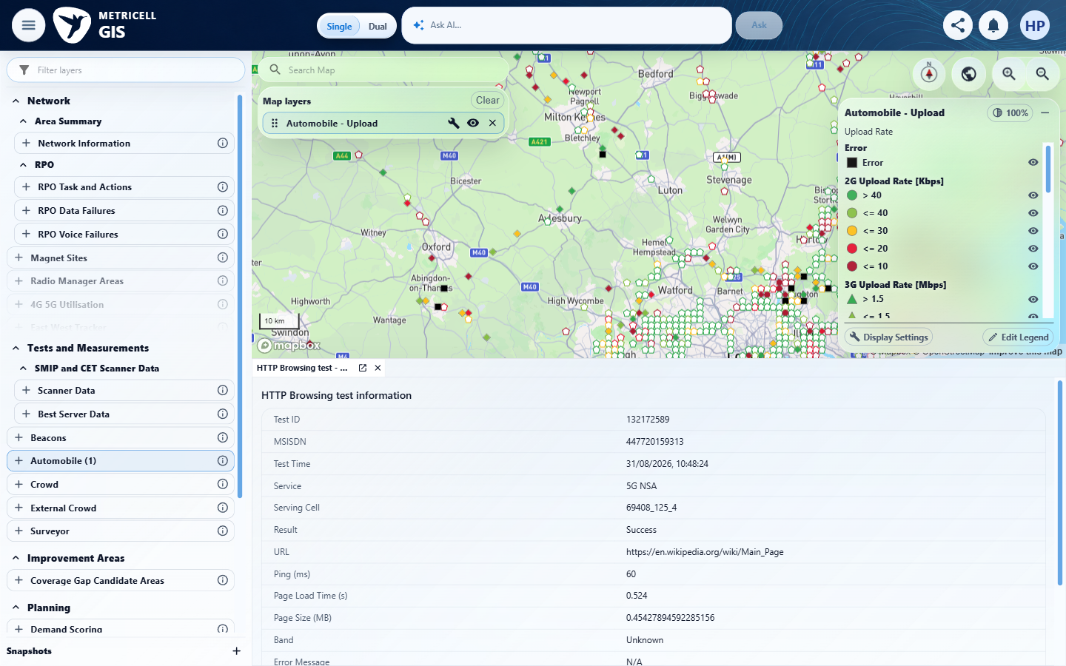 | E12 - Final (criterion-3-final.png)  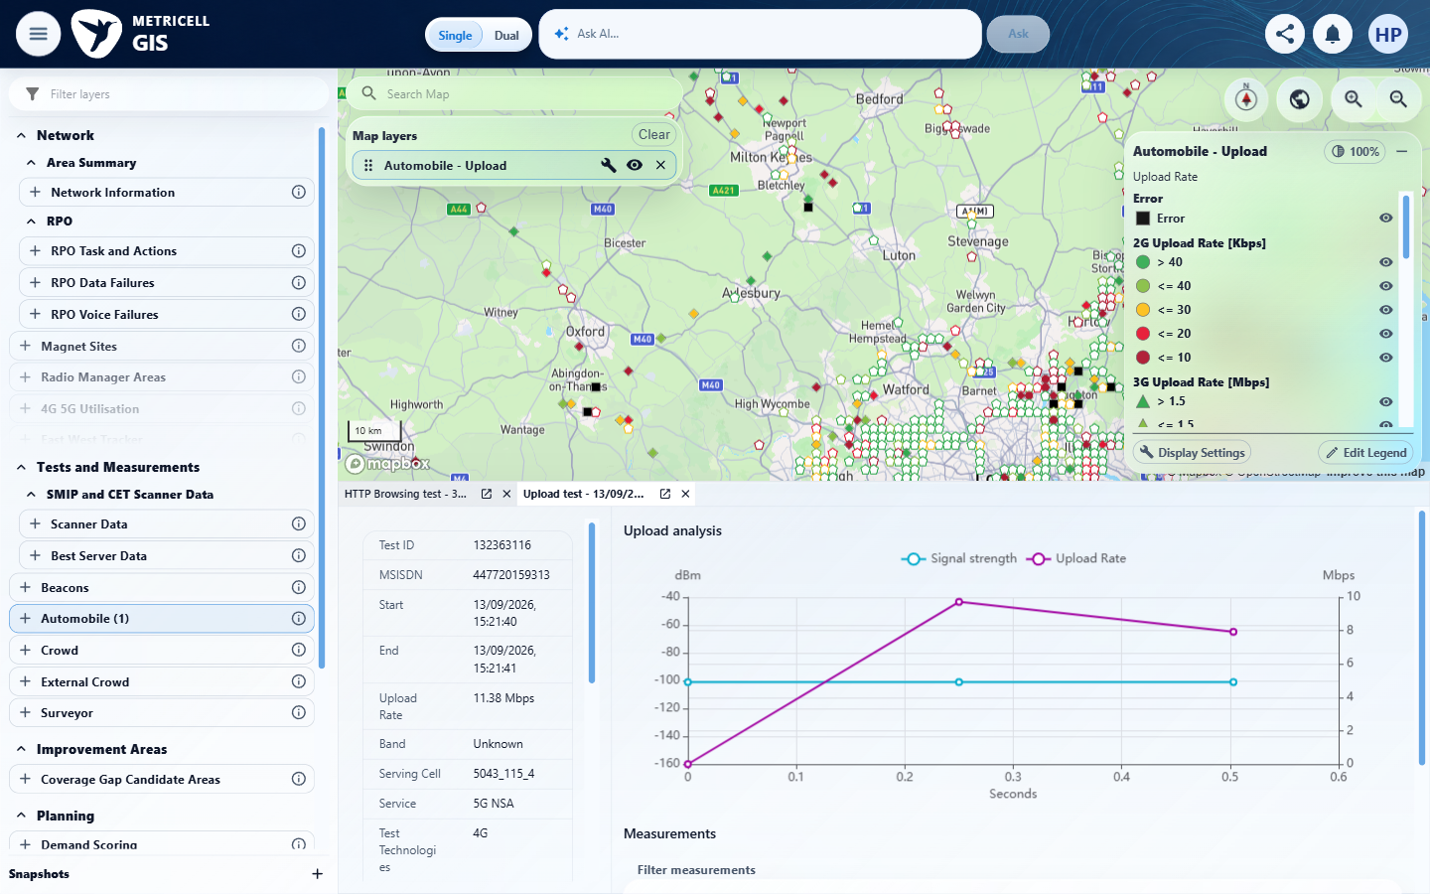

4.0.0 | Selecting a Download result point opens its details dialog with Data Technology, MSISDN, Service, Serving Cell, Test Duration, Test Technologies, Download Rate, and Wi-Fi Connected. | Selecting a Download result point opens its details dialog with Data Technology, MSISDN, Service, Serving Cell, Test Duration, Test Technologies, Download Rate, and Wi-Fi Connected. | criterion-4-map.png and criterion-4-details.png show Download selection and result 132363237 with MSISDN, rate, Serving Cell, Service and Test Technologies; criterion-4-final.png shows Technology and Test Duration 31.147 s, but its Wi-Fi Connected row is clipped above the viewport. Complete coverage of all eight fields remains inconclusive.  Evidence: E05, E02, E13, E14, E07, E08, E15 | Failed
Criterion 4 assessment: criterion-4-map.png and criterion-4-details.png show Download selection and result 132363237 with MSISDN, rate, Serving Cell, Service and Test Technologies; criterion-4-final.png shows Technology and Test Duration 31.147 s, but its Wi-Fi Connected row is clipped above the viewport. Complete coverage of all eight fields remains inconclusive.
Criterion 4 evidence: Selecting a Download result point opens its details dialog with Data Technology, MSISDN, Service, Serving Cell, Test Duration, Test Technologies, Download Rate, and Wi-Fi Connected.
Browser URL recorded after criterion: https://o2intelligence-v4-dev.metricell.com/gis
E05 - Before configure (criterion-4-before-configure.png) | E02 - Configuration (criterion-4-configuration.png)

Criterion 4 continued: Selecting a Download result point opens its details dialog with Data Technology, MSISDN, Service, Serving Cell, Test Duration, Test Technologies, Download Rate, and Wi-Fi Connected.
Browser URL recorded after criterion: https://o2intelligence-v4-dev.metricell.com/gis
E13 - Test types (criterion-4-test-types.png)  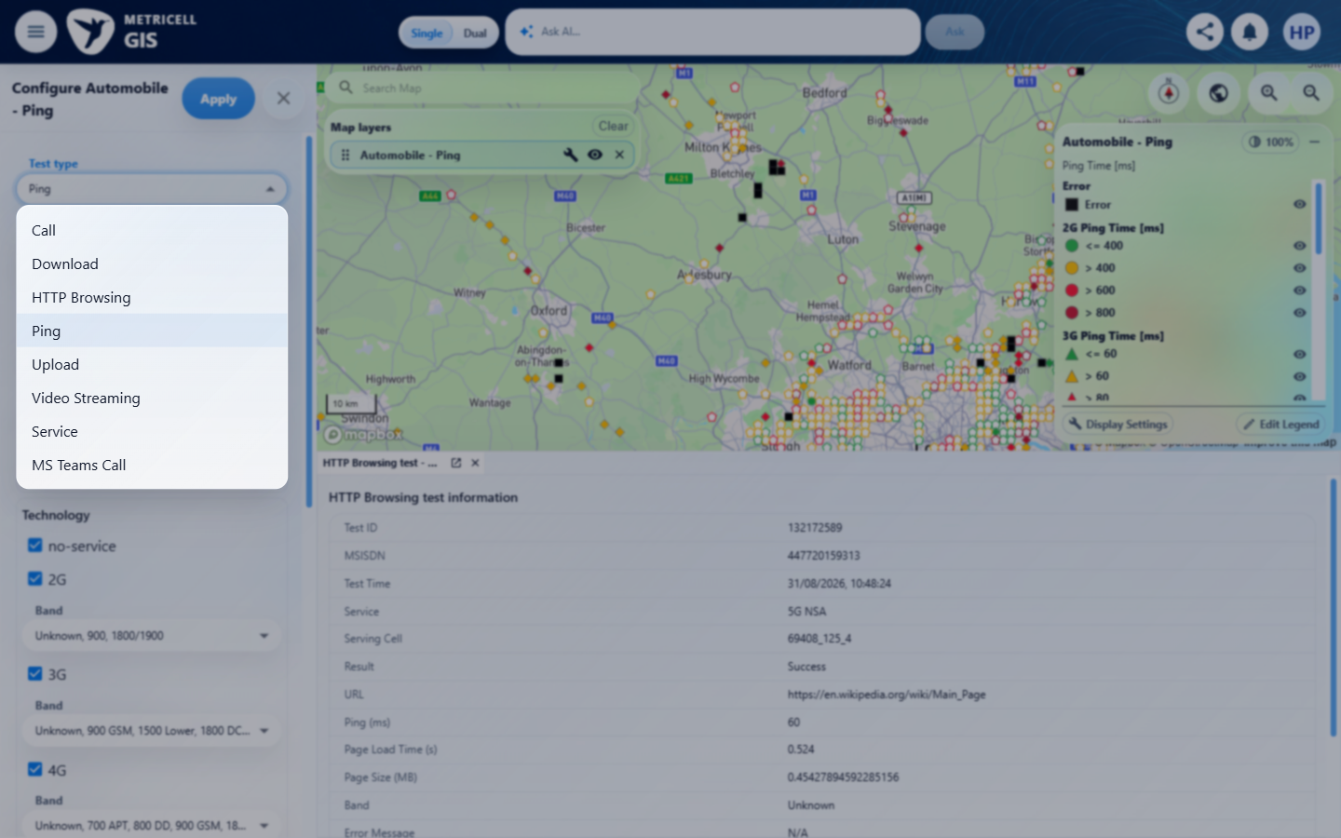 | E14 - Before apply (criterion-4-before-apply.png)  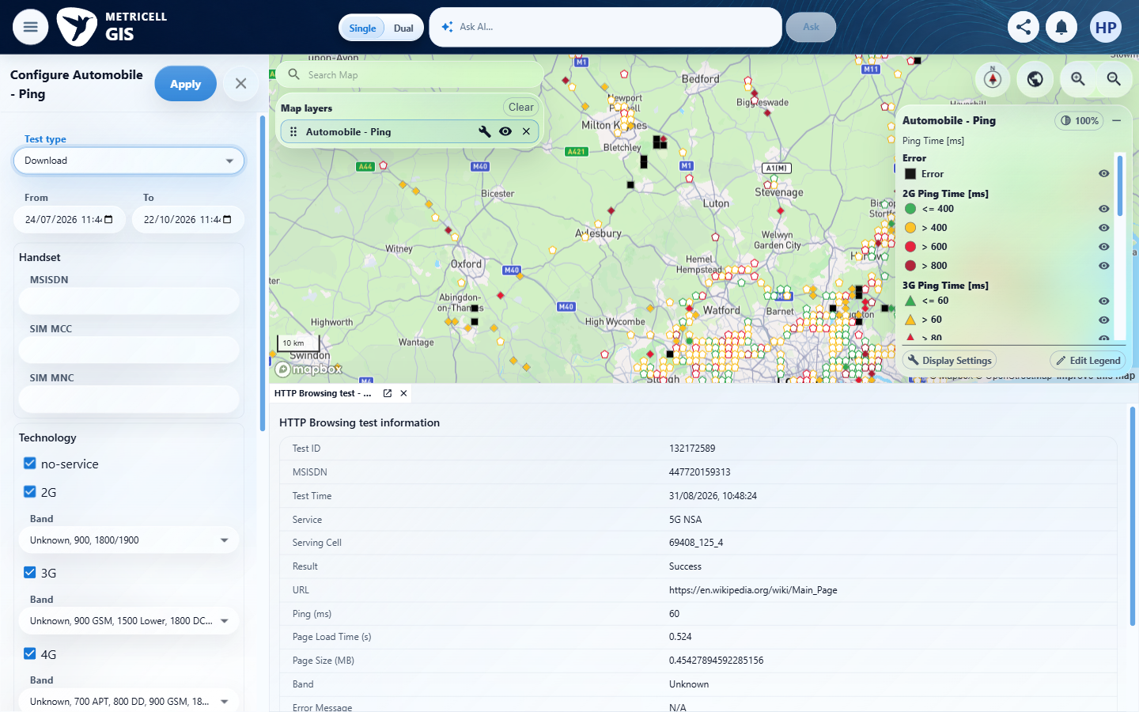

Criterion 4 continued: Selecting a Download result point opens its details dialog with Data Technology, MSISDN, Service, Serving Cell, Test Duration, Test Technologies, Download Rate, and Wi-Fi Connected.
Browser URL recorded after criterion: https://o2intelligence-v4-dev.metricell.com/gis
E07 - Map (criterion-4-map.png) | E08 - Details (criterion-4-details.png)

Criterion 4 continued: Selecting a Download result point opens its details dialog with Data Technology, MSISDN, Service, Serving Cell, Test Duration, Test Technologies, Download Rate, and Wi-Fi Connected.
Browser URL recorded after criterion: https://o2intelligence-v4-dev.metricell.com/gis
E15 - Final (criterion-4-final.png)
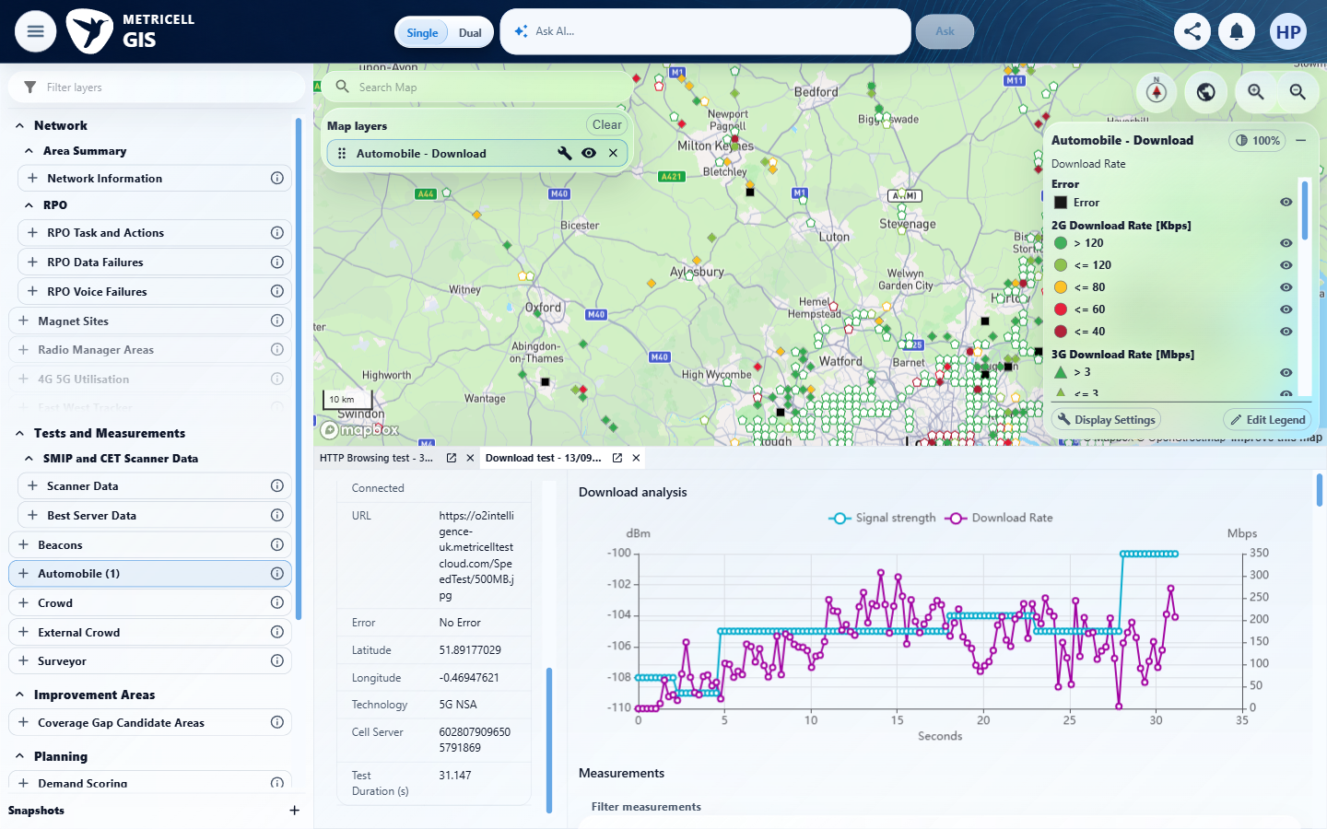

5.0.0 | Selecting an Upload result point opens its details dialog with Data Technology, MSISDN, Service, Serving Cell, Test Duration, Test Technologies, Upload Rate, and Wi-Fi Connected. | Selecting an Upload result point opens its details dialog with Data Technology, MSISDN, Service, Serving Cell, Test Duration, Test Technologies, Upload Rate, and Wi-Fi Connected. | criterion-5-map.png shows Automobile - Upload; criterion-5-details.png shows selected result 132363116 with MSISDN, Upload Rate 11.38 Mbps, Serving Cell, Service and Test Technologies. criterion-5-final.png shows Wi-Fi Connected No, Technology 5G NSA and Test Duration 0.703 s, completing the requested summary fields across this criterion's own captures.  Evidence: E05, E02, E13, E10, E11, E16, E17 | Passed
Criterion 5 assessment: criterion-5-map.png shows Automobile - Upload; criterion-5-details.png shows selected result 132363116 with MSISDN, Upload Rate 11.38 Mbps, Serving Cell, Service and Test Technologies. criterion-5-final.png shows Wi-Fi Connected No, Technology 5G NSA and Test Duration 0.703 s, completing the requested summary fields across this criterion's own captures.
Criterion 5 evidence: Selecting an Upload result point opens its details dialog with Data Technology, MSISDN, Service, Serving Cell, Test Duration, Test Technologies, Upload Rate, and Wi-Fi Connected.
Browser URL recorded after criterion: https://o2intelligence-v4-dev.metricell.com/gis
E05 - Before configure (criterion-5-before-configure.png) | E02 - Configuration (criterion-5-configuration.png)

Criterion 5 continued: Selecting an Upload result point opens its details dialog with Data Technology, MSISDN, Service, Serving Cell, Test Duration, Test Technologies, Upload Rate, and Wi-Fi Connected.
Browser URL recorded after criterion: https://o2intelligence-v4-dev.metricell.com/gis
E13 - Test types (criterion-5-test-types.png) | E10 - Before apply (criterion-5-before-apply.png)

Criterion 5 continued: Selecting an Upload result point opens its details dialog with Data Technology, MSISDN, Service, Serving Cell, Test Duration, Test Technologies, Upload Rate, and Wi-Fi Connected.
Browser URL recorded after criterion: https://o2intelligence-v4-dev.metricell.com/gis
E11 - Map (criterion-5-map.png) | E16 - Details (criterion-5-details.png)  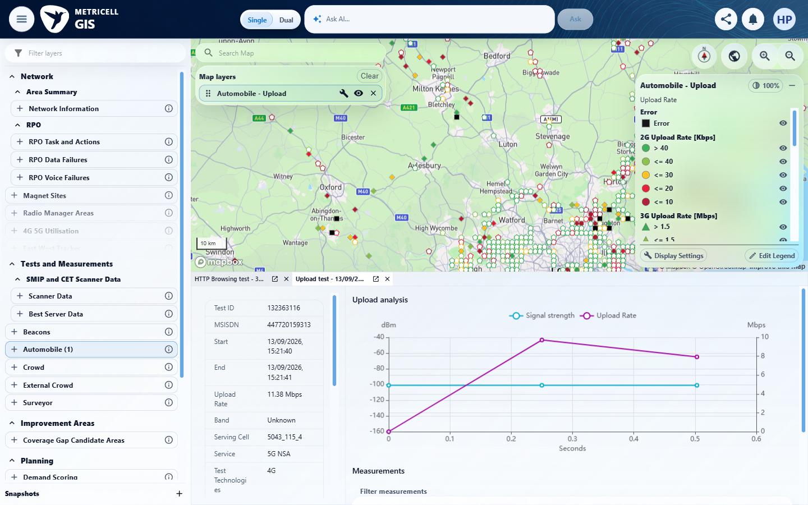

Criterion 5 continued: Selecting an Upload result point opens its details dialog with Data Technology, MSISDN, Service, Serving Cell, Test Duration, Test Technologies, Upload Rate, and Wi-Fi Connected.
Browser URL recorded after criterion: https://o2intelligence-v4-dev.metricell.com/gis
E17 - Final (criterion-5-final.png)
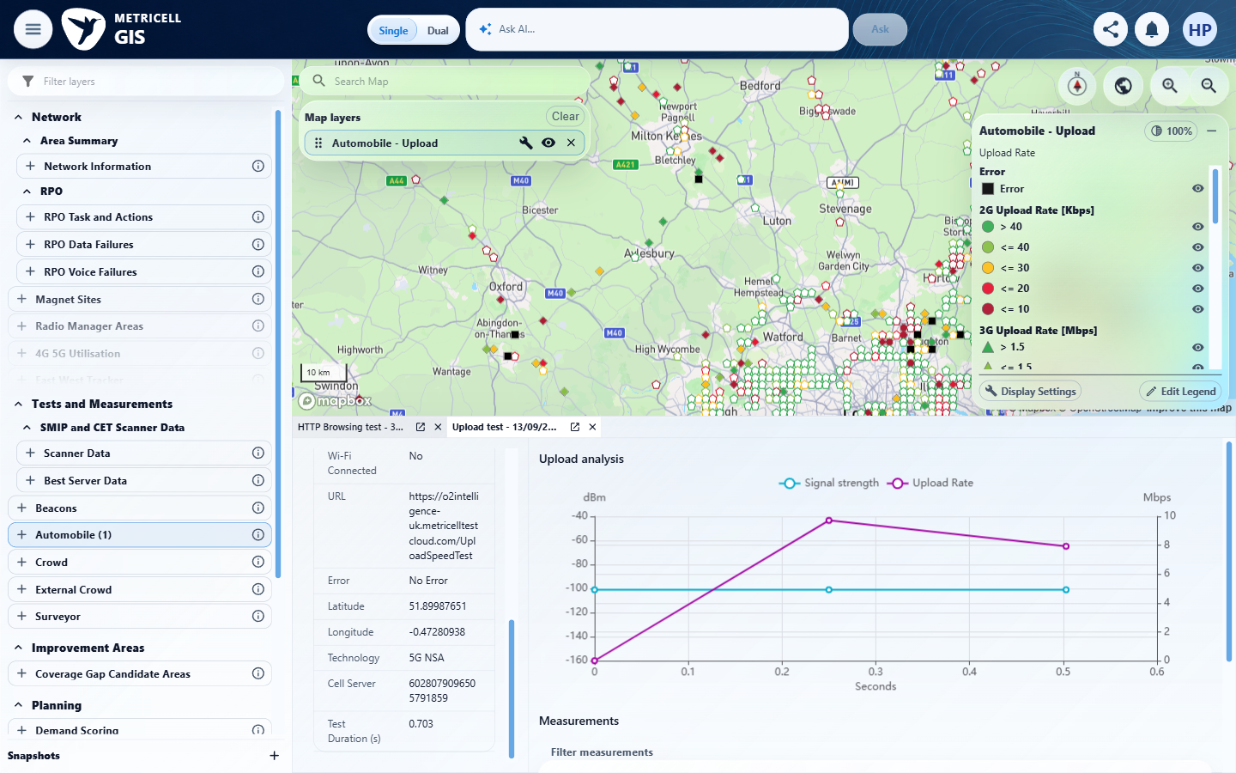

6.0.0 | The Download result details chart plots Signal Strength in dBm and Download Rate in Mbps over time. | The Download result details chart plots Signal Strength in dBm and Download Rate in Mbps over time. | criterion-6-map.png shows Automobile - Download; criterion-6-details.png and criterion-6-final.png show selected Download result 132363237 with Signal strength and Download Rate series, dBm and Mbps axes, and Seconds on the time axis.  Evidence: E09, E02, E13, E14, E07, E18, E08 | Passed
Criterion 6 assessment: criterion-6-map.png shows Automobile - Download; criterion-6-details.png and criterion-6-final.png show selected Download result 132363237 with Signal strength and Download Rate series, dBm and Mbps axes, and Seconds on the time axis.
Criterion 6 evidence: The Download result details chart plots Signal Strength in dBm and Download Rate in Mbps over time.
Browser URL recorded after criterion: https://o2intelligence-v4-dev.metricell.com/gis
E09 - Before configure (criterion-6-before-configure.png) | E02 - Configuration (criterion-6-configuration.png)

Criterion 6 continued: The Download result details chart plots Signal Strength in dBm and Download Rate in Mbps over time.
Browser URL recorded after criterion: https://o2intelligence-v4-dev.metricell.com/gis
E13 - Test types (criterion-6-test-types.png) | E14 - Before apply (criterion-6-before-apply.png)

Criterion 6 continued: The Download result details chart plots Signal Strength in dBm and Download Rate in Mbps over time.
Browser URL recorded after criterion: https://o2intelligence-v4-dev.metricell.com/gis
E07 - Map (criterion-6-map.png) | E18 - Details (criterion-6-details.png)  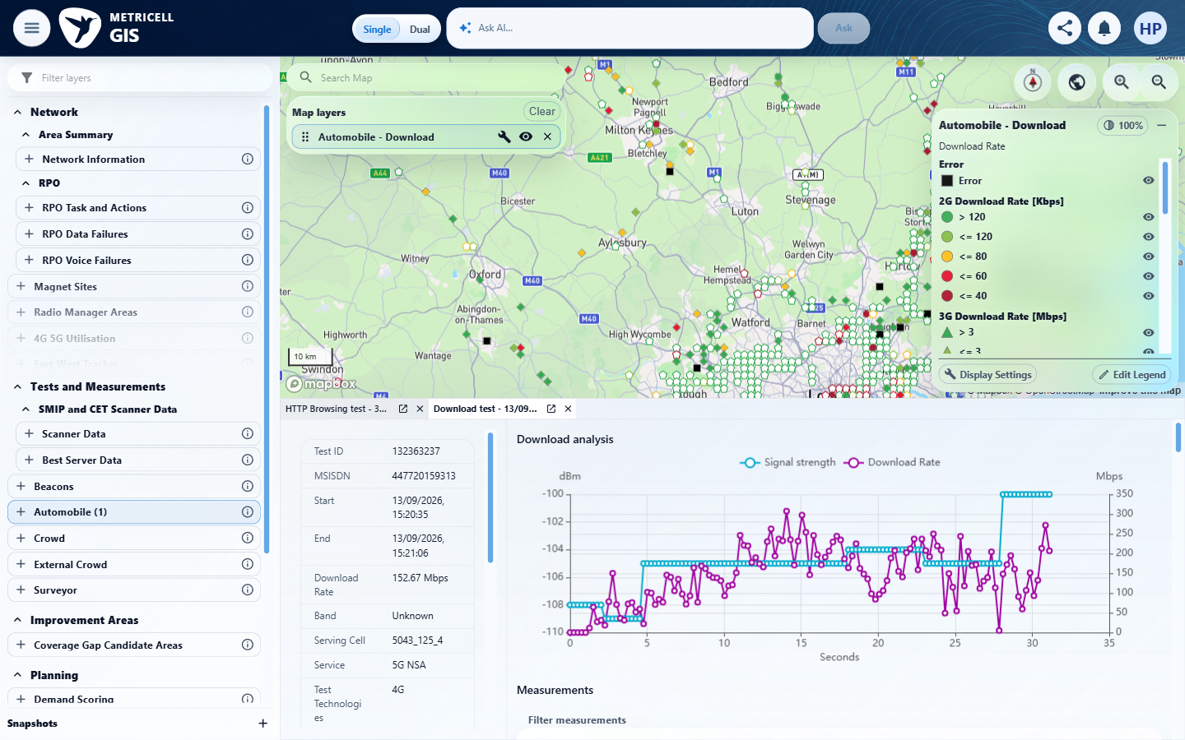

Criterion 6 continued: The Download result details chart plots Signal Strength in dBm and Download Rate in Mbps over time.
Browser URL recorded after criterion: https://o2intelligence-v4-dev.metricell.com/gis
E08 - Final (criterion-6-final.png)

7.0.0 | The Upload result details chart plots Signal Strength in dBm and Upload Rate in Mbps over time. | The Upload result details chart plots Signal Strength in dBm and Upload Rate in Mbps over time. | Browser execution stopped after a wait timeout and stale code-mode host error. criterion-7-before-apply.png shows Upload selected in configuration while the map still shows Ping; no criterion-owned Upload chart or final browserUrl was captured. Testing could not be completed; post-interruption state and restoration require coordinator reconciliation.  Evidence: E05, E02, E19, E10 | Blocked
Criterion 7 assessment: Browser execution stopped after a wait timeout and stale code-mode host error. criterion-7-before-apply.png shows Upload selected in configuration while the map still shows Ping; no criterion-owned Upload chart or final browserUrl was captured. Testing could not be completed; post-interruption state and restoration require coordinator reconciliation.
Testing notes: Tool interruption: functions.wait reported 'code-mode host timed out waiting for wait response', then 'cell 32 belongs to a stale code-mode host generation'. Criterion 7 has no verified final assertion or current final browserUrl. Only the saved launcher/configuration evidence is available; whether Apply completed is unverified. Per the QA brief's interruption rule, browser work stopped and the existing owned lease was preserved for coordinator reconciliation. Automobile state after criterion 7 and any incomplete UI restoration must be checked by the coordinator. Browser identity was observed once for this session; it does not imply this criterion ran.
Criterion 7 evidence: The Upload result details chart plots Signal Strength in dBm and Upload Rate in Mbps over time.
Browser URL recorded after criterion: Not recorded
E05 - Before configure (criterion-7-before-configure.png) | E02 - Configuration (criterion-7-configuration.png)

Criterion 7 continued: The Upload result details chart plots Signal Strength in dBm and Upload Rate in Mbps over time.
Browser URL recorded after criterion: Not recorded
E19 - Test types (criterion-7-test-types.png)  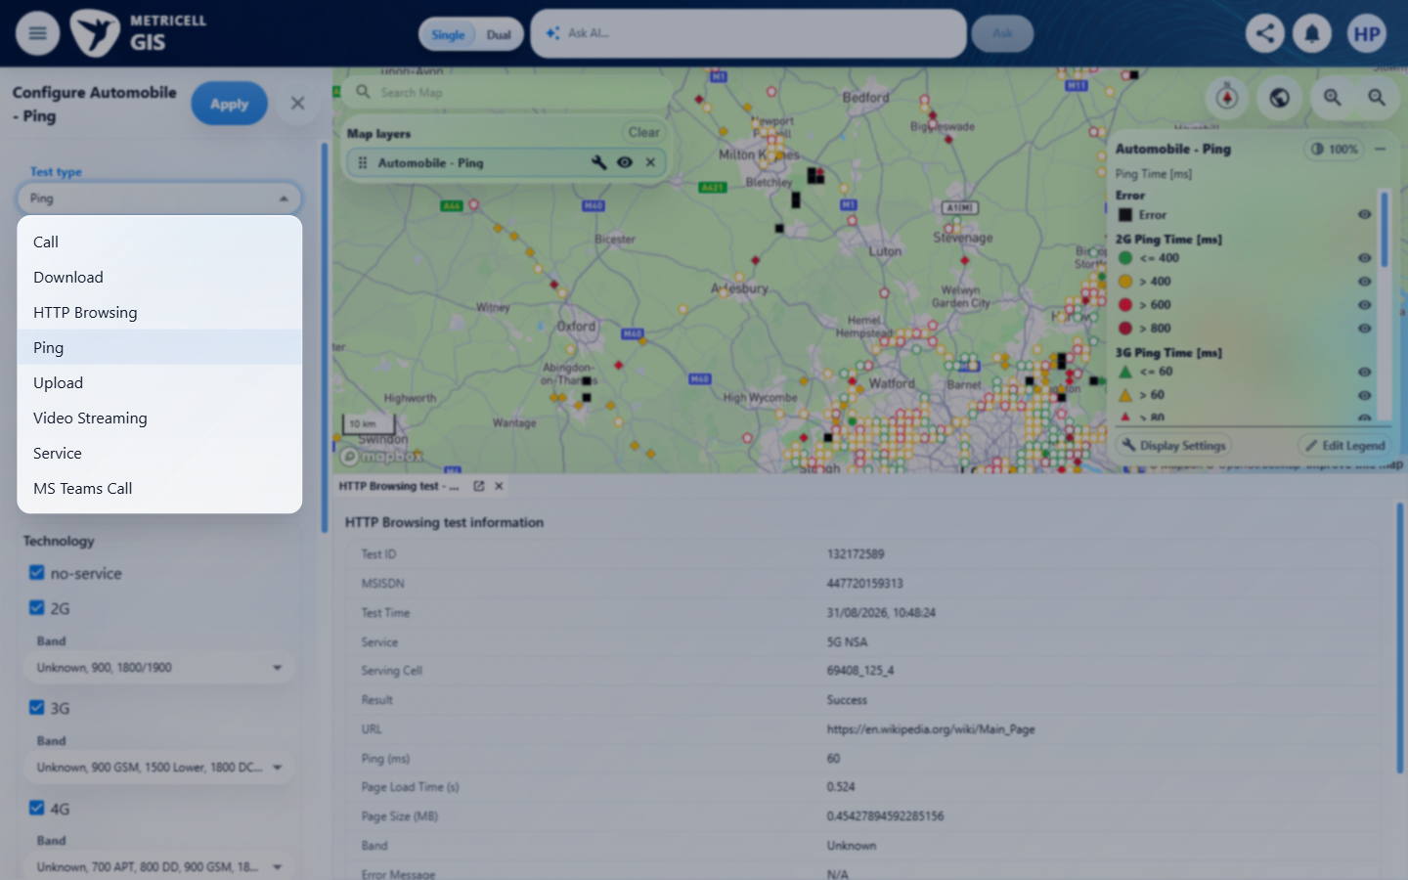 | E10 - Before apply (criterion-7-before-apply.png)

8.0.0 | The Download details table displays MSISDN, Start Time, End Time, Download Rate, Band, Serving Cell, Service, Test Technologies, Data Technology, Wi-Fi Connected, URL, and Error Message. | The Download details table displays MSISDN, Start Time, End Time, Download Rate, Band, Serving Cell, Service, Test Technologies, Data Technology, Wi-Fi Connected, URL, and Error Message. | Browser execution stopped during criterion 7 after a wait timeout and stale code-mode host error. This criterion was not executed; no criterion-owned browser evidence was captured and testing could not be completed. Post-interruption Automobile state and restoration require coordinator reconciliation.  Evidence: Unavailable  Browser URL recorded after criterion: Not recorded | Blocked
Criterion 8 assessment: Browser execution stopped during criterion 7 after a wait timeout and stale code-mode host error. This criterion was not executed; no criterion-owned browser evidence was captured and testing could not be completed. Post-interruption Automobile state and restoration require coordinator reconciliation.
Testing notes: Tool interruption: functions.wait reported 'code-mode host timed out waiting for wait response', then 'cell 32 belongs to a stale code-mode host generation'. Criterion 8 has no verified final assertion or current final browserUrl. No PNG was possible for this criterion because browser execution had stopped. Per the QA brief's interruption rule, browser work stopped and the existing owned lease was preserved for coordinator reconciliation. Automobile state after criterion 7 and any incomplete UI restoration must be checked by the coordinator. Browser identity was observed once for this session; it does not imply this criterion ran.
9.0.0 | The Upload details table displays MSISDN, Start Time, End Time, Upload Rate, Band, Serving Cell, Service, Test Technologies, Data Technology, Wi-Fi Connected, URL, and Error Message. | The Upload details table displays MSISDN, Start Time, End Time, Upload Rate, Band, Serving Cell, Service, Test Technologies, Data Technology, Wi-Fi Connected, URL, and Error Message. | Browser execution stopped during criterion 7 after a wait timeout and stale code-mode host error. This criterion was not executed; no criterion-owned browser evidence was captured and testing could not be completed. Post-interruption Automobile state and restoration require coordinator reconciliation.  Evidence: Unavailable  Browser URL recorded after criterion: Not recorded | Blocked
Criterion 9 assessment: Browser execution stopped during criterion 7 after a wait timeout and stale code-mode host error. This criterion was not executed; no criterion-owned browser evidence was captured and testing could not be completed. Post-interruption Automobile state and restoration require coordinator reconciliation.
Testing notes: Tool interruption: functions.wait reported 'code-mode host timed out waiting for wait response', then 'cell 32 belongs to a stale code-mode host generation'. Criterion 9 has no verified final assertion or current final browserUrl. No PNG was possible for this criterion because browser execution had stopped. Per the QA brief's interruption rule, browser work stopped and the existing owned lease was preserved for coordinator reconciliation. Automobile state after criterion 7 and any incomplete UI restoration must be checked by the coordinator. Browser identity was observed once for this session; it does not imply this criterion ran.
10.0.0 | Where signal strength or rate values are shown, each value includes its applicable unit (dBm or Mbps). | Where signal strength or rate values are shown, each value includes its applicable unit (dBm or Mbps). | Browser execution stopped during criterion 7 after a wait timeout and stale code-mode host error. This criterion was not executed; no criterion-owned browser evidence was captured and testing could not be completed. Post-interruption Automobile state and restoration require coordinator reconciliation.  Evidence: Unavailable  Browser URL recorded after criterion: Not recorded | Blocked
Criterion 10 assessment: Browser execution stopped during criterion 7 after a wait timeout and stale code-mode host error. This criterion was not executed; no criterion-owned browser evidence was captured and testing could not be completed. Post-interruption Automobile state and restoration require coordinator reconciliation.
Testing notes: Tool interruption: functions.wait reported 'code-mode host timed out waiting for wait response', then 'cell 32 belongs to a stale code-mode host generation'. Criterion 10 has no verified final assertion or current final browserUrl. No PNG was possible for this criterion because browser execution had stopped. Per the QA brief's interruption rule, browser work stopped and the existing owned lease was preserved for coordinator reconciliation. Automobile state after criterion 7 and any incomplete UI restoration must be checked by the coordinator. Browser identity was observed once for this session; it does not imply this criterion ran.
11.0.0 | For a result whose Error Message is null, the details table displays “No Error”. | For a result whose Error Message is null, the details table displays “No Error”. | Browser execution stopped during criterion 7 after a wait timeout and stale code-mode host error. This criterion was not executed; no criterion-owned browser evidence was captured and testing could not be completed. Post-interruption Automobile state and restoration require coordinator reconciliation.  Evidence: Unavailable  Browser URL recorded after criterion: Not recorded | Blocked
Criterion 11 assessment: Browser execution stopped during criterion 7 after a wait timeout and stale code-mode host error. This criterion was not executed; no criterion-owned browser evidence was captured and testing could not be completed. Post-interruption Automobile state and restoration require coordinator reconciliation.
Testing notes: Tool interruption: functions.wait reported 'code-mode host timed out waiting for wait response', then 'cell 32 belongs to a stale code-mode host generation'. Criterion 11 has no verified final assertion or current final browserUrl. No PNG was possible for this criterion because browser execution had stopped. Per the QA brief's interruption rule, browser work stopped and the existing owned lease was preserved for coordinator reconciliation. Automobile state after criterion 7 and any incomplete UI restoration must be checked by the coordinator. Browser identity was observed once for this session; it does not imply this criterion ran.
12.0.0 | Sorting a supported Download or Upload details-table column changes the displayed row order to match the selected sort. | Sorting a supported Download or Upload details-table column changes the displayed row order to match the selected sort. | Browser execution stopped during criterion 7 after a wait timeout and stale code-mode host error. This criterion was not executed; no criterion-owned browser evidence was captured and testing could not be completed. Post-interruption Automobile state and restoration require coordinator reconciliation.  Evidence: Unavailable  Browser URL recorded after criterion: Not recorded | Blocked
Criterion 12 assessment: Browser execution stopped during criterion 7 after a wait timeout and stale code-mode host error. This criterion was not executed; no criterion-owned browser evidence was captured and testing could not be completed. Post-interruption Automobile state and restoration require coordinator reconciliation.
Testing notes: Tool interruption: functions.wait reported 'code-mode host timed out waiting for wait response', then 'cell 32 belongs to a stale code-mode host generation'. Criterion 12 has no verified final assertion or current final browserUrl. No PNG was possible for this criterion because browser execution had stopped. Per the QA brief's interruption rule, browser work stopped and the existing owned lease was preserved for coordinator reconciliation. Automobile state after criterion 7 and any incomplete UI restoration must be checked by the coordinator. Browser identity was observed once for this session; it does not imply this criterion ran.
13.0.0 | Filtering a supported Download or Upload details-table column displays rows matching the applied filter. | Filtering a supported Download or Upload details-table column displays rows matching the applied filter. | Browser execution stopped during criterion 7 after a wait timeout and stale code-mode host error. This criterion was not executed; no criterion-owned browser evidence was captured and testing could not be completed. Post-interruption Automobile state and restoration require coordinator reconciliation.  Evidence: Unavailable  Browser URL recorded after criterion: Not recorded | Blocked
Criterion 13 assessment: Browser execution stopped during criterion 7 after a wait timeout and stale code-mode host error. This criterion was not executed; no criterion-owned browser evidence was captured and testing could not be completed. Post-interruption Automobile state and restoration require coordinator reconciliation.
Testing notes: Tool interruption: functions.wait reported 'code-mode host timed out waiting for wait response', then 'cell 32 belongs to a stale code-mode host generation'. Criterion 13 has no verified final assertion or current final browserUrl. No PNG was possible for this criterion because browser execution had stopped. Per the QA brief's interruption rule, browser work stopped and the existing owned lease was preserved for coordinator reconciliation. Automobile state after criterion 7 and any incomplete UI restoration must be checked by the coordinator. Browser identity was observed once for this session; it does not imply this criterion ran.
14.0.0 | Requesting details for a zero-duration test does not open a details dialog. | Requesting details for a zero-duration test does not open a details dialog. | Browser execution stopped during criterion 7 after a wait timeout and stale code-mode host error. This criterion was not executed; no criterion-owned browser evidence was captured and testing could not be completed. Post-interruption Automobile state and restoration require coordinator reconciliation.  Evidence: Unavailable  Browser URL recorded after criterion: Not recorded | Blocked
Criterion 14 assessment: Browser execution stopped during criterion 7 after a wait timeout and stale code-mode host error. This criterion was not executed; no criterion-owned browser evidence was captured and testing could not be completed. Post-interruption Automobile state and restoration require coordinator reconciliation.
Testing notes: Tool interruption: functions.wait reported 'code-mode host timed out waiting for wait response', then 'cell 32 belongs to a stale code-mode host generation'. Criterion 14 has no verified final assertion or current final browserUrl. No PNG was possible for this criterion because browser execution had stopped. Per the QA brief's interruption rule, browser work stopped and the existing owned lease was preserved for coordinator reconciliation. Automobile state after criterion 7 and any incomplete UI restoration must be checked by the coordinator. Browser identity was observed once for this session; it does not imply this criterion ran.
15.0.0 | While result details are loading, the interface shows a loading state without stale or misleading detail data. | While result details are loading, the interface shows a loading state without stale or misleading detail data. | Browser execution stopped during criterion 7 after a wait timeout and stale code-mode host error. This criterion was not executed; no criterion-owned browser evidence was captured and testing could not be completed. Post-interruption Automobile state and restoration require coordinator reconciliation.  Evidence: Unavailable  Browser URL recorded after criterion: Not recorded | Blocked
Criterion 15 assessment: Browser execution stopped during criterion 7 after a wait timeout and stale code-mode host error. This criterion was not executed; no criterion-owned browser evidence was captured and testing could not be completed. Post-interruption Automobile state and restoration require coordinator reconciliation.
Testing notes: Tool interruption: functions.wait reported 'code-mode host timed out waiting for wait response', then 'cell 32 belongs to a stale code-mode host generation'. Criterion 15 has no verified final assertion or current final browserUrl. No PNG was possible for this criterion because browser execution had stopped. Per the QA brief's interruption rule, browser work stopped and the existing owned lease was preserved for coordinator reconciliation. Automobile state after criterion 7 and any incomplete UI restoration must be checked by the coordinator. Browser identity was observed once for this session; it does not imply this criterion ran.
16.0.0 | If result details fail to load, the interface shows an error state without stale or misleading detail data. | If result details fail to load, the interface shows an error state without stale or misleading detail data. | Browser execution stopped during criterion 7 after a wait timeout and stale code-mode host error. This criterion was not executed; no criterion-owned browser evidence was captured and testing could not be completed. Post-interruption Automobile state and restoration require coordinator reconciliation.  Evidence: Unavailable  Browser URL recorded after criterion: Not recorded | Blocked
Criterion 16 assessment: Browser execution stopped during criterion 7 after a wait timeout and stale code-mode host error. This criterion was not executed; no criterion-owned browser evidence was captured and testing could not be completed. Post-interruption Automobile state and restoration require coordinator reconciliation.
Testing notes: Tool interruption: functions.wait reported 'code-mode host timed out waiting for wait response', then 'cell 32 belongs to a stale code-mode host generation'. Criterion 16 has no verified final assertion or current final browserUrl. No PNG was possible for this criterion because browser execution had stopped. Per the QA brief's interruption rule, browser work stopped and the existing owned lease was preserved for coordinator reconciliation. Automobile state after criterion 7 and any incomplete UI restoration must be checked by the coordinator. Browser identity was observed once for this session; it does not imply this criterion ran.

About Metricell

Metricell is on a mission to deliver connectivity. We work with our customers to design, deliver and manage wireless communication networks – with a shared ambition of achieving flawless network experience. We’ve been responsible for many first-to-market products, and our technology is characterised by the relentless pursuit of automation and digitalisation.

Our geospatial intelligence tools traverse a wide variety of business processes – from Test & Measurement to Customer Experience Management – and we’re pioneers in Crowdsourcing and Digital Self Care. Our technology is today in use by a range of customers; thousands of their personnel; and millions of subscribers worldwide.

Find out more at www.metricell.com




