

Automated Test Case Document
Jira Ticket: TEST2-79

Document Classification: | Company Confidential
Document Ref: | Automated Test Case Document
Version: | 1.2
Date: | 28/10/2026
Document Author: | Automated TEST2 Evidence Review
Document Owner: | Quality Assurance / Metricell




This document and its content is copyright of Metricell Limited @ 2026 all rights reserved. All information contained herein is the intellectual property of Metricell Limited and should be treated as confidential. Any external redistribution of reproduction of part or all of the contents in any form is prohibited unless expressly agreed with Metricell Limited in writing. Any reproduced content must include the following statement; “Part or all of the content contained herein is copyright of Metricell Limited @ 2026 all rights reserved”.
Table of Contents
1 Revision History 2
2 Test Cycle Information 3
3 Test Summary 4
4 Test Cases 5
4.1 Tests 5
About Metricell 36

Revision History

Version | Date | Revision Author | Summary of Changes
1.2 | 28/10/2026 | TEST2 QA follow-up | Graph unit labels accepted by Harry. All 16 criteria passed.

Test Cycle Information

Tester: | Automated
Jira Ticket: | TEST2-79
Environment: | o2intelligence-v4-dev.metricell.com
Browser Details: | Google Chrome 156.0.8078.48
Date of Test: | 28/10/2026
Limitations during Testing: | Criteria 15, 16 used simulated UI conditions; see their assessments.
Overall review outcome: | Passed
Browser URL(s) recorded after criteria: | https://o2intelligence-v4-dev.metricell.com/gis
Review update: | 16 Passed, 0 Failed, 0 Blocked. Criterion 10 accepted by Harry: graph unit labels satisfy the requirement. Original attempt and focused follow-up evidence retained.

Test Summary

Area of test | Pass (Y/N) | Fail (Y/N) | Blocked (Y/N) | Defect No
1. With neither layer selected, the map shows no Download or Upload test-result points. | Y | N | N | 0
2. After selecting Download, the map shows selectable points for matching authorised Download results only. | Y | N | N | 0
3. After selecting Upload, the map shows selectable points for matching authorised Upload results only. | Y | N | N | 0
4. Selecting a Download result point opens its details dialog with Data Technology, MSISDN, Service, Serving Cell, Test Duration, Test Technologies, Download Rate, and Wi-Fi Connected. | Y | N | N | 0
5. Selecting an Upload result point opens its details dialog with Data Technology, MSISDN, Service, Serving Cell, Test Duration, Test Technologies, Upload Rate, and Wi-Fi Connected. | Y | N | N | 0
6. The Download result details chart plots Signal Strength in dBm and Download Rate in Mbps over time. | Y | N | N | 0
7. The Upload result details chart plots Signal Strength in dBm and Upload Rate in Mbps over time. | Y | N | N | 0
8. The Download details table displays MSISDN, Start Time, End Time, Download Rate, Band, Serving Cell, Service, Test Technologies, Data Technology, Wi-Fi Connected, URL, and Error Message. | Y | N | N | 0
9. The Upload details table displays MSISDN, Start Time, End Time, Upload Rate, Band, Serving Cell, Service, Test Technologies, Data Technology, Wi-Fi Connected, URL, and Error Message. | Y | N | N | 0
10. Where signal strength or rate values are shown, each value includes its applicable unit (dBm or Mbps). | Y | N | N | 0
11. For a result whose Error Message is null, the details table displays “No Error”. | Y | N | N | 0
12. Sorting a supported Download or Upload details-table column changes the displayed row order to match the selected sort. | Y | N | N | 0
13. Filtering a supported Download or Upload details-table column displays rows matching the applied filter. | Y | N | N | 0
14. Requesting details for a zero-duration test does not open a details dialog. | Y | N | N | 0
15. While result details are loading, the interface shows a loading state without stale or misleading detail data. | Y | N | N | 0
16. If result details fail to load, the interface shows an error state without stale or misleading detail data. | Y | N | N | 0

Test Cases
Each test maps to a criterion and decisive browser evidence. Inconclusive results are reported as Failed.

Tests

Preconditions: | V4 access and ticket conditions. | Associated Requirements: | Ticket criteria below. | Automation Notes: | Screenshots below each criterion; full log retained locally.
ID / Criterion | Criteria Tested | Expected Result | Actual Result / Evidence Path | Outcome
1.0.0 | With neither layer selected, the map shows no Download or Upload test-result points. | With neither layer selected, the map shows no Download or Upload test-result points. | criterion-1-final.png shows a settled unobscured map with no selected layer list and no Download or Upload test-result markers; Automobile is available in the catalogue. This establishes absence in the displayed scope.  Evidence: E01 | Passed
Criterion 1 evidence: With neither layer selected, the map shows no Download or Upload test-result points.
Browser URL recorded after criterion: https://o2intelligence-v4-dev.metricell.com/gis
E01 - Final (criterion-1-final.png)
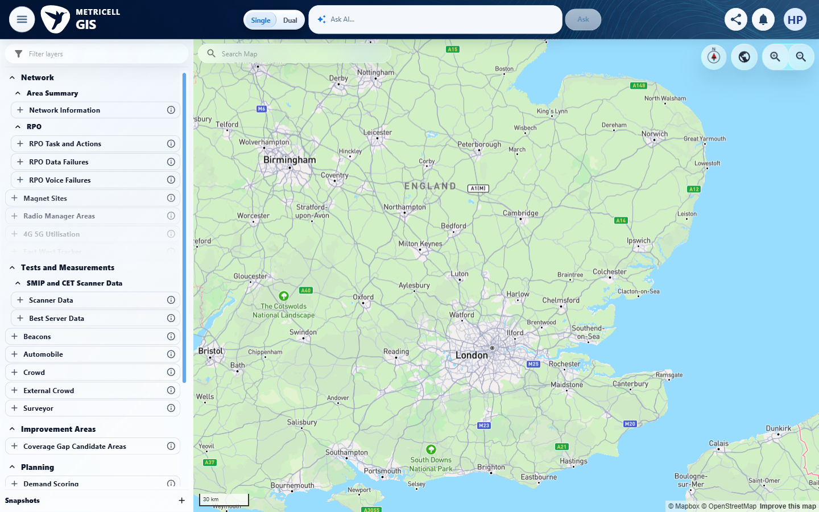

2.0.0 | After selecting Download, the map shows selectable points for matching authorised Download results only. | After selecting Download, the map shows selectable points for matching authorised Download results only. | Focused 28 October check: the applied 30 September day, handset and cell filters returned one Download aggregate containing one record, 132617095. The entire bounded response was reconciled with the single selectable map result; normal activation opened the matching populated details. No nonmatching result was observed in that filtered viewport. This is scoped verification, not a global database or other-account permissions audit.  Evidence: E02, E03, E04 | Passed
Fresh Download map capture on 30 October 2026. Coloured result symbols are visible; blue linked-site markers are hidden. Right: enlarged map detail from the same screenshot. Follow-up scope: Cambridge, 1 August to 30 October; separate from the earlier filtered completeness check. This supplements map visibility and selection only.
Browser URL recorded after criterion: https://o2intelligence-v4-dev.metricell.com/gis
E50 - Live map overview (criterion-2-live-map-overview.png)  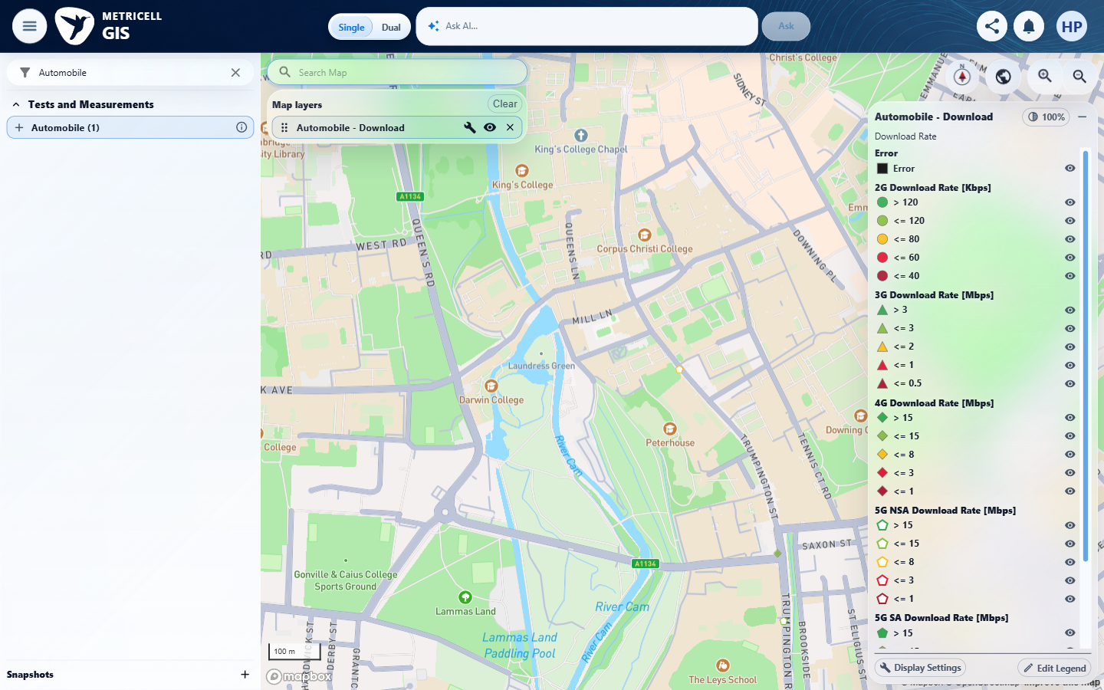 | E50 detail enlargement - full screenshot above

Fresh Download point selection on 30 October 2026 opened genuine test 132617095. The map and selected result are shown together. Follow-up scope: Cambridge, 1 August to 30 October; separate from the earlier filtered completeness check. This supplements map visibility and selection only.
Browser URL recorded after criterion: https://o2intelligence-v4-dev.metricell.com/gis
E52 - Live map selected (criterion-2-live-map-selected.png)
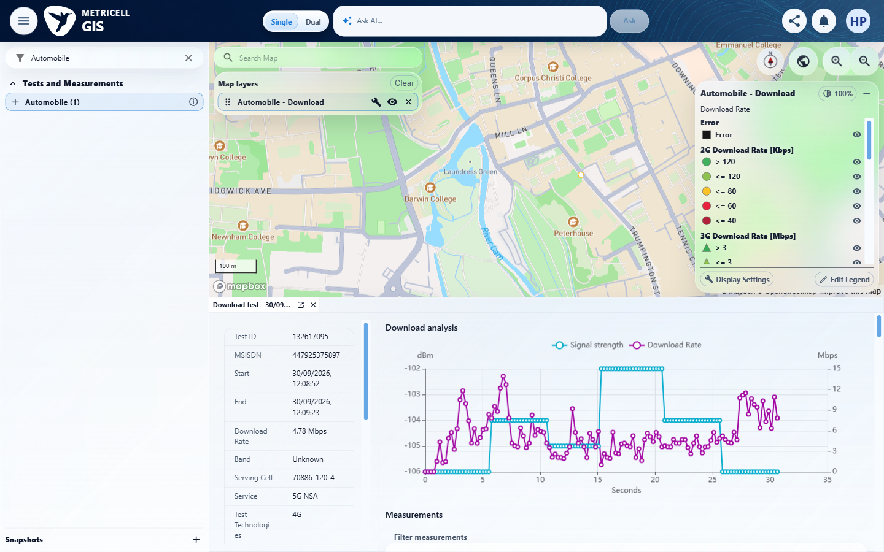

Criterion 2 evidence: After selecting Download, the map shows selectable points for matching authorised Download results only.
Browser URL recorded after criterion: https://o2intelligence-v4-dev.metricell.com/gis
E02 - Followup configuration (criterion-2-followup-configuration.png)  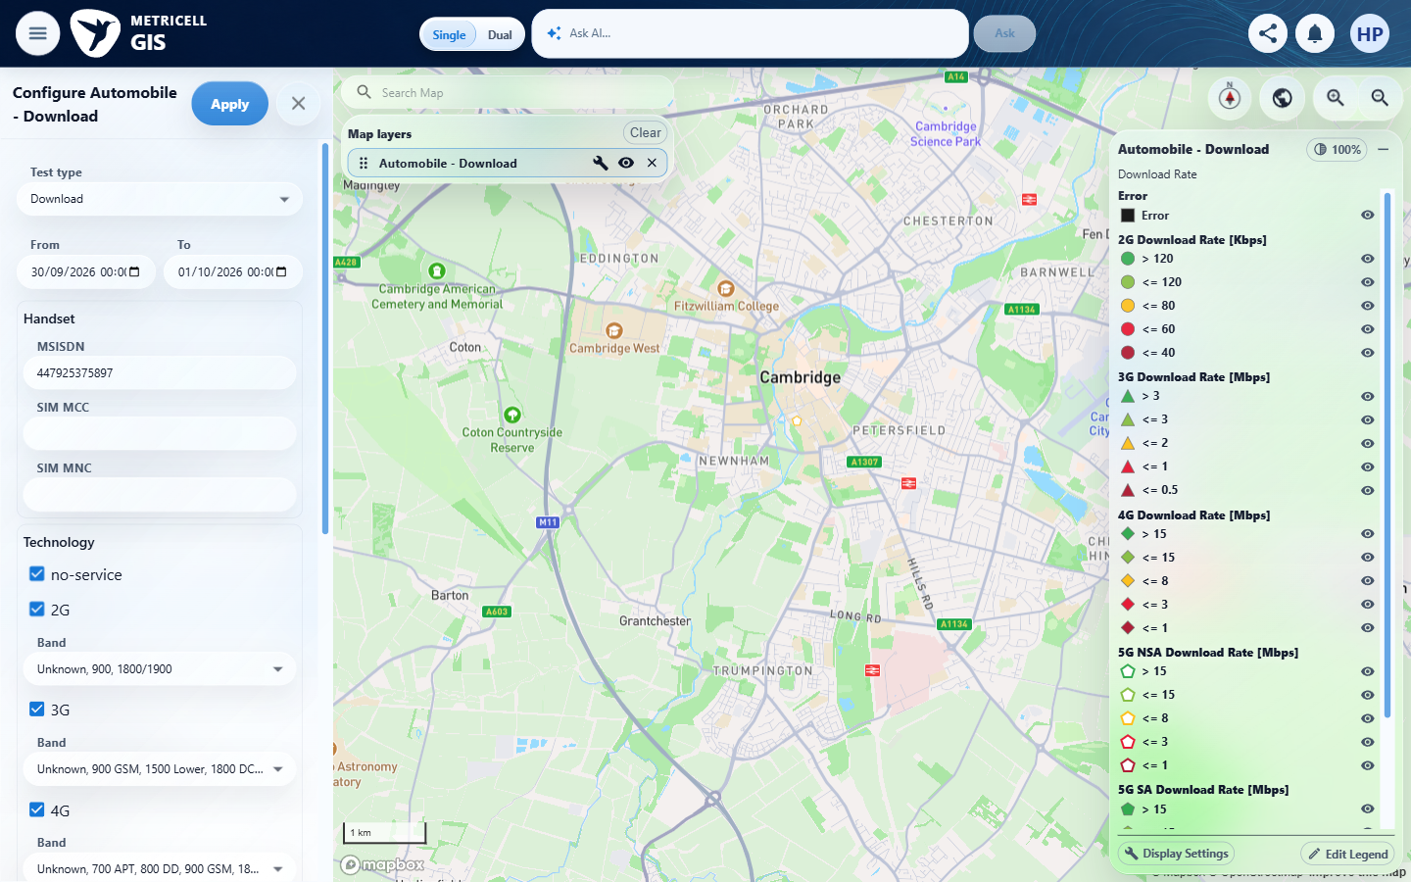 | E03 - Filtered followup viewport; not plotted-point proof (criterion-2-followup-map.png)  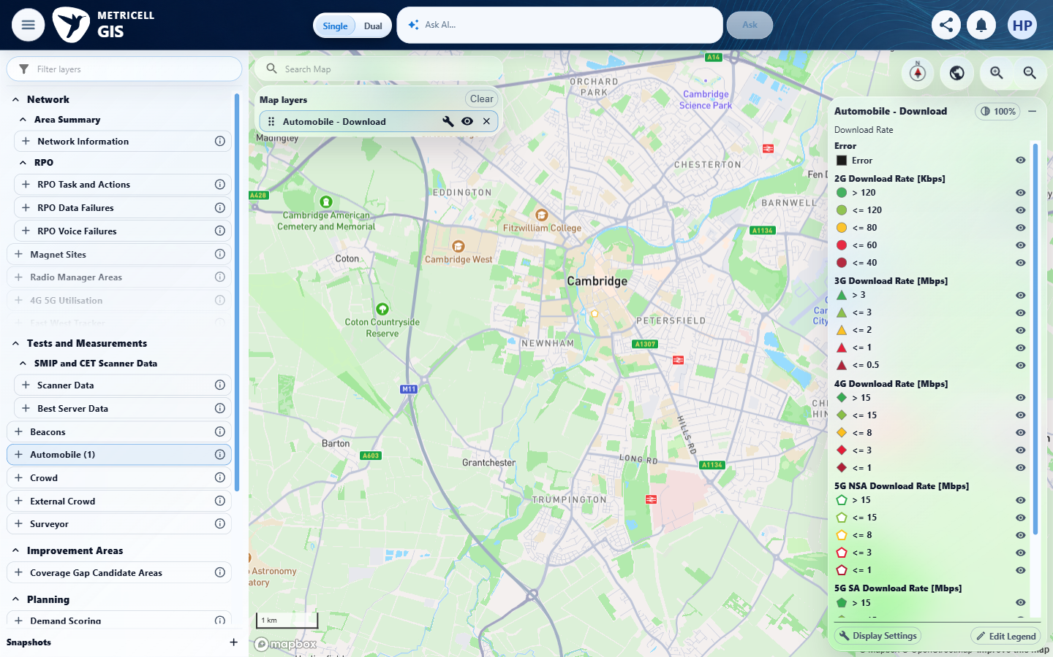

Criterion 2 continued: After selecting Download, the map shows selectable points for matching authorised Download results only.
Browser URL recorded after criterion: https://o2intelligence-v4-dev.metricell.com/gis
E04 - Followup final (criterion-2-followup-final.png)
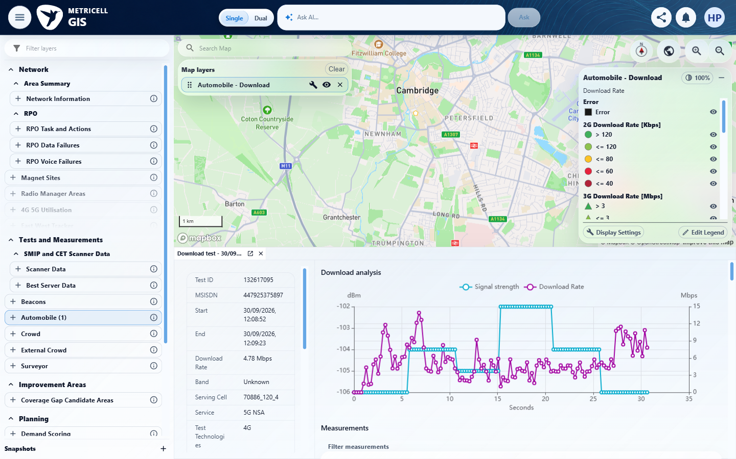

3.0.0 | After selecting Upload, the map shows selectable points for matching authorised Upload results only. | After selecting Upload, the map shows selectable points for matching authorised Upload results only. | Focused 28 October check: the applied 19 August day, handset and cell filters returned one Upload aggregate containing seven records. Both overlapping member-list captures show the complete set. Every returned member was selected normally; all seven opened matching populated summaries and settled without an analysis error. No nonmatching result was observed in this bounded scope. The complete identity comparison is retained in browser-audit.json.  Evidence: E05, E06, E07, E08, E09, E10, E11, E12, E13, E14, E15 | Passed
Fresh Upload map capture on 30 October 2026. Coloured result symbols are visible; blue linked-site markers are hidden. Right: enlarged map detail from the same screenshot. Follow-up scope: Cambridge, 1 August to 30 October; separate from the earlier filtered completeness check. This supplements map visibility and selection only.
Browser URL recorded after criterion: https://o2intelligence-v4-dev.metricell.com/gis
E51 - Live map overview (criterion-3-live-map-overview.png)  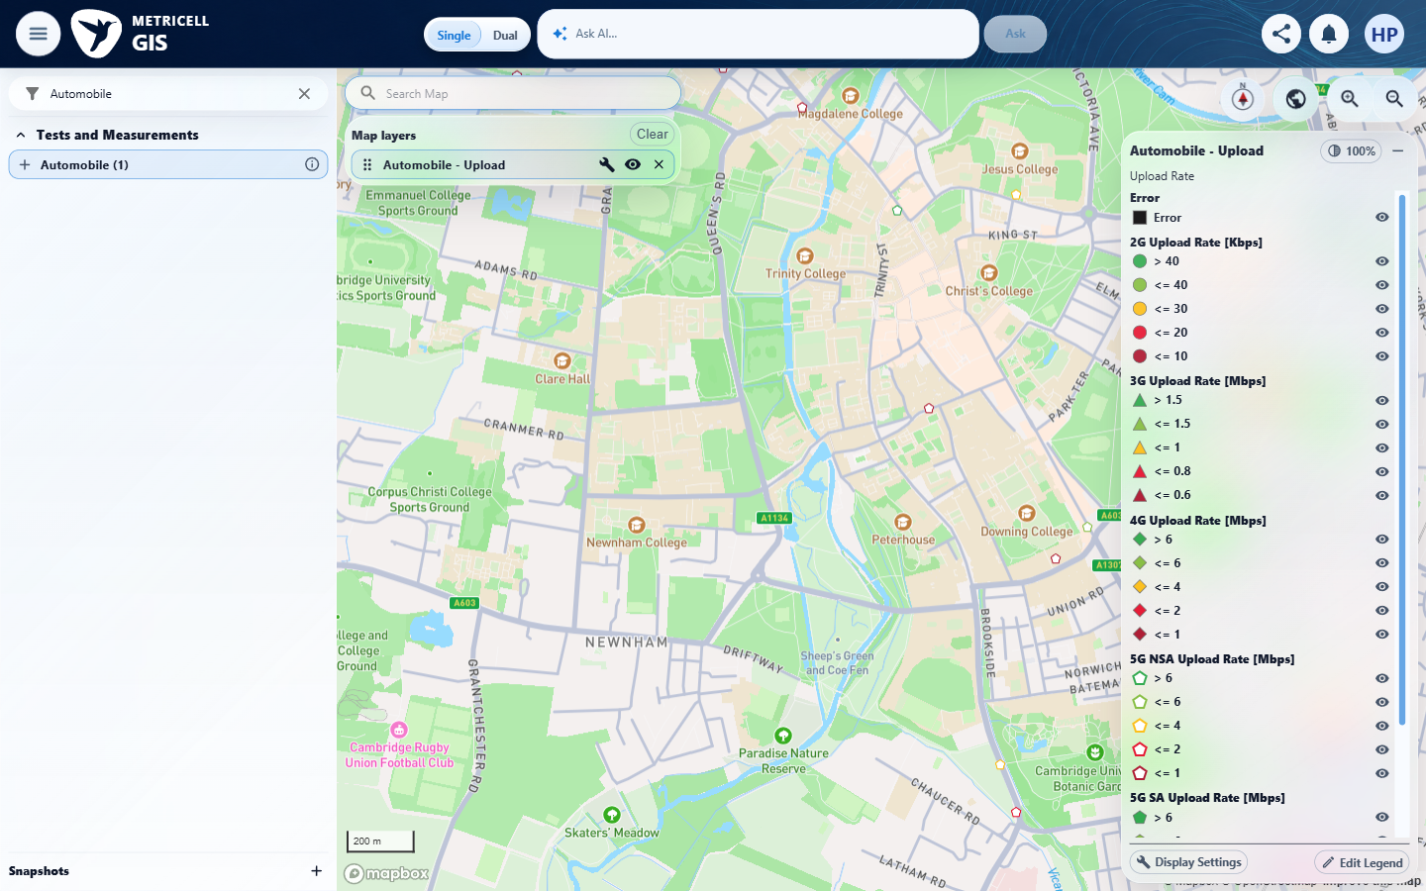 | E51 detail enlargement - full screenshot above

Fresh Upload point selection on 30 October 2026 opened genuine test 132610935. The map and selected result are shown together. Follow-up scope: Cambridge, 1 August to 30 October; separate from the earlier filtered completeness check. This supplements map visibility and selection only.
Browser URL recorded after criterion: https://o2intelligence-v4-dev.metricell.com/gis
E53 - Live map selected (criterion-3-live-map-selected.png)
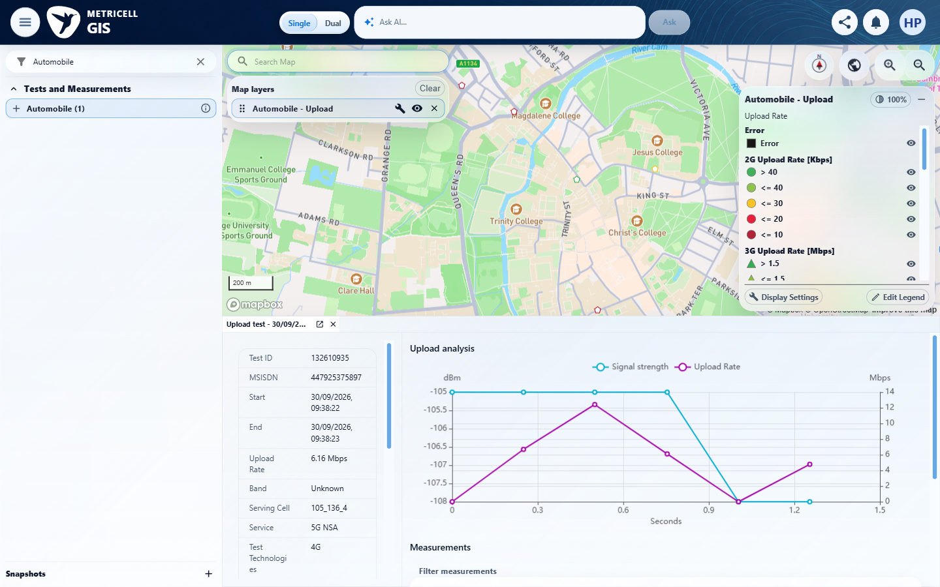

Criterion 3 evidence: After selecting Upload, the map shows selectable points for matching authorised Upload results only.
Browser URL recorded after criterion: https://o2intelligence-v4-dev.metricell.com/gis
E05 - Followup configuration (criterion-3-followup-configuration.png)  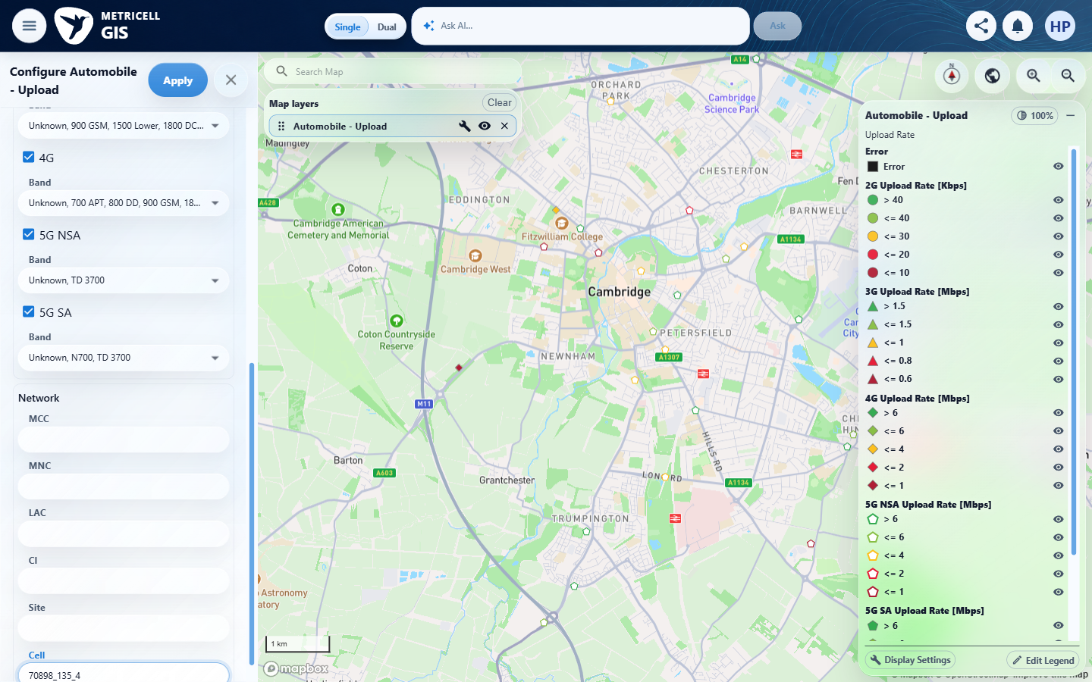 | E06 - Filtered followup viewport; not plotted-point proof (criterion-3-followup-map.png)  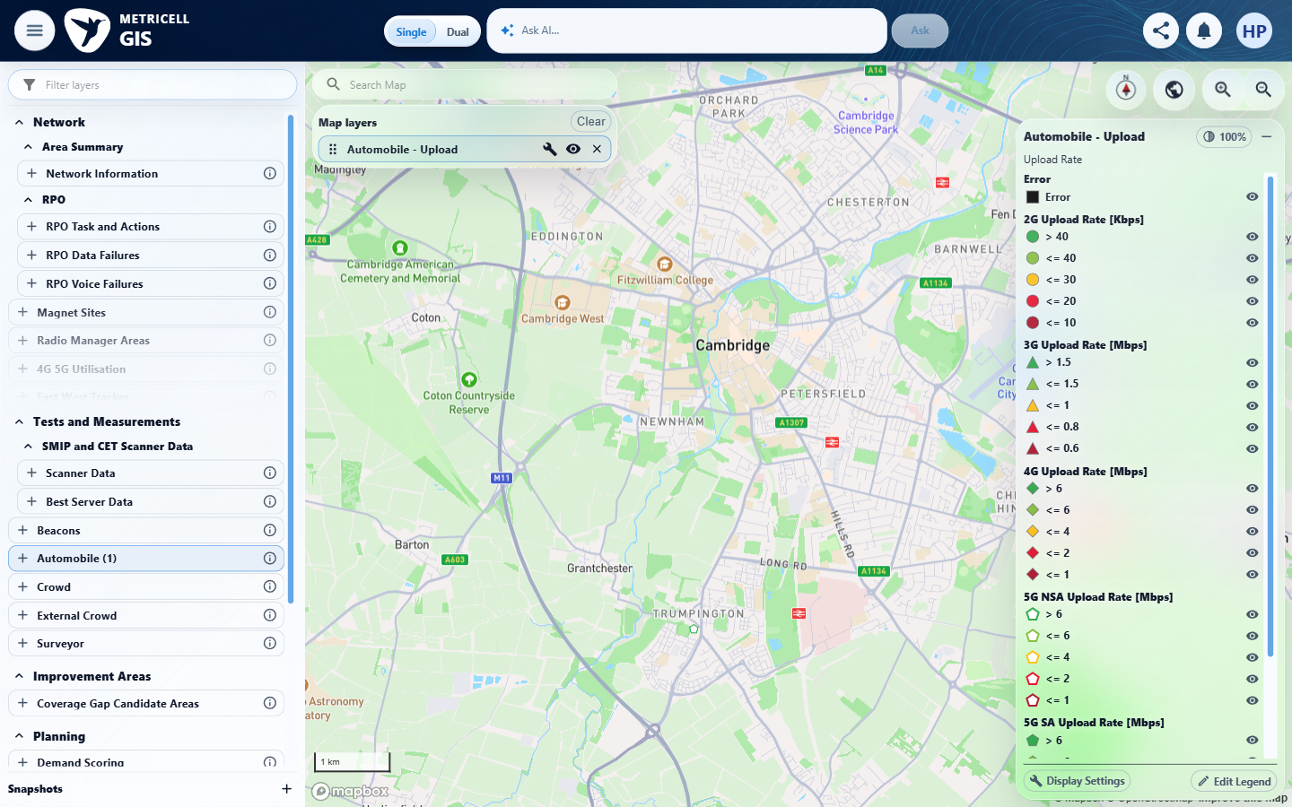

Criterion 3 continued: After selecting Upload, the map shows selectable points for matching authorised Upload results only.
Browser URL recorded after criterion: https://o2intelligence-v4-dev.metricell.com/gis
E07 - Followup members top (criterion-3-followup-members-top.png)  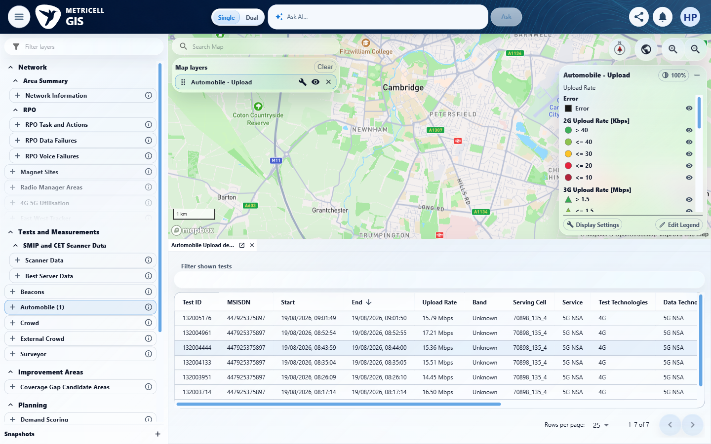 | E08 - Followup members bottom (criterion-3-followup-members-bottom.png)  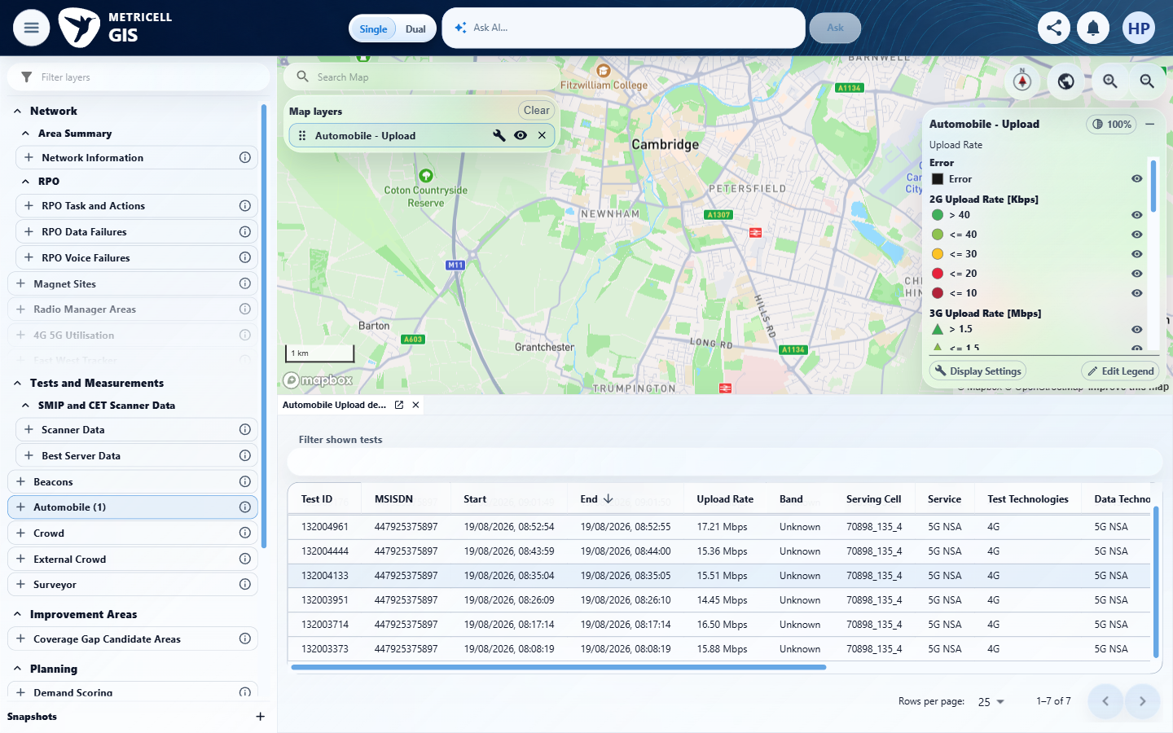

Criterion 3 continued: After selecting Upload, the map shows selectable points for matching authorised Upload results only.
Browser URL recorded after criterion: https://o2intelligence-v4-dev.metricell.com/gis
E09 - Followup member 132005176 (criterion-3-followup-member-132005176.png)  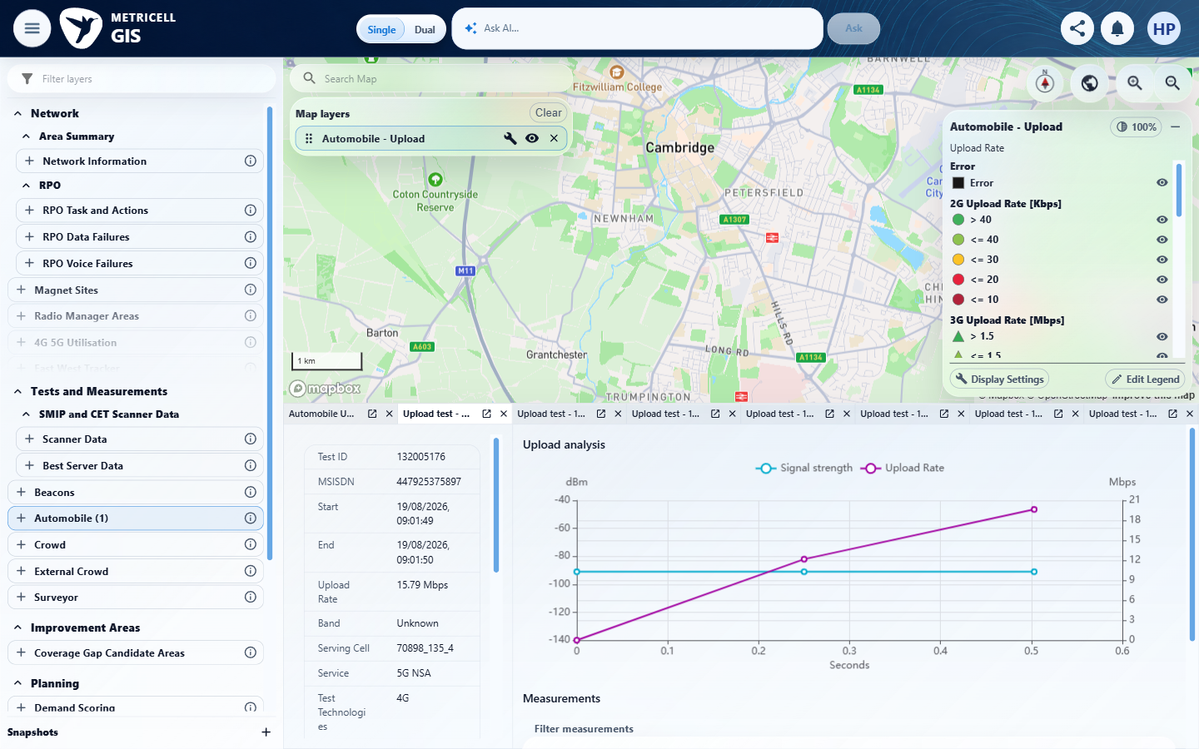 | E10 - Followup member 132004961 (criterion-3-followup-member-132004961.png)  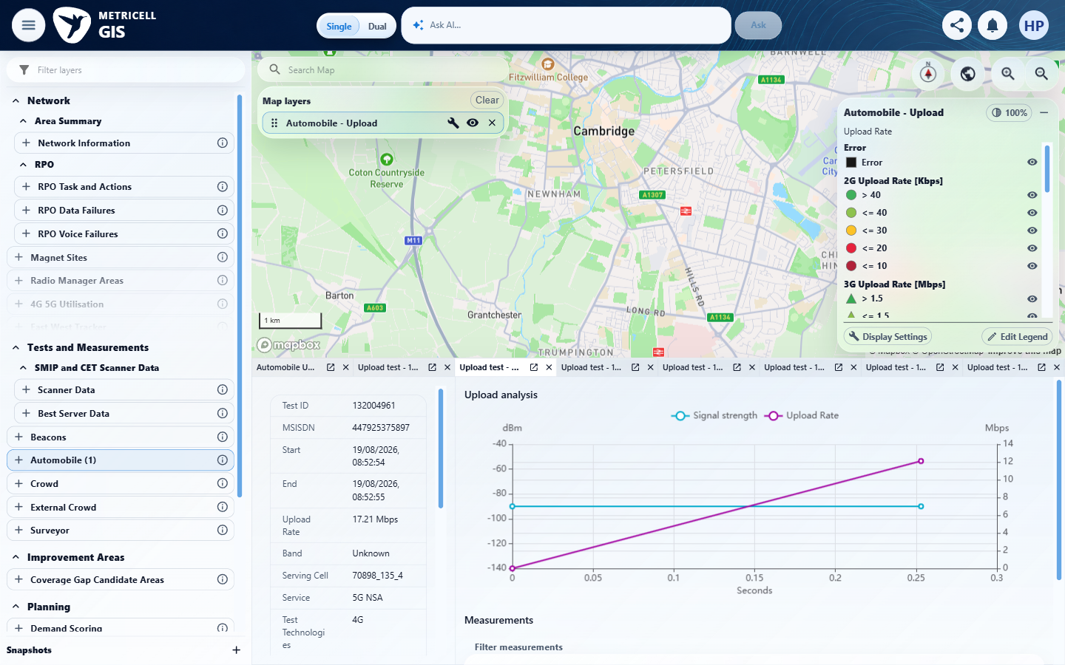

Criterion 3 continued: After selecting Upload, the map shows selectable points for matching authorised Upload results only.
Browser URL recorded after criterion: https://o2intelligence-v4-dev.metricell.com/gis
E11 - Followup member 132004444 (criterion-3-followup-member-132004444.png)  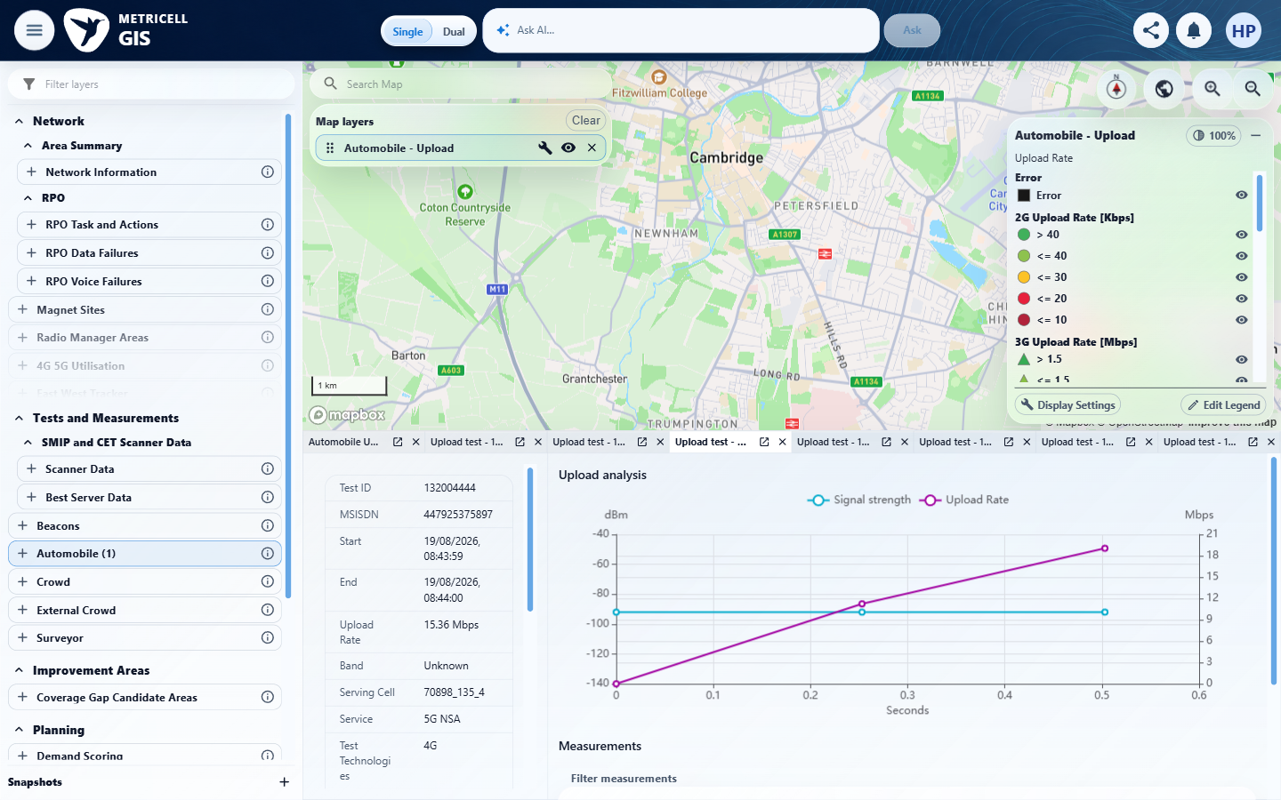 | E12 - Followup member 132004133 (criterion-3-followup-member-132004133.png)  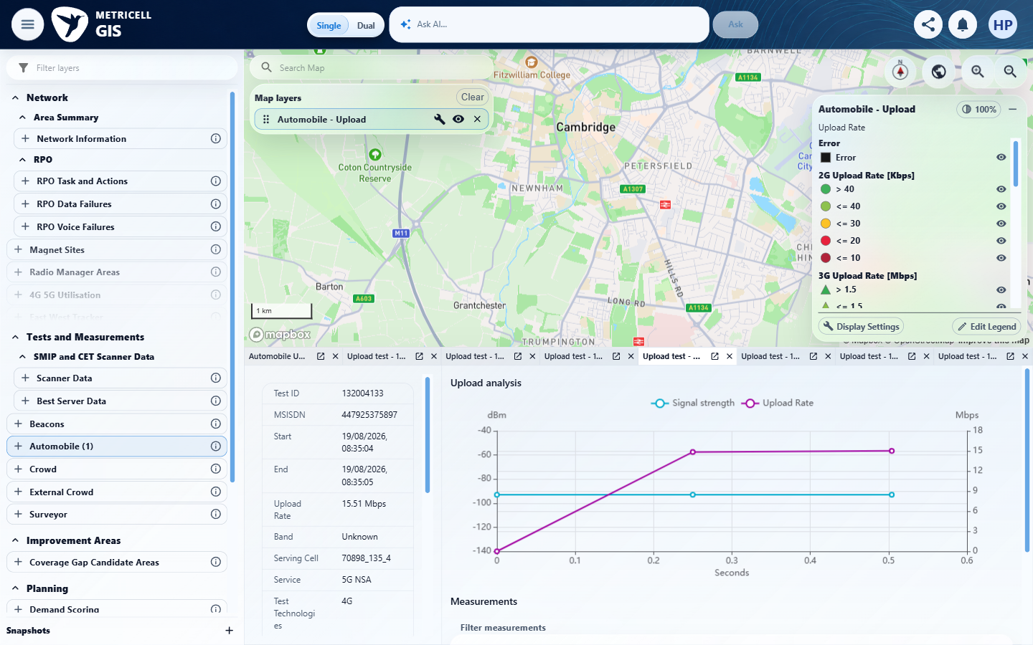

Criterion 3 continued: After selecting Upload, the map shows selectable points for matching authorised Upload results only.
Browser URL recorded after criterion: https://o2intelligence-v4-dev.metricell.com/gis
E13 - Followup member 132003951 (criterion-3-followup-member-132003951.png)  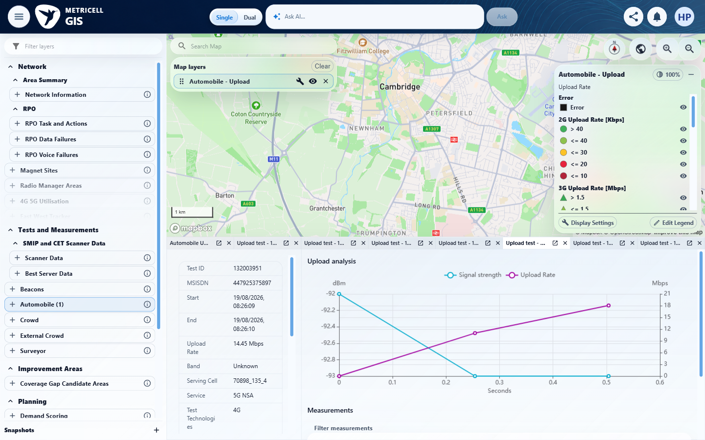 | E14 - Followup member 132003714 (criterion-3-followup-member-132003714.png)  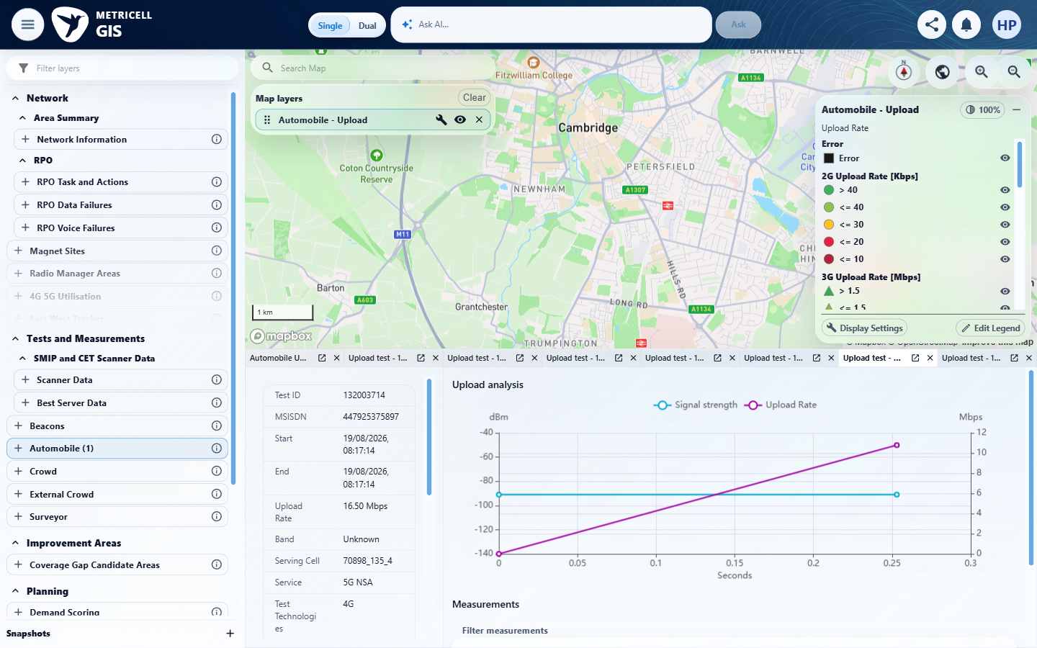

Criterion 3 continued: After selecting Upload, the map shows selectable points for matching authorised Upload results only.
Browser URL recorded after criterion: https://o2intelligence-v4-dev.metricell.com/gis
E15 - Followup member 132003373 (criterion-3-followup-member-132003373.png)
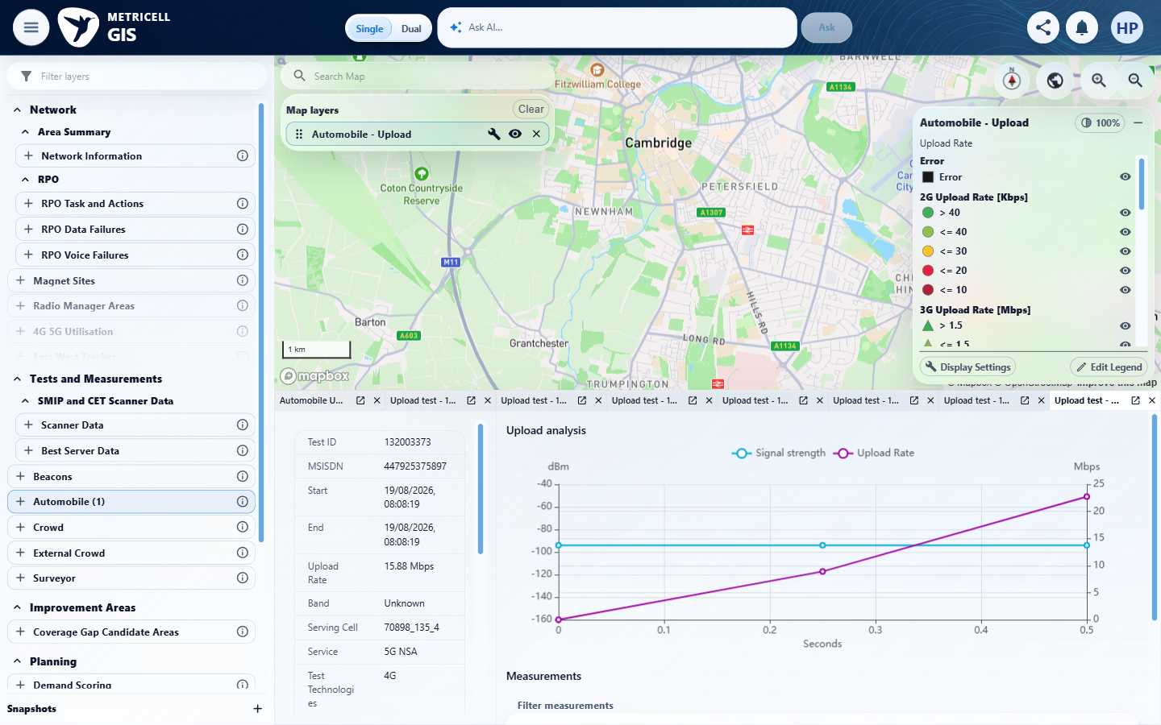

4.0.0 | Selecting a Download result point opens its details dialog with Data Technology, MSISDN, Service, Serving Cell, Test Duration, Test Technologies, Download Rate, and Wi-Fi Connected. | Selecting a Download result point opens its details dialog with Data Technology, MSISDN, Service, Serving Cell, Test Duration, Test Technologies, Download Rate, and Wi-Fi Connected. | criterion-4-repair-summary-top.png, repair-summary-middle.png and repair-final.png show Download 132617095 with MSISDN 447925375897, Service/Data Technology 5G NSA, Serving Cell 70886_120_4, Test Technologies 4G, rate 4.78 Mbps, Wi-Fi Connected No and duration 30.841 s. These overlapping settled summary views follow the recorded point selection and supersede the exploratory sequence.  Evidence: E16, E17, E18 | Passed
Criterion 4 evidence: Selecting a Download result point opens its details dialog with Data Technology, MSISDN, Service, Serving Cell, Test Duration, Test Technologies, Download Rate, and Wi-Fi Connected.
Browser URL recorded after criterion: https://o2intelligence-v4-dev.metricell.com/gis
E16 - Repair summary top (criterion-4-repair-summary-top.png)  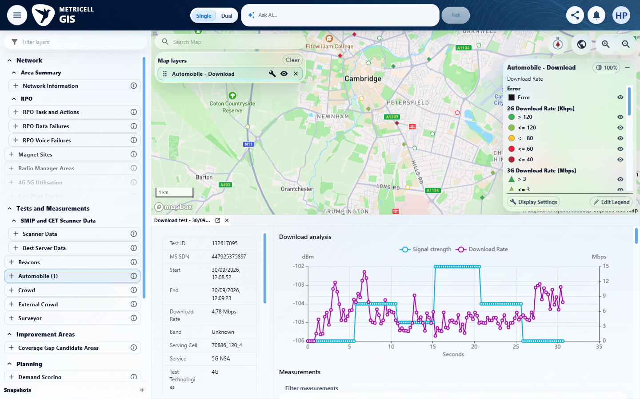 | E17 - Repair summary middle (criterion-4-repair-summary-middle.png)  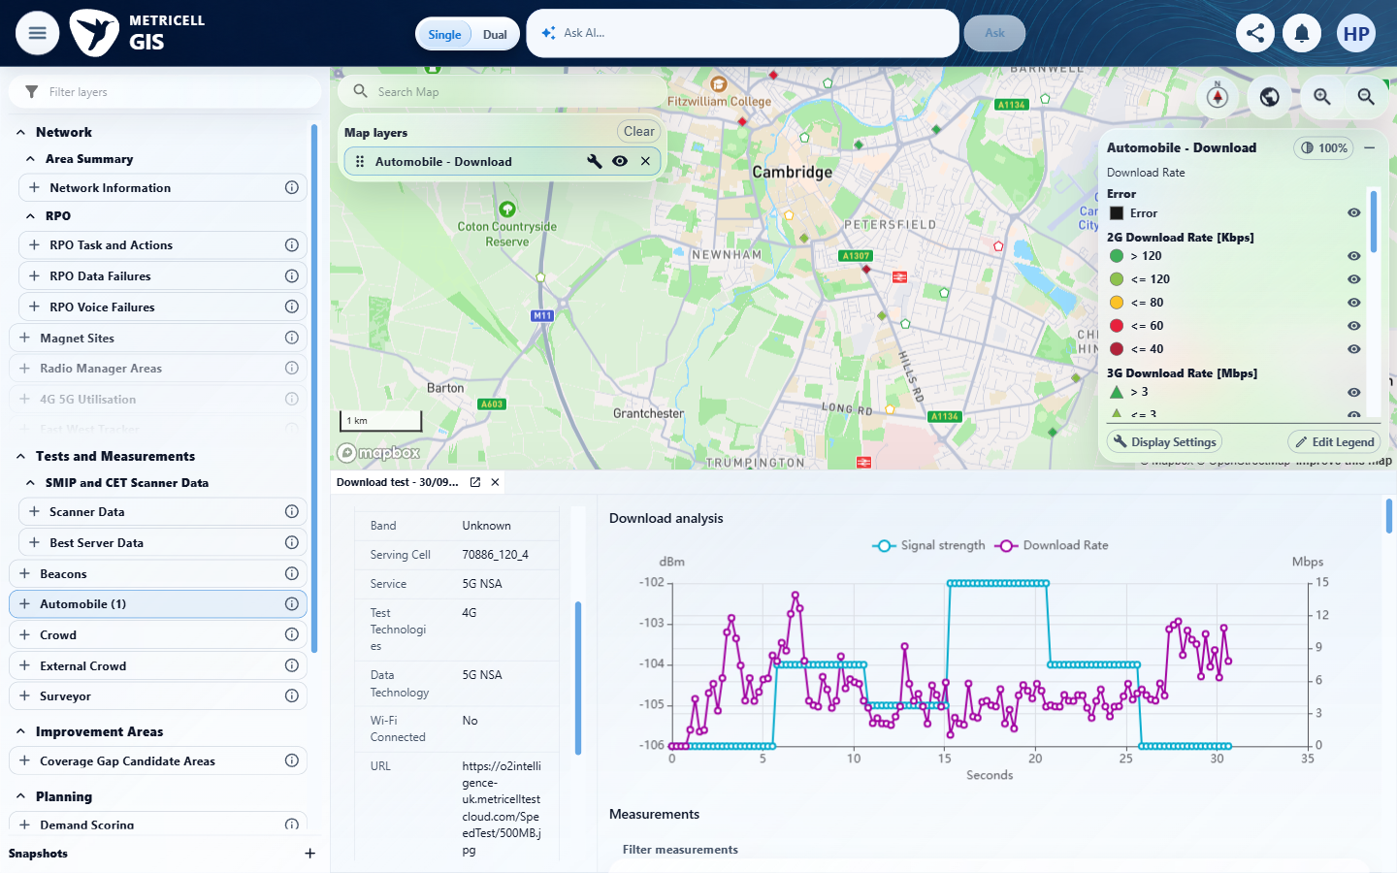

Criterion 4 continued: Selecting a Download result point opens its details dialog with Data Technology, MSISDN, Service, Serving Cell, Test Duration, Test Technologies, Download Rate, and Wi-Fi Connected.
Browser URL recorded after criterion: https://o2intelligence-v4-dev.metricell.com/gis
E18 - Repair final (criterion-4-repair-final.png)
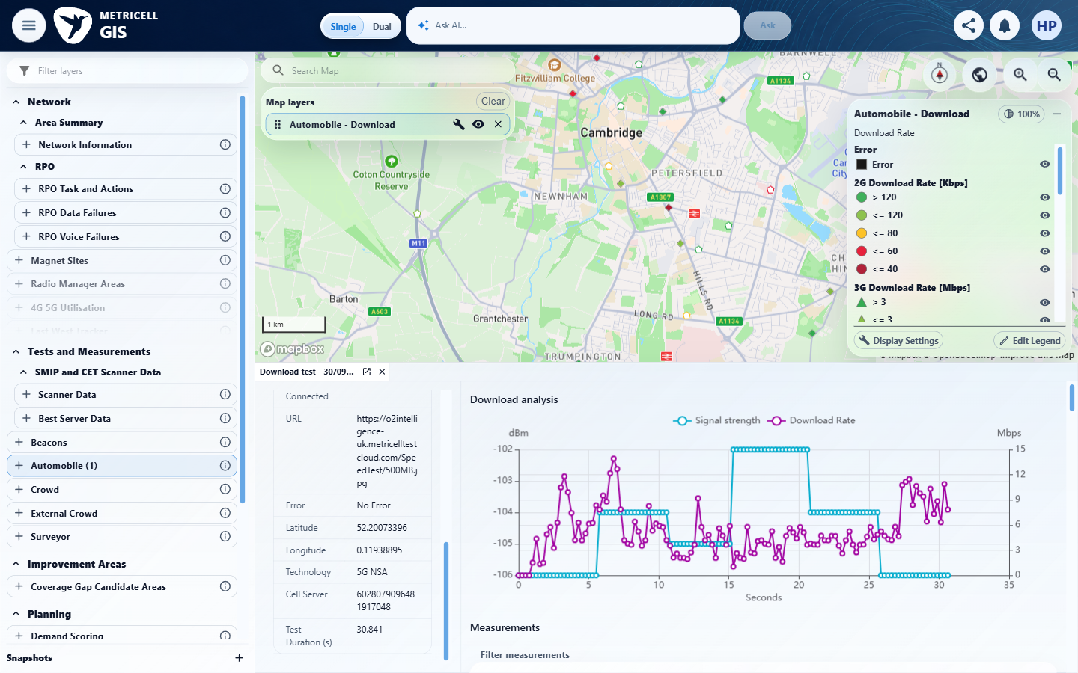

5.0.0 | Selecting an Upload result point opens its details dialog with Data Technology, MSISDN, Service, Serving Cell, Test Duration, Test Technologies, Upload Rate, and Wi-Fi Connected. | Selecting an Upload result point opens its details dialog with Data Technology, MSISDN, Service, Serving Cell, Test Duration, Test Technologies, Upload Rate, and Wi-Fi Connected. | criterion-5-repair-top.png, repair-middle.png and repair-final.png show Upload 132610532 with MSISDN 447925375897, Service/Data Technology 5G NSA, Serving Cell 105_120_4, Test Technologies 4G, rate 0.85 Mbps, Wi-Fi Connected No and duration 9.777 s. The repaired criterion-owned sequence proves the eight required summary fields.  Evidence: E19, E20, E21 | Passed
Criterion 5 evidence: Selecting an Upload result point opens its details dialog with Data Technology, MSISDN, Service, Serving Cell, Test Duration, Test Technologies, Upload Rate, and Wi-Fi Connected.
Browser URL recorded after criterion: https://o2intelligence-v4-dev.metricell.com/gis
E19 - Repair top (criterion-5-repair-top.png)  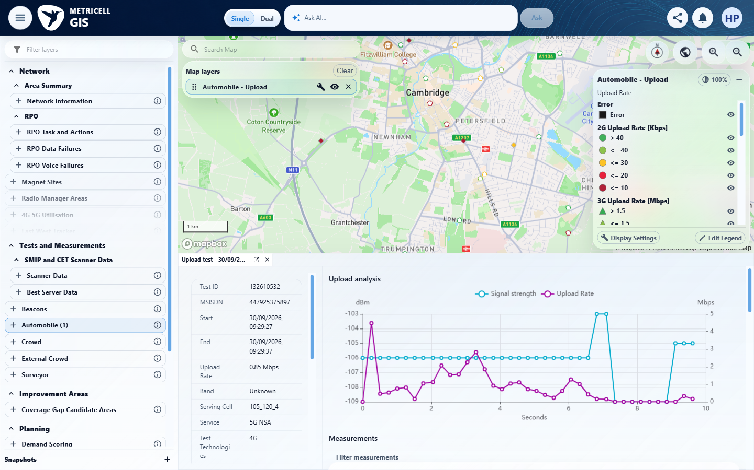 | E20 - Repair middle (criterion-5-repair-middle.png)  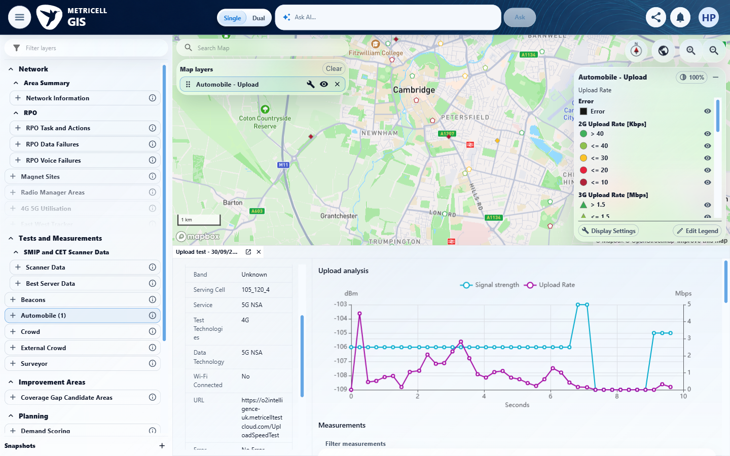

Criterion 5 continued: Selecting an Upload result point opens its details dialog with Data Technology, MSISDN, Service, Serving Cell, Test Duration, Test Technologies, Upload Rate, and Wi-Fi Connected.
Browser URL recorded after criterion: https://o2intelligence-v4-dev.metricell.com/gis
E21 - Repair final (criterion-5-repair-final.png)
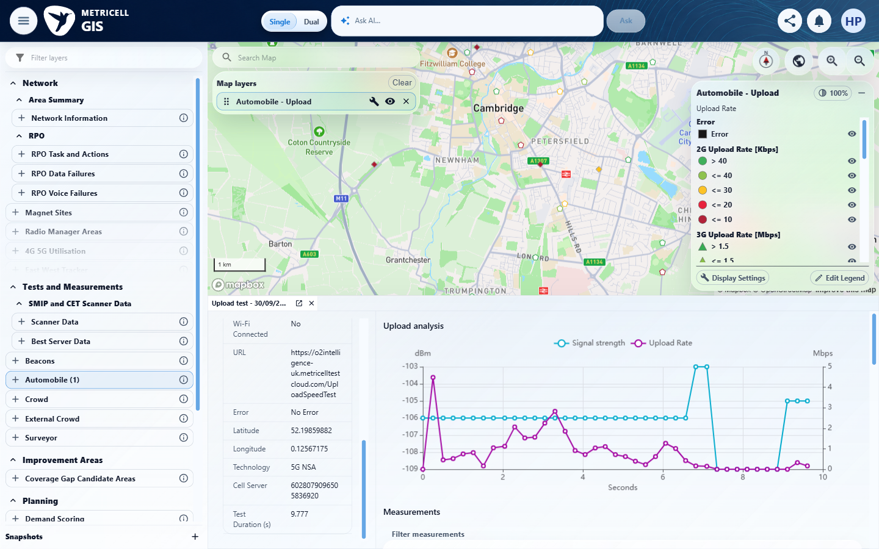

6.0.0 | The Download result details chart plots Signal Strength in dBm and Download Rate in Mbps over time. | The Download result details chart plots Signal Strength in dBm and Download Rate in Mbps over time. | criterion-6-repair-final.png shows Download 132617095's plotted Signal strength and Download Rate series, dBm and Mbps axes and Seconds horizontal axis; the visible tooltip confirms samples belong to the plotted chart. Tooltip unit formatting is assessed separately under criterion 10.  Evidence: E22 | Passed
Criterion 6 evidence: The Download result details chart plots Signal Strength in dBm and Download Rate in Mbps over time.
Browser URL recorded after criterion: https://o2intelligence-v4-dev.metricell.com/gis
E22 - Repair final (criterion-6-repair-final.png)
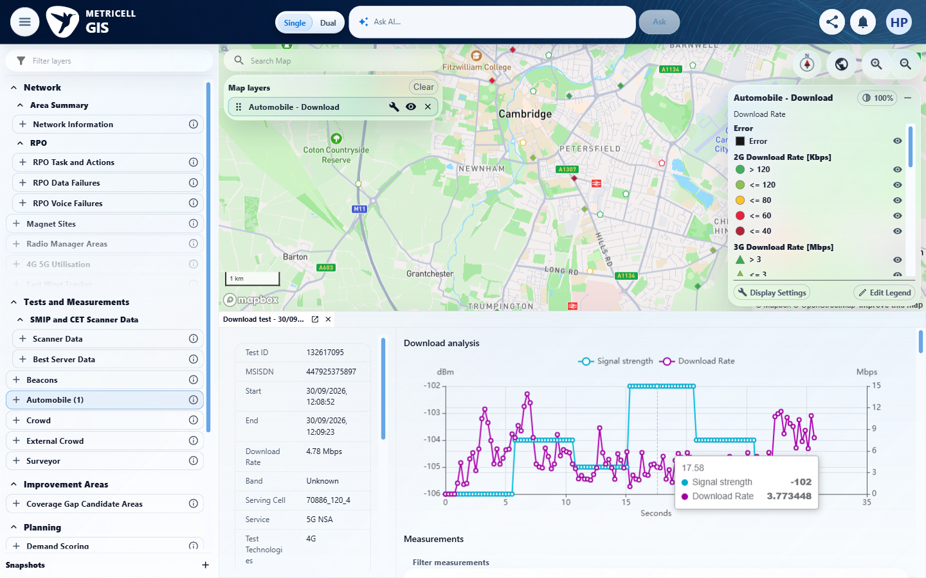

7.0.0 | The Upload result details chart plots Signal Strength in dBm and Upload Rate in Mbps over time. | The Upload result details chart plots Signal Strength in dBm and Upload Rate in Mbps over time. | criterion-7-repair-final.png shows Upload 132610532's two plotted series with dBm/Mbps axes over Seconds; criterion-7-tooltip.png also exposes the samples. Both signals are visible on the chart, independently of the measurements table.  Evidence: E23, E24 | Passed
Criterion 7 evidence: The Upload result details chart plots Signal Strength in dBm and Upload Rate in Mbps over time.
Browser URL recorded after criterion: https://o2intelligence-v4-dev.metricell.com/gis
E23 - Repair final (criterion-7-repair-final.png)  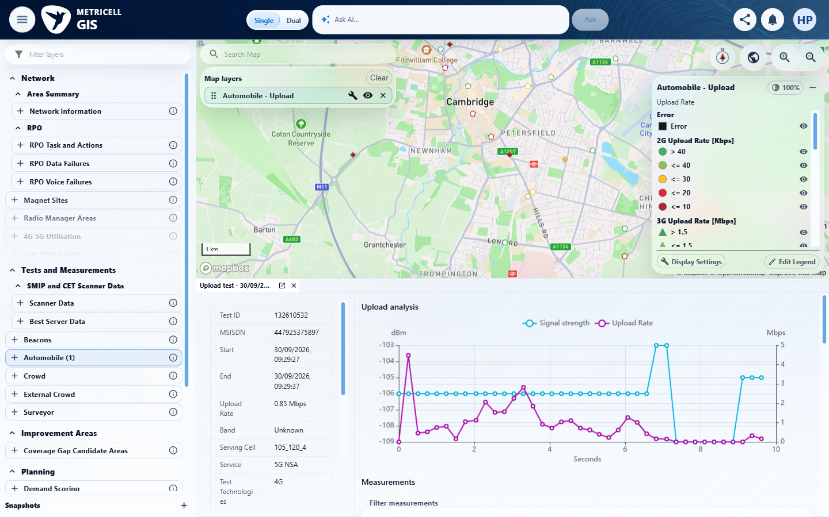 | E24 - Tooltip (criterion-7-tooltip.png)  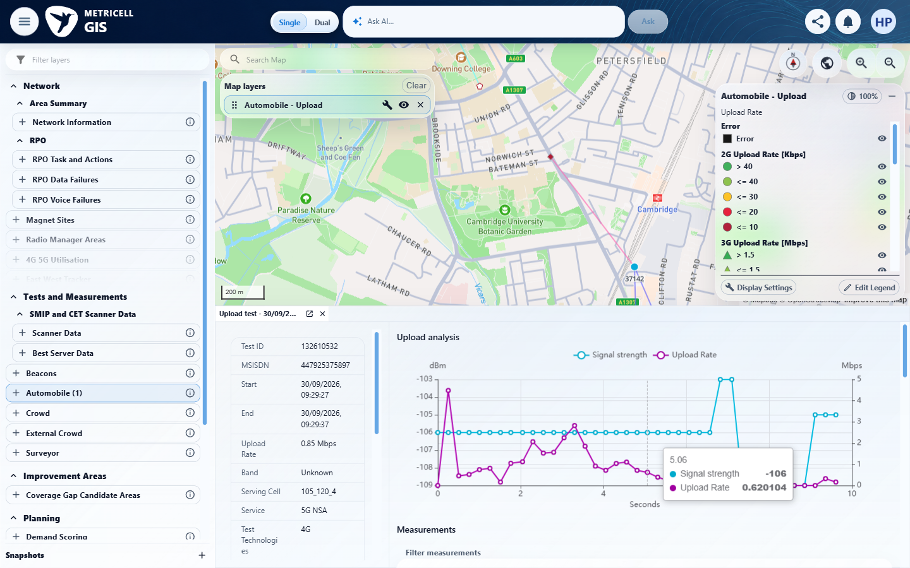

8.0.0 | The Download details table displays MSISDN, Start Time, End Time, Download Rate, Band, Serving Cell, Service, Test Technologies, Data Technology, Wi-Fi Connected, URL, and Error Message. | The Download details table displays MSISDN, Start Time, End Time, Download Rate, Band, Serving Cell, Service, Test Technologies, Data Technology, Wi-Fi Connected, URL, and Error Message. | criterion-8-recheck-left.png and recheck-final.png show the Automobile Download test-results table, whose row entities are tests, for 132616647. Across horizontal scroll states all 12 specified columns and their displayed values are readable, including Start/End and Error labels corresponding to Start Time/End Time and Error Message. Rate is N/A and technologies UNKNOWN for this failed record; this proves column presence, not a successful rate. The separate measurement table is not used as column proof.  Evidence: E25, E26 | Passed
Criterion 8 assessment: Testing notes: The actual Download test-results table contains every required field. The earlier exploratory measurement-table interpretation is superseded; no missing-column product failure is claimed. In Automobile Download with 30 September local day filters, selected the failed map result 132616647; the test-results table remained open rather than an individual analysis view. Actual labels Start, End and Error correspond to specified Start Time, End Time and Error Message. Rate was N/A on this zero-duration Network Error record; column presence is verified, not a successful rate value.
Criterion 8 evidence: The Download details table displays MSISDN, Start Time, End Time, Download Rate, Band, Serving Cell, Service, Test Technologies, Data Technology, Wi-Fi Connected, URL, and Error Message.
Browser URL recorded after criterion: https://o2intelligence-v4-dev.metricell.com/gis
E25 - Recheck left (criterion-8-recheck-left.png)  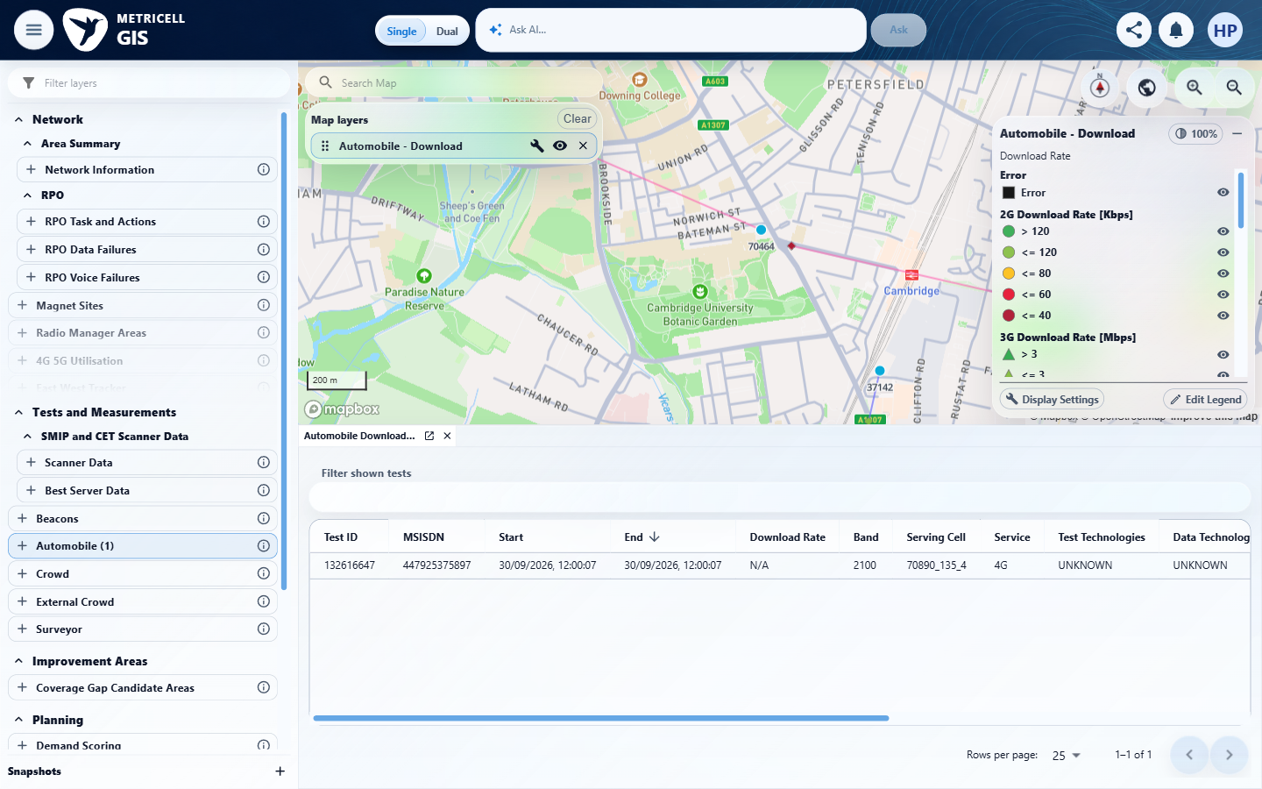 | E26 - Recheck final (criterion-8-recheck-final.png)  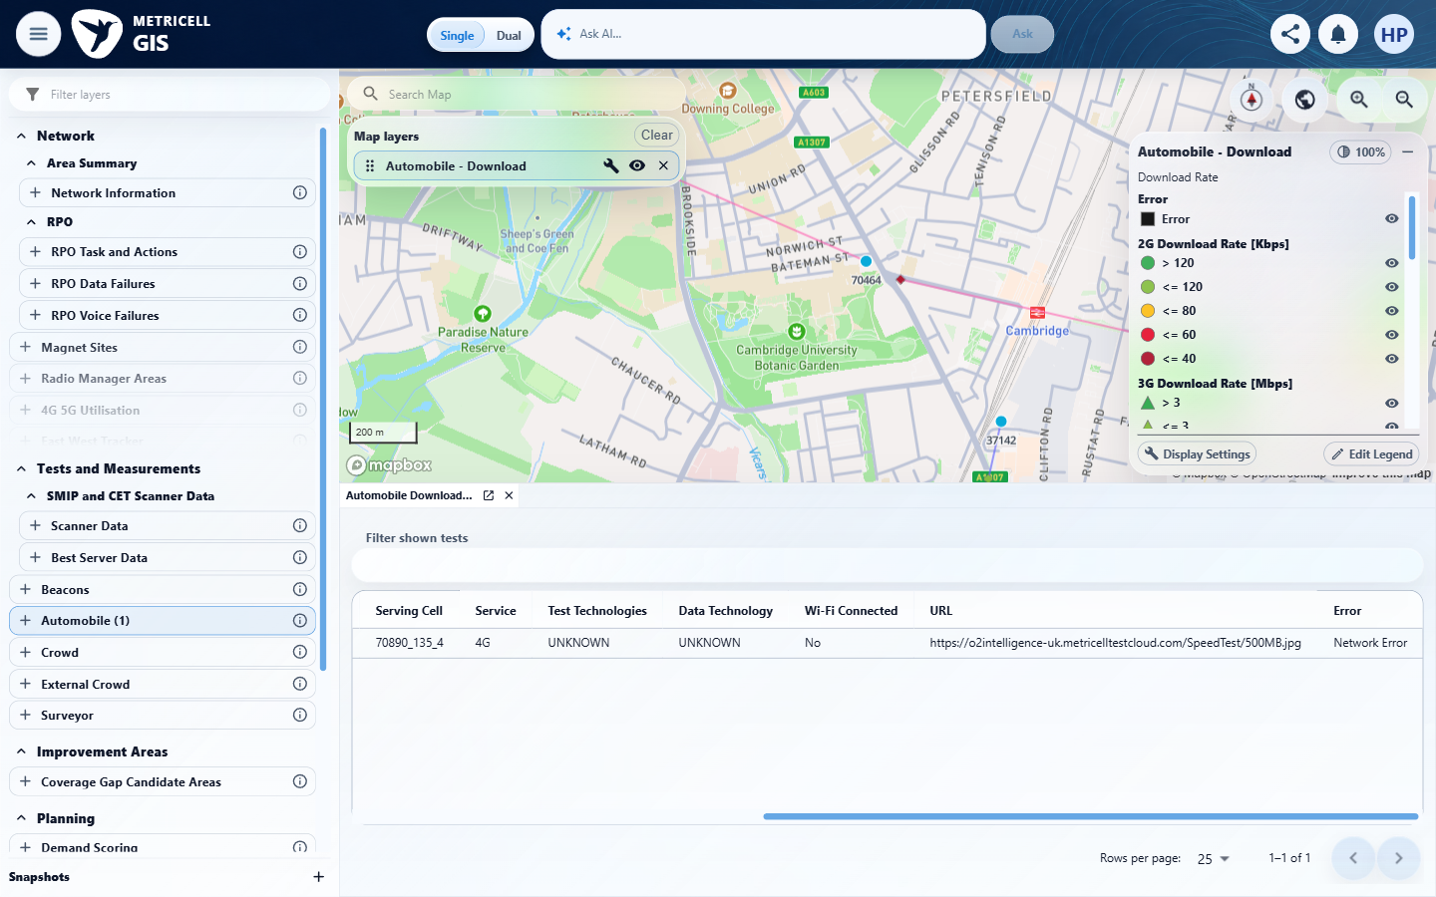

9.0.0 | The Upload details table displays MSISDN, Start Time, End Time, Upload Rate, Band, Serving Cell, Service, Test Technologies, Data Technology, Wi-Fi Connected, URL, and Error Message. | The Upload details table displays MSISDN, Start Time, End Time, Upload Rate, Band, Serving Cell, Service, Test Technologies, Data Technology, Wi-Fi Connected, URL, and Error Message. | criterion-9-repair-left.png and repair-final.png show the Automobile Upload test-results table for 132616657 across horizontal scroll states, including every specified column. Start/End and Error correspond to the source's time/error labels. The failed record displays N/A rate, UNKNOWN technologies and Network Error; no successful rate value is claimed. Measurement-table exploration is excluded.  Evidence: E27, E28 | Passed
Criterion 9 assessment: Testing notes: The actual Upload test-results table contains every required field. The earlier exploratory measurement-table interpretation is superseded; no missing-column product failure is claimed. In Automobile Upload with 30 September local day filters, selected the failed map result 132616657; the test-results table remained open rather than an individual analysis view. Actual labels Start, End and Error correspond to specified Start Time, End Time and Error Message. Rate was N/A on this zero-duration Network Error record; column presence is verified, not a successful rate value.
Criterion 9 evidence: The Upload details table displays MSISDN, Start Time, End Time, Upload Rate, Band, Serving Cell, Service, Test Technologies, Data Technology, Wi-Fi Connected, URL, and Error Message.
Browser URL recorded after criterion: https://o2intelligence-v4-dev.metricell.com/gis
E27 - Repair left (criterion-9-repair-left.png)  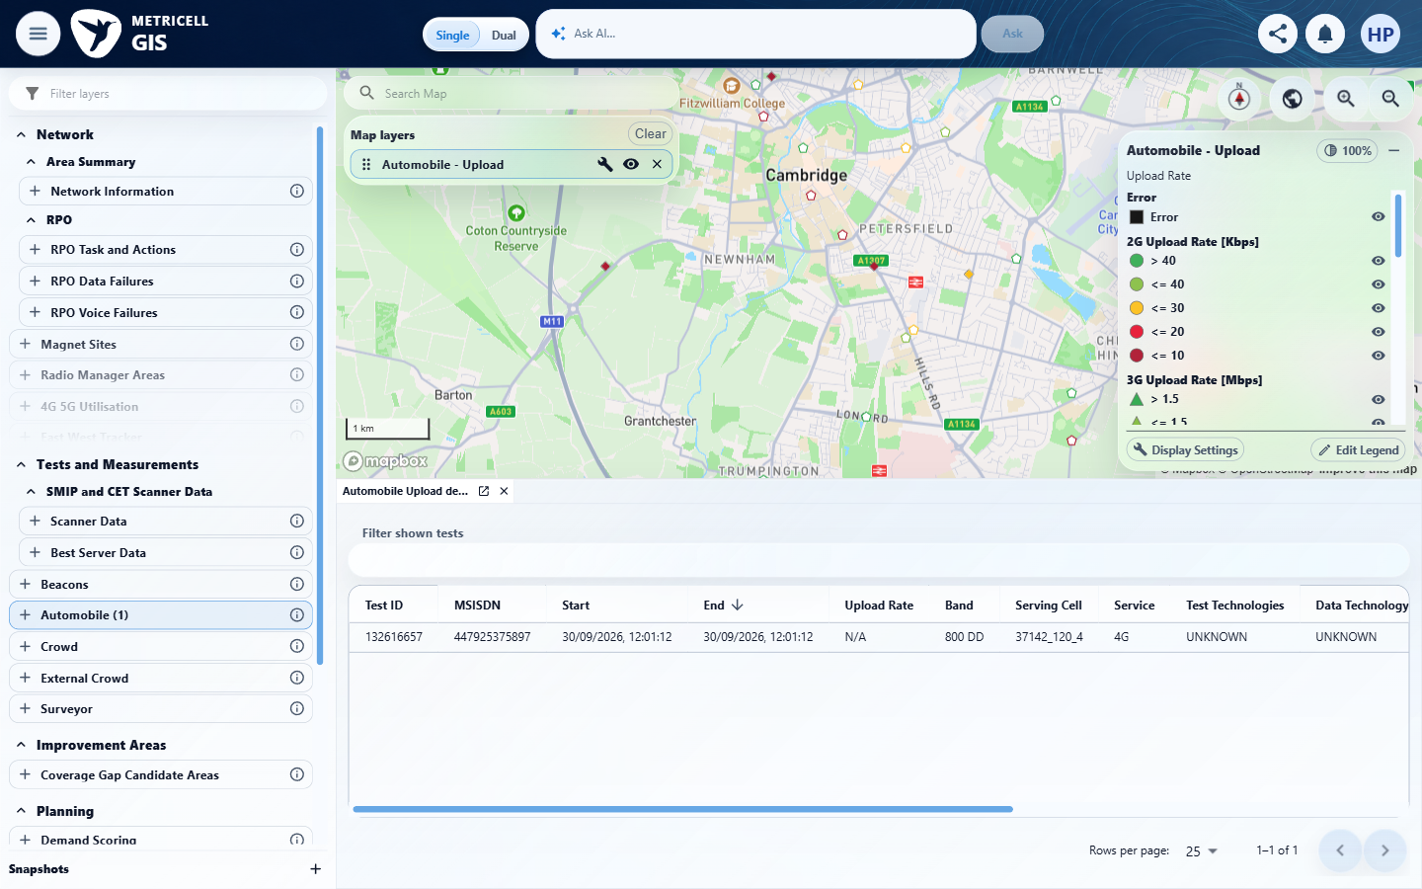 | E28 - Repair final (criterion-9-repair-final.png)  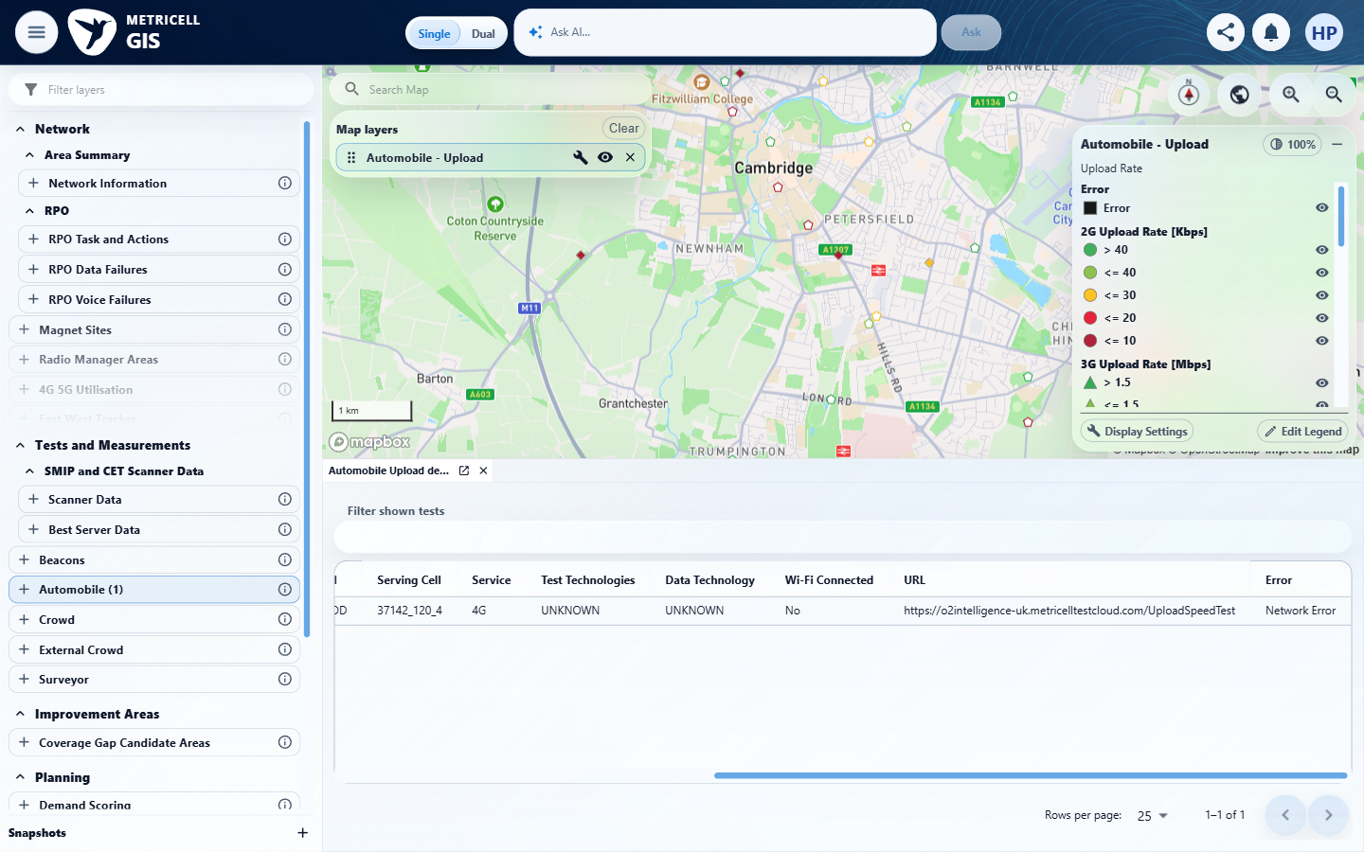

10.0.0 | Where signal strength or rate values are shown, each value includes its applicable unit (dBm or Mbps). | Where signal strength or rate values are shown, each value includes its applicable unit (dBm or Mbps). | The screenshots show dBm and Mbps on the graph axes, with applicable units also present in the summary and measurement table. Harry clarified on 28 October that units on the graph satisfy this requirement; repeating them beside each hover-tooltip value is not required. Passed on that explicit acceptance clarification; no new browser test was performed.  Evidence: E29, E30 | Passed
Criterion 10 evidence: Where signal strength or rate values are shown, each value includes its applicable unit (dBm or Mbps).
Browser URL recorded after criterion: https://o2intelligence-v4-dev.metricell.com/gis
E29 - Repair tooltip (criterion-10-repair-tooltip.png)  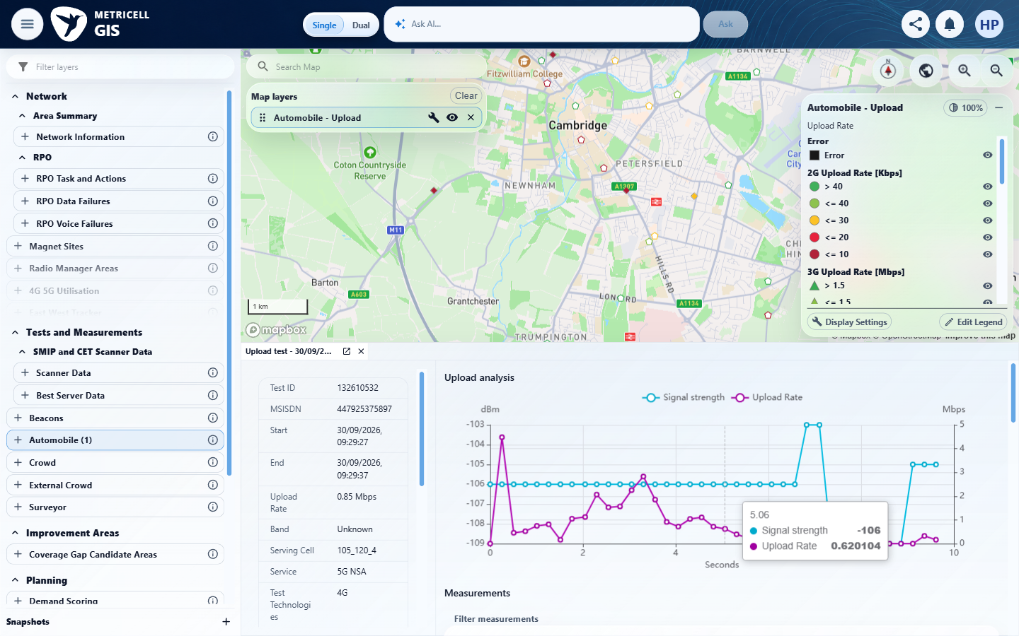 | E30 - Repair final (criterion-10-repair-final.png)  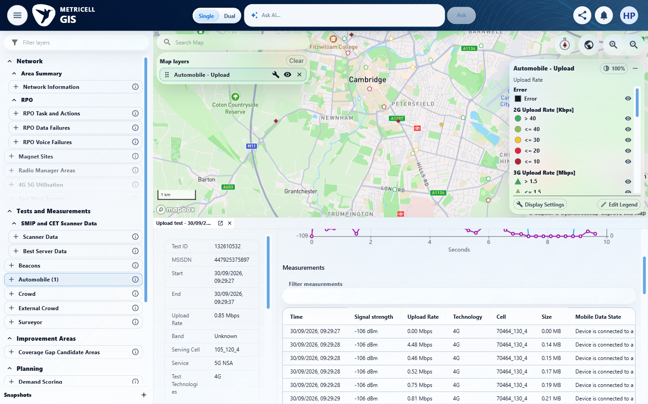

11.0.0 | For a result whose Error Message is null, the details table displays “No Error”. | For a result whose Error Message is null, the details table displays “No Error”. | criterion-11-recheck-table-left.png identifies Upload tests and recheck-table-final.png shows No Error on the six visible rows. The criterion-owned genuine POST /api/platform/automobile/upload/cluster-details HTTP 200 observation records errorMessage:null for these IDs. This proves null-to-No Error presentation for the visible records; the seventh row is below the captured scroll area, so the tester's claim that all seven Error cells were visibly verified is not adopted. The source requires a null-error result, not exhaustive null-error records.  Evidence: E31, E32 | Passed
Criterion 11 assessment: Testing notes: Compared the selected cluster's table, including all seven Error cells, with the genuine null-error values. Each displayed No Error.
Criterion 11 evidence: For a result whose Error Message is null, the details table displays “No Error”.
Browser URL recorded after criterion: https://o2intelligence-v4-dev.metricell.com/gis
E31 - Recheck table left (criterion-11-recheck-table-left.png)  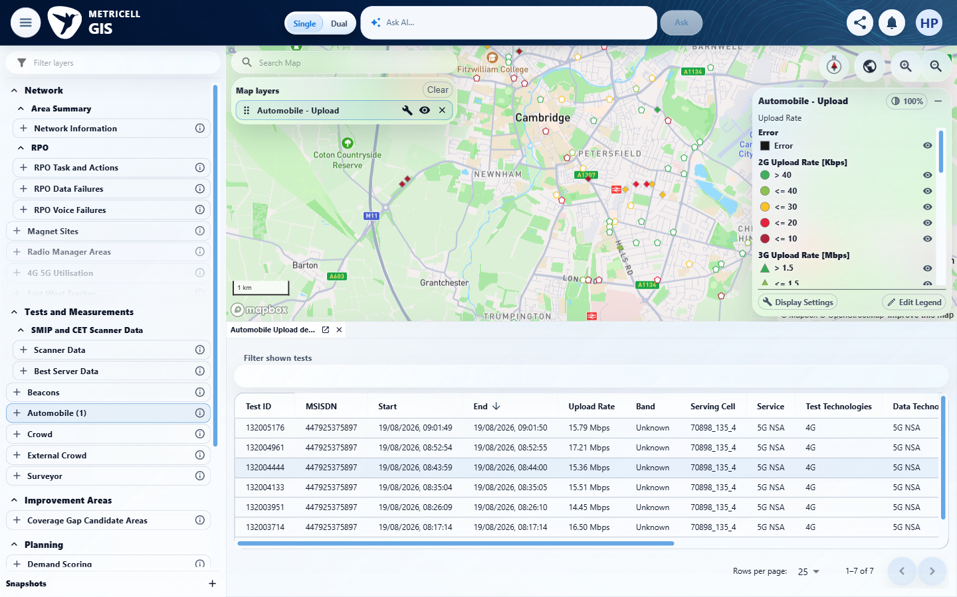 | E32 - Recheck table final (criterion-11-recheck-table-final.png)  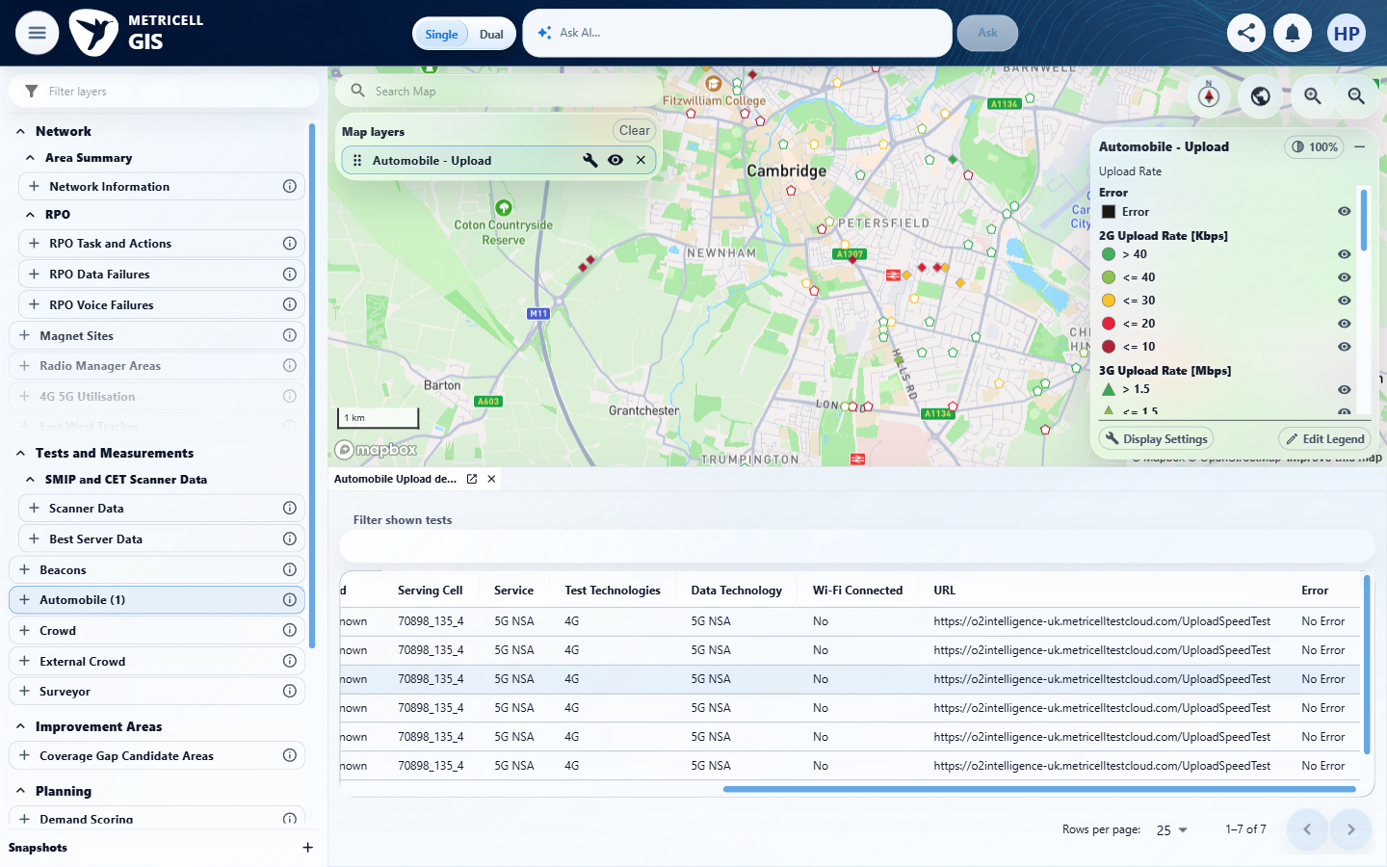

12.0.0 | Sorting a supported Download or Upload details-table column changes the displayed row order to match the selected sort. | Sorting a supported Download or Upload details-table column changes the displayed row order to match the selected sort. | The complete seven-record Upload test-results table was checked in both directions. Overlapping top/bottom captures retain the Upload Rate header and collectively show every row. Ascending rates are 14.45, 15.36, 15.51, 15.79, 15.88, 16.50 and 17.21 Mbps; descending reverses that order. Both states preserve exactly the seven IDs returned by the genuine cluster response. The earlier clipped-row evidence gap is resolved.  Evidence: E33, E34, E35, E36, E37, E38 | Passed
Criterion 12 evidence: Sorting a supported Download or Upload details-table column changes the displayed row order to match the selected sort.
Browser URL recorded after criterion: https://o2intelligence-v4-dev.metricell.com/gis
E33 - Followup baseline top (criterion-12-followup-baseline-top.png)  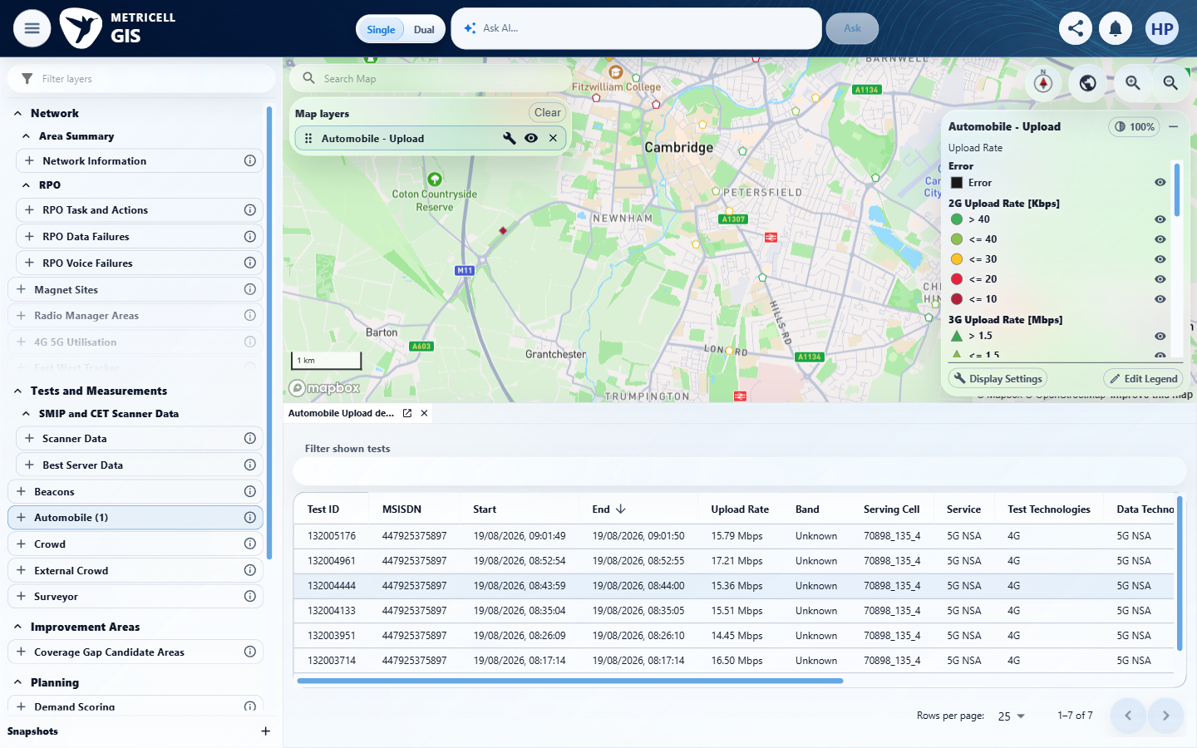 | E34 - Followup baseline bottom (criterion-12-followup-baseline-bottom.png)  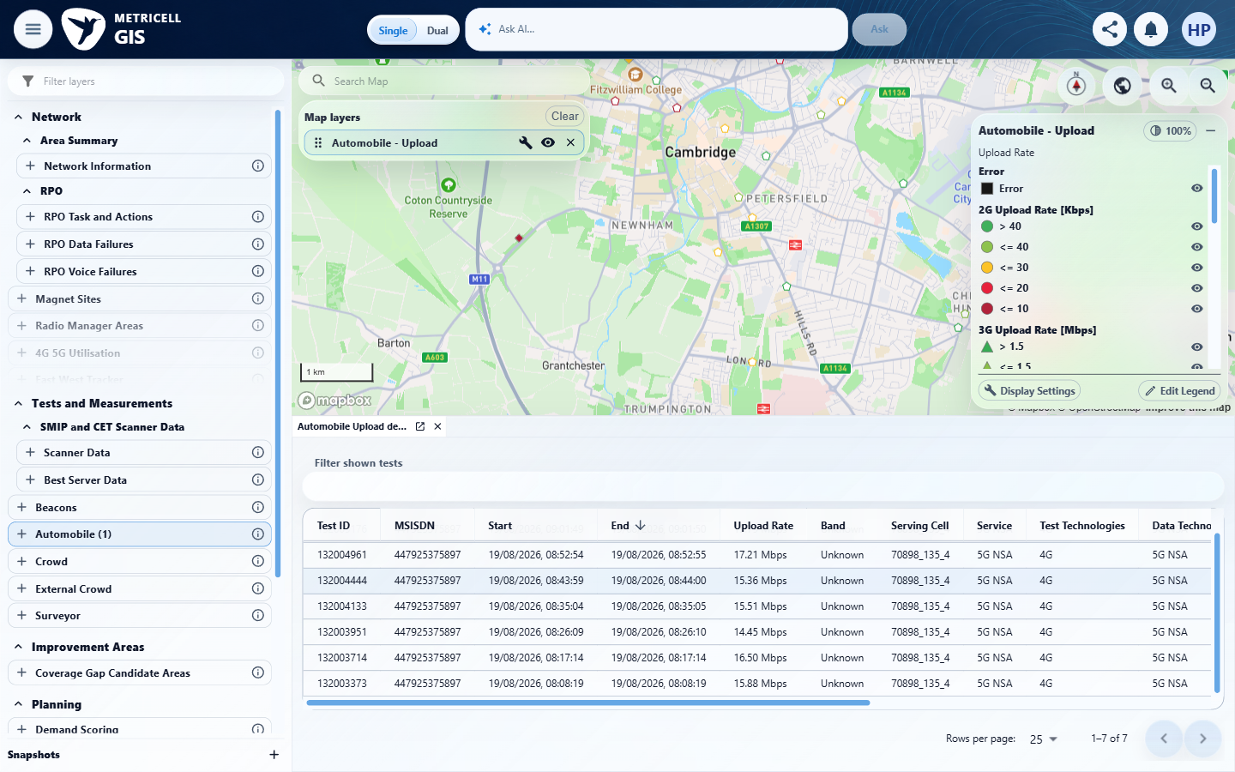

Criterion 12 continued: Sorting a supported Download or Upload details-table column changes the displayed row order to match the selected sort.
Browser URL recorded after criterion: https://o2intelligence-v4-dev.metricell.com/gis
E35 - Followup ascending top (criterion-12-followup-ascending-top.png)  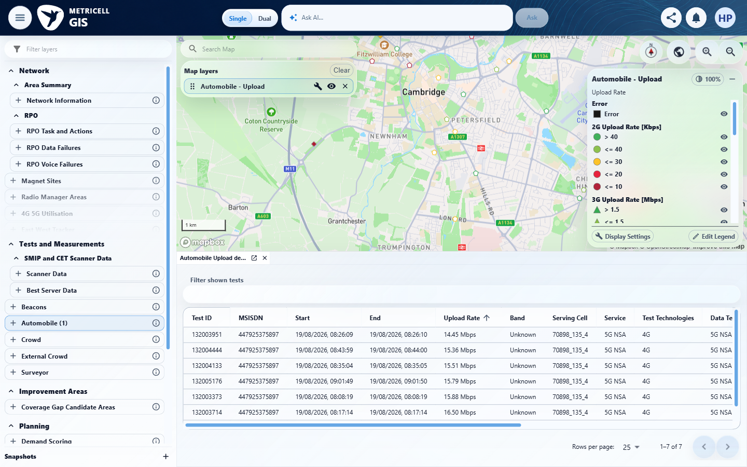 | E36 - Followup ascending bottom (criterion-12-followup-ascending-bottom.png)  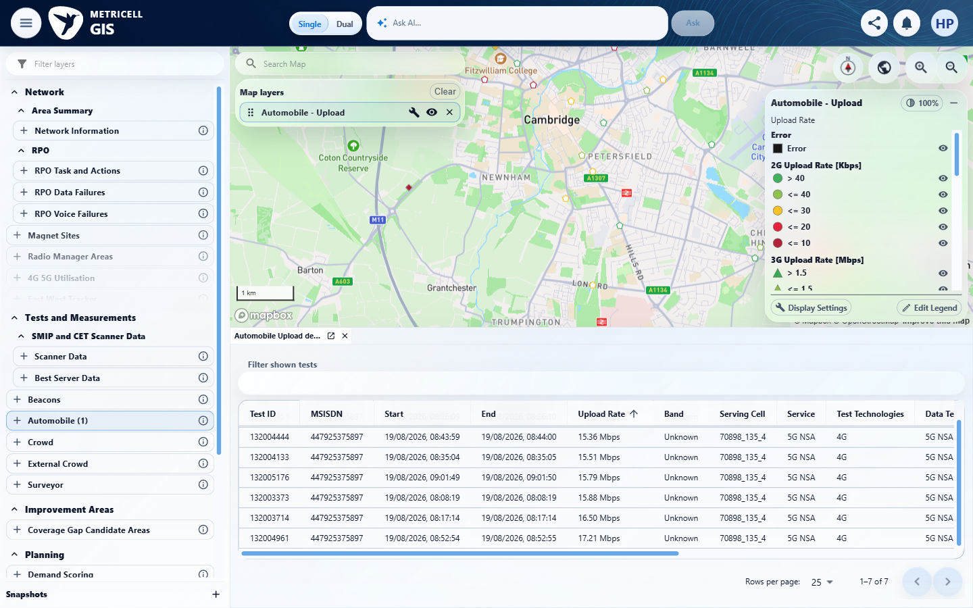

Criterion 12 continued: Sorting a supported Download or Upload details-table column changes the displayed row order to match the selected sort.
Browser URL recorded after criterion: https://o2intelligence-v4-dev.metricell.com/gis
E37 - Followup descending top (criterion-12-followup-descending-top.png)  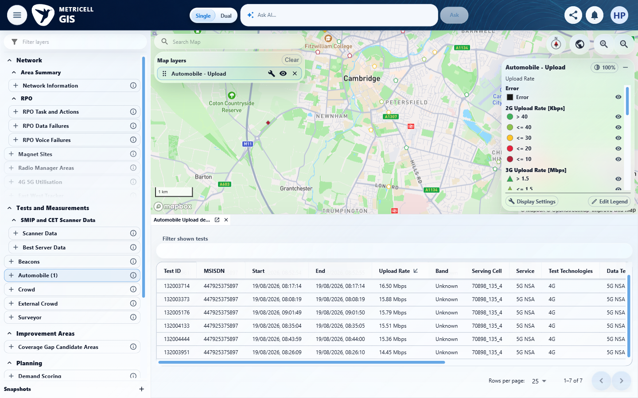 | E38 - Followup descending bottom (criterion-12-followup-descending-bottom.png)  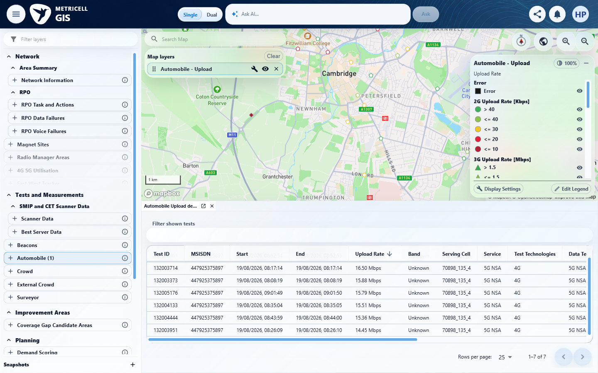

13.0.0 | Filtering a supported Download or Upload details-table column displays rows matching the applied filter. | Filtering a supported Download or Upload details-table column displays rows matching the applied filter. | criterion-13-recheck-before-filter.png establishes the unfiltered Automobile Upload test-results table with seven total test rows. recheck-final.png shows Filter shown tests set to 132005176, exactly that readable matching test remaining and pagination 1-1 of 1. This proves the supported Test ID filtering assertion on the test-results table. Post-clear restoration is described in steps but has no matching capture and is not part of this criterion's required assertion.  Evidence: E39, E40 | Passed
Criterion 13 evidence: Filtering a supported Download or Upload details-table column displays rows matching the applied filter.
Browser URL recorded after criterion: https://o2intelligence-v4-dev.metricell.com/gis
E39 - Recheck before filter (criterion-13-recheck-before-filter.png)  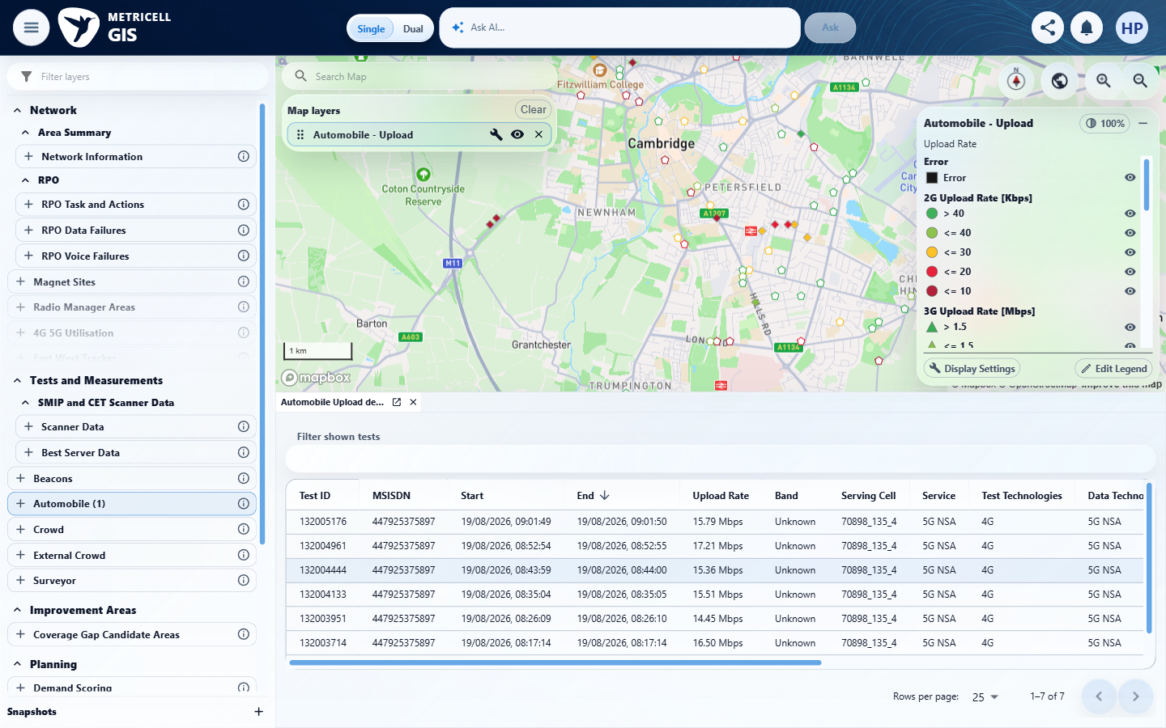 | E40 - Recheck final (criterion-13-recheck-final.png)  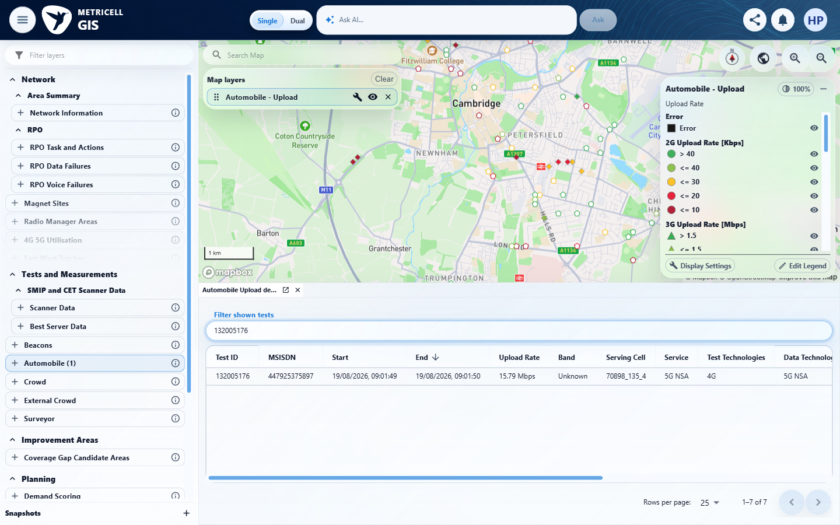
E39 detail enlargement - full screenshot above | E40 detail enlargement - full screenshot above

14.0.0 | Requesting details for a zero-duration test does not open a details dialog. | Requesting details for a zero-duration test does not open a details dialog. | criterion-14-before-disabled-pointer.png and criterion-14-final.png show the same settled Download test-results row 132616647 with equal displayed Start/End 30/09/2026 12:00:07 and no individual analysis tab after the recorded ordinary pointer activation on its Test ID cell. The genuine cluster-details observation identifies testDurationMs:0 and equal underlying times. This is actual pointer prevention proof, not an inference from aria-disabled. The recorded row inspection found no tabindex/focusable keyboard path; no keyboard requirement is invented. The open aggregate's test list is distinct from individual details.  Evidence: E41, E42 | Passed
Criterion 14 assessment: Testing notes: Activated the failed map aggregate near 52.19498/0.13184; genuine POST /api/platform/automobile/download/cluster-details HTTP 200 returned test 132616647 with testDurationMs:0 and identical startTime/endTime 2026-09-30T12:00:07.383.
Criterion 14 evidence: Requesting details for a zero-duration test does not open a details dialog.
Browser URL recorded after criterion: https://o2intelligence-v4-dev.metricell.com/gis
E41 - Before disabled pointer (criterion-14-before-disabled-pointer.png)  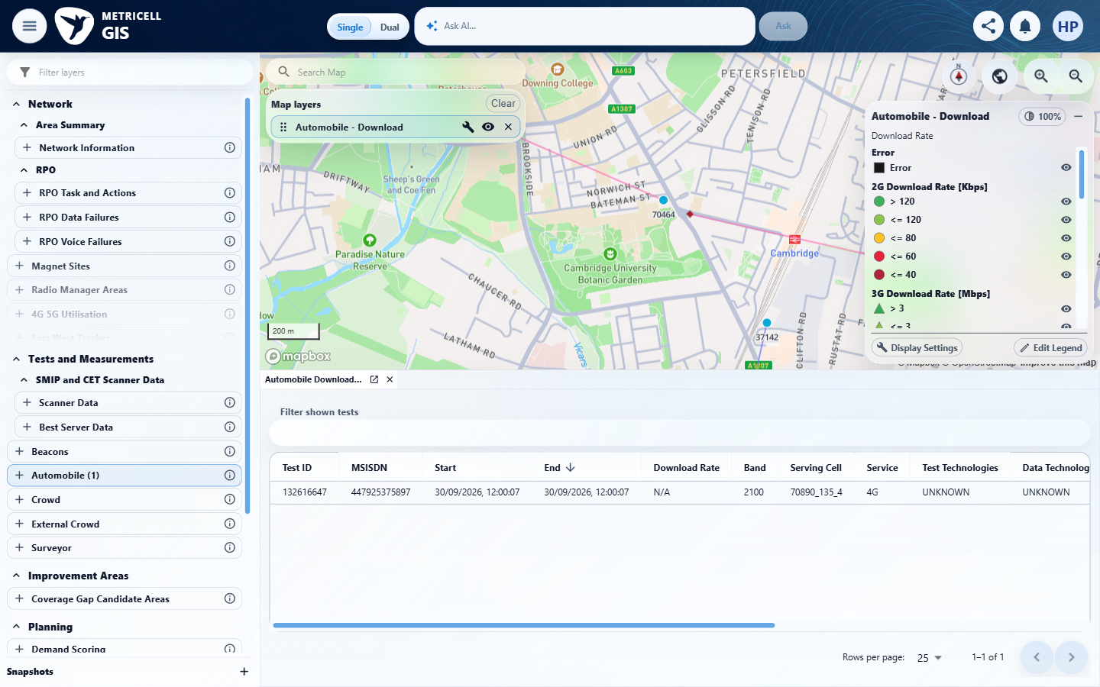 | E42 - Final (criterion-14-final.png)  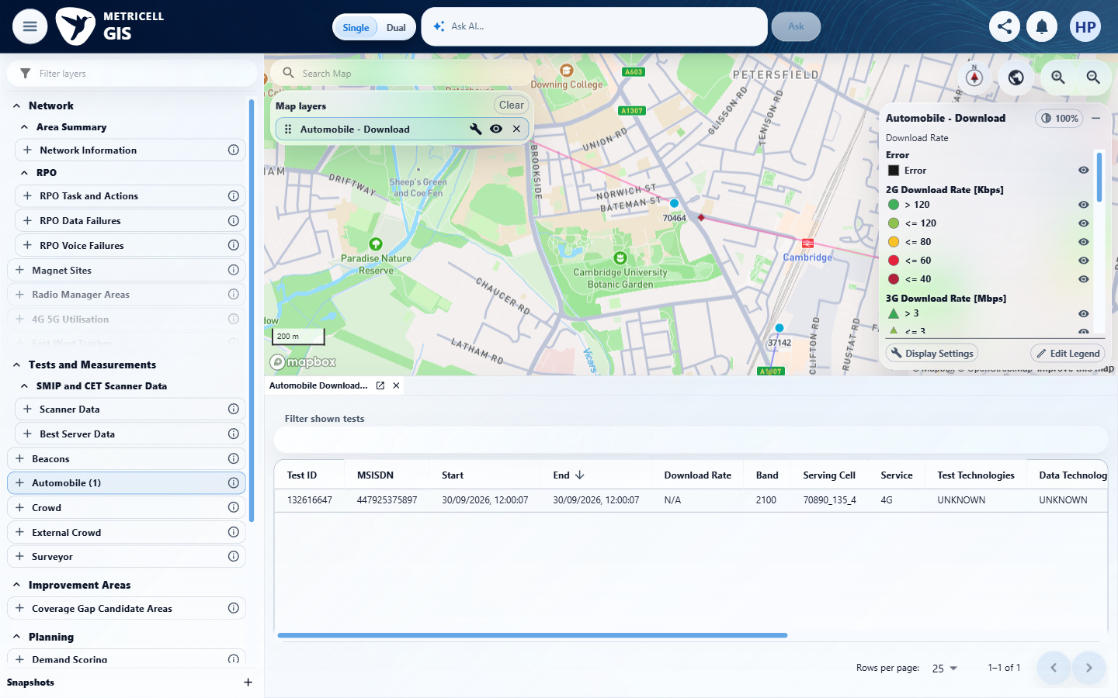

15.0.0 | While result details are loading, the interface shows a loading state without stale or misleading detail data. | While result details are loading, the interface shows a loading state without stale or misleading detail data. | The recorded check satisfied the criterion; see the assessment below.  Evidence: E43, E44, E45, E46, E47 | Passed
Criterion 15 assessment: SIMULATED UI STATE: Delayed the selected detail request to check loading. The evidence shows target 132004961 and Loading Automobile test analysis without the baseline chart or sample table.
Criterion 15 evidence: While result details are loading, the interface shows a loading state without stale or misleading detail data.
Browser URL recorded after criterion: https://o2intelligence-v4-dev.metricell.com/gis
E43 - Valid baseline chart (criterion-15-valid-baseline-chart.png)  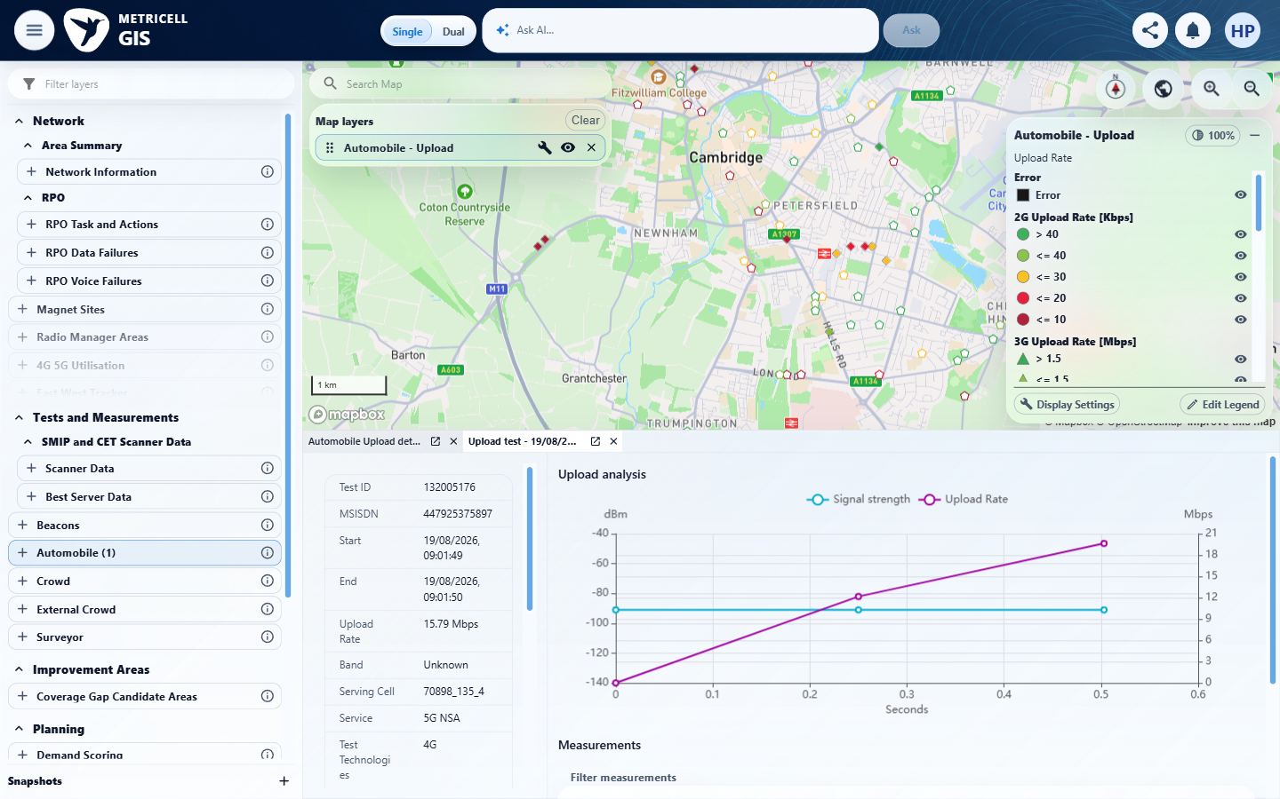 | E44 - Genuine target chart (criterion-15-genuine-target-chart.png)  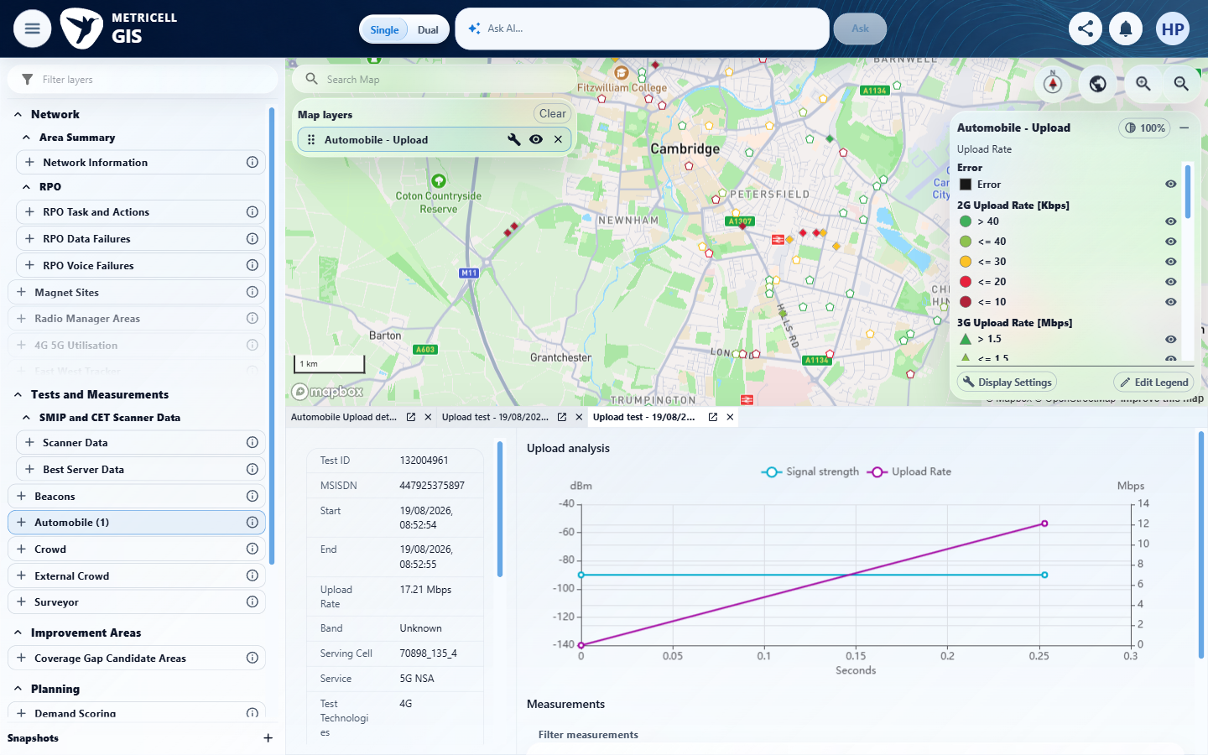

Criterion 15 continued: While result details are loading, the interface shows a loading state without stale or misleading detail data.
Browser URL recorded after criterion: https://o2intelligence-v4-dev.metricell.com/gis
E45 - Genuine target table (criterion-15-genuine-target-table.png)  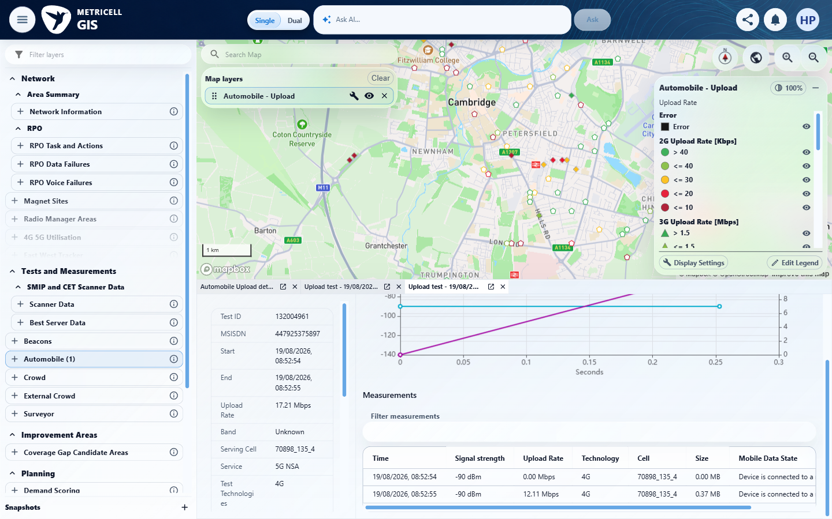 | E46 - Distinct baseline before delay (criterion-15-distinct-baseline-before-delay.png)  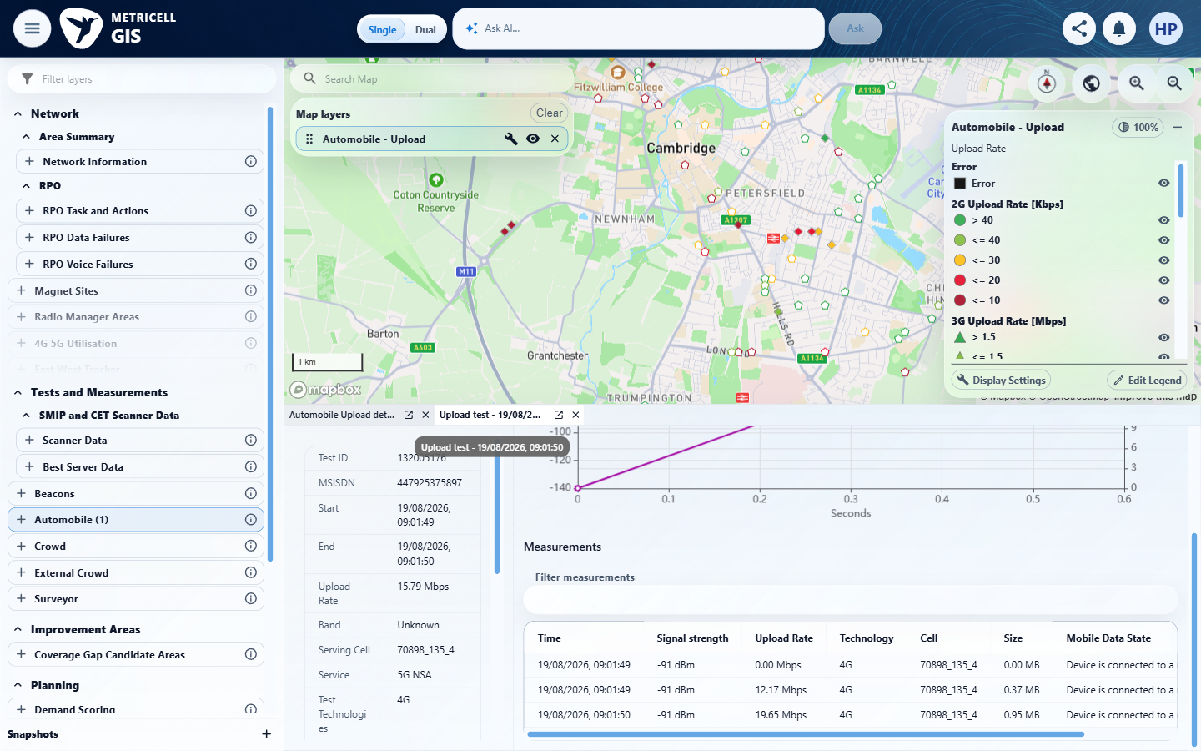

Criterion 15 continued: While result details are loading, the interface shows a loading state without stale or misleading detail data.
Browser URL recorded after criterion: https://o2intelligence-v4-dev.metricell.com/gis
E47 - Final (criterion-15-final.png)
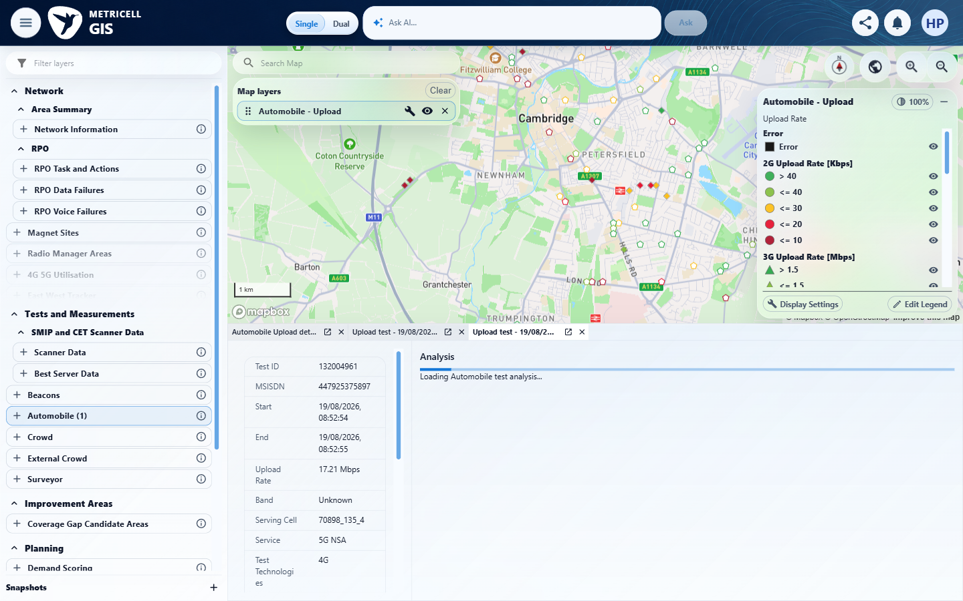

16.0.0 | If result details fail to load, the interface shows an error state without stale or misleading detail data. | If result details fail to load, the interface shows an error state without stale or misleading detail data. | The recorded check satisfied the criterion; see the assessment below.  Evidence: E48, E49 | Passed
Criterion 16 assessment: SIMULATED UI STATE: Returned HTTP 503 for the selected detail request to check error handling. Normal target selection received one synthetic HTTP 503 Service Unavailable, text/plain Service Unavailable, using standard HTTP failure semantics rather than an invented project response body/empty-data contract. repair-final.png shows target 132004961's genuine summary and Unable to load Automobile test analysis with Retry; the previous record's chart/sample table is absent from selected analysis.
Criterion 16 evidence: If result details fail to load, the interface shows an error state without stale or misleading detail data.
Browser URL recorded after criterion: https://o2intelligence-v4-dev.metricell.com/gis
E48 - Repair distinct baseline (criterion-16-repair-distinct-baseline.png)  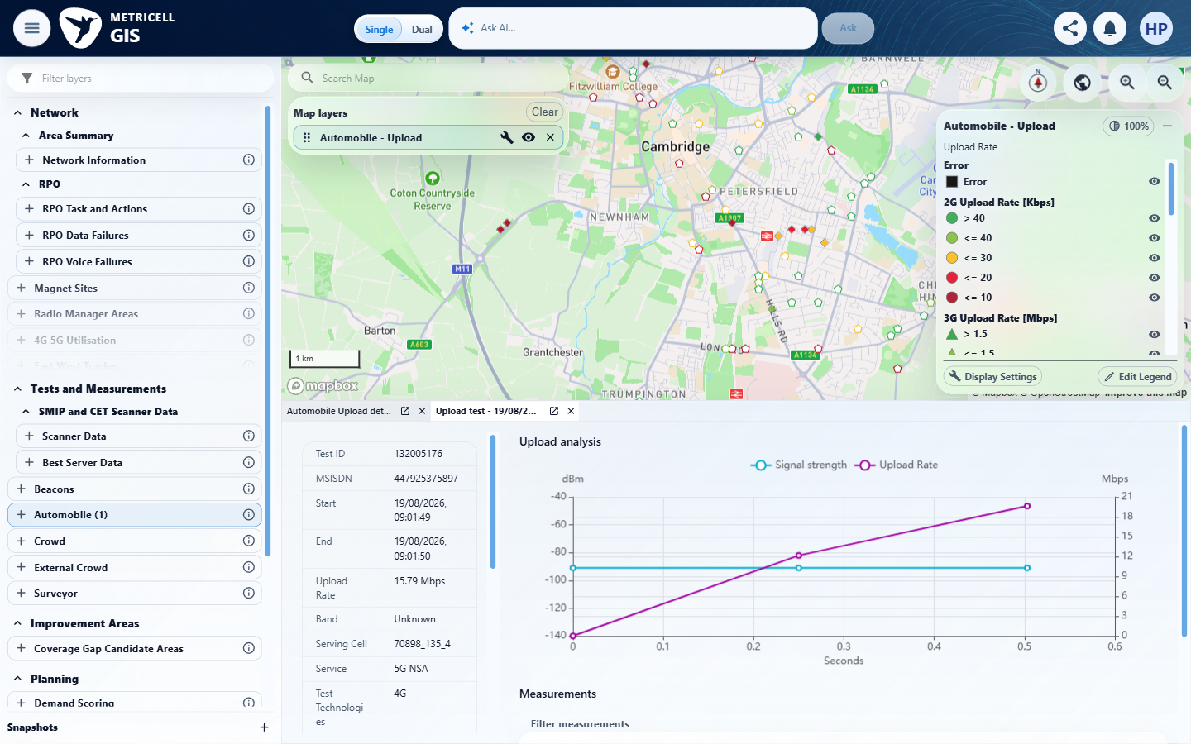 | E49 - Repair final (criterion-16-repair-final.png)  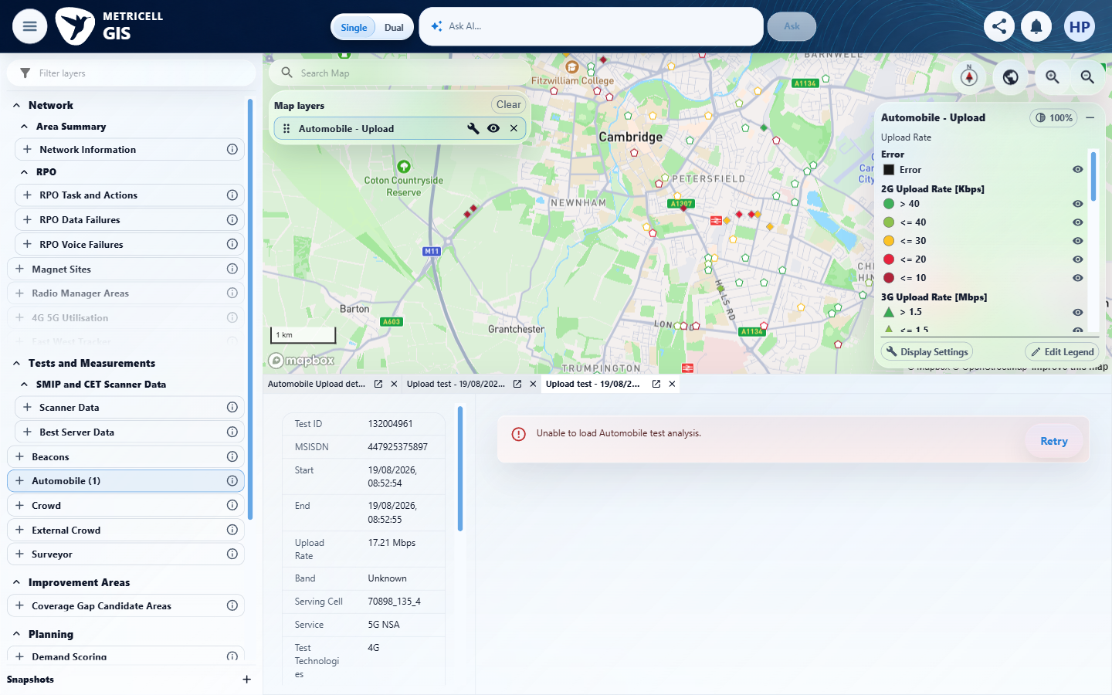

About Metricell

Metricell is on a mission to deliver connectivity. We work with our customers to design, deliver and manage wireless communication networks – with a shared ambition of achieving flawless network experience. We’ve been responsible for many first-to-market products, and our technology is characterised by the relentless pursuit of automation and digitalisation.

Our geospatial intelligence tools traverse a wide variety of business processes – from Test & Measurement to Customer Experience Management – and we’re pioneers in Crowdsourcing and Digital Self Care. Our technology is today in use by a range of customers; thousands of their personnel; and millions of subscribers worldwide.

Find out more at www.metricell.com




