

TEST2-3 Evidence Review
TEST2-3 Evidence Review

Document Classification: | Company Confidential
Document Ref: | Phase 3 Test Case Document
Version: | 1.0
Date: | 08/09/2026
Document Author: | Automated TEST2 Evidence Review
Document Owner: | Quality Assurance/Metricell




This document and its content is copyright of Metricell Limited @ 2026 all rights reserved. All information contained herein is the intellectual property of Metricell Limited and should be treated as confidential. Any external redistribution of reproduction of part or all of the contents in any form is prohibited unless expressly agreed with Metricell Limited in writing. Any reproduced content must include the following statement; “Part or all of the content contained herein is copyright of Metricell Limited @ 2026 all rights reserved”.
Table of Contents
1 Revision History 2
2 Test Cycle Information 3
3 Test Summary 3
4 Test Cases 4
About Metricell 12

Revision History

Version | Date | Revision Author | Summary of Changes
1.0 | 22/05/2026 | David Sharpe | Document creation
2.0 | 03/09/2026 | Harry Piper | Altered for automated testing

Test Cycle Information

Tester: | Automated
Environment: | TEST2 evidence review
Browser Details: | Chrome
Date of Test: | 08/09/2026
Limitations during Testing: | None recorded

Test Summary

Area of test | Pass | Fail | Defects (No.)
TEST2-3 | Y | N | 0
 | Y/N | Y/N

Test Cases
Please note that all test cases are to meet requirements Coverage_Portal_Phase3_059 through to Coverage_Portal_Phase3_064 and Coverage_Portal_Phase3_073 through to Coverage_Portal_Phase3_077

Tests

Preconditions: | User has relevant permissions | Associated Requirements: | Coverage_Portal_Phase3 59,60,61,62,63,64,73,74,75,76,77 | Notes:

ID | Criteria | Testing Steps | Expected Results | Actual Results | Outcome
1.0.0 | you should be able to favourite a beacon it comes up in favourites. | Opened the authenticated V4 GIS page with Beacons loaded.  Captured the initial beacon list.  Clicked Add to favourites for Colin Pitts 1 #447925375841.  Selected Favourites and verified the beacon was listed. | Criterion is satisfied with direct evidence. | Screenshots 02 and 03 directly show the beacon star changed to Remove from favourites and Favourites (1) containing Colin Pitts 1 #447925375841. | Passed
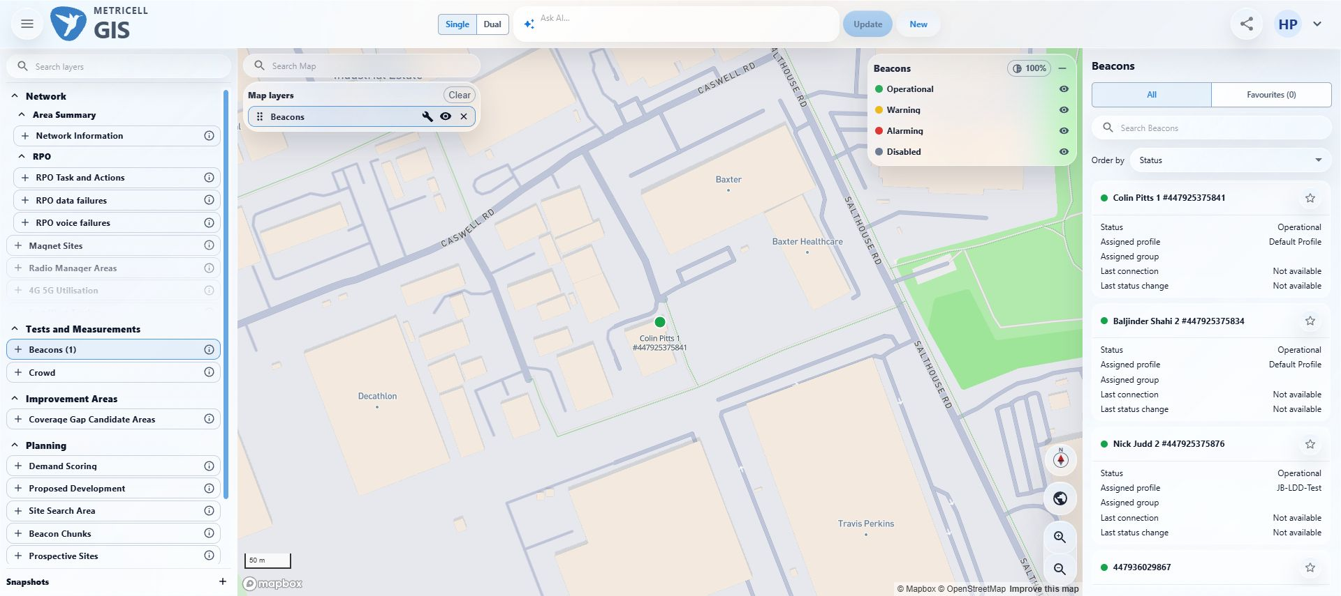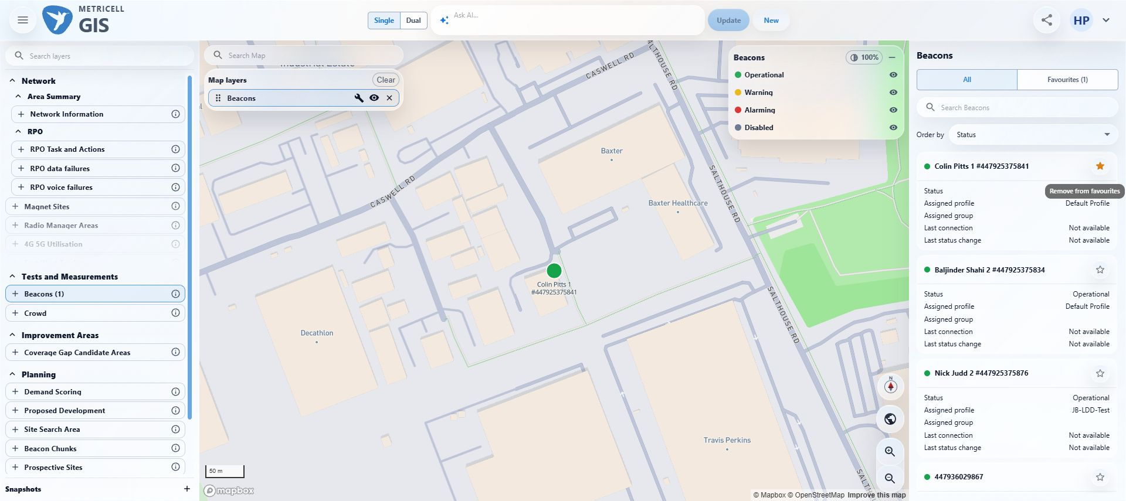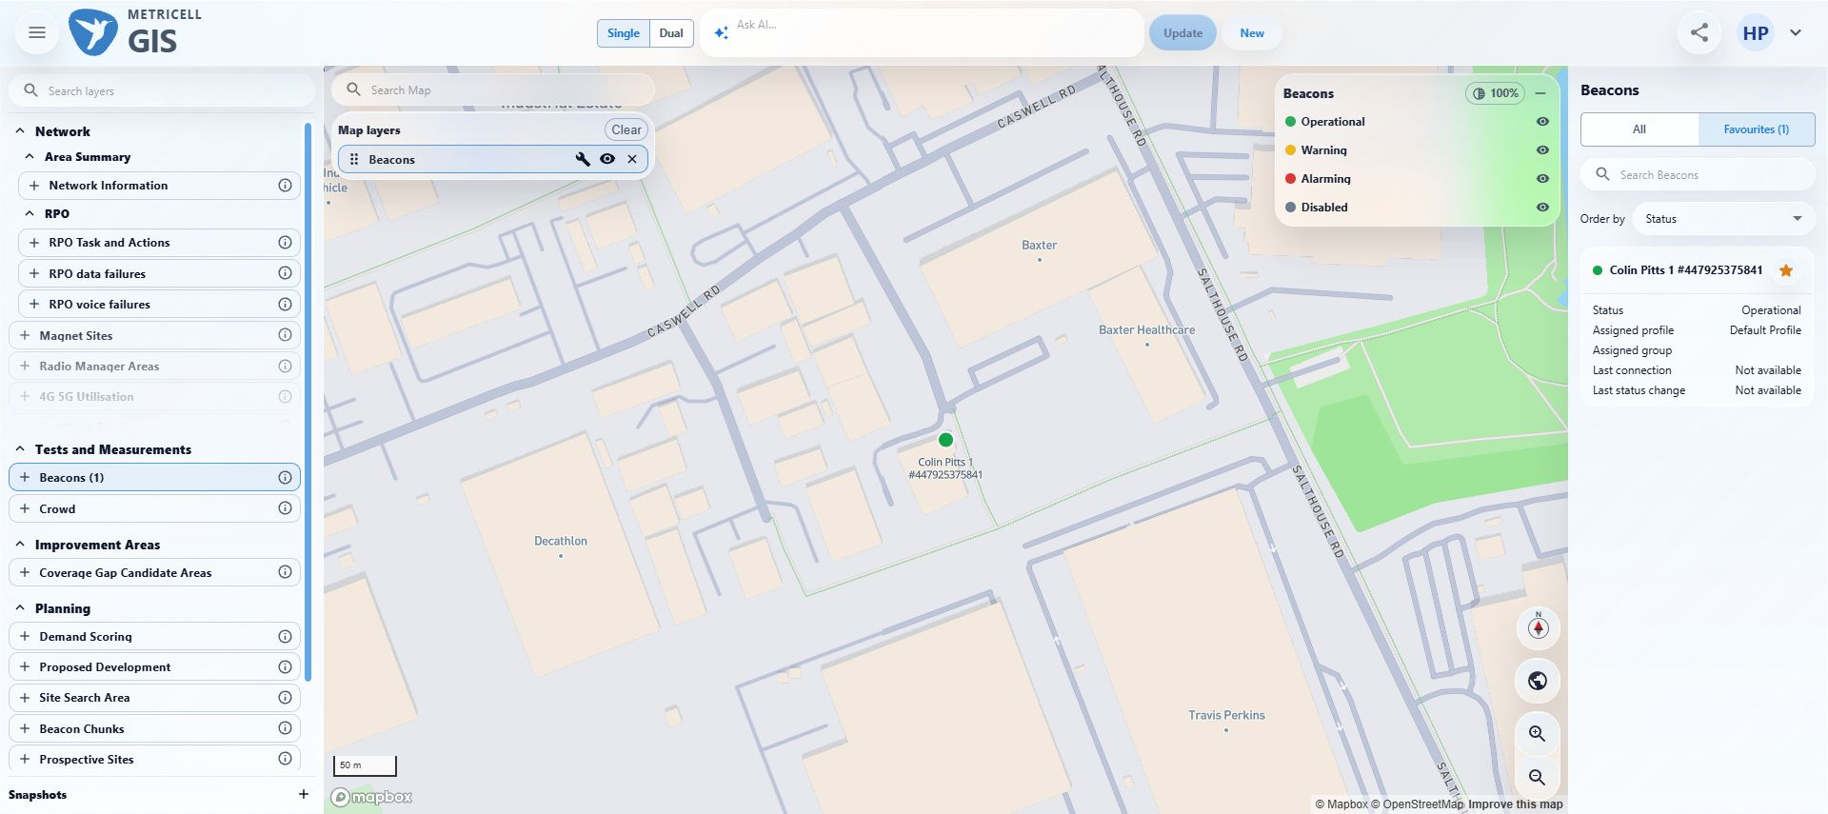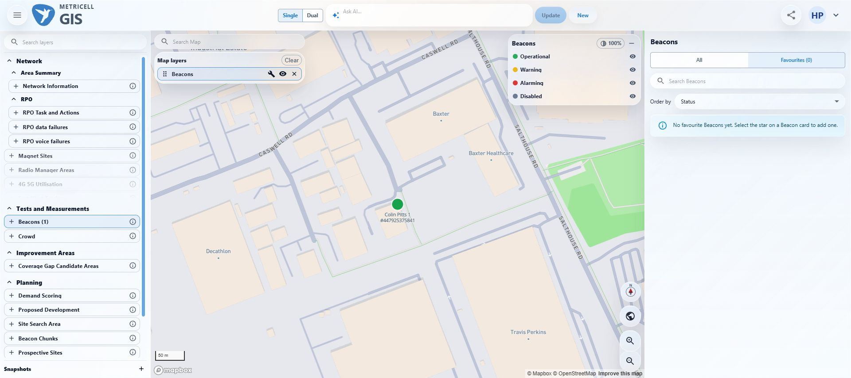
2.0.0 | then un fav it and it goes out of favourite beacon | With Favourites selected, clicked Remove from favourites for Colin Pitts 1 #447925375841.  Verified the filtered view showed No favourite Beacons yet.  Captured the final state. | Criterion is satisfied with direct evidence. | Screenshot 04 directly shows Favourites (0) and No favourite Beacons yet after removal. | Passed

About Metricell

Metricell is on a mission to deliver connectivity. We work with our customers to design, deliver and manage wireless communication networks – with a shared ambition of achieving flawless network experience. We’ve been responsible for many first-to-market products, and our technology is characterised by the relentless pursuit of automation and digitalisation.

Our geospatial intelligence tools traverse a wide variety of business processes – from Test & Measurement to Customer Experience Management – and we’re pioneers in Crowdsourcing and Digital Self Care. Our technology is today in use by a range of customers; thousands of their personnel; and millions of subscribers worldwide.

Find out more at www.metricell.com




