

Automated Test Case Document
Jira Ticket: TEST2-80

Document Classification: | Company Confidential
Document Ref: | Automated Test Case Document
Version: | 1.0
Date: | 26/10/2026
Document Author: | Automated TEST2 Evidence Review
Document Owner: | Quality Assurance / Metricell




This document and its content is copyright of Metricell Limited @ 2026 all rights reserved. All information contained herein is the intellectual property of Metricell Limited and should be treated as confidential. Any external redistribution of reproduction of part or all of the contents in any form is prohibited unless expressly agreed with Metricell Limited in writing. Any reproduced content must include the following statement; “Part or all of the content contained herein is copyright of Metricell Limited @ 2026 all rights reserved”.
Table of Contents
1 Revision History 2
2 Test Cycle Information 3
3 Test Summary 3
4 Test Cases 4
About Metricell 12

Revision History

Version | Date | Revision Author | Summary of Changes
[1.0] | 26/10/2026 | TEST2 QA Automation | Generated from TEST2 evidence review

Test Cycle Information

Tester: | Automated
Jira Ticket: | TEST2-80
Environment: | o2intelligence-v4-dev.metricell.com
Browser Details: | Google Chrome 156.0.8078.48
Date of Test: | 22/10/2026
Limitations during Testing: | Criteria 8, 9 used simulated UI conditions; see their assessments.
Overall review outcome: | Passed
Browser URL(s) recorded after criteria: | https://o2intelligence-v4-dev.metricell.com/gis

Test Summary

Area of test | Pass (Y/N) | Fail (Y/N) | Blocked (Y/N) | Defect No
1. The map layer selector includes Service as a selectable layer. | Y | N | N | 0
2. With Service unselected, the map displays no Service test-result points. | Y | N | N | 0
3. When the user selects Service and matching authorised results are available, each matching result is displayed as a selectable map point. | Y | N | N | 0
4. When the user selects a Service result point and its details load successfully, a Service details dialog displays MSISDN, Test Time, Signal, Band, Service, Data Technology, PLMN and Serving Cell. | Y | N | N | 0
5. With the Service details table displayed, sorting a supported column reorders the displayed rows according to that column. | Y | N | N | 0
6. With the Service details table displayed, filtering a supported column limits the displayed rows to those matching the filter. | Y | N | N | 0
7. When returned details include cell-neighbour data, the dialog displays each neighbour in its own labelled details table. | Y | N | N | 0
8. While Service details are loading, the dialog displays a loading state. | Y | N | N | 0
9. If Service details cannot be retrieved, the dialog displays an error state and does not display stale details. | Y | N | N | 0

Test Cases
Each test maps to a criterion and decisive browser evidence. Inconclusive results are reported as Failed.

Tests

Preconditions: | V4 access and ticket conditions. | Associated Requirements: | Ticket criteria below. | Automation Notes: | Screenshots below each criterion; full log retained locally.
ID / Criterion | Criteria Tested | Expected Result | Actual Result / Evidence Path | Outcome
1.0.0 | The map layer selector includes Service as a selectable layer. | The map layer selector includes Service as a selectable layer. | criterion-1-automobile-config.png, criterion-1-service-choice.png and criterion-1-final.png show Service offered and selected within Automobile Test type.  Evidence: E01, E02, E03, E04 | Passed
Criterion 1 evidence: The map layer selector includes Service as a selectable layer.
Browser URL recorded after criterion: https://o2intelligence-v4-dev.metricell.com/gis
E01 - Before automobile (criterion-1-before-automobile.png)  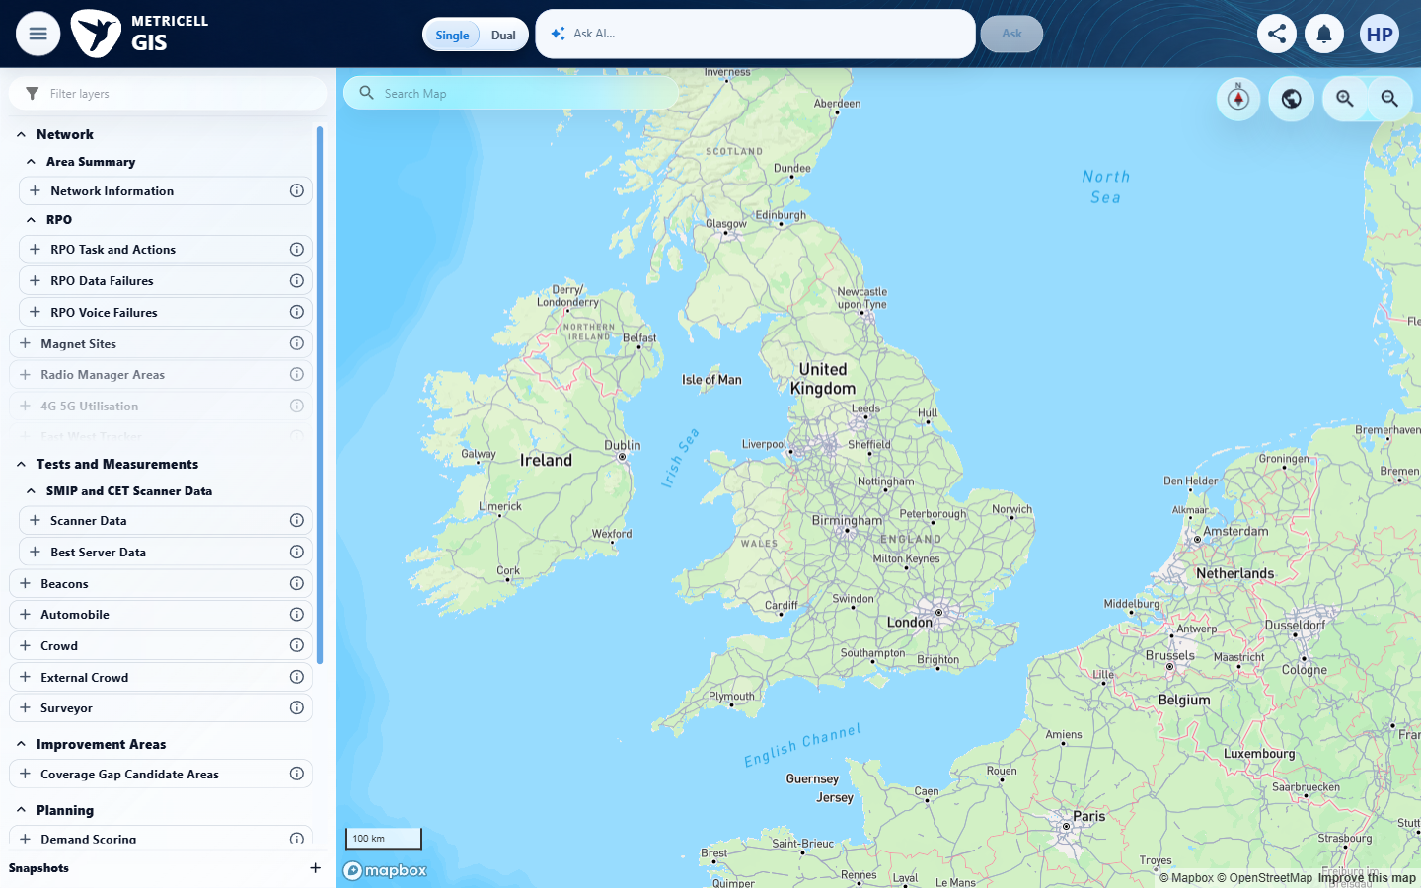 | E02 - Automobile config (criterion-1-automobile-config.png)  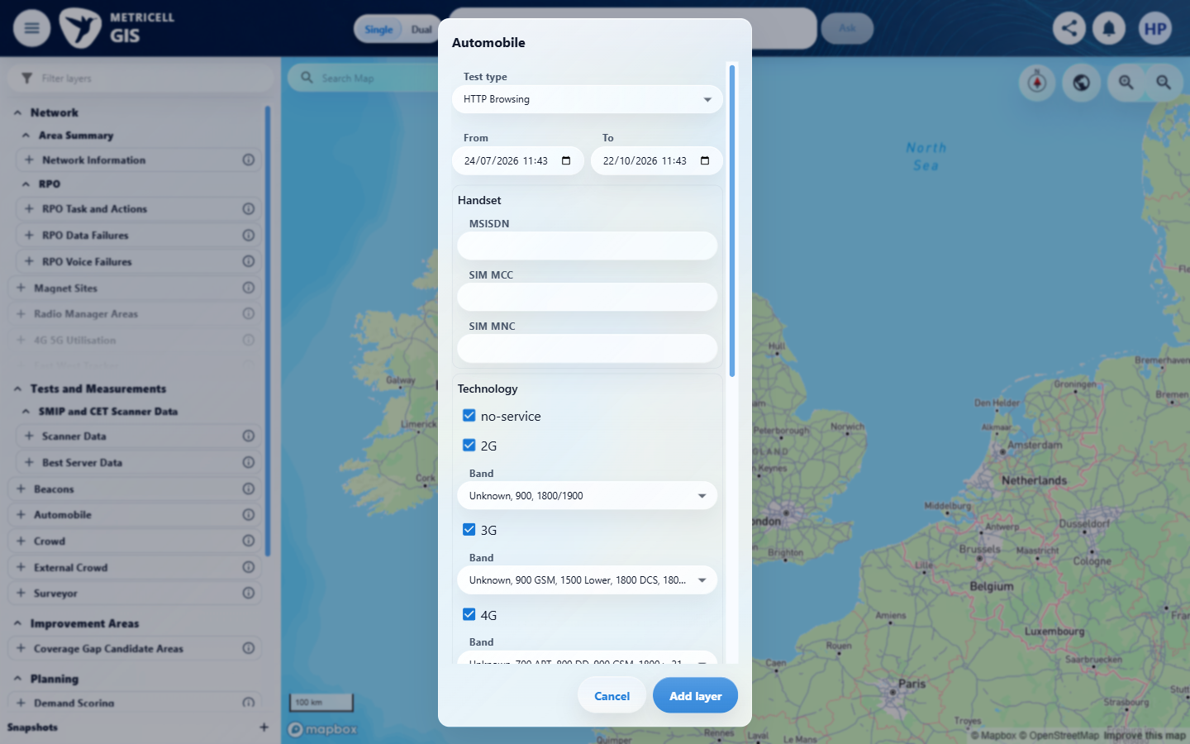

Criterion 1 continued: The map layer selector includes Service as a selectable layer.
Browser URL recorded after criterion: https://o2intelligence-v4-dev.metricell.com/gis
E03 - Service choice (criterion-1-service-choice.png)  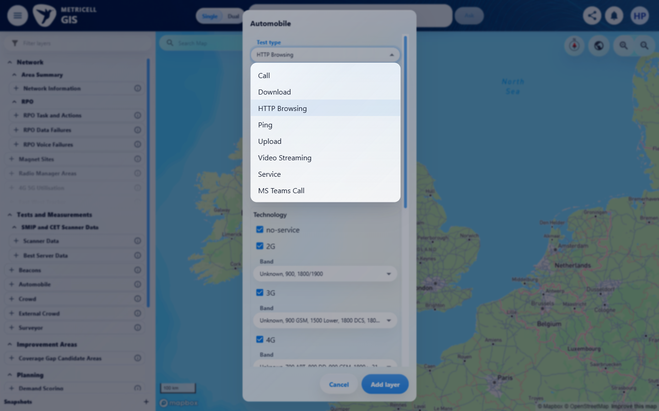 | E04 - Final (criterion-1-final.png)  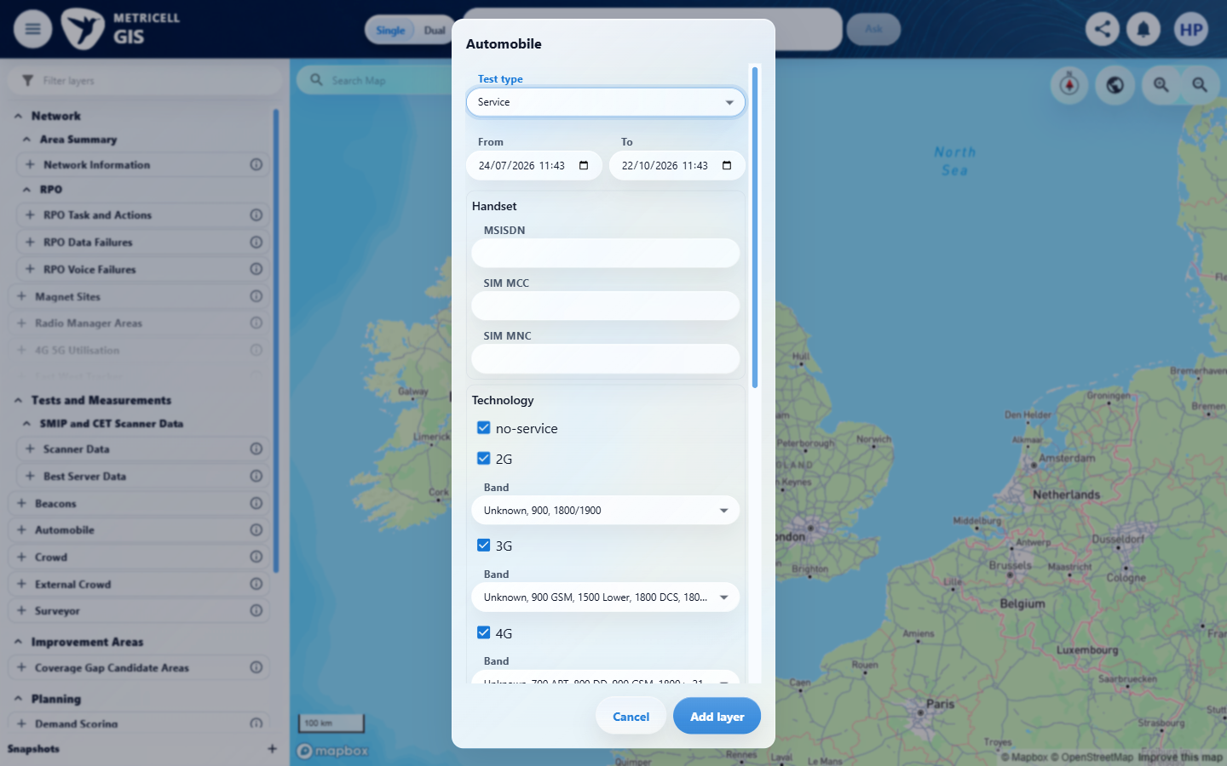

2.0.0 | With Service unselected, the map displays no Service test-result points. | With Service unselected, the map displays no Service test-result points. | criterion-2-service-unselected.png and criterion-2-final.png show the settled map with only Automobile - Ping selected and its legend; no Service layer or Service result points are displayed in the visible viewport. Existing HTTP Browsing details are unrelated.  Evidence: E05, E06 | Passed
Criterion 2 evidence: With Service unselected, the map displays no Service test-result points.
Browser URL recorded after criterion: https://o2intelligence-v4-dev.metricell.com/gis
E05 - Service unselected (criterion-2-service-unselected.png)  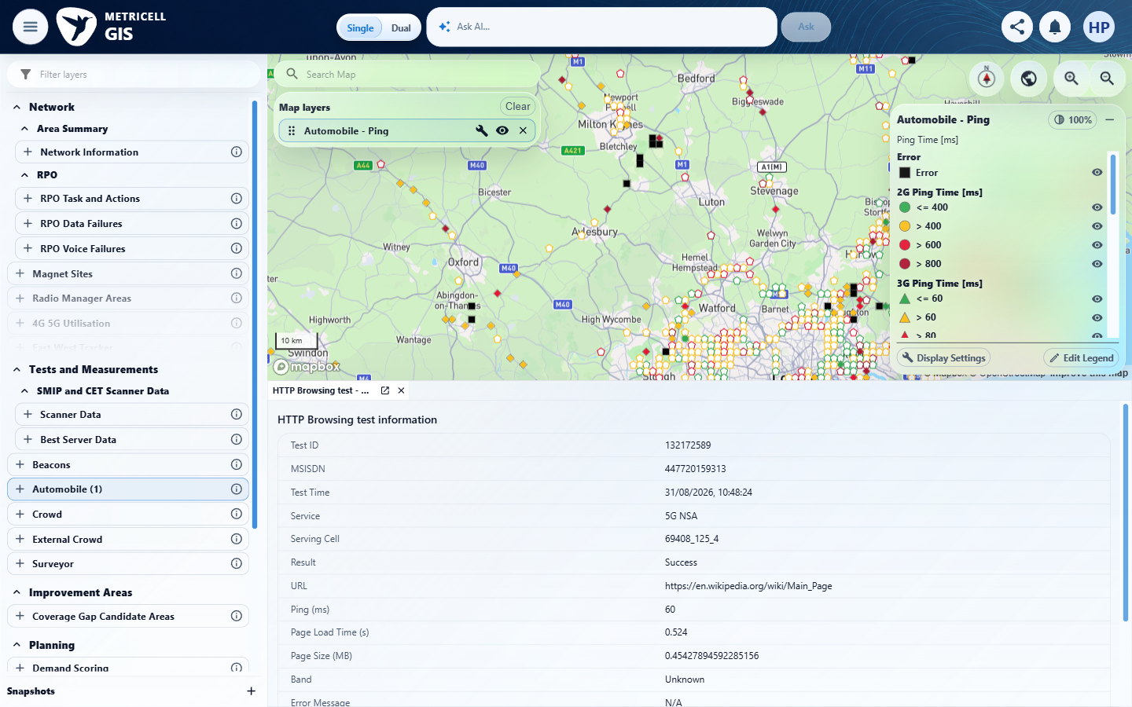 | E06 - Final (criterion-2-final.png)  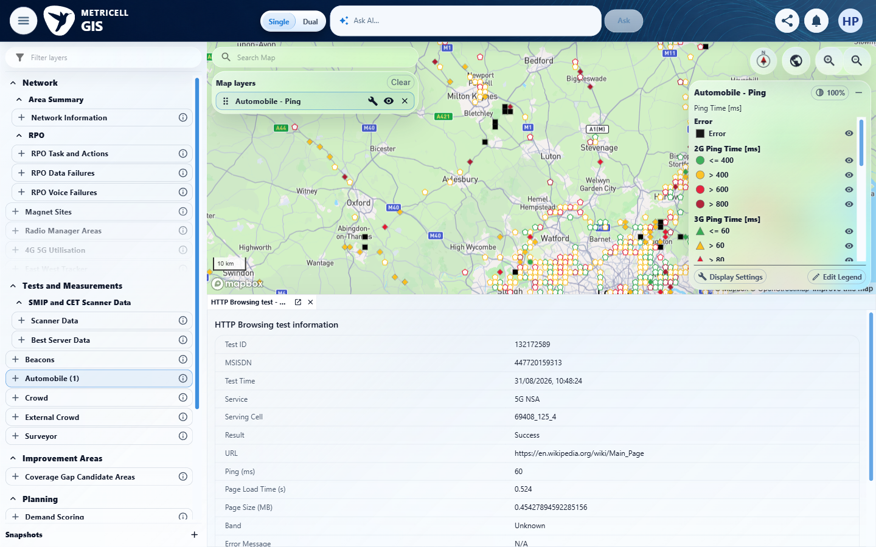

3.0.0 | When the user selects Service and matching authorised results are available, each matching result is displayed as a selectable map point. | When the user selects Service and matching authorised results are available, each matching result is displayed as a selectable map point. | criterion-3-before-add-service.png shows Automobile Service selection; criterion-3-final.png shows the added Service layer, legend and populated markers; criterion-3-final-selected.png shows marker selection opening Service tests. Recorded GET /api/platform/automobile/service/points and POST /api/platform/automobile/service/cluster-details returned 200. Evidence samples the visible viewport.  Evidence: E07, E08, E09 | Passed
Criterion 3 assessment: Testing notes: Initial exact Automobile text locator timed out because catalogue label was Automobile (1); inspected current snapshot and opened that actual parent item.
Criterion 3 evidence: When the user selects Service and matching authorised results are available, each matching result is displayed as a selectable map point.
Browser URL recorded after criterion: https://o2intelligence-v4-dev.metricell.com/gis
E07 - Before add service (criterion-3-before-add-service.png)  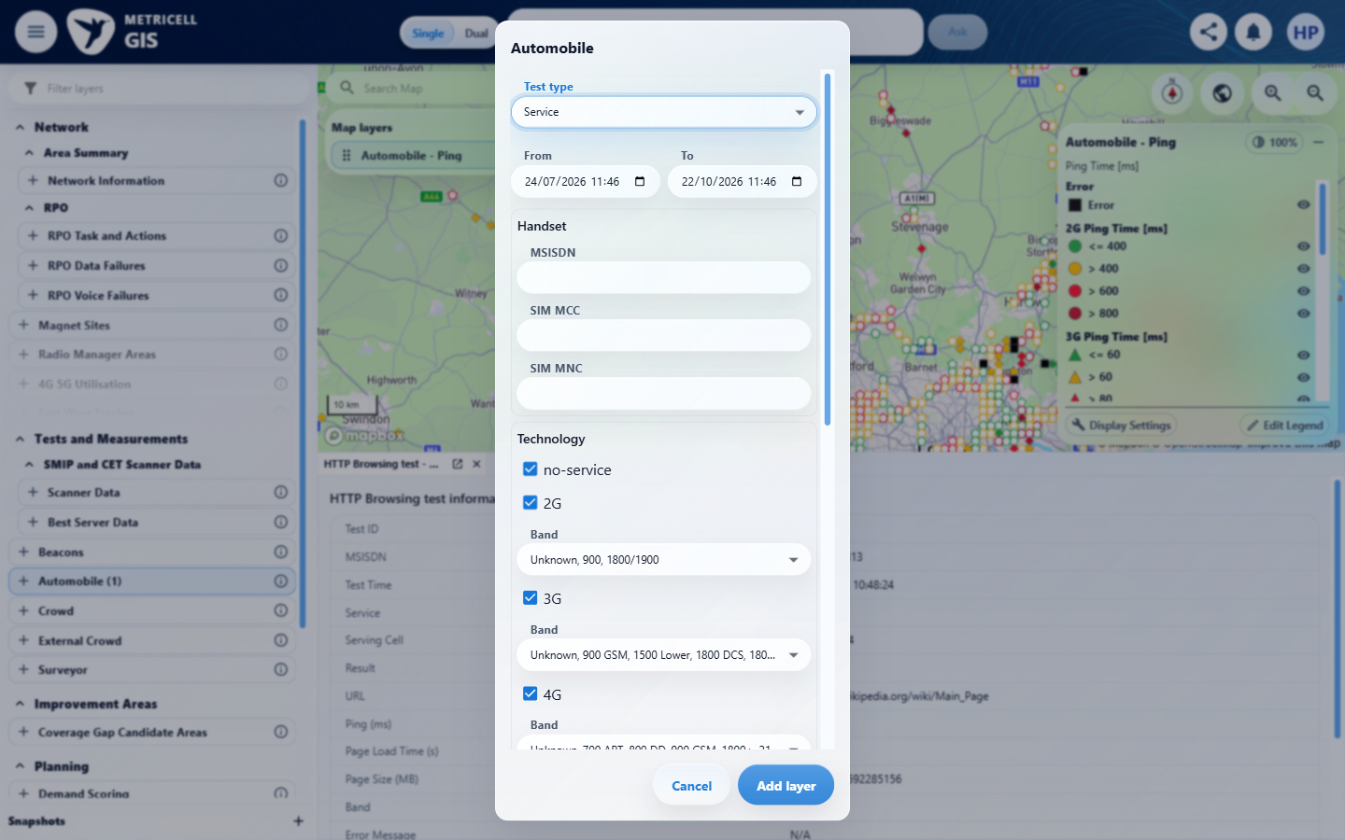 | E08 - Final (criterion-3-final.png)  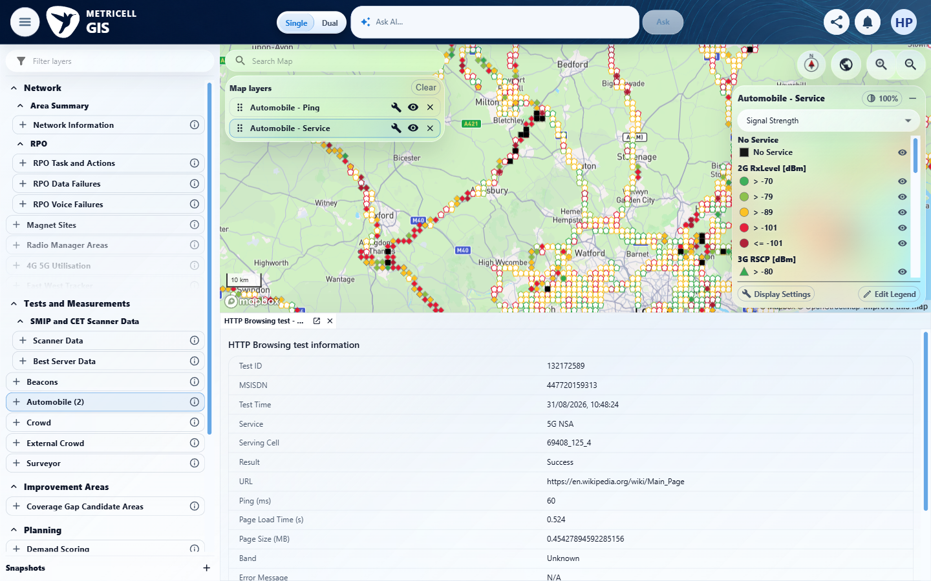

Criterion 3 continued: When the user selects Service and matching authorised results are available, each matching result is displayed as a selectable map point.
Browser URL recorded after criterion: https://o2intelligence-v4-dev.metricell.com/gis
E09 - Final selected (criterion-3-final-selected.png)
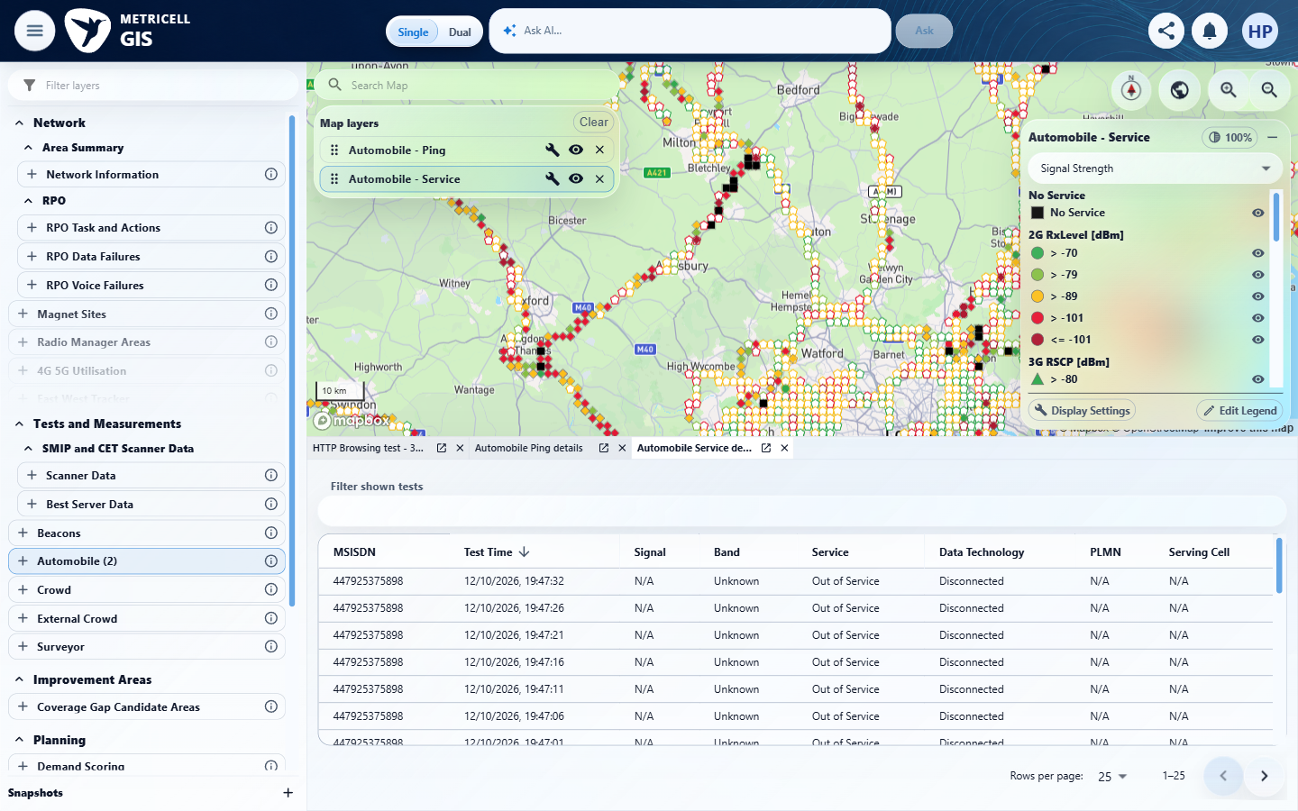

4.0.0 | When the user selects a Service result point and its details load successfully, a Service details dialog displays MSISDN, Test Time, Signal, Band, Service, Data Technology, PLMN and Serving Cell. | When the user selects a Service result point and its details load successfully, a Service details dialog displays MSISDN, Test Time, Signal, Band, Service, Data Technology, PLMN and Serving Cell. | criterion-4-before-select-point.png and criterion-4-final.png show Service marker selection opening a docked details table containing all eight required headings and returned rows. Signal, PLMN and Serving Cell are N/A for the sampled out-of-service records; details are presented in a docked panel.  Evidence: E08, E09 | Passed
Criterion 4 evidence: When the user selects a Service result point and its details load successfully, a Service details dialog displays MSISDN, Test Time, Signal, Band, Service, Data Technology, PLMN and Serving Cell.
Browser URL recorded after criterion: https://o2intelligence-v4-dev.metricell.com/gis
E08 - Before select point (criterion-4-before-select-point.png) | E09 - Final (criterion-4-final.png)

5.0.0 | With the Service details table displayed, sorting a supported column reorders the displayed rows according to that column. | With the Service details table displayed, sorting a supported column reorders the displayed rows according to that column. | criterion-5-before-sort.png shows descending Test Time rows from 12/10/2026 19:47:32; criterion-5-final.png shows the ascending indicator and increasing rows from 15/08/2026 15:37:13, 15:37:19 and 15:37:24. The criterion-owned comparison demonstrates reordering.  Evidence: E09, E10 | Passed
Criterion 5 evidence: With the Service details table displayed, sorting a supported column reorders the displayed rows according to that column.
Browser URL recorded after criterion: https://o2intelligence-v4-dev.metricell.com/gis
E09 - Before sort (criterion-5-before-sort.png) | E10 - Final (criterion-5-final.png)  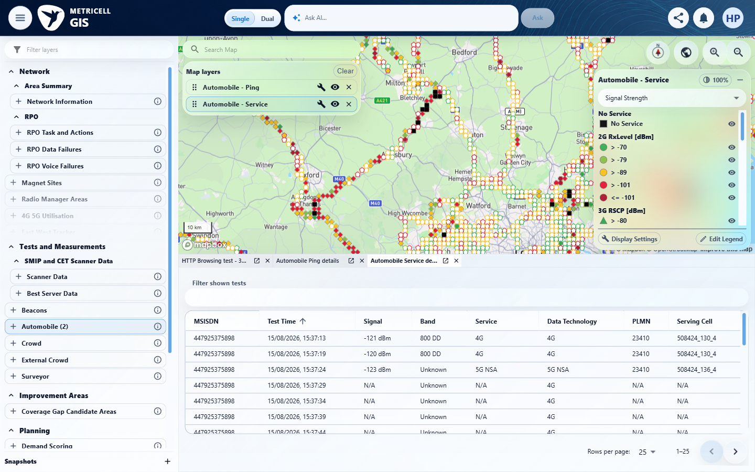
E09 detail enlargement - full screenshot above | E10 detail enlargement - full screenshot above

6.0.0 | With the Service details table displayed, filtering a supported column limits the displayed rows to those matching the filter. | With the Service details table displayed, filtering a supported column limits the displayed rows to those matching the filter. | criterion-6-before-filter.png shows multiple Service rows with differing Test Times; criterion-6-final.png shows filter 19:47:32 and only the matching 12/10/2026 19:47:32 row. The provided table-wide filter matches the supported Test Time column.  Evidence: E09, E11 | Passed
Criterion 6 evidence: With the Service details table displayed, filtering a supported column limits the displayed rows to those matching the filter.
Browser URL recorded after criterion: https://o2intelligence-v4-dev.metricell.com/gis
E09 - Before filter (criterion-6-before-filter.png) | E11 - Final (criterion-6-final.png)  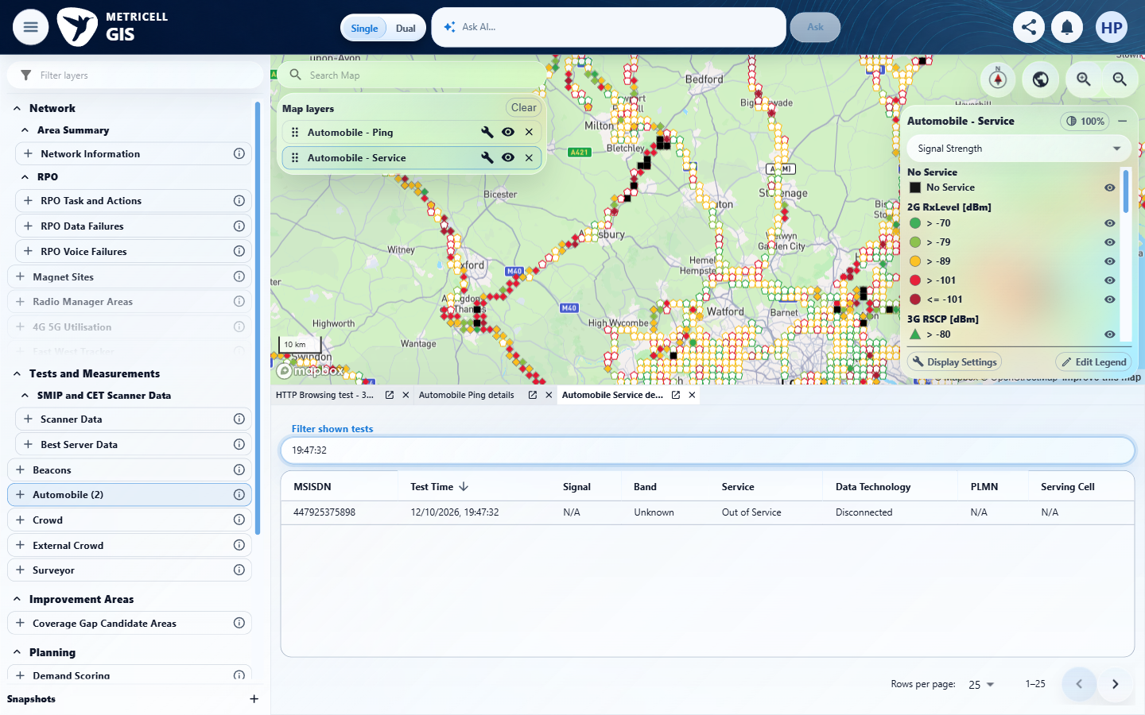
E09 detail enlargement - full screenshot above | E11 detail enlargement - full screenshot above

7.0.0 | When returned details include cell-neighbour data, the dialog displays each neighbour in its own labelled details table. | When returned details include cell-neighbour data, the dialog displays each neighbour in its own labelled details table. | criterion-7-before-earliest-record.png shows the selected 15/08/2026 15:37:13 record. criterion-7-final-earliest-record.png and criterion-7-final-all-neighbours.png together show separately labelled Cell Neighbour 1, 2 and 3 tables, matching the three returned neighbours recorded for 131974812: RSRP -120/-118/-128 dBm, RSRQ -18/-16/-20, EARFCN 6400/6400/39448, PCI 117/272/62.  Evidence: E12, E13, E14, E15 | Passed
Criterion 7 evidence: When returned details include cell-neighbour data, the dialog displays each neighbour in its own labelled details table.
Browser URL recorded after criterion: https://o2intelligence-v4-dev.metricell.com/gis
E12 - Before earliest record sort (criterion-7-before-earliest-record-sort.png)  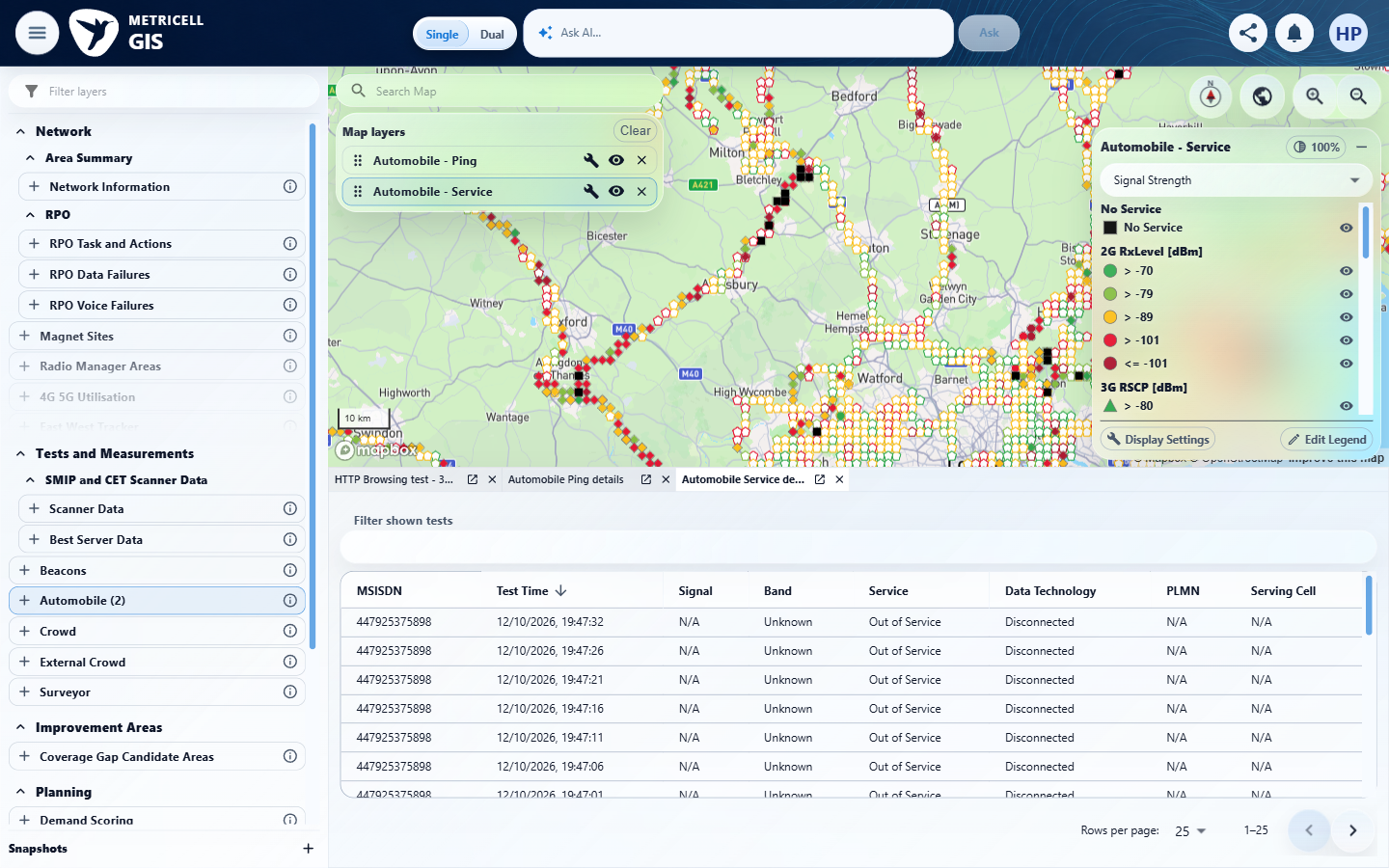 | E13 - Before earliest record (criterion-7-before-earliest-record.png)  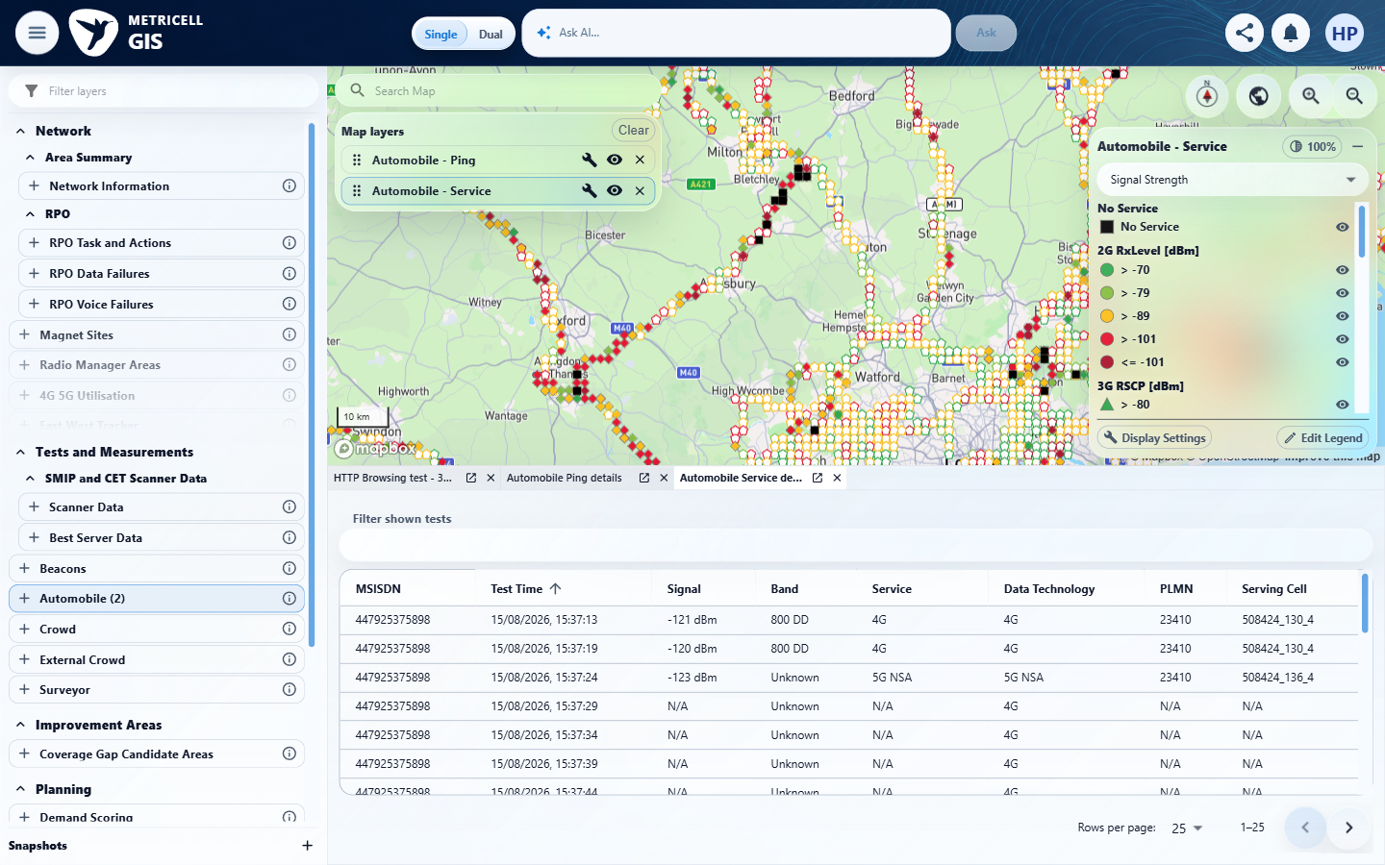

Criterion 7 continued: When returned details include cell-neighbour data, the dialog displays each neighbour in its own labelled details table.
Browser URL recorded after criterion: https://o2intelligence-v4-dev.metricell.com/gis
E14 - Final earliest record (criterion-7-final-earliest-record.png)  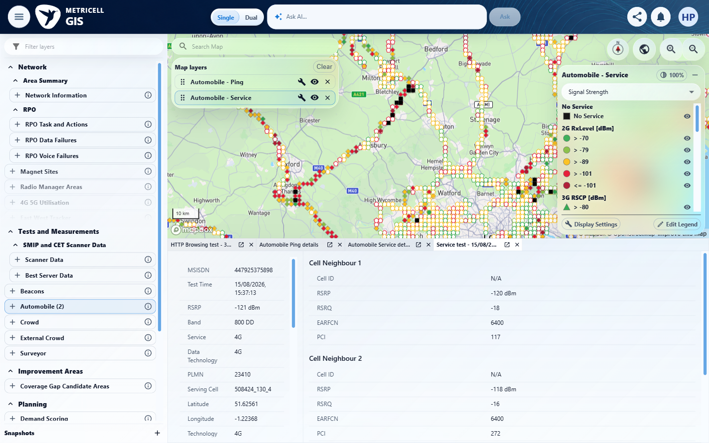 | E15 - Final all neighbours (criterion-7-final-all-neighbours.png)  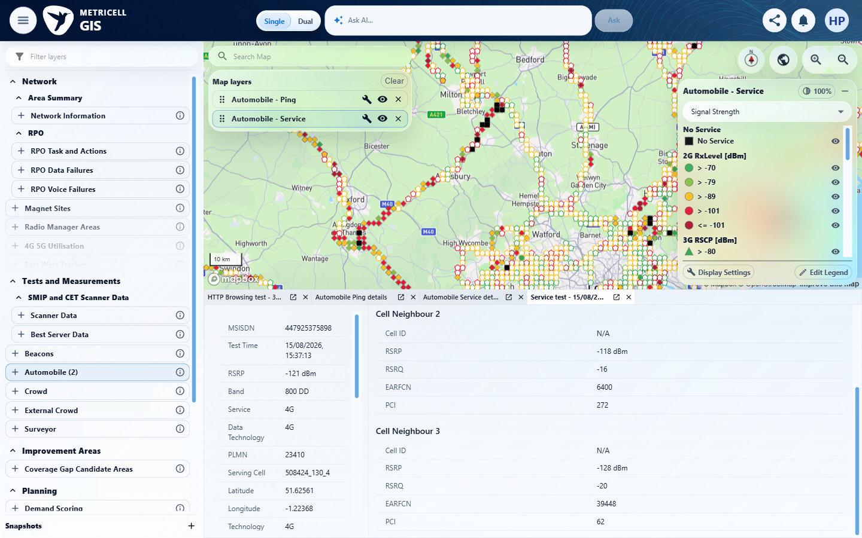

8.0.0 | While Service details are loading, the dialog displays a loading state. | While Service details are loading, the dialog displays a loading state. | The recorded check satisfied the criterion; see the assessment below.  Evidence: E16, E17, E18, E09 | Passed
Criterion 8 assessment: SIMULATED UI STATE: Delayed the selected detail request to check loading. The evidence visibly shows a small blue loading spinner in the selected Service detail panel, rather than visible Loading point details text.
Criterion 8 evidence: While Service details are loading, the dialog displays a loading state.
Browser URL recorded after criterion: https://o2intelligence-v4-dev.metricell.com/gis
E16 - Final (criterion-8-final.png)  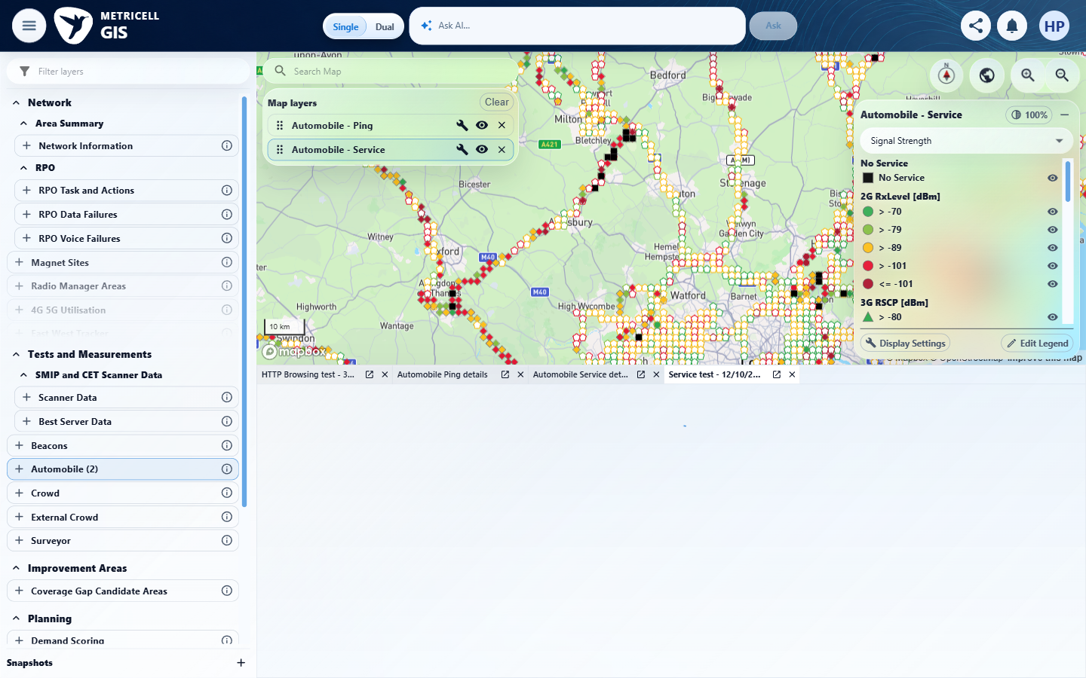 | E17 - Recovery (criterion-8-recovery.png)  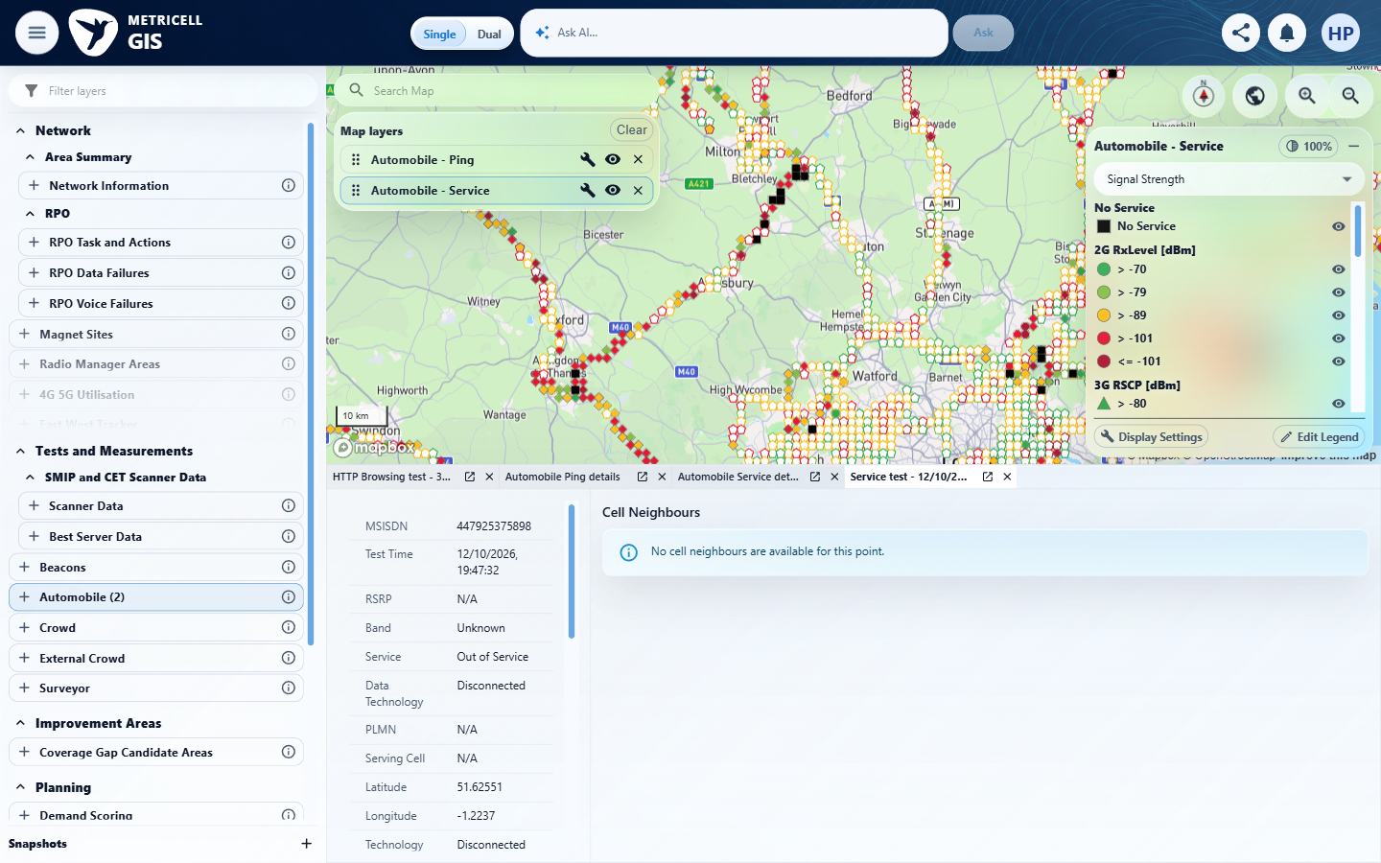

Criterion 8 continued: While Service details are loading, the dialog displays a loading state.
Browser URL recorded after criterion: https://o2intelligence-v4-dev.metricell.com/gis
E18 - Genuine baseline (criterion-8-genuine-baseline.png)  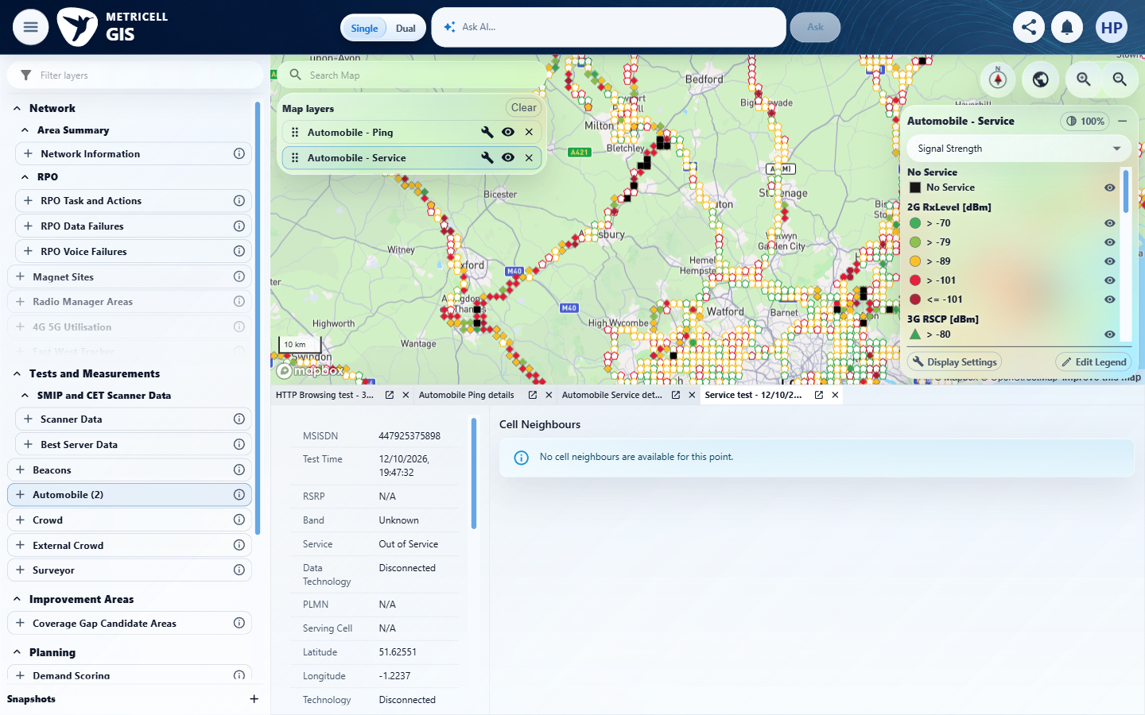 | E09 - Before delayed reopen (criterion-8-before-delayed-reopen.png)

9.0.0 | If Service details cannot be retrieved, the dialog displays an error state and does not display stale details. | If Service details cannot be retrieved, the dialog displays an error state and does not display stale details. | The recorded check satisfied the criterion; see the assessment below.  Evidence: E19, E20, E21, E22, E23 | Passed
Criterion 9 assessment: SIMULATED UI STATE: Returned HTTP 503 for the selected detail request to check error handling. The evidence shows Unable to load point details and Retry with no prior details in the active target panel; the prior record is an inactive tab.
Criterion 9 evidence: If Service details cannot be retrieved, the dialog displays an error state and does not display stale details.
Browser URL recorded after criterion: https://o2intelligence-v4-dev.metricell.com/gis
E19 - Final (criterion-9-final.png)  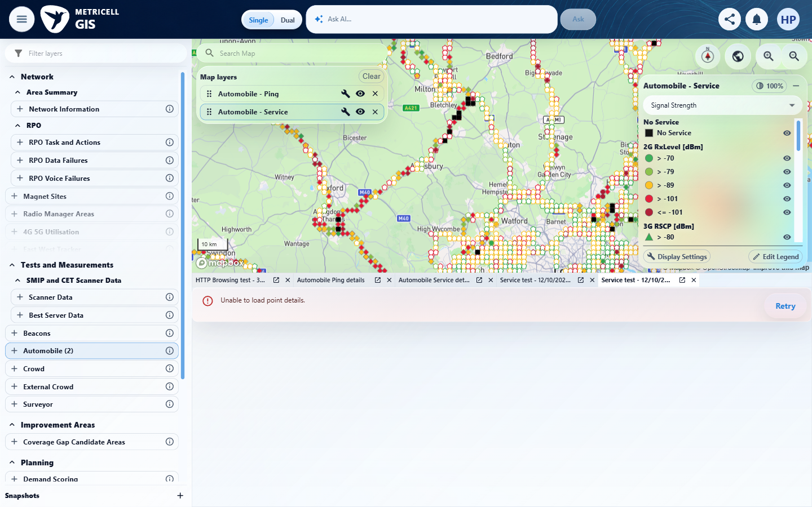 | E20 - Recovery (criterion-9-recovery.png)  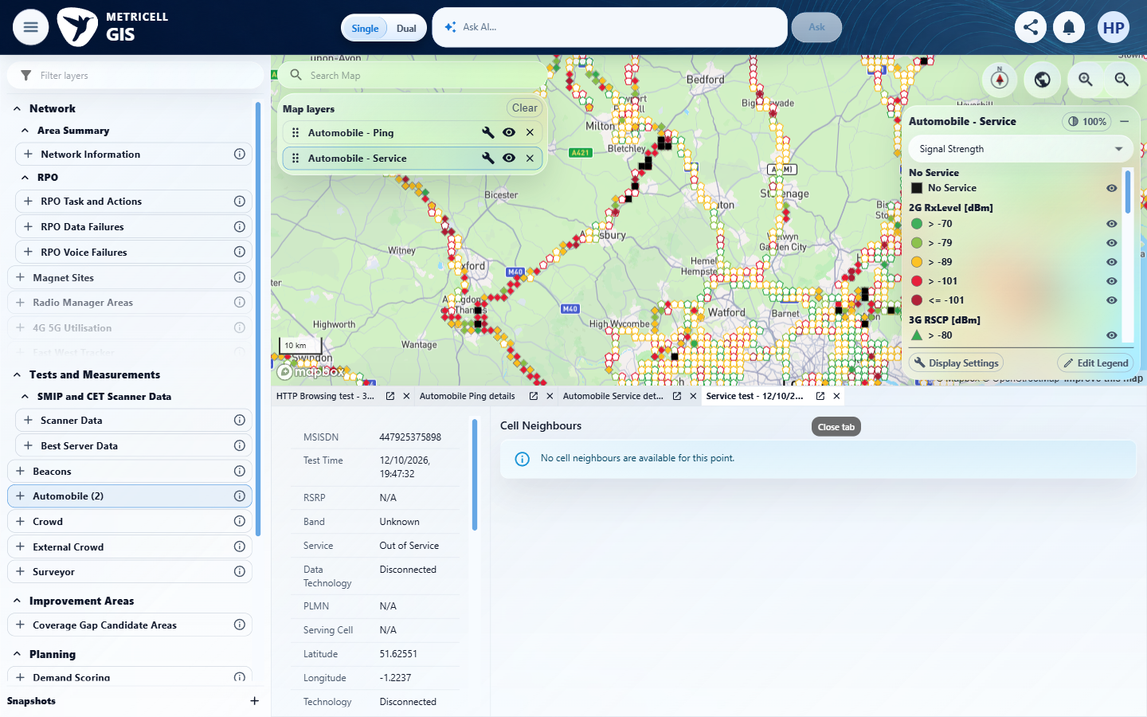

Criterion 9 continued: If Service details cannot be retrieved, the dialog displays an error state and does not display stale details.
Browser URL recorded after criterion: https://o2intelligence-v4-dev.metricell.com/gis
E21 - Target genuine baseline (criterion-9-target-genuine-baseline.png)  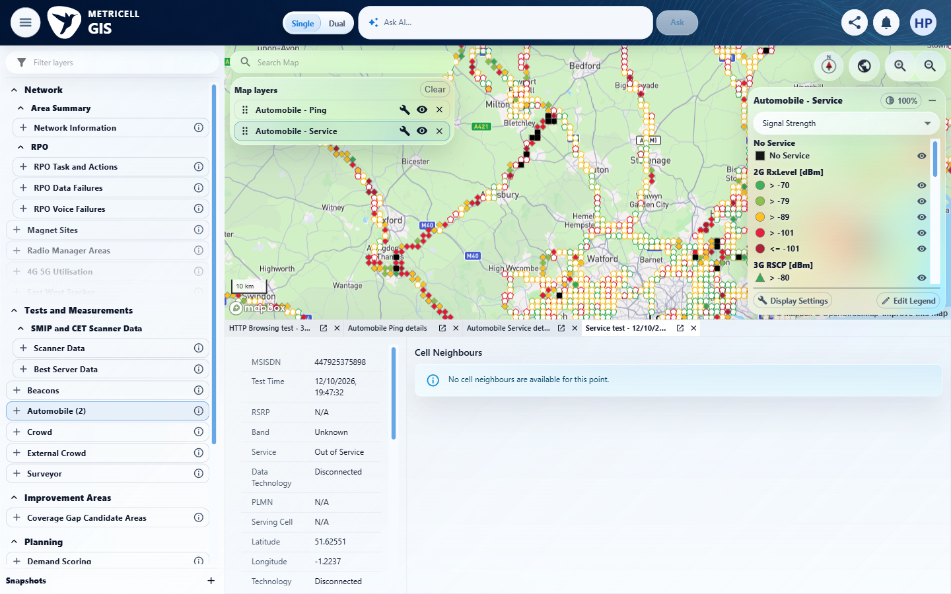 | E22 - Distinct record baseline (criterion-9-distinct-record-baseline.png)  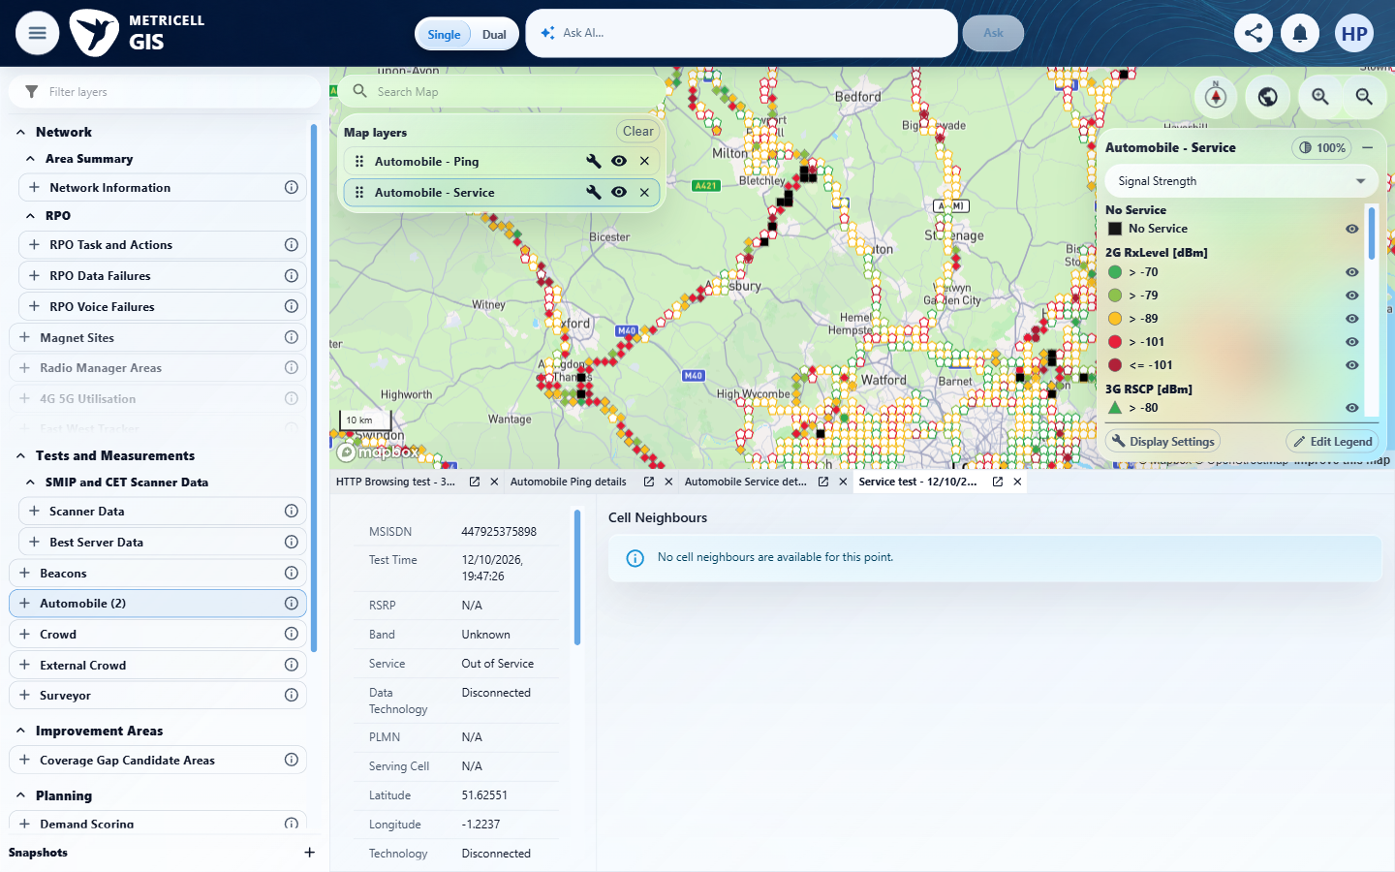

Criterion 9 continued: If Service details cannot be retrieved, the dialog displays an error state and does not display stale details.
Browser URL recorded after criterion: https://o2intelligence-v4-dev.metricell.com/gis
E23 - Before failing target (criterion-9-before-failing-target.png)
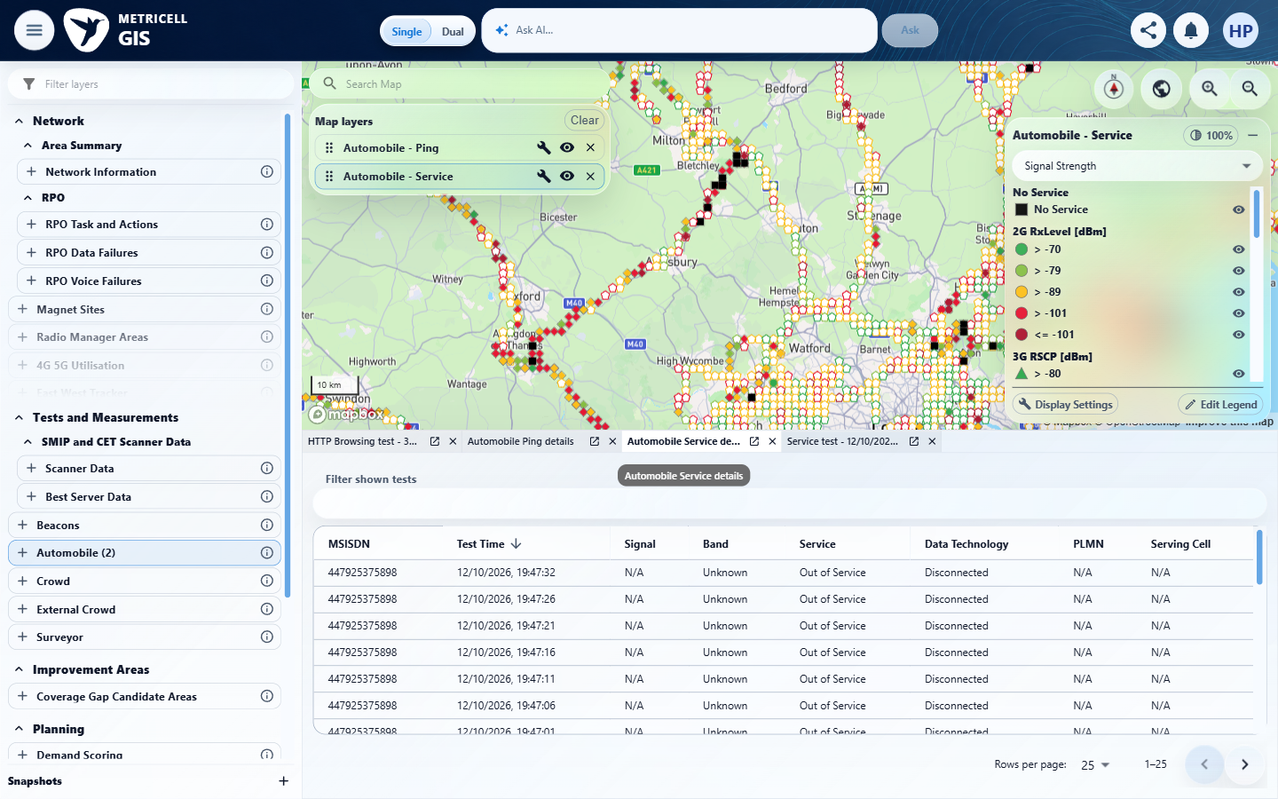

Supporting setup captures - full attempt evidence remains in the local evidence folder
E24 - Before automobile (criterion-3-before-automobile.png)  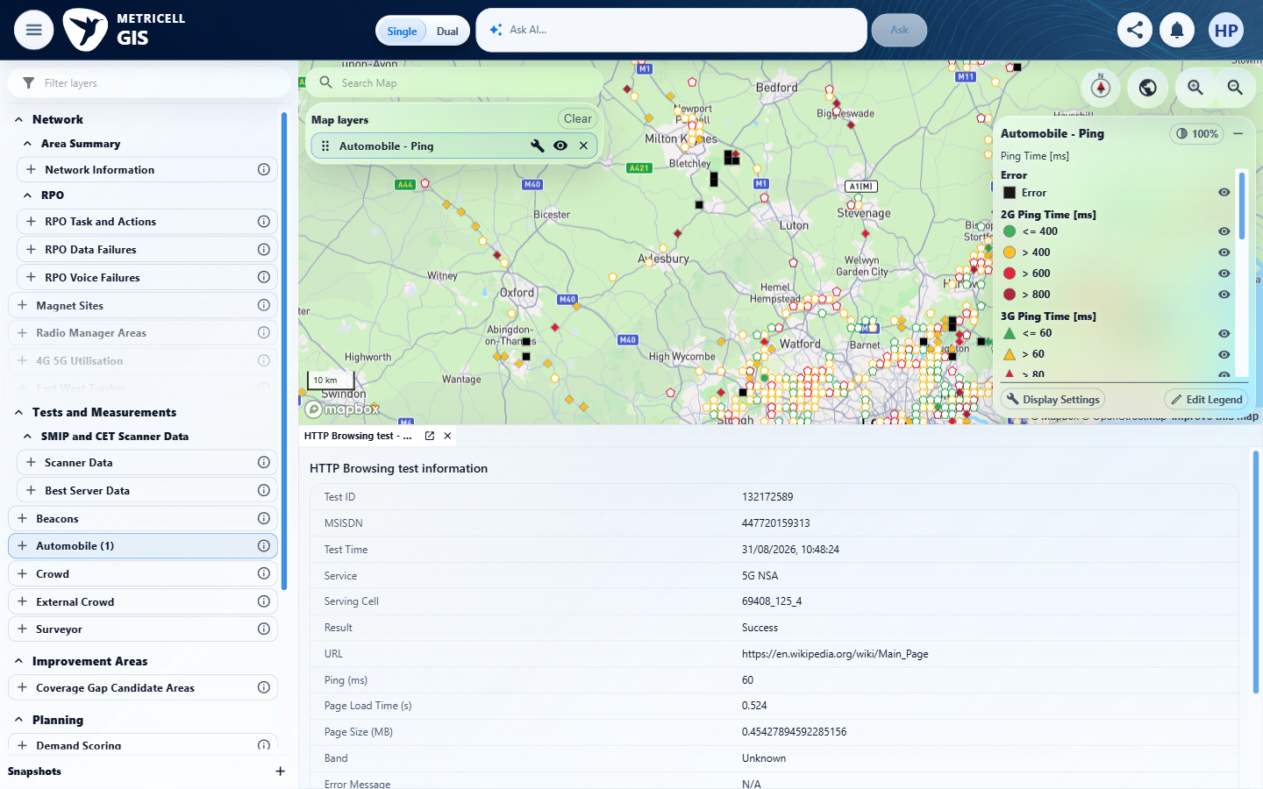 | E25 - Actual automobile config (criterion-3-actual-automobile-config.png)  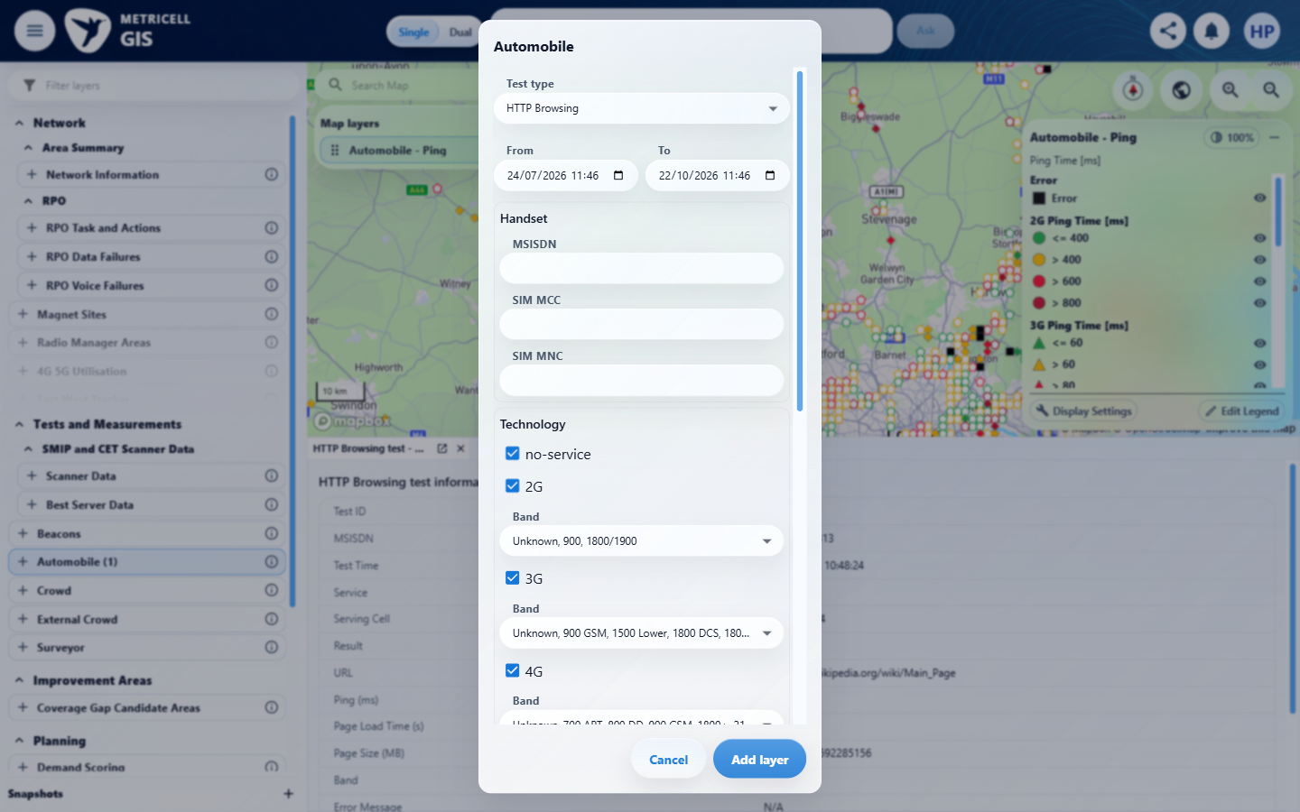

About Metricell

Metricell is on a mission to deliver connectivity. We work with our customers to design, deliver and manage wireless communication networks – with a shared ambition of achieving flawless network experience. We’ve been responsible for many first-to-market products, and our technology is characterised by the relentless pursuit of automation and digitalisation.

Our geospatial intelligence tools traverse a wide variety of business processes – from Test & Measurement to Customer Experience Management – and we’re pioneers in Crowdsourcing and Digital Self Care. Our technology is today in use by a range of customers; thousands of their personnel; and millions of subscribers worldwide.

Find out more at www.metricell.com




