

Automated Test Case Document
Jira Ticket: TEST2-88

Document Classification: | Company Confidential
Document Ref: | Automated Test Case Document
Version: | 1.0
Date: | 20/10/2026
Document Author: | Automated TEST2 Evidence Review
Document Owner: | Quality Assurance / Metricell




This document and its content is copyright of Metricell Limited @ 2026 all rights reserved. All information contained herein is the intellectual property of Metricell Limited and should be treated as confidential. Any external redistribution of reproduction of part or all of the contents in any form is prohibited unless expressly agreed with Metricell Limited in writing. Any reproduced content must include the following statement; “Part or all of the content contained herein is copyright of Metricell Limited @ 2026 all rights reserved”.
Table of Contents
1 Revision History 2
2 Test Cycle Information 3
3 Test Summary 3
4 Test Cases 4
About Metricell 12

Revision History

Version | Date | Revision Author | Summary of Changes
[1.0] | 20/10/2026 | TEST2 QA Automation | Generated from TEST2 evidence review

Test Cycle Information

Tester: | Automated
Jira Ticket: | TEST2-88
Environment: | o2intelligence-v4-dev.metricell.com
Browser Details: | Google Chrome 155.0.8059.85
Date of Test: | 20/10/2026
Limitations during Testing: | 12 blocked; 0 inconclusive criterion(s). All 12 criteria are blocked by the unavailable MS Teams Call layer: each criterion's final screenshot shows the MS Teams search returning no matching layers on a rendered GIS map. Required display-setting scenarios could not be exercised; no application defect is established. All 36 referenced PNGs exist and are non-empty. The pre-search captures for criteria 2 and 11 show map loading; their own later final captures establish the settled prerequisite blocker. Criterion 1: The loaded GIS catalogue offers no MS Teams match for the current account/environment. The required active MS Teams Call layer and its display settings could not be reached; no setting or underlying result data was changed. Display controls could not be inspected. Criterion 1: Navigated to the launcher and verified it was visible; saved initial evidence. Initial screenshot first failed because its directory did not exist; created the staging directory and restarted from the launcher with a verified saved initial PNG. Criterion 2: The loaded GIS catalogue offers no MS Teams match for the current account/environment. The required active MS Teams Call layer and its display settings could not be reached; no setting or underlying result data was changed. Configured point colouring and corresponding legend could not be exercised. Criterion 3: The loaded GIS catalogue offers no MS Teams match for the current account/environment. The required active MS Teams Call layer and its display settings could not be reached; no setting or underlying result data was changed. Detailed route geometry could not be enabled or observed. Criterion 4: The loaded GIS catalogue offers no MS Teams match for the current account/environment. The required active MS Teams Call layer and its display settings could not be reached; no setting or underlying result data was changed. The prerequisite visible detailed route geometry could not be established or disabled. Criterion 5: The loaded GIS catalogue offers no MS Teams match for the current account/environment. The required active MS Teams Call layer and its display settings could not be reached; no setting or underlying result data was changed. The linked-site control and its below-threshold zoom explanation could not be inspected. Criterion 6: The loaded GIS catalogue offers no MS Teams match for the current account/environment. The required active MS Teams Call layer and its display settings could not be reached; no setting or underlying result data was changed. Linked-site overlays could not be enabled at a supported zoom. Criterion 7: The loaded GIS catalogue offers no MS Teams match for the current account/environment. The required active MS Teams Call layer and its display settings could not be reached; no setting or underlying result data was changed. The prerequisite visible linked-site overlays could not be established or disabled. Criterion 8: The loaded GIS catalogue offers no MS Teams match for the current account/environment. The required active MS Teams Call layer and its display settings could not be reached; no setting or underlying result data was changed. Linked-cell control availability with linked sites enabled could not be inspected. Criterion 9: The loaded GIS catalogue offers no MS Teams match for the current account/environment. The required active MS Teams Call layer and its display settings could not be reached; no setting or underlying result data was changed. Linked-cell control unavailability with linked sites disabled or insufficient zoom could not be inspected. Criterion 10: The loaded GIS catalogue offers no MS Teams match for the current account/environment. The required active MS Teams Call layer and its display settings could not be reached; no setting or underlying result data was changed. Linked-cell overlays could not be enabled at a supported zoom. Criterion 11: The loaded GIS catalogue offers no MS Teams match for the current account/environment. The required active MS Teams Call layer and its display settings could not be reached; no setting or underlying result data was changed. The prerequisite visible linked-cell overlays could not be established or disabled. Criterion 12: The loaded GIS catalogue offers no MS Teams match for the current account/environment. The required active MS Teams Call layer and its display settings could not be reached; no setting or underlying result data was changed. A display-setting change could not be performed, so layer/filter/legend isolation could not be compared. Defects (No.) counts directly contradicted criteria, not unique Jira bugs; blockers and inconclusive evidence count as zero.
Overall review outcome: | Blocked
Browser URL(s) recorded after criteria: | https://o2intelligence-v4-dev.metricell.com/gis

Test Summary

Area of test | Pass | Fail | Defects (No.)
1. Given the MS Teams Call layer is active, when the user opens its display settings, then the configured map-colouring choices and controls for detailed routes, linked sites and linked cells are visible. | N | N | 0
2. Given the MS Teams Call layer is active and a configured colouring choice is selected, when the map updates, then MS Teams Call result points and the legend display the selected configured colouring and its corresponding legend section. | N | N | 0
3. Given the MS Teams Call layer is active, when the user turns detailed routes on and the map refreshes, then detailed route geometry for the active MS Teams Call results is visible. | N | N | 0
4. Given the MS Teams Call layer is active and detailed routes are visible, when the user turns detailed routes off and the map refreshes, then that detailed route geometry is hidden. | N | N | 0
5. Given the MS Teams Call layer is active and the map is below the configured zoom level for linked sites, when display settings are open, then the linked-site control is unavailable and indicates that the user must zoom in. | N | N | 0
6. Given the MS Teams Call layer is active and the map is at or above the configured zoom level for linked sites, when the user turns linked sites on and the map refreshes, then linked-site overlays for the active MS Teams Call results are visible. | N | N | 0
7. Given linked-site overlays are visible at a supported zoom level, when the user turns linked sites off and the map refreshes, then those linked-site overlays are hidden. | N | N | 0
8. Given linked sites are enabled and the map is at a zoom level that supports linked cells, when display settings are open, then the linked-cell control is available. | N | N | 0
9. Given linked sites are disabled or the map is below the zoom level that supports linked cells, when display settings are open, then the linked-cell control is unavailable. | N | N | 0
10. Given linked sites are enabled and the map is at a zoom level that supports linked cells, when the user turns linked cells on and the map refreshes, then linked-cell overlays are visible. | N | N | 0
11. Given linked-cell overlays are visible, when the user turns linked cells off and the map refreshes, then those linked-cell overlays are hidden. | N | N | 0
12. Given any MS Teams Call display setting is changed, when the map refreshes, then the setting is applied only to the active MS Teams Call layer and other visible map layers, standard map filters and legend point-filtering state retain their prior visible states. | N | N | 0

Test Cases
Each test maps to a criterion and decisive browser evidence. Inconclusive results are reported as Failed.

Tests

Preconditions: | V4 access and ticket conditions. | Associated Requirements: | Ticket criteria below. | Automation Notes: | Screenshots below each criterion; full log retained locally.
ID / Criterion | Criteria Tested | Expected Result | Actual Result / Evidence Path | Outcome
1.0.0 | Given the MS Teams Call layer is active, when the user opens its display settings, then the configured map-colouring choices and controls for detailed routes, linked sites and linked cells are visible. | Given the MS Teams Call layer is active, when the user opens its display settings, then the configured map-colouring choices and controls for detailed routes, linked sites and linked cells are visible. | criterion-1-final.png shows a rendered GIS map with the layer search set to MS Teams and “No layers match this search.” The required MS Teams Call layer is unavailable in this run. Display controls could not be inspected.  Evidence: E01, E02 | Blocked
Criterion 1 evidence: Given the MS Teams Call layer is active, when the user opens its display settings, then the configured map-colouring choices and controls for detailed routes, linked sites and linked cells are visible.
Browser URL recorded after criterion: https://o2intelligence-v4-dev.metricell.com/gis
E01 - Before layer search (criterion-1-before-layer-search.png)  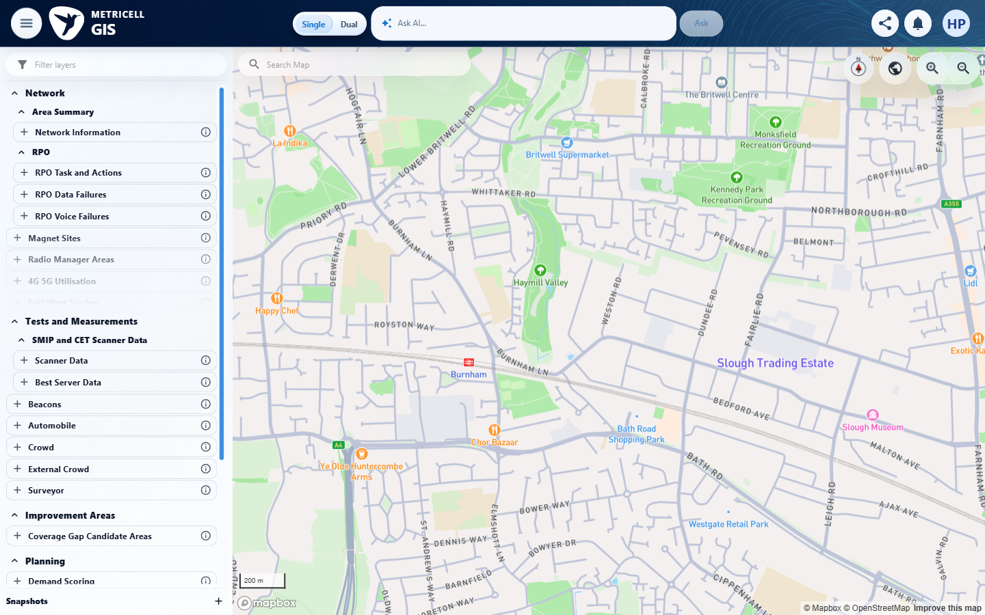 | E02 - Final (criterion-1-final.png)  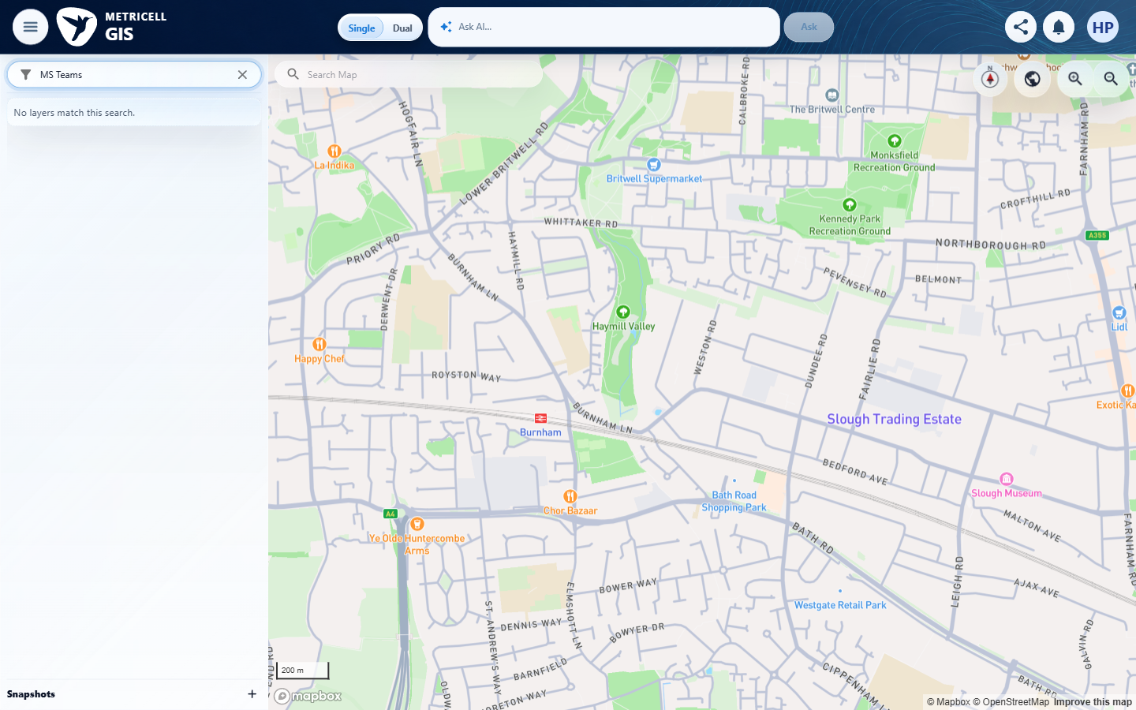

2.0.0 | Given the MS Teams Call layer is active and a configured colouring choice is selected, when the map updates, then MS Teams Call result points and the legend display the selected configured colouring and its corresponding legend section. | Given the MS Teams Call layer is active and a configured colouring choice is selected, when the map updates, then MS Teams Call result points and the legend display the selected configured colouring and its corresponding legend section. | criterion-2-final.png shows a rendered GIS map with the layer search set to MS Teams and “No layers match this search.” The required MS Teams Call layer is unavailable in this run. Configured point colouring and its corresponding legend could not be exercised. criterion-2-before-layer-search.png still shows map loading, despite the step's claim; the later criterion-2-final.png shows the settled blocker.  Evidence: E03, E04 | Blocked
Criterion 2 evidence: Given the MS Teams Call layer is active and a configured colouring choice is selected, when the map updates, then MS Teams Call result points and the legend display the selected configured colouring and its corresponding legend section.
Browser URL recorded after criterion: https://o2intelligence-v4-dev.metricell.com/gis
E03 - Before layer search (criterion-2-before-layer-search.png)  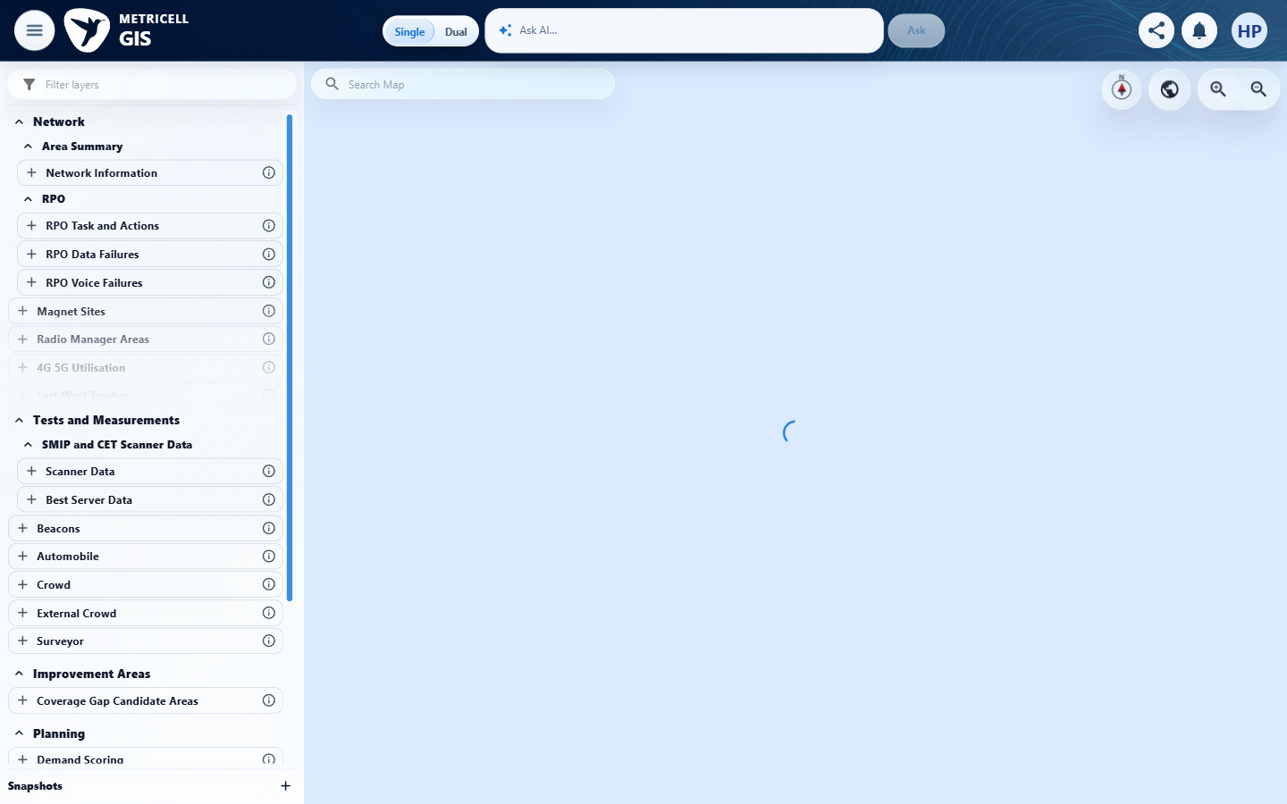 | E04 - Final (criterion-2-final.png)  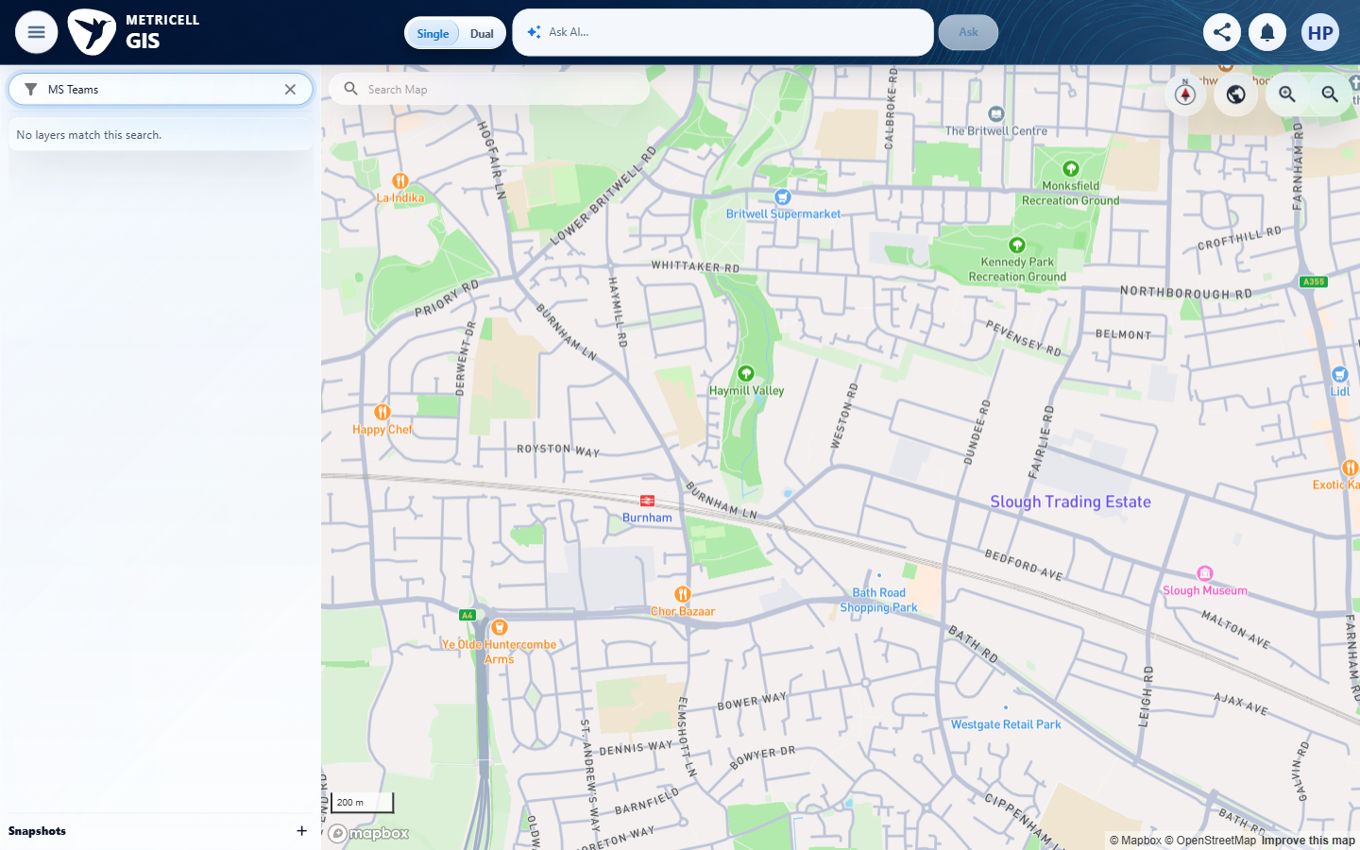

3.0.0 | Given the MS Teams Call layer is active, when the user turns detailed routes on and the map refreshes, then detailed route geometry for the active MS Teams Call results is visible. | Given the MS Teams Call layer is active, when the user turns detailed routes on and the map refreshes, then detailed route geometry for the active MS Teams Call results is visible. | criterion-3-final.png shows a rendered GIS map with the layer search set to MS Teams and “No layers match this search.” The required MS Teams Call layer is unavailable in this run. Detailed routes could not be enabled or observed.  Evidence: E05, E04 | Blocked
Criterion 3 evidence: Given the MS Teams Call layer is active, when the user turns detailed routes on and the map refreshes, then detailed route geometry for the active MS Teams Call results is visible.
Browser URL recorded after criterion: https://o2intelligence-v4-dev.metricell.com/gis
E05 - Before layer search (criterion-3-before-layer-search.png)  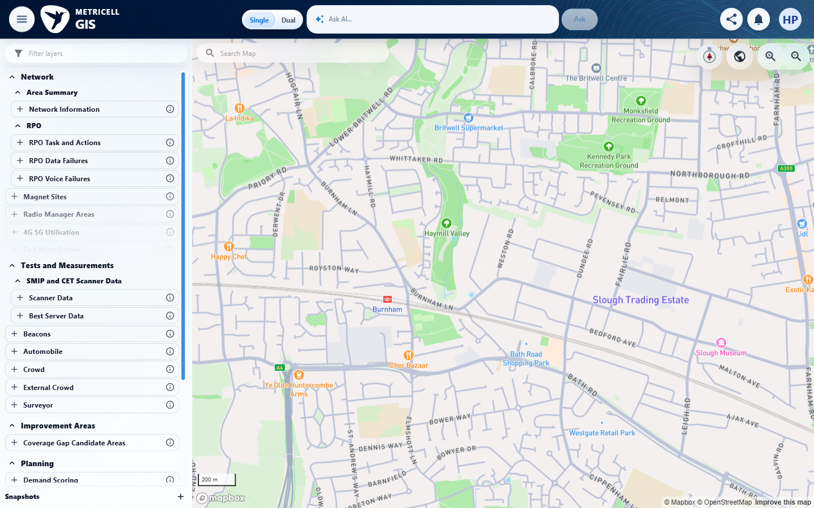 | E04 - Final (criterion-3-final.png)

4.0.0 | Given the MS Teams Call layer is active and detailed routes are visible, when the user turns detailed routes off and the map refreshes, then that detailed route geometry is hidden. | Given the MS Teams Call layer is active and detailed routes are visible, when the user turns detailed routes off and the map refreshes, then that detailed route geometry is hidden. | criterion-4-final.png shows a rendered GIS map with the layer search set to MS Teams and “No layers match this search.” The required MS Teams Call layer is unavailable in this run. The visible-routes prerequisite could not be established, so hiding routes could not be exercised.  Evidence: E05, E04 | Blocked
Criterion 4 evidence: Given the MS Teams Call layer is active and detailed routes are visible, when the user turns detailed routes off and the map refreshes, then that detailed route geometry is hidden.
Browser URL recorded after criterion: https://o2intelligence-v4-dev.metricell.com/gis
E05 - Before layer search (criterion-4-before-layer-search.png) | E04 - Final (criterion-4-final.png)

5.0.0 | Given the MS Teams Call layer is active and the map is below the configured zoom level for linked sites, when display settings are open, then the linked-site control is unavailable and indicates that the user must zoom in. | Given the MS Teams Call layer is active and the map is below the configured zoom level for linked sites, when display settings are open, then the linked-site control is unavailable and indicates that the user must zoom in. | criterion-5-final.png shows a rendered GIS map with the layer search set to MS Teams and “No layers match this search.” The required MS Teams Call layer is unavailable in this run. The linked-site control and its below-threshold zoom explanation could not be inspected.  Evidence: E05, E04 | Blocked
Criterion 5 evidence: Given the MS Teams Call layer is active and the map is below the configured zoom level for linked sites, when display settings are open, then the linked-site control is unavailable and indicates that the user must zoom in.
Browser URL recorded after criterion: https://o2intelligence-v4-dev.metricell.com/gis
E05 - Before layer search (criterion-5-before-layer-search.png) | E04 - Final (criterion-5-final.png)

6.0.0 | Given the MS Teams Call layer is active and the map is at or above the configured zoom level for linked sites, when the user turns linked sites on and the map refreshes, then linked-site overlays for the active MS Teams Call results are visible. | Given the MS Teams Call layer is active and the map is at or above the configured zoom level for linked sites, when the user turns linked sites on and the map refreshes, then linked-site overlays for the active MS Teams Call results are visible. | criterion-6-final.png shows a rendered GIS map with the layer search set to MS Teams and “No layers match this search.” The required MS Teams Call layer is unavailable in this run. Linked-site overlays could not be enabled at a supported zoom.  Evidence: E05, E04 | Blocked
Criterion 6 evidence: Given the MS Teams Call layer is active and the map is at or above the configured zoom level for linked sites, when the user turns linked sites on and the map refreshes, then linked-site overlays for the active MS Teams Call results are visible.
Browser URL recorded after criterion: https://o2intelligence-v4-dev.metricell.com/gis
E05 - Before layer search (criterion-6-before-layer-search.png) | E04 - Final (criterion-6-final.png)

7.0.0 | Given linked-site overlays are visible at a supported zoom level, when the user turns linked sites off and the map refreshes, then those linked-site overlays are hidden. | Given linked-site overlays are visible at a supported zoom level, when the user turns linked sites off and the map refreshes, then those linked-site overlays are hidden. | criterion-7-final.png shows a rendered GIS map with the layer search set to MS Teams and “No layers match this search.” The required MS Teams Call layer is unavailable in this run. The visible linked-site prerequisite could not be established, so hiding linked sites could not be exercised.  Evidence: E05, E04 | Blocked
Criterion 7 evidence: Given linked-site overlays are visible at a supported zoom level, when the user turns linked sites off and the map refreshes, then those linked-site overlays are hidden.
Browser URL recorded after criterion: https://o2intelligence-v4-dev.metricell.com/gis
E05 - Before layer search (criterion-7-before-layer-search.png) | E04 - Final (criterion-7-final.png)

8.0.0 | Given linked sites are enabled and the map is at a zoom level that supports linked cells, when display settings are open, then the linked-cell control is available. | Given linked sites are enabled and the map is at a zoom level that supports linked cells, when display settings are open, then the linked-cell control is available. | criterion-8-final.png shows a rendered GIS map with the layer search set to MS Teams and “No layers match this search.” The required MS Teams Call layer is unavailable in this run. Linked-cell control availability with linked sites enabled could not be inspected.  Evidence: E01, E04 | Blocked
Criterion 8 evidence: Given linked sites are enabled and the map is at a zoom level that supports linked cells, when display settings are open, then the linked-cell control is available.
Browser URL recorded after criterion: https://o2intelligence-v4-dev.metricell.com/gis
E01 - Before layer search (criterion-8-before-layer-search.png) | E04 - Final (criterion-8-final.png)

9.0.0 | Given linked sites are disabled or the map is below the zoom level that supports linked cells, when display settings are open, then the linked-cell control is unavailable. | Given linked sites are disabled or the map is below the zoom level that supports linked cells, when display settings are open, then the linked-cell control is unavailable. | criterion-9-final.png shows a rendered GIS map with the layer search set to MS Teams and “No layers match this search.” The required MS Teams Call layer is unavailable in this run. Linked-cell control unavailability with linked sites disabled or insufficient zoom could not be inspected.  Evidence: E05, E04 | Blocked
Criterion 9 evidence: Given linked sites are disabled or the map is below the zoom level that supports linked cells, when display settings are open, then the linked-cell control is unavailable.
Browser URL recorded after criterion: https://o2intelligence-v4-dev.metricell.com/gis
E05 - Before layer search (criterion-9-before-layer-search.png) | E04 - Final (criterion-9-final.png)

10.0.0 | Given linked sites are enabled and the map is at a zoom level that supports linked cells, when the user turns linked cells on and the map refreshes, then linked-cell overlays are visible. | Given linked sites are enabled and the map is at a zoom level that supports linked cells, when the user turns linked cells on and the map refreshes, then linked-cell overlays are visible. | criterion-10-final.png shows a rendered GIS map with the layer search set to MS Teams and “No layers match this search.” The required MS Teams Call layer is unavailable in this run. Linked-cell overlays could not be enabled at a supported zoom.  Evidence: E05, E04 | Blocked
Criterion 10 evidence: Given linked sites are enabled and the map is at a zoom level that supports linked cells, when the user turns linked cells on and the map refreshes, then linked-cell overlays are visible.
Browser URL recorded after criterion: https://o2intelligence-v4-dev.metricell.com/gis
E05 - Before layer search (criterion-10-before-layer-search.png) | E04 - Final (criterion-10-final.png)

11.0.0 | Given linked-cell overlays are visible, when the user turns linked cells off and the map refreshes, then those linked-cell overlays are hidden. | Given linked-cell overlays are visible, when the user turns linked cells off and the map refreshes, then those linked-cell overlays are hidden. | criterion-11-final.png shows a rendered GIS map with the layer search set to MS Teams and “No layers match this search.” The required MS Teams Call layer is unavailable in this run. The visible linked-cell prerequisite could not be established, so hiding linked cells could not be exercised. criterion-11-before-layer-search.png still shows map loading, despite the step's claim; the later criterion-11-final.png shows the settled blocker.  Evidence: E06, E04 | Blocked
Criterion 11 evidence: Given linked-cell overlays are visible, when the user turns linked cells off and the map refreshes, then those linked-cell overlays are hidden.
Browser URL recorded after criterion: https://o2intelligence-v4-dev.metricell.com/gis
E06 - Before layer search (criterion-11-before-layer-search.png)  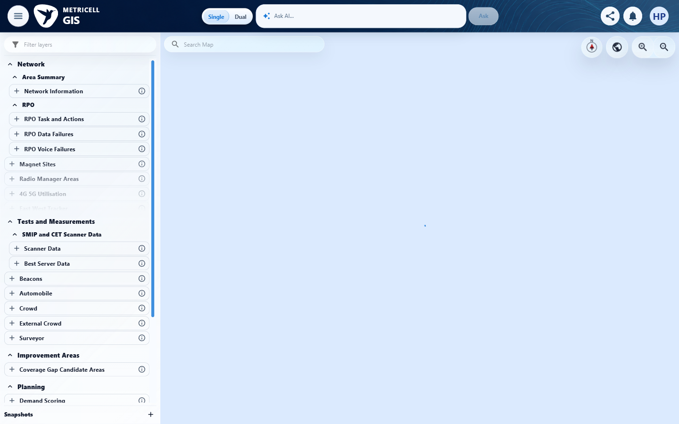 | E04 - Final (criterion-11-final.png)

12.0.0 | Given any MS Teams Call display setting is changed, when the map refreshes, then the setting is applied only to the active MS Teams Call layer and other visible map layers, standard map filters and legend point-filtering state retain their prior visible states. | Given any MS Teams Call display setting is changed, when the map refreshes, then the setting is applied only to the active MS Teams Call layer and other visible map layers, standard map filters and legend point-filtering state retain their prior visible states. | criterion-12-final.png shows a rendered GIS map with the layer search set to MS Teams and “No layers match this search.” The required MS Teams Call layer is unavailable in this run. No MS Teams Call display setting could be changed, so preservation of other layers, standard filters and legend point filtering could not be compared.  Evidence: E05, E04 | Blocked
Criterion 12 evidence: Given any MS Teams Call display setting is changed, when the map refreshes, then the setting is applied only to the active MS Teams Call layer and other visible map layers, standard map filters and legend point-filtering state retain their prior visible states.
Browser URL recorded after criterion: https://o2intelligence-v4-dev.metricell.com/gis
E05 - Before layer search (criterion-12-before-layer-search.png) | E04 - Final (criterion-12-final.png)

About Metricell

Metricell is on a mission to deliver connectivity. We work with our customers to design, deliver and manage wireless communication networks – with a shared ambition of achieving flawless network experience. We’ve been responsible for many first-to-market products, and our technology is characterised by the relentless pursuit of automation and digitalisation.

Our geospatial intelligence tools traverse a wide variety of business processes – from Test & Measurement to Customer Experience Management – and we’re pioneers in Crowdsourcing and Digital Self Care. Our technology is today in use by a range of customers; thousands of their personnel; and millions of subscribers worldwide.

Find out more at www.metricell.com




