

Automated Test Case Document
Jira Ticket: TEST2-86

Document Classification: | Company Confidential
Document Ref: | Automated Test Case Document
Version: | 1.1
Date: | 27/10/2026
Document Author: | Existing evidence reassessment
Document Owner: | Quality Assurance / Metricell




This document and its content is copyright of Metricell Limited @ 2026 all rights reserved. All information contained herein is the intellectual property of Metricell Limited and should be treated as confidential. Any external redistribution of reproduction of part or all of the contents in any form is prohibited unless expressly agreed with Metricell Limited in writing. Any reproduced content must include the following statement; “Part or all of the content contained herein is copyright of Metricell Limited @ 2026 all rights reserved”.
Table of Contents
1 Revision History 2
2 Test Cycle Information 3
3 Test Summary 4
4 Test Cases 5
4.1 Tests 5
About Metricell 29

Revision History

Version | Date | Revision Author | Summary of Changes
1.1 | 27/10/2026 | TEST2 QA reassessment | Reassessed existing evidence against source-qualified criteria; original test history preserved.

Test Cycle Information

Tester: | Automated
Jira Ticket: | TEST2-86
Environment: | o2intelligence-v4-dev.metricell.com
Browser Details: | Google Chrome 156.0.8078.48
Date of Test: | 26/10/2026; existing-evidence reassessment 27/10/2026; loading follow-up 27/10/2026
Limitations during Testing: | Blocked criterion(s): 6, 9. See the assessment below each criterion.  Criteria 8, 10 used simulated UI conditions; see their assessments.
Overall review outcome: | Blocked
Browser URL(s) recorded after criteria: | https://o2intelligence-v4-dev.metricell.com/gis
Review basis: | Reassessed existing evidence against the corrected source-qualified criteria. Original test attempt and earlier review retained; no new test attempt. 8/10 criteria passed; 0 failed and 2 blocked. Manual existing-evidence reassessment on 27 October 2026; no new independent worker or test attempt. Criteria 6 and 9 still need a genuine returned-average fixture and an authoritative unavailable-details response contract/example. Earlier tester history and the prior independent review are preserved.

Test Summary

Area of test | Pass (Y/N) | Fail (Y/N) | Blocked (Y/N) | Defect No
1. Given a completed Upload test is selected and its details have loaded, the summary shows the test and device information available for that record, including Upload Rate and Wi-Fi connection status. Returned technology, user, handset, service, serving cell, duration, tested technologies and indoor/outdoor values are displayed accurately. | Y | N | N | 0
2. Given Upload samples are available, a time-series chart shows Signal Strength in dBm and Upload Rate in Mbps across the test duration. | Y | N | N | 0
3. Given per-sample Upload data is available, each returned sample is shown in a table with its relevant units. | Y | N | N | 0
4. Given the per-sample table contains multiple rows, sorting by a displayed column changes their visible order according to that column. | Y | N | N | 0
5. Given per-sample data is available, filtering the table shows only rows matching the selected filter. | Y | N | N | 0
6. Given average signal metrics are returned, Average Signal Strength, Average Signal Quality, and Average SNR appear in the summary immediately after Upload Rate. | N | N | Y | 0
7. Given an Upload point has no measurable duration, its row is disabled as the no-data state and selecting it does not open an empty details view. | Y | N | N | 0
8. While Upload details are loading, the detail presentation shows the standard loading state. | Y | N | N | 0
9. When Upload details are unavailable, the detail presentation shows the standard no-data state. | N | N | Y | 0
10. When loading Upload details fails, the detail presentation shows the standard error state and does not display incorrect data. | Y | N | N | 0

Test Cases
Each test maps to a criterion and decisive browser evidence. Inconclusive results are reported as Failed.

Tests

Preconditions: | V4 access and ticket conditions. | Associated Requirements: | Ticket criteria below. | Automation Notes: | Screenshots below each criterion; full log retained locally.
ID / Criterion | Criteria Tested | Expected Result | Actual Result / Evidence Path | Outcome
1.0.0 | Given a completed Upload test is selected and its details have loaded, the summary shows the test and device information available for that record, including Upload Rate and Wi-Fi connection status. Returned technology, user, handset, service, serving cell, duration, tested technologies and indoor/outdoor values are displayed accurately. | Given a completed Upload test is selected and its details have loaded, the summary shows the test and device information available for that record, including Upload Rate and Wi-Fi connection status. Returned technology, user, handset, service, serving cell, duration, tested technologies and indoor/outdoor values are displayed accurately. | Existing-evidence reassessment against the corrected source-qualified criterion. Automobile Upload point 131921554 shows Upload Rate 0.78 Mbps, Wi-Fi Connected No, technology/service/data technology 5G NSA, serving cell 2591_110_4, tested technologies 4G and duration 7.005 s. The captured summary and recorded genuine response agree for the returned values. User, handset and indoor/outdoor values were not supplied for this record; the source requires available information, not fabricated values. MSISDN is not treated as proof of a user identity.  Evidence: E01, E02, E03 | Passed
Criterion 1 evidence: Given a completed Upload test is selected and its details have loaded, the summary shows the test and device information available for that record, including Upload Rate and Wi-Fi connection status. Returned technology, user, handset, service, serving cell, duration, tested technologies and indoor/outdoor values are displayed accurately.
Browser URL recorded after criterion: https://o2intelligence-v4-dev.metricell.com/gis
E01 - Summary top (criterion-1-summary-top.png)  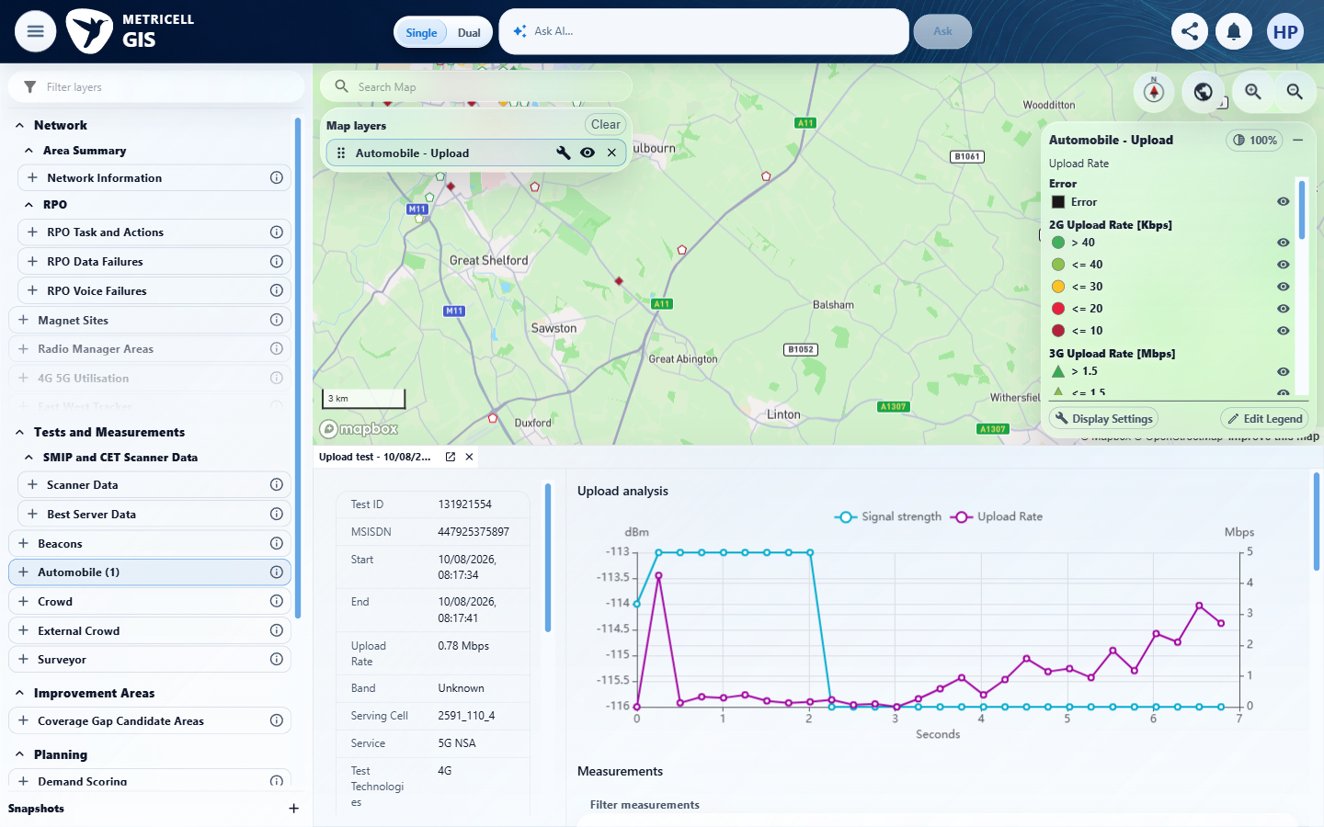 | E02 - Summary middle (criterion-1-summary-middle.png)  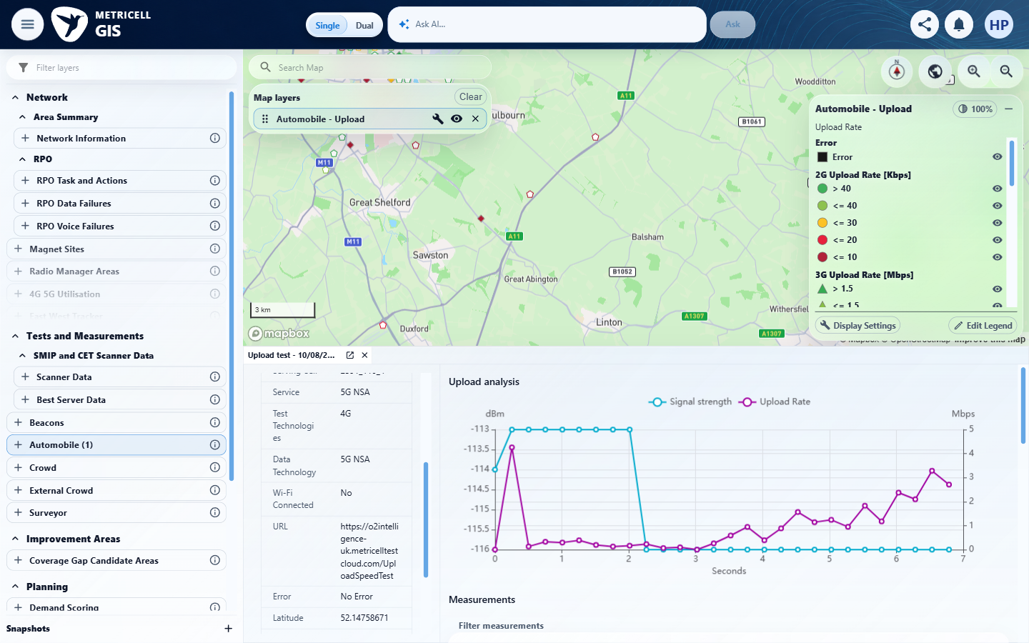

Criterion 1 continued: Given a completed Upload test is selected and its details have loaded, the summary shows the test and device information available for that record, including Upload Rate and Wi-Fi connection status. Returned technology, user, handset, service, serving cell, duration, tested technologies and indoor/outdoor values are displayed accurately.
Browser URL recorded after criterion: https://o2intelligence-v4-dev.metricell.com/gis
E03 - Final (criterion-1-final.png)
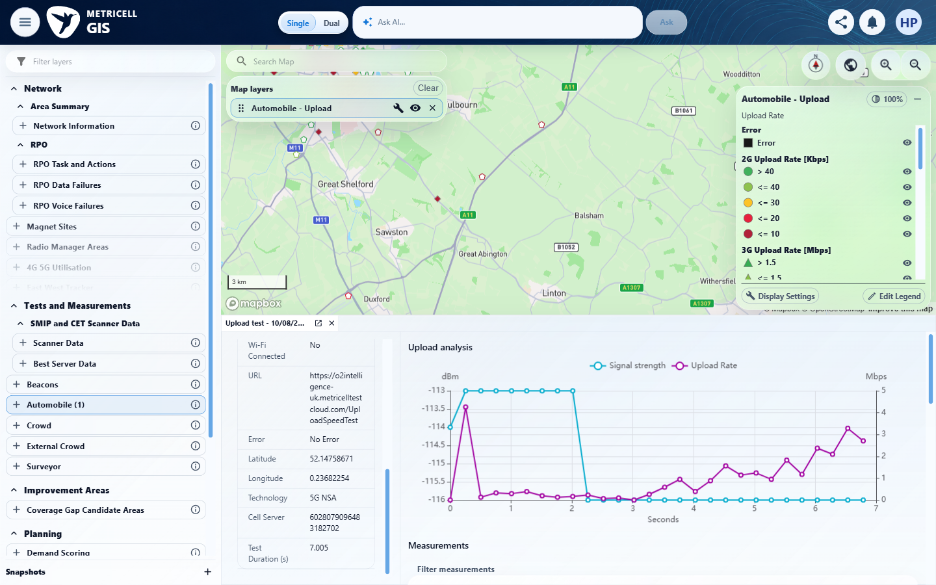

2.0.0 | Given Upload samples are available, a time-series chart shows Signal Strength in dBm and Upload Rate in Mbps across the test duration. | Given Upload samples are available, a time-series chart shows Signal Strength in dBm and Upload Rate in Mbps across the test duration. | criterion-2-final.png shows both Signal strength and Upload Rate series with dBm and Mbps axes over Seconds 0–7; the recorded 7.005 s test duration is consistent with this extent. The repaired Automobile Upload sequence supplies the proof; the earlier selector error does not establish a product defect.  Evidence: E04, E05, E06 | Passed
Criterion 2 assessment: Testing notes: A genuine 28-sample response for completed Automobile Upload test 131921554 rendered two series labelled Signal strength and Upload Rate, dBm/Mbps axes and Seconds 0–7 matching 7.005 s duration. Corrected setup selector failure within this criterion; earlier misnamed pre-repair captures are excluded from proof.
Criterion 2 evidence: Given Upload samples are available, a time-series chart shows Signal Strength in dBm and Upload Rate in Mbps across the test duration.
Browser URL recorded after criterion: https://o2intelligence-v4-dev.metricell.com/gis
E04 - Repaired upload config (criterion-2-repaired-upload-config.png)  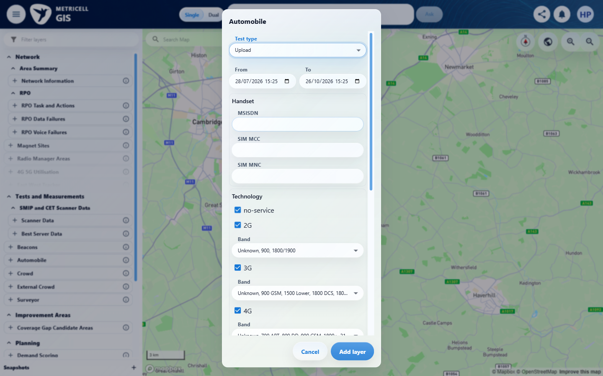 | E05 - Repaired before select (criterion-2-repaired-before-select.png)  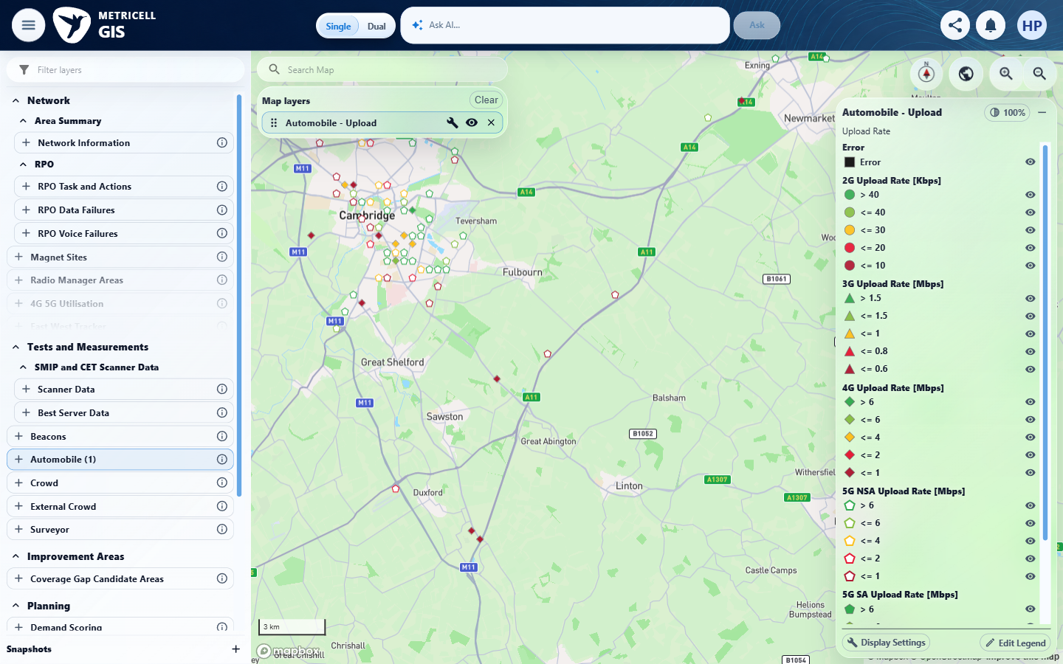

Criterion 2 continued: Given Upload samples are available, a time-series chart shows Signal Strength in dBm and Upload Rate in Mbps across the test duration.
Browser URL recorded after criterion: https://o2intelligence-v4-dev.metricell.com/gis
E06 - Final (criterion-2-final.png)
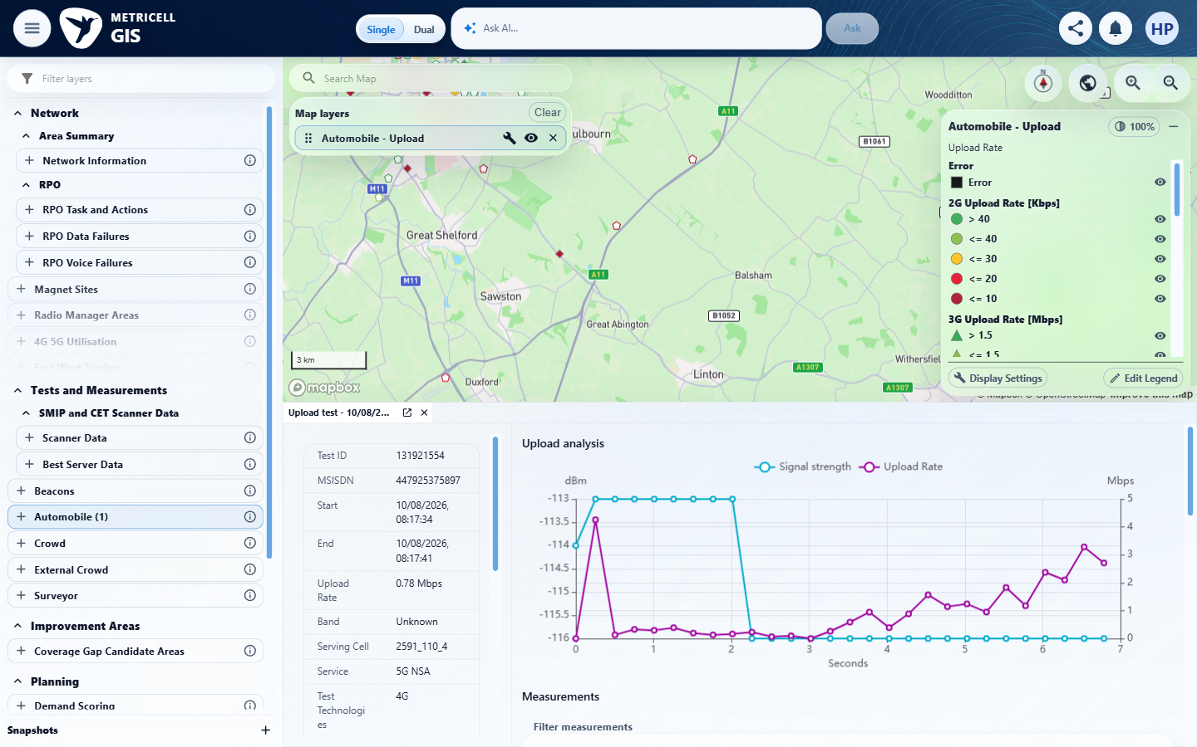

3.0.0 | Given per-sample Upload data is available, each returned sample is shown in a table with its relevant units. | Given per-sample Upload data is available, each returned sample is shown in a table with its relevant units. | criterion-3-final.png readably shows all 28 rows and seven columns for the bounded test 131921554 dataset, including two 08:17:34 rows, four 08:17:35, three 08:17:36, four 08:17:37, four 08:17:38, four 08:17:39, four 08:17:40 and three 08:17:41. This reconciles the complete returned-sample scope recorded in the result. Signal strength dBm, Upload Rate Mbps and Size MB are readable; no aggregate or sampled subset substitutes for these rows.  Evidence: E07, E08, E05, E06, E09 | Passed
Criterion 3 evidence: Given per-sample Upload data is available, each returned sample is shown in a table with its relevant units.
Browser URL recorded after criterion: https://o2intelligence-v4-dev.metricell.com/gis
E07 - Test type choices (criterion-3-test-type-choices.png)  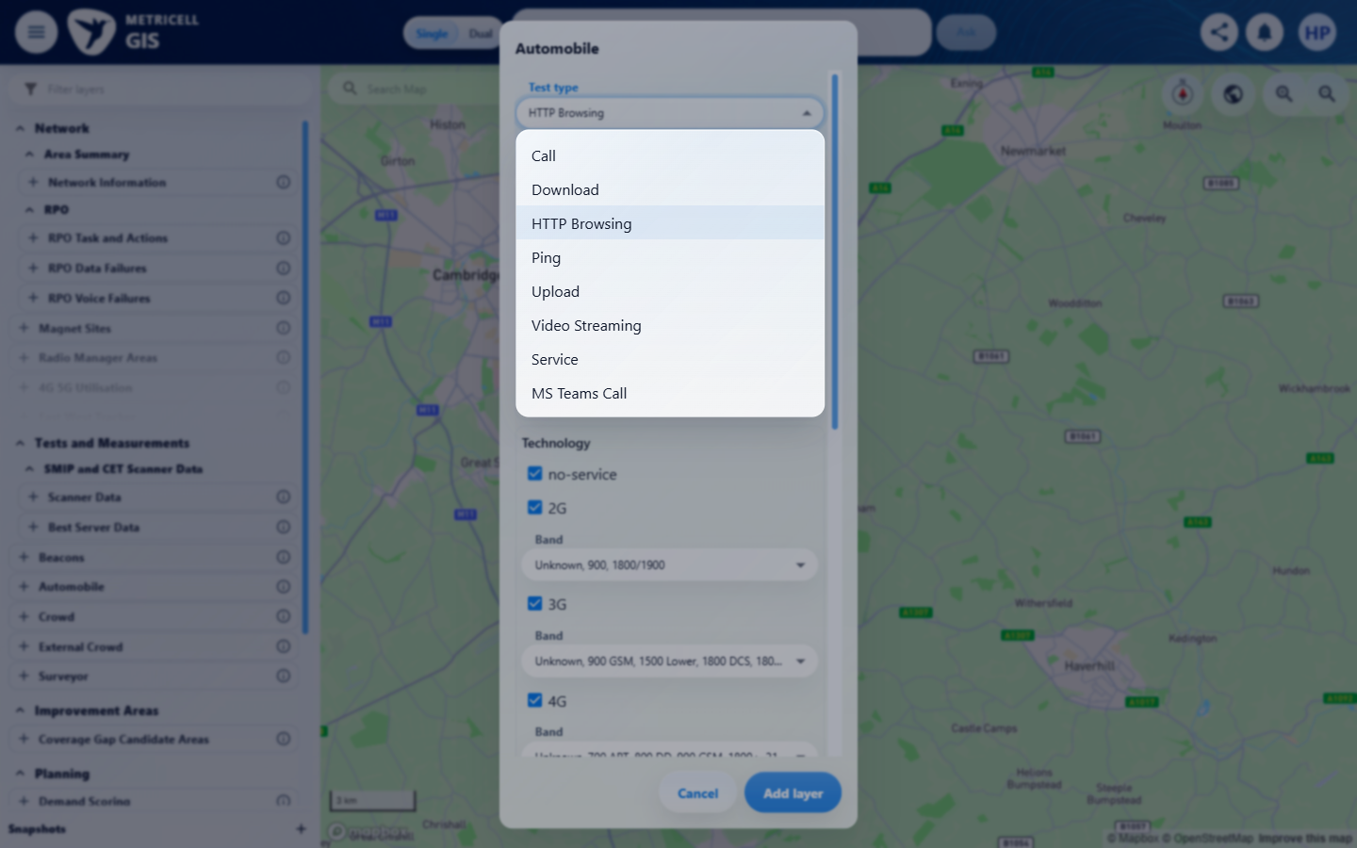 | E08 - Upload config (criterion-3-upload-config.png)  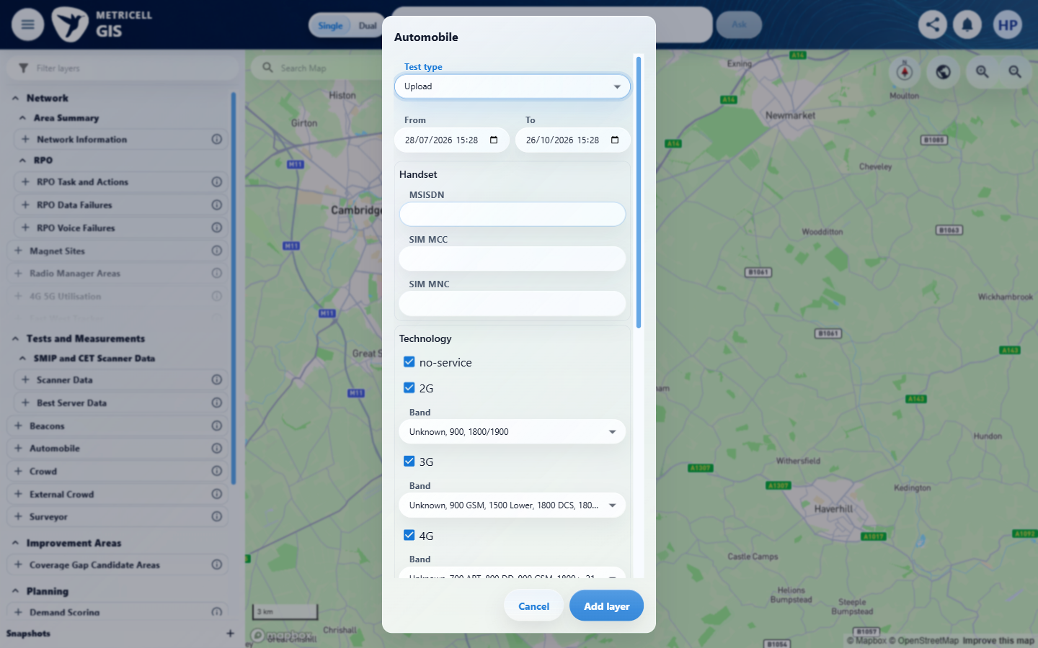

Criterion 3 continued: Given per-sample Upload data is available, each returned sample is shown in a table with its relevant units.
Browser URL recorded after criterion: https://o2intelligence-v4-dev.metricell.com/gis
E05 - Before select (criterion-3-before-select.png) | E06 - Loaded (criterion-3-loaded.png)

Criterion 3 continued: Given per-sample Upload data is available, each returned sample is shown in a table with its relevant units.
Browser URL recorded after criterion: https://o2intelligence-v4-dev.metricell.com/gis
E09 - Final (criterion-3-final.png)
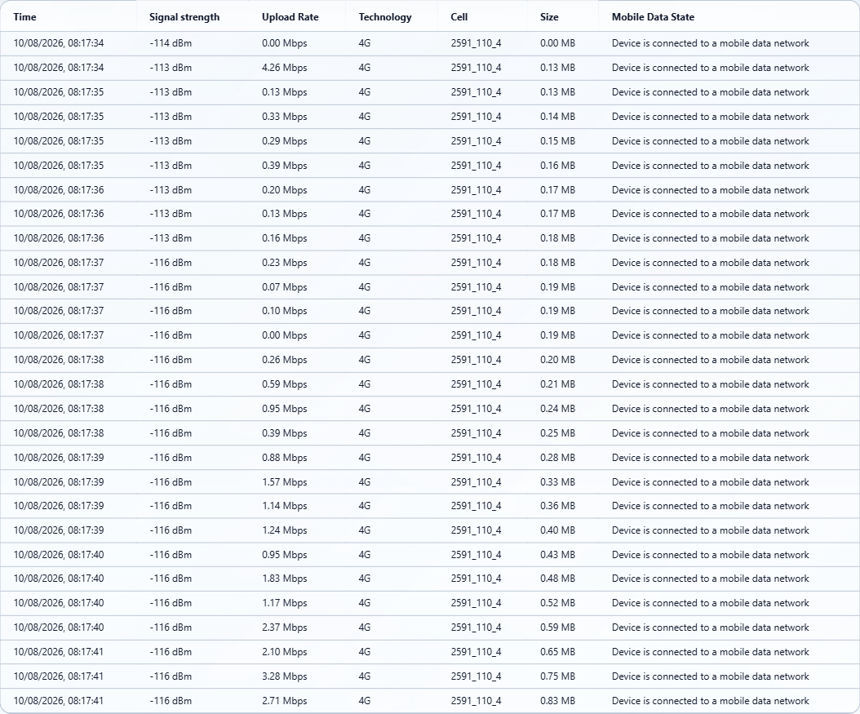

4.0.0 | Given the per-sample table contains multiple rows, sorting by a displayed column changes their visible order according to that column. | Given the per-sample table contains multiple rows, sorting by a displayed column changes their visible order according to that column. | criterion-4-before-sort.png shows 28 rows beginning with Upload Rates 0.00, 4.26, 0.13 and 0.33 Mbps. criterion-4-final.png shows the Upload Rate ascending indicator and all 28 rates in nondecreasing numeric order from two 0.00 values through 3.28 to 4.26 Mbps. The settled order changes according to the displayed target column.  Evidence: E10, E11, E12, E06, E13, E14 | Passed
Criterion 4 evidence: Given the per-sample table contains multiple rows, sorting by a displayed column changes their visible order according to that column.
Browser URL recorded after criterion: https://o2intelligence-v4-dev.metricell.com/gis
E10 - Test type choices (criterion-4-test-type-choices.png)  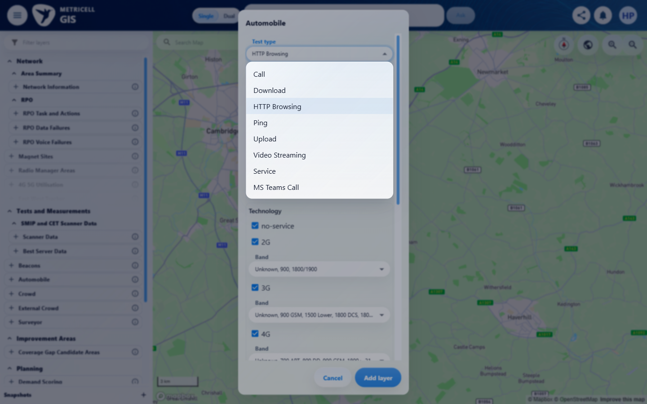 | E11 - Upload config (criterion-4-upload-config.png)  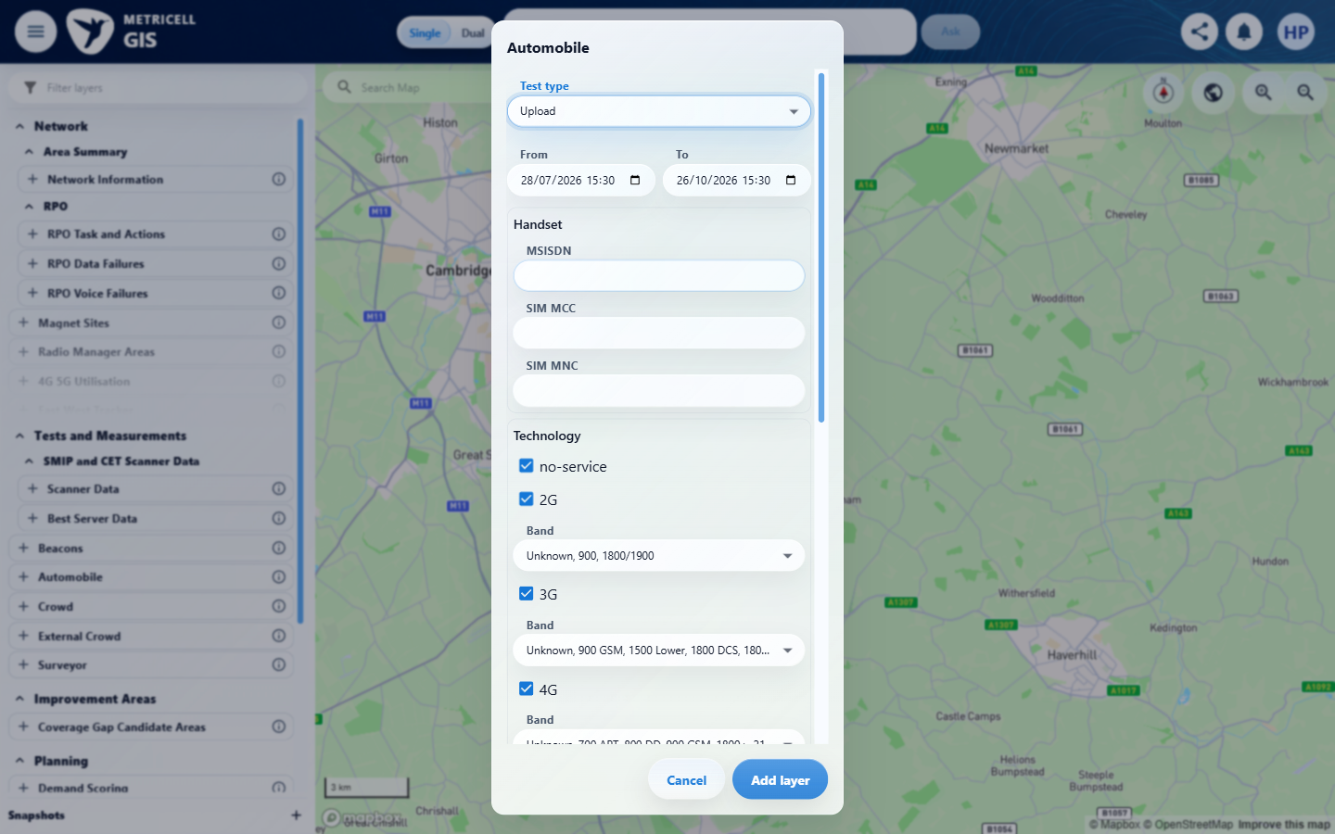

Criterion 4 continued: Given the per-sample table contains multiple rows, sorting by a displayed column changes their visible order according to that column.
Browser URL recorded after criterion: https://o2intelligence-v4-dev.metricell.com/gis
E12 - Before select (criterion-4-before-select.png)  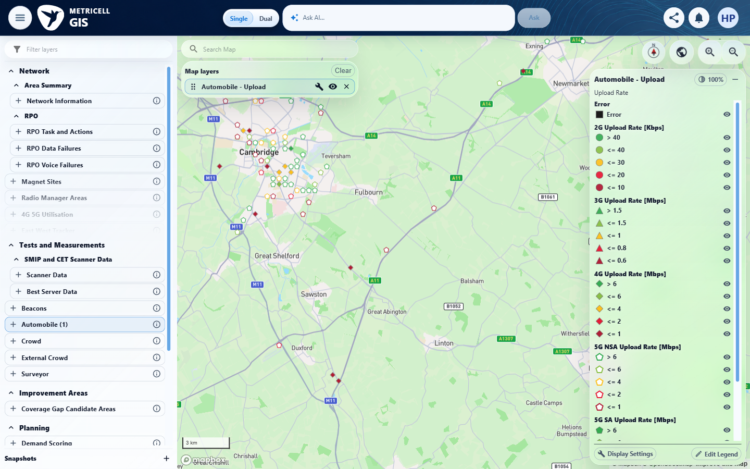 | E06 - Loaded (criterion-4-loaded.png)

Criterion 4 continued: Given the per-sample table contains multiple rows, sorting by a displayed column changes their visible order according to that column.
Browser URL recorded after criterion: https://o2intelligence-v4-dev.metricell.com/gis
E13 - Before sort (criterion-4-before-sort.png)  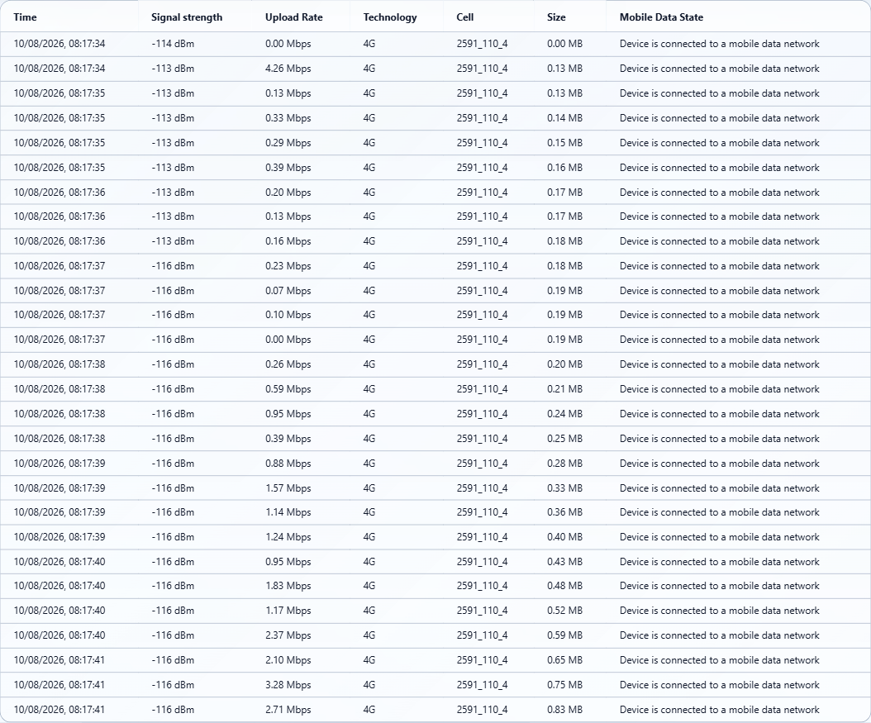 | E14 - Final (criterion-4-final.png)  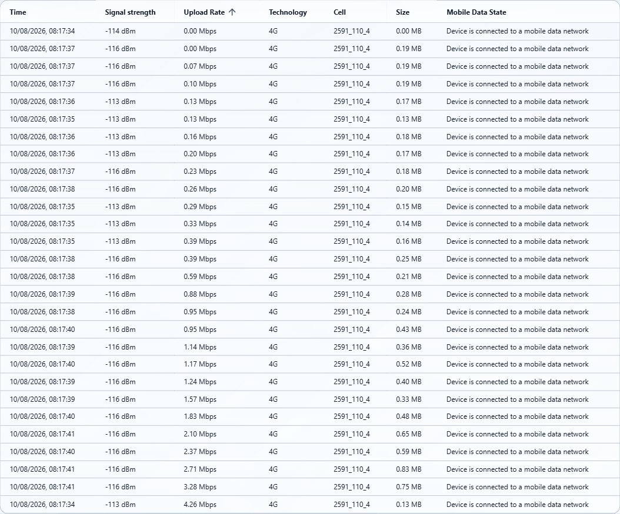

5.0.0 | Given per-sample data is available, filtering the table shows only rows matching the selected filter. | Given per-sample data is available, filtering the table shows only rows matching the selected filter. | criterion-5-before-filter.png shows all 28 rows with an empty filter. criterion-5-final.png shows filter 08:17:41 and exactly its three matching rows, with rates 2.10, 3.28 and 2.71 Mbps; every other baseline row is excluded. criterion-5-filter-restored.png shows the empty filter and restored 28-row table.  Evidence: E15, E16, E05, E06, E17, E18, E19 | Passed
Criterion 5 evidence: Given per-sample data is available, filtering the table shows only rows matching the selected filter.
Browser URL recorded after criterion: https://o2intelligence-v4-dev.metricell.com/gis
E15 - Test type choices (criterion-5-test-type-choices.png)  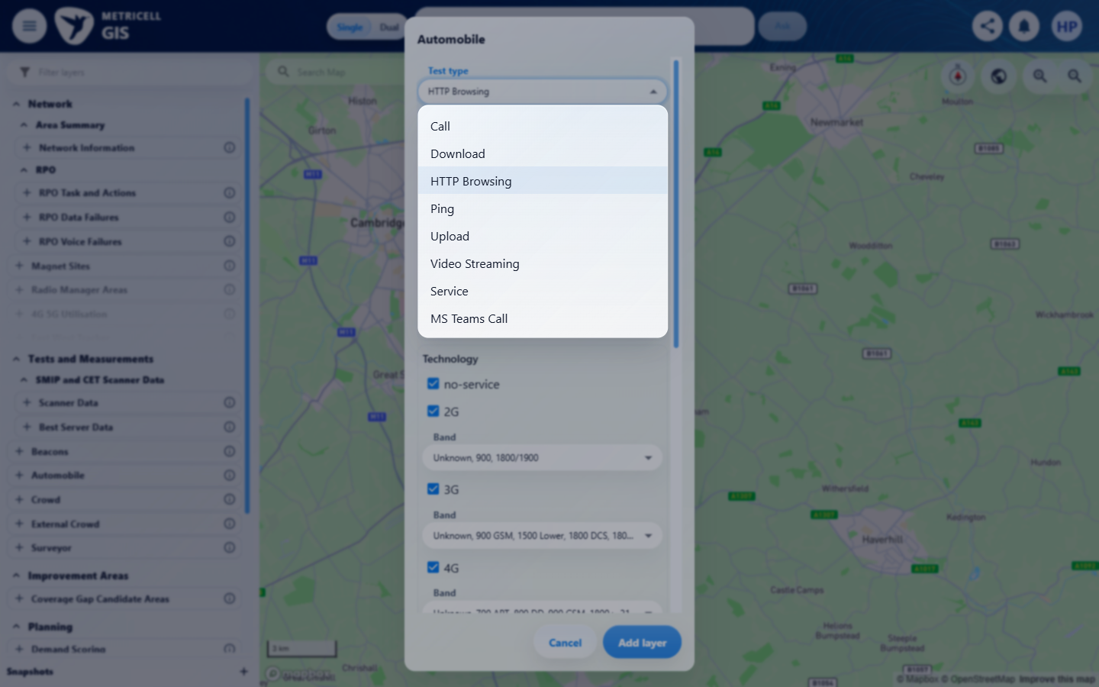 | E16 - Upload config (criterion-5-upload-config.png)  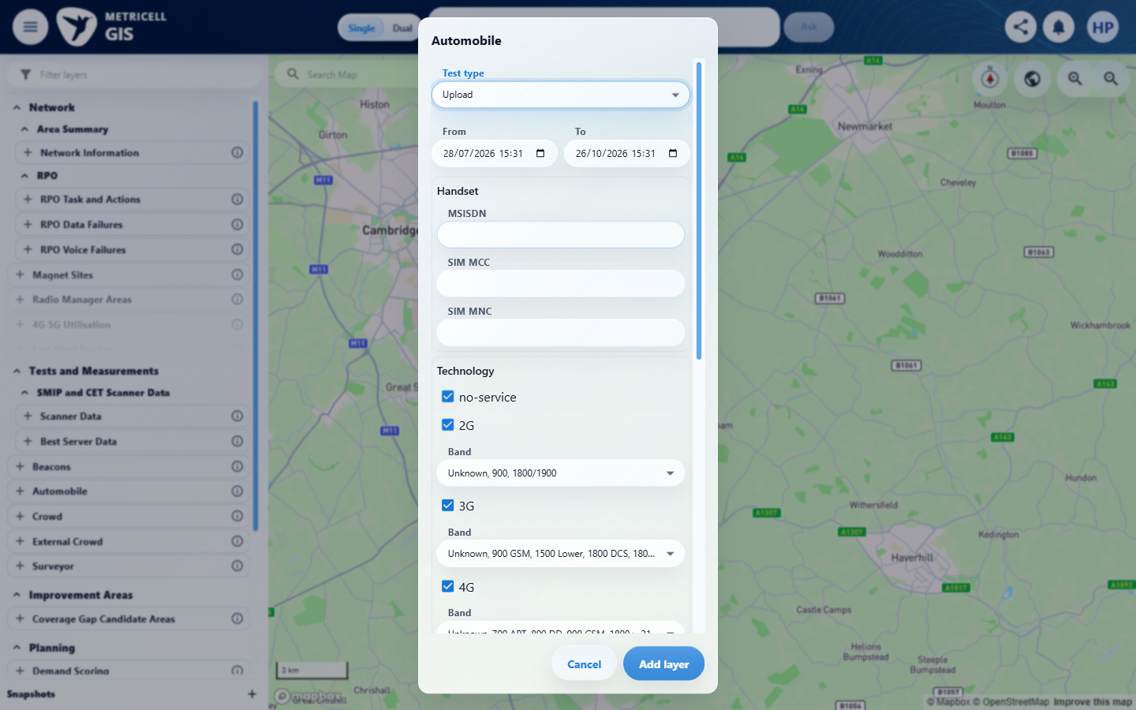

Criterion 5 continued: Given per-sample data is available, filtering the table shows only rows matching the selected filter.
Browser URL recorded after criterion: https://o2intelligence-v4-dev.metricell.com/gis
E05 - Before select (criterion-5-before-select.png) | E06 - Loaded (criterion-5-loaded.png)

Criterion 5 continued: Given per-sample data is available, filtering the table shows only rows matching the selected filter.
Browser URL recorded after criterion: https://o2intelligence-v4-dev.metricell.com/gis
E17 - Before filter (criterion-5-before-filter.png)  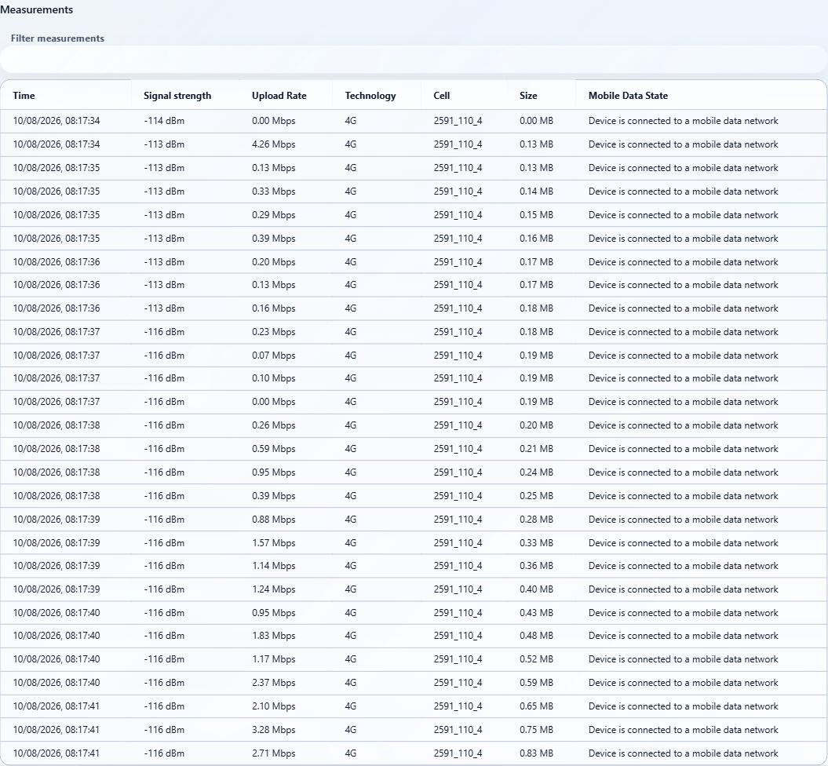 | E18 - Final (criterion-5-final.png)  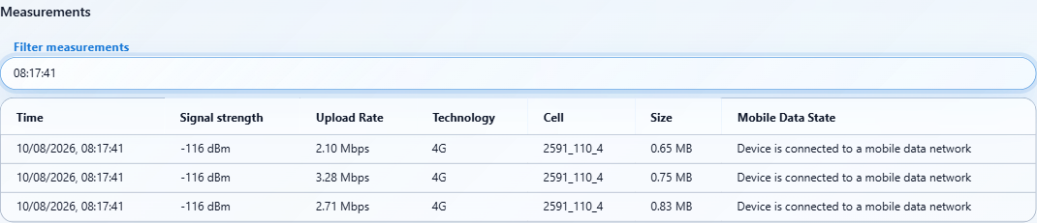

Criterion 5 continued: Given per-sample data is available, filtering the table shows only rows matching the selected filter.
Browser URL recorded after criterion: https://o2intelligence-v4-dev.metricell.com/gis
E19 - Filter restored (criterion-5-filter-restored.png)
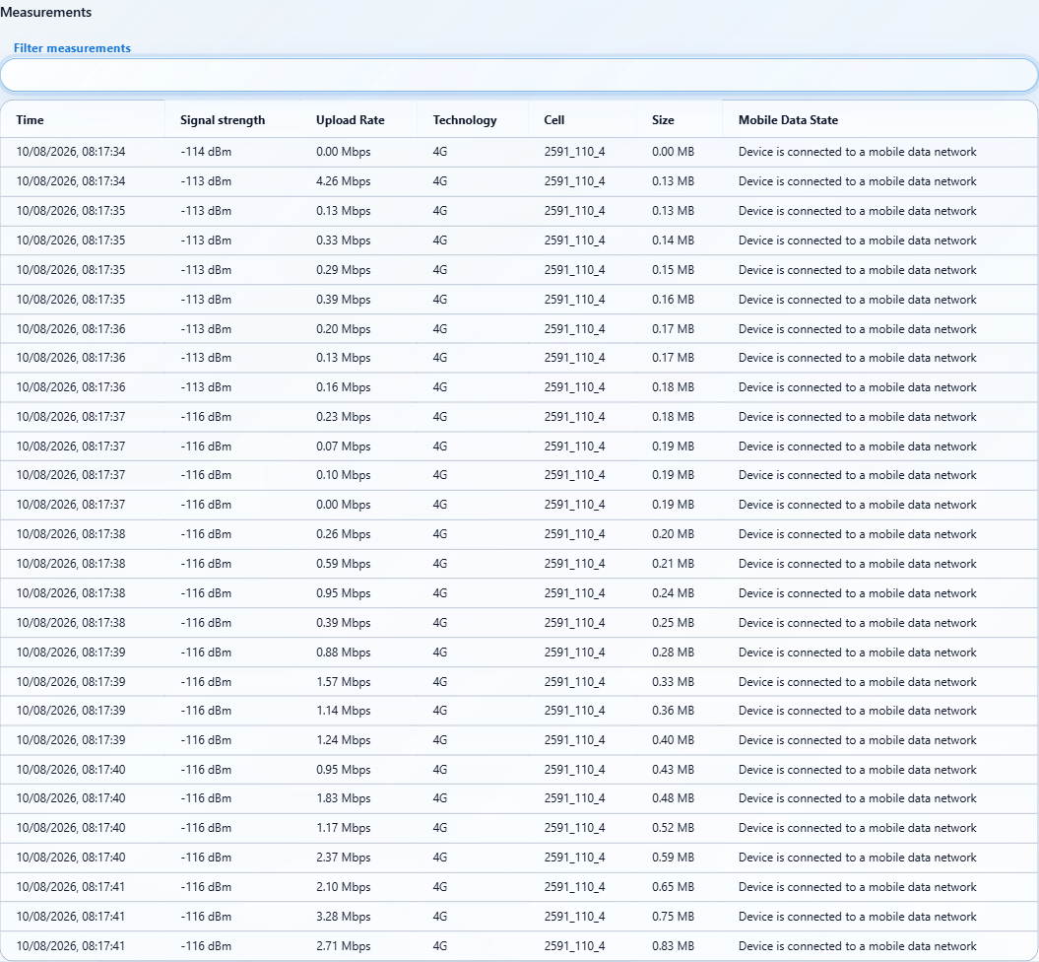

6.0.0 | Given average signal metrics are returned, Average Signal Strength, Average Signal Quality, and Average SNR appear in the summary immediately after Upload Rate. | Given average signal metrics are returned, Average Signal Strength, Average Signal Quality, and Average SNR appear in the summary immediately after Upload Rate. | criterion-6-after-upload-rate.png shows Band immediately after Upload Rate; criterion-6-final.png shows the lower summary. The recorded genuine analysis for test 131921554 returns none of the three average signal metrics, so the required returned-metric fixture is unavailable. Their display and immediate ordering remain Blocked; this is not proof that supplied averages render incorrectly.  Evidence: E20, E21, E12, E06, E22 | Blocked
Criterion 6 evidence: Given average signal metrics are returned, Average Signal Strength, Average Signal Quality, and Average SNR appear in the summary immediately after Upload Rate.
Browser URL recorded after criterion: https://o2intelligence-v4-dev.metricell.com/gis
E20 - Test type choices (criterion-6-test-type-choices.png)  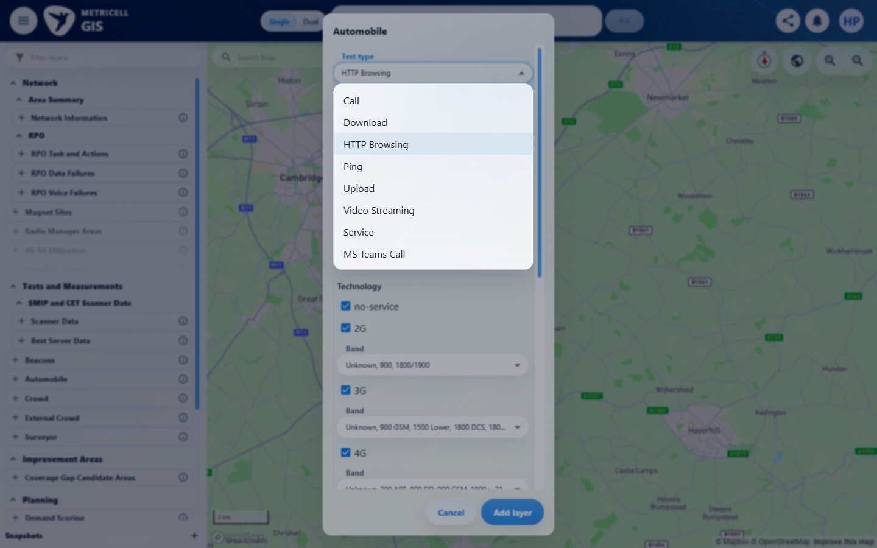 | E21 - Upload config (criterion-6-upload-config.png)  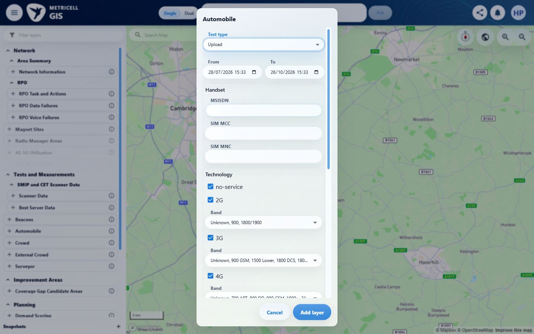

Criterion 6 continued: Given average signal metrics are returned, Average Signal Strength, Average Signal Quality, and Average SNR appear in the summary immediately after Upload Rate.
Browser URL recorded after criterion: https://o2intelligence-v4-dev.metricell.com/gis
E12 - Before select (criterion-6-before-select.png) | E06 - After upload rate (criterion-6-after-upload-rate.png)

Criterion 6 continued: Given average signal metrics are returned, Average Signal Strength, Average Signal Quality, and Average SNR appear in the summary immediately after Upload Rate.
Browser URL recorded after criterion: https://o2intelligence-v4-dev.metricell.com/gis
E22 - Final (criterion-6-final.png)
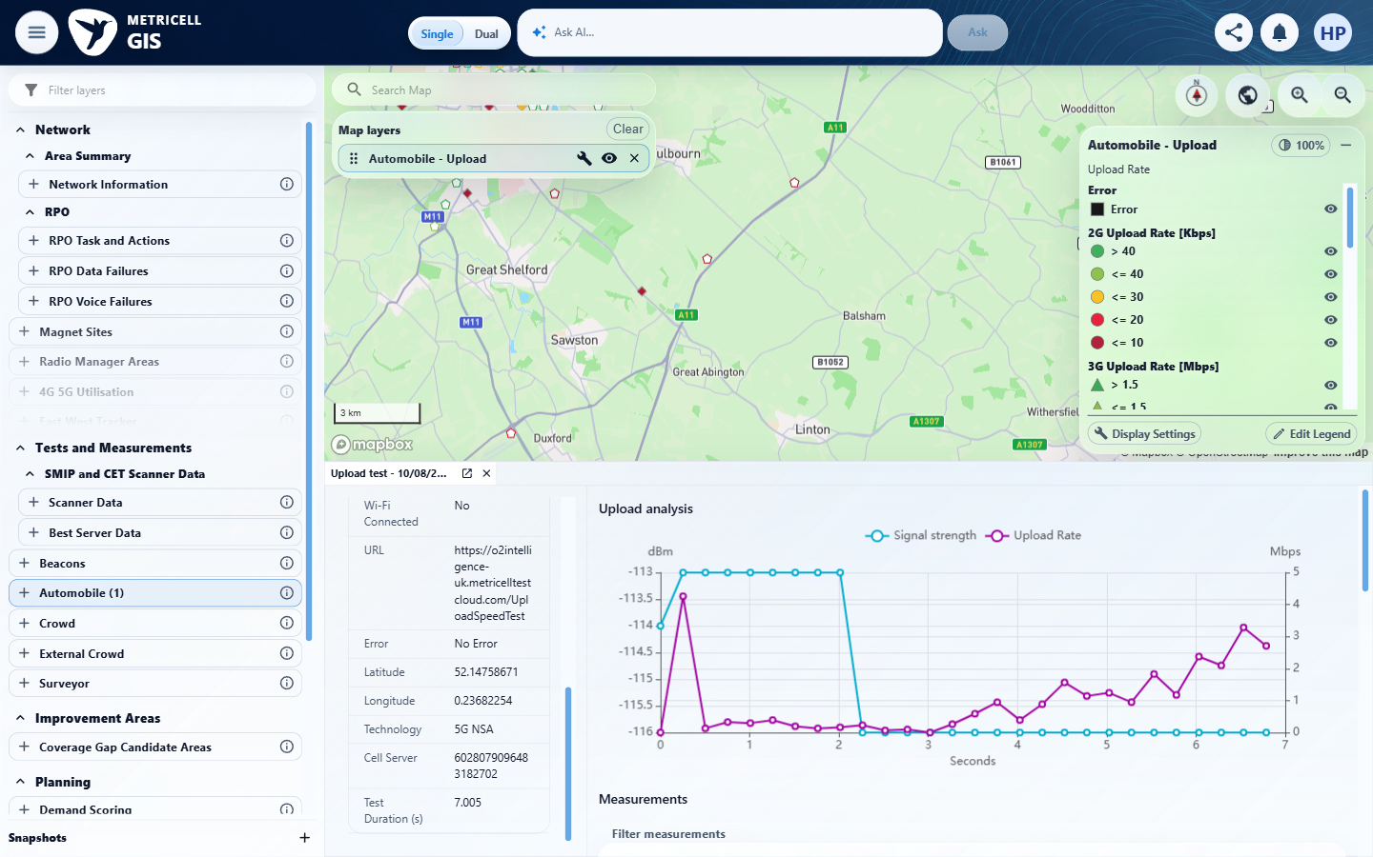

7.0.0 | Given an Upload point has no measurable duration, its row is disabled as the no-data state and selecting it does not open an empty details view. | Given an Upload point has no measurable duration, its row is disabled as the no-data state and selecting it does not open an empty details view. | Existing-evidence reassessment of the original genuine Upload record 131921687. The recorded cluster-details response returned testDurationMs=0 and equal start/end timestamps. Its row was aria-disabled with the title "Test details require a positive test duration." The screenshots show the disabled record with N/A rate and no empty details view; the PNG alone does not establish millisecond duration. The user confirmed on 27 October that this disabled row is the accepted no-data state. No analysis request or response was manufactured.  Evidence: E23, E24 | Passed
Criterion 7 evidence: Given an Upload point has no measurable duration, its row is disabled as the no-data state and selecting it does not open an empty details view.
Browser URL recorded after criterion: https://o2intelligence-v4-dev.metricell.com/gis
E23 - Failed point details (criterion-7-failed-point-details.png)  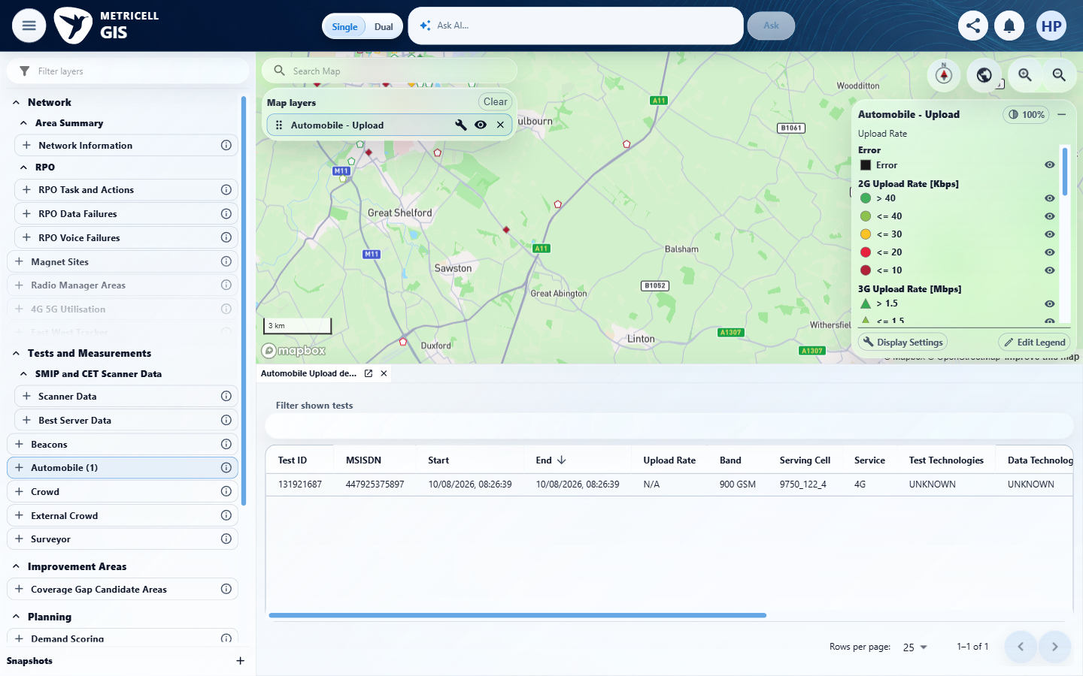 | E24 - Final (criterion-7-final.png)  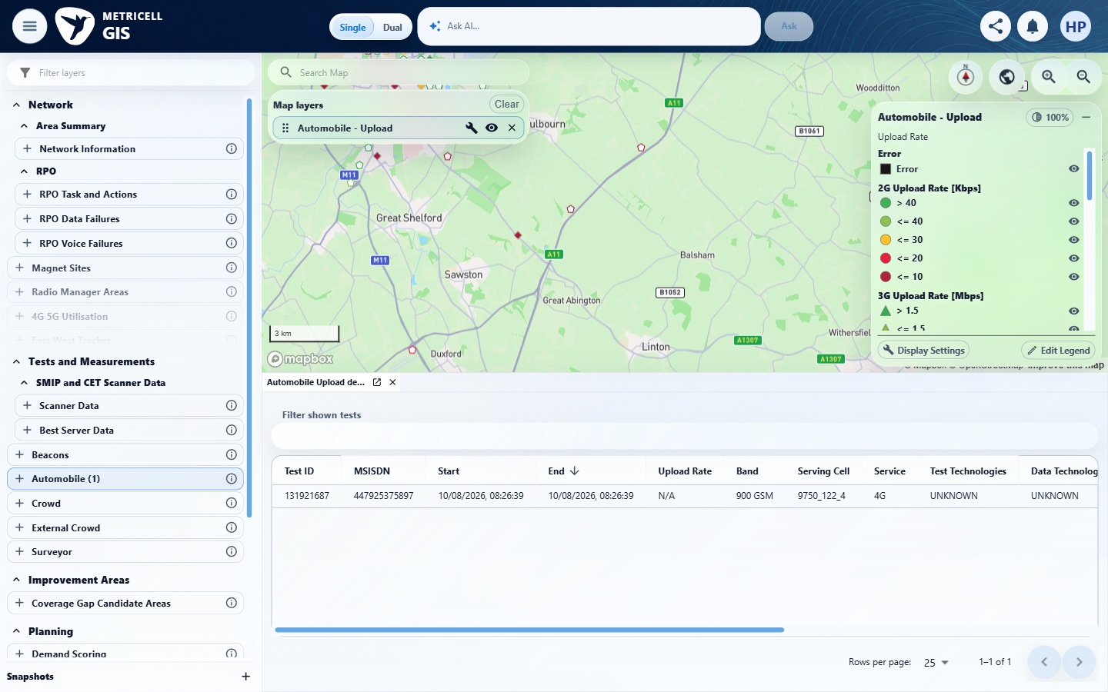

8.0.0 | While Upload details are loading, the detail presentation shows the standard loading state. | While Upload details are loading, the detail presentation shows the standard loading state. | The recorded check satisfied the criterion; see the assessment below.  Evidence: E25, E26, E27, E28, E29, E30, E31 | Passed
Criterion 8 assessment: SIMULATED UI STATE: Delayed the selected detail request to check loading. SIMULATED UI STATE: On 27 October, held the original analysis read for Upload point 131921554 to check loading, then released that same genuine request. loading-held-final.png shows the loading message/progress indicator. This checks controlled analysis-panel loading and recovery, not natural backend latency or whole-dialog loading.
Criterion 8 evidence: While Upload details are loading, the detail presentation shows the standard loading state.
Browser URL recorded after criterion: https://o2intelligence-v4-dev.metricell.com/gis
E25 - Loading before held request (loading-before-held-request.png)  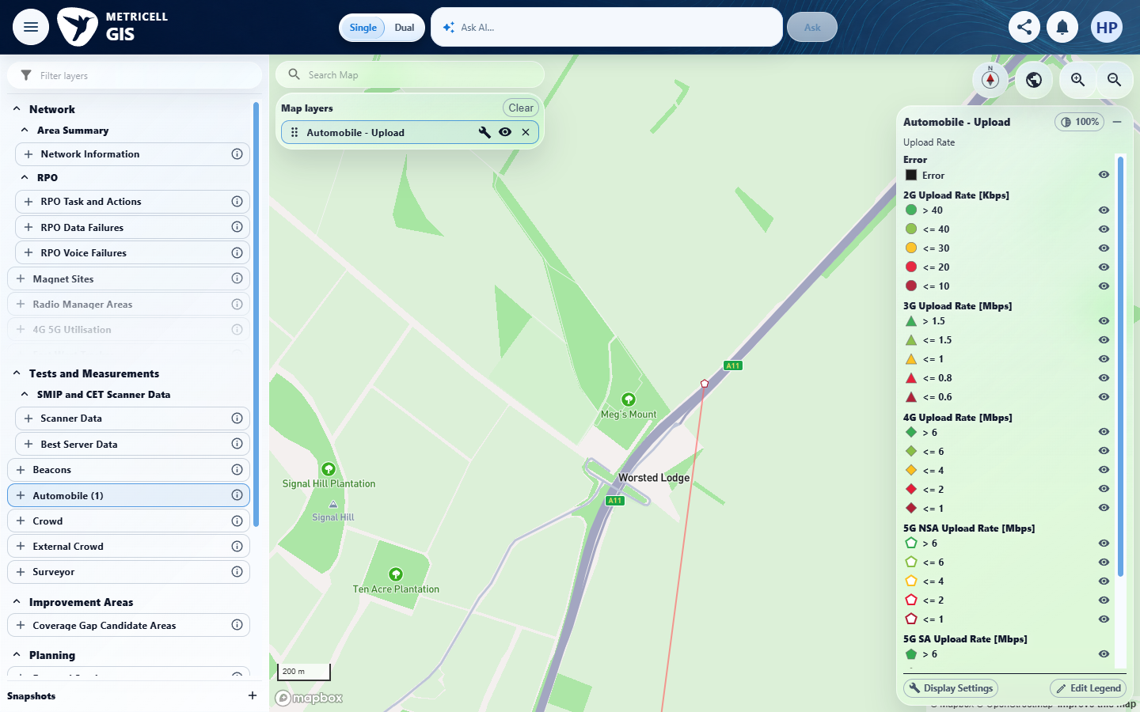 | E26 - Loading before selection (loading-before-selection.png)  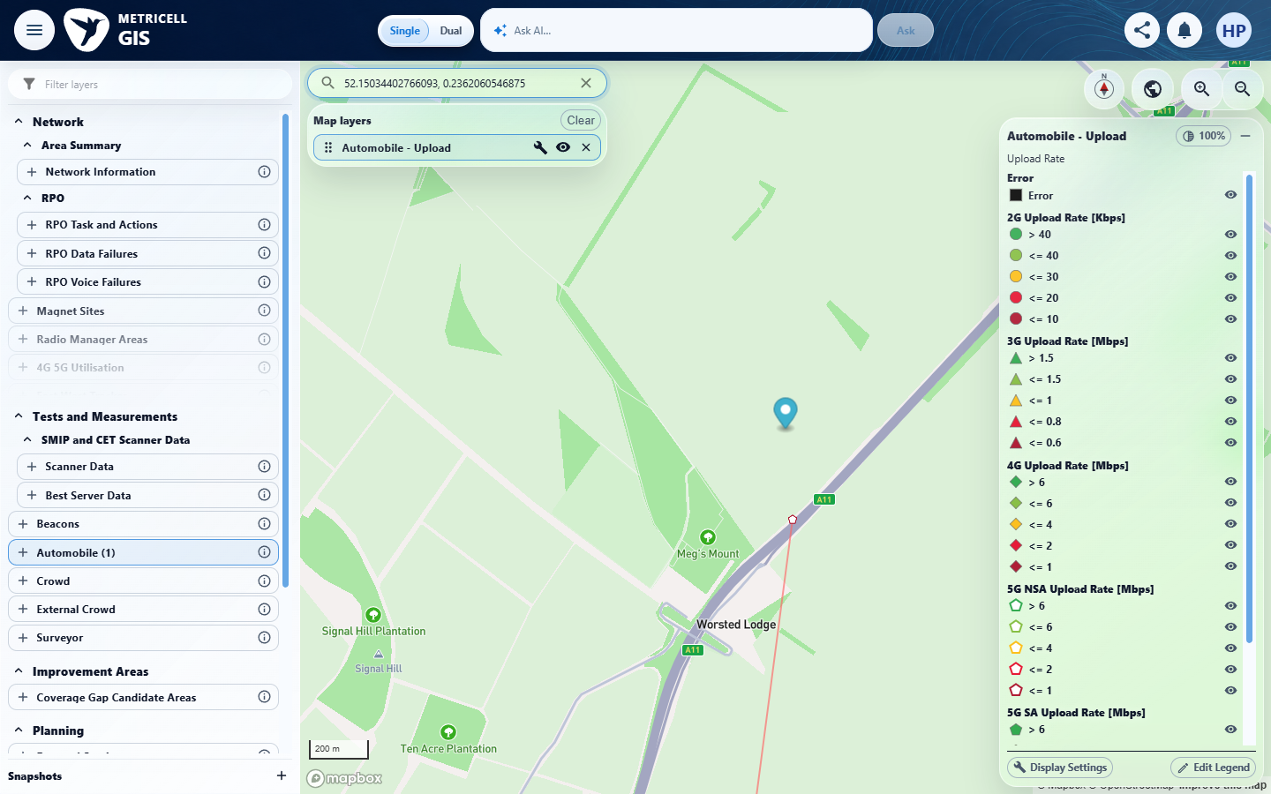

Criterion 8 continued: While Upload details are loading, the detail presentation shows the standard loading state.
Browser URL recorded after criterion: https://o2intelligence-v4-dev.metricell.com/gis
E27 - Loading genuine chart baseline (loading-genuine-chart-baseline.png)  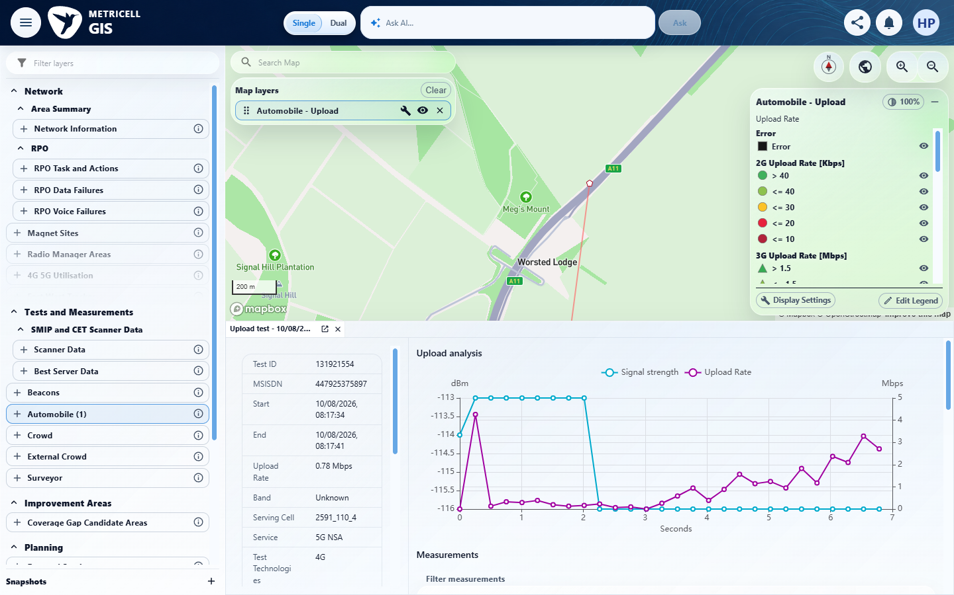 | E28 - Loading genuine table baseline (loading-genuine-table-baseline.png)  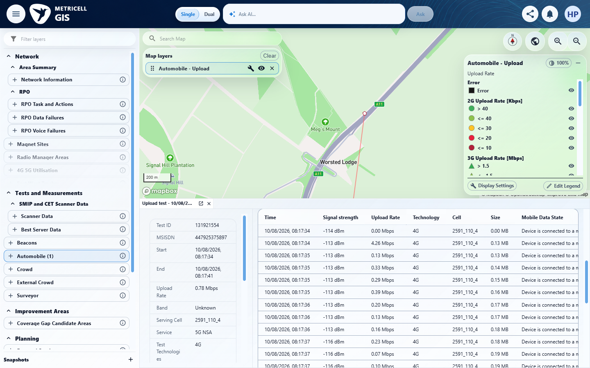

Criterion 8 continued: While Upload details are loading, the detail presentation shows the standard loading state.
Browser URL recorded after criterion: https://o2intelligence-v4-dev.metricell.com/gis
E29 - Loading held final (loading-held-final.png)  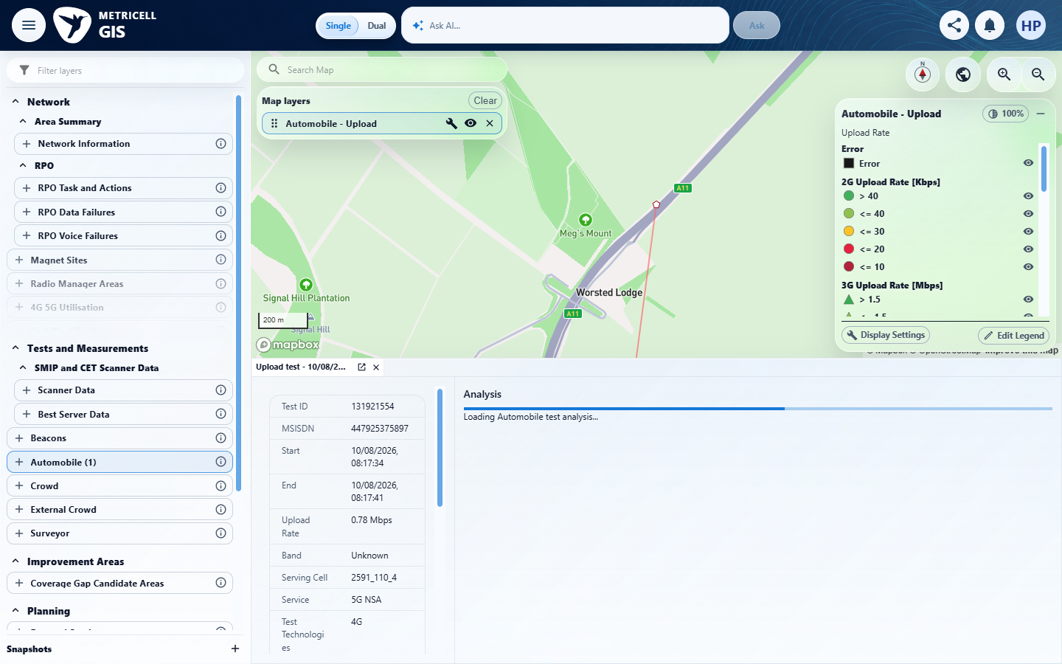 | E27 - Loading recovery chart (loading-recovery-chart.png)

Criterion 8 continued: While Upload details are loading, the detail presentation shows the standard loading state.
Browser URL recorded after criterion: https://o2intelligence-v4-dev.metricell.com/gis
E28 - Loading recovery table first (loading-recovery-table-first.png) | E30 - Loading recovery table last (loading-recovery-table-last.png)  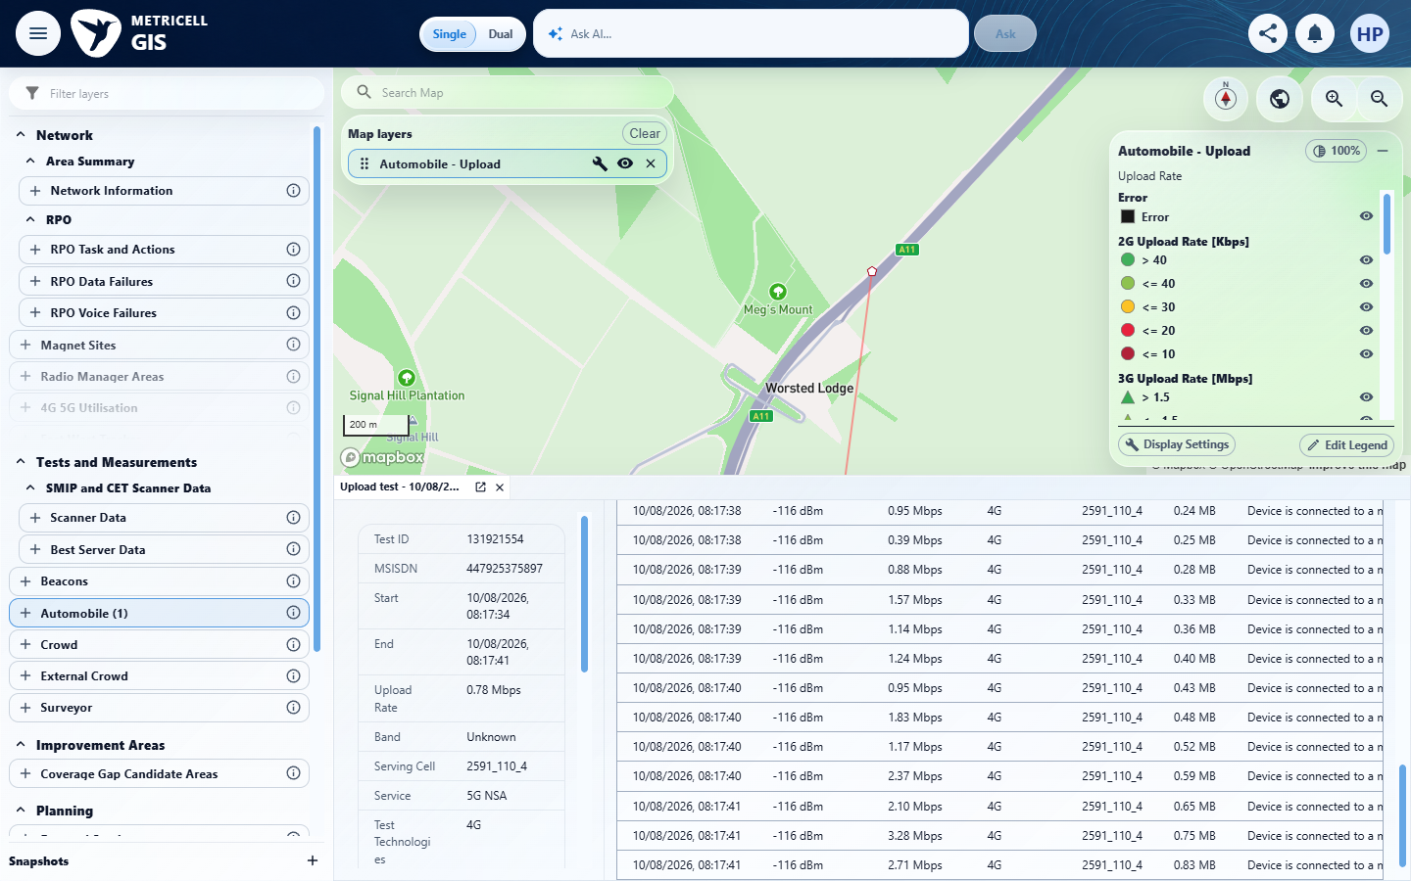

Criterion 8 continued: While Upload details are loading, the detail presentation shows the standard loading state.
Browser URL recorded after criterion: https://o2intelligence-v4-dev.metricell.com/gis
E31 - Loading recovery table middle (loading-recovery-table-middle.png)
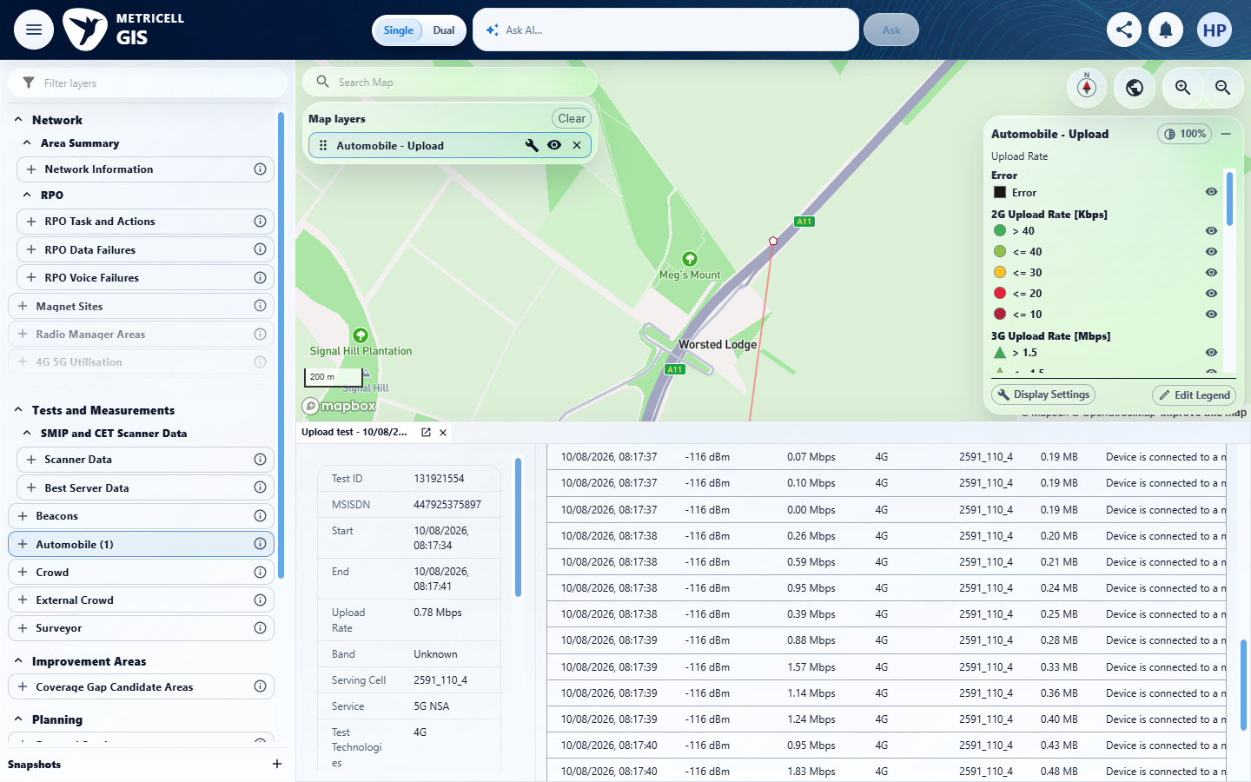

9.0.0 | When Upload details are unavailable, the detail presentation shows the standard no-data state. | When Upload details are unavailable, the detail presentation shows the standard no-data state. | criterion-9-final.png shows populated Automobile Upload analysis for test 131921554, not a no-data state. The recorded genuine HTTP200 supplied 28 samples; no actual unavailable-details fixture or authoritative empty-response schema was established. Required no-data coverage is Blocked by the missing fixture/contract. A fabricated empty array would not resolve that contract gap.  Evidence: E32, E33, E34, E01, E35 | Blocked
Criterion 9 assessment: Testing notes: Unavailable Upload details could not be reproduced with the supplied fixture: genuine Automobile Upload test 131921554 returns populated summary and 28 samples (HTTP200). No actual empty analysis response or project empty-response schema is supplied/established. The authoritative no-data response contract is missing, so no synthetic arrays/null response was invented. Inspected actual populated detail presentation; this does not prove unavailable-details handling. No safe unavailable-data fixture or authoritative empty-response contract was established in complete supplied inputs or observed response.
Criterion 9 evidence: When Upload details are unavailable, the detail presentation shows the standard no-data state.
Browser URL recorded after criterion: https://o2intelligence-v4-dev.metricell.com/gis
E32 - Test type choices (criterion-9-test-type-choices.png)  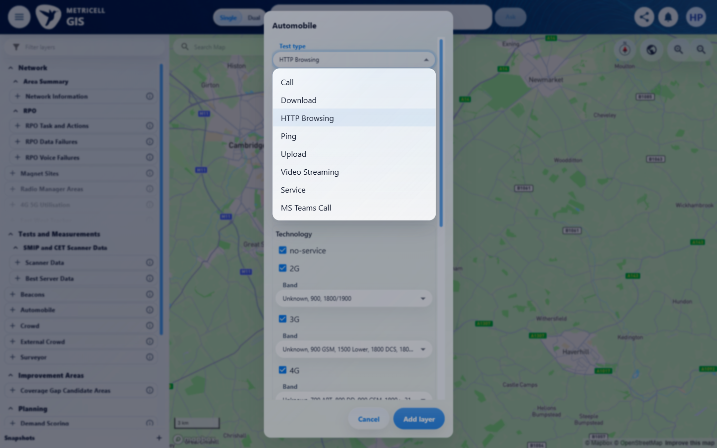 | E33 - Upload config (criterion-9-upload-config.png)  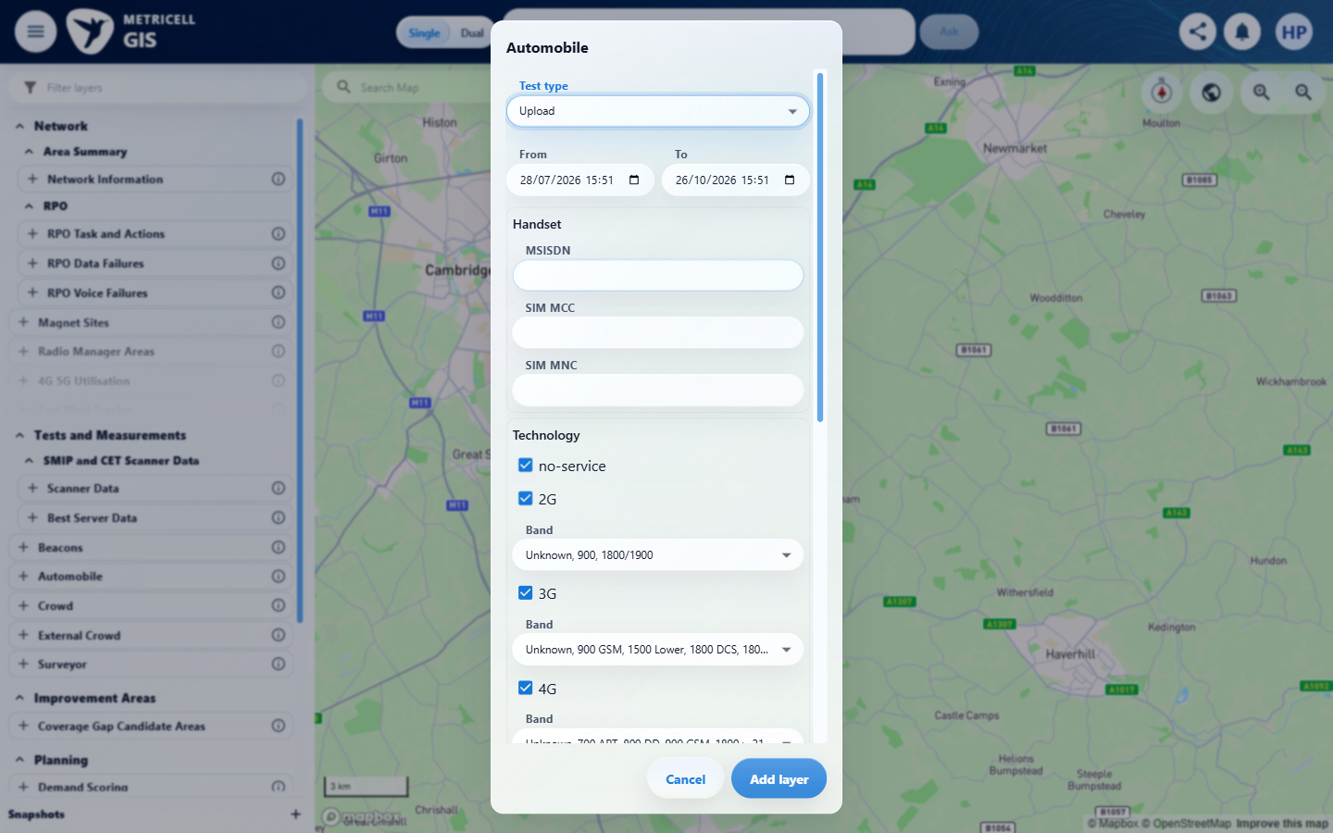

Criterion 9 continued: When Upload details are unavailable, the detail presentation shows the standard no-data state.
Browser URL recorded after criterion: https://o2intelligence-v4-dev.metricell.com/gis
E34 - Before select (criterion-9-before-select.png)  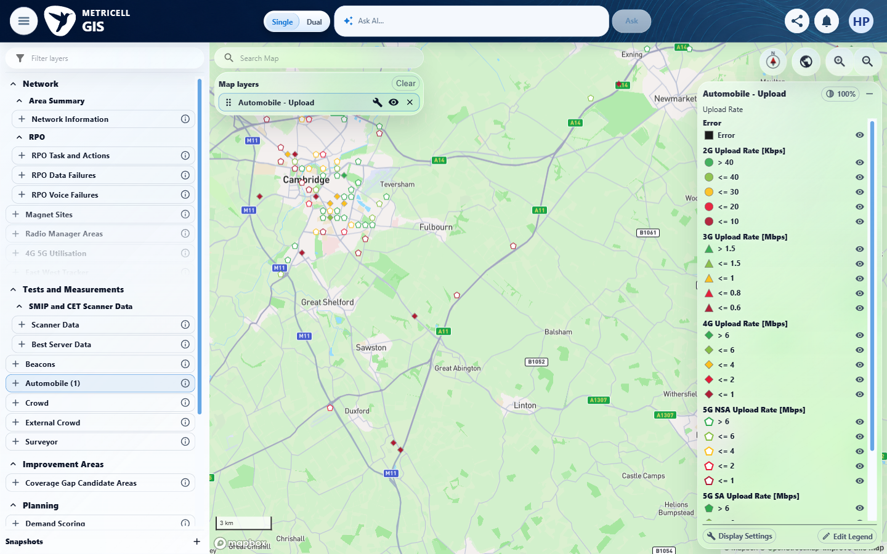 | E01 - Loaded (criterion-9-loaded.png)

Criterion 9 continued: When Upload details are unavailable, the detail presentation shows the standard no-data state.
Browser URL recorded after criterion: https://o2intelligence-v4-dev.metricell.com/gis
E35 - Final (criterion-9-final.png)
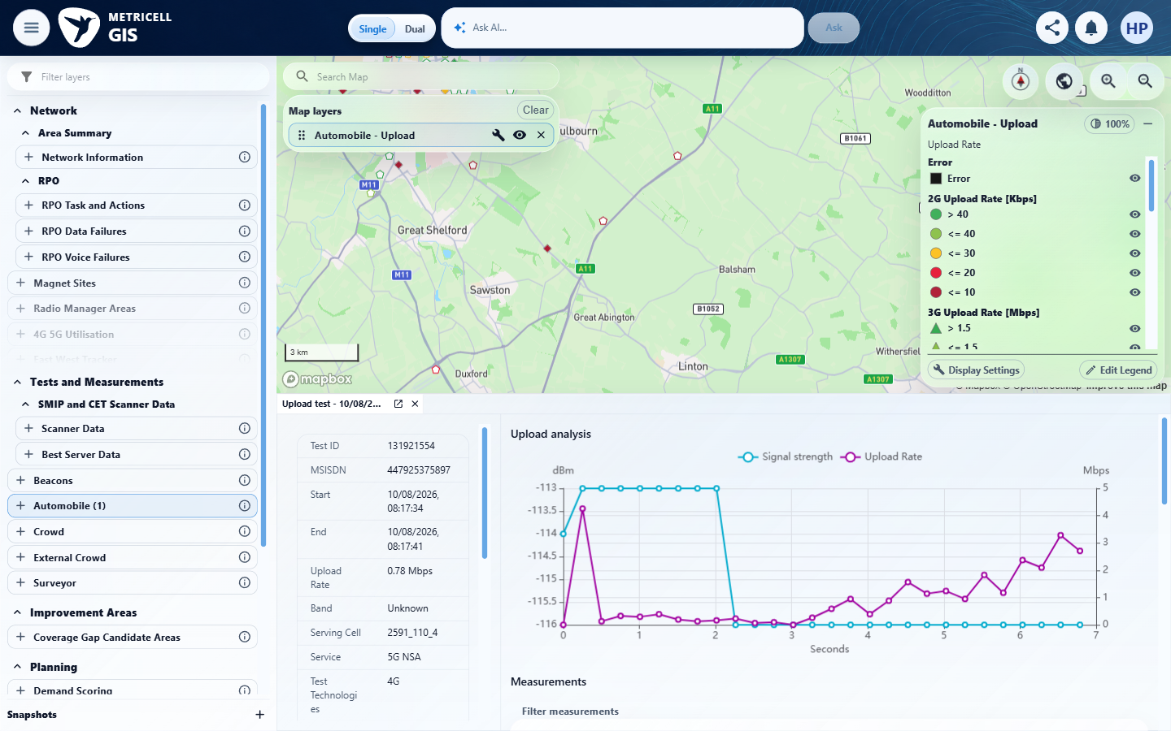

10.0.0 | When loading Upload details fails, the detail presentation shows the standard error state and does not display incorrect data. | When loading Upload details fails, the detail presentation shows the standard error state and does not display incorrect data. | The recorded check satisfied the criterion; see the assessment below.  Evidence: E36, E37, E38, E39 | Passed
Criterion 10 assessment: SIMULATED UI STATE: On https://o2intelligence-v4-dev.metricell.com, the tester locally fulfilled only POST /api/platform/automobile/upload/test-analysis for pointId 131921554 with one HTTP503 application/json response {message:'QA simulated analysis failure'}; unmatched requests fell through. Scope and successful-contract provenance came from the genuine observed Automobile Upload read; this synthetic error asserts no empty-response contract and no naturally occurring backend failure. criterion-10-distinct-record-baseline.png and criterion-10-before-simulated-error.png show distinct previously loaded test 132301449, cell 70478_110_4 and rate 0.43 Mbps. criterion-10-final.png shows active target 131921554, cell 2591_110_4 and rate 0.78 Mbps, with 'Unable to load Automobile test analysis.' and Retry; the prior chart/table is absent from the active panel. The prior record's inactive tab remains intentionally visible and is not stale active content. The result records exact owned handler removal in finally, Retry and genuine HTTP200 with 28 samples. criterion-10-recovery.png directly shows the target chart recovering; criterion-10-cleanup.png shows both test tabs and layer cleared, and the result records verified absence of owned simulation state. This passes the scoped analysis-error UI and incorrect-data comparison; it does not prove a failure of every point-detail component or an actual backend error.
Criterion 10 evidence: When loading Upload details fails, the detail presentation shows the standard error state and does not display incorrect data.
Browser URL recorded after criterion: https://o2intelligence-v4-dev.metricell.com/gis
E36 - Final (criterion-10-final.png)  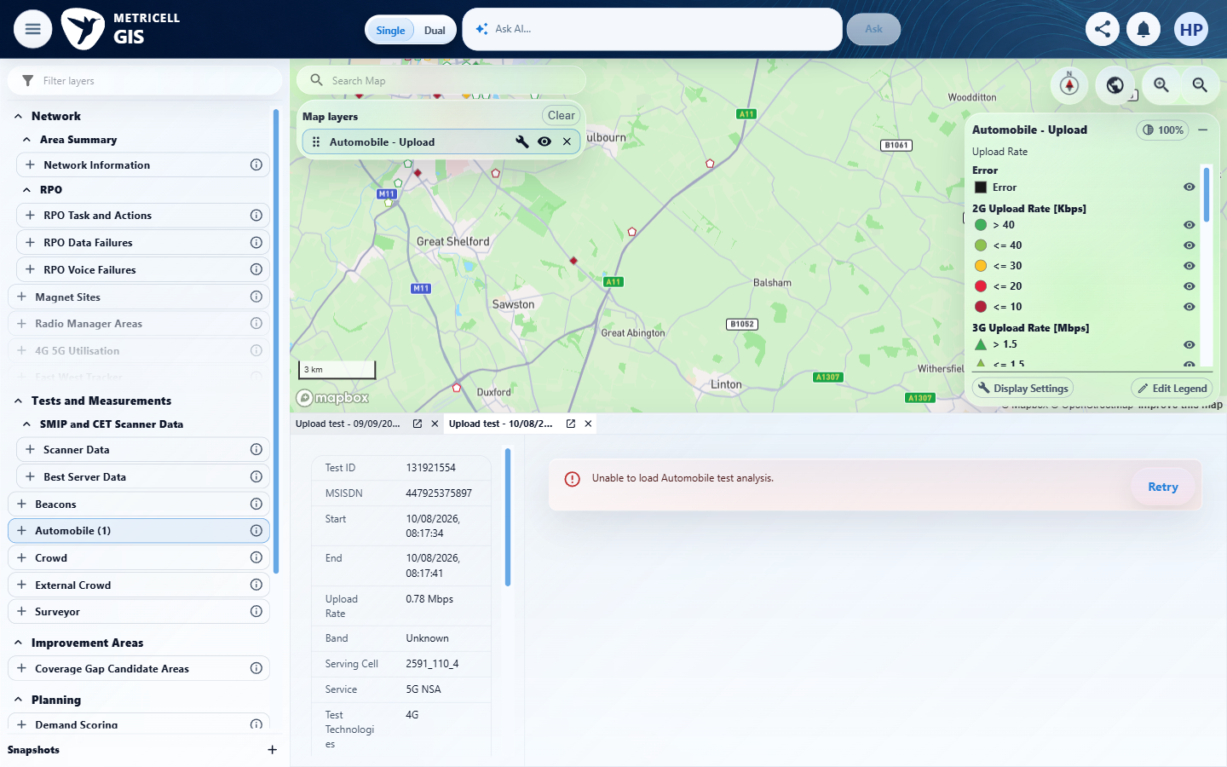 | E37 - Recovery (criterion-10-recovery.png)  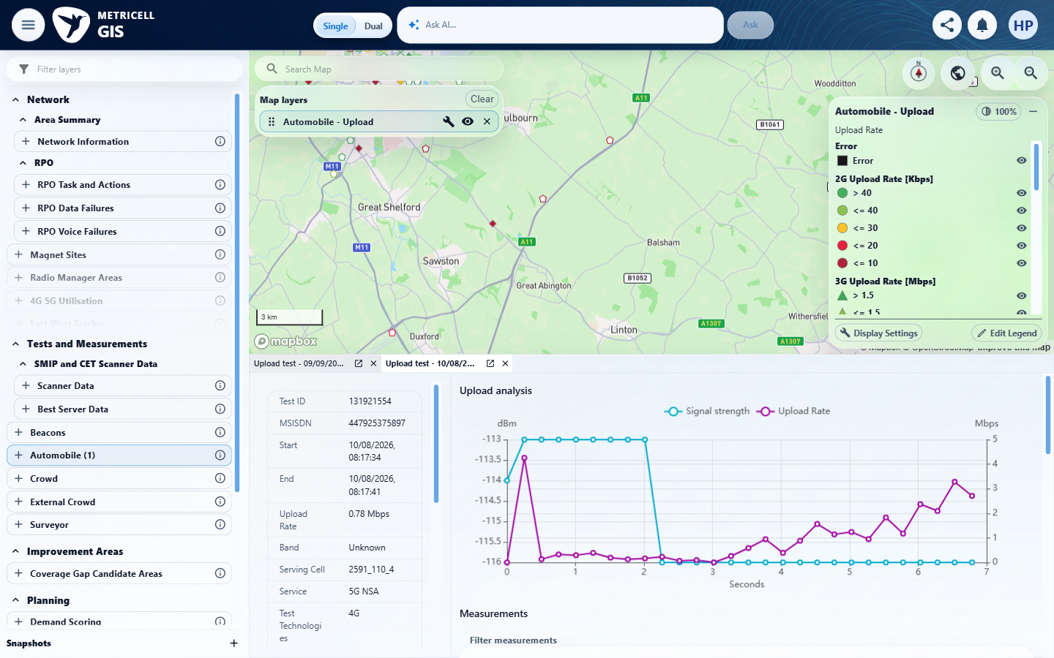

Criterion 10 continued: When loading Upload details fails, the detail presentation shows the standard error state and does not display incorrect data.
Browser URL recorded after criterion: https://o2intelligence-v4-dev.metricell.com/gis
E38 - Distinct record baseline (criterion-10-distinct-record-baseline.png)  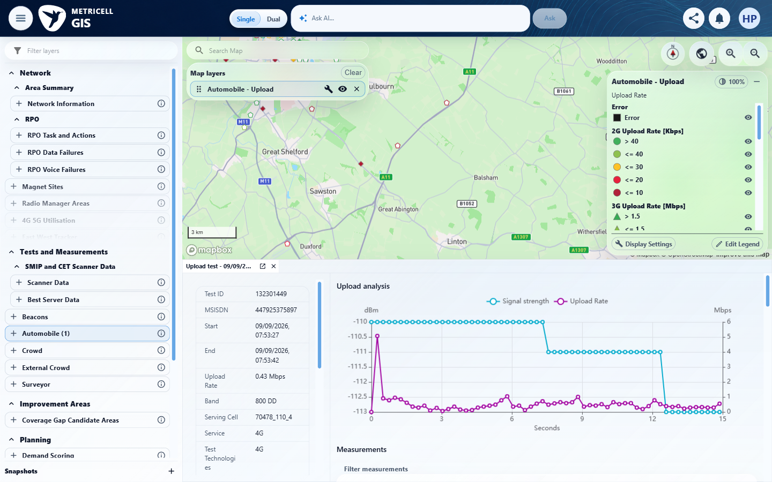 | E39 - Before simulated error (criterion-10-before-simulated-error.png)  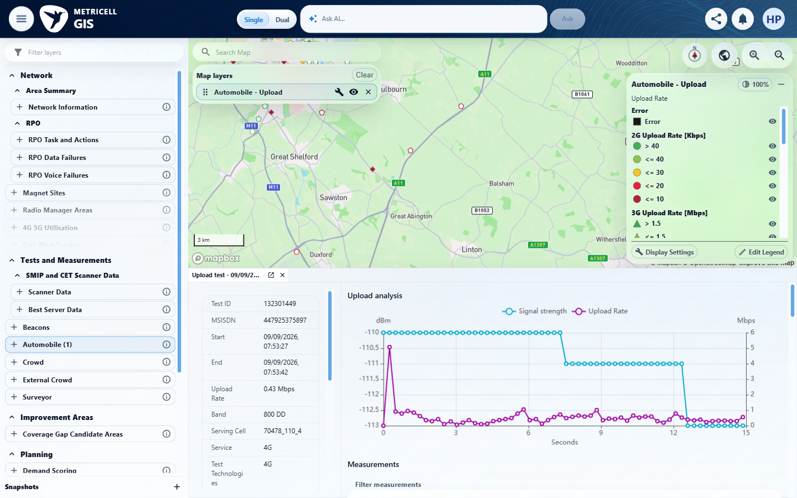

Supporting setup captures - full attempt evidence remains in the local evidence folder
E40 - Before automobile (criterion-2-before-automobile.png)  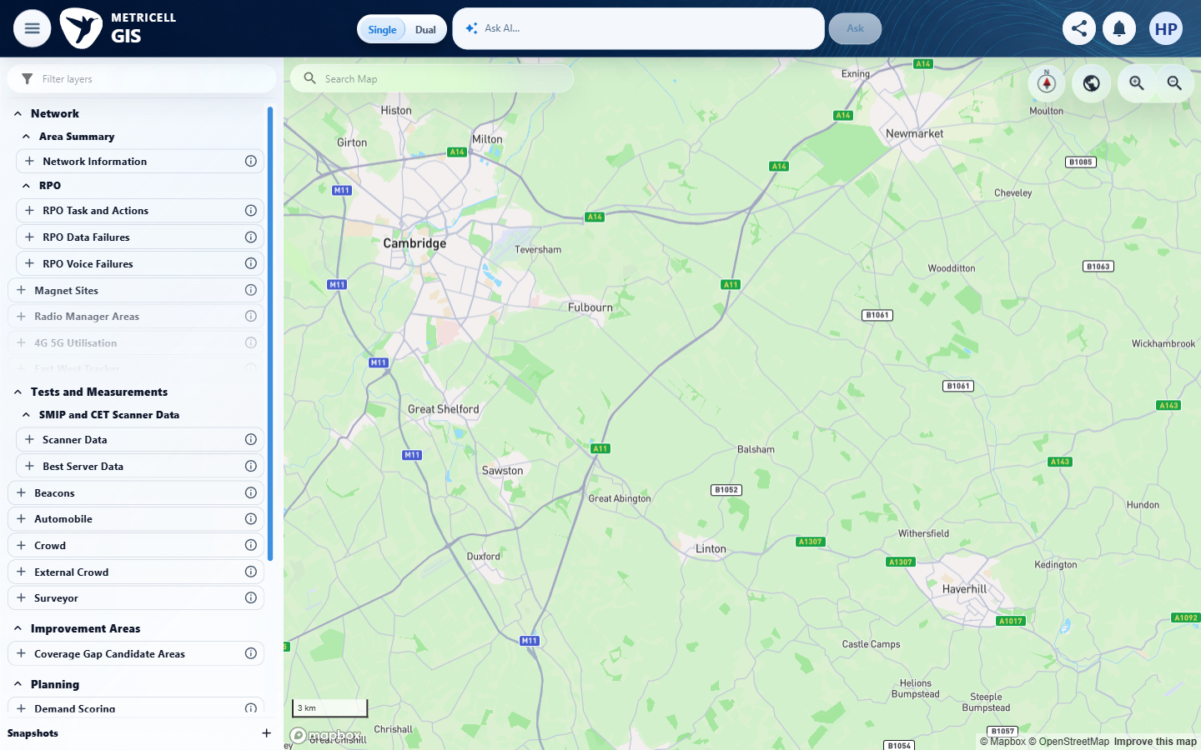 | E41 - Automobile config (criterion-2-automobile-config.png)  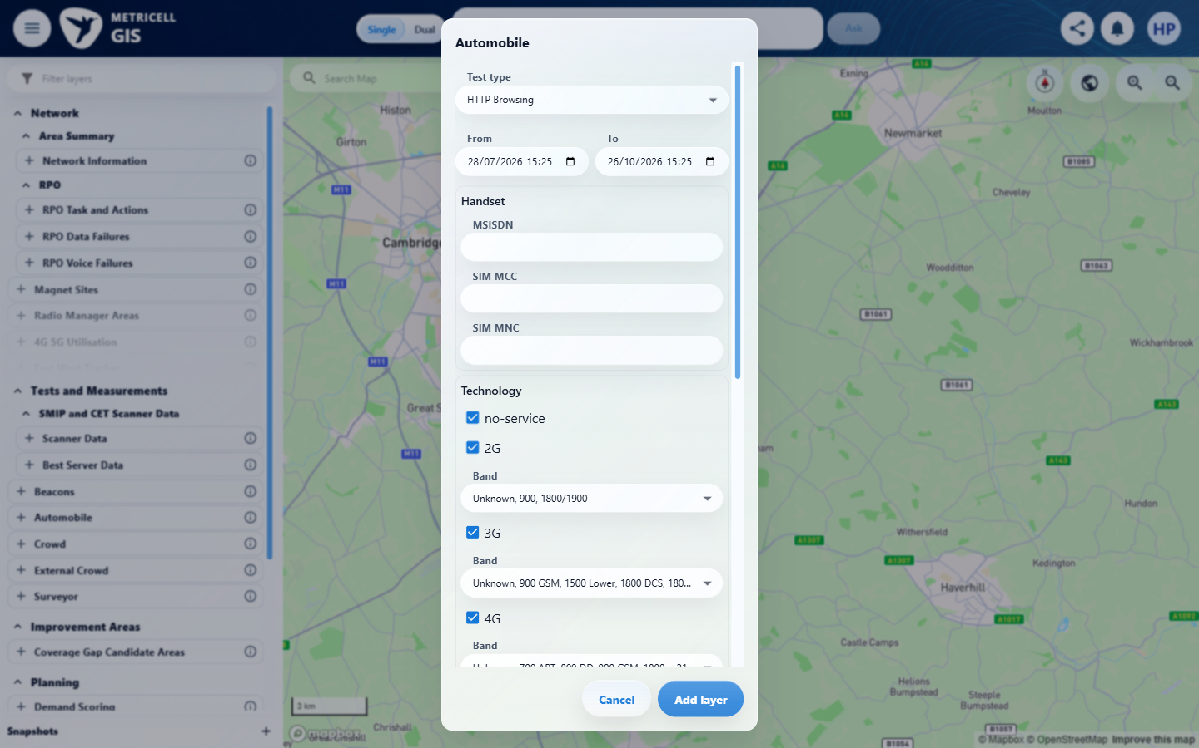

About Metricell

Metricell is on a mission to deliver connectivity. We work with our customers to design, deliver and manage wireless communication networks – with a shared ambition of achieving flawless network experience. We’ve been responsible for many first-to-market products, and our technology is characterised by the relentless pursuit of automation and digitalisation.

Our geospatial intelligence tools traverse a wide variety of business processes – from Test & Measurement to Customer Experience Management – and we’re pioneers in Crowdsourcing and Digital Self Care. Our technology is today in use by a range of customers; thousands of their personnel; and millions of subscribers worldwide.

Find out more at www.metricell.com




