

Automated Test Case Document
Jira Ticket: TEST2-92

Document Classification: | Company Confidential
Document Ref: | Automated Test Case Document
Version: | 1.0
Date: | 20/10/2026
Document Author: | Automated TEST2 Evidence Review
Document Owner: | Quality Assurance / Metricell




This document and its content is copyright of Metricell Limited @ 2026 all rights reserved. All information contained herein is the intellectual property of Metricell Limited and should be treated as confidential. Any external redistribution of reproduction of part or all of the contents in any form is prohibited unless expressly agreed with Metricell Limited in writing. Any reproduced content must include the following statement; “Part or all of the content contained herein is copyright of Metricell Limited @ 2026 all rights reserved”.
Table of Contents
1 Revision History 2
2 Test Cycle Information 3
3 Test Summary 3
4 Test Cases 4
About Metricell 12

Revision History

Version | Date | Revision Author | Summary of Changes
[1.0] | 20/10/2026 | TEST2 QA Automation | Generated from TEST2 evidence review

Test Cycle Information

Tester: | Automated
Jira Ticket: | TEST2-92
Environment: | o2intelligence-v4-dev.metricell.com
Browser Details: | Google Chrome 155.0.8059.85
Date of Test: | 20/10/2026
Limitations during Testing: | 2 blocked; 9 inconclusive criterion(s). Completed independent review of all 15 canonical criteria and 92 referenced non-empty PNGs for cycle-001 attempt-002; required multi-field consumer evidence is unavailable. Criterion 1: Groups and markers render, but the live inputs provide no versioned definition or expected colours/shapes/thresholds for an exact configuration comparison. Rendering alone cannot establish that complete assertion. Initial screenshot ENOENT was recovered by creating the staging directory and restarting from launcher. Temporary auto-review mismatch was resolved by inspecting the Automobile dialog and confirming HTTP Browsing is an expressly scoped Automobile test type. Test-created layer retained temporarily for subsequent criteria; removed in final cleanup. Criterion 1: Inspected titled groups Error, 2G, 3G, 4G, 5G NSA, 5G SA and Out of Threshold; observed configured-looking circle, triangle, diamond and pentagon markers and thresholds. Criterion 6: Captured unavailable multi-field prerequisite state; no field switch or field-specific save was possible. Criterion 11: Boundary ordering contradiction: first 2G numeric bound13 exceeded next12, but no immediate inline validation error appeared and Save stayed enabled. Empty/negative/above10000/non-finite cases disabled Save. Ping/Video and accepted endpoints remain unverified; no invalid value was saved. Inconclusive evidence is reported as Failed, but is not a confirmed application defect. Defects (No.) counts directly contradicted criteria, not unique Jira bugs; blockers and inconclusive evidence count as zero.
Overall review outcome: | Blocked
Browser URL(s) recorded after criteria: | https://o2intelligence-v4-dev.metricell.com/gis

Test Summary

Area of test | Pass | Fail | Defects (No.)
1. With a standard Automobile layer active, the legend shows the titled groups and items defined by that layer’s selected legend section, using the configured categories, thresholds, colours, shapes and outlines. | N | Y | 0
2. When a visible legend item is selected, matching points in the active layer are hidden and the item is visibly muted; selecting it again restores the points and normal item appearance. | Y | N | 0
3. When a legend item is double-clicked, that item remains visible and all other items in its group are hidden; items in other groups retain their visibility. | N | Y | 1
4. Legend filtering and legend edits change only the active layer’s presentation; other layers, underlying data, and form-based filters retain their prior state. | N | Y | 0
5. When a layer supplies one Colour By field, its title is displayed as a label; when it supplies multiple fields, a dropdown displays exactly those fields. | N | N | 0
6. When Colour By changes on a consuming layer that supplies multiple fields and measurements, the displayed groups, map classification, markers and linked-context visibility follow the selected field, form filters remain unchanged, and the same points are not fetched again. This end-to-end behavior requires a multi-field consuming layer; current Automobile types provide only one field. | N | N | 0
7. Restoring a layer’s state restores its selected Colour By field and that field’s saved overrides independently of other layers. | N | Y | 0
8. In Edit Legend, changing labels, colours or numeric boundaries creates drafts for the active field only; the map remains unchanged until Save, while Cancel or Close discards drafts. After Save, refreshed values remain visible in the open dialog. | N | Y | 0
9. After a valid legend edit is saved, the legend and cached map points use the same labels, colours and classification; saved overrides for other fields and layers remain unchanged. | N | Y | 0
10. In a numeric generation group, the add control below the marker column adds a range row, eligible rows have delete controls, at least one range remains, and editing a value does not reorder Automobile rows. | Y | N | 0
11. Numeric Value fields use number inputs. Empty, non-finite, out-of-limit or incorrectly ordered boundary values show an inline error immediately and disable Save. HTTP Browsing boundaries accept 0–10,000; Ping and Video Streaming boundaries have a minimum of zero and no additional maximum. Video Streaming categories cannot be changed. | N | Y | 1
12. Reset displays default labels, colours, boundaries, categories and visibility as drafts; saving applies defaults to the active field only, preserving other fields and layers. | N | Y | 0
13. Linked-site and linked-cell display settings use the shared Network context and follow visible result categories; linked cells are disabled when linked sites are off, and settings persist per layer. | N | Y | 0
14. With or without a details tab, the legend remains scrollable when the map pane is resized and does not overlap Reset North or other map controls. | N | Y | 0
15. For existing consumers of the shared legend, established markers, visibility, editor actions and default behavior remain unchanged unless a consumer opts into the new options. | N | Y | 0

Test Cases
Each test maps to a criterion and decisive browser evidence. Inconclusive results are reported as Failed.

Tests

Preconditions: | V4 access and ticket conditions. | Associated Requirements: | Ticket criteria below. | Automation Notes: | Screenshots below each criterion; full log retained locally.
ID / Criterion | Criteria Tested | Expected Result | Actual Result / Evidence Path | Outcome
1.0.0 | With a standard Automobile layer active, the legend shows the titled groups and items defined by that layer’s selected legend section, using the configured categories, thresholds, colours, shapes and outlines. | With a standard Automobile layer active, the legend shows the titled groups and items defined by that layer’s selected legend section, using the configured categories, thresholds, colours, shapes and outlines. | criterion-1-final.png shows titled Error, 2G, 3G, 4G, 5G NSA, 5G SA and Out of Threshold groups with differing marker shapes and thresholds. The supplied inputs contain no versioned expected definition against which to verify exact categories, colours, outlines and thresholds.  Evidence: E01, E02, E03 | Failed
Criterion 1 evidence: With a standard Automobile layer active, the legend shows the titled groups and items defined by that layer’s selected legend section, using the configured categories, thresholds, colours, shapes and outlines.
Browser URL recorded after criterion: https://o2intelligence-v4-dev.metricell.com/gis
E01 - After open form (criterion-1-after-open-form.png)  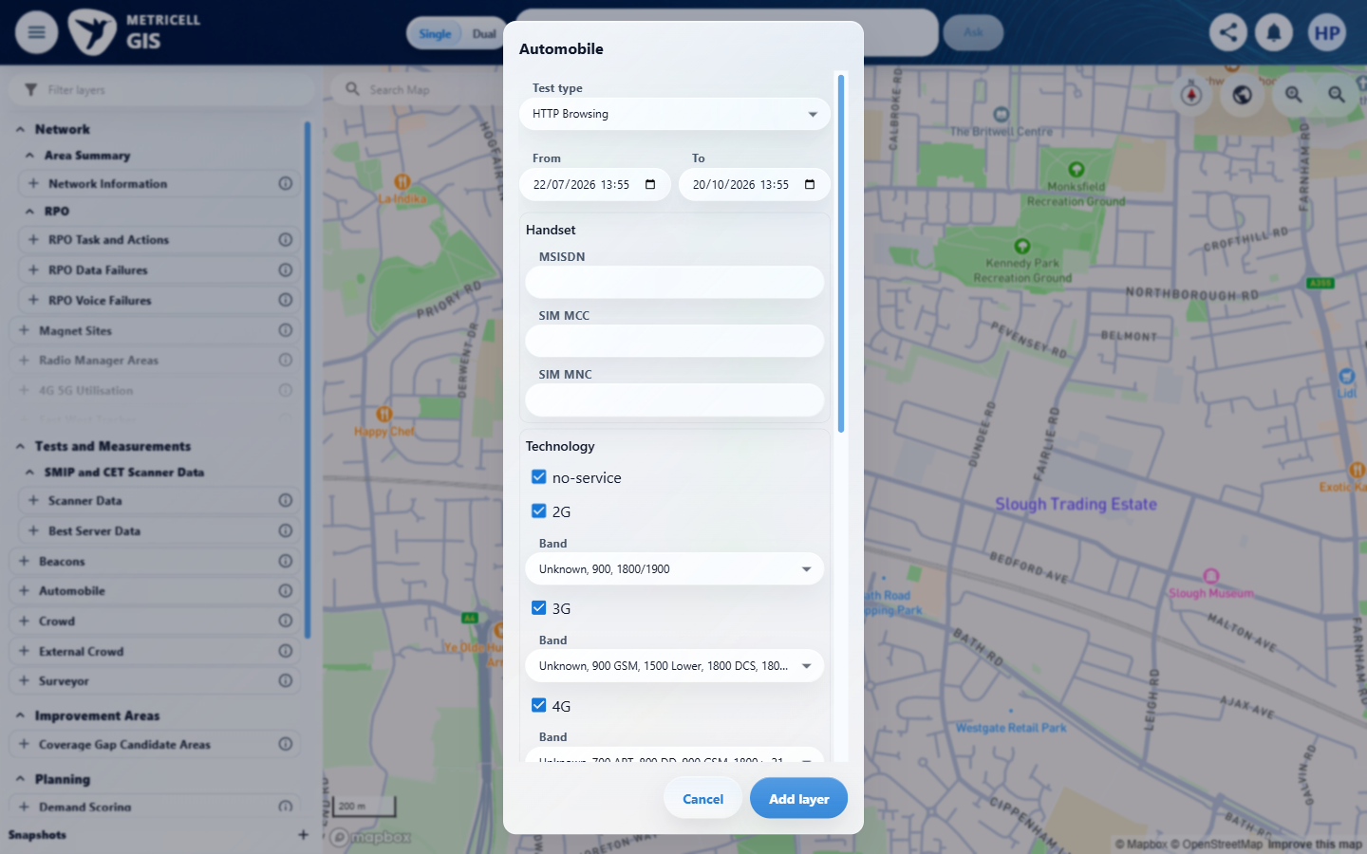 | E02 - After add layer (criterion-1-after-add-layer.png)  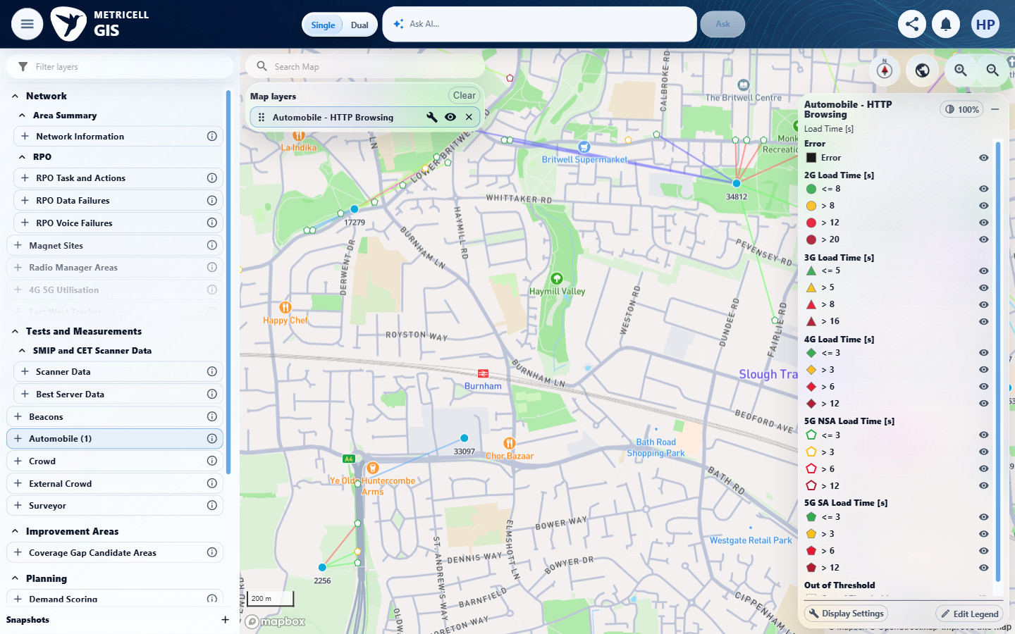

Criterion 1 continued: With a standard Automobile layer active, the legend shows the titled groups and items defined by that layer’s selected legend section, using the configured categories, thresholds, colours, shapes and outlines.
Browser URL recorded after criterion: https://o2intelligence-v4-dev.metricell.com/gis
E03 - Final (criterion-1-final.png)
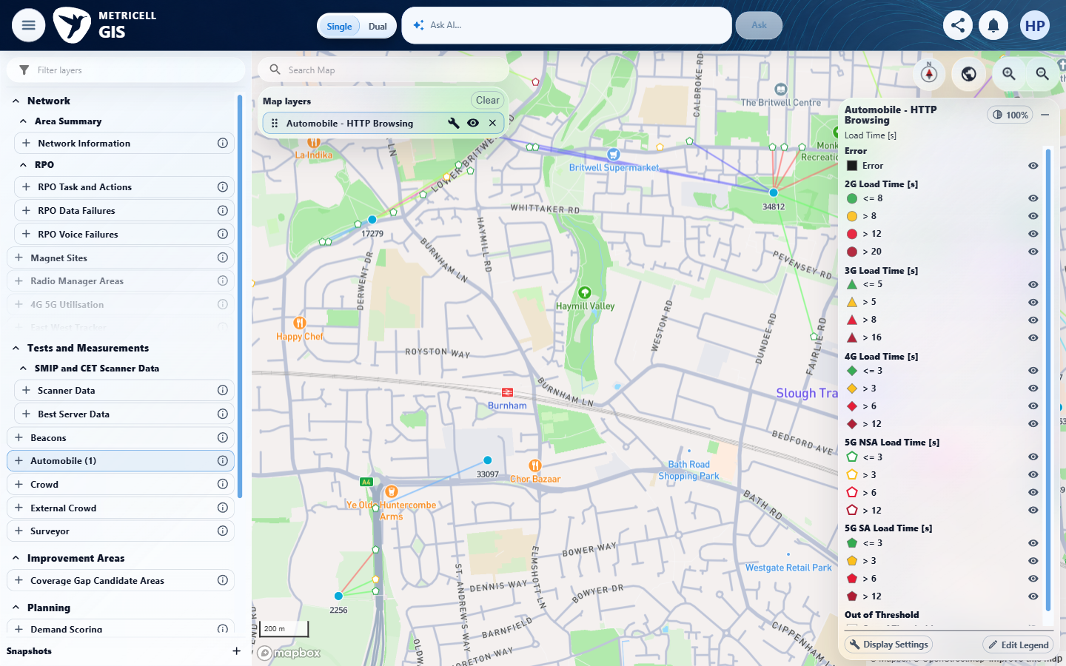

2.0.0 | When a visible legend item is selected, matching points in the active layer are hidden and the item is visibly muted; selecting it again restores the points and normal item appearance. | When a visible legend item is selected, matching points in the active layer are hidden and the item is visibly muted; selecting it again restores the points and normal item appearance. | criterion-2-before-hide.png shows green outlined NSA <=3 pentagons; criterion-2-after-hide-before-restore.png shows those points absent and the row muted while other categories remain; criterion-2-final.png restores the points and normal row appearance.  Evidence: E04, E05, E06 | Passed
Criterion 2 evidence: When a visible legend item is selected, matching points in the active layer are hidden and the item is visibly muted; selecting it again restores the points and normal item appearance.
Browser URL recorded after criterion: https://o2intelligence-v4-dev.metricell.com/gis
E04 - Before hide (criterion-2-before-hide.png)  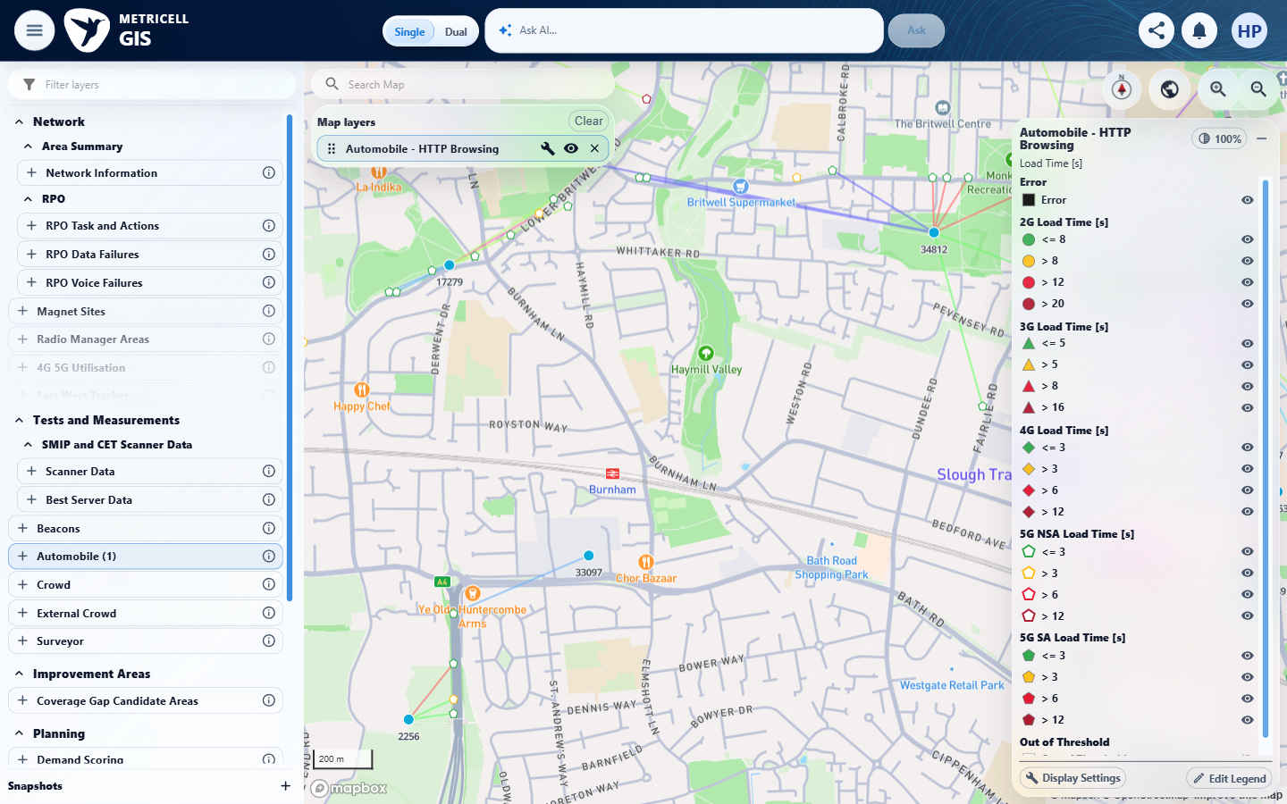 | E05 - After hide before restore (criterion-2-after-hide-before-restore.png)  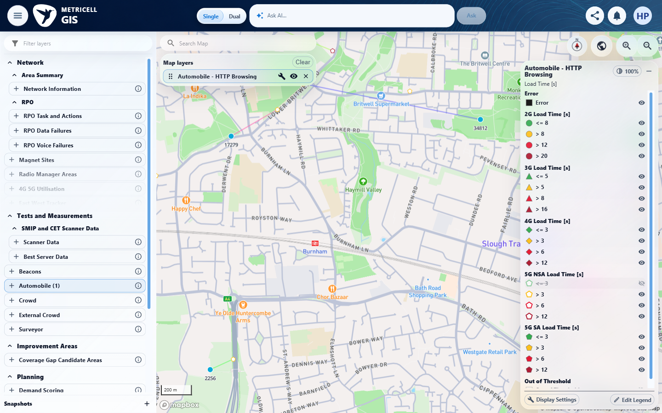

Criterion 2 continued: When a visible legend item is selected, matching points in the active layer are hidden and the item is visibly muted; selecting it again restores the points and normal item appearance.
Browser URL recorded after criterion: https://o2intelligence-v4-dev.metricell.com/gis
E06 - Final (criterion-2-final.png)
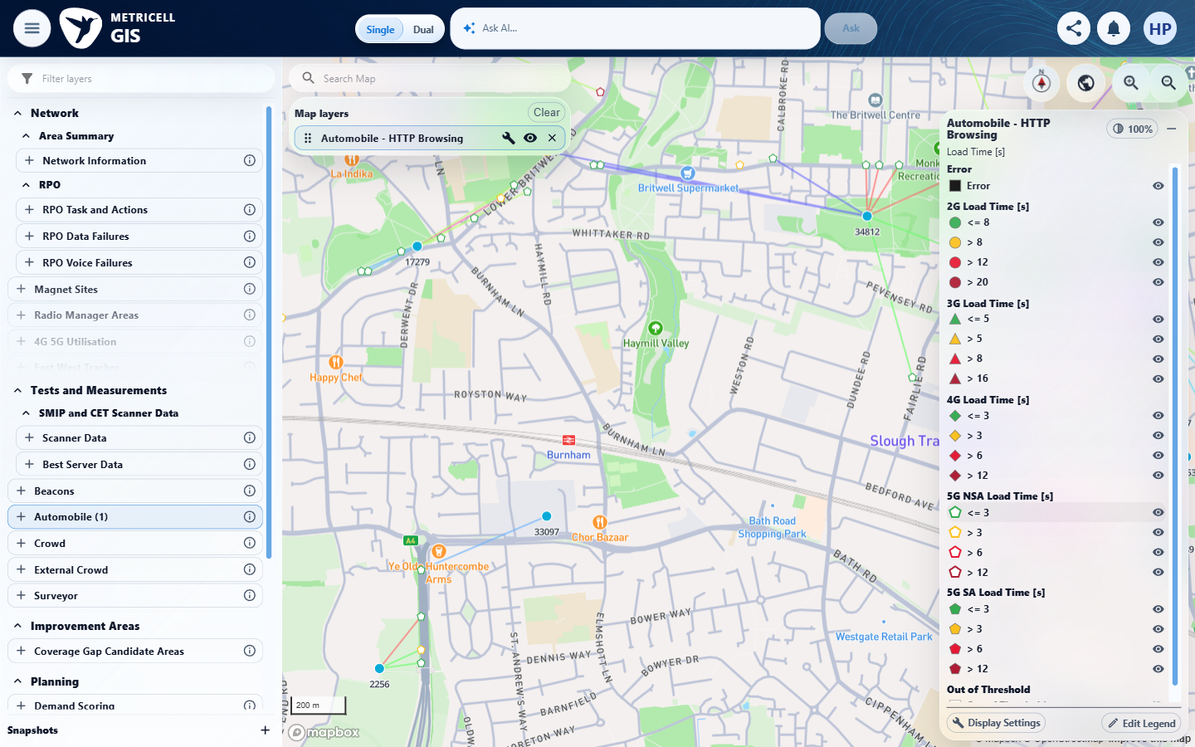

3.0.0 | When a legend item is double-clicked, that item remains visible and all other items in its group are hidden; items in other groups retain their visibility. | When a legend item is double-clicked, that item remains visible and all other items in its group are hidden; items in other groups retain their visibility. | Following the recorded double-click on NSA >3, criterion-3-after-isolate.png and criterion-3-final.png retain normal visibility icons for all four NSA rows and their points, matching criterion-3-before-isolate.png. Sibling isolation did not occur; other groups remain unchanged.  Evidence: E07, E08 | Failed
Criterion 3 evidence: When a legend item is double-clicked, that item remains visible and all other items in its group are hidden; items in other groups retain their visibility.
Browser URL recorded after criterion: https://o2intelligence-v4-dev.metricell.com/gis
E07 - Before isolate (criterion-3-before-isolate.png)  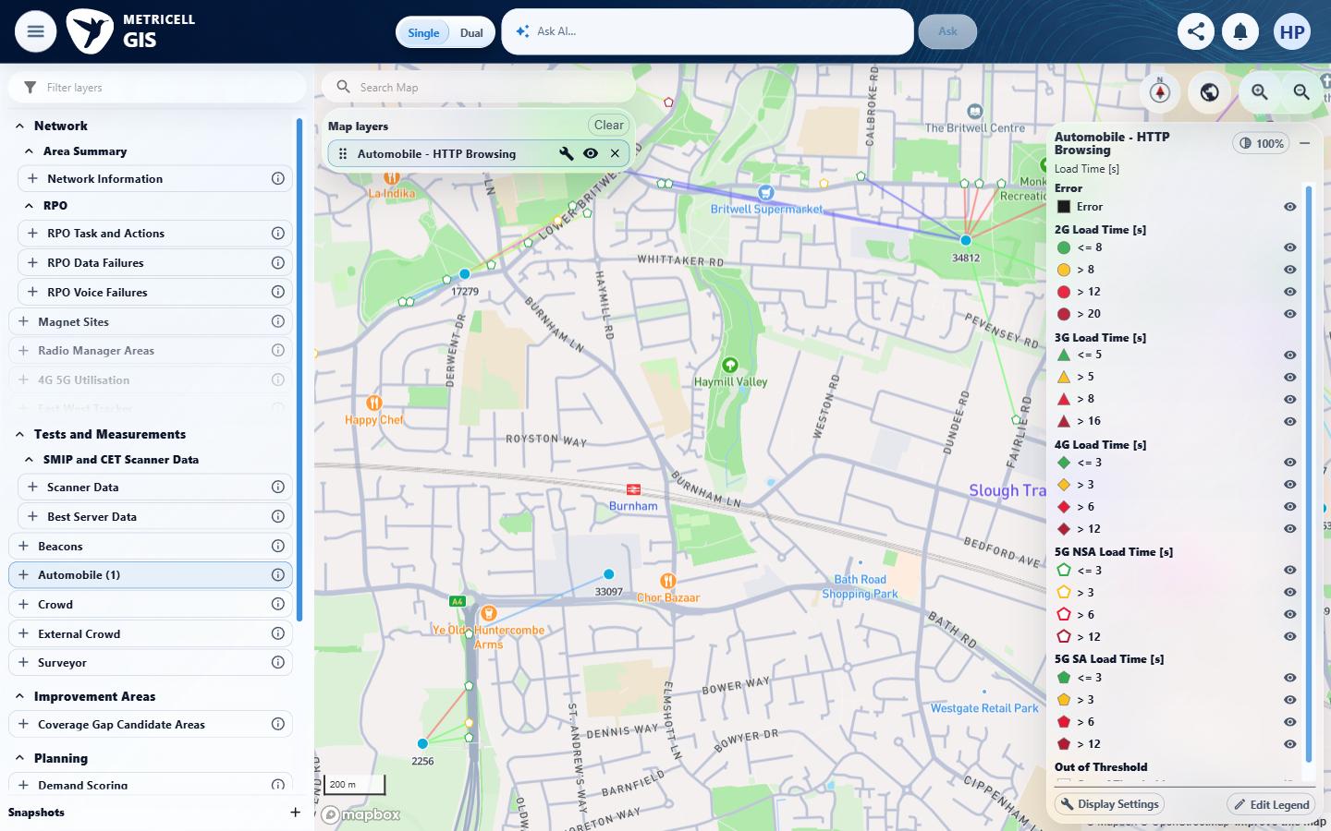 | E08 - Final (criterion-3-final.png)  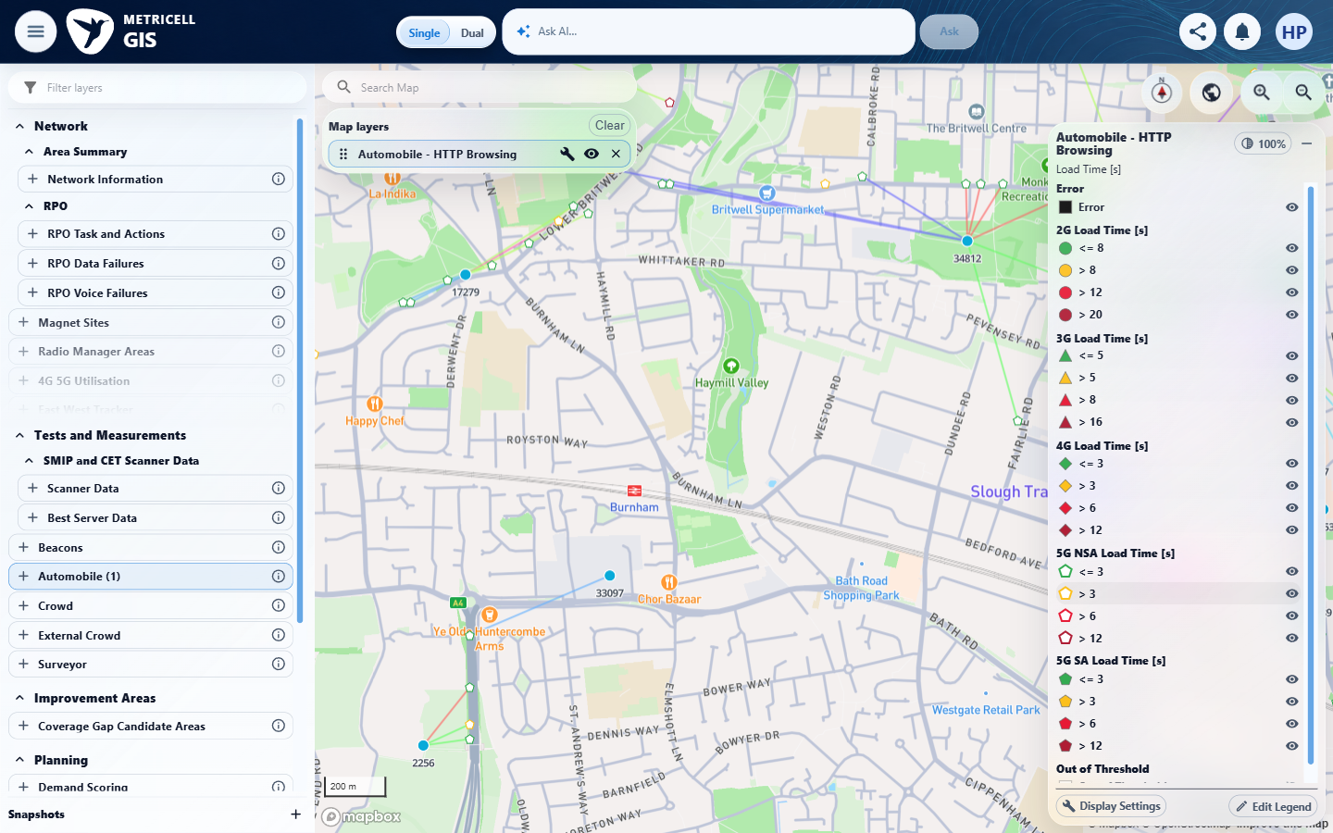

4.0.0 | Legend filtering and legend edits change only the active layer’s presentation; other layers, underlying data, and form-based filters retain their prior state. | Legend filtering and legend edits change only the active layer’s presentation; other layers, underlying data, and form-based filters retain their prior state. | criterion-4-baseline-map.png and criterion-4-baseline-layers.png show the settled single-layer baseline. criterion-4-baseline-form.png, criterion-4-after-filter.png and criterion-4-final.png show unchanged visible form values across hide/restore. No legend-edit sequence, other-layer comparison or underlying-data comparison establishes the full isolation assertion.  Evidence: E07, E09, E10, E11, E12 | Failed
Criterion 4 evidence: Legend filtering and legend edits change only the active layer’s presentation; other layers, underlying data, and form-based filters retain their prior state.
Browser URL recorded after criterion: https://o2intelligence-v4-dev.metricell.com/gis
E07 - Baseline map (criterion-4-baseline-map.png) | E09 - Baseline layers (criterion-4-baseline-layers.png)  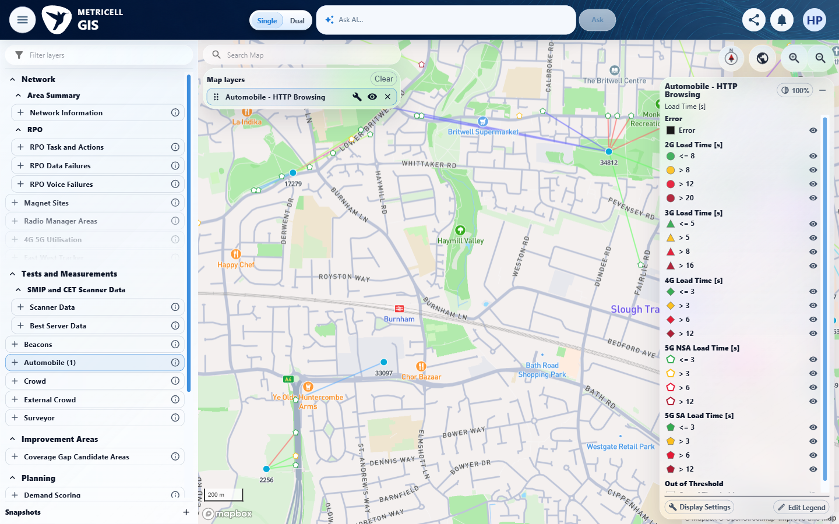

Criterion 4 continued: Legend filtering and legend edits change only the active layer’s presentation; other layers, underlying data, and form-based filters retain their prior state.
Browser URL recorded after criterion: https://o2intelligence-v4-dev.metricell.com/gis
E10 - Baseline form (criterion-4-baseline-form.png)  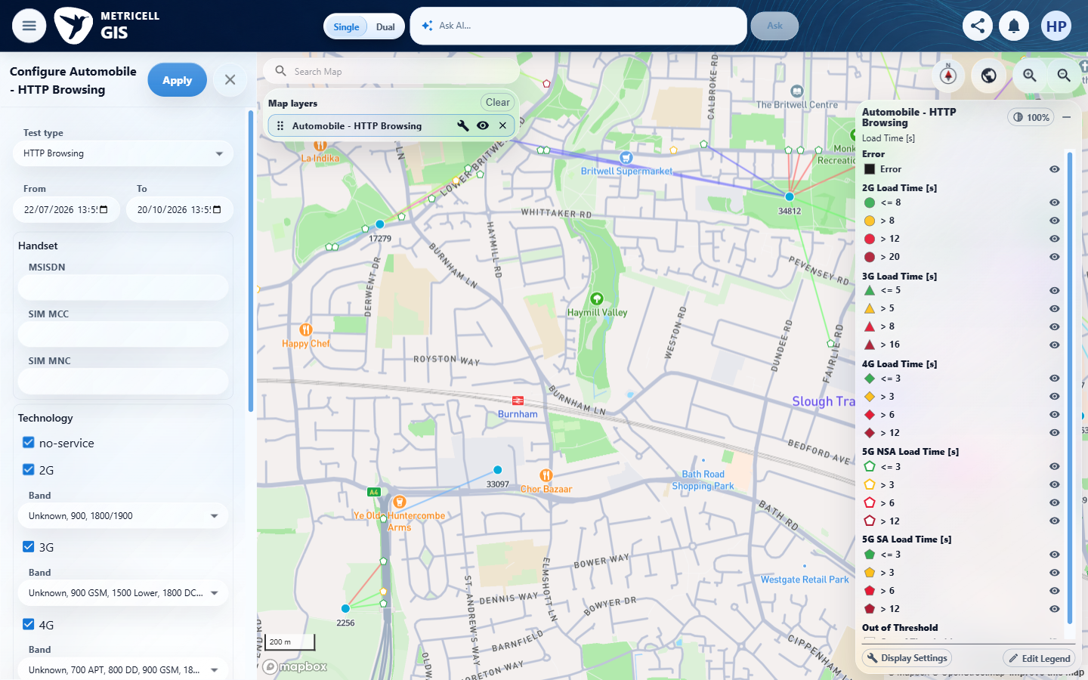 | E11 - After filter (criterion-4-after-filter.png)  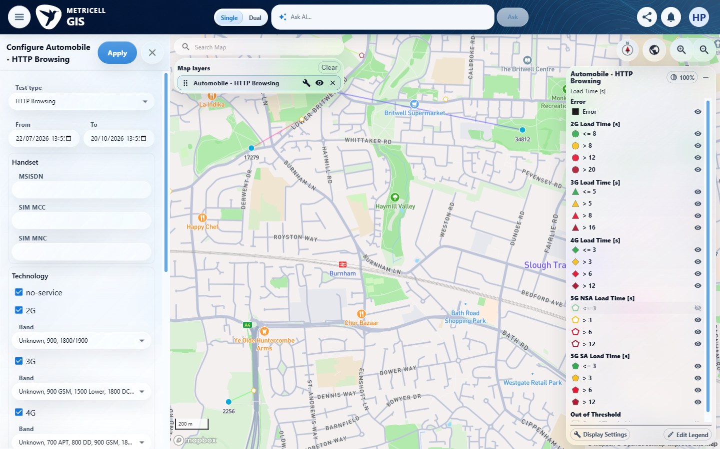

Criterion 4 continued: Legend filtering and legend edits change only the active layer’s presentation; other layers, underlying data, and form-based filters retain their prior state.
Browser URL recorded after criterion: https://o2intelligence-v4-dev.metricell.com/gis
E12 - Final (criterion-4-final.png)
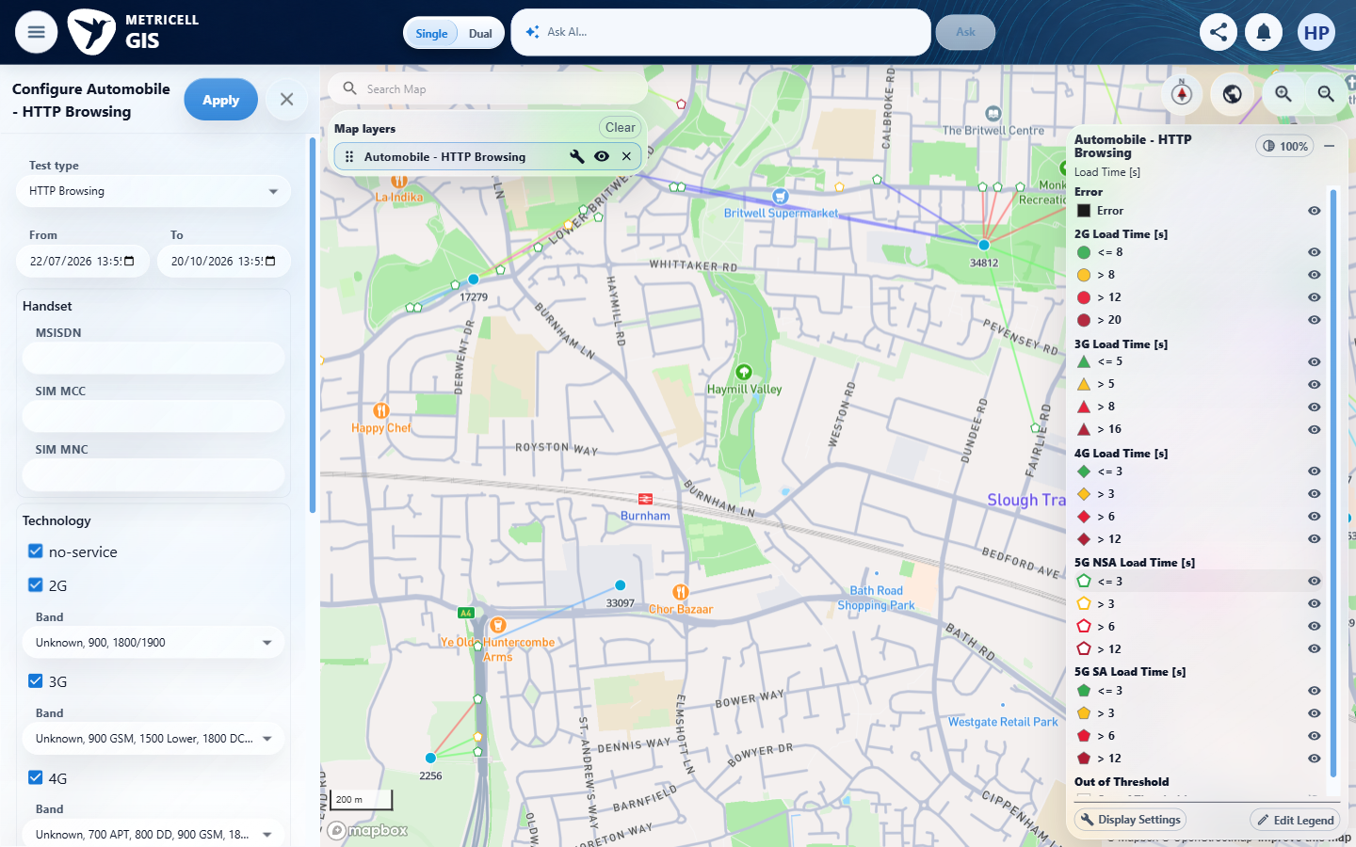

5.0.0 | When a layer supplies one Colour By field, its title is displayed as a label; when it supplies multiple fields, a dropdown displays exactly those fields. | When a layer supplies one Colour By field, its title is displayed as a label; when it supplies multiple fields, a dropdown displays exactly those fields. | criterion-5-single-field-label.png and criterion-5-final.png show the single Load Time [s] label. The required multi-field consuming layer and expected option list are unavailable in the supplied inputs; current Automobile types explicitly supply one field.  Evidence: E13, E14 | Blocked
Criterion 5 evidence: When a layer supplies one Colour By field, its title is displayed as a label; when it supplies multiple fields, a dropdown displays exactly those fields.
Browser URL recorded after criterion: https://o2intelligence-v4-dev.metricell.com/gis
E13 - Single field label (criterion-5-single-field-label.png)  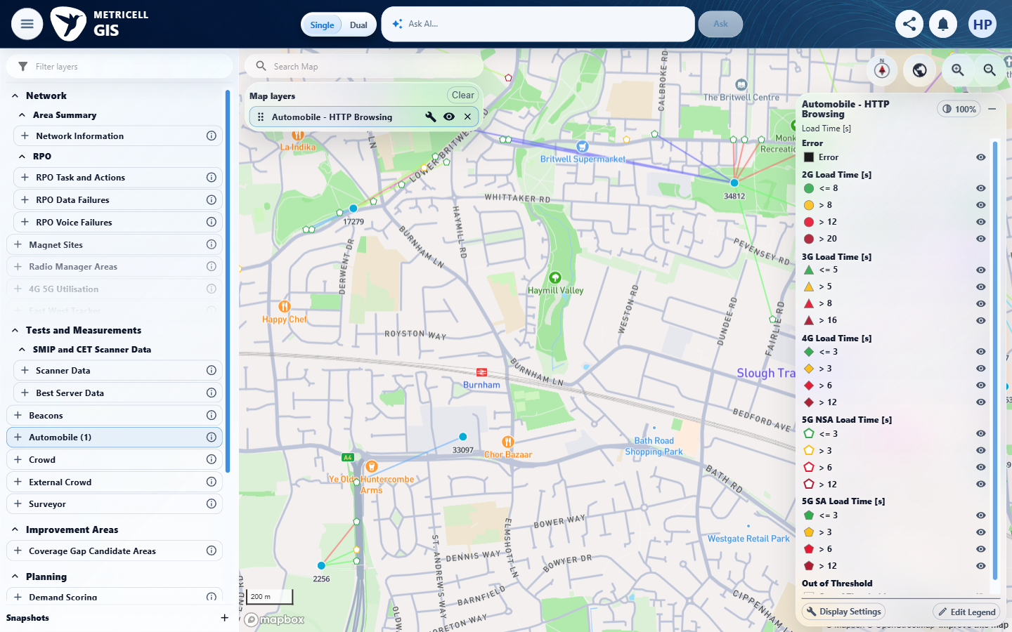 | E14 - Final (criterion-5-final.png)  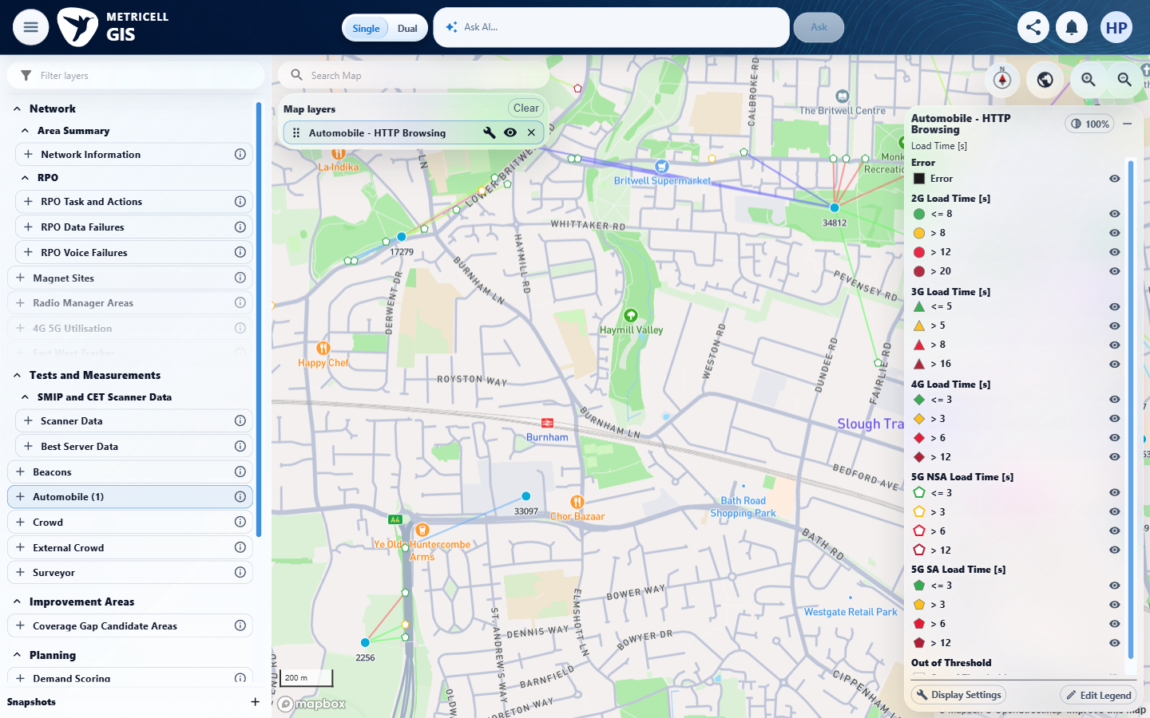

6.0.0 | When Colour By changes on a consuming layer that supplies multiple fields and measurements, the displayed groups, map classification, markers and linked-context visibility follow the selected field, form filters remain unchanged, and the same points are not fetched again. This end-to-end behavior requires a multi-field consuming layer; current Automobile types provide only one field. | When Colour By changes on a consuming layer that supplies multiple fields and measurements, the displayed groups, map classification, markers and linked-context visibility follow the selected field, form filters remain unchanged, and the same points are not fetched again. This end-to-end behavior requires a multi-field consuming layer; current Automobile types provide only one field. | criterion-6-blocked-single-field.png shows the single Load Time [s] field. The required consuming layer supplying multiple fields and measurements is unavailable, preventing field switching, classification, linked-context and no-refetch verification.  Evidence: E15 | Blocked
Criterion 6 evidence: When Colour By changes on a consuming layer that supplies multiple fields and measurements, the displayed groups, map classification, markers and linked-context visibility follow the selected field, form filters remain unchanged, and the same points are not fetched again. This end-to-end behavior requires a multi-field consuming layer; current Automobile types provide only one field.
Browser URL recorded after criterion: https://o2intelligence-v4-dev.metricell.com/gis
E15 - Blocked single field (criterion-6-blocked-single-field.png)
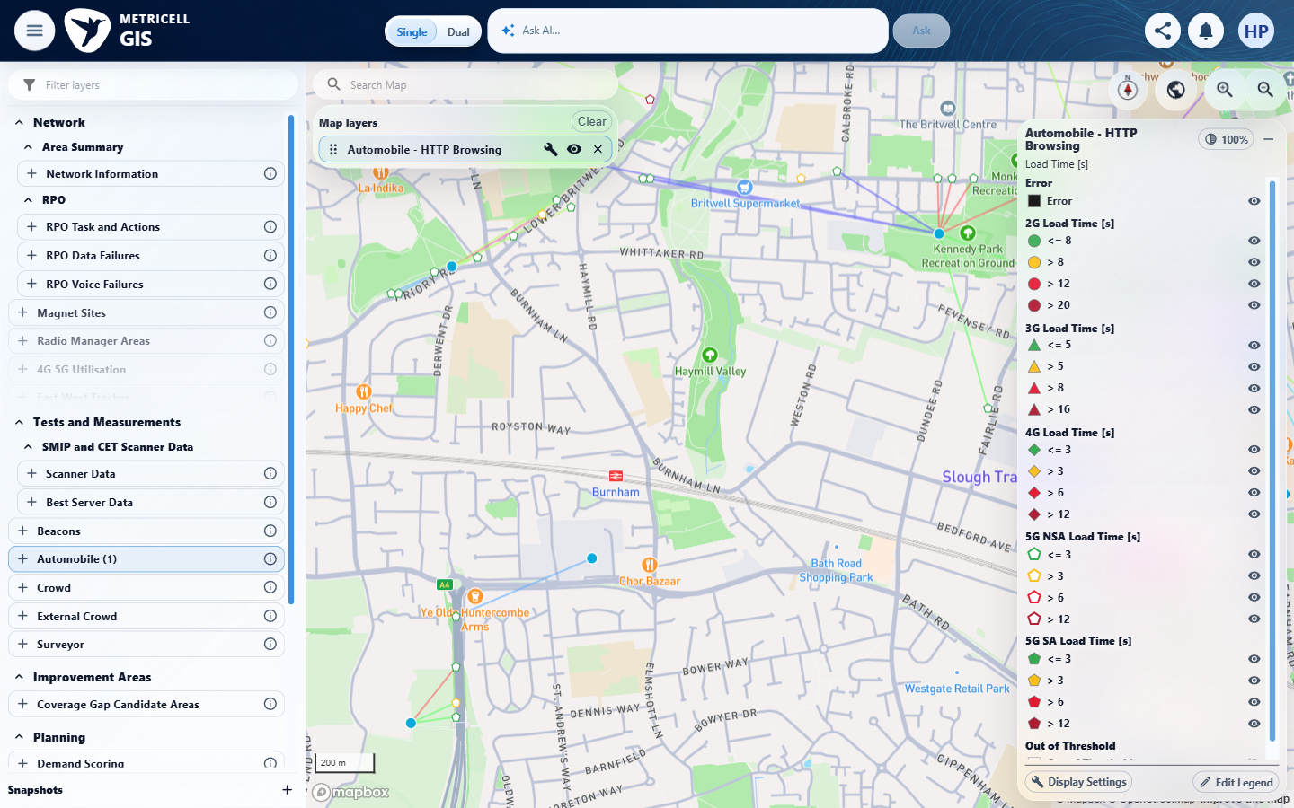

7.0.0 | Restoring a layer’s state restores its selected Colour By field and that field’s saved overrides independently of other layers. | Restoring a layer’s state restores its selected Colour By field and that field’s saved overrides independently of other layers. | criterion-7-blocked-single-field.png shows only the current single-field layer. No saved-override setup, state restoration or independent other-layer comparison is captured. A single available field alone does not establish or contradict this restoration assertion.  Evidence: E13 | Failed
Criterion 7 evidence: Restoring a layer’s state restores its selected Colour By field and that field’s saved overrides independently of other layers.
Browser URL recorded after criterion: https://o2intelligence-v4-dev.metricell.com/gis
E13 - Blocked single field (criterion-7-blocked-single-field.png)

8.0.0 | In Edit Legend, changing labels, colours or numeric boundaries creates drafts for the active field only; the map remains unchanged until Save, while Cancel or Close discards drafts. After Save, refreshed values remain visible in the open dialog. | In Edit Legend, changing labels, colours or numeric boundaries creates drafts for the active field only; the map remains unchanged until Save, while Cancel or Close discards drafts. After Save, refreshed values remain visible in the open dialog. | criterion-8-baseline-map.png is still loading; criterion-8-baseline-layers.png provides the settled map and complete one-layer baseline. First label draft in criterion-8-first-edit-before-cancel.png is discarded in criterion-8-after-first-cancel-map.png and criterion-8-second-reopen.png; second draft in criterion-8-second-edit-before-close.png is discarded in criterion-8-after-second-close-map.png and criterion-8-final-reopen.png. criterion-8-final-edit-before-save.png to criterion-8-final.png shows the saved label refreshed in the open dialog. Colour/boundary draft behavior and other-field draft isolation remain unverified.  Evidence: E16, E17 | Failed
Criterion 8 evidence: In Edit Legend, changing labels, colours or numeric boundaries creates drafts for the active field only; the map remains unchanged until Save, while Cancel or Close discards drafts. After Save, refreshed values remain visible in the open dialog.
Browser URL recorded after criterion: https://o2intelligence-v4-dev.metricell.com/gis
E16 - Baseline map (criterion-8-baseline-map.png)  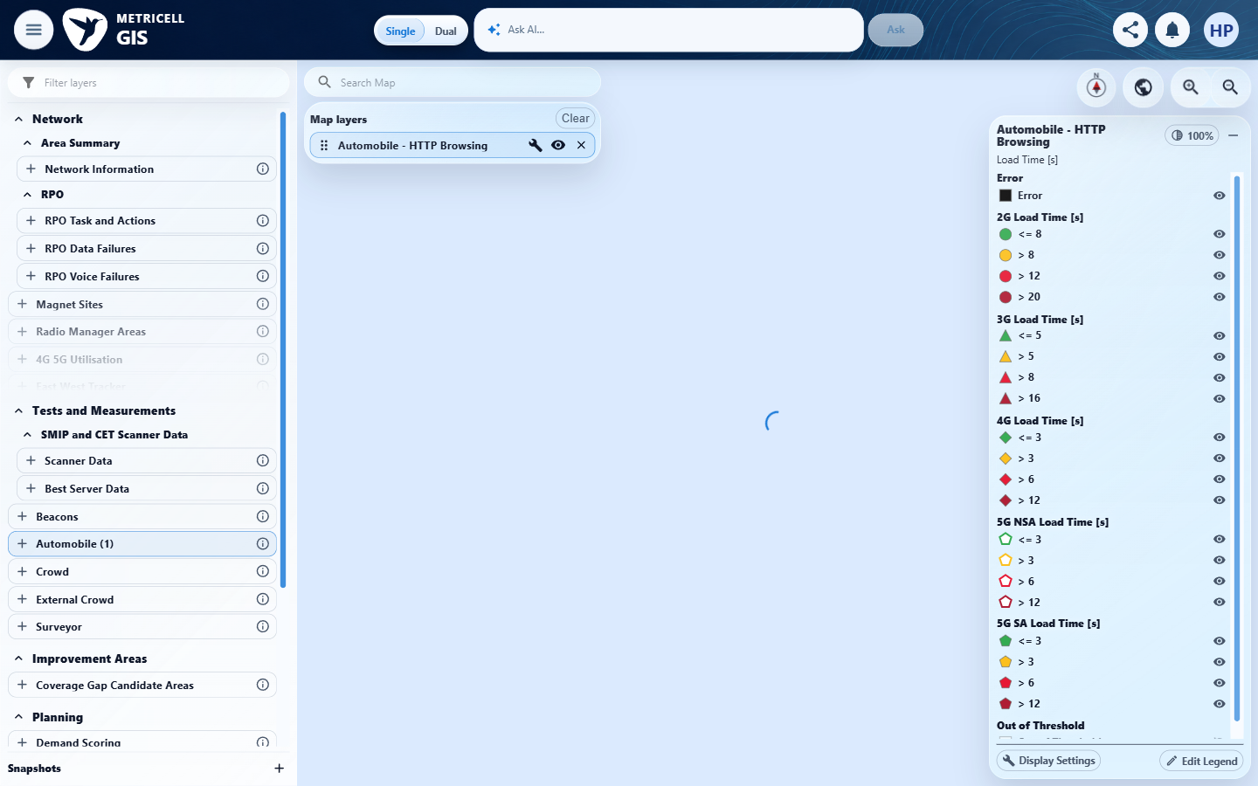 | E17 - Final (criterion-8-final.png)  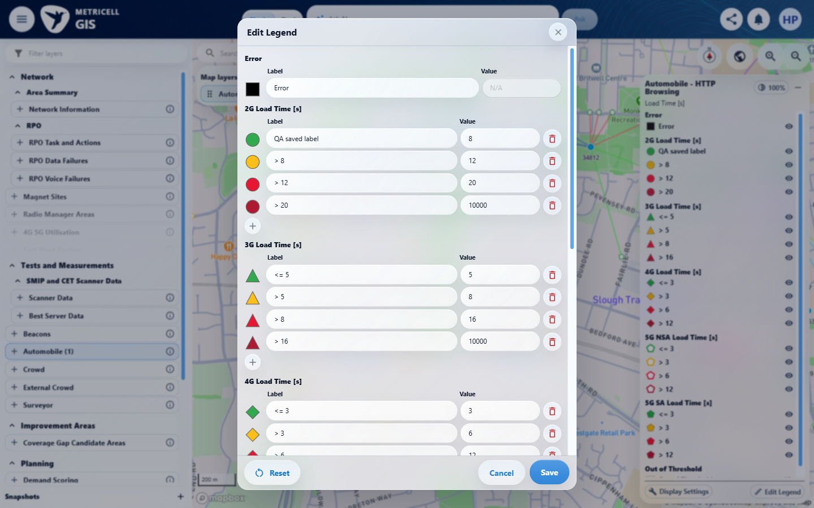

9.0.0 | After a valid legend edit is saved, the legend and cached map points use the same labels, colours and classification; saved overrides for other fields and layers remain unchanged. | After a valid legend edit is saved, the legend and cached map points use the same labels, colours and classification; saved overrides for other fields and layers remain unchanged. | criterion-9-baseline-map.png is loading; use settled criterion-9-baseline-layers.png. criterion-9-draft-before-save.png, criterion-9-saved-dialog.png and criterion-9-final.png show the NSA label and boundary changing to QA NSA low and 1, with adjacent >1 and changed map categories after Save. No colour edit or comparison of saved overrides in other fields/layers establishes the complete assertion.  Evidence: E18, E19, E20 | Failed
Criterion 9 evidence: After a valid legend edit is saved, the legend and cached map points use the same labels, colours and classification; saved overrides for other fields and layers remain unchanged.
Browser URL recorded after criterion: https://o2intelligence-v4-dev.metricell.com/gis
E18 - Baseline map (criterion-9-baseline-map.png)  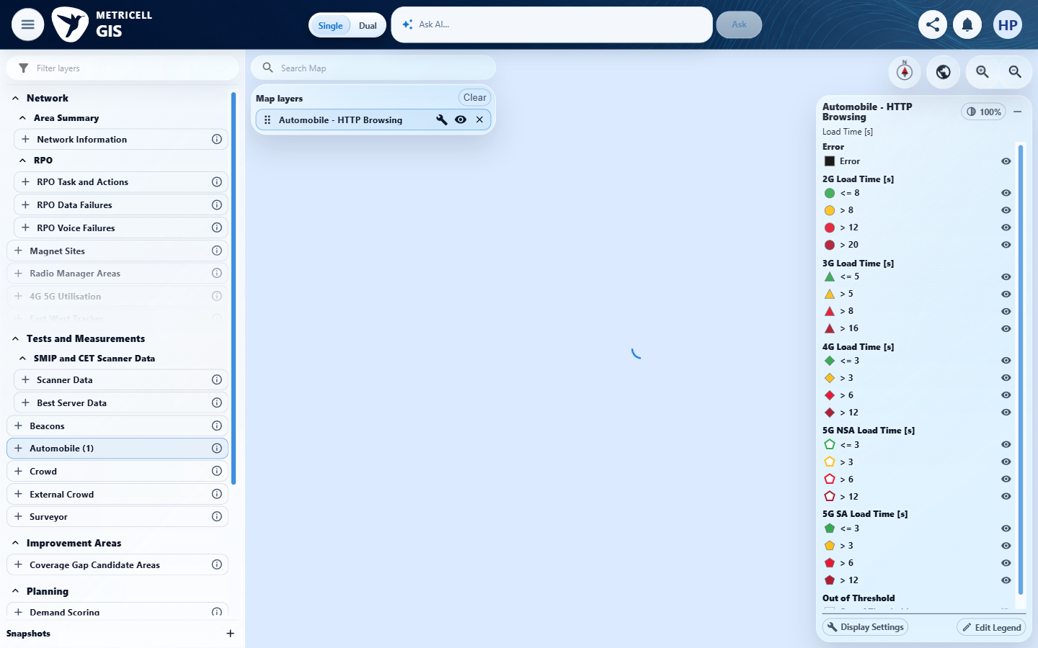 | E19 - Final (criterion-9-final.png)  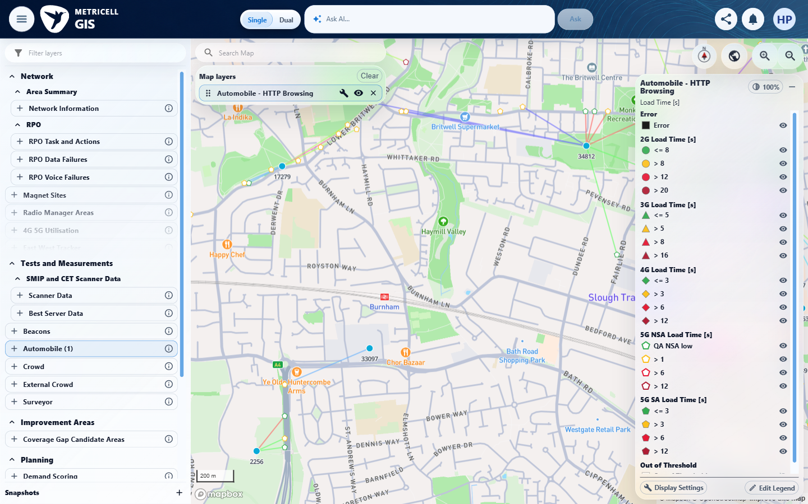

Criterion 9 continued: After a valid legend edit is saved, the legend and cached map points use the same labels, colours and classification; saved overrides for other fields and layers remain unchanged.
Browser URL recorded after criterion: https://o2intelligence-v4-dev.metricell.com/gis
E20 - Baseline layers (criterion-9-baseline-layers.png)  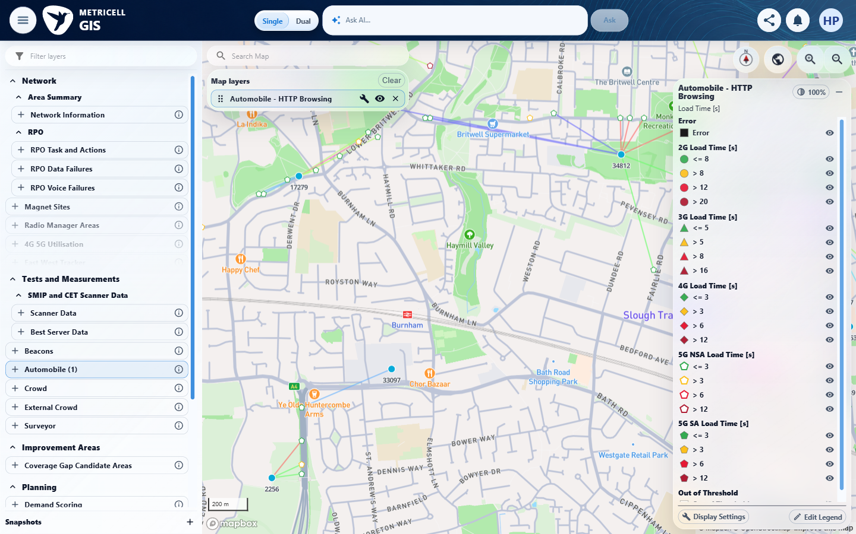 | E19 - Final (criterion-9-final.png)

10.0.0 | In a numeric generation group, the add control below the marker column adds a range row, eligible rows have delete controls, at least one range remains, and editing a value does not reorder Automobile rows. | In a numeric generation group, the add control below the marker column adds a range row, eligible rows have delete controls, at least one range remains, and editing a value does not reorder Automobile rows. | criterion-10-before-add.png to criterion-10-after-add.png shows a fifth range below the marker-column add control and eligible delete actions. criterion-10-after-value-edit-before-delete.png shows first value 9 with row order retained. criterion-10-after-delete-added.png, criterion-10-after-delete-last.png, criterion-10-after-delete-third.png and criterion-10-final.png show successive removals ending with one range and a disabled delete control.  Evidence: E21, E22, E23, E24, E25, E26, E27 | Passed
Criterion 10 evidence: In a numeric generation group, the add control below the marker column adds a range row, eligible rows have delete controls, at least one range remains, and editing a value does not reorder Automobile rows.
Browser URL recorded after criterion: https://o2intelligence-v4-dev.metricell.com/gis
E21 - Before open (criterion-10-before-open.png)  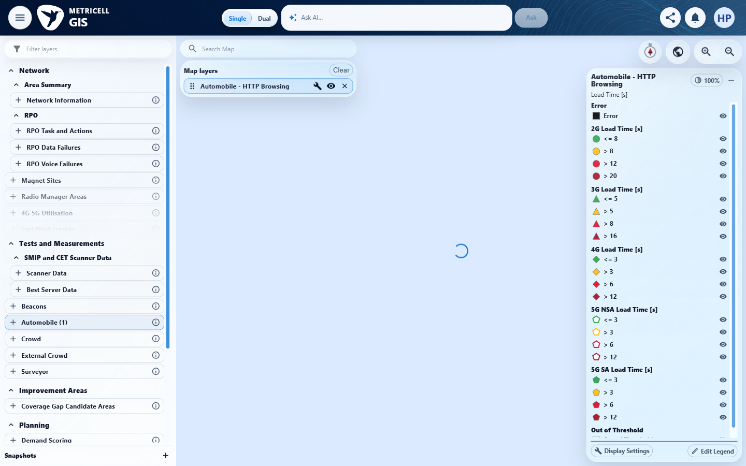 | E22 - After add (criterion-10-after-add.png)  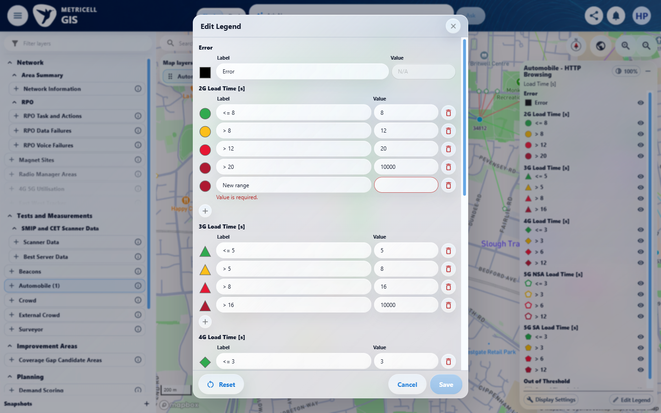

Criterion 10 continued: In a numeric generation group, the add control below the marker column adds a range row, eligible rows have delete controls, at least one range remains, and editing a value does not reorder Automobile rows.
Browser URL recorded after criterion: https://o2intelligence-v4-dev.metricell.com/gis
E23 - After value edit before delete (criterion-10-after-value-edit-before-delete.png)  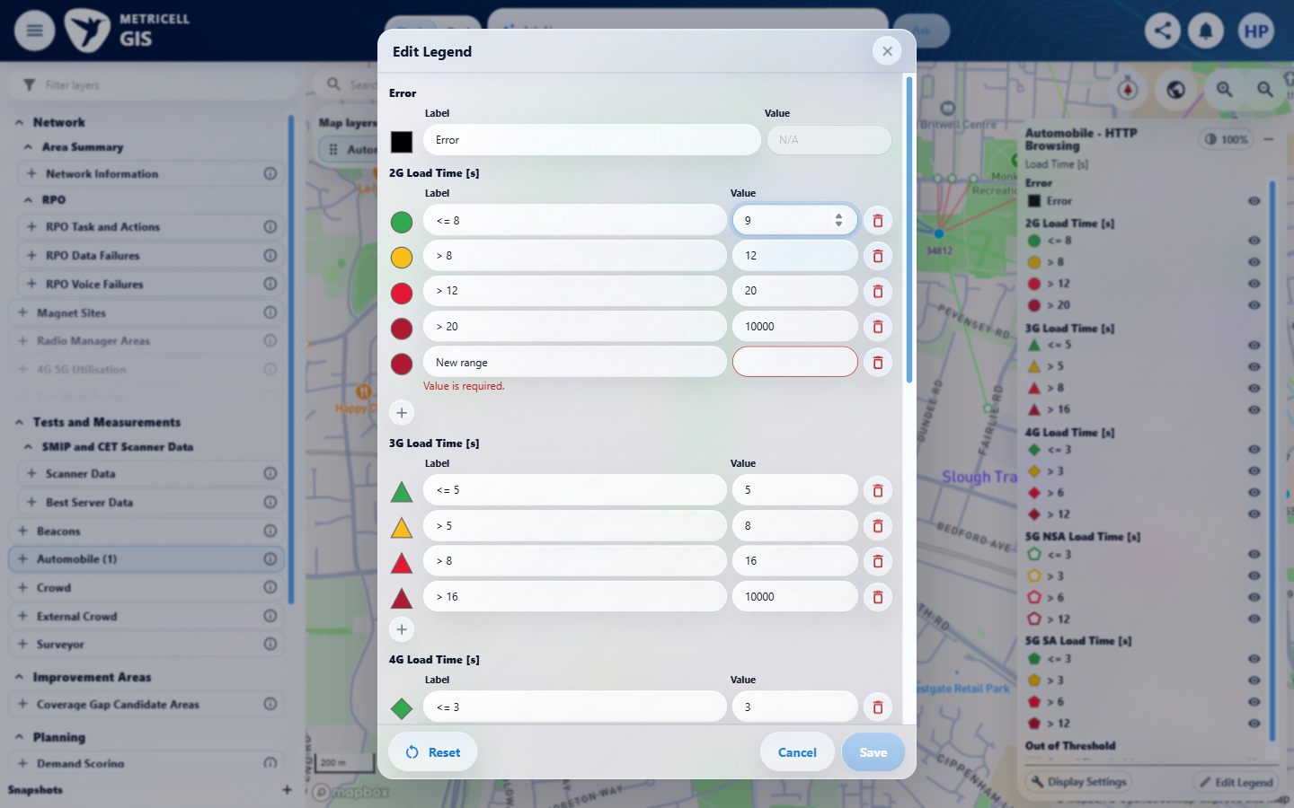 | E24 - After delete added (criterion-10-after-delete-added.png)  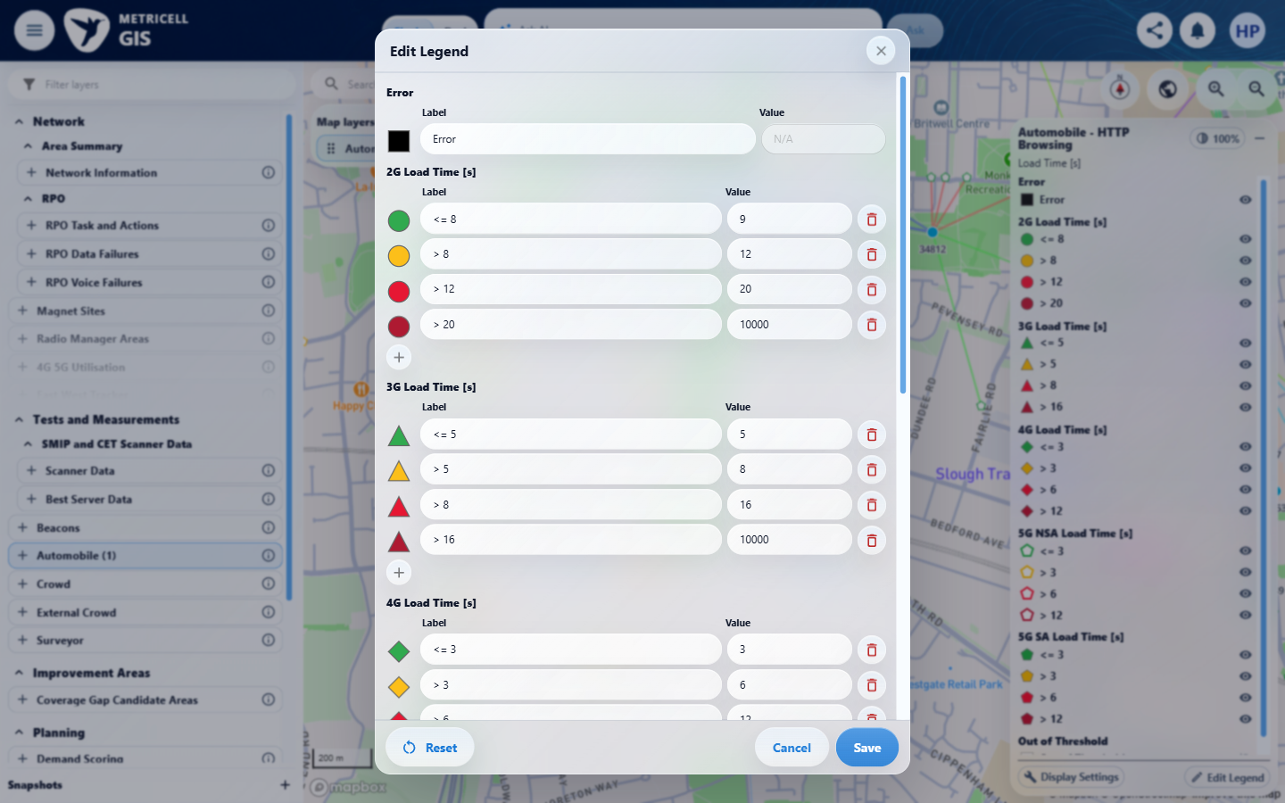

Criterion 10 continued: In a numeric generation group, the add control below the marker column adds a range row, eligible rows have delete controls, at least one range remains, and editing a value does not reorder Automobile rows.
Browser URL recorded after criterion: https://o2intelligence-v4-dev.metricell.com/gis
E25 - After delete last (criterion-10-after-delete-last.png)  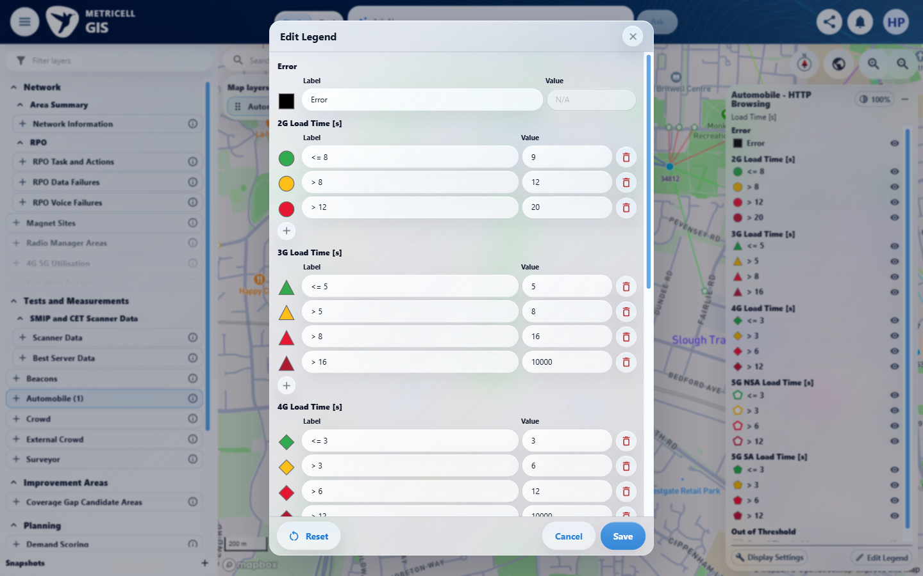 | E26 - After delete third (criterion-10-after-delete-third.png)  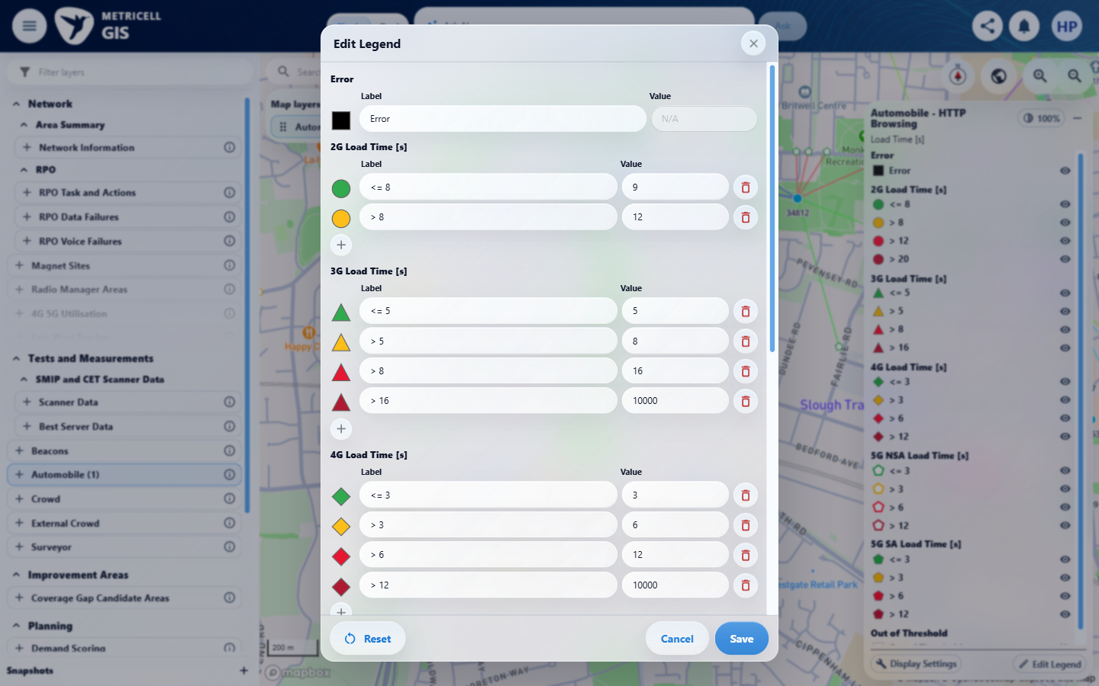

Criterion 10 continued: In a numeric generation group, the add control below the marker column adds a range row, eligible rows have delete controls, at least one range remains, and editing a value does not reorder Automobile rows.
Browser URL recorded after criterion: https://o2intelligence-v4-dev.metricell.com/gis
E27 - Final (criterion-10-final.png)
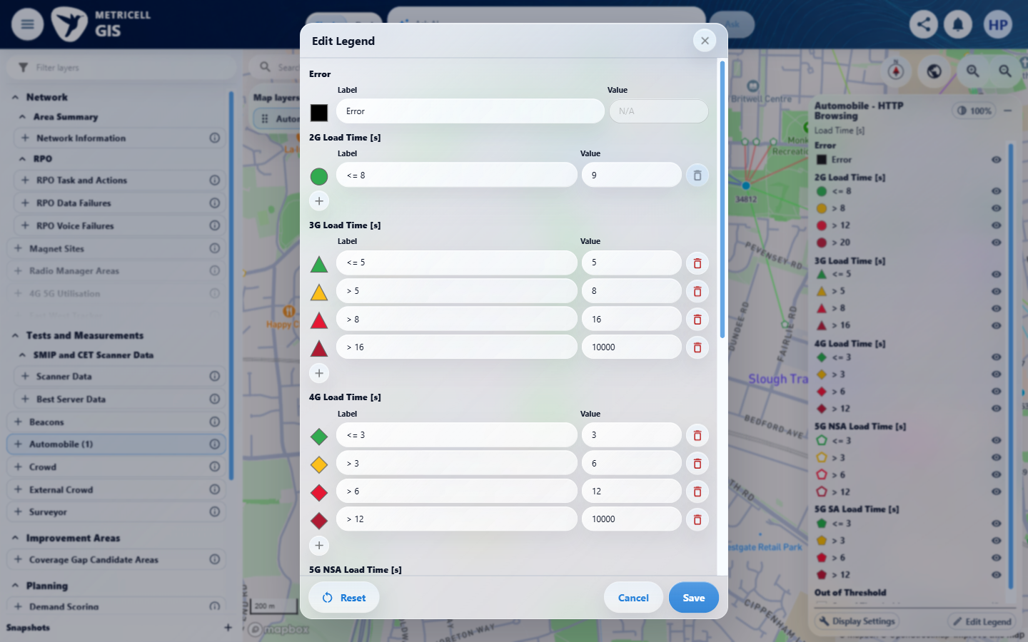

11.0.0 | Numeric Value fields use number inputs. Empty, non-finite, out-of-limit or incorrectly ordered boundary values show an inline error immediately and disable Save. HTTP Browsing boundaries accept 0–10,000; Ping and Video Streaming boundaries have a minimum of zero and no additional maximum. Video Streaming categories cannot be changed. | Numeric Value fields use number inputs. Empty, non-finite, out-of-limit or incorrectly ordered boundary values show an inline error immediately and disable Save. HTTP Browsing boundaries accept 0–10,000; Ping and Video Streaming boundaries have a minimum of zero and no additional maximum. Video Streaming categories cannot be changed. | criterion-11-confirmation-before-unordered.png shows first two HTTP boundaries 8 and 12; criterion-11-final.png shows 13 followed by 12 with no inline ordering error and Save visibly enabled. Empty, negative and above-maximum captures show errors and disabled Save, but the ordering contradiction fails the criterion. Ping/Video limits and fixed categories are unverified; no invalid save is evidenced.  Evidence: E28, E29, E30, E31, E32, E33, E34, E35, E36 | Failed
Criterion 11 evidence: Numeric Value fields use number inputs. Empty, non-finite, out-of-limit or incorrectly ordered boundary values show an inline error immediately and disable Save. HTTP Browsing boundaries accept 0–10,000; Ping and Video Streaming boundaries have a minimum of zero and no additional maximum. Video Streaming categories cannot be changed.
Browser URL recorded after criterion: https://o2intelligence-v4-dev.metricell.com/gis
E28 - Before open (criterion-11-before-open.png)  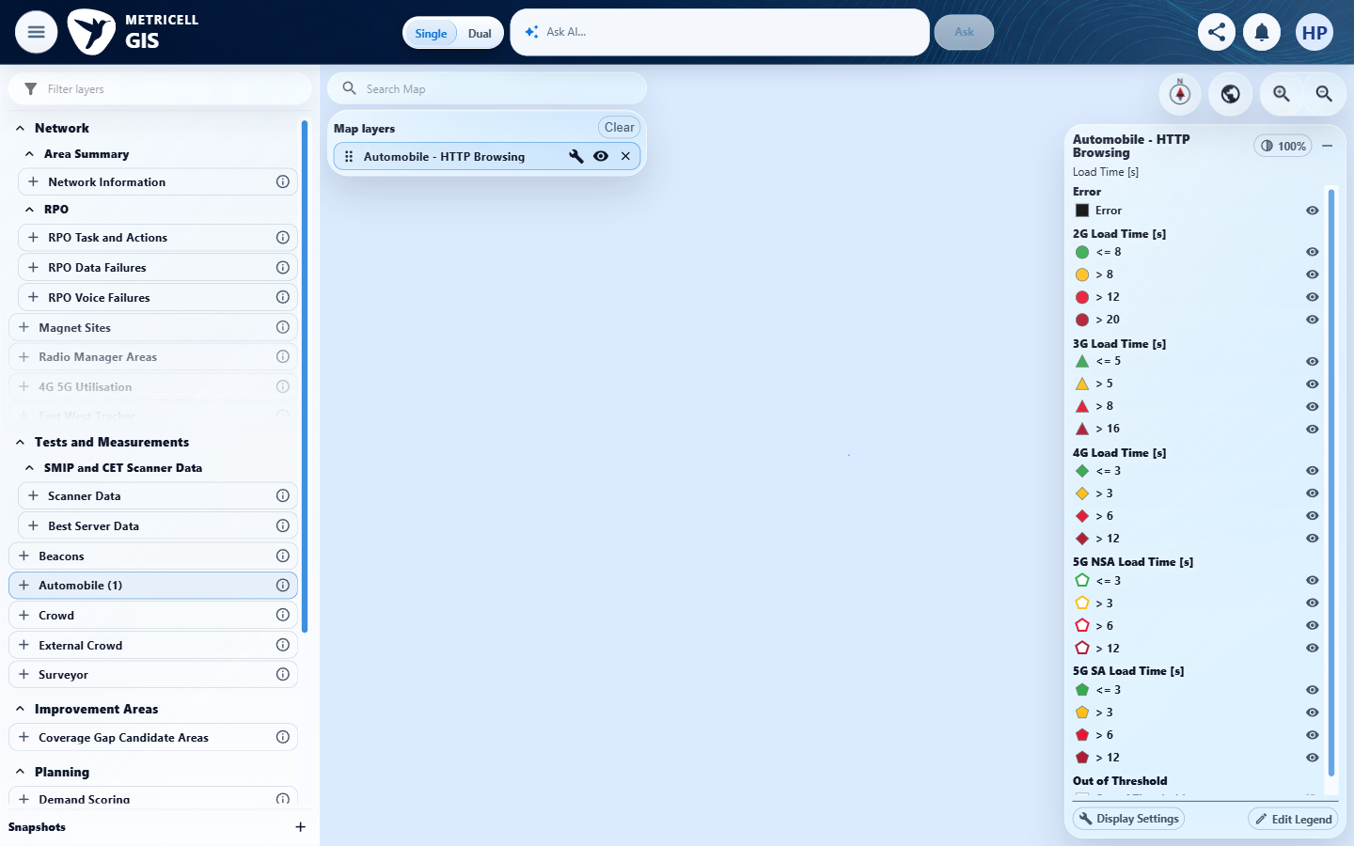 | E29 - Before invalid (criterion-11-before-invalid.png)  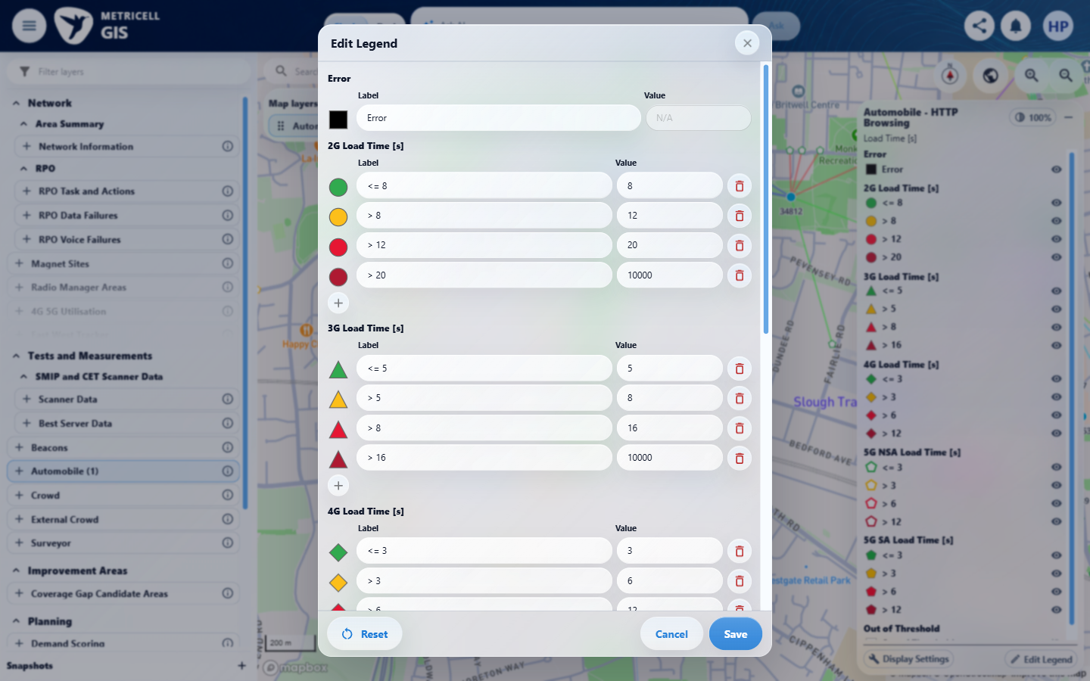

Criterion 11 continued: Numeric Value fields use number inputs. Empty, non-finite, out-of-limit or incorrectly ordered boundary values show an inline error immediately and disable Save. HTTP Browsing boundaries accept 0–10,000; Ping and Video Streaming boundaries have a minimum of zero and no additional maximum. Video Streaming categories cannot be changed.
Browser URL recorded after criterion: https://o2intelligence-v4-dev.metricell.com/gis
E30 - Empty invalid (criterion-11-empty-invalid.png)  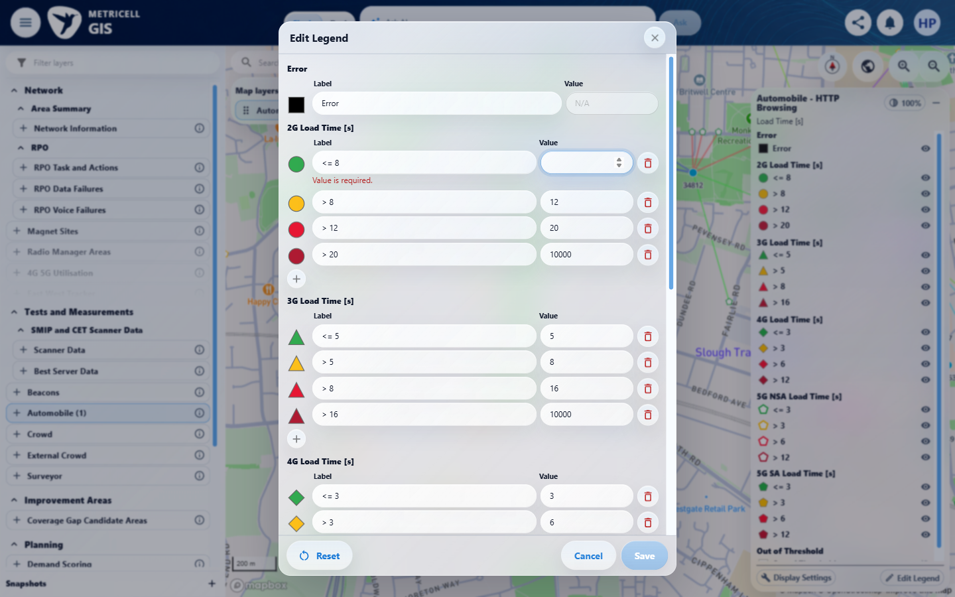 | E31 - Negative invalid (criterion-11-negative-invalid.png)  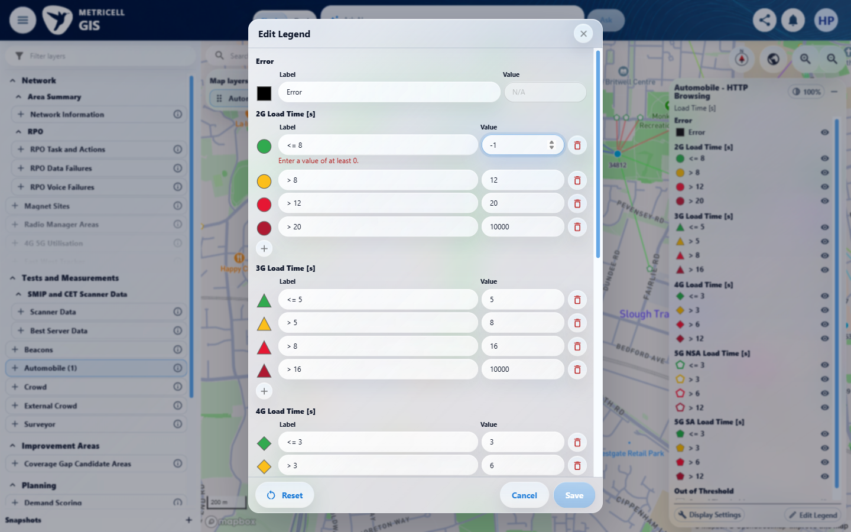

Criterion 11 continued: Numeric Value fields use number inputs. Empty, non-finite, out-of-limit or incorrectly ordered boundary values show an inline error immediately and disable Save. HTTP Browsing boundaries accept 0–10,000; Ping and Video Streaming boundaries have a minimum of zero and no additional maximum. Video Streaming categories cannot be changed.
Browser URL recorded after criterion: https://o2intelligence-v4-dev.metricell.com/gis
E32 - Above maximum invalid (criterion-11-above-maximum-invalid.png)  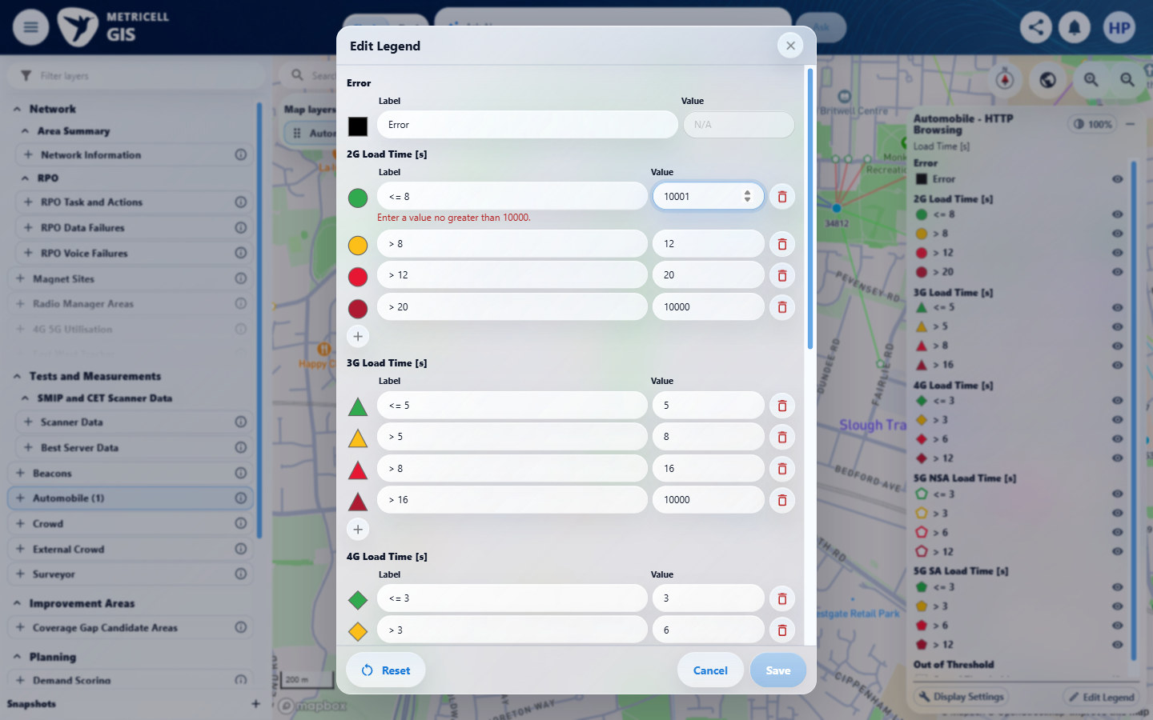 | E33 - Unordered invalid (criterion-11-unordered-invalid.png)  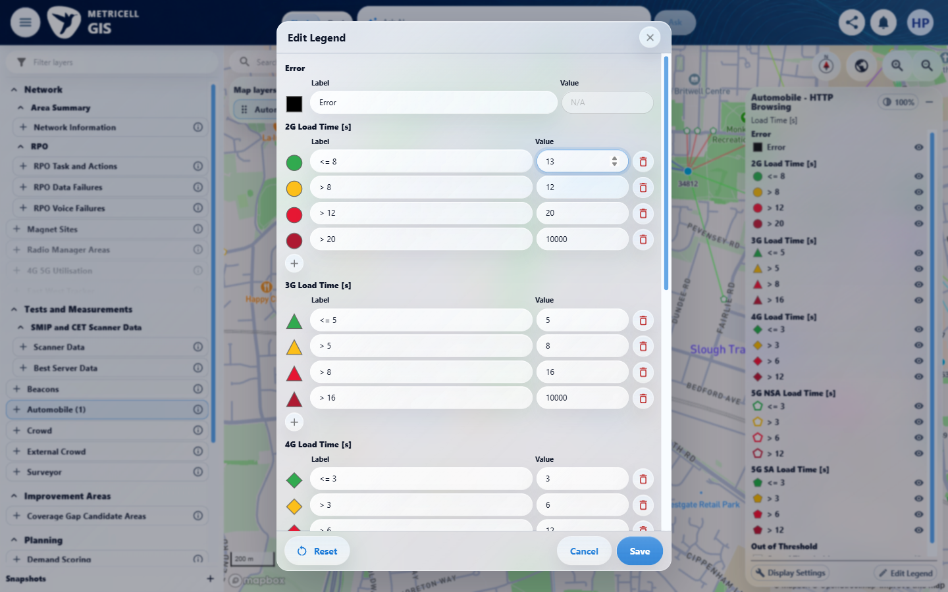

Criterion 11 continued: Numeric Value fields use number inputs. Empty, non-finite, out-of-limit or incorrectly ordered boundary values show an inline error immediately and disable Save. HTTP Browsing boundaries accept 0–10,000; Ping and Video Streaming boundaries have a minimum of zero and no additional maximum. Video Streaming categories cannot be changed.
Browser URL recorded after criterion: https://o2intelligence-v4-dev.metricell.com/gis
E34 - Confirmation before open (criterion-11-confirmation-before-open.png)  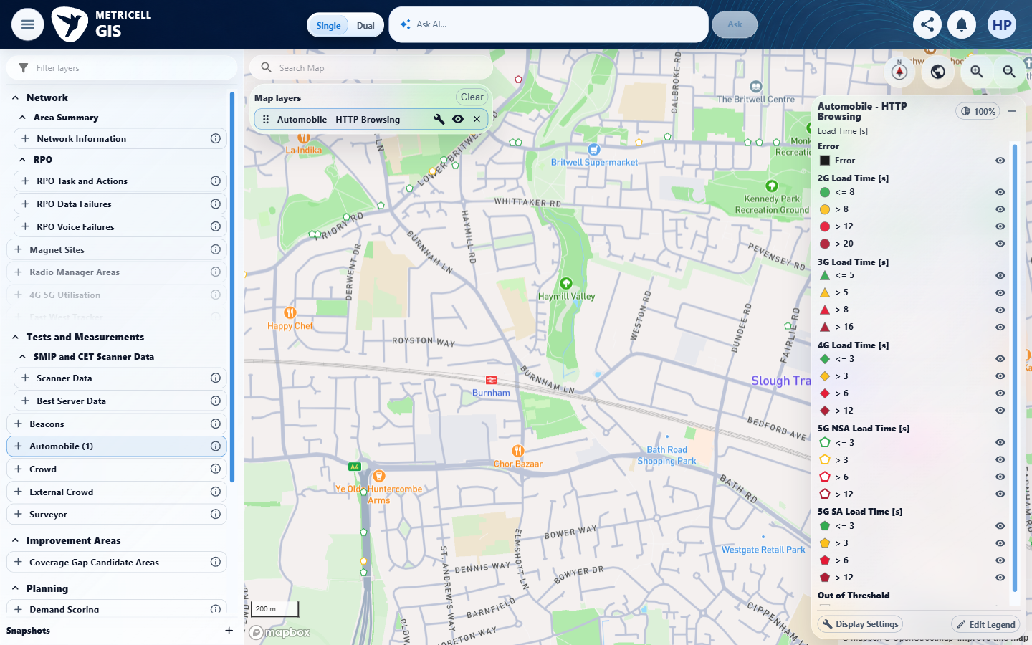 | E35 - Confirmation before unordered (criterion-11-confirmation-before-unordered.png)  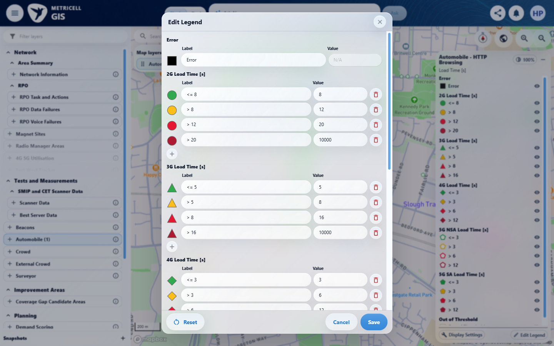

Criterion 11 continued: Numeric Value fields use number inputs. Empty, non-finite, out-of-limit or incorrectly ordered boundary values show an inline error immediately and disable Save. HTTP Browsing boundaries accept 0–10,000; Ping and Video Streaming boundaries have a minimum of zero and no additional maximum. Video Streaming categories cannot be changed.
Browser URL recorded after criterion: https://o2intelligence-v4-dev.metricell.com/gis
E36 - Final (criterion-11-final.png)
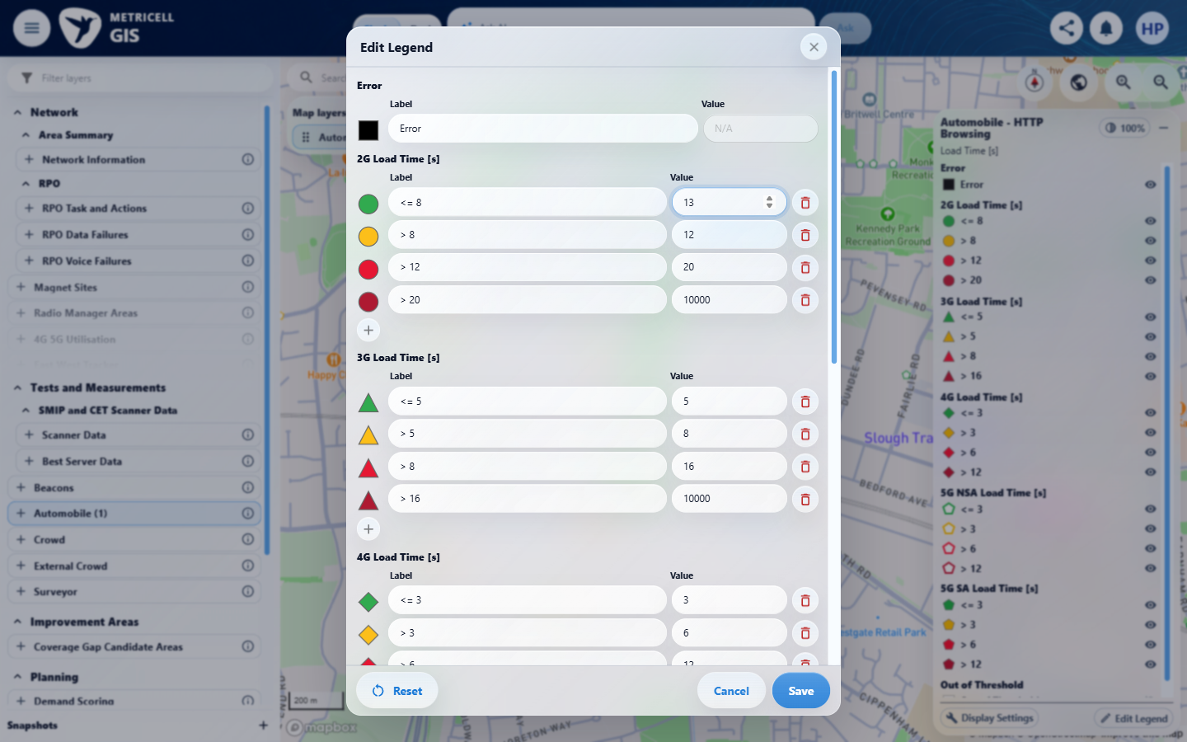

12.0.0 | Reset displays default labels, colours, boundaries, categories and visibility as drafts; saving applies defaults to the active field only, preserving other fields and layers. | Reset displays default labels, colours, boundaries, categories and visibility as drafts; saving applies defaults to the active field only, preserving other fields and layers. | criterion-12-baseline-map.png and criterion-12-baseline-layers.png show the settled baseline. criterion-12-custom-saved-before-reset.png to criterion-12-reset-draft-before-cancel.png shows <=8 as a reset draft while the saved custom label remains behind; criterion-12-after-cancel-reset.png retains that custom label. criterion-12-reopen-before-final-reset.png, criterion-12-final-reset-before-save.png, criterion-12-saved-defaults.png and criterion-12-final.png show the repeated Reset/Save restoring <=8. Independent configured defaults and reset effects for colours, boundaries, categories, visibility and other field/layer overrides are not established.  Evidence: E13, E14, E37, E38, E39, E40, E41, E42, E43, E44 | Failed
Criterion 12 evidence: Reset displays default labels, colours, boundaries, categories and visibility as drafts; saving applies defaults to the active field only, preserving other fields and layers.
Browser URL recorded after criterion: https://o2intelligence-v4-dev.metricell.com/gis
E13 - Baseline map (criterion-12-baseline-map.png) | E14 - Baseline layers (criterion-12-baseline-layers.png)

Criterion 12 continued: Reset displays default labels, colours, boundaries, categories and visibility as drafts; saving applies defaults to the active field only, preserving other fields and layers.
Browser URL recorded after criterion: https://o2intelligence-v4-dev.metricell.com/gis
E37 - Before custom edit (criterion-12-before-custom-edit.png)  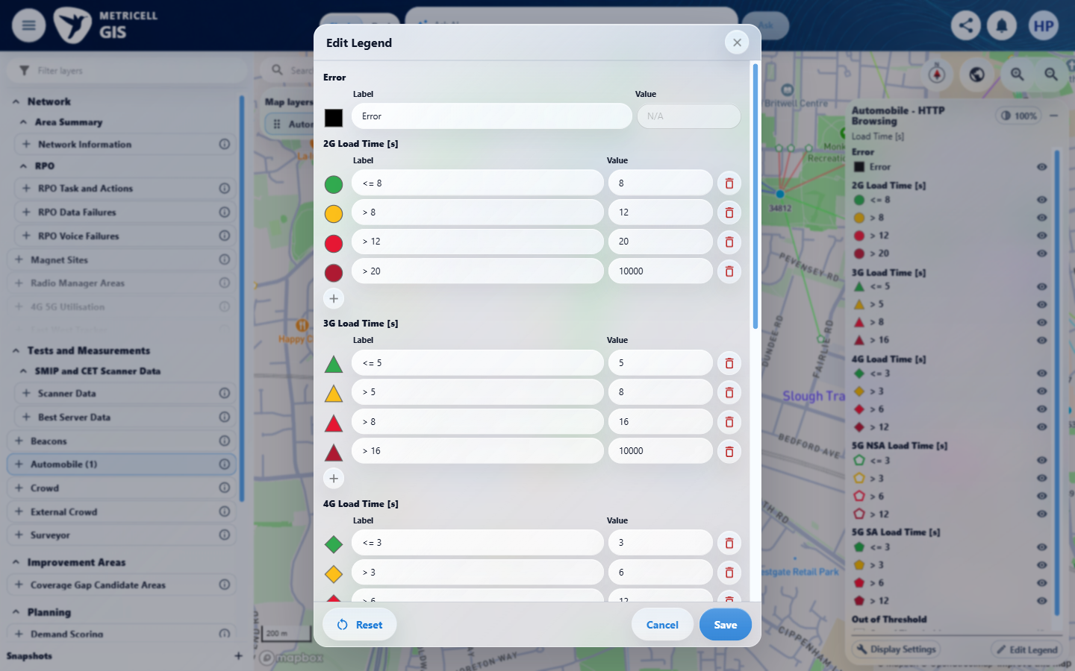 | E38 - Custom draft (criterion-12-custom-draft.png)  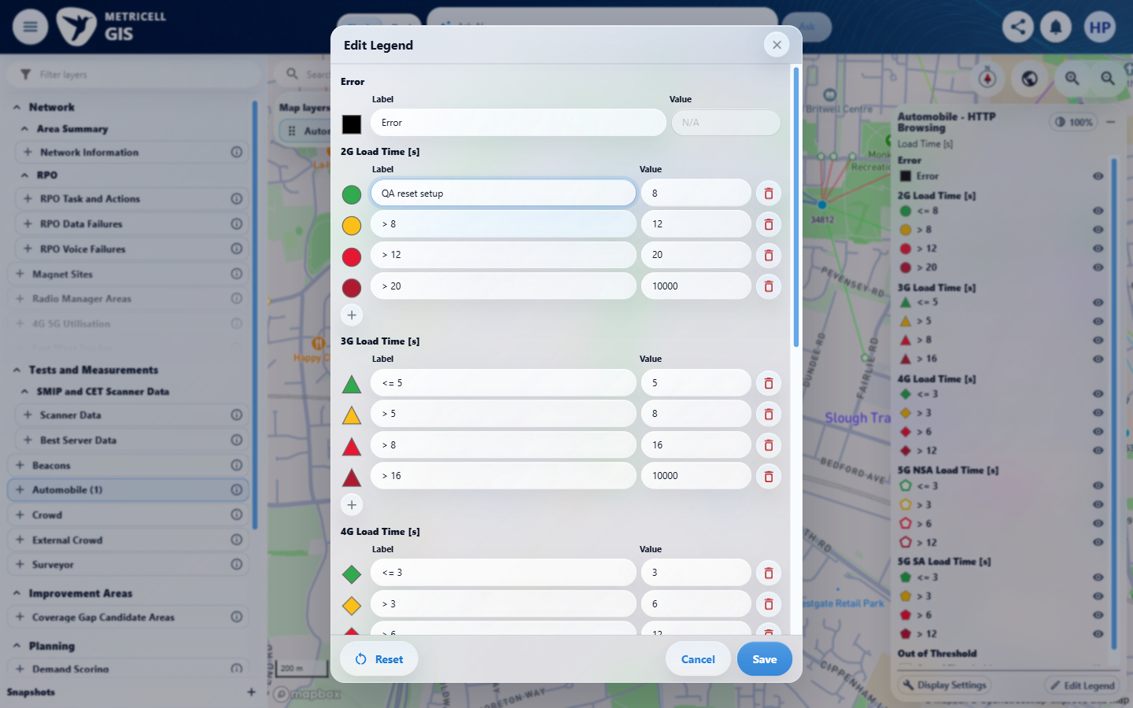

Criterion 12 continued: Reset displays default labels, colours, boundaries, categories and visibility as drafts; saving applies defaults to the active field only, preserving other fields and layers.
Browser URL recorded after criterion: https://o2intelligence-v4-dev.metricell.com/gis
E39 - Custom saved before reset (criterion-12-custom-saved-before-reset.png)  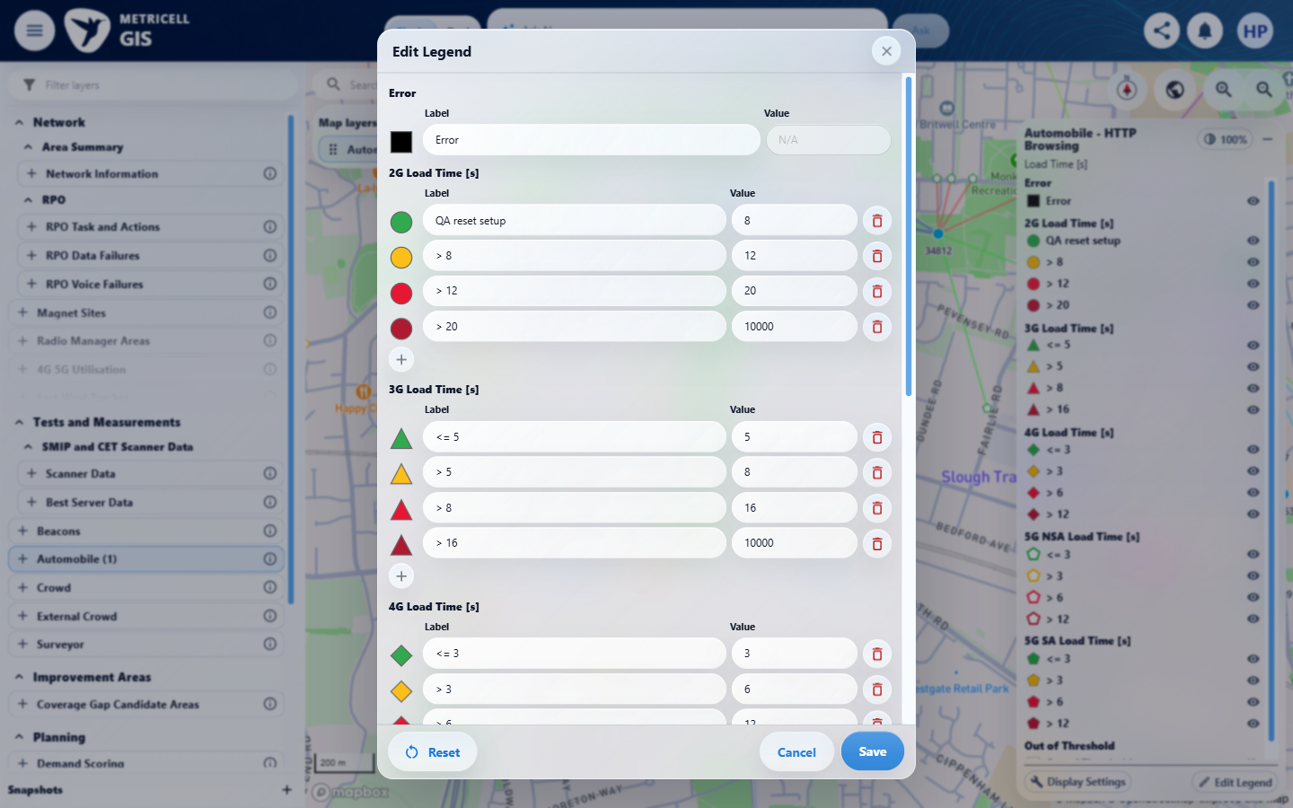 | E40 - Reset draft before cancel (criterion-12-reset-draft-before-cancel.png)  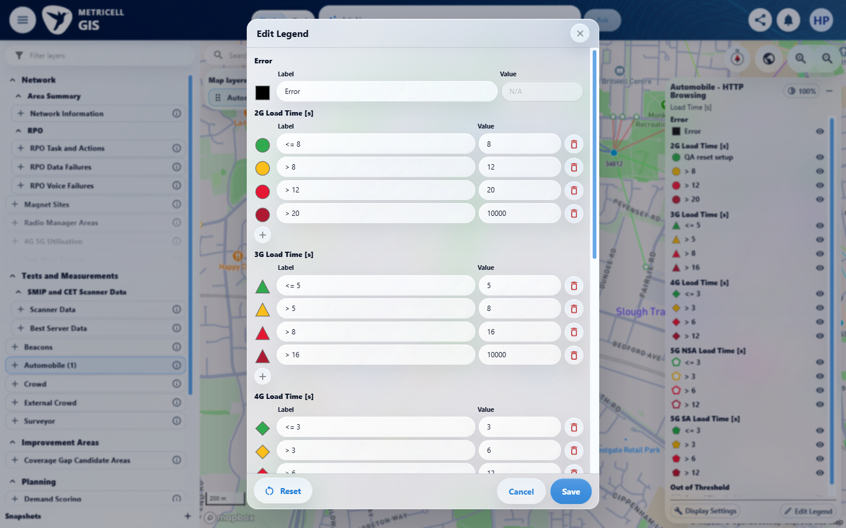

Criterion 12 continued: Reset displays default labels, colours, boundaries, categories and visibility as drafts; saving applies defaults to the active field only, preserving other fields and layers.
Browser URL recorded after criterion: https://o2intelligence-v4-dev.metricell.com/gis
E41 - After cancel reset (criterion-12-after-cancel-reset.png)  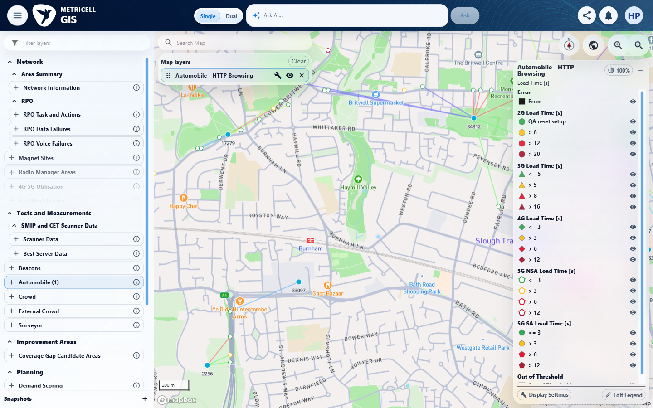 | E42 - Reopen before final reset (criterion-12-reopen-before-final-reset.png)  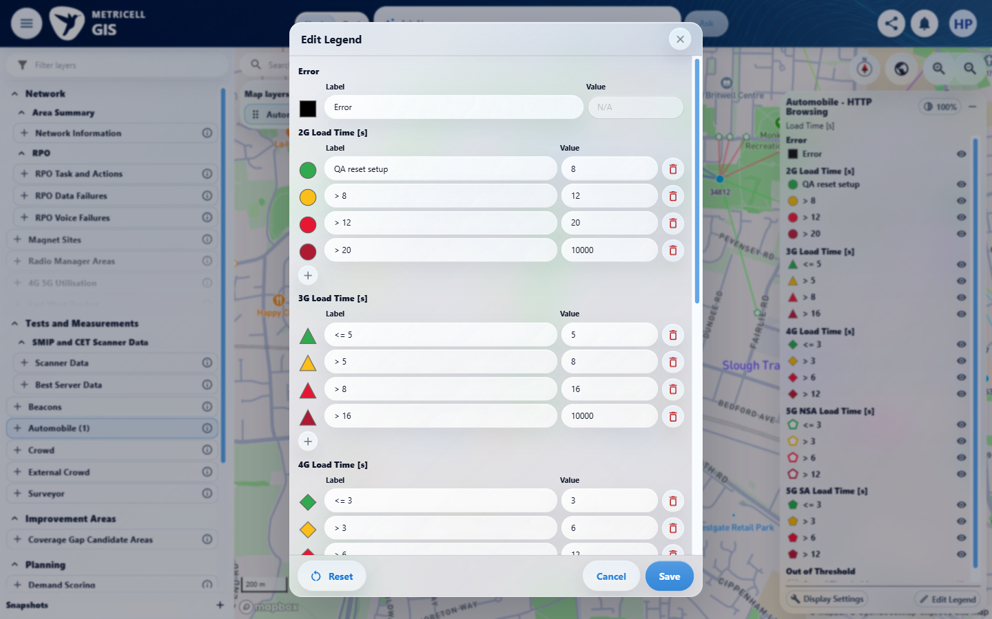

Criterion 12 continued: Reset displays default labels, colours, boundaries, categories and visibility as drafts; saving applies defaults to the active field only, preserving other fields and layers.
Browser URL recorded after criterion: https://o2intelligence-v4-dev.metricell.com/gis
E40 - Final reset before save (criterion-12-final-reset-before-save.png) | E43 - Saved defaults (criterion-12-saved-defaults.png)  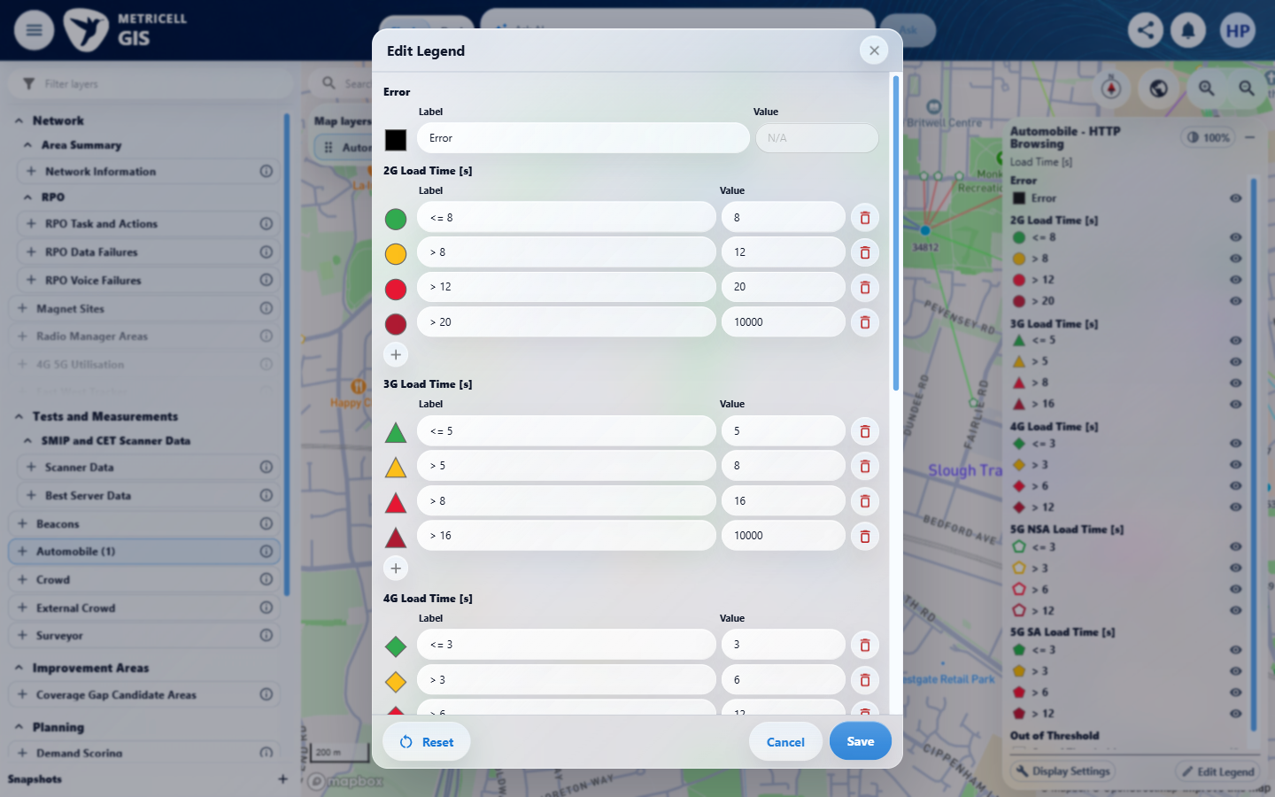

Criterion 12 continued: Reset displays default labels, colours, boundaries, categories and visibility as drafts; saving applies defaults to the active field only, preserving other fields and layers.
Browser URL recorded after criterion: https://o2intelligence-v4-dev.metricell.com/gis
E44 - Final (criterion-12-final.png)
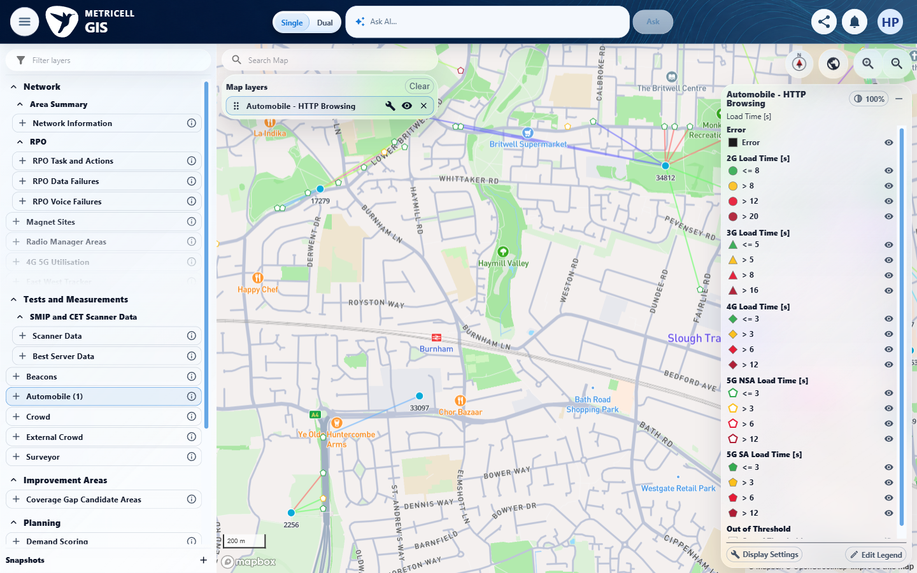

13.0.0 | Linked-site and linked-cell display settings use the shared Network context and follow visible result categories; linked cells are disabled when linked sites are off, and settings persist per layer. | Linked-site and linked-cell display settings use the shared Network context and follow visible result categories; linked cells are disabled when linked sites are off, and settings persist per layer. | criterion-13-baseline-map.png and criterion-13-baseline-layers.png show the original linked map. criterion-13-settings-baseline.png, criterion-13-sites-off-cells-disabled.png and criterion-13-sites-off-map.png show sites off and cells disabled, with site connections removed. After criterion-13-persistence-launcher.png, criterion-13-restored-sites-off-map.png and criterion-13-final.png retain sites off. Shared Network context, category-following, linked-cell rendering and independent per-layer settings remain unverified.  Evidence: E13, E14, E45, E46, E47, E48, E34, E49 | Failed
Criterion 13 evidence: Linked-site and linked-cell display settings use the shared Network context and follow visible result categories; linked cells are disabled when linked sites are off, and settings persist per layer.
Browser URL recorded after criterion: https://o2intelligence-v4-dev.metricell.com/gis
E13 - Baseline map (criterion-13-baseline-map.png) | E14 - Baseline layers (criterion-13-baseline-layers.png)

Criterion 13 continued: Linked-site and linked-cell display settings use the shared Network context and follow visible result categories; linked cells are disabled when linked sites are off, and settings persist per layer.
Browser URL recorded after criterion: https://o2intelligence-v4-dev.metricell.com/gis
E45 - Settings baseline (criterion-13-settings-baseline.png)  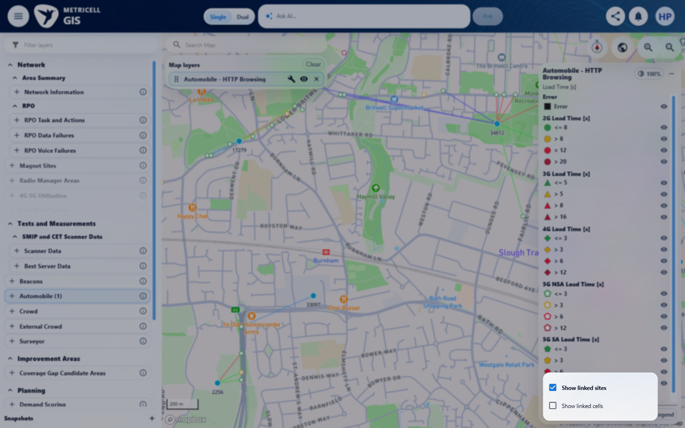 | E46 - Sites off cells disabled (criterion-13-sites-off-cells-disabled.png)  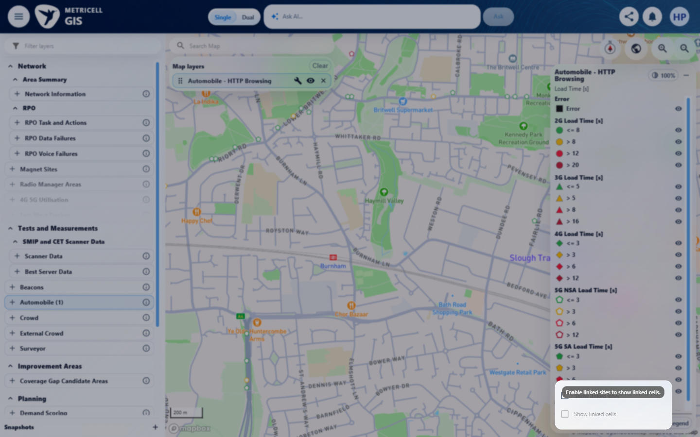

Criterion 13 continued: Linked-site and linked-cell display settings use the shared Network context and follow visible result categories; linked cells are disabled when linked sites are off, and settings persist per layer.
Browser URL recorded after criterion: https://o2intelligence-v4-dev.metricell.com/gis
E47 - Sites off map (criterion-13-sites-off-map.png)  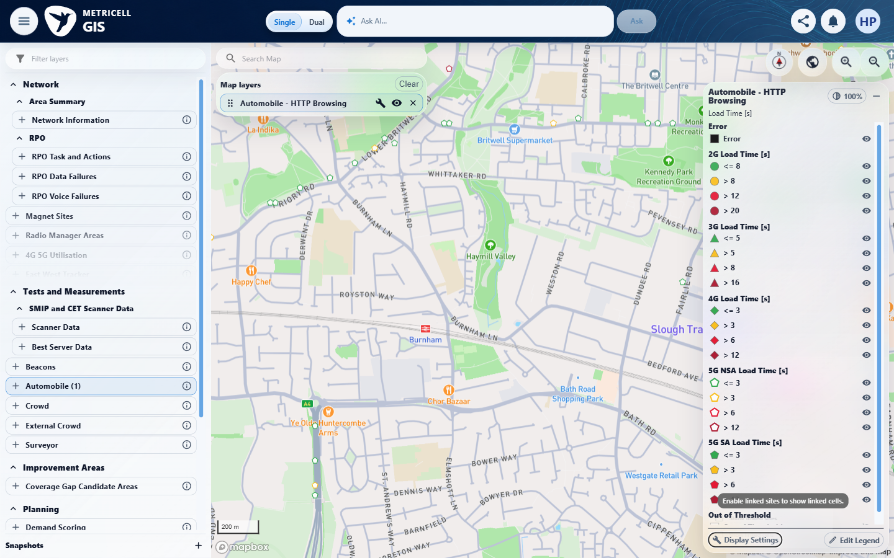 | E48 - Persistence launcher (criterion-13-persistence-launcher.png)  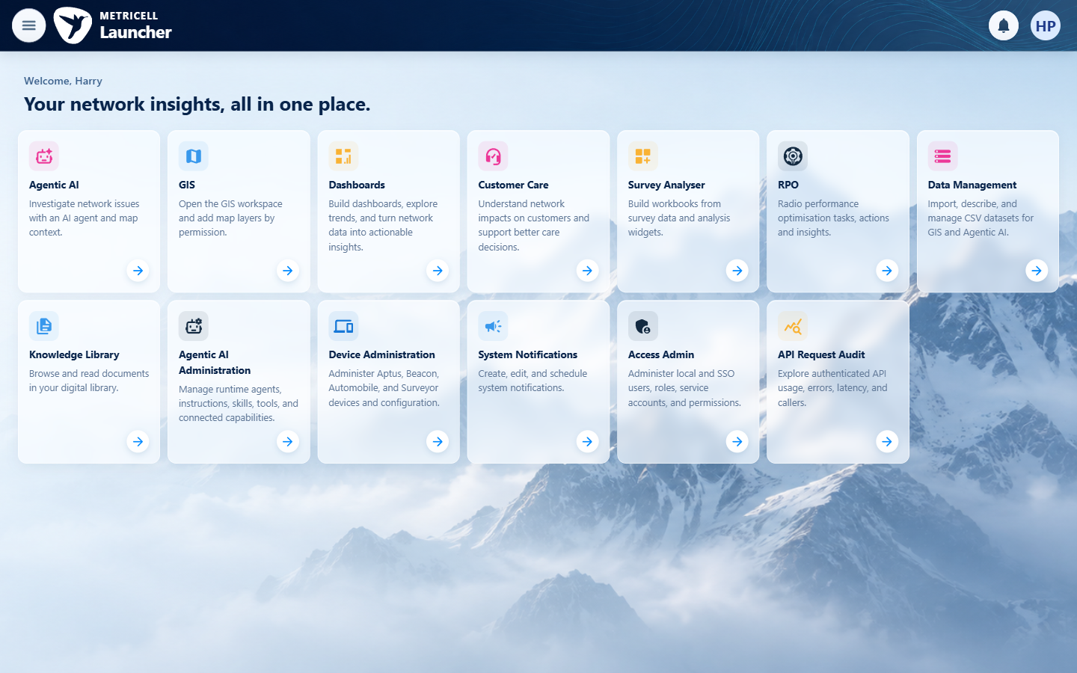

Criterion 13 continued: Linked-site and linked-cell display settings use the shared Network context and follow visible result categories; linked cells are disabled when linked sites are off, and settings persist per layer.
Browser URL recorded after criterion: https://o2intelligence-v4-dev.metricell.com/gis
E34 - Restored sites off map (criterion-13-restored-sites-off-map.png) | E49 - Final (criterion-13-final.png)  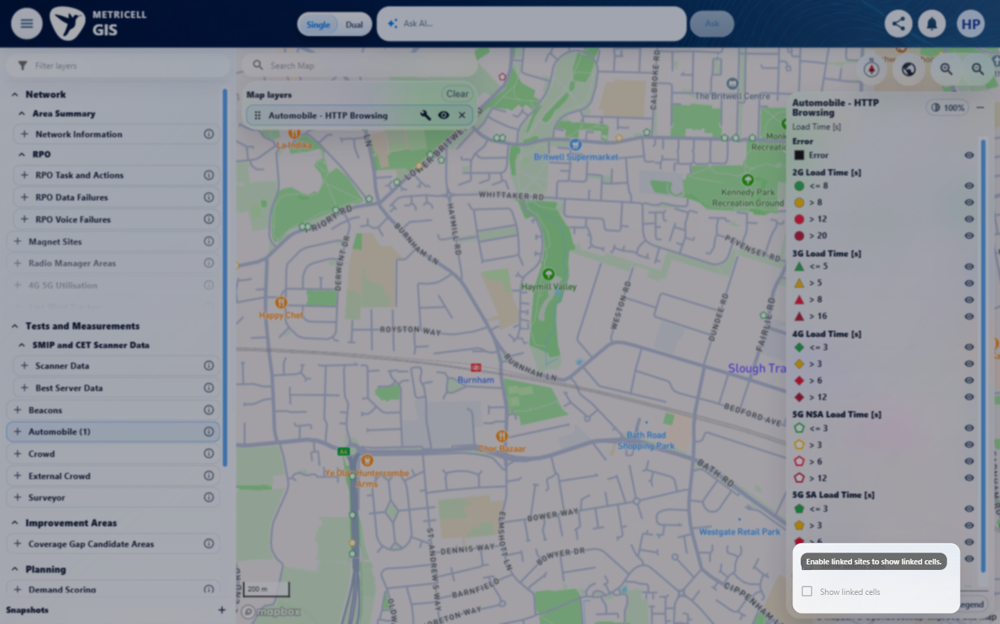

14.0.0 | With or without a details tab, the legend remains scrollable when the map pane is resized and does not overlap Reset North or other map controls. | With or without a details tab, the legend remains scrollable when the map pane is resized and does not overlap Reset North or other map controls. | criterion-14-before-resize.png, criterion-14-resized-without-details.png and criterion-14-final.png show the reduced pane, different legend scroll positions and clear space below the map controls. No details-tab state is captured, so the combined layout assertion remains unverified.  Evidence: E34, E50, E51 | Failed
Criterion 14 evidence: With or without a details tab, the legend remains scrollable when the map pane is resized and does not overlap Reset North or other map controls.
Browser URL recorded after criterion: https://o2intelligence-v4-dev.metricell.com/gis
E34 - Before resize (criterion-14-before-resize.png) | E50 - Resized without details (criterion-14-resized-without-details.png)  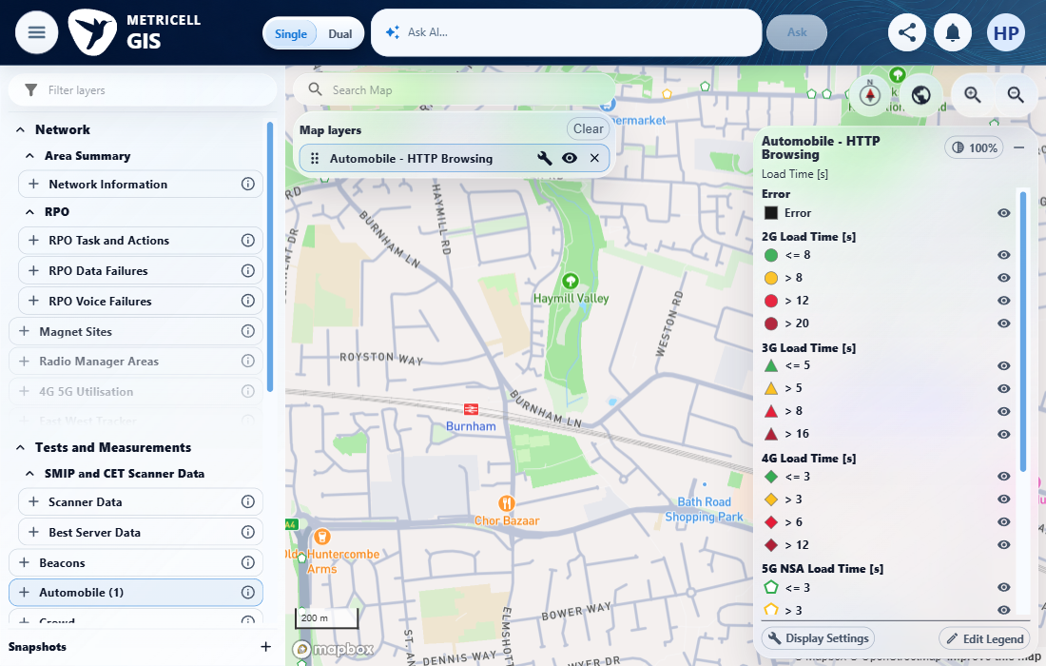

Criterion 14 continued: With or without a details tab, the legend remains scrollable when the map pane is resized and does not overlap Reset North or other map controls.
Browser URL recorded after criterion: https://o2intelligence-v4-dev.metricell.com/gis
E51 - Final (criterion-14-final.png)
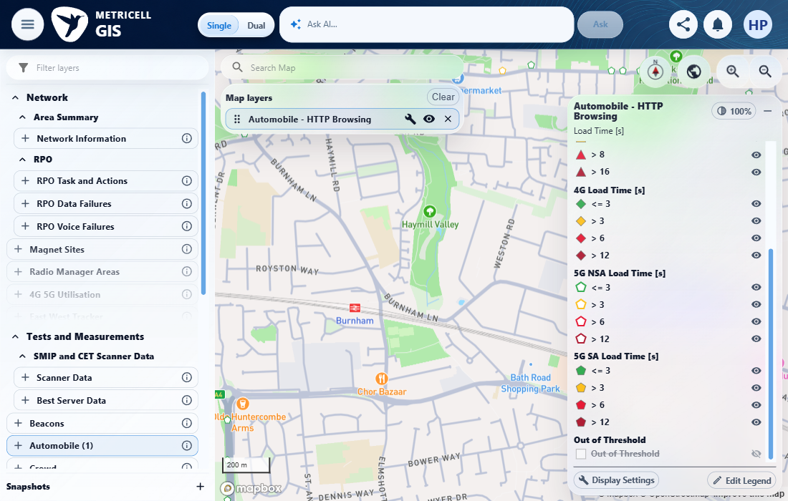

15.0.0 | For existing consumers of the shared legend, established markers, visibility, editor actions and default behavior remain unchanged unless a consumer opts into the new options. | For existing consumers of the shared legend, established markers, visibility, editor actions and default behavior remain unchanged unless a consumer opts into the new options. | criterion-15-existing-consumer-prerequisite.png shows the current Automobile layer and catalogue, but supplies no identified existing consumer, opt-in status or independent pre-change baseline. Established marker, visibility, editor and default behavior cannot be compared for preservation.  Evidence: E34 | Failed
Criterion 15 evidence: For existing consumers of the shared legend, established markers, visibility, editor actions and default behavior remain unchanged unless a consumer opts into the new options.
Browser URL recorded after criterion: https://o2intelligence-v4-dev.metricell.com/gis
E34 - Existing consumer prerequisite (criterion-15-existing-consumer-prerequisite.png)

About Metricell

Metricell is on a mission to deliver connectivity. We work with our customers to design, deliver and manage wireless communication networks – with a shared ambition of achieving flawless network experience. We’ve been responsible for many first-to-market products, and our technology is characterised by the relentless pursuit of automation and digitalisation.

Our geospatial intelligence tools traverse a wide variety of business processes – from Test & Measurement to Customer Experience Management – and we’re pioneers in Crowdsourcing and Digital Self Care. Our technology is today in use by a range of customers; thousands of their personnel; and millions of subscribers worldwide.

Find out more at www.metricell.com




