

Automated Test Case Document
Jira Ticket: TEST2-82

Document Classification: | Company Confidential
Document Ref: | Automated Test Case Document
Version: | 1.0
Date: | 21/10/2026
Document Author: | Automated TEST2 Evidence Review
Document Owner: | Quality Assurance / Metricell




This document and its content is copyright of Metricell Limited @ 2026 all rights reserved. All information contained herein is the intellectual property of Metricell Limited and should be treated as confidential. Any external redistribution of reproduction of part or all of the contents in any form is prohibited unless expressly agreed with Metricell Limited in writing. Any reproduced content must include the following statement; “Part or all of the content contained herein is copyright of Metricell Limited @ 2026 all rights reserved”.
Table of Contents
1 Revision History 2
2 Test Cycle Information 3
3 Test Summary 3
4 Test Cases 4
About Metricell 12

Revision History

Version | Date | Revision Author | Summary of Changes
[1.0] | 21/10/2026 | TEST2 QA Automation | Generated from TEST2 evidence review

Test Cycle Information

Tester: | Automated
Jira Ticket: | TEST2-82
Environment: | o2intelligence-v4-dev.metricell.com
Browser Details: | Google Chrome 155.0.8059.85
Date of Test: | 21/10/2026
Limitations during Testing: | Blocked criterion(s): 5. See the assessment below each criterion.  SIMULATED UI STATE: criterion(s) 4, 6 use browser-local conditions, not backend integration tests. Method and recovery are disclosed with their evidence. Pass, Fail and Blocked use Y/N. Defect No counts directly contradicted criteria, not unique Jira bugs; blockers and inconclusive evidence count as zero.
Overall review outcome: | Blocked
Browser URL(s) recorded after criteria: | https://o2intelligence-v4-dev.metricell.com/gis

Test Summary

Area of test | Pass (Y/N) | Fail (Y/N) | Blocked (Y/N) | Defect No
1. When a selected Ping point’s details have loaded, the detail view shows that point’s Ping Time with the unit milliseconds (ms). | Y | N | N | 0
2. When Ping attributes are returned for the selected point, the detail view displays those attributes alongside the Ping Time. | Y | N | N | 0
3. With 5G NSA as the only selected technology, opening a Ping point displays details for that selected point without an error state. | Y | N | N | 0
4. While Ping details are loading, the detail view shows a loading state. | N | Y | N | 1
5. When Ping details are unavailable, the detail view shows a no-data state. | N | N | Y | 0
6. When Ping details fail to load, the detail view shows an error state and does not display data as if it belonged to the selected point. | Y | N | N | 0

Test Cases
Each test maps to a criterion and decisive browser evidence. Inconclusive results are reported as Failed.

Tests

Preconditions: | V4 access and ticket conditions. | Associated Requirements: | Ticket criteria below. | Automation Notes: | Screenshots below each criterion; full log retained locally.
ID / Criterion | Criteria Tested | Expected Result | Actual Result / Evidence Path | Outcome
1.0.0 | When a selected Ping point’s details have loaded, the detail view shows that point’s Ping Time with the unit milliseconds (ms). | When a selected Ping point’s details have loaded, the detail view shows that point’s Ping Time with the unit milliseconds (ms). | criterion-1-test-types.png shows Ping nested under Automobile; criterion-1-ping-map.png establishes the applied Automobile - Ping layer, and criterion-1-final.png shows selected Test ID 131925029 with Ping Time (ms) 0. The reported genuine Automobile detail response matches that identity/value; a failed measurement is not a failed detail load. criterion-1-after-apply.png still shows the prior HTTP Browsing table, so the later Ping map/final are decisive.  Evidence: E01, E02, E03, E04, E05, E06, E07 | Passed
Criterion 1 assessment: criterion-1-test-types.png shows Ping nested under Automobile; criterion-1-ping-map.png establishes the applied Automobile - Ping layer, and criterion-1-final.png shows selected Test ID 131925029 with Ping Time (ms) 0. The reported genuine Automobile detail response matches that identity/value; a failed measurement is not a failed detail load. criterion-1-after-apply.png still shows the prior HTTP Browsing table, so the later Ping map/final are decisive.
Testing notes: The selected record is a failed Ping measurement with valid, successfully loaded details; zero is its actual returned value, not a detail-load error. Cleanup limitation: original HTTP Browsing detail-panel selection was closed and not restored. Original Automobile HTTP Browsing type and technology selections were restored at run end. First screenshot save returned ENOENT; created this handoff's owned screenshot directory and restarted at the launcher before testing.
Criterion 1 evidence: When a selected Ping point’s details have loaded, the detail view shows that point’s Ping Time with the unit milliseconds (ms).
Browser URL recorded after criterion: https://o2intelligence-v4-dev.metricell.com/gis
E01 - Before configure (criterion-1-before-configure.png)  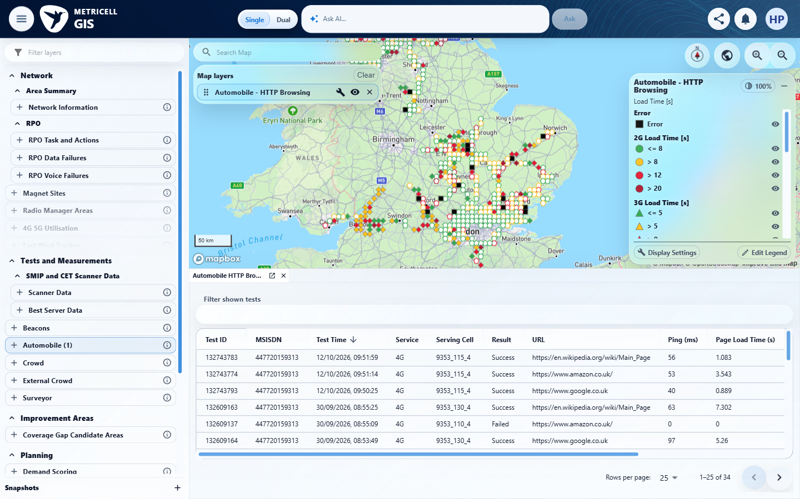 | E02 - Configured parent (criterion-1-configured-parent.png)  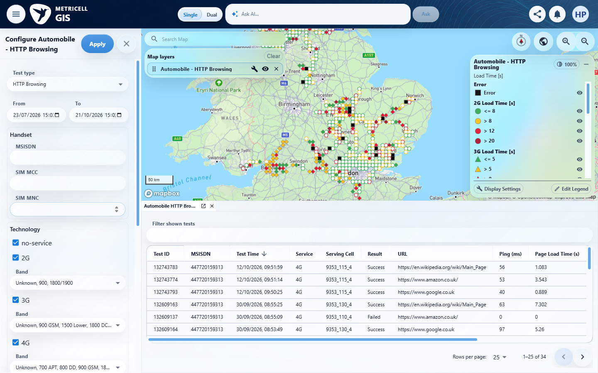

Criterion 1 continued: When a selected Ping point’s details have loaded, the detail view shows that point’s Ping Time with the unit milliseconds (ms).
Browser URL recorded after criterion: https://o2intelligence-v4-dev.metricell.com/gis
E03 - Test types (criterion-1-test-types.png)  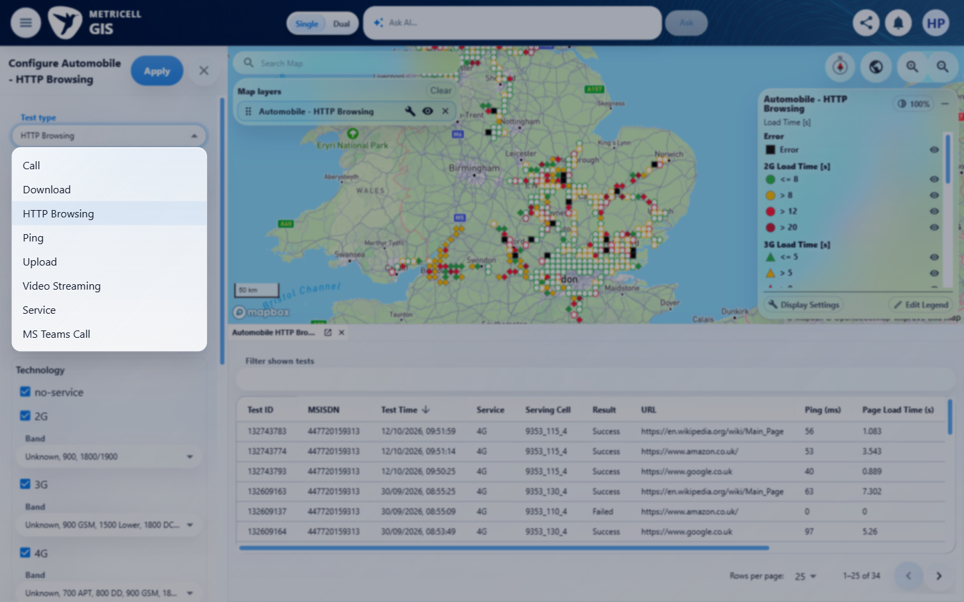 | E04 - Before apply (criterion-1-before-apply.png)  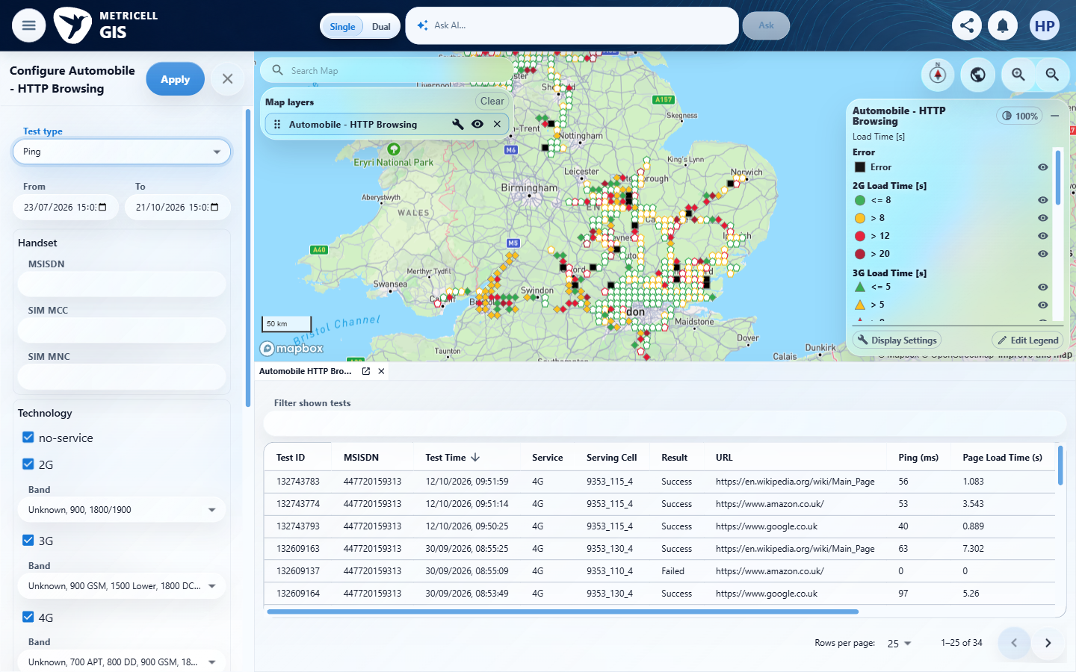

Criterion 1 continued: When a selected Ping point’s details have loaded, the detail view shows that point’s Ping Time with the unit milliseconds (ms).
Browser URL recorded after criterion: https://o2intelligence-v4-dev.metricell.com/gis
E05 - After apply (criterion-1-after-apply.png)  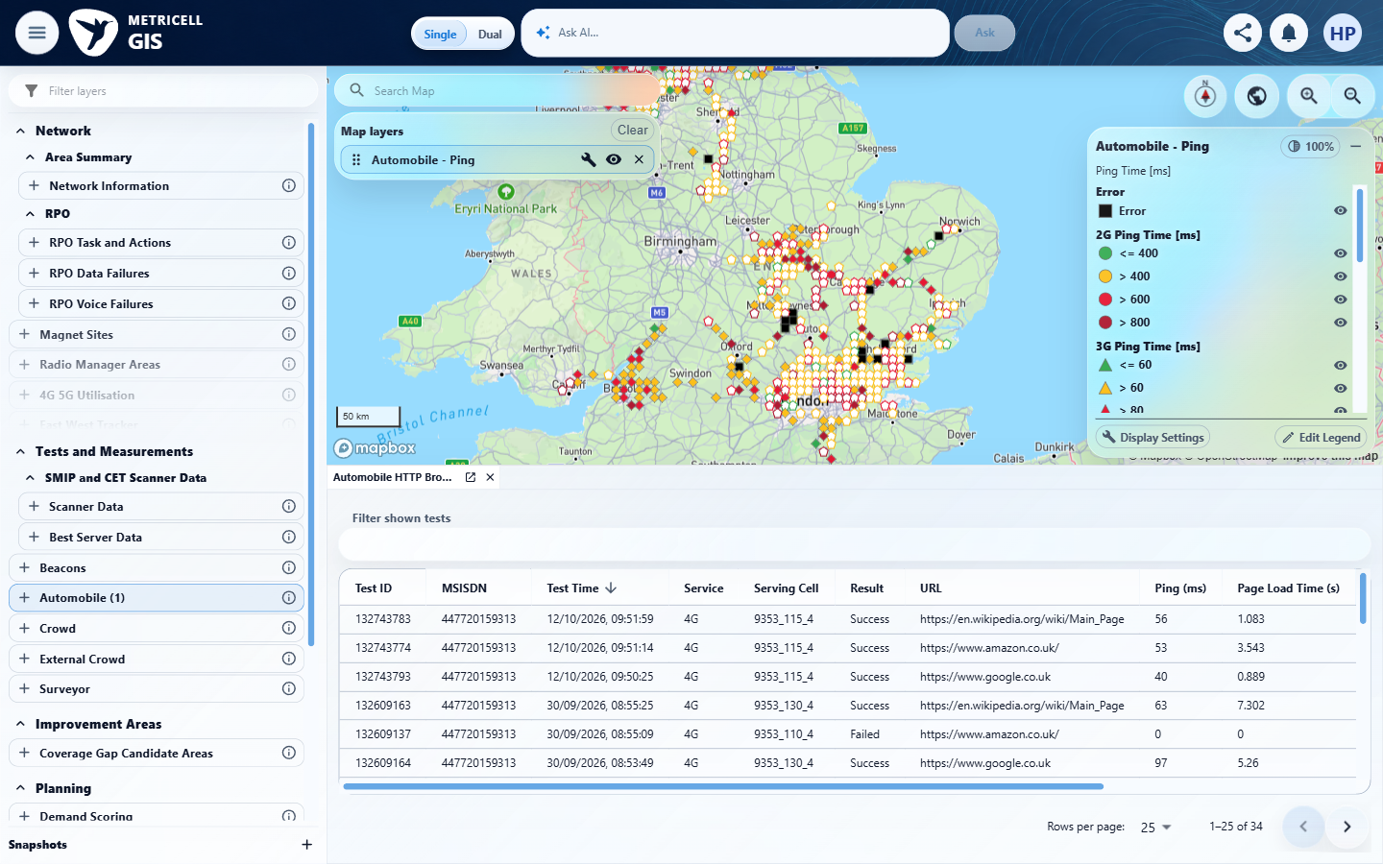 | E06 - Ping map (criterion-1-ping-map.png)  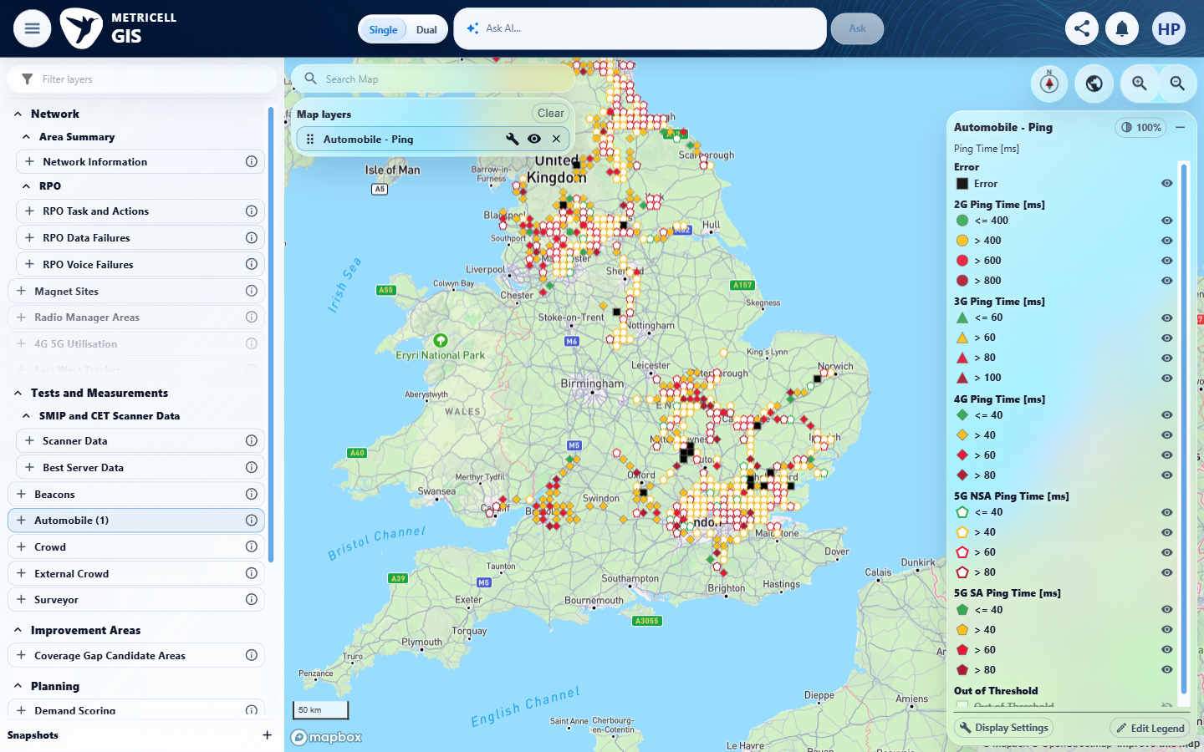

Criterion 1 continued: When a selected Ping point’s details have loaded, the detail view shows that point’s Ping Time with the unit milliseconds (ms).
Browser URL recorded after criterion: https://o2intelligence-v4-dev.metricell.com/gis
E07 - Final (criterion-1-final.png)
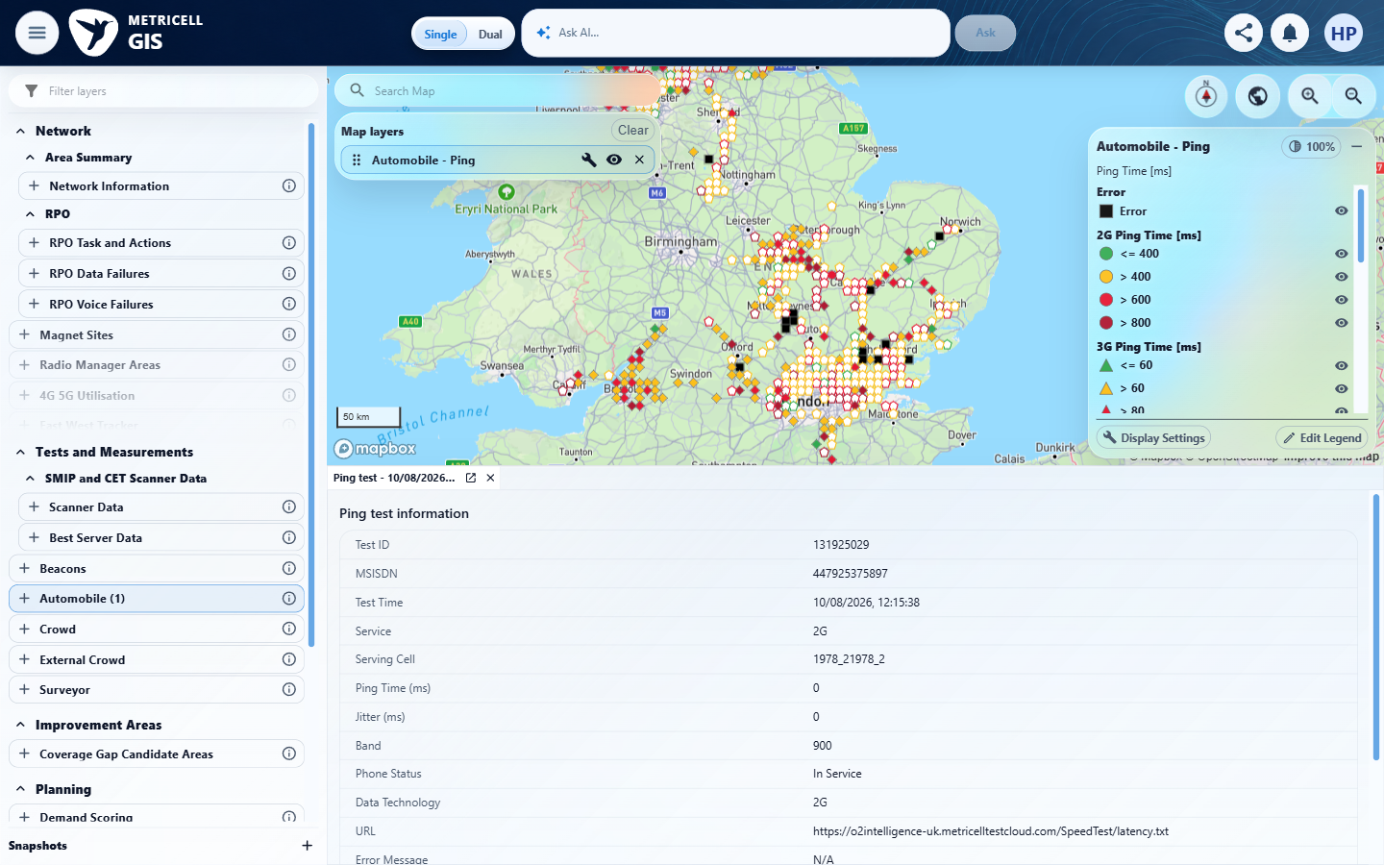

2.0.0 | When Ping attributes are returned for the selected point, the detail view displays those attributes alongside the Ping Time. | When Ping attributes are returned for the selected point, the detail view displays those attributes alongside the Ping Time. | criterion-2-final.png shows Test ID 131925029 with Ping Time (ms) 0 alongside Jitter (ms) 0, Service/Data Technology 2G, Band 900 and Phone Status In Service, matching the reported genuine Automobile Ping response. criterion-2-before-select.png is still loading the map; the final image proves the required populated presentation.  Evidence: E08, E09 | Passed
Criterion 2 assessment: criterion-2-final.png shows Test ID 131925029 with Ping Time (ms) 0 alongside Jitter (ms) 0, Service/Data Technology 2G, Band 900 and Phone Status In Service, matching the reported genuine Automobile Ping response. criterion-2-before-select.png is still loading the map; the final image proves the required populated presentation.
Criterion 2 evidence: When Ping attributes are returned for the selected point, the detail view displays those attributes alongside the Ping Time.
Browser URL recorded after criterion: https://o2intelligence-v4-dev.metricell.com/gis
E08 - Before select (criterion-2-before-select.png)  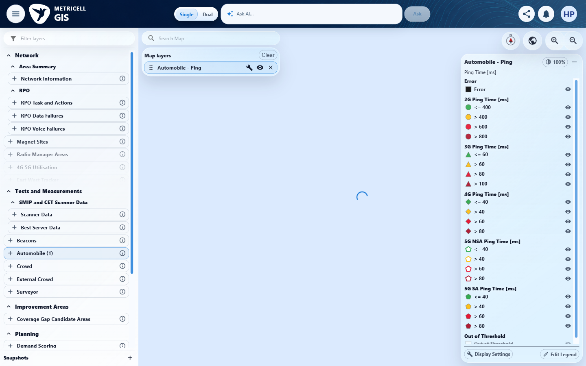 | E09 - Final (criterion-2-final.png)  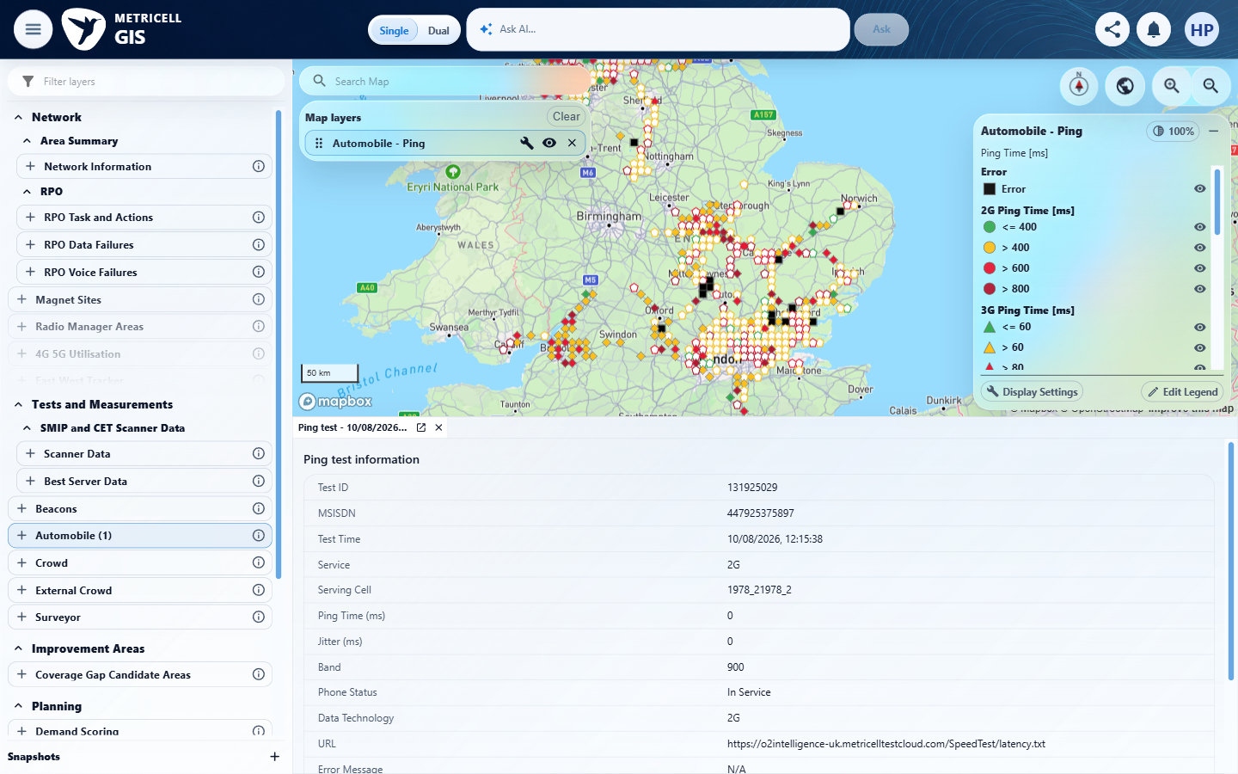

3.0.0 | With 5G NSA as the only selected technology, opening a Ping point displays details for that selected point without an error state. | With 5G NSA as the only selected technology, opening a Ping point displays details for that selected point without an error state. | criterion-3-before-deselect-1.png through criterion-3-after-deselect-5.png show the criterion-owned configuration sequence leaving only 5G NSA checked. criterion-3-after-apply.png shows the filtered Automobile - Ping map, and criterion-3-final.png shows Test ID 131925408, Service/Data Technology 5G NSA, Ping Time (ms) 34 and Jitter (ms) 2 without an error. Reported Automobile requests use technologies=13/[13] and match the displayed record.  Evidence: E10, E11, E12, E13, E14, E15, E16, E17, E18, E19, E20 | Passed
Criterion 3 assessment: criterion-3-before-deselect-1.png through criterion-3-after-deselect-5.png show the criterion-owned configuration sequence leaving only 5G NSA checked. criterion-3-after-apply.png shows the filtered Automobile - Ping map, and criterion-3-final.png shows Test ID 131925408, Service/Data Technology 5G NSA, Ping Time (ms) 34 and Jitter (ms) 2 without an error. Reported Automobile requests use technologies=13/[13] and match the displayed record.
Criterion 3 evidence: With 5G NSA as the only selected technology, opening a Ping point displays details for that selected point without an error state.
Browser URL recorded after criterion: https://o2intelligence-v4-dev.metricell.com/gis
E10 - Before configure (criterion-3-before-configure.png)  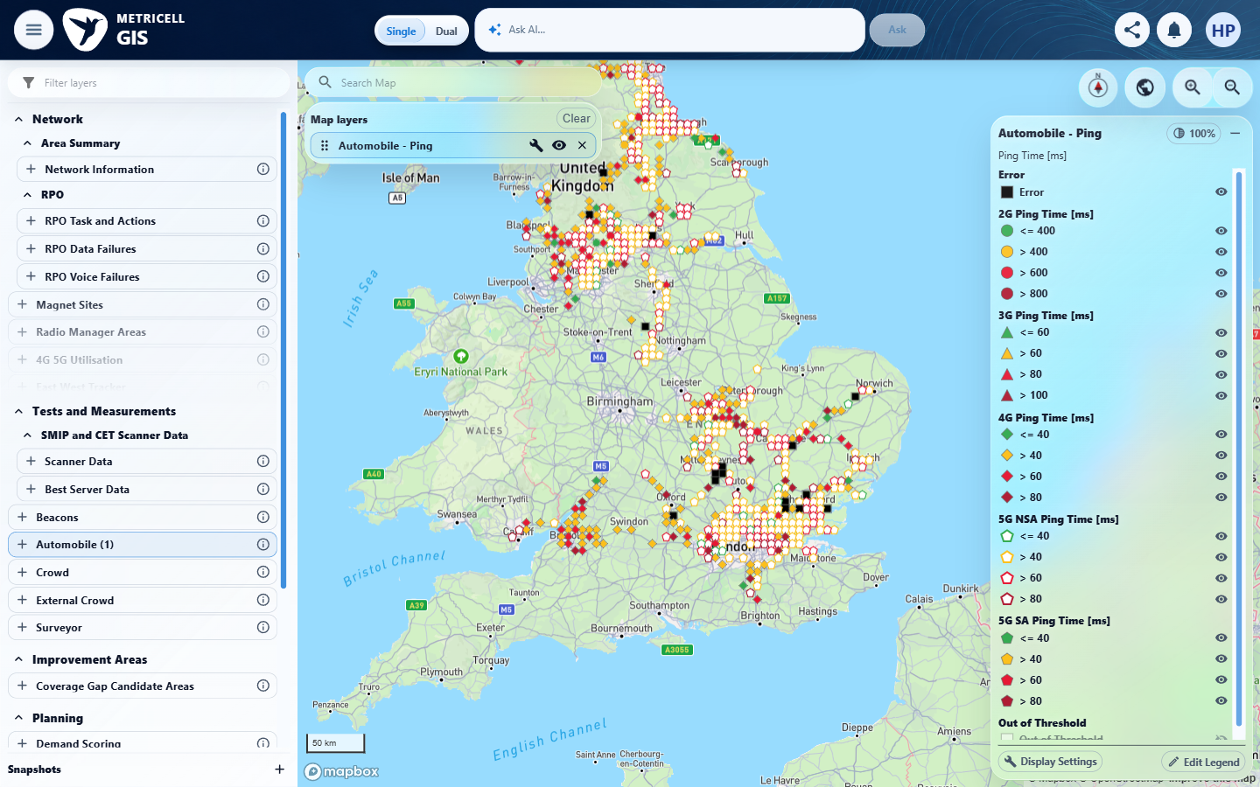 | E11 - Before deselect 1 (criterion-3-before-deselect-1.png)  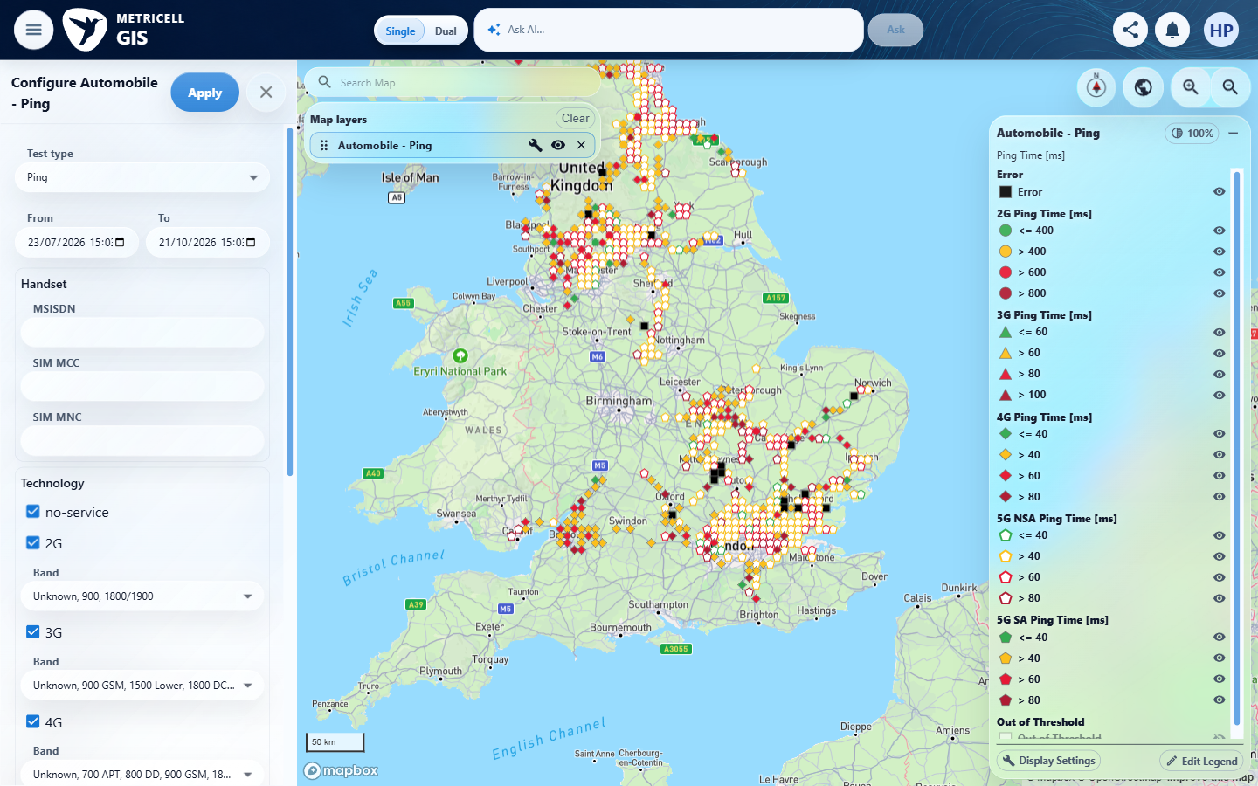

Criterion 3 continued: With 5G NSA as the only selected technology, opening a Ping point displays details for that selected point without an error state.
Browser URL recorded after criterion: https://o2intelligence-v4-dev.metricell.com/gis
E12 - After deselect 1 (criterion-3-after-deselect-1.png)  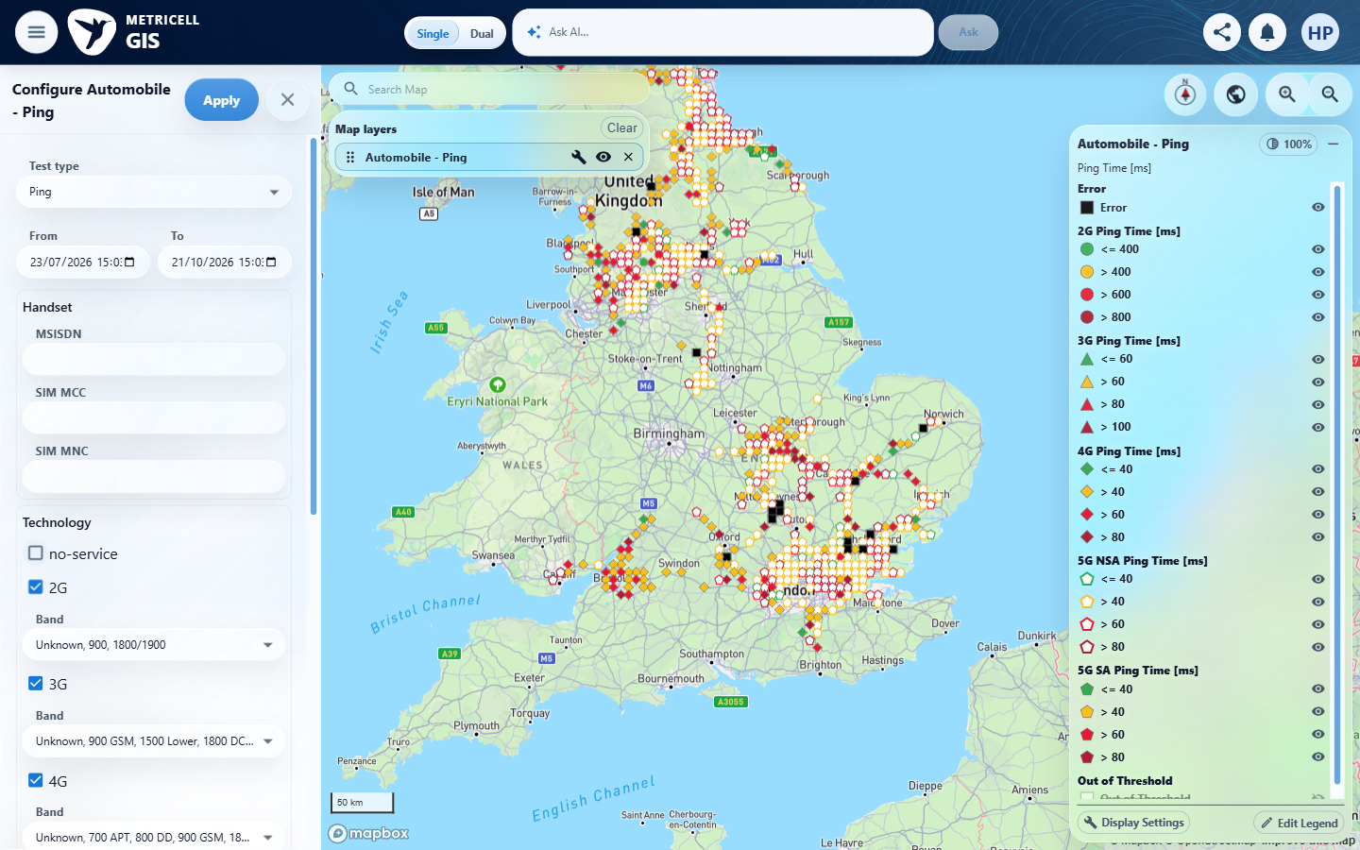 | E13 - Before deselect 2 (criterion-3-before-deselect-2.png)  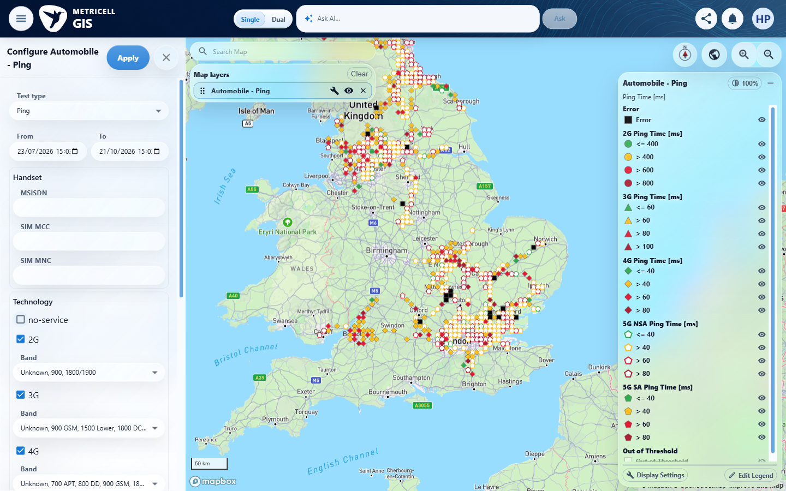

Criterion 3 continued: With 5G NSA as the only selected technology, opening a Ping point displays details for that selected point without an error state.
Browser URL recorded after criterion: https://o2intelligence-v4-dev.metricell.com/gis
E14 - Before deselect 3 (criterion-3-before-deselect-3.png)  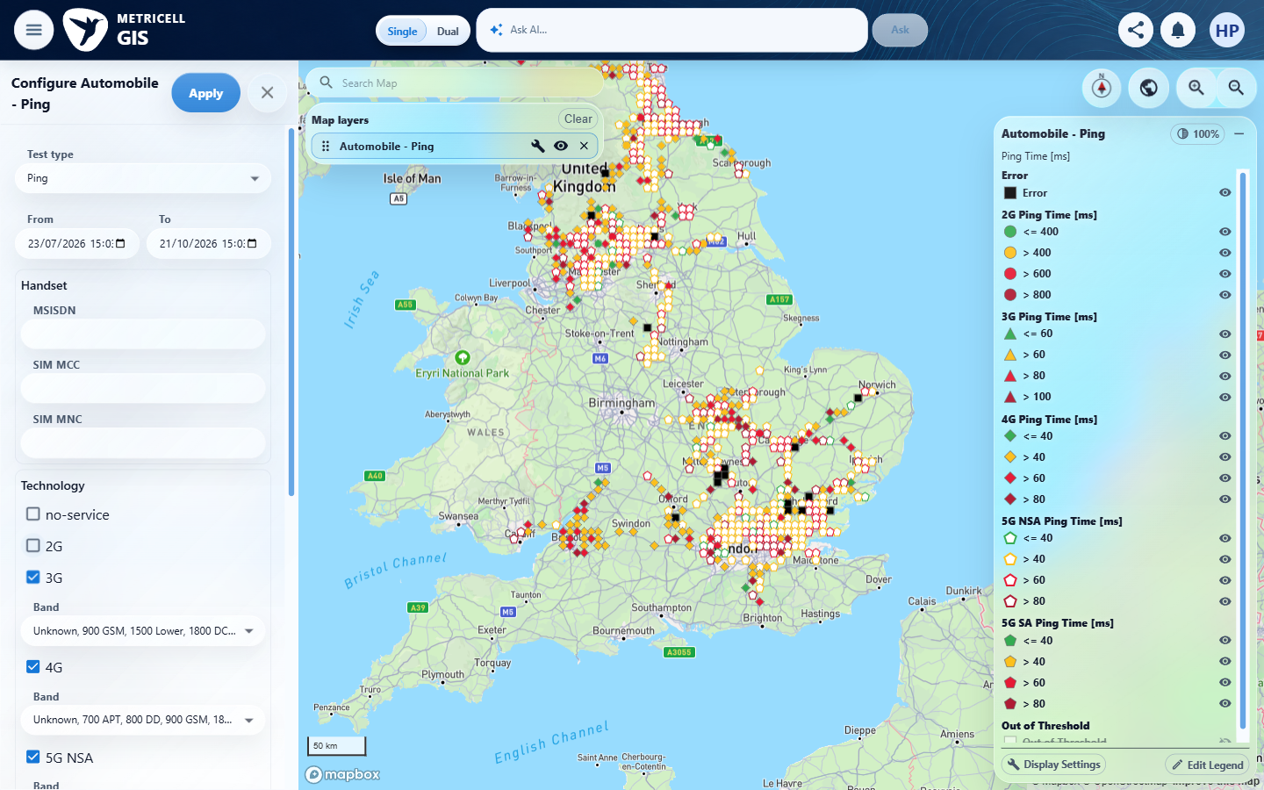 | E15 - Before deselect 4 (criterion-3-before-deselect-4.png)  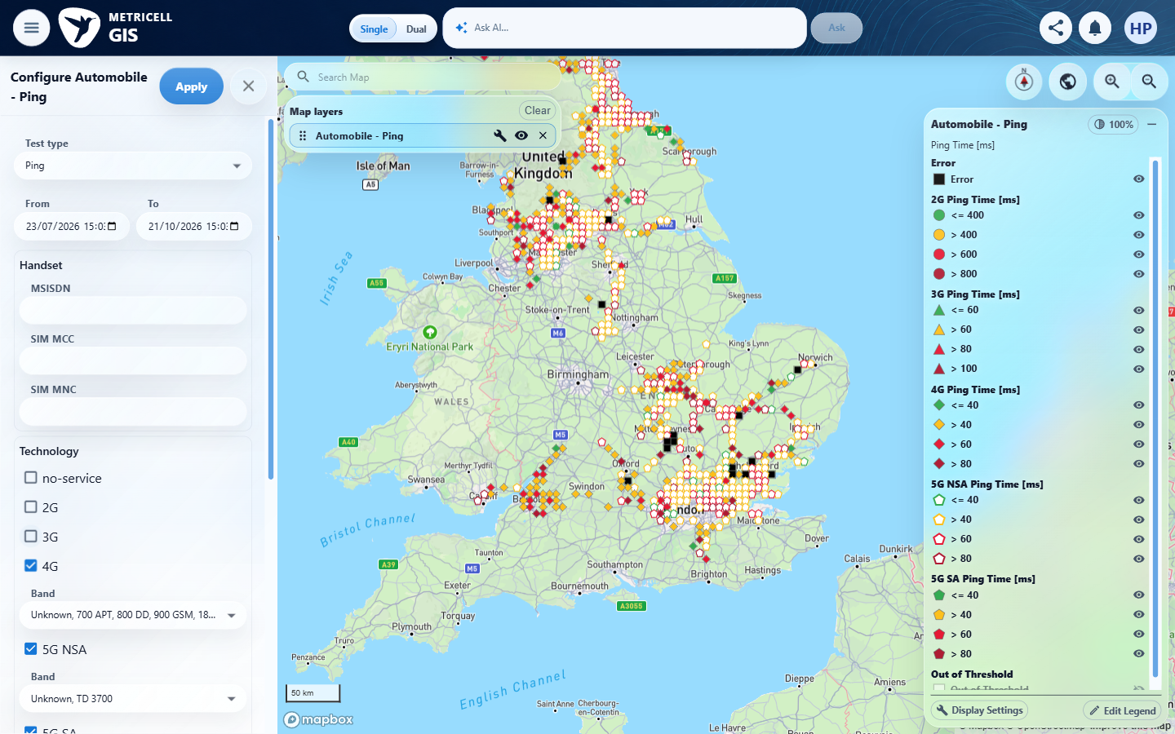

Criterion 3 continued: With 5G NSA as the only selected technology, opening a Ping point displays details for that selected point without an error state.
Browser URL recorded after criterion: https://o2intelligence-v4-dev.metricell.com/gis
E16 - After deselect 4 (criterion-3-after-deselect-4.png)  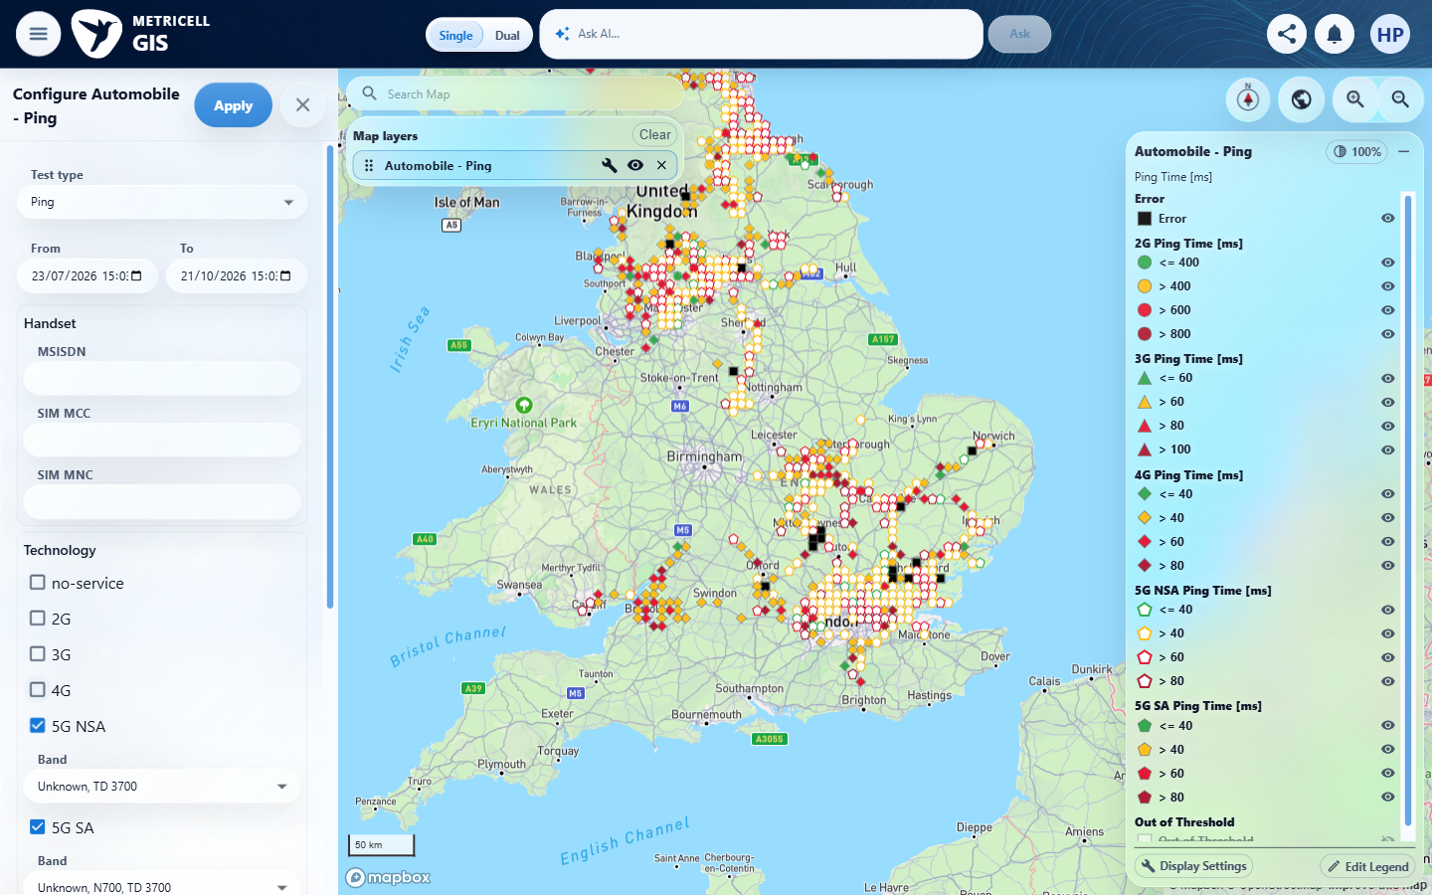 | E17 - Before deselect 5 (criterion-3-before-deselect-5.png)  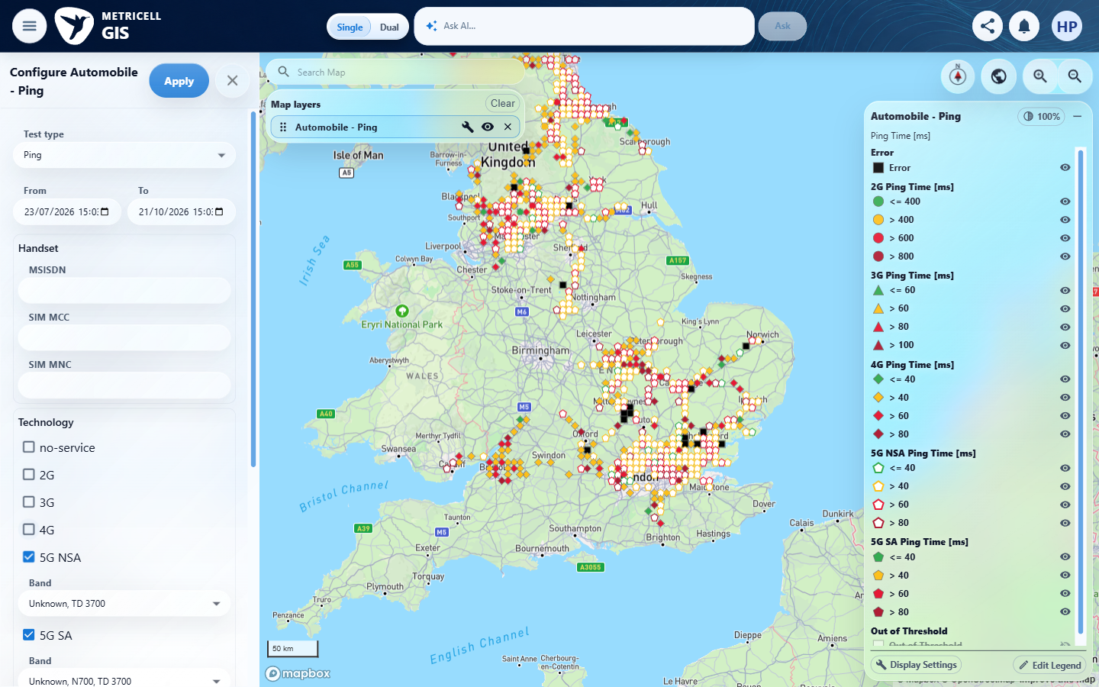

Criterion 3 continued: With 5G NSA as the only selected technology, opening a Ping point displays details for that selected point without an error state.
Browser URL recorded after criterion: https://o2intelligence-v4-dev.metricell.com/gis
E18 - After deselect 5 (criterion-3-after-deselect-5.png)  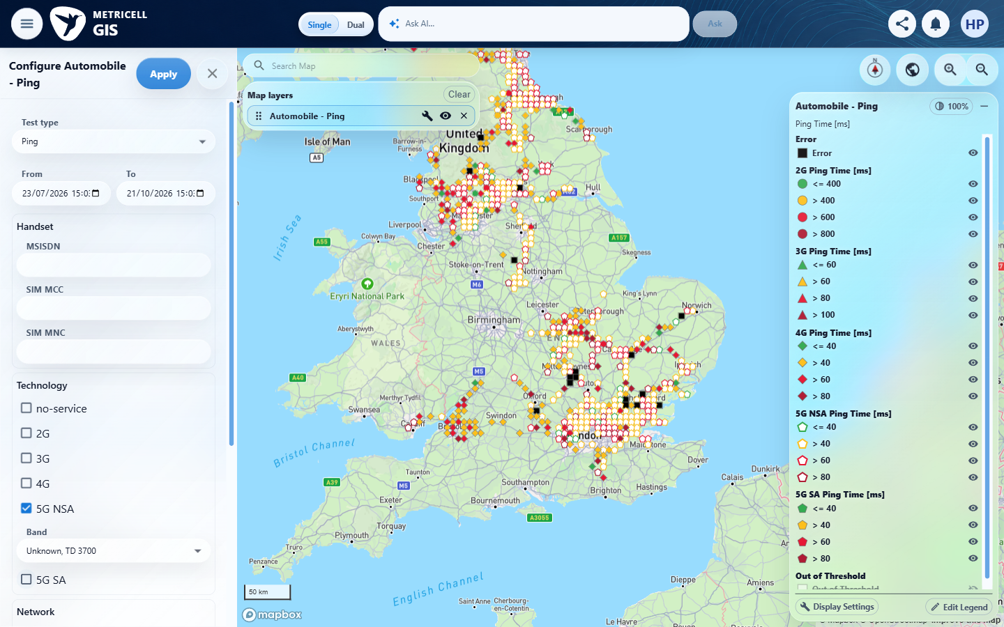 | E19 - After apply (criterion-3-after-apply.png)  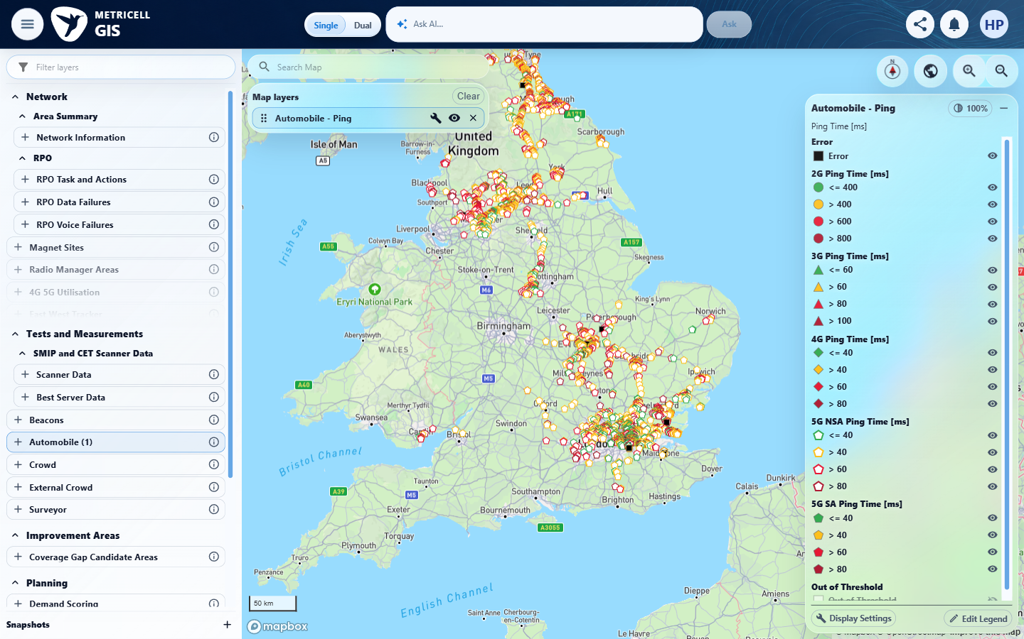

Criterion 3 continued: With 5G NSA as the only selected technology, opening a Ping point displays details for that selected point without an error state.
Browser URL recorded after criterion: https://o2intelligence-v4-dev.metricell.com/gis
E20 - Final (criterion-3-final.png)
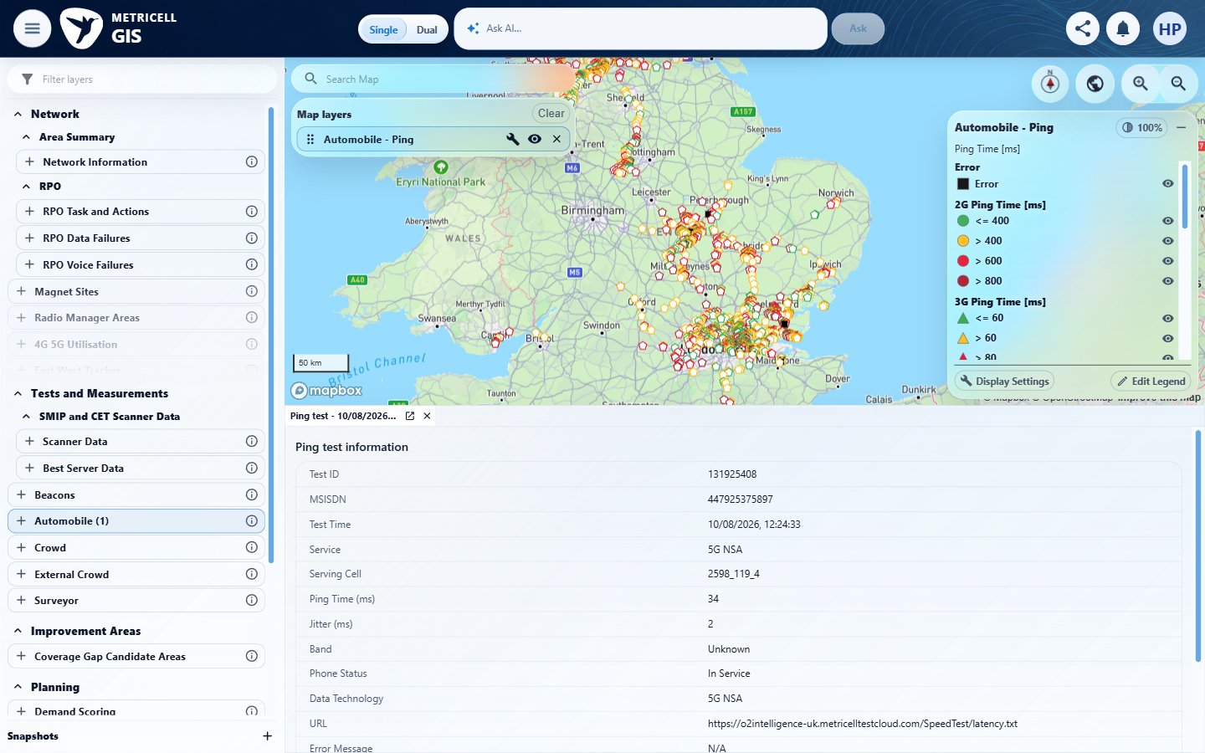

4.0.0 | While Ping details are loading, the detail view shows a loading state. | While Ping details are loading, the detail view shows a loading state. | SIMULATED UI STATE: Browser-local delay of approximately 28,056 ms on POST https://o2intelligence-v4-dev.metricell.com/api/platform/automobile/ping/cluster-details, scoped to mercatorKey 864691681432175934 / established point 131925029; no response body or success was fabricated. criterion-4-genuine-details.png establishes the target, criterion-4-before-delayed-select.png shows the cleared map, and criterion-4-final.png during the reported intercepted pending request shows no detail panel or visible loading presentation. criterion-4-recovery.png shows target 131925029 after the unchanged real 200 response was released. This contradicts loading feedback at the map-to-point-detail boundary; it does not establish backend latency or a separate analysis-panel defect. Results record request settlement, exact owned handler removal and absent simulation state.  Evidence: E21, E22 | Failed
Criterion 4 assessment: SIMULATED UI STATE: Browser-local delay of approximately 28,056 ms on POST https://o2intelligence-v4-dev.metricell.com/api/platform/automobile/ping/cluster-details, scoped to mercatorKey 864691681432175934 / established point 131925029; no response body or success was fabricated. criterion-4-genuine-details.png establishes the target, criterion-4-before-delayed-select.png shows the cleared map, and criterion-4-final.png during the reported intercepted pending request shows no detail panel or visible loading presentation. criterion-4-recovery.png shows target 131925029 after the unchanged real 200 response was released. This contradicts loading feedback at the map-to-point-detail boundary; it does not establish backend latency or a separate analysis-panel defect. Results record request settlement, exact owned handler removal and absent simulation state.
Criterion 4 evidence: While Ping details are loading, the detail view shows a loading state.
SIMULATED UI STATE: browser-local condition; recovery uses the genuine service.
Browser URL recorded after criterion: https://o2intelligence-v4-dev.metricell.com/gis
E21 - Final (criterion-4-final.png)  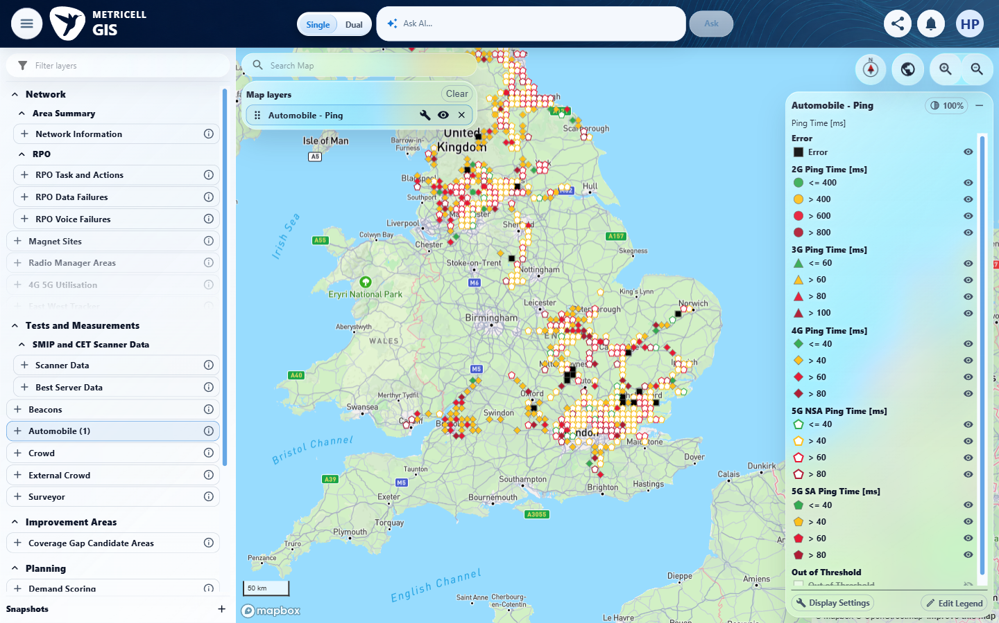 | E22 - Recovery (criterion-4-recovery.png)  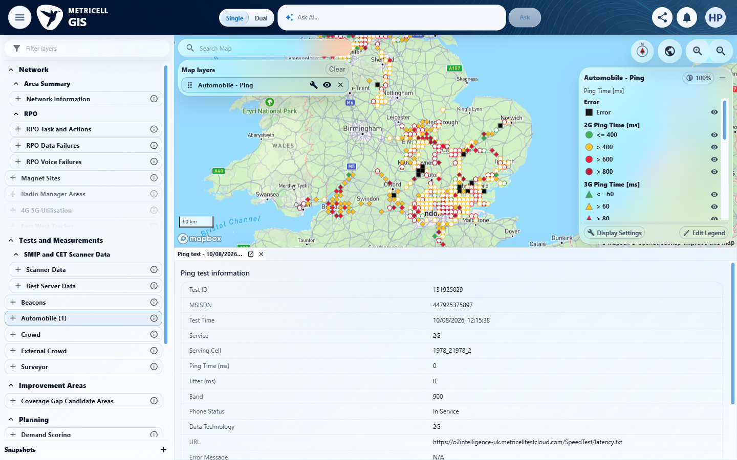

5.0.0 | When Ping details are unavailable, the detail view shows a no-data state. | When Ping details are unavailable, the detail view shows a no-data state. | Blocked because no genuine unavailable Ping fixture/response or authoritative empty-response contract for the Automobile detail endpoint was established. criterion-5-before-open-point.png contains two populated Ping records; criterion-5-final.png shows populated Test ID 132646698 with Ping Time 41 ms and Jitter 8 ms, not a no-data state. Testing the no-data condition could not be completed; require a genuine unavailable record/response or an authoritative endpoint schema before simulation.  Evidence: E10, E23, E24 | Blocked
Criterion 5 assessment: Blocked because no genuine unavailable Ping fixture/response or authoritative empty-response contract for the Automobile detail endpoint was established. criterion-5-before-open-point.png contains two populated Ping records; criterion-5-final.png shows populated Test ID 132646698 with Ping Time 41 ms and Jitter 8 ms, not a no-data state. Testing the no-data condition could not be completed; require a genuine unavailable record/response or an authoritative endpoint schema before simulation.
Testing notes: No unavailable Ping fixture was supplied or encountered in normal UI use, and no authoritative empty-response contract was established. Populated arrays do not prove the empty-response contract. The brief therefore prevents a no-data simulation. Needed: a genuine unavailable Ping record/response or authoritative empty-response schema for this exact detail endpoint. Final.png shows the reachable populated record, not a no-data state. No genuine unavailable/empty detail response or authoritative empty-response schema was established from the supplied scope. Did not fabricate an empty response from populated data. Closed both this criterion's point and cluster panels.
Criterion 5 evidence: When Ping details are unavailable, the detail view shows a no-data state.
Browser URL recorded after criterion: https://o2intelligence-v4-dev.metricell.com/gis
E10 - Baseline map (criterion-5-baseline-map.png) | E23 - Before open point (criterion-5-before-open-point.png)  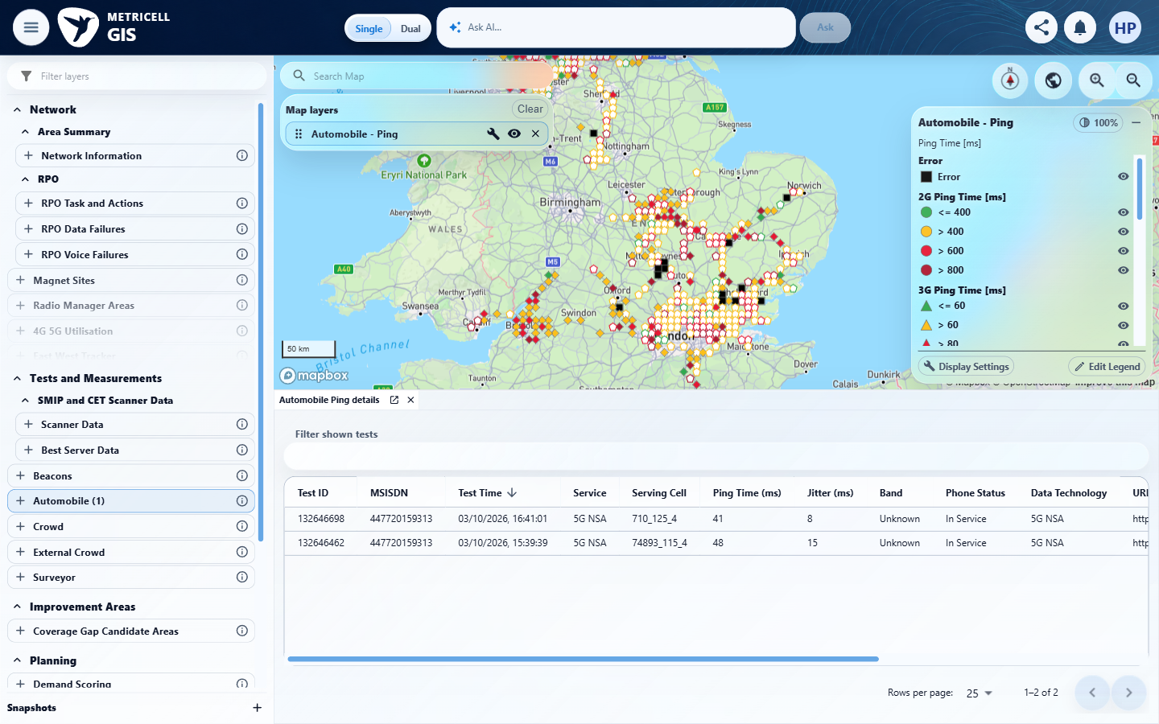

Criterion 5 continued: When Ping details are unavailable, the detail view shows a no-data state.
Browser URL recorded after criterion: https://o2intelligence-v4-dev.metricell.com/gis
E24 - Final (criterion-5-final.png)
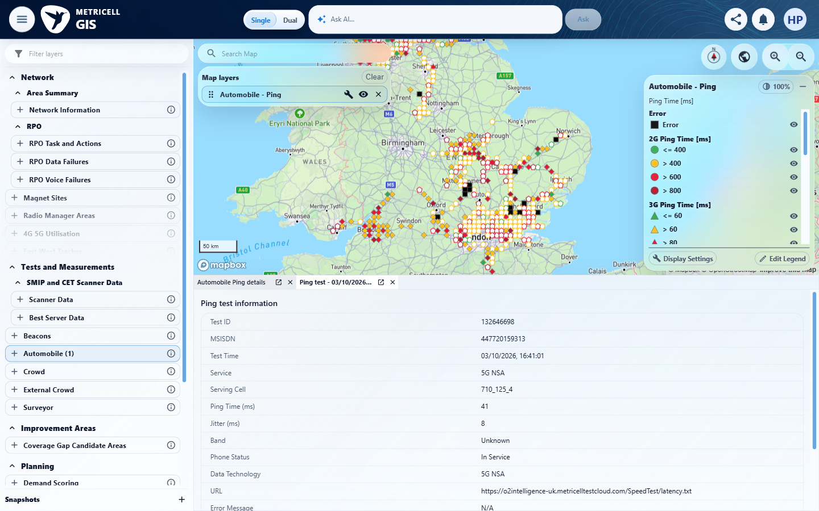

6.0.0 | When Ping details fail to load, the detail view shows an error state and does not display data as if it belonged to the selected point. | When Ping details fail to load, the detail view shows an error state and does not display data as if it belonged to the selected point. | SIMULATED UI STATE: A standard HTTP 503 (RFC 9110 section 15.6.4), text/plain synthetic Service Unavailable body, was injected only for POST https://o2intelligence-v4-dev.metricell.com/api/platform/automobile/ping/cluster-details and mercatorKey 864691681432175934, established by the genuine UI response as point 131925029. criterion-6-target-genuine.png establishes the target; criterion-6-baseline-list.png and criterion-6-baseline-details.png establish distinct prior point 132646698 (41 ms, Jitter 8 ms), retained in criterion-6-before-error-select.png. criterion-6-final.png shows the active target error 'Unable to load point details.' and Retry, without prior point values; the prior point remains a separate inactive tab. criterion-6-recovery.png shows genuine target 131925029 after Retry and reported exact route removal. criterion-6-cleanup.png shows Automobile HTTP Browsing restored with Ping tabs closed; results verify absent owned simulation state. UI error handling only, not a naturally occurring backend error. The original pre-existing HTTP Browsing detail-panel selection was not restored.  Evidence: E25, E26 | Passed
Criterion 6 assessment: SIMULATED UI STATE: A standard HTTP 503 (RFC 9110 section 15.6.4), text/plain synthetic Service Unavailable body, was injected only for POST https://o2intelligence-v4-dev.metricell.com/api/platform/automobile/ping/cluster-details and mercatorKey 864691681432175934, established by the genuine UI response as point 131925029. criterion-6-target-genuine.png establishes the target; criterion-6-baseline-list.png and criterion-6-baseline-details.png establish distinct prior point 132646698 (41 ms, Jitter 8 ms), retained in criterion-6-before-error-select.png. criterion-6-final.png shows the active target error 'Unable to load point details.' and Retry, without prior point values; the prior point remains a separate inactive tab. criterion-6-recovery.png shows genuine target 131925029 after Retry and reported exact route removal. criterion-6-cleanup.png shows Automobile HTTP Browsing restored with Ping tabs closed; results verify absent owned simulation state. UI error handling only, not a naturally occurring backend error. The original pre-existing HTTP Browsing detail-panel selection was not restored.
Criterion 6 evidence: When Ping details fail to load, the detail view shows an error state and does not display data as if it belonged to the selected point.
SIMULATED UI STATE: browser-local condition; recovery uses the genuine service.
Browser URL recorded after criterion: https://o2intelligence-v4-dev.metricell.com/gis
E25 - Final (criterion-6-final.png)  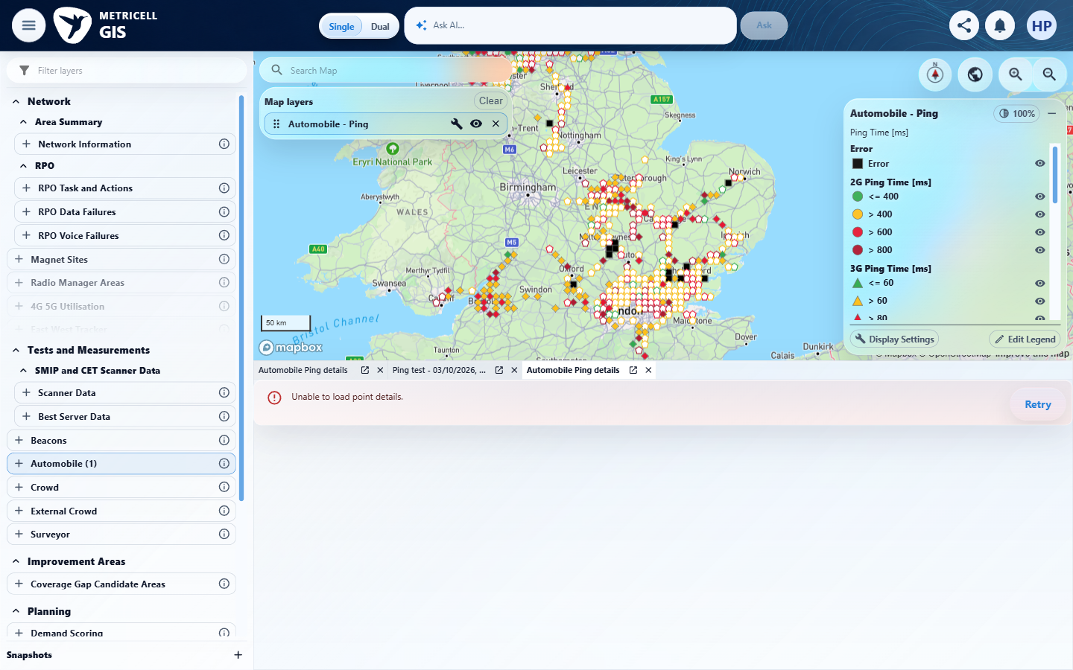 | E26 - Recovery (criterion-6-recovery.png)  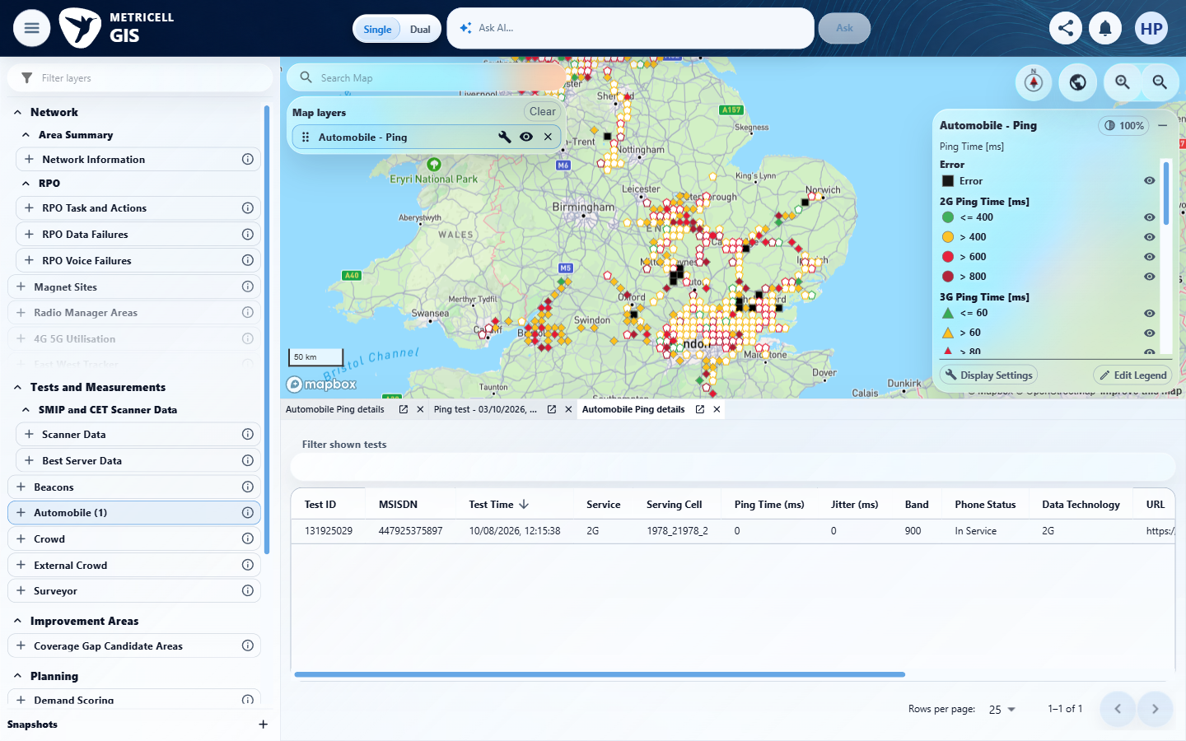

About Metricell

Metricell is on a mission to deliver connectivity. We work with our customers to design, deliver and manage wireless communication networks – with a shared ambition of achieving flawless network experience. We’ve been responsible for many first-to-market products, and our technology is characterised by the relentless pursuit of automation and digitalisation.

Our geospatial intelligence tools traverse a wide variety of business processes – from Test & Measurement to Customer Experience Management – and we’re pioneers in Crowdsourcing and Digital Self Care. Our technology is today in use by a range of customers; thousands of their personnel; and millions of subscribers worldwide.

Find out more at www.metricell.com




