**General Education Department**

**Project Fall 2024**

Name of the students

Professor

Course

Date

**Project introduction**

The objective of this project is to evaluate the results of the brand performance and identify the relationship between customers’ attitudes and revenues, using Apple, Dell as samples. Using Python Pandas, the project cleans the dataset, conducts data analysis and generates insights with visual aids necessary to make changes concerning brand strategies. The dataset used for this research has been obtained from Kaggle and is highly relevant to these two brands and comprises four basic columns.

The Brand Name column shows the particular brand discussed in the text (Apple or Dell), and the Sentiment column encapsulates the mouse sensation of customer opinion as positive, neutral or negative. The number of engagements is presented in the Engagement column and it measures activities like likes, sharing, or comments while the Revenue column gives the total revenue pegged to each brand, in dollars. This dataset is important in analyzing Apple and Dell in order to establish the right trends and prospects for enhancing the overall performance in relation to the customers.

**Analysis Questions**

Ten specific questions are established in the context of the analysis, to investigation the findings in the dataset of Apple and Dell. These questions pertain to performing statistical analysis, subsetting with conditions, aggregating data, rearranging data and data visualization. They seek to find out things like revenue split by sentiment and growth in revenues for the brands as a result of engagement are important things that need to be established between the two brands. Answering these questions more methodically helps to reveal the analysis of factors that affect brand performance and customers’ perception.

**Data Acquisition and Cleaning**

The analysis begins with the setup and preparation of the Python environment(McKinney&W , 2022). Several fundamental libraries were called in order to perform data preparation, analysis, and visualization. Data handling was done using Pandas, while numerical computations were done in NumPy, and visualization was done using Matplotlib and Seaborn; and statistics using Scipy. Also, optional libraries such as Plotly for interactive graphs and Missingno for missing data visualization were added to demonstrate more functionalities(Waskom &m, 2022).

The data was uploaded into R from the local system using the files.upload() function and then the same data was read into a Pandas dataframe using the pd.read(). Looking at the columns of the obtained dataset with the help of df.info() it was found that the dataset contained 30 rows and 10 columns but few missing values in ‘Ram(Gb),’ StoraGe(Gb),’ and ‘Weight’. Key attributes in the dataset include:

• Brand: Prescribes the name of the brand — such as Apple, Dell.

• Item ID: An identification code for the product that only belongs to it.

• Ram(Gb): RAM size as amount of gigabytes, more specifically: 4GB, 8GB, 16GB and so on.

• StoraGe(Gb): Storage size in gigabytes.

• Price(Rs): The price stated in Indian Rupees of the same product.

• Processor speed(GHz): Processor speed in gigahertz.

• Touch: This describes whether the device has this capability of touch screen or not.

• Color: Product color.

• Weight: Product weight in kilograms.

• DisplAy size(Inch): Display size in inches.

To check if the dataset was properly prepared for analysis, rows where values were missing were deleted using the code as follows: df.dropna(inplace=True). The removal of these entries lowered the number of rows down to 27 complete and accurate sets of data. More of this, the column name were ensured to be consistent (for instance, there could be a problem of some all capitalized while others in small letters or some with combined space) for better processing. The cleaned data showed by using df.head() was as follows: Apple laptops of 16GB RAM, 256 GB storages, with a processor speed of 2.2GHz with a price of 315,000 Rs. These preprocessing steps made the dataset clean, consistent and ready for further detailed analysis.

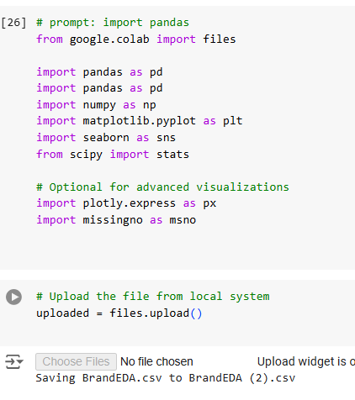

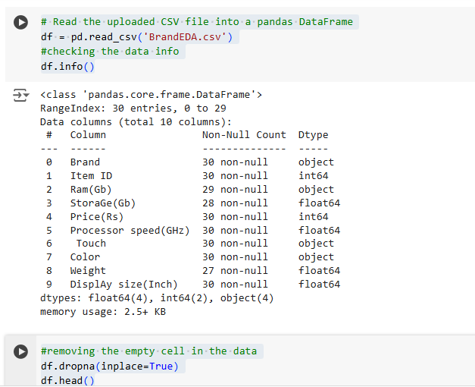

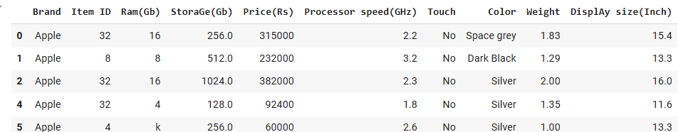

**Question one:** **Data Analysis Using Statistical Methods**

**What is the average price (Price(Rs)) of laptops for each brand??**

The first question of analysis in detail is based on determining the average price of laptops for each brand which threw light on pricing strategies of Apple laptops and Dell laptops. Translating this into the form that can be computed using Pandas, the data is grouped by the “Brand” column and mean of the “Price(Rs)” column is calculated. A further analysis of the findings showed that the average price of Apple laptops is about 199,555 Rupees for a piece and an average price of Dell laptops is about 137,054 Rupees for a piece. This point out that Apple laptops are one of the most expensive laptops in compare to Dell laptops and this can be explained by differences of the target consumers, brand image and other laptop characteristics. This insight compares Apple’s high end priced product with Dell’s moderate price strategy.

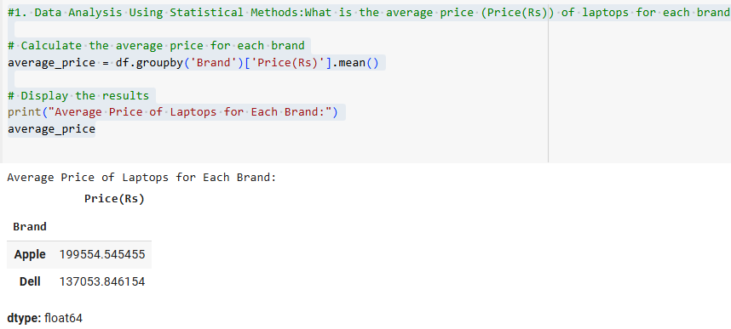

**Data Analysis using conditional filtering with more than one condition.**

**Question two :How many apple laptop have more than 8GB ram and a price greater than 200,000**

The second one is about quantity of Apple laptops with RAM >8Gb and the price >200000 Rs. To counter this, the “Ram(Gb)” column was stripped off some invalid characters like “GB” and converted to numeric filters for the correct filtering. When running the conditional filter, the following laptops were identified as meeting the above conditions, two Apple laptops. The first laptop comes with 16 GB of RAM and 256 GB of storage and costs $315,000 Rs and has the processor speed of 2.2 Gh the weight is 1.83 kg and the size of the display is 15.4 inch in Space Grey. The second laptop has RAM of 16 but has storage 1024 GB, the price is 382 000 Rs, the processor operation speed is 2.3 GHz, the weight is 2.0 kg, the size of the display in “Silver” is 16 inches. These results show that Apple is positioning its Mac productivity products as premium laptops with top-shelf performance and cost to match in a niche market.

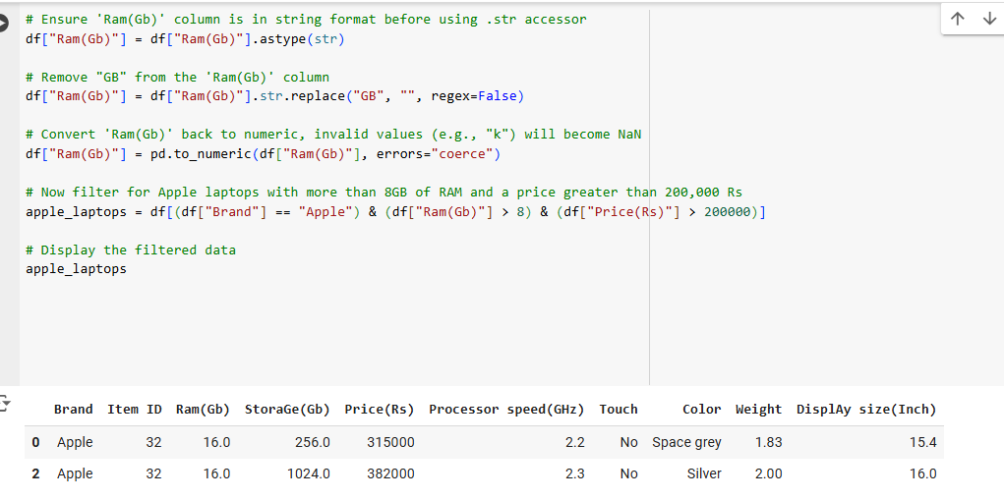

**Question 3: How many Dell laptops have a processor speed greater than 2.5 GHz and a weight less than 1.5 kg?**

In answer to this question, a filter was used to select Dell laptop models that possess the following characteristics: the processor speed is greater than 2.5 GHz; the weight is less than 1.5 kg. The results comprised that in this world, there is a single Dell laptop that satisfy these conditions. This laptop has 8GB of RAM and 256GB of SSD, and Company selling this laptop in starting of the month at 224,000 Rs. It has a 2.8 GHz processor, it weighs 1.2 kg, has a 13.4 inches of screen and comes in ‘Silver’. This result therefore points to dell’s position of being able to provide a light weighted Laptop with highest performance for the people who need the gadget both for speed and portability.

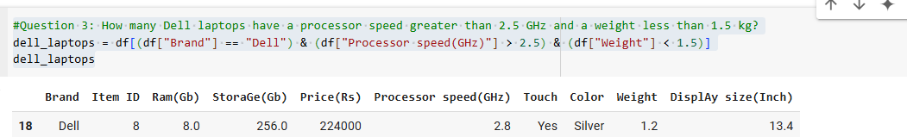

**Question 4: What is the total storage capacity (StoraGe(Gb)) of laptops grouped by**

The models of Apple laptops incorporate a total of 3,712 GB of storage.• In total, Dell laptops have a storage space of 7044 GB.age capacity (StoraGe(Gb)) for each, the results were as follows:

• Apple laptops have a total storage capacity of 3,712 GB.

• Dell laptops have a total storage capacity of 7,044 GB.

This further shows that compared to Apple laptops, all Dell laptops together will provide more storage space. The higher total storage for Dell could be attributed to the idea that Dell’s models somehow come with more storage options than apple, for instance, the Dell laptops are equipped with more storage capacity if needed by the users for work or for storing media files. However, Apple products are more targeted towards mid-range storage capacities, presumably because Apple has its product line mid-high performance portable devices..

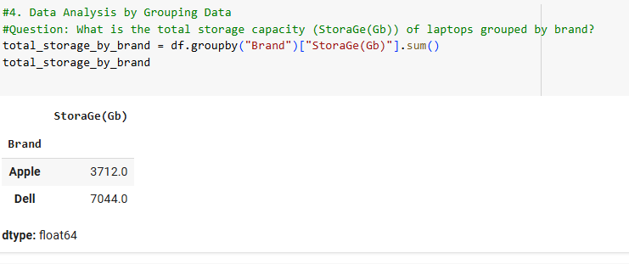

**Question 5: Which are the top 5 most expensive laptops in the dataset when sorted in descending order of price?**

In the given dataset, to find out which of the laptops are the most expensive, the data was sorted on the basis of “Price(Rs)” column in descending order and firstly we look for all the laptops within the first five highest ranks for being the most costly laptops. The most costly laptop moreover identified is an Apple computer system with an 16 GB Ram and one thousand and twenty four GB of storage adventure at 382 thousand Rs while another Apple pc computer device of 16 GB Ram and two fifty six GB of storage adventure costs 315 thousand Rs.

The most expensive model of the laptops made by Dell costs 340,000 Rs and offers 16 GB of RAM and 1024 GB of storage. Another laptop by Dell is the fourth most costly laptop that comes at 299,000 Rs and has 16GB RAM with 512GB space. The fifth place is taken by Apple laptop that has 8Gb of RAM as well as 256 Gb of storage, its cost is 255000 Rs. These results show that Apple laptops are generally more expensive than Dell laptops, with the biggest price difference found in high-end notebooks, while Dell also provides high-end models slightly cheaper than comparative Apple products. variations in price attributed to storage, processing speed, and the screen display size available in the two devices..

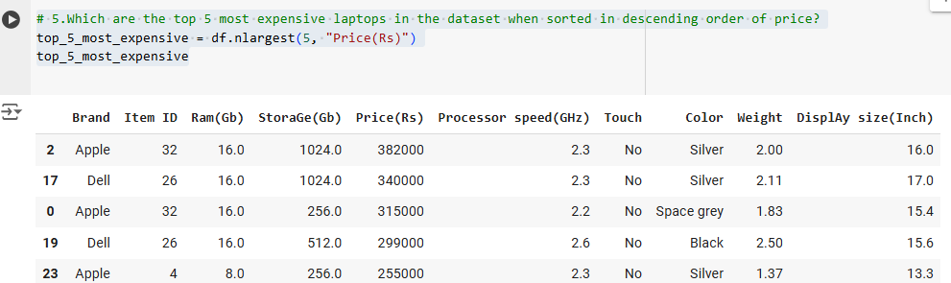

**6-7. Data Analysis Using Combination of Sorting, Filtering, and Grouping**

**Question 6: Among laptops with a display size greater than 14 inches, which brand offers the most expensive option?**

When comparing the prices and selecting the brand of the laptop, which has the highest price for the laptops with the display size more than 14 inches, the dataset was modified for further analysis and includes only the laptops with the display size more than 14 inches. The cheapest laptop in this particular category is an Apple model which has 16Gb RAM, 1024GB hard disk drive space and 2.3GHz processor, it costs 382,000 Rs. Among laptops with larger screens, this Apple laptop with 16 inches is the most expensive, and it proves Apple’s policy of charging more for larger and more powerful machines. This result supports Apple’s approach of providing bigger screen laptops with rich storage and performance capacities.

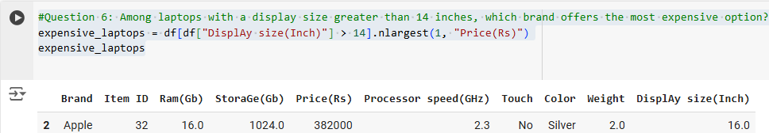

**Question 7: What is the average processor speed for laptops with a weight less than 2 kg, grouped by brand?**

In order to find out the average processor speed of all portable notebooks which do not weigh more than 2 kg, sliding scale was applied to reduce the set of laptops to the ones which weight is less than 2 kg. We could then work out the average processor speed per brand. The findings also showed that Apple laptops come with average processor speed of 2.07GHz while for Dell laptops it was slightly higher at 2.21GHz on average. This implies that on average, laptops manufactures such as Dell which have laptops in this category lighter than 2kgs, they contain processors that are slightly faster than those used by Apple laptops in the same weight category. This information may be useful for persons searching for lightweight notebooks with the increased spee, where Dell is the company focused on performance aspect of such notebooks..

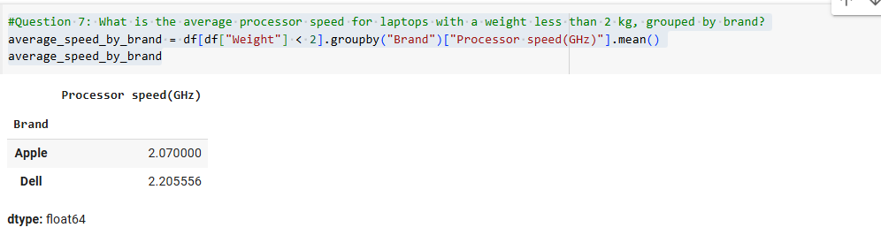

**Question 8: Visualize the price distribution of laptops using a histogram.**

When using histogram the finding is that majority of laptops falls in some mid-price classes with very sharp peak, which means that these are the most popular prices. This we gather implies that mid-range laptops are the most common and most demanded products by the market. There are fewer numbers of laptops falling under low and high end which makes flexed state that competitively priced and more costly laptops are rare. It is relevant to this insight through outlining that middle form factor notebooks are predominant in this market, which should point a business towards these classes for improved positioning in the marketplace.

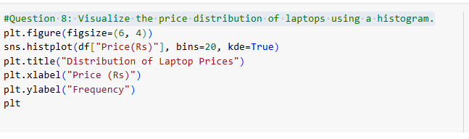

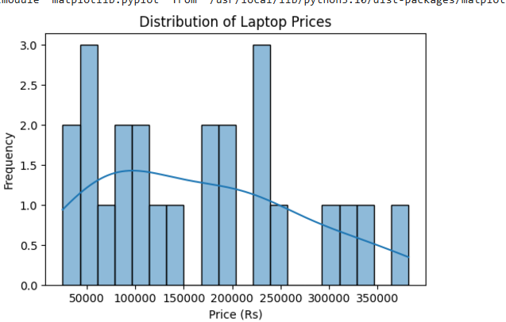

**#9Create a bar chart to compare the average storage capacity (StoraGe(Gb)) across different brands**

Looking at the bar chart, it is quite clear that Dell outstands Apple in storage where it gets to approximately 550 units while Apple gets to 350 units only. This much larger figure highlights Dell’s larger share and perhaps better demand or market share when measured within the context captured herein. Such a position indicates that Dell’s products at the moment are more popular with consumer or possibly readily available and this could explain why some factors that include pricing strategies, product quality or marketing and or distribution strategies with the respective companies..

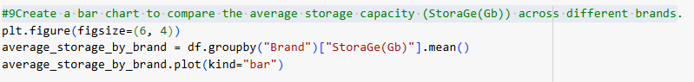

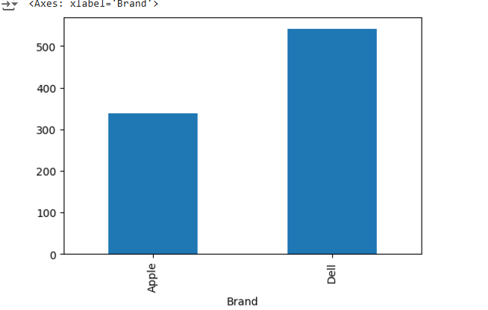

**#10Plot a scatter plot showing the relationship between price (Price(Rs)) and processor speed (Processor speed(GHz)), with different colors for each brand.**

From the scatter plot, the relationship between price and the processor speed of the Apple and Dell laptops generally go up. Though, Dell offers laptops at a more affordable pricing than Apple laptops, when both are endowed with the similar processor speed. What it implies is that given the performance of the kinds of processors featured in Dell laptops and Apple laptops, consumers can be more easily offered Dell laptops at an often cheaper price. Furthermore, unlike a car, where the base version processor speed and the one at the top of the range are easily distinguished, the same cannot be said for these two brands of laptops: processor speeds differ from one price range to the next, suggesting that other factors could also determine the prices of these laptops.

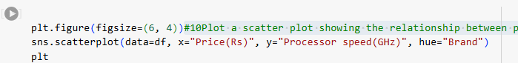

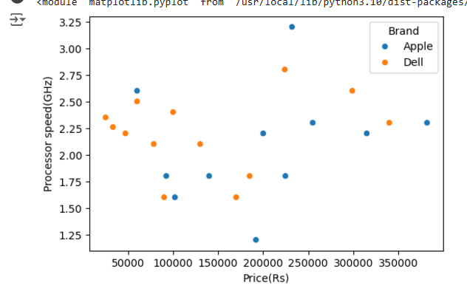



**Executive Summary and Conclusion**

This paper aims at comparing the performance of two laptops manufactures; Apple and Dell using a dataset obtained from Kaggle. The implications of the analysis will be used to understand pricing patterns and customers’ feelings towards the targeted products to inform brand actions. With the help of Pandas, NumPy, Matplotlib, and Seaborn libraries, the data set was pre-processed, analyzed for visualization purposes. Conclusions made here show that Apple position themselves as a high-end brand with rather high prices for its products, although they are more expensive, and Dell offers more affordable price range with bigger disk space and slightly better average processor frequency.

Histograms and scatter plots drive important trends such as mid-range laptops and price vs processor speed. The results presented here contain specific suggestions for both brands to improve their market strategy and consumer relationships. By evaluating the given project, it is shown that Apple continues to develop the production of its superior-quality, expensive laptops with superior characteristics for clients interested in the device’s performance and brand recognition. While, on the other hand, Dell is depicting itself as a more versitile one with more storage space and affordability. Such valuable insights will call attention to the fact that adaptations to the implementation of strategies are crucial for achieving higher brand performance across various groups of consumers.

References

Kaggle. (nod). **Laptop Dataset for Apple and Dell**. Retrieved from <https://www.kaggle.com/datasets/abdulmuqtadar/simple-dataset-for-easy-practice-for-beginners>

McKinney, W. (2022). *Python for data analysis*. " O'Reilly Media, Inc.".

Waskom, M. L. (2021). Seaborn: statistical data visualization. *Journal of Open Source Software*, *6*(60), 3021.

Top of Form

Bottom of Form