Assignment 3.1: Purchasing a car
Step 1:. Go online to Kijiji or Castanet to find three used cars for sale (over $5000.00). Try and find a car that would be reasonable for a high school student to own.
- Question #1: What is the make, model and price of the each vehicle you would like to purchase (3 marks)?
  - Car #1: Make: Subaru Model: STI Price:$48,000
  - Car #2: Make: YAMAHA Model: FZ-07 Price $8,000
  - Car #3: Make: Subaru Model: WRX Price: $25,000
Step 2: Determine how much money you will need to borrow. Subtract the money you have for a down payment (the amount you give to the dealer on the day of purchase) from the total purchase price. For this exercise, imagine you have saved $5,000 for a down payment. The resulting total is the loan principal.
- Question #2: What is the loan principal that you will need to borrow (3 marks)?﻿
  - Car #1 - Loan Principal: $43,000
  - Car #2 – Loan Principal:$3,000
  - Car #3 – Loan Principal: $20,000

Step 3: Determine which of the three cars you will purchase (1 mark): Car #2

Step 4: Question #3: Do you think that this is a practical car for you to purchase? Why or why not? (2 marks) Remember you will need to pay for insurance, gas and maintenance.
Yes Because it is one of the best things out there you can buy for your money.

Step 5: Get quotes from several lenders. The term and interest rate of the loan will vary and both of these factors will affect your monthly payment. (For this exercise, pretend that you have received the rates below.)

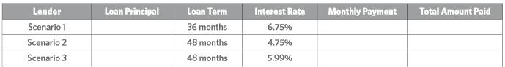

Step 4: Calculate your monthly payments and total amounts paid. Your monthly payment is your principal divided by the number of months in your loan term, and then multiplied by 1 plus your interest rate:
. Next, multiply the monthly payment by the loan term to determine the total amount paid.
Example calculations
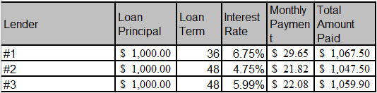

- Question #4: Complete the chart below (4 marks). ***There is a calculator tool in the course titled – Purchasing a Car Calculator – it will help you to fill this out
Lender | Loan Principal | Loan Term | Interest Rate | Monthly Payment | Total Amount Paid
#1 | 43,000 | 36 months | 6.75% | 1,275.07 | 45,902.50
#2 | 3,000 | 48 months | 4.75% | 65.47 | 3,142.50
#3 | 20,000 | 48 months | 5.99% | 441.63 | 21,198.00

Step 5: Decide which loan makes the most sense for you.
- Question #5: Which loan do you think is the best for your situation? Why? (2 marks)
#2 because the total amount paid is lower as well as the monthly payment.

