rCom: A route-based framework for inferencing inter cell type communication and regulatory network using single cell data

Honglin Wang†
Computer Sci. and Engr. Dept., Univ. of Connecticut, Storrs, USA
honglin.wang@uconn.edu
FirstName Surname
Department Name
Institution/University Name
City State Country
email@email.com
FirstName Surname
Department Name
Institution/University Name
City State Country
email@email.com

ABSTRACT
The foundation of analyzing complex intercellular responses is to map ligand-receptor pairs. Thanks to the single cell RNA sequencing techniques, method of cell type communication inferences can be accomplished in single cell level. However, the deficiency of these existing pathway resources is that when inference the cell type communication, only ligand and receptor pairs are considered, the known upper-stream of ligand and down-stream of receptor are not taken into account while inferencing the communication. In our previous work, a novel route-based pathway analysis method (rPAC) is invented to analysis the biological process in pathway routes which are extracted from KEGG pathway. This inspirit us that inferencing inter cell type communication be done in a route based method since ligand and receptor is a part of rPAC pathway routes. However, gene signaling pathway databases like: KEGG has a limited annotation on ligand and receptor pairs which can’t satisfy the quantity of analyzing cell type communication. To tackle these deficiencies, a novel frame for inferencing route-based inter cell type communication and regulatory networks (rCom) are developed
rCom first try to solve the deficiency of limited annotation ligand and receptor pairs by combining multiple categories of known biological knowledge databases include: (i) transcription factor-target database, (ii) ligand-receptor database and (iii) gene signaling pathway databases. rCom extract the information by combining of these databases and form multiple communication route pairs: the communication ligand routes and communication receptor routes. To tackle the other deficiency, a novel algorithm and a heuristic rule are used to scoring each route pairs between each cell groups. Finally, permutation test is used to find the significant route pairs between each two cell groups. A route based inter cell type regulatory network are generated based on the significant routes.
We demonstrate how rCom can be used to inference the inter cell type communications on two independent bone marrow datasets. Our literature survey shows the correctness of rCom in independent gene level, but the discovered communication among cell types merit wet-lab experiments for validation.
KEYWORDS
Cell communication, Topology and route-based pathway analysis, Bone marrow, Single cell RNA seq
1 Introduction
Complex intercellular responses start with the binding of a ligand to its cognate receptor and the activation of specific cell signaling pathways. Mapping ligand- receptor pairs is fundamental to understanding how cell response to the signaling from neighboring cells and decode the intercellular communication networks. Single cell RNA-seq tonology holds great promise for studying cell-cell communication at much higher resolution. Using scRNA-seq data, several methods have developed to infer ligand-receptor pair communications that activated between two cell types. Skelly et al. [1] and Kumar et al.[2] predict ligand-receptor pairs if the two genes are highly expressed in the two respective cell types. Zhou et al. [3] and Vento-Tormo et al. [4] identify ligand-receptor pairs whose expression is specific to the cell types considered. Signaling pathways are highly dynamic, and crosstalk among them is prevalent. Because of these two features, simply examining expression levels of ligand and receptor genes cannot reliably capture the overall activities of signaling pathways and interactions among them [5], [6]. As a step forward, Wang et al. [7] developed SoptSC and Browaeys et al. [8] developed NicheNet to identify both ligand-receptor pairs and genes downstream of them. Hu et al [9] developed a signal transduction networks using single-cell transcriptomic data called CytoTalk.
With the development of pathway analysis, topology-based or route-based pathway analysis shows its advantage by considering gene-gene regulatory relationship. In our previous work, we demonstrate how to use a novel route-based pathway analysis method, rPAC [10], to analysis TCGA cancer dataset. It draws our attention that mapping the ligand-receptor pairs in the gene signaling pathway routes might give us a new understand of analyzing inter cell types communication. However, the existing gene signaling pathway databases have a limited annotations to the ligand-receptor pairs which is the key to analyzing cell type communications. A novel framework named rCOM is developed which can combine multiple categories biological databases and inference the inter cell type communication in gene regulatory signaling route level.
The rCom identifies inferenced cell type communication by mapping the preprocessed scRNA-seq transcriptomic data to two types of communication routes: communication ligand route and communication receptor route which are extracted from well-established biological knowledge databases. Each route in every cell is scored by an algorithm which considering the consistence of regulatory pattern of gene in routes. The inter cell type communication is inferenced by a heuristic rule based on the balanced of the inter and intra cell type communication. In the end, p-value of permutation test is used to identify the statical significance for communication between two cell types through each route. A route based inter cell type regulatory network (rICRN) are built based significant communication route pairs. The details will be introduced in section 2.
The rest of this paper is organized as follow: The detail of method is stated in the section 2. We demonstrate how rCOM can be used to analyzed single cell datasets in two independent bone related scRNA-seq dataset and discuss the result in the section 3. The conclusion is stated in the last section.
2 System and Methods
The overall process of the rCom framework is shown in the Fig. 1. Three different databases including: TF-target database, ligand-receptor pairs database and gene signaling regulated route databases are used to build communication routes. The source databases are downloaded in text or KGML format (Fig 1a). All the nodes (ligands, receptor, gene and TF) and edges (gene regulated relationship) are extracted from databases and stored in a graph structure. In the graph structure, nodes regulated interactions are directional and are encoded as either activation or inhibition (Fig.1a, 1c).
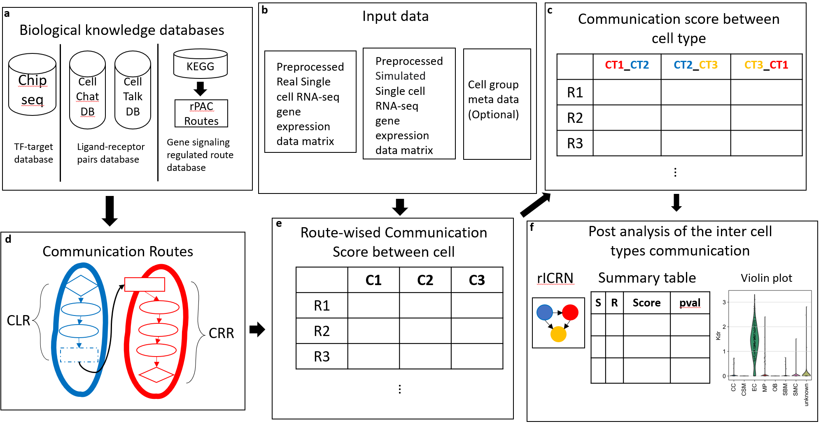
Fig 1. The overall view of rCom. a. The three categories of biological knowledge databases used in the rCom. b. The input data for rCom including: (i). preprocessed scRNA-seq with real cell group label for inferencing inter cell type communication. (ii). preprocessed scRNA-seq with randomized group label for permutation test. (iii). Cell group label meta data file. c. The matrix of communication score between cell type. d. The communication route pairs extract from 3 type databases. e. Route-wised communication scored in each cell. f. The post analysis of the inter cell types communication include: inferenced rICRN, summary table including cell type with permutation p-value, violin plot for the ligand-receptor expression value.

The input data are revealed in the fig 1b. Single cell matrix contains gene expression values which are preprocessed through quality control, normalization, scaled and log transform. In the matrix, columns indicate cells and rows indicate genes. After log transformed, rCom treated gene with negative value as inhibited genes and gene with positive value as activated genes.
2.1 Communication Routes
Unlike other methods that only consider ligand-receptor, the rCom inference cell communication based on the communication routes that are extended from L-R pairs. In the figure X, we show how we generate communication routes from four different biological knowledge databases including: Chip-seq [11], CellChat[12] , CellTalkDB[13] and KEGG[].
Communication route pairs has two routes: (i) communication ligand route (CLR) and (ii) communication receptor route (CRR). Communication ligand route captures the signals which are cell-secreted ligands produced when the transcription factor (TF) binds to the target genes. The cell that secreting ligands is known as secretor. CLR usually starts from TF and follow the path to the ligands. Two biological knowledge databased are used to generate CLR, rPAC routes and Chip-seq DB. The CLR is similar to p2 routes in rPAC, but the starts TF of CLR are not only from KEGG but also can from Chip-seq. Communication receptor route captures the signals transduction from cell surface into the nucleus in which each route starts from receptor and follows a path to the TFs. The cell that receiving ligand signal is known as receiver. CRR are transformed from p1 routes in rPAC(KEGG). The connection of CLR and CRR are ligand and receptor pairs derived from two ligand-receptors pairs databases: CellChatDB, CellTalk and ligand-receptors pairs in p1 routes of rPAC. Totally 104004 communication route pairs are built and stored in graph structure in rCom.
2.2 Node expected value and evaluation value
2.2.1 Node expected value. A node expected value ($E_{k}$) is either +1 or -1 which indicates whether node should be up-regulated or down-regulated in the route to activate ligand or activated by receptor. A node is assigned an expected value using propagation method which starts from ligands in CLR or receptors in CRR to the end node of the route (TF in both CLR and CRR). The equation of this method is given in Eq 1.
$E_{k}= \left\{\begin{aligned} 1 k=1 \\ E_{k-1}*e_{k} other wise\end{aligned}\right.$ (1)
In this equation, k stands for the kth nodes from the starter (ligand in CLR and receptor in CRR.). ek stands the edge between ek and ek-1. The value of ek can be assign using Eq 2.
$e_{k}= \left\{\begin{aligned} +1 the edge is activation \\ -1 the edge is inhibition\end{aligned}\right. (2)$
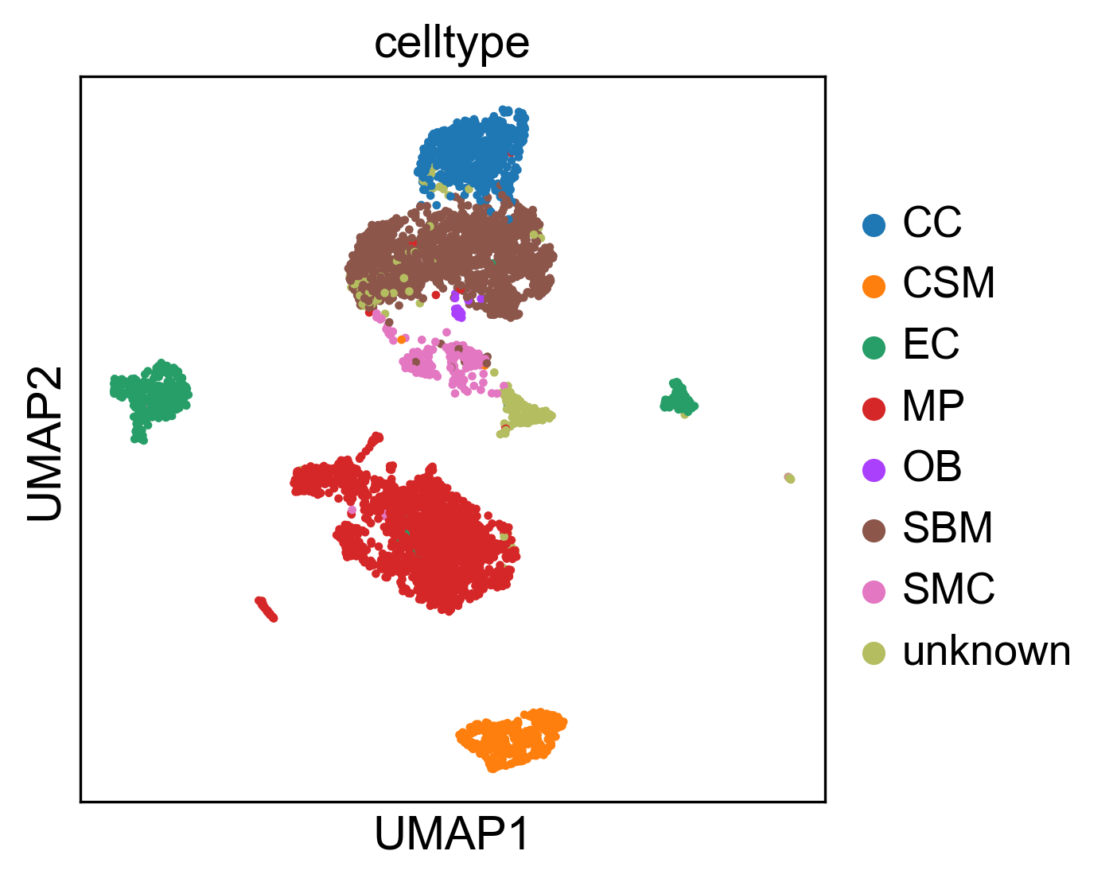Fig 3. The reproduce 2-D visualization of UMAP, colored by cell label provided by studies.
2.2.2 Node evaluation value. Node evaluation value ($V_{k}$) is assigned based on the node expected value and node type. Two types of nodes will appear in the communication routes: singleton node and bundle node. A singleton node stands for only one gene in the node which is computed using the Eq 3.
$V_{k}= \left\{\begin{aligned} abs\left(V_{g_{k}}\right) { V}_{gi}*E_{k}≥0 \\ 0 { V}_{gi}*E_{k}<0\end{aligned}\right. (3)$
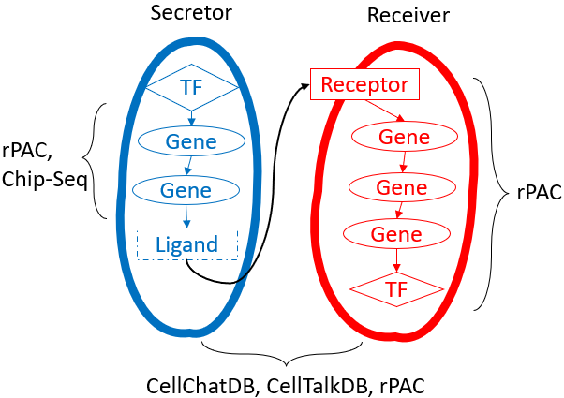
Fig 2. The overview of the communication route. The blue route is CLR, and the red route is CRR. The CLR is generated from rPAC routes and Chip-seq database. The CRR is generated from rPAC routes. The ligand and receptor pairs are derived from CellChatDB, CellTablkDB and rPAC.
$V_{gi}$ stands for the expression value of gene g in node k after preprocessed. Bundle node is composed of multiple nodes which collectively contribute to regulate the downstream genes
2.3 Communication route score
A communication route ($CLR_{j} and CRR_{j}$) score ($SL_{ij} and SR_{ij}$) measure the capability of cell $i$ to communicated with other cells through communication route $j$. A cell with high CLR score means it has a high capability to secret ligand which are highly regulated in this specific route and with a high CRR score indicates a high capability to receive signals through the receptor and regulate it downstream gene and TF. The score is assigned using the equation given in Eq. 6a, 6b.
$SL_{ij}=\left\{\begin{aligned}w*VL+\left(1-w\right)\frac{1}{n_{i}-1}\sum_{k}^{n_{i}-1}{V_{k}}+1 if VL>0 \\ 1 if VL≤0\end{aligned}\right. (6a)$
$SR_{ij}=\left\{\begin{aligned}w*VR+\left(1-w\right)\frac{1}{n_{i}-1}\sum_{k}^{n_{i}-1}{V_{k}}+1 if VR>0 \\ 1 if VR≤0\end{aligned}\right. (6b)$
where $n_{i}$ is the number of nodes in communication route $i$, $VL$ and $VR$ are the node evaluation value of ligand node or receptor node in CLR or CRR. Since the communication behavior is mostly rely on the ligand and receptor, an adjustable hyperparameter $w$ is given to emphasize the effect of ligand or receptor. The choice of $w$ will be “context-dependent” rang from 0 to 1 and need to be determined empirically like hyperparameters of machine learning models.
2.4 Inference of intercellular communications
To infer the inter and intracellular communications, a novel heuristic rule are invented based on the two distinct types of cell-cell communication: autocrine and paracrine. Since the mass of ligand secreted by a cell type is constant, a strong inter cell type communication will lead to a week intra cell type communication and vice versa. According to this rule, a score of communication between the cell type $α$ and $β$ through communication route pair $j$ are computed using equation given in Eq.7.
$$C_{jαβ}=\frac{SL_{αj}*SR_{βj}}{SL_{αj}*SR_{αj}+SL_{βj}*SR_{βj}} (7)$$
Here $SL_{αj}$ and $SR_{αj}$ represent the CLR and CRR score in cell group $α$ and were computed using Eq. 8a and 8b. $SL_{kj}$ and $SR_{kj}$ stands for the score of communication route $j$ for cell $k$ in cell group $α$.
$SL_{αj}= \sqrt[n]{SL_{1j}*…*SL_{kj}*…*SL_{nj}} \left(8a\right)$
$$SR_{αj}= \sqrt[n]{SR_{1j}*…*SR_{kj}*…*SR_{nj}} (8a)$$
By checking the communication score $(C_{jαβ})$, it is possible to inference the cell communication between the whole dataset. The higher score represents for a higher probability that communication between the cell in two cell type through the specific communication routes.
2.5 Identification of statistically significant intercellular communication routes
To prove the inference of intercellular communication is not coincidence, the identification of statistically significance is necessary. The significant interactions between two cell groups are identified using permutation test by randomly permuting the cell type label and then recalculating the communication score $(C_{jαβ}')$ between cell type $α$ and $β$ through communication route pair $j$. The p-value of each communication score $(C_{jαβ})$ is calculated using Eq. 9
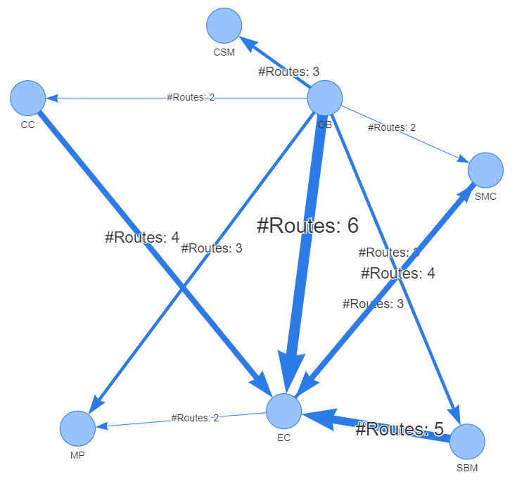
Fig. 4 rICRN generated from rCOM, the weight of edge shows the number of communication routes between two cell group higher than the threshold.
$$p-value=1-\frac{\left\{\#m\right|{C_{jαβ}^{\left(m\right)}}^{'}≤ C_{jαβ}, m=1,2, .. . , M\}}{M} (9)$$
Where the score $C_{jαβ}^{\left(m\right)}'$ is the communication probability for the m-th permutation. M is the total number permutations (default is 100). The communications with p-value < 0.05 are considered as significant.
3 Experiment results
To demonstrate the correctness and practicality of rCom. We show how independent two single cell datasets can be analyzed using rCom with 4 biological knowledge databases as mentioned in methods part. We built 2 rICRNs based on the significant communication route pairs and validate the result by checking the gene expression value of ligand and receptor and by literature survey.
3.1 Experiments with Acta2-lineage cells in osseointegration dataset
The first study that applied to rCom identified the specific bone marrow stromal cell populations that contribute to bone formation around metal implants [14]. After preprocess, the scRNA-seq data matrix we collected from this study has 4397 cells and 31053 features (genes). The labels of each cell group are given in this dataset including: cell of skeletal muscle (CSM) (269 cells), chondrocyte (CC) (545 cells), endothelia cell (EC) (394 cells), macrophage (MP) (1608 cells), osteoblast (OB) (19 cells), smooth muscle cell (SMC) (191 cells) and stromal cell of bone marrow (SBM) (1371 cells). To prove the dataset that applied in the rCom are correctly preprocessed, the 2-D visualization of UMAP with the given labels is shown in the Fig 3.
The significant communication routes of intercellular communication are shown in Tab. 1 with the threshold of the score larger than 8. And the rICRN of this dataset using the highest score route is shown in Fig 4 generated using pyvis. By checking the networks, we notice that the communication from SBM to EC, from OB to EC and from CC to EC have the most significa nt communication routes. To prove the correctness of the inferred communications, we generated the violin plot with the ligand and receptor gene expression values in the datasets. In Fig. 5, we try to validate the identified communication route (id: 70072) between EC and MP through the ICAM2 – ITGB2 pairs. The gene expression highly supports our results with the ICAM2 highly expressed in the EC group and poorly expressed in the MP group while on the receptor ends, ITGB2 is highly expressed in the MP cells but poorly expressed in the EC. Our literature survey shows that in 2011, Zhang et al. [15] identified the communication between EC and MP through ICAM family gene. In another case, OB are known to communicate to MP cell through VEGFA as state by Mayer et al. [16]. We identified the communication happens between these two cell types through communication route with id 103917. The violin plot of the ligand and receptor in this route proves our result as shown in figure. The VEGFA gene are relatively highly expressed in the OB group and poorly expressed in the EC group. But the as receptor of VEGFA, KDR is highly expressed in the EC and poorly expressed in the rest of cell groups.
S | R | R id | Score | Ligand | Receptor | Pval
OB | EC | 82280 | 9.83 | IBSP | ITGB3 | <0.0005
OB | MP | 96177 | 9.53 | IBSP | ITGAV | <0.0005
OB | SMC | 96177 | 9.18 | IBSP | ITGAV | <0.0005
OB | SBM | 96177 | 9.05 | IBSP | ITGAV | <0.0005
EC | MP | 70072 | 9.04 | ICAM2 | ITGB2 | <0.0005
OB | EC | 6452 | 8.68 | TNC | PTPRB | <0.0005
EC | OB | 77882 | 8.66 | GNAI2 | LPAR3 | <0.0005
OB | EC | 103917 | 8.65 | VEGFA | KDR | <0.0005
OB | EC | 4562 | 8.64 | SEMA5A | MET | <0.0005
OB | EC | 103718 | 8.63 | PDGFC | KDR | <0.0005
OB | EC | 89677 | 8.55 | IBSP | ITGAV | <0.0005
SMC | EC | 103686 | 8.53 | VTN | KDR | <0.0005
OB | SMC | 95280 | 8.49 | IBSP | ITGB3 | <0.0005
OB | CSM | 93655 | 8.48 | IBSP | ITGB3 | <0.0005
OB | CSM | 94552 | 8.46 | IBSP | ITGAV | <0.0005
OB | SBM | 82280 | 8.42 | IBSP | ITGB3 | <0.0005
CC | EC | 103767 | 8.42 | GREM1 | KDR | <0.0005
SBM | EC | 103695 | 8.41 | PDGFC | KDR | <0.0005
OB | CC | 94552 | 8.37 | IBSP | ITGAV | <0.0005
EC | SMC | 11106 | 8.29 | GNAI2 | EDNRA | <0.0005
SBM | EC | 6448 | 8.28 | TNC | PTPRB | <0.0005
EC | SMC | 81908 | 8.27 | JAG2 | NOTCH3 | <0.0005
CC | EC | 6448 | 8.24 | TNC | PTPRB | <0.0005
EC | MP | 96764 | 8.24 | COL4A1 | ITGAV | <0.0005
SBM | EC | 6478 | 8.20 | PTN | PTPRB | <0.0005
EC | SMC | 81697 | 8.20 | DLL4 | NOTCH3 | <0.0005
OB | MP | 95280 | 8.19 | IBSP | ITGB3 | <0.0005
OB | SBM | 4562 | 8.19 | SEMA5A | MET | <0.0005
CC | EC | 103929 | 8.17 | VEGFA | KDR | <0.0005
SMC | EC | 6457 | 8.17 | TNC | PTPRB | <0.0005
SMC | EC | 103693 | 8.15 | PDGFC | KDR | <0.0005
CC | EC | 82241 | 8.14 | COMP | ITGB3 | <0.0005
SBM | EC | 103664 | 8.12 | VEGFA | KDR | <0.0005
OB | CC | 87155 | 8.10 | IBSP | ITGB3 | <0.0005
OB | MP | 4562 | 8.10 | SEMA5A | MET | <0.0005
SBM | EC | 103769 | 8.09 | VEGFD | KDR | <0.0005
OB | CSM | 4562 | 8.07 | SEMA5A | MET | <0.0005
SMC | EC | 103664 | 8.02 | VEGFA | KDR | <0.0005
CSM | EC | 103769 | 8.01 | VEGFD | KDR | <0.0005
Table 1. The significant communication routes pairs between each two cell types with score higher than threshold (8.0). In the header, S stands for secretor and R stands for receiver.
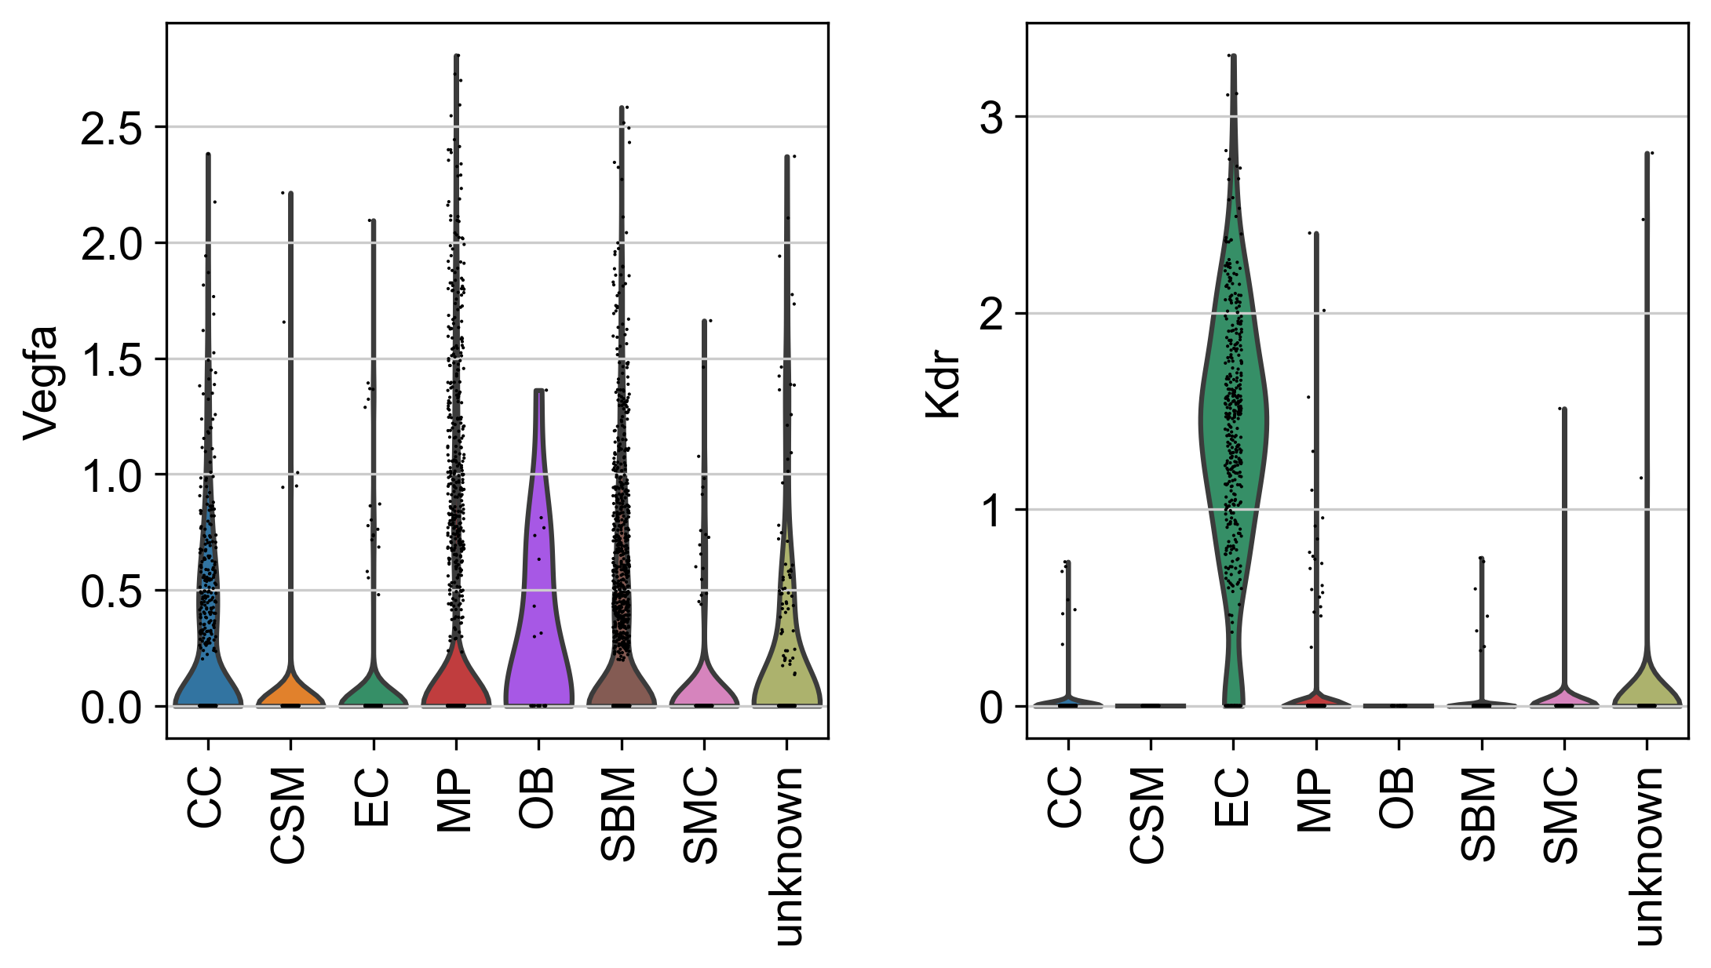
Fig 6. The violin plot of VEGFA and KDR gene expression value in each cell type.

Fig 5. The violin plot of ICAM2 and ITGB2 gene expression value in each cell type.

S | R | R id | Score | Ligand | Receptor | pval
SMC | PL | 95696 | 12.64 | COL18A1 | ITGB3 | <0.0005
SMC | MC | 80134 | 11.58 | LGALS1 | PTPRC | <0.0005
SMC | PL | 95739 | 11.03 | COL4A2 | ITGB3 | <0.0005
SMC | PL | 95421 | 10.34 | MFGE8 | ITGB3 | <0.0005
SMC | PL | 95367 | 9.7 | NID1 | ITGB3 | <0.0005
MC | SMC | 72456 | 9.63 | IL1B | IL1R1 | <0.0005
OB | PL | 82280 | 9.6 | IBSP | ITGB3 | <0.0005
OB | PL | 82619 | 9.45 | FN1 | ITGB3 | <0.0005
MC | EC | 72456 | 9.44 | IL1B | IL1R1 | <0.0005
CC | PL | 90899 | 9.42 | TGM2 | ITGB3 | <0.0005
OB | PL | 82963 | 9.41 | CCN1 | ITGB3 | <0.0005
SMC | PL | 95503 | 9.39 | FBN1 | ITGB3 | <0.0005
OB | MC | 69430 | 9.36 | CCN1 | ITGB2 | <0.0005
SMC | PL | 95268 | 9.35 | VTN | ITGB3 | <0.0005
SMC | MC | 69220 | 9.3 | JAM3 | ITGB2 | <0.0005
MC | CC | 72456 | 9.11 | IL1B | IL1R1 | <0.0005
SMC | PL | 95290 | 9.08 | TGFB3 | ITGB3 | <0.0005
SMC | PL | 96031 | 9.08 | ITGAV | ITGB3 | <0.0005
MC | OB | 72456 | 9.04 | IL1B | IL1R1 | <0.0005
OB | PL | 82885 | 9.04 | SPP1 | ITGB3 | <0.0005
SMC | MC | 69430 | 9 | CCN1 | ITGB2 | <0.0005
SMC | PL | 95963 | 9 | CCN1 | ITGB3 | <0.0005
SMC | MC | 69337 | 8.98 | CCN2 | ITGB2 | <0.0005
HP | SMC | 6394 | 8.88 | CDH1 | PTPRF | <0.0005
MC | PL | 73780 | 8.88 | IL1B | IL1R1 | <0.0005
MC | PL | 95780 | 8.88 | TGM2 | ITGB3 | <0.0005
SMC | MC | 69032 | 8.83 | PLAT | ITGB2 | <0.0005
MC | SMC | 11108 | 8.76 | GNAI2 | EDNRA | <0.0005
MC | PH | 72456 | 8.75 | IL1B | IL1R1 | <0.0005
OB | PL | 82724 | 8.72 | ADAM15 | ITGB3 | <0.0005
OB | MC | 69220 | 8.71 | JAM3 | ITGB2 | <0.0005
SMC | PL | 95841 | 8.71 | THBS2 | ITGB3 | <0.0005
SMC | PL | 95640 | 8.7 | FN1 | ITGB3 | <0.0005
SMC | MC | 69438 | 8.66 | SPON2 | ITGB2 | <0.0005
MC | PL | 78576 | 8.61 | GNAI2 | F2R | <0.0005
OB | MC | 69439 | 8.6 | SPON2 | ITGB2 | <0.0005
SMC | MC | 69190 | 8.6 | VCAM1 | ITGB2 | <0.0005
OB | PL | 83036 | 8.58 | ITGAV | ITGB3 | <0.0005
OB | PL | 82822 | 8.57 | THBS2 | ITGB3 | <0.0005
OB | PL | 83001 | 8.55 | VEGFA | ITGB3 | <0.0005
HP | PL | 95712 | 8.54 | ADAM15 | ITGB3 | <0.0005
MC | EC | 81406 | 8.54 | SLPI | CD4 | <0.0005
MC | PH | 81406 | 8.54 | SLPI | CD4 | <0.0005
MC | OB | 77886 | 8.54 | GNAI2 | LPAR3 | <0.0005
MC | SMC | 81406 | 8.53 | SLPI | CD4 | <0.0005
MC | OB | 81406 | 8.52 | SLPI | CD4 | <0.0005
HP | PL | 95592 | 8.47 | ICAM4 | ITGB3 | <0.0005
PH | MC | 70058 | 8.46 | SPON2 | ITGB2 | <0.0005
SMC | MC | 69406 | 8.43 | PLAU | ITGB2 | <0.0005
MC | PL | 95964 | 8.42 | VEGFA | ITGB3 | <0.0005
HP | EC | 6357 | 8.39 | CDH1 | PTPRM | <0.0005
OB | HP | 70050 | 8.39 | CCN1 | ITGB2 | <0.0005
OB | MC | 69337 | 8.36 | CCN2 | ITGB2 | <0.0005
HP | PL | 95866 | 8.35 | ITGB3BP | ITGB3 | <0.0005
SMC | MC | 69175 | 8.35 | KNG1 | ITGB2 | <0.0005
OB | MC | 69010 | 8.33 | PLAT | ITGB2 | <0.0005
MC | SMC | 101117 | 8.32 | S100A8 | TLR4 | <0.0005
MC | EC | 100813 | 8.3 | S100A8 | TLR4 | <0.0005
Table 2. The significant communication routes pairs between each two cell types with score higher than threshold (8.3).

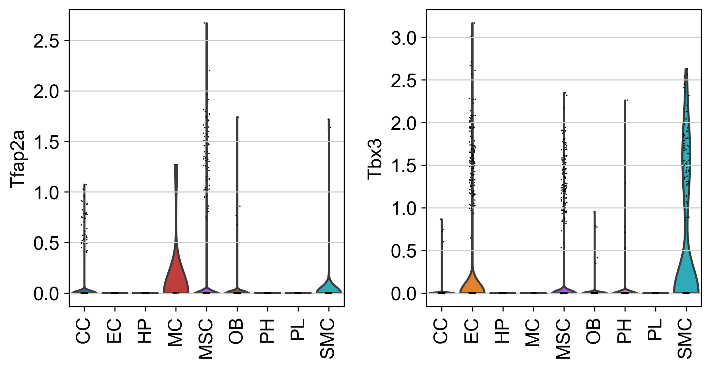
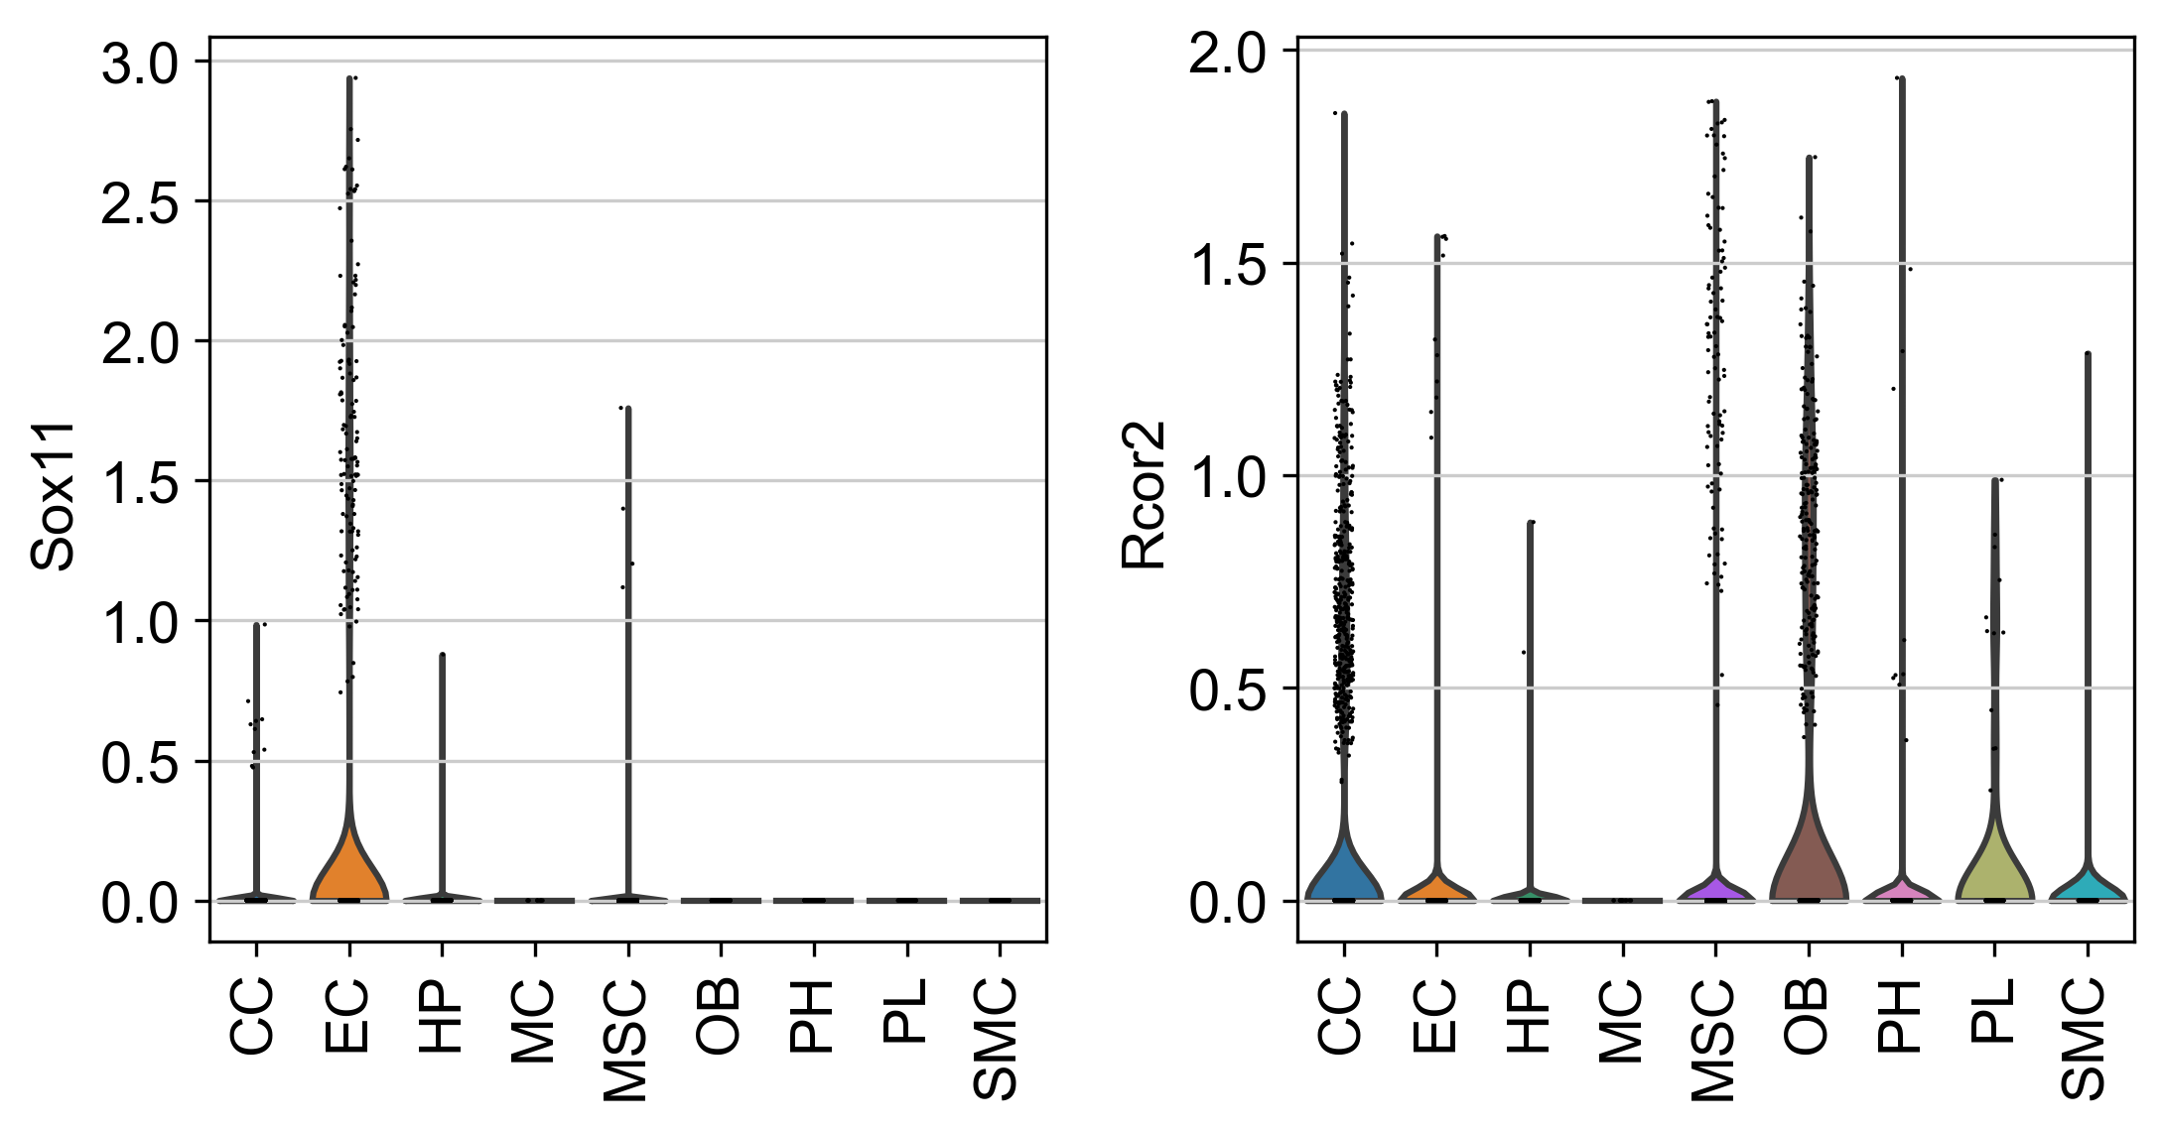
Fig 11. The violin plot for upper stream gene expression value of COL18A1 and ITGB3.
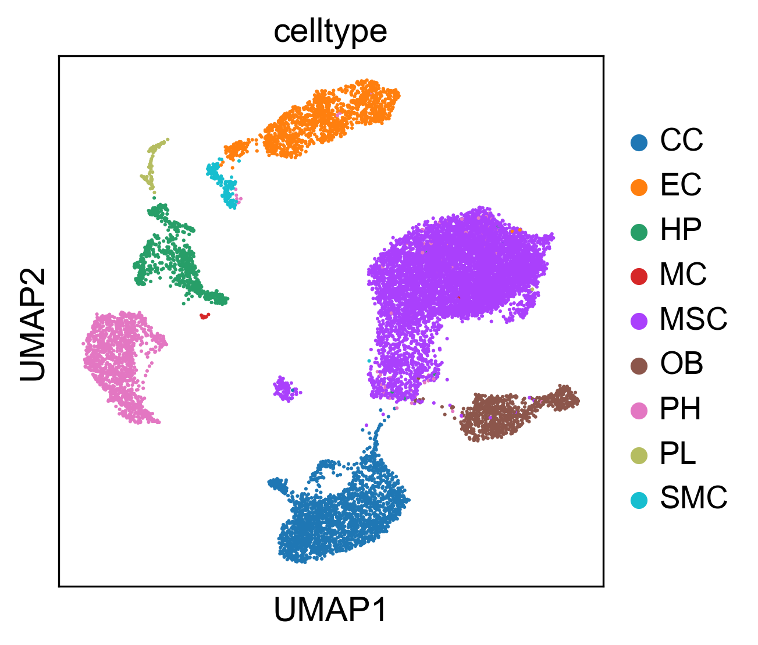
Fig 7. The reproduce 2-D visualization of UMAP, colored by cell label provided by studies.

3.2 Experiments with bone marrow stromal scRNA-seq of 11 weeks old mice dataset
Another dataset we collected from a study [17] which explored osteogenesis in adult mice and show that a bone-targeting, high affinity without causing adverse effects in other organs, which are known to reply on intact Notch signaling interactions. After preprocess, the scRNA-seq data matrix has 17015 cells and 15046 features(genes). The labels of each cell groups are given in the meta file of the dataset including, CC (2270 cells), EC (1677 cells), Hematopoietic (HP) (849 cells), MSC (9168 cells), OB (971 cells), platelets (PL) (232 cells), proliferating Hem (PH) (1532 cells), SMC (238 cells), MC (78 cells). Our reproduced single cell 2-D plot visualization using UMAP is shown in Fig 7. The pattern those cells sharing same group are close to each other stands for the correctness of our preprocess.
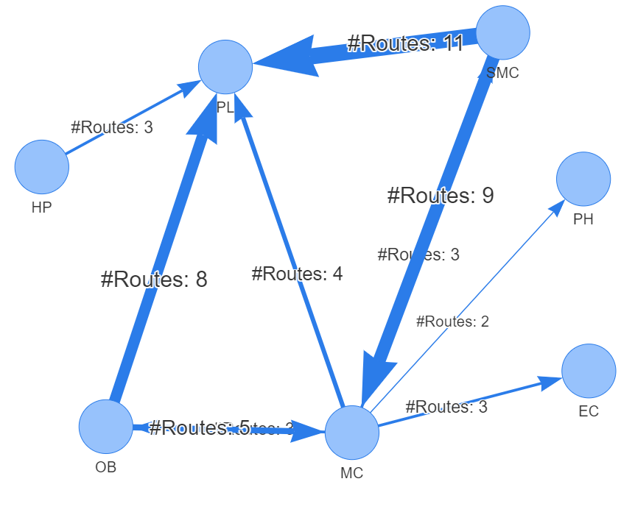
Fig. 8 rICRN generated from rCOM, the weight of edge shows the number of communication routes between two cell group higher than the threshold.

The significant communication routes identified by rCom are shown in Tab.1 with threshold of score larger than 8.3 and the rICRN are build and shown in figure 8. Among all the communication between each two cell types. The communication between SMC and PL has the largest number of significant routes pairs, and the communication from MC to PH only have 2 route pairs. To prove the correctness of the identified significant communication routes, the violin plot is used to find the gene expression of ligand and receptor in each cell groups. In Fig 9, the gene expression value of COL18A1 and ITGB3 ligand and receptor pairs are compared using violin plot. In all cell groups, COL18A1 only highly expressed in the SMC and its receptor, ITGB3 are highly expressed in the PL and only few MC cells have ITGB3 expressed. This inferred that SMC cells are communicated with PL cells through COL18A1 and ITGB3. Our literature shows that in 2018, Misra et al. [18] indicates that ITGB3 plays and important role for smoothing muscle-derived atherosclerotic plaque cells including: SMC and PL. Another case we use is the communication between SMC and MC through LGALS1-PTPRC pairs. As shown in Fig 10, LGALS1 is highly expressed in SMC, OB and HP. But its receptor, PTPRC, are only expressed in HP and MC. Which also proves rCOM’s finding in gene expression level.
To validate the gene signaling route that actives the ligand genes and the routes that are activated by the receptors. We demonstrate the violin plot of gene expression value in the dataset of all the TFs that can regulate the COL18A1 include: TFAP2A, TBX3, NUCKS1, SOX11 and RCOR2 as shown in Fig 11. Only TBX3 are highly expressed in the SMC and rCOM picks the TBX3 as the upper stream for the COL18A1 instead of other. The consistent result between gene expression value and the output of rCOM validate the correctness of route identification. The complete route is shown in Fig 12, which the TBX2 transcripts COL18A1 and actives a route in thyroid hormone signaling pathways through ITGB3.
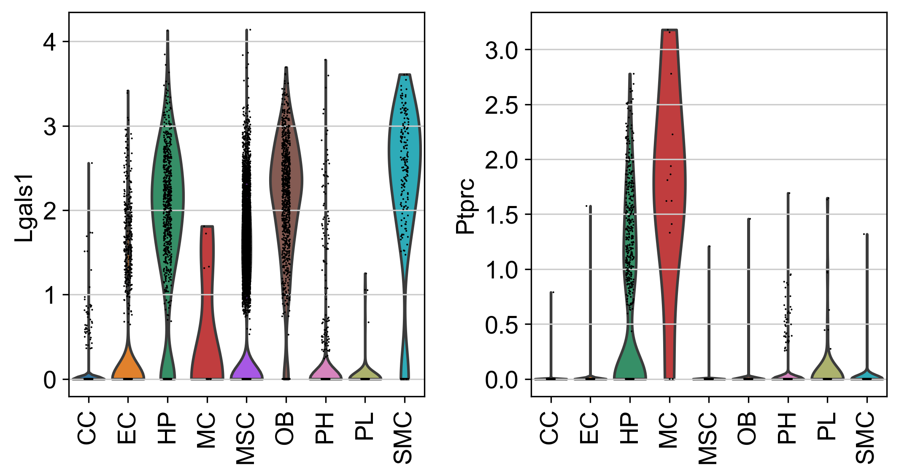
Fig 10. The violin plot of LGALS1 and PTPRC gene expression value in each cell type.

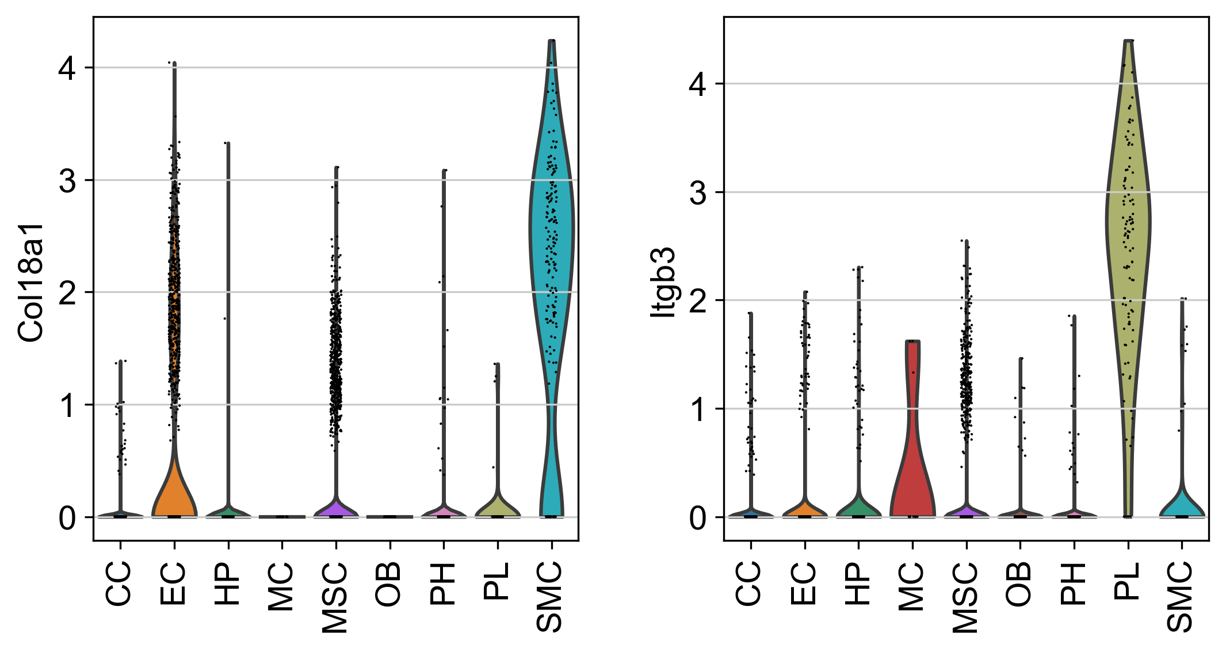
Fig 9. The violin plot of COL18A1 and ITGB3 gene expression value in each cell type.

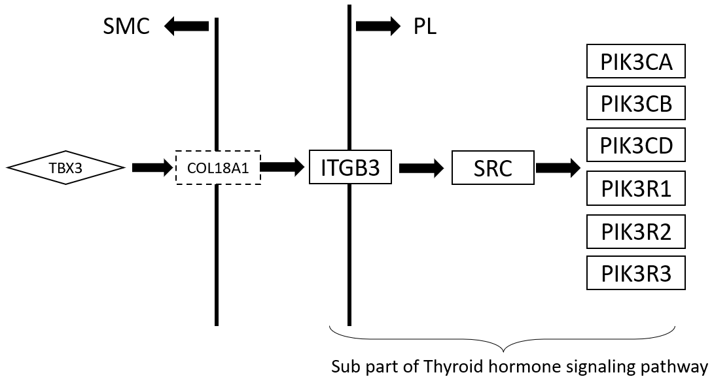

Fig 12. The complete view of communication route pairs id 95696

4. Discussion and conclusion
Developing rCom was inspired by mapping the ligand-receptor in the gene signaling pathway route then inferencing the inter cell type communication at route-based level. Among all the existing methods, Ctyotalk returns a signal transduction network between cell types which is similar to rCOM but the network in Cytotalk is inferred from a PCSF problem and rCOM try to identify the crosstalk between routes extracted from well-established pathway databases. To our best knowledge, no method currently exists inferring inter cell type communication considering the gene regulatory patterns (activated or inhibited) and the consistence of regulatory patterns in the signaling routes as prior knowledge at the scRNA-seq level. rCom provide a new to using well-established prior knowledge to translate the communication behavior. With rCom, a complete identification of gene in upper stream of ligand and downstream of receptor can acquired.
rCOM also provide a new way for exploring of pathway crosstalk and combining biological knowledge databases. Identifying crosstalk between interacting pathways has been an active research area. Nodes-in-Common (NIC) predicts crosstalk by checking if two pathways share any proteins [19]–[21]. Hsu et.al. estimate pathway crosstalk based on similarities in Gene Ontology annotations[22]. Given a protein-protein interaction network, Li et al. links two pathways A and B if more edges connect the proteins in A to the proteins in B than expected by chance in a randomly wired network [23]. In our previous work, ctBuilder [24] is developed to identify a subnetwork interconnecting two pathways. However, with combination of biological databases with gene signaling pathway, rCom provide a novel aspect of exploring and identifying pathway crosstalk, which is the connection between ligand and receptor pairs.
By analyzing the communication route pairs, unknown crosstalk between two independent pathways might be identified.
ACKNOWLEDGMENTS
Insert paragraph text here. Insert paragraph text here. Insert paragraph text here. Insert paragraph text here. Insert paragraph text here. Insert paragraph text here. Insert paragraph text here. Insert paragraph text here. Insert paragraph text here. Insert paragraph text here. Insert paragraph text here.
REFERENCES
[1] D. A. Skelly et al., “Single-Cell Transcriptional Profiling Reveals Cellular Diversity and Intercommunication in the Mouse Heart,” Cell Rep., vol. 22, no. 3, pp. 600–610, Jan. 2018, doi: 10.1016/J.CELREP.2017.12.072.
[2] M. P. Kumar et al., “Analysis of Single-Cell RNA-Seq Identifies Cell-Cell Communication Associated with Tumor Characteristics,” Cell Rep., vol. 25, no. 6, pp. 1458-1468.e4, Nov. 2018, doi: 10.1016/J.CELREP.2018.10.047.
[3] J. X. Zhou, R. Taramelli, E. Pedrini, T. Knijnenburg, and S. Huang, “Extracting Intercellular Signaling Network of Cancer Tissues using Ligand-Receptor Expression Patterns from Whole-tumor and Single-cell Transcriptomes,” Sci. Reports 2017 71, vol. 7, no. 1, pp. 1–15, Aug. 2017, doi: 10.1038/s41598-017-09307-w.
[4] R. Vento-Tormo et al., “Single-cell reconstruction of the early maternal–fetal interface in humans,” Nat. 2018 5637731, vol. 563, no. 7731, pp. 347–353, Nov. 2018, doi: 10.1038/s41586-018-0698-6.
[5] Y. E. Antebi, N. Nandagopal, and M. B. Elowitz, “An operational view of intercellular signaling pathways,” Curr. Opin. Syst. Biol., vol. 1, pp. 16–24, Feb. 2017, doi: 10.1016/J.COISB.2016.12.003.
[6] M. Billmann, V. Chaudhary, M. F. ElMaghraby, B. Fischer, and M. Boutros, “Widespread Rewiring of Genetic Networks upon Cancer Signaling Pathway Activation,” Cell Syst., vol. 6, no. 1, pp. 52-64.e4, Jan. 2018, doi: 10.1016/J.CELS.2017.10.015.
[7] S. Wang, M. Karikomi, A. L. Maclean, and Q. Nie, “Cell lineage and communication network inference via optimization for single-cell transcriptomics,” Nucleic Acids Res., vol. 47, no. 11, pp. e66–e66, Jun. 2019, doi: 10.1093/NAR/GKZ204.
[8] R. Browaeys, W. Saelens, and Y. Saeys, “NicheNet: modeling intercellular communication by linking ligands to target genes,” Nat. Methods 2019 172, vol. 17, no. 2, pp. 159–162, Dec. 2019, doi: 10.1038/s41592-019-0667-5.
[9] Y. Hu, T. Peng, L. Gao, and K. Tan, “CytoTalk: De novo construction of signal transduction networks using single-cell transcriptomic data,” Sci. Adv., vol. 7, no. 16, Apr. 2021, doi: 10.1126/SCIADV.ABF1356
[10] P. Joshi, B. Basso, H. Wang, S. H. Hong, C. Giardina, and D. G. Shin, “rPAC: Route based pathway analysis for cohorts of gene expression data sets,” Methods, Oct. 2021, doi: 10.1016/J.YMETH.2021.10.002.
[11] “Chromatin Immunoprecipitation Sequencing (ChIP-Seq).” https://www.illumina.com/techniques/sequencing/dna-sequencing/chip-seq.html (accessed May 11, 2022).
[12] S. Jin et al., “Inference and analysis of cell-cell communication using CellChat,” Nat. Commun. 2021 121, vol. 12, no. 1, pp. 1–20, Feb. 2021, doi: 10.1038/s41467-021-21246-9.
[13] X. Shao, J. Liao, C. Li, X. Lu, J. Cheng, and X. Fan, “CellTalkDB: a manually curated database of ligand–receptor interactions in humans and mice,” Brief. Bioinform., vol. 22, no. 4, Jul. 2021, doi: 10.1093/BIB/BBAA269.
[14] A. Vesprey et al., “Tmem100- and Acta2-Lineage Cells Contribute to Implant Osseointegration in a Mouse Model,” J. Bone Miner. Res., vol. 36, no. 5, pp. 1000–1011, May 2021, doi: 10.1002/JBMR.4264.
[15] J. Zhang et al., “Regulation of Endothelial Cell Adhesion Molecule Expression by Mast Cells, Macrophages, and Neutrophils,” PLoS One, vol. 6, no. 1, 2011, doi: 10.1371/JOURNAL.PONE.0014525.
[16] H. Mayer, H. Bertram, W. Lindenmaier, T. Korff, H. Weber, and H. Weich, “Vascular endothelial growth factor (VEGF-A) expression in human mesenchymal stem cells: autocrine and paracrine role on osteoblastic and endothelial differentiation,” J. Cell. Biochem., vol. 95, no. 4, pp. 827–839, Jul. 2005, doi: 10.1002/JCB.20462.
[17] C. Xu et al., “Induction of osteogenesis by bone-targeted Notch activation,” Elife, vol. 11, Feb. 2022, doi: 10.7554/ELIFE.60183.
[18] F. Hartmann et al., “SMC-Derived Hyaluronan Modulates Vascular SMC Phenotype in Murine Atherosclerosis,” Circ. Res., vol. 129, no. 11, pp. 992–1005, Nov. 2021, doi: 10.1161/CIRCRESAHA.120.318479.
[19] D. M et al., “Analysis and correction of crosstalk effects in pathway analysis,” Genome Res., vol. 23, no. 11, pp. 1885–1893, Nov. 2013, doi: 10.1101/GR.153551.112.
[20] K. H and K. MR, “Abiotic stress signalling pathways: specificity and cross-talk,” Trends Plant Sci., vol. 6, no. 6, pp. 262–267, 2001, doi: 10.1016/S1360-1385(01)01946-X.
[21] T. CM, E. B, and K. CR, “Critical nodes in signalling pathways: insights into insulin action,” Nat. Rev. Mol. Cell Biol., vol. 7, no. 2, pp. 85–96, Feb. 2006, doi: 10.1038/NRM1837.
[22] C.-L. Hsu and U.-C. Yang, “Discovering pathway cross-talks based on functional relations between pathways,” BMC Genomics 2012 137, vol. 13, no. 7, pp. 1–15, Dec. 2012, doi: 10.1186/1471-2164-13-S7-S25.
[23] L. Y, A. P, and R. D, “A global pathway crosstalk network,” Bioinformatics, vol. 24, no. 12, pp. 1442–1447, Jun. 2008, doi: 10.1093/BIOINFORMATICS/BTN200.
[24] H. Wang, P. Joshi, S. H. Hong, D. J. Shin, and D. G. Shin, “CtBuilder: A framework for building pathway crosstalks by combining single cell data with bulk cell data,” Proc. - 2021 IEEE Int. Conf. Bioinforma. Biomed. BIBM 2021, pp. 270–273, 2021, doi: 10.1109/BIBM52615.2021.9669811.

