rCom: A route-based framework for inferencing cell type communication and regulatory network using single cell data

Honglin Wang†
Computer Sci. and Engr. Dept., Univ. of Connecticut, Storrs, USA
honglin.wang@uconn.edu
xxxxx
Computer Sci. and Engr. Dept., Univ. of Connecticut, Storrs, USA email@email.com
Chenyu Zhang
Computer Sci. and Engr. Dept., Univ. of Connecticut, Storrs, USA
email@email.com
xxxx
Computer Sci. and Engr. Dept., Univ. of Connecticut, Storrs, USA
honglin.wang@uconn.edu
Chenyu Zhang
Computer Sci. and Engr. Dept., Univ. of Connecticut, Storrs, USA email@email.com
Dong-Guk Shin
Computer Sci. and Engr. Dept., Univ. of Connecticut, Storrs, USA
dong.shin@uconn.edu

ABSTRACT
The mapping of ligand-receptor pairs is the cornerston of understanding complicated intercellular interactions. With recent advances of single cell RNA (scRNA) sequencing technology, and easy availability of scRNA data, several methods have been proposed to infer cell-cell communication by analyzing ligand-receptor pairs and their expressions in cell-pairs. However, these methods consider only ligand-receptor pairs to infer the communication, thereby missing information from the known portion of pathways that are upstream to ligand and downstream from receptor. In this paper, we present a novel framework, called rCom, for inferring cell-cell interactions by considering portions of pathways that are directly associated with ligand and receptors. Pathway databases like KEGG have limited annotation on ligand-receptor pairs. Therefore, the rCom framework integrates knowledge from multiple biological databases such as (i) transcription factor-target database, (ii) ligand-receptor database and (iii) gene signaling pathway databases. The rCom framework extracts information by combining these databases and form multiple communication route pairs: the communication ligand routes and communication receptor routes. A novel algorithm and a heuristic rule are applied to score each route pair between cell groups. Finally, permutation test is performed to find the significant route pairs between each two cell groups. A route based inter cell type regulatory network is generated based on the significant routes.
We demonstrate how rCom can be used to infer the inter cell type communications on two independent bone marrow datasets. While our literature survey revealed that all the identified ligand-receptor pairs are related to cell types in bone marrow, the results merit wet-lab experiments for validation.
KEYWORDS
Cell communication, Topology and route-based pathway analysis, Bone marrow, Single cell RNA seq
1 Introduction
Complex intercellular responses start with binding of a ligand to its cognate receptor to activate specific cell signaling pathways. Mapping ligand- receptor pairs is fundamental to understanding how cell responds to signaling from neighboring cells and to decode the intercellular communication networks. Single cell RNA-seq technology holds great promise for studying cell-cell communication at much higher resolution. Using scRNA-seq data, several methods have been developed to infer ligand-receptor pair communications between two cell types. Skelly et al. [1] and Kumar et al. [2] predict ligand-receptor pairs if the two genes are highly expressed in the two respective cell types. Zhou et al. [3] and Vento-Tormo et al. [4] identify ligand-receptor pairs whose expressions are specific to the cell types considered. Signaling pathways are highly dynamic, and crosstalk among them is prevalent. Because of these two features, simply examining expression levels of ligand and receptor genes cannot reliably capture the overall activities of signaling pathways and interactions among them [5], [6]. Coming forward, SoptSC from Wang et al. [7] and NicheNet from Browaeys et al. [8] identify both ligand-receptor pairs and genes downstream of them. Hu et al [9] proposed a method, called CytoTalk, to generate a signal transduction network using single-cell transcriptomic data.
With the advent of topology-based pathway analysis, a particular kind, namely route-based, has shown great promise by considering gene-gene regulatory relationships in certain portions or routes of pathways. In our previous work, we analyzed TCGA [10], [11] dataset to demonstrate the strength of route-based pathway analysis by identifying and scoring transcription factor (TF)-centric routes in pathways [12]. Some of these pathway routes can lead to regulation of a ligand, and other routes can be directly activated by binding of the ligand. Analyzing these routes which are directly associated with ligand-receptor binding can give us better understanding of cell-cell interactions (CCIs). However, the existing gene signaling pathway databases have a limited annotations on the ligand-receptor pairs which is the key to analyzing cell type communications. Other databases like CellChat[13] , CellTalkDB[14], namely ligand-receptor pairs databases, only provide the ligand and receptor pairs but never map them into the signaling pathway routes. We postulate that when these two related curated resources are combined and “mined” properly, one can produce an extended ligand and receptor centric cell-cell communication and regulatory routes. In this manuscript, we present a novel computational framework, named rCom, that uses signaling pathway routes extracted from multiple curated biological sources to identify statistically significant CCIs and visualize them as a network called route-based inter cell type regulatory network (rICRN). In the rICRN, nodes represent cell groups and edges represent the number of interaction routes between the nodes.
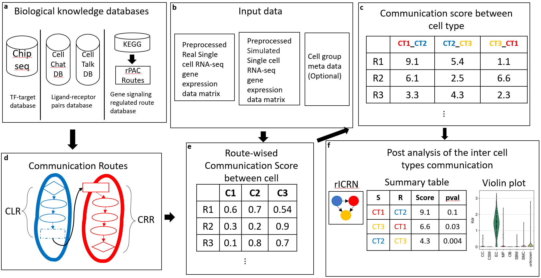
Fig 1. The overall view of rCom. a. The three categories of biological knowledge databases used in the rCom. b. The input data for rCom including: (i). preprocessed scRNA-seq with real cell group label for inferencing inter cell type communication. (ii). preprocessed scRNA-seq with randomized group label for permutation test. (iii). Cell group label meta data file. c. The matrix of communication score between cell type. d. The communication route pairs extract from 3 type databases. e. Route-wised communication scored in each cell. f. The post analysis of the cell types communication include: inferenced rICRN, summary table including cell type with permutation p-value, violin plot for the ligand-receptor expression value.

The rCom framework infers cell type communication by mapping preprocessed scRNA-seq transcriptomic data to two types of communication routes: communication ligand route and communication receptor route. Each route in every cell is scored by considering the consistency of regulatory pattern of gene in routes. The inter cell type communication is inferenced by a heuristic rule based on the comparison of the inter and intra cell type communication. In the end, p-value of permutation test is used to identify the statical significance for communication between two cell types through each route. A route based inter cell type regulatory network (rICRN) are built based on significant communication route pairs. The details will be introduced in section 2. We demonstrate how rCom can be used to analyze single cell datasets in two independent bone related scRNA-seq dataset and discuss the result in the section 3. The conclusion is stated in the last section.
2 System and Methods
The overall process of the rCom framework is shown in Fig. 1. Three different catogories databases, include (i).TF-target database, (ii).ligand-receptor pairs database and (iii).gene signaling regulated route databases, are used to build communication routes. The source databases are downloaded in text or KGML format (Fig 1a). All the nodes (ligands, receptor, gene, and TF) and edges (gene regulated relationship) are extracted from databases and stored in a graph structure. In the graph structure, nodes regulated interactions are directional and are encoded as either activation or inhibition (Fig.1a, 1c).
The input data are revealed in fig 1b. Single cell gene expression matrix is preprocessed through quality control, normalization, scaled and log transform using SCANPY[15]. In the matrix, columns indicate cells and rows indicate genes. After log transformed, rCom treated gene with negative value as inhibited genes and gene with positive value as activated genes.
2.1 Cell-Cell communication routes
Unlike other methods that only consider ligand-receptor, the rCom infer cell communication based on the communication routes that are extended from L-R pairs. In the Fig 2, we show how we generate communication routes from four different biological knowledge databases including: Chip-seq [16], CellChat , CellTalkDB and rPAC.
Communication route pair has two routes: (i) communication ligand route (CLR) and (ii) communication receptor route (CRR). Communication ligand route captures the signals which are cell-secreted ligands produced when the transcription factor (TF) binds to the target genes. The cell that secrets ligands is known as secretor. CLR usually starts from TF and follow the path to the ligands. Two biological knowledge databases are used to generate CLR, rPAC routes and Chip-seq DB. The CLR is like effector routes in rPAC, but the primary TFs of CLR are not only from KEGG but also from Chip-seq. Communication receptor route captures the signals transduction from cell surface into the nucleus in which each route starts from receptor and follows a path to the TFs. The cell that where ligand binds is known as receiver. CRR are transformed from signaling routes in rPAC (KEGG). The connection of CLR and CRR are ligand and receptor pairs derived from two ligand-receptors pairs databases: CellChatDB, CellTalk and ligand-receptors pairs in signaling routes of rPAC. Totally 104004 communication route pairs are identified and stored in graph structure in rCom.
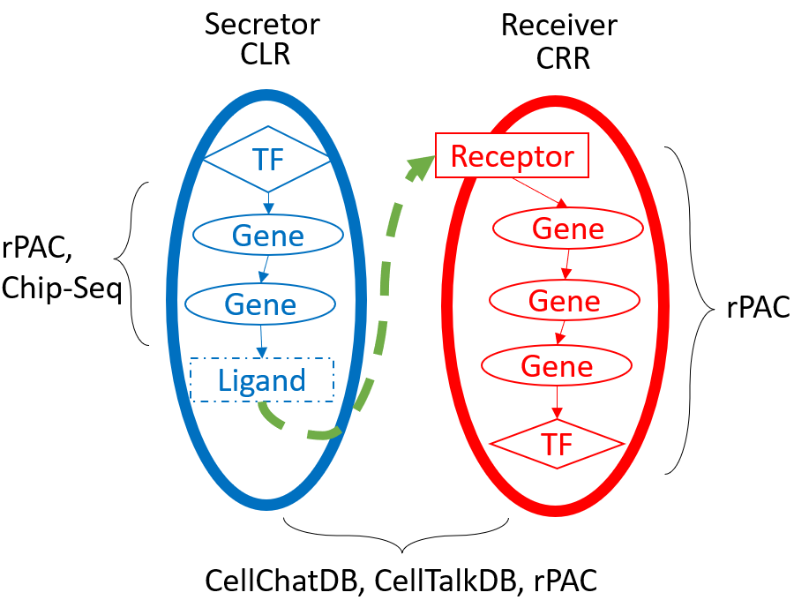
Fig 2. The overview of the communication route. The blue route is CLR, and the red route is CRR. The CLR is generated from rPAC routes and Chip-seq database. The CRR is generated from rPAC routes. The ligand and receptor pairs are derived from CellChatDB, CellTablkDB and rPAC.
2.2 Node expected value and evaluation value
2.2.1 Node expected value. A node expected value ($E_{k}$) is either +1 or -1 which indicates whether node should be up-regulated or down-regulated in the route to activate ligand or activated by receptor. A node is assigned an expected value using propagation method which starts from ligands in CLR or receptors in CRR to the end node of the route (TF in both CLR and CRR). The equation of this method is given in Eq 1.
$E_{k}= \left\{\begin{aligned} 1 k=1 \\ E_{k-1}*e_{k} other wise\end{aligned}\right.$ (1)
In this equation, $k$ stands for the $k_{th}$ nodes from the starter node (ligand in CLR and receptor in CRR.). $e_{k}$ stands the edge expectation value between $k_{th}$ node and $k_{th}-1$ node. The value of $e_{k}$ can be assign using Eq 2.
$e_{k}= \left\{\begin{aligned} +1 the edge is activation \\ -1 the edge is inhibition\end{aligned}\right. (2)$
2.2.2 Node evaluation value. Node evaluation value ($V_{k}$) is assigned based on the node expected value and node type. Two types of nodes will appear in the communication routes: singleton node and bundle node. A singleton node stands for only one gene in the node which is computed using the Eq 3.
$V_{k}= \left\{\begin{aligned} abs\left(V_{g_{k}}\right) { V}_{gi}*E_{k}≥0 \\ 0 { V}_{gi}*E_{k}<0\end{aligned}\right. (3)$
$V_{gi}$ stands for the expression value of gene g in node k after preprocessed. Bundle node is composed of multiple nodes which collectively contribute to regulate the downstream genes
2.3 Communication route score
A communication route ($CLR_{j} and CRR_{j}$) score ($SL_{ij} and SR_{ij}$) measure the probability of cell $i$ to communicated with other cells through communication route $j$. A cell with high CLR score means it has a high capability to secret ligand which are highly regulated in this specific route. Meanwhile, a cell with a high CRR score indicates a high probability to receive signals through the receptor and regulate it downstream gene and TF. The score is assigned using the equation given in Eq. 4a, 4b.
$SL_{ij}=\left\{\begin{aligned}w*VL+\left(1-w\right)\frac{1}{n_{i}-1}\sum_{k}^{n_{i}-1}{V_{k}}+1 if VL>0 \\ 1 if VL≤0\end{aligned}\right. (4a)$
$SR_{ij}=\left\{\begin{aligned}w*VR+\left(1-w\right)\frac{1}{n_{i}-1}\sum_{k}^{n_{i}-1}{V_{k}}+1 if VR>0 \\ 1 if VR≤0\end{aligned}\right. (4b)$
where $n_{i}$ is the number of nodes in communication route $i$, $VL$ and $VR$ are the node evaluation value of ligand node or receptor node in CLR or CRR. Since the communication behavior is mostly rely on the ligand and receptor, an adjustable hyperparameter $w$ is given to emphasize the effect of ligand or receptor. The choice of $w$ will be “context-dependent” rang from 0 to 1 and need to be determined empirically like hyperparameters of machine learning models.
2.4 Inferencing cell type communication
To infer the inter and intracellular communications, novel heuristic rule are invented based on two distinct types of cell-cell communication: autocrine and paracrine. Since the mass of ligand secreted by a cell type is constant, a strong inter cell type communication will lead to a week intra cell type communication and vice versa. According to this rule, a score of communication between the cell type $α$ and $β$ through communication route pair $j$ is computed using Eq.5.
$$C_{jαβ}=\frac{SL_{αj}*SR_{βj}}{SL_{αj}*SR_{αj}+SL_{βj}*SR_{βj}} (5)$$
Here $SL_{αj}$ and $SR_{αj}$ represent the CLR and CRR score in cell group $α$ and were computed using Eq. 6a and 6b. $SL_{kj}$ and $SR_{kj}$ stands for the score of communication route $j$ for cell $k$ in cell group $α$.
$SL_{αj}= \sqrt[n]{SL_{1j}*…*SL_{kj}*…*SL_{nj}} \left(6a\right)$
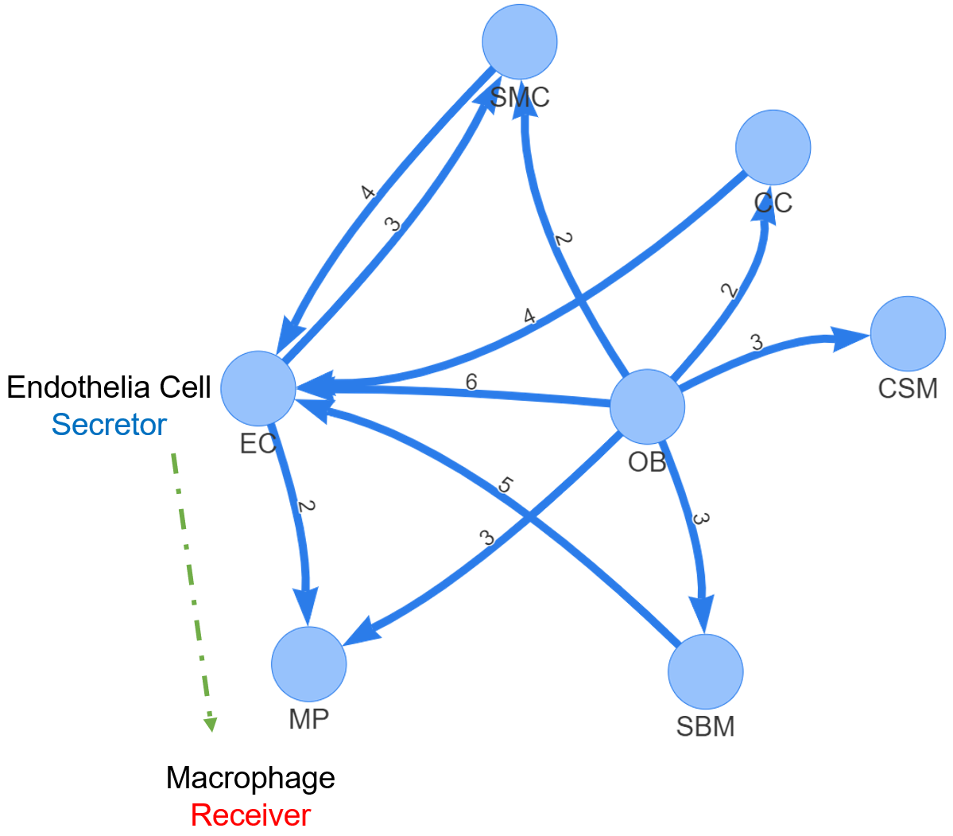
Fig. 4 rICRN generated by rCOM using Acta2-lineage cell in osseointegration. The label of edge shows the number of communication routes between two cell groups
$$SR_{αj}= \sqrt[n]{SR_{1j}*…*SR_{kj}*…*SR_{nj}} (6b)$$
By checking the communication score $(C_{jαβ})$, it is possible to infer the cell type communication between all possible pairs of cell types in the data set. The higher score represents for a higher probability of communication between the cells in two cell types through the specific communication routes.
2.5 Identification of statistically significant cell type communication routes
The significant interactions between cell groups are identified using permutation test by randomly permuting the cell type label and then recalculating the communication score $(C_{jαβ}')$ between cell type $α$ and $β$ through communication route pair $j$. The p-value of each communication score $(C_{jαβ})$ is calculated using Eq. 7
$$Pvalue=1-\frac{\left\{\#m\right|{C_{jαβ}^{\left(m\right)}}^{'}≤ C_{jαβ}, m=1,2, .. . , M\}}{M} (7)$$
Where the score $C_{jαβ}^{\left(m\right)}'$ is the communication probability for the m-th permutation. M is the total number permutations (default is 100). The communications with p-value < 0.05 are considered as significant.
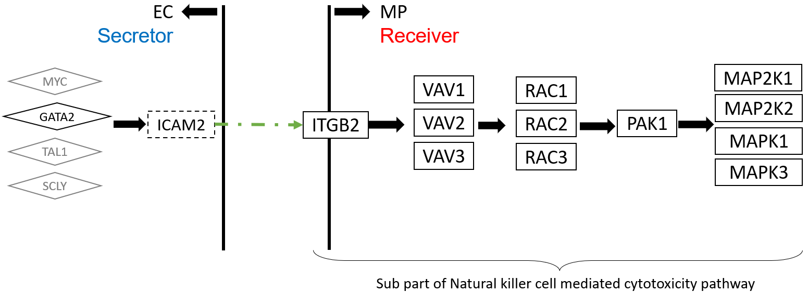
Fig 5. The upper stream and downstream genes in the communication route pair id:70072
3 Experiment results
We show how two independent bone marrow single cell datasets can be analyzed using rCom with 4 biological knowledge databases as mentioned in methods part. The rICRN is build based on the number significant communication route pairs for each dataset. We check the ligand and receptor expression value for the significant cell type communication route along with the upper or downstream gene in the routes. Our literature survey for cell type related genes gives us confidence of the correctness for identified cell type communications.
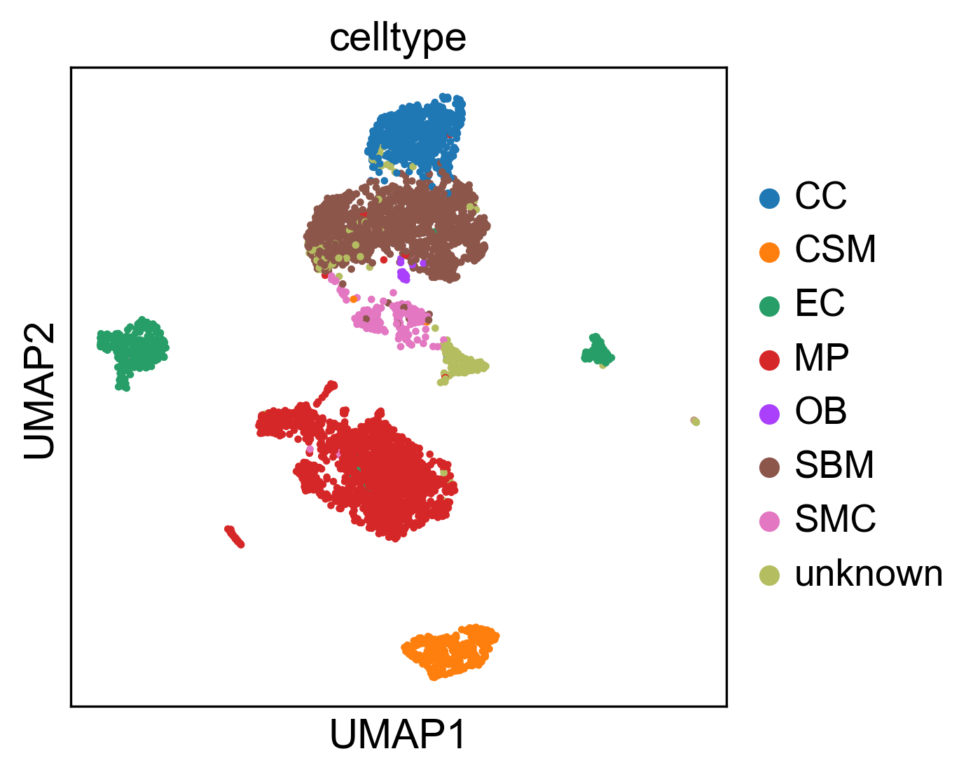Fig 3. The reproduce 2-D visualization of UMAP, colored by cell label provided by studies.
3.1 Experiments with Acta2-lineage cells in osseointegration dataset
The first study in the experiment determined the specific bone marrow stromal cell populations that contribute to bone formation around metal implants [17]. After preprocess, the scRNA-seq data matrix we collected has 4397 cells and 31053 features (genes). The labels of each cell group are given in this dataset include a). cell of skeletal muscle (CSM) (269 cells), b). chondrocyte (CC) (545 cells), c). endothelia cell (EC) (394 cells), d). macrophage (MP) (1608 cells), e). osteoblast (OB) (19 cells), f). smooth muscle cell (SMC) (191 cells) and g). stromal cell of bone marrow (SBM) (1371 cells). The repoduced 2-D visualization of UMAP with the given labels is shown in the Fig 3. The consistence between cell type label and the cell 2-D location indicate the correctness of our preprocess procedure.
The significant communication routes pairs of cell type communication are shown in Tab. 1 with the threshold of the score larger than 8.5. Fig 4 shows the rICRN of this dataset generated using Pyvis. Each node stands for a cell type, and the direct of edges indicate the signaling direction (From ligand in CLR to receptor in CRR). For example, as highlighted in this Fig, two significant route pairs are identified in between EC and MP. EC is the secretor and the MP is the receiver. The label of edge shows the number of the significant communication pairs between two cell groups. From the networks, we notice that from SBM to EC, from OB to EC and from CC to EC have the greatest number of significant communication routes.
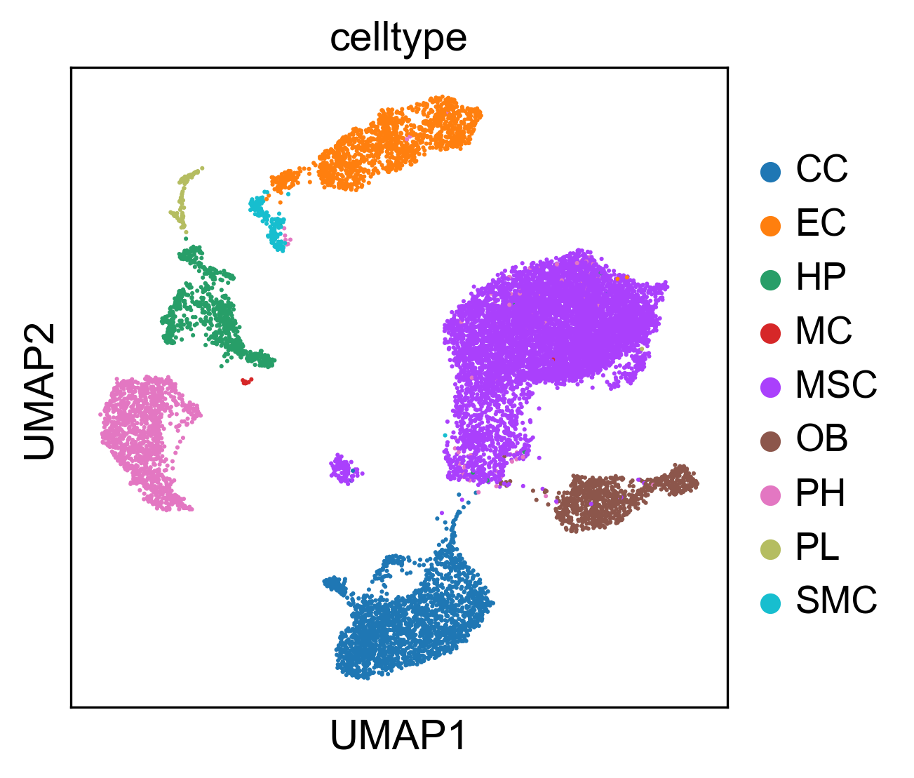
Fig 8. The reproduce 2-D visualization of UMAP, colored by cell label provided by studies.

Fig 6. The violin plot of ICAM2 and ITGB2 gene expression value in each cell type.

Among all the cell type communications, the communications between EC and MP are well studied[18]. Our rCom also identified a communication route with id: 70072 (highlighted in Tab. 1) as a significant route between EC and MP as shown in the Fig 5. In this pair, GATA2 transcripts ICAM2 in EC at first. Then ICAM2 is secreted by EC and binds its receptor ITGB2 in MP. Finally, ITGB2 regulates its down steam genes and actives the MAPK family genes at the end of the routes. The violin plots for gene expression of ICAM2 and ITGB2 in different cell groups are shown in Fig 6. ICAM2 highly expressed in the EC group and poorly expressed in the MP group while on the receptor ends, ITGB2 is highly expressed in the MP cells but poorly expressed in the EC. This indicates a high probability of activation for the ligand and receptor. Our literature survey also indicates that in 2011, Zhang et al. [19] identified the communication between EC and MP through ICAM family gene. Though GATA2, MYC, TAL1 and SCLY are all the TFs that can regulate ICAM2 (Fig 5), only route starts from GATA2 got picked up by rCom. To verify that the rCom find appropriate route, the violin plots of gene expression for upper stream TFs of ICAM2 are shown in Fig 7. Only GATA2 are highly expressed in the EC. The consistence between gene expression value and the output of rCom validate the correctness of route identification.
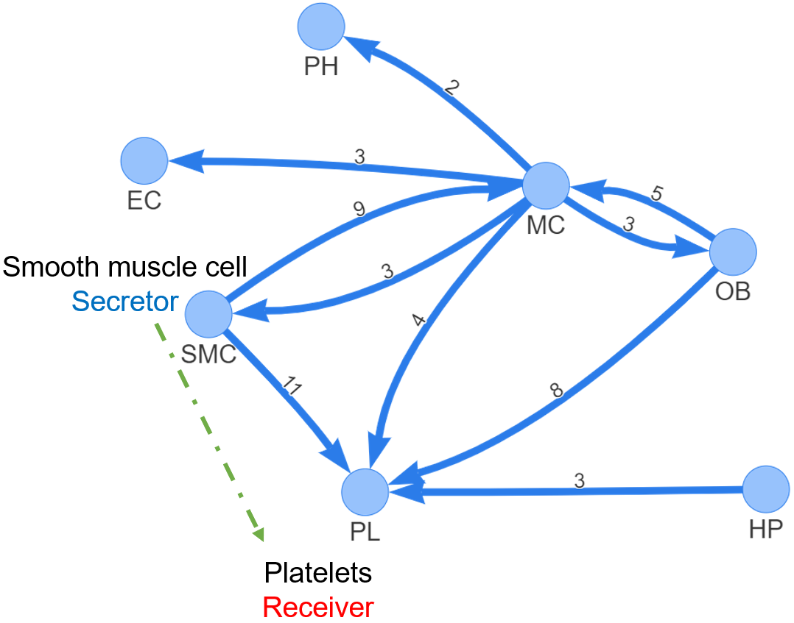
Fig. 9 rICRN generated by rCOM using bone marrow stromal dataset scRNA-seq of 11 weeks old mice dataset

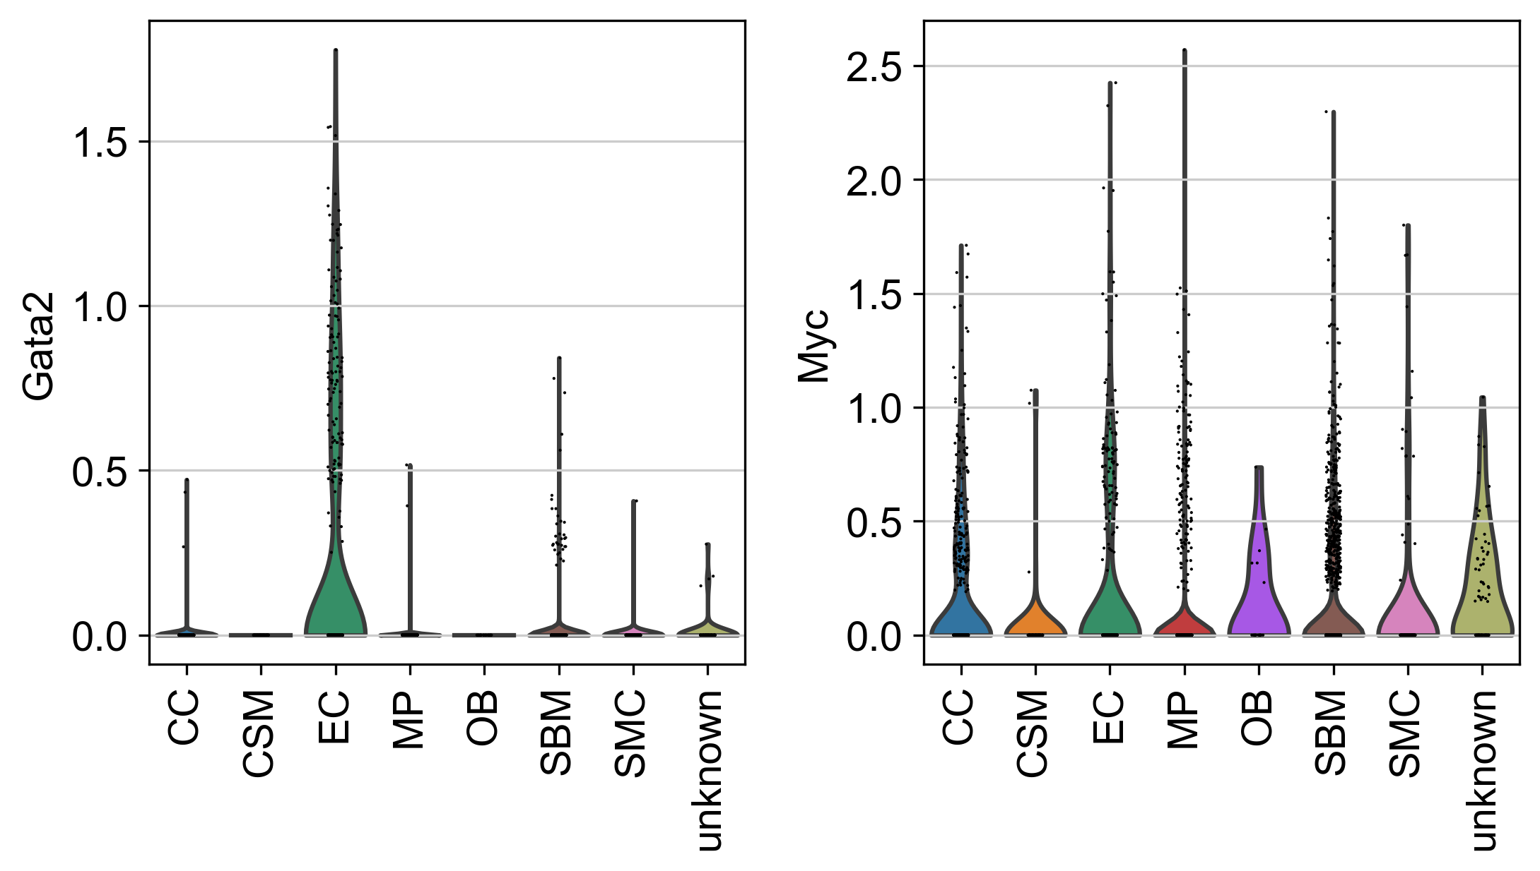
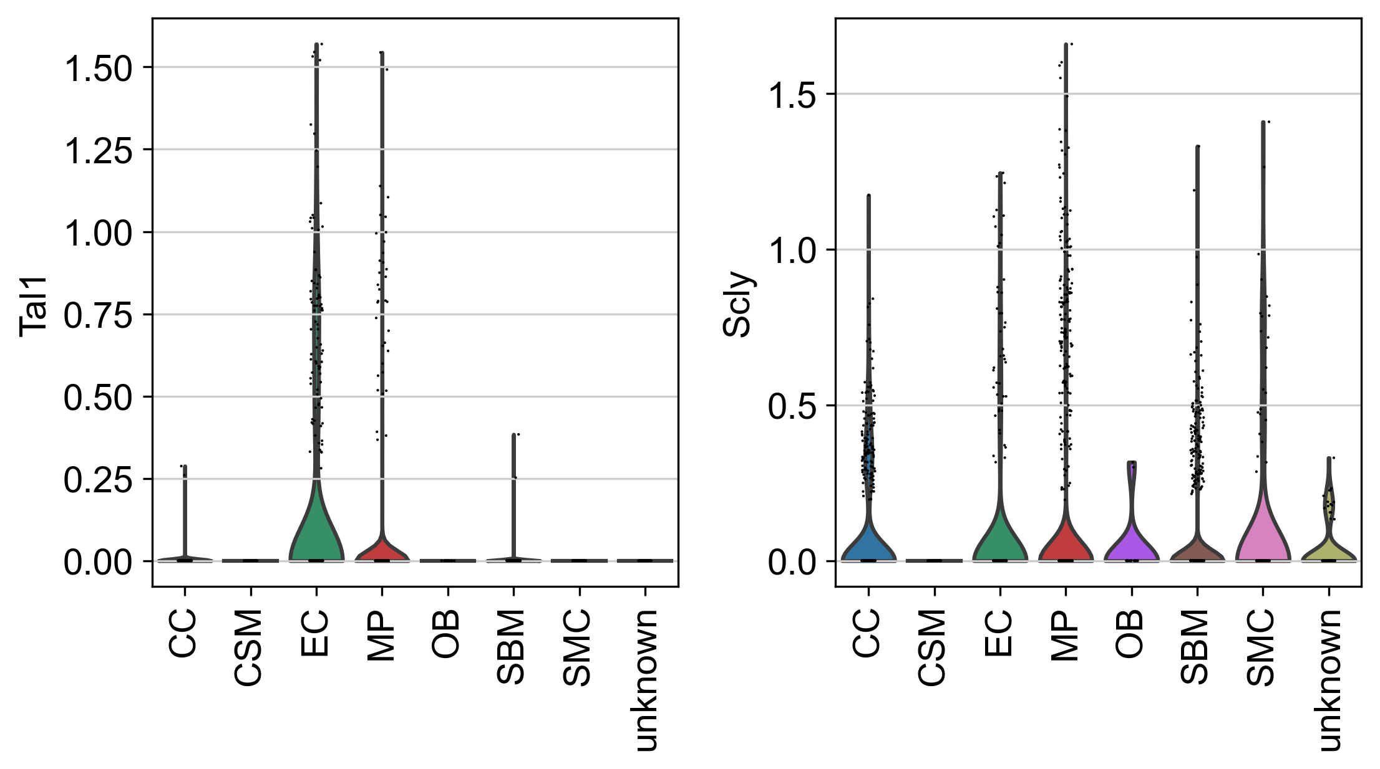
Fig 7. The violin plot of COL18A1 and ITGB3 gene expression value in each cell type.
3.2 Experiments with bone marrow stromal scRNA-seq of 11 weeks old mice dataset
Another dataset we collected from a study [21] which explored osteogenesis in adult mice and show that a bone-targeting, high affinity without causing adverse effects in other organs, which are known to reply on intact Notch signaling interactions. After preprocess, the scRNA-seq data matrix has 17015 cells and 15046 features(genes). The labels of each cell groups are given in the meta file of the dataset including, CC (2270 cells), EC (1677 cells), Hematopoietic (HP) (849 cells), MSC (9168 cells), OB (971 cells), platelets (PL) (232 cells), proliferating Hem (PH) (1532 cells), SMC (238 cells), MC (78 cells). Our reproduced single cell 2-D plot visualization using UMAP is shown in Fig 9. The pattern those cells sharing same group are close to each other stands for the correctness of our preprocess.
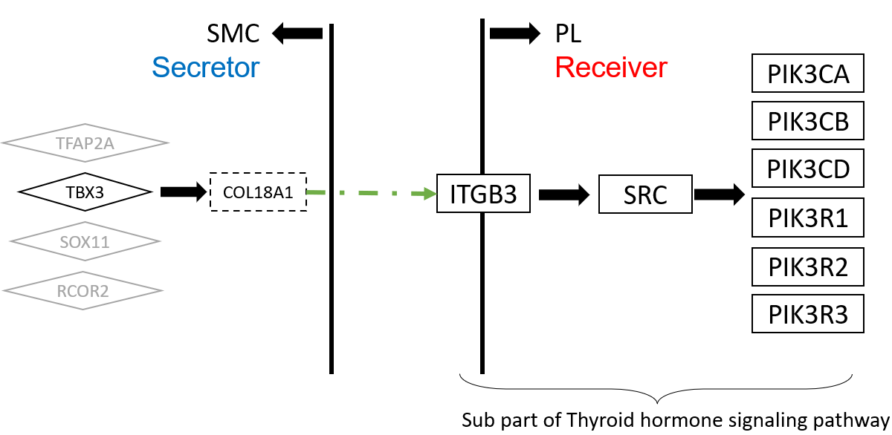
Fig 10. The upper stream and downstream genes in the communication route pair id 95696
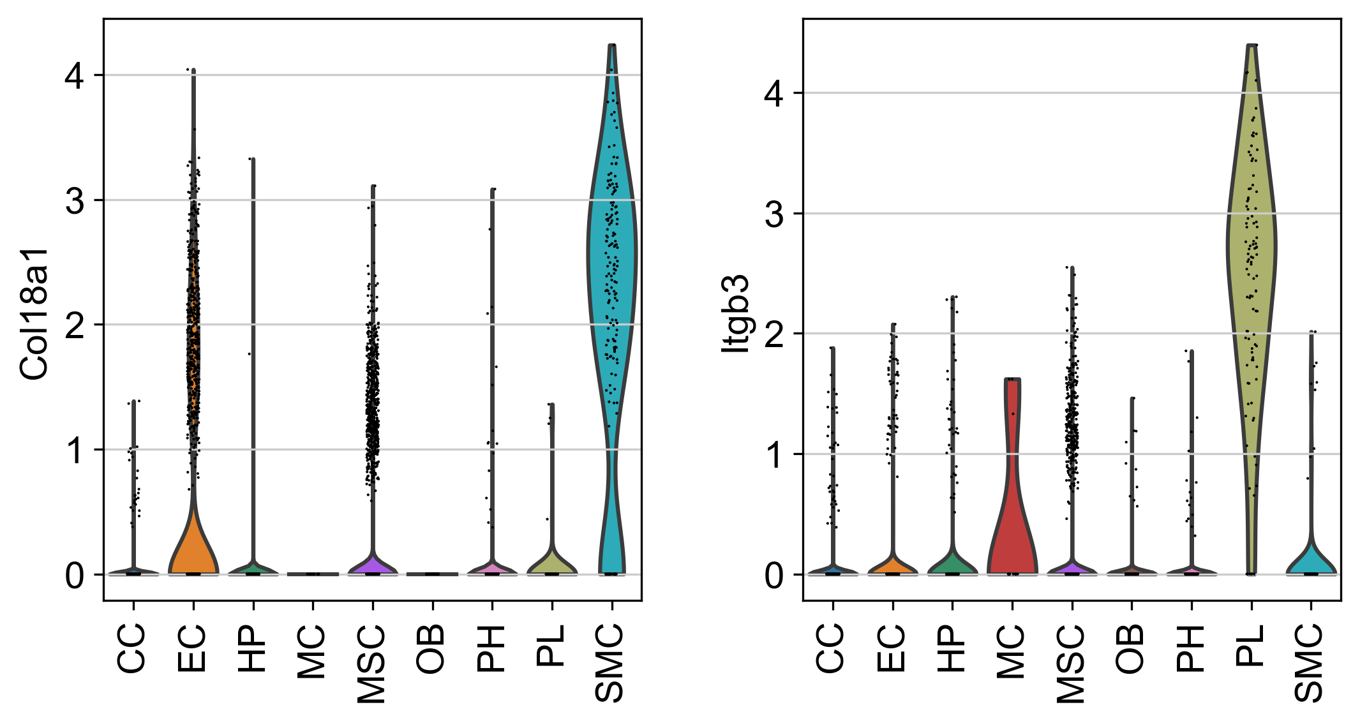
Fig 11. The complete view of communication route pairs id 95696
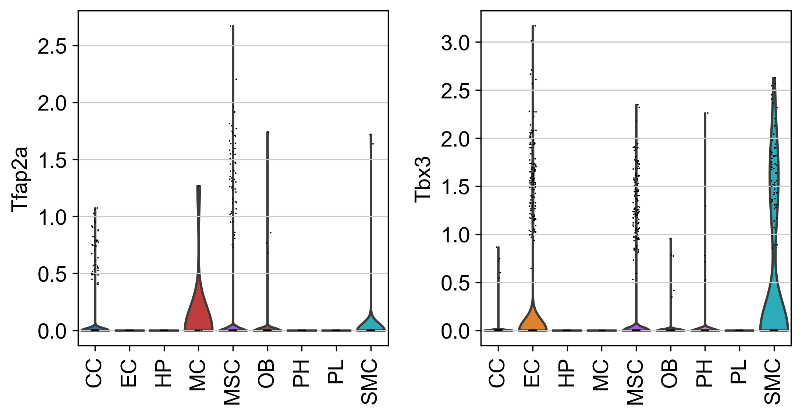
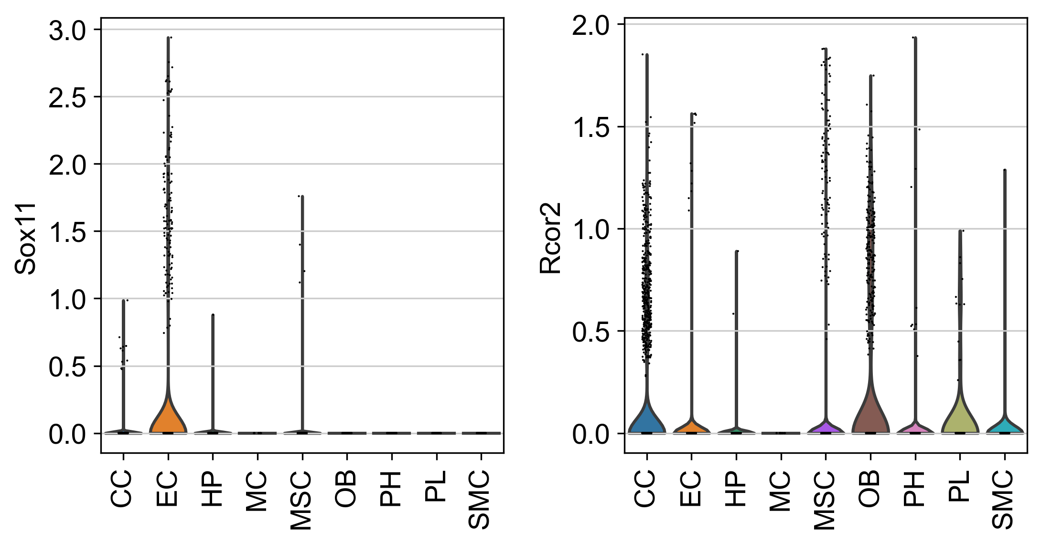
Fig 12. The violin plot for upper stream gene expression value of COL18A1 and ITGB3.
The significant communication routes identified by rCom are shown in Tab.2 with threshold of score larger than 9 and the rICRN is shown in Fig.9. Among all the communication between each two cell types. The communication between SMC and PL has the largest number of significant routes pairs, and the communication from MC to PH have the least route pairs. In the network, communication route pairs between SMC and PL draws our attention as SMC and PL are known to communicate to each other [22]. As highlighted in this Fig 9, SMC as secretors sending ligands to their receivers, PL. In all these route pairs, the pair id: 95696 gain the highest communication score, as highlighted in the Tab 2. As shown in Fig 10, TBX3 transcripts COL18A1 in SMC at first. Then COL18A1 is secreted by SMC and binds its receptor, ITGB3 in MP. Finally, ITGB3 regulates its down steam genes and actives the PIK family genes at the end of the routes. The gene expression value of COL18A1 and ITGB3 ligand and receptor pairs are compared using violin plot in Fig. 11. In all cell groups, COL18A1 only highly expressed in the SMC and its receptor, ITGB3 are highly expressed in the PL and only few MC cells have ITGB3 expressed. This inferred that SMC cells have a high chance of sending COL18A1 and communicate with PL cells through ITGB3. Our literature shows that in 2018, Misra et al. [23] indicates that ITGB3 plays and important role for smoothing muscle-derived atherosclerotic plaque cells including: SMC and PL. We demonstrate the violin plot of gene expression value in the dataset of all the TFs that can regulate the COL18A1 include: TFAP2A, TBX3, NUCKS1, SOX11 and RCOR2 as shown in Fig 13. Only TBX3 are highly expressed in the SMC and rCom picks the TBX3 as the upper stream for the COL18A1 instead of other. The consistence between gene expression value and the output of rCom validate the correctness of route identification.
4. Discussion and conclusion
Developing rCom was motivated by inferencing the cell type communication at route-based level through gene signaling pathway route with ligand-receptor pairs mapped. Among all the existing methods, Ctyotalk returns a signal transduction network between cell types which is similar to rCom. The difference between rCom and Cytoalk is how we borrow the strength of prior knowledge. The network inferred by Cytotalk is data driven while rCom try to identify the meaningful network by connecting routes which are already well studied and supported by wet lab experiments. While we acknowledge that there are number of existing methods which focus on inferring cell type communication using ligand-receptor expression patterns, our survey revealed that none of these methods use pathway topology (activation/inhibition) and regulatory consistency in their model. The rCom framework provides a new way of using well-established prior knowledge to translate the communication behavior.
rCom also provide a new way for combining biological knowledge databases to study pathway crosstalk. Identifying crosstalk between interacting pathways has been an active research area. Nodes-in-Common (NIC) predicts crosstalk by checking if two pathways share any proteins [24]–[26]. Hsu et.al. estimate pathway crosstalk based on similarities in Gene Ontology annotations[27]. Given a protein-protein interaction network, Li et al. links two pathways A and B if more edges connect the proteins in A to the proteins in B than expected by chance in a randomly wired network [28]. In our previous work, ctBuilder [29] is developed to identify a subnetwork interconnecting two pathways. However, with combination of ligand-receptor pairs databases and curated gene signaling pathway databases, the rCom framework can provide a novel aspect of exploring and identifying pathway crosstalk, which is the connection between ligand and receptor pairs. More specifically, without finding NIC, signal originating from CLR of pathway A in one cell can impact its downstream gene in CRR which is derived from a different pathway B in another cell. These two routes can be connected through the ligand-receptor pairs which is not originally annotated in pathways but supported by curated ligand-receptor databases. By analyzing the communication route pairs, unknown crosstalk between two independent pathways might be identified.
The current experiment with rCom was done using Chip-seq, CellChat, CellTalkDB and KEGG to utilize the causal information curated in the database. But it can be easily extended to use other databases like BioGrid [30]. An extendable work of rCom framework is to use spatial genomics data to validate result by checking if two cell types are co-localizing two each other. With the spatial genomic data, the interaction between cells instead of cell types may be identified and validated. How to utilize the spatial data and combine to rCom is an interesting future problem.
ACKNOWLEDGMENTS
Research reported in this work was supported in part by NIH/NICHD Grant No.1R01HD098636-01. Its contents are solely the responsibility of the authors and do not necessarily represent the official views of the NIH.
REFERENCES
[1] D. A. Skelly et al., “Single-Cell Transcriptional Profiling Reveals Cellular Diversity and Intercommunication in the Mouse Heart,” Cell Reports, vol. 22, no. 3, pp. 600–610, Jan. 2018, doi: 10.1016/J.CELREP.2017.12.072.
[2] M. P. Kumar et al., “Analysis of Single-Cell RNA-Seq Identifies Cell-Cell Communication Associated with Tumor Characteristics,” Cell Reports, vol. 25, no. 6, pp. 1458-1468.e4, Nov. 2018, doi: 10.1016/J.CELREP.2018.10.047.
[3] J. X. Zhou, R. Taramelli, E. Pedrini, T. Knijnenburg, and S. Huang, “Extracting Intercellular Signaling Network of Cancer Tissues using Ligand-Receptor Expression Patterns from Whole-tumor and Single-cell Transcriptomes,” Scientific Reports 2017 7:1, vol. 7, no. 1, pp. 1–15, Aug. 2017, doi: 10.1038/s41598-017-09307-w.
[4] R. Vento-Tormo et al., “Single-cell reconstruction of the early maternal–fetal interface in humans,” Nature 2018 563:7731, vol. 563, no. 7731, pp. 347–353, Nov. 2018, doi: 10.1038/s41586-018-0698-6.
[5] Y. E. Antebi, N. Nandagopal, and M. B. Elowitz, “An operational view of intercellular signaling pathways,” Current Opinion in Systems Biology, vol. 1, pp. 16–24, Feb. 2017, doi: 10.1016/J.COISB.2016.12.003.
[6] M. Billmann, V. Chaudhary, M. F. ElMaghraby, B. Fischer, and M. Boutros, “Widespread Rewiring of Genetic Networks upon Cancer Signaling Pathway Activation,” Cell Systems, vol. 6, no. 1, pp. 52-64.e4, Jan. 2018, doi: 10.1016/J.CELS.2017.10.015.
[7] S. Wang, M. Karikomi, A. L. Maclean, and Q. Nie, “Cell lineage and communication network inference via optimization for single-cell transcriptomics,” Nucleic Acids Research, vol. 47, no. 11, pp. e66–e66, Jun. 2019, doi: 10.1093/NAR/GKZ204.
[8] R. Browaeys, W. Saelens, and Y. Saeys, “NicheNet: modeling intercellular communication by linking ligands to target genes,” Nature Methods 2019 17:2, vol. 17, no. 2, pp. 159–162, Dec. 2019, doi: 10.1038/s41592-019-0667-5.
[9] Y. Hu, T. Peng, L. Gao, and K. Tan, “CytoTalk: De novo construction of signal transduction networks using single-cell transcriptomic data,” Science Advances, vol. 7, no. 16, Apr. 2021, doi: 10.1126/SCIADV.ABF1356/SUPPL_FILE/ABF1356_TABLE_S6.XLSX.
[10] A. J. Bass et al., “Comprehensive molecular characterization of gastric adenocarcinoma,” Nature, vol. 513, no. 7517, p. 202, Sep. 2014, doi: 10.1038/NATURE13480.
[11] D. M. Muzny et al., “Comprehensive molecular characterization of human colon and rectal cancer,” Nature, vol. 487, no. 7407, p. 330, Jul. 2012, doi: 10.1038/NATURE11252.
[12] P. Joshi, B. Basso, H. Wang, S. H. Hong, C. Giardina, and D. G. Shin, “rPAC: Route based pathway analysis for cohorts of gene expression data sets,” Methods, Oct. 2021, doi: 10.1016/J.YMETH.2021.10.002.
[13] S. Jin et al., “Inference and analysis of cell-cell communication using CellChat,” Nature Communications 2021 12:1, vol. 12, no. 1, pp. 1–20, Feb. 2021, doi: 10.1038/s41467-021-21246-9.
[14] X. Shao, J. Liao, C. Li, X. Lu, J. Cheng, and X. Fan, “CellTalkDB: a manually curated database of ligand–receptor interactions in humans and mice,” Briefings in Bioinformatics, vol. 22, no. 4, Jul. 2021, doi: 10.1093/BIB/BBAA269.
[15] F. A. Wolf, P. Angerer, and F. J. Theis, “SCANPY: Large-scale single-cell gene expression data analysis,” Genome Biology, vol. 19, no. 1, pp. 1–5, Feb. 2018, doi: 10.1186/S13059-017-1382-0/FIGURES/1.
[16] “Chromatin Immunoprecipitation Sequencing (ChIP-Seq).” https://www.illumina.com/techniques/sequencing/dna-sequencing/chip-seq.html (accessed May 11, 2022).
[17] A. Vesprey et al., “Tmem100- and Acta2-Lineage Cells Contribute to Implant Osseointegration in a Mouse Model,” J Bone Miner Res, vol. 36, no. 5, pp. 1000–1011, May 2021, doi: 10.1002/JBMR.4264.
[18] H. He et al., “Endothelial cells provide an instructive niche for the differentiation and functional polarization of M2-like macrophages,” Blood, vol. 120, no. 15, p. 3152, Oct. 2012, doi: 10.1182/BLOOD-2012-04-422758.
[19] J. Zhang et al., “Regulation of Endothelial Cell Adhesion Molecule Expression by Mast Cells, Macrophages, and Neutrophils,” PLoS ONE, vol. 6, no. 1, 2011, doi: 10.1371/JOURNAL.PONE.0014525.
[20] H. Mayer, H. Bertram, W. Lindenmaier, T. Korff, H. Weber, and H. Weich, “Vascular endothelial growth factor (VEGF-A) expression in human mesenchymal stem cells: autocrine and paracrine role on osteoblastic and endothelial differentiation,” J Cell Biochem, vol. 95, no. 4, pp. 827–839, Jul. 2005, doi: 10.1002/JCB.20462.
[21] C. Xu et al., “Induction of osteogenesis by bone-targeted Notch activation,” Elife, vol. 11, Feb. 2022, doi: 10.7554/ELIFE.60183.
[22] R. Ross and L. Harker, “Platelets, endothelium, and smooth muscle cells in atherosclerosis,” Adv Exp Med Biol, vol. 102, pp. 135–141, 1978, doi: 10.1007/978-1-4757-1217-9_8.
[23] F. Hartmann et al., “SMC-Derived Hyaluronan Modulates Vascular SMC Phenotype in Murine Atherosclerosis,” Circ Res, vol. 129, no. 11, pp. 992–1005, Nov. 2021, doi: 10.1161/CIRCRESAHA.120.318479.
[24] D. M et al., “Analysis and correction of crosstalk effects in pathway analysis,” Genome Res, vol. 23, no. 11, pp. 1885–1893, Nov. 2013, doi: 10.1101/GR.153551.112.
[25] K. H and K. MR, “Abiotic stress signalling pathways: specificity and cross-talk,” Trends Plant Sci, vol. 6, no. 6, pp. 262–267, 2001, doi: 10.1016/S1360-1385(01)01946-X.
[26] T. CM, E. B, and K. CR, “Critical nodes in signalling pathways: insights into insulin action,” Nat Rev Mol Cell Biol, vol. 7, no. 2, pp. 85–96, Feb. 2006, doi: 10.1038/NRM1837.
[27] C.-L. Hsu and U.-C. Yang, “Discovering pathway cross-talks based on functional relations between pathways,” BMC Genomics 2012 13:7, vol. 13, no. 7, pp. 1–15, Dec. 2012, doi: 10.1186/1471-2164-13-S7-S25.
[28] L. Y, A. P, and R. D, “A global pathway crosstalk network,” Bioinformatics, vol. 24, no. 12, pp. 1442–1447, Jun. 2008, doi: 10.1093/BIOINFORMATICS/BTN200.
[29] H. Wang, P. Joshi, S. H. Hong, D. J. Shin, and D. G. Shin, “CtBuilder: A framework for building pathway crosstalks by combining single cell data with bulk cell data,” Proceedings - 2021 IEEE International Conference on Bioinformatics and Biomedicine, BIBM 2021, pp. 270–273, 2021, doi: 10.1109/BIBM52615.2021.9669811.
[30] C. Stark, B.-J. Breitkreutz, T. Reguly, L. Boucher, A. Breitkreutz, and M. Tyers, “BioGRID: a general repository for interaction datasets”, doi: 10.1093/nar/gkj109.

S | R | R id | Score | CLR | Ligand | Receptor | CRR | Pval
OB | EC | 82280 | 9.83 | RUNX2 | IBSP | ITGB3 | PLCD3, PLCB1, PLCE1, PLCB2, PLCB3, PLCB4, PLCD1, PLCG1, PLCG2, PLCD4, PLCZ1, C00165, PRKCA, PRKCB, PRKCG, MAPK1, MAPK3, STAT1 | <0.0005
OB | MP | 96177 | 9.53 | RUNX2 | IBSP | ITGAV | SRC, PIK3CA, PIK3CB, PIK3CD, PIK3R1, PIK3R2, PIK3R3 | <0.0005
OB | SMC | 96177 | 9.18 | RUNX2 | IBSP | ITGAV | SRC, PIK3CA, PIK3CB, PIK3CD, PIK3R1, PIK3R2, PIK3R3 | <0.0005
OB | SBM | 96177 | 9.05 | RUNX2 | IBSP | ITGAV | SRC, PIK3CA, PIK3CB, PIK3CD, PIK3R1, PIK3R2, PIK3R3 | <0.0005
EC | MP | 70072 | 9.04 | GATA2 | ICAM2 | ITGB2 | ITGAL, VAV3, VAV1, VAV2, RAC1, RAC2, RAC3, PAK1, MAP2K1, MAP2K2, MAPK1, MAPK3 | <0.0005
OB | EC | 6452 | 8.68 | SMAD3 | TNC | PTPRB | CTNNB1, CTNNA1, CTNNA2, CTNNA3, ACTB, ACTG1 | <0.0005
EC | OB | 77882 | 8.66 | CREM | GNAI2 | LPAR3 | GNAS, ADCY1, ADCY2, ADCY3, ADCY5, ADCY6, ADCY7, ADCY8, ADCY9, ADCY4, C00575, RAPGEF3, RAPGEF4, RAP1A, RAP1B | <0.0005
OB | EC | 103917 | 8.65 | RUNX2 | VEGFA | KDR | PLCG1, PLCG2, C00076, PRKCA, PRKCB, PRKCG, SPHK2,  SPHK1, HRAS, KRAS, NRAS, RAF1, MAP2K1, MAP2K2,  MAPK1, MAPK3 | <0.0005
OB | EC | 4562 | 8.64 | RUNX2 | SEMA5A | MET | MAPK1, MAPK3, SNAI2, SNAI1 | <0.0005
OB | EC | 103718 | 8.63 | CTNNB1 | PDGFC | KDR | PLCG1, PLCG2, C00076, PRKCA, PRKCB, PRKCG, SPHK2,  SPHK1, HRAS, KRAS, NRAS, RAF1, MAP2K1, MAP2K2,  MAPK1, MAPK3 | <0.0005
OB | EC | 89677 | 8.55 | RUNX2 | IBSP | ITGAV | HRAS, KRAS, NRAS, RAF1, MAP2K1, MAP2K2, MAPK1,  MAPK3, STAT1 | <0.0005
SMC | EC | 103686 | 8.53 | PBX1 | VTN | KDR | PLCG1, PLCG2, C00076, PRKCA, PRKCB, PRKCG,  SPHK2, SPHK1, HRAS, KRAS, NRAS, RAF1, MAP2K1, MAP2K2,  MAPK1, MAPK3 | <0.0005
Table 1. The significant communication routes pairs with score higher than threshold (8.5). S stands for secretor and R stands for receiver.
S | R | R id | Score | CLR | Ligand | Receptor | CRR | Pval
SMC | PL | 95696 | 12.64 | TBX3 | COL18A1 | ITGB3 | SRC, PIK3CA, PIK3CB, PIK3CD, PIK3R1, PIK3R2, PIK3R3 | <0.0005
SMC | MC | 80134 | 11.58 | NFIB | LGALS1 | PTPRC | LCK, ZAP70, LAT, GRB2, SOS1, SOS2, RASGRP1, HRAS, KRAS,  NRAS, RAF1, MAP2K1, MAP2K2, MAPK1, MAPK3, FOS, JUN | <0.0005
SMC | PL | 95739 | 11.03 | PPARG | COL4A2 | ITGB3 | SRC, PIK3CA, PIK3CB, PIK3CD, PIK3R1, PIK3R2, PIK3R3 | <0.0005
SMC | PL | 95421 | 10.34 | NR3C1 | MFGE8 | ITGB3 | SRC, PIK3CA, PIK3CB, PIK3CD, PIK3R1, PIK3R2, PIK3R3 | <0.0005
SMC | PL | 95367 | 9.7 | PPARG | NID1 | ITGB3 | SRC, PIK3CA, PIK3CB, PIK3CD, PIK3R1, PIK3R2, PIK3R3 | <0.0005
MC | SMC | 72456 | 9.63 | RELA,  RELB | IL1B | IL1R1 | IRAK1, IRAK4, MYD88, TRAF6, MAP3K7, TAB1, TAB2, TAB3,  IKBKG, CHUK, IKBKB, NFKBIA, NFKB1, RELA | <0.0005
OB | PL | 82280 | 9.6 | RUNX2 | IBSP | ITGB3 | PLCD3, PLCB1, PLCE1, PLCB2, PLCB3, PLCB4, PLCD1, PLCG1, PLCG2, PLCD4, PLCZ1, C00165, PRKCA, PRKCB, PRKCG, MAPK1, MAPK3, STAT1 | <0.0005
OB | PL | 82619 | 9.45 | KLF4 | FN1 | ITGB3 | PLCD3, PLCB1, PLCE1, PLCB2, PLCB3, PLCB4, PLCD1, PLCG1, PLCG2, PLCD4, PLCZ1, C00165, PRKCA, PRKCB, PRKCG, MAPK1, MAPK3, STAT1 | <0.0005
MC | EC | 72456 | 9.44 | RELA,  RELB | IL1B | IL1R1 | IRAK1, IRAK4, MYD88, TRAF6, MAP3K7, TAB1, TAB2, TAB3, IKBKG, CHUK, IKBKB, NFKBIA, NFKB1, RELA | <0.0005
CC | PL | 90899 | 9.42 | STAT3 | TGM2 | ITGB3 | HRAS, KRAS, NRAS, RAF1, MAP2K1, MAP2K2, MAPK1, MAPK3, TP53 | <0.0005
OB | PL | 82963 | 9.41 | CCN1 | CCN1 | ITGB3 | PLCD3, PLCB1, PLCE1, PLCB2, PLCB3, PLCB4, PLCD1, PLCG1, PLCG2, PLCD4, PLCZ1, C00165, PRKCA, PRKCB, PRKCG, MAPK1, MAPK3, STAT1 | <0.0005
SMC | PL | 95503 | 9.39 | TCF4 | FBN1 | ITGB3 | SRC, PIK3CA, PIK3CB, PIK3CD, PIK3R1, PIK3R2, PIK3R3 | <0.0005
OB | MC | 69430 | 9.36 | CCN1 | CCN1 | ITGB2 | PTK2B, RAC1, RAC2, RAC3, PAK1, MAP2K1, MAP2K2, MAPK1, MAPK3 | <0.0005
SMC | PL | 95268 | 9.35 | CCND1 | VTN | ITGB3 | SRC, PIK3CA, PIK3CB, PIK3CD, PIK3R1, PIK3R2, PIK3R3 | <0.0005
HP | PL | 95560 | 9.34 | MYB | HSP | ITGB3 | SRC, PIK3CA, PIK3CB, PIK3CD, PIK3R1, PIK3R2, PIK3R3 | <0.0005
SMC | MC | 69220 | 9.3 | MEF2A | JAM3 | ITGB2 | PTK2B, RAC1, RAC2, RAC3, PAK1, MAP2K1, MAP2K2, MAPK1, MAPK3 | <0.0005
MC | CC | 72456 | 9.11 | RELA,  RELB | IL1B | IL1R1 | IRAK1, IRAK4, MYD88, TRAF6, MAP3K7, TAB1, TAB2, TAB3, IKBKG, CHUK, IKBKB, NFKBIA, NFKB1 | <0.0005
SMC | PL | 95290 | 9.08 | EP300 | TGFB3 | ITGB3 | SRC, PIK3CA, PIK3CB, PIK3CD, PIK3R1, PIK3R2, PIK3R3 | <0.0005
SMC | PL | 96031 | 9.08 | TRIM28 | ITGAV | ITGB3 | SRC, PIK3CA, PIK3CB, PIK3CD, PIK3R1, PIK3R2, PIK3R3 | <0.0005
MC | OB | 72456 | 9.04 | RELA,  RELB | IL1B | IL1R1 | IRAK1, IRAK4, MYD88, TRAF6, MAP3K7, TAB1, TAB2, TAB3, IKBKG, CHUK, IKBKB, NFKBIA, NFKB1 | <0.0005
OB | PL | 82885 | 9.04 | KLF4 | SPP1 | ITGB3 | PLCD3, PLCB1, PLCE1, PLCB2, PLCB3, PLCB4, PLCD1, PLCG1, PLCG2,  PLCD4, PLCZ1, C00165, PRKCA, PRKCB, PRKCG, MAPK1, MAPK3, STAT1 | <0.0005
SMC | MC | 69430 | 9 | CCN1 | CCN1 | ITGB2 | PTK2B, RAC1, RAC2, RAC3, PAK1, MAP2K1, MAP2K2, MAPK1, MAPK3 | <0.0005
SMC | PL | 95963 | 9 | CCN1 | CCN1 | ITGB3 | PTK2B, RAC1, RAC2, RAC3, PAK1, MAP2K1, MAP2K2, MAPK1, MAPK3 | <0.0005
Table 2. The significant communication routes pairs with score higher than threshold (9). S stands for secretor and R stands for receiver.

