rCom: A route-based framework inferring cell type communication and regulatory network using single cell data

Honglin Wang†
Computer Sci. and Engr. Dept., Univ. of Connecticut, Storrs, USA
honglin.wang@uconn.edu
Peter F. Maye
Dept. of Reconstructive Sciences, UCHC, Farmington, USA pmaye@uchc.edu
Pujan Joshi
Computer Sci. and Engr. Dept., Univ. of Connecticut, Storrs, USA
email@email.com
David W. Rowe
Dept. of Reconstructive Sciences, UCHC, Farmington, USA drowe@uchc.edu
Chenyu Zhang
Computer Sci. and Engr. Dept., Univ. of Connecticut, Storrs, USA chenyu.zhang@uconn.edu
Dong-Guk Shin
Computer Sci. and Engr. Dept., Univ. of Connecticut, Storrs, USA
dong.shin@uconn.edu

ABSTRACT
The mapping of ligand-receptor pairs is the cornerstone of understanding complicated intercellular interactions. With recent advances of single cell RNA (scRNA) sequencing technology, several methods have been proposed to infer cell-cell communication by analyzing ligand-receptor pairs. However, existing methods have limited ways of using what we call “prior knowledge”, i.e., what are already known (albeit incompletely) about the upstream for the ligand and the downstream for the receptor. In this paper, we present a novel framework, called rCom, capable of inferring cell-cell interactions by considering portions of pathways that would be associated with upstream of the ligand and downstream of receptors under examination. The rCom framework integrates knowledge from multiple biological databases including transcription factor-target database, ligand-receptor database and publicly available curated signaling pathway databases. The rCom framework examines combinatoric ways of integrating the partially known relationships against the cohorts of gene expression datasets obtainable through subtyped cells. We combine both algorithmic methods and heuristic rules to score how each putative ligand-receptor pair may matchup between all possible cell subtype pairs. Permutation test is performed to rank the hypothesized cell-cell communication routes. We performed two case studies using single cell transcriptomic data from bone biology. Our literature survey suggests that rCom could be effective in discovering novel cell-cell communication relationships that have been only partially known in the field.
KEYWORDS
Cell communication, Topology and route-based pathway analysis, Bone marrow, Single cell RNA seq
1 Introduction
Complex intercellular responses start with binding of a ligand to its cognate receptor to activate specific cell signaling pathways. Mapping ligand-receptor pairs is fundamental to understanding how cells respond to signaling from neighboring cells. Single cell RNA-seq technology holds great promise for studying cell-cell communication which was not easy when gene expression data is obtained from cell population-based technologies such as microarray and bulk RNA-seq. Using scRNA-seq data, several methods have been developed to infer ligand-receptor pair communications between interacting cell types. Skelly et al. [1] and Kumar et al. [2] predict ligand-receptor pairs by studying if the two genes are highly co-expressed in different cell types. Zhou et al. [3] suggest identifying ligand-receptor pair signal between cell types is needed in addition to genetic mutations or intracellular signaling to better understand cancer progression. Vento-Tormo et al. [4] produce a repository of ligand-receptor complexes which could potentially explain interaction between decidua and placenta during the early human pregnancy. More recently, the cell-cell interaction analysis has gone beyond identifying ligand-receptor pairs to produce entire gene regulation networks that could model interaction relationships among subpopulations of cells. Wang et al. [5] introduce SoptSC which can predict cell-cell communication networks by constructing a structured cell-to-cell similarity matrix and. Browaeys et al. [6] report NicheNet which aims to identify not only ligand-receptor pairs of interacting cells but also the genes downstream of the identified pairs. Hu et al [7] present that CytoTalk can de novo generate a signal transduction network between a pair of cell types, which is basically interconnecting a pair of GRNs, each constructed for the cell types under consideration.
Among these more recent cell-cell communication network discovery methods based on single cell transcriptomics data, our system, namely, rCom, is similar to NicheNet in the sense that both uses prior knowledge in identifying cell-cell communication network. One key difference between the two systems is in the way we use the prior knowledge curated into signaling/molecular pathways for the analysis. In rCom, inferring cell-cell interactions is decomposed into three parts, analysis of the upstream of the ligand, analysis of the downstream of receptors, and analysis of the most plausible ligand-receptor pairing. Our approach assumes subtyping cells are performed a priori and the labels for each cell subtype are known. Thanks to this refinement, rCom takes advantage of estimating if a certain route (branch) of a curated pathway is activated/ inhibited which in turn provides clues for picking which ligand-receptor pairs are more likely utilized in the regulatory system. In contrast, NicheNet does not use gene regulation notions such as activation/inhibition in pathway scoring and simply uses aggregation of pathways sources based on gene expression values.
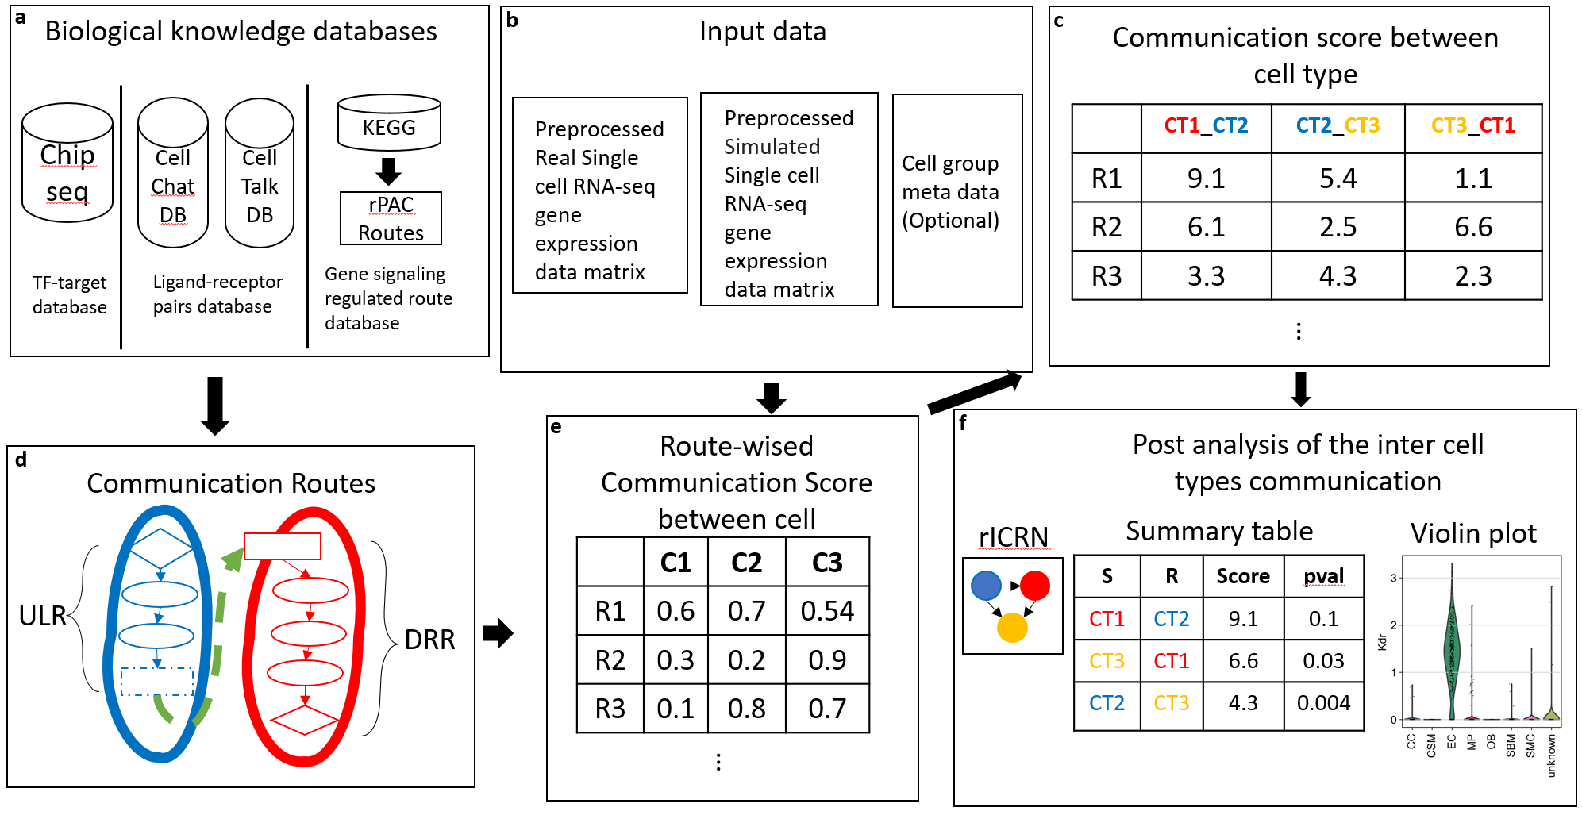
Fig 1. The overview architecture of rCom. a. The three categories of biological knowledge databases used in the rCom. b. The input data for rCom including: (i). preprocessed scRNA-seq with real cell group label for inferencing inter cell type communication. (ii). preprocessed scRNA-seq with randomized group label for permutation test. (iii). Cell group label meta data file. c. The matrix of communication score between cell type. d. The communication route pairs extract from 3 type databases. e. Route-wised communication scored in each cell. f. The post analysis of the cell types communication include: inferenced rICRN, summary table including cell type with permutation p-value, violin plot for the ligand-receptor expression value.

Creating rCom is based on our earlier works in which pathway analysis uses routes of pathways, i.e., branches of curated pathways (e.g., KEGG) as the unit for the analysis as opposed to the entire assembled genes of a pathway. This idea is based on the observation that the relationships between signaling/molecular pathways and biological processes are N:M, and thus the granularity of pathway analysis should be “routes”, i.e., which particular branch of pathway could be responsible for exerting the biological process under question. Our previous route-based pathway analysis works include BioTarget which uses the route-based pathway method to extend existing Th1/Th2 pathways using TCGA data sets [8] and rPAC [9] which use a transcription factor (TF) centric analysis to identify more refined cancer subtype signatures [9]. Development of rCom was motivated to use this route-based pathway analysis to estimate how two cells may interact with each other through ligand-receptor pairing.
The rest of the paper is organized in the following way. In Section 2, we present the overview framework of rCom and key technical details of the system. In Section 3 we summarize the results of applying rCom to two different single cell transcriptomics data sets produced by the bone biology field. Section 4 is Discussion and Conclusion.
2 System and Methods
The overview of the rCom framework is given in Fig. 1. Fig 1a shows that three different types databases, TF-target database, ligand-receptor pairs database and gene signaling regulated route databases, are examined as prior knowledge in building ligand-receptor (denoted as L-R from here on) communication routes. These source databases are downloaded in text or KGML format and parsed to build a network graph where ligands, receptors, genes, and TFs become nodes and their regulated relationships are formed into edges interconnecting nodes. In rCom’s graph structure, edges are directional encoding either activation or inhibition relationships (Fig.1a, 1c).
Fig 1b shows the use of three types of input data, single cell gene expression matrix which is obtained through quality control, normalization, scaling and log transform using SCANPY[10]. In the matrix, columns indicate cells and rows indicate genes. After log transformed, rCom treated gene with negative value as inhibited genes and gene with positive value as activated genes.
2.1 Cell-Cell communication routes
Fig 2 provides the detailed view of the conceptually depicted cell-cell communication given in Fig 1d. This model labels two interacting cells as “Secretor” denoting the cell secreting a ligand and “Receiver” denoting the cell in which the ligand binds to its cognate receptor. This binding is represented as the green dashed line in Fig 2. We call the two cells as an L-R pair. We show how we generate communication routes from four different biological knowledge databases including: Chip-seq [11], CellChat , CellTalkDB and rPAC. Unlike other methods that only consider
ligand-receptor, the rCom infer cell communication based on the communication routes that are extended from L-R pairs.
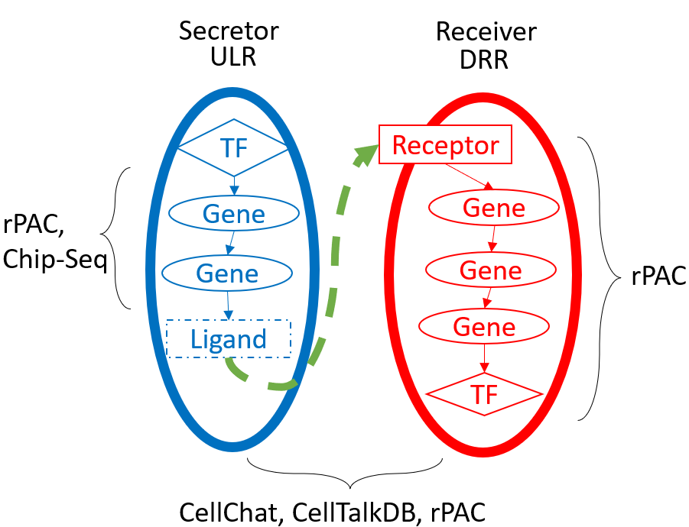
Fig 2. The overview of the communication route. The blue route is ULR, and the red route is DRR. The ULR is generated from rPAC routes and Chip-seq database. The DRR is generated from rPAC routes. The ligand and receptor pairs are derived from CellChatDB, CellTablkDB and rPAC.
Each L-R pair has two routes: (i) upstream ligand route (ULR) and (ii) downstream receptor route (DRR). Upstream ligand route captures the signals which are cell-secreted ligands produced when the transcription factor (TF) binds to the target genes and for this reason the cell that secrets ligands is label a Secretor. ULR usually starts from TF and follow the path to the ligands. Two biological knowledge databases are used to generate ULR, rPAC routes and ChIP-seq DB. The ULR is like effector routes in rPAC, but the primary TFs of ULR are not only from KEGG but also from Chip-seq. Communication receptor route captures the signals transduction from cell surface into the nucleus in which each route starts from receptor and follows a path to the TFs. The cell that where ligand binds is known as receiver. DRR are transformed from signaling routes in rPAC (KEGG). The connection of ULR and DRR are ligand and receptor pairs derived from two ligand-receptors pairs databases: CellChatDB, CellTalk and ligand-receptors pairs in signaling routes of rPAC. Totally 104004 communication route pairs are identified and stored in graph structure in rCom.
2.2 Node expected value and evaluation value
2.2.1 Node expected value. A node expected value ($E_{k}$) is either +1 or -1 which indicates whether node should be up-regulated or down-regulated in the route to activate ligand or activated by receptor. A node is assigned an expected value using propagation method which starts from ligands in ULR or receptors in DRR to the end node of the route (TF in both ULR and DRR). The equation of this method is given in Eq 1.
$E_{k}= \left\{\begin{aligned} 1 k=1 \\ E_{k-1}*e_{k} other wise\end{aligned}\right.$ (1)
In this equation, $k$ stands for the $k_{th}$ nodes from the starter node (ligand in ULR and receptor in DRR.). $e_{k}$ stands the edge expectation value between $k_{th}$ node and $k_{th}-1$ node. The value of $e_{k}$ can be assign using Eq 2.
$e_{k}= \left\{\begin{aligned} +1 the edge is activation \\ -1 the edge is inhibition\end{aligned}\right. (2)$
2.2.2 Node evaluation value. Node evaluation value ($V_{ki}$) is assigned based on the node expected value and gene expression value in cell $i$. The evaluation value is computed using the Eq 3.
$V_{k_{i}}= \left\{\begin{aligned} abs\left(EV_{ki}\right) EV_{ki}*E_{k}≥0 \\ 0 EV_{ki}*E_{k}<0\end{aligned}\right. (3)$
$EV_{ki}$ stands for the preprocessed expression value for gene in node $k$ of cell $i$.
2.3 Communication route score
A communication route (${ULR}_{j}$and $DRR_{j}$) score ($SL_{ij} and SR_{ij}$) measure the probability of cell $i$ to communicated with other cells through communication route $j$. A cell with high ULR score means it has a high capability to secret ligand which are highly regulated in this specific route, whereas a cell with a high DRR score indicates a high probability to receive signals through the receptor and regulate it downstream gene and TF. The score is assigned using the equation given in Eq. 4a, 4b.
$SL_{ij}=\left\{\begin{aligned}w*VL+\left(1-w\right)\frac{1}{n_{i}-1}\sum_{k}^{n_{i}-1}{V_{k}}+1 if VL>0 \\ 1 if VL≤0\end{aligned}\right. (4a)$
$SR_{ij}=\left\{\begin{aligned}w*VR+\left(1-w\right)\frac{1}{n_{i}-1}\sum_{k}^{n_{i}-1}{V_{k}}+1 if VR>0 \\ 1 if VR≤0\end{aligned}\right. (4b)$
where $n_{i}$ is the number of nodes in communication route $i$, $VL$ and $VR$ are the node evaluation value of ligand node or receptor node in ULR or DRR. Since the communication behavior is mostly rely on the ligand and receptor, an adjustable hyperparameter $w$ is given to emphasize the effect of ligand or receptor. The choice of $w$ will be “context-dependent” rang from 0 to 1 and need to be determined empirically like hyperparameters of machine learning models.
2.4 Inferencing cell type communication
To infer the inter and intra-cellular communications, we introduce a heuristic rule which can model two distinct types of cell-cell communication known as autocrine signaling and paracrine signaling. In autocrine signaling, a cell secretes a messenger molecule (ligand) that binds to receptors on the same cell. While in paracrine signaling, the ligand binds to receptors on a different cell. [12] As a mass of ligand secreted by a cell is constant, a strong autocrine will lead a week paracrine and vice versa. This rule can be easily modified in measuring cell type communication. As the total mass of ligand secreted by a cell type is constant, a strong inter cell type communication will lead to a week intra cell type communication and vice versa. According to this rule, a score of communication between the cell type $α$ and $β$ through communication route pair $j$ is computed using Eq.5.
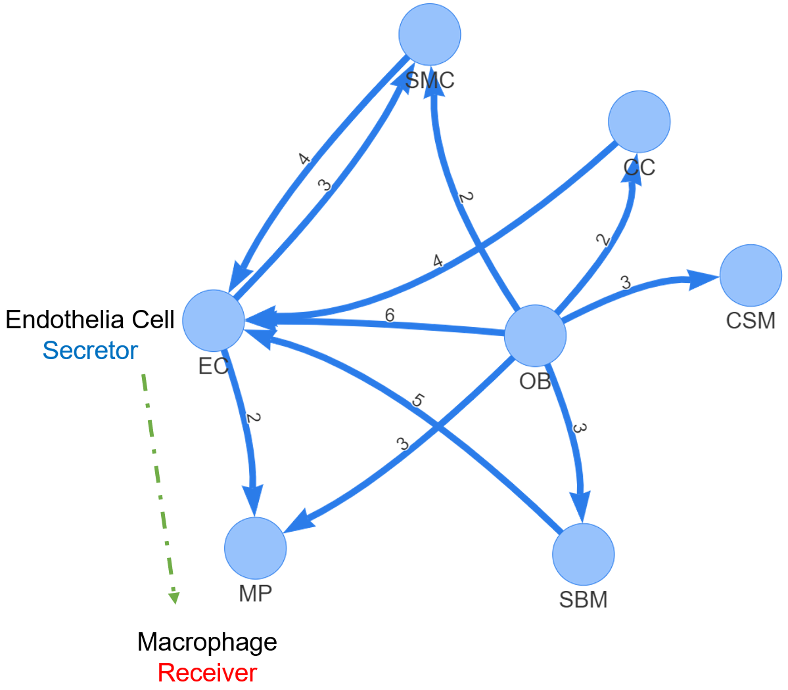
Fig. 4 rICRN generated by rCOM using Acta2-lineage cell in osseointegration. The label of edge shows the number of communication routes between two cell groups

$$C_{jαβ}=\frac{SL_{αj}*SR_{βj}}{SL_{αj}*SR_{αj}+SL_{βj}*SR_{βj}} (5)$$
Here $SL_{αj}$ and $SR_{αj}$ represent the ULR and DRR score in cell group $α$ and were computed using Eq. 6a and 6b. $SL_{kj}$ and $SR_{kj}$ stands for the score of communication route $j$ for cell $k$ in cell group $α$.
$SL_{αj}= \sqrt[n]{SL_{1j}*…*SL_{kj}*…*SL_{nj}} \left(6a\right)$
$$SR_{αj}= \sqrt[n]{SR_{1j}*…*SR_{kj}*…*SR_{nj}} (6b)$$
By checking the communication score $(C_{jαβ})$, it is possible to infer the cell type communication between all possible pairs of cell types in the data set. The higher score represents for a higher probability of communication between the cells in two cell types through the specific communication routes.
2.5 Identification of statistically significant cell type communication routes
The significant interactions between cell groups are identified using permutation test by randomly permuting the cell type label and then recalculating the communication score $(C_{jαβ}')$ between cell type $α$ and $β$ through communication route pair $j$. The p-value of each communication score $(C_{jαβ})$ is calculated using Eq. 7
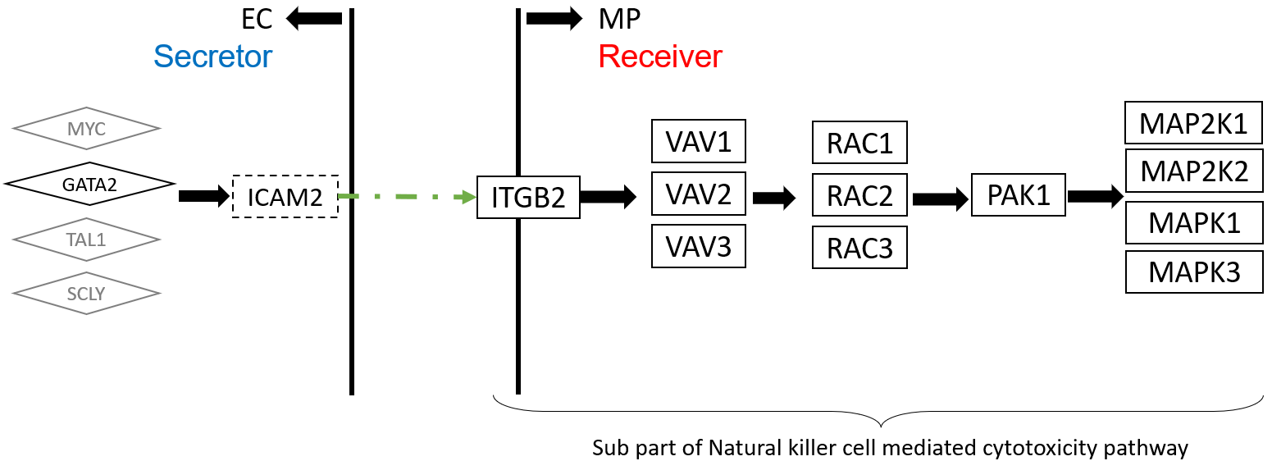
Fig 5. The upper stream and downstream genes in the communication route pair id:70072

$$Pvalue=1-\frac{\left\{\#m\right|{C_{jαβ}^{\left(m\right)}}^{'}≤ C_{jαβ}, m=1,2, .. . , M\}}{M} (7)$$
Where the score $C_{jαβ}^{\left(m\right)}'$ is the communication probability for the m-th permutation. M is the total number permutations (default is 100). The communications with p-value < 0.05 are considered as significant.
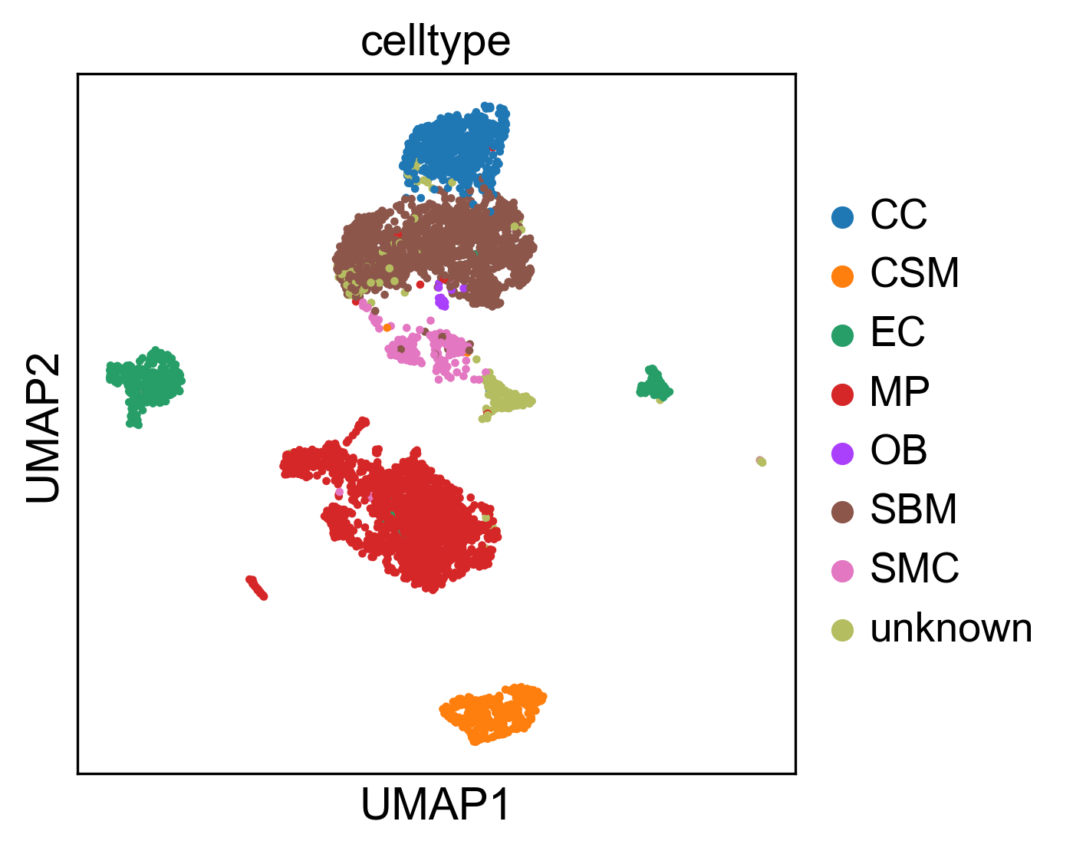Fig 3. The reproduce 2-D visualization of UMAP, colored by cell label provided by studies.
3 Experiment results
We experimented rCom with two sets of independent single cell transcriptomics datas related to bone biology, one from xxx and one from NCBI GEO. Two sets of independent but related data sets are used to demonstrate the generality of rCOM and if common cell type specific communication relationships can be derived from studies done by two independent laboratories.
3.1 Experiments with Acta2-lineage cells in osseointegration dataset
The first single cell transcriptomics datasets we applied rCOM analyze how subtypes of bone marrow stromal cell populations contribute to bone formation around metal implants [13]. After the QC preprocessing and data formatting, our method creates the scRNA-seq data matrix made up of 4397 cells with 31053 features (genes). Vesprey et al. [13] provide the labels of each cell subgroup such as: a) cell of skeletal muscle (CSM) (269 cells), b) chondrocyte (CC) (545 cells), c) endothelia cell (EC) (394 cells), d) macrophage (MP) (1608 cells), e) osteoblast (OB) (19 cells), f) smooth muscle cell (SMC) (191 cells) and g) stromal cell of bone marrow (SBM) (1371 cells). We were able to reproduce this particular subgrouping of the study cells using the 2-D UMAP visualization as shown in Fig 3, similar to what has been reported in [13] providing confidence in our use of reported cell type labels.
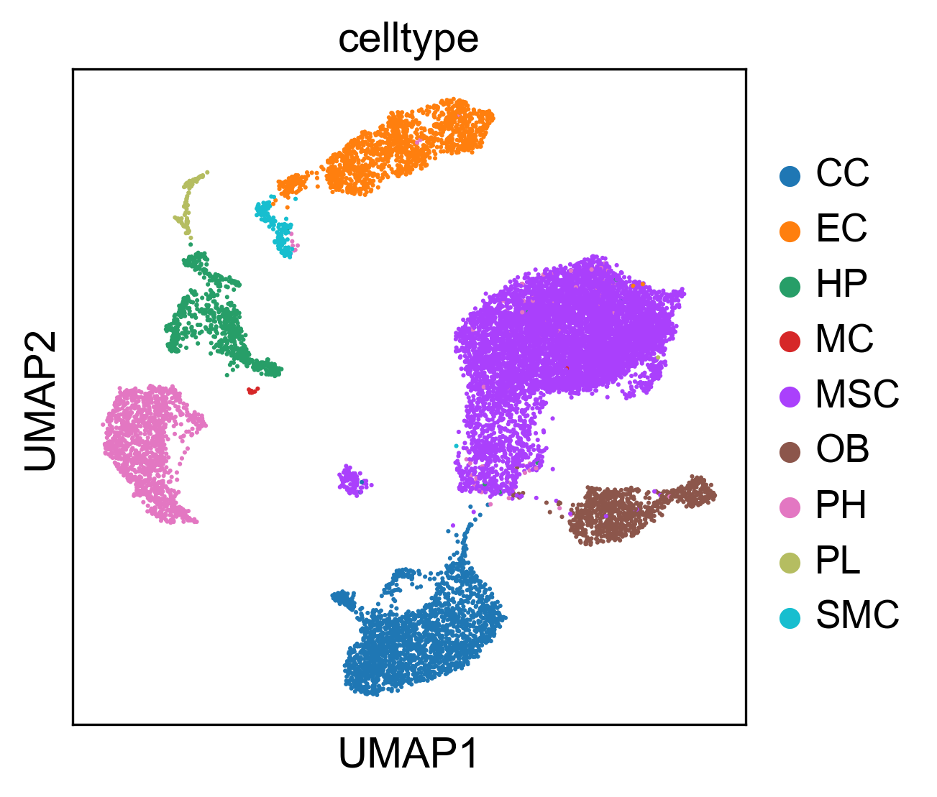
Fig 8. The reproduce 2-D visualization of UMAP, colored by cell label provided by studies.

Fig 6. The violin plot of ICAM2 and ITGB2 gene expression value in each cell type.

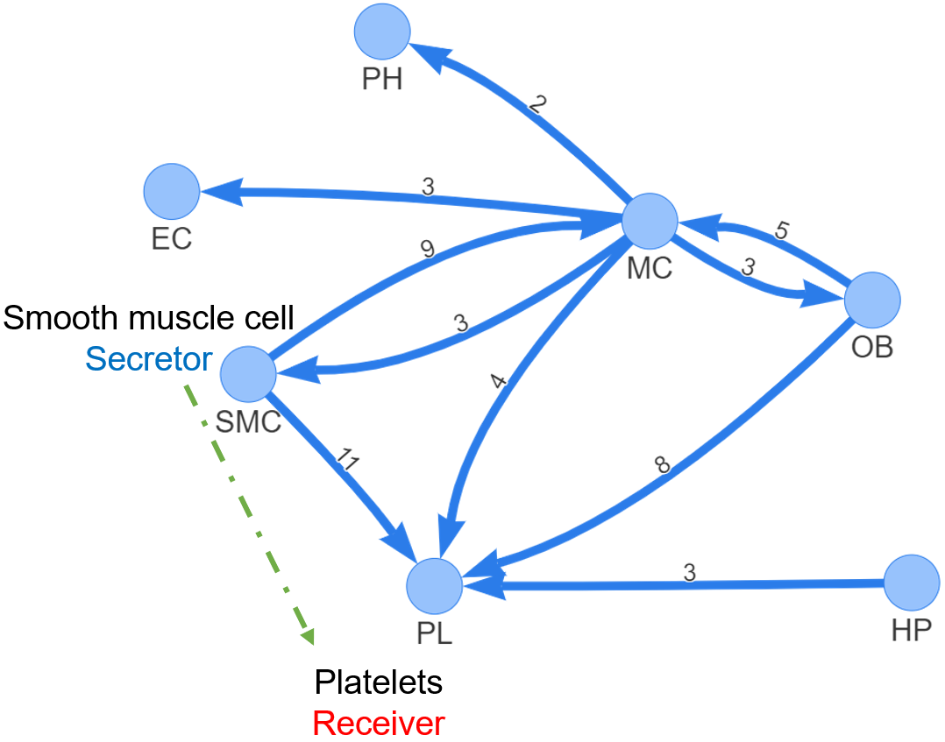
Fig. 9 rICRN generated by rCOM using bone marrow stromal dataset scRNA-seq of 11 weeks old mice dataset

The analysis outcome of applying rCOM to this dataset is summarized in Tab 1. It shows a small portion of discovered communication routes whose route score threshold > 8.5 for various of L-R pairs. Fig 4 shows the network rendering rICRN of the generated communication routes using Pyvis. Here each node denotes a cell type and the direct of edges the signaling direction (e.g., from ligand in ULR to receptor in DRR). For example, Fig 4 includes two significant route pairs identified between EC and MP where EC is the secretor and the MP the receiver. The edge label is given to show the number of the significant communication pairs identified between the two involved cell subtypes. From the networks, we notice that the edges from SBM to EC, from OB to EC and from CC to EC have the greater number of significant communication routes. Among these, the communications between EC and MP seems well studied in the field [14]. In Fig 5, we elaborate the particular route (Id: 70072, as highlighted in Tab. 1) as rCom identified significant route between EC and MP. This figure shows the identification of the ULR interconnecting the transcription factor GATA2 and its target ICAM2 in EC. The route 70072 basically suggests that the secreted ICAM2 by EC may bind to its receptor ITGB2 in MP. ICAM2, a member of intercellular adhesion molecule family is generally known to bind to the leukocyte adhesion LFA-1 protein. But in this particular context of bone marrow stromal cell populations designed to form bone around metal implants, ICAM2 may more likely bind to ITGB2 where the role of ITGB2 in differentiation of osteoblast precursor cells has been reported by Kim and Adchi 2019 [15]. Finally, the DRR discovered by rCom suggests that ITGB2 may regulate its downstream genes (e.g., VAV1, RAC1, etc.) and eventually activate the MAPK family genes as shown at the end of the route in Fig 5. The violin plots for gene expression of ICAM2 and ITGB2 in different cell groups are shown in Fig 6. ICAM2 is highly expressed in EC but scarcely expressed in MP while ITGB2 is highly expressed in MP but scarcely in EC, supporting the idea that the route 70072 signifies a paracrine signaling activity. Our literature survey also finds that in their 2011 work Zhang et al. [16] identified the communication between EC and MP through ICAM family gene, although not the details provided in the route 70072 were reported. Lastly, we point out that there are multiple other transcription factors known to regulate ICAM2 such as MYC, TAL1 and SCLY besides GATA2 as shown in Fig 5. The ULR picked by rCom includes only GATA2 and this fact can also be verified from the violin plots of gene expression for the upper stream TFs of ICAM2 as shown in Fig 7. GATA2’s expression level stands out in EC.
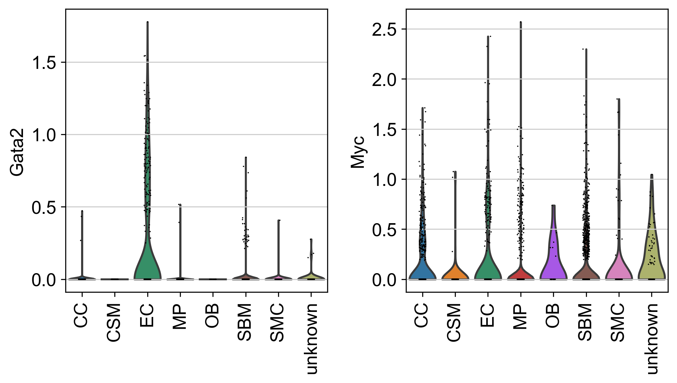
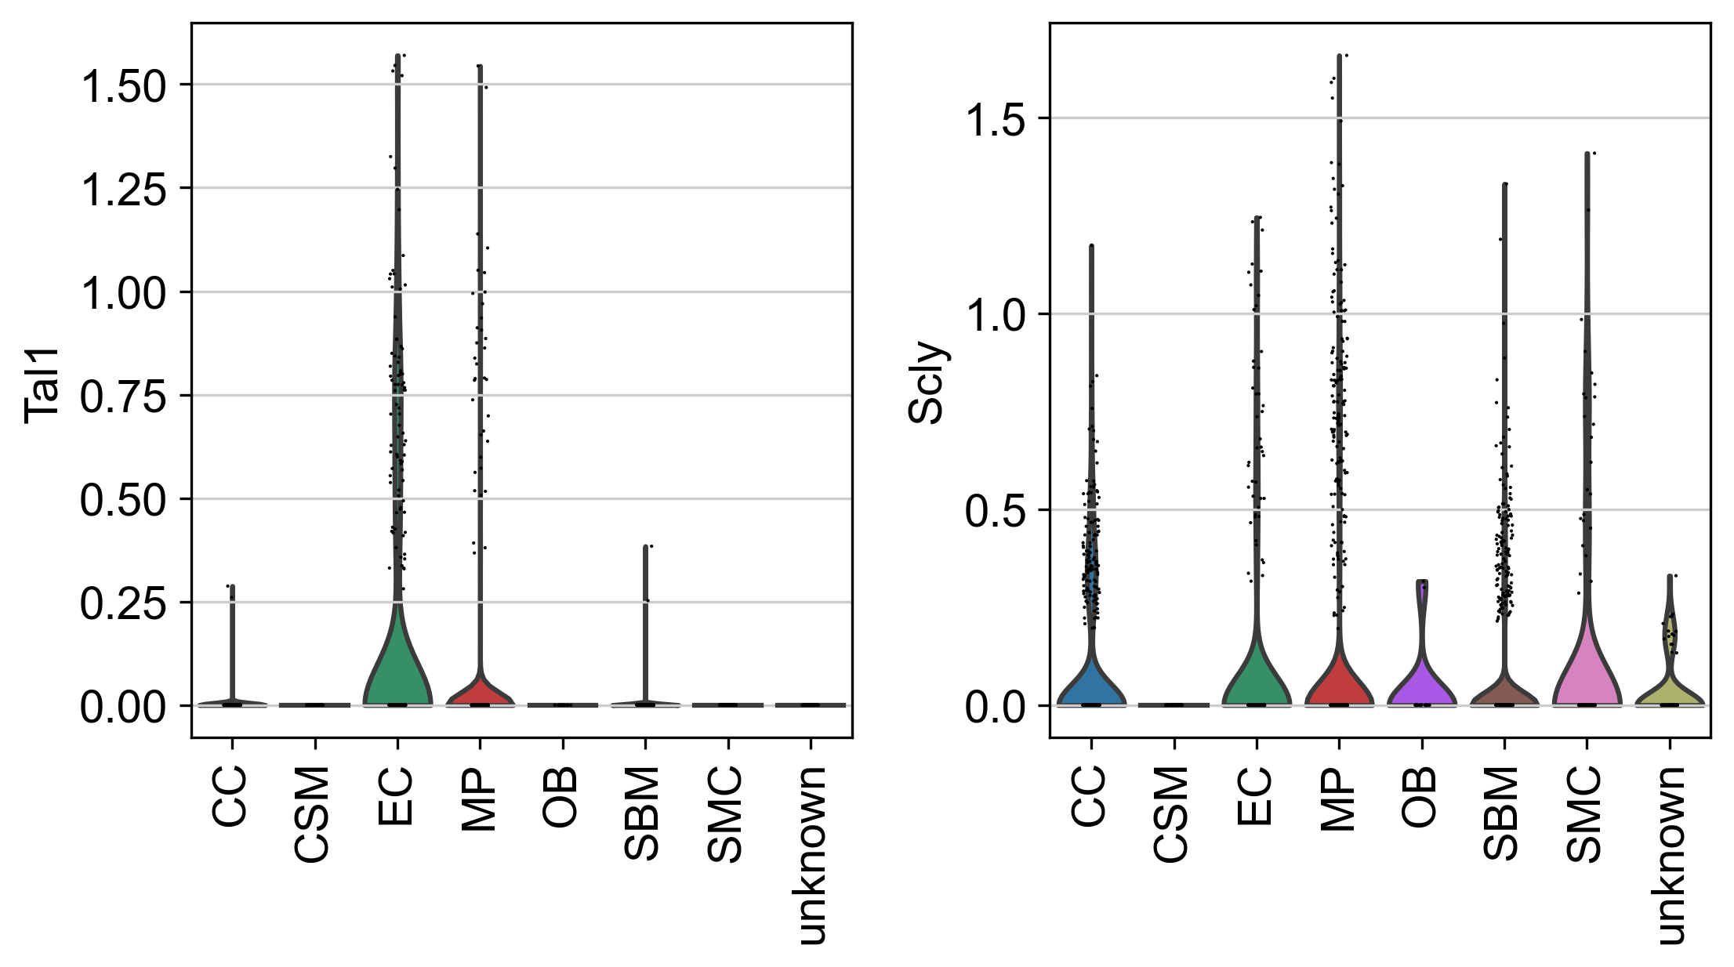
Fig 7. The violin plot of COL18A1 and ITGB3 gene expression value in each cell type.
3.2 Experiments with bone marrow stromal scRNA-seq of 11 weeks old mice dataset
The second single cell transcriptomics dataset is from a study [17] which explored osteogenesis in adult mice and show that a bone-targeting, high affinity without causing adverse effects in other organs, which are known to reply on intact Notch signaling interactions. Single cell analysis of bone stromal cells indicates GEO GSE152285. After preprocessing, the scRNA-seq data matrix has 17015 cells and 15046 features(genes). The authors of the study also provide the labels of each cell subtype such as CC (2270 cells), EC (1677 cells), Hematopoietic (HP) (849 cells), mesenchymal stromal cells (MSC) (9168 cells), osteoblast (OB) (971 cells), platelets (PL) (232 cells), proliferating Hem (PH) (1532 cells), smooth muscle cells (SMC) (238 cells), MC (78 cells). We repeated their cell subtyping and show in Fig 9 that our UMAP analysis approximately reproduces the authors’ single cell 2-D visualization.
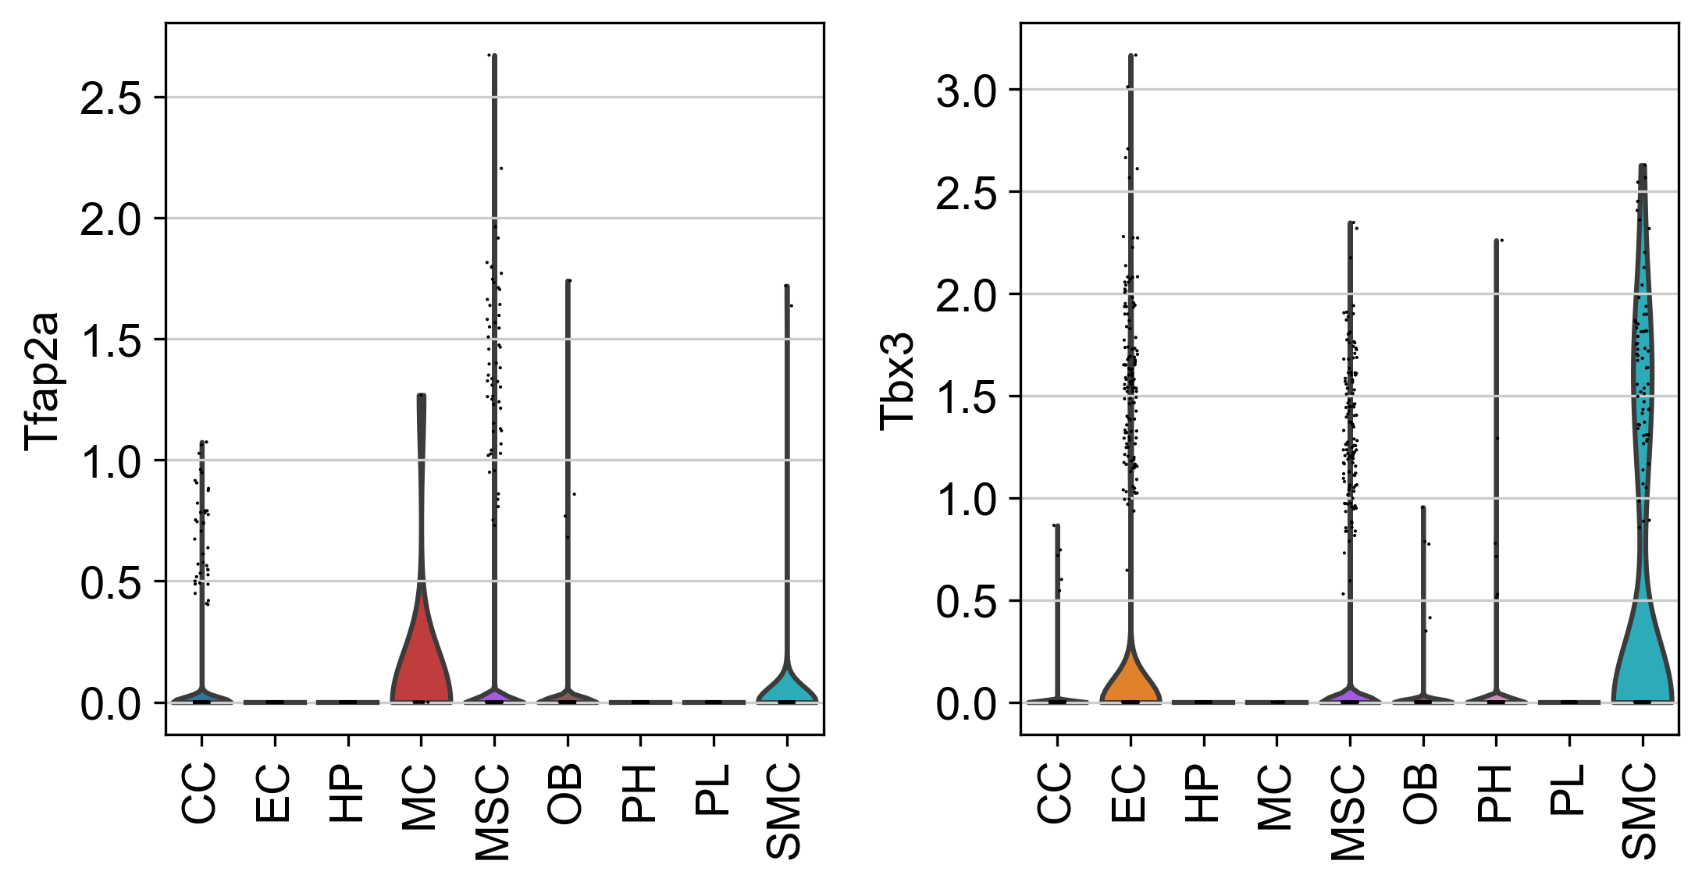
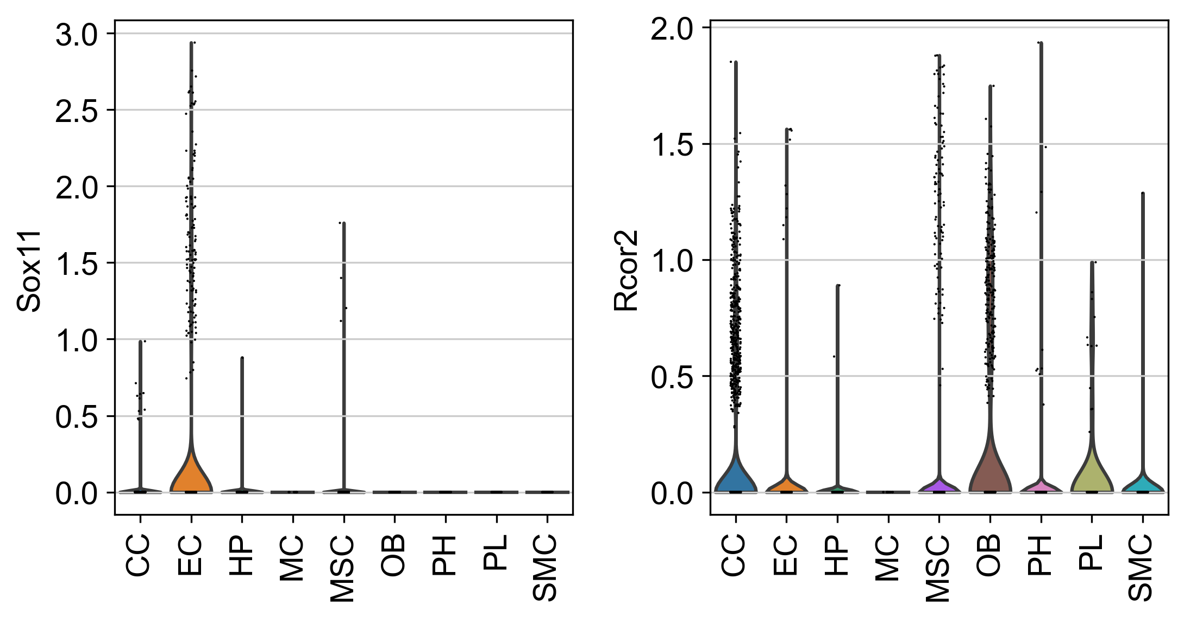
Fig 12. The violin plot for upper stream gene expression value of COL18A1 and ITGB3.
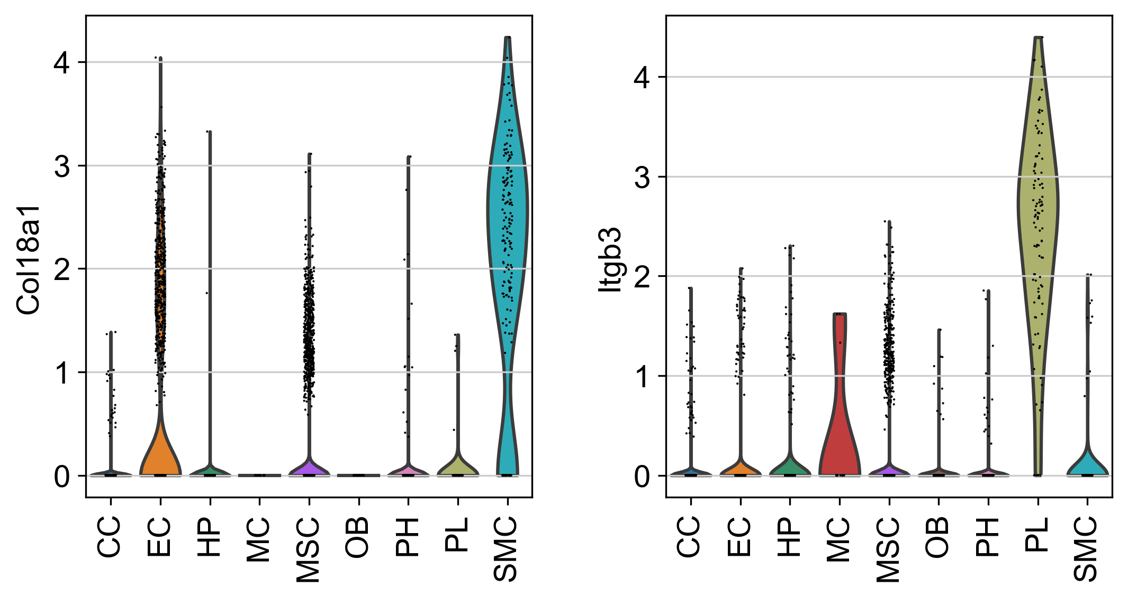
Fig 11. The complete view of communication route pairs id 95696
The outcome of applying rCom to this dataset is summarized in Tab. 2 in which only a portion of communication routes with their route score > 9 is shown. The network rendering rICRN of the generated communication routes using Pyvis is given in Fig.11. Noticeable in the figure is that the communication between SMC and PL has the largest number of significant route pairs whereas the communication from MC to PH has only 2 route pairs. In fact, the interaction between SMC and PL appears to be well documented in the bone biology field [18]. We elaborate on the specific route (ID: 95696) which acquired the highest route score 12.64 by rCom as shown in Tab 2. The pictorial presentation of this route is shown in Fig 10 which highlights SMC as the Secretor and PL as the Receiver. In its ULR identification, the transcription factor TBX3 is estimated to target COL18A in SMC, and then this COL18A1 binds to ITGB3 in PL. In the DRR identification, ITGB3 regulates its downstream genes and activates the PIK family genes in PL as shown at the end of the route given in Fig 10. The gene expression value distribution for COL18A1 and ITGB3 is shown for all identified cell subtypes using violin plots in Fig. 11. Noticeable here are that among all cell subtypes, COL18A1 and ITGB3 are predominantly expressed in the SMC and ITGB3, respectively. Our literature survey reveals that according to Misra et al. [19] SMC and PL are interacting with each other and ITGB3 plays an important role in smoothing muscle-derived atherosclerotic plaque cells. A similar report about the interface between SMC and PL is also reported by Inoue et al 2015 [20] who state that smooth muscle cells stimulate platelets in atherothrombosis. We show the gene expression value distribution for all the TFs that are known to regulate the COL18A1 including TFAP2A, TBX3, NUCKS1, SOX11 and RCOR2 in Fig 13. Only TBX3 are highly expressed in the SMC suggesting a support for rCOM’s pick of TBX3 as the upstream for COL18A. Lastly, Sipola et al (2009) [21] report that COL18A1 affects osteoblast behavior. It remains to be seen how and if COL18A1 may play a role in interfacing SMC and PL in osteoblast driven bone biology.
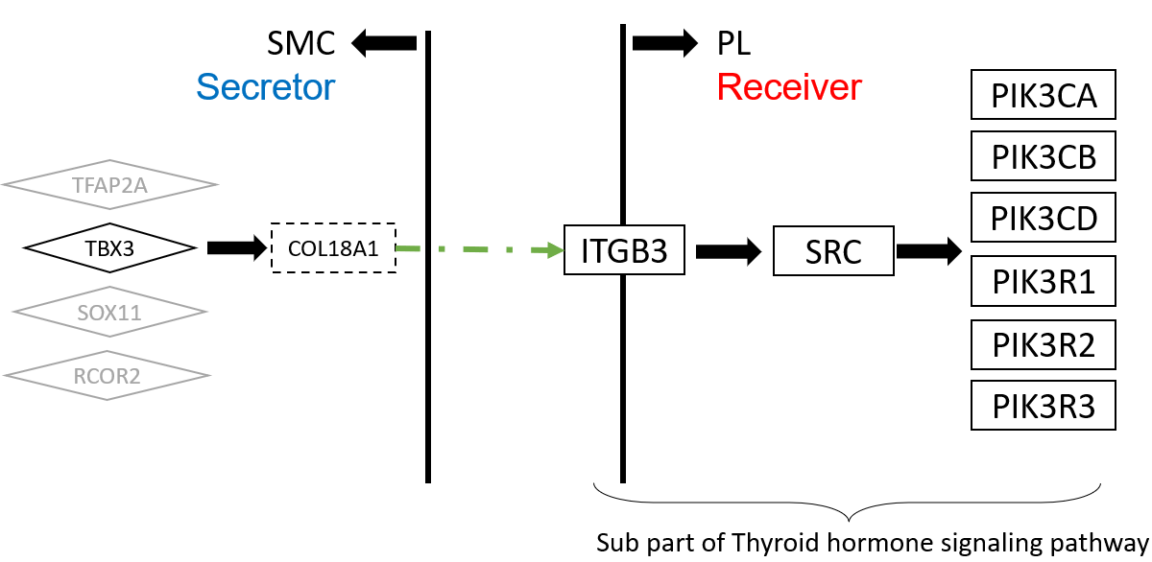
Fig 10. The upper stream and downstream genes in the communication route pair id 95696
4. Discussion and conclusion
The key outcome from the case studies is that rCOM can be effective in inferring partially or incompletely known regulatory relationships to be filled based on the observation obtained from the single cell transcriptomics data.
Developing rCom was motivated by inferencing the cell type communication at route-based level through gene signaling pathway route with ligand-receptor pairs mapped. Among all the existing methods, Ctyotalk returns a signal transduction network between cell types which is similar to rCOM. The difference between rCom and Cytoalk is how we borrow the strength of prior knowledge. The network inferred by Cytotalk is data driven while rCom try to identify the meaningful network by connecting routes which are already well studied and supported by wet lab experiments. While we acknowledge that there are number of existing methods which focus on inferring cell type communication using ligand-receptor expression patterns, our survey revealed that none of these methods use pathway topology (activation/inhibition) and regulatory consistency in their model. The rCom framework provides a new way of using well-established prior knowledge to translate the communication behavior.
rCOM also provide a new way for combining biological knowledge databases to study pathway crosstalk. Identifying crosstalk between interacting pathways has been an active research area. Nodes-in-Common (NIC) predicts crosstalk by checking if two pathways share any proteins [22]–[24]. Hsu et.al. estimate pathway crosstalk based on similarities in Gene Ontology annotations[25]. Given a protein-protein interaction network, Li et al. links two pathways A and B if more edges connect the proteins in A to the proteins in B than expected by chance in a randomly wired network [26]. In our previous work, ctBuilder [27] is developed to identify a subnetwork interconnecting two pathways. However, with combination of ligand-receptor pairs databases and curated gene signaling pathway databases, the rCom framework can provide a novel aspect of exploring and identifying pathway crosstalk, which is the connection between ligand and receptor pairs. More specifically, without finding NIC, signal originating from ULR of pathway A in one cell can impact its downstream gene in DRR which is derived from a different pathway B in another cell. These two routes can be connected through the ligand-receptor pairs which is not originally annotated in pathways but supported by curated ligand-receptor databases. By analyzing the communication route pairs, unknown crosstalk between two independent pathways might be identified.
The current experiment with rCom was done using Chip-seq, CellChat, CellTalkDB and KEGG to utilize the causal information curated in the database. But it can be easily extended to use other databases like BioGrid [28]. An extendable work of rCom framework is to use spatial genomics data to validate result by checking if two cell types are co-localizing two each other. With the spatial genomic data, the interaction between cells instead of cell types may be identified and validated. How to utilize the spatial data and combine to rCom is an interesting future problem.
ACKNOWLEDGMENTS
Research reported in this work was supported in part by NIH/NICHD Grant No.1R01HD098636-01. Its contents are solely the responsibility of the authors and do not necessarily represent the official views of the NIH.
REFERENCES
[1] D. A. Skelly et al., “Single-Cell Transcriptional Profiling Reveals Cellular Diversity and Intercommunication in the Mouse Heart,” Cell Reports, vol. 22, no. 3, pp. 600–610, Jan. 2018, doi: 10.1016/J.CELREP.2017.12.072.
[2] M. P. Kumar et al., “Analysis of Single-Cell RNA-Seq Identifies Cell-Cell Communication Associated with Tumor Characteristics,” Cell Reports, vol. 25, no. 6, pp. 1458-1468.e4, Nov. 2018, doi: 10.1016/J.CELREP.2018.10.047.
[3] J. X. Zhou, R. Taramelli, E. Pedrini, T. Knijnenburg, and S. Huang, “Extracting Intercellular Signaling Network of Cancer Tissues using Ligand-Receptor Expression Patterns from Whole-tumor and Single-cell Transcriptomes,” Scientific Reports 2017 7:1, vol. 7, no. 1, pp. 1–15, Aug. 2017, doi: 10.1038/s41598-017-09307-w.
[4] R. Vento-Tormo et al., “Single-cell reconstruction of the early maternal–fetal interface in humans,” Nature 2018 563:7731, vol. 563, no. 7731, pp. 347–353, Nov. 2018, doi: 10.1038/s41586-018-0698-6.
[5] S. Wang, M. Karikomi, A. L. Maclean, and Q. Nie, “Cell lineage and communication network inference via optimization for single-cell transcriptomics,” Nucleic Acids Research, vol. 47, no. 11, pp. e66–e66, Jun. 2019, doi: 10.1093/NAR/GKZ204.
[6] R. Browaeys, W. Saelens, and Y. Saeys, “NicheNet: modeling intercellular communication by linking ligands to target genes,” Nature Methods 2019 17:2, vol. 17, no. 2, pp. 159–162, Dec. 2019, doi: 10.1038/s41592-019-0667-5.
[7] Y. Hu, T. Peng, L. Gao, and K. Tan, “CytoTalk: De novo construction of signal transduction networks using single-cell transcriptomic data,” Science Advances, vol. 7, no. 16, Apr. 2021, doi: 10.1126/SCIADV.ABF1356/SUPPL_FILE/ABF1356_TABLE_S6.XLSX.
[8] T. H. Hoang et al., “BioTarget: A Computational Framework Identifying Cancer Type Specific Transcriptional Targets of Immune Response Pathways,” Scientific Reports, vol. 9, no. 1, p. 9029, 2019, doi: 10.1038/s41598-019-45304-x.
[9] P. Joshi, B. Basso, H. Wang, S. H. Hong, C. Giardina, and D. G. Shin, “rPAC: Route based pathway analysis for cohorts of gene expression data sets,” Methods, Oct. 2021, doi: 10.1016/J.YMETH.2021.10.002.
[10] F. A. Wolf, P. Angerer, and F. J. Theis, “SCANPY: Large-scale single-cell gene expression data analysis,” Genome Biology, vol. 19, no. 1, pp. 1–5, Feb. 2018, doi: 10.1186/S13059-017-1382-0/FIGURES/1.
[11] “Chromatin Immunoprecipitation Sequencing (ChIP-Seq).” https://www.illumina.com/techniques/sequencing/dna-sequencing/chip-seq.html (accessed May 10, 2022).
[12] A. Caicedo, “PARACRINE AND AUTOCRINE INTERACTIONS IN THE HUMAN ISLET: MORE THAN MEETS THE EYE,” Semin Cell Dev Biol, vol. 24, no. 1, p. 11, 2013, doi: 10.1016/J.SEMCDB.2012.09.007.
[13] A. Vesprey et al., “Tmem100- and Acta2-Lineage Cells Contribute to Implant Osseointegration in a Mouse Model,” J Bone Miner Res, vol. 36, no. 5, pp. 1000–1011, May 2021, doi: 10.1002/JBMR.4264.
[14] H. He et al., “Endothelial cells provide an instructive niche for the differentiation and functional polarization of M2-like macrophages,” Blood, vol. 120, no. 15, p. 3152, Oct. 2012, doi: 10.1182/BLOOD-2012-04-422758.
[15] J. Kim and T. Adachi, “Cell Condensation Triggers the Differentiation of Osteoblast Precursor Cells to Osteocyte-Like Cells,” Frontiers in Bioengineering and Biotechnology, vol. 7, p. 288, Oct. 2019, doi: 10.3389/FBIOE.2019.00288/BIBTEX.
[16] J. Zhang et al., “Regulation of Endothelial Cell Adhesion Molecule Expression by Mast Cells, Macrophages, and Neutrophils,” PLoS ONE, vol. 6, no. 1, 2011, doi: 10.1371/JOURNAL.PONE.0014525.
[17] C. Xu et al., “Induction of osteogenesis by bone-targeted Notch activation,” Elife, vol. 11, Feb. 2022, doi: 10.7554/ELIFE.60183.
[18] R. Ross and L. Harker, “Platelets, endothelium, and smooth muscle cells in atherosclerosis,” Adv Exp Med Biol, vol. 102, pp. 135–141, 1978, doi: 10.1007/978-1-4757-1217-9_8.
[19] F. Hartmann et al., “SMC-Derived Hyaluronan Modulates Vascular SMC Phenotype in Murine Atherosclerosis,” Circ Res, vol. 129, no. 11, pp. 992–1005, Nov. 2021, doi: 10.1161/CIRCRESAHA.120.318479.
[20] O. Inoue et al., “Vascular Smooth Muscle Cells Stimulate Platelets and Facilitate Thrombus Formation through Platelet CLEC-2: Implications in Atherothrombosis,” PLOS ONE, vol. 10, no. 9, p. e0139357, Sep. 2015, doi: 10.1371/JOURNAL.PONE.0139357.
[21] A. Sipola, L. Seppinen, T. Pihlajaniemi, and J. Tuukkanen, “Endostatin affects osteoblast behavior in vitro, but collagen XVIII/endostatin is not essential for skeletal development in vivo,” Calcif Tissue Int, vol. 85, no. 5, pp. 412–420, Nov. 2009, doi: 10.1007/S00223-009-9287-X.
[22] D. M et al., “Analysis and correction of crosstalk effects in pathway analysis,” Genome Res, vol. 23, no. 11, pp. 1885–1893, Nov. 2013, doi: 10.1101/GR.153551.112.
[23] K. H and K. MR, “Abiotic stress signalling pathways: specificity and cross-talk,” Trends Plant Sci, vol. 6, no. 6, pp. 262–267, 2001, doi: 10.1016/S1360-1385(01)01946-X.
[24] T. CM, E. B, and K. CR, “Critical nodes in signalling pathways: insights into insulin action,” Nat Rev Mol Cell Biol, vol. 7, no. 2, pp. 85–96, Feb. 2006, doi: 10.1038/NRM1837.
[25] C.-L. Hsu and U.-C. Yang, “Discovering pathway cross-talks based on functional relations between pathways,” BMC Genomics 2012 13:7, vol. 13, no. 7, pp. 1–15, Dec. 2012, doi: 10.1186/1471-2164-13-S7-S25.
[26] L. Y, A. P, and R. D, “A global pathway crosstalk network,” Bioinformatics, vol. 24, no. 12, pp. 1442–1447, Jun. 2008, doi: 10.1093/BIOINFORMATICS/BTN200.
[27] H. Wang, P. Joshi, S. H. Hong, D. J. Shin, and D. G. Shin, “CtBuilder: A framework for building pathway crosstalks by combining single cell data with bulk cell data,” Proceedings - 2021 IEEE International Conference on Bioinformatics and Biomedicine, BIBM 2021, pp. 270–273, 2021, doi: 10.1109/BIBM52615.2021.9669811.
[28] C. Stark, B.-J. Breitkreutz, T. Reguly, L. Boucher, A. Breitkreutz, and M. Tyers, “BioGRID: a general repository for interaction datasets”, doi: 10.1093/nar/gkj109.

S | R | R id | Score | ULR | Ligand | Receptor | DRR | Pval
OB | EC | 82280 | 9.83 | RUNX2 | IBSP | ITGB3 | PLCD3, PLCB1, PLCE1, PLCB2, PLCB3, PLCB4, PLCD1, PLCG1, PLCG2, PLCD4, PLCZ1, C00165, PRKCA, PRKCB, PRKCG, MAPK1, MAPK3, STAT1 | <0.0005
OB | MP | 96177 | 9.53 | RUNX2 | IBSP | ITGAV | SRC, PIK3CA, PIK3CB, PIK3CD, PIK3R1, PIK3R2, PIK3R3 | <0.0005
OB | SMC | 96177 | 9.18 | RUNX2 | IBSP | ITGAV | SRC, PIK3CA, PIK3CB, PIK3CD, PIK3R1, PIK3R2, PIK3R3 | <0.0005
OB | SBM | 96177 | 9.05 | RUNX2 | IBSP | ITGAV | SRC, PIK3CA, PIK3CB, PIK3CD, PIK3R1, PIK3R2, PIK3R3 | <0.0005
EC | MP | 70072 | 9.04 | GATA2 | ICAM2 | ITGB2 | ITGAL, VAV3, VAV1, VAV2, RAC1, RAC2, RAC3, PAK1, MAP2K1, MAP2K2, MAPK1, MAPK3 | <0.0005
OB | EC | 6452 | 8.68 | SMAD3 | TNC | PTPRB | CTNNB1, CTNNA1, CTNNA2, CTNNA3, ACTB, ACTG1 | <0.0005
EC | OB | 77882 | 8.66 | CREM | GNAI2 | LPAR3 | GNAS, ADCY1, ADCY2, ADCY3, ADCY5, ADCY6, ADCY7, ADCY8, ADCY9, ADCY4, C00575, RAPGEF3, RAPGEF4, RAP1A, RAP1B | <0.0005
OB | EC | 103917 | 8.65 | RUNX2 | VEGFA | KDR | PLCG1, PLCG2, C00076, PRKCA, PRKCB, PRKCG, SPHK2,  SPHK1, HRAS, KRAS, NRAS, RAF1, MAP2K1, MAP2K2,  MAPK1, MAPK3 | <0.0005
OB | EC | 4562 | 8.64 | RUNX2 | SEMA5A | MET | MAPK1, MAPK3, SNAI2, SNAI1 | <0.0005
OB | EC | 103718 | 8.63 | CTNNB1 | PDGFC | KDR | PLCG1, PLCG2, C00076, PRKCA, PRKCB, PRKCG, SPHK2,  SPHK1, HRAS, KRAS, NRAS, RAF1, MAP2K1, MAP2K2,  MAPK1, MAPK3 | <0.0005
OB | EC | 89677 | 8.55 | RUNX2 | IBSP | ITGAV | HRAS, KRAS, NRAS, RAF1, MAP2K1, MAP2K2, MAPK1,  MAPK3, STAT1 | <0.0005
SMC | EC | 103686 | 8.53 | PBX1 | VTN | KDR | PLCG1, PLCG2, C00076, PRKCA, PRKCB, PRKCG,  SPHK2, SPHK1, HRAS, KRAS, NRAS, RAF1, MAP2K1, MAP2K2,  MAPK1, MAPK3 | <0.0005
Table 1. The significant communication routes pairs with score higher than threshold (8.5). S stands for secretor and R stands for receiver.
S | R | R id | Score | ULR | Ligand | Receptor | DRR | Pval
SMC | PL | 95696 | 12.64 | TBX3 | COL18A1 | ITGB3 | SRC, PIK3CA, PIK3CB, PIK3CD, PIK3R1, PIK3R2, PIK3R3 | <0.0005
SMC | MC | 80134 | 11.58 | NFIB | LGALS1 | PTPRC | LCK, ZAP70, LAT, GRB2, SOS1, SOS2, RASGRP1, HRAS, KRAS,  NRAS, RAF1, MAP2K1, MAP2K2, MAPK1, MAPK3, FOS, JUN | <0.0005
SMC | PL | 95739 | 11.03 | PPARG | COL4A2 | ITGB3 | SRC, PIK3CA, PIK3CB, PIK3CD, PIK3R1, PIK3R2, PIK3R3 | <0.0005
SMC | PL | 95421 | 10.34 | NR3C1 | MFGE8 | ITGB3 | SRC, PIK3CA, PIK3CB, PIK3CD, PIK3R1, PIK3R2, PIK3R3 | <0.0005
SMC | PL | 95367 | 9.7 | PPARG | NID1 | ITGB3 | SRC, PIK3CA, PIK3CB, PIK3CD, PIK3R1, PIK3R2, PIK3R3 | <0.0005
MC | SMC | 72456 | 9.63 | RELA,  RELB | IL1B | IL1R1 | IRAK1, IRAK4, MYD88, TRAF6, MAP3K7, TAB1, TAB2, TAB3,  IKBKG, CHUK, IKBKB, NFKBIA, NFKB1, RELA | <0.0005
OB | PL | 82280 | 9.6 | RUNX2 | IBSP | ITGB3 | PLCD3, PLCB1, PLCE1, PLCB2, PLCB3, PLCB4, PLCD1, PLCG1, PLCG2, PLCD4, PLCZ1, C00165, PRKCA, PRKCB, PRKCG, MAPK1, MAPK3, STAT1 | <0.0005
OB | PL | 82619 | 9.45 | KLF4 | FN1 | ITGB3 | PLCD3, PLCB1, PLCE1, PLCB2, PLCB3, PLCB4, PLCD1, PLCG1, PLCG2, PLCD4, PLCZ1, C00165, PRKCA, PRKCB, PRKCG, MAPK1, MAPK3, STAT1 | <0.0005
MC | EC | 72456 | 9.44 | RELA,  RELB | IL1B | IL1R1 | IRAK1, IRAK4, MYD88, TRAF6, MAP3K7, TAB1, TAB2, TAB3, IKBKG, CHUK, IKBKB, NFKBIA, NFKB1, RELA | <0.0005
CC | PL | 90899 | 9.42 | STAT3 | TGM2 | ITGB3 | HRAS, KRAS, NRAS, RAF1, MAP2K1, MAP2K2, MAPK1, MAPK3, TP53 | <0.0005
OB | PL | 82963 | 9.41 | CCN1 | CCN1 | ITGB3 | PLCD3, PLCB1, PLCE1, PLCB2, PLCB3, PLCB4, PLCD1, PLCG1, PLCG2, PLCD4, PLCZ1, C00165, PRKCA, PRKCB, PRKCG, MAPK1, MAPK3, STAT1 | <0.0005
SMC | PL | 95503 | 9.39 | TCF4 | FBN1 | ITGB3 | SRC, PIK3CA, PIK3CB, PIK3CD, PIK3R1, PIK3R2, PIK3R3 | <0.0005
OB | MC | 69430 | 9.36 | CCN1 | CCN1 | ITGB2 | PTK2B, RAC1, RAC2, RAC3, PAK1, MAP2K1, MAP2K2, MAPK1, MAPK3 | <0.0005
SMC | PL | 95268 | 9.35 | CCND1 | VTN | ITGB3 | SRC, PIK3CA, PIK3CB, PIK3CD, PIK3R1, PIK3R2, PIK3R3 | <0.0005
HP | PL | 95560 | 9.34 | MYB | HSP | ITGB3 | SRC, PIK3CA, PIK3CB, PIK3CD, PIK3R1, PIK3R2, PIK3R3 | <0.0005
SMC | MC | 69220 | 9.3 | MEF2A | JAM3 | ITGB2 | PTK2B, RAC1, RAC2, RAC3, PAK1, MAP2K1, MAP2K2, MAPK1, MAPK3 | <0.0005
MC | CC | 72456 | 9.11 | RELA,  RELB | IL1B | IL1R1 | IRAK1, IRAK4, MYD88, TRAF6, MAP3K7, TAB1, TAB2, TAB3, IKBKG, CHUK, IKBKB, NFKBIA, NFKB1 | <0.0005
SMC | PL | 95290 | 9.08 | EP300 | TGFB3 | ITGB3 | SRC, PIK3CA, PIK3CB, PIK3CD, PIK3R1, PIK3R2, PIK3R3 | <0.0005
SMC | PL | 96031 | 9.08 | TRIM28 | ITGAV | ITGB3 | SRC, PIK3CA, PIK3CB, PIK3CD, PIK3R1, PIK3R2, PIK3R3 | <0.0005
MC | OB | 72456 | 9.04 | RELA,  RELB | IL1B | IL1R1 | IRAK1, IRAK4, MYD88, TRAF6, MAP3K7, TAB1, TAB2, TAB3, IKBKG, CHUK, IKBKB, NFKBIA, NFKB1 | <0.0005
OB | PL | 82885 | 9.04 | KLF4 | SPP1 | ITGB3 | PLCD3, PLCB1, PLCE1, PLCB2, PLCB3, PLCB4, PLCD1, PLCG1, PLCG2,  PLCD4, PLCZ1, C00165, PRKCA, PRKCB, PRKCG, MAPK1, MAPK3, STAT1 | <0.0005
SMC | MC | 69430 | 9 | CCN1 | CCN1 | ITGB2 | PTK2B, RAC1, RAC2, RAC3, PAK1, MAP2K1, MAP2K2, MAPK1, MAPK3 | <0.0005
SMC | PL | 95963 | 9 | CCN1 | CCN1 | ITGB3 | PTK2B, RAC1, RAC2, RAC3, PAK1, MAP2K1, MAP2K2, MAPK1, MAPK3 | <0.0005
Table 2. The significant communication routes pairs with score higher than threshold (9). S stands for secretor and R stands for receiver.

