2D equations tests:

2 inputs, 2 outputs, from this:

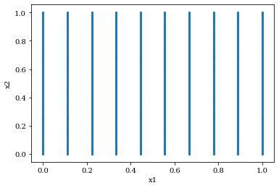

To this:

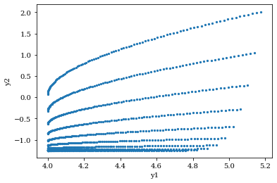

4 layers, 16 neurons, 100\*10 datapoints, lr=0.0001: evaluation loss = 0.015795286744832993

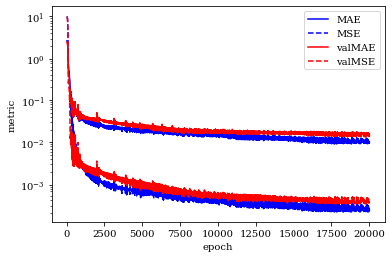

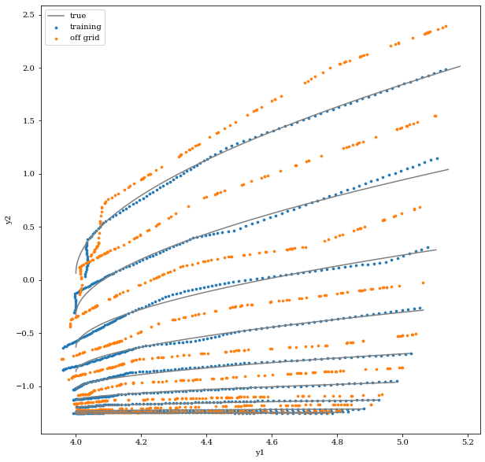

Not bad, trying to improve goodness of fit, increasing number of data N=100\*10 -> 1000\*10: evaluation loss = 0.010413877837359906

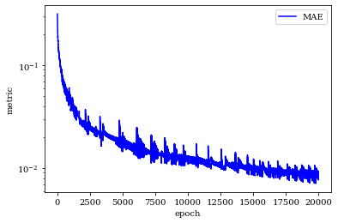

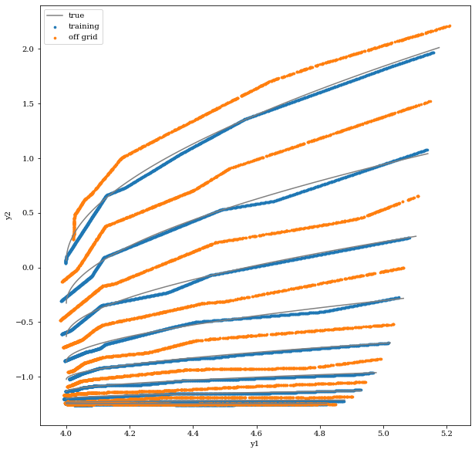

Still quite not there, increasing NN structure,

4 layers, 64 neurons, evaluation loss = 0.01132111109048128

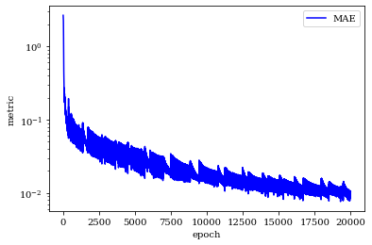

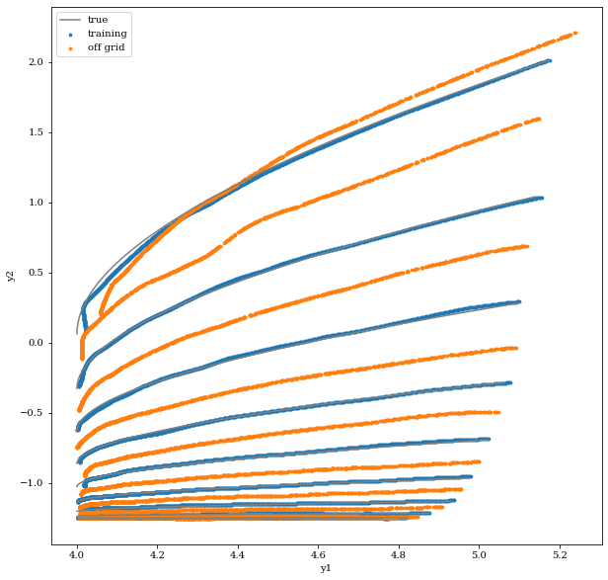

Better estimation at the majority of the lines, potential signs of over fitting at the top orange and blue lines. The history plot is still sloping down, can continue to train NN:

Evaluation error after another 20k epoch: 0.008245443142950535

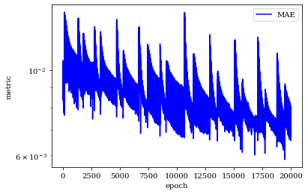

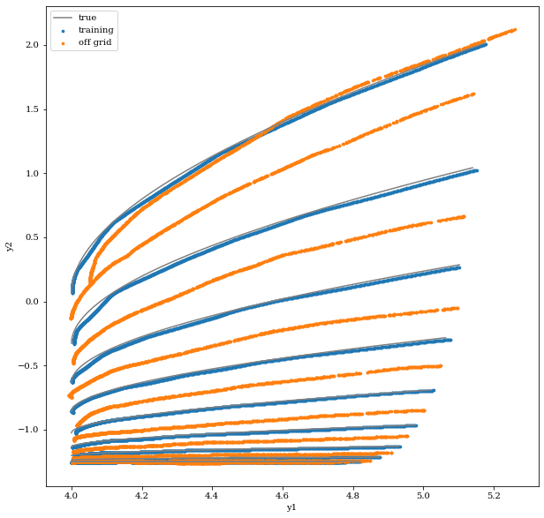

Top blue line is much closer to correct, but second to top and third to top deviates at low y1 values, and have a low y2 at high y1s, compared to before further training. Top orange is still being crazy.