spring.application.name=Productsapi
spring.datasource.url=jdbc:mysql://localhost:3306/kluh
spring.datasource.username=root
spring.datasource.password=root
spring.jpa.hibernate.ddl-auto=update
spring.jpa.show-sql=true
server.port=8989

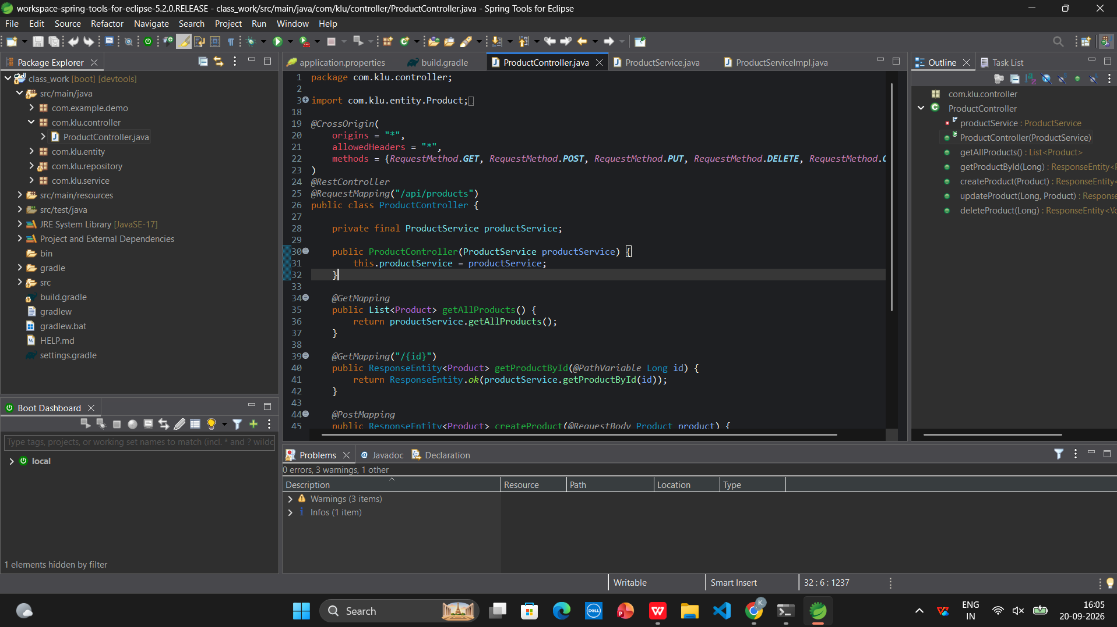

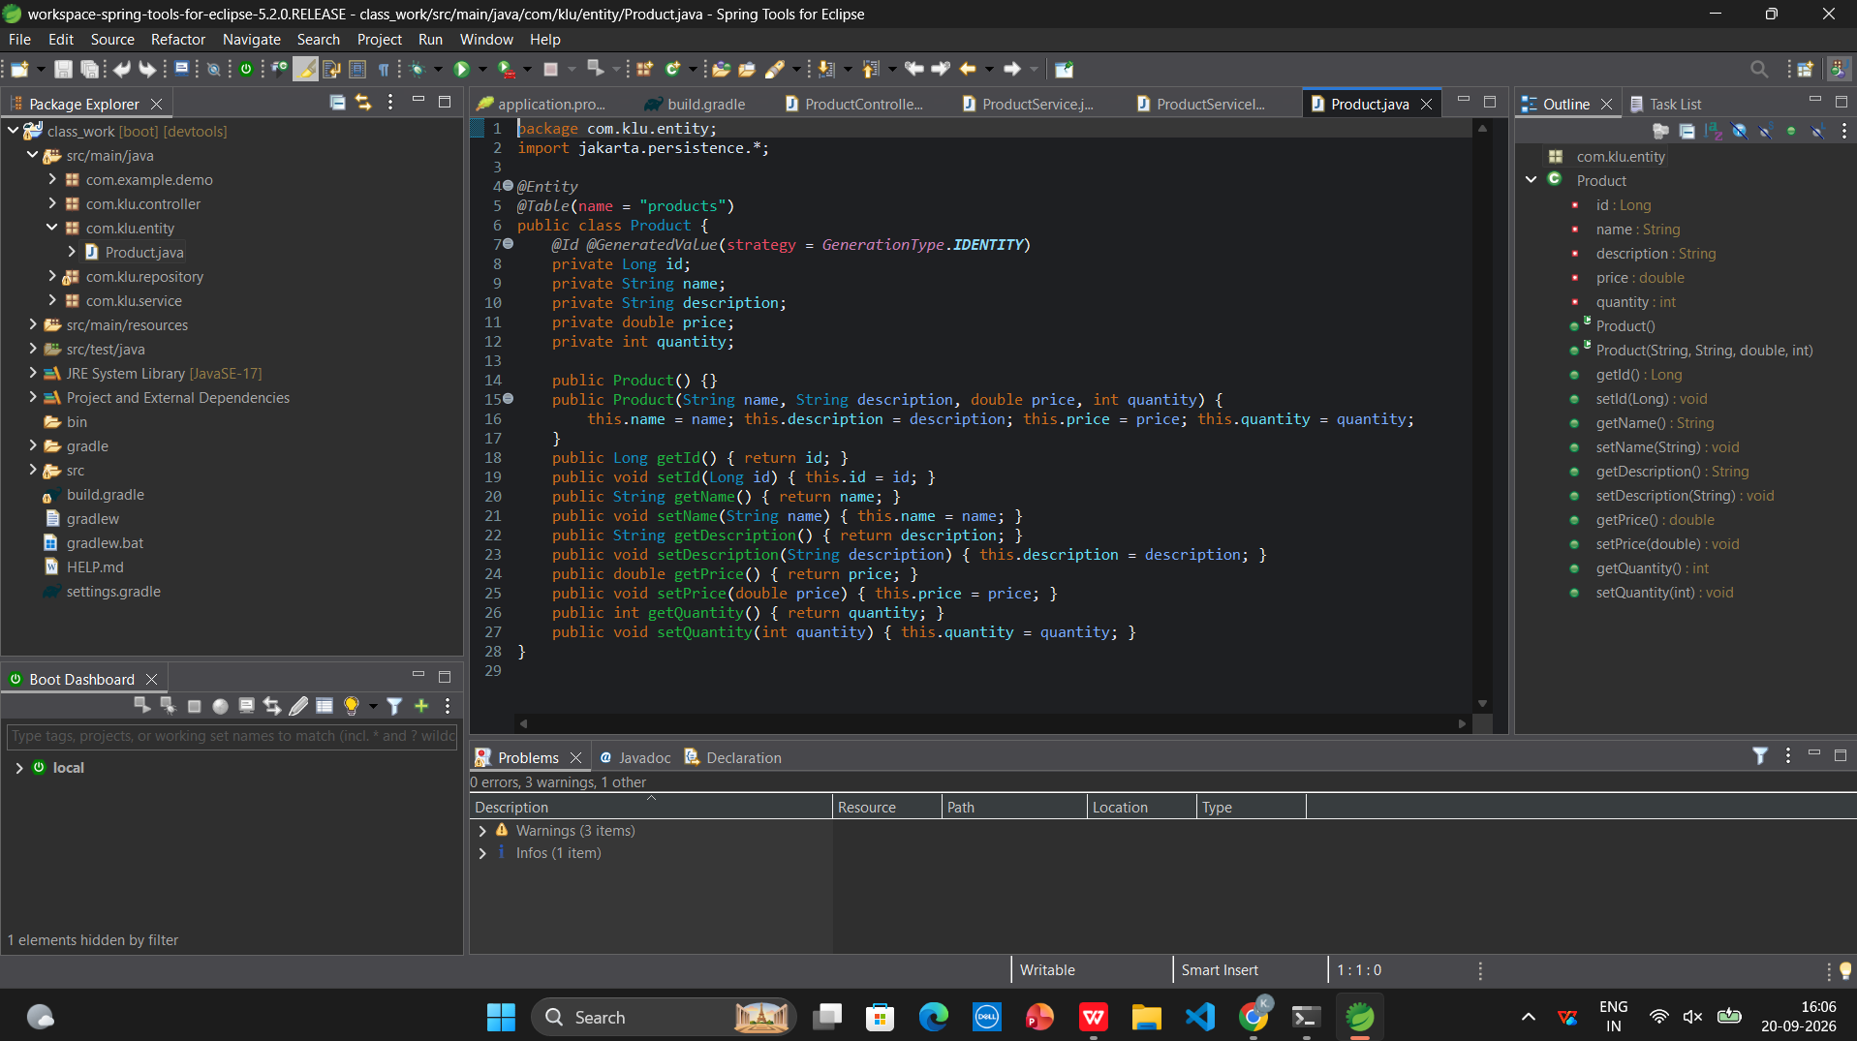

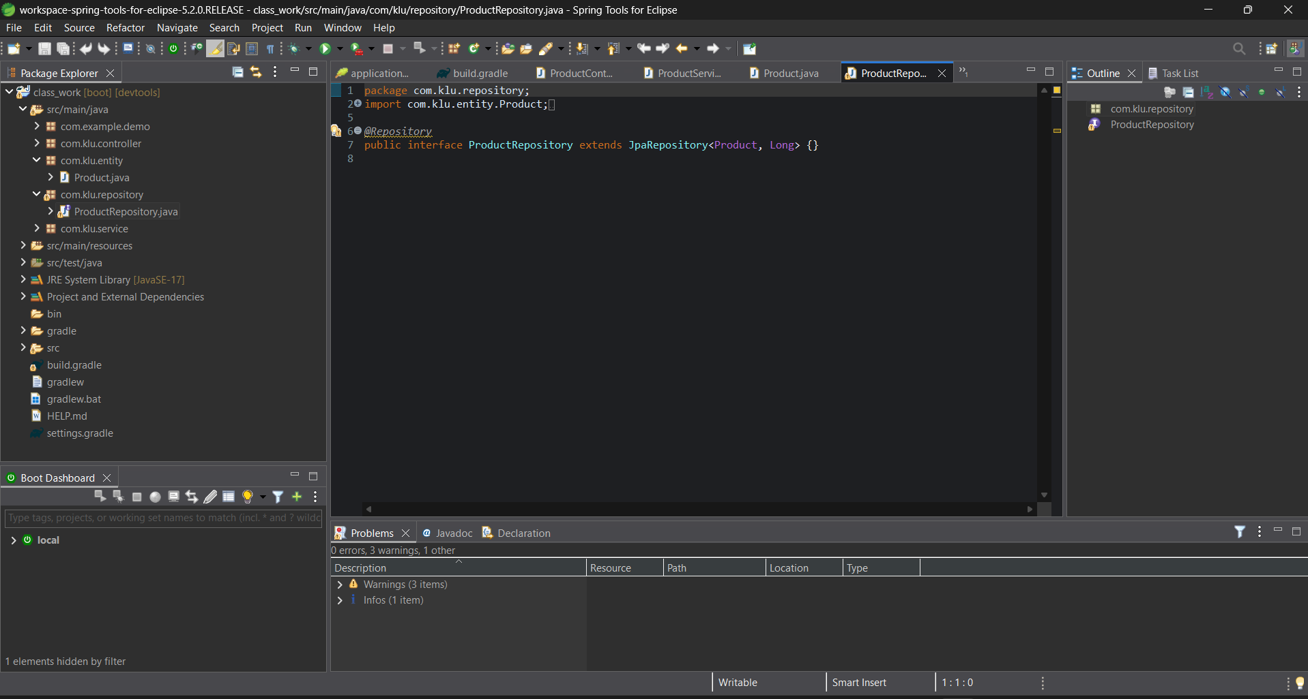

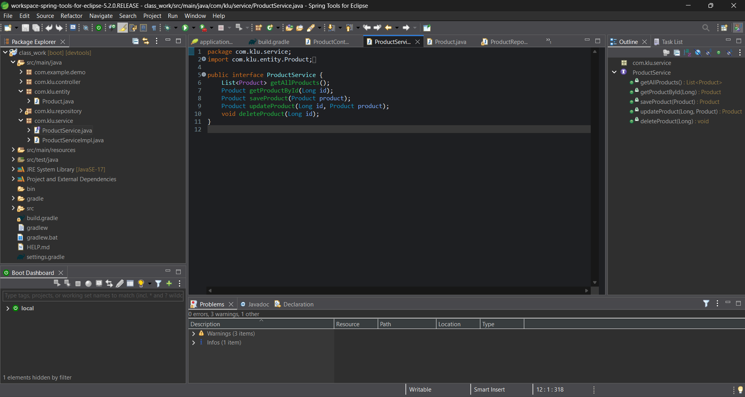
package com.klu.entity;

import jakarta.persistence.Entity;
import jakarta.persistence.GeneratedValue;
import jakarta.persistence.GenerationType;
import jakarta.persistence.Id;
import jakarta.persistence.Table;

@Entity
@Table(name = "products")
public class Product {
@Id
@GeneratedValue(strategy = GenerationType.IDENTITY)
private Long id;
private String name;
private String description;
private double price;
private int quantity;

public Product() {}

public Long getId() { return id; }
public void setId(Long id) { this.id = id; }
public String getName() { return name; }
public void setName(String name) { this.name = name; }
public String getDescription() { return description; }
public void setDescription(String description) { this.description = description; }
public double getPrice() { return price; }
public void setPrice(double price) { this.price = price; }
public int getQuantity() { return quantity; }
public void setQuantity(int quantity) { this.quantity = quantity; }
}

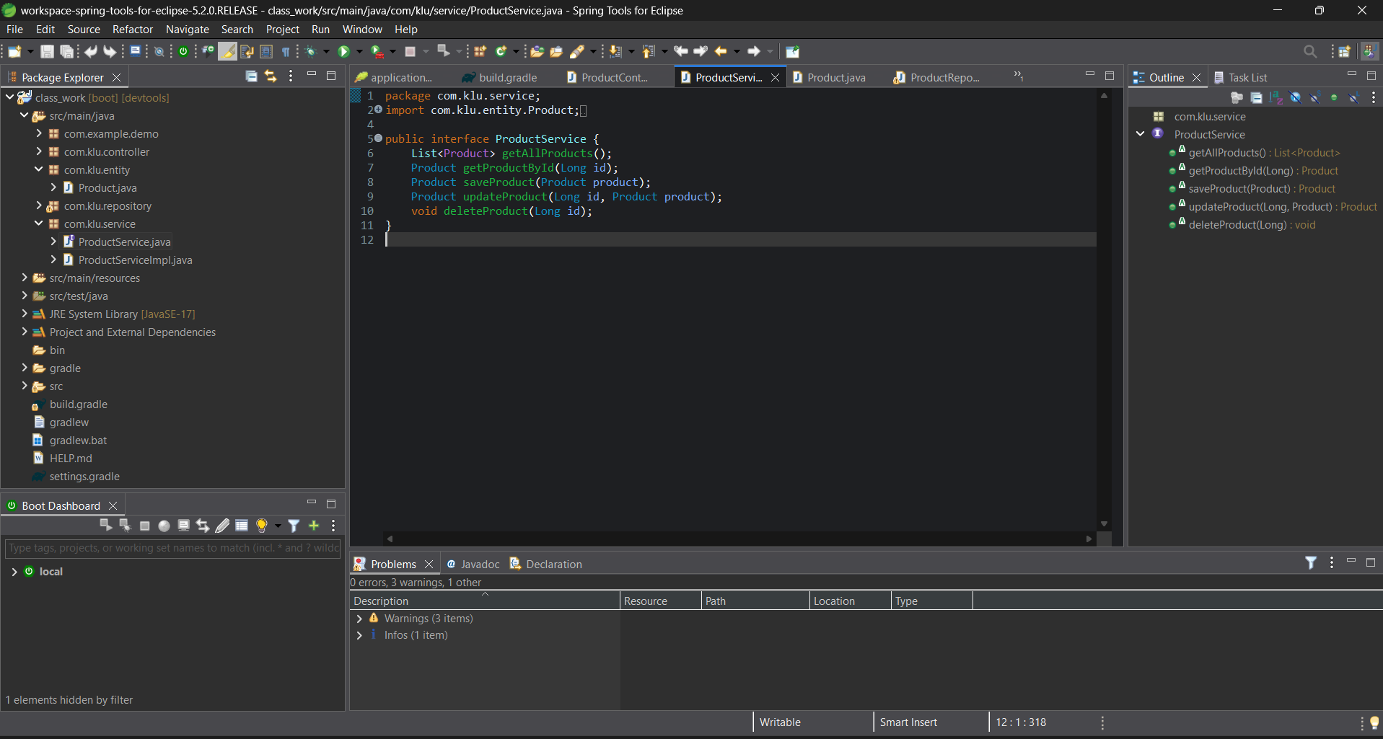

package com.klu.repository;

import org.springframework.data.jpa.repository.JpaRepository;
import org.springframework.stereotype.Repository;
import com.klu.entity.Product;

@Repository
public interface ProductRepository extends JpaRepository<Product, Long> {
}
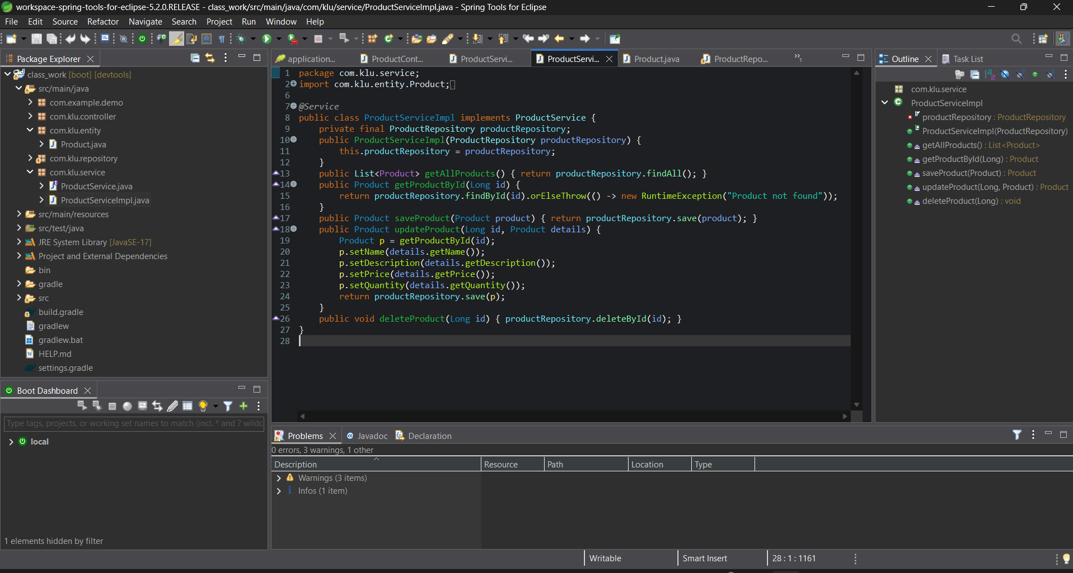

package com.klu.service;

import java.util.List;
import com.klu.entity.Product;

public interface ProductService {
Product saveProduct(Product product);
List<Product> getAllProducts();
}

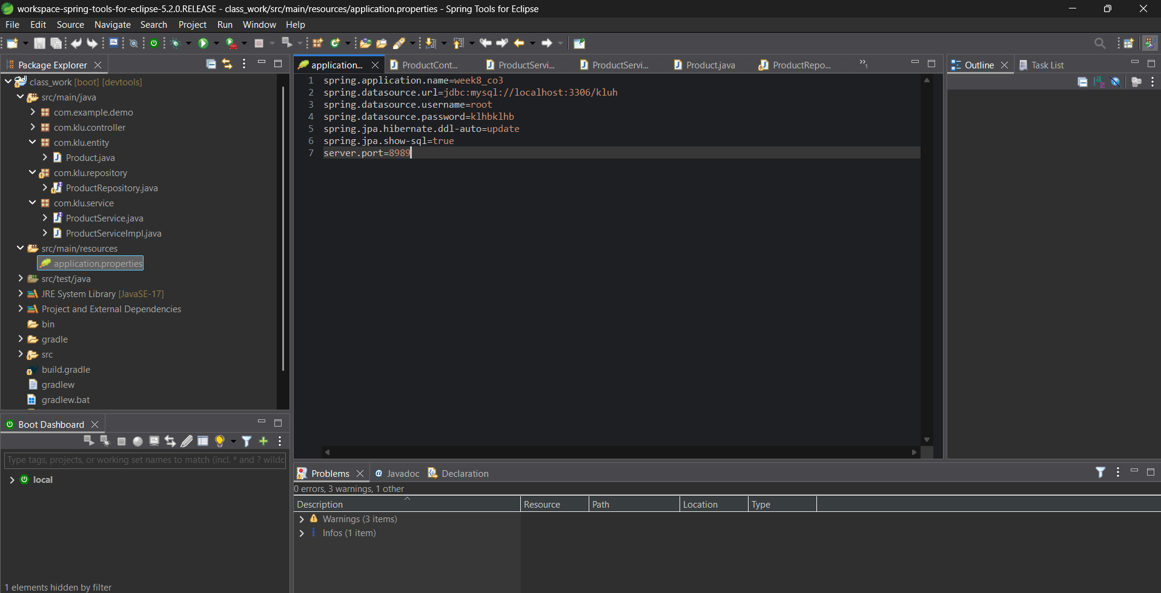

package com.klu.controller;

import java.util.List;
import org.springframework.beans.factory.annotation.Autowired;
import org.springframework.web.bind.annotation.GetMapping;
import org.springframework.web.bind.annotation.PostMapping;
import org.springframework.web.bind.annotation.RequestBody;
import org.springframework.web.bind.annotation.RequestMapping;
import org.springframework.web.bind.annotation.RestController;
import com.klu.entity.Product;
import com.klu.service.ProductService;

@RestController
@RequestMapping("/api/products")
public class ProductController {
@Autowired
private ProductService productService;

@PostMapping
public Product addProduct(@RequestBody Product product) {
return productService.saveProduct(product);
}

@GetMapping
public List<Product> getProducts() {
return productService.getAllProducts();
}
}
