use bankdb;

// Insert 8 Customers
db.customers.insertMany([ ... ]);

// Insert 15 Transactions
db.transactions.insertMany([ ... ]);

db.customers.countDocuments();
db.transactions.countDocuments();

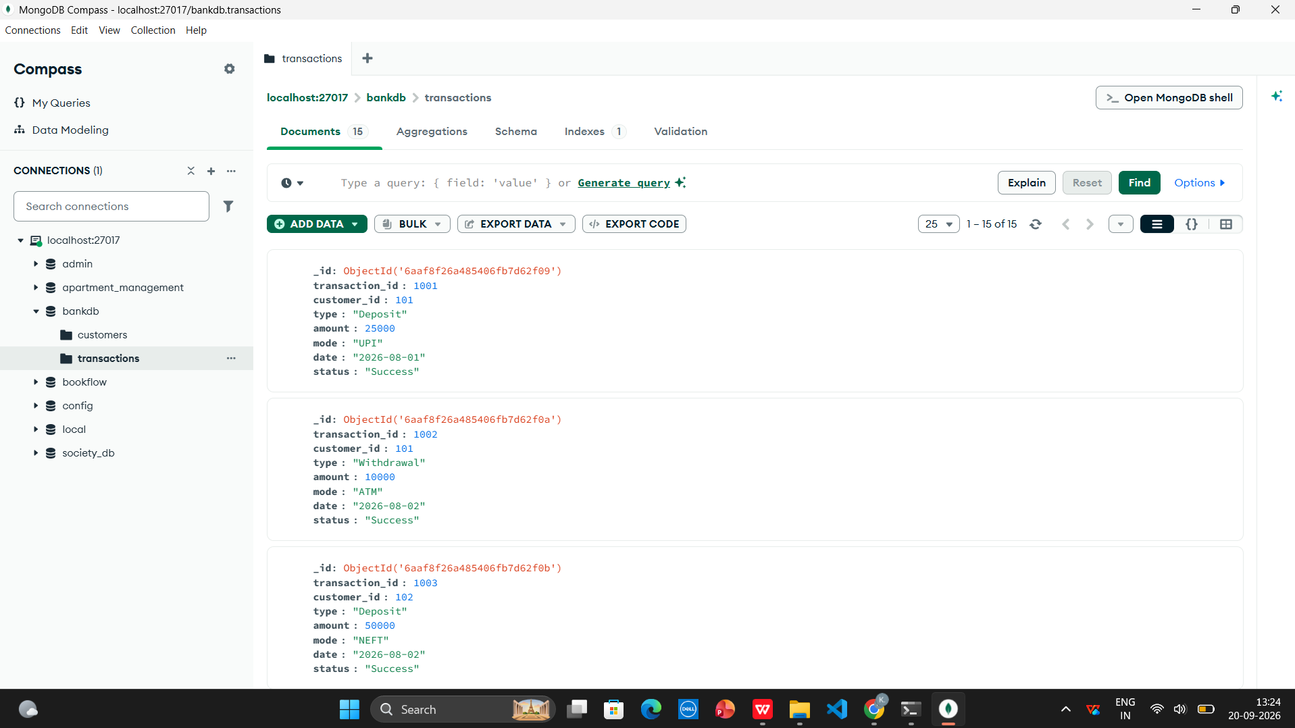

// Find Customers with Balance > 100000
db.customers.find({ balance: { $gt: 100000 } });

// Find Hyderabad Customers with High Balance
db.customers.find({ city: "Hyderabad", balance: { $gt: 100000 } });

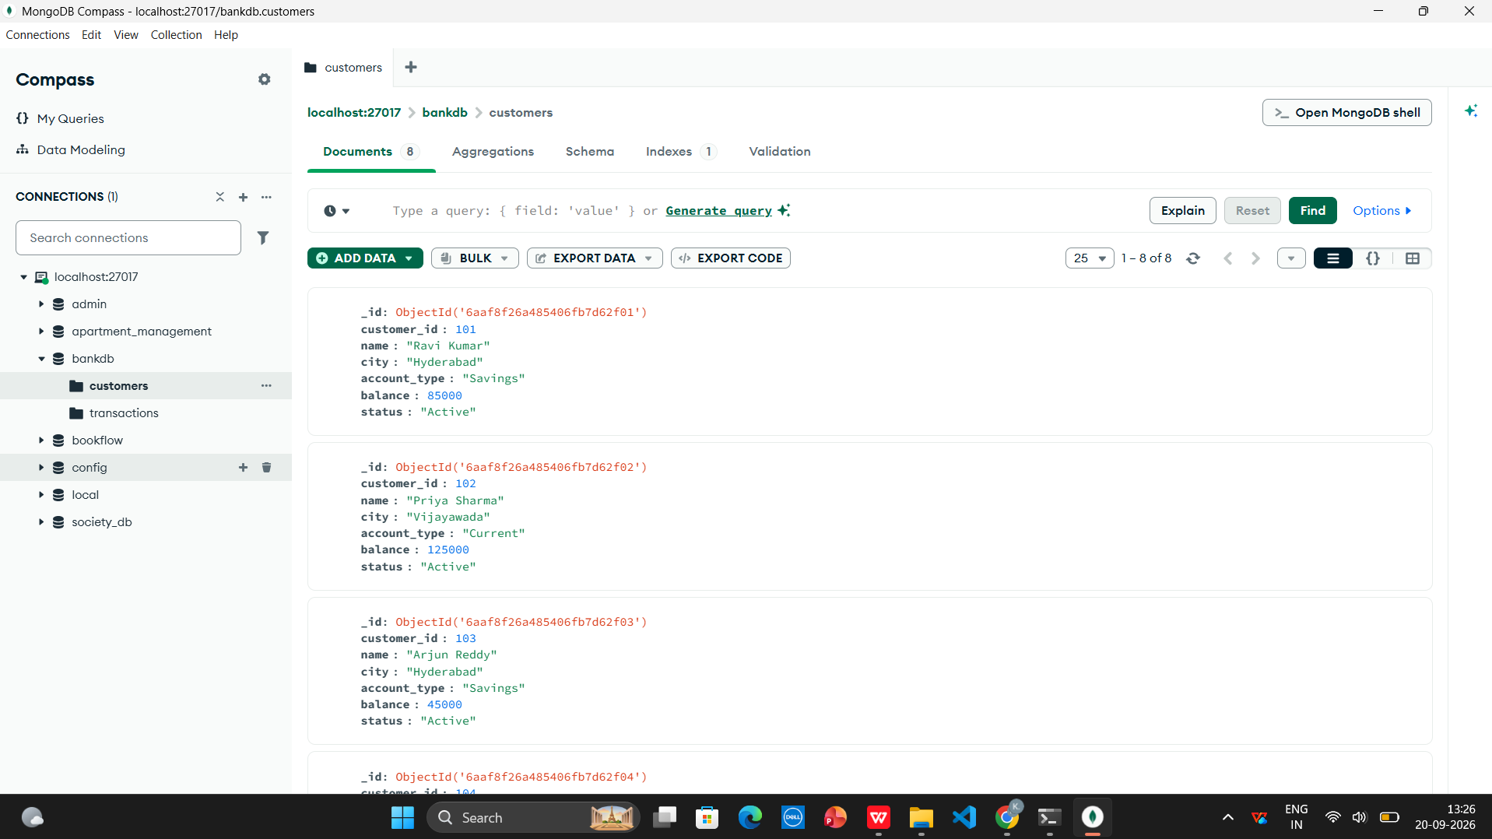

db.transactions.aggregate([
{
$lookup: {
from: "customers",
localField: "customer_id",
foreignField: "customer_id",
as: "customer"
}
},
{ $unwind: "$customer" },
{
$project: {
_id: 0,
transaction_id: 1,
customer_name: "$customer.name",
city: "$customer.city",
type: 1,
amount: 1,
mode: 1
}
}
]);

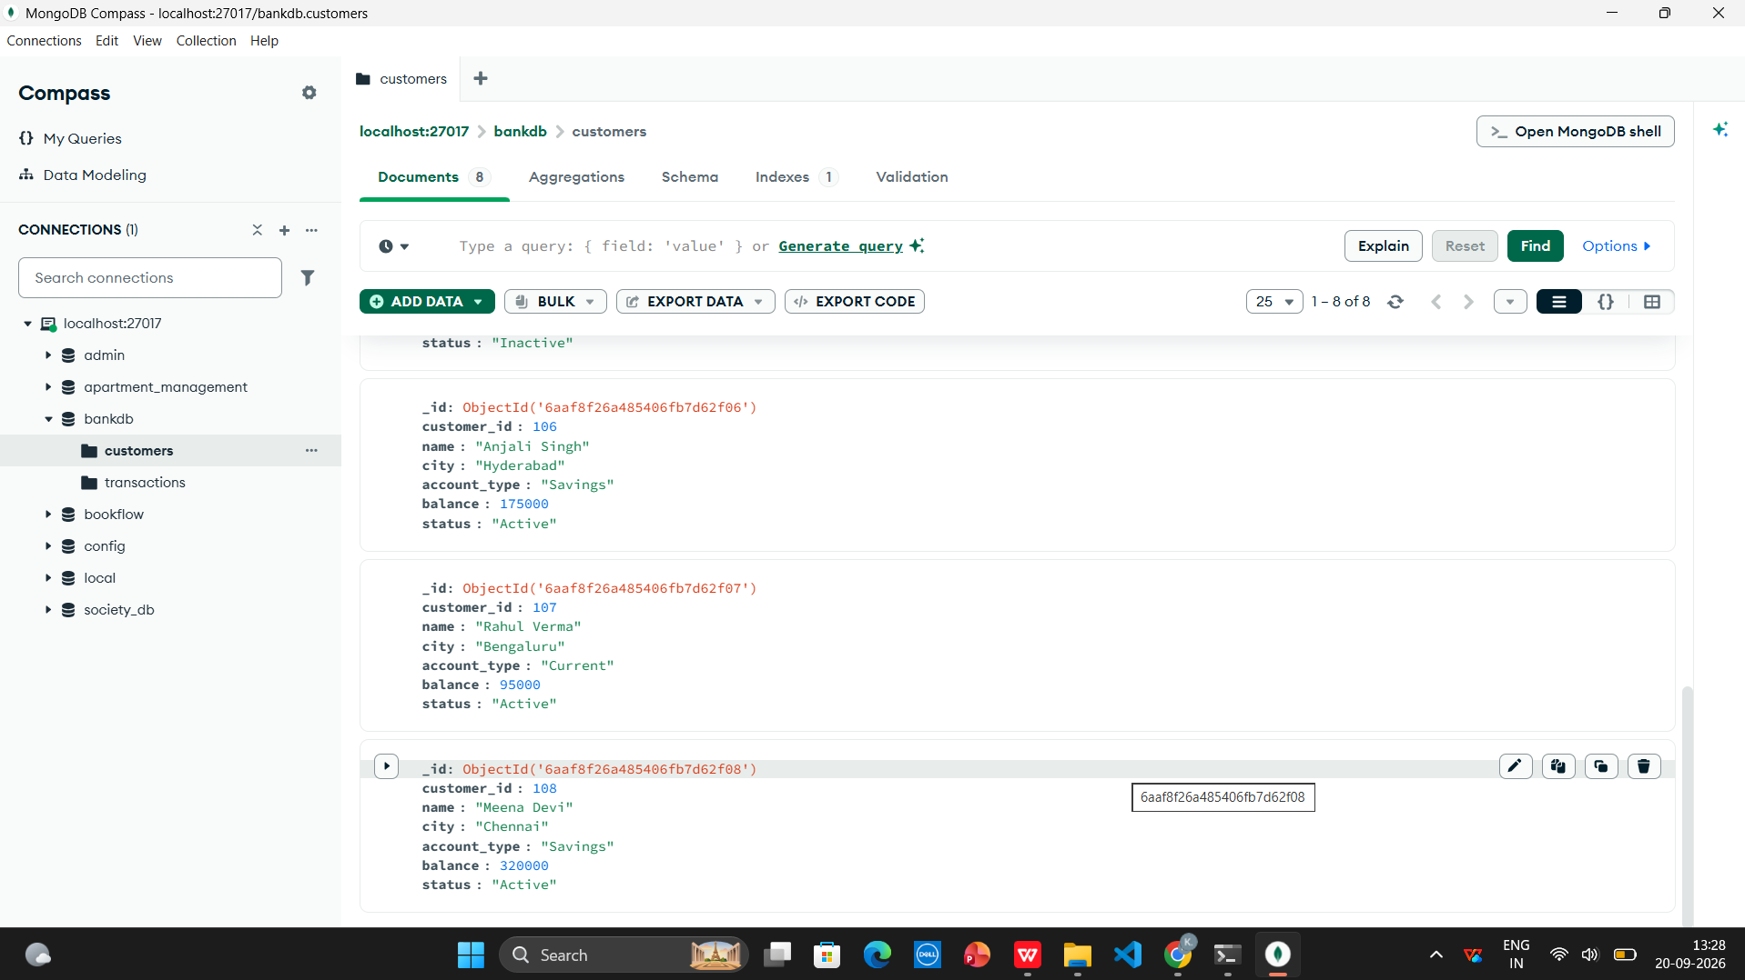

db.customers.aggregate([
{
$match: {
status: "Active",
balance: { $gt: 80000 }
}
},
{
$lookup: {
from: "transactions",
localField: "customer_id",
foreignField: "customer_id",
as: "transactions"
}
},
{ $unwind: "$transactions" },
{
$group: {
_id: "$customer_id",
customer_name: { $first: "$name" },
city: { $first: "$city" },
balance: { $first: "$balance" },
total_transactions: { $sum: "$transactions.amount" },
transaction_count: { $sum: 1 }
}
},
{
$sort: { total_transactions: -1 }
}
]);

