SELECT m.full_name AS Member_Name, b.title AS Book_Title
FROM Loans l
INNER JOIN Members m ON l.member_id = m.member_id
INNER JOIN Books b ON l.book_id = b.book_id;

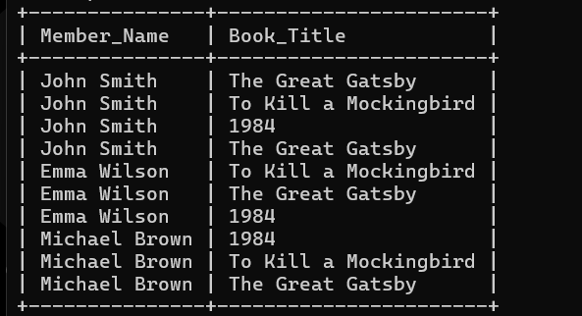SELECT published_year, COUNT(book_id) AS Total_Books
FROM Books
GROUP BY published_year
ORDER BY published_year;

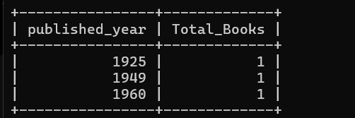

CREATE TABLE Donation_History (
donation_id INT PRIMARY KEY,
book_id INT,
donor_name VARCHAR(100),
donation_date DATE,
FOREIGN KEY (book_id) REFERENCES Books(book_id)
);

START TRANSACTION;

INSERT INTO Books (book_id, title, isbn, published_year)
VALUES (4, 'Animal Farm', '9780451526342', 1945);

INSERT INTO Donation_History (donation_id, book_id, donor_name, donation_date)
VALUES (1, 4, 'Raj Kumar', CURDATE());

COMMIT;

SELECT * FROM Donation_History;
SELECT * FROM Books;
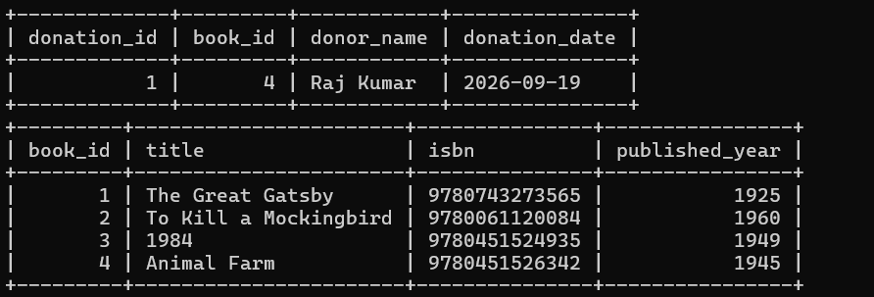

CREATE INDEX idx_books_isbn ON Books(isbn);

SELECT * FROM Books WHERE isbn = '9780451524935';

