### Task 1: Create Database and Tables

**SQL Query:**
```sql
CREATE DATABASE IF NOT EXISTS bookflow_db;
USE bookflow_db;

CREATE TABLE books (
book_id INT AUTO_INCREMENT PRIMARY KEY,
title VARCHAR(255) NOT NULL,
isbn VARCHAR(13) NOT NULL UNIQUE,
published_year INT,
CONSTRAINT chk_published_year CHECK (published_year < 2027)
);

CREATE TABLE members (
member_id INT AUTO_INCREMENT PRIMARY KEY,
full_name VARCHAR(100) NOT NULL,
email VARCHAR(150) NOT NULL UNIQUE
);
```

**Output:**
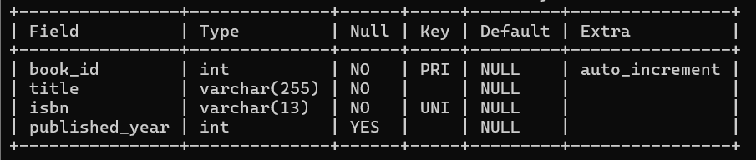

### Task 2
INSERT INTO books (title, isbn, published_year) VALUES
('The Alchemist', '9780061122415', 1988),
('Clean Code', '9780132350884', 2008),
('Atomic Habits', '9780735211292', 2018);

INSERT INTO members (full_name, email) VALUES
('Anil Kumar', 'anil.kumar@example.com'),
('Priya Sharma', 'priya.sharma@example.com'),
('Ravi Verma', 'ravi.verma@example.com');

SELECT * FROM books;
SELECT * FROM members;

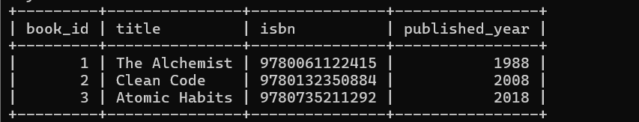
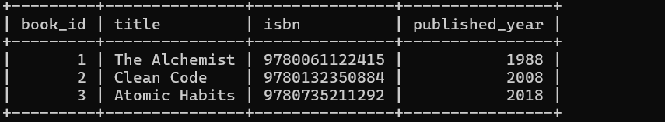

-- Test 1: Duplicate ISBN (Violates UNIQUE constraint)
INSERT INTO books (title, isbn, published_year)
VALUES ('Fake Copy', '9780061122415', 2000);

-- Test 2: NULL Title (Violates NOT NULL constraint)
INSERT INTO books (title, isbn, published_year)
VALUES (NULL, '9999999999999', 2010);

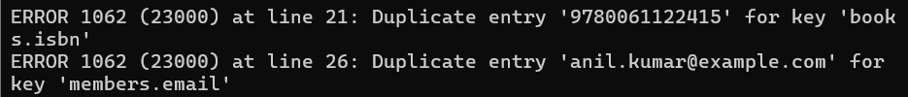

-- Test 3: Future Publication Year (Violates CHECK constraint)
INSERT INTO books (title, isbn, published_year)
VALUES ('Time Traveler', '8888888888888', 2030);

-- Test 4: Duplicate Email (Violates UNIQUE constraint)
INSERT INTO members (full_name, email)
VALUES ('Anil Clone', 'anil.kumar@example.com');

