package com.klu;

import org.springframework.context.annotation.Configuration;
import org.springframework.web.servlet.config.annotation.CorsRegistry;
import org.springframework.web.servlet.config.annotation.WebMvcConfigurer;

@Configuration
public class WebConfig implements WebMvcConfigurer {
@Override
public void addCorsMappings(CorsRegistry registry) {
registry.addMapping("/**")
.allowedOrigins("http://localhost:5173")
.allowedMethods("GET", "POST", "PUT", "DELETE", "OPTIONS");
}
}

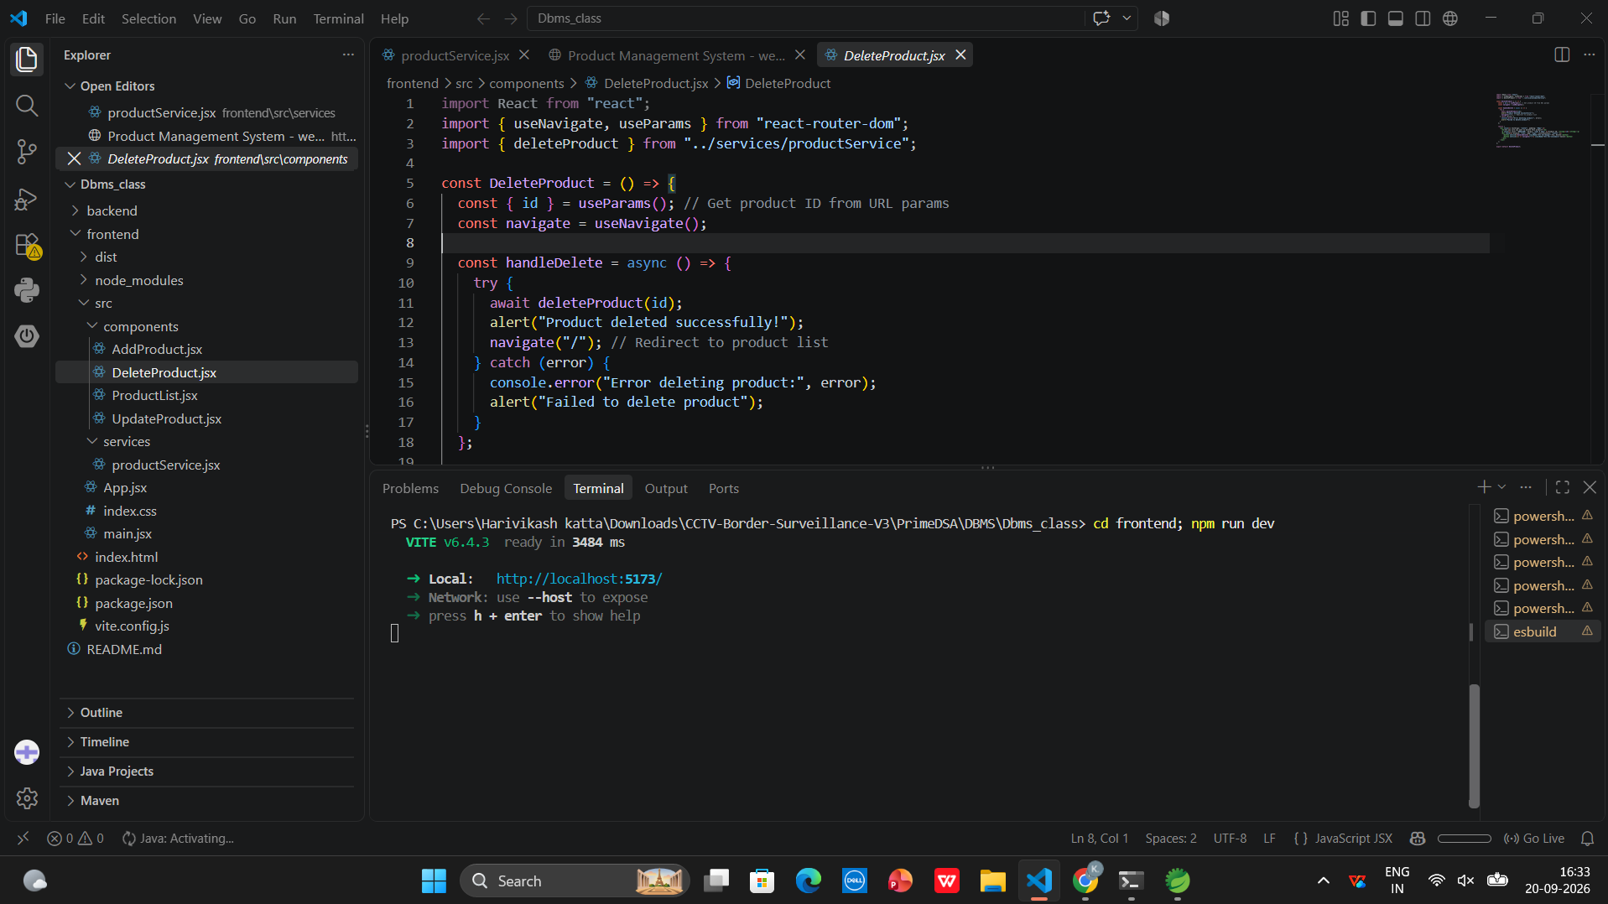
package com.klu.entity;

import jakarta.persistence.*;

@Entity
@Table(name = "products")
public class Product {
@Id
@GeneratedValue(strategy = GenerationType.IDENTITY)
private Long id;
private String name;
private String description;
private double price;
private int quantity;

public Product() {}

public Long getId() { return id; }
public void setId(Long id) { this.id = id; }
public String getName() { return name; }
public void setName(String name) { this.name = name; }
public String getDescription() { return description; }
public void setDescription(String description) { this.description = description; }
public double getPrice() { return price; }
public void setPrice(double price) { this.price = price; }
public int getQuantity() { return quantity; }
public void setQuantity(int quantity) { this.quantity = quantity; }
}

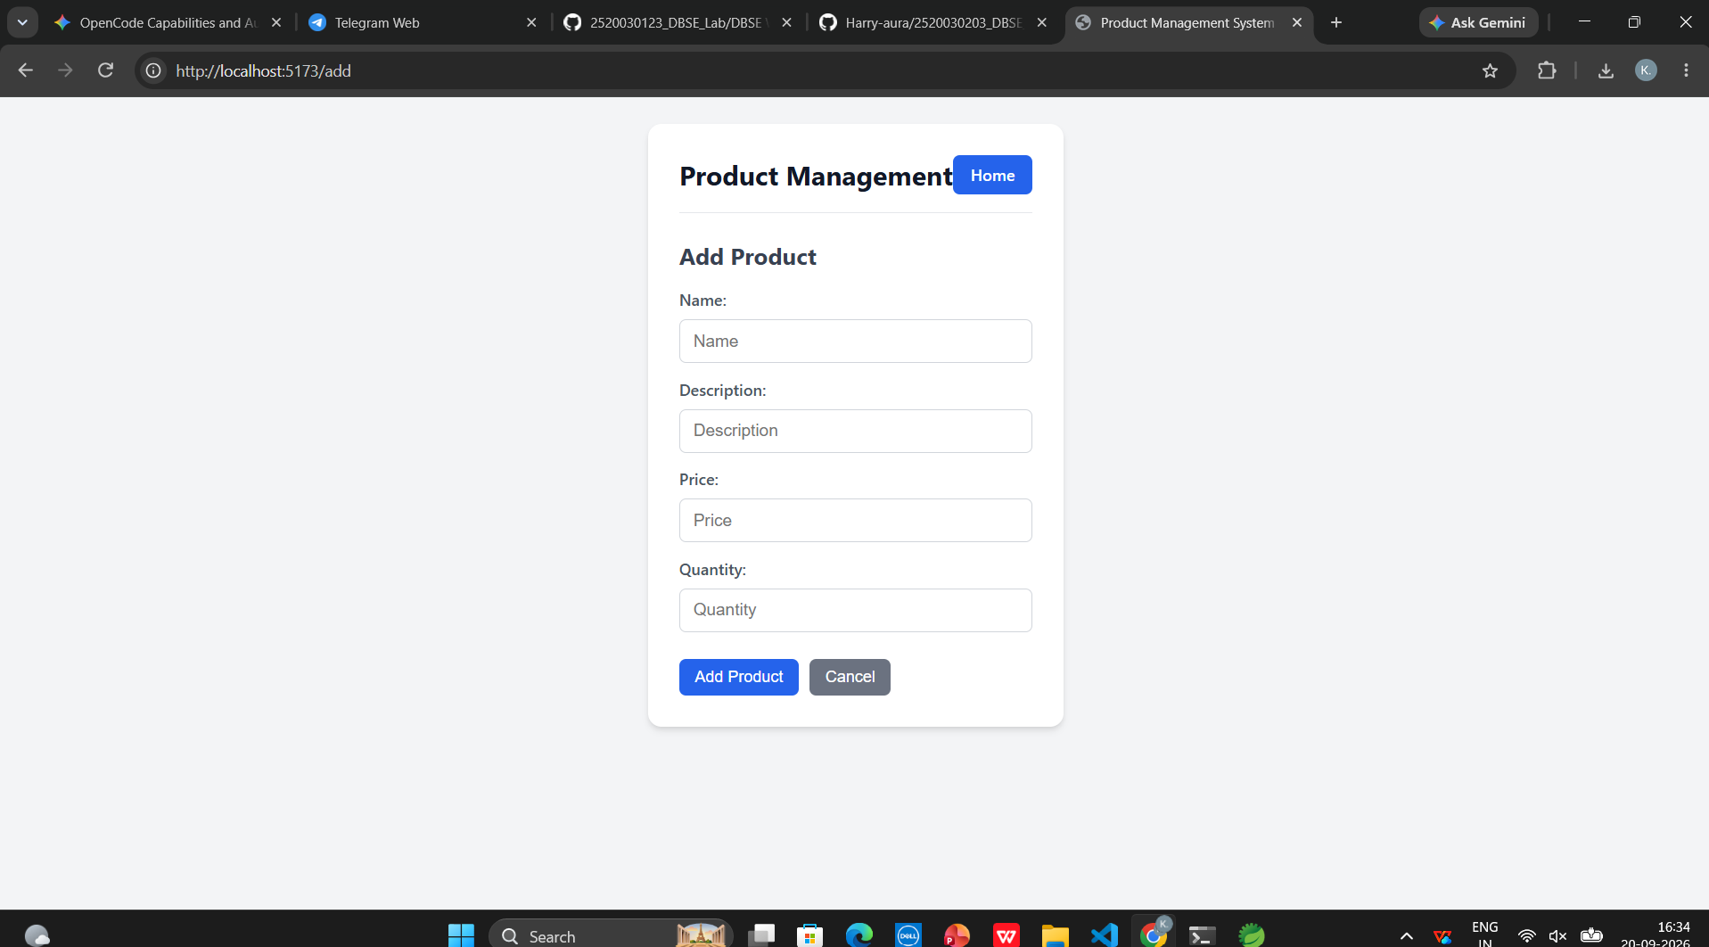
package com.klu.repository;

import org.springframework.data.jpa.repository.JpaRepository;
import org.springframework.stereotype.Repository;
import com.klu.entity.Product;

@Repository
public interface ProductRepository extends JpaRepository<Product, Long> {
}

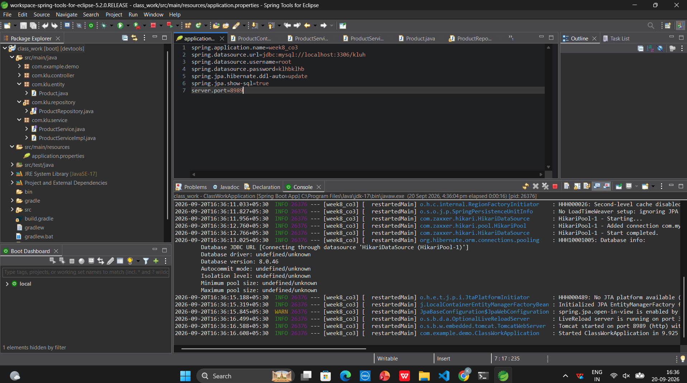

package com.klu.service;

import java.util.List;
import org.springframework.beans.factory.annotation.Autowired;
import org.springframework.stereotype.Service;
import com.klu.entity.Product;
import com.klu.repository.ProductRepository;

@Service
public class ProductServiceImpl implements ProductService {
@Autowired
private ProductRepository productRepository;

@Override
public Product saveProduct(Product product) {
return productRepository.save(product);
}

@Override
public List<Product> getAllProducts() {
return productRepository.findAll();
}

@Override
public void deleteProduct(Long id) {
productRepository.deleteById(id);
}
}

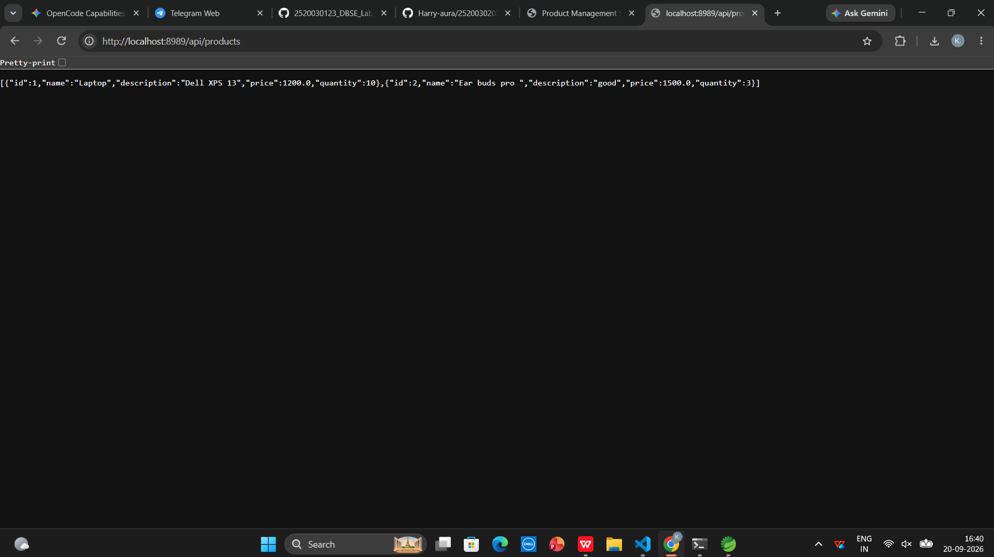

package com.klu.service;

import java.util.List;
import com.klu.entity.Product;

public interface ProductService {
Product saveProduct(Product product);
List<Product> getAllProducts();
void deleteProduct(Long id);
}

#task

import React from 'react';
import { useNavigate, useParams } from 'react-router-dom';
import { deleteProduct } from '../services/productService';

const DeleteProduct = () => {
const { id } = useParams();
const navigate = useNavigate();

const handleDelete = async () => {
try {
await deleteProduct(id);
alert('Product deleted successfully!');
navigate('/');
} catch (error) {
console.error('Error deleting product:', error);
alert('Failed to delete product');
}
};

return (
<div>
<h3>Are you sure you want to delete this product?</h3>
<button onClick={handleDelete}>Confirm Delete</button>
</div>
);
};

export default DeleteProduct;

