
Department of CSE

B.Tech. CSE Trimester -5

Roll Number: 2520030203
Name: Harivikash Katta
Section: 3

Cloud Infrastructure and Services
25CS2206E

LAB RECORD
2026

Experiment -2

AIM: To create an IAM user with console access and access keys, and to set up a zero-spend budget for cost control in AWS.

Description:
AWS Identity and Access Management (IAM) is a global AWS service used to securely control who can sign in (authentication) and what they are allowed to do (authorization) in an AWS account. The account owner signs in as the root user, which has unrestricted access, so it is a best practice not to use it for daily work. Instead, IAM users are created with only the permissions they need. Permissions are given through policies; for example, the AWS managed policy AdministratorAccess allows full access to all services.
An IAM user can be given console access (user name and password used on the account-specific sign-in URL) and programmatic access (an access key ID and secret access key used by the AWS CLI, SDKs or APIs). Access keys are long-term credentials, so they must never be stored in code or shared, and should be deleted when no longer needed. Enabling multi-factor authentication (MFA) adds a second layer of security.
AWS Budgets, part of Billing and Cost Management, lets users track spending and receive alerts. The Zero-spend budget template sends a notification as soon as the account spends more than $0.01, which helps to avoid unexpected charges while using the Free Tier.
In this experiment an IAM user named Student is created with AdministratorAccess, console access is enabled and the user signs in, an access key is generated, and a Zero-Spend Budget is created.
Steps:
1. Sign in to the AWS Management Console as the root user and type "IAM" in the search bar. Select IAM from the Services results (Fig 1).
2. In the IAM left navigation pane, click Users under Access management. The IAM users list is empty at this stage (Fig 2).
3. Click "Create user". In Specify user details, enter the user name "Student" and click Next (Fig 3).
4. In Set permissions, choose "Attach policies directly", search the permissions policies and select AdministratorAccess. Click Next (Fig 4).
5. Review the user details and the permissions summary, then click "Create user" (Fig 5).
6. A message "User created successfully" appears and the user Student is listed under IAM users (Fig 6).
7. Click the user Student to open its summary. The ARN, creation time and attached permissions policy are displayed (Fig 7).
8. Open the Security credentials tab to view the console sign-in link, console password status and the MFA section (Fig 8).
9. Click "Enable console access", choose "Autogenerated password" and click "Enable console access" (Fig 9).
10. Note the console sign-in URL, user name and console password shown in the dialog (the password is shown only once) and click Close; the .csv file can be downloaded for safe keeping (Fig 10).
11. Open the console sign-in URL in the browser. On the IAM user sign-in page enter the account ID, IAM user name and password, then click Sign in (Fig 11).
12. The console opens with the IAM user Student signed in, and the account's Free plan status is visible (Fig 12).
13. To create an access key, go to Security credentials > Access keys > Create access key and choose the use case "Command Line Interface (CLI)" (Fig 13).
14. Click Create access key to generate the Access key ID and Secret access key. Download the .csv file and click Done, since the secret key cannot be viewed again (Fig 14).
15. The Student summary now shows console access enabled and Access key 1 as Active (Fig 15).
16. Open the IAM Dashboard to verify IAM resources (1 user) and review the security recommendations, such as adding MFA for the root user (Fig 16).
17. Open Billing and Cost Management > Budgets and click "Create budget". Under Budget setup choose "Use a template (simplified)", select the "Zero spend budget" template and enter the budget name "My Zero-Spend Budget" (Fig 17).
18. Enter the email address to receive alerts and click Create budget. The message "Your budget My Zero-Spend Budget has been created successfully" is shown and the budget appears as Healthy with a $1.00 budget (Fig 18).
19. Finally, return to the Security credentials page of the user Student to verify the credentials; no active access key remains (Access keys (0)) and the MFA can be assigned for extra security (Fig 19).
Output:
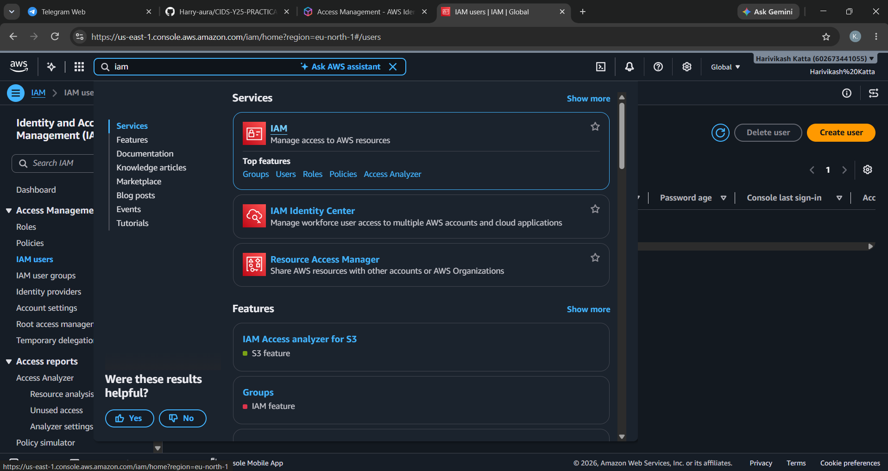
Fig 1: Searching for IAM in the AWS Console search bar
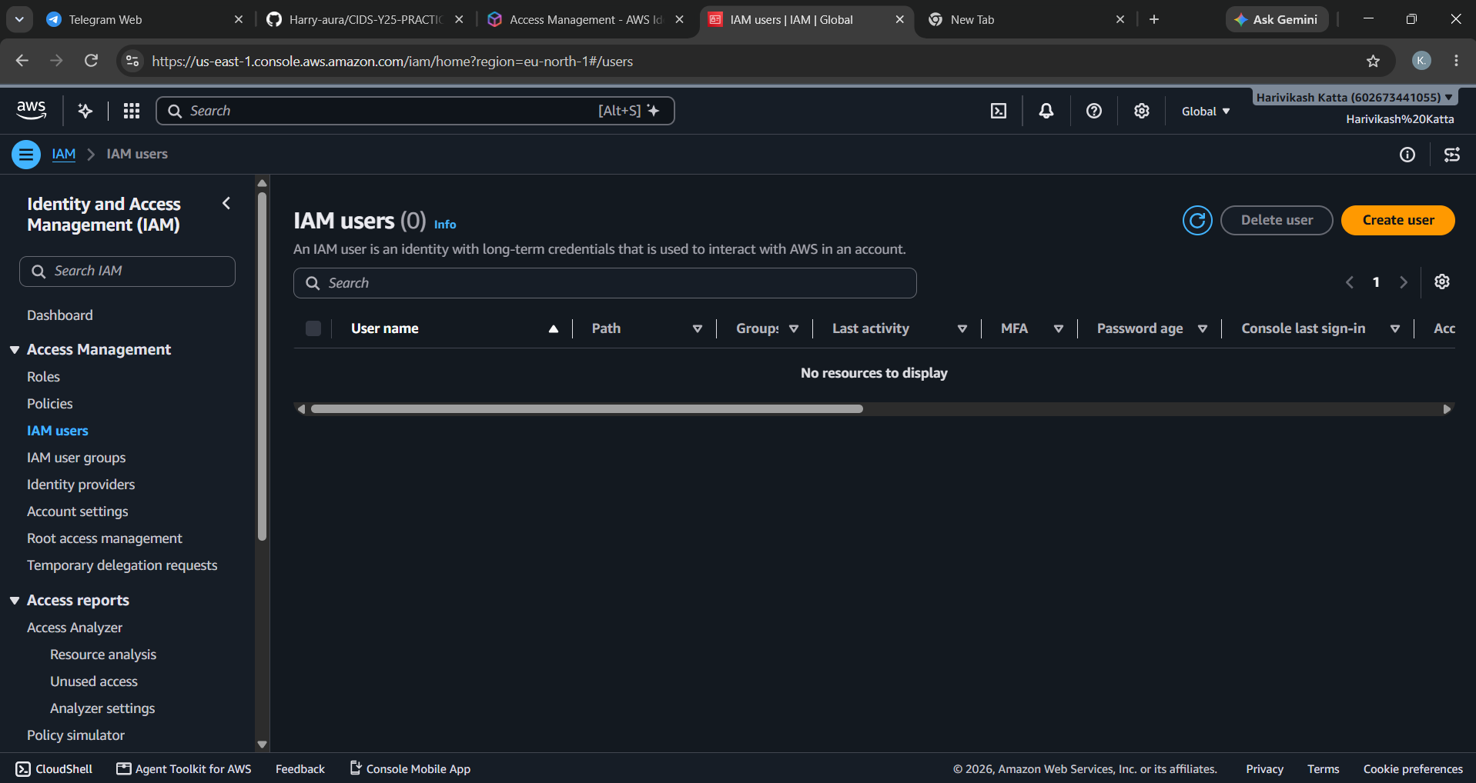
Fig 2: IAM users page showing no users
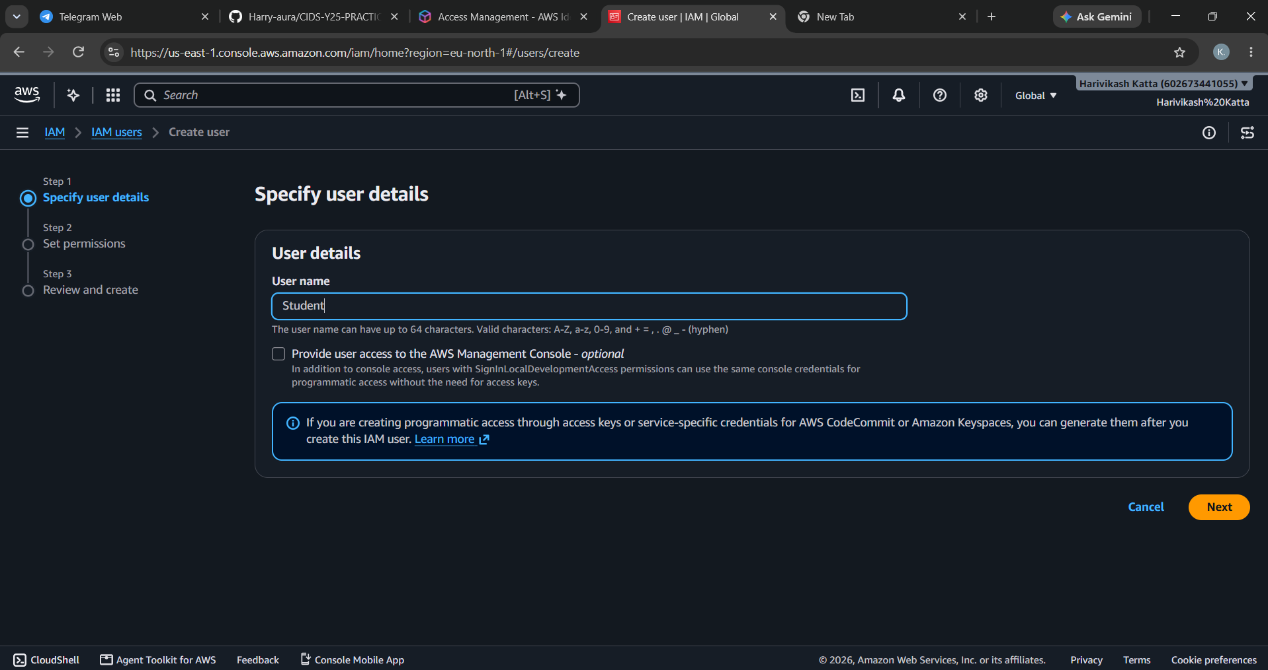
Fig 3: Create user - specifying the user name "Student"
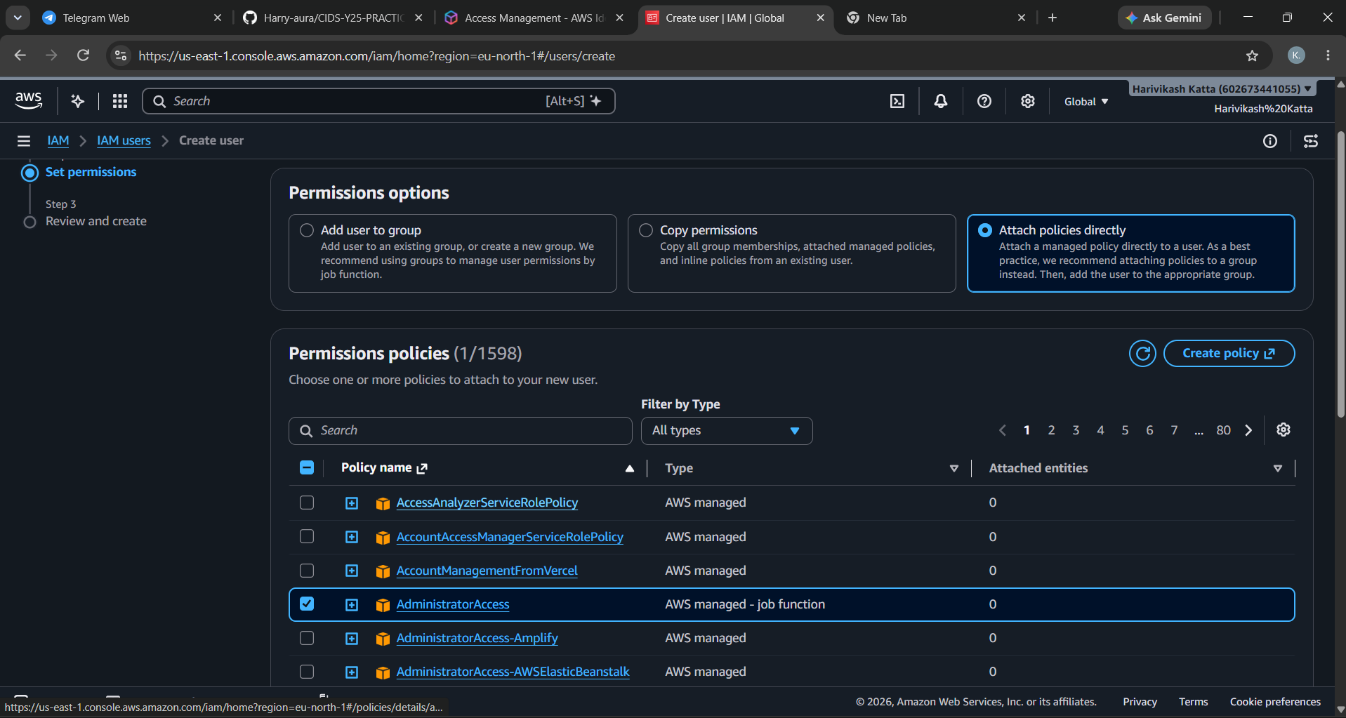
Fig 4: Set permissions - attaching AdministratorAccess policy directly
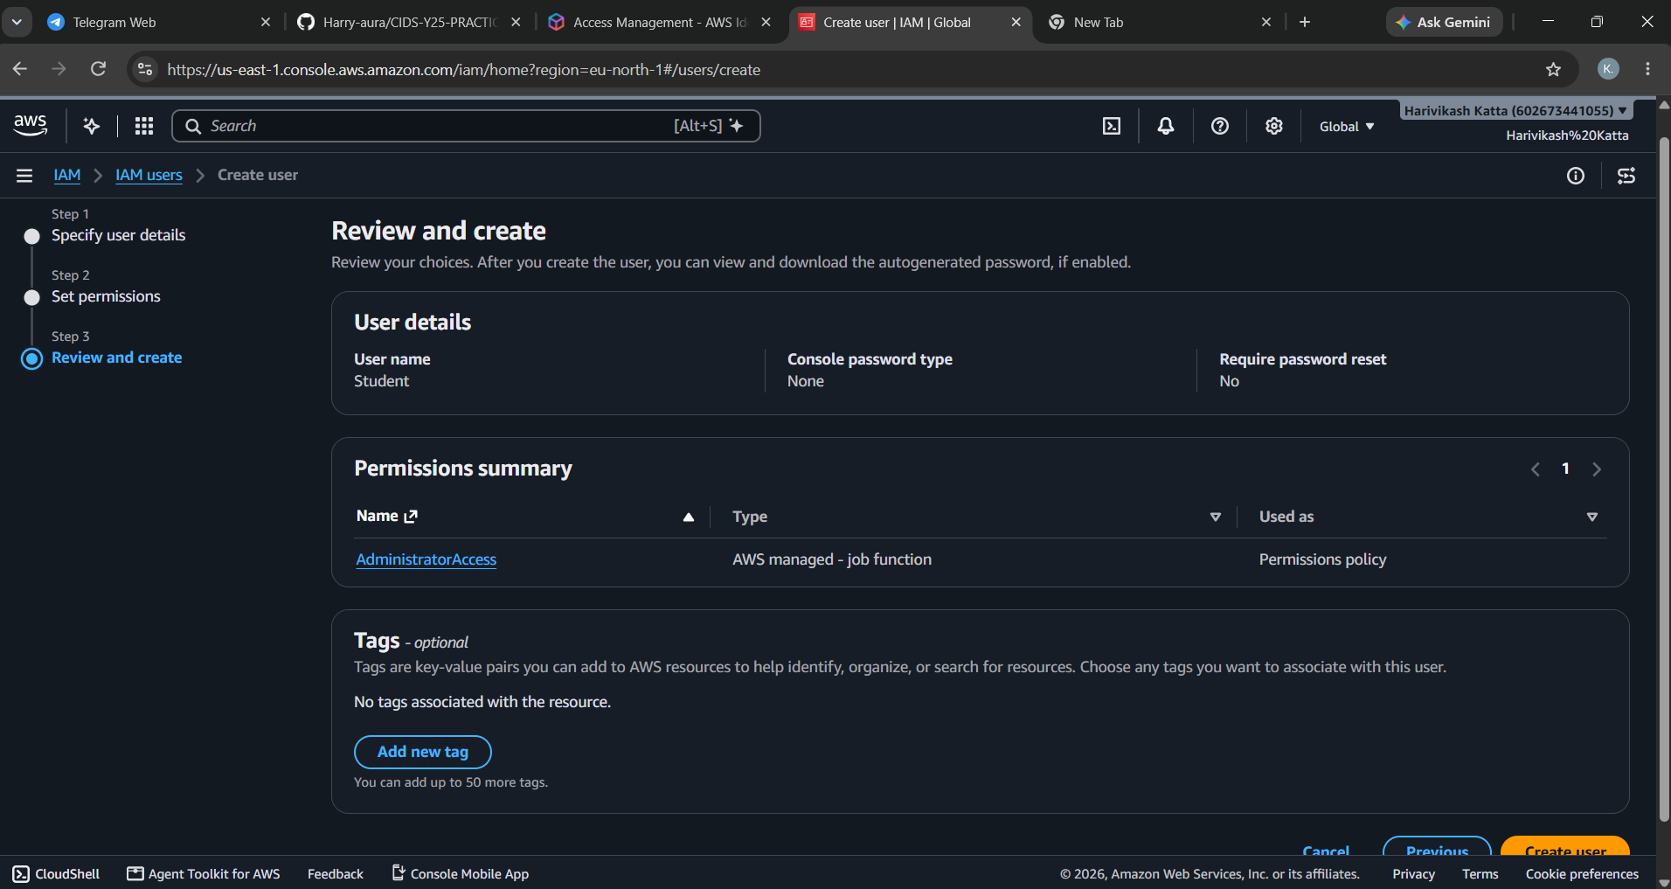
Fig 5: Review and create page for the new user
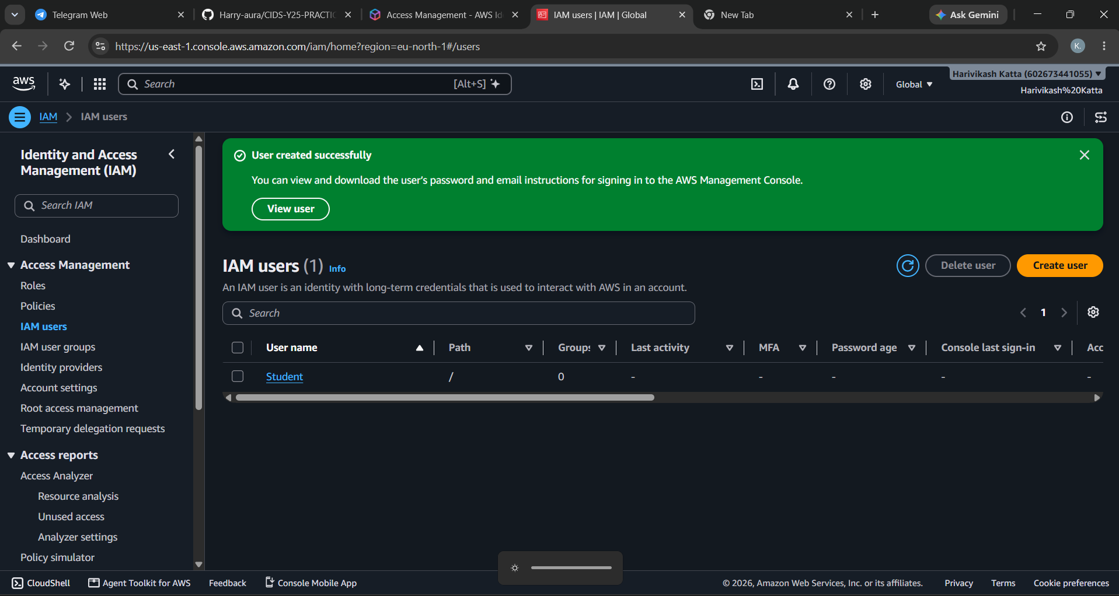
Fig 6: User created successfully and listed in IAM users
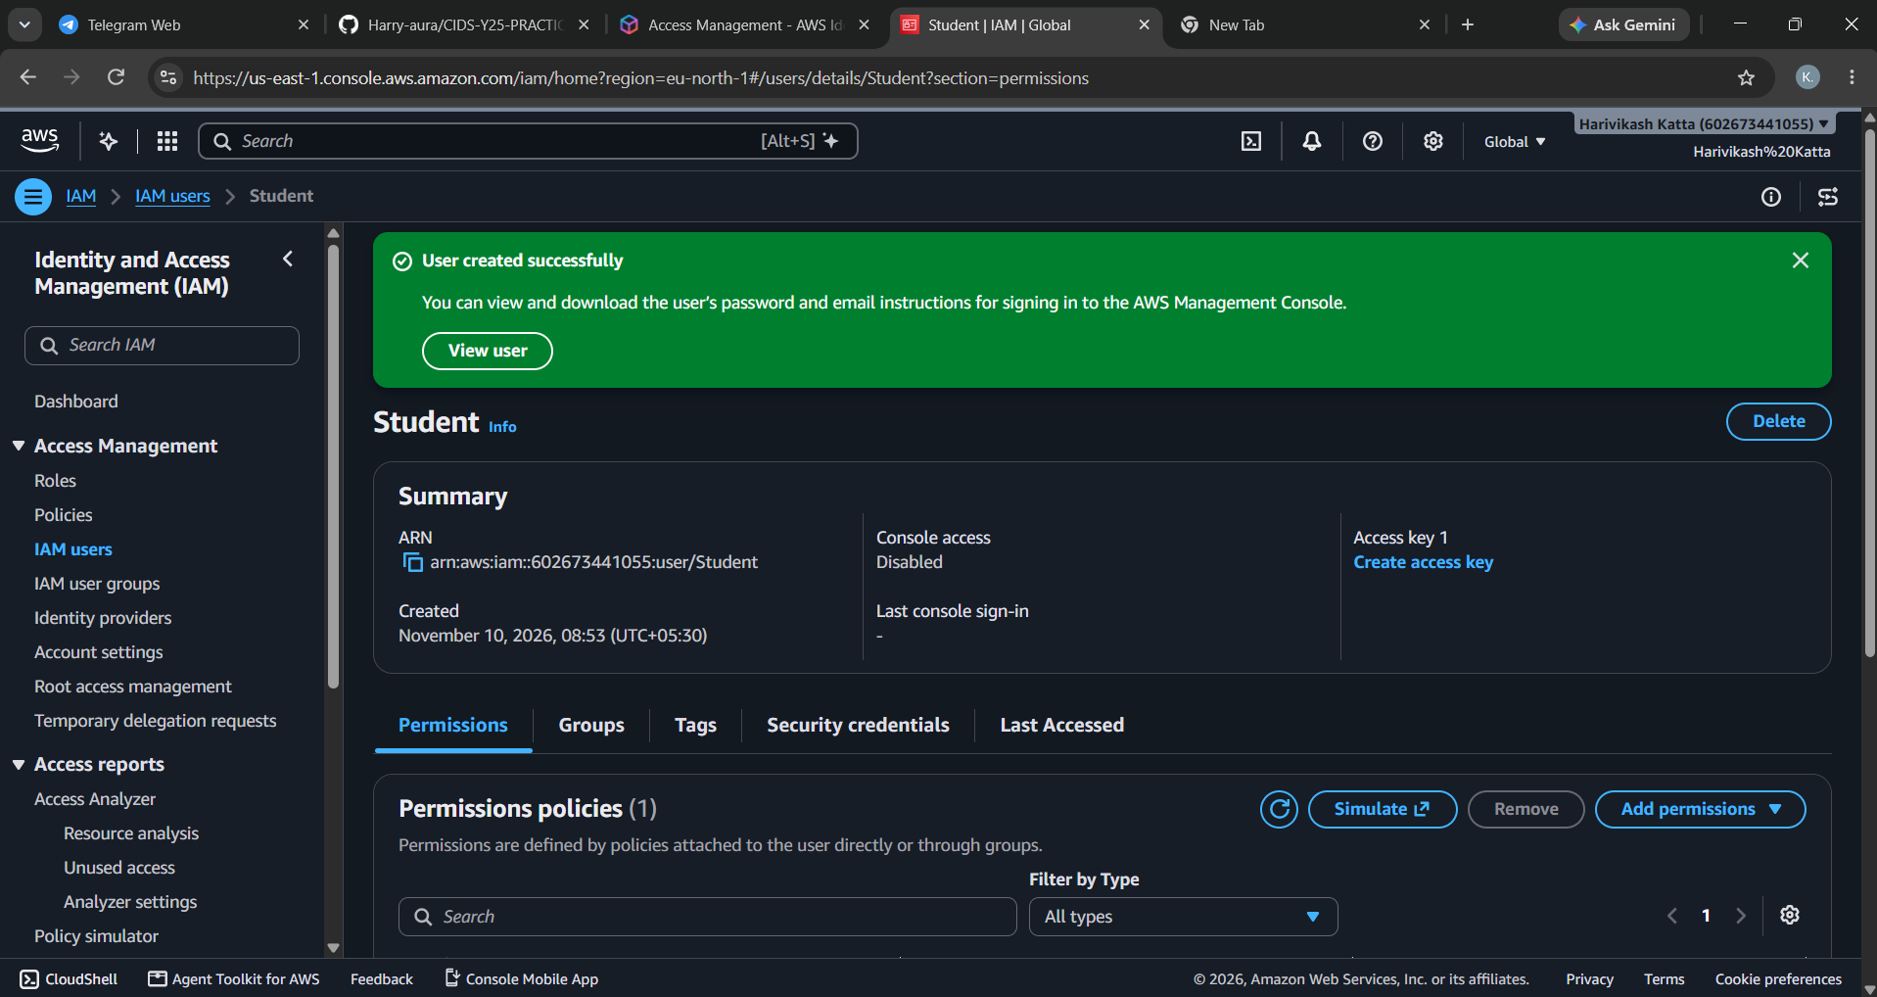
Fig 7: Student user summary showing ARN and permissions policy
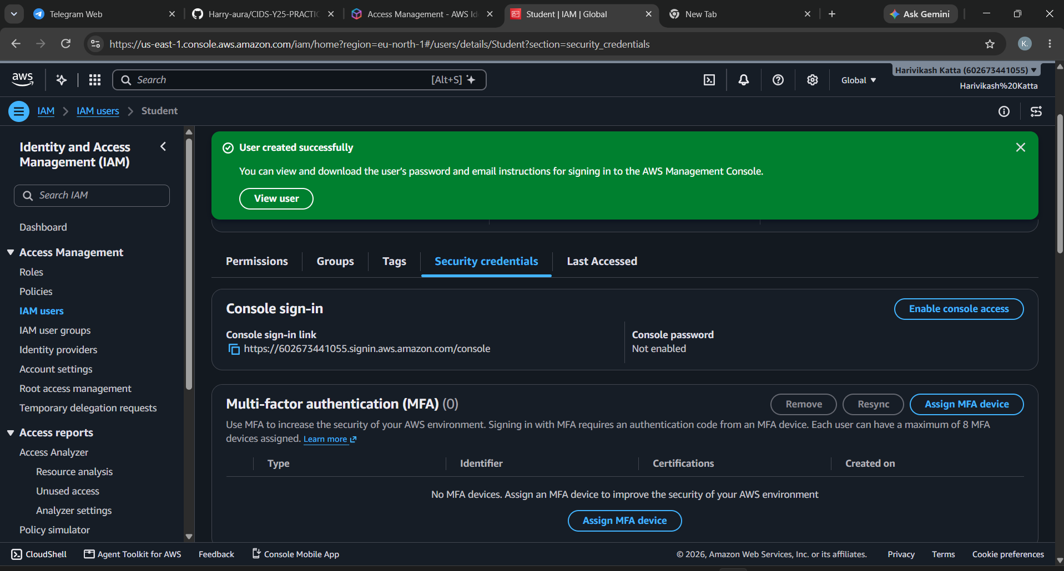
Fig 8: Security credentials tab showing console sign-in link and MFA section
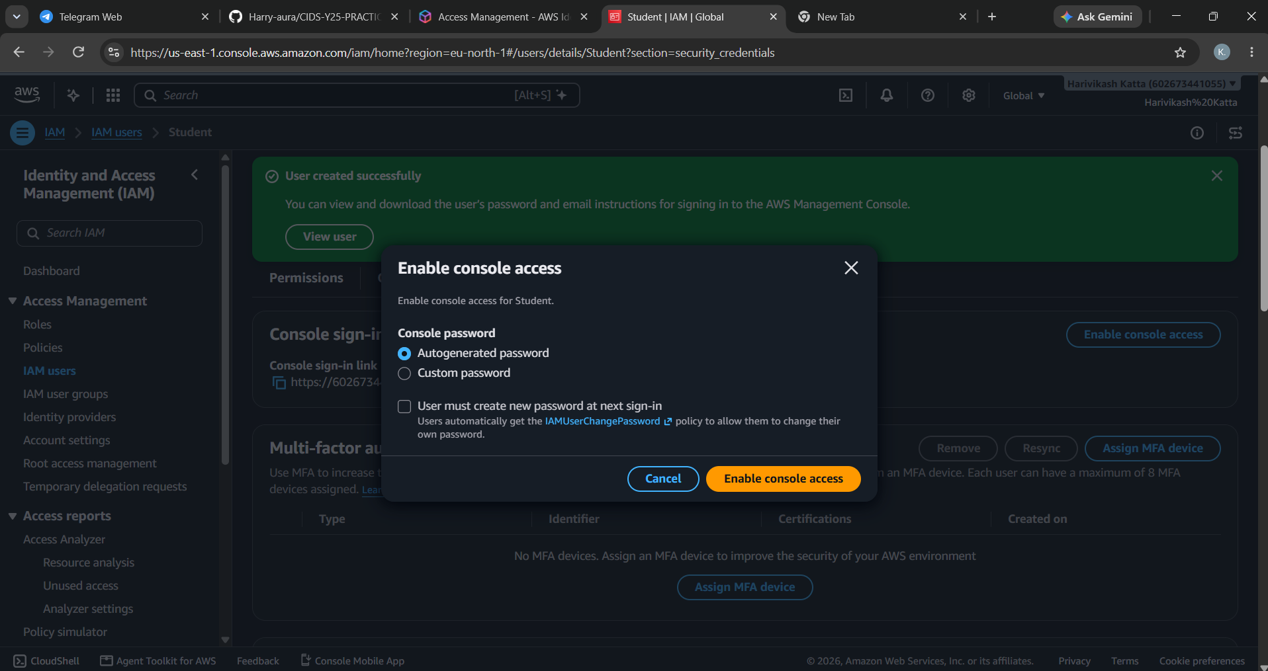
Fig 9: Enable console access with an autogenerated password
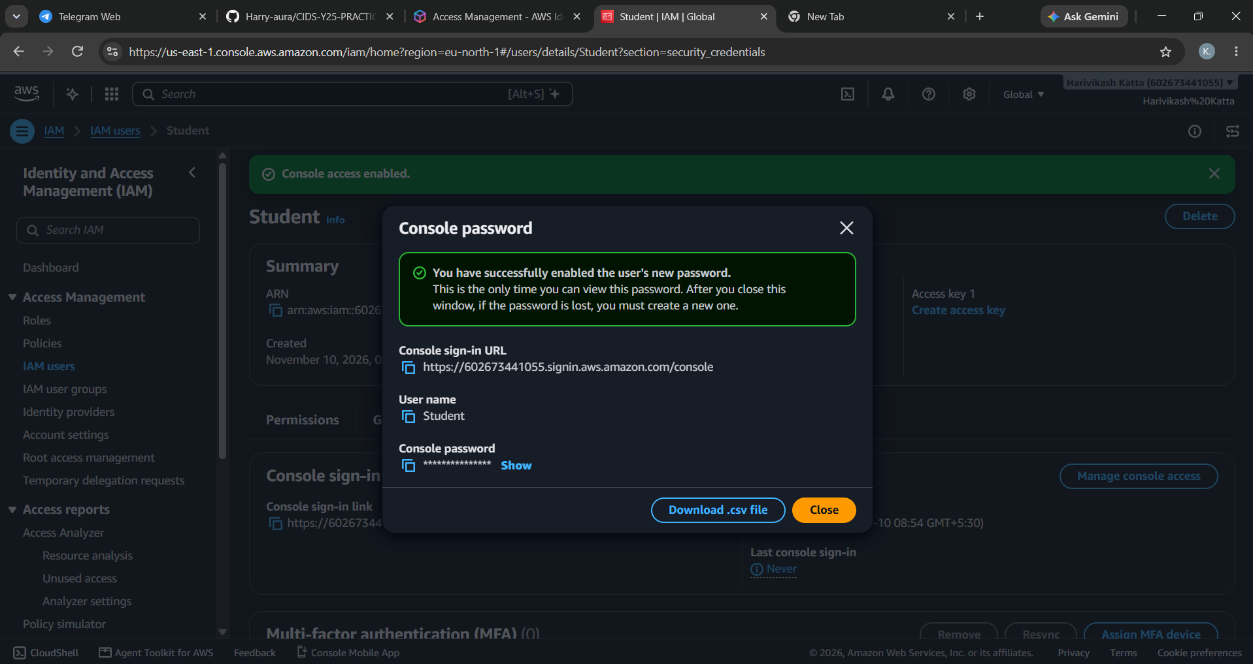
Fig 10: Console password dialog with sign-in URL, user name and password
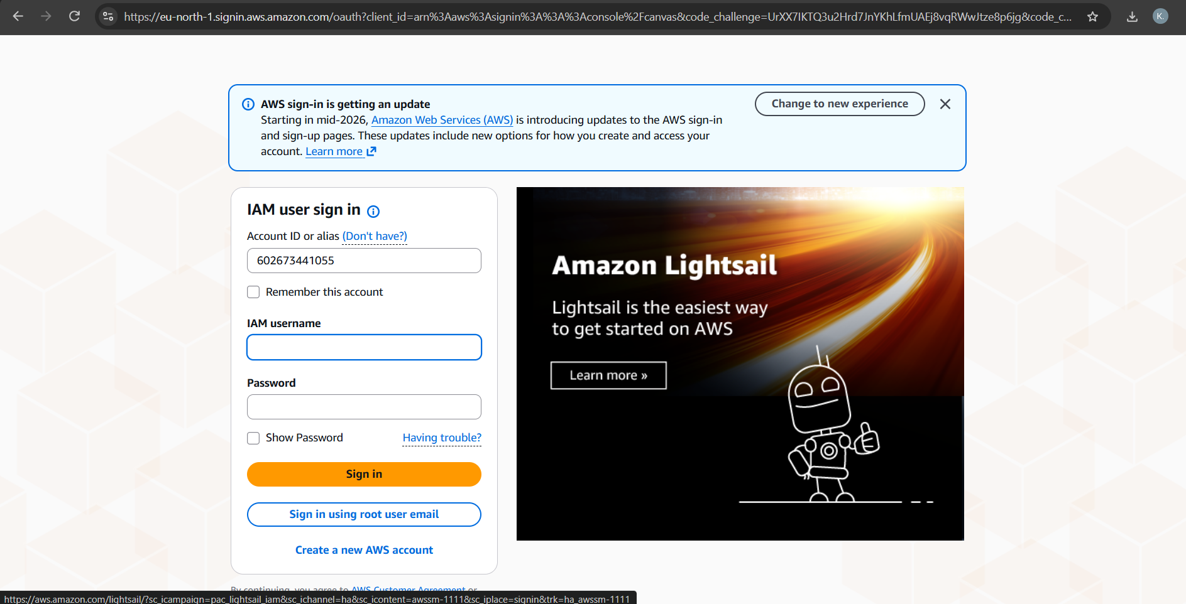
Fig 11: IAM user sign-in page using the account ID and user name
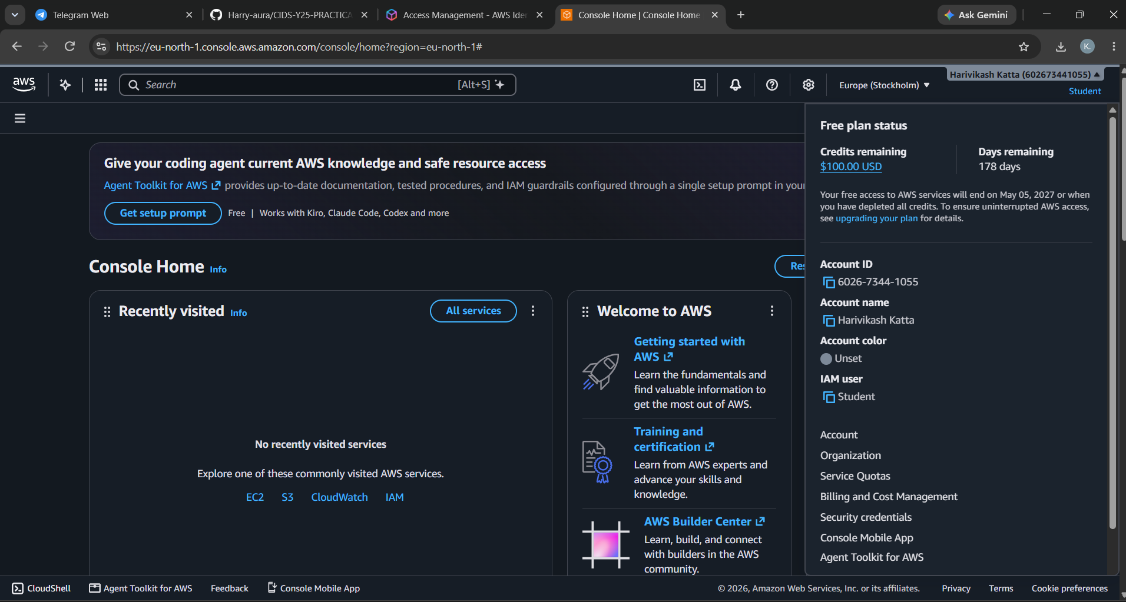
Fig 12: Signed in to the console as IAM user Student
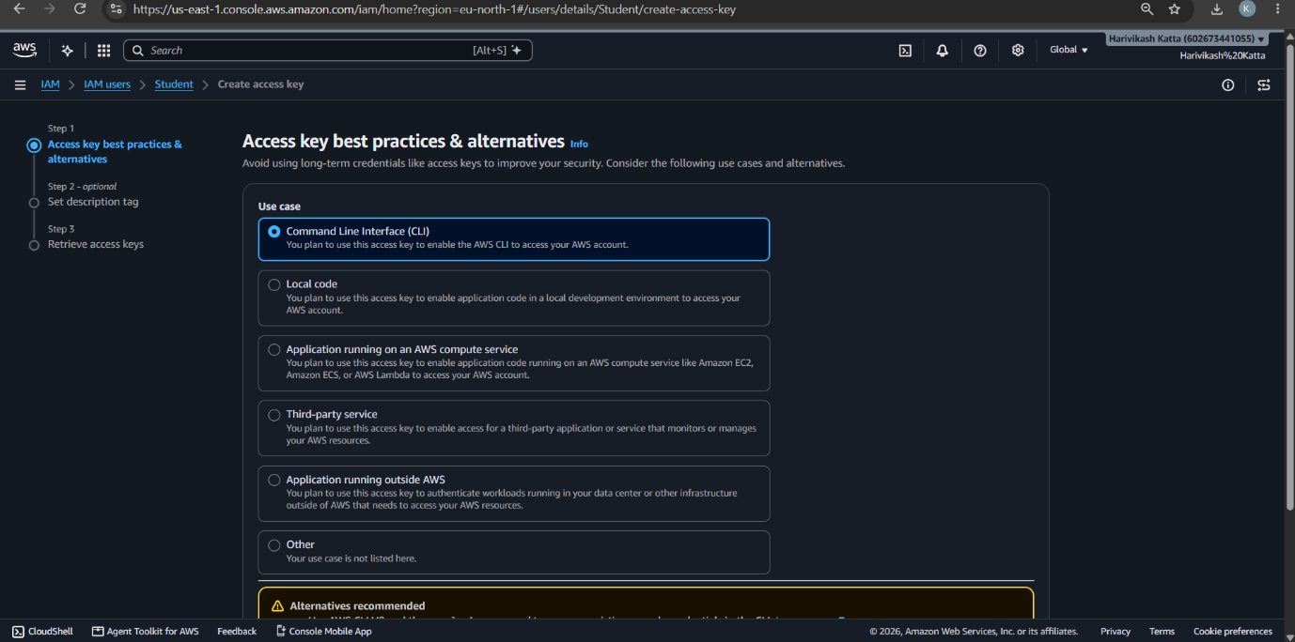
Fig 13: Create access key - selecting Command Line Interface (CLI) use case
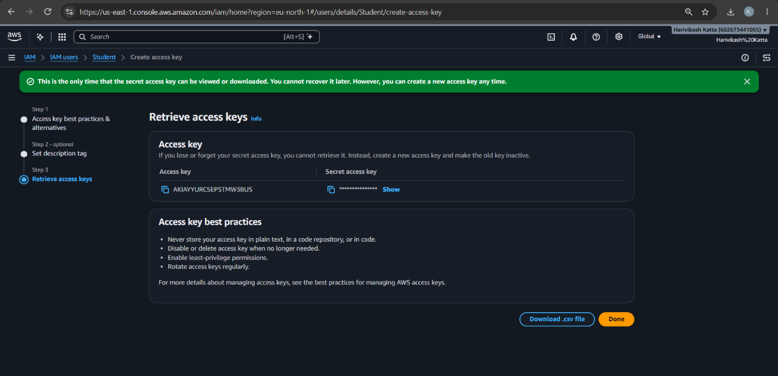
Fig 14: Retrieve access keys page
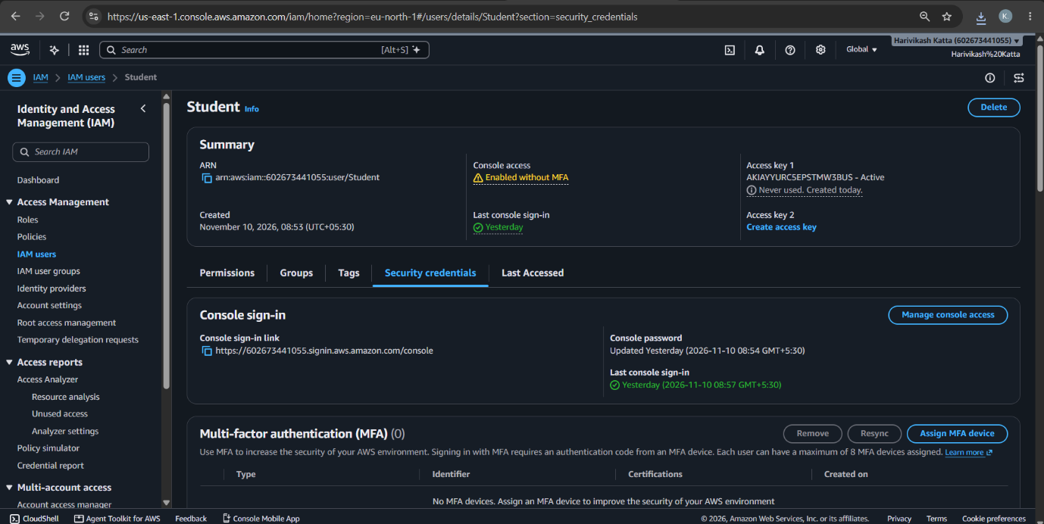
Fig 15: Student summary showing console access enabled and Access key 1 active
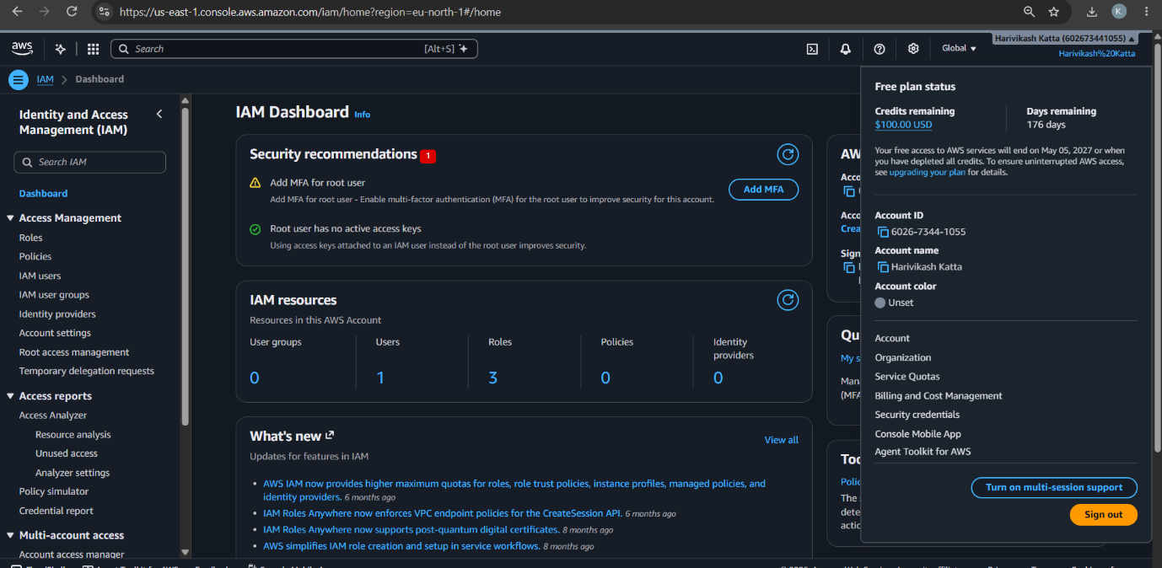
Fig 16: IAM Dashboard showing 1 user and security recommendations
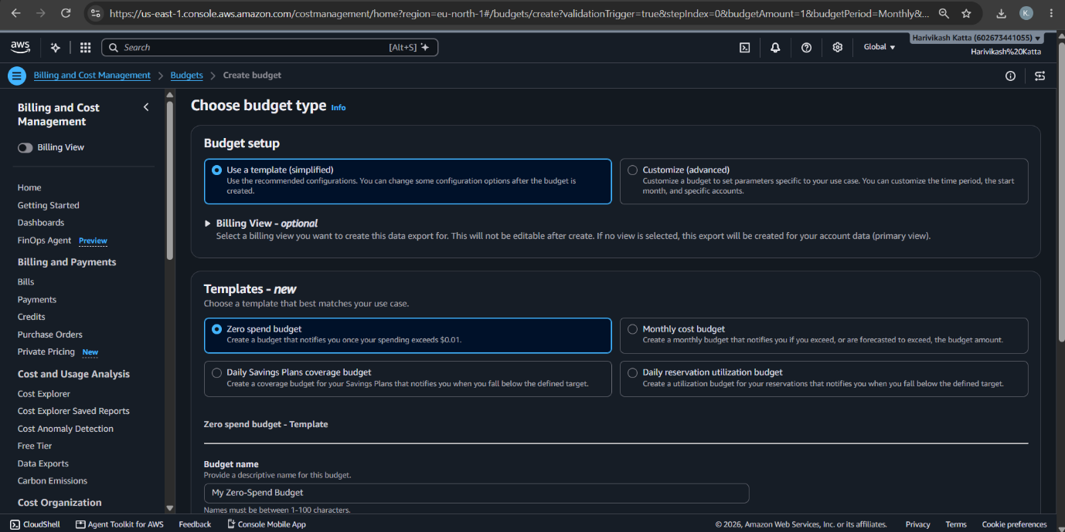
Fig 17: Billing and Cost Management - creating a Zero spend budget from template
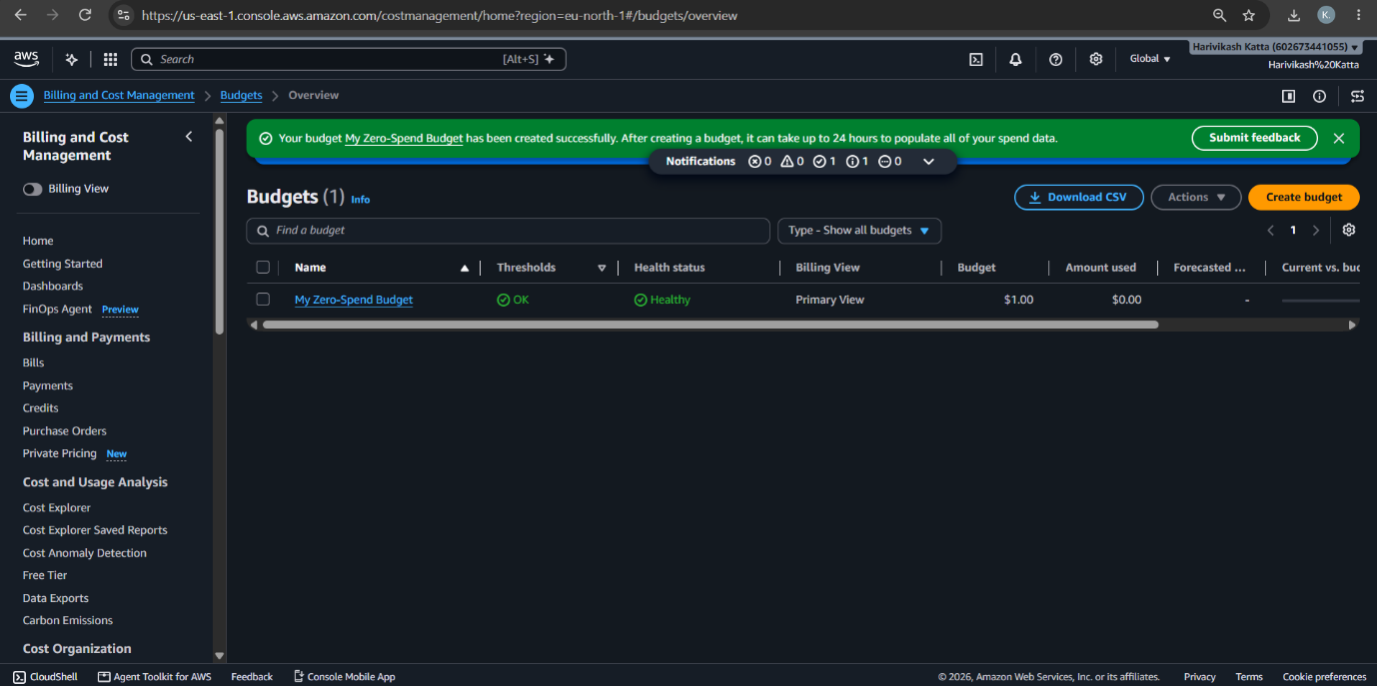
Fig 18: My Zero-Spend Budget created successfully
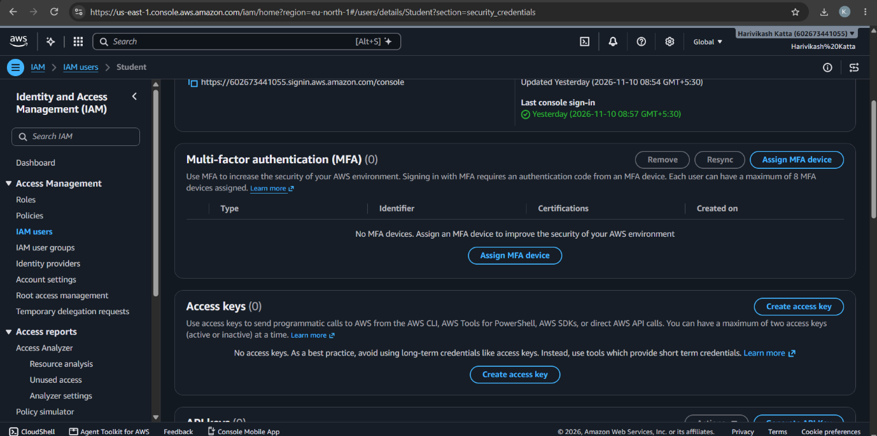
Fig 19: Student security credentials page showing Access keys (0)
GitHub:
1. Project: https://github.com/karkalashivareddy/CDIS-KLH-Y25-Project
2. Practical Skill: https://github.com/Harry-aura/CIDS-Y25-PRACTICAL-SKILL

