
Department of CSE

B.Tech. CSE Trimester -5

Roll Number: 2520030203
Name: Harivikash Katta
Section: 3

Cloud Infrastructure and Services
25CS2206E

LAB RECORD
2026

Experiment -1

AIM: To create an AWS free tier account to provision the resources.

Description:
Amazon Web Services (AWS) is a cloud computing platform from Amazon that provides on-demand compute, storage, database, networking and security services over the internet on a pay-as-you-go basis. Instead of buying and maintaining physical servers, users can provision resources such as virtual machines (EC2), object storage (S3) and managed databases within minutes.
The AWS Free Tier lets new users explore and test these services at no cost within defined usage limits (for example, limited EC2 instance hours, S3 storage and database usage per month for a limited period). An AWS account is the basic container for all resources and billing. It is created with a root user (email and password) and is secured with multi-factor authentication (MFA) and IAM users.
This experiment covers creating an AWS Free Tier account, verifying identity, signing in to the AWS Management Console and selecting a Region (Europe - Stockholm, eu-north-1) so that cloud resources can be provisioned in later experiments.
Steps:
1. Open a web browser and go to https://aws.amazon.com, then click "Create an AWS Account".
2. Enter the root user email address and an AWS account name, then click "Verify email address" and enter the verification code sent to the email.
3. Create a strong root user password and confirm it.
4. Choose the account type (Personal) and fill in the contact details: full name, phone number, country and address.
5. Enter the payment information (credit/debit card). A small temporary amount may be charged only to verify the card; the Free Tier itself is not charged within limits.
6. Complete identity verification by entering the phone number and the OTP received through SMS or voice call.
7. Select the "Basic support - Free" plan and click "Complete sign up".
8. Wait for the account activation email, then sign in to the AWS Management Console as the Root user with the email and password.
9. Select the required Region (Europe - Stockholm, eu-north-1) from the Region selector at the top right of the console. An opt-in Region such as Asia Pacific (Hyderabad) can also be enabled from the account settings; it takes a few minutes to configure.
10. The Console Home page opens, showing widgets like Recently visited, Welcome to AWS and AWS Health. The account is now ready to provision resources such as EC2, S3, CloudWatch and IAM.
Output:
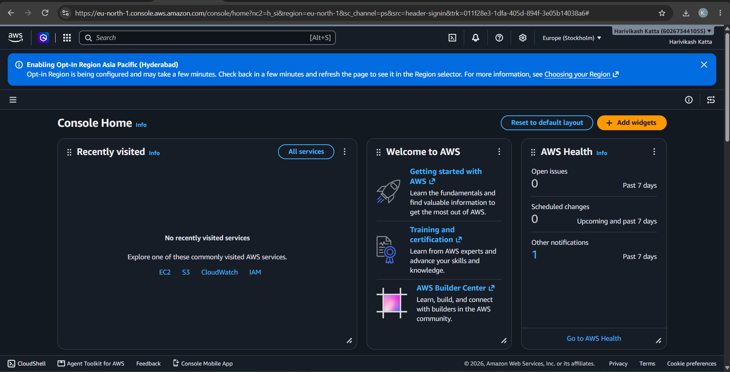
Fig 1: AWS Management Console Home after account creation
GitHub:
1. Project: https://github.com/karkalashivareddy/CDIS-KLH-Y25-Project
2. Practical Skill: https://github.com/Harry-aura/CIDS-Y25-PRACTICAL-SKILL

