
Department of CSE

B.Tech. CSE Trimester -5

Roll Number: 2520030203
Name: Harivikash Katta
Section: 3

Cloud Infrastructure and Services
25CS2206E

LAB RECORD
2026

Experiment -3

AIM: To enable multi-factor authentication (MFA) for the AWS root user using a passkey / security key.

Description:
Multi-factor authentication (MFA) is a security feature that asks for a second proof of identity in addition to the user name and password when signing in. Even if a password is stolen, an attacker cannot sign in without the second factor, which is something the user has (a device) or is (a fingerprint or face).
The AWS root user has complete, unrestricted access to every resource and to billing in the account, so protecting it is the most important security step. AWS strongly recommends assigning an MFA device to the root user. The supported MFA types are: Passkey or security key (FIDO2, using fingerprint, face, screen lock or a hardware key and the most phishing-resistant option), Authenticator app (time-based one-time codes generated in an app on a mobile device) and Hardware TOTP token. Up to 8 MFA devices can be registered for one user.
In this experiment MFA is enabled for the root user of the account by registering a passkey as the MFA device from the My security credentials page of IAM.
Steps:
1. Sign in to the AWS Management Console as the root user. Click the account name (top right corner) and select "Security credentials" from the menu (Fig 1).
2. The "My security credentials" page opens with the message "You don't have MFA assigned". Under Multi-factor authentication (MFA) there are no devices (0). Click "Assign MFA device" (Fig 2).
3. In Select MFA device, enter a name in the Device name box and, under MFA device, choose "Passkey or security key" (Fig 3).
4. Review the other available options (Authenticator app and Hardware TOTP token). Keep the passkey display name (default is the account ID with "root"), then click Next (Fig 4).
5. Follow the browser/operating system prompt to create the passkey using the fingerprint, face or screen lock of the device. After this the message "Passkey MFA device assigned" is displayed and the Multi-factor authentication (MFA) count changes to 1 with the type "Passkeys and security keys" (Fig 5).
6. From now on, signing in as the root user asks for the registered passkey in addition to the password.
Output:
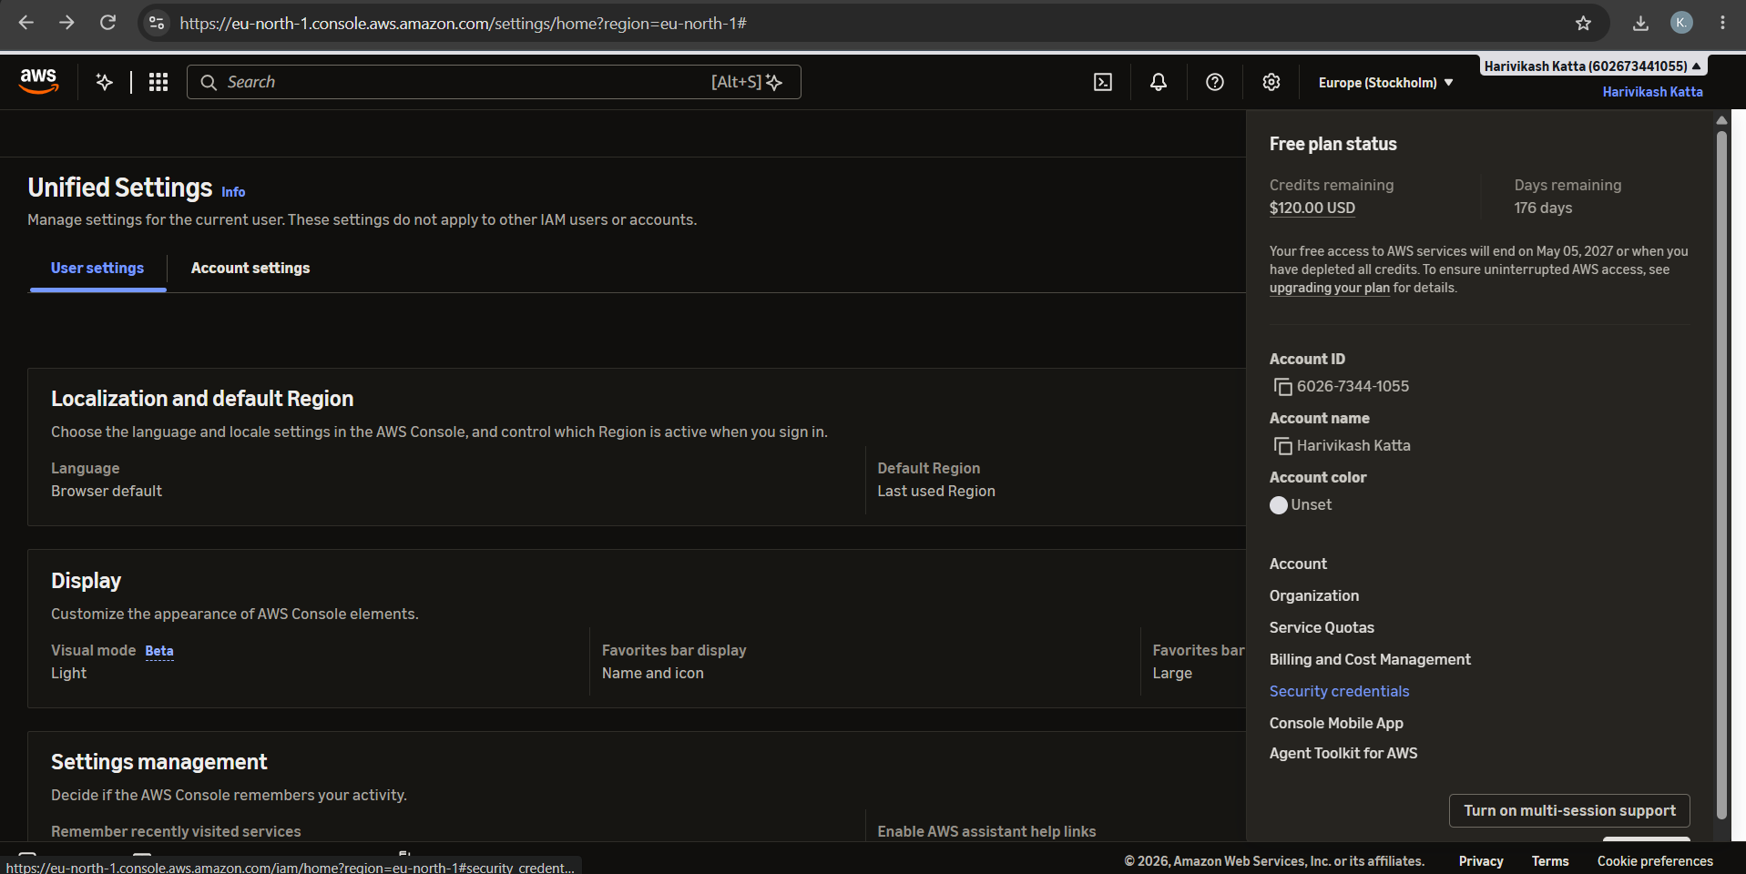
Fig 1: Account menu in the AWS Console with the Security credentials option
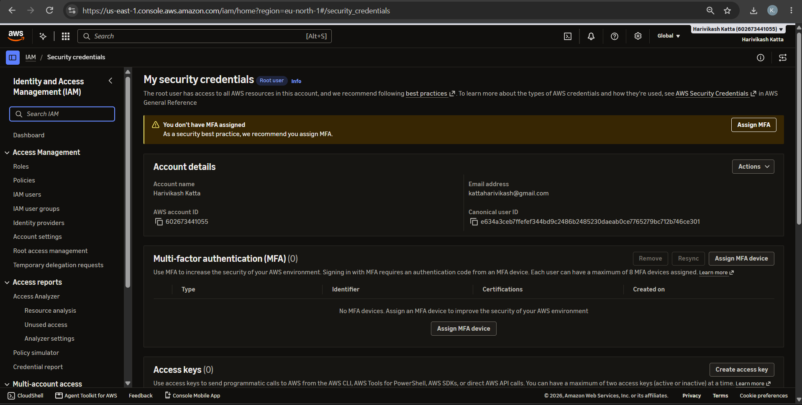
Fig 2: My security credentials page showing no MFA devices assigned
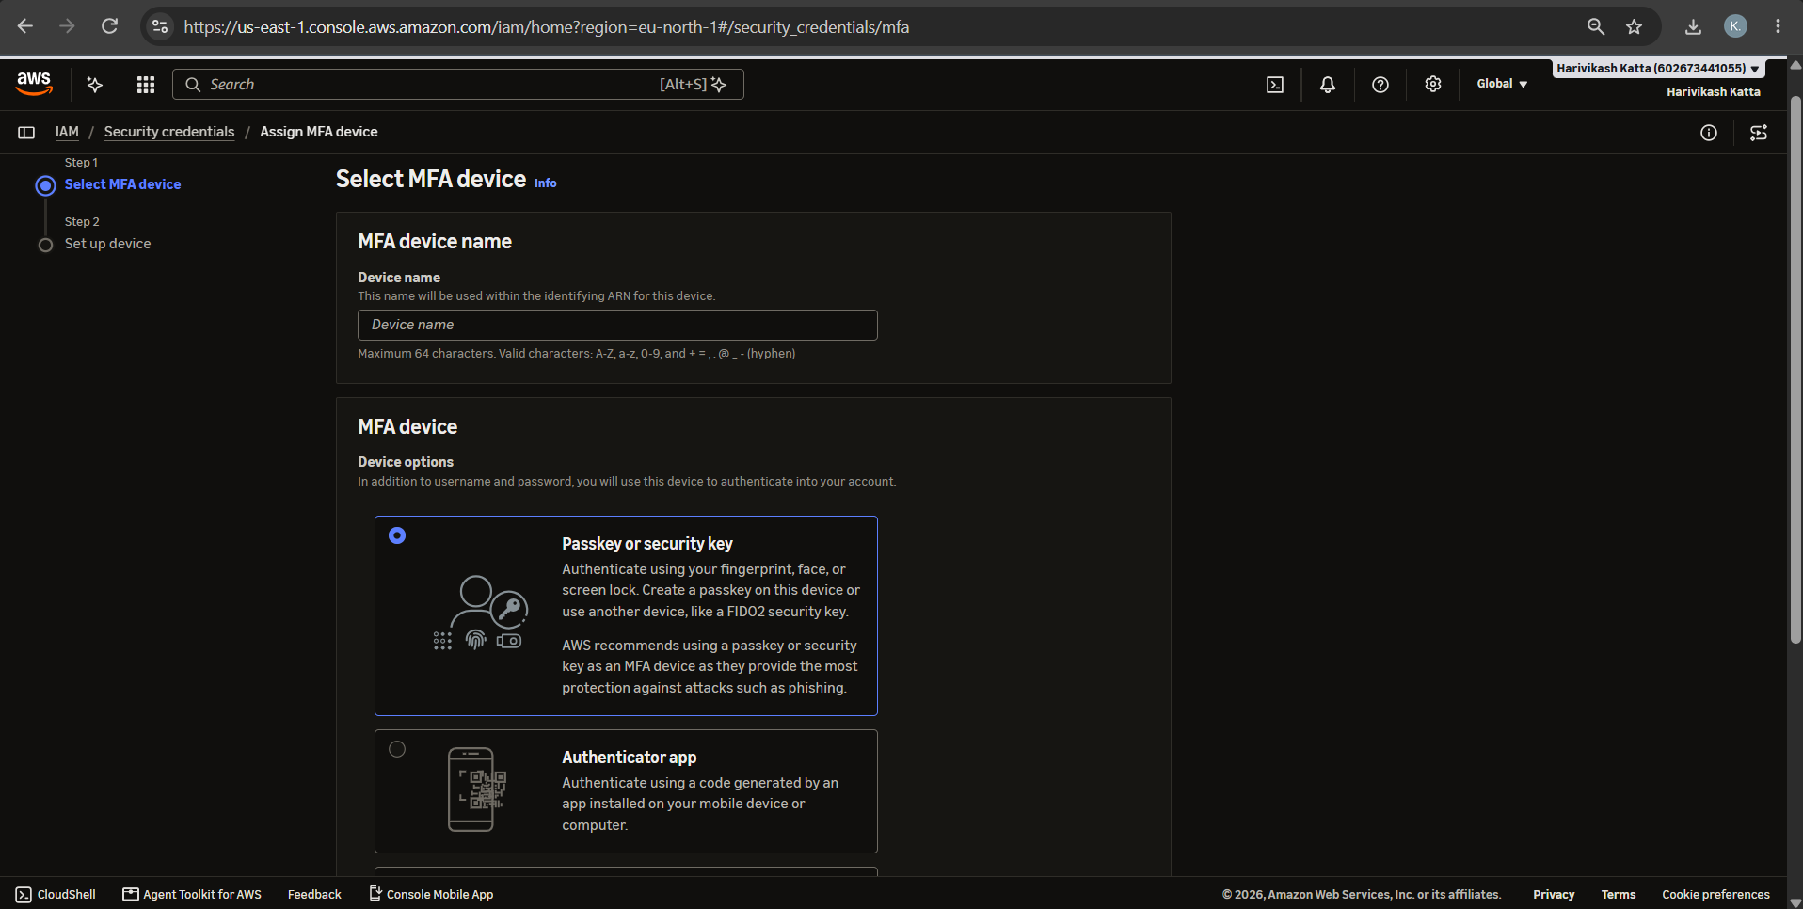
Fig 3: Select MFA device - entering the device name and choosing Passkey or security key
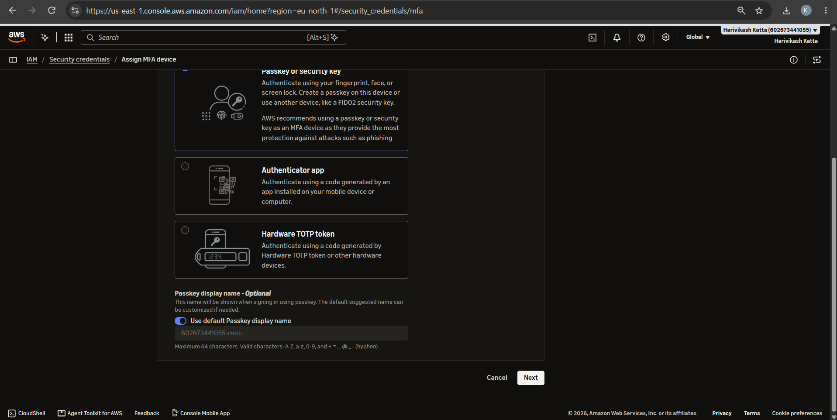
Fig 4: MFA device options and passkey display name
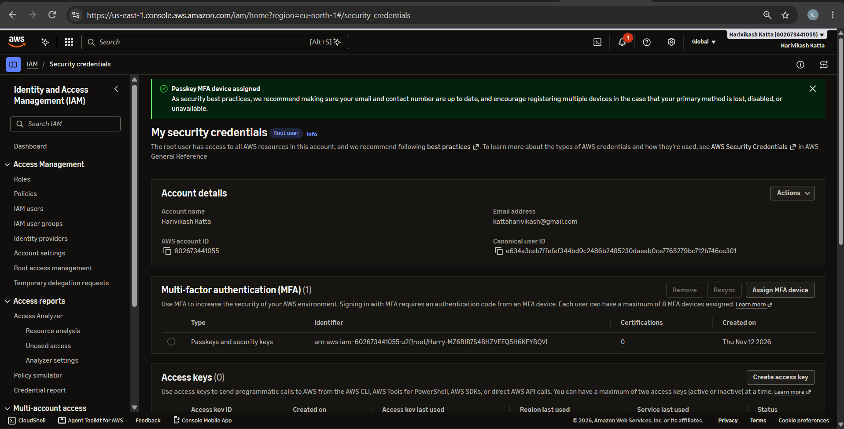
Fig 5: Passkey MFA device assigned successfully
GitHub:
1. Project: https://github.com/karkalashivareddy/CDIS-KLH-Y25-Project
2. Practical Skill: https://github.com/Harry-aura/CIDS-Y25-PRACTICAL-SKILL

