
Department of CSE

B.Tech. CSE Trimester -5

Roll Number: 2520030203
Name: Harivikash Katta
Section: 3

Cloud Infrastructure and Services
25CS2206E

LAB RECORD
2026

Experiment -4

AIM: To launch an Amazon EC2 instance (virtual server) in the AWS Free Tier and connect to it using EC2 Instance Connect.

Description:
Amazon Elastic Compute Cloud (Amazon EC2) provides resizable virtual servers, called instances, in the AWS cloud. Instead of buying physical hardware, a user can launch a server in minutes, choose its operating system, size and network settings, and pay only for the time it runs. Instances are launched in a Region (here Europe - Stockholm, eu-north-1) and an Availability Zone.
While launching an instance the following are selected: a name and tags; an Amazon Machine Image (AMI), which is the template containing the operating system and software (here Amazon Linux 2023); an instance type, which defines the CPU and memory (here t3.micro, which is Free Tier eligible); a key pair, which is used to securely log in; network settings with a security group, which works as a virtual firewall controlling the inbound and outbound traffic (here SSH on port 22); and storage, which is provided by Amazon EBS volumes (here 8 GiB gp3). Advanced details such as monitoring, metadata options and user data are optional.
In this experiment an instance named HARRY_COMPUTER is launched, its details are verified, and a connection is made from the browser using EC2 Instance Connect to reach the Amazon Linux terminal.
Steps:
1. Sign in to the AWS Management Console, type "EC2" in the search bar and select EC2 (Virtual Servers in the Cloud) from the results (Fig 1).
2. The EC2 Dashboard opens for the Europe (Stockholm) Region and shows the resources (0 instances running). Click "Launch instance" (Fig 2).
3. On the Launch an instance page, the Name and tags section appears first (Fig 3).
4. Enter the instance name as "HARRY_COMPUTER". Under Application and OS Images (Amazon Machine Image) select the Quick Start tab and choose "Amazon Linux" (Amazon Linux 2023 AMI). The instance type is t3.micro (Fig 4).
5. Under Key pair (login), open the Key pair name list and select the key pair "Harry" (RSA) (Fig 5).
6. In Network settings, keep "Create security group" and tick "Allow SSH traffic from" (Anywhere 0.0.0.0/0). AWS shows a warning that rules with source 0.0.0.0/0 allow all IP addresses to access the instance (Fig 6).
7. In Configure storage keep the root volume as 1x 8 GiB gp3 and set File systems to None. Then expand Advanced details (Fig 7).
8. In Advanced details the options such as hostname type, DNS hostname, instance auto-recovery, shutdown behavior, termination protection and stop protection are reviewed and kept at their default values (Fig 8).
9. Further down, the options for detailed CloudWatch monitoring, credit specification, placement group, EBS-optimized instance and purchasing option (None / On-Demand) are reviewed and left as default (Fig 9).
10. The options for capacity reservation, tenancy, RAM disk ID, kernel ID, Nitro Enclave, license configurations and CPU options (default CPU options) are kept as default (Fig 10).
11. In the metadata options, Metadata accessible is Enabled and Metadata version is "V2 only (token required)"; the hop limit is 2 (Fig 11).
12. The User data (optional) field is left empty (Fig 12).
13. Click "Launch instance". The message "Successfully initiated launch of instance" is displayed with the instance ID i-03fb68131a7ba0222. Click the instance ID to open it (Fig 13).
14. The Instance summary shows the Instance state as Running, the instance type t3.micro and the Public IPv4 address 13.48.194.150 (Fig 14).
15. Click "Connect". On the Connect to Linux instance page choose the "EC2 Instance Connect" tab (In web browser), keep the public IPv4 address option selected and click Connect (Fig 15).
16. A browser-based terminal opens, showing the Amazon Linux 2023 banner and the prompt of the user ec2-user, which confirms that the connection to the instance is successful (Fig 16).
17. Return to the EC2 Instances page. The instance HARRY_COMPUTER is listed with Instance state Running and Status check 3/3 checks passed (Fig 17).
Output:
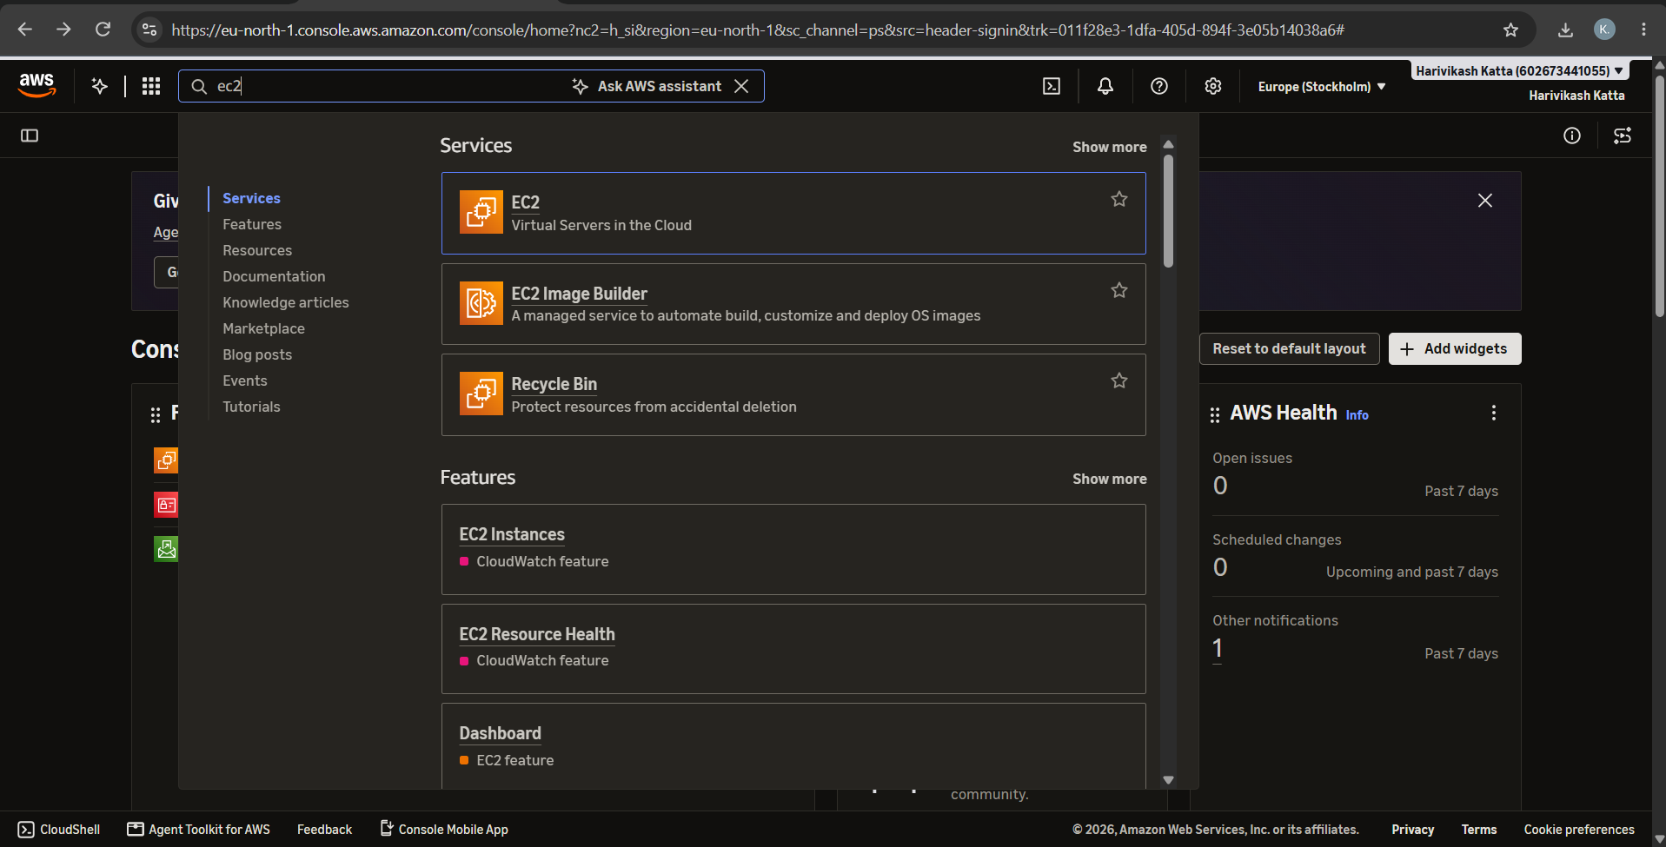
Fig 1: Searching for EC2 in the AWS Console search bar
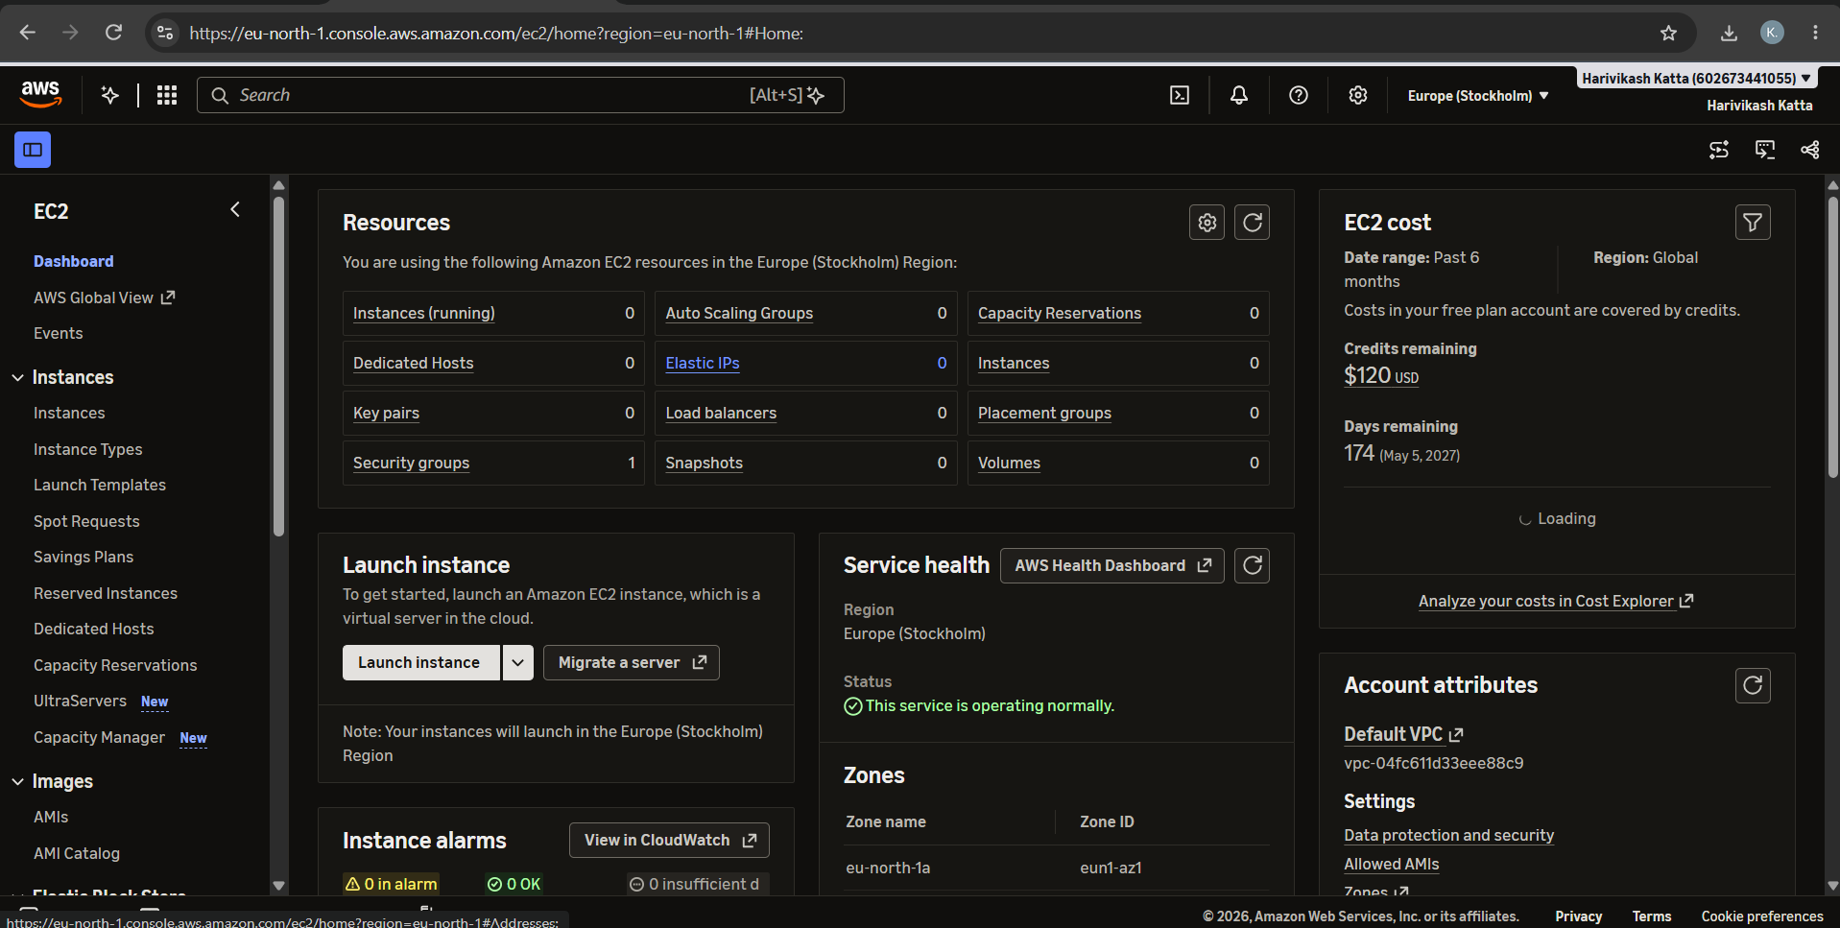
Fig 2: EC2 Dashboard in the Europe (Stockholm) Region
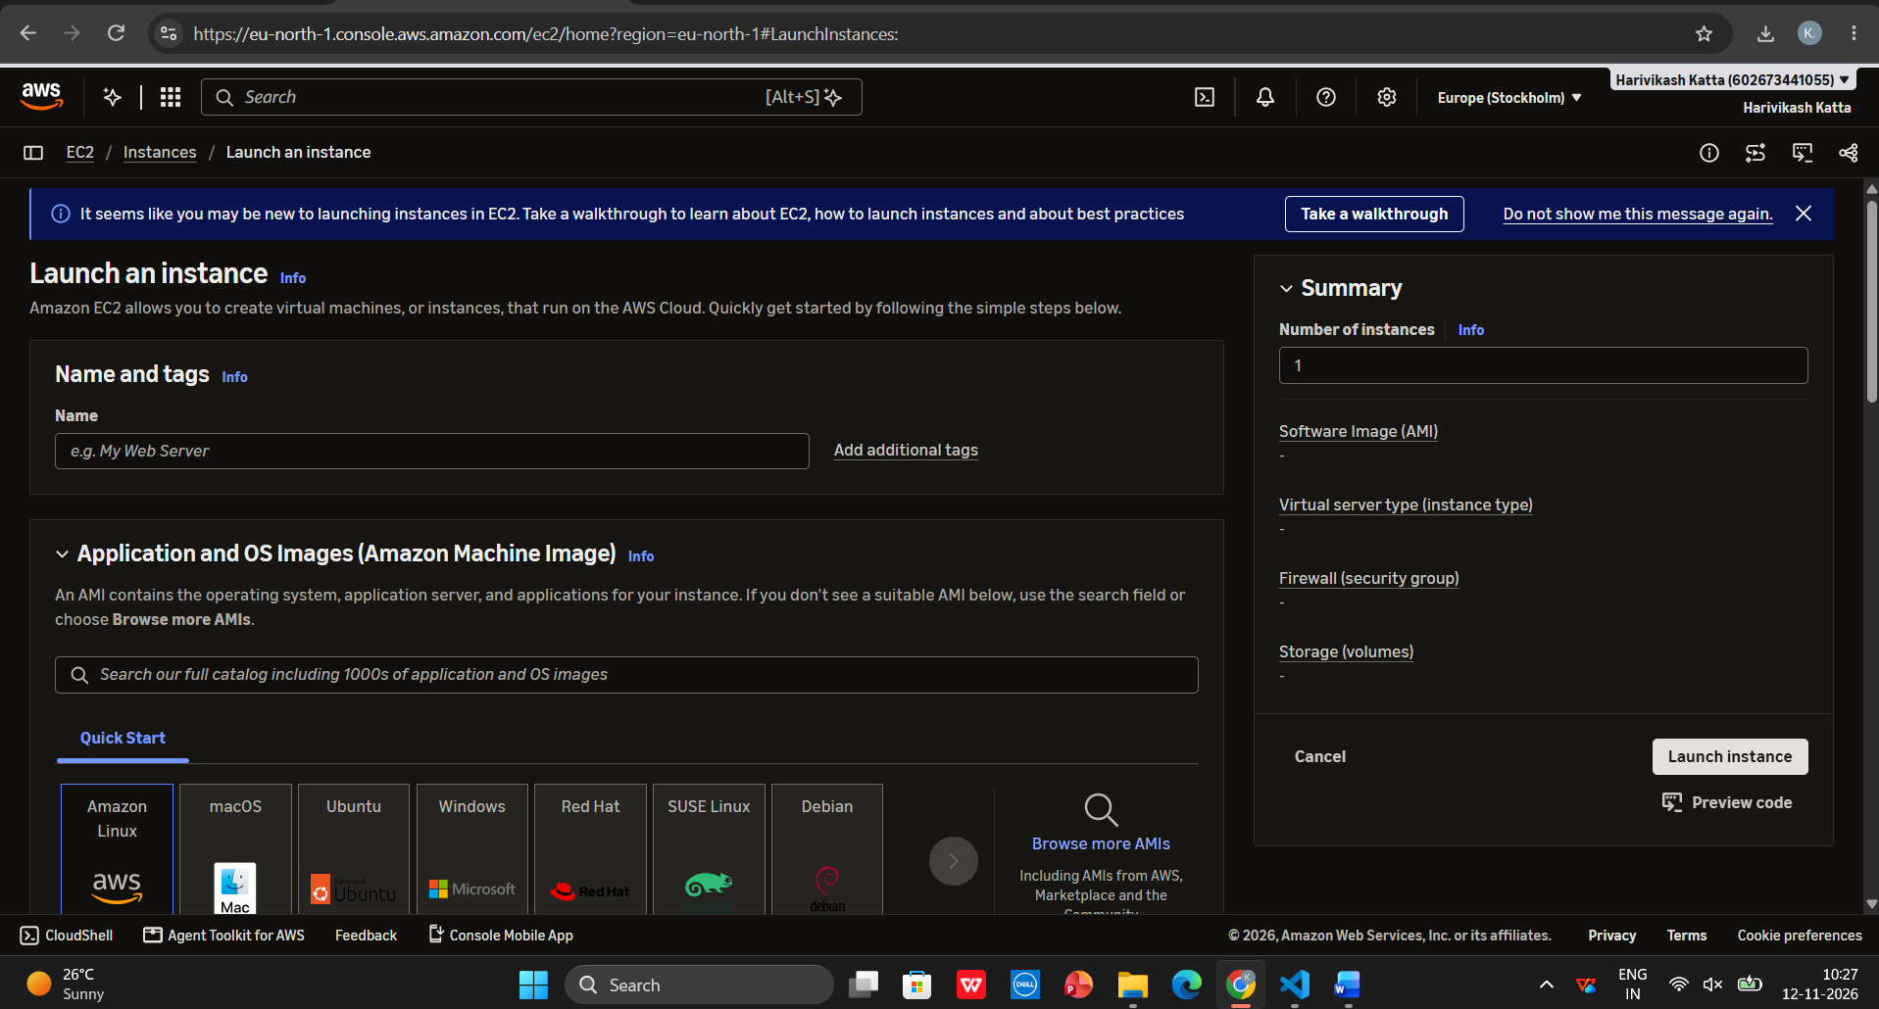
Fig 3: Launch an instance - Name and tags
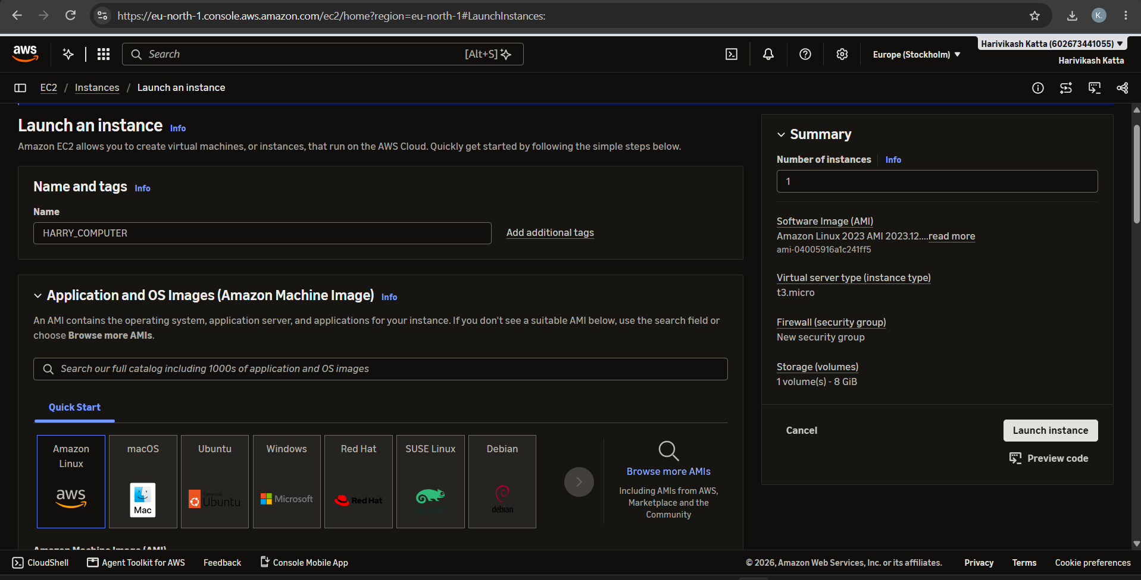
Fig 4: Instance name HARRY_COMPUTER and Amazon Linux AMI selection
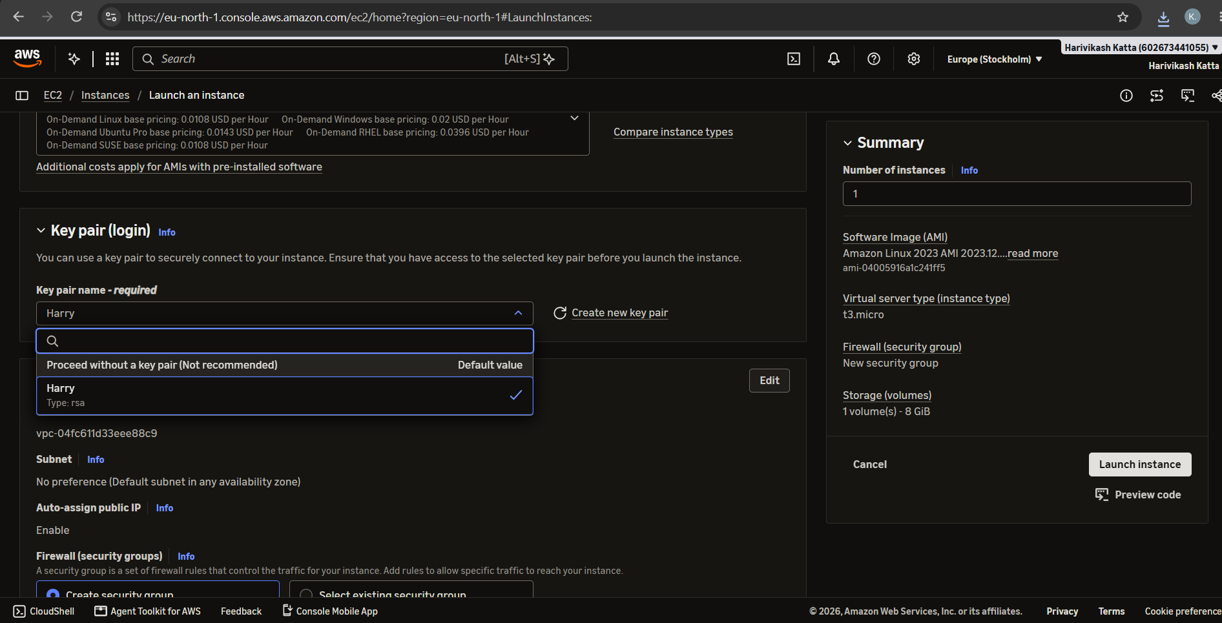
Fig 5: Key pair (login) - selecting the key pair Harry
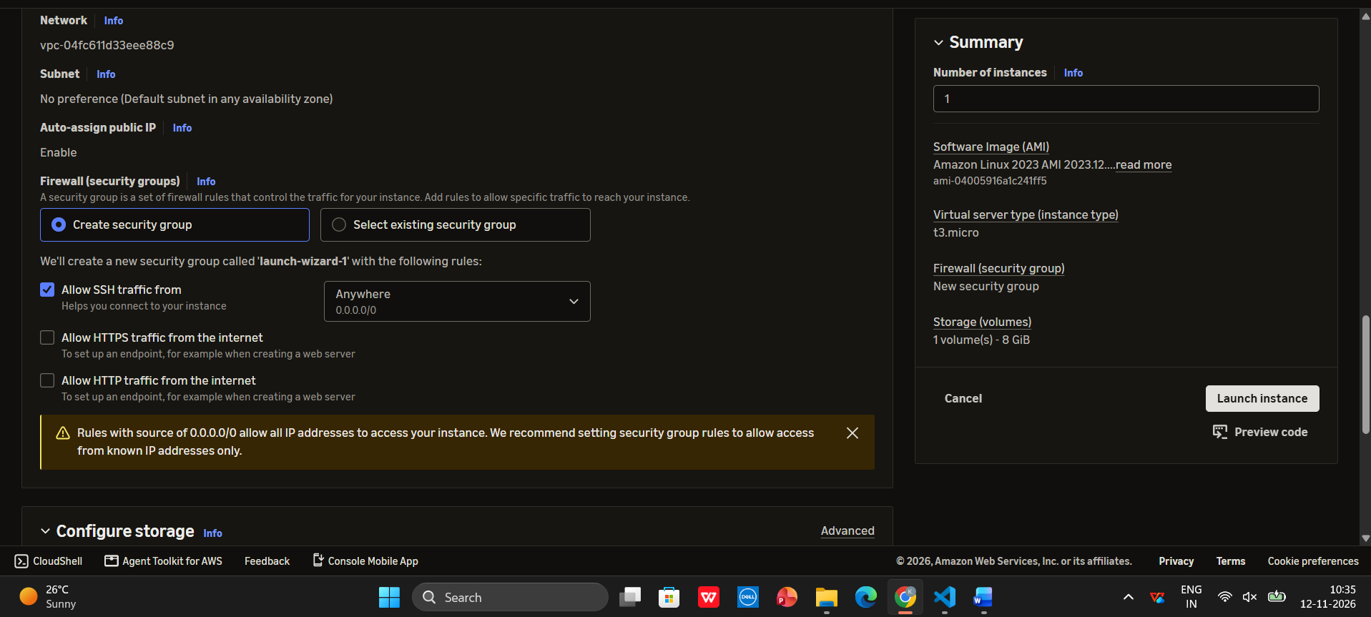
Fig 6: Network settings - security group allowing SSH traffic
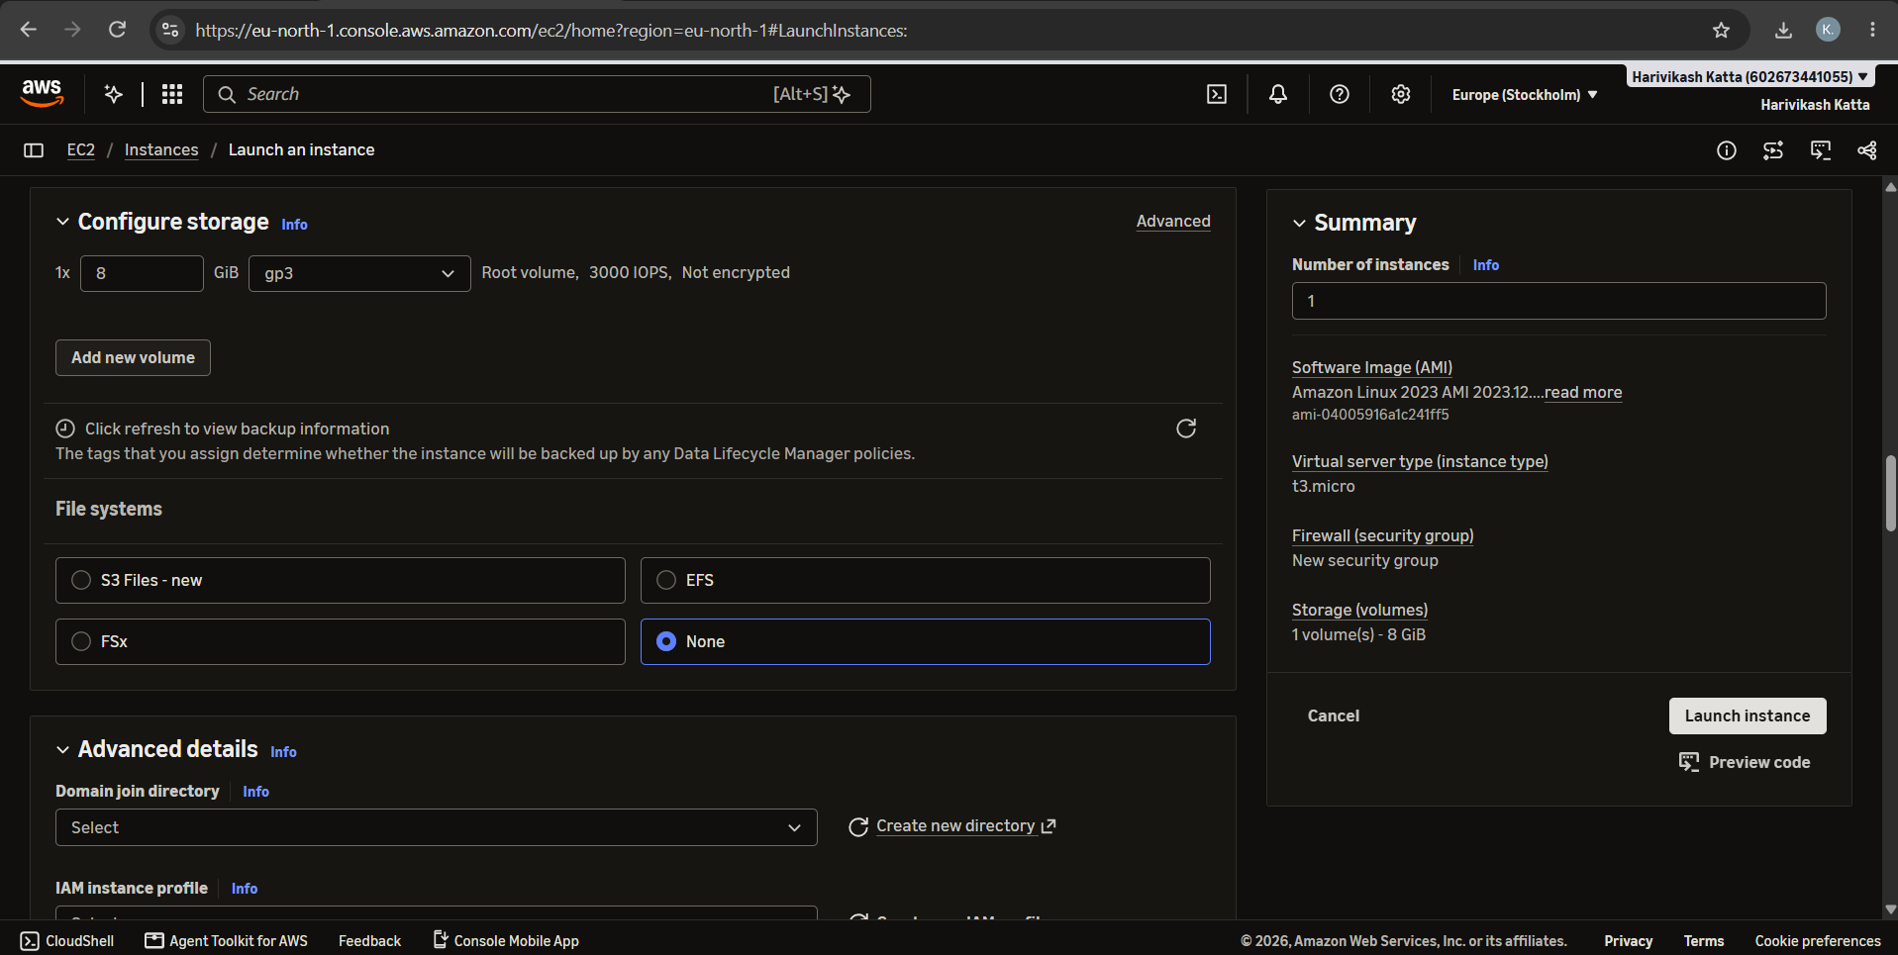
Fig 7: Configure storage (8 GiB gp3) and file systems
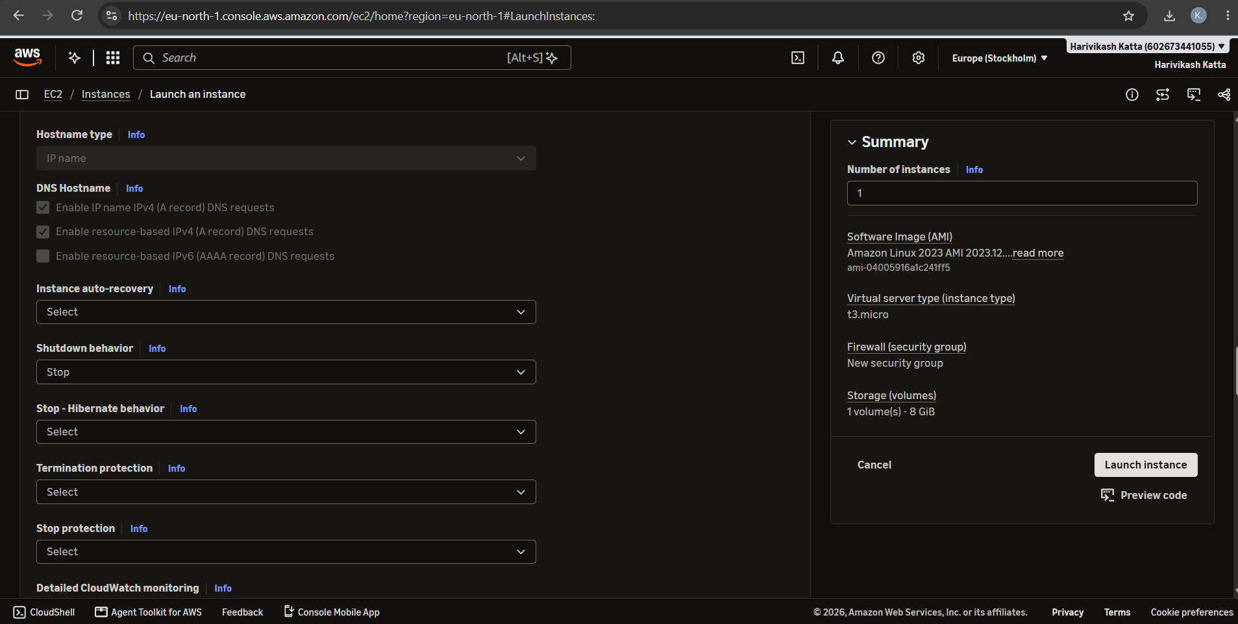
Fig 8: Advanced details - hostname, DNS, shutdown behavior and protection options
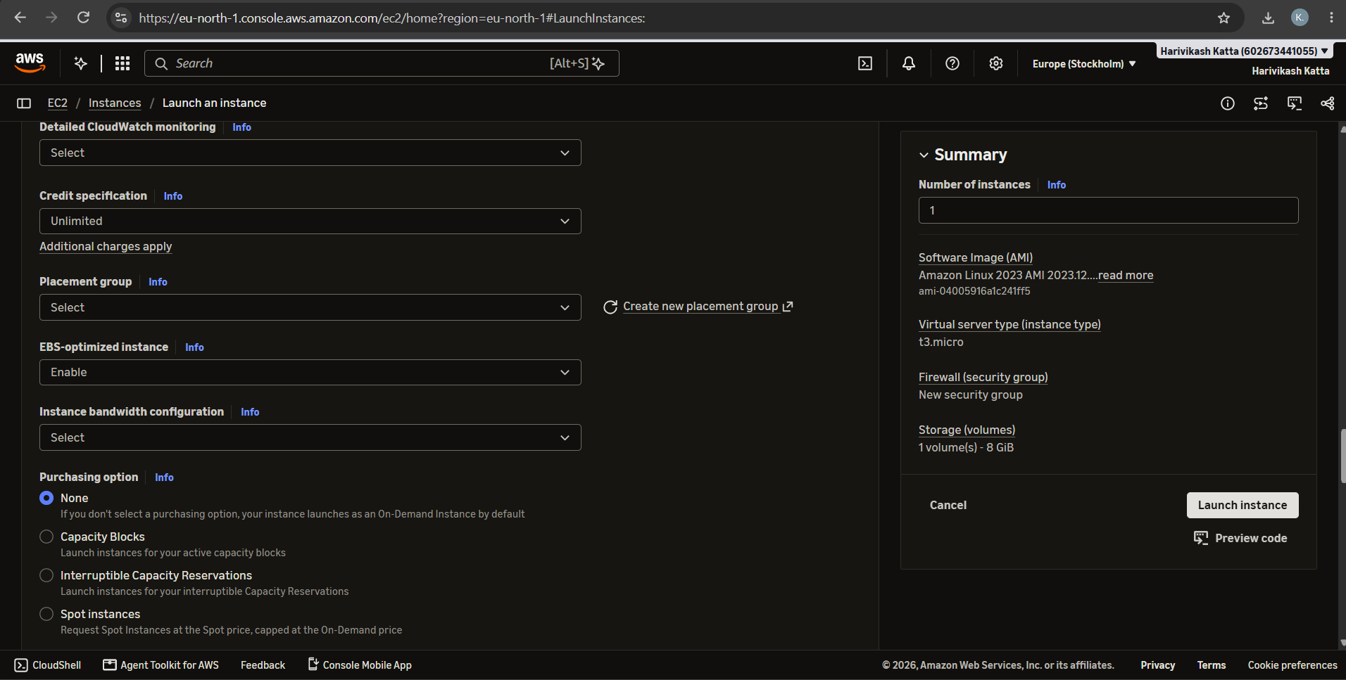
Fig 9: Advanced details - monitoring, credit specification, placement group and purchasing option
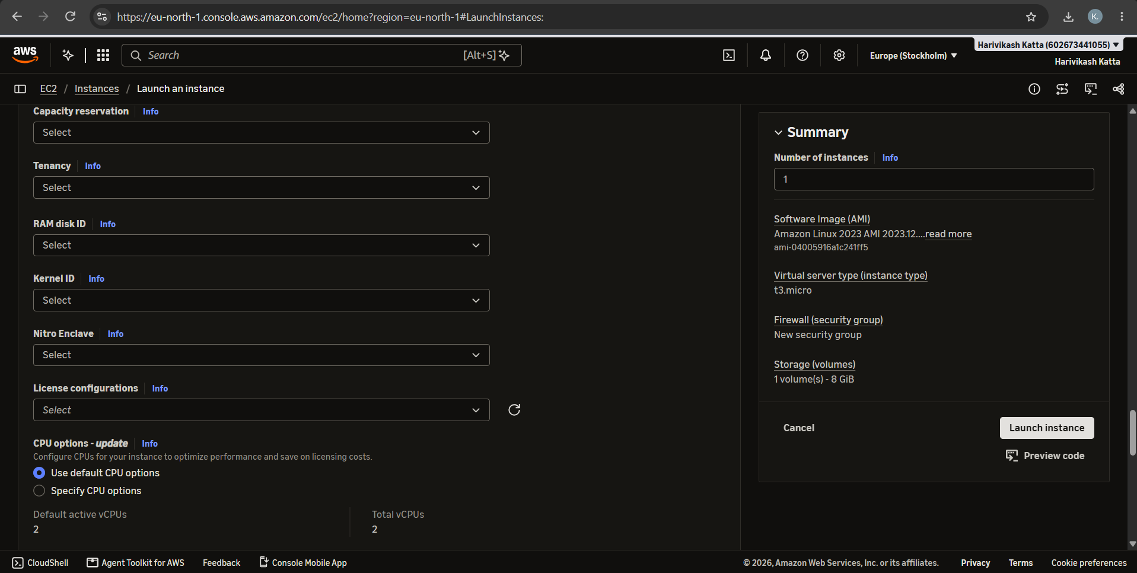
Fig 10: Advanced details - capacity reservation, tenancy and CPU options
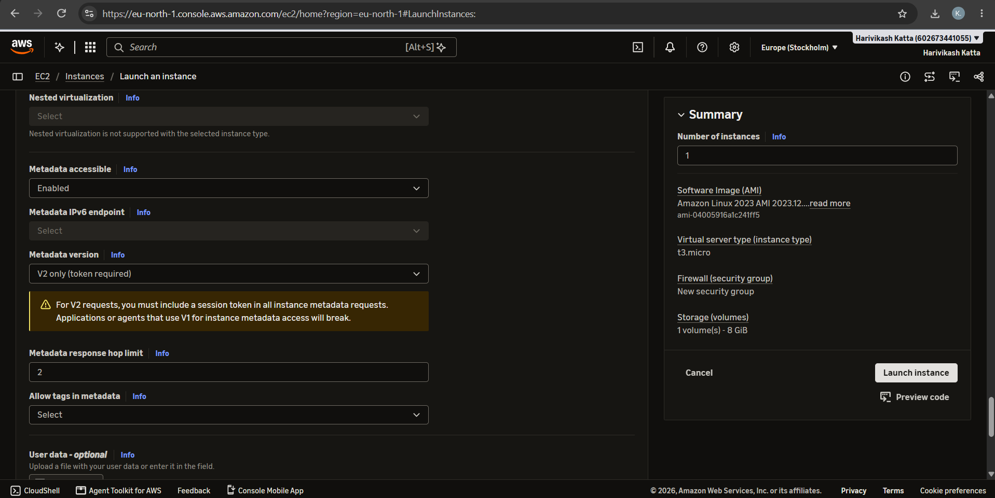
Fig 11: Advanced details - metadata options (IMDSv2)
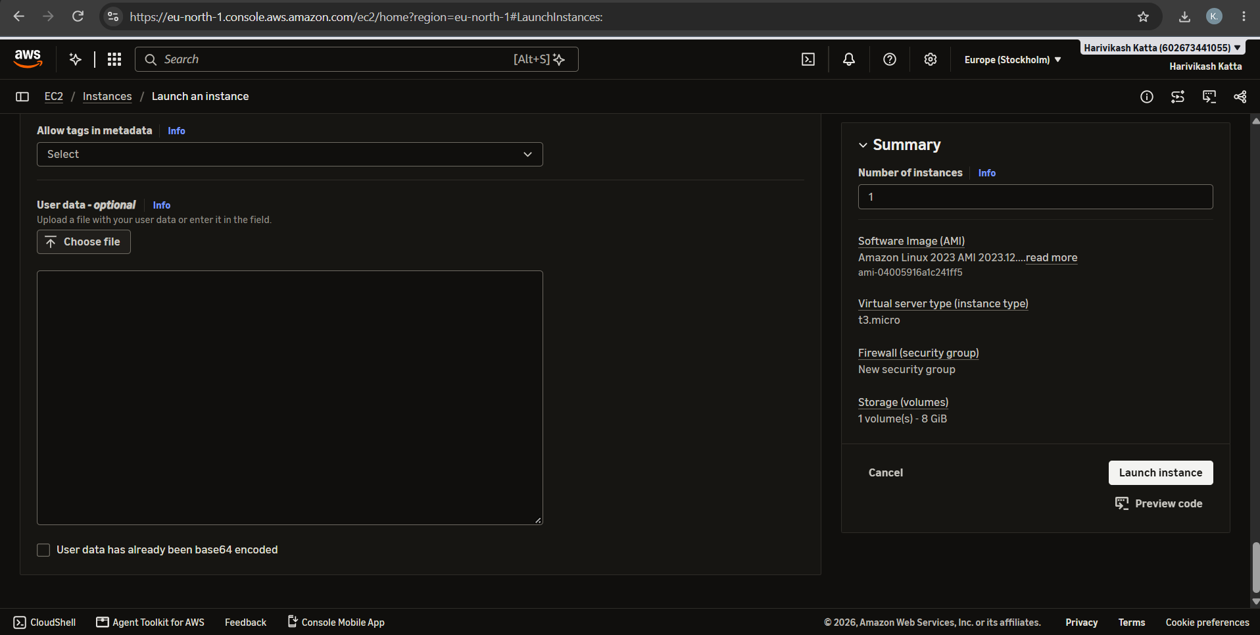
Fig 12: Advanced details - user data (optional)
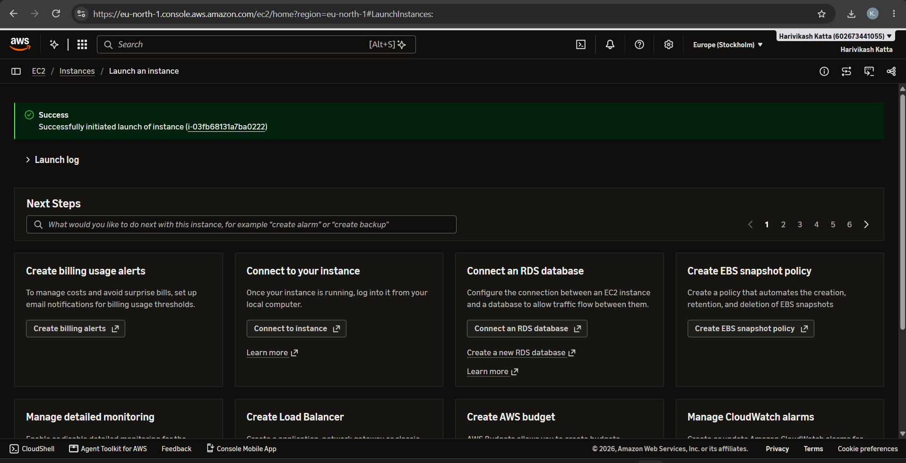
Fig 13: Instance launched successfully
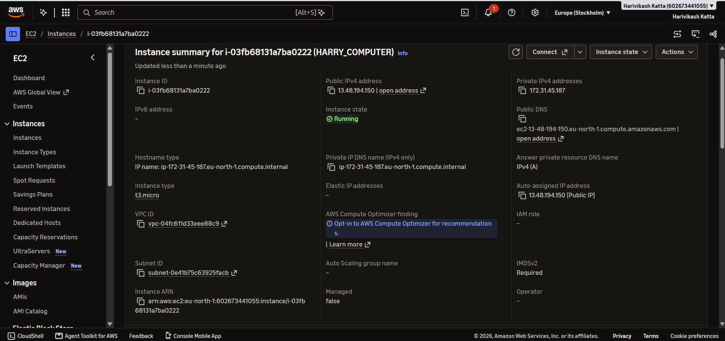
Fig 14: Instance summary showing the instance in Running state with its public IPv4 address
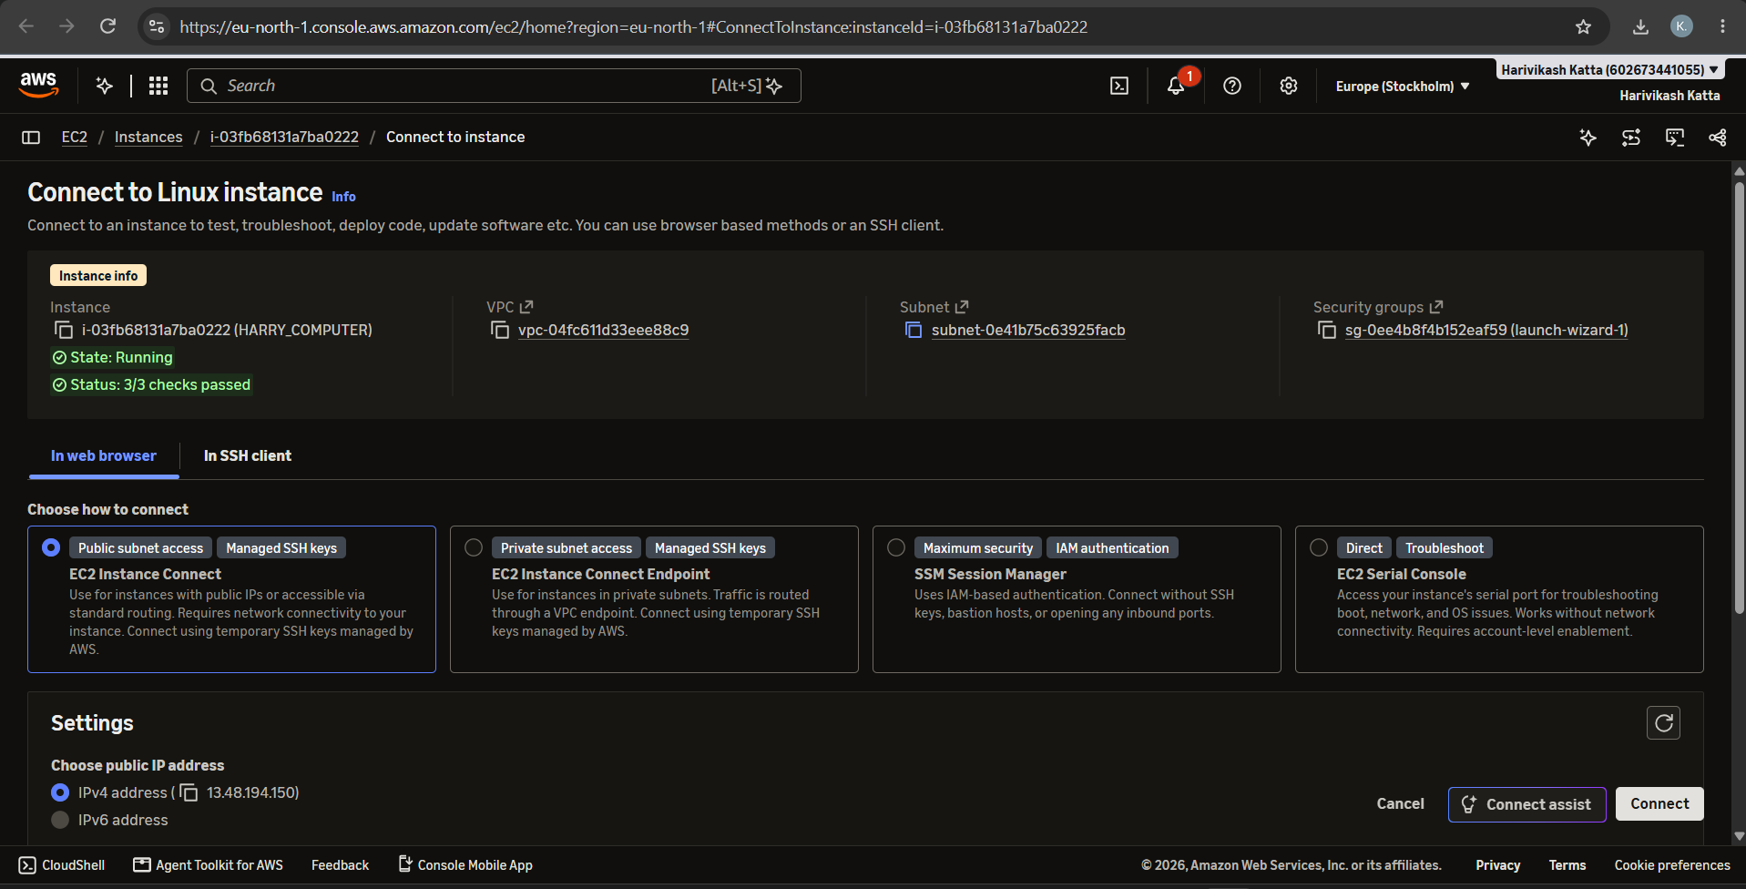
Fig 15: Connect to Linux instance - EC2 Instance Connect
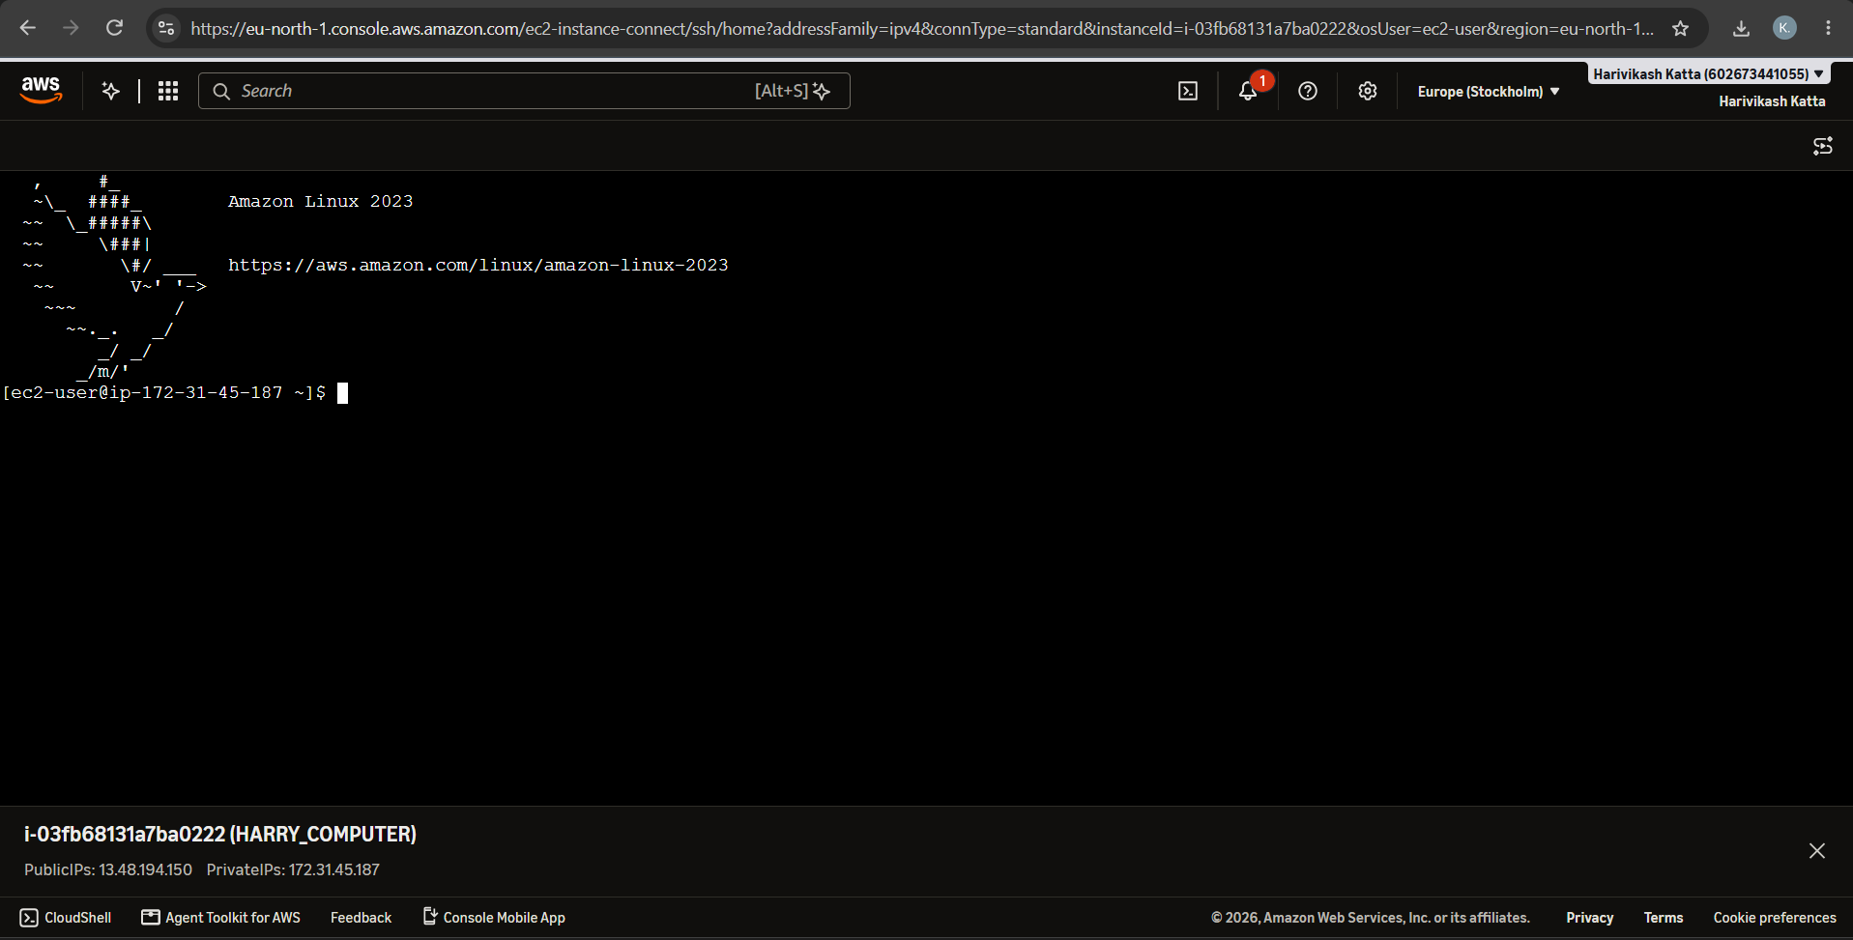
Fig 16: Amazon Linux 2023 terminal after connecting to the instance
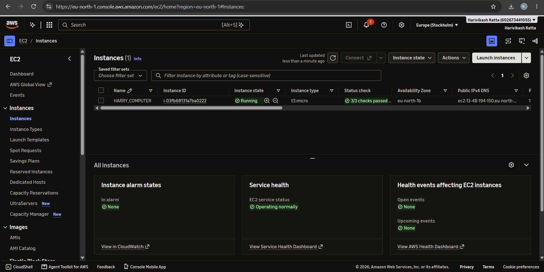
Fig 17: Instances list showing HARRY_COMPUTER running with 3/3 status checks passed
GitHub:
1. Project: https://github.com/karkalashivareddy/CDIS-KLH-Y25-Project
2. Practical Skill: https://github.com/Harry-aura/CIDS-Y25-PRACTICAL-SKILL

