
Department of CSE

B.Tech. CSE Trimester -5

Roll Number: 2520030203
Name: Harivikash Katta
Section: 3

Cloud Infrastructure and Services
25CS2206E

LAB RECORD
2026

Experiment -5

AIM: To create an Amazon S3 bucket and upload an object to it, and to view the object properties.

Description:
Amazon Simple Storage Service (Amazon S3) is an object storage service that offers scalable, durable and highly available storage over the internet. Data is stored as objects (a file and its metadata) inside containers called buckets. Each object is identified by a unique key and can be accessed using its URL, subject to permissions. S3 is used for backups, static website content, data lakes, application data and archives.
While creating a bucket the bucket type (General purpose), the AWS Region (Europe - Stockholm, eu-north-1) and a globally unique bucket name are specified. Other settings include Object Ownership (ACLs disabled is recommended), Block Public Access (all public access is blocked by default to keep the data private), Bucket Versioning (keeps multiple versions of an object), tags, and Default encryption (server-side encryption with Amazon S3 managed keys, SSE-S3, is applied to every new object).
In this experiment a general purpose bucket named demo-bucket1-602673441055-eu-north-1-an is created with the default security settings, a PDF file is uploaded to it, and the properties of the uploaded object, including its S3 URI, ARN and Object URL, are viewed. A presigned URL is also generated to share the object temporarily.
Steps:
1. Sign in to the AWS Management Console and open the Amazon S3 service. The Buckets page shows that there are no buckets (0). Click "Create bucket" (Fig 1).
2. In General configuration select the Bucket type "General purpose" and the Region Europe (Stockholm) eu-north-1. Under Bucket namespace the global namespace or the account regional namespace can be chosen (Fig 2).
3. Enter the bucket name prefix. The full bucket name is formed by adding the account number and Region suffix automatically. Keep Object Ownership as "ACLs disabled (recommended)" (Fig 3).
4. Keep "Block all public access" ticked so that the bucket stays private, and keep Bucket Versioning as Disable (Fig 4).
5. Tags are optional and are not added. Under Default encryption keep "Server-side encryption with Amazon S3 managed keys (SSE-S3)" and keep the Bucket Key enabled (Fig 5).
6. Scroll down and click "Create bucket". The message "Successfully created bucket demo-bucket1-602673441055-eu-north-1-an" is displayed and the bucket opens with Objects (0) (Fig 6).
7. Click "Upload" to open the Upload page, which shows no files or folders chosen yet (Fig 7).
8. Click "Add files" and choose the file AgentTx_Team_NeuroPulse_Pitch.pdf (186 KB, application/pdf). The destination is shown as the new bucket. Click "Upload" (Fig 8).
9. The "Upload succeeded" message is displayed. The summary shows 1 file (186.0 KB, 100%) uploaded successfully and 0 files failed. Click Close (Fig 9).
10. Open the uploaded object to view its Properties: owner, AWS Region, size, type, key, S3 URI, ARN, entity tag (ETag) and Object URL. Under Object actions a presigned URL can be created; the message "A presigned URL has been created and copied to your clipboard" is shown (Fig 10).
Output:
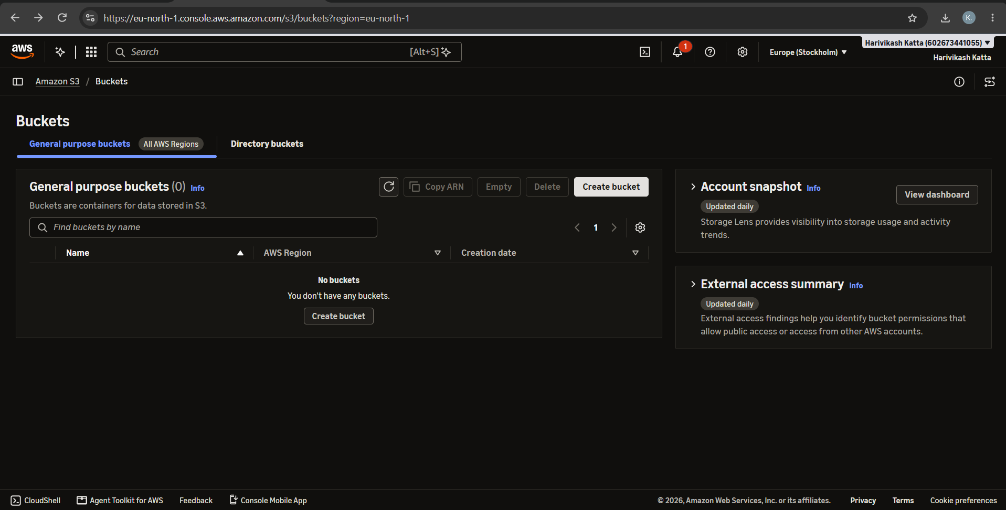
Fig 1: Amazon S3 Buckets page with no buckets
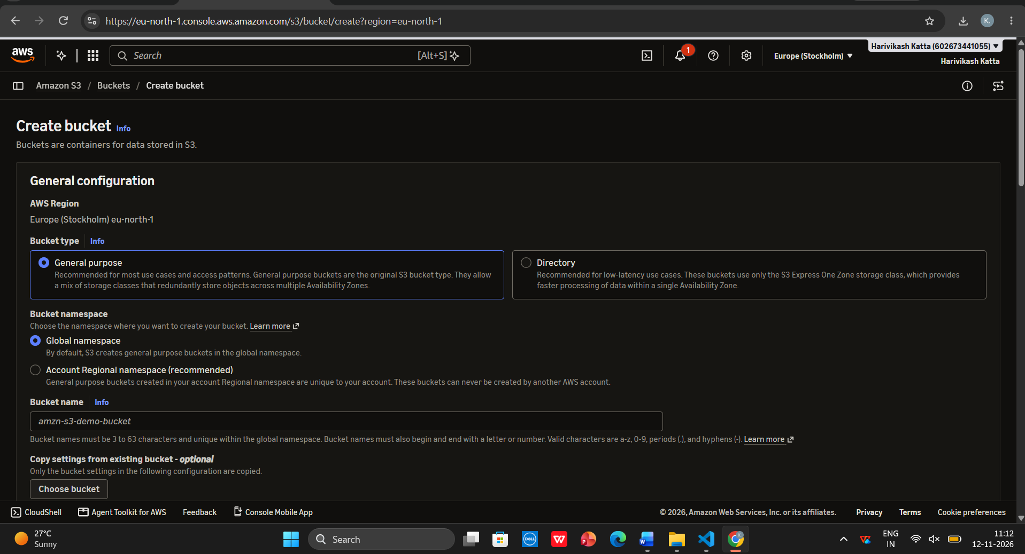
Fig 2: Create bucket - general configuration (General purpose, Region and namespace)
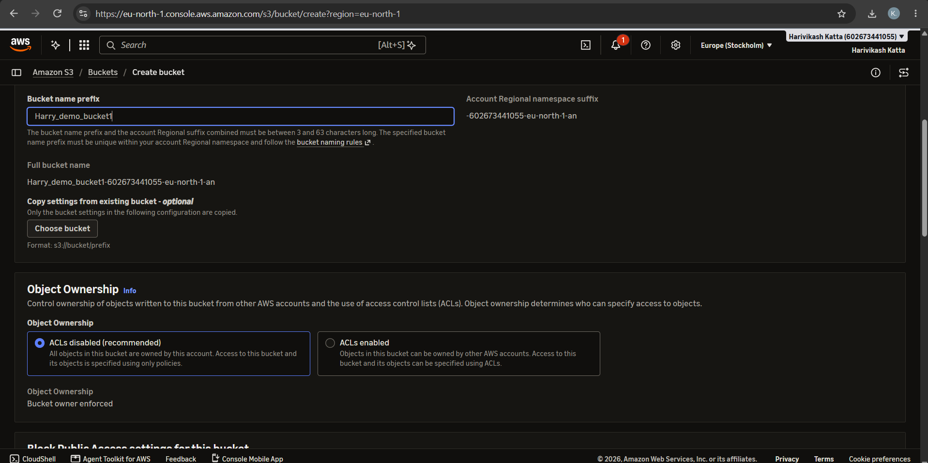
Fig 3: Create bucket - bucket name prefix and Object Ownership
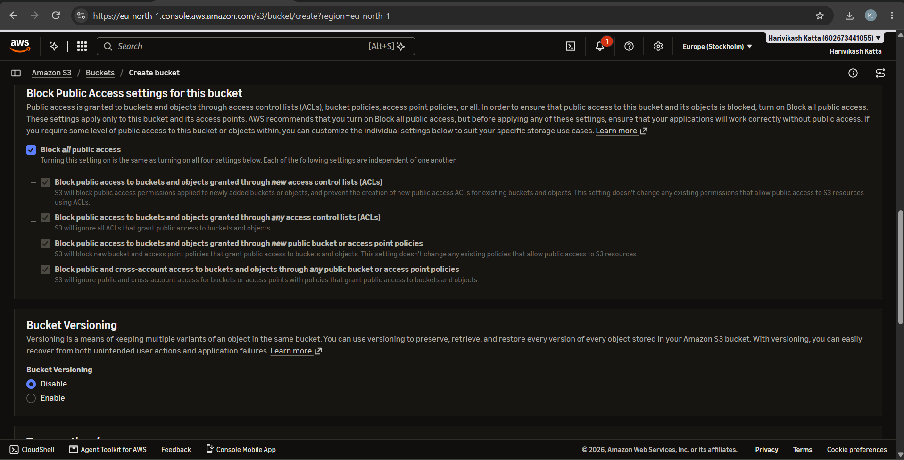
Fig 4: Block Public Access settings and Bucket Versioning
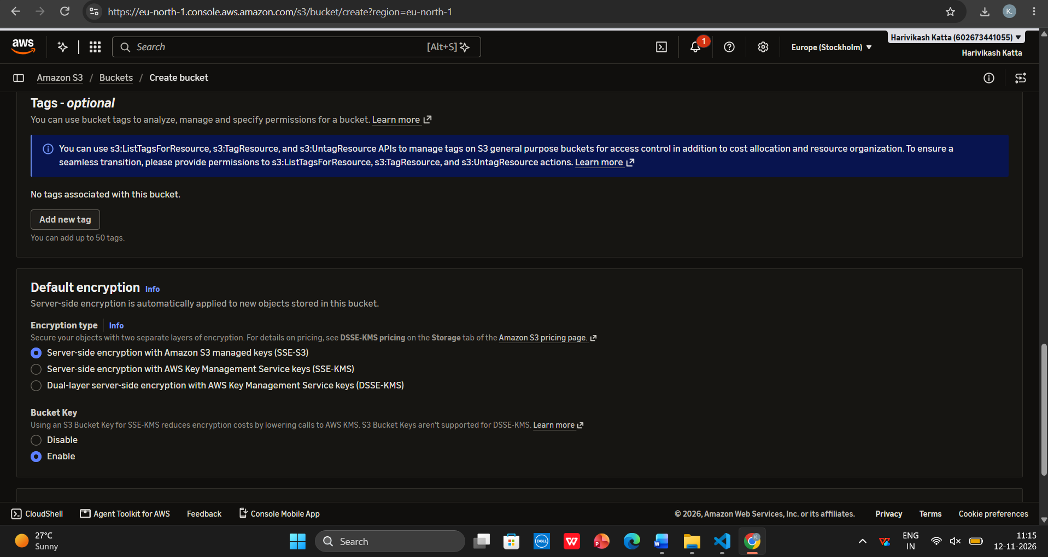
Fig 5: Tags and Default encryption (SSE-S3)
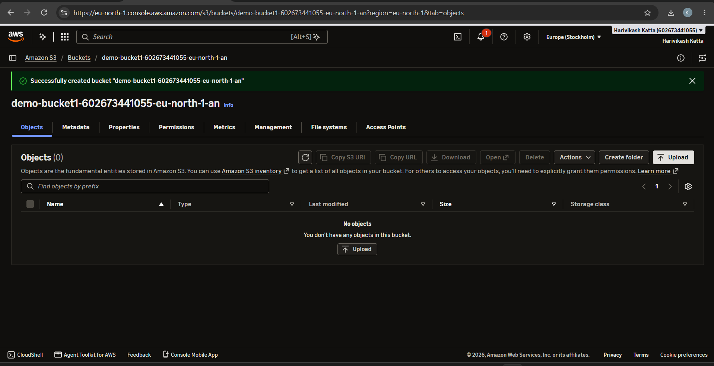
Fig 6: Bucket created successfully
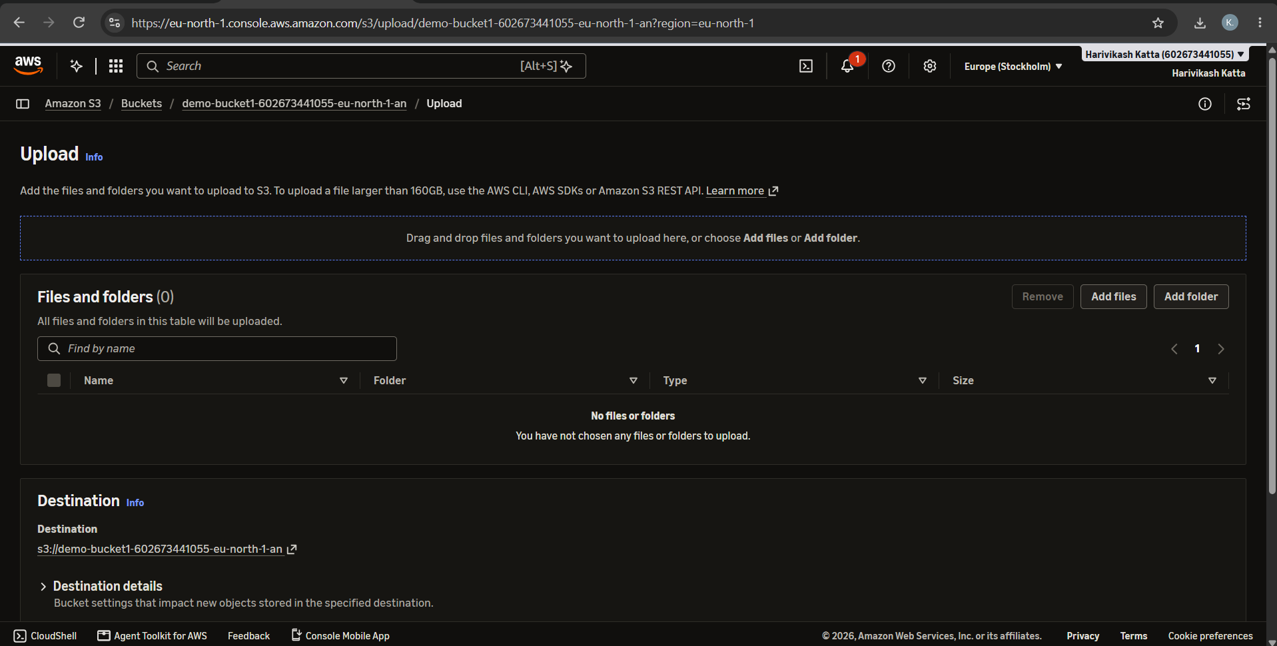
Fig 7: Upload page
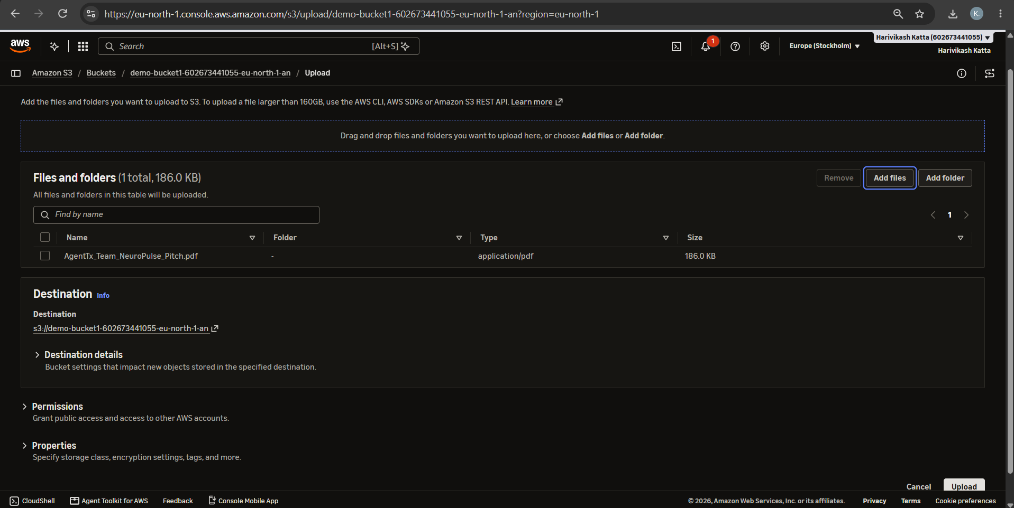
Fig 8: Selecting the file to upload and the destination bucket
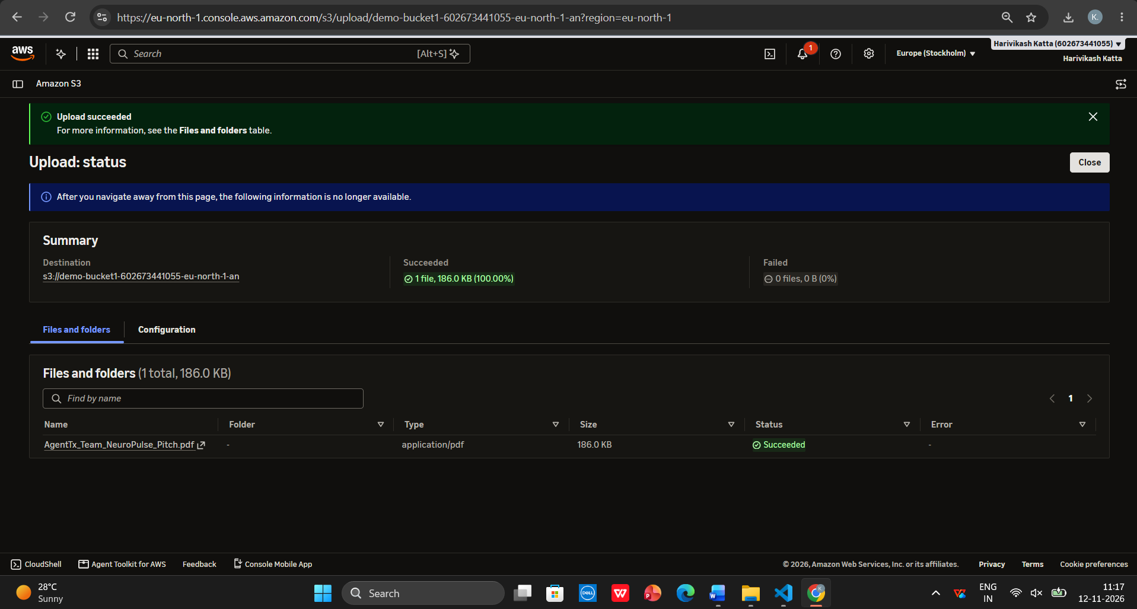
Fig 9: Upload succeeded status
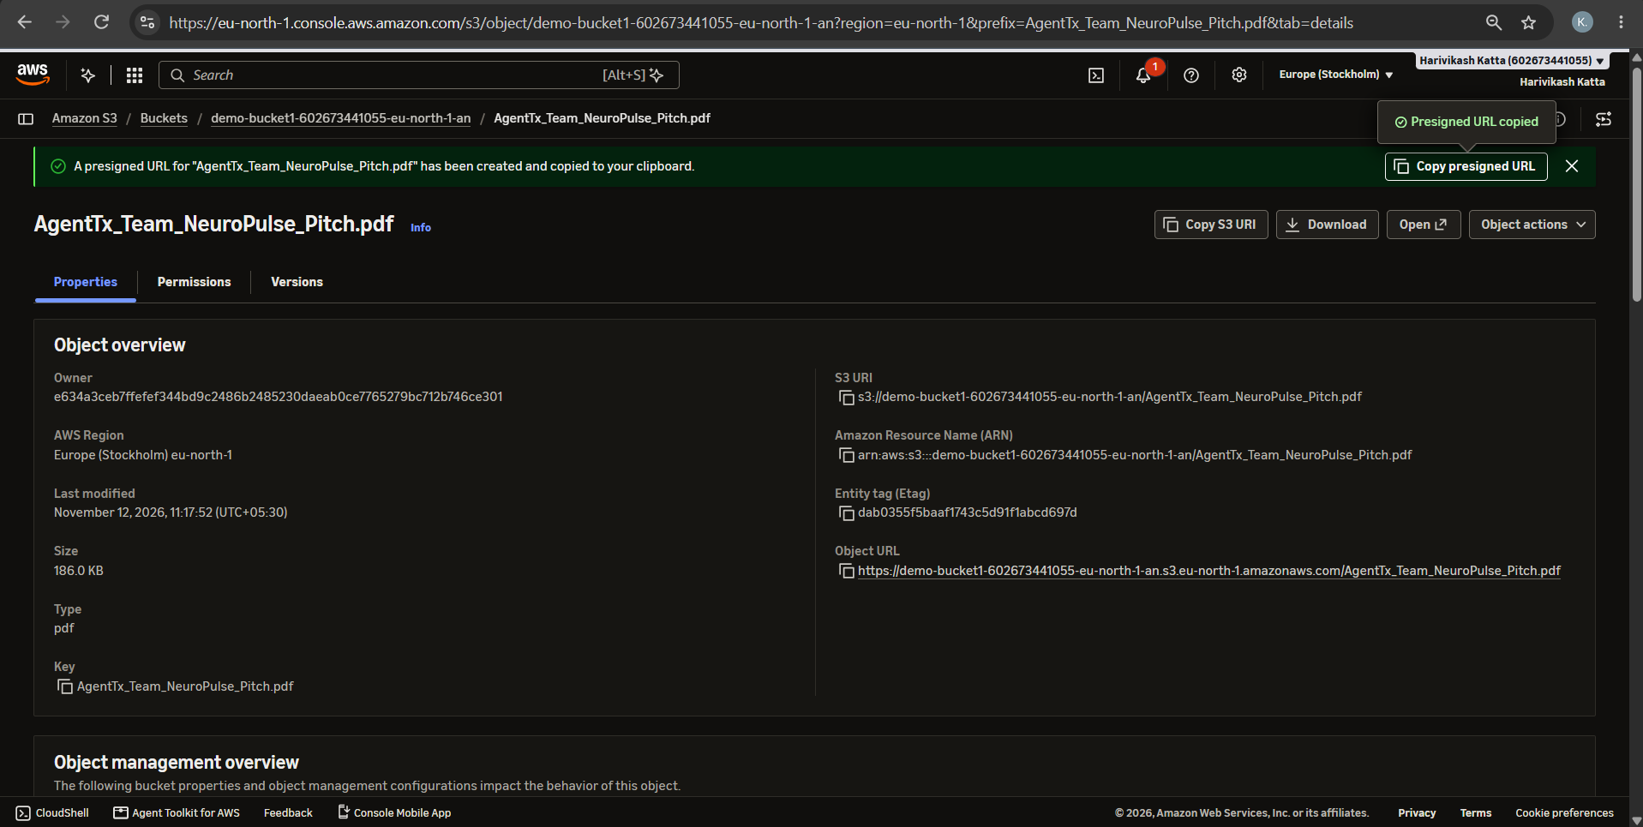
Fig 10: Object properties and presigned URL
GitHub:
1. Project: https://github.com/karkalashivareddy/CDIS-KLH-Y25-Project
2. Practical Skill: https://github.com/Harry-aura/CIDS-Y25-PRACTICAL-SKILL

