Department of Computer Science and Engineering
2025-2026
Odd Semester


DATA STRUCTURES AND ALGORITHMS-3
(25CS2103E)

PrimeDSA: 1024-Bit Miller–Rabin Primality Engine

HARIVIKASH KATTA – 2520030203
MANOJ KUMAR – 2520030040

COURSE INSTRUCTOR

Dr. J Sirisha Devi
Professor
Department of Computer Science and Engineering
TITLE OF THE PBL

PrimeDSA: 1024-Bit Miller–Rabin Primality Engine
1. Introduction
Prime numbers are the foundation of public-key cryptography. RSA, Diffie–Hellman and ECDSA all need very large primes (512 to 4096 bits), so a system must be able to decide quickly whether a huge number is prime. This project, PrimeDSA (Prime Check Web Service), is a web application that tests the primality of integers up to 1024 bits (about 309 decimal digits) using the Miller–Rabin probabilistic primality test. It also generates random primes and benchmarks Miller–Rabin against the classical trial division method.
2. Problem Statement
Given an integer n of up to 1024 bits, decide whether n is prime or composite in a few milliseconds, with an error probability that is negligible for cryptographic use. The solution must also work for arbitrary-precision integers, show its working step by step, and demonstrate why it is better than the naive approaches.
3. Why Simple Methods Are Not Enough
• Trial division is exponential. To test an n of b bits, trial division may need up to √n = 2^(b/2) divisions. For a 1024-bit number this is about 2^512 operations, which is impossible in practice.
• The Fermat test can be fooled. By Fermat’s little theorem, a prime n satisfies a^(n−1) ≡ 1 (mod n) for every a coprime to n. Carmichael numbers such as 561 = 3 × 11 × 17 also satisfy this for every coprime a, so the Fermat test wrongly reports them as prime.
4. Core Idea of the Miller–Rabin Test
Write n − 1 = 2^s · d with d odd. If n is prime and a is a base with 1 < a < n − 1, then one of the following must hold:
• a^d ≡ 1 (mod n), or
• a^(2^r · d) ≡ −1 (mod n) for some r with 0 ≤ r < s.
This works because the only square roots of 1 modulo a prime are +1 and −1. If neither condition holds, a is a witness and n is definitely composite. For every odd composite n, at least 3/4 of all bases are witnesses, so after k independent random rounds the probability of wrongly accepting a composite is at most 4^(−k). With k = 40 rounds this is at most 2^(−80), about 8.27 × 10^(−25).
5. Worked Examples
Example 1: n = 97 (prime), base a = 2. Here n − 1 = 96 = 2^5 · 3, so s = 5 and d = 3. The sequence 2^3, 2^6, 2^12, 2^24 (mod 97) is 8, 64, 22, 96. The last value is 96 ≡ −1, so the round passes and 97 is reported probably prime.
Example 2: n = 221 = 13 × 17 (composite). Here n − 1 = 220 = 2^2 · 55, so s = 2 and d = 55. For a = 2, the sequence is 2^55 ≡ 128 and 128^2 ≡ 30 (mod 221). Neither value is 1 or 220, so 2 is a witness and 221 is composite. For a = 174, the sequence is 47 and then 220, so the round passes: 174 is a strong liar for 221. This is why several random bases are used instead of one.
Example 3: n = 561 (Carmichael number). The Fermat test passes for 561 (for instance 2^560 ≡ 1 mod 561). For Miller–Rabin, n − 1 = 560 = 2^4 · 35. With a = 2, the sequence is 263, 166, 67, 1. The value 1 appears after 67, which is not ±1, so 67 is a non-trivial square root of 1 and 561 is proven composite.
n | Type | Base a | Sequence a^d, a^2d, … (mod n) | Result
97 | Prime | 2 | 8, 64, 22, 96 (= −1) | Passes
221 | Composite | 2 | 128, 30 | Composite (witness)
221 | Composite | 174 | 47, 220 (= −1) | Passes (strong liar)
561 | Carmichael | 2 | 263, 166, 67, 1 | Composite (witness)

6. Features of the System
• Primality Validator. Accepts any integer up to 1024 bits, with quick presets (128, 256, 512 and 1024-bit primes such as the RFC 3526 MODP Group 2 prime, secp256k1 field size, Mersenne primes M127 and M521). The number of rounds k is adjustable (default 40) and the error probability and confidence are shown live. A random prime generator is included.
• Performance Benchmark. Compares Miller–Rabin with trial division for 16 to 1024-bit numbers, with a logarithmic execution-time chart and a speedup table.
• Theory & Algorithm page. Explains the mathematics, Carmichael numbers, error probability and time complexity inside the application.
• Engine optimisations. Small primes are checked first and numbers below 2^64 are tested with a fixed set of bases, so the result for them is deterministic. Larger numbers use k random bases, and each round is recorded as a trace (base, passed or not, reason).
7. System Architecture
Component | Location | Role
Engine | engine/ | Core algorithms: small-prime pre-check, modular arithmetic, Miller–Rabin test, prime generator, benchmark runner
Backend | server/ | FastAPI REST service that exposes the engine to the browser
Frontend | static/ | Web interface (HTML, CSS, JavaScript) with the three tabs and the benchmark chart
Tests | tests/ | pytest test cases for the engine
Launcher | run.py | Starts the web service at http://127.0.0.1:8000

8. Complexity and Applications
Each Miller–Rabin round performs one modular exponentiation (O(b^3) bit operations with schoolbook multiplication) plus at most s − 1 squarings, so k rounds cost O(k · b^3). Trial division costs O(√n) = O(2^(b/2)). The method is used in RSA key generation, Diffie–Hellman parameter checking, ECDSA domain parameters and in the prime tests of libraries such as OpenSSL and GMP.

ALGORITHM / PSEUDO CODE

1. Overall Flow
Step 1: Read the integer n and the number of rounds k from the web interface.
Step 2: If n < 2, return composite. If n is a small prime, return prime. If n is divisible by a small prime, return composite.
Step 3: Decompose n − 1 as 2^s · d with d odd.
Step 4: If n < 2^64, test the fixed deterministic bases {2, 3, 5, 7, 11, 13, 17, 19, 23, 29, 31, 37}. Otherwise choose k random bases in [2, n − 2].
Step 5: For each base a, compute x = a^d mod n using fast modular exponentiation, then square x up to s − 1 times, checking for n − 1.
Step 6: If any base is a witness, return composite. If all bases pass, return probably prime (or prime, in the deterministic case).
Step 7: Return the verdict with the trace of every round, the execution time and the error bound 4^(−k).
2. Pseudo Code
Algorithm 1: Fast modular exponentiation (square and multiply)
function MODPOW(a, e, n):
result ← 1
a ← a mod n
while e > 0:
if e is odd:
result ← (result × a) mod n
a ← (a × a) mod n
e ← e >> 1
return result

Algorithm 2: Decompose n − 1
function DECOMPOSE(n):
d ← n - 1; s ← 0
while d is even:
d ← d / 2; s ← s + 1
return (s, d) // n - 1 = 2^s * d, d odd

Algorithm 3: One Miller–Rabin round (base a)
function WITNESS_ROUND(n, a, s, d):
x ← MODPOW(a, d, n)
if x = 1 or x = n - 1:
return PASS
repeat s - 1 times:
x ← (x × x) mod n
if x = n - 1:
return PASS
if x = 1:
return COMPOSITE // non-trivial square root of 1
return COMPOSITE // a is a witness

Algorithm 4: Miller–Rabin primality test
function MILLER_RABIN(n, k):
if n < 2: return COMPOSITE
for each small prime p in SMALL_PRIMES:
if n = p: return PRIME
if n mod p = 0: return COMPOSITE
(s, d) ← DECOMPOSE(n)
if n < 2^64:
bases ← {2,3,5,7,11,13,17,19,23,29,31,37} // deterministic
else:
bases ← k random integers in [2, n - 2]
for each a in bases:
if WITNESS_ROUND(n, a, s, d) = COMPOSITE:
return COMPOSITE
return PROBABLY_PRIME

Algorithm 5: Random prime generation
function GENERATE_PRIME(bits, k):
loop:
c ← random integer of the given bit length
set the top bit and the lowest bit of c // exactly `bits` bits, odd
if MILLER_RABIN(c, k) = PROBABLY_PRIME:
return c

Algorithm 6: Trial division (baseline for the benchmark)
function TRIAL_DIVISION(n):
if n < 2: return COMPOSITE
if n mod 2 = 0: return (n = 2)
for i ← 3; i × i ≤ n; i ← i + 2:
if n mod i = 0: return COMPOSITE
return PRIME

3. Complexity Analysis
Operation | Time complexity | Remarks
MODPOW | O(b) multiplications, O(b^3) bit operations | b = bit length of n
One Miller–Rabin round | O(b^3) | one MODPOW plus at most s − 1 squarings
MILLER_RABIN with k rounds | O(k · b^3) | polynomial; k = 40 for 2^(−80) error
TRIAL_DIVISION | O(√n) = O(2^(b/2)) | exponential; infeasible beyond about 50 bits
GENERATE_PRIME | about (b · ln 2)/2 odd candidates on average | about 355 candidates for 1024 bits, before small-prime filtering

4. Correctness and Error Bound
If n is prime, no base can be a witness, so Miller–Rabin never rejects a prime. If n is composite, at least 3/4 of the bases in [2, n − 2] are witnesses, so a random base fails to expose it with probability at most 1/4. For k independent bases the probability that a composite is accepted is at most 4^(−k). For k = 40 this is at most 2^(−80). For n < 2^64 the fixed set of 12 prime bases is known to give an exact answer.

CODE

Repository: https://github.com/Harry-aura/KLH_CSE_2026-27_DSA-3_S3_PrimeDSA_r2520030203
Project structure: engine/, server/, static/, tests/, docs/, run.py, requirements.txt, README.md. Paste the source of each file below, in Consolas 9 pt.
engine/small_primes.py
# engine/small_primes.py
def get_small_primes(limit=1000):
"""Generates small primes up to limit using Sieve of Eratosthenes."""
sieve = [True] * (limit + 1)
sieve[0] = sieve[1] = False
for p in range(2, int(limit**0.5) + 1):
if sieve[p]:
for i in range(p * p, limit + 1, p):
sieve[i] = False
return [p for p, is_prime in enumerate(sieve) if is_prime]
engine/modular_arithmetic.py
# engine/modular_arithmetic.py
def mod_exp(base, exp, mod):
"""Calculates (base ** exp) % mod efficiently using modular exponentiation."""
res = 1
base = base % mod
while exp > 0:
if exp % 2 == 1:
res = (res * base) % mod
base = (base * base) % mod
exp //= 2
return res
engine/miller_rabin.py
# engine/miller_rabin.py
from engine.modular_arithmetic import mod_exp
from engine.small_primes import get_small_primes
import random

def miller_rabin_test(n, k=5):
"""Miller-Rabin primality test."""
if n < 2:
return False
small_primes = get_small_primes(100)
for p in small_primes:
if n == p:
return True
if n % p == 0:
return False

r, d = 0, n - 1
while d % 2 == 0:
r += 1
d //= 2

for _ in range(k):
a = random.randint(2, n - 2)
x = mod_exp(a, d, n)
if x == 1 or x == n - 1:
continue
for _ in range(r - 1):
x = mod_exp(x, 2, n)
if x == n - 1:
break
else:
return False
return True
engine/prime_generator.py
# engine/prime_generator.py
from engine.miller_rabin import miller_rabin_test
import random

def generate_large_prime(bits=1024):
"""Generates a random prime number of specified bit length."""
while True:
num = random.getrandbits(bits)
# Ensure it has the correct bit length and is odd
num |= (1 << bits - 1) | 1
if miller_rabin_test(num):
return num
engine/benchmark_runner.py
# engine/prime_generator.py
from engine.miller_rabin import miller_rabin_test
import random

def generate_large_prime(bits=1024):
"""Generates a random prime number of specified bit length."""
while True:
num = random.getrandbits(bits)
# Ensure it has the correct bit length and is odd
num |= (1 << bits - 1) | 1
if miller_rabin_test(num):
return num
server/ (FastAPI application file)
# server/app.py
from fastapi import FastAPI, HTTPException
from pydantic import BaseModel
from engine.miller_rabin import miller_rabin_test
from engine.prime_generator import generate_large_prime
from engine.benchmark_runner import run_benchmark

app = FastAPI(title="PrimeDSA Service", version="1.0")

class PrimeCheckRequest(BaseModel):
number: str

class GeneratePrimeRequest(BaseModel):
bits: int = 512

@app.get("/")
def read_root():
return {"status": "running", "service": "PrimeDSA API"}

@app.post("/api/check")
def check_prime(req: PrimeCheckRequest):
try:
n = int(req.number)
is_prime = miller_rabin_test(n)
return {"number": req.number, "is_prime": is_prime}
except ValueError:
raise HTTPException(status_code=400, detail="Invalid integer format.")

@app.post("/api/generate")
def generate_prime(req: GeneratePrimeRequest):
if req.bits < 8 or req.bits > 4096:
raise HTTPException(status_code=400, detail="Bits must be between 8 and 4096.")
p = generate_large_prime(req.bits)
return {"bits": req.bits, "prime": str(p)}

@app.get("/api/benchmark")
def benchmark(bits: int = 512, count: int = 3):
return run_benchmark(bits, count)
static/ (index.html, CSS and JavaScript)
<!DOCTYPE html>
<html lang="en">
<head>
<meta charset="UTF-8">
<meta name="viewport" content="width=device-width, initial-scale=1.0">
<title>PrimeDSA Dashboard</title>
<link rel="stylesheet" href="style.css">
</head>
<body>
<div class="container">
<h1>PrimeDSA Service</h1>
<div class="card">
<h2>Primality Test</h2>
<input type="text" id="primeInput" placeholder="Enter number...">
<button onclick="checkPrime()">Check</button>
<p id="primeResult"></p>
</div>
<div class="card">
<h2>Generate Large Prime</h2>
<input type="number" id="bitsInput" value="512" placeholder="Bits">
<button onclick="generatePrime()">Generate</button>
<p id="generateResult"></p>
</div>
</div>
<script src="app.js"></script>
</body>
</html>
run.py
# run.py
import uvicorn

if __name__ == "__main__":
uvicorn.run("server.app:app", host="127.0.0.1", port=8000, reload=True)
RESULTS
Screenshots
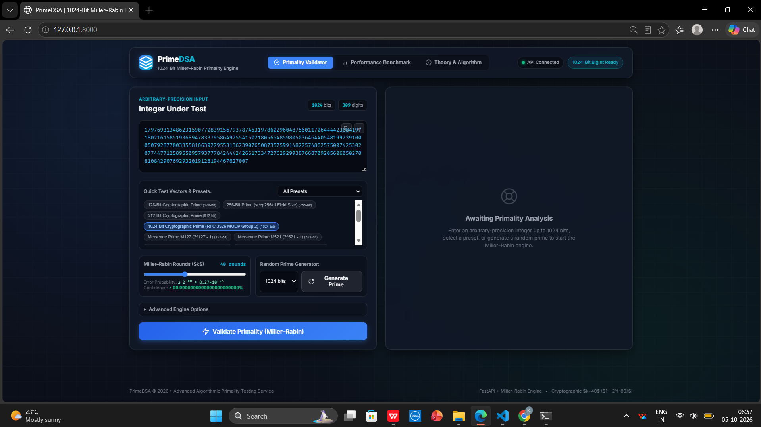
Figure 1: Primality Validator page with a 1024-bit input, 40 Miller–Rabin rounds and the random prime generator.
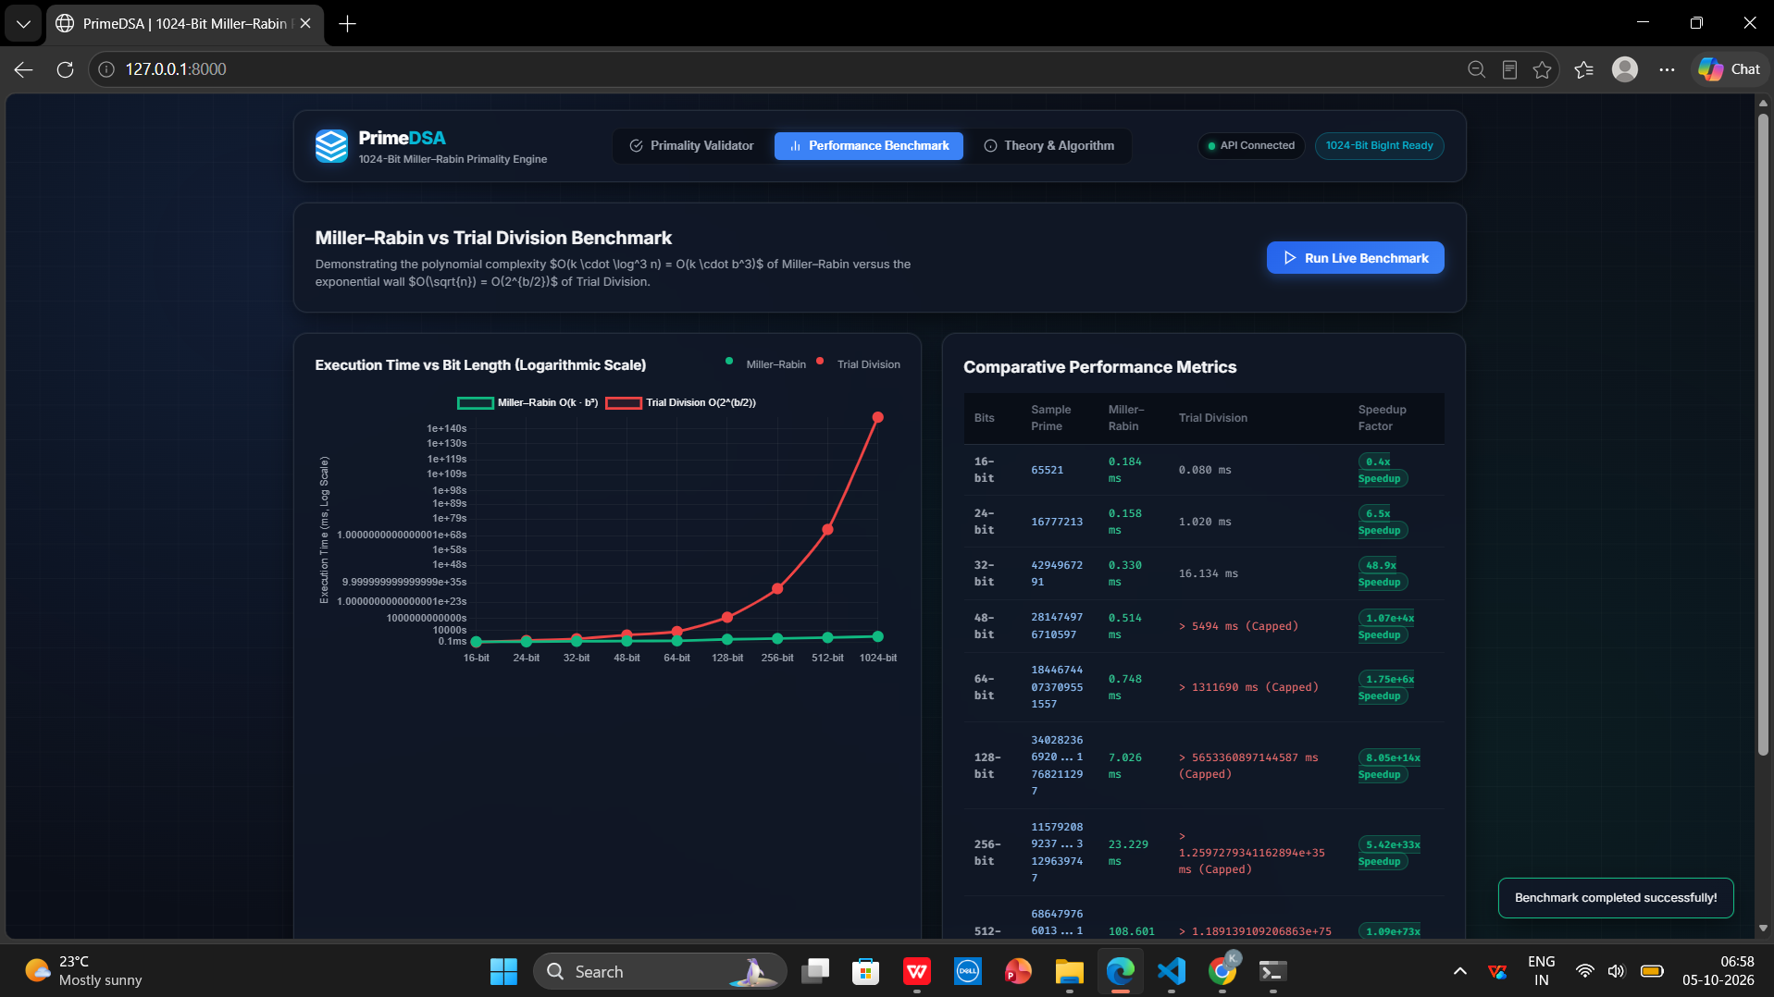
Figure 2: Performance Benchmark page comparing Miller–Rabin with trial division from 16 to 1024 bits.

Figure 3: Theory & Algorithm page explaining the mathematics, Carmichael numbers, error probability and complexity.
Observations
• For 16-bit numbers trial division is faster (0.080 ms against 0.184 ms for Miller–Rabin), because the numbers are tiny.
• From 24 bits onward Miller–Rabin wins (6.5× faster at 24 bits, 48.9× at 32 bits), and from 48 bits upward trial division hits the time cap while Miller–Rabin stays in milliseconds.
• Miller–Rabin time grows smoothly with bit length (about 0.7 ms at 64 bits and 7 ms at 128 bits), matching the O(k · b^3) analysis.
CONCLUSION
PrimeDSA shows that the Miller–Rabin algorithm makes primality testing of 1024-bit integers practical. It runs in polynomial time, handles Carmichael numbers correctly and has an error probability that can be made as small as 2^(−80) with k = 40 rounds. The benchmark confirms the gap between the polynomial Miller–Rabin test and the exponential trial division method. Possible future work includes testing 2048 and 4096-bit numbers, adding the Baillie–PSW test, and using the Chinese Remainder Theorem to speed up generation of RSA keys.
REFERENCES
• G. L. Miller, “Riemann’s Hypothesis and Tests for Primality,” Journal of Computer and System Sciences, vol. 13, no. 3, pp. 300–317, 1976.
• M. O. Rabin, “Probabilistic Algorithm for Testing Primality,” Journal of Number Theory, vol. 12, no. 1, pp. 128–138, 1980.
• T. H. Cormen, C. E. Leiserson, R. L. Rivest and C. Stein, Introduction to Algorithms, MIT Press, chapter on number-theoretic algorithms (primality testing).
• FastAPI documentation, https://fastapi.tiangolo.com
• RFC 3526, More Modular Exponential (MODP) Diffie-Hellman groups for Internet Key Exchange (IKE), IETF.

