Report for final project
Group Two
12311003 郭锦添
12310916 姜灿翔
12313555 凌莹
12412317 马嘉麒
(The authors are listed in alphabetical order by surname in pinyin. This order does not reflect the relative contributions of the authors.)
I. Overview
We chose Direction B, the "citation-conclusion inconsistency" experiment under scientific report generation task and used OpenClaw for the experiment. We removed related work of papers and gave the remaining papers to OpenClaw and asked OpenClaw to complete the related work and the corresponding references. We then compared them with the original papers' related work and corresponding references through the benchmark we built and manual correction. We used DeepXiv to collect real references from arXiv and other websites, scored the text generated by openclaw across multiple dimensions, and identified problems such as citation-conclusion inconsistency in the text generated by openclaw. We designed a total of 4 ablation experiments, showing the impact of different tools on agent capability from four perspectives: skill, memory, base model, and agent itself.
II. benchmark Construction
2.1 Construction of the benchmark dataset - RWGenBench-ICLR26
RWGenBench-ICLR26 dataset has been open-sourced on huggingface: LiberCamo/RWGenBench-ICLR26 · Datasets at Hugging Face
RWGenBench-ICLR26 is a high-quality benchmark dataset built from real ICLR 2026 papers for related work content and citation generation. We retained the main body of each paper, but removed the related work, body citation, and references from the body text, then separately saved the original related work and corresponding references to form paired input and target output data. The current final benchmark dataset contains 262 papers. The core files for each paper include:
- source.pdf: original paper PDF.
- source.tex: cleaned paper tex, with related work, citation, references, images, and tables removed.
- source_extracted.tex: main body fragment from abstract to before appendix.
- source_related_work.tex: complete related work section from the original paper.
- source_references.tex: references corresponding to citation in related work.
2.2 Construction of evaluation pipeline
Evaluation pipeline has been open-sourced on github: https://github.com/Spiritswin/RWEval
This is an evaluation pipeline for assessing the quality of related work and references automatically completed by OpenClaw. Its core goal is to compare the candidate related work and its references against the standard related work and its references, systematically identify content omissions, citation errors, insufficient citation support, overclaiming, structural organization problems and length redundancy, and output an overall score from 0-10 with submetric diagnostics. The project input consists of four parts:
- s_text: candidate related work to be evaluated.
- s_references: reference list corresponding to the candidate related work.
- g_text：ground-truth related work。
- g_references：ground-truth reference list。
The output includes a structured JSON report and a human-readable Markdown report. The project report can locate the following common issues:
- Missing points: Candidate does not cover important content in the gold related work.
- Hallucinated references: Reference does not match the real reference and may be fabricated or mismatched.
- Bibliographic accuracy issues: The title, authors, year, and other bibliographic information are inconsistent.
- Bad citation claim pairs: Citation cannot support the corresponding claim, or is only weakly related.
- Overclaim citation claim pairs: The strength, scope, causality, or degree of generalization of a claim exceeds the support range of the citation.
- Citation group support: whether multiple citation entries, as a group, can jointly support the complete claim.
- Topic structure issues: Paragraph topics are mixed, the topic order is unreasonable, or coverage is insufficient.
- Length conciseness issues: The length ratio is imbalanced, information density is low, or content is repetitive.
The scoring focuses on 7 main metrics, with an overall score range of 0-10:
Metric | Weight | Evaluation Focus
Content coverage | 0.17 | Whether it covers important content in the gold related work.
Citation quality | 0.35 | Weighted from five subitems.
Relevance | 0.08 | Whether candidate claims are relevant to the target task and gold content.
Thematic structure | 0.14 | Whether topic division and paragraph order are reasonable.
Synthesis quality | 0.10 | Whether it truly synthesizes prior work rather than simply listing papers.
Writing quality | 0.08 | Whether the clarity of academic expression and the accuracy of terminology are reasonable.
Length conciseness | 0.08 | Whether the length is appropriate, the information density is sufficient, and the content is repetitive or redundant.

Citation Subitem | Weight | Evaluation Focus
Citation validity | 0.25 | Whether the reference is real.
Citation appropriateness | 0.35 | Whether the citation can support the corresponding claim, and whether the claim exceeds the support range of the citation.
Citation coverage | 0.20 | Whether it covers important references in the gold set.
Citation placement | 0.10 | Whether the citation is placed near the claim it actually supports.
Citation topic consistency | 0.10 | Whether the citation topic is consistent with the topic of the claim.
III. Experimental Design
We selected 5 papers. For each paper, we conducted 4 ablation experiments: adding skill, adding memory, changing the base model behind openclaw, and changing agent itself.
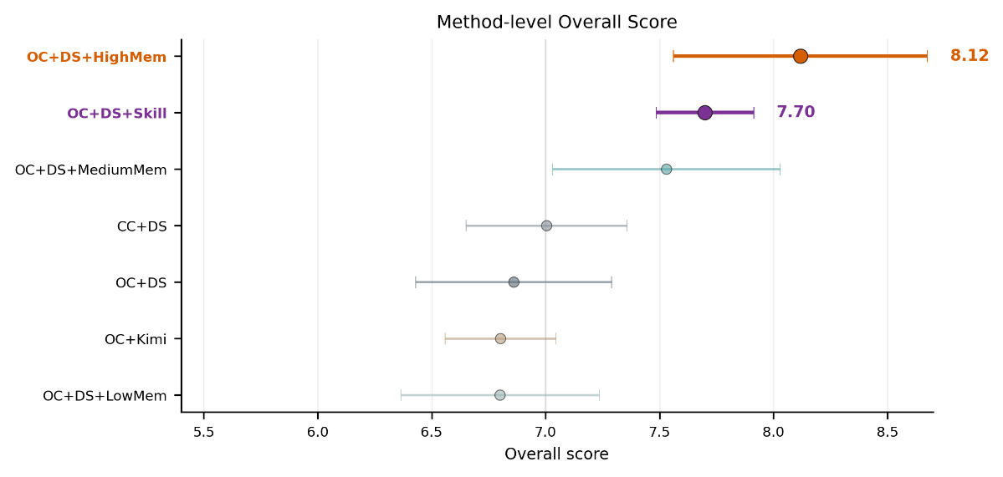
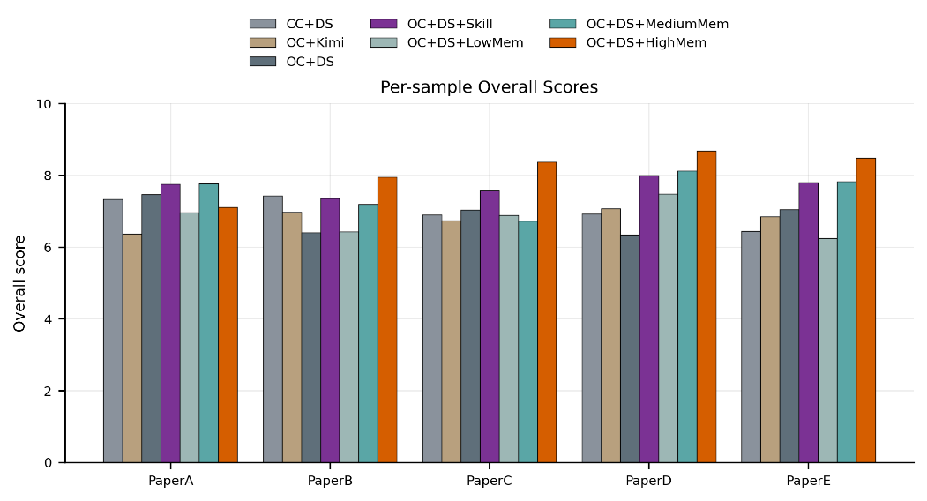
(OC-OpenClaw DS-DeepSeek CC-Claude Code Mem-Memory)
3.1 Baseline
Baseline is the OpenClaw + DeepSeek-V4-Pro result without skill or memory. Overall, baseline can identify most task topics, with average Relevance reaching 8.15, but average Content coverage is only 4.09 and average Citation quality is 7.04, indicating that it can write related work that looks reasonable but easily misses key references or has problems such as bad citation and overclaim.
Metric | paperA | paperB | paperC | paperD | paperE | Average
Overall | 7.47 | 6.40 | 7.04 | 6.34 | 7.05 | 6.86
Content coverage | 3.64 | 4.68 | 4.20 | 4.58 | 3.33 | 4.09
Citation quality | 9.11 | 5.00 | 7.79 | 5.00 | 8.28 | 7.04
Relevance | 8.33 | 8.59 | 8.09 | 7.50 | 8.24 | 8.15
Thematic structure | 8.57 | 8.35 | 8.25 | 8.17 | 7.65 | 8.20
Synthesis quality | 8.00 | 9.00 | 8.00 | 7.50 | 7.00 | 7.90
Writing quality | 8.00 | 9.50 | 8.50 | 8.50 | 8.00 | 8.50
Length conciseness | 7.58 | 4.21 | 4.02 | 7.96 | 6.44 | 6.04
Citation validity | 9.25 | 9.17 | 9.72 | 9.19 | 9.75 | 9.42
Citation appropriateness | 8.79 | 9.62 | 9.00 | 9.39 | 8.57 | 9.07
Citation coverage | 6.67 | 10.00 | 2.17 | 7.50 | 6.00 | 6.47
Citation placement | 9.39 | 9.72 | 8.22 | 8.61 | 7.71 | 8.73
Citation topic consistency | 9.26 | 9.72 | 9.49 | 9.70 | 8.71 | 9.38
In the Baseline experiment, the first typical error is that candidate does not cover important content in the gold related work. For example, paperA lacks key points such as ReAct, Chain-of-Retrieval, and DeepRAG that support the development of agentic retrieval, while paperE lacks the theme of using MLLM as an evaluator to score, filter, and provide feedback on agent trajectory.
The second typical error is citation-claim mismatch. In paperB, DeepSeek-Coder is used to support an RLVR-related claim, but the paper is mainly about code pretraining and generation and does not support that statement. In paperE, the Chain-of-Thought paper is used to support verification process, which also exceeds the paper's own content.
The third type of error is overclaim. In the Baseline experiment, openclaw extrapolates DeepSeek-R1's reinforcement learning results for reasoning to autonomous search or retrieval, or describes certain studies as first or substantially improved.
Therefore, the core problem exposed by baseline is that openclaw lacks a set of constraints and correction mechanisms: candidate paper screening, claim-citation alignment, citation data validation, and memory of the previous failure. The subsequent skill and memory are designed for these problems.
3.2 Ablation Experiment with skill
It turns related work generation from a normal writing task into a citation-grounded workflow. It requires candidate paper screening, reference validity checks, and citation-claim pair checks.
Metric | Setting | paperA | paperB | paperC | paperD | paperE | Average
Overall | Baseline | 7.47 | 6.40 | 7.04 | 6.34 | 7.05 | 6.86
 | Skill | 7.75 | 7.36 | 7.59 | 8.00 | 7.80 | 7.70
Content coverage | Baseline | 3.64 | 4.68 | 4.20 | 4.58 | 3.33 | 4.09
 | Skill | 4.71 | 4.32 | 3.18 | 4.12 | 5.42 | 4.35
Citation quality | Baseline | 9.11 | 5.00 | 7.79 | 5.00 | 8.28 | 7.04
 | Skill | 8.79 | 8.77 | 8.39 | 9.93 | 9.04 | 8.98
Relevance | Baseline | 8.33 | 8.59 | 8.09 | 7.50 | 8.24 | 8.15
 | Skill | 8.61 | 8.70 | 9.52 | 6.67 | 8.50 | 8.40
Thematic structure | Baseline | 8.57 | 8.35 | 8.25 | 8.17 | 7.65 | 8.20
 | Skill | 7.80 | 7.18 | 9.30 | 8.45 | 7.67 | 8.08
Synthesis quality | Baseline | 8.00 | 9.00 | 8.00 | 7.50 | 7.00 | 7.90
 | Skill | 7.50 | 6.50 | 8.50 | 7.50 | 9.00 | 7.80
Writing quality | Baseline | 8.00 | 9.50 | 8.50 | 8.50 | 8.00 | 8.50
 | Skill | 8.00 | 8.00 | 8.50 | 8.50 | 9.00 | 8.40
Length conciseness | Baseline | 7.58 | 4.21 | 4.02 | 7.96 | 6.44 | 6.04
 | Skill | 8.82 | 7.08 | 6.49 | 8.50 | 4.25 | 7.03
Citation validity | Baseline | 9.25 | 9.17 | 9.72 | 9.19 | 9.75 | 9.42
 | Skill | 9.70 | 9.73 | 9.75 | 9.70 | 9.71 | 9.72
Citation appropriateness | Baseline | 8.79 | 9.62 | 9.00 | 9.39 | 8.57 | 9.07
 | Skill | 10.00 | 9.47 | 9.91 | 10.00 | 9.74 | 9.82
Citation coverage | Baseline | 6.67 | 10.00 | 2.17 | 7.50 | 6.00 | 6.47
 | Skill | 4.33 | 5.33 | 2.61 | 10.00 | 7.14 | 5.88
Citation placement | Baseline | 9.39 | 9.72 | 8.22 | 8.61 | 7.71 | 8.73
 | Skill | 10.00 | 9.88 | 9.64 | 10.00 | 7.95 | 9.49
Citation topic consistency | Baseline | 9.26 | 9.72 | 9.49 | 9.70 | 8.71 | 9.38
 | Skill | 10.00 | 9.65 | 10.00 | 10.00 | 9.79 | 9.89
From the comparison, the average Overall score increases from 6.86 to 7.70, and the Citation quality score increases from 7.04 to 8.98, showing that the main benefit of skill is concentrated in citation quality. More importantly, if we analyze the Markdown reports for the 5 papers after adding skill, bad citation-claim pairs have disappeared, and overclaim citation claim pairs and citation group support issues are greatly reduced, indicating that skill is very effective at improving citation quality.
However, Content coverage remains the weakness. The skill group has an average Content coverage of 4.35, only 0.26 higher than baseline. For example, paperA still lacks key papers such as ReAct, Chain-of-Retrieval, and DeepRAG, and skill cannot eliminate overclaim. For example, paperB still has overclaim related to verbosity bias, ReAct, and others.
3.3 Ablation Experiment with memory
Memory-related files are stored in markdown form under workspace/memory, and long-term memory is also summarized by OpenClaw as MEMORY.md. The content is mainly retrospectives and lessons after previous related work generation problems.
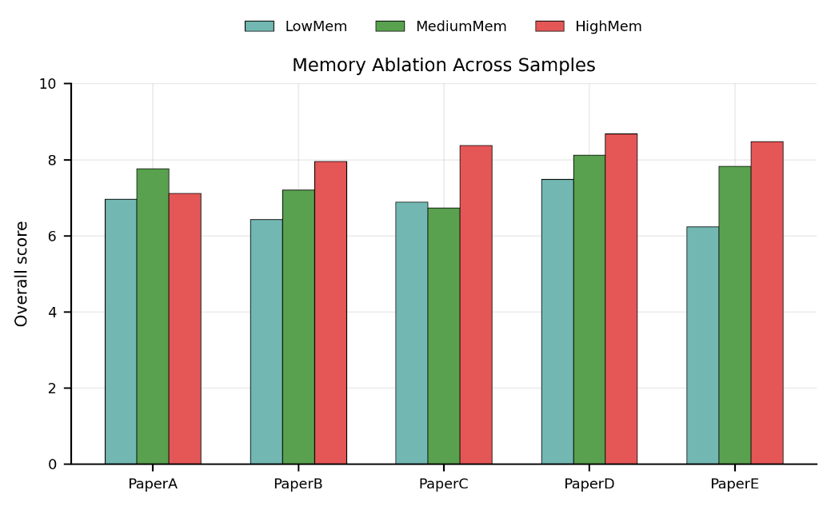
Metric | Setting | paperA | paperB | paperC | paperD | paperE | Average
Overall | Low memory | 6.96 | 6.43 | 6.89 | 7.48 | 6.24 | 6.80
 | Medium memory | 7.77 | 7.20 | 6.73 | 8.12 | 7.83 | 7.53
 | High memory | 7.11 | 7.95 | 8.37 | 8.68 | 8.48 | 8.12
Content coverage | Low memory | 4.61 | 2.57 | 4.38 | 3.71 | 0.53 | 3.16
 | Medium memory | 6.79 | 4.40 | 5.00 | 5.85 | 4.81 | 5.37
 | High memory | 2.69 | 7.27 | 7.11 | 7.26 | 6.39 | 6.14
Citation quality | Low memory | 6.10 | 8.43 | 8.31 | 8.73 | 8.88 | 8.09
 | Medium memory | 8.85 | 9.38 | 8.36 | 8.63 | 8.96 | 8.84
 | High memory | 7.31 | 9.33 | 8.03 | 9.05 | 9.62 | 8.67
Relevance | Low memory | 10.00 | 7.69 | 9.48 | 7.22 | 7.50 | 8.38
 | Medium memory | 9.76 | 6.79 | 9.52 | 6.61 | 8.75 | 8.29
 | High memory | 8.21 | 7.50 | 10.00 | 9.05 | 7.50 | 8.45
Thematic structure | Low memory | 7.94 | 2.14 | 9.18 | 8.20 | 7.55 | 7.00
 | Medium memory | 2.85 | 6.79 | 0.00 | 9.32 | 9.04 | 5.60
 | High memory | 8.17 | 3.18 | 8.75 | 8.62 | 9.43 | 7.63
Synthesis quality | Low memory | 7.50 | 6.50 | 2.50 | 7.50 | 3.50 | 5.50
 | Medium memory | 9.00 | 5.00 | 8.00 | 8.50 | 6.00 | 7.30
 | High memory | 9.00 | 9.00 | 8.50 | 9.00 | 7.00 | 8.50
Writing quality | Low memory | 9.00 | 8.50 | 5.50 | 8.00 | 8.00 | 7.80
 | Medium memory | 9.00 | 7.00 | 9.00 | 9.00 | 8.50 | 8.50
 | High memory | 9.00 | 9.50 | 9.00 | 9.00 | 8.50 | 9.00
Length conciseness | Low memory | 8.24 | 5.24 | 6.32 | 8.48 | 4.99 | 6.65
 | Medium memory | 8.97 | 7.66 | 8.35 | 8.83 | 7.94 | 8.35
 | High memory | 8.37 | 9.21 | 9.44 | 9.37 | 9.03 | 9.08
Citation validity | Low memory | 8.00 | 10.00 | 10.00 | 9.44 | 10.00 | 9.49
 | Medium memory | 10.00 | 10.00 | 10.00 | 9.17 | 10.00 | 9.83
 | High memory | 10.00 | 9.55 | 10.00 | 9.23 | 9.55 | 9.67
Citation appropriateness | Low memory | 5.17 | 8.89 | 9.79 | 9.37 | 9.86 | 8.62
 | Medium memory | 9.31 | 10.00 | 9.06 | 8.60 | 10.00 | 9.39
 | High memory | 7.88 | 9.18 | 8.26 | 9.64 | 9.86 | 8.96
Citation coverage | Low memory | 5.88 | 4.84 | 2.40 | 6.25 | 4.62 | 4.80
 | Medium memory | 6.00 | 6.92 | 4.00 | 8.24 | 4.81 | 5.99
 | High memory | 2.67 | 8.82 | 4.74 | 7.08 | 8.95 | 6.45
Citation placement | Low memory | 5.39 | 8.96 | 9.00 | 8.63 | 10.00 | 8.40
 | Medium memory | 9.46 | 10.00 | 9.50 | 7.93 | 10.00 | 9.38
 | High memory | 7.12 | 9.55 | 8.32 | 9.86 | 10.00 | 8.97
Citation topic consistency | Low memory | 5.72 | 9.57 | 10.00 | 9.74 | 10.00 | 9.01
 | Medium memory | 9.46 | 10.00 | 9.44 | 8.87 | 10.00 | 9.55
 | High memory | 8.12 | 9.73 | 8.63 | 9.64 | 9.91 | 9.21
The role of memory is not to give OpenClaw a fixed prompt, but to convert the previous failure into an executable checklist of experience. For example, paperA's memory explicitly states “No search = document the limitation”, “Verify every citation”, and “Each distinct work needs its own verified reference”, while paperC's memory requires “Never attribute the input paper's own claims to a citation” and “Never miscategorize a paper's domain”. This experience directly changes subsequent behavior, and the trend is visible in the results: Overall increases from Low memory's 6.80 to Medium memory's 7.53 and then to High memory's 8.12. Content coverage increases from 3.16 to 5.37 and then to 6.14. This shows that memory affects Content coverage more clearly than skill.
However, memory still cannot replace tool retrieval or completely eliminate citation errors. In the High memory experiment on paperA, it still uses AutoSearch for claims related to β-GRPO and length penalty, while still missing key works such as Chain-of-Retrieval and DeepRAG. On the other hand, memory can inherit and even amplify imprecise statements from previous work. In paperC's High memory experiment, although Content coverage increases to 7.11, 4 bad citation claim pairs appear. For example, the CoAT paper does not support the statement overfitting to limited reasoning patterns.
3.4 Ablation Experiments Replacing the Model and agent itself
This group of experiments does not add skill or memory and only changes the underlying model and agent itself.

Metric | Setting | paperA | paperB | paperC | paperD | paperE | Average
Overall | OpenClaw + DeepSeek | 7.47 | 6.40 | 7.04 | 6.34 | 7.05 | 6.86
 | Claude Code + DeepSeek | 7.33 | 7.43 | 6.90 | 6.92 | 6.44 | 7.00
 | OpenClaw + Kimi | 6.37 | 6.98 | 6.74 | 7.07 | 6.85 | 6.80
Content coverage | OpenClaw + DeepSeek | 3.64 | 4.68 | 4.20 | 4.58 | 3.33 | 4.09
 | Claude Code + DeepSeek | 4.73 | 3.80 | 3.81 | 1.52 | 2.74 | 3.32
 | OpenClaw + Kimi | 5.00 | 3.33 | 2.17 | 5.62 | 3.41 | 3.91
Citation quality | OpenClaw + DeepSeek | 9.11 | 5.00 | 7.79 | 5.00 | 8.28 | 7.04
 | Claude Code + DeepSeek | 9.63 | 9.39 | 7.16 | 8.29 | 7.95 | 8.48
 | OpenClaw + Kimi | 5.00 | 8.52 | 7.74 | 8.78 | 8.30 | 7.67
Relevance | OpenClaw + DeepSeek | 8.33 | 8.59 | 8.09 | 7.50 | 8.24 | 8.15
 | Claude Code + DeepSeek | 8.71 | 6.86 | 8.33 | 5.26 | 8.64 | 7.56
 | OpenClaw + Kimi | 6.15 | 9.66 | 8.70 | 6.19 | 9.06 | 7.95
Thematic structure | OpenClaw + DeepSeek | 8.57 | 8.35 | 8.25 | 8.17 | 7.65 | 8.20
 | Claude Code + DeepSeek | 8.80 | 7.95 | 8.79 | 8.30 | 7.43 | 8.25
 | OpenClaw + Kimi | 8.64 | 7.53 | 8.66 | 8.08 | 7.76 | 8.13
Synthesis quality | OpenClaw + DeepSeek | 8.00 | 9.00 | 8.00 | 7.50 | 7.00 | 7.90
 | Claude Code + DeepSeek | 9.00 | 7.00 | 6.50 | 8.50 | 5.00 | 7.20
 | OpenClaw + Kimi | 7.50 | 5.50 | 7.50 | 8.00 | 6.50 | 7.00
Writing quality | OpenClaw + DeepSeek | 8.00 | 9.50 | 8.50 | 8.50 | 8.00 | 8.50
 | Claude Code + DeepSeek | 9.50 | 8.50 | 8.50 | 9.00 | 8.00 | 8.70
 | OpenClaw + Kimi | 8.00 | 7.50 | 8.50 | 8.00 | 8.50 | 8.10
Length conciseness | OpenClaw + DeepSeek | 7.58 | 4.21 | 4.02 | 7.96 | 6.44 | 6.04
 | Claude Code + DeepSeek | 7.02 | 5.69 | 6.42 | 7.55 | 3.99 | 6.13
 | OpenClaw + Kimi | 8.52 | 8.44 | 6.20 | 8.75 | 5.32 | 7.45
Citation validity | OpenClaw + DeepSeek | 9.25 | 9.17 | 9.72 | 9.19 | 9.75 | 9.42
 | Claude Code + DeepSeek | 10.00 | 9.66 | 9.50 | 10.00 | 9.29 | 9.69
 | OpenClaw + Kimi | 9.52 | 10.00 | 10.00 | 10.00 | 10.00 | 9.90
Citation appropriateness | OpenClaw + DeepSeek | 8.79 | 9.62 | 9.00 | 9.39 | 8.57 | 9.07
 | Claude Code + DeepSeek | 9.91 | 9.70 | 9.50 | 8.20 | 8.57 | 9.18
 | OpenClaw + Kimi | 5.17 | 9.95 | 9.05 | 8.31 | 9.20 | 8.34
Citation coverage | OpenClaw + DeepSeek | 6.67 | 10.00 | 2.17 | 7.50 | 6.00 | 6.47
 | Claude Code + DeepSeek | 8.42 | 8.18 | 2.00 | 5.88 | 4.44 | 5.78
 | OpenClaw + Kimi | 7.00 | 2.73 | 1.00 | 5.71 | 3.50 | 3.99
Citation placement | OpenClaw + DeepSeek | 9.39 | 9.72 | 8.22 | 8.61 | 7.71 | 8.73
 | Claude Code + DeepSeek | 9.82 | 9.70 | 9.61 | 8.60 | 8.71 | 9.29
 | OpenClaw + Kimi | 5.13 | 10.00 | 9.16 | 9.38 | 9.30 | 8.59
Citation topic consistency | OpenClaw + DeepSeek | 9.26 | 9.72 | 9.49 | 9.70 | 8.71 | 9.38
 | Claude Code + DeepSeek | 9.95 | 9.77 | 10.00 | 8.80 | 8.71 | 9.45
 | OpenClaw + Kimi | 5.35 | 9.95 | 9.53 | 7.44 | 9.50 | 8.35
Claude Code + DeepSeek does not stably outperform baseline. Although its average performance on the overall metric is better than baseline, from the perspective of individual papers, it only outperforms baseline on the overall metric for paperB and paperD, while it is weaker than baseline on the other three papers. This result shows that switching to a stronger agent cannot solve the problem of related work generation.
OpenClaw + Kimi's average Overall is 6.80, slightly lower than baseline, while Citation quality improves from 7.04 to 7.67. However, paperA has 12 bad citation-claim pairs and the Citation quality metric is only 5.00. The overall average Content coverage is 3.91, lower than baseline's 4.09.
Therefore, simply replacing the agent or model can only bring local changes and cannot stably solve the fundamental problem in the related work generation task. In contrast, skill and memory are more direct ablation variables and improve task completion more strongly.
3.5 Summary
This group of ablation experiments leads to a clear conclusion: OpenClaw baseline already has strong topic recognition capability, but lacks the constraints and accumulated historical experience required for reliable citation generation. Its problems are concentrated in content coverage, bad citation claim pairs, and overclaim citation claim pairs.
The value of skill is to turn the task into a workflow. It significantly reduces erroneous citations, especially by eliminating all bad citation-claim pairs, and average Citation quality improves by 1.94. It can improve citation quality, but has limited help for content coverage.
The value of memory is to turn failures into experience. As memory increases, Overall and Content coverage improve significantly and missing points decrease substantially, but the High memory experiment also proves that more experience does not automatically mean citation problems will not occur. Without constraints like skill and with only memory, there is no guarantee that openclaw will not have citation problems.
Replacing the model or agent has the most unstable effect. The average overall metrics of the Claude Code + DeepSeek experiment is slightly higher than baseline while the average overall metrics of the OpenClaw + Kimi experiment is slightly lower than baseline. They show that agent itself and the model cannot replace constraints and memory mechanisms.

Combine skill + memory: use skill for hard constraints and citation safety, and use memory for cross-round coverage correction. Only by combining them is it more likely to improve citation reliability and content coverage at the same time.
IV. OOD（灿翔）
V. Group Contributions:
郭锦添: completed baseline, skill ablation experiment, kimi ablation experiment, and poster production
姜灿翔: ood and poster production
凌莹: evaluation pipeline and slide production
马嘉麒: benchmark dataset production, completed memory ablation experiment, claude code ablation experiment, and report production

