EXPERIMENT 1

BASIC LINUX COMMANDS

Name : Ananth Anand P.B
Reg No. : 21BCE1576
Slot : L

COMMANDS:

- ifconfig

You can use the ifconfig command to assign an address to a network interface and to configure or display the current network interface configuration information. The ifconfig command must be used at system startup to define the network address of each interface present on a system.

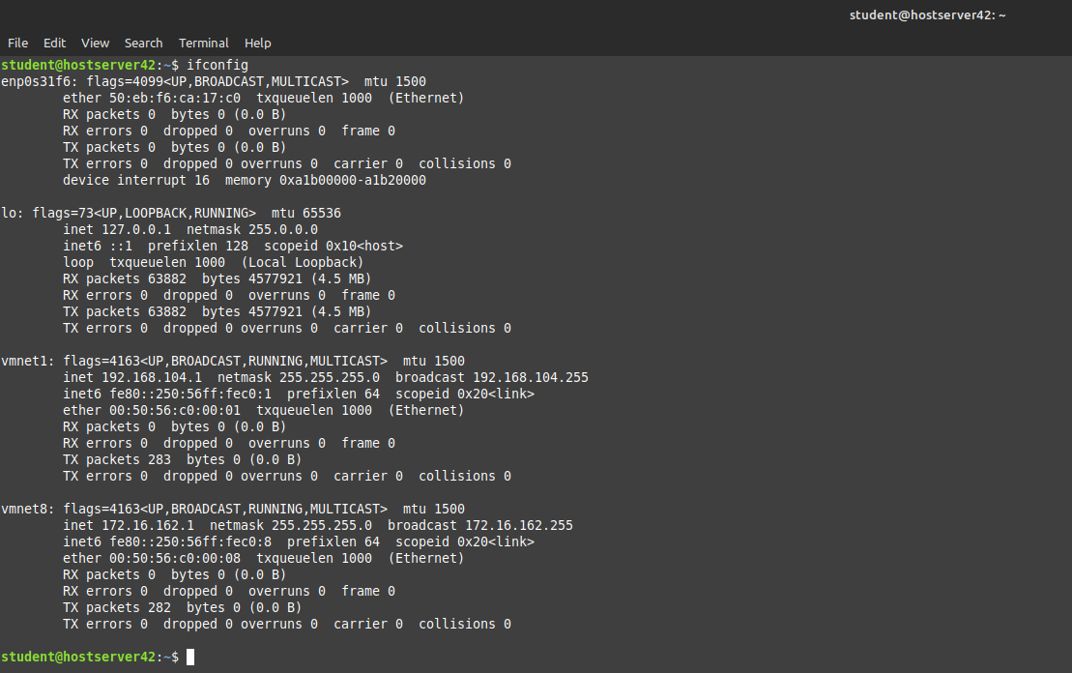

- ip

The ip command in Linux is a powerful tool that not only displays the current IP address of a system but also allows you to view and manage the current configuration of network interfaces, IP addresses, routes, and ARP tables.

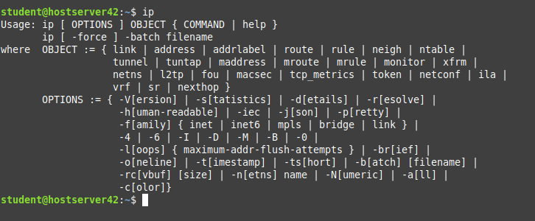

- ping

With the Linux ping command, we can also access the time duration for sending and receiving responses from a network. It works by sending a series of Internet Control Message Protocol (ICMP) messages to the target host and waiting for an ICMP echo message from and to the host and Device.
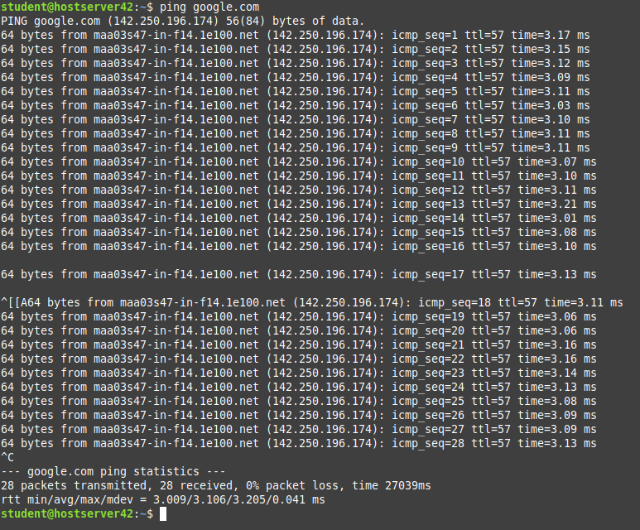

- dig

The dig (domain information groper) command is a flexible tool for interrogating DNS name servers. It performs DNS lookups and displays the answers that are returned from the queried name server(s).

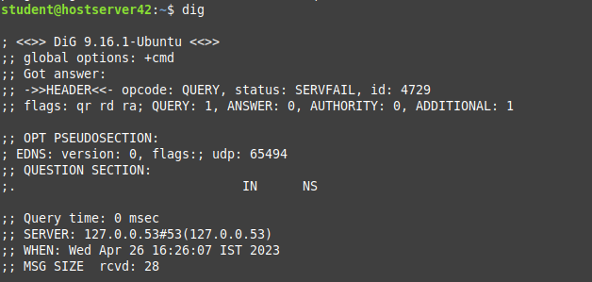

- traceroute

The tracert command (in Windows) or traceroute command (in Linux or Mac) is a network analysis tool that can be used to know the path a packet goes through or follows from the source to destination.

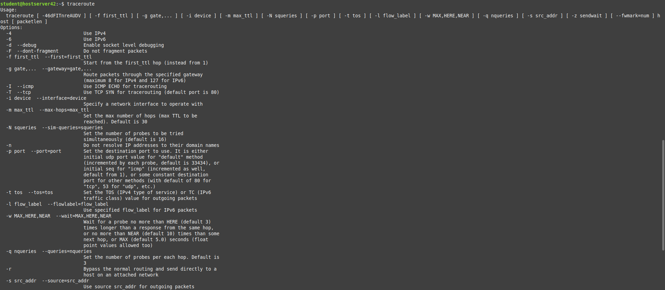

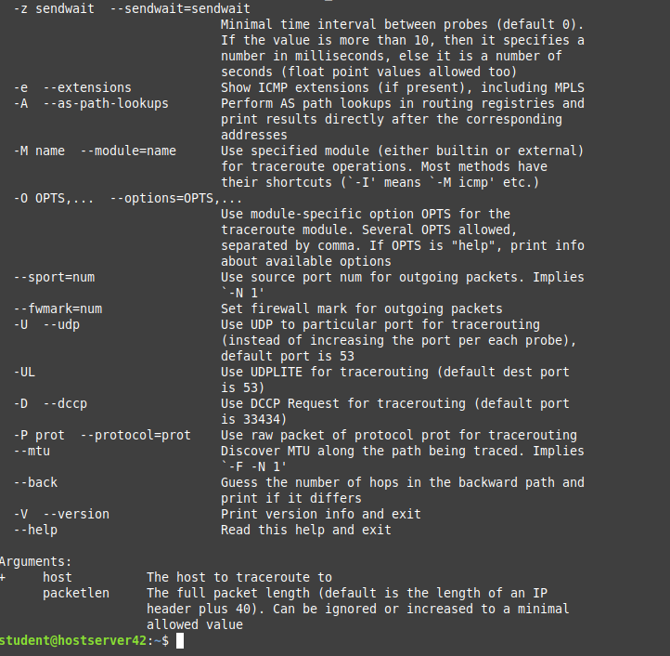

- tracepath

The tracepath command is used to trace the path from the origin to the destination. Each line in the tracepath output represents a router (hop) that the packet passes through.

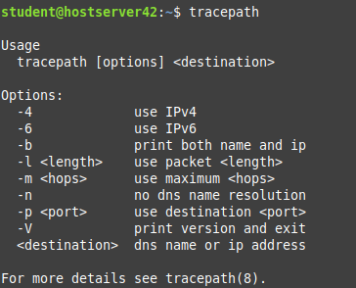

- netstat

The netstat command generates displays that show network status and protocol statistics. You can display the status of TCP and UDP endpoints in table format, routing table information, and interface information. The most frequently used options for determining network status are: s , r , and i .

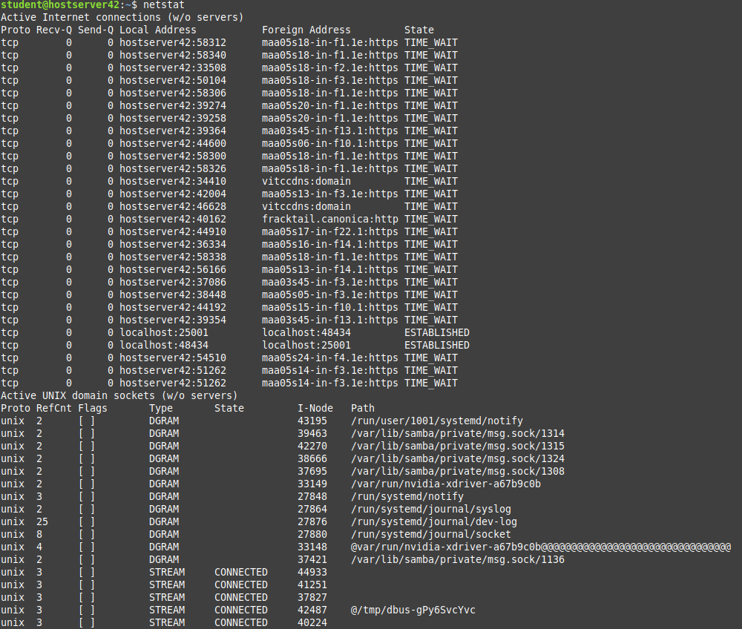
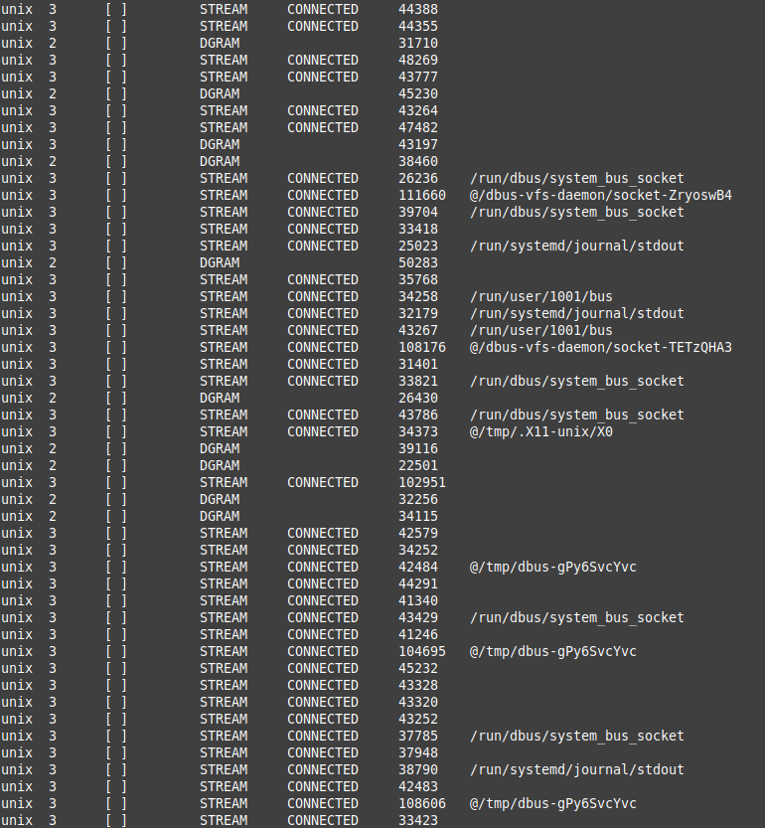

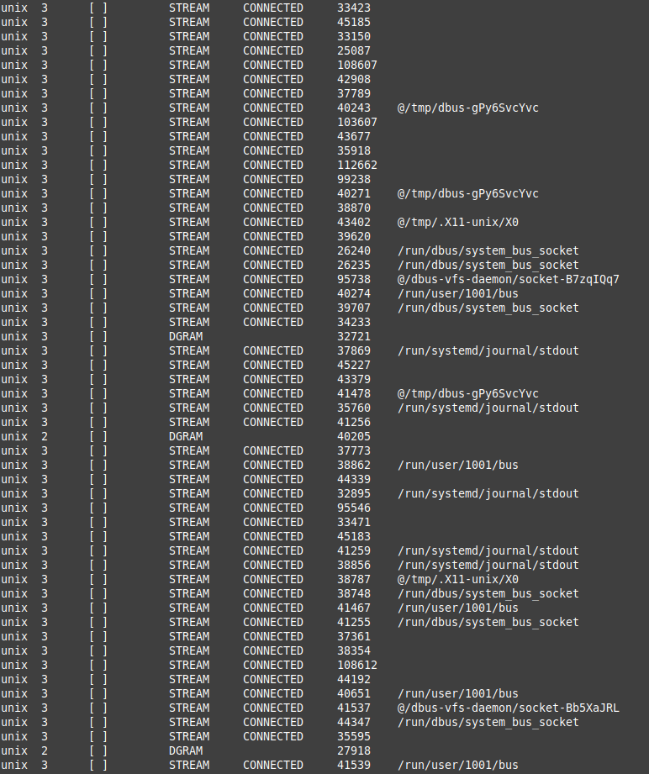

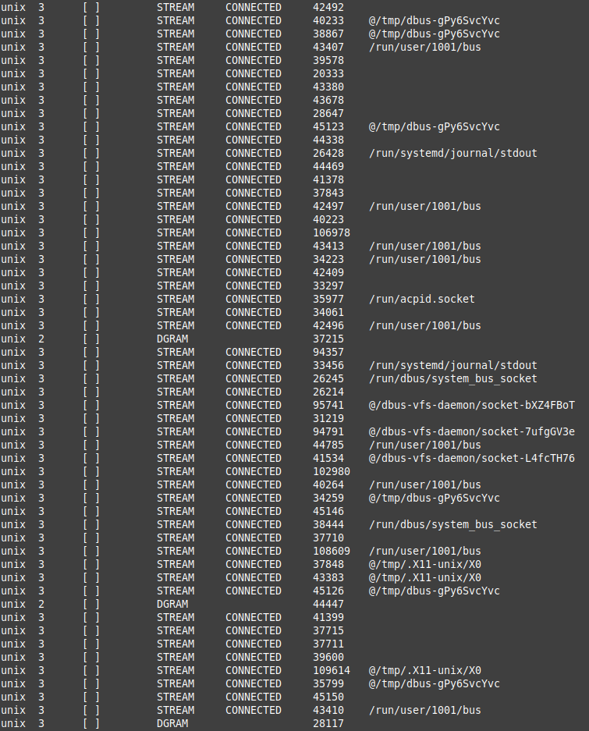

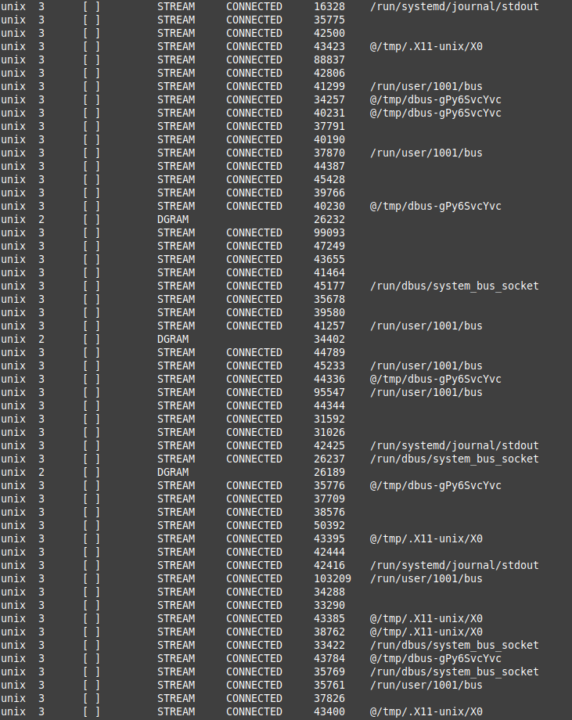

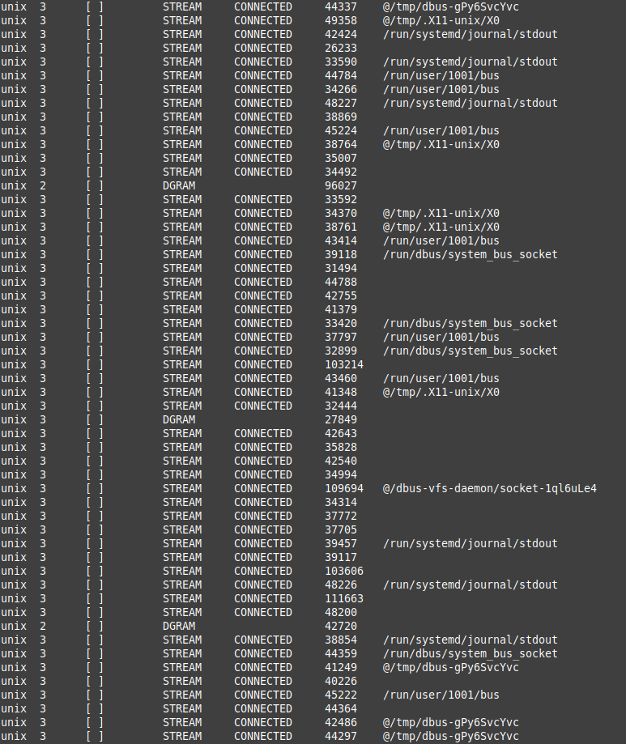

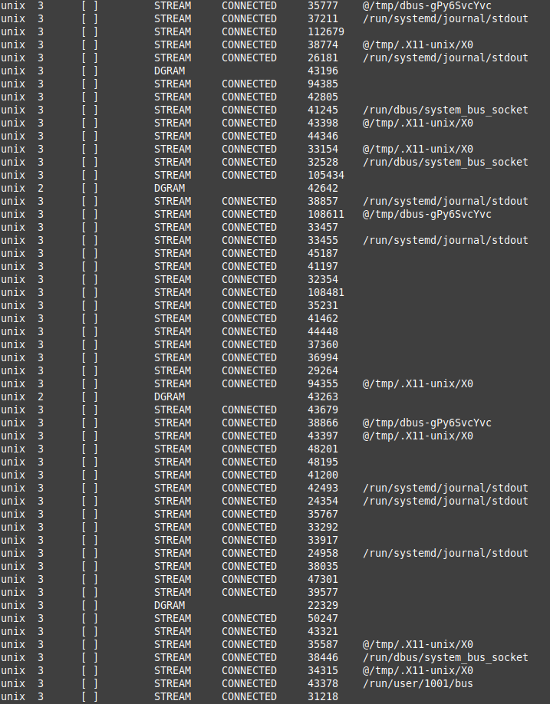

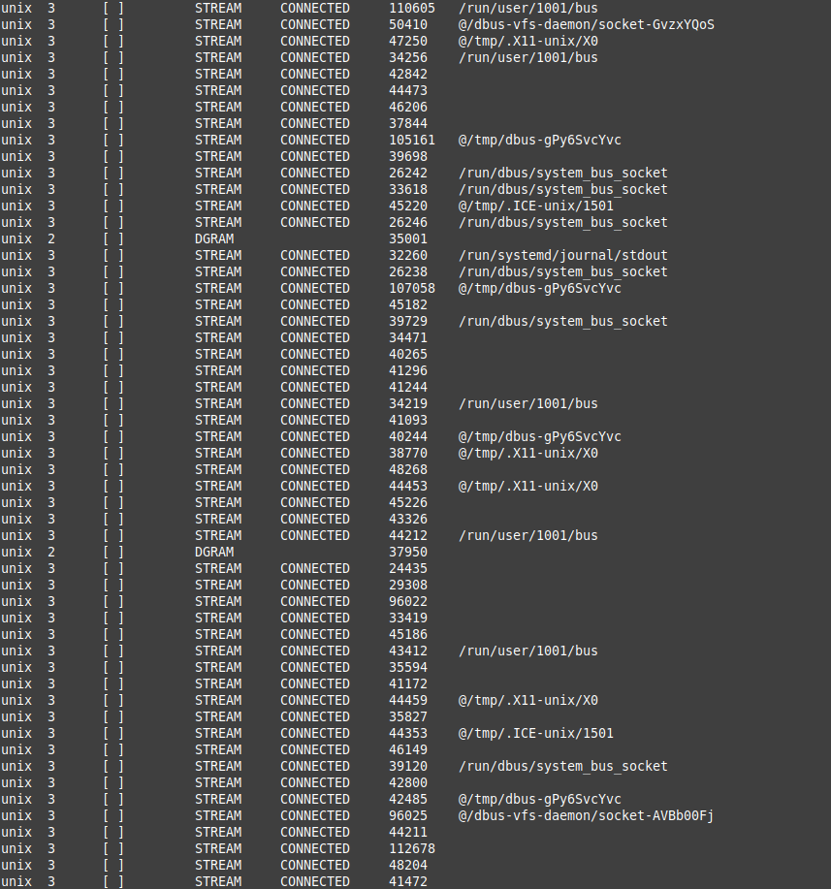

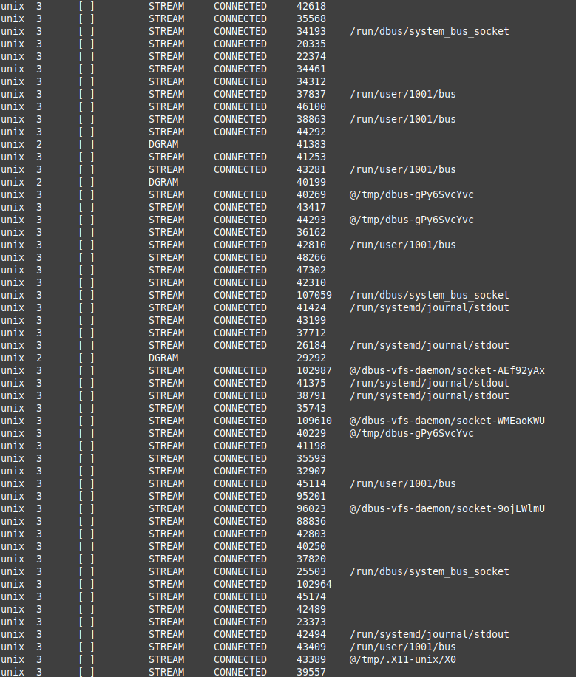

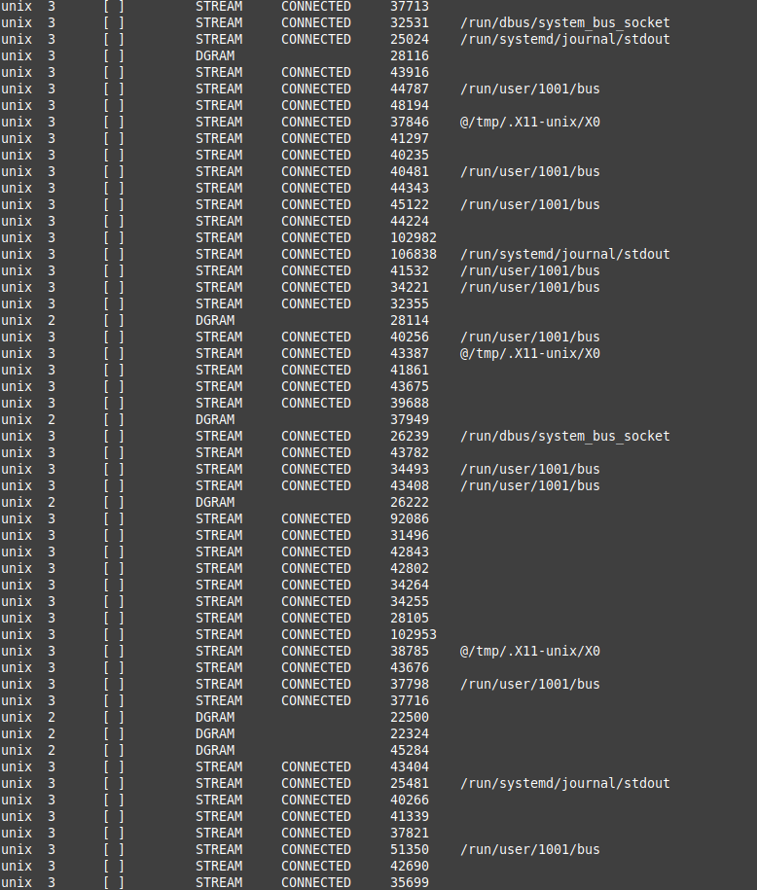

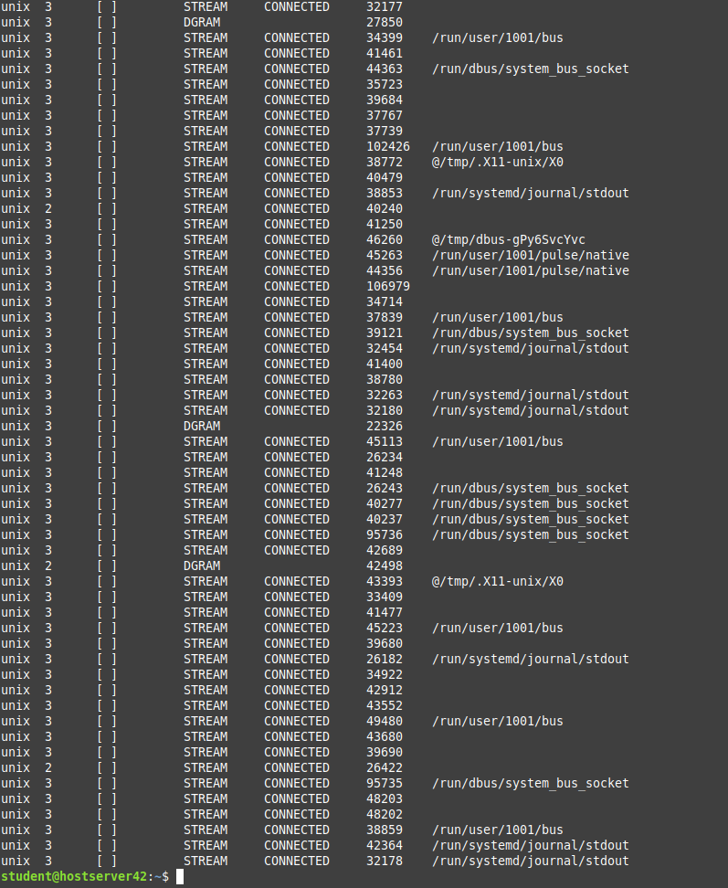

- ss
The ss command on Linux systems can provide extensive details on the sockets that provide communications between systems. The ss command is used to dump socket statistics on Linux systems. It serves as a replacement for the netstat command and is often used for troubleshooting network problems.

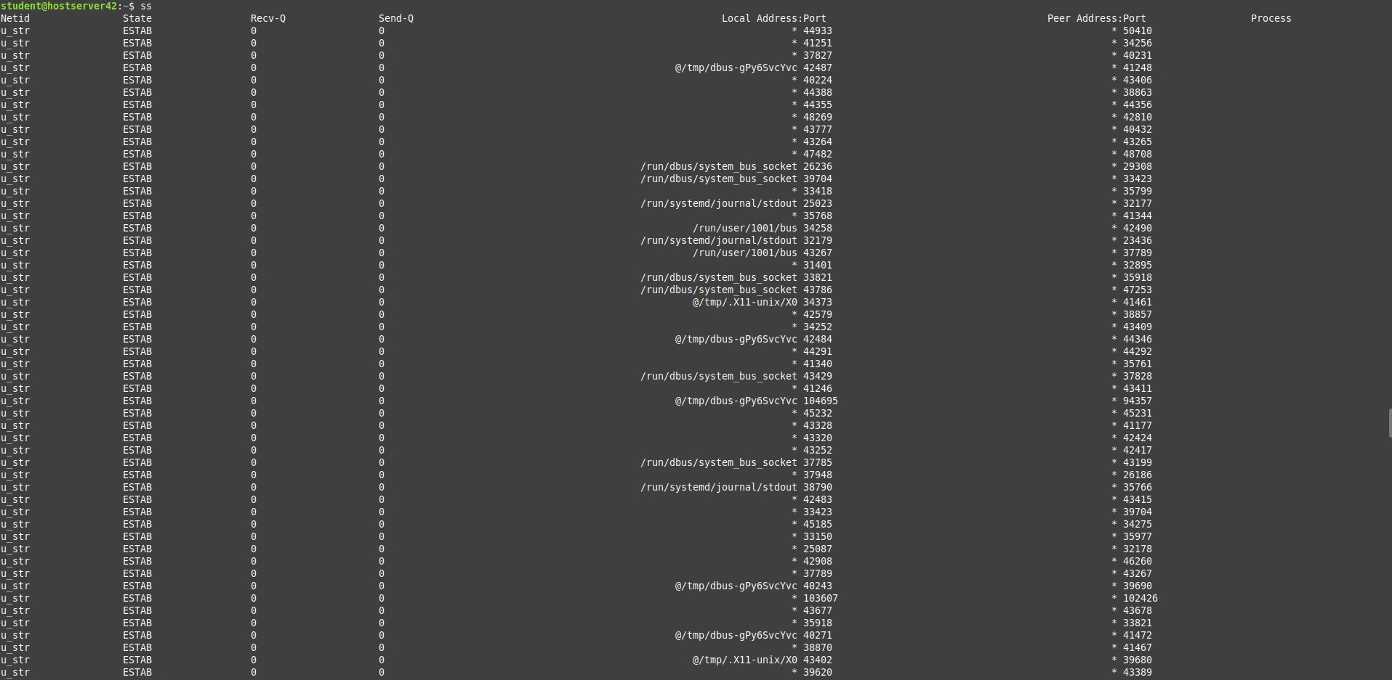
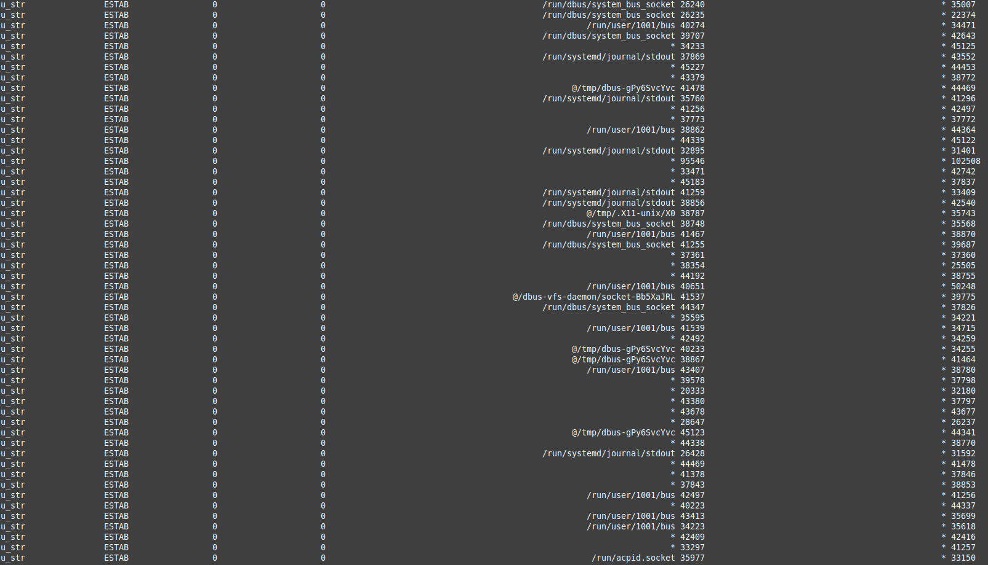

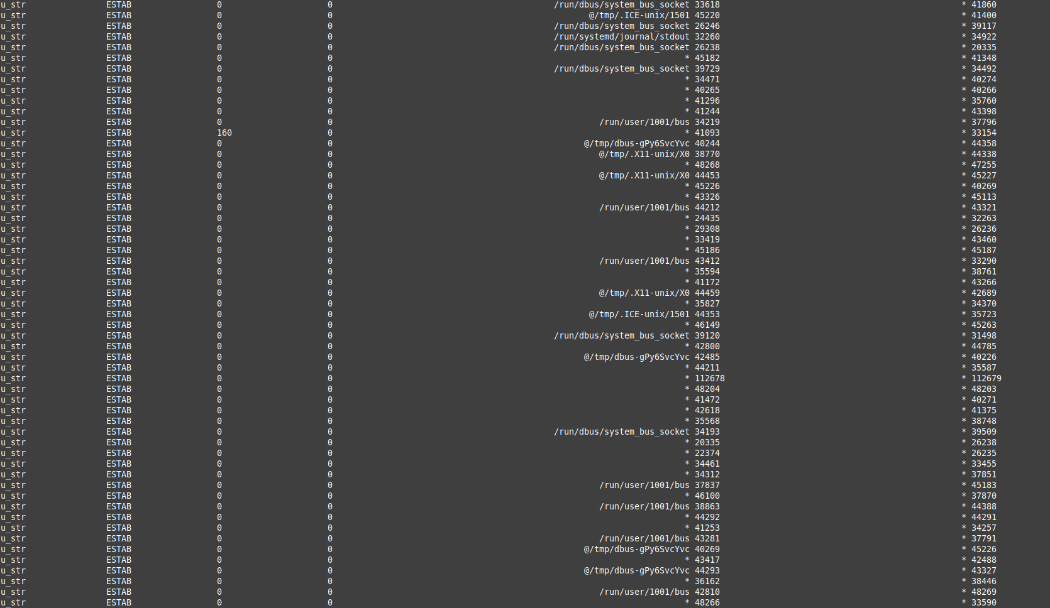

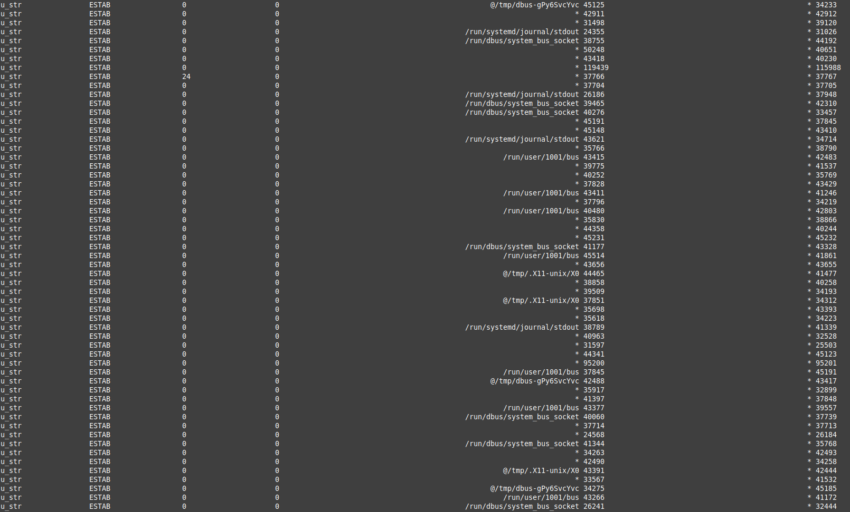

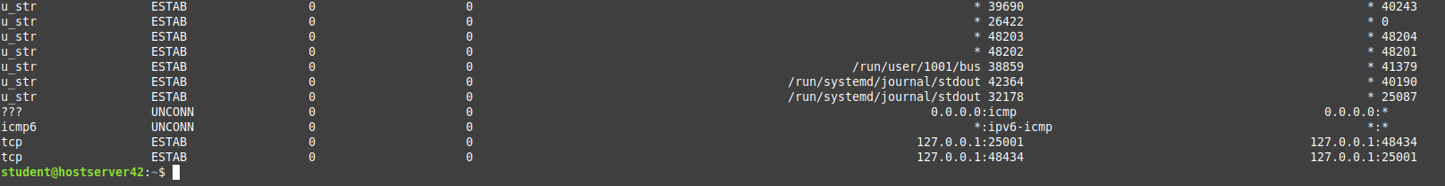

- nslookup

The nslookup command queries internet domain name servers in two modes. Interactive mode allows you to query name servers for information about various hosts and domains, or to print a list of the hosts in a domain. In noninteractive mode, the names and requested information are printed for a specified host or domain.

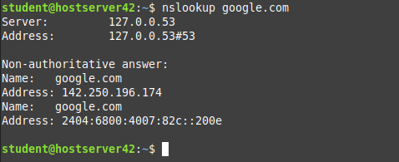

- route
route command in Linux is used when you want to work with the IP/kernel routing table. It is mainly used to set up static routes to specific hosts or networks via an interface. It is used for showing or update the IP/kernel routing table.

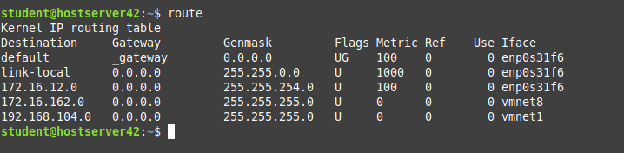

- host

Linux host command displays domain name for given IP address or vice-versa. It also performs DNS lookups related to the DNS query. The host command's default behavior displays a summary of its command-line arguments and supported options.

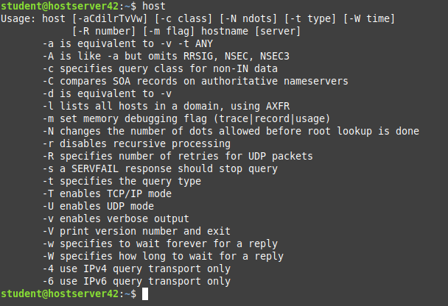

- arp

The arp command displays and modifies the Internet-to-adapter address translation tables used by the Address in Networks and communication management. The arp command displays the current ARP entry for the host specified by the HostName variable.

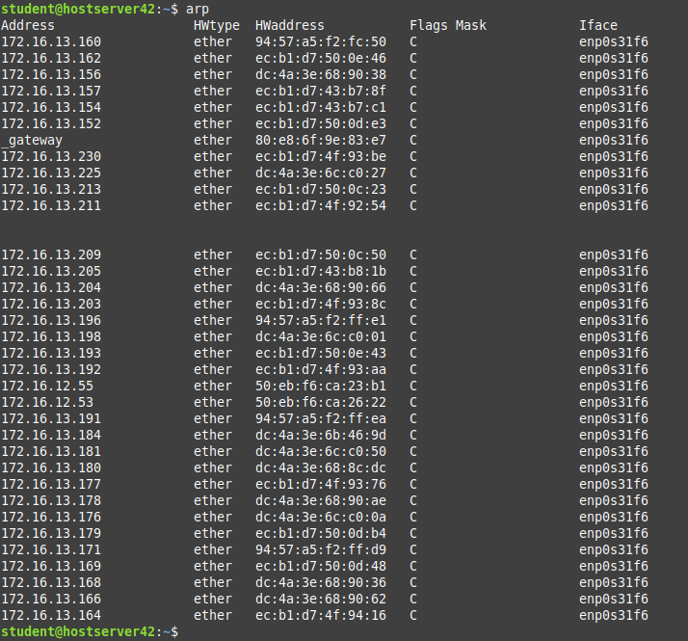

- iwconfig

iwconfig command in Linux is like ifconfig command, in the sense it works with kernel-resident network interface but it is dedicated to wireless networking interfaces only. It is used to set the parameters of the network interface that are particular to the wireless operation like SSID, frequency etc. iwconfig may also be used to display the parameters, and the wireless statistics which are extracted from /proc/net/wireless.

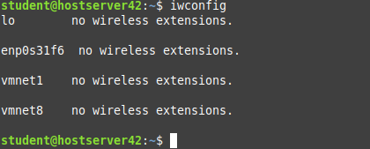

- hostname
he /usr/bin/hostname command displays the name of the current host system. Only users with root user authority can set the host name. The mkdev command and the chdev commands also set the host name permanently.
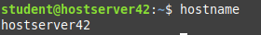

- curl

curl is a command-line tool to transfer data to or from a server, using any of the supported protocols (HTTP, FTP, IMAP, POP3, SCP, SFTP, SMTP, TFTP, TELNET, LDAP, or FILE). Curl is powered by Libcurl. This tool is preferred for automation since it is designed to work without user interaction. curl can transfer multiple files at once.

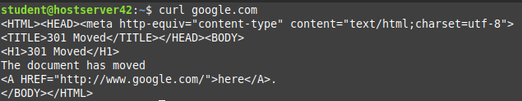

- Wget
Wget is the non-interactive network downloader which is used to download files from the server even when the user has not logged on to the system and it can work in the background without hindering the current process.

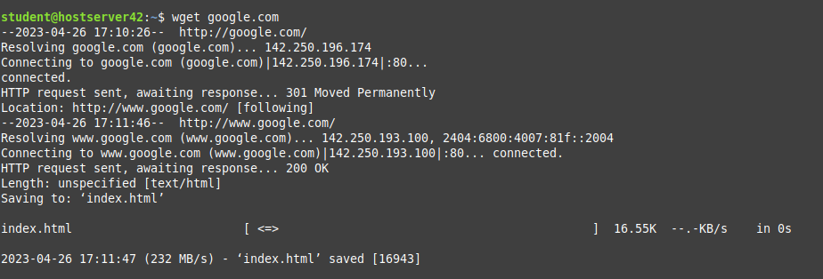

- mtr
The mtr command is a combination of ping and traceroute commands. It is a network diagnostic tool that continuously sends packets showing ping time for each hop. It also displays network problems of the entire route taken by the network packets.

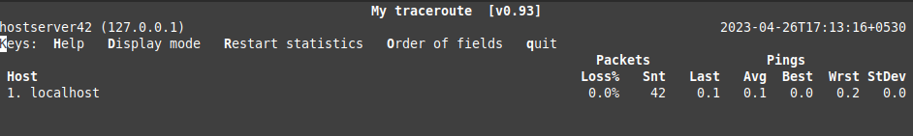

- whois
The /usr/bin/whois command searches a user name directory and displays information about the user ID or nickname specified in the Name parameter.

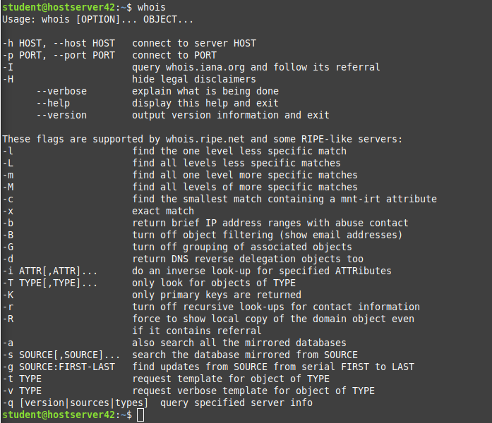

- Ifplugstatus

This command tells us whether a cable is plugged into our network interface or not.

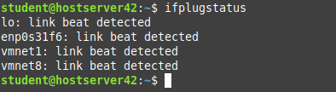

- iftop

iftop is a network analyzing tool used by system administrators to view the bandwidth related stats. It shows a quick overview of the networking activities on an interface.

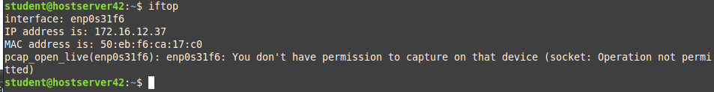

- Tcpdump

tcpdump is a data-network packet analyzer computer program that runs under a command line interface. It allows the user to display TCP/IP and other packets being transmitted or received over a network to which the computer is attached.



