Information Security Analysis and Audit

Experiment-1

Name: V. Shreya
Register Number: 21BCE5614

Cisco Packet Tracer

Using Hub:

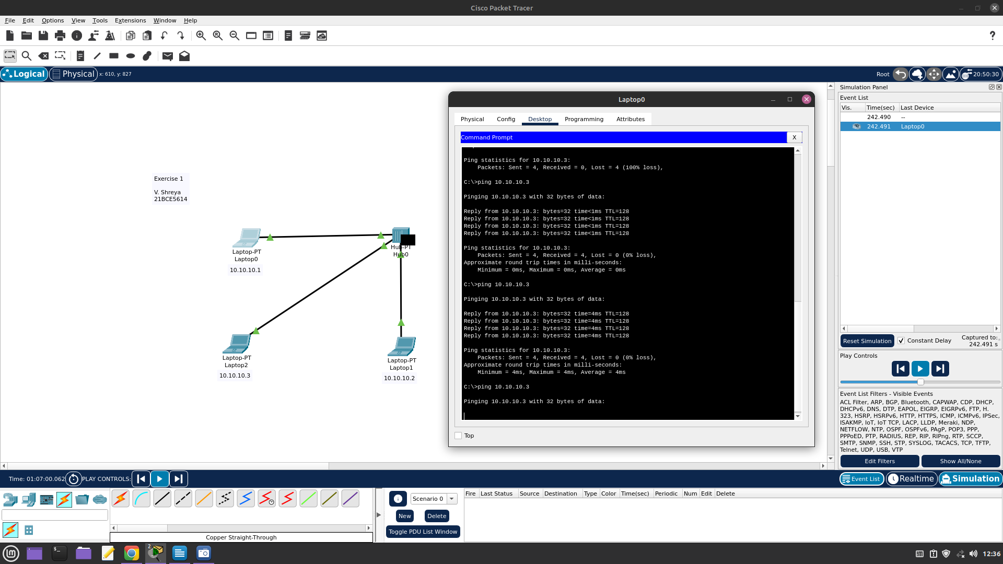

Using Switch:

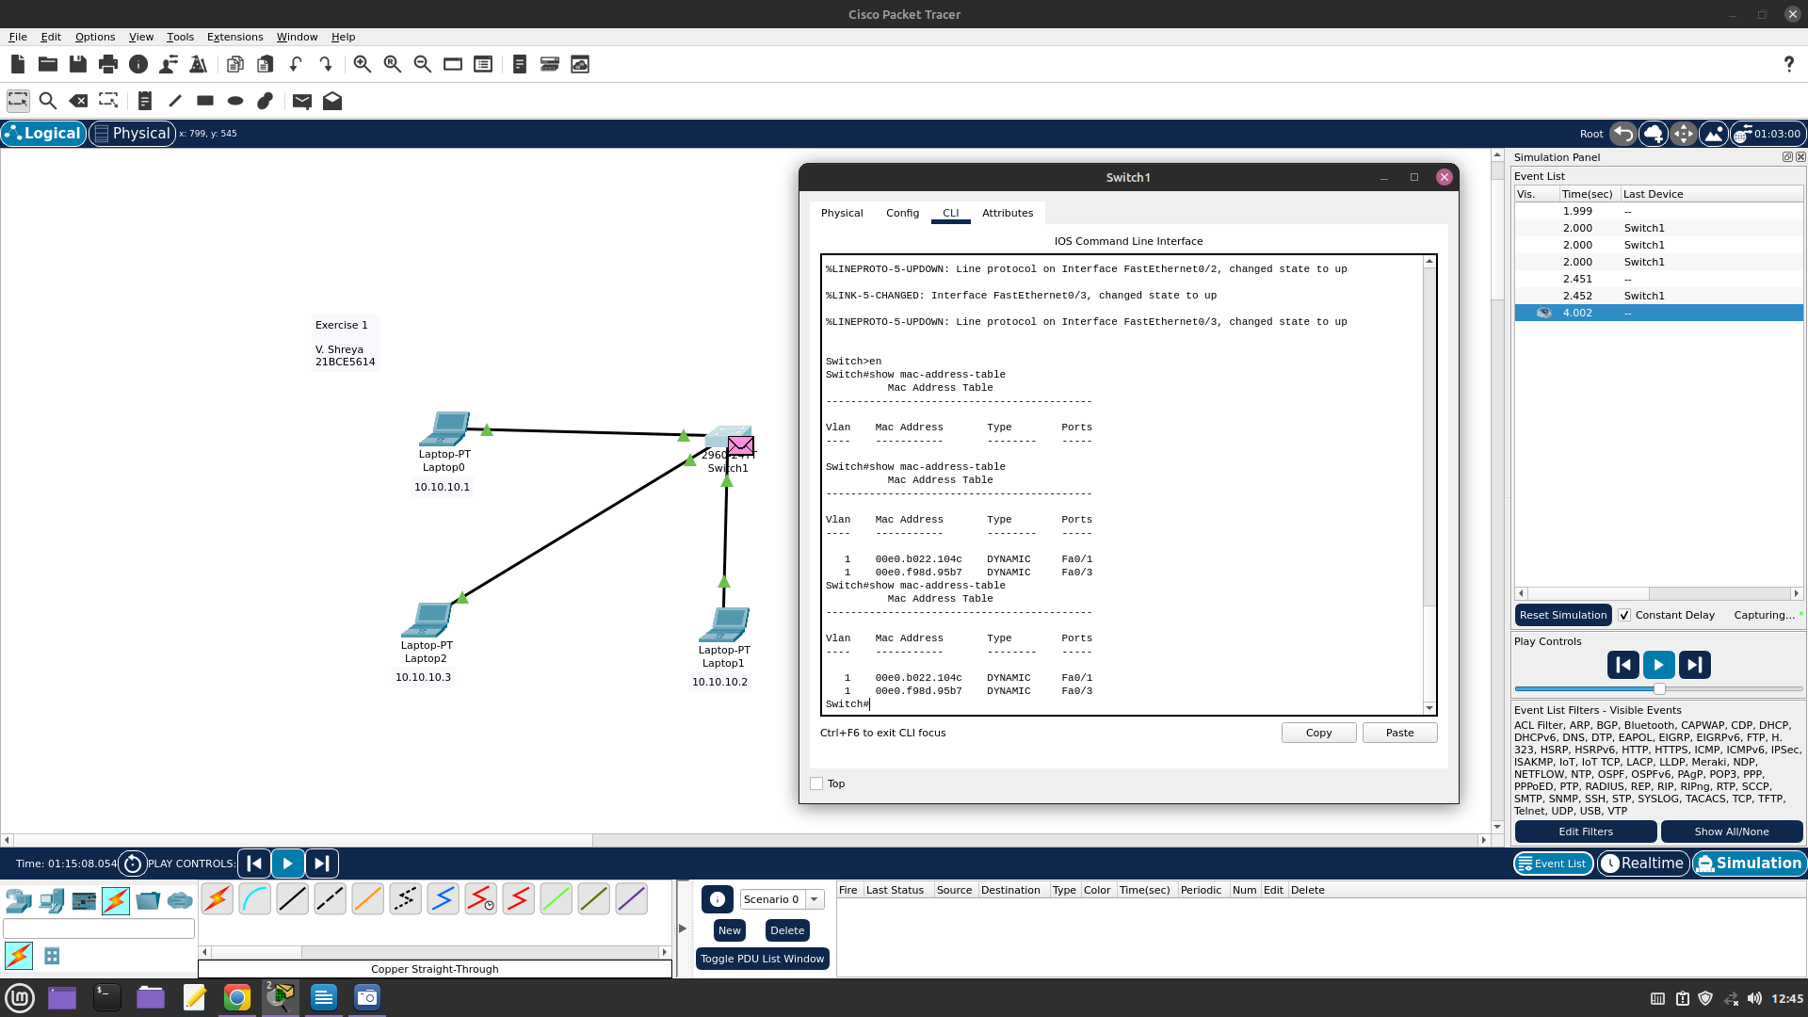
Using Router:

