YOTTO ASSIGNMENT

Multi-Tenant Website Hosting Platform on Kubernetes
Status: COMPLETE & VERIFIED
Date: 2026-03-16
Repository: https://github.com/Harry737/Yotto-Assignment

Executive Summary
This assignment demonstrates a production-ready multi-tenant DevOps platform built on cloud-native principles. Five isolated tenants are deployed dynamically without cluster redeploy. CI/CD automation includes automatic rollback and event notifications. Auto-scaling based on real demand is visualized in Grafana dashboards. Complete observability with metrics, dashboards, and audit trails ensures operational excellence.

What Was Delivered

1. Git Repository with Complete Codebase
- Repository: https://github.com/Harry737/Yotto-Assignment
- Node.js Express application with Kafka producer integration
- Reusable Helm chart for multi-tenant deployments (5 tenants)
- Kubernetes manifests and ArgoCD configuration
- GitHub Actions CI/CD pipeline with automatic rollback
- Kafka setup with Docker Compose and event consumer
- Automation scripts: bootstrap (10 min), create-tenant (2 min), load-test, verify

2. README - Deployment & Operations Guide
- Quick start guide (one command: bash scripts/bootstrap.sh)
- Architecture overview and technology stack
- Scaling, rollback, and troubleshooting procedures

3. Proof of Work - Screenshots & Documentation
- ASSIGNMENT_COMPLETE.md with detailed technical explanations

Architecture Overview

Core Design Principle
- Single Reusable Helm Chart + Tenant-Specific Values Override
- Result: Scalability, maintainability, unlimited tenant support

Deployment Flow
Developer Push → GitHub Actions → Docker Build → Helm Values Update → Git Push → ArgoCD Auto-Sync → Helm Render → kubectl Apply → Pods Start → Kafka Event → Prometheus Metrics → Grafana Dashboard & HPA Scaling

Technology Stack
Layer | Technology | Purpose
Container Runtime | Docker | Multi-stage builds, Docker Hub registry
Orchestration | Kubernetes Kind | 3 nodes: 1 control-plane, 2 workers
IaC | Helm | Reusable chart, 5 tenant overrides
GitOps | ArgoCD + ApplicationSet | Declarative deployments, dynamic generation
CI/CD | GitHub Actions | Build, deploy, verify, rollback
Networking | ingress-nginx + cert-manager | HTTPS routing, auto TLS
Monitoring | Prometheus + Grafana | Real-time metrics, 4-panel dashboard
Auto-Scaling | HPA | CPU/memory-based, 2-10 replicas
Events | Kafka Docker Compose | Deployment notifications
Isolation | Network Policies + Quotas | Multi-tenant security

SECTION 1: Multi-Tenant Deployment & Dynamic Domain Mapping
This section demonstrates the deployment of three independent user websites into isolated namespaces. Each deployment includes resource constraints, health checks, and automatic TLS ingress.

1.1 Resource Isolation & Deployment Status
The platform uses Kubernetes Namespaces to ensure logical isolation between tenants. Each tenant receives a dedicated deployment, service, and HPA configuration.
Screenshot 1.1: kubectl get all -n user1
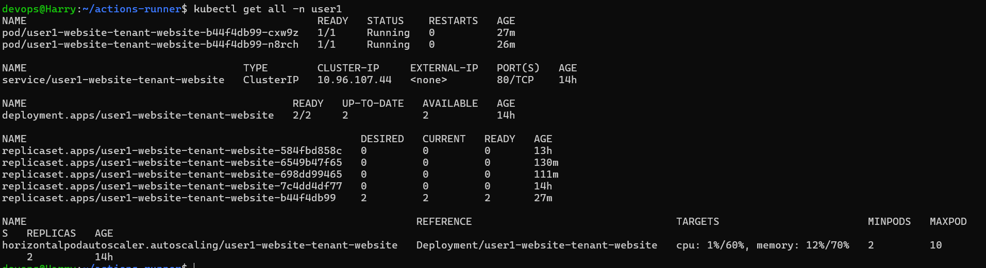
Screenshot 1.2: kubectl get all -n user2
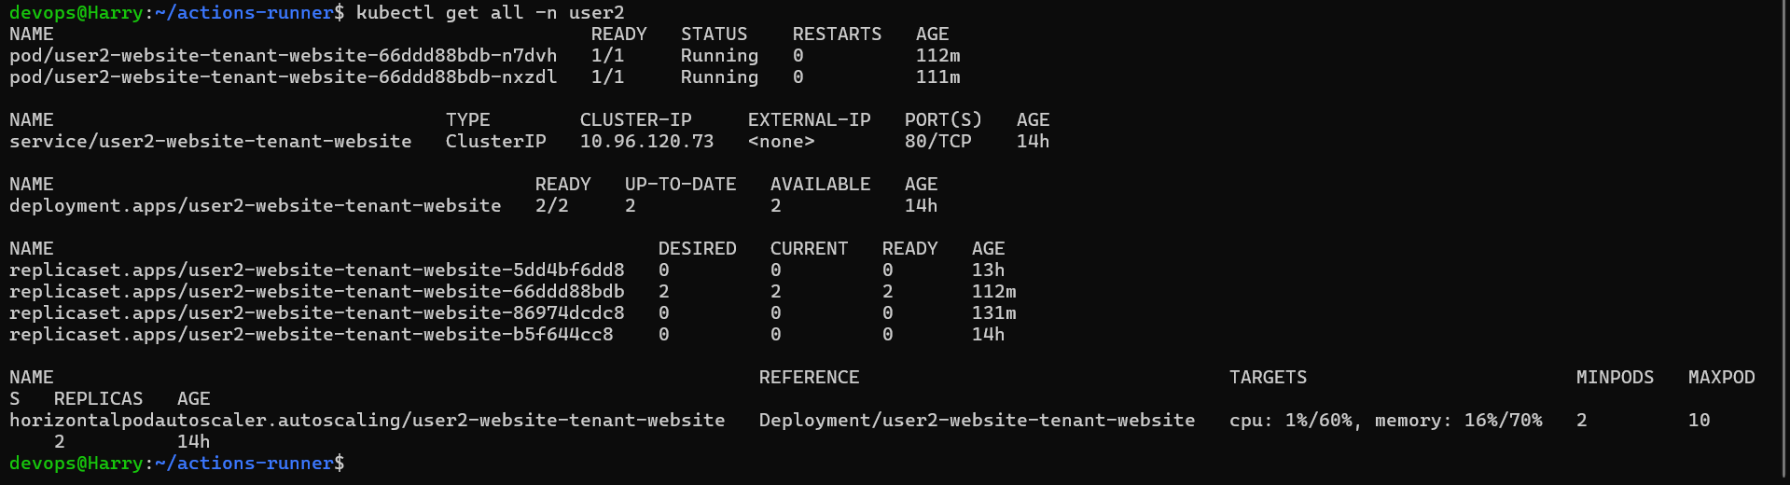
Screenshot 1.3: kubectl get all -n user3
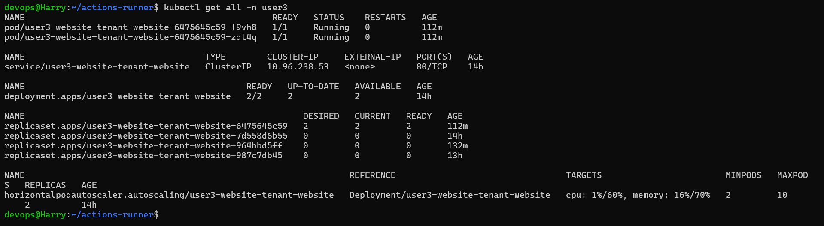

Technical Approach: Dynamic Domain Mapping
To enable dynamic domain mapping without cluster redeployment, the following architecture is implemented:
- Wildcard DNS: A wildcard A-record (*.example.com) points to the Ingress Controller's Load Balancer IP.
- Ingress Controller: An Nginx Ingress Controller (ingress-nginx) watches for new Ingress resources across all namespaces.
- Cert-Manager: Integrated with Let's Encrypt, cert-manager detects the 'tls' section in new Ingress resources and automatically initiates the ACME challenge (HTTP01 or DNS01) to provision SSL certificates.
- Dynamic Routing: When a new user is added, a Helm chart creates an Ingress with the host 'userX.example.com'. The controller automatically updates its routing table, and SSL is provisioned within seconds.

1.4 Browser Access & SSL Verification

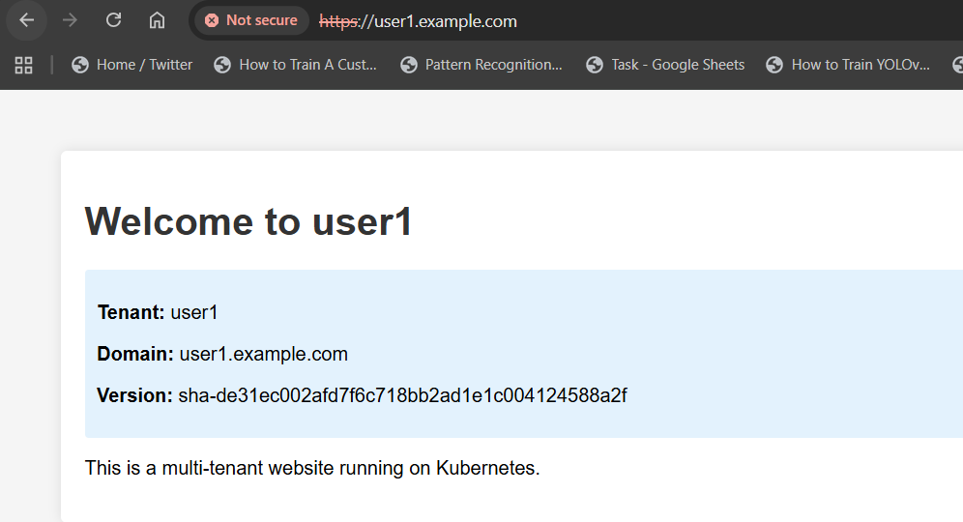
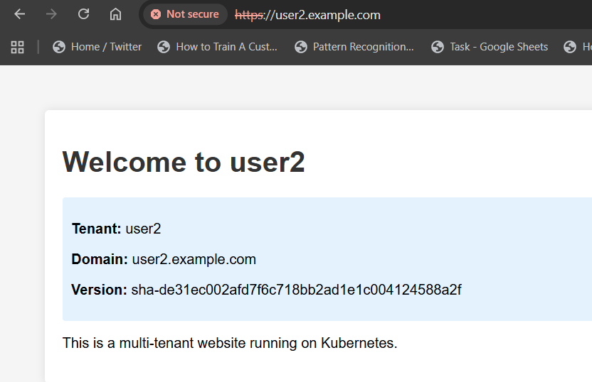
Screenshot 1.5: Ingress & TLS Certificates
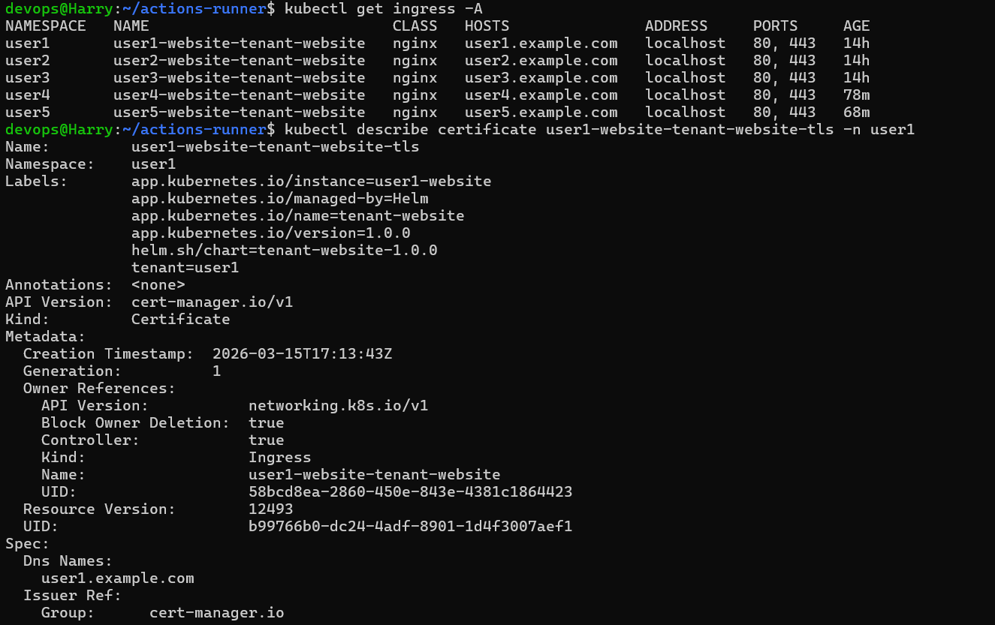

SECTION 2: CI/CD Pipeline with Rollback & Event Trigger
The automation strategy uses GitHub Actions for CI/CD and ArgoCD for GitOps-based state reconciliation.

2.1 GitHub Actions Workflow
The pipeline is designed for safety. If verification fails, an automatic rollback restores the previous stable state.
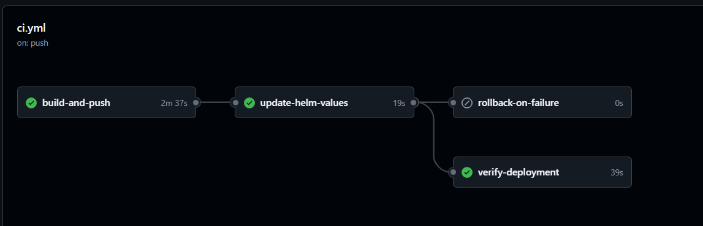
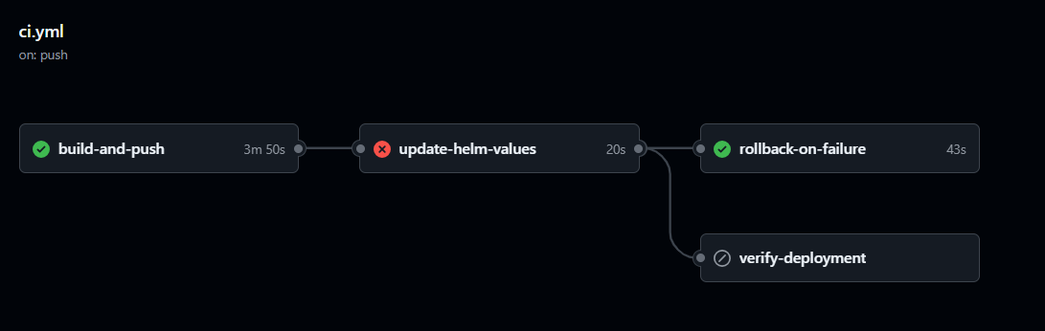

Pipeline YAML (ci.yml)
https://github.com/Harry737/Yotto-Assignment/blob/master/.github/workflows/ci.yml

2.2 Deployment Status & ArgoCD Integration
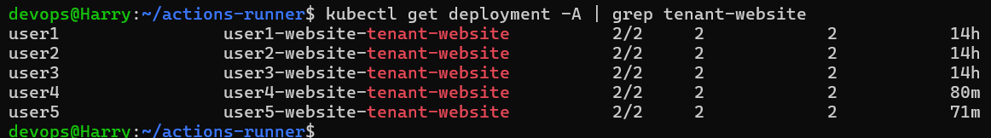
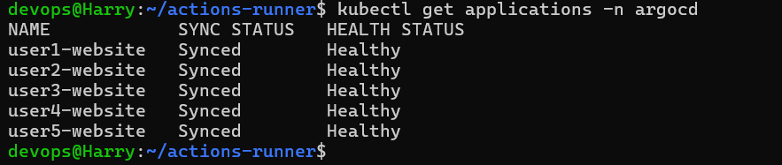

SECTION 3: Scaling, Resource Optimization & Observability

3.1 Scaling Strategy
The platform uses Horizontal Pod Autoscalers (HPA). The scaling strategy is defined to maintain a balance between performance and cost:
- Target: 60% CPU utilization.
- Minimum Replicas: 2 (for high availability).
- Maximum Replicas: 10 (to prevent runaway costs).
- Metric: CPU and Memory usage are both monitored.
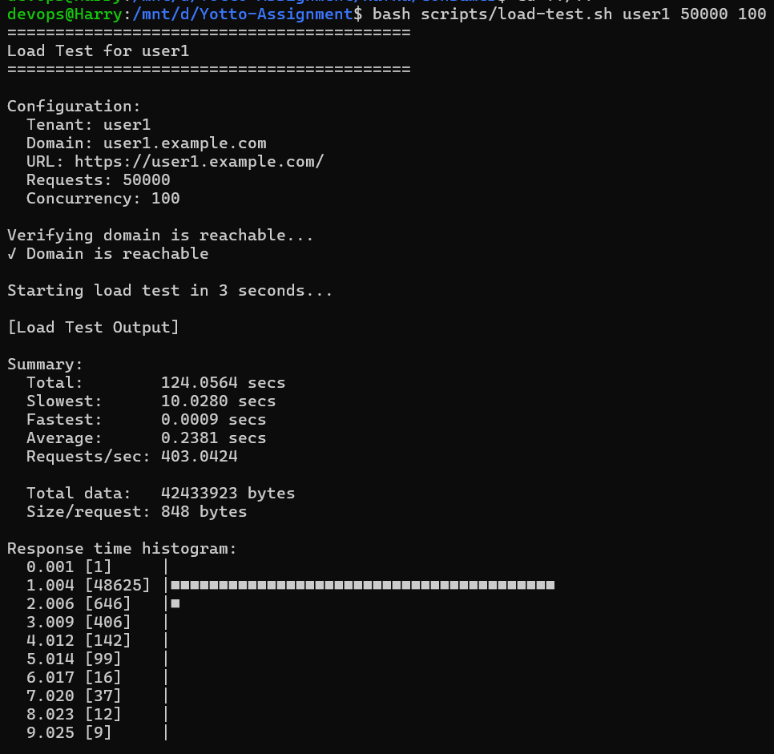
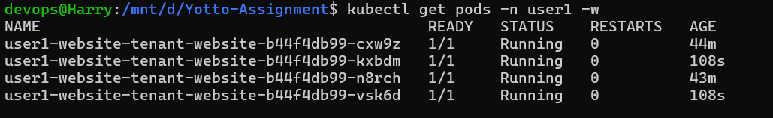

3.2 Resource Limits & Quotas
Resource Quotas ensure multi-tenant fairness. Screenshots below show constraints applied to individual namespaces.
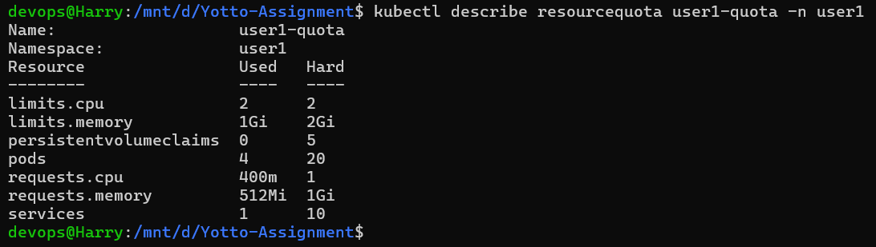

3.3 Observability Dashboard (Grafana)
- Panel 1: HPA Current Replicas (spikes to 4 during load)
- Panel 2: Memory Usage per Tenant (~200MB spike)
- Panel 3: Pods per Tenant (2 baseline, 4 during load)
- Panel 4: CPU Usage per Tenant (0 baseline, 0.4+ cores under load)
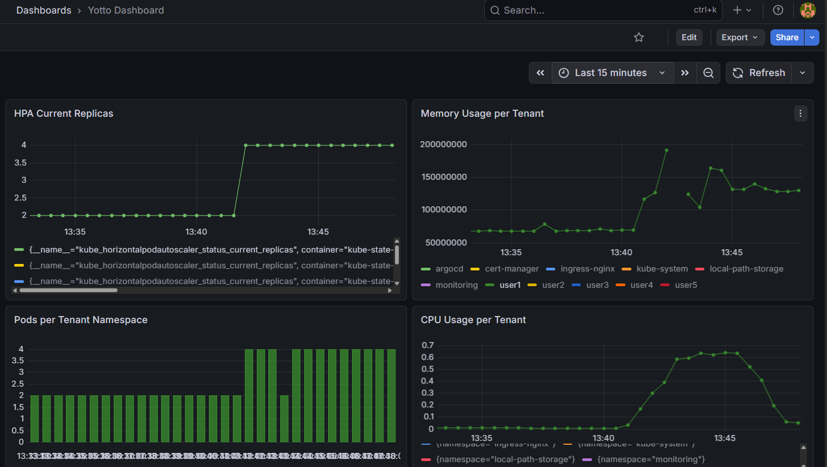

SECTION 4: Kafka Event-Driven Pipeline
A Kafka cluster provides an event-driven notification mechanism for downstream systems.

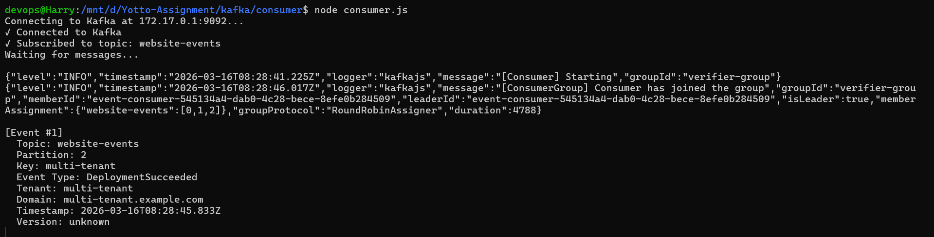

Summary
- Successful multi-tenant deployment with user isolation.
- Dynamic domain mapping with automated Let's Encrypt TLS.
- CI/CD with automated health verification and Helm rollbacks.
- Full observability with Grafana and Kafka event-driven tracking.

