**Report on the fairness of sailor scoring**

Problem

The problem that we are investigating is the fairness of the scoring in a sailing race. The current way that races are scored is the first to cross the finish line is award 1 point, second person across 2 points, etc. Once all the races have been counted the sailors remove their highest point and add up the rest of the scores. I expect that this would be fair way to score the sailors, this is because if the sailor has an anomalous result in one race then it wouldn’t count towards their final score.

Method

My method to determine the fairness of the scoring of sailors was to plot a graph of Skill of the sailors against the amount of people that got the race score.

Assumptions

In this report I have assumed that all the sailors turn up to all the races. Otherwise this would wildly affect their scores because there is currently nothing in place to give a score to a sailor who missed a race.

Another assumption that I have made is that the random module is 100% random. Although the module isn’t truly accurate, because that is impossible, it is close enough to that it wouldn’t affect the results too much, but I am still assuming that it is fully random.

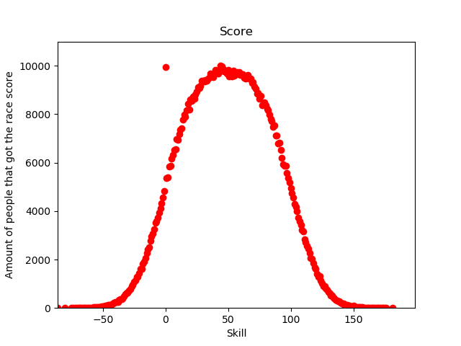Results

This graph shows the skill of the sailors plotted against the amount of the people that got the race score. The clear line that is plotted by the results shows that the sailors have a normal distribution. This shows that the sailors will normally produce an average skill of about 50 but only a few will deviate from the average going to the extremes of high and low skill.

Conclusions

To conclude the scoring currently in place in sailing races is fair. We can see this from the graph produced that the scoring is fair, this is because the graph mimics a normal distribution bell curve with lots of sailors with average skill, and only a few sailors being at the two extremes (high/low skill)