# WEEK 2

1. From this article I have learnt that most users of the Nest thermostat will enjoy using it. However on the whole the nest didn’t lead to energy savings despite the countless features aimed towards saving energy. This could be to do with the limitations of the nest itself. The article found these limitations to mainly stem from the machine learning. This is brought up when the paper talks about the avenues for future development. The exception flagging was a big one. This is to do with the fundamental gap between what a computing system can sense and the user’s actual intentions. During the time with the nests the users were actually able to find ways to work with the intelligence such as correcting the schedule for the nest and monitoring the patterns it had made. This lead to users getting an overall better experience even if they had to do some work to it first.

Another thing I learnt from reading the paper was that many of the users struggled to fully understand how the system actually operated. This was discussed in the paper under the section of incidental intelligibility. What this meant was that users struggled to get to grips fully with the nest, but also the researchers observed that the users desire to understand the system more was very infrequent. So this suggests that if the users put time into the nest they will get a better experience in the end.

1. My real world scenario would be for a house of three early twenty graduates all working in tech up in London. A nest would work for this group of people as they are likely to have other smart home products such as an amazon Alexa or similar, meaning that they can control their nest by talking to their Alexa. Another reason this product would work is they are already technology literate meaning they shouldn’t struggle to get to grips with the nest, compared to someone in their late 60s for example.

One problem that might arise with the nest is that often times the tech industry requires staff to work overtime, as such the nest might struggle to get an accurate schedule for every day, but this can be solved by the person using the app to delay the heating.

Another great benefit for this household would be that they can easily track how much they are using the heating allowing them to be more energy saving conscious to try and lower the price of living a little bit.

One more problem that could arouse with three different people using the nest all at once is deciding who is actually in charge of the heating. For example, if one person is back home earlier but one of the other two turns the heating off then this is a problem. This also works the opposite way round, if no one ends up turning the heating off if they’re not going to be home till later then they are wasting money and almost defeating the purpose of the nest.

As discussed above, the nest can also take some fiddling to get it exactly right, if these three graduates don’t have the time to spend to do this fiddling then they might end up spending more money than they save using the nest, once again defeating the purpose.

Along with the points above, if no one in the house talk to each other, which can be a problem in shared housing, then often no one wants to take responsibility for things such as heating, and as such the nest won’t be used to its full efficiency.

1. There are a few options when it comes to multiple users. My first thought would be to have a history tab, showing all the users who changed what, at what time and what setting. This way there is an easy chain of events so people understand what everyone else is doing.

A second option could also be to have an instant messaging section where you could talk between the different users in the house to discuss what needs to be changed within the nest device. This is a simple solution, yet the user uptake could be lacking. This is because there is already countless instant messaging apps which the members of the household already use. Along with the number of other instant messaging apps, the main barrier is the house dynamic, if none one speaks to each other face to face, they probably won’t end up using another messaging app to discuss the plans of the heating.

# WEEK 3

I have learnt for this week’s activity, that working in a group online can be difficult. For example it was hard to stay focused as a group and stay on task. Although we struggled to stay on task, the work that we did get done was of a high quality. With everyone inputting an equal amount to come up with ideas for our circular design strategy.

The ideas we learnt about in this week has helped influence our hackathon project, especially the circular design strategy.

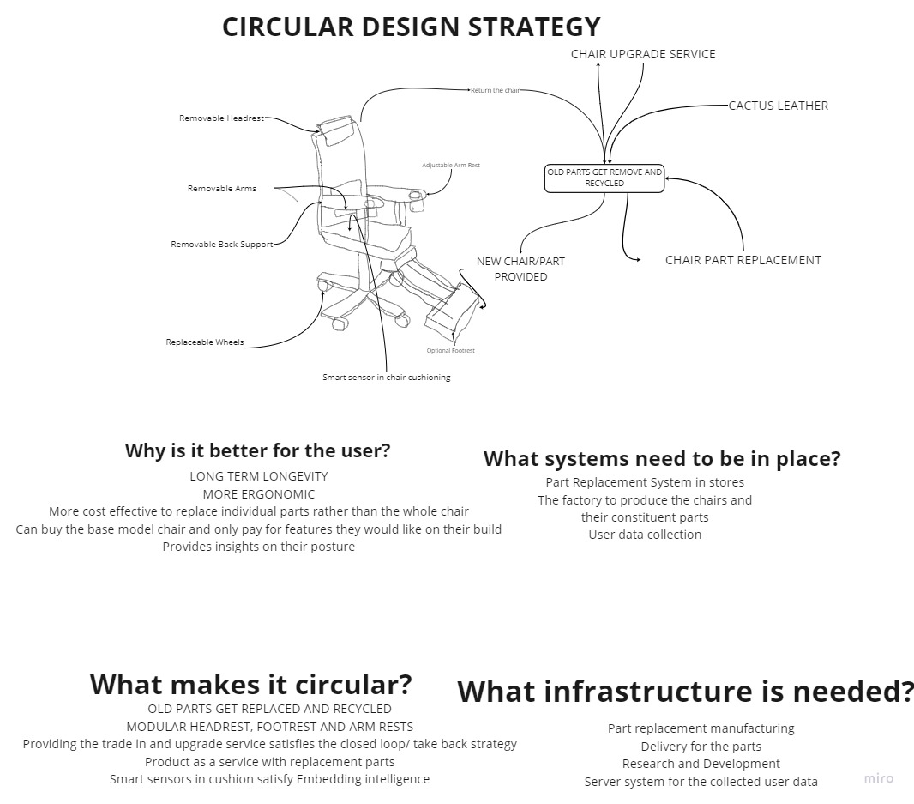As a group we were able to work together more to start thinking in the right mindset to start thinking about new plans and emerging tech. I think the reason we struggled to start with was because we hadn’t fully got into the mindset of what is needed for the task, but slowly we worked towards it, and future tasks went a lot better.

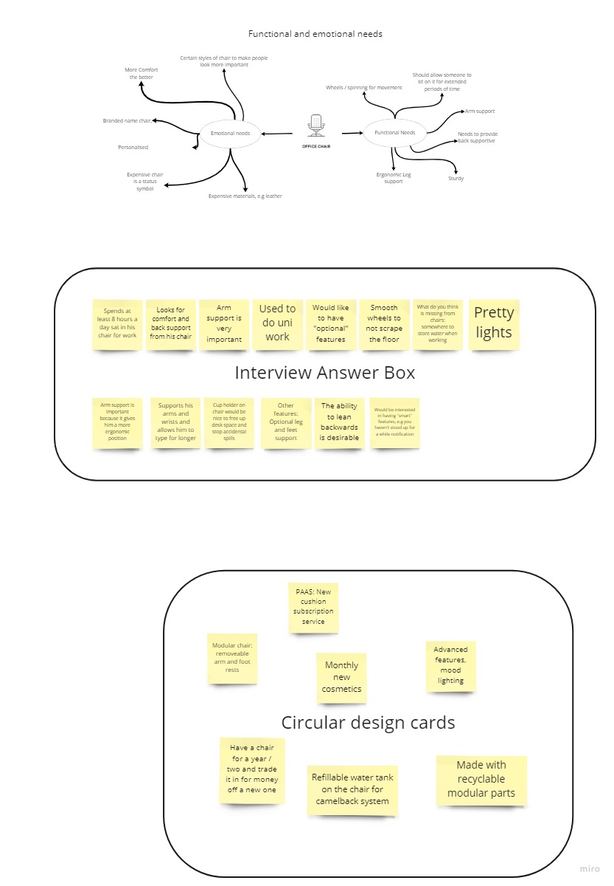

Miro board link

<https://miro.com/app/board/uXjVOKUWMQA=/?share_link_id=576613504429>

# WEEK 4

I believe in this weeks activity the team worked a lot better and stayed focus to get the task done. I believe we brainstormed better and was able to come up with better ideas for what we were working on. I think this could be down to getting used to the style of working.

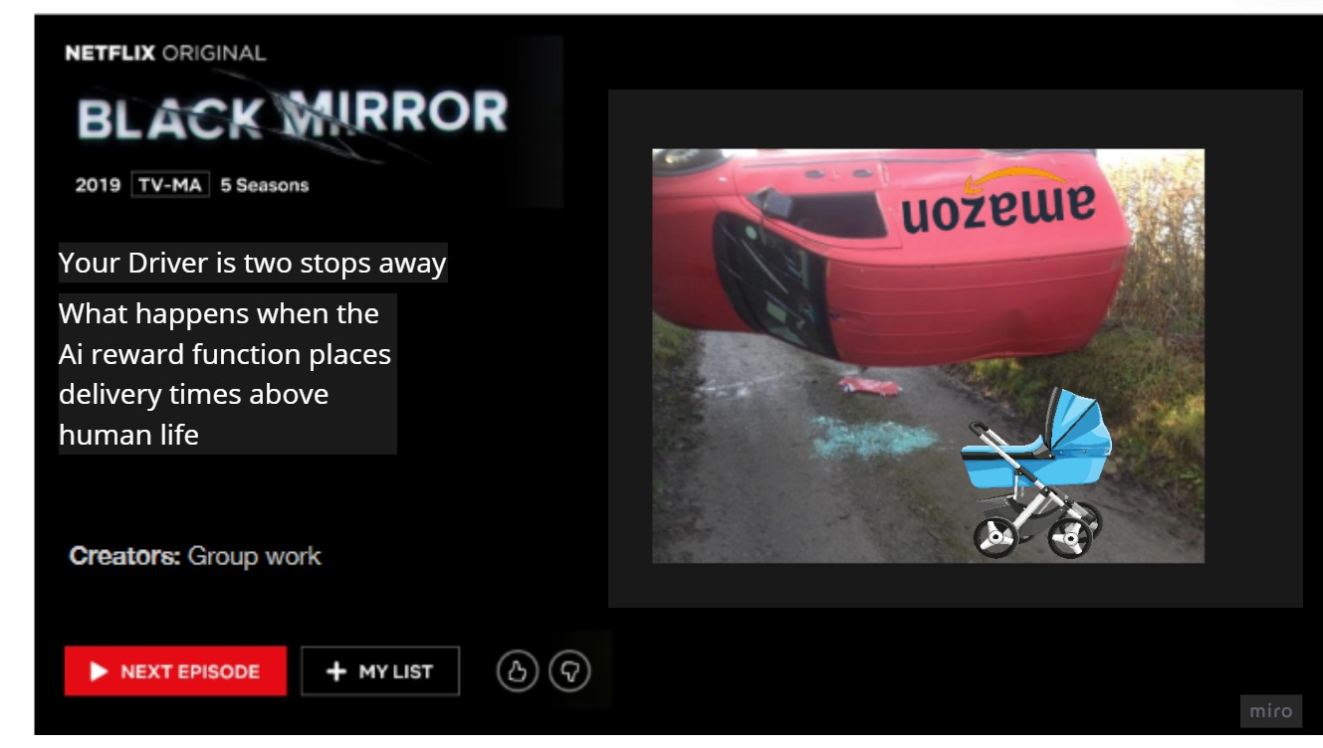Miro has also been a small hurdle that our team needed to get used to. After using it and working outs the small details of how to use it effectively our team quickly and smoothly worked through the tasks using the Miro board to our advantage to plan out what we were doing. I think that this will help us out in future tasks as Miro becomes used more often in the upcoming tasks.

Picture of the episode we created, along with a link to the Miro board

<https://miro.com/app/board/uXjVOIgqYp8=/?share_link_id=296477098245>

# WEEK 5

Leyla Takayama: What's it like to be a robot?

From this video I have learnt that from using robots more, we can learn a lot more about ourselves and the world around us. The video really opened my mind about the actual definition of a robot. I found it particularly interesting that she mentioned about the thermostat. I believe that most people think robots are far off from being in everyone’s home but taking the wider approach of a computer that “has a goal... and senses the world… [and then] makes a plan and acts on the physical world” we can see that robots live among us a lot more than we believe. These robots might not be the typical robots we see in media, but they still make our lives easier by doing jobs automatically, that we wouldn’t want to do every day. In short, I agree with Takayama and the way she is widening people’s views on the robots in everyday use.

On the other hand, I don’t fully agree with Takayama and her stories about the robots in the workspace. I believe this because after using zoom and other video meeting platforms over the pandemic I saw how people really struggled to use a very simple bit of software where everyone was in the same boat. I saw the struggles of people’s internet speeds not being able to cope with hosting a meeting, I saw when people didn’t understand their microphones and how loud or quiet they were. So I think these robots that allow for people working from home to attend in person meetings would actually not fail if they came to a larger audience especially people who aren’t working in tech, or even just the robotics industry. My solution for this, would be to have a robot on both ends of the call, so having the robot that Takayama described, but then also having a robot for the person in their own home. This would then reduce the chance of the person at home not being able to work their microphone or their camera as it is now in the control of the robot. There is one major problem with this. Giving control of your microphone and camera to a robot that is probably controlled by a large faceless organisation like Amazon or Meta is a major security concern for many people including myself.

# WEEK 6

1. I have learnt that three, technically four, rules of robotics set out by Isaac Asimov many years ago. I have also learnt that all these rules have fundamental problems with them. For example, the problems surrounding abortion and rules one and two, or the problems with the zeroth rule about what does harm to humankind mean. I was also fascinated to learn that Asimov came up with these rules in 1942 many years before robots started to become a big thing.
2. I agree with the podcast. I believe this because all of the points that question the different rules are all valid arguments. I believe it is also good to question these rules that are made, especially ones that are set so long ago. If we look beyond the set rules we might see flaws in the rules or we might be able to push technology further than we thought possible.
3. I believe that the role of a software engineer for requirements design will be limited. I believe the role of minimising societal challenges with robotics should be done by specialist robotic philosophers and law makers, these people would have a strong background in both computer science and philosophy. In my opinion there are large problems that would occur if a large company such as amazon, meta or similar were to obtain a fleet of robots of which they had control to programme. The same would apply if it were for governments. The only way I could see this happening is if there was legislation in place that meant the code had to be open source. Even then, when it comes to something so major as a group of human-centred robots there would be an inherent lack of trust towards these large companies with everything already in popular culture.

# WEEK 8

1. I have learnt that there are more real world uses for VR than I originally thought. I’ve also learnt that positive thinking is an actual effective technique to deal with pain management. All of this does make sense but seeing it in writing from proper trained medical professionals instils more confidence in the techniques than anything else.
2. I’m not sure if I fully 100% agree with the article, as I believe there are still cases where strong pain killers are needed, such as sever broken bones, but a combination of painkillers and VR treatment could work wonders for patients. I do agree with the use of VR for smaller accidents where opioids have been over prescribed. I also think that I would need to use VR treatment for myself or have a first-hand witness for me to trust it more and fully believe in it. I think this because currently it sounds a bit too fake for it to be real, even though it has backing from medical professionals and the base science does make sense.
3. Opioids are a big problem in the US, it is even classed as a public health emergency with over 100 people dying each day (at the time the article was written) so if there is any way the over prescription of opioids, and other highly addictive drugs, can be reduced it is a major benefit, especially if it uses a low cost option such as a VR headset which are getting better and cheaper as time moves on.
4. This article has taught me that VR can be used in the least likely ways possible. Going into this article I would have never thought that VR could be an alternative for painkillers as strong as opioids. It has also taught me that these uses could come at point in time, even when you’re least expecting it. These real world uses for VR could be all around us, but the right person hasn’t come along and suggested it yet.

# WEEK 9

Week 9 was challenging for us as a group. This was because we struggled to find the drive to read the article. In hindsight, we didn’t all need to read the article, we could have either all skimmed the article or we could have each read one small section and reported back to the group on that.

Individually I think I worked well. My role was thinking more towards the future. I mean this by starting off the first few points of each of the main sections before moving on, while others carried on and finished off the sections and fleshed it out.

I personally believe that the article we read was a bit weird and had some major flaws to it. Such as the fact that Nigeria are trying to solve their healthcare problems with blockchain without even having a working power grid. Without the major flaws of the power grid, I think that the article could bring some good change, but I don’t necessarily think the system works for a place like Nigeria.

Link to Miro board:

<https://miro.com/app/board/uXjVO8XWpRg=/?share_link_id=388525697390>

# Final activity