PERSONAL DATA

|  |  |
| --- | --- |
| **Name:** | Evgeny Rozhnowsky |
| **Date of Birth:** | 28/08/1992 |
| **Location:** | Belarus, Minsk |
| **Mobile:** | +375 (25) 670-45-39 |
| **E-mail:** | harryfingerling@gmail.com |
| **Skype:** | harryfingerling |
| **LinkedIn:** | [**https://www.linkedin.com/in/rozhnowsky**](https://www.linkedin.com/in/rozhnowsky) |
| **GitHub:** | [**https://github.com/HarryFinger**](https://github.com/HarryFinger) |

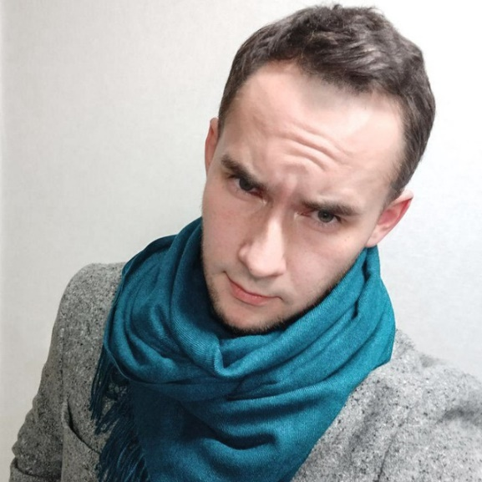

OBJECTIVE

Desired Position: Junior C++ Developer

SUMMARY OF QUALIFICATION

I am working in Game Development since 2019.

My current stack of technologies is: C++, Unreal Engine.

To see my current projects follow the GitHub link.

TECHNICAL SKILLS

* C++
* Unreal Engine, C++ STL, SFML
* Asana, GitHub
* Visual Studio, Visual Studio Code, Bourne Shell (Linux)

ADDITIONAL SKILLS

* Assembly language (NASM), C, OS device (Linux)
* CPU and computer science knowledge
* Graphic skills: 3ds Max, Photoshop, Blender

LANGUAGES

* English – Pre-Intermediate/Intermediate
* Russian – Native Speaker

EDUCATION

* 2009 – 2014 /Belarusian National Technical University, Builder Faculty/ Industrial and civil construction / Minsk, Belarus

SEVERAL FACTS ABOUT ME

In my spare time I love to play computer games.

In 2012 I played World Cyber Games (Belarus stage), as StarCraft 2 player, took 2nd place.

I like traveling, biking.

I am interested in historical literature as well as scientific.

I have a dog, named “Chuck”)). He is French bulldog.

COURSES AND CERTIFICATES

|  |  |
| --- | --- |
| **Course name:** | Speak Out Intermediate (B1) |
| **Issued:** | November 26, 2021 |
| **Years of study:** | 2021 |
| **Files:** | <https://drive.google.com/file/d/1pRTy_VP6CETDArWyAlZrwO0sr_1iHLHU/view?usp=sharing> |

PROFESSIOANL EXPERIENCE

|  |  |
| --- | --- |
| **Game “Design Masters”** | |
| **Project Industry:** | Game Development |
| **Company:** | “Playgendary” |
| **Project Web Site:** | <https://playgendary.com/ru/games/design-masters> |
| **Project Location:** | Belarus |
| **Duration:** | 04/2019 – 08/2021 |
| **Position:** | Senior 3d Artist |
| **Responsibilities:** | Creation and design of game locations.  Material creation and 3d modeling.  Work on workflow optimization for 3d artists. Research of render engines for the purposes of the project.  Render 2d sprites with further processing in Photoshop. |
| **Tools & Technologies:** | 3ds max, Photoshop, Corona Renderer |

|  |  |
| --- | --- |
| **Exterior and interior visualisations** | |
| **Project Industry:** | Architectural visualization |
| **Company:** | “Shmidt studio” |
| **Project Location:** | Belarus |
| **Duration:** | 01/2017 – 04/2019 |
| **Position:** | Computer Graphic Artist |
| **Responsibilities:** | Production of exterior and interior visualizations.  Post-processing render in photoshop. |
| **Tools & Technologies:** | 3ds max, Photoshop, Corona Renderer |

07/2016 – 01/2017: work as freelancer (3ds max).

07/2014 – 07/2016: work as an engineer (builder). Develop constructions in metal. Work in Autocad.